# [***81 FR 77008***](https://advance.lexis.com/api/document?collection=administrative-codes&id=urn:contentItem:5M3D-MP10-006W-80MT-00000-00&context=)

Vol. 81, No. 214, Part II, Friday, November 4, 2016

Rules and Regulations

**Reporter**

81 FR 77008 *

***Federal Register* > *2016* > *November* > *Friday, November 4, 2016* > *Rules and Regulations* > *DEPARTMENT OF HEALTH AND HUMAN SERVICES (HHS) -- Centers for Medicare & Medicaid Services (CMS)***

**Title:** **Medicare Program; Merit-Based Incentive Payment System (MIPS) and Alternative Payment Model (APM) Incentive Under the Physician Fee Schedule, and Criteria for Physician-Focused Payment Models**

**Action:**  Final rule with comment period.

**Agency**

DEPARTMENT OF HEALTH AND HUMAN SERVICES (HHS) > Centers for Medicare & Medicaid Services (CMS)

**Identifier:** **[CMS-5517-FC]** > **RIN 0938-AS69**

**Administrative Code Citation**

**42 CFR Parts 414 and 495**

**Synopsis**

**SUMMARY:** The Medicare Access and CHIP Reauthorization Act of 2015 (MACRA) repeals the Medicare sustainable growth rate (SGR) methodology for updates to the physician fee schedule (PFS) and replaces it with a new approach to payment called the Quality Payment Program that rewards the delivery of high-quality patient care through two avenues: Advanced Alternative Payment Models (Advanced APMs) and the Merit-based Incentive Payment System (MIPS) for eligible clinicians or groups under the PFS. This final rule with comment period establishes incentives for participation in certain alternative payment models (APMs) and includes the criteria for use by the Physician-Focused Payment Model Technical Advisory Committee (PTAC) in making comments and recommendations on physician-focused payment models (PFPMs). Alternative Payment Models are payment approaches, developed in partnership with the clinician community, that provide added incentives to deliver high-quality and cost-efficient care. APMs can apply to a specific clinical condition, a care episode, or a population. This final rule with comment period also establishes the MIPS, a new program for certain Medicare-enrolled practitioners. MIPS will consolidate components of three existing programs, the Physician Quality Reporting System (PQRS), the Physician Value-based Payment Modifier (VM), and the Medicare Electronic Health Record (EHR) Incentive Program for Eligible Professionals (EPs), and will continue the focus on quality, cost, and use of certified EHR technology (CEHRT) in a cohesive program that avoids redundancies. In this final rule with comment period we have rebranded key terminology based on feedback from stakeholders, with the goal of selecting terms that will be more easily identified and understood by our stakeholders.

**Text**

**SUPPLEMENTARY INFORMATION:**

**Table of Contents**

I. Executive Summary

II. Provisions of the Proposed ***Regulations*** and Analysis of and Responses to Comments

A. Establishing MIPS and the Advanced APM Incentive

B. Program Principles and Goals

C. Changes to Existing Programs

D. Definitions

E. MIPS Program Details

F. Overview of Incentives for Participation in Advanced Alternative Payment Models

III. Collection of Information Requirements

IV. Regulatory Impact Analysis

A. Statement of Need

B. Overall Impact

C. Changes in Medicare Payments

D. Impact on Beneficiaries

E. Impact on Other Health Care Programs and Providers

F. Alternatives Considered

G. Assumptions and Limitations

H. Accounting Statement

**Acronyms**

Because of the many terms to which we refer by acronym in this rule, we are listing the acronyms used and their corresponding meanings in alphabetical order below:

ABC(TM) Achievable Benchmark of Care

ACO Accountable Care Organization

APM Alternative Payment Model

APRN Advanced Practice Registered Nurse

ASPE HHS' Office of the Assistant Secretary for Planning and Evaluation

BPCI Bundled Payments for Care Improvement

CAH Critical Access Hospital

CAHPS Consumer Assessment of Healthcare Providers and Systems

CBSA Non-Core Based Statistical Area

CDS Clinical Decision Support

CEHRT Certified EHR technology

CFR Code of Federal ***Regulations***

CHIP Children's Health Insurance Program

CJR Comprehensive Care for Joint Replacement

CMMI Center for Medicare & Medicaid Innovation (CMS Innovation Center)

COI Collection of Information **[*77009]**

CPIA Clinical Practice Improvement Activity

CPOE Computerized Provider Order Entry

CPR Customary, Prevailing, and Reasonable

CPS Composite Performance Score

CPT Current Procedural Terminology

CQM Clinical Quality Measure

CY Calendar Year

eCQM electronic Clinician Quality Measure

ED Emergency Department

EHR Electronic Health Record

EP Eligible Professional

ESRD End-Stage Renal Disease

FFS Fee-for-Service

FR Federal Register

FQHC Federally Qualified Health Center

GAO Government Accountability Office

HIE Health Information Exchange

HIPAA Health Insurance Portability and Accountability Act of 1996

HITECH Health Information Technology for Economic and Clinical Health

HPSA Health Professional Shortage Area

HHS Department of Health & Human Services

HRSA Health Resources and Services Administration

IHS Indian Health Service

IT Information Technology

LDO Large Dialysis Organization

MACRA Medicare Access and CHIP Reauthorization Act of 2015

MEI Medicare Economic Index

MIPAA Medicare Improvements for Patients and Providers Act of 2008

MIPS Merit-based Incentive Payment System

MLR Minimum Loss Rate

MSPB Medicare Spending per Beneficiary

MSR Minimum Savings Rate

MUA Medically Underserved Area

NPI National Provider Identifier

OCM Oncology Care Model

ONC Office of the National Coordinator for Health Information Technology

PECOS Medicare Provider Enrollment, Chain, and Ownership System

PFPMs Physician-Focused Payment Models

PFS Physician Fee Schedule

PHS Public Health Service

PQRS Physician Quality Reporting System

PTAC Physician-Focused Payment Model Technical Advisory Committee

QCDR Qualified Clinical Data Registry

QP Qualifying APM Participant

QRDA Quality Reporting Document Architecture

QRUR Quality and Cost Reports

RBRVS Resource-Based Relative Value Scale

RFI Request for Information

RHC Rural Health Clinic

RIA Regulatory Impact Analysis

RVU Relative Value Unit

SGR Sustainable Growth Rate

TCPI Transforming Clinical Practice Initiative

TIN Tax Identification Number

VM Value-Based Payment Modifier

VPS Volume Performance Standard

**I. Executive Summary**

1. Overview

The Medicare Access and CHIP Reauthorization Act of 2015 (MACRA) (*Pub. L. 114-10*, enacted April 16, 2015), amended title XVIII of the Social Security Act (the Act) to repeal the Medicare sustainable growth rate, to reauthorize the Children's Health Insurance Program, and to strengthen Medicare access by improving physician and other clinician payments and making other improvements. This rule finalizes policies to improve physician and other clinician payments by changing the way Medicare incorporates quality measurement into payments and by developing new policies to address and incentivize participation in Alternative Payment Models (APMs). These unified policies to promote greater value within the healthcare system are referred to as the Quality Payment Program.

The MACRA, landmark bipartisan legislation, advances a forward-looking, coordinated framework for health care providers to successfully take part in the CMS Quality Payment Program that rewards value and outcomes in one of two ways:

* Advanced Alternative Payment Models (Advanced APMs).

1. Merit-based Incentive Payment System (MIPS).

The MACRA marks a milestone in efforts to improve and reform the health care system. Building off of the successful coverage expansions and improvements to access under the Patient Protection and Affordable Care Act (Affordable Care Act), the MACRA puts an increased focus on the quality and value of care delivered. By implementing MACRA to promote participation in certain APMs, such as the Shared Saving Program, Medical Home Models, and innovative episode payment models for cardiac and joint care, and by paying eligible clinicians for quality and value under MIPS, we support the nation's progress toward achieving a patient-centered health care system that delivers better care, smarter spending, and healthier people and communities. By driving significant changes in how care is delivered to make the health care system more responsive to patients and families, we believe the Quality Payment Program supports eligible clinicians in improving the health of their patients, including encouraging interested eligible clinicians in their successful transition into APMs. To implement this vision, we are finalizing a program that emphasizes high-quality care and patient outcomes while minimizing burden on eligible clinicians and that is flexible, highly transparent, and improves over time with input from clinical practices. To aid in this process, we have sought feedback from the health care community through various public avenues and solicited comment through the proposed rule. As we establish policies for effective implementation of the MACRA, we do so with the explicit understanding that technology, infrastructure, physician support systems, and clinical practices will change over the next few years. In addition, we are aware of the diversity of clinician practices in their experience with quality-based payments. As a result of these factors, we expect the Quality Payment Program to evolve over multiple years in order to achieve our national goals. In the early years of the program, we will begin by laying the groundwork for expansion towards an innovative, outcome-focused, patient-centered, resource-effective health system. Through a staged approach, we can develop policies that are operationally feasible and made in consideration of system capabilities and our core strategies to drive progress and reform efforts. Thus, due to this staged approach, we are finalizing the rule with a comment period. We commit to continue iterating on these policies.

The Quality Payment Program aims to do the following: (1) Support care improvement by focusing on better outcomes for patients, decreased provider burden, and preservation of independent clinical practice; (2) promote adoption of alternative payment models that align incentives across healthcare stakeholders; and (3) advance existing efforts of Delivery System Reform, including ensuring a smooth transition to a new system that promotes high-quality, efficient care through unification of CMS legacy programs.

This final rule with comment period establishes the Quality Payment Program and its two interrelated pathways: Advanced APMs and the MIPS. This final rule with comment period establishes incentives for participation in Advanced APMs, supporting the Administration's goals of transitioning from fee-for-service (FFS) payments to payments for quality and value, including approaches that focus on better care, smarter spending, and healthier people. This final rule with comment period also includes definitions of Qualifying APM Participants (QPs) in Advanced APMs and outlines the criteria for use by the Physician-Focused Payment Model Technical Advisory Committee (PTAC) in making comments and recommendations to the Secretary on physician-focused payment models (PFPMs).

MIPS is a new program for certain Medicare-participating eligible **[*77010]** clinicians that will make payment adjustments based on performance on quality, cost and other measures, and will consolidate components of three existing programs--the Physician Quality Reporting System (PQRS), the Physician Value-based Payment Modifier (VM), and the Medicare Electronic Health Record (EHR) Incentive Program for eligible professionals (EPs). As prescribed by Congress, MIPS will focus on: Quality--both a set of evidence-based, specialty-specific standards as well as practice-based improvement activities; cost; and use of certified electronic health record (EHR) technology (CEHRT) to support interoperability and advanced quality objectives in a single, cohesive program that avoids redundancies. Many features of MIPS are intended to simplify and integrate further during the second and third years.

2. Quality Payment Program Strategic Objectives

We solicited and reviewed over 4000 comments and had over 100,000 physicians and other stakeholders attend our outreach sessions. Through this outreach, we created six strategic objectives to drive continued progress and improvement.

These objectives guided our final policies and will guide our future rulemaking in order to design, implement and evolve a Quality Payment Program that aims to improve health outcomes, promote smarter spending, minimize burden of participation, and provide fairness and transparency in operations. These strategic objectives are as follows: (1) To improve beneficiary outcomes and engage patients through patient-centered Advanced APM and MIPS policies; (2) to enhance clinician experience through flexible and transparent program design and interactions with easy-to-use program tools; (3) to increase the availability and adoption of robust Advanced APMs; (4) to promote program understanding and maximize participation through customized communication, education, outreach and support that meet the needs of the diversity of physician practices and patients, especially the unique needs of small practices; (5) to improve data and information sharing to provide accurate, timely, and actionable feedback to clinicians and other stakeholders; and (6) to ensure operational excellence in program implementation and ongoing development. More information on these objectives and the Quality Payment Program can be found at *QualityPaymentProgram.cms.gov.*

With these objectives we recognize that the Quality Payment Program provides new opportunities to improve care delivery by supporting and rewarding clinicians as they find new ways to engage patients, families and caregivers and to improve care coordination and population health management. In addition, we recognize that by developing a program that is flexible instead of one-size-fits-all, clinicians will be able to choose to participate in a way that is best for them, their practice, and their patients. For clinicians interested in APMs, we believe that by setting ambitious yet achievable goals, eligible clinicians will move with greater certainty toward these new approaches of delivering care. To these ends, and to ensure this program works for all stakeholders, we further recognize that we must provide ongoing education, support, and technical assistance so that clinicians can understand program requirements, use available tools to enhance their practices, and improve quality and progress toward participation in alternative payment models if that is the best choice for their practice. Finally, we understand that we must achieve excellence in program management, focusing on customer needs, promoting problem-solving, teamwork, and leadership to provide continuous improvements in the Quality Payment Program.

3. One Quality Payment Program

Clinicians have told us that they do not separate their patient care into domains, and that the Quality Payment Program needs to reflect typical clinical workflows in order to achieve its goals of better patient care. Advanced APMs, the focus of one pathway of the Quality Payment Program, contribute to better care and smarter spending by allowing physicians and other clinicians to deliver coordinated, customized, high-quality care to their patients within a streamlined payment system. Within MIPS, the second pathway of the Quality Payment Program, we believe that the unification into one Quality Payment Program can best be accomplished by making connections across the four pillars of the MIPS payment structure identified in the MACRA legislation--quality, clinical practice improvement activities (referred to as "improvement activities"), meaningful use of CEHRT (referred to as "advancing care information"), and resource use (referred to as "cost")--and by emphasizing that the Quality Payment Program is at its core about improving the quality of patient care. Indeed, the bedrock of the Quality Payment Program is high-quality, patient-centered care followed by useful feedback, in a continuous cycle of improvement. The principal way MIPS measures quality of care is through evidence-based clinical quality measures (CQMs) which MIPS eligible clinicians can select, the vast majority of which are created by or supported by clinical leaders and endorsed by a consensus-based process. Over time, the portfolio of quality measures will grow and develop, driving towards outcomes that are of the greatest importance to patients and clinicians. Through MIPS, we have the opportunity to measure quality not only through clinician-proposed measures, but to take it a step further by also accounting for activities that physicians themselves identify: Namely, practice-driven quality improvement. The MACRA requires us to measure whether technology is used meaningfully. Based on significant feedback, this area is simplified into supporting the exchange of patient information and how technology specifically supports the quality goals selected by the practice. The cost performance category has also been simplified and weighted at zero percent of the final score for the transition year of CY 2017. Given the primary focus on quality, we have accordingly indicated our intention to align these measures fully to the quality measures over time in the scoring system (see section II.E.6.a. for further details). That is, we are establishing special policies for the first year of the Quality Payment Program, which we refer to as the "transition year" throughout this final rule with comment period; this transition year corresponds to the first performance period of the program, calendar year (CY) 2017, and the first payment year, CY 2019. We envision that it will take a few years to reach a steady state in the program, and we therefore anticipate a ramp-up process and gradual transition with less financial risk for clinicians in at least the first 2 years. In the transition year in 2017, we will test this performance category alignment, for example by allowing certain improvement activities that are completed using CEHRT to achieve a bonus score in the advancing care information performance category with the intent of analyzing adoption, and in future years, potentially adding activities that reinforce integration of the program. Our hope is for the program to evolve to the point where all the clinical activities captured in MIPS across the four performance categories reflect the single, unified goal of quality improvement. **[*77011]**

4. Summary of the Major Provisions

a. Transition Year and Iterative Learning and Development Period

We recognize, as described through many insightful comments, that many eligible clinicians face challenges in understanding the requirements and being prepared to participate in the Quality Payment Program in 2017. As a result, we have decided to finalize transitional policies throughout this final rule with comment period, which will focus the program in its initial years on encouraging participation and educating clinicians, all with the primary goal of placing the patient at the center of the healthcare system. At the same time, we will also increase opportunities to join Advanced APMs, allowing eligible clinicians who chose to do so an opportunity to participate.

Given the wide diversity of clinical practices, the initial development period of the Quality Payment Program implementation would allow physicians to pick their pace of participation for the first performance period that begins January 1, 2017. Eligible clinicians will have three flexible options to submit data to MIPS and a fourth option to join Advanced APMs in order to become QPs, which would ensure they do not receive a negative payment adjustment in 2019.

In the transition year CY 2017 of the program, this rule finalizes a period during which clinicians and CMS will build capabilities to report and gain experience with the program. Clinicians can choose their course of participation in this year with four options.

(1) Clinicians can choose to report to MIPS for a full 90-day period or, ideally, the full year, and maximize the MIPS eligible clinician's chances to qualify for a positive adjustment. In addition, MIPS eligible clinicians who are exceptional performers in MIPS, as shown by the practice information that they submit, are eligible for an additional positive adjustment for each year of the first 6 years of the program.

(2) Clinicians can choose to report to MIPS for a period of time less than the full year performance period 2017 but for a full 90-day period at a minimum and report more than one quality measure, more than one improvement activity, or more than the required measures in the advancing care information performance category in order to avoid a negative MIPS payment adjustment and to possibly receive a positive MIPS payment adjustment.

(3) Clinicians can choose to report one measure in the quality performance category; one activity in the improvement activities performance category; or report the required measures of the advancing care information performance category and avoid a negative MIPS payment adjustment. Alternatively, if MIPS eligible clinicians choose to not report even one measure or activity, they will receive the full negative 4 percent adjustment.

(4) MIPS eligible clinicians can participate in Advanced APMs, and if they receive a sufficient portion of their Medicare payments or see a sufficient portion of their Medicare patients through the Advanced APM, they will qualify for a 5 percent bonus incentive payment in 2019.

We are finalizing the 2017 performance period for the 2019 MIPS payment year to be a transition year as part of the development period in the program. For this transition year, for MIPS the performance threshold will be lowered to a threshold of 3 points. Clinicians who achieve a final score of 70 or higher will be eligible for the exceptional performance adjustment, funded from a pool of $ 500 million.

For full participation in MIPS and in order to achieve the highest possible final scores, MIPS eligible clinicians are encouraged to submit measures and activities in all three integrated performance categories: Quality, improvement activities, and advancing care information. To address public comments on the cost performance category, the weighting of the cost performance category has been lowered to 0 percent for the transition year. For full participation in the quality performance category, clinicians will report on six quality measures, or one specialty-specific or subspecialty-specific measure set. For full participation in the advancing care information performance category, MIPS eligible clinicians will report on five required measures. For full participation in the improvement activities performance category, clinicians can engage in up to four activities, rather than the proposed six activities, to earn the highest possible score of 40.

For the transition year CY 2017, for quality, clinicians who submit one out of at least six quality measures will meet the MIPS performance threshold of 3; however, more measures are required for groups who submit measures using the CMS Web Interface. For the transition year CY 2017, for quality, higher measure points may be awarded based on achieving higher performance in the measure. For improvement activities, attesting to at least one improvement activity will also be sufficient to meet the MIPS performance threshold in the transition year CY 2017. For advancing care information, clinicians reporting on the required measures in that category will meet the performance threshold in the transition year. These transition year policies for CY 2017 will encourage participation by clinicians and will provide a ramp up period for clinicians to prepare for higher performance thresholds in the second year of the program.

Historical evidence has shown that clinical practices of all sizes can successfully submit data, including over 110,000 solo and small practices with 15 or fewer clinicians who participated in PQRS in 2015. The transition year and development period approach gives clinicians structured, practical choices that can best suit their practices. Resources will be made available to assist clinicians and practices through this transition. The hope is that by lowering the barriers to participation at the outset, we can set the foundation for a program that supports long-term, high-quality patient care through feedback and open communication between CMS and other stakeholders.

We anticipate that the iterative learning and development period will last longer than the first year, CY 2017, of the program as we move towards a steady state; therefore, we envision CY 2018 to also be transitional in nature to provide a ramp-up of the program and of the performance thresholds. We anticipate making proposals on the parameters of this second transition year through rule-making in 2017.

b. Legacy Quality Reporting Programs

This final rule with comment period will sunset payment adjustments under the current Medicare EHR Incentive Program for EPs (section 1848(o) of the Act), the PQRS (section 1848(k) and (m) of the Act), and the VM (section 1848(p) of the Act) programs after CY2018. Components of these three programs will be carried forward into MIPS. This final rule with comment period establishes new subpart O of our ***regulations*** at 42 CFR part 414 to implement the new MIPS program as required by the MACRA.

c. Significant Changes From Proposed Rule

In developing this final rule with comment period, we sought feedback from stakeholders throughout the process, including through Requests for Information in October 2015 and through the comment process for the proposed rule from April to June 2016. We received thousands of comments from a broad range of sources including professional associations and societies, physician practices, hospitals, patient **[*77012]** groups, and health IT vendors, and we thank our many commenters and acknowledge their valued input throughout the proposed rule process. In response to comments to the proposed rule, we have made significant changes in this final rule with comment period, including (1) bolstering support for small and independent practices; (2) strengthening the movement towards Advanced Alternative Payment Models by offering potential new opportunities such as the Medicare ACO Track 1+ (3) securing a strong start to the program with a flexible, pick-your-own-pace approach to the initial years of the program; and (4) connecting the statutory domains into one unified program that supports clinician-driven quality improvement. These themes are illustrated in the following specific policy changes: (1) The creation of a transition year and iterative learning and development period in the beginning of the program; (2) the adjustment of the MIPS low-volume threshold; (3) the establishment of an Advanced APM financial risk standard that promotes participation in robust, high-quality models; (4) the simplification of prior "all-or-nothing" requirements in the use of certified EHR technology; and (5) the establishment of Medical Home Model standards that promote care coordination.

We intend to continue open communication with stakeholders, including consultation with tribes and tribal officials, on an ongoing basis as we develop the Quality Payment Program in future years.

d. Small Practices

As outlined above, protection of small, independent practices is an important thematic objective for this final rule with comment. For 2017, many small practices will be excluded from new requirements due to the low-volume threshold, which has been set at less than or equal to $ 30,000 in Medicare Part B allowed charges or less than or equal to 100 Medicare patients, representing 32.5 percent of pre-exclusion Medicare clinicians but only 5 percent of Medicare Part B spending. Stakeholder comments suggested setting a higher low-volume threshold for exclusion from MIPS but allowing clinicians that would be excluded by the threshold to opt in to the program if they wished to report to MIPS and receive a MIPS payment adjustment for the year. We considered this option but determined that it was inconsistent with the statutory MIPS exclusion based on the low-volume threshold. We anticipate that more clinicians will be determined to be eligible to participate in the program in future years.

MACRA also provides that solo and small practices may join "virtual groups" and combine their MIPS reporting. Many commenters suggested that we allow groups with more than 10 clinicians to participate as virtual groups. As noted, the statute limits the virtual group option to individuals and groups of not more than 10 clinicians. We are not implementing virtual groups in the transition year CY 2017 of the program; however, through the policies of the transition year and development period, we believe we have addressed some of the concerns expressed by clinicians hesitant to participate in the Quality Payment Program. CMS wants to make sure the virtual group technology is meaningful and simple to use for clinicians, and we look forward to stakeholder engagement on how to structure and implement virtual groups in future years of the program.

In keeping with the objectives of providing education about the program and maximizing participation, and as mandated by the MACRA, $ 100 million in technical assistance will be available to MIPS eligible clinicians in small practices, rural areas, and practices located in geographic health professional shortage areas (HPSAs), including IHS, tribal, and urban Indian clinics, through contracts with quality improvement organizations, regional health collaboratives, and others to offer guidance and assistance to MIPS eligible clinicians in practices of 15 or fewer MIPS eligible clinicians. Priority will be given to practices located in rural areas, defined as clinicians in zip codes designated as rural, using the most recent Health Resources and Services Administration (HRSA) Area Health Resource File data set available; medically underserved areas (MUAs); and practices with low MIPS final scores or in transition to APM participation. The MACRA also includes provisions requiring an examination of the pooling of financial risk for physician practices, in particular for small practices. Specifically, section 101(c)(2)(C) of MACRA requires the Government Accountability Office (GAO) to submit a report to Congress, not later than January 1, 2017, examining whether entities that pool financial risk for physician practices, such as independent risk managers, can play a role in supporting physician practices, particularly small physician practices, in assuming financial risk for the treatment of patients. We have been closely engaged with the GAO throughout their study to better understand the unique needs and challenges faced by clinicians in small practices and practices in rural or health professional shortage areas. We have provided information to the GAO, and the GAO has shared some of their initial findings regarding these challenges. We look forward to further engagement with the GAO on this topic and to the release of GAO's final report. Using the knowledge obtained from small practices, other stakeholders, and the public, as well as from GAO, we continue to work to improve the flexibility and support available to small, underserved, and rural practices. Throughout the evolution of the Quality Payment Program that will unfold over the years to come, CMS is committed to working together with stakeholders to address the unique challenges these practices encounter.

Using updated policies for the transition year and development period, we performed an updated regulatory impact analysis, including for small and solo practices. With the extensive changes to policy and increased flexibility, we believe that estimating impacts of this final rule with comment period using only historic 2015 quality submission data significantly overestimates the impact on small and solo practices. Although small and solo practices have historically been less likely to engage in PQRS and quality reporting, we believe that small and solo practices will respond to MIPS by participating at a rate close to that of other practice sizes. In order to quantify the impact of the rule on MIPS eligible clinicians, including small and solo practices, we have prepared two sets of analyses that assume the participation rates for some categories of small practices will be similar to those of other practice size categories. Specifically, our primary analysis assumes that each practice size grouping will achieve at least 90 percent participation rate and our alternative assumption is that each practice size grouping will achieve at least an 80 percent participation rate. In both sets of analyses, we estimate that over 90 percent of MIPS eligible clinicians will receive a positive or neutral MIPS payment adjustment in the transition year, and that at least 80 percent of clinicians in small and solo practices with 1-9 clinicians will receive a positive or neutral MIPS payment adjustment.

e. Advanced Alternative Payment Models (Advanced APMs)

In this rule, we finalize requirements we will use for the purposes of the incentives for participation in Advanced **[*77013]** APMs, and the following is a summary of our finalized policies. The MACRA defines APM for the purposes of the incentive as a model under section 1115A of the Act (excluding a health care innovation award), the Shared Savings Program under section 1899 of the Act, a demonstration under section 1866C of the Act, or a demonstration required by federal law.

APMs represent an important step forward in the Administration's efforts to move our healthcare system from volume-based to value-based care. APMs that meet the criteria to be Advanced APMs provide the pathway through which eligible clinicians, who would otherwise participate in MIPS, can become Qualifying APM Participants (QPs), and therefore, earn incentive payments for their Advanced APM participation. In the proposed rule, we estimated that 30,000 to 90,000 clinicians would be QPs in 2017. With new Advanced APMs expected to become available for participation in 2017 and 2018, including the Medicare ACO Track 1 Plus (1+), and anticipated amendments to reopen applications for or modify current APMs, such as the Maryland All-Payer Model and Comprehensive Care for Joint Replacement (CJR) model, we anticipate higher numbers of QPs--approximately 70,000 to 120,000 in 2017 and 125,000 to 250,000 in 2018.

As discussed in section II.F.4.b. of this final rule with comment period, we are exploring development of the Medicare ACO Track 1+ Model to begin in 2018. The model would be voluntary for ACOs currently participating in Track 1 of the Shared Savings Program or ACOs seeking to participate in the Shared Savings Program for the first time. It would test a payment model that incorporates more limited downside risk than is currently present in Tracks 2 or 3 of the Shared Savings Program but sufficient financial risk in order to be an Advanced APM. We will announce additional information about the model in the future.

This rule finalizes two types of Advanced APMs: Advanced APMs and Other Payer Advanced APMs. To be considered an Advanced APM, an APM must meet all three of the following criteria, as required under section 1833(z)(3)(D) of the Act: (1) The APM must require participants to use CEHRT; (2) The APM must provide for payment for covered professional services based on quality measures comparable to those in the quality performance category under MIPS and; (3) The APM must either require that participating APM Entities bear risk for monetary losses of a more than nominal amount under the APM, or be a Medical Home Model expanded under section 1115A(c) of the Act. In this rule, we finalize proposals pertaining to all of these criteria.

To be an Other Payer Advanced APM, as set forth in section 1833(z)(2) of the Act, a payment arrangement with a payer (for example, Medicaid or a commercial payer) must meet all three of the following criteria: (1) The payment arrangement must require participants to use CEHRT; (2) The payment arrangement must provide for payment for covered professional services based on quality measures comparable to those in the quality performance category under MIPS and; (3) The payment arrangement must require participants to either bear more than nominal financial risk if actual aggregate expenditures exceed expected aggregate expenditures; or be a Medicaid Medical Home Model that meets criteria comparable to Medical Home Models expanded under section 1115A(c) of the Act.

We are completing an initial set of Advanced APM determinations that we will release as soon as possible but no later than January 1, 2017. For new APMs that are announced after the initial determination, we will include Advanced APM determinations in conjunction with the first public notice of the APM, such as the Request for Applications (RFA) or final rule. All determinations of Advanced APMs will be posted on our Web site and updated on an ad hoc basis, but no less frequently than annually, as new APMs become available and others end or change.

An important avenue for the creation of innovative payment models is the PTAC, created by the MACRA. The PTAC is an 11-member independent federal advisory committee to the HHS Secretary. The PTAC will review stakeholders' proposed PFPMs, and make comments and recommendations to the Secretary regarding whether the PFPMs meet criteria established by the Secretary. PTAC comments and recommendations will be reviewed by the CMS Innovation Center and the Secretary, and we will post a detailed response to them on the CMS Web site.

(i) QP Determination

QPs are eligible clinicians in an Advanced APM who have a certain percentage of their patients or payments through an Advanced APM. QPs are excluded from MIPS and receive a 5 percent incentive payment for a year beginning in 2019 through 2024. We finalize our proposal that professional services furnished at Critical Access Hospitals (CAHs), Rural Health Clinics (RHCs), and Federally Qualified Health Centers (FQHCs) that meet certain criteria be counted towards the QP determination using the patient count method.

We finalize definitions of Medical Home Model and Medicaid Medical Home Model and the unique standards by which Medical Home Models may meet the financial risk criterion to be an Advanced APM.

The statute sets thresholds for the level of participation in Advanced APMs required for an eligible clinician to become a QP for a year. The Medicare Option, based on Part B payments for covered professional services or counts of patients furnished covered professional services under Part B, is applicable beginning in the payment year 2019. The All-Payer Combination Option, which utilizes the Medicare Option as well as an eligible clinician's participation in Other Payer Advanced APMs, is applicable beginning in the payment year 2021. For eligible clinicians to become QPs through the All-Payer Combination Option, an Advanced APM Entity or eligible clinician must participate in an Advanced APM under Medicare and also submit information to CMS so that we can determine whether payment arrangements with non-Medicare payers are an Other Payer Advanced APMs and whether an eligible clinician meets the requisite QP threshold of participation. We are finalizing our methodologies to evaluate eligible clinicians using the Medicare and All-Payer Combination Options.

We are finalizing the two methods by which we will calculate Threshold Scores to compare to the QP thresholds and make QP determinations for eligible clinicians. The payment amount method assesses the amount of payments for Part B covered professional services that are furnished through an Advanced APM. The patient count method assesses the amount of patients furnished Part B covered professional services through an Advanced APM.

We are finalizing our proposal to identify individual eligible clinicians by a unique APM participant identifier using the individuals' APM, APM Entity, and TIN/NPI combinations, and to assess as an APM Entity group all individual eligible clinicians listed as participating in an Advanced APM Entity to determine their QP status for a year. We are finalizing that if an individual eligible clinician who participates in multiple Advanced APM Entities does not achieve QP status through participation in any single APM Entity, we will assess the eligible **[*77014]** clinician individually to determine QP status based on combined participation in Advanced APMs.

We are finalizing the method to calculate and disburse the lump-sum APM Incentive Payments to QPs, and we are finalizing a specific approach for calculating the APM Incentive Payment when a QP also receives non-FFS payments or has received payment adjustments through the Medicare EHR Incentive Program, PQRS, VM, or MIPS during the prior period used for determining the APM Incentive Payment.

We are finalizing a modified policy such that, following a final determination that an Advanced APM Entity group or eligible clinician is determined to be a Partial Qualifying APM Participant (Partial QP), the Advanced APM Entity--or eligible clinician in the case of an individual determination--will make an election on behalf of all of its eligible clinicians in the group of whether to report to MIPS, thus making all eligible clinicians in the Advanced APM Entity group subject to MIPS payment adjustments; or not report to MIPS, thus excluding all eligible clinicians in the APM Entity group from MIPS adjustments. We finalize our proposals to vet and monitor APM Entities, Advanced APM Entities, and eligible clinicians participating in those entities. We are finalizing a definition for PFPMs and criteria for use by the PTAC in fulfilling its responsibility to evaluate proposals for PFPMs.

We are finalizing an accelerated timeline for making QP determinations, and will notify eligible clinicians of their QP status as soon as possible, in advance of the end of the MIPS performance period so that QPs will know whether they are excluded from MIPS prior to having to submit information to CMS for purposes of MIPS.

We are finalizing the requirement that MIPS eligible clinicians, as well as EPs, eligible hospitals, and CAHs under the existing Medicare and Medicaid EHR Incentive Programs demonstrate cooperation with certain provisions concerning blocking the sharing of information under section 106(b)(2) of the MACRA and, separately, to demonstrate engagement with activities that support health care providers with the performance of their CEHRT such as cooperation with ONC direct review of certified health information technologies.

f. Merit-Based Incentive Payment System (MIPS)

In establishing MIPS, this final rule with comment period will define MIPS participants as "MIPS eligible clinicians" rather than "MIPS EPs" as that term is defined at section 1848(q)(1)(C) and used throughout section 1848(q) of the Act. MIPS eligible clinicians will include physicians, physician assistants, nurse practitioners, clinical nurse specialists, certified registered nurse anesthetists, and groups that include such clinicians who bill under Medicare Part B. The rule finalizes definitions and requirements for groups. In addition to finalizing definitions for MIPS eligible clinicians, the rule also finalizes rules for the specific Medicare-enrolled clinicians that will be excluded from MIPS, including newly Medicare-enrolled MIPS eligible clinicians, QPs, certain Partial QPs, and clinicians that fall under the finalized low-volume threshold.

For the 2017 performance period, we estimate that more than half of clinicians--approximately 738,000 to 780,000--billing under the Medicare PFS will be excluded from MIPS due to several factors, including the MACRA itself. We estimate that nearly 200,000 clinicians, or approximately 14.4 percent, are not one of the eligible types of clinicians for the transition year CY 2017 of MIPS under section 1848(q)(1)(C) of the Act. The largest cohort of clinicians excluded from MIPS is low-volume clinicians, defined as those clinicians with less than or equal to $ 30,000 in allowed charges or less than or equal to 100 Medicare patients, representing approximately 32.5 percent of all clinicians billing Medicare Part B services or over 380,000 clinicians. Additionally, between 70,000 and 120,000 clinicians (approximately 5-8 percent of all clinicians billing under the Medicare Part B) will be excluded from MIPS due to being QPs based on participation in Advanced APMs. In aggregate, the eligible clinicians excluded from MIPS represent only 22 to 27 percent of total Part B allowed charges.

This rule finalizes MIPS performance standards and a minimum MIPS performance period of any 90 continuous days during CY 2017 (January 1 through December 31) for all measures and activities applicable to the integrated performance categories. After consideration of public comments, this rule finalizes a shorter than annual performance period in 2017 to allow flexible participation options for MIPS eligible clinicians as the program begins and evolves over time. For performance periods occurring in 2017, MIPS eligible clinicians will be able to pick a pace of participation that best suits their practices, including submitting data, in special circumstances as discussed in section II.E.5. of this rule, for a period of less than 90 days, to avoid a negative MIPS payment adjustment. Further, we are finalizing our proposal to use performance in 2017 as the performance period for the 2019 payment adjustment. Therefore, the first performance period will start in 2017 and consist of a minimum period of any 90 continuous days during the calendar year in order for clinicians to be eligible for payment adjustment above neutral. Performance in that period of 2017 will be used to determine the 2019 payment adjustment. This timeframe is needed to allow data and claims to be submitted and data analysis to occur in the initial years. In subsequent years, we intend to explore ways to shorten the period between the performance period and the payment year, and ongoing performance feedback will be provided more frequently. The final policies for CY 2017 provide flexibilities to ensure clinicians have ample participation opportunities.

As directed by the MACRA, this rule finalizes measures, activities, reporting, and data submission standards across four integrated performance categories: Quality, cost, improvement activities, and advancing care information, each linked by the same overriding mission of supporting care improvement under the vision of one Quality Payment Program. Consideration will be given to the application of measures and activities to non-patient facing MIPS eligible clinicians.

Under the requirements finalized in this rule, there will be options for reporting as an individual MIPS eligible clinician or as part of a group. Some data may be submitted via relevant third party intermediaries, such as qualified clinical data registries (QCDRs), health IT vendors, n1 qualified registries, and CMS-approved survey vendors.

n1 We also note that throughout this final rule, as in the proposed rule, we use the terms "EHR Vendor" and "Health IT Vendor." First, the use of the term "health IT" and "EHR" are based on the common terminology within the specified program (see [*80 FR 62604;*](https://advance.lexis.com/api/document?collection=administrative-codes&id=urn:contentItem:5H5B-72Y0-006W-851T-00000-00&context=) and the advancing care information performance category in this rule). Second, we recognize that a "health IT vendor" may or may not also be a "health IT developer" and, in some cases, the developer and the vendor of a single product may be different entities. Under the ONC Health IT Certification Program (Program), a health IT developer constitutes a vendor, self-developer, or other entity that presents health IT for certification or has health IT certified under the Program. Therefore, for purposes of this final rule, we clarify that the term "vendor" shall also include developers who create or develop health IT. Throughout this final rule, we use the term "health IT vendor" or "EHR vendor" to refer to entities that support the health IT requirements of a MIPS eligible clinician participating in the proposed Quality Payment Program. This use is consistent with prior CMS rules, see for example the 2014 CEHRT Flexibility final rule [*(79 FR 52915).*](https://advance.lexis.com/api/document?collection=administrative-codes&id=urn:contentItem:5D2J-47M0-006W-82N9-00000-00&context=) **[*77015]**

Within each performance category, we are finalizing specific requirements for full participation in MIPS which involves submitting data on quality measures, improvement activities, and use of certified EHR technology on a minimum of any continuous 90 days up to the full calendar year in 2017 in order to be eligible for a positive MIPS payment adjustment. It is at the MIPS eligible clinician's discretion whether to submit data for the same 90-day period for the various measures and activities or for different time periods for different measures and activities. Note that during the 2017 transition year, MIPS eligible clinicians may choose to report a minimum of a single measure in the quality performance category, a single activity in the improvement activities performance category or the required measures in the advancing care information performance category, in order to avoid a negative payment adjustment. For full participation in MIPS, the specific requirements are as follows:

(i) Quality

Quality measures will be selected annually through a call for quality measures process, and a final list of quality measures will be published in the **Federal Register** by November 1 of each year. For MIPS eligible clinicians choosing full participation in MIPS and the potential for a higher payment adjustment, we note that for a minimum of a continuous 90-day performance period, the MIPS eligible clinician or group will report at least six measures including at least one outcome measure if available. If fewer than six measures apply to the individual MIPS eligible clinician or group, then the MIPS eligible clinician or group will only be required to report on each measure that is applicable.

Alternatively, for a minimum of a continuous 90-day period, the MIPS eligible clinician or group can report one specialty-specific measure set, or the measure set defined at the subspecialty level, if applicable. If the measure set contains fewer than six measures, MIPS eligible clinicians will be required to report all available measures within the set. If the measure set contains six or more measures, MIPS eligible clinicians can choose six or more measures to report within the set. Regardless of the number of measures that are contained in the measure set, MIPS eligible clinicians reporting on a measure set will be required to report at least one outcome measure or, if no outcome measures are available in the measure set, report another high priority measure (appropriate use, patient safety, efficiency, patient experience, and care coordination measures) within the measure set in lieu of an outcome measure.

(ii) Improvement Activities

Improvement activities are those that support broad aims within healthcare delivery, including care coordination, beneficiary engagement, population management, and health equity. In response to comments from experts and stakeholders across the healthcare system, improvement activities were given relative weights of high and medium. We are reducing the number of activities required to achieve full credit from six medium-weighted or three high-weighted activities to four medium-weighted or two high-weighted activities to receive full credit in this performance category in CY 2017. For small practices, rural practices, or practices located in geographic health professional shortage areas (HPSAs), and non-patient facing MIPS eligible clinicians, we will reduce the requirement to only one high-weighted or two medium-weighted activities. We also expand our definition of how CMS will recognize a MIPS eligible clinician or group as being a certified patient-centered medical home or comparable specialty practice to include certification from a national program, regional or state program, private payer or other body that administers patient-centered medical home accreditation. As previously mentioned, in recognition of improvement activities as supporting the central mission of a unified Quality Payment Program, we will include a designation in the inventory of improvement activities of which activities also qualify for the advancing care information bonus score, consistent with our desire to recognize that EHR technology is often deployed to improve care in ways that our programs should recognize.

(iii) Advancing Care Information Performance Category

Measures and objectives in the advancing care information performance category focus on the secure exchange of health information and the use of certified electronic health record technology (CEHRT) to support patient engagement and improved healthcare quality. We are maintaining alignment of the advancing care information performance category with the other integrated performance categories for MIPS. We are reducing the total number of required measures from eleven in the proposed rule to only five in our final policy. All other measures would be optional for reporting. Reporting on all five of the required measures would earn the MIPS eligible clinician 50 percent. Reporting on the optional measures would allow a clinician to earn a higher score. For the transition year, we will award a bonus score for improvement activities that utilize CEHRT and for reporting to public health or clinical data registries.

Public commenters requested that the advancing care information performance category allow for reporting on "use cases" such as the use of CEHRT to manage referrals and consultations ("closing the referral loop") and other practice-based activities for which CEHRT is used as part of the typical workflow. This is an area we intend to explore in future rulemaking but did not finalize any such policies in this rule. However, for the 2017 transition year, we will award bonus points for improvement activities that utilize CEHRT and for reporting to a public health or clinical data registry, reflecting the belief that the advancing care information performance category should align with the other performance categories to achieve the unified goal of quality improvement.

(iv) Cost

For the transition year, we are finalizing a weight of zero percent for the cost performance category in the final score, and MIPS scoring in 2017 will be determined based on the other three integrated MIPS performance categories. Cost measures do not require reporting of any data by MIPS eligible clinicians to CMS. Although cost measures will not be used to determine the final score in the transition year, we intend to calculate performance on certain cost measures and give this information in performance feedback to clinicians. We intend to calculate measures of total per capita costs for all attributed beneficiaries and a Medicare Spending per Beneficiary (MSPB) measure. In addition, we are finalizing 10 episode-based measures that were previously made available to clinicians in feedback reports and met standards for reliability. Starting in performance year 2018, as performance feedback is available on at least an annual basis, the cost performance category contribution to the final score will gradually increase from 0 to the 30 percent level required **[*77016]** by MACRA by the third MIPS payment year of 2021.

(v) Clinicians in MIPS APMs

We are finalizing standards for measures, scoring, and reporting for MIPS eligible clinicians across all four performance categories outlined in this section II.E.5.h of this final rule with comment period. Beginning in 2017, some APMs, by virtue of their structure, will not meet statutory requirements to be categorized as Advanced APMs. Eligible clinicians in these APMs, hereafter referred to as MIPS APMs, will be subject to MIPS reporting requirements and the MIPS payment adjustment. In addition, eligible clinicians who are in Advanced APMs but do not meet participation thresholds to be excluded from MIPS for a year will be subject to the scoring standards for MIPS reporting requirements and the MIPS payment adjustment. In response to comments, in an effort to recognize these eligible clinicians' participation in delivery system reform and to avoid potential duplication or conflicts between these APMs and MIPS, we finalize an APM scoring standard that is different from the generally applicable standard. We finalize our proposal that MIPS eligible clinicians who participate in MIPS APMs will be scored using the APM scoring standard instead of the generally applicable MIPS scoring standard.

(vi) Scoring Under MIPS

We are finalizing that MIPS eligible clinicians have the flexibility to submit information individually or via a group or an APM Entity group; however, the MIPS eligible clinician will use the same identifier for all performance categories. The finalized scoring methodology has a unified approach across all performance categories, which will help MIPS eligible clinicians understand in advance what they need to do in order to perform well in MIPS. The three performance category scores (quality, improvement activities, and advancing care information) will be aggregated into a final score. The final score will be compared against a MIPS performance threshold of 3 points. The final score will be used to determine whether a MIPS eligible clinician receives an upward MIPS payment adjustment, no MIPS payment adjustment, or a downward MIPS payment adjustment as appropriate. Upward MIPS payment adjustments may be scaled for budget neutrality, as required by MACRA. The final score will also be used to determine whether a MIPS eligible clinician qualifies for an additional positive adjustment factor for exceptional performance. The performance threshold will be set at 3 points for the transition year, such that clinicians engaged in the program who successfully report one quality measure can avoid a downward adjustment. MIPS eligible clinicians submitting additional data for one or more of the three performance categories for at least a full 90-day period may quality for varying levels of positive adjustments.

In future years of the program, we will require longer performance periods and higher performance in order to avoid a negative MIPS payment adjustment.

(vii) Performance Feedback

We are finalizing a process for providing performance feedback to MIPS eligible clinicians. Initially, we will provide performance feedback on an annual basis. In future years, we aim to provide performance feedback on a more frequent basis, as well as providing feedback on the performance categories of improvement activities and advancing care information in line with clinician requests for timely, actionable feedback that they can use to improve care. We are finalizing our proposal to make performance feedback available using a web-based application. Further, we are finalizing our proposal to leverage additional mechanisms such as health IT vendors and registries to help disseminate data contained in the performance feedback to MIPS eligible clinicians where applicable.

(viii) Targeted Review Processes

We are finalizing a targeted review process under MIPS wherein a MIPS eligible clinician may request that we review the calculation of the MIPS payment adjustment factor and, as applicable, the calculation of the additional MIPS payment adjustment factor applicable to such MIPS eligible clinician for a year.

(ix) Third Party Intermediaries

We are finalizing requirements for third party data submission to MIPS that are intended to decrease burden to individual clinicians. Specifically, qualified registries, QCDRs, health IT vendors, and CMS-approved survey vendors will have the ability to act as intermediaries on behalf of MIPS eligible clinicians and groups for submission of data to CMS across the quality, improvement activities, and advancing care information performance categories.

(x) Public Reporting

We are finalizing a process for public reporting of MIPS information through the Physician Compare Web site, with the intention of promoting fairness and transparency. We are finalizing public reporting of a MIPS eligible clinician's data; for each program year, we will post on a public Web site, in an easily understandable format, information regarding the performance of MIPS eligible clinicians or groups under MIPS.

5. Payment Adjustments

We estimate that approximately 70,000 to 120,000 clinicians will become QPs in 2017 and approximately 125,000 to 250,000 clinicians will become QPs in 2018 through participation in Advanced APMs; they are estimated to receive between $ 333 million and $ 571 million in APM Incentive Payments for CY 2019. As with MIPS, we expect that APM participation will drive quality improvement for clinical care provided to Medicare beneficiaries and to all patients in the health care system.

Under the policies finalized in this rule, we estimate that, between approximately 592,000 and 642,000 eligible clinicians will be required to participate in MIPS in its transition year. In 2019, MIPS payment adjustments will be applied based on MIPS eligible clinicians' performance on specified measures and activities within three integrated performance categories; the fourth category of cost, as previously outlined, will be weighted to zero in the transition year. Assuming that 90 percent of eligible clinicians of all practice sizes participate in the program, we estimate that MIPS payment adjustments will be approximately equally distributed between negative MIPS payment adjustments ($ 199 million) and positive MIPS payment adjustments ($ 199 million) to MIPS eligible clinicians, to ensure budget neutrality. Positive MIPS payment adjustments will also include an additional $ 500 million for exceptional performance payments to MIPS eligible clinicians whose performance meets or exceeds a threshold final score of 70. These MIPS payment adjustments are expected to drive quality improvement in the provision of MIPS eligible clinicians' care to Medicare beneficiaries and to all patients in the health care system. However, the distribution could change based on the final population of MIPS eligible clinicians for CY 2019 and the distribution of scores under the program. We believe that starting with these modest initial MIPS payment adjustments, representing less than 0.2 percent of Medicare expenditures for physician and clinical services, is in the long-term best interest of maximizing **[*77017]** participation and starting the Quality Payment Program off on the right foot, even if it limits the upside during the transition year. The increased availability of Advanced APM opportunities, including through Medical Home models, also provides earlier avenues to earn bonus payments for those who choose to participate.

6. The Broader Context of Delivery System Reform and Healthcare System Innovation

In January 2015, the Administration announced new goals for transforming Medicare by moving away from traditional FFS payments in Medicare towards a payment system focused on linking physician reimbursements to quality care through APMs ([*http://www.hhs.gov/about/news/2015/01/26/better-smarter-healthier-in-historic-announcement-hhs-sets-clear-goals-and-timeline-for-shifting-medicare-reimbursements-from-volume-to-value.html#*](http://www.hhs.gov/about/news/2015/01/26/better-smarter-healthier-in-historic-announcement-hhs-sets-clear-goals-and-timeline-for-shifting-medicare-reimbursements-from-volume-to-value.html#)) and other value-based purchasing arrangements. This is part of an overarching Administration strategy to transform how health care is delivered in America, changing payment structures to improve quality and patient health outcomes. The policies finalized in this rule are intended to continue to move Medicare away from a primarily volume-based FFS payment system for physicians and other professionals.

The Affordable Care Act includes a number of provisions, for example, the Medicare Shared Savings Program, designed to improve the quality of Medicare services, support innovation and the establishment of new payment models, better align Medicare payments with health care provider costs, strengthen Medicare program integrity, and put Medicare on a firmer financial footing.

The Affordable Care Act created the Center for Medicare and Medicaid Innovation (Innovation Center). The Innovation Center was established by section 1115A of the Act (as added by section 3021 of the Affordable Care Act). The Innovation Center's mandate gives it flexibility within the parameters of section 1115A of the Act to select and test promising innovative payment and service delivery models. The Congress created the Innovation Center for the purpose of testing innovative payment and service delivery models to reduce program expenditures while preserving or enhancing the quality of care provided to those individuals who receive Medicare, Medicaid, or CHIP benefits. See [*https://innovation.cms.gov/about/index.html*](https://innovation.cms.gov/about/index.html)*.* The Secretary may through rulemaking expand the duration and scope of a model being tested if (1) the Secretary finds that such expansion (i) is expected to reduce spending without reducing the quality of care, or (ii) improve the quality of patient care without increasing spending; (2) the CMS Chief Actuary certifies that such expansion would reduce (or would not result in any increase in) net program spending under applicable titles; and (3) the Secretary finds that such expansion would not deny or limit the coverage or provision of benefits under the applicable title for applicable individuals.

The Innovation Center's portfolio of models has attracted participation from a broad array of health care providers, states, payers, and other stakeholders, and serves Medicare, Medicaid, and CHIP beneficiaries in all 50 states, the District of Columbia, and Puerto Rico. We estimate that over 4.7 million Medicare, Medicaid, and CHIP beneficiaries are or soon will be receiving care furnished by the more than 61,000 eligible clinicians currently participating in models tested by the CMS Innovation Center.

Beyond the care improvements for these beneficiaries, the Innovation Center models are affecting millions of additional Americans by engaging thousands of other health care providers, payers, and states in model tests and through quality improvement efforts across the country. Many payers other than CMS have implemented alternative payment arrangements or models, or have collaborated in the Innovation Center models. The participation of multiple payers in alternative delivery and payment models increases momentum for delivery system transformation and encourages efficiency for health care organizations.

The Innovation Center works directly with other CMS components and colleagues throughout the federal government in developing and testing new payment and service delivery models. Other federal agencies with which the Innovation Center has collaborated include the Centers for Disease Control and Prevention (CDC), Health Resources and Services Administration (HRSA), Agency for Healthcare Research and Quality (AHRQ), Office of the National Coordinator for Health Information Technology (ONC), Administration for Community Living (ACL), Department of Housing and Urban Development (HUD), Administration for Children and Families (ACF), and the Substance Abuse and Mental Health Services Administration (SAMHSA). These collaborations help the Innovation Center effectively test new models and execute mandated demonstrations.

7. Stakeholder Input

In developing this final rule with comment period, we sought feedback from stakeholders and the public throughout the process such as in the 2016 Medicare PFS Proposed Rule; the Request for Information Regarding Implementation of the Merit-based Incentive Payment System, Promotion of Alternative Payment Models, and Incentive Payments for Participation in Eligible Alternative Payment Models (hereafter referred to as the MIPS and APMs RFI); listening sessions; conversations with a wide number of stakeholders; and consultation with tribes and tribal officials through an All Tribes' Call on May 19, 2016 and several conversations with the CMS' Tribal Technical Advisory Group. Through the MIPS and APMs RFI published in the **Federal Register** on October 1, 2015 [*(80 FR 59102*](https://advance.lexis.com/api/document?collection=administrative-codes&id=urn:contentItem:5H24-D010-006W-835C-00000-00&context=) through 59113), the Secretary of Health and Human Services (the Secretary) solicited comments regarding implementation of certain aspects of the MIPS and broadly sought public comments on the topics in section 101 of the MACRA, including the incentive payments for participation in APMs and increasing transparency of PFPMs. We received numerous public comments in response to the MIPS and APMs RFI from a broad range of sources including professional associations and societies, physician practices, hospitals, patient groups, and health IT vendors. On May 9, 2016, we published in the **Federal Register** a proposed rule for the Merit-based Incentive Payment System and Alternative Payment Model Incentive under the Physician Fee Schedule, and Criteria for Physician-Focused Payment Models *(81 FR 28161* through 28586). In our proposed rule, we provided the public with proposed policies, implementation strategies, and ***regulation*** text, in addition to seeking additional comments on alternative and future approaches for MIPS and APMs. The comment period closed June 27, 2016.

In response to both the RFI and the proposed rule, we received a high degree of interest from a broad spectrum of stakeholders. We thank our many commenters and acknowledge their valued input throughout the proposed rule process. We discuss and respond to the substance of relevant comments in the appropriate sections of this final rule with comment period. In general, commenters continue to support establishment of the Quality Payment Program and maintain optimism as we **[*77018]** move from FFS Medicare payment towards an enhanced focus on the quality and value of care. Public support for our proposed approach and policies in the proposed rule focused on the potential for improving the quality of care delivered to beneficiaries and increasing value to the public--while rewarding eligible clinicians for their efforts. In this early stage of a new program, commenters urged CMS to maintain flexibility and promote maximized clinician participation in MIPS and APMs. Commenters also expressed a willingness and desire to work with CMS to increase the relevance of MIPS activities and measures for physicians and patients and to expand the number and scope of APMs. We have sought to adopt these sentiments throughout relevant sections of this final rule with comment period. Commenters continue to express concern with elements of the legacy programs incorporated into MIPS. We appreciate the many comments received regarding the proposed measures and activities and address those throughout this final rule with comment period. We intend to work with stakeholders to continually seek to connect the program to activities and measures that will result in improvement in care for Medicare beneficiaries. Commenters also continue to be concerned regarding the burden of current and future requirements. Although many commenters recognize the reduced burden from streamlined reporting in MIPS compared to prior programs, they believe CMS could undertake additional steps to improve reporting efficiency. We appreciate provider concerns with reporting burden and have tried to reduce burden where possible while meeting the intent of the MACRA, including our obligations to improve patient outcomes through this quality program.

In several cases, commenters made suggestions for changes that we considered and ultimately found to be inconsistent with the statute. In keeping with our objectives of maintaining transparency in the program, we outline in the appropriate sections of the rule suggestions from commenters that were considered but found to be inconsistent with the statute.

Commenters have many concerns about their ability to participate effectively in MIPS in 2017 and the program's impacts on small practices, rural practitioners, and various specialty practitioner types. We have attempted to address these concerns by including transitional policies and additional flexibility in relevant sections of the final rule with comment period to encourage participation by all eligible clinicians and practitioner types, and avoid undue impact on any particular group.

Commenters present substantial enthusiasm for broadening opportunities to participate in APMs and the development of new Advanced APMs. Commenters suggest a number of resources should be made available to assist them in moving towards participation in APMs and have submitted numerous proposals for enhancing the APM portfolio and shortening the development process for new APMs. In particular, commenters urged us to modify existing Innovation Center models so they can be classified as Advanced APMs. We appreciate commenters' eagerness to participate in Advanced APMs and to be a part of transforming care. While not within the scope of this rule, we note that CMS has developed in conjunction with this rule a new strategic vision for the development of Advanced APMs over the coming years that will provide significantly enhanced opportunities for clinicians to participate in the program. We thank stakeholders again for their considered responses throughout our process, in various venues, including comments to the MIPS and APMs RFI and the proposed rule. We intend to continue open communication with stakeholders, including consultation with tribes and tribal officials, on an ongoing basis as we develop the Quality Payment Program in future years.

**II. Provisions of the Proposed *Regulations* and Analysis of and Responses to Comments**

*A. Establishing MIPS and the Advanced APM Incentive*

Section 1848(q) of the Act, as added by section 101(c) of the MACRA, requires establishment of MIPS. Section 101(e) of the MACRA promotes the development of, and participation in, Advanced APMs for eligible clinicians.

*B. Program Principles and Goals*

Through the implementation of the Quality Payment Program, we strive to continue to support health care quality, efficiency, and patient safety. MIPS promotes better care, healthier people, and smarter spending by evaluating MIPS eligible clinicians using a final score that incorporates MIPS eligible clinicians' performance on quality, cost, improvement activities, and advancing care information. Under the incentives for participation in Advanced APMs, our goals, described in greater detail in section II.F of this final rule with comment period, are to expand the opportunities for participation in both APMs and Advanced APMs, improve care quality and reduce health care costs in current and future Advanced APMs, create clear and attainable standards for incentives, promote the continued flexibility in the design of APMs, and support multi-payer initiatives across the health care market. The Quality Payment Program is designed to encourage eligible clinicians to participate in Advanced APMs. The APM Incentive Payment will be available to eligible clinicians who qualify as QPs through Advanced APMs. MIPS eligible clinicians participating in APMs (who do not qualify as QPs) will receive favorable scoring under certain MIPS categories.

Our strategic objectives in developing the Quality Payment Program include: (1) Improve beneficiary outcomes through patient-centered MIPS and APM policy development and patient engagement and achieve smarter spending through strong incentives to provide the right care at the right time; (2) enhance clinician experience through flexible and transparent program design and interactions with exceptional program tools; (3) increase the availability and adoption of alternative payment models; (4) promote program understanding and participation through customized communication, education, outreach and support; (5) improve data and information sharing to provide accurate, timely, and actionable feedback to clinicians and other stakeholders; (6) deliver IT systems capabilities that meet the needs of users and are seamless, efficient and valuable on the front- and back-end; and (7) ensure operational excellence in program implementation and ongoing development.

*C. Changes to Existing Programs*

1. Sunsetting of Current Payment Adjustment Programs

Section 101(b) of the MACRA calls for the sunsetting of payment adjustments under three existing programs for Medicare enrolled physicians and other practitioners:

* The PQRS that incentivizes EPs to report on quality measures;

1. The VM that provides for budget neutral, differential payment adjustment for EPs in physician groups and solo practices based on quality of care compared to cost; and
2. The Medicare EHR Incentive Program for EPs that entails meeting certain requirements for the use of CEHRT.

Accordingly, we are finalizing revisions to certain ***regulations*** **[*77019]** associated with these programs. We are not deleting these ***regulations*** entirely, as the final payment adjustments under these programs will not occur until the end of 2018. For PQRS, we are revising § 414.90(e) introductory text and § 414.90(e)(1)(ii) to continue payment adjustments through 2018.

Similarly, for the Medicare EHR Incentive Program for EPs we are amending § 495.102(d) to remove references to the payment adjustment percentage for years after the 2018 payment adjustment year and add a terminal limit of the 2018 payment adjustment year.

We did not make changes to 42 CFR part 414, subpart N--Value-Based Payment Modifier Under the PFS (§§ 414.1200 through 414.1285). These ***regulations*** are already limited to certain years.

The following is a summary of the comments we received regarding sunsetting current payment adjustment programs:

*Comment:* Several commenters expressed appreciation for CMS's decision to streamline the prior reporting programs into MIPS.

*Response:* We appreciate the commenters support for our proposals.

*Comment:* Some commenters were confused by the term "sunsetting," the timeline for when the prior programs "end," and whether there would be an overlap in reporting.

*Response:* Because of the nature of regulatory text and statutory requirements, we cannot delete text from the public record in order to end or change regulatory programs. Instead, we must amend the text with a date that marks an end to the program, and we refer to this as "sunsetting." We would also like to clarify that the PQRS, VM, and Medicare EHR Incentive Program for FFS EPs will "end" in 2018 because that is the final year in which payment adjustments for each of these programs will be applied. As the commenters noted, however, the reporting periods or performance periods associated with the 2018 payment year for each of these programs occur prior to 2018. As discussed in section II.E.4. of this final rule with comment period, beginning in 2017, MIPS eligible clinicians will report data for MIPS during at minimum any period of 90 continuous days within CY 2017, and MIPS payment adjustments will begin in 2019 based on the 2017 performance year. Eligible clinicians may also seek to qualify as QPs through participation in Advanced APMs. Eligible clinicians who are QPs for the year are not subject to the MIPS reporting requirements and payment adjustment.

We plan to provide additional educational materials so that clinicians can easily understand the timelines and requirements for the existing and the new programs.

Based on the comments received we are finalizing the revision to PQRS at § 414.90(e) introductory text and § 414.90(e)(1)(ii) and to the Medicare EHR Incentive Program at § 495.102(d) as proposed.

2. Supporting Health Care Providers With the Performance of Certified EHR Technology, and Supporting Health Information Exchange and the Prevention of Health Information Blocking

a. Supporting Health Care Providers With the Performance of Certified EHR Technology

We proposed to require EPs, eligible hospitals, and CAHs to attest (as part of their demonstration of meaningful use under the Medicare and Medicaid EHR Incentive Programs) that they have cooperated with the surveillance and direct review of certified EHR technology under the ONC Health IT Certification Program, as authorized by 45 CFR part 170, subpart E. Similarly, we proposed to require such an attestation from all eligible clinicians under the advancing care information performance category of MIPS, including eligible clinicians who report on the advancing care information performance category as part of an APM Entity group under the APM scoring standard.

As we note below, it is our intent to support MIPS eligible clinicians, eligible clinicians part of an APM Entity, EPs, eligible hospitals, and CAHs' (hereafter collectively referred to in this section as "health care providers") participation in health IT surveillance and direct review activities. While cooperating with these activities may require prioritizing limited time and other resources, we note that ONC will work with health care providers to accommodate their schedules and consider other circumstances [*(80 FR 62715).*](https://advance.lexis.com/api/document?collection=administrative-codes&id=urn:contentItem:5H5B-72Y0-006W-851T-00000-00&context=) Additionally, ONC has established certain safeguards that can minimize potential burden on health care providers in the event that they are asked to cooperate with the surveillance of their certified EHR technology. Examples of these safeguards, which we described in the proposed rule [*(81 FR 28171),*](https://advance.lexis.com/api/document?collection=administrative-codes&id=urn:contentItem:5JR6-TD50-006W-8163-00000-00&context=) include: (1) Requiring ONC-Authorized Certification Bodies (ONC-ACBs) to use consistent, objective, valid, and reliable methods when selecting locations at which to perform randomized surveillance of certified health IT [*(80 FR 62715);*](https://advance.lexis.com/api/document?collection=administrative-codes&id=urn:contentItem:5H5B-72Y0-006W-851T-00000-00&context=) (2) allowing ONC-ACBs to use appropriate sampling methodologies to minimize disruption to any individual provider or class of providers and to maximize the value and impact of ONC-ACB surveillance activities for all providers and stakeholders [*(80 FR 62715);*](https://advance.lexis.com/api/document?collection=administrative-codes&id=urn:contentItem:5H5B-72Y0-006W-851T-00000-00&context=) and (3) allowing ONC-ACBs to excuse a health care provider from surveillance and select a different health care provider under certain circumstances [*(80 FR 62716).*](https://advance.lexis.com/api/document?collection=administrative-codes&id=urn:contentItem:5H5B-72Y0-006W-851T-00000-00&context=)

As background to this proposal, we noted that on October 16, 2015, ONC published the 2015 Edition Health Information Technology (Health IT) Certification Criteria, 2015 Edition Base Electronic Health Record (EHR) Definition, and ONC Health IT Certification Program Modifications final rule ("2015 Edition final rule"). The 2015 Edition final rule made changes to the ONC Health IT Certification Program that enhance the testing, certification, and surveillance of health IT. Importantly, the rule strengthened requirements for the ongoing surveillance of certified EHR technology and other health IT certified on behalf of ONC. Under these requirements established by the 2015 Edition final rule, ONC-ACBs are required to conduct more frequent and more rigorous surveillance of certified technology and capabilities "in the field" [*(80 FR 62707).*](https://advance.lexis.com/api/document?collection=administrative-codes&id=urn:contentItem:5H5B-72Y0-006W-851T-00000-00&context=)

The purpose of in-the-field surveillance is to provide greater assurance that health IT meets certification requirements not only in a controlled testing environment, but also when used by health care providers in actual production environments [*(80 FR 62707).*](https://advance.lexis.com/api/document?collection=administrative-codes&id=urn:contentItem:5H5B-72Y0-006W-851T-00000-00&context=) In-the-field surveillance can take two forms: First, ONC-ACBs conduct "reactive surveillance" in response to complaints or other indications that certified health IT may not conform to the requirements of its certification ([*45 CFR 170.556(b)*](https://advance.lexis.com/api/document?collection=administrative-codes&id=urn:contentItem:5M1F-DKG0-008H-015D-00000-00&context=)). Second, ONC-ACBs carry out ongoing "randomized surveillance" based on a randomized sample of all certified Complete EHRs and Health IT Modules to assess certified capabilities and other requirements prioritized by the National Coordinator ([*45 CFR 170.556(c)*](https://advance.lexis.com/api/document?collection=administrative-codes&id=urn:contentItem:5M1F-DKG0-008H-015D-00000-00&context=)). Consistent with the purpose of ONC-ACB surveillance--which is to verify that certified health IT performs in accordance with the requirements of its certification when it is implemented and used in the field--an ONC-ACB's assessment of a certified capability must be based on the use of the capability in the live production environment in which the capability has been implemented and is in use ([*45 CFR* ***[*77020]*** *170.556(a)(1)*](https://advance.lexis.com/api/document?collection=administrative-codes&id=urn:contentItem:5M1F-DKG0-008H-015D-00000-00&context=)) and must use production data unless test data is specifically approved by the National Coordinator ([*45 CFR 170.556(a)(2)*](https://advance.lexis.com/api/document?collection=administrative-codes&id=urn:contentItem:5M1F-DKG0-008H-015D-00000-00&context=)). Throughout this section, we refer to surveillance by an ONC-ACB as "surveillance."

On October 19, 2016, ONC will publish the ONC Enhanced Oversight and Accountability final rule, which enhances oversight under the ONC Health IT Certification Program by establishing processes to facilitate ONC's direct review and evaluation of the performance of certified health IT in certain circumstances, including in response to problems or issues that could pose serious risks to public health or safety (see the October 19, 2016 **Federal Register**). ONC's direct review of certified health IT may require ONC to review and evaluate the performance of health IT in the production environment in which it has been implemented. Throughout this section, we refer to actions carried out by ONC under the ONC Enhanced Oversight and Accountability final rule as "direct review."

When carrying out ONC-ACB surveillance or ONC direct review, ONC-ACBs and/or ONC may request that health care providers supply information (for example, by way of telephone inquiries or written surveys) about the performance of the certified EHR technology capabilities the provider possesses and, when necessary, may request access to the provider's certified EHR technology (and data stored in such certified EHR technology) to confirm that capabilities certified by the developer are functioning appropriately. Health care providers may also be asked to demonstrate capabilities and other aspects of the technology that are the focus of such efforts.

In the Quality Payment Program proposed rule, we explained that these efforts to strengthen surveillance and direct review of certified health IT are critical to the success of HHS programs and initiatives that require the use of certified health IT to improve health care quality and the efficient delivery of care. We explained that effective ONC-ACB surveillance and ONC direct review is fundamental to providing basic confidence that the certified health IT used under the HHS programs consistently meets applicable standards, implementation specifications, and certification criteria adopted by the Secretary when it is used by health care providers, as well as by other persons with whom health care providers need to exchange electronic health information to comply with program requirements. In particular, the need to ensure that certified health IT consistently meets applicable standards, implementation specifications, and certification criteria is important both at the time the technology is certified (by meeting the requirements for certification in a controlled testing environment) and on an ongoing basis to ensure that the technology continues to meet certification requirements when it is actually implemented and used by health care providers in real-world production environments. We explained that efforts to strengthen surveillance and direct review of certified EHR technology in the field will become even more important as the types and capabilities of certified EHR technology continue to evolve and with the onset of Stage 3 of the Medicare and Medicaid EHR Incentive Programs and MIPS, which include heightened requirements for sharing electronic health information with other providers and with patients. Finally, we noted that effective surveillance and direct review of certified EHR technology is necessary if health care providers are to be able to rely on certifications issued under the ONC Health IT Certification Program as the basis for selecting appropriate technologies and capabilities that support the use of certified EHR technology while avoiding potential implementation and performance issues [*(81 FR 28170-28171).*](https://advance.lexis.com/api/document?collection=administrative-codes&id=urn:contentItem:5JR6-TD50-006W-8163-00000-00&context=)

For all of these reasons, the effective surveillance and direct review of certified health IT, and certified EHR technology as it applies to providers covered by this provision, provide greater assurance to health care providers that their certified EHR technology will perform in a manner that meets their expectations and that will enable them to demonstrate that they are using certified EHR technology in a meaningful manner as required by sections 1848(o)(2)(A)(i) and 1886(n)(3)(A)(i) of the Act. We stressed in the proposed rule [*(81 FR 28170-28171),*](https://advance.lexis.com/api/document?collection=administrative-codes&id=urn:contentItem:5JR6-TD50-006W-8163-00000-00&context=) however, that such surveillance and direct review will not be effective unless health care providers are actively engaged and cooperate with these activities, including by granting access to and assisting ONC-ACBs and ONC to observe the performance of production systems (*see also* the 2015 Edition final rule at [*80 FR 62716).*](https://advance.lexis.com/api/document?collection=administrative-codes&id=urn:contentItem:5H5B-72Y0-006W-851T-00000-00&context=)

Accordingly, we proposed that as part of demonstrating the use of certified EHR technology in a meaningful manner, a health care provider must demonstrate its good faith cooperation with authorized surveillance and direct review. We proposed to revise the definition of a meaningful EHR user at § 495.4 as well as the attestation requirements at § 495.40(a)(2)(i)(H) and § 495.40(b)(2)(i)(H) to require EPs, eligible hospitals, and CAHs to attest their cooperation with certain authorized health IT surveillance and direct review activities as part of demonstrating meaningful use under the Medicare and Medicaid EHR Incentive Programs. Similarly, we proposed to include an identical attestation requirement in the submission requirements for MIPS eligible clinicians under the advancing care information performance category proposed at § 414.1375.

We proposed that health care providers would be required to attest that they have cooperated in good faith with the authorized ONC-ACB surveillance and ONC direct review of their health IT certified under the ONC Health IT Certification Program, as authorized by 45 CFR part 170, subpart E, to the extent that such technology meets (or can be used to meet) the definition of CEHRT. Under the terms of the attestation, we stated that such cooperation would include responding in a timely manner and in good faith to requests for information (for example, telephone inquiries and written surveys) about the performance of the certified EHR technology capabilities in use by the provider in the field [*(81 FR 28170*](https://advance.lexis.com/api/document?collection=administrative-codes&id=urn:contentItem:5JR6-TD50-006W-8163-00000-00&context=) through 28171). It would also include accommodating requests (from ONC-ACBs or from ONC) for access to the provider's certified EHR technology (and data stored in such certified EHR technology) as deployed by the health care provider in its production environment, for the purpose of carrying out authorized surveillance or direct review, and to demonstrate capabilities and other aspects of the technology that are the focus of such efforts, to the extent that doing so would not compromise patient care or be unduly burdensome for the health care provider.

We stated that the proposed attestation would support providers in meeting the requirements for the meaningful use of certified EHR technology while at the same time minimizing burdens for health care providers and patients [*(81 FR 28170*](https://advance.lexis.com/api/document?collection=administrative-codes&id=urn:contentItem:5JR6-TD50-006W-8163-00000-00&context=) through 28171). We requested public comment on this proposal.

Through public forums, listening sessions, and correspondence received by CMS and ONC, and through the methods available for health care providers to submit <2> technical concerns related to the function of their certified EHR technology, we have received requests that ONC and CMS assist providers in mitigating issues with the performance of their technology, **[*77021]** including issues that relate to the safety and interoperability of health IT. Our proposal was designed to help health care providers with these very issues by strengthening participation in surveillance and direct review activities that help assure that their certified EHR technology performs as intended. However, the comments we have received, and which we discuss below, suggest that the support that the policy provides for health IT performance was not understood by some stakeholders. For this reason, we are adopting a modification to the title and language describing this policy in this final rule with comment period to reflect the intent articulated in the proposed rule and to be responsive to the concerns raised by commenters.

As we have explained, our proposal to require that health care providers cooperate with ONC-ACB surveillance of certified health IT and ONC direct review of certified health IT reflects the need to address technical issues with the functionality of certified EHR technology and to support health care providers with the performance of their certified EHR technology. By cooperating with these activities, health care providers would assist ONC-ACBs and ONC in working with health IT developers to identify and rectify problems and issues with their technology. In addition, a health care provider who assists an ONC-ACB or ONC with these activities is also indirectly supporting other health care providers, interoperability goals, and the health IT infrastructure by helping to ensure the integrity and efficacy of certified health IT products in health care settings. To more clearly and accurately communicate the context and role of health care providers in these activities, and consistent with our approach to clarifying terminology and references, we have adopted new terminology in this final rule with comment period that focuses on the requirements for the health care provider rather than ONC or ONC-ACB actions and processes. In this section, the activities to be engaged in by health care providers in cooperation with ONC direct review or ONC-ACB surveillance are intended to support health care providers with the performance of certified EHR technology. We therefore use the phrase "Supporting Providers with the Performance of Certified EHR technology activities" (hereinafter referred to as "SPPC activities") to refer to a health care provider's actions related to cooperating in good faith with ONC-ACB authorized surveillance and, separately or collectively as the context requires, a health care provider's actions in cooperating in good faith with ONC direct review.

Notwithstanding the terminology used in this final rule with comment period, and to avoid any confusion for health care providers engaging with ONC-ACBs or ONC in the future, we note that, when communicating with health care providers about the surveillance or direct review of certified health IT, ONC-ACBs and ONC will use the terminology in the 2015 Edition final rule, the ONC Enhanced Oversight and Accountability final rule, or other relevant ONC rulemakings and ***regulations***, if applicable. In particular, a request for cooperation made by an ONC-ACB to a health care provider will not refer to "SPPC activities." Rather, the request will typically refer to the ONC-ACB's need to carry out "surveillance" of the certified health IT used by the health care provider. Similarly, if ONC requests the cooperation of a health care provider in connection with ONC's direct review of certified health IT, as described in the ONC Enhanced Oversight and Accountability final rule scheduled for publication in the **Federal Register** on October 19, 2016, ONC will not use the terminology "SPPC activities." Rather, ONC will request the cooperation of the health care provider with ONC's "direct review" or "review" of the certified health IT. In addition, throughout this final rule with comment period, we use the term "health IT vendor" to refer to third party entities supporting providers with technology requirements for the Quality Payment Program. In this section, we instead use the term "health IT developer" to distinguish between these third parties and those developers of a health IT product under the ONC rules. In order to maintain consistency with the ONC rules, we use the term "health IT developer" for those that have presented a health IT product to ONC for certification.

We received public comment on the proposals and our response follows.

*Comment:* Several commenters expressed concern that the proposed attestation would be unduly burdensome for health care providers. A number of commenters stated that requiring health care providers to engage in SPPC activities related to their certified EHR technology would place a disproportionate burden on providers relative to other stakeholders who share the responsibility of advancing the use of health IT and the exchange of electronic health information. More specifically, several commenters stated that SPPC activities related to a provider's certified EHR technology could disrupt health care operations. According to one commenter, this disruption may be especially burdensome for small practices who may need to engage a third party to assist them in cooperating in good faith to a request to assist ONC or an ONC-ACB, such as evaluating the performance of certified EHR technology capabilities in the field. Another commenter requested clarification on how evaluations of certified EHR technology would be conducted in production environments without disturbing patient encounters and clinical workflows.

Commenters offered a number of suggestions to reduce the potential burden of this proposal on health care providers. First, some commenters strongly endorsed the safeguards established by ONC--including methods used to select locations, such as sampling and weighting considerations and the exclusion of certain locations in appropriate circumstances. In addition, one commenter recommended that, where ONC-ACB surveillance or ONC direct review involves evaluating certified EHR technology in the field, the ONC-ACB surveillance or ONC direct review should be scheduled 30 days in advance and at a time that is convenient to accommodate the health care providers' schedules, such as after hours or on weekends. The commenter suggested that this would avoid disruption both to administrative operations and patient care.

*Response:* We understand that, if a request to assist ONC or an ONC-ACB is received, cooperating in good faith may require providers to prioritize limited time and other resources--especially for in-the-field evaluations of certified EHR technology. As we explained in the proposed rule, we believe that several safeguards established by ONC will minimize the burden of these activities [*(81 FR 28171).*](https://advance.lexis.com/api/document?collection=administrative-codes&id=urn:contentItem:5JR6-TD50-006W-8163-00000-00&context=) We note that under the 2015 Edition final rule, randomized surveillance is limited annually to 2 percent of unique certified health IT products [*(80 FR 62714).*](https://advance.lexis.com/api/document?collection=administrative-codes&id=urn:contentItem:5H5B-72Y0-006W-851T-00000-00&context=) To illustrate the potential impact of these activities, for CY 2016 ONC estimates that up to approximately 24 products would be selected by each of its three ONC-ACBs, for a maximum of 72 total products selected across all ONC-ACBs [*(80 FR 62714).*](https://advance.lexis.com/api/document?collection=administrative-codes&id=urn:contentItem:5H5B-72Y0-006W-851T-00000-00&context=) While ONC-ACB surveillance may be carried out at one or more locations for each product selected, we believe the likelihood that a health care provider will be asked to participate in the ONC-ACB surveillance of that product will in many cases be quite small due to the **[*77022]** number of other health care providers using the health IT product. Further, the 2015 Edition final rule states that ONC-ACBs may use appropriate sampling methodologies to minimize disruption to any individual or class of health care providers and to maximize the value and impact of randomized surveillance for all health care providers and stakeholders [*(80 FR 62715).*](https://advance.lexis.com/api/document?collection=administrative-codes&id=urn:contentItem:5H5B-72Y0-006W-851T-00000-00&context=) In addition, we reiterate that if an ONC-ACB is unable to complete its randomized surveillance of certified EHR technology at a particular location--such as where, despite a good faith effort, the health care provider at a chosen location is unable to provide the requisite cooperation--the ONC-ACB may exclude the location and substitute a different location for observation (*See* ONC 2015 Edition final rule [*80 FR 62716).*](https://advance.lexis.com/api/document?collection=administrative-codes&id=urn:contentItem:5H5B-72Y0-006W-851T-00000-00&context=) ONC has also explained that in many cases in-the-field evaluations of certified EHR technology may be accomplished through an in-person site visit or may instead be accomplished remotely [*(80 FR 62708).*](https://advance.lexis.com/api/document?collection=administrative-codes&id=urn:contentItem:5H5B-72Y0-006W-851T-00000-00&context=) Thus, in general, we expect that health care providers will be presented with a choice of evaluation approaches and be able to choose one that is convenient for their practice.

We also understand the concerns expressed by some commenters that engaging in SPPC activities should not unreasonably disrupt the workflow or operations of a health care provider. In consultation with ONC, we expect that in most cases ONC and ONC-ACBs will accommodate providers' schedules and other circumstances, and that in most cases providers will be given ample notice of and time to respond to requests from ONC and ONC-ACBs. We note that in some cases it may be necessary to secure a health care provider's cooperation relatively quickly, such as if a potential problem or issue with certified EHR technology poses potentially serious risks to public health or safety (see the ONC Enhanced Oversight and Accountability final rule scheduled for publication in the **Federal Register** on October 19, 2016).

Finally, through public comment on the proposed rule, we note that in addition to these specific concerns expressed and addressed regarding SPPC activities, stakeholders share a general concern over the risks and potential negative impact of transitioning to MIPS and upgrading certified health IT in a short time without adequate preparation and support. Stakeholders are particularly concerned about this impact on solo practitioners, small practices, and health care providers with limited resources that may be providing vital access to health care in under-served communities. As noted previously, we believe the safeguards and policies established for ONC-ACBs' activities, discussed above, mitigate the risk of disruption to health care providers under normal circumstances. However, consistent with our overall approach for implementing new programs and requirements such as the Quality Payment Program and historically under the EHR Incentive Programs, we are modifying our final policy from the proposal to allow for additional flexibility for health care providers.

Our proposed policy would require health care providers to attest that they cooperated in good faith with ONC-ACB surveillance and ONC's direct review of certified health IT in order to demonstrate they have used certified EHR technology in a meaningful manner. In this final rule with comment period, we are finalizing a modified approach that splits the SPPC activities into two parts and draws a distinction between cooperation with ONC direct review and cooperation with ONC-ACB surveillance requests.

We are finalizing as proposed the requirement to cooperate in good faith with a request relating to ONC direct review of certified health IT. We do not believe it is appropriate to modify this requirement because ONC direct review is designed to mitigate potentially serious risk to public health and safety and to address practical challenges in reviewing certified health IT by an ONC-ACB. However, we are finalizing a modification to the requirement to cooperate with a request relating to ONC-ACB surveillance, which is different from ONC direct review (see discussion above). The modification to ONC-ACB surveillance will allow providers to choose whether to participate in SPPC activities supporting ONC-ACB surveillance of certified EHR technology.

As described in this section, ONC direct review focuses on situations involving (1) public health and safety and (2) practical challenges for ONC-ACBs, such as when a situation exceeds an ONC-ACB's resources or expertise. We maintain that cooperation in ONC direct review, when applicable, is important to demonstrating that a health care provider used certified EHR technology in a meaningful manner as required by sections 1848(o)(2)(A)(i) and 1886(n)(3)(A)(i) of the Act as stated in the proposed rule [*(81 FR 28170*](https://advance.lexis.com/api/document?collection=administrative-codes&id=urn:contentItem:5JR6-TD50-006W-8163-00000-00&context=) through 28171).

We are therefore finalizing a two part attestation that splits the SPPC activities. As it relates to ONC direct review, the attestation is required. As it relates to ONC-ACB surveillance, the attestation is optional. The attestations are as follows:

* Health care providers must attest that they engaged in good faith in SPPC activities related to ONC direct review by: (1) Attesting their acknowledgment of the requirement to cooperate in good faith with ONC direct review of their health information technology certified under the ONC Health IT Certification Program if a request to assist in ONC direct review is received; and (2) if a request is received, attesting that they cooperated in good faith in ONC direct review of health IT under the ONC Health IT Certification Program to the extent that such technology meets (or can be used to meet) the definition of certified EHR technology.

1. Optionally, health care providers may attest that they engaged in good faith in SPPC activities related to ONC-ACB surveillance by: (1) Attesting their acknowledgement of the option to cooperate in good faith with ONC-ACB surveillance of their health information technology certified under the ONC Health IT Certification Program if a request to assist in ONC-ACB surveillance is received; and (2) if a request is received, attesting that they cooperated in good faith in ONC-ACB surveillance of health IT under the ONC Health IT Certification Program, to the extent that such technology meets (or can be used to meet) the definition of certified EHR technology.

As noted previously, only a small percentage of providers are likely to receive a request for assistance from ONC or an ONC-ACB in a given year. Therefore under this final policy, for both the mandatory attestation and for the optional attestation, a health care provider is considered to be engaging in SPPC activities related to supporting providers with the performance of certified EHR technology first by an attestation of acknowledgment of the policy and second by an attestation of cooperation in good faith if a request to assist was received from ONC or an ONC-ACB. However, we reiterate that the attestation requirement as it pertains to cooperation with ONC-ACB surveillance is optional for health care providers.

Operationally, we expect that the submission method selected by the health care provider will influence how these attestations are accomplished (*See* section II.E.5.a on MIPS submission mechanisms for details or the 2015 EHR Incentive Programs final rule [*(80 FR 62896-62901).*](https://advance.lexis.com/api/document?collection=administrative-codes&id=urn:contentItem:5H5B-72Y0-006W-851V-00000-00&context=) For example, a Medicaid EP attesting to their state for the EHR Incentive Programs may be provided a series of statements within the **[*77023]** attestations system. In this case the attestation would be offered in two parts. For the first part, in order to successfully demonstrate meaningful use, the EP must attest that they engaged in SPPC activities related to ONC direct review of certified EHR technology, first by their acknowledgement of the policy, and second by attesting that they cooperated in good faith with ONC direct review of the certified EHR technology if a request to assist was received. For the second part in this example, the Medicaid EP *may* choose to attest that they engaged in SPPC activities related to ONC-ACB surveillance of certified EHR technology, including attesting to having cooperated in good faith if a request to assist was received, or the EP may choose not to so attest.

A health care provider electronically submitting data for MIPS would be required to use the form and manner specified for the submission mechanism to indicate their attestation to the first part, and may indicate their attestation to the second part if they so choose. CMS and ONC will also offer continued support and guidance both through educational resources to support participating in and reporting to CMS programs, and through specific guidance for those health care providers who receive requests related to engaging in SPPC activities.

*Comment:* Several commenters opposed any in-the-field observation of a health care provider's certified EHR technology and insisted that such observations be conducted with the developer of the certified EHR technology instead. Some commenters questioned the need to perform observations of certified EHR technology in production environments, observing that health care providers and other users of certified EHR technology often depend on the developer of the certified EHR technology to deliver required functionality and capabilities. One commenter recommended that the observation of certified EHR technology be limited to the use of test systems and test data rather than observation of production systems and data.

Several commenters stated that health care providers should not be required to cooperate with on-premises observation of their certified EHR technology because an ONC-ACB should be able to access and evaluate the performance of certified health IT capabilities using remote access methods. By contrast, other commenters stated that remote observation could create security risks and that all observations should be conducted on the premises, preferably under the direction of the health care provider's clinical staff.

*Response:* To provide adequate assurance that certified EHR technology meets applicable certification requirements and provides the capabilities health care providers need, it is critical to determine not only how certified EHR technology performs in a controlled testing environment but also how it performs in the field. Indeed, a fundamental purpose of ONC-ACB surveillance and ONC direct review is to allow ONC-ACBs and ONC to identify problems or deficiencies in certified EHR technology that may only become apparent once the technology has been implemented and is in use by health care providers in production environments [*(80 FR 62709).*](https://advance.lexis.com/api/document?collection=administrative-codes&id=urn:contentItem:5H5B-72Y0-006W-851T-00000-00&context=) These activities necessarily require the cooperation of the clinicians and other persons who actually use the capabilities of certified EHR technology implemented in production environments, including health care providers. (*See* [*81 FR 28170-71).*](https://advance.lexis.com/api/document?collection=administrative-codes&id=urn:contentItem:5JR6-TD50-006W-8163-00000-00&context=) This cooperation ultimately benefits health care providers and is critical to provider success in the Medicare and Medicaid EHR Incentive Programs and MIPS because it provides confidence that certified EHR technology capabilities will function as expected and that health care providers will be able to demonstrate compliance with CMS program requirements.

We decline to limit health care providers' engagement in SPPC activities to any particular form of observation, such as on-premises or remote observation of certified capabilities. We note that in the 2015 Edition final rule, ONC explained the observation of certified health IT capabilities in a production environment may require a variety of methodologies and approaches [*(80 FR 62709).*](https://advance.lexis.com/api/document?collection=administrative-codes&id=urn:contentItem:5H5B-72Y0-006W-851T-00000-00&context=) In addition, as the comments suggest, individual health care providers are likely to have different preferences and should have the flexibility to work with an ONC-ACB or ONC to identify an approach to these activities that is most effective and convenient. In this connection, we have consulted with ONC and expect that, where feasible, a health care provider's preference for a particular form of observation will be accommodated.

For similar reasons, we decline to limit engagement in SPPC activities to the use of test systems or test data. The use of test systems and test data may be allowed in some circumstances, but may not be appropriate in all circumstances. For example, a problem with certified EHR technology capabilities may be difficult or impossible to replicate with test systems or test data. More fundamentally, limiting cooperation to observations of test systems and test data may not provide the same degree of assurance that certified EHR technology used by health care providers (for example, production systems used with production data) continue to meet applicable certification requirements and function in a manner that supports health care providers participation in the EHR Incentive Programs and MIPS.

*Comment:* One commenter suggested that health care providers who engage in SPPC activities be able to file a formal complaint with ONC or CMS in the event that the ONC-ACB were to "handle matters inappropriately," and that the ONC-ACB should not be permitted to continue its activities until the complaint has been resolved.

*Response:* If a provider has any concerns about the propriety of an ONC-ACB's conduct, including in connection with a request to assist in ONC-ACB surveillance of certified health IT or during in-the-field surveillance of the certified EHR technology, the health care provider should make a formal complaint to ONC detailing the conduct in question. For further information, we direct readers to ONC's Web site: [*https://www.healthit.gov/healthitcomplaints*](https://www.healthit.gov/healthitcomplaints).

*Comment:* A number of commenters were opposed to or raised concerns regarding this proposal on the grounds that requiring health care providers to engage in SPPC activities would violate the HIPAA Rules. Relatedly, a number of commenters stated that requiring providers to give ONC or ONC-ACBs access to their production systems may be inconsistent with a health care organization's privacy or security policies and could introduce security risks. A few commenters stated that observation of certified EHR technology in the field would violate patients' or providers' privacy rights or expectations. Some of these commenters expressed the view that any requirement to engage in SPPC activities would be an unjustified governmental invasion of privacy or other interests.

*Response:* As noted in the Quality Payment Program proposed rule and in the 2015 Edition final rule, in consultation with the Office for Civil Rights, ONC has clarified that as a result of ONC's health oversight authority a health care provider is permitted, without patient authorization, to disclose PHI to an ONC-ACB or directly to ONC for purposes of engaging in SPPC activities in cooperation with a request to assist from ONC or an ONC-ACB [*(81 FR 28171;*](https://advance.lexis.com/api/document?collection=administrative-codes&id=urn:contentItem:5JR6-TD50-006W-8163-00000-00&context=) [*80 FR 62716).*](https://advance.lexis.com/api/document?collection=administrative-codes&id=urn:contentItem:5H5B-72Y0-006W-851T-00000-00&context=) Health **[*77024]** care providers are permitted without patient authorization to make disclosures to a health oversight authority (as defined in [*45 CFR 164.501*](https://advance.lexis.com/api/document?collection=administrative-codes&id=urn:contentItem:5S7T-7JB0-008H-020P-00000-00&context=)) for oversight activities authorized by law (as described in [*45 CFR 164.512(d)*](https://advance.lexis.com/api/document?collection=administrative-codes&id=urn:contentItem:5S7T-7HY0-008H-04CK-00000-00&context=)), including activities to determine compliance with program standards, and ONC may delegate its authority to ONC-ACBs to perform surveillance of certified health IT under the Program. n3 This disclosure of PHI to an ONC-ACB does not require a business associate agreement with the ONC-ACB since the ONC-ACB is not performing a function on behalf of the covered entity. In the same way, a provider, health IT developer, or other person or entity is permitted to disclose PHI directly to ONC, without patient authorization and without a business associate agreement, for purposes of ONC's direct review of certified health IT or the performance of any other oversight responsibilities of ONC to determine compliance under the Program.

n3 See, [*45 CFR 164.512(d)(1)(iii)*](https://advance.lexis.com/api/document?collection=administrative-codes&id=urn:contentItem:5S7T-7HY0-008H-04CK-00000-00&context=); [*80 FR 62716*](https://advance.lexis.com/api/document?collection=administrative-codes&id=urn:contentItem:5H5B-72Y0-006W-851T-00000-00&context=) and ONC ***Regulation*** FAQ #45 [12-13-045-1]. Available at [*http://www.healthit.gov/policy-researchers-implementers/45-question-12-13-045*](http://www.healthit.gov/policy-researchers-implementers/45-question-12-13-045).

We disagree with commenters who maintained that the disclosure of PHI to ONC or an ONC-ACB could be inconsistent with reasonable privacy or other organizational policies or would otherwise be an unjustified invasion of privacy or any other interest. As noted, the disclosure of this information would be authorized by law on the basis that it is a disclosure to a health oversight agency (ONC) for the purpose of determining compliance with a federal program (the ONC Health IT Certification Program). In addition, we note that any further disclosure of PHI by an ONC-ACB or ONC would be limited to disclosures authorized by law, such as under the federal Privacy Act of 1974, or the Freedom of Information Act (FOIA), as applicable.

*Comment:* Several commenters requested clarification concerning the types of production data that ONC or an ONC-ACB would be permitted to access (and that a health care provider would make accessible to ONC, or the ONC-ACB) when assessing certified EHR technology in a production environment. Several commenters recommended that production data be limited to the certified capabilities and not extend to other aspects of the health IT.

*Response:* A request to assist in ONC-ACB surveillance or ONC direct review may include in-the-field surveillance or direct review of the certified EHR technology to determine whether the capabilities of the health IT are functioning in accordance with the requirements of the ONC Health IT Certification Program. We note that it is common for certified EHR technology to be deployed and integrated with other technologies (including technologies that produce data used across multiple systems and components). Therefore, we believe it is feasible that determining whether certified EHR technology is operating as it should could mean, for example, ONC reviewing whether the certified EHR technology does not operate as it should when it interacts with other technologies. We also refer commenters to the 2015 Edition final rule and the ONC Enhanced Oversight and Accountability final rule for more information about the scope of ONC-ACB surveillance and ONC direct review, and for a discussion about the types of capabilities that may be subject to ONC-ACB surveillance and ONC direct review.

*Comment:* A commenter observed that while the proposed attestation would be retrospective, health care providers may be unaware of the requirement to engage in SPPC activities until they are presented with the attestation statement. The commenter suggested that health care providers be required to attest only that they will prospectively engage in SPPC activities.

*Response:* The attestation is retrospective because it is part of health care provider's demonstration that it has used certified EHR technology in a meaningful manner for a certain period. Based on our consultation with ONC, the health care providers will be made aware of both their obligation to cooperate if they are contacted to assist in ONC direct review of certified health IT and their option to cooperate if they are contacted to assist an ONC-ACB in surveillance of certified health IT. Thus, we believe that health care providers will be able to appropriately engage in SPPC activities for CMS programs and attest to their cooperation.

*Comment:* A commenter urged that health care providers be held harmless if engagement in SPPC activities results in a finding that their certified EHR technology no longer conforms to the requirements of the ONC Health IT Certification Program due to the actions of the certified EHR technology developer.

*Response:* ONB-ACB surveillance and ONC direct review provide an opportunity to assess the performance of certified EHR technology capabilities in a production environment to determine whether the technology continues to perform in accordance with the requirements of the ONC Health IT Certification Program. This analysis will necessarily be focused on the performance of the technology, which may require the consideration of a provider's use of the technology. However, health care providers that cooperate with the analysis of the performance of certified EHR technology are not themselves subject to ONC or an ONC-ACB's authority under, as applicable, the surveillance requirements of the 2015 Edition final rule, or the direct review requirements of the ONC Enhanced Oversight and Accountability final rule. As such, no adverse finding or determination can be made by ONC or an ONC-ACB against a provider in connection with ONC direct review or ONC-ACB surveillance. If ONC or an ONC-ACB determined that the performance issue being analyzed arose solely from the provider's use of the technology and not from a problem with the technology itself, ONC or an ONC-ACB would not make a nonconformity finding against the health IT, but may decide to notify the provider of its determination for information purposes only. We do acknowledge, however, that if in the course of ONC-ACB surveillance or ONC direct review, ONC became aware of a violation of law or other requirements, ONC could share that information with relevant federal or state entities. If a certified health IT product is determined to no longer conform with the requirements of the ONC Health IT Certification Program and the health IT's certification were to be terminated by ONC or withdrawn by an ONC-ACB, there exists a process by which an affected health care provider may apply for exception from payment adjustments related to CMS programs on the basis of significant hardship or exclusion from the requirement. For example, we direct readers to CMS FAQ# 12657 n4 related to hardship exceptions for the EHR Incentive Programs related to the certification of a health IT product being terminated or withdrawn.

n4 CMS FAQ#12657 "What if your product is decertified?": [*https://questions.cms.gov/faq.php?isDept=0&search=decertified&searchType=keyword&submitSearch=1&id=5005*](https://questions.cms.gov/faq.php?isDept=0&search=decertified&searchType=keyword&submitSearch=1&id=5005).

*Comment:* Multiple commenters suggested that, in lieu of the proposed attestation, we provide incentives to encourage voluntary participation in SPPC activities, such as counting voluntary participation towards an eligible clinician's performance score for the advancing care information category of MIPS.

*Response:* We have considered the commenters' suggestion but conclude **[*77025]** that it would be impracticable for two main reasons. First, a key component of the oversight of certified EHR technology is the randomized surveillance of certified EHR technology by ONC-ACBs. To ensure a representative sample, we believe it is important that all health care providers are required to use certified EHR technology as an EP, eligible hospital, or CAH under the Medicare and Medicaid EHR Incentive Programs and as a MIPS eligible clinicians under the advancing care information performance category be part of the pool from which ONC-ACBs select locations for in-the-field surveillance, not only those who volunteer for participation. Second, as we explained in connection with commenters' concerns regarding the potential impact of SPPC activities on providers, we anticipate that the opportunity for health care providers to participate in randomized surveillance of their certified EHR technology will arise relatively infrequently due to the relatively small number of practices and other locations that would be selected for this type of ONC-ACB surveillance. This means that only a limited number of health care providers would have an opportunity to participate in this way for reasons outside the control of the health care provider. Consequently, health care providers would not have an equal opportunity to participate in these activities, which would make adopting an incentive within the scoring methodology for these activities potentially unfair to providers who are participating in CMS programs but are not selected by the randomized selection process. This would unfairly skew scores in a manner unrelated to a health care provider's performance in a given program. For these reasons we decline to adopt such an arrangement.

*Comment:* Multiple commenters stated that this proposal was premature because ONC has yet to finalize the ONC Health IT Certification Program: Enhanced Oversight and Accountability proposed rule. Commenters urged us to withdraw the proposal until such time as any changes to the ONC Health IT Certification Program have been finalized.

*Response:* We recognize that the pendency of the ONC Health IT Certification Program: Enhanced Oversight and Accountability proposed rule, which outlines the policies for ONC direct review of certified health IT, at the time of our proposal may have been challenging for some commenters. However, health care provider engagement in SPPC activities is important regardless of whether a request to assist relates to ONC direct review of certified health IT or ONC-ACB surveillance of certified health IT. As we have explained, we expect health care providers will engage in SPPC activities because doing so is fundamental to ensuring that certified EHR technology performs in a manner that supports the goals of health care providers seeking to meet the requirements of the MIPS and Medicare and Medicaid EHR Incentive Programs. We further believe that the publication of the ONC Enhanced Oversight and Accountability final rule in concert with the flexibilities finalized in this final rule with comment period, as well as the timeline for implementation of these policies, which apply to reporting periods beginning in CY 2017, supports resolution of this concern.

*Comment:* A commenter stated that the proposed attestation would compel meaningful EHR users to cooperate with far-ranging or unbounded inquiries into their certified health IT. Other commenters expressed similar concerns and pointed to what they perceived as the broad range of issues that could be subject to ONC's direct review under the ONC Health IT Certification Program: Enhanced Oversight and Accountability proposed rule.

*Response:* We reiterate that, whatever form engagement in SPPC activities may take, any conclusions by ONC or ONC-ACBs will necessarily be focused on the performance of the technology. Moreover, as we have explained, health care providers will only be required to attest their engagement in SPPC activities in relation to requests received to assist in ONC direct review of certified capabilities of their health IT that meet (or can be used to meet) the definition of certified EHR technology. Further, because a health care provider's attestation will be retrospective as noted previously, the attestation relates only to acknowledgment if no request was received or the health care provider's cooperation with requests for assistance that have already been received at the time of making the attestation. The attestation requirement does not require that health care providers commit to engaging in unknown future activities.

*Comment:* A commenter requested more information about the circumstances that would trigger direct review of certified EHR technology. Separately, the commenter recommended that such review be conducted only as part of an audit of a health care provider's demonstration of meaningful use or an eligible clinician's reporting for the advancing care information performance category.

*Response:* ONC determines the requirements for and circumstances under which health IT may be subject to ONC-ACB surveillance or ONC direct review under the ONC Health IT Certification Program. We refer the commenter to the 2015 Edition final rule [*(80 FR 62601)*](https://advance.lexis.com/api/document?collection=administrative-codes&id=urn:contentItem:5H5B-72Y0-006W-851S-00000-00&context=) for a discussion of existing requirements related to the observation of certified health IT by ONC-ACBs and to the ONC Enhanced Oversight and Accountability final rule (scheduled for publication in the **Federal Register** on October 19, 2016) for a discussion of ONC's direct review activities. To, be effective, ONC-ACB surveillance or ONC direct review of SPPC activities must be timely to identify an issue with the certified health IT. If these actions are limited to the timing of retrospective audits of a health care provider's compliance with program requirements, they may not reflect the current implementation of the technology in a production setting where the issue exists. For these reasons, it is not appropriate for a health care provider's cooperation to be limited to the context of a program audit on prior participation.

*Comment:* To assist health care providers in complying with the proposed attestation, a commenter recommended that any requests for engagement in SPPC activities be clearly labeled as such so as to differentiate them from other types of communications.

*Response:* We acknowledge this commenter's concern that, to support health care providers engaging in SPPC activities, a request to assist should be designed to clearly inform the recipient as to the purpose of the communication and avoid, as much as possible, the request being inadvertently overlooked or unnoticed. We have consulted with ONC and clarify that ONC-ACBs currently initiate contact with health care providers for randomized surveillance by emailing the person or office holder of a practice or organization that is the primary contact for the health IT developer whose product is being surveilled or reviewed. The contact information is supplied by the developer, and ONC-ACBs would not ordinarily contact a health care provider directly unless they are identified by the developer as being the most appropriate point of contact for a practice location. However, we note that in addition to clarity on the point of contact, clarity within the request itself is essential for the health care provider engaging in SPPC activities. This relates not only to clarity as to the purpose of the request, but also in relation to the mandatory and optional SPPC activities which are differentiated based on if the request is for ONC direct review of **[*77026]** certified health IT or ONC-ACB surveillance of certified health IT.

As program guidance is developed, CMS and ONC will work to ensure that requests from ONC and ONC-ACBs provide clear context and guidance for health care providers when requesting that health care providers engage in SPPC activities as part of their participation in CMS programs.

*Comment:* A commenter stated that some EHR contracts specifically prohibit customers or users of certified EHR technology from providing ONC or ONC-ACBs with access to the technology or data.

*Response:* Developers of certified health IT are required to cooperate with ONC program activities such as ONC direct review or ONC-ACB surveillance of certified health IT, which includes furnishing information to ONC or an ONC-ACB that is necessary to the performance of these activities (*See* [*80 FR 62716-18)*](https://advance.lexis.com/api/document?collection=administrative-codes&id=urn:contentItem:5H5B-72Y0-006W-851T-00000-00&context=) in order to obtain and maintain certification of health IT. Access to certified health IT that is under observation by ONC or an ONC-ACB, together with production data relevant to the certified capability or capabilities being assessed, is essential to this process. For example, in the 2015 Edition final rule, ONC stated that a health IT developer must furnish to the ONC-ACB upon request, accurate and complete customer lists, user lists, and other information that the ONC-ACB determines is necessary to enable it to carry out its surveillance responsibilities [*(80 FR 62716).*](https://advance.lexis.com/api/document?collection=administrative-codes&id=urn:contentItem:5H5B-72Y0-006W-851T-00000-00&context=) If a health care provider reasonably believes that it is unable to engage in SPPC activities due to these or other actions of its health IT developer, the health care provider should notify ONC or the ONC-ACB, as applicable. If the developer has indeed limited, discouraged, or prevented the health care provider from cooperation in good faith with a request to assist ONC direct review, the health care provider would not be required to cooperate with such activities unless and until the developer removed the contractual restrictions or other impediments.

*Comment:* A commenter expressed concern about sharing data with ONC or an ONC-ACB without a clear description of the data to be accessed.

*Response:* The nature of the data that will need to be accessed by ONC or an ONC-ACB will be made clear to the health care provider at the time that their cooperation is sought. To alleviate any concerns commenters may have, we will work with ONC to provide guidance to ONC-ACBs and to providers, as necessary, to address issues such as the communication protocols to be used when requesting a health care provider's engagement in SPPC activities.

*Comment:* Several commenters requested additional guidance on specific actions health care providers would be expected to take to engage in SPPC activities and cooperate in good faith with a request to assist if so requested. One commenter recommended that CMS and ONC create a check-list tool that clinicians could use to track their compliance with the required activities.

*Response:* As specified in the proposed rule, engaging in SPPC activities and cooperation in good faith may simply require the provision of information, such as in response to telephone inquiries and written surveys, about the performance of the certified EHR technology being used. Engagement in SPPC activities and cooperation in good faith might also involve facilitating requests (from ONC or ONC-ACBs) for access to the certified EHR technology (and related data) as deployed in the provider's production environment and to demonstrate capabilities and other aspects of the technology that are the focus of the ONC-ACB surveillance or ONC direct review.

Because assistance with ONC-ACB surveillance or ONC direct review will typically be carried out at a practice or facility level, we expect that it will be rare for a health care provider to be directly involved in the conduct of many of these activities, including in-the-field observations of certified EHR technology capabilities. To comply with the attestation requirements, a health care provider should establish to their own satisfaction that appropriate processes and policies are in place in their practice to ensure that all relevant personnel, such as a practice manager or IT officer, are aware of the health care provider's obligation to engage in SPPC activities related to requests to assist in ONC direct review of certified health IT and the health care provider's option to engage in SPPC activities related to requests to assist in ONC-ACB surveillance of certified health IT. This includes understanding the requirement to cooperate in good faith with a request to assist in ONC direct review if received. Health care providers should also ensure that appropriate processes and policies are in place for the practice to document all requests and communications concerning SPPC activities as they would for other requirements of CMS programs in which they participate. We note that for a health care provider participating in a CMS program as an individual, if that health care provider practices at multiple locations or switches locations throughout the course of a year, they would only need to make inquiries about any requests to assist in ONC direct review of certified health IT during the period in which the eligible clinician or EP worked at the practice.

We acknowledge the commenter's desire for a checklist tool to provide greater certainty for clinicians. However, as ONC explained in the 2015 Edition final rule, an evaluation of certified health IT in a production environment may require a variety of methodologies and approaches [*(80 FR 62709)*](https://advance.lexis.com/api/document?collection=administrative-codes&id=urn:contentItem:5H5B-72Y0-006W-851T-00000-00&context=) and individual health care providers are able to express different preferences and should have the flexibility to work with ONC or an ONC-ACB to identify an effective approach that is most convenient. Because the specific actions required will be addressed on a case-by-case basis, the development of a checklist tool may not be feasible. Rather, as noted previously, if any request is made, ONC or an ONC-ACB will work directly with the health care provider to provide clear guidance on the actions needed to assist in the request. The health care provider would then retain any such documentation concerning the request for their records as they would for other similar requirements in CMS programs.

*Comment:* A commenter asked how ONC-ACBs will identify themselves and how a health care provider will be able to verify that it is not dealing with an imposter.

*Response:* Each health IT developer contracts with one or more ONC-ACBs to provide certification services. As such, health IT developers should be familiar with the processes used by their ONC-ACB(s) and have existing practices for communicating with the personnel of their ONC-ACB(s). A health care provider can, on receipt of a request to assist an ONC-ACB, contact their health IT developer and request information about the identity of the ONC-ACB personnel that will carry out the activities. Health care providers should, before providing access to their facility or the certified health IT, request that the ONC-ACB personnel provide appropriate identification that matches the information about the ONC-ACB provided by the provider's certified health IT developer.

*Comment:* Several commenters requested that we elaborate on the requirements for engaging in SPPC activities "in good faith" and for permitting timely access to certified EHR technology.

*Response:* Health care providers are required to attest to engaging in SPPC **[*77027]** activities which requires that they cooperate in good faith and in a timely manner with a request to assist in ONC direct review of certified health IT if such a request is received. A health care provider may also optionally attest to engaging in SPPC activities, including having cooperated in good faith, in response to a request to assist an ONC-ACB with surveillance of certified health IT. This includes cooperating in a manner that aids and assists ONC or an ONC-ACB to perform ONC direct review or ONC-ACB surveillance activities to the extent that such cooperation is practicable and not unduly burdensome to the provider. As previously mentioned, the particular needs of any request for assistance from ONC or an ONC-ACB may vary depending on a wide range of factors. In addition, "in good faith" is necessarily dependent upon the particular facts and circumstances of the health care provider who attests. For example, a request for assistance may relate to a capability the health care provider does not have enabled in their EHR as it is not needed for their unique practice, which might be costly, time consuming, or otherwise unreasonable for the provider to enable solely for the purposes of ONC direct review of that function. In such a case, the health care provider who communicates these limitations to ONC, and maintains documentations of the request and these circumstances related to their practice, may be found to have cooperated in good faith based on this documentation. However, if the health care provider received such a request and provided no response to the request and did not retain documentation of these circumstances, they may be found not to have cooperated in good faith.

*Comment:* One commenter asked us to clarify that a health care provider will have satisfied the requirements of the proposed attestation in the event that the health care provider was never approached by ONC or an ONC-ACB with a request for assistance during the relevant reporting period.

*Response:* In the circumstances the commenter describes, the health care provider would be able to attest to both the mandatory attestation (related to ONC direct review) and the optional attestation (related to ONC-ACB surveillance) on the basis that they acknowledge the policy. In other words, for the mandatory attestation, the health care provider that receives no request related to ONC direct review could successfully meet the attestation requirement by attesting that they acknowledge the requirement to cooperate in good faith with all requests for assistance with ONC direct review of their certified EHR technology. Likewise, a health care provider that did not receive a request for assistance with ONC-ACB surveillance during the reporting year but still seeks to attest to the optional attestation would attest that they are aware of the option to cooperate in good faith with all requests for assistance in ONC-ACB surveillance. We have revised the ***regulation*** text provisions at §§ 495.4, 495.40(a)(2)(i)(H), 495.40(b)(2)(i)(H), and 414.1375(b)(3)(i) to state that a health care provider engages in SPPC activities by cooperating in good faith with the ONC-ACB surveillance or ONC direct review of its certified EHR technology, to the extent that the health care provider receives a request from an ONC-ACB or ONC during the relevant reporting period; and that in the absence of any requests being made during the reporting period, the health care provider would demonstrate their engagement in the SPPC activities simply by attesting that they are aware of the SPPC policy.

*Comment:* Several commenters requested clarification regarding the documentation that would be required to demonstrate compliance with the terms of the attestation so that health care providers could plan and prepare for an audit of this requirement. Among other topics, commenters requested guidance on expected documentation requirements related to a health care provider's responsiveness to requests for engagement in SPPC activities and the extent of cooperation required.

*Response:* We acknowledge commenters' concerns about required documentation in cases of an audit. We clarify that we will provide guidance to auditors relating to this final rule with comment period and the attestation process in a similar manner as guidance is provided for other requirements under current CMS programs. This instruction includes requiring auditors to work closely with health care providers on identifying the appropriate supporting documentation applicable to the health care provider's individual case. We further stress that audit determinations are made on a case by case basis, which allows us to give individual consideration to each health care provider. We believe that such case-by-case review will allow us to adequately account for the varied circumstances that may be relevant.

*Comment:* Commenters requested clarification concerning the effective date of the attestation requirement and, more specifically, the period to which an attestation that a health care provider engaged in SPPC activities would apply. Several commenters expressed concerns related to the timing of the attestation, noting that health care providers may submit attestations for reporting periods that have already begun or that will have begun prior to the effective date of this final rule with comment period.

*Response:* We understand the commenters' concerns and are finalizing the requirement to attest to engagement in SPPC activities for health care providers for MIPS performance periods or EHR reporting periods beginning on or after January 1, 2017. The requirement includes only requests to engage in SPPC activities received after the effective date of this final rule with comment period. In other words, if a health care provider receives a request from ONC or an ONC-ACB to engage in SPPC activities before the effective date of this final rule with comment period, the attestation requirement will not apply to that request, and the health care provider is not required to cooperate with the request.

After review and consideration of public comment, we are finalizing revisions to the definition of a meaningful EHR user at §§ 495.4 and 414.1305 to include "engaging in activities related to supporting providers with the performance of certified EHR technology."

We are finalizing modifications to the attestation requirements at § 495.40(a)(2)(i)(H) and (b)(2)(i)(H) to require an EP, eligible hospital or CAH to attest that they engaged in SPPC activities by attesting that they: (1) Acknowledge the requirement to cooperate in good faith with ONC direct review of their health information technology certified under the ONC Health IT Certification Program if a request to assist in ONC direct review is received; and (2) if requested, cooperated in good faith with ONC direct review of their health information technology certified under the ONC Health IT Certification Program, as authorized by 45 CFR part 170, subpart E, to the extent that such technology meets (or can be used to meet) the definition of CEHRT, including by permitting timely access to such technology and demonstrating its capabilities as implemented and used by the EP, eligible hospital, or CAH in the field.

Additionally, we are finalizing that, optionally, the EP, eligible hospital, or CAH may also attest that they engaged in SPPC activities by attesting that they: (1) Acknowledge the option to cooperate in good faith with ONC-ACB surveillance of their health information technology certified under the ONC Health IT Certification Program if a **[*77028]** request to assist in ONC-ACB surveillance is received; and (2) if requested, cooperated in good faith with ONC-ACB surveillance of their health information technology certified under the ONC Health IT Certification Program, as authorized by 45 CFR part 170, subpart E, to the extent that such technology meets (or can be used to meet) the definition of CEHRT, including by permitting timely access to such technology and demonstrating its capabilities as implemented and used by the EP, eligible hospital, or CAH in the field.

We are also finalizing at § 404.1375(3) that the same attestations be made by all eligible clinicians under the advancing care information performance category of MIPS, including eligible clinicians who report on the advancing care information performance category as part of an APM Entity group under the APM scoring standard, as discussed in section II.E.5.h. of this final rule with comment period (*See* [*81 FR 28170-71).*](https://advance.lexis.com/api/document?collection=administrative-codes&id=urn:contentItem:5JR6-TD50-006W-8163-00000-00&context=)

b. Support for Health Information Exchange and the Prevention of Information Blocking

To prevent actions that block the exchange of information, section 106(b)(2)(A) of the MACRA amended section 1848(o)(2)(A)(ii) of the Act to require that, to be a meaningful EHR user, an EP must demonstrate that he or she has not knowingly and willfully taken action (such as to disable functionality) to limit or restrict the compatibility or interoperability of certified EHR technology. Section 106(b)(2)(B) of MACRA made corresponding amendments to section 1886(n)(3)(A)(ii) of the Act for eligible hospitals and, by extension, under section 1814(l)(3) of the Act for CAHs. Sections 106(b)(2)(A) and (B) of the MACRA provide that the manner of this demonstration is to be through a process specified by the Secretary, such as the use of an attestation. Section 106(b)(2)(C) of the MACRA states that the demonstration requirements in these amendments shall apply to meaningful EHR users as of the date that is 1 year after the date of enactment, which would be April 16, 2016.

As legislative background, on December 16, 2014, in an explanatory statement accompanying the Consolidated and Further Continuing Appropriations Act, n5 the Congress advised ONC to take steps to "decertify products that proactively block the sharing of information because those practices frustrate congressional intent, devalue taxpayer investments in certified EHR technology, and make certified EHR technology less valuable and more burdensome for eligible hospitals and eligible providers to use." n6 The Congress also requested a detailed report on health information blocking (referred to in this final rule with comment period as "the Information Blocking Report"). In the report, which was submitted to the Congress on April 10, 2015, n7 ONC concluded from its experience and available evidence that some persons and entities--including some health care providers--are knowingly and unreasonably interfering with the exchange or use of electronic health information in ways that limit its availability and use to improve health and health care. n8

n5 [*Public Law 113-235*](https://advance.lexis.com/api/document?collection=statutes-legislation&id=urn:contentItem:5RW6-6GD0-0019-T3N0-00000-00&context=).

n6 160 Cong. Rec. H9047, H9839 (daily ed. Dec. 11, 2014) (explanatory statement submitted by Rep. Rogers, chairman of the House Committee on Appropriations, regarding the Consolidated and Further Continuing Appropriations Act, 2015).

n7 ONC, *Report to Congress on Health Information Blocking* (April 10, 2015), available at [*https://www.healthit.gov/sites/default/files/reports/info_blocking_040915.pdf*](https://www.healthit.gov/sites/default/files/reports/info_blocking_040915.pdf).

n8 *Id.* at 33.

We explained in the proposed rule that the demonstration required by section 106(b)(2) of the MACRA must provide substantial assurance not only that certified EHR technology was connected in accordance with applicable standards during the relevant EHR reporting period, but that the health care provider acted in good faith to implement and use the certified EHR technology in a manner that supported and did not interfere with the electronic exchange of health information among health care providers and with patients to improve quality and promote care coordination [*(81 FR 28172).*](https://advance.lexis.com/api/document?collection=administrative-codes&id=urn:contentItem:5JR6-TD50-006W-8163-00000-00&context=) We proposed that such a demonstration be made through an attestation (referred to in this section of the preamble as the "information blocking attestation"), which would comprise three statements related to health information exchange and information blocking, which were described in the proposed rule [*(81 FR 28172).*](https://advance.lexis.com/api/document?collection=administrative-codes&id=urn:contentItem:5JR6-TD50-006W-8163-00000-00&context=) Accordingly, we proposed to revise the definition of a meaningful EHR user at § 495.4 and to revise the corresponding attestation requirements at § 495.40(a)(2)(i)(I) and (b)(2)(i)(I) to require this attestation for all EPs, eligible hospitals, and CAHs under the Medicare and Medicaid EHR Incentive Programs, beginning with attestations submitted on or after April 16, 2016. Further, we proposed this attestation requirement (at § 414.1375(b)(3)(ii)) for all eligible clinicians under the advancing care information performance category of MIPS, including eligible clinicians who report on the advancing care information performance category as part of an APM Entity group under the APM scoring standard, as discussed in section II.E.5.h of the proposed rule [*(81 FR 28181).*](https://advance.lexis.com/api/document?collection=administrative-codes&id=urn:contentItem:5JR6-TD50-006W-8163-00000-00&context=)

We invited public comment on this proposal, including whether the proposed attestation statements could provide the Secretary with adequate assurances that an eligible clinician, EP, eligible hospital, or CAH has complied with the statutory requirements for information exchange. We also encouraged public comment on whether there are additional facts or circumstances to which eligible clinicians, EPs, eligible hospitals, and CAHs should be required to attest, or whether there is additional information that they should be required to report.

*Comment:* A number of commenters expressed strong support for this proposal and urged us to finalize the information blocking attestation as proposed. Commenters anticipated that such an attestation would discourage information blocking; encourage more robust sharing of information among all members of a patient's care team; increase demand for more open and interoperable health IT platforms and systems; and strengthen efforts to enhance health care quality and value, including the capturing and sharing of information about quality, costs, and outcomes. One commenter stated that the information blocking attestation would also help independent physicians ***compete*** by deterring predatory information sharing policies or practices, especially by large health systems or hospitals.

Many commenters expressed partial support for this proposal but voiced concerns about the particular content or form of the information blocking attestation as proposed. Several commenters stated that the language of the attestation was unclear and should provide more detail regarding the specific actions health care providers would be required to attest. Conversely, several commenters (including some of the same commenters) believe that the language of the attestation was too prescriptive. Some commenters recommended revising or removing one or more of the three statements that comprise the attestation. A few commenters suggested that we finalize only the first statement--which mirrors the statutory language in section 106(b)(2) of the MACRA--and contended that the other statements were unnecessary or, alternatively, go beyond what section 106(b)(2) requires.

Some commenters were opposed in principle to requiring health care **[*77029]** providers to attest to any statement regarding information blocking. Most of these commenters insisted that such a requirement would impose unnecessary burdens or unfair obligations on health care providers, who, in the view of the commenters, are seldom responsible for information blocking.

The majority of commenters, whether they supported or opposed the proposal, stressed that certain factors that prevent interoperability and the ability to successfully exchange and use electronic health information are beyond the ability of a health care provider to control. Many of these commenters stated that EHR vendors should be required to submit an information blocking attestation because they have greater control over these factors and, in the experience of some commenters, are more likely to engage in information blocking.

*Response:* After consideration of the comments as well as the statutory provisions cited above, and in consultation with ONC, we believe the proposed attestation requirement is an appropriate and effective means to implement the demonstration required by section 106(b)(2) of the MACRA; we are therefore finalizing this requirement as proposed, as discussed in greater detail below and in our responses to specific comments that follow.

As many commenters recognized, the information blocking concerns expressed by Congress are serious and reflect a systemic problem: A growing body of evidence establishes that persons and entities--including some health care providers--have strong incentives to unreasonably interfere with the exchange and use of electronic health information, undermining federal programs and investments in the meaningful use of certified EHR technology to improve health and the delivery of care. n9 While effectively addressing this problem will require additional and more comprehensive measures, n10 section 106(b)(2) of the MACRA represents an important first step towards increasing accountability for certain types of information blocking in the specific context of meaningful EHR users.

n9 *See,* for example, Julia Adler-Milstein and Eric Pfeifer, *Information Blocking: Is it occurring and what policy strategies can address it?,* Milbank Quarterly (forthcoming Mar 2017) (reporting results of national survey of health information leaders in which 25 percent of respondents experienced routine information blocking by hospitals and health systems and over 50 percent of respondents experienced routine information blocking by EHR vendors); American Society of Clinical Oncology, *Barriers to interoperability and information blocking* (2015), [*http://www.asco.org/sites/www.asco.org/files/position_paper_for_clq_briefing_09142015.pdf*](http://www.asco.org/sites/www.asco.org/files/position_paper_for_clq_briefing_09142015.pdf) (describing a growing number of reports from members concerning information blocking and stating that preventing these practices "is critically important to ensuring that every patient with cancer receives the highest quality health care services and support"); David C. Kendrick, Statement to the Senate, Committee on Health, Education, Labor, and Pensions, *Achieving the promise of health information technology: information blocking and potential solutions,* Hearing (Jul 23, 2015), *available at* [*http://www.help.senate.gov/hearings/achieving-the-promise-of-health-information-technology-information-blocking-and-potential-solutions*](http://www.help.senate.gov/hearings/achieving-the-promise-of-health-information-technology-information-blocking-and-potential-solutions) (describing information blocking as "intentional interruption or prevention of interoperability" by providers or EHR vendors and stating "we have so many specific experiences with inappropriate data blocking . . . that we have created a nomenclature [to classify the most common types]."); David C. Kibbe, Statement to Senate, Committee on Health, Education, Labor, and Pensions, *Achieving the promise of health information technology: information blocking and potential solutions,* Hearing (Jul 23, 2015), *available at* [*http://www.help.senate.gov/hearings/achieving-the-promise-of-health-information-technology-information-blocking-and-potential-solutions*](http://www.help.senate.gov/hearings/achieving-the-promise-of-health-information-technology-information-blocking-and-potential-solutions) (testifying that despite progress in interoperable health information exchange, "information blocking by health care provider organizations and their EHRs, whether intentional or not, is still a problem"); H.R. 6, 114th Cong. § 3001 (as passed by House of Representatives, July 10, 2015) (prohibiting information blocking and providing enforcement mechanisms, including civil monetary penalties and decertification of products); see also H.R. Rep. No. 114-190, pt. 1, at 126 (2015) (reporting that provisions of H.R. 6 "would refocus national efforts on making systems interoperable and holding individuals responsible for blocking or otherwise inhibiting the flow of patient information throughout our healthcare system."); Connecticut Public Act No. 15-146 (enacted June 30, 2015) (making information blocking an unfair trade practice, authorizing state attorney general to bring civil enforcement actions for penalties and punitive damages); ONC, *Report to Congress on Health Information Blocking* (April 10, 2015), *available at* [*https://www.healthit.gov/sites/default/files/reports/info_blocking_040915.pdf*](https://www.healthit.gov/sites/default/files/reports/info_blocking_040915.pdf) ("[B]ased on the evidence and knowledge available, it is apparent that some health care providers and health IT developers are knowingly interfering with the exchange or use of electronic health information in ways that limit its availability and use to improve health and health care. This conduct may be economically rational for some actors in light of current market realities, but it presents a serious obstacle to achieving the goals of the HITECH Act and of health care reform.")

n10 *See* ONC, *FY 2017: Justification of Estimates for Appropriations Committee,* [*https://www.healthit.gov/sites/default/files/final_onc_cj_fy_2017_clean.pdf*](https://www.healthit.gov/sites/default/files/final_onc_cj_fy_2017_clean.pdf) (2016), Appendix I (explaining that current law does not directly prohibit or provide an effective means to investigate and address information blocking by EHR vendors, health care providers, and other persons and entities, and proposing that Congress prohibit and prescribe appropriate penalties for these practices, including civil monetary penalties and program exclusion).

The proposed information blocking attestation consists of three statements that contain several specific representations about a health care provider's implementation and use of certified EHR technology. These representations, taken together, will enable the Secretary to infer with reasonable confidence that the attesting health care provider acted in good faith to support the appropriate exchange of electronic health information and therefore did not knowingly and willfully limit or restrict the compatibility or interoperability of certified EHR technology.

We believe that this level of specificity is necessary and that a more generalized attestation would not provide the necessary assurances described above. This does not mean, however, that the information blocking attestation imposes unnecessary or unreasonable requirements on health care providers. To the contrary, we have carefully tailored the attestation to the demonstration required by section 106(b)(2) of the MACRA. In particular, the attestation focuses on whether a health care provider acted in good faith to implement and use certified EHR technology in a manner that supports interoperability and the appropriate exchange of electronic health information. Recognizing that a variety of factors may prevent the exchange or use of electronic health information, and consistent with the focus of section 106(b)(2) on actions that are knowing and willful, this good faith standard takes into account health care providers' individual circumstances and does not hold them accountable for consequences they cannot reasonably influence or control.

For these and the additional reasons set forth in our responses to comments immediately below, and subject to the clarifications therein, we are finalizing this attestation requirement as proposed.

*Comment:* A number of commenters, several of whom expressed support for our proposal, regarded the language of the attestation as quite broad and stated that additional guidance may be needed to enable health care providers to understand the actions they would be required to attest.

*Response:* We agree that health care providers must be able to understand and comply with program requirements. For this reason, the information blocking attestation consists of three statements related to health information exchange and the prevention of health information blocking. These statements--which we are finalizing at § 495.40(a)(2)(i)(I) for EPs, § 495.40(b)(2)(i)(I) for eligible hospitals and CAHs, and § 414.1375(b)(3)(ii) for eligible clinicians--contain specific representations about a health care provider's implementation and use of certified EHR technology. We believe that these statements, taken together, communicate with appropriate specificity the actions health care providers must attest to in order to **[*77030]** demonstrate that they have complied with the requirements established by section 106(b)(2) of the MACRA. To provide further clarity, we set forth and explain each of these statements in turn below.

* *Statement 1:* A health care provider must attest that it did not knowingly and willfully take action (such as to disable functionality) to limit or restrict the compatibility or interoperability of certified EHR technology.

This statement mirrors the language of section 106(b)(2) of the MACRA. We note that except for one illustrative example (concerning actions to disable functionality), the above statement does not contain specific guidance as to the types of actions that are likely to "limit or restrict" the compatibility or interoperability of certified EHR technology, nor the circumstances in which a health care provider who engages in such actions does so "knowingly and willfully." The information blocking attestation supplements the foregoing statement with two more detailed statements concerning the specific actions a health care provider took to support interoperability and the exchange of electronic health information.

* *Statement 2:* A health care provider must attest that it implemented technologies, standards, policies, practices, and agreements reasonably calculated to ensure, to the greatest extent practicable and permitted by law, that the certified EHR technology was, at all relevant times: (1) Connected in accordance with applicable law; (2) compliant with all standards applicable to the exchange of information, including the standards, implementation specifications, and certification criteria adopted at 45 CFR part 170; (3) implemented in a manner that allowed for timely access by patients to their electronic health information (including the ability to view, download, and transmit this information); and (4) implemented in a manner that allowed for the timely, secure, and trusted bi-directional exchange of structured electronic health information with other health care providers (as defined by [*42 U.S.C. 300jj(3)*](https://advance.lexis.com/api/document?collection=statutes-legislation&id=urn:contentItem:4YF7-GTP1-NRF4-44DH-00000-00&context=)), including unaffiliated health care providers, and with disparate certified EHR technology and vendors.

This statement focuses on the manner in which a health care provider implemented its certified EHR technology during the relevant reporting period, which is directly relevant to whether the health care provider took any actions to limit or restrict the compatibility or interoperability of the certified EHR technology. By attesting to this statement, a health care provider represents that it acted in good faith to implement its certified EHR technology in a manner that supported--and did not limit or restrict--access to and the exchange of electronic health information, to the extent that such access or exchange was appropriate (that is, practicable under the circumstances and authorized, permitted, or required by law). More specifically, the health care provider represents that it took reasonable steps (including working with its health IT developer and others as necessary) to verify that its certified EHR technology was connected (that is, implemented and configured) in accordance with applicable standards and law.

In addition to verifying that certified EHR technology was connected and accessible during the relevant reporting period, a health care provider must represent that it took reasonable steps to implement corresponding technologies, standards, policies, practices, and agreements to enable the use of certified EHR technology, including by patients and by other health care providers, and not to limit or restrict appropriate access to or use of information in the health care provider's certified EHR technology. For example, actions to limit or restrict compatibility or interoperability could include implementing or configuring certified EHR technology so as to limit access to certain types of data elements or to the "structure" of the data, or implementing certified EHR technology in ways that limit the types of persons or entities that may be able to access and exchange information, or the types of technologies through which they may do so.

* *Statement 3:* A health care provider must attest that it responded in good faith and in a timely manner to requests to retrieve or exchange electronic health information, including from patients, health care providers (as defined by [*42 U.S.C. 300jj(3)*](https://advance.lexis.com/api/document?collection=statutes-legislation&id=urn:contentItem:4YF7-GTP1-NRF4-44DH-00000-00&context=)), and other persons, regardless of the requestor's affiliation or technology vendor.

This third and final statement builds on a health care provider's representations concerning the manner in which its certified EHR technology was implemented by focusing on how the health care provider actually *used* the technology during the relevant reporting period. By attesting to this statement, a health care provider represents that it acted in good faith to use the certified EHR technology to support the appropriate exchange and use of electronic health information. This includes, for example, taking reasonable steps to respond to requests to access or exchange information, provided that such access or exchange is appropriate, and not unreasonably discriminating on the basis of the requestor's affiliation, technology vendor, or other characteristics, as described in the statement.

We provide further discussion and analysis of the foregoing statements and their application in our responses to the specific comments summarized in the remainder of this section. We believe that these statements, taken together, provide a clear and appropriately detailed description of a health care provider's obligations under section 106(b)(2) of the MACRA, will enable them to demonstrate compliance to the satisfaction of the Secretary, and will promote fair and consistent application of program requirements across all attesting health care providers.

*Comment:* Several commenters asked us to identify the specific actions and circumstances that would support a finding that a health care provider has knowingly and willfully limited or restricted the compatibility or interoperability of certified EHR technology. Some commenters inquired whether this determination would turn on a health care provider's individual circumstances or other case-by-case considerations, such as a health care provider's practice size, setting, specialty, and level of technology adoption. Commenters also asked whether other circumstances could justify limitations or restrictions on the compatibility or interoperability of certified EHR technology. For example, a commenter asked whether an office-based clinic that periodically turns its computer network off overnight to perform system maintenance would be deemed to have limited the interoperability of its certified EHR technology on the basis that other health care providers might be unable to request and retrieve records during that time. Commenters gave other potential justifications for blocking access to or the exchange of information, such as privacy or security concerns or the need to temporarily block the disclosure of sensitive test results to allow clinicians who order tests an opportunity to discuss the results with their patients prior to sharing the results with other health care providers.

One commenter suggested that we approach this question in the manner described in the Information Blocking Report, which focuses on whether actions that interfere with the exchange or use of electronic health information have any objectively reasonable justification.

*Response:* The compatibility or interoperability of certified EHR **[*77031]** technology may be limited or restricted in ways that are too numerous and varied to catalog. While section 106(b)(2) of the MACRA specifically mentions actions to disable the functionality of certified EHR technology, other actions that are likely to interfere with the exchange or use of electronic health information could limit or restrict compatibility or interoperability. For example, the Information Blocking Report describes certain categories of business, technical, and organizational practices that are inherently likely to interfere with the exchange or use of electronic health information. n11 These practices include but are not limited to:

n11 ONC, *Report to Congress on Health Information Blocking* (April 10, 2015) at 13, available at [*https://www.healthit.gov/sites/default/files/reports/info_blocking_040915.pdf*](https://www.healthit.gov/sites/default/files/reports/info_blocking_040915.pdf).

* Contract terms, policies, or other business or organizational practices that restrict individuals' access to their electronic health information or restrict the exchange or use of that information for treatment and other permitted purposes.

1. Charging prices or fees that make exchanging and using electronic health information cost prohibitive.
2. Implementing certified EHR technology in non-standard ways that are likely to substantially increase the costs, complexity, or burden of sharing electronic health information (especially when relevant interoperability standards have been adopted by the Secretary).
3. Implementing certified EHR technology in ways that are likely to "lock in" users or electronic health information (including using certified EHR technology to inappropriately limit or steer referrals).

Such actions would be contrary to section 106(b)(2) only when engaged in "knowingly and willfully." We believe the purpose of this requirement is to ensure that health care providers are not penalized for actions that are inadvertent or beyond their control.

To illustrate these concepts, we consider several hypothetical scenarios raised by the commenters. First, we consider the situation suggested by one commenter in which a health care provider disables its computer network overnight to perform system maintenance. In this situation, the health care provider knows that the natural and probable consequence of its actions will be to prevent access to information in the certified EHR technology and in this way limit and restrict the interoperability of the technology. However, we recognize that health IT requires maintenance to ensure that capabilities function properly, including in accordance with applicable standards and law. We also appreciate that in many cases it may not be practicable to implement redundant capabilities and systems for all functionality within certified EHR technology, especially for physician practices and other health care providers with comparatively less health IT resources and expertise. Assuming that a health care provider acts in good faith to disable functionality for the purpose of performing system maintenance, it is unlikely that the health care provider would knowingly and willfully limit or restrict the compatibility or interoperability of the certified EHR technology. We note that our assumption that the health care provider acted in good faith presupposes that it did not disable functionality except to the extent and for the duration necessary to ensure the proper maintenance of its certified EHR technology, and that it took reasonable steps to minimize the impact of such maintenance on the ability of patients and other health care providers to appropriately access and exchange information, such as by scheduling maintenance overnight and responding to any requests for access or exchange once the maintenance has been completed and it is otherwise practicable to do so.

Next, we consider the situation in which a health care provider blocks access to information in its certified EHR technology due to concerns related to the security of the information. Depending on the circumstances, certain access restrictions may be reasonable and necessary to protect the security of information maintained in certified EHR technology. In contrast, restrictions that are unnecessary or unreasonably broad could constitute a knowing and willful restriction of the compatibility or interoperability of the certified EHR technology. Because of the complexity of these issues, determining whether a health care provider's actions were reasonable would require additional information about the health care provider's actions and the circumstances in which they took place.

As a final example, we consider whether it would be permissible for a health care provider to restrict access to a patient's sensitive test results until the clinician who ordered the tests, or another designated health care professional, has had an opportunity to review and appropriately communicate the results to the patient. We assume for purposes of this example that, consistent with the HIPAA Privacy Rule, the restriction does not apply to the patient herself or to the patient's request in writing to send this information to any other person the patient designates. With that assumption and under the circumstances we have described, it is likely that the health care provider is knowingly restricting interoperability. We believe that the restriction may be reasonable so long as the health care provider reasonably believes, based on its relationship with the particular patient and its best clinical judgment, that the restriction is necessary to protect the health or wellbeing of the patient. We note that our analysis would be different if the restriction were not based on a health care provider's individualized assessment of the patient's best interests and instead reflected a blanket policy to block access to test results until released by the ordering physician. Similarly, while clinical judgment and the health care provider-patient relationship are entitled to substantial deference, they may not be used as a pretext for limiting or restricting the compatibility or interoperability of certified EHR technology.

The examples provided in this section of the final rule with comment period are intended to be illustrative. We reiterate the need to consider the unique facts and circumstances in each case in order to determine whether a health care provider knowingly and willfully limited or restricted the compatibility or interoperability of certified EHR technology.

*Comment:* One commenter asked whether the requirement that certified EHR technology complies with federal standards precludes the use of other standards for the exchange of electronic health information.

*Response:* In general, while certified EHR technology must be connected in accordance with applicable federal standards, this requirement does not preclude the use of other standards or capabilities, provided the use of such standards or capabilities does not limit or restrict the compatibility or interoperability of the certified EHR technology.

*Comment:* Several commenters requested that we clarify our expectations for timeliness of access to or exchange of information.

*Response:* As we have explained, whether a health care provider has knowingly and willfully limited or restricted the interoperability of certified EHR technology will depend on the relevant facts and circumstances. While for this reason we decline to **[*77032]** adopt any bright-line rules, we reiterate that a health care provider must attest that it responded in good faith and in a timely manner to requests to retrieve or exchange electronic health information. What will be "timely" will of course vary based on relevant factors such as a health care provider's level of technology adoption and the types of information requested. For requests from patients, we note that while the HIPAA Privacy Rule provides that a covered entity may take up to 30 days to respond to a patient's written request for access to his or her PHI maintained by the covered entity, it is expected that the use of technology will enable the covered entity to fulfill the individual's request in far fewer than 30 days. n12 Where information requested or directed by a patient can be readily provided using the capabilities of certified EHR technology, access should in most cases be immediate and in all cases as expeditious as is practicable under the circumstances.

n12 HHS Office for Civil Rights, *Individuals' Right under HIPAA to Access their Health Information* [*45 CFR 164.524*](https://advance.lexis.com/api/document?collection=administrative-codes&id=urn:contentItem:5S7T-7HX0-008H-03YX-00000-00&context=)*,* [*http://www.hhs.gov/hipaa/for-professionals/privacy/guidance/access/index.html*](http://www.hhs.gov/hipaa/for-professionals/privacy/guidance/access/index.html) (last accessed Sept. 6, 2016).

*Comment:* Many commenters stated that health care professionals and organizations should not be held responsible for adherence to health IT certification standards or other technical details of health IT implementation that are beyond their expertise or control. According to these commenters, requiring health care providers to attest to these technical implementation details would unfairly place them at financial risk for factors that are beyond the scope of their medical training. Additionally, many commenters took the position that EHR vendors are in the best position to ensure that certified EHR technology is connected in accordance with applicable law and compliant with applicable standards, implementation specifications, and certification criteria.

*Response:* We reiterate that a health care provider will not be held accountable for factors that it cannot reasonably influence or control, including the actions of EHR vendors. Nor do we expect health care providers themselves to have any special technical expertise or to personally tend to the technical details of their health IT implementations. We do expect, however, that a health care provider will take reasonable steps to verify that the certified EHR technology is connected (that is, implemented and configured) in accordance with applicable standards and law and in a manner that will allow the health care provider to attest to having satisfied the conditions described in the information blocking attestation. In this respect, a health care provider's obligations include communicating these requirements to health IT developers, implementers, and other persons who are responsible for implementing and configuring the health care provider's certified EHR technology. In addition, the health care provider should obtain adequate assurances from these persons to satisfy itself that its certified EHR technology was connected in accordance with applicable standards and law and in a manner that will enable the health care provider to demonstrate that it has not knowingly and willfully take action to limit or restrict the compatibility or interoperability of certified EHR technology.

*Comment:* Several commenters supported the attestation's emphasis on the bi-directional exchange of structured electronic health information. Multiple commenters suggested that this requirement would expand access to relevant information by members of a patient's care team, allowing them to deliver more effective and comprehensive care, enhance health outcomes, and contribute directly to the goals of quality and affordability. As an example, commenters stated that the bi-directional exchange of information among pharmacists and other clinicians can provide important information for comprehensive medication management.

Other commenters opposed or raised concerns regarding this aspect of our proposal, stating that bi-directional information exchange may not be feasible for many health care providers or may raise a variety of technical and operational challenges and potential privacy or security concerns.

Some commenters requested that CMS clarify the term "bi-directional exchange" and the actions a health care provider would be expected to take to satisfy this aspect of the attestation. One commenter inquired specifically whether bi-directional exchange could include using a health information exchange or other intermediary to connect disparate certified EHR technology so that users could both send and receive information in an interoperable manner. If so, the commenter asked whether a health care provider would be expected to participate in multiple arrangements of this kind (and, if so, how many). Multiple commenters stated that it is not appropriate to allow bi-directional exchange in all circumstances and that privacy, security, safety, and other considerations require health care providers to restrict the types of information that the certified EHR technology will accept and the persons or other sources of that information.

*Response:* We appreciate that bi-directional exchange of information presents challenges, including the need to validate the authenticity, accuracy, and integrity of data received from outside sources, mitigating potential privacy and security risks, and overcoming technical, workflow, and other related challenges. We also acknowledge that accomplishing bi-directional exchange may be challenging for certain health care providers or for certain types of information or use cases. However, a significant number of health care providers are already exchanging some types of electronic health information in a bi-directional manner. Based upon data collected in 2014, approximately one-fifth of non-federal acute care hospitals electronically sent, received, found (queried), and were able to easily integrate summary of care records into their EHRs. n13 We also note that meaningful EHR users are required to use certified EHR technology that has the capacity to "exchange electronic health information with, and to integrate such information from other sources," as required by the 2014 and 2015 Edition Base EHR definitions at [*45 CFR 170.102*](https://advance.lexis.com/api/document?collection=administrative-codes&id=urn:contentItem:5J86-9SR0-008H-02TK-00000-00&context=) and corresponding certification criteria, such as the transitions of care criteria ([*45 CFR 170.314(b)(1)*](https://advance.lexis.com/api/document?collection=administrative-codes&id=urn:contentItem:5JCK-P4D0-008H-01K6-00000-00&context=) and (2) (2014 Edition) and [*45 CFR 170.315(b)(2)*](https://advance.lexis.com/api/document?collection=administrative-codes&id=urn:contentItem:5JCK-P4D0-008H-01K7-00000-00&context=) (2015 Edition)).

n13 Charles D, Swain M Patel V. (August 2015) Interoperability among U.S. Non-federal Acute Care Hospitals. ONC Data Brief, No. 25 ONC: Washington DC. [*https://www.healthit.gov/sites/default/files/briefs/onc_databrief25_interoperabilityv16final_081115.pdf*](https://www.healthit.gov/sites/default/files/briefs/onc_databrief25_interoperabilityv16final_081115.pdf) Similar data for office-based physicians will be available in 2016. ONC, *Request for Information Regarding Assessing Interoperability for MACRA,* *81 FR 20651* (April 8, 2016).

We expect these trends to increase as standards and technologies improve and as health care providers, especially those participating in Advanced APMs, seek to obtain more complete and accurate information about their patients with which to coordinate care, manage population health, and engage in other efforts to improve quality and value.

We clarify that bi-directional exchange may include using certified EHR technology with a health information exchange or other intermediary to connect disparate certified EHR technology so that users could both send and receive information in an interoperable manner. Whether a health care provider could participate in **[*77033]** arrangements of this kind, or multiple arrangements, would depend on its particular circumstances, including its technological capabilities and sophistication, its financial resources, its role within the local health care community, and the availability of state or regional health information exchange infrastructure, among other relevant factors. A health care provider is not obligated to participate in every information sharing arrangement or to accommodate every request to connect via a custom interface. On the other hand, a health care provider with substantial resources that refuses to participate in any health information exchange efforts might invite scrutiny if, combined with other relevant facts and circumstances, there were reason to suspect that the health care provider's refusal to participate in certain health information exchange efforts were part of a larger pattern of behavior or a course of conduct to knowingly and willfully limit the compatibility or interoperability of the certified EHR technology.

*Comment:* Several commenters were concerned about the requirement to respond to requests to retrieve or exchange electronic health information. Commenters stated that health care providers may have difficulty responding to requests from unaffiliated health care providers or from EHR vendors with whom they do not have a business associate agreement.

A few commenters were concerned that health care providers may be penalized for limiting or restricting access to information despite not knowing whether an unaffiliated health care provider or EHR vendor is authorized or permitted to access a patient's PHI. Another commenter noted that some state laws require written patient consent before certain types of health information may be exchanged electronically. Some commenters contested the technical feasibility of exchanging information with unaffiliated health care providers and across disparate certified EHR technologies, explaining that federally-adopted standards such as the Direct standard do not support such robust information sharing. In particular, there is no widely-accepted and standardized method to encode requests in Direct messages, which means that a receiving system will often be unable to understand what information is being requested.

*Response:* The ability to exchange and use information across multiple systems and health care organizations is integral to the concept of interoperability and, consequently, to a health care provider's demonstration under section 106(b)(2) of the MACRA. Consistent with its attestation, a health care provider must implement technologies, standards, policies, practices, and agreements reasonably calculated to ensure, to the greatest extent practicable and permitted by law, that the certified EHR technology was, at all relevant times implemented in a manner that allowed for timely access by patients to their electronic health information (including the ability to view, download, and transmit this information) and implemented in a manner that allowed for the timely, secure, and trusted bi-directional exchange of structured electronic health information with other health care providers, including unaffiliated providers, and with disparate certified EHR technology and vendors.

We recognize that technical, legal, and other practical constraints may prevent a health care provider from responding to some requests to access, exchange, or use electronic health information in a health care provider's certified EHR technology, even when the requester has permission or the right to access and use the information. We reiterate that in these circumstances a health care provider probably would not have knowingly and willfully limited or restricted the compatibility or interoperability of the certified EHR technology. We expect that these technical and other challenges will become less significant over time and that health care providers will be able to respond to requests from an increasing range of health care providers and health IT systems.

In response to the concerns regarding the disclosure of PHI without a business associate agreement, we remind commenters that the HIPAA Privacy Rule expressly permits covered entities to disclose PHI for treatment, payment, and operations. We refer commenters to numerous guidance documents and fact sheets issued by the HHS Office for Civil Rights and ONC on this subject. n14 We also caution that mischaracterizing or misapplying the HIPAA Privacy Rule or other legal requirements in ways that are likely to limit or restrict the compatibility or interoperability of certified EHR technology might be inconsistent with the requirements of section 106(b)(2) of the MACRA and a health care provider's information blocking attestation. As an example, a health system that maintains a policy or practice of refusing to share PHI with unaffiliated health care providers on the basis of generalized and unarticulated "HIPAA compliance concerns" could be acting contrary to section 106(b)(6) and the information blocking attestation. The same would be true were a health care provider to inform a patient that it is unable to share information electronically with the patient's other health care professionals "due to HIPAA."

n14 *See, e.g.,* HHS Office for Civil Rights, *Understanding Some of HIPAA's Permitted Uses and Disclosures,* [*http://www.hhs.gov/hipaa/for-professionals/privacy/guidance/permitted-uses/index.html*](http://www.hhs.gov/hipaa/for-professionals/privacy/guidance/permitted-uses/index.html) (last accessed Sept. 1, 2016); see also Lucia Savage and Aja Brooks, *The Real HIPAA Supports Interoperability,* Health IT Buzz Blog, [*https://www.healthit.gov/buzz-blog/electronic-health-and-medical-records/interoperability-electronic-health-and-medical-records/the-real-hipaa-supports-interoperability/*](https://www.healthit.gov/buzz-blog/electronic-health-and-medical-records/interoperability-electronic-health-and-medical-records/the-real-hipaa-supports-interoperability/) (last accessed Sept. 1, 2016).

*Comment:* A small number of commenters, primarily health IT developers, recommended that any requirements to exchange information be limited to the use of certified health IT capabilities required by the 2015 Edition health IT certification criteria or 2014 Edition EHR certification criteria ([*45 CFR 170.102*](https://advance.lexis.com/api/document?collection=administrative-codes&id=urn:contentItem:5J86-9SR0-008H-02TK-00000-00&context=)), as applicable. In contrast, a commenter stated that a significant amount of health information is exchanged through means other than the standards and capabilities supported by ONC's certification criteria for health IT. The commenter cited as an example the widespread use of health information exchanges (HIEs) and network-to-network exchanges, which may or may not incorporate the use of certified health IT capabilities. The commenter insisted that these approaches should not be regarded as information blocking and should be treated as evidence that a health care provider is supporting and participating in efforts to exchange electronic health information. Another commenter stated that the requirement to respond to requests to retrieve or exchange electronic health information should be satisfied by connecting certified EHR technology to a network that can be accessed by other health care providers.

*Response:* We decline to limit the attestation to the use of certified health IT capabilities or to give special weight to any particular form or method of exchange. As observed by the commenters, certified EHR technology may be implemented and used in many different ways that support the exchange and use of electronic health information. A health care provider's use of these forms and methods of exchange may be relevant to determining whether it acted in good faith to implement and use its certified EHR technology in a manner that supported and did not limit or restrict the compatibility or interoperability of the technology. As an example, certified **[*77034]** EHR technology may come bundled with a health information service provider (HISP) that limits the ability to send and receive Direct messages to certain health care providers, such as those whose EHR vendor participates in a particular trust network. To overcome this or other technical limitations, a health care provider may participate in a variety of other health information sharing arrangements, whether to expand the reach of its Direct messaging capabilities or to enable other methods of exchanging and using electronic health information in its certified EHR technology. We believe that these and similar actions may be relevant to and should not be excluded from the consideration of the health care provider's overall actions to enable the interoperability of its certified EHR technology and to respond in good faith to requests to access or exchange electronic health information.

*Comment:* Some commenters recommended that we revise the language of the attestation in whole or in part. Most of these commenters suggested removing certain language or statements, or combining them, to make the requirements of the attestation easier to understand or comply with. One commenter suggested that we abandon the proposed language and adopt the commenter's alternative language, which would require health care providers to attest that they established a workflow for responding to requests to retrieve or exchange electronic health information and did not knowingly or willfully limit or restrict the compatibility or interoperability of certified EHR technology during the development or implementation of the workflow, or in any subsequent actions related to the workflow.

*Response:* We appreciate commenters' suggestions, but for the reasons we have explained, we do not believe it is appropriate to remove or to further simplify the language of the attestation. Although we do not adopt the alternative language suggested by one commenter, we observe that the actions the commenter describes are consistent with our expectation that health care providers implement certified EHR technology in a manner reasonably calculated to facilitate interoperability, to the greatest extent practicable, and respond in good faith to requests to retrieve or exchange information.

*Comment:* Several commenters claimed that the proposed attestation is not necessary because most health care providers are not knowingly or willfully engaging in actions to limit or restrict the interoperability or compatibility of certified EHR technology, or to otherwise interfere with the exchange or use of electronic health information. Some of these commenters, while acknowledging that some health care providers may be engaging in actions that could limit or restrict the interoperability or compatibility of certified EHR technology, maintained that such actions are justified or are beyond a health care provider's control. Some commenters supported an attestation for hospitals or health systems but not for physicians, on the basis that the majority of individual EHR users are not engaging in information blocking.

*Response:* The belief that health care providers do not engage in information blocking is contradicted by an increasing body of evidence and research, by the experience of CMS and ONC, and by many of the comments on this proposal. n15 It is also inconsistent with section 106(b)(2) of the MACRA, which is entitled "Preventing Blocking The Sharing Of Information" and expressly requires health care providers to demonstrate that they did not knowingly and willingly take action to limit or restrict the interoperability of certified EHR technology.

n15 *See,* for example, Julia Adler-Milstein and Eric Pfeifer, et al. referenced in this final rule with comment period.

We need not contemplate whether health systems or any other class of health care provider is more predisposed to engage in information blocking, because the attestation we are finalizing implements section 106(b)(2) of the MACRA, which extends to all MIPS eligible clinicians, eligible clinicians part of an APM Entity, EPs, eligible hospitals, and CAHs.

*Comment:* Some commenters suggested that, in lieu of an attestation, that CMS allow health care providers to demonstrate compliance with section 106(b)(2) by reporting on objectives and measures under the Medicare and Medicaid EHR Incentive Programs or the advancing care information performance category of MIPS. Commenters noted that health care providers participating in these programs must utilize CEHRT, including application programing interfaces (APIs) that provide access to patient data, and that participation in these programs should itself provide an adequate assurance that health care providers are not knowingly and willfully limiting or restricting the compatibility or interoperability of certified EHR technology.

*Response:* We do not believe that a health care provider's reporting of objectives and measures can provide the demonstration required by section 106(b)(2) of the MACRA. The compatibility or interoperability of certified EHR technology may be limited or restricted in numerous and varied ways that are difficult to anticipate and that may not be reflected in objectives and measures under the EHR Incentive Programs and MIPS, which address a broad range of aspects related to the use of certified health IT. It is therefore entirely possible that a health care provider could implement and use certified EHR technology and meet relevant objectives and measures while still engaging in many actions that limit or restrict compatibility or interoperability. While in theory we could specify additional objectives and measures specifically related to the prevention of health information blocking, at this time we believe a less burdensome and more effective way to obtain adequate assurances that health care providers have not engaged in these prohibited practices is through the information blocking attestation we proposed and are finalizing.

*Comment:* Many commenters stated that EHR vendors, not health care providers, are the primary cause of existing barriers to interoperability and information exchange. Many of these commenters stated that EHR vendors are engaging in information blocking, with some commenters alleging that EHR vendors are routinely engaging in these practices. Commenters alleged that EHR vendors are unwilling to share data in certain circumstances or charge fees that make such sharing cost-prohibitive for most physicians, which poses a significant barrier to interoperability and the efficient exchange of electronic health information.

For these reasons, many commenters suggested that CMS or ONC to require EHR vendors and other health IT developers to attest to an information blocking attestation or to impose other requirements and penalties on developers to deter them from limiting or restricting the interoperability of certified EHR technology and to encourage them to proactively facilitate the sharing of electronic health information. For example, commenters supported the decertification of EHR vendors that charge excessive fees or engage in other practices that may constitute information blocking.

*Response:* We agree that eligible clinicians, EPs, eligible hospitals, and CAHs are by no means the only persons or entities that may engage in information blocking. However, requirements for EHR vendors or other health IT developers are beyond the **[*77035]** scope of section 106(b)(2) of the MACRA and this rulemaking.

We note a series of legislative proposals included in the President's Fiscal Year 2017 Budget would prohibit information blocking by health IT developers and others and to provide civil monetary penalties and other remedies to deter this behavior. n16 In addition, ONC has taken a number of immediate actions to expose and discourage information blocking by health IT developers, including requiring developers to disclose material information about limitations and types of costs associated with their certified health IT (*See* [*45 CFR 170.523(k)(1)*](https://advance.lexis.com/api/document?collection=administrative-codes&id=urn:contentItem:5M1F-DKG0-008H-015C-00000-00&context=); *see also* [*80 FR 62719)*](https://advance.lexis.com/api/document?collection=administrative-codes&id=urn:contentItem:5H5B-72Y0-006W-851T-00000-00&context=) and requiring ONC-ACBs to conduct more extensive and more stringent surveillance of certified health IT, including surveillance of certified health IT "in the field" (*See* [*45 CFR 170.556*](https://advance.lexis.com/api/document?collection=administrative-codes&id=urn:contentItem:5M1F-DKG0-008H-015D-00000-00&context=); *see also* [*80 FR 62707).*](https://advance.lexis.com/api/document?collection=administrative-codes&id=urn:contentItem:5H5B-72Y0-006W-851T-00000-00&context=) ONC has also published resources, including a new guide to EHR contracts that can assist health care providers to compare EHR vendors and products and negotiate appropriate contract terms that do not block access to data or otherwise impair the use of certified EHR technology. n17

n16 *See* ONC, *FY 2017: Justification of Estimates for Appropriations Committee,* [*https://www.healthit.gov/sites/default/files/final_onc_cj_fy_2017_clean.pdf*](https://www.healthit.gov/sites/default/files/final_onc_cj_fy_2017_clean.pdf) (2016), Appendix I (explaining that current law does not directly prohibit or provide an effective means to investigate and address information blocking by EHR vendors, health care providers, and other persons and entities, and proposing that Congress prohibit and prescribe appropriate penalties for these practices, including civil monetary penalties and program exclusion).

n17 ONC, *EHR Contracts Untangled: Selecting Wisely, Negotiating Terms, and Understanding the Fine Print* (Sept. 2016), *available at* [*https://www.healthit.gov/sites/default/files/EHR_Contracts_Untangled.pdf*](https://www.healthit.gov/sites/default/files/EHR_Contracts_Untangled.pdf).

*Comment:* Several commenters requested clarification regarding the documentation that would be required to demonstrate compliance with the terms of the attestation so that health care providers could both better understand and prepare for an audit of this requirement. Among other topics, commenters requested guidance on expected documentation requirements related to particular technologies or capabilities as well as a health care provider's responsiveness to requests to exchange information.

*Response:* We acknowledge commenters' concerns about required documentation in cases of an audit. To alleviate those concerns, we clarify that we will provide guidance to auditors relating to the final policy and the attestation process. This instruction should include requiring auditors to work closely with health care providers on the supporting documentation needed applicable to the health care provider's individual case. We further stress that audit determinations are made on a case by case basis, which allows us to give individual consideration to each health care provider. We believe that such case-by-case review will allow us to adequately account for the varied circumstances that may be relevant to assessing compliance.

*Comment:* Some commenters stated that it would be inappropriate for ONC or an ONC-ACB to perform surveillance of a health care provider's certified EHR technology to determine whether the health care provider is limiting or restricting interoperability.

*Response:* The scope of ONC-ACB surveillance or, if finalized, ONC's review of a health care provider's certified EHR technology is limited to determining whether the technology continues to perform in accordance with the requirements of the ONC Health IT Certification Program. Because this oversight focuses on the performance of the technology itself, not on the actions of health care providers or users of the technology, we do not anticipate that information obtained in the course of such ONC-ACB surveillance or ONC review would be used to audit a health care provider's compliance with its information blocking attestation. As a caveat, we acknowledge that if ONC became aware that a health care provider had submitted a false attestation or engaged in other actions in violation of federal law or requirements, ONC could share that information with relevant federal entities.

*Comment:* Some commenters asked how often attestations would be required (for example, once per year). Commenters also stated that the information blocking attestation should apply prospectively, possibly beginning with reporting periods commencing in 2017, to provide reasonable notice to affected parties.

*Response:* MIPS eligible clinicians, eligible clinicians part of an APM Entity, EPs, eligible hospitals, and CAHs must submit an information blocking attestation covering each reporting period during which they seek to demonstrate that they were a meaningful EHR user or for which they seek to report on the advancing care information performance category. We agree that the attestation requirements should apply only to actions occurring after the effective date of this final rule with comment period. For this reason and to promote alignment with other reporting requirements, we are finalizing the information blocking attestation for attestations covering EHR reporting periods and MIPS performance periods beginning on or after January 1, 2017.

After review and consideration of public comment, we are finalizing the attestation requirement as proposed. We are finalizing this requirement for EPs, eligible hospitals, and CAHs under the Medicare and Medicaid EHR Incentive Programs and for eligible clinicians under the advancing care information performance category in MIPS, including eligible clinicians who report on the advancing care information performance category as part of an APM Entity group under the APM scoring standard. We are finalizing this requirement for attestations covering EHR reporting periods and MIPS performance periods beginning on or after January 1, 2017.

We have revised and are finalizing the proposed ***regulation*** text accordingly. Specifically, we are finalizing the revisions to the definition of a meaningful EHR user at § 495.4 and we are adding the same to the definition of a meaningful EHR user for MIPS at § 414.1305. We are finalizing the attestation requirements at § 495.40(a)(2)(i)(I) and (b)(2)(i)(I) to require such an attestation from EPs, eligible hospitals, and CAHs as part of their demonstration of meaningful EHR use under the Medicare and Medicaid EHR Incentive Programs. We are also finalizing § 414.1375(b)(3) to require this attestation from all eligible clinicians under the advancing care information performance category of MIPS, including eligible clinicians who report on the advancing care information performance category as part of an APM Entity group under the APM scoring standard as discussed in section II.E.5.h. of this final rule with comment period.

*D. Definitions*

At § 414.1305, in subpart O, we proposed definitions for the following terms:

* Additional performance threshold.

1. Advanced Alternative Payment Model (Advanced APM).
2. Advanced APM Entity.
3. Affiliated practitioner.
4. Affiliated practitioner list.
5. Alternative Payment Model (APM).
6. APM Entity.
7. APM Entity group.
8. APM Incentive Payment.
9. Attestation.
10. Attributed beneficiary.
11. Attribution-eligible beneficiary.
12. Certified Electronic Health Record Technology (CEHRT). **[*77036]**
13. CMS-approved survey vendor.
14. CMS Web Interface.
15. Covered professional services.
16. Eligible clinician.
17. Episode payment model.
18. Estimated aggregate payment amounts.
19. Final score.
20. Group.
21. Health Professional Shortage Areas (HPSA).
22. High priority measure.
23. Hospital-based MIPS eligible clinician.
24. Improvement activities.
25. Incentive payment base period.
26. Low-volume threshold.
27. Meaningful EHR user for MIPS.
28. Measure benchmark.
29. Medicaid APM.
30. Medical Home Model.
31. Medicaid Medical Home Model.
32. Merit-based Incentive Payment System (MIPS).
33. MIPS APM.
34. MIPS eligible clinician.
35. MIPS payment year.
36. New Medicare-Enrolled MIPS eligible clinician.
37. Non-patient facing MIPS eligible clinician.
38. Other Payer Advanced APM.
39. Other payer arrangement.
40. Partial Qualifying APM Participant (Partial QP).
41. Partial QP patient count threshold.
42. Partial QP payment amount threshold.
43. Participation List.
44. Performance category score.
45. Performance standards.
46. Performance threshold.
47. Qualified Clinical Data Registry (QCDR).
48. Qualified registry.
49. QP patient count threshold.
50. QP payment amount threshold.
51. QP Performance Period.
52. Qualifying APM Participant (QP).
53. Rural areas.
54. Small practices.
55. Threshold Score.
56. Topped out non-process measure.
57. Topped out process measure.

Some of these terms are new in conjunction with MIPS and APMs, while others are used in existing CMS programs. For the new terms and definitions, we note that some of them have been developed alongside policies of this ***regulation*** while others are defined by statute. Specifically, the following terms and definitions were established by the MACRA: APM, Eligible Alternative Payment Entity (which we refer to as an Advanced APM Entity), Composite Performance Score (which we refer to as final score), Eligible professional or EP (which we refer to as an eligible clinician), MIPS Eligible professional or MIPS EP (which we refer to as a MIPS eligible clinician), MIPS adjustment factor (which we refer to as a MIPS payment adjustment factor), additional positive MIPS payment adjustment factor (which we refer to as additional MIPS payment adjustment factor), Qualifying APM Participant, and Partial Qualifying APM Participant.

These terms and definitions are discussed in detail in relevant sections of this final rule with comment period.

*E. MIPS Program Details*

1. MIPS Eligible Clinicians

We believe a successful MIPS program fully equips clinicians identified as MIPS eligible clinicians with the tools and incentives to focus on improving health care quality, efficiency, and patient safety for all their patients. Under MIPS, MIPS eligible clinicians are incentivized to engage in proven improvement measures and activities that impact patient health and safety and are relevant for their patient population. One of our strategic goals in developing the MIPS program is to advance a program that is meaningful, understandable, and flexible for participating MIPS eligible clinicians. One way we believe this will be accomplished is by minimizing MIPS eligible clinicians' burden. We have made an effort to focus on policies that remove as much administrative burden as possible from MIPS eligible clinicians and their practices while still providing meaningful incentives for high-quality, efficient care. In addition, we hope to balance practice diversity with flexibility to address varied MIPS eligible clinicians' practices. Examples of this flexibility include special consideration for non-patient facing MIPS eligible clinicians, an exclusion from MIPS for eligible clinicians who do not exceed the low-volume threshold, and other proposals discussed below.

a. Definition of a MIPS Eligible Clinician

Section 1848(q)(1)(C)(i) of the Act, as added by section 101(c)(1) of the MACRA, outlines the general definition of a MIPS eligible clinician for the MIPS program. Specifically, for the first and second year for which MIPS applies to payments (and the performance period for such years) a MIPS eligible clinician is defined as a physician (as defined in section 1861(r) of the Act), a physician assistant, nurse practitioner, clinical nurse specialist (as such terms are defined in section 1861(aa)(5) of the Act), a certified registered nurse anesthetist (as defined in section 1861(bb)(2) of the Act), and a group that includes such professionals. The statute also provides flexibility to specify additional eligible clinicians (as defined in section 1848(k)(3)(B) of the Act) as MIPS eligible clinicians in the third and subsequent years of MIPS. As discussed in the proposed rule [*(81 FR 28177*](https://advance.lexis.com/api/document?collection=administrative-codes&id=urn:contentItem:5JR6-TD50-006W-8163-00000-00&context=) through 28178), section 1848(q)(1)(C)(ii) and (v) of the Act specifies several exclusions from the definition of a MIPS eligible clinician, which includes clinicians who are determined to be new Medicare-enrolled eligible clinicians, QPs and Partial QPs, or do not exceeded the low-volume threshold pertaining to the dollar value of billed Medicare Part B allowed charges or Part B-enrolled beneficiary count. In addition, section 1848(q)(1)(A) of the Act requires the Secretary to permit any eligible clinician (as defined in section 1848(k)(3)(B) of the Act) who is not a MIPS eligible clinician the option to volunteer to report on applicable measures and activities under MIPS. Section 1848(q)(1)(C)(vi) of the Act clarifies that a MIPS payment adjustment factor (or additional MIPS payment adjustment factor) will not be applied to an individual who is not a MIPS eligible clinician for a year, even if such individual voluntarily reports measures under MIPS. For purposes of this section of the final rule with comment period, we use the term "MIPS payment adjustment" to refer to the MIPS payment adjustment factor (or additional MIPS payment adjustment factor) as specified in section 1848(q)(1)(C)(vi) of the Act.

To implement the MIPS program we must first establish and define a MIPS eligible clinician in accordance with the statutory definition. We proposed to define a MIPS eligible clinician at § 414.1305 as a physician (as defined in section 1861(r) of the Act), a physician assistant, nurse practitioner, and clinical nurse specialist (as such terms are defined in section 1861(aa)(5) of the Act), a certified registered nurse anesthetist (as defined in section 1861(bb)(2) of the Act), and a group that includes such professionals. In addition, we proposed that QPs and Partial QPs who do not report data under MIPS, low-volume threshold eligible clinicians, and new Medicare-enrolled eligible clinicians as defined at § 414.1305 would be excluded from this definition per the statutory exclusions defined in section 1848(q)(1)(C)(ii) and (v) of the Act. We intend to consider using our authority under section 1848(q)(1)(C)(i)(II) of the Act to expand the definition of a MIPS eligible **[*77037]** clinician to include additional eligible clinicians (as defined in section 1848(k)(3)(B) of the Act) through rulemaking in future years.

Additionally, in accordance with section 1848(q)(1)(A) and (q)(1)(C)(vi) of the Act, we proposed to allow eligible clinicians who are not MIPS eligible clinicians, as defined at proposed § 414.1305, the option to voluntarily report measures and activities for MIPS. We proposed at § 414.1310(d) that those eligible clinicians who are not MIPS eligible clinicians, but who voluntarily report on applicable measures and activities specified under MIPS, would not receive an adjustment under MIPS; however, they would have the opportunity to gain experience in the MIPS program. We were particularly interested in public comments regarding the feasibility and advisability of voluntary reporting in the MIPS program for entities such as RHCs and/or FQHCs, including comments regarding the specific technical issues associated with reporting that are unique to these health care providers. We anticipate some eligible clinicians that will not be MIPS eligible clinicians during the first 2 years of MIPS, such as physical and occupational therapists, clinical social workers, and others that have been reporting quality measures under the PQRS for a number of years, will want to have the ability to continue to report and gain experience under MIPS. We requested comments on these proposals.

The following is a summary of the comments we received regarding our proposed definition of the term MIPS eligible clinician and our proposal to allow eligible clinicians who are not MIPS eligible clinicians the option to voluntarily report measures and activities for MIPS.

*Comment:* Commenters supported the option for RHCs and FQHCs to voluntary report, but noted that RHCs and FQHCs may not have experience using EHR technology or the resources to invest in CEHRT and requested that CMS adjust for the social determinants of health status.

*Response:* We appreciate the feedback on the role of socioeconomic status in quality measurement. We continue to evaluate the potential impact of social risk factors on measure performance. One of our core objectives is to improve beneficiary outcomes, and we want to ensure that complex patients as well as those with social risk factors receive excellent care.

*Comment:* Several commenters expressed support for the proposed definition of a MIPS eligible clinician and the proposal to allow eligible clinicians who are not MIPS eligible to voluntarily report, which encourages interdisciplinary and team-based services necessary to address the full spectrum of patient and family needs and quality of life concerns throughout the care continuum and across health system and community-based care settings. One commenter expressed appreciation for CMS using practitioner-neutral language and including nurse practitioners.

*Response:* We appreciate the support from commenters.

*Comment:* In regard to the definition of a MIPS eligible clinician, one commenter recommended that certified registered nurse anesthetists be removed from the list of MIPS eligible clinicians because there are not applicable measures for their job duties and they do not treat diseases. Another commenter requested that CMS align the definition of an eligible clinician in both the Medicare and Medicaid programs because nurse practitioners do not qualify for the Medicare EHR Incentive Program for Eligible Professionals, but do qualify for the Medicaid EHR Incentive Program for Eligible Professionals. One commenter expressed concern with the inclusion of nurse practitioners and physician assistants in the definition of a MIPS eligible clinician due to such providers needing to purchase and implement an EHR system in a short timeframe and requested that CMS postpone the inclusion of nurse practitioners and physician assistants.

*Response:* We appreciate the recommendations from the commenters and note that section 1848(q)(1)(C)(i) of the Act defines a MIPS eligible clinician, for the first and second MIPS payment years, as a physician (as defined in section 1861(r) of the Act), a physician assistant, nurse practitioner, clinical nurse specialist (as such terms are defined in section 1861(aa)(5) of the Act), a certified registered nurse anesthetist (as defined in section 1861(bb)(2) of the Act), and a group that includes such professionals. We do not have discretion under the statute to amend the definition of a MIPS eligible clinician by excluding clinician types that the statute expressly includes, such as certified registered nurse anesthetists, nurse practitioners, and physician assistants. We note, however, that several policies may alleviate the concerns of commenters regarding the availability of applicable measures and activities, and health IT implementation costs. For example, as discussed in section II.E.3.c. of this final rule with comment period, we are finalizing a higher low-volume threshold to ensure that MIPS eligible clinicians who do not exceed $ 30,000 of billed Medicare Part B allowed charges or 100 Part B-enrolled Medicare beneficiaries are excluded from MIPS. Also, we note that while non-patient facing MIPS eligible clinicians are not exempt from participating in MIPS or a performance category entirely, as discussed in section II.E.1.b. of this final rule with comment period, we are establishing a process that applies, to the extent feasible and appropriate, alternative measures or activities for non-patient facing MIPS eligible clinicians that fulfill the goals of the applicable performance category. In addition, as discussed in section II.E.6.b.(2) of this final rule with comment period, we may re-weight performance categories if there are not sufficient measures applicable and available to each MIPS eligible clinician to ensure that MIPS eligible clinicians, including those who are non-patient facing, who do not have sufficient alternative measures and activities that are applicable and available in a performance category are scored appropriately.

In addition, we recognize that under MIPS, there will be more eligible clinicians subject to the requirements of EHR reporting than were previously eligible under the Medicare and/or Medicaid EHR Incentive Program, including hospital-based MIPS eligible clinicians, nurse practitioners, physician assistants, clinical nurse specialists, and certified registered nurse anesthetists. Since many of these non-physician clinicians are not eligible to participate in the Medicare and/or Medicaid EHR Incentive Program, we have little evidence as to whether there are sufficient measures applicable and available to these types of MIPS eligible clinicians under our proposals for the advancing care information performance category. As a result, we have provided additional flexibilities to mitigate negative adjustments for the first performance year (CY 2017) in order to allow hospital-based MIPS eligible clinicians, nurse practitioners, physician assistants, clinical nurse specialists, certified registered nurse anesthetists, and other MIPS eligible clinicians to familiarize themselves with the MIPS program. Section II.E.5.g.(8) of this final rule with comment period describes our final policies regarding the re-weighting of the advancing care information performance category within the final score, in which we would assign a weight of zero when there are not sufficient measures applicable and available.

*Comment:* One commenter requested for suppliers of portable x-ray and **[*77038]** independent diagnostic testing facility services to be excluded from the definition of a MIPS eligible clinician and recommended that CMS create an alternate pathway allowing for adequate payment updates to reflect the rising cost of care.

*Response:* We note that the MIPS payment adjustment applies only to the amount otherwise paid under Part B with respect to items and services furnished by a MIPS eligible clinician during a year. As discussed in section II.E.7. of this final rule with comment period, we will apply the MIPS adjustment at the TIN/NPI level. In regard to suppliers of portable x-ray and independent diagnostic testing facility services, we note that such suppliers are not themselves included in the definition of a MIPS eligible clinician. However, there may be circumstances in which a MIPS eligible clinician would furnish the professional component of a Part B covered service that is billed by such a supplier. For example, a radiologist who is a MIPS eligible clinician could furnish the interpretation and report (professional component) for an x-ray service, and the portable x-ray supplier could bill for the global x-ray service (combined technical and professional component) or bill separately for the professional component of the x-ray service. In that case, the professional component (billed either on its own or as part of the global service) could be considered a service for which payment is made under Part B and furnished by a MIPS eligible clinician. Those services could be subject to MIPS adjustment based on the MIPS eligible clinician's performance during the applicable performance period. Because, however, those services are billed by suppliers that are not MIPS eligible clinicians, it is not operationally feasible for us at this time to associate those billed allowed charges with a MIPS eligible clinician at an NPI level in order to include them for purposes of applying any MIPS payment adjustment.

*Comment:* One commenter indicated that the status of pathologists working in independent laboratories is unclear with regard to the definition of a MIPS eligible clinician and requested clarification as to whether or not they would be included given that they were considered EPs under PQRS.

*Response:* We note that pathologists, including pathologists practicing in independent laboratories, are considered MIPS eligible clinicians and thus, required to participate in MIPS and subject to the MIPS payment adjustment. The MIPS payment adjustment applies only to the amount otherwise paid under Part B with respect to items and services furnished by a MIPS eligible clinician during a year, in which we will apply the MIPS adjustment at the TIN/NPI level (see section II.E.7. of this final rule with comment period). For items and services furnished by a pathologist practicing in an independent laboratory that are billed by the laboratory, such items and services may be subject to MIPS adjustment based on the MIPS eligible clinician's performance during the applicable performance period. For those billed Medicare Part B allowed charges we are able to associate with a MIPS eligible clinician at an NPI level, such items and services furnished by such pathologist would be included for purposes of applying any MIPS payment adjustment.

*Comment:* A few commenters encouraged CMS to expand the list of MIPS eligible clinicians further to promote integrated care. One commenter suggested that we include certified nurse midwives as MIPS eligible clinicians. Another commenter encouraged CMS to ensure that specialists can successfully participate in the MIPS. One commenter indicated that MIPS accommodates the masses of physicians, but falls short in including consulted clinicians. A few commenters requested that we expand the definition of a MIPS eligible clinician to include therapists, dieticians, social workers, and other Medicare Part B suppliers as soon as possible in order for such clinicians to earn positive MIPS payment adjustments. One commenter recommended that the definition of MIPS eligible clinician be expanded to include all Medicare supplier types, including ambulatory services.

*Response:* We appreciate the suggestions from the commenters and will take them into account as we consider expanding the definition of a MIPS eligible clinician for year 3 in future rulemaking. We interpret the comment regarding consulted clinicians to refer to locum tenens and clinicians contracted by a practice. We note that contracted clinicians who meet the definition of a MIPS eligible clinician are required to participate in MIPS. In regard to locum tenens clinicians, they bill for the items and services they furnish using the NPI of the clinician for whom they are substituting and, as such, do not bill Medicare in their own right for the items and services they furnish. As such, locum tenens clinicians are not MIPS eligible clinicians when they practice in that capacity.

*Comment:* One commenter indicated that it is feasible to include physical therapists in the expanded definition of a MIPS eligible clinician given that physical therapists have been included in PQRS since 2007. The commenter noted that there will be a negative impact on the quality reporting rates of physical therapists if they are excluded from MIPS in 2017 and 2018. Another commenter recommended that CMS define provisions for physical therapists, occupational therapists, and speech language pathologists as soon as possible in order to provide sufficient time for building new systems for operation in year 3 of MIPS. A few commenters requested clarification on how MIPS will apply to physical therapists, occupational therapists, and speech language pathologists working with Medicare beneficiaries. One commenter suggested that therapists participating in MIPS should be scored using the same scoring weights for the quality and cost performance categories that apply to MIPS eligible clinicians in the first 2 years. The commenter noted that the same transition scoring would be fair and could mitigate severe penalties for clinicians new to MIPS.

*Response:* We appreciate the concerns and recommendations from the commenters. In regard to expanding the definition of a MIPS eligible clinician for year 3, we will consider the suggestions from the commenters. We anticipate that some eligible clinicians who will not be included in the definition of a MIPS eligible clinician during the first 2 years of MIPS, such as physical and occupational therapists, clinical social workers, and others that have been reporting quality measures under the PQRS for a number of years, will want to have the ability to continue to report and gain experience under MIPS. We note that eligible clinicians who are not included in the definition of a MIPS eligible clinician during the first 2 years of MIPS (or any subsequent year) may voluntarily report on measures and activities under MIPS, but will not be subject to the MIPS payment adjustment. We do intend however to provide informative performance feedback to clinicians who voluntarily report to MIPS, which would include the same performance category and final score rules that apply to all MIPS eligible clinicians. We believe this informational performance feedback will help prepare those clinicians who voluntarily report to MIPS.

*Comment:* Some commenters requested that CMS allow facility-based clinicians who provide outpatient services, such as physical therapists, occupational therapists, and speech language pathologists, to participate in MIPS and earn MIPS payment **[*77039]** adjustments by the third year of the program. One commenter expressed concern that without inclusion in the Quality Payment Program, these facility-based clinicians would be disadvantaged. Another commenter expressed concern that the criteria for including non-physician clinicians later in MIPS are not clear and recommended that clarity be provided, including performance categories that are specific to each specialty and type of practice.

*Response:* We appreciate the concerns and recommendations from the commenters, and will take them into account as we consider expanding the definition of a MIPS eligible clinician for year 3 in future rulemaking.

*Comment:* One commenter did not support the expanding of the definition of a MIPS eligible clinician in year 3. The commenter noted that none of their physical therapists operate on the use of CEHRT and switching in year 3 would require significant capital and personnel. The commenter recommended postponing any expansion until year 4 or 5.

*Response:* We appreciate the commenter expressing concerns and recognize that eligible clinicians and MIPS eligible clinicians will have a spectrum of experiences with using EHR technology. As we consider expanding the definition of a MIPS eligible clinician to include additional eligible clinicians in year 3, we will consider how such eligible clinicians would be scored for each performance category in future rulemaking.

*Comment:* One commenter recommended that CMS convene a technical expert panel of eligible clinicians who will not be included in the definition of a MIPS eligible clinician during the first 2 years of MIPS to help adapt the Quality Payment Program to their needs.

*Response:* We thank the commenter for the suggestion and will consider the recommendation as we consider expanding the definition of a MIPS eligible clinician to include additional eligible clinicians for year 3 in future rulemaking and prepare for the operationalization of the expanded definition. We are committed to continuously engage stakeholders as we implement MIPS, and establish and operationalize future policies.

*Comment:* One commenter expressed concern about the difficulties hospital-based clinicians have had reporting under PQRS and recommended offering hospital-based clinicians more flexibility in adopting MIPS.

*Response:* As previously noted, we recognize that there may not be sufficient measures applicable and available for certain performance categories for hospital-based MIPS eligible clinicians participating in MIPS. In section II.E.5.g.(8)(a)(i) of this final rule with comment period, we describe the re-weighting of the advancing care information performance category when there are not sufficient measures applicable and available for hospital-based MIPS eligible clinicians.

*Comment:* A few commenters expressed concerns that our MIPS proposals focused on clinicians in large groups or who are hospital-based and did not include non-physician clinicians. One commenter requested that non-physician clinicians be recognized for their critical role in the health delivery system and providing high quality, low cost health care to the Medicare population.

*Response:* We disagree with the commenters and note that the definition of a MIPS eligible clinician includes non-physician clinicians such physician assistants, nurse practitioners, clinical nurse specialists, and certified registered nurse anesthetists. As previously noted, in future rulemaking, we will consider expanding the definition of a MIPS eligible clinician to include additional eligible clinicians starting in year 3.

*Comment:* A few commenters requested clarification regarding whether or not Doctors of Chiropractic would be able to participate in MIPS. Another commenter appreciated that Doctors of Chiropractic are included as MIPS eligible clinicians, but believed that chiropractors would be put at a severe disadvantage in participating in MIPS or APMs due to CMS' restrictions on chiropractic coverage. The commenter encouraged CMS to expand the billing codes for Doctors of Chiropractic to cover the full scope of licensure.

*Response:* We note that chiropractors are included in the definition of "physician" under section 1861(r) of the Act, and therefore, are MIPS eligible clinicians. In regard to the comment pertaining to the expansion of billing codes for chiropractors, we note that such comment is out-of-scope given that we did not propose any billing code policies in the proposed rule.

*Comment:* One commenter requested clarification on whether or not participation in MIPS is mandatory.

*Response:* We note that clinicians who are included in the definition of a MIPS eligible clinicians as defined in section II.E.1.a. of this final rule with comment period are required to participate in MIPS unless they are excluded from the definition of a MIPS eligible clinician based on one of the three exclusions described in sections II.E.3.a., II.E.3.b., and II.E.3.c. of this final rule with comment period.

*Comment:* One commenter requested clarification on how CMS will treat hospitalist services under MIPS, specifically, what measures will they report, whether the hospital's PFS payment amount for the hospitalists' services will be subject to the MIPS payment adjustment, and how hospitalists should report data since they do not have an office practice or an EHR to participate.

*Response:* We note that hospitalists are required to participate in MIPS unless otherwise excluded. As discussed in section II.E.6.b.(2) of this final rule with comment period, we may re-weight performance categories if there are not sufficient measures applicable and available to each MIPS eligible clinician to ensure that MIPS eligible clinicians, including hospitalists, who do not have sufficient alternative measures and activities that are applicable and available in a performance category are scored appropriately. For hospitalists who meet the definition of a hospital-based MIPS eligible clinician, section II.E.5.g.(8)(a)(i) of this final rule with comment period describes the re-weighting of the advancing care information performance category within the final score, in which we would assign a weight of zero when there are not sufficient measures applicable and available for hospital-based MIPS eligible clinicians. In section II.E.5.b.(5) of the proposed rule [*(81 FR 28192),*](https://advance.lexis.com/api/document?collection=administrative-codes&id=urn:contentItem:5JR6-TD50-006W-8163-00000-00&context=) we sought comment on the application of additional system measures, which would directly impact hospitalists, and intend to address such policies in future rulemaking. Also, we note that the MIPS payment adjustment would be applied to the Medicare Part B payments for items and services furnished by a hospital-based MIPS eligible clinician.

*Comment:* Some commenters expressed concern regarding the exclusion of pharmacists under MIPS and APMs, and indicated that the payment models would prevent program goals from being met unless all practitioners, including pharmacists, are effectively integrated into team-based care. A few commenters noted that pharmacists are medication-use experts in the health care system, and directly contribute toward many of the quality measures under both MIPS and Advanced APMs. Because pharmacists are neither MIPS eligible clinicians nor required practitioners under APMs, pharmacist expertise and contributions may be underutilized and/or unavailable to certain patients. A few **[*77040]** commenters recommended that the definition of a MIPS eligible clinician include pharmacists given that they are a critical part of a patient care team, in which they can provide a broad array of services to patients and have a role in optimizing patient health outcomes as the number and complexity of medications continues to rise. One commenter recommended that the Quality Payment Program include metrics and payment methodologies that recognize services provided by pharmacists and align with other CMS and CDC programs.

*Response:* We appreciate the suggestions from the commenters. We note that we do not have discretion under the statute to include clinicians who do not meet the definition of a MIPS eligible clinician. Thus, pharmacists would not be able to participate in MIPS.

*Comment:* One commenter requested that CMS clarify whether or not MIPS requirements would apply to clinicians who are not Medicare-enrolled eligible clinicians. Another commenter expressed concern that the proposed rule did not address how MIPS payment adjustments would be applied for clinicians who are not Medicare-enrolled eligible clinicians.

*Response:* We note that clinicians who are included in the definition of a MIPS eligible clinician and not otherwise excluded are required to report under MIPS. However, a clinician who is not included in the definition of a MIPS eligible clinician can voluntarily report under MIPS and would not be subject to the MIPS payment adjustment. Also, we note that eligible clinicians who are not Medicare-enrolled eligible clinicians are not required to participate in MIPS, and would not be subject to the MIPS payment adjustment given that the MIPS payment adjustment is applied to Medicare Part B payments for items and services furnished by a MIPS eligible clinician.

*Comment:* One commenter requested information on how locum tenens clinicians will be assessed under MIPS.

*Response:* As previously noted, locum tenens clinicians bill for the items and services they furnish using the NPI of the clinician for whom they are substituting and, as such, do not bill Medicare in their own right for the items and services they furnish. As such, locum tenens clinicians are not MIPS eligible clinicians when they practice in that capacity.

*Comment:* One commenter noted that facility-based clinicians in California face unique challenges under state law and recommended that rather than automatically using an eligible clinician's facility's performance as a proxy for the quality and cost performance categories as proposed, CMS should develop a voluntary option to allow eligible clinicians who meet criteria to be considered a facility-based clinician.

*Response:* We appreciate the suggestions from the commenter and will consider them as we develop policies for applying a facility's performance to a MIPS eligible clinician or group.

*Comment:* One commenter suggested that the types of eligible clinicians who are not included in the definition of a MIPS eligible clinician in 2017 and who have been submitting PQRS measures for years, should be allowed to voluntarily participate in 2017 and earn MIPS payment adjustments if they complete a successful attestation.

*Response:* We thank the commenter for their suggestion and note that clinicians not included in the definition of a MIPS eligible clinicians have the option to voluntarily report on applicable measures and activities under MIPS. However, the statute does not permit such clinicians to be subject to the MIPS payment adjustment. Should we expand the definition of a MIPS eligible clinician in future rulemaking, such clinicians may be able to earn MIPS payment adjustments beginning as early as the 2021 payment year.

*Comment:* A few commenters recommended that certified anesthesiologist assistants be included in the definition of a MIPS eligible clinician. One commenter stated that such inclusion would provide the clarification that certified anesthesiologist assistants are health care providers, increase the amount of quality reporting under MIPS, and ensure certified anesthesiologist assistant participation in APMs. The commenter noted that if certified anesthesiologist assistants are not included in the definition of a MIPS eligible clinician, patient access to care would be restricted. Another commenter requested clarification regarding whether or not anesthesiologist assistants would be excluded from MIPS reporting in 2017.

*Response:* We appreciate the suggestion from the commenters and note that section 1861(bb)(2) of the Act specifies that the term "certified registered nurse anesthetist" includes an anesthesiologist assistant. Thus, anesthesiologist assistants are considered eligible for MIPS beginning with the CY 2017 performance period.

*Comment:* One commenter requested that audiologists remain active stakeholders in the MIPS implementation process, although they may not be included in the program until year 3.

*Response:* We appreciate the recommendation from the commenter and note that we are committed to actively engaging with all stakeholders during the development and implementation of MIPS.

*Comment:* One commenter suggested that CPC+ clinicians should be waived from MIPS if the group TIN is participating in CPC+.

*Response:* We appreciate the suggestion from the commenter, but note that the exclusions in this final rule with comment period only pertain to new Medicare-enrolled eligible clinicians, QPs and Partial QPs who do not report on applicable MIPS measures and activities, and eligible clinicians who do not exceed the low-volume threshold. We refer readers to section II.E.5.h. of this final rule with comment period, which describes the APM scoring standard for MIPS eligible clinicians participating in MIPS APMs; such provisions are applicable to MIPS eligible clinicians participating in CPC+.

*Comment:* One commenter requested that CMS allow psychiatrists who participate in ACOs or who work at least 30 percent of their time in eligible integrated care settings to opt out of the reporting requirements to avoid a negative MIPS payment adjustment. Another commenter recommended that CMS exempt from the definition of a MIPS eligible clinician those clinicians participating in all Alternative Payment Models defined in Category 3 of the HCPLAN Alternative Payment Models Framework. The commenter indicated that the exemption should include all upside-gain sharing only models defined in the Framework, including patient-centered medical home models, bundled payment models, and episode of care models.

*Response:* We note that the statute only allows for certain exclusions for MIPS, two of which are for QPs and Partial QPs participating in an APM or other innovative payment model is not in itself sufficient for an eligible clinician to become a QP or Partial QP. As described in section II.F. of this final rule with comment period, only eligible clinicians who are identified on CMS-maintained lists as participants in Advanced APMs and meet the relevant QP or Partial QP threshold may become QPs or Partial QPs.

After consideration of the public comments we received, we are finalizing the following policies. We are **[*77041]** finalizing the definition at § 414.1305 of a MIPS eligible clinician, as identified by a unique billing TIN and NPI combination used to assess performance, as any of the following (excluding those identified at § 414.1310(b)): A physician (as defined in section 1861(r) of the Act), a physician assistant, nurse practitioner, and clinical nurse specialist (as such terms are defined in section 1861(aa)(5) of the Act), a certified registered nurse anesthetist (as defined in section 1861(bb)(2) of the Act), and a group that includes such clinicians. We are finalizing our proposed policies at § 414.1310(b) and (c) that QPs, Partial QPs who do not report on applicable measures and activities that are required to be reported under MIPS for any given performance period in a year, low-volume threshold eligible clinicians, and new Medicare-enrolled eligible clinicians as defined at § 414.1305 are excluded from this definition per the statutory exclusions defined in section 1848(q)(1)(C)(ii) and (v) of the Act. In accordance with section 1848(q)(1)(A) and (q)(1)(C)(vi) of the Act, we are finalizing our proposal at § 414.1310(b)(2) to allow eligible clinicians (as defined at § 414.1305) who are not MIPS eligible clinicians the option to voluntarily report measures and activities for MIPS. Additionally, we are finalizing our proposal at § 414.1310(d) that in no case will a MIPS payment adjustment apply to the items and services furnished during a year by individual eligible clinicians, as described in paragraphs (b) and (c) of this section, who are not MIPS eligible clinicians including eligible clinicians who are not MIPS eligible clinicians, but who voluntarily report on applicable measures and activities specified under MIPS.

b. Non-Patient Facing MIPS Eligible Clinicians

Section 1848(q)(2)(C)(iv) of the Act requires the Secretary, in specifying measures and activities for a performance category, to give consideration to the circumstances of professional types (or subcategories of those types determined by practice characteristics) who typically furnish services that do not involve face-to-face interaction with a patient. To the extent feasible and appropriate, the Secretary may take those circumstances into account and apply alternative measures or activities that fulfill the goals of the applicable performance category to such non-patient facing MIPS eligible clinicians. In carrying out these provisions, we are required to consult with non-patient facing MIPS eligible clinicians.

In addition, section 1848(q)(5)(F) of the Act allows the Secretary to re-weight MIPS performance categories if there are not sufficient measures and activities applicable and available to each type of MIPS eligible clinician. We assume many non-patient facing MIPS eligible clinicians will not have sufficient measures and activities applicable and available to report under the performance categories under MIPS. We refer readers to section II.E.6.b.(2) of this final rule with comment period for the discussion regarding how we addressed performance categories weighting for MIPS eligible clinicians for whom no measures exist in a given category.

To establish policies surrounding non-patient facing MIPS eligible clinicians, we must first define the term "non-patient facing." Currently, the PQRS, VM, and Medicare EHR Incentive Program include two existing policies for considering whether an EP is providing patient-facing services. To determine, for purposes of PQRS, whether an EP had a "face-to-face" encounter with Medicare patients, we assess whether the EP billed for services under the PFS that are associated with face-to-face encounters, such as whether an EP billed general office visit codes, outpatient visits, and surgical procedures. Under PQRS, if an EP bills for at least one service under the PFS during the performance period that is associated with face-to-face encounters and reports quality measures via claims or registries, then the EP is required to report at least one "cross-cutting" measure. EPs who do not meet these criteria are not required to report a cross-cutting measure. For the purposes of PQRS, telehealth services have not historically been included in the definition of face-to-face encounters. For more information, please see the CY 2016 PFS final rule for these discussions [*(80 FR 71140).*](https://advance.lexis.com/api/document?collection=administrative-codes&id=urn:contentItem:5HCY-PC70-006W-831M-00000-00&context=)

In the Stage 2 final rule [*(77 FR 54098*](https://advance.lexis.com/api/document?collection=administrative-codes&id=urn:contentItem:56GV-SP50-006W-822R-00000-00&context=) through 54099), the Medicare EHR Incentive Program established a significant hardship exception from the meaningful use payment adjustment under section 1848(a)(7)(A) of the Act for EPs that lack face-to-face interactions with patients and those who lack the need to follow-up with patients. EPs with a primary specialty of anesthesiology, pathology or radiology listed in the Provider Enrollment, Chain, and Ownership System (PECOS) as of 6 months prior to the first day of the payment adjustment year automatically receive this hardship exemption [*(77 FR 54100).*](https://advance.lexis.com/api/document?collection=administrative-codes&id=urn:contentItem:56GV-SP50-006W-822R-00000-00&context=) Specialty codes associated with these specialties include 05-Anesthesiology, 22-Pathology, 30-Diagnostic Radiology, 36-Nuclear Medicine, 94-Interventional Radiology. EPs with a different specialty are also able to request this hardship exception through the hardship application process. However, telehealth services could be counted by EPs who choose to include these services within the definition of "seen by the EP" for the purposes of calculating patient encounters with the EHR Incentive Program [*(77 FR 53982).*](https://advance.lexis.com/api/document?collection=administrative-codes&id=urn:contentItem:56GV-SP50-006W-822R-00000-00&context=)

In the MIPS and APMs RFI [*(80 FR 63484),*](https://advance.lexis.com/api/document?collection=administrative-codes&id=urn:contentItem:5H66-6PG0-006W-800M-00000-00&context=) we sought comments on MIPS eligible clinicians that should be considered non-patient facing MIPS eligible clinicians and the criteria we should use to identify these MIPS eligible clinicians. Commenters were split when it came to defining and identifying non-patient facing MIPS eligible clinicians. Many took a specialty-driven approach. Commenters generally did not support use of specialty codes alone, which is the approach used by the Medicare EHR Incentive Program. Commenters indicated that these codes do not necessarily delineate between the same specialists who may or may not have patient-facing interaction. One example is cardiologists who specialize in cardiovascular imaging which is also coded as cardiology. On the other hand, as one commenter mentioned, physicians with specialty codes other than "cardiology" (for example, internal medicine) may perform cardiovascular imaging services. Therefore, using the specialty code for cardiology to identify clinicians who typically do not provide patient-facing services would be both over-inclusive and under-inclusive. Other commenters identified specialty types that they believe should be considered non-patient facing MIPS eligible clinicians. Specific specialty types included radiologists, anesthesiologists, nuclear cardiology or nuclear medicine physicians, and pathologists. Others pointed out that certain MIPS eligible clinicians may be primarily non-patient facing MIPS eligible clinicians even though they practice within a traditionally patient-facing specialty. The MIPS and APMs RFI comments and listening sessions with medical societies representing non-patient facing MIPS eligible clinicians specified radiology/imaging, anesthesiology, nuclear cardiology and oncology, and pathology as inclusive of non-patient facing MIPS eligible clinicians. Commenters noted that roles within specific types of specialties may need to be further delineated between patient-facing and non-patient facing **[*77042]** MIPS eligible clinicians. An illustrative list of specific types of clinicians within the non-patient facing spectrum include:

* Pathologists who may be primarily dedicated to working with local hospitals to identify early indicators related to evolving infectious diseases;

1. Radiologists who primarily provide consultative support back to a referring physician or provide image interpretation and diagnosis versus therapy;
2. Nuclear medicine physicians who play an indirect role in patient care, for example as a consultant to another physician in proper dose administration; or
3. Anesthesiologists who are primarily providing supervision oversight to Certified Registered Nurse Anesthetists.

After reviewing current policies, we proposed to define a non-patient facing MIPS eligible clinician for MIPS at § 414.1305 as an individual MIPS eligible clinician or group that bills 25 or fewer patient-facing encounters during a performance period. We considered a patient-facing encounter as an instance in which the MIPS eligible clinician or group billed for services such as general office visits, outpatient visits, and procedure codes under the PFS. We intend to publish the list of patient-facing encounter codes on a CMS Web site similar to the way we currently publish the list of face-to-face encounter codes for PQRS. This proposal differs from the current PQRS policy in two ways. First, it creates a minimum threshold for the quantity of patient-facing encounters that MIPS eligible clinicians or groups would need to furnish to be considered patient-facing, rather than classifying MIPS eligible clinicians as patient-facing based on a single patient-facing encounter. Second, this proposal includes telehealth services in the definition of patient-facing encounters.

We believed that setting the non-patient facing MIPS eligible clinician threshold for individual MIPS eligible clinician or group at 25 or fewer billed patient-facing encounters during a performance period is appropriate. We selected this threshold based on an analysis of non-patient facing Healthcare Common Procedure Coding System (HCPCS) codes billed by MIPS eligible clinicians. Using these codes and this threshold, we identified approximately one quarter of MIPS eligible clinicians as non-patient facing before MIPS exclusions, such as low-volume and newly-enrolled eligible clinician policies, were applied. The majority of clinicians enrolled in Medicare with specialties such as anesthesiology, nuclear medicine, and pathology were identified as non-patient facing in this analysis. The addition of telehealth to the analysis did not affect the outcome, as it created a less than 0.01 percent change in MIPS eligible clinicians categorized as non-patient facing.

Therefore, the proposed approach allows the definition of non-patient facing MIPS eligible clinicians, to include both MIPS eligible clinicians who practice within specialties traditionally considered non-patient facing, as well as MIPS eligible clinicians who provide occasional patient-facing services that do not represent the bulk of their practices. This definition is also consistent with the statutory requirement that refers to professional types who typically furnish services that do not involve patient-facing interaction with a patient.

In response to the MIPS and APMs RFI, some commenters believed that MIPS eligible clinicians should be defined as non-patient facing MIPS eligible clinicians based on whether their billing indicates they provide face-to-face services. Commenters indicated that the use of specific HCPCS codes in combination with specialty codes, may be a more appropriate way to identify MIPS eligible clinicians that have no patient interaction.

We also proposed to include telehealth services in the definition of patient-facing encounters. Various MIPS eligible clinicians use telehealth services as an innovative way to deliver care to beneficiaries and we believe these services, while not furnished in-person, should be recognized as patient-facing. In addition, Medicare eligible telehealth services substitute for an in-person encounter and meet other site requirements under the PFS as defined at § 410.78.

The proposed addition of the encounter threshold for patient-facing MIPS eligible clinicians was intended to minimize concerns that a MIPS eligible clinician could be misclassified as patient-facing as a result of providing occasional telehealth services that do not represent the bulk of their practice. Finally, we believed that this proposed definition of a non-patient facing MIPS eligible clinician for MIPS could be consistently used throughout the MIPS program to identify those MIPS eligible clinicians for whom certain proposed requirements for patient-facing MIPS eligible clinicians (such as reporting cross-cutting measures) may not be meaningful.

We weighed several options when considering the appropriate definition of non-patient facing MIPS eligible clinicians for MIPS; and some options were similar to those we considered in implementing the Medicare EHR Incentive Program. One option we considered was basing the non-patient facing MIPS eligible clinician's definition on a set percentage of patient-facing encounters, such as 5 to 10 percent, that was tied to the same list of patient-facing encounter codes discussed in this section of this final rule with comment period. Another option we considered was the identification of non-patient facing MIPS eligible clinicians for MIPS only by specialty, which might be a simpler approach. However, we did not consider this approach sufficient for identifying all the possible non-patient facing MIPS eligible clinicians, as some patient-facing MIPS eligible clinicians practice in multi-specialty practices with non-patient facing MIPS eligible clinician's practices with different specialties. We would likely have had to develop a separate process to identify non-patient facing MIPS eligible clinicians in other specialties, whereas maintaining a single definition that is aligned across performance categories is simpler. Many comments from the MIPS and APMs RFI discouraged use of specialty codes alone. Additionally, we believed our proposal would allow us to more accurately identify MIPS eligible clinicians who are non-patient facing by applying a threshold to recognize that a MIPS eligible clinician who furnishes almost exclusively non-patient facing services should be treated as a non-patient facing MIPS eligible clinician despite furnishing a small number of patient-facing services.

In the MIPS and APMs RFI [*(80 FR 63484),*](https://advance.lexis.com/api/document?collection=administrative-codes&id=urn:contentItem:5H66-6PG0-006W-800M-00000-00&context=) we also requested comments on what types of measures and/or improvement activities (new or from other payment systems) we should use to assess non-patient facing MIPS eligible clinicians' performance and how we should apply the MIPS performance categories to non-patient facing MIPS eligible clinicians. Commenters were split on these subjects. A number of commenters stated that non-patient facing MIPS eligible clinicians should be exempt from specific performance categories under MIPS or should be exempt from MIPS as a whole. Commenters who did not favor exemptions generally suggested that we focus on process measures and work with specialty societies to develop new, more clinically relevant measures for non-patient facing MIPS eligible clinicians.

We took these stakeholder comments into consideration. We note that section 1848(q)(2)(C)(iv) of the Act does not **[*77043]** grant the Secretary discretion to exempt non-patient facing MIPS eligible clinicians from a performance category entirely, but rather to apply to the extent feasible and appropriate alternative measures or activities that fulfill the goals of the applicable performance category. However, we have placed safeguards to ensure that MIPS eligible clinicians, including those who are non-patient facing, who do not have sufficient alternative measures that are applicable and available in a performance category are scored appropriately. We proposed to apply the Secretary's authority under section 1848(q)(5)(F) of the Act to re-weight such performance categories score to zero if there is no performance category score or to lower the weight of the quality performance category score if there are not at least three scored measures. Please refer to section II.E.6.b.(2)(b) in the proposed rule for details on the re-weighting proposals. Accordingly, we proposed alternative requirements for non-patient facing MIPS eligible clinicians across the proposed rule (see sections II.E.5.b., II.E.5.e., and II.E.5.f. of the proposed rule for more details). While non-patient facing MIPS eligible clinicians will not be exempt from any performance category under MIPS, we believe these alternative requirements fulfill the goals of the applicable performance categories and are in line with the commenters' desire to ensure that non-patient facing MIPS eligible clinicians are not placed at an unfair disadvantage under the new program. The requirements also build on prior program components in meaningful ways and are meant to help us appropriately assess and incentivize non-patient facing MIPS eligible clinicians. We requested comments on these proposals.

The following is a summary of the comments we received regarding our proposal that defines non-patient facing MIPS eligible clinicians for MIPS as an individual MIPS eligible clinician or group that bills 25 or fewer patient-facing encounters (including telehealth services) during a performance period.

*Comment:* A few commenters supported the proposed definition of non-patient facing MIPS eligible clinicians.

*Response:* We appreciate the support from commenters.

*Comment:* One commenter requested that pathologists (as identified in PECOS) be automatically identified as non-patient facing MIPS eligible clinicians at the beginning of each year. The commenter noted that it seems reasonable to use PECOS to identify non-patient facing specialties.

*Response:* We appreciate the commenter expressing the importance for MIPS eligible clinicians to be identified as non-patient facing MIPS eligible clinicians at the beginning of each year. We believe that it would be beneficial for individual MIPS eligible clinicians and groups to know in advance of a performance period whether or not they qualify as a non-patient facing MIPS eligible clinician. For purposes of this section, we are coining the term "non-patient facing determination period" to refer to the timeframe used to assess claims data for making eligibility regarding non-patient facing status. We define the non-patient facing determination period to mean a 24-month assessment period, which includes a two-segment analysis of claims data regarding patient-facing encounters during an initial 12-month period prior to the performance period followed by another 12-month period during the performance period.

The initial 12-month segment of the non-patient facing determination period would span from the last 4 months of a calendar year 2 years prior to the performance period followed by the first 8 months of the next calendar year and include a 60-day claims run out, which will allow us to inform eligible clinicians and groups of their non-patient status during the month (December) prior to the start of the performance period. We believe that the initial non-patient facing determination period enables us to make eligibility determinations based on 12 months of data that is as close to the performance period as possible while informing eligible clinicians of their non-patient facing status prior to the performance period. The second 12-month segment of the non-patient facing determination period would span from the last 4 months of a calendar year 1 year prior to the performance period followed by the first 8 months of the performance period in the next calendar year and include a 60-day claims run out, which will allow us to inform additional eligible clinicians and groups of their non-patient status during the performance period.

Thus, for purposes of the 2019 MIPS payment adjustment, we will initially identify individual eligible clinicians and groups who are considered non-patient facing MIPS eligible clinicians based on 12 months of data starting from September 1, 2015 to August 31, 2016. In order to account for the identification of additional individual eligible clinicians and groups that may qualify as non-patient facing during the 2017 performance period, we will conduct another eligibility determination analysis based on 12 months of data starting from September 1, 2016 to August 31, 2017.

*Comment:* One commenter requested that CMS consider allowing physicians in other specialties to declare by exception that they deserve a similar exemption as those that are identified in the proposed rule as non-patient facing MIPS eligible clinicians, which can be confirmed by CMS through coding analysis.

*Response:* We disagree with the approach described by the commenter because the statute does not provide discretion in establishing exclusions other than the three exclusions specified in section II.E.3. of this final rule with comment period. Also, we note that non-patient facing MIPS eligible clinicians are identified based on an analysis we conduct using claims data to determine such status; this is not a status that clinicians make an election for purposes of MIPS.

*Comment:* Many commenters expressed concerns that the threshold set forth in the proposed definition of a non-patient facing MIPS eligible clinician (for example, an individual MIPS eligible clinician or group that bills 25 or fewer patient-facing encounters during a performance period) was too low. The commenters believed that many clinicians in certain specialties would be classified as patient-facing even though clinicians in those specialties are predominately non-patient facing. One commenter stated that MIPS eligible clinicians with such a low number of patient-facing encounters may not realize they would be considered patient-facing and subject to additional reporting requirements. Many commenters recommended alternative options for establishing a threshold relating to the billing of patient-facing encounters, including the following: A threshold of 50 or fewer patient-facing encounters; a threshold of 100 or fewer patient-facing encounters, which would represent a somewhat larger portion of the MIPS eligible clinician's practice, averaging approximately two patient-facing encounters per week; and a threshold of 150 or fewer billed Medicare patient-facing encounters. Other commenters suggested that CMS consider automatically designating certain specialties, such as anesthesiology or radiology, as non-patient facing unless a clinician in such specialty bills more than 100 patient-facing encounters. One commenter suggested that CMS base the threshold on a percentage of patients seen (for example, 80 percent of services furnished are determined to be non-patient facing) or claims or allowed **[*77044]** charges (for example, 85 percent of claims or charges are for non-patient facing services), or a combination of the two percentage-based options.

*Response:* We thank the commenters for expressing their concerns and recommendations regarding the proposed threshold used to define a non-patient facing MIPS eligible clinician. Based on the comments indicating that the proposed threshold would misclassify certain specialties that are predominately non-patient facing, and in order to more accurately identify MIPS eligible clinicians who are non-patient facing, we are modifying our proposal and increasing the threshold to determine when a MIPS eligible clinician is considered non-patient facing. Therefore, we are finalizing a modification to our proposal to define a non-patient facing MIPS eligible clinician as an individual MIPS eligible clinician that bills 100 or fewer patient-facing encounters (including Medicare telehealth services defined in section 1834(m) of the Act) during the non-patient facing determination period, and a group provided that more than 75 percent of the NPIs billing under the group's TIN meet the definition of a non-patient facing individual MIPS eligible clinician during the non-patient facing determination period. We believe that the 100 or fewer billed patient-facing encounters as a threshold more accurately reflects a differentiation of annual patient-facing encounters between MIPS eligible clinicians who furnish a majority of patient-facing services and considered patient-facing and MIPS eligible clinicians who provide occasional patient-facing services that do not reflect the bulk of services provided by the practice or would traditionally be considered non-patient facing. This modified threshold that applies at the individual level would reduce the risk of identifying individual MIPS eligible clinicians as patient-facing who would otherwise be considered non-patient facing. Similarly, the modified threshold that applies at the group level as previously noted, would reduce the risk of identifying groups as patient-facing that would otherwise be considered non-patient facing. Also, we considered increasing the threshold based on different approaches. As previously described, one option was basing the definition of a non-patient facing MIPS eligible clinician on a set percentage of patient-facing encounters, such as 5 to 10 percent, that was tied to the same list of patient-facing encounter codes discussed in this section of the final rule with comment period. We did not pursue this approach because a percentage would not apply consistency, which could miscategorize MIPS eligible clinicians who would otherwise be considered patient-facing. Another option we considered was the identification of non-patient facing MIPS eligible clinicians only by specialty, which might be a simpler approach. However, we did not consider this approach sufficient for identifying all the possible non-patient facing MIPS eligible clinicians, as some patient-facing MIPS eligible clinicians practice in multi-specialty practices with non-patient facing MIPS eligible clinician's practices with different specialties. We would likely have had to develop a separate process to identify non-patient facing MIPS eligible clinicians in other specialties, whereas maintaining a single definition that is aligned across performance categories is simpler. Thus, we did not modify our approach along these lines.

*Comment:* In regard to the illustrative list of specific types of clinicians within the non-patient facing spectrum outlined in the proposed rule, one commenter requested that CMS remove the reference to anesthesiologist supervision and ensure that the Quality Payment Program would not impose any unnecessary supervision. The commenter noted that physician supervision of nurse anesthetists did not improve care outcomes and was therefore unnecessary. Another commenter stated that most anesthesiologists should be designated as non-patient facing and recommended that CMS reconsider the non-patient facing determination criteria while another commenter requested that CMS ensure the equal treatment of certified registered nurse anesthetists and anesthesiologists when determining who qualifies as a non-patient facing MIPS eligible clinician. One commenter suggested that CMS publish the list of patient-facing services as quickly as possible in order for anesthesiologists to determine if they are considered non-patient facing MIPS eligible clinicians. The commenter requested that CMS provide details on how it estimated that a majority of anesthesiologists would qualify as non-patient facing.

*Response:* We appreciate the suggestions from commenters regarding the types of MIPS eligible clinicians to be considered non-patient facing. We want to clarify that our proposed definition of a non-patient facing MIPS eligible clinician did not include the identification of any specific type of physician or clinician specialty, and note that the statutory definition of an anesthesiologist does not specify a supervision requisite as a requirement. However, our proposed definition of a non-patient facing MIPS eligible clinician is based on a methodology that would allow us to more accurately identify MIPS eligible clinicians who are non-patient facing by applying a threshold to recognize that a MIPS eligible clinician who furnishes almost exclusively non-patient facing services should be treated as a non-patient facing MIPS eligible clinician despite furnishing a small number of patient-facing services. Our methodology used to identify non-patient facing MIPS eligible clinicians included a quantitative, comparative analysis of claims and HCPCS code data. Contrary to the commenter's belief, we believe that our proposed definition of a non-patient facing clinician would not capture the majority of MIPS eligible clinicians or groups within specialties such as anesthesiology, pathology, radiology, and nuclear medicine who may provide a small portion of services that would be considered patient-facing, but would otherwise be considered non-patient facing MIPS eligible clinicians. As a result of this dynamic, we are finalizing a modification to our proposed definition of a non-patient facing MIPS eligible clinician. As previously noted, we will identify MIPS eligible clinicians who are considered non-patient facing in advance of the performance period.

*Comment:* One commenter requested that MIPS eligible clinicians within the interventional pain management specialty be exempt from negative, but not positive, MIPS payment adjustments. The commenter noted that MIPS will destroy independent practices and increase the costs of Medicare, making Medicare insolvent even sooner than expected.

*Response:* We thank the commenter for the suggestion. We note that the statute does not grant the Secretary discretion to exclude non-patient facing MIPS eligible clinicians from the requirement to participate in MIPS. However, non-patient facing MIPS eligible clinicians will benefit from other policies that we are finalizing throughout this final rule with comment period such as reduced performance requirements and lower performance threshold. Accordingly, we describe alternative requirements for non-patient facing MIPS eligible clinicians across this final rule with comment period (see sections II.E.5.b., II.E.5.e., and II.E.5.f. of this final rule with comment period for more details). We disagree with the comment regarding MIPS negatively impacting independent practices. We **[*77045]** believe that independent practices will benefit from other policies that we are finalizing throughout this final rule with comment period such as reduced performance requirements and lower performance threshold.

*Comment:* One commenter requested that CMS abandon the term "non-patient facing" in reference to MIPS eligible clinicians or physician specialties. The commenter indicated that the patient-facing/non-patient facing terminology is appropriate for describing the Current Procedural Terminology (CPT) code, but not appropriated for describing a clinician relative to quality improvement. Another commenter recommended that CMS consider an alternative term to "non-patient facing" as it applies to anesthesiologists. One commenter expressed concern that the term non-patient facing diminishes the importance of specialists.

*Response:* We appreciate the commenters expressing their concerns regarding the use of the term "non-patient facing" and as a result of the concerns from commenters, we are interested in obtaining further input from stakeholders regarding potential terms that could be used to describe "non-patient facing" under MIPS. Therefore, we are seeking additional comment on modifying the terminology used to reference "non-patient facing" MIPS eligible clinicians for future consideration. What alternative terms could be used to describe "non-patient facing"?

*Comment:* One commenter indicated that the proposed definition of non-patient facing clinicians is overly stringent and does not recognize a number of "hybrid" physicians such as nuclear cardiologists, who split time between patient-facing and non-patient facing activity. The commenter requested an alternative pathway for "hybrid" physicians in order for nuclear cardiologists and others to successfully participate in MIPS, which is important for medical specialists with no alternative payment models. As an interim solution, the commenter requested that the reporting period be shortened and be flexibility for MIPS eligible clinicians to select the reporting period within the applicable calendar year.

*Response:* We thank the commenter for expressing concerns and recognize that MIPS eligible clinicians in certain specialties may not have a majority of their services categorized as non-patient facing. We want to ensure that MIPS eligible clinicians, including non-patient facing MIPS eligible clinicians are able to participate in MIPS successfully and thus, in this final rule with comment period, we not only establish requirements for MIPS eligible clinicians in each performance category, but we apply, to the extent feasible and appropriate, alternative measures or activities that fulfill the goals of each performance category. In sections II.E.5.b., II.E.5.e., and II.E.5.f. of this final rule with comment period, we describe the alternative requirements for non-patient facing MIPS eligible clinicians. Also, as described in section II.E.4. of this final rule with comment period, we are finalizing a modification to the MIPS performance period to be a minimum of one continuous 90-day period within CY 2017.

*Comment:* Several commenters indicated that the definition of a non-patient facing MIPS eligible clinician is inadequate since the definition is dependent on the codes that define patient-facing encounters, which are not yet available. The commenters requested that CMS provide the applicable CPT codes as soon as possible in order for affected MIPS eligible clinicians to have sufficient time to assess the alignment of the codes. One commenter recommended that only evaluation and management services (the denominators of the cross-cutting measures as specified in Table C: Proposed Individual Quality Cross-Cutting Measures for the MIPS to Be Available to Meet the Reporting Criteria Via Claims, Registry, and EHR Beginning in 2017 of the proposed rule [*(81 FR 28447*](https://advance.lexis.com/api/document?collection=administrative-codes&id=urn:contentItem:5JR6-TD50-006W-8163-00000-00&context=) through 28449)) be considered when determining whether a MIPS eligible clinician provides face-to-face services. The commenter indicated that the inclusion of other services, particularly 000 global codes, will inappropriately classify many radiologists as patient-facing and put small and rural practices at a distinct disadvantage.

*Response:* We thank the commenters for their support and expressing their concerns. While we did not propose specific patient-facing encounter codes in the proposed rule, we considered a patient-facing encounter to be an instance in which the MIPS eligible clinician or group billed for items and services furnished such as general office visits, outpatient visits, and procedure codes under the PFS. We agree with the commenters that a non-patient facing MIPS eligible clinician is identified based on the evaluation and management of services, which reflects the list of patient-facing encounter codes. We note that the denominators, as specified in Table C of the proposed rule, used for determining the non-patient facing status of MIPS eligible clinicians are the same as the denominators of the cross-cutting measures. Based on our experience with PQRS, we believe that the use of patient-facing encounter codes is the most appropriate approach for determining whether or not MIPS eligible clinicians are non-patient facing. We intend to publish a list of patient-facing encounters on the CMS Web site located at *QualityPaymentProgram.cms.gov.*

In regard to the comment pertaining to misclassification, we note that the definition of non-patient facing MIPS eligible clinicians creates a minimum threshold for the quantity of patient-facing encounters that MIPS eligible clinicians or groups would need to furnish to be considered patient-facing, rather than classifying MIPS eligible clinicians as patient-facing based on a single patient-facing encounter. This approach allows for the definition of non-patient facing MIPS eligible clinicians to include both MIPS eligible clinicians who practice within specialties traditionally considered non-patient facing as well as MIPS eligible clinicians who provide occasional patient-facing services that do not represent the bulk of their practices. We believe our modified policy will allow us to more accurately identify MIPS eligible clinicians who are non-patient facing by applying a threshold in recognition of the fact that a MIPS eligible clinician who furnishes almost exclusively non-patient facing services should be treated as a non-patient facing MIPS eligible clinician despite furnishing a small number of patient-facing services.

*Comment:* One commenter requested clarification on whether or not the definition of a patient-facing encounter includes procedures such as peripheral nerve blocks (64400-64530) and epidural injections (62310-62319).

*Response:* We intend to publish the list of patient-facing encounters on the CMS Web site located at *QualityPaymentProgram.cms.gov*, which will include procedures such as peripheral nerve blocks (64400-64530) and epidural injections (62310-62319).

*Comment:* One commenter requested that CMS justify how 25 or fewer patient-facing encounters was determined as the threshold for non-patient facing MIPS eligible clinicians.

*Response:* As previously noted, we believed that setting the non-patient facing MIPS eligible clinician threshold for individual MIPS eligible clinician or group at 25 or fewer billed patient-facing encounters during a performance period was appropriate. We selected this threshold based on an analysis of **[*77046]** non-patient facing HCPCS codes billed by MIPS eligible clinicians. Using these codes and this threshold, we determined that approximately one quarter of MIPS eligible clinicians would be identified as non-patient facing before MIPS exclusions, such as the low-volume threshold and new Medicare-enrolled eligible clinician policies, were applied. Based on our analysis, a significant portion of clinicians enrolled in Medicare with specialties such as anesthesiology, nuclear medicine, and pathology were identified as non-patient facing in this analysis. We believe that our approach allows the definition of non-patient facing MIPS eligible clinicians, to include both MIPS eligible clinicians who practice within specialties traditionally considered non-patient facing, as well as MIPS eligible clinicians who provide occasional patient-facing services that do not represent the bulk of their practices.

However, as discussed above, we are finalizing a modification to our proposal to define a non-patient facing MIPS eligible clinician as an individual MIPS eligible clinician that bills 100 or fewer patient-facing encounters (including Medicare telehealth services defined in section 1834(m) of the Act) during the non-patient facing determination period, and a group provided that more than 75 percent of the NPIs billing under the group's TIN meet the definition of a non-patient facing individual MIPS eligible clinician during the non-patient facing determination period. When we applied our prior methodology to make determinations at the group level, the percentage of MIPS eligible clinicians classified as non-patient facing at the group level was higher because at the group level, MIPS eligible clinicians with less than 100 encounters who would otherwise be considered patient-facing (for example, pediatricians) are included in the group level calculation for the non-patient facing determination. Thus, there would be more specialists classified as non-patient facing when we make determinations at the group level, particularly when the percentage of specialists identified as non-patient facing at the group level is compared to the overall percentage of individual MIPS eligible clinicians. We note that the reason for the increase in the number of non-patient facing determinations is due to individual MIPS eligible clinicians in groups who have with less than 100 encounters would be classified as non-patient facing and would otherwise be considered patient-facing.

*Comment:* Several commenters disagreed with CMS's proposal to apply the same billing threshold for patient-facing encounters to both individual MIPS eligible clinicians and groups. One commenter noted that such a policy would force groups of non-patient facing MIPS eligible clinicians to be required to report on inapplicable outcomes and cross-cutting measures if several individuals' rare face-to-face patient encounters are summed as a group (for example, a group of 10 physicians with 2 to 3 face-to-face patient encounters per year per MIPS eligible clinician). Another commenter specifically indicated that if the proposed non-patient facing threshold is applied at a group level, specialties such as diagnostic radiology, pathology, nuclear medicine, and anesthesiology would be considered patient-facing even though practices in these specialties could be considered non-patient facing if evaluated individually.

A few commenters indicated that when the proposed threshold is applied to groups without scaling the threshold by the number of clinicians in a group, a single individual clinician could push the entire group into the patient-facing category, even if the other individual clinicians in the group would, otherwise, be considered non-patient facing. One commenter indicated that the proposed definition of a non-patient facing MIPS eligible clinician would impact small and rural practices whose general radiologists perform more interventional procedures even though such patient-facing encounters represent only a very small fraction of the group's total Medicare services.

Several commenters provided alternative options for determining how the definition of non-patient facing MIPS eligible clinicians could be applied to groups. One commenter suggested scaling the patient-facing encounter threshold by the number of clinicians in a group practice while another commenter suggested doing so by patient-facing encounter codes. A few other commenters recommended one or more of the following alternatives: (1) Apply a patient-facing encounter threshold that is proportional to the group size, and, for non-patient facing MIPS eligible clinicians who meet the definition, identify such MIPS eligible clinicians at the beginning of the performance year; (2) classify groups based on whether the majority of individual MIPS eligible clinicians meet the threshold; (3) compare a group's average number of patient-facing encounters to the threshold, where a group's average would be defined by the total number of patient-facing encounters billed by the group divided by the number of MIPS eligible clinicians in the group and as a result, would not be skewed by a few MIPS eligible clinicians; or (4) redefine a non-patient facing MIPS eligible clinician by using the threshold of 50 or fewer patient-facing encounters per individual such that, if 51 percent or more members of the group individually fall below the threshold, then the entire group is considered non-patient facing.

*Response:* We thank the commenters for expressing their concerns regarding the proposed definition of a non-patient facing MIPS eligible clinician. Based on the comments received, we recognize that having a similar threshold applied at the individual and group levels would inadvertently identify groups composed of certain specialties or multi-specialties as patient-facing that would traditionally be considered non-patient facing or provide occasional patient-facing services that do not represent the bulk of their group. Thus, we are modifying our proposed definition of a non-patient facing MIPS eligible clinician to establish two separate thresholds that apply at the individual and group level.

Specifically, we are modifying our proposal to define a non-patient facing MIPS eligible clinician for MIPS as an individual MIPS eligible clinician that bills 100 or fewer patient-facing encounters (including Medicare telehealth services defined in section 1834(m) of the Act) during the non-patient facing determination period, and a group provided that more than 75 percent of the NPIs billing under the group's TIN meet the definition of a non-patient facing individual MIPS eligible clinician during the non-patient facing determination period.

In regard to the threshold applying at the group level, we recognize that groups vary in size and composition and thus, we believe that a percentage-based approach applies such a threshold equally across all types of groups. Also, we believe that a percentage-based threshold for groups is a more appropriate and accurate approach for distinguishing between groups composed of certain specialty or multi-specialty practices that should be considered non-patient facing. We are establishing a percentage-based threshold pertaining to groups above 75 percent in order to succinctly identify whether or not the majority of services furnished by groups are non-patient facing. We are specifying that more than 75 percent of the NPIs billing under the group's TIN would need to meet the **[*77047]** definition of a non-patient facing individual MIPS eligible clinician in order for the group to be considered non-patient facing because such a threshold is applicable to any group size and composition and clearly delineates which groups furnish primarily non-patient facing services while remaining consistent with the individual-level threshold. For purposes of defining a non-patient facing MIPS eligible clinician as it relates to groups, we believe that more than 75 percent is an adequate percentage threshold. Based on the comments received regarding the establishment of a separate non-patient facing threshold for groups, we are seeking additional comment on our modified policy for future consideration, which determines that a group would be considered non-patient facing if more than 75 percent of the NPIs billing under the group's TIN meet the definition of a non-patient facing individual MIPS eligible clinician during the non-patient facing determination period.

*Comment:* One commenter indicated that clarification is needed on how the requirements for each performance category would apply to clinicians who do not have face-to-face encounters with patients.

*Response:* We refer readers to sections II.E.5.b., II.E.5.e., and II.E.5.f. of this final rule with comment period, which describe the requirements for each performance category pertaining to non-patient facing MIPS eligible clinicians.

*Comment:* One commenter inquired about whether or not CMS would be able to distinguish claims for patient-facing encounters from claims for non-patient facing encounters to ensure that Part B claims for non-patient facing encounters are not subject to the MIPS payment adjustment.

*Response:* The statute makes it clear that the MIPS payment adjustment applies to the amount otherwise paid under Medicare Part B charges with respect to items and services furnished by a MIPS eligible clinician during a year. We note that here is no carve-out for amounts paid for claims for non-patient facing services given that the statute does not grant the Secretary discretion to establish such a carve-out through rulemaking.

*Comment:* One commenter requested that CMS include safeguards that prevent unintended consequences of scoring newly introduced quality measures. Specifically, the commenter indicated that the three proposed population-based measures have rarely been, or ever, reported by physician anesthesiologists. The three measures--Acute Conditions Composite (Bacterial Pneumonia, Urinary Tract Infection and Dehydration), Chronic Conditions Composite (Diabetes, Chronic Obstructive Pulmonary Disease or Asthma, Heart Failure) and All-cause Hospital Readmission Measure are measures that the physician anesthesiologist would have little control over, especially since these measures are calculated by CMS using administrative claims data. The commenter indicated that the use of these measures would place anesthesiology at a disadvantage to other MIPS eligible clinicians. The commenter expressed concern that attribution of these measures to individual physician anesthesiologists may prove to be equally or less transparent than current measures under VM.

*Response:* We appreciate the commenter's concerns and note that, as discussed in section II.E.5.b.(4) of this final rule with comment period, we are establishing alternative requirements under the quality performance category for non-patient facing MIPS eligible clinicians. As discussed in section II.E.6.b.(2) of this final rule with comment period, we may re-weight performance categories if there are not sufficient measures applicable and available for each MIPS eligible clinician in order to ensure that all MIPS eligible clinicians, including those who are non-patient facing, are scored appropriately. Lastly, as discussed in section II.E.5.b.(6) of this final rule with comment period, we note that 2 of the 3 proposed population measures are not being finalized. In section II.E.8.e. of this final rule with comment period, we describe a validation process for claims and registry submissions to validate whether MIPS eligible clinicians have submitted all applicable measures when MIPS eligible clinicians submit fewer than six measures.

*Comment:* One commenter requested clarification on how MIPS incentives or penalties would be applied when facilities (for example, hospitals) bill and collect the Medicare Part B payments through reassignment from their hospital-based MIPS eligible clinicians. The commenter indicated that as hospitals continue to employ primary care clinicians and specialists and bill payers on their behalf, hospitals are concerned that their Medicare Part B payments will be subject to MIPS payment adjustments for poor final scores. The commenter inquired about whether a hospital-based clinician would be required to participate in MIPS. The commenter recommended that CMS consider the consequences of applying a MIPS payment adjustment factor that may adversely affect financially vulnerable hospitals, such as safety net hospitals.

*Response:* We appreciate the commenter expressing concerns. We note that the requirements described in this final rule with comment period apply to MIPS eligible clinicians participating in MIPS as individual MIPS eligible clinicians or groups and do not apply to hospitals directly. In regard to the commenter's concern about the MIPS payment adjustment affecting financially vulnerable hospitals and safety net hospitals, section 1848(q)(6)(E) of the Act provides that the MIPS payment adjustment is applied to the amount otherwise paid under Part B for the items and services furnished by a MIPS eligible clinician during a year (beginning with 2019). Thus, the MIPS payment adjustment would apply to payments made for items and services furnished by MIPS eligible clinicians for Medicare Part B charges billed such as those under the PFS, but it would not apply to the facility payment to the hospital itself under the inpatient prospective payment system (IPPS) or other facility-based payment methodology. We refer readers to sections II.E.1.c. and II.E.1.d. of this final rule with comment period, which address MIPS eligible clinicians who practice in Method I CAHs, Method II CAHs, RHCs, and FQHCs.

*Comment:* A commenter suggested that CMS focus on inpatient care, rather than outpatient care, because savings are more achievable in the inpatient setting (particularly in the last 6 months of life). The commenter noted that the MIPS program should track hospitals, rather than clinicians.

*Response:* We appreciate the suggestions from the commenter and will consider them into consideration in future rulemaking.

*Comment:* Several commenters supported the inclusion of telehealth services as patient-facing encounters. A few commenters described the potential benefits of telehealth, including: Increasing access to health care services that otherwise may not be available to many patients, reducing avoidable hospitalizations for nursing facility residents who otherwise may not receive early enough treatment, and providing an option to help address clinician shortages. Another commenter expressed concern that telehealth would become common and is not a viable substitute for face-to-face patient care.

A few commenters discussed the definition of telehealth. One commenter recommended a revision to the current Medicare telehealth definition to reflect simple, plain language for MIPS **[*77048]** reporting and suggested the following, "Telehealth means a health care service provided to a patient from a provider at other location." Another commenter requested that CMS define and adopt a technology neutral definition of telehealth that would allow MIPS eligible clinicians to report the full range of evidence-based telehealth services they provide, rather than limiting MIPS telehealth reporting to be "Medicare eligible telehealth services" as defined at [*42 CFR 410.78*](https://advance.lexis.com/api/document?collection=administrative-codes&id=urn:contentItem:5S1D-40S0-008H-02PG-00000-00&context=). One commenter requested that CMS expand the definition, use, and reporting of telehealth services, and clearly distinguish between MIPS eligible clinicians who are and are not patient-facing (for example, radiology, physician-to-physician consult). Another commenter suggested that CMS publish, at the beginning of a performance year, a comprehensive list of each telehealth service cross-mapped to whether it is determined to be patient-facing or non-patient facing.

Also, a few commenters recommended that telehealth services should be restricted to true direct patient encounters (which would count toward a threshold of patient-facing encounters) and exclude the use of telehealth services by clinicians to consult with one another. One commenter disagreed with the eligibility criteria for telehealth services in contributing towards the scoring of the four performance categories and recommended that CMS treat telehealth services the same as all other in-person services for purposes of calculating MIPS program requirements.

*Response:* We appreciate the support from commenters regarding our proposal to include telehealth services in the definition of patient-facing encounters. We note that telehealth services means the Medicare telehealth services defined in section 1834(m) of the Act. Under the PFS and for purposes of this final rule with comment period, Medicare telehealth services that are evaluation and management services (the denominators for the cross-cutting measures) are considered patient-facing encounters, which will be made available at *QualityPaymentProgram.cms.gov*. The list of all Medicare telehealth services is located on the CMS Web site at [*https://www.cms.gov/Medicare/Medicare-General-Information/Telehealth/Telehealth-Codes.html*](https://www.cms.gov/Medicare/Medicare-General-Information/Telehealth/Telehealth-Codes.html). For eligible telehealth services, the use of telecommunications technology (real-time audio and video communication) substitutes for an in-person encounter. Services furnished with the use of telecommunications technology that do not use a real-time interactive communication between a patient and clinician are not considered telehealth services. Such services encompass circumstances in which a clinician would be able to assess an aspect of a patient's condition without the presence of the patient or without the interposition of another clinician. In regard to the recommendation from commenters requesting CMS to modify the definition of telehealth, we note that section 1834(m) of the Act defines Medicare telehealth services and we believe this is the appropriate definition for purposes of delineating the scope of patient-facing encounters.

*Comment:* One commenter requested that the registration process for non-patient facing MIPS eligible clinicians be very clear, and noted that it is difficult to register in more than one place with multiple logins and passwords. The commenter requested that CMS make sure that the personnel handling the Quality Payment Program Service Center have knowledge of areas such as pathology and radiology. The commenter also recommended that CMS reach out to the specialty clinician community in order for specialists to know that they need to register.

*Response:* We did not propose a registration process for non-patient facing MIPS eligible clinicians. All MIPS eligible clinicians who meet the definition of a non-patient facing MIPS eligible clinician will be considered non-patient facing for the duration of a performance period. In order for non-patient facing MIPS eligible clinicians to know in advance of a performance period whether or not they qualify as a non-patient facing MIPS eligible clinician, we will identify non-patient facing individual MIPS eligible clinicians and groups based on the 24-month non-patient facing determination period. The non-patient facing determination period has an initial 12-month segment that would span from the last 4 months of a calendar year 2 years prior to the performance period followed by the first 8 months of the next calendar year and include a 60-day claims run out, which will allow us to inform MIPS eligible clinicians and groups of their non-patient facing status during the month (December) prior to the start of the performance period.

For purposes of the 2019 MIPS payment adjustment, we will initially identify individual MIPS eligible clinicians and groups who are considered non-patient facing MIPS eligible clinicians based on 12 months of data starting from September 1, 2015 to August 31, 2016. In order to account for the identification of additional individual MIPS eligible clinicians and groups that may qualify as non-patient facing during the 2017 performance period, we will conduct another eligibility determination analysis based on 12 months of data starting from September 1, 2016 to August 31, 2017. In regard to the suggestion regarding the Quality Payment Program Service Center, we strive to ensure that any MIPS eligible clinician or group that will seeks assistance through the Quality Payment Program Service Center will be provided with adequate and consistent information pertaining to the various components of MIPS.

After consideration of the public comments we received, we are finalizing a modification to our proposal to define a non-patient facing MIPS eligible clinician for MIPS at § 414.1305 as an individual MIPS eligible clinician that bills 100 or fewer patient-facing encounters (including Medicare telehealth services defined in section 1834(m) of the Act) during the non-patient facing determination period, and a group provided that more than 75 percent of the NPIs billing under the group's TIN meet the definition of a non-patient facing individual MIPS eligible clinician during the non-patient facing determination period. As noted above, we believe that it would be beneficial for individual MIPS eligible clinicians and groups to know in advance of a performance period whether or not they qualify as a non-patient facing MIPS eligible clinician.

We establish the non-patient facing determination period for purposes of identifying non-patient facing MIPS eligible clinicians in advance of the performance period using historical claims data. This eligibility determination process will allow us to identify non-patient facing MIPS eligible clinicians prior to or shortly after the start of the performance period. In order to conduct an analysis of the data prior to the performance period, we are establishing an initial non-patient facing determination period consisting of 12 months. The initial 12-month segment of the non-patient facing determination period would span from the last 4 months of a calendar year 2 years prior to the performance period followed by the first 8 months of the next calendar year and include a 60-day claims run out, which will allow us to inform MIPS eligible clinicians and groups of their non-patient facing status during the month (December) prior to the start of the performance period. The second 12-month segment of the non-patient facing determination period would span from the last 4 months of a calendar year 1 year prior to the performance period followed by the first **[*77049]** 8 months of the performance period in the next calendar year and include a 60-day claims run out, which will allow us to inform additional eligible clinicians and groups of their non-patient status during the performance period.

Thus, for purposes of the 2019 MIPS payment adjustment, we will initially identify individual MIPS eligible clinicians and groups who are considered non-patient facing MIPS eligible clinicians based on 12 months of data starting from September 1, 2015 to August 31, 2016. In order to account for the identification of additional individual MIPS eligible clinicians and groups that may qualify as non-patient facing during the 2017 performance period, we will conduct another eligibility determination analysis based on 12 months of data starting from September 1, 2016 to August 31, 2017.

Similarly, for future years, we will conduct an initial eligibility determination analysis based on 12 months of data (consisting of the last 4 months of the calendar year 2 years prior to the performance period and the first 8 months of the calendar year prior to the performance period) to determine the non-patient facing status of individual MIPS eligible clinicians and groups, and conduct another eligibility determination analysis based on 12 months of data (consisting of the last 4 months of the calendar year prior to the performance period and the first 8 months of the performance period) to determine the non-patient facing status of additional individual MIPS eligible clinicians and groups. We will not change the non-patient facing status of any individual MIPS eligible clinician or group identified as non-patient facing during the first eligibility determination analysis based on the second eligibility determination analysis. Thus, an individual MIPS eligible clinician or group that is identified as non-patient facing during the first eligibility determination analysis will continue to be considered non-patient facing for the duration of the performance period regardless of the results of the second eligibility determination analysis. We will conduct the second eligibility determination analysis to account for the identification of additional, previously unidentified individual MIPS eligible clinicians and groups that are considered non-patient facing.

In addition, we consider a patient-facing encounter as the evaluation and management services (the denominators for the cross-cutting measures). Lastly, as noted above, we are finalizing our proposal to include Medicare telehealth services (as defined in section 1834(m) of the Act) in the definition of patient-facing encounters. We intend to publish a list of patient-facing encounters on the CMS Web site located at *QualityPaymentProgram.cms.gov*.

c. MIPS Eligible Clinicians Who Practice in Critical Access Hospitals Billing Under Method II (Method II CAHs)

Section 1848(q)(6)(E) of the Act provides that the MIPS payment adjustment is applied to the amount otherwise paid under Part B for the items and services furnished by a MIPS eligible clinician during a year (beginning with 2019). In the case of MIPS eligible clinicians who practice in CAHs that bill under Method I ("Method I CAHs"), the MIPS payment adjustment would apply to payments made for items and services billed by MIPS eligible clinicians under the PFS, but it would not apply to the facility payment to the CAH itself. In the case of MIPS eligible clinicians who practice in Method II CAHs and have not assigned their billing rights to the CAH, the MIPS payment adjustment would apply in the same manner as for MIPS eligible clinicians who bill for items and services in Method I CAHs.

Under section 1834(g)(2) of the Act, a Method II CAH bills and is paid for facility services at 101 percent of its reasonable costs and for professional services at 115 percent of such amounts as would otherwise be paid under Part B if such services were not included in outpatient CAH services. In the case of MIPS eligible clinicians who practice in Method II CAHs and have assigned their billing rights to the CAHs, those professional services would constitute "covered professional services" under section 1848(k)(3)(A) of the Act because they are furnished by an eligible clinician and payment is "based on" the PFS. Moreover, this is consistent with the precedent CMS has established by applying the PQRS and meaningful use payment adjustments to Method II CAH payments. Therefore, we proposed that the MIPS payment adjustment does apply to Method II CAH payments under section 1834(g)(2)(B) of the Act when MIPS eligible clinicians who practice in Method II CAHs have assigned their billing rights to the CAH. We requested comments on this proposal.

The following is a summary of the comments we received regarding our proposal that the MIPS payment adjustment does apply to Method II CAH payments under section 1834(g)(2)(B) of the Act when MIPS eligible clinicians who practice in Method II CAHs have assigned their billing rights to the CAH.

*Comment:* One commenter requested clarification regarding whether or not clinicians who are part of a CAH would be considered a group and required to participate MIPS.

*Response:* We note that clinicians meeting the definition of a MIPS eligible clinician unless eligible for an exclusion, are generally required to participate in MIPS. For MIPS eligible clinicians who practice in Method I CAHs, the MIPS payment adjustment would apply to payments made for items and services that are Medicare Part B charges billed by MIPS eligible clinicians, but it would not apply to the facility payment to the CAH itself. For MIPS eligible clinicians who practice in Method II CAHs and have not assigned their billing rights to the CAH, the MIPS payment adjustment would apply in the same manner as for MIPS eligible clinicians who bill for items and services in Method I CAHs. Moreover, in this final rule with comment period, we are finalizing our proposal that the MIPS payment adjustment does apply to Method II CAH payments under section 1834(g)(2)(B) of the Act when MIPS eligible clinicians who practice in Method II CAHs have assigned their billing rights to the CAH. We note that if a CAH is reporting as a group, then MIPS eligible clinicians part of a CAH would be considered a group as defined at § 414.1305.

*Comment:* Several commenters stated that CMS must address the problems with Method II Critical Access Hospital reporting prior to Quality Payment Program implementation, particularly relating to the attribution methodology and data capture issues. For example, commenters suggested that CMS examine whether there are mechanisms for better capturing information on MIPS eligible clinicians from the CMS-1450 form. Another commenter expressed concerns that Method II CAH participation in PQRS did not work as planned and the same issues may affect Method II CAH participation in the Quality Payment Program such as attribution issues may arise when any portion of the items and services furnished by eligible clinicians are excluded from Medicare's claims data database. The commenter believed that cost and quality measures are skewed because most patients attributed to Method II CAH facilities are institutionalized, causing them to appear to have much higher costs and lower quality than the average, and because not all CAH services are reported on CMS-1500 claim forms. Specifically, commenters indicated that Method II CAHs see only a small portion of their services reimbursed **[*77050]** under Medicare Part B, including hospital inpatient, swing bed, nursing home, psychiatric and rehabilitation inpatient, and hospital outpatient services rendered in non-CAH settings. Services rendered for outpatients in the CAH setting (for example provider-based clinic, observation, emergency room, surgery, etc.) are reimbursed through Part A and are exempt from the Quality Payment Program. The commenters noted that this results in beneficiaries who are less acute and low cost to the Medicare program (those seen in clinic settings and those who have avoided inpatient and post-acute care settings) being excluded in the Quality Payment Program attribution, with only potentially high-cost beneficiaries being counted. Therefore, while a CAH-based eligible clinician may have a substantial portion of his or her patient population in a low-cost category, the use of the PQRS attribution methodology for MIPS could still easily result in the MIPS eligible clinician being reported as high-cost if only high-cost patients are included in the Quality Payment Program attribution. The commenters recommended that all Method II CAH ambulatory services be included in the attribution methodology of the Quality Payment Program.

For Method II claims, this would involve scrubbing outpatient claims for services reported with professional revenue codes (96X, 97X and 98X) that are matched up with the applicable CPT codes. Commenters recommended an alternative, in which the Method II CAHs could be benchmarked only against themselves. Commenters indicated that the penalties would be relatively small, given that Method II CAHs bill primarily under Part A, but the publishing of these negative scores on Physician Compare will cause patients to seek care elsewhere, further destabilizing the rural delivery system.

*Response:* We appreciate the commenters expressing their concerns and note that MIPS eligible clinicians who practice in Method II CAHs may be eligible for the low-volume threshold exclusion, in which such eligible clinicians who do not exceed $ 30,000 of billed Medicare Part B allowed charges or 100 Part B-enrolled Medicare beneficiaries would be excluded from MIPS. We believe this exclusion will benefit eligible clinicians who practice in Method II CAHs. We refer readers to section II.E.10. of this final rule with comment period for final policies regarding public reporting on Physician Compare.

*Comment:* One commenter suggested that CMS delay the start of the MIPS program for MIPS eligible clinicians who practice in Method II CAHs and have assigned their billing rights to the CAH.

*Response:* We appreciate the suggestion from the commenter. However, we do not deem it necessary or justifiable to delay the participation of MIPS eligible clinicians who provide services in Method II CAHs and have assigned their billing rights to the CAH given that Method II CAHs were required to participate in PQRS and the Medicare EHR Incentive Program.

*Comment:* One commenter indicated that many clinicians who practice in Method II CAHs would provide their clinical care in RHCs/FQHCs, and as such, their only qualifying Part B charges would be documented in the CAH's inpatient CEHRT. The commenter noted that while PQRS was mandated for these clinicians, facilities face difficulty creating quality PQRS reports based on extremely limited encounters. The commenter also indicated that it is overly burdensome to require these low-volume "inpatient only" CAH providers to participate in the MIPS program until inpatient CEHRT software is required through the certification process to produce NQF measure reports (on a clinician by clinician basis) relevant to any and all CMS quality programs. The commenter recommended that all clinicians who practice in Method II CAHs be exempt from reporting under MIPS, similar to the provisions established under the EHR Incentive Program that exempt hospital-based EPs from the application of the meaningful use payment adjustment.

*Response:* We appreciate the concerns expressed by the commenter regarding MIPS eligible clinicians who practice in Method II CAHs and note that clinicians meeting the definition of a MIPS eligible clinician, unless eligible for an exclusion, are generally required to participate in MIPS (section II.E.3. of this final rule with comment period describes the provisions pertaining to the exclusions from MIPS participation). For MIPS eligible clinicians who practice in Method II CAHs and have not assigned their billing rights to the CAH, the MIPS payment adjustment would apply to payments made for items and services billed by MIPS eligible clinicians under the PFS, but it would not apply to the facility payment to the CAH itself. However, for MIPS eligible clinicians who practice in Method II CAHs and have assigned their billing rights to the CAH, the MIPS payment adjustment applies to Method II CAH payments under section 1834(g)(2)(B) of the Act.

In section II.E.5.g.(8)(a)(i) of this final rule with comment period, we noted that CAHs (and eligible hospitals) are subject to meaningful use requirements under sections 1886(b)(3)(B) and (n) and 1814(l) of the Act, respectively, which were not affected by the enactment of the MACRA. CAHs (and eligible hospitals) are required to report on objectives and measures of meaningful use under the EHR Incentive Program, as outlined in the 2015 EHR Incentive Programs final rule. The objectives and measures of the EHR Incentive Programs for CAHs (and eligible hospitals) are specific to these facilities, and are more applicable and better represent the EHR technology available in these settings. Section 1848(a)(7)(D) of the Act exempts hospital-based EPs from the application of the payment adjustment under the EHR Incentive Program and section 1848(a)(7)(B) of the Act provides the authority to exempt an EP who is not a meaningful EHR user from the application of the payment adjustment if it is determined that compliance with the meaningful EHR user requirements would result in a significant hardship, such as in the case of an EP who practices in a rural area without sufficient internet access. The MACRA did not maintain these statutory exceptions for the advancing care information performance category under MIPS. Thus, the exceptions under sections 1848(a)(7)(B) and (D) of the Act are limited to the meaningful use payment adjustment under section 1848(a)(7)(A) of the Act and do not apply in the context of the MIPS program.

Section 1848(q)(5)(F) of the Act provides the authority to assign different scoring weights (including a weight of zero) for each performance category if there are not sufficient measures and activities applicable and available to each type of MIPS eligible clinician, including hospital-based clinicians. Accordingly, as described in section II.E.5.g.(8)(a)(i) of this final rule with comment period, we may assign a weight of zero percentage for the advancing care information performance category for hospital-based MIPS eligible clinicians. Under MIPS, we define a hospital-based MIPS eligible clinician as a MIPS eligible clinician who furnishes 75 percent or more of his or her covered professional services in sites of service identified by the Place of Service (POS) codes 21, 22, and 23 used in the HIPAA standard transaction as an inpatient hospital, on campus outpatient hospital or emergency room setting in the year preceding the performance period. Consistent with the **[*77051]** EHR Incentive Program, we will determine which MIPS eligible clinicians qualify as "hospital-based" for a MIPS payment year.

*Comment:* One commenter requested that CMS address data capture issues for CAHs that may be required to participate in the MIPS and examine whether there are mechanisms for better capturing information on eligible clinicians from the CMS-1450 form. Some CAHs have reported issues with capturing full information about eligible clinicians from the institutional billing form used by CAHs (UB-04/CMS-1450). Under existing billing rules, CAHs may bill one CMS-1450 per day, with claims from multiple providers are combined into one submission.

*Response:* We appreciate the commenter expressing these concerns and intend to address operational and system-infrastructure issues experienced under previously established CMS programs and ensure that MIPS eligible clinicians have an improved experience when participating in the MIPS program.

After consideration of the public comments we received, we are finalizing our proposal that the MIPS payment adjustment will apply to Method II CAH payments under section 1834(g)(2)(B) of the Act when MIPS eligible clinicians who practice in Method II CAHs have assigned their billing rights to the CAH.

d. MIPS Eligible Clinicians Who Practice in Rural Health Clinics (RHCs) and/or Federally Qualified Health Centers (FQHCs)

As noted in section II.E.1.d. of the proposed rule [*(81 FR 28176),*](https://advance.lexis.com/api/document?collection=administrative-codes&id=urn:contentItem:5JR6-TD50-006W-8163-00000-00&context=) section 1848(q)(6)(E) of the Act provides that the MIPS payment adjustment is applied to the amount otherwise paid under Part B with respect to the items and services furnished by a MIPS eligible clinician during a year. Some eligible clinicians may not receive MIPS payment adjustments due to their billing methodologies. If a MIPS eligible clinician furnishes items and services in an RHC and/or FQHC and the RHC and/or FQHC bills for those items and services under the RHC's or FQHC's all-inclusive payment methodology, the MIPS adjustment would not apply to the facility payment to the RHC or FQHC itself. However, if a MIPS eligible clinician furnishes other items and services in an RHC and/or FQHC and bills for those items and services under the PFS, the MIPS adjustment would apply to payments made for items and services. We note that eligible clinicians providing services for a RHC or FQHC as an employee or contractor is paid by the RHC or FQHC, not under the PFS. When a MIPS eligible clinician furnishes professional services in an RHC and/or FQHC, the RHC bills for those services under the RHC's all-inclusive rate methodology and the FQHC bills for those services under the FQHC prospective payment system methodology, in which the MIPS payment adjustment would not apply to the RHC or FQHC payment. Therefore, we proposed that services rendered by an eligible clinician that are payable under the RHC or FQHC methodology would not be subject to the MIPS payments adjustments. However, these eligible clinicians have the option to voluntarily report on applicable measures and activities for MIPS, in which the data received would not be used to assess their performance for the purpose of the MIPS payment adjustment. We requested comments on this proposal.

The following is a summary of the comments we received regarding our proposal that services rendered by an eligible clinician that are payable under the RHC or FQHC methodology would not be subject to the MIPS payments adjustments.

*Comment:* Several commenters supported CMS' proposal that items and services furnished by a MIPS eligible clinician that are payable under the RHC or FQHC methodology would not be subject to the MIPS payment adjustments.

*Response:* We appreciate the support from commenters.

*Comment:* One commenter noted that it is unclear what the participation requirements are for MIPS eligible clinicians who practice in FQHCs.

*Response:* In this final rule with comment period, we note that items and services furnished by a MIPS eligible clinician that are payable under the RHC or FQHC methodology would not be subject to the MIPS payments adjustment. These MIPS eligible clinicians have the option to voluntarily report on applicable measures and activities for MIPS. If such MIPS eligible clinicians voluntarily participate in MIPS, they would follow the requirements established for each performance category. We note that the data received from such MIPS eligible clinicians would not be used to assess their performance for the purpose of the MIPS payment adjustment. However, items and services furnished by a MIPS eligible clinician that are billed Medicare Part B charges by the MIPS eligible clinician would be subject to the MIPS payment adjustment. Also, we note that such MIPS eligible clinicians who furnished items and services that are billed Medicare Part B allowed charges by such MIPS eligible clinicians may be excluded from the requirement to participate in MIPS if they do not exceed the low-volume threshold as described in section II.E.3.c. of this final rule with comment period.

*Comment:* Several commenters agreed with voluntary reporting of MIPS data for FQHC and RHC clinicians as described in the proposed rule, and recommended that quality reporting requirements should be matched with HRSA measures. Commenters noted that drawing conclusions from the initial data could be problematic based upon coding and documentation differences compared to other clinicians reporting MIPS data. One commenter requested that CMS not request FQHCs and RHCs to voluntarily submit data. The commenter indicated such organizations have neither the IT support nor administrative staff to submit extended data.

*Response:* We thank the commenters for expressing their concerns regarding the comparability of data submitted by MIPS eligible clinicians who practice in RHCs and FQHCs. We want to reiterate that such MIPS eligible clinicians have the option to decide whether or not they voluntarily participate in MIPS.

*Comment:* A few commenters requested CMS to ensure that FQHC clinicians are not subject to MIPS for the limited number of FQHC-related claims submitted under the PFS. Alternatively, one commenter requested that fee service claims for non-specialty services furnished by clinicians practicing in FQHCs or RHCs not be counted when determining eligibility for the low-volume threshold.

*Response:* We appreciate the concern expressed by the commenter and note that section 1848(q)(6)(E) of the Act provides that the MIPS payment adjustment is applied to the amount otherwise billed under Medicare Part B charges with respect to the items and services furnished by a MIPS eligible clinician during a year. With respect to the comment regarding the low-volume threshold, we refer readers to section II.E.3.c. of this final rule with comment period, in which we establish a low-volume threshold to identify MIPS eligible clinicians excluded from participating in MIPS. We disagree with the recommendation that the fee for service claims for non-specialty items and services furnished by clinicians practicing in FQHCs or RHCs should be excluded from the low-volume threshold eligibility determination. We believe that the low-volume threshold established in this final rule with comment period retains as MIPS eligible **[*77052]** clinicians those MIPS eligible clinicians who are treating relatively few beneficiaries, but engage in resource intensive specialties, or those treating many beneficiaries with relatively low-priced services. We can meaningfully measure the performance and drive quality improvement across the broadest range of MIPS eligible clinician types and specialties. Conversely, it excludes MIPS eligible clinicians who do not have a substantial quantity of interactions with Medicare beneficiaries or furnish high cost services. Clinicians practicing in a RHC or FQHC not exceeding the low-volume threshold would be excluded from the MIPS requirements.

*Comment:* Several commenters indicated that RHCs should be incentivized to participate and report quality data under the Quality Payment Program. One commenter indicated that the voluntary participation option is unlikely to be used without an incentive. Another commenter recommended that CMS conduct a survey of RHCs before it makes the effort to set up a voluntary reporting program that no one is likely to use. The commenter's own survey found that without incentives or penalties, very few RHCs would voluntarily participate in MIPS, and found that an incentive payment of $ 10,000 per clinic per year would prompt about half of RHCs to report under MIPS. A few commenters suggested that CMS include RHCs in MIPS, as these are the only primary care system left in the country with no tie to value.

*Response:* We appreciate the suggestions from commenters and will consider them as we assess the volume of voluntary reporting under MIPS.

*Comment:* One commenter expressed concern that under CMS' proposal to exclude RHCs from MIPS, RHCs' patients will fail to benefit from the rigorous quality measurement that comparable practices under MIPS program will experience. The commenter is concerned about the growing disparities in quality and life expectancy between rural and urban patients. The commenter notes that the number of RHCs has grown from 400 in 1990 to more than 4,000 today, with new conversions continuing as more rural providers realize they can get paid more than FFS under this model.

*Response:* We thank the commenter for expressing concerns and note that MIPS eligible clinicians who practice in RHCs and furnish items and services that are payable under the RHC methodology have the option to voluntarily report on applicable measures and activities for MIPS.

*Comment:* A few commenters requested that consideration be given to phase-in requests for FQHC voluntary reporting to allow for the development of social determinants of health status measure adjustments.

*Response:* We appreciate the feedback on the role of socioeconomic status in quality measurement. We continue to evaluate the potential impact of social risk factors on measure performance. One of our core objectives is to improve beneficiary outcomes, and we want to ensure that complex patients as well as those with social risk factors receive excellent care.

*Comment:* A few commenters supported CMS' proposal to be inclusive of rural practices, but encouraged CMS to have special conditions for such rural clinicians that have not participated in PQRS, VM, or the Medicare EHR Incentive Program for EPs in the past and suggested a phased approach for full participation that protects safety net clinicians from downside risk.

*Response:* We appreciate the support from commenters and note that MIPS eligible clinicians who practice in RHCs and furnish items and services that are payable under the RHC methodology would not be subject to the MIPS payments adjustments for such items and services, but would have the option to voluntarily report on applicable measures and activities for MIPS. For such MIPS eligible clinicians who voluntarily participate in MIPS, the data submitted to CMS would not be used to assess their performance for the purpose of the MIPS payment adjustment.

*Comment:* One commenter recommended that CMS create a system permitting the voluntary reporting of performance information by excluded clinicians, and that the data reported be used to help define rural-specific measures and standards for these clinicians and for all rural clinicians. Under this system, data would be released only on an aggregate basis, protecting the privacy of individual entities reporting.

*Response:* We thank the commenter for the suggestions and will consider them as we establish policies pertaining to MIPS eligible clinicians who practice in RHCs and FQHCs in future rulemaking.

*Comment:* One commenter noted that in certain communities, clinical services are delivered in RHCs, small independent practices and community health centers, in which hospital-based services billed under the PFS may only represent a small portion of total care provided. The commenter requested that CMS develop a method for rural clinicians such as those practicing in RHCs and FQHCs to have a meaningful avenue to participate in the Quality Payment Program. Another commenter indicated that RHCs, CAHs, and FQHCs were created to assure the availability of health care services to remote and underserved populations, and while a majority of clinicians who practice in RHCs, CAHs, and FQHCs bill under Medicare Part A, may have a limited number of encounters for which services are billed under Medicare Part B. Thus, such clinicians may exceed the low-volume threshold and therefore be subject to the MIPS payment adjustment. The commenter expressed concerns that RHCs, CAHs, and FQHCs would be negatively impacted by having their resources stretched even further if required to meet the requirements under MIPS or be subject to a negative MIPS payment adjustment. The commenter also noted that many RHCs and FQHCs have not implemented EHR technology due to the lack of available resources and struggle to recruit qualified clinicians and staff, and as a result, such clinicians and staff are disproportionately older than the average health care workforce. If RHCs and FQHCs are required to participate in MIPS and meet all requirements or be subject to a negative MIPS payment adjustment, the fiscal resources reduced by either a MIPS payment adjustment or investment in EHR technology would significantly impact and reduce the availability of services available to remote and underserved populations. The commenter recommended that CMS consider permanent exclusions for clinicians practicing in RHCs and FQHCs from the requirement to participate in the MIPS program. One commenter noted that CMS should provide exemptions from entire performance categories, not just individual measures and activities, consider the feasibility of shorter reporting timeframes, and ensure that there are free or low cost reporting options within each MIPS performance category.

*Response:* We appreciate the commenters expressing their concerns and providing recommendations. We will take into consideration the suggestions from commenters in future rulemaking. We note that the MIPS payment adjustment is limited to items and services furnished by MIPS eligible clinicians for billed Medicare Part B charges such as those under the PFS. We note that MIPS eligible clinicians practicing in RHCs and FQHCs will benefit from other policies that we are finalizing throughout this final rule with **[*77053]** comment period such as the higher low-volume threshold, lower reporting requirements, and lower performance threshold.

*Comment:* One commenter requested clarification on how CMS would define rural areas and suggested that CMS adopt a consistent definition for the term "small practices" across all CMS programs. The commenter suggested that a small practice be defined as having 25 or fewer clinicians. Another commenter recommended that the low-volume threshold be set at an even higher level for rural and underserved areas to ensure that MIPS does not endanger the financial stability of rural safety net practices or reduce access to services for rural Medicare beneficiaries.

*Response:* We note that we define rural areas as clinicians in zip codes designated as rural, using the most recent HRSA Area Health Resource File data set available as described in section II.E.5.f.(5) of this final rule with comment period. Also, in section II.E.5.f.(5) of this final rule with comment period, we define small practices as practices consisting of 15 or fewer clinicians. We are finalizing our proposed definition of small practices because the statute provides special considerations for small practices consisting of 15 or fewer clinicians. In regard to the commenter's suggestion pertaining to the low-volume threshold, we are finalizing a modification to our proposal, which establishes a higher low-volume threshold as described in section II.E.3.c. of this final rule with comment period.

*Comment:* Some commenters recommended that CMS follow the recommendations of the NQF Report on Performance Measurement for Rural Low-Volume Providers and establish rural peer groups and rural-specific standards for assessment of rural provider performance in all domains. Commenters noted that the NQF developed specific recommendations for how pay-for-performance mechanisms should be implemented for rural providers. The NQF Report on Performance Measurement for Rural Low-Volume Providers sets out both overarching and specific approaches for how rural provider performance measurement should be handled. The NQF Report on Performance Measurement for Rural Low-Volume Providers also makes recommendations about rural performance measures of domains other than quality, including cost. One commenter noted that as rural-specific quality measures are developed, such measures should be both mandatory core measures and elective supplementary measures.

*Response:* We appreciate the recommendations provided by the commenters and will take them into consideration for future rulemaking.

*Comment:* One commenter agreed with the goals of the proposed rule, but believed that the proposed rule had one thematic deficiency as a result of the quality reporting constructs, which implied a dichotomy of "primary care" versus "specialist" with the correlate implication that all specialists and specialties impact value of current health care similarly (and generally adversely) and marginalized specialties as leaders in care quality and efficiency improvement. The commenter recommended that CMS create specialty-specific quality and efficiency targets that incentivize specialists caring for high risk, high-cost chronically ill patients to provide the best long-term care and coordinate care with primary care physicians (including chronic care subspecialists practicing across multiple health systems rather than as part of a larger provider entity) with each specialty having specific quality goals and efficiency targets.

*Response:* We appreciate the feedback from the commenter, but disagree with commenter's assessment that our policies marginalize specialists. We will take into consideration the recommendations provided by the commenter for future rulemaking.

*Comment:* Due to complexity of the proposed rule and the extremely short projected turnaround time before the start of the 2017 performance period, a few commenters recommended that Frontier Health Professional Shortage Area (HPSA) clinicians should be exempt from mandatory MIPS/APM participation until 2019, when the program has had a chance to evaluate its successes and failures with respect to larger, more economically stable participants. The commenters suggested that Frontier HPSA clinicians should be allowed to voluntarily participate if they want to, but they should not be penalized due to the low-income, low-population challenges faced in extremely rural areas until payment year 2021 or later.

*Response:* We note that the statute does not grant the Secretary discretion to establish exclusions other than the three exclusions described in section II.E.3. of this final rule with comment period. Thus, Frontier HPSA clinicians who are MIPS eligible clinicians are required to participate in MIPS. However, we believe that Frontier HPSA clinicians will benefit from other policies that we are finalizing throughout this final rule with comment period such as the higher low-volume threshold, lower reporting requirements, and lower performance threshold.

After consideration of the public comments we received, we are finalizing our proposal that services rendered by an eligible clinician under the RHC or FQHC methodology, will not be subject to the MIPS payments adjustments. However, these eligible clinicians have the option to voluntarily report on applicable measures and activities for MIPS, in which the data received will not be used to assess their performance for the purpose of the MIPS payment adjustment.

e. Group Practice (Group)

Section 1848(q)(1)(D) of the Act, requires the Secretary to establish and apply a process that includes features of the PQRS group practice reporting option (GPRO) established under section 1848(m)(3)(C) of the Act for MIPS eligible clinicians in a group for purposes of assessing performance in the quality performance category. In addition, it gives the Secretary the discretion to do so for the other three performance categories. Additionally, we will assess performance either for individual MIPS eligible clinicians or for groups. As discussed in section II.E.2.b. of the proposed rule [*(81 FR 28177),*](https://advance.lexis.com/api/document?collection=administrative-codes&id=urn:contentItem:5JR6-TD50-006W-8163-00000-00&context=) we proposed to define a group at § 414.1305 as a single Taxpayer Identification Number (TIN) with two or more MIPS eligible clinicians, as identified by their individual National Provider Identifier (NPI), who have reassigned their Medicare billing rights to the TIN. Also, as outlined in section II.E.2.c. of the proposed rule [*(81 FR 28177),*](https://advance.lexis.com/api/document?collection=administrative-codes&id=urn:contentItem:5JR6-TD50-006W-8163-00000-00&context=) we proposed to define an APM Entity group at § 414.1305 identified by a unique APM participant identifier. However, we are finalizing a modification to the definition of a group as described in section II.E.2.b. of this final rule with comment period and finalizing the definition of an APM Entity group as described in section II.E.2.c. of this final rule with comment period.

2. MIPS Eligible Clinician Identifier

To support MIPS eligible clinicians reporting to a single comprehensive and cohesive MIPS program, we need to align the technical reporting requirements from PQRS, VM, and EHR-MU into one program. This requires an appropriate MIPS eligible clinician identifier. We currently use a variety of identifiers to assess an individual eligible clinician or group under different programs. For example, under the PQRS for individual reporting, CMS uses a combination of TIN and NPI to assess eligibility and **[*77054]** participation, where each unique TIN and NPI combination is treated as a distinct eligible clinician and is separately assessed for purposes of the program. Under the PQRS GPRO, eligibility and participation are assessed at the TIN level. Under the Medicare EHR Incentive Program, we utilize the NPI to assess eligibility and participation. And under the VM, performance and payment adjustments are assessed at the TIN level. Additionally, for APMs such as the Pioneer Accountable Care Organization (ACO) Model, we also assign a program-specific identifier (in the case of the Pioneer ACO Model, an ACO ID) to the organization(s), and associate that identifier with individual eligible clinicians who are, in turn, identified through a combination of a TIN and an NPI.

In the MIPS and APMs RFI [*(80 FR 63484),*](https://advance.lexis.com/api/document?collection=administrative-codes&id=urn:contentItem:5H66-6PG0-006W-800M-00000-00&context=) we sought comments on which specific identifier(s) should be used to identify a MIPS eligible clinician for purposes of determining eligibility, participation, and performance under the MIPS performance categories. In addition, we requested comments pertaining to what safeguards should be in place to ensure that MIPS eligible clinicians do not switch identifiers to avoid being considered "poor-performing" and comments on what safeguards should be in place to address any unintended consequences, if the MIPS eligible clinician identifier were a unique TIN/NPI combination, to ensure an appropriate assessment of the MIPS eligible clinician's performance. In the MIPS and APMs RFI [*(80 FR 63484),*](https://advance.lexis.com/api/document?collection=administrative-codes&id=urn:contentItem:5H66-6PG0-006W-800M-00000-00&context=) we sought comment on using a MIPS eligible clinician's TIN, NPI, or TIN/NPI combination as potential MIPS eligible clinician identifiers, or creating a unique MIPS eligible clinician identifier. The commenters did not demonstrate a consensus on a single best identifier.

Commenters favoring the use of the MIPS eligible clinician's TIN recommended that MIPS eligible clinicians should be associated with the TIN used for receiving payment from CMS claims. They further commented that this approach will deter MIPS eligible clinicians from "gaming" the system by switching to a higher performing group. Under this approach, commenters suggested that MIPS eligible clinicians who bill under more than one TIN can be assigned the performance and MIPS payment adjustment for the primary practice based upon majority of dollar amount of claims or encounters from the prior year.

Other commenters supported using unique TIN and NPI combinations to identify MIPS eligible clinicians. Commenters suggested many eligible clinicians are familiar with using TIN and NPI together from PQRS and other CMS programs. Commenters also noted this approach can calculate performance for multiple unique TIN/NPI combinations for those MIPS eligible clinicians who practice under more than one TIN. Commenters who supported the TIN/NPI also believed this approach enables greater accountability for individual MIPS eligible clinicians beyond what might be achieved when using TIN as an identifier and would provide a safeguard from MIPS eligible clinicians changing their identifier to avoid payment penalties.

Some commenters supported the use of only the NPI as the MIPS identifier. They believed this approach would best provide for individual accountability for quality in MIPS while minimizing potential confusion because providers do not generally change their NPI over time. Supporters of using the NPI only as the MIPS identifier also commented that this approach would be simplest for administrative purposes. These commenters also note the continuity inherent with the NPI would address the safeguard issue of providers attempting to change their identifier for MIPS performance purposes.

In the MIPS and APMs RFI [*(80 FR 63484),*](https://advance.lexis.com/api/document?collection=administrative-codes&id=urn:contentItem:5H66-6PG0-006W-800M-00000-00&context=) we also solicited feedback on the potential for creating a new MIPS identifier for the purposes of identifying MIPS eligible clinicians within the MIPS program. In response, many commenters indicated they would not support a new MIPS identifier. Commenters generally expressed concern that a new identifier for MIPS would only add to administrative burden, create confusion for MIPS eligible clinicians and increase reporting errors.

After reviewing the comments, we did not propose to create a new MIPS eligible clinician identifier. However, we appreciated the various ways a MIPS eligible clinician may engage with MIPS, either individually or through a group. Therefore, we proposed to use multiple identifiers that allow MIPS eligible clinicians to be measured as an individual or collectively through a group's performance. We also proposed that the same identifier be used for all four performance categories; for example, if a group is submitting information collectively, then it must be measured collectively for all four MIPS performance categories: Quality, cost, improvement activities, and advancing care information. As discussed in the final score methodology section II.E.6. of the proposed rule [*(81 FR 28247*](https://advance.lexis.com/api/document?collection=administrative-codes&id=urn:contentItem:5JR6-TD50-006W-8163-00000-00&context=) through 28248), we proposed to use a single identifier, TIN/NPI, for applying the MIPS payment adjustment, regardless of how the MIPS eligible clinician is assessed. Specifically, if the MIPS eligible clinician is identified for performance only using the TIN, we proposed to use the TIN/NPI when applying the MIPS payment adjustment. We requested comments on these proposals.

The following is a summary of the comments we received regarding our proposals to use multiple identifiers that allow MIPS eligible clinicians to be measured as an individual or collectively through a group's performance and use a single identifier, TIN/NPI, for applying the MIPS payment adjustment.

*Comment:* Several commenters supported the proposal to have each unique TIN/NPI combination considered a different MIPS eligible clinician and to use the TIN to identify group practices. One commenter noted that using a group's billing TIN to identify a group is consistent with the current CMS approach under PQRS and VM, and is preferable to creating a new MIPS-specific identifier for groups.

*Response:* We appreciate the support from commenters.

*Comment:* One commenter noted that the proposed MIPS identifiers (combination of TIN/NPI, etc.) would be sufficient for individual, group, and APM reporting to MIPS, but requested that CMS establish an identifier for virtual groups. Another commenter questioned the use of these identifiers beyond their original purposes.

*Response:* We appreciate the feedback from the commenters. We did not propose an identifier for virtual groups, but in future rulemaking, we will take into consideration the establishment of a virtual group identifier. As noted in this final rule with comment period, the use of the identifiers enables us to identify individual MIPS eligible clinicians at the TIN/NPI level and groups at the TIN level.

*Comment:* A few commenters opposed the approach of creating a new MIPS eligible clinician identifier at the initiation of the Quality Payment Program because it would be premature and cause confusion. The commenter further noted that there may be times when a clinician is not MIPS eligible and then becomes MIPS eligible. Also, the commenter indicated that there is currently not a way to report the identifier on claims.

*Response:* We disagree with the commenter and believe that it is **[*77055]** essential for us to be able to identify individual MIPS eligible clinicians using a unique identifier because the MIPS payment adjustment would be applied to the Medicare Part B charges billed by individual MIPS eligible clinicians at the TIN/NPI level. We note that we will be able to identify, at the NPI level, individual eligible clinicians who are excluded from the MIPS requirements and not subject to the MIPS payment adjustment for exclusions pertaining to new Medicare-enrolled eligible clinicians and QPs and Partial QPs not participating MIPS. In our analyses of claims data, we will be able to identify individual MIPS eligible clinicians at the TIN/NPI level given that billing is associated with a TIN or TIN/NPI.

*Comment:* One commenter recommended the use of TINs plus alphanumeric codes as identifiers.

*Response:* We disagree with the commenter's suggestion to use a TIN with an alphanumeric code because it would add complexity and not facilitate the identification of individual eligible clinicians at the NPI level who are associated with a group at the TIN level. For certain exclusions (for example, new Medicare-enrolled eligible clinicians, and QPs and Partial QPs who are not participating in MIPS), eligibility determinations will be made and applied at the NPI level.

*Comment:* Several commenters requested that small physician practices be exempt from MIPS. A few commenters indicated that penalizing small practices would decrease access to care for patients. One commenter indicated that small groups and independent physicians are unfairly penalized and are being forced to integrate into larger hospital or corporations. Another commenter expressed concern that additional administrative duties will affect patient care and will not improve healthcare. One commenter indicated that the proposed rule was discriminatory toward solo or small group practices. The commenter noted that the financial burden of MACRA will result in the closure of many solo and small group practitioners.

*Response:* We appreciate the concerns expressed by the commenters. We note that the statute does not grant the Secretary with discretion to establish exclusions other than the exclusions described in section II.E.3. of this final rule with comment period. However, we believe that small practices will benefit from policies we are finalizing throughout this final rule with comment period such as the higher low-volume threshold, lower performance requirements, and lower performance threshold.

*Comment:* A few commenters requested that CMS determine and state eligibility status for clinicians providing services at independent diagnostic testing facilities (IDTFs) and to provide clear, detailed guidance under what circumstances eligibility would occur under MIPS. The commenter noted that CMS has issued similar guidance under the PQRS system of "eligible but not able to participate"; however, the commenter indicated that the guidance provided in PQRS does not address all variations of billing and coding practices of IDTFs.

*Response:* We note that the MIPS payment adjustment applies only to the amount otherwise paid under Part B with respect to items and services furnished by a MIPS eligible clinician during a year. As discussed in section II.E.7. of this final rule with comment period, we will apply the MIPS adjustment at the TIN/NPI level. In regard to suppliers of independent diagnostic testing facility services, we note that such suppliers are not themselves included in the definition of a MIPS eligible clinician. However, there may be circumstances in which a MIPS eligible clinician would furnish the professional component of a Part B covered service that is billed by such a supplier. Those services could be subject to MIPS adjustment based on the MIPS eligible clinician's performance during the applicable performance period. Because, however, those services are billed by suppliers that are not MIPS eligible clinicians, it is not operationally feasible for us at this time to associate those billed allowed charges with a MIPS eligible clinician at an NPI level in order to include them for purposes of applying any MIPS payment adjustment.

*Comment:* One commenter expressed concern regarding the definition of a group (unique TIN) because large health systems and hospitals operate large medical groups spanning practices and specialties, and all of them share a TIN and EHRs. The commenter indicated that grouping all clinicians together takes away the advantages of group participation. The commenter noted that CMS should generate another way for group practices to differentiate themselves.

*Response:* We thank the commenter for expressing their concern. We disagree with the commenter because we believe that group level reporting is advantageous for groups in that it encourages coordination, teamwork, and shared responsibility. However, we recognize that we are not able to identify groups with eligible clinicians who are excluded from the MIPS requirements both at the individual level and group level such as new Medicare-enrolled clinicians. We note that we could establish new identifiers to more accurately identify such eligible clinicians. For future consideration, we are seeking additional comment on the identifiers. What are the advantages and disadvantages of identifying new Medicare-enrolled eligible clinicians and eligible clinicians not included in the definition of a MIPS eligible clinician until year 3 such as therapists? What are the possible identifiers that could be established for identifying such eligible clinicians?

*Comment:* One commenter requested clarification about how CMS intends to treat group practices participating in MIPS in regard to satisfying the "hospital-based clinician" definition, and questioned if it would evaluate the group as a whole, or each individual within the group. And if the latter, the commenter questioned if CMS would adopt a process for scoring individuals in a group differently than the overall group. Another commenter requested that CMS consider how the definition of a group, and use of a single TIN, could represent facility-based outpatient therapy clinicians. Currently, many facility-based outpatient clinicians operate under the facility's TIN.

*Response:* We note that hospital-based MIPS eligible clinicians are considered MIPS eligible clinicians are required to participate in MIPS. However, section II.E.5.g.(8)(a)(i) of this final rule with comment period describes our final policies regarding the re-weighting of the advancing care information performance category within the final score, in which we would assign a weight of zero when there are not sufficient measures applicable and available for hospital-based MIPS eligible clinicians.

In regard to how the definition of a group corresponds facility-based outpatient clinicians, we noted that the MIPS payment adjustment applies only to the amount otherwise paid under Part B with respect to items and services furnished by a MIPS eligible clinician during a year, in which we will apply the MIPS adjustment at the TIN/NPI level (see section II.E.7. of this final rule with comment period). For items and services furnished by such clinicians practicing in a facility that are billed by the facility, such items and services may be subject to MIPS adjustment based on the MIPS eligible clinician's performance during the applicable performance period. For those billed Medicare Part B allowed charges we are **[*77056]** able to associate with a MIPS eligible clinician at an NPI level, such items and services furnished by such clinicians would be included for purposes of applying any MIPS payment adjustment.

*Comment:* Several commenters recommended that CMS extend groups to include multiple TINs and require that those TINs share and have access to the same EHR. Commenters noted that group reporting would be complicated by clinicians joining the group, and clinicians assigned to multiple TINs using different EHR systems. The commenters also expressed concern about the ability for groups to submit quality data under the group reporting option using different types of EHRs. Commenter requested the submission of multiple specialty specific data sets and to alter the scoring methodology.

*Response:* We appreciate the commenters expressing their concerns and providing their suggestions. We are finalizing the definition of a group as proposed. We disagree with commenters that the definition of a group should be modified in order to account for operational and technical data mapping issues. We believe that the finalized definition of a group provides groups with the opportunity to utilize its performance data in ways that can improve coordination, teamwork, and shared responsibility.

We do not believe that the definition of a group would create complications for eligible clinicians associated with multiple TINs. We note that individual eligible clinicians would be required to meet the MIPS requirements for each TIN/NPI association unless they are excluded from MIPS based on an exclusion established in section II.E.3. of this final rule with comment period.

*Comment:* One commenter requested CMS to ensure that each service provided to a patient is associated with the actual clinician furnishing that service.

*Response:* We note that the MIPS payment adjustment for individual MIPS eligible clinicians is applied to the Medicare Part B payments for items and services furnished by each MIPS eligible clinician. For groups reporting at the group level, scoring and the application of the MIPS payment adjustment is applied at the TIN level for Medicare Part B payments for items and services furnished by the eligible clinicians of the group.

*Comment:* One commenter supported CMS' proposal for optional group performance tracking and submission, but recommended that CMS provide additional guidelines for clinicians who practice under multiple identifiers. The commenter requested additional clarification on how MIPS payment adjustments would impact clinicians working under multiple identifiers at multiple organizations.

*Response:* We appreciate the support from the commenter. As previously noted, individual eligible clinicians who are part of several groups and thus, associated with multiple TINs, such individual eligible clinicians would be required to participate in MIPS for each group (TIN) association unless the eligible clinician (NPI) is excluded from the MIPS. Section II.E.3.e. of this final rule with comment period describes how the exclusion policies relate to groups with eligible clinicians excluded from MIPS.

*Comment:* With many clinicians practicing within multiple TINs, one commenter suggested that even though it is unclear how multiple-TIN clinicians who choose individual reporting would be scored, CMS should use the clinician's highest TIN performance score for each of the four performance categories. Another commenter requested clarification on how the Quality Payment Program rule will apply to clinicians who work under multiple TINs, including the scenario where one TIN is participating in an ACO and another is not.

*Response:* We note that groups have to the option to report at the individual or group level. For individual eligible clinicians associated with multiple TINs, the individual eligible clinician will either report at the individual level if the group elects to report at the individual or be included in the group-level reporting if the group elects group-level reporting. As previously noted, individual eligible clinicians who are associated with multiple TINs would be required to participate in MIPS for each group (TIN) association unless the eligible clinician (NPI) is excluded from the MIPS.

*Comment:* One commenter noted as a reminder to CMS that using TINs as identifiers has caused some problems in the past such as the accuracy of TINs. When TINs are not accurate, performance rates and program metrics may be incorrect. The commenter recommended that CMS establish clear and efficient mechanisms for groups to resolve inconsistencies.

*Response:* We appreciate the feedback from the commenter and will take into consideration the commenter's suggestions in future rulemaking.

*Comment:* Several commenters supported the proposal to permit clinicians to report either at the individual or group level. However, one commenter expressed concern about limitations on the ability of clinicians, in the context of group-level reporting, to report the most appropriate and meaningful specialty measures. Another commenter indicated that it was not clear how group reporting would allow for specialty specific reporting, given the lack of a TIN for individual departments within a larger faculty practice plan or physician group. The commenter noted that this could cause thousands of providers to miss out on the best use of MIPS because their facilities chose reporting measures and activities that would not reflect the care they individually provide. Therefore, the commenter suggested that CMS create a reporting option within MIPS that would allow specialty-specific groups to self-designate as "group" under MIPS even if they were part of the TIN for a larger facility practice plan or physician group. The commenter noted that this would facilitate the comparison of physicians providing a similar mix of procedures for comparison for the purpose of assigning a final score. Another commenter recommended that CMS consider the common business model where large hospitals and health systems acquire multiple physician practices.

*Response:* We appreciate the support from the commenters. We will consider the recommendations from the commenters in future rulemaking. We note that group-level reporting does not provide the option for groups to report at sub-levels of the group by specialty. We believe that group-level reporting ensures coordination, teamwork, and shared responsibility.

*Comment:* A few commenters expressed concern regarding MIPS eligible clinicians moving practices in the middle of a reporting period. One commenter recommended that if a clinician changes TINs during the course of a year, their final composite score should be attributed to their final TIN on December 31 of that year. Another commenter indicated that by using a TIN/NPI combination, CMS could accurately match reporting data to an individual clinician because often the NPI of the clinician will not change, and CMS could match the new TIN to ensure accurate attribution.

*Response:* We appreciate the concerns and suggestions from the commenters and note that individual MIPS eligible clinicians may be associated with more than one TIN during the performance period due to a variety of reasons with differing timeframes. In sections II.E.6. and II.E.7. of this final rule with comment period, we describe how individual MIPS eligible will have their performance assessed and scored and **[*77057]** how the MIPS payment adjustment would be applied if a MIPS eligible clinician changes TINs during the performance period.

*Comment:* One commenter expressed concern regarding how group size would be calculated, particularly how clinicians that are not subject to MIPS would be included in the size of the group.

*Response:* CMS does not make an eligibility determination regarding a group size. We note that groups attest to their group size for purpose of using the CMS Web Interface or a group identifying as a small practice. In order for groups to determine their group size, we note that a group size would be determined before exclusions are applied.

*Comment:* One commenter recommended that CMS allow validation or updating of clinicians' identifying information in the PECOS system, and not a separate system.

*Response:* We appreciate the suggestion from the commenter and will consider it as we operationalize the use of PECOS for MIPS.

After consideration of the public comments we received, we are finalizing the use of multiple identifiers that allow MIPS eligible clinicians to be measured as an individual or collectively through a group's performance. Additionally, we are finalizing our proposal that the same identifier be used for all four performance categories. For example, if a group is submitting information collectively, then it must be measured collectively for all four MIPS performance categories: Quality, cost, improvement activities, and advancing care information. While we have multiple identifiers for participation and performance, we are finalizing the use of a single identifier, TIN/NPI, for applying the MIPS payment adjustment, regardless of how the MIPS eligible clinician is assessed (see final score methodology outlined in section II.E.6. of this final rule with comment period). Specifically, if the MIPS eligible clinician is identified for performance only using the TIN, we will use the TIN/NPI when applying the MIPS payment adjustment.

a. Individual Identifiers

We proposed to use a combination of billing TIN/NPI as the identifier to assess performance of an individual MIPS eligible clinician. Similar to PQRS, each unique TIN/NPI combination would be considered a different MIPS eligible clinician, and MIPS performance would be assessed separately for each TIN under which an individual bills. While we considered using the NPI only, we believe TIN/NPI is a better approach for MIPS. Both TIN and NPI are needed for payment purposes and using a combination of billing TIN/NPI as the MIPS eligible clinician identifier allows us to match MIPS performance and MIPS payment adjustments with the appropriate practice, particularly for MIPS eligible clinicians that bill under more than one TIN. In addition, using TIN/NPI also provides the flexibility to allow individual MIPS eligible clinician and group reporting, as the proposed group identifiers also include TIN as part of the identifier. We recognize that TIN/NPI is not a static identifier and can change if an individual MIPS eligible clinician changes practices and/or if a group merges with another between the performance period and payment adjustment period. Section II.E.7.a. of the proposed rule describes in more detail how we proposed to match performance in cases where the TIN/NPI changes. We requested comments on this proposal.

The following is a summary of the comments we received regarding our proposal to use a combination of billing TIN/NPI as the identifier to assess performance of an individual MIPS eligible clinician.

*Comment:* One commenter expressed concern that independent physicians would not fare well as a result of the proposed rule.

*Response:* We appreciate the concern expressed by the commenter. We believe that independent clinicians will benefit from policies we are finalizing throughout this final rule with comment period such as the higher low-volume threshold, lower performance requirements, and lower performance threshold.

*Comment:* One commenter found the MIPS terminology confusing and believed that tracking individual clinicians for reimbursement, as outlined in the proposed rule, would be difficult.

*Response:* We appreciate the feedback from the commenter and will consider the ways we can explain the MIPS requirements to ensure that information is clear, understandable, and consistent.

*Comment:* Several commenters requested clarification regarding how individual MIPS eligible clinicians who bill to multiple TINs would have their performance assessed. Commenters questioned if they are eligible for MIPS payment adjustment under multiple TINs, if they are expected to perform under all four categories for each TIN where they practice, and how a Partial QP and individual in a group practice would be assessed for purposes of the 2019 MIPS payment adjustment based on the TIN/NPI combination.

*Response:* For MIPS eligible clinicians associated with multiple TINs, we note that MIPS eligible clinicians will need to meet the MIPS requirements for each TIN they are associated with unless they are excluded from the MIPS requirements based on one of the three exclusions (as described in section II.E.3. of this final rule with comment period) at the individual and/or group level.

*Comment:* One commenter questioned the benefit to clinicians reporting at the TIN/NPI level compared to the NPI level.

*Response:* We note that groups have the option to report at the individual (TIN/NPI) level or the group (TIN) level. Depending on the composition of groups, groups may find that reporting at the individual level may be more advantageous for the group than the reporting at the group level and vice versa. Individual eligible clinicians who are not part of a group, would report at the individual level.

*Comment:* To facilitate individual clinician-level information, one commenter recommended that CMS use the NPI identifier throughout the MIPS program. The commenter noted that the NPI is also used by the private sector, promoting greater alignment than would a newly created MIPS clinician identifier.

*Response:* We appreciate the suggestion from the commenter, but disagree with the commenter that we should establish an identifier only at the NPI level because we need to be able to not only account for individual NPIs, but we need to have a capacity that allows us to identify eligible clinicians and MIPS eligible clinicians who are associated with a group given that group level reporting is an option and scoring and MIPS payment adjustments would need be applied accordingly. As a result, we are finalizing the individual MIPS eligible clinician identifier using the TIN/NPI combination.

*Comment:* One commenter requested clarification on how clinicians using only a TIN will be scored, and then have their payment adjusted based on the TIN/NPI.

*Response:* We note that groups reporting at the group level will be assessed and scored, at the TIN level and have a MIPS payment adjustment applied at the TIN/NPI level. We note that the MIPS payment adjustment is applied to the MIPS eligible clinicians within the TIN for billed Medicare Part B charges. **[*77058]**

After consideration of the public comments we received, we are finalizing our proposed definition of a MIPS eligible clinician at § 414.1305 to use a combination of unique billing TIN and NPI combination as the identifier to assess performance of an individual MIPS eligible clinician. Each unique TIN/NPI combination will be considered a different MIPS eligible clinician, and MIPS performance will be assessed separately for each TIN under which an individual bills. We recognize that TIN/NPI is not a static identifier and can change if an individual MIPS eligible clinician changes practices and/or if a group merges with another between the performance period and payment adjustment period. We refer readers to section II.E.7.a. of this final rule with comment period, which describes our final policy for matching performance in cases where the TIN/NPI changes.

b. Group Identifiers for Performance

We proposed the following way a MIPS eligible clinician may have their performance assessed as part of a group under MIPS. We proposed to use a group's billing TIN to identify a group. This approach has been used as a group identifier for both PQRS and VM. The use of the TIN would significantly reduce the participation burden that could be experienced by large groups. Additionally, the utilization of the TIN benefits large and small practices by allowing such entities to submit performance data one time for their group and develop systems to improve performance. Groups that report on quality performance measures through certain data submission methods must register to participate in MIPS as described in section II.E.5.b. of the proposed rule.

We proposed to codify the definition of a group at § 414.1305 as a group that would consist of a single TIN with two or more MIPS eligible clinicians (as identified by their individual NPI) who have reassigned their billing rights to the TIN. We requested comments on this proposal.

The following is a summary of the comments we received regarding our proposal establishing the way a MIPS eligible clinician may have their performance assessed as part of a group under MIPS.

*Comment:* Several commenters expressed concern regarding the group identifier. Commenters indicated that a group identifier restricts group reporting to TIN-level identification because TINs may represent many different specialties and subspecialists that have elected to join together for non-practice related reasons, such as billing purposes. Commenters recommended that CMS allow TINs to subdivide into smaller groups for the purposes of participating in MIPS. A few commenters recommended that CMS expand the definition of a group to include subsets in a TIN so that groups of specialists or sub-specialists within a TIN can be allowed to group accordingly. One commenter suggested expanding the allowable group identifiers for physician groups to include a group's sub-tax identification numbers based on the Medicare PFS area or the hospital payment area in which they provide care. A few commenters encouraged CMS to consider providing additional flexibility to allow clinicians to submit group rosters of TIN/NPI combinations to CMS to define a MIPS reporting group. The commenters noted that this approach would allow a large, multispecialty group under one TIN to split into clinically-relevant reporting groups, or multiple TINs within a delivery system to group report under a common group. In addition to the options that CMS proposed regarding use of multiple identifiers to assess physician/group performance under MIPS, one commenter recommended that CMS permit groups to "split" TINs for this purpose. Another commenter noted that such flexibility would be a very useful precursor to future APM participation.

*Response:* We appreciate the commenters expressing their concerns and providing recommendations. We recognize that groups have varying compositions of eligible clinicians and will consider the suggestions from commenters in future rulemaking. We disagree with commenters regarding their suggested approach for defining a group because multiple sublevel identifiers create more complexity given that it would require the establishment of numerous identifiers in order to account for all types of group compositions. We note that except for groups that contain APM participants, we are not permitting groups to "split" TINs if they choose to participate in MIPS as a group. We believe it is critical to establish the definition of a group that ensures coordination, teamwork, and shared responsibility at the group level, in which our proposed definition achieves this objective. We note that groups have the opportunity to analyze its data in ways that are meaningful to the group, which may include analyses for each segment of a group to promote and enhance the coordination of care and improve the quality of care and health outcomes.

*Comment:* Several commenters supported the proposed approach to reduce the participation burden by allowing large groups to report as a group. One commenter requested clarification on how a group's performance and final score would be applied to all NPIs in the TIN, particularly whether CMS would assess each individual across the four performance categories and then cumulatively calculate the final score or whether CMS would assess a group-based collective set of objectives that could be met by any combination of individual clinicians inside the group to calculate the final score.

*Response:* In section II.E.3.d. of this final rule with comment period, we note that groups reporting at the group level (TIN) must meet the definition of a group at all times during the performance period for the MIPS payment year. In order for groups to have their performance assessed as a group across all performance categories, individual eligible clinicians and MIPS eligible clinicians within a group must aggregate their performance data across the TIN.

*Comment:* One commenter indicated that the scoring methodology for large TINs is ambiguous.

*Response:* We note that the scoring methodology for groups, regardless of size, is the same as described in section II.E.6. of this final rule with comment period.

*Comment:* One commenter requested further clarification of attribution of eligible activities (for example, improvement activities) for one organization with one TIN that participates in MIPS and multiple APMs.

*Response:* For those TINs that have MIPS eligible clinicians that are subject to the APM scoring standard, we refer readers to section II.E.5.h. of this final rule with comment period for our discussion regarding policies pertaining to the APM scoring standard.

*Comment:* Several commenters agreed with our proposal to not require an additional identifier for qualified clinicians and instead use a combination of MIPS eligible clinician NPI and group billing TIN. To ease the administrative burden, commenters recommended the following: have attribution of a qualified clinician to a group's billing TIN be done automatically by CMS based on billing PECOS data; do not require individual third party rights for qualified clinicians, but instead let program administrators at each health system register for their groups and automatically have access to qualified **[*77059]** clinicians associated with that TIN; and provide for the ability to look up statuses, eligibility, program history and other information by both individual NPI and group TIN.

*Response:* We appreciate the recommendations from the commenters and will consider them as we establish subregulatory guidance regarding the voluntary registration process for groups and the registration process for groups electing to use the CMS Web Interface data submission mechanism and/or administer the CAHPS for MIPS survey.

*Comment:* Several commenters requested that CMS consistently define "small" practices and consider additional accommodations for such practices. Commenter noted that the proposal may overburden smaller groups. There were a few commenters indicating that solo or small practices with less than 25 clinicians should be exempt from MIPS while other commenters recommended that group practices of 15 or fewer clinicians be exempt from MIPS. One commenter suggested that CMS review opportunities to provide incentives targeted around quality metrics reflective of the patient population served.

*Response:* We note that a small practice is defined as a practice consisting of 15 or fewer eligible clinicians. We note that the statute does not provide the discretion to establish exclusions other than the exclusions pertaining to new Medicare-enrolled eligible clinicians, QPs and Partial QPs who do not participate in MIPS, and eligible clinicians who do not exceed the low-volume threshold. However, small groups may be excluded from MIPS if they do not exceed the low-volume threshold as established in section II.E.3.c. of this final rule with comment period.

*Comment:* One commenter requested that post-acute and long-term care practices be considered separately in this proposal. The commenter indicated that grouping them with their specialty peers practicing in a traditional ambulatory setting creates inequities. In particular, the commenter noted that benchmarks and thresholds are not comparable due to the different natures of the types of practice.

*Response:* We recognize that groups will have varying compositions and note that groups have the option to report at the individual level or group level. In section II.E.3.c. of this final rule with comment period, we describe the low-volume threshold exclusion which is applied at the individual eligible clinician level or the group level. A group that would not be excluded from MIPS when reporting at a group level may find it advantageous to report at the individual level.

After consideration of the public comments we received, we are finalizing a modification to our proposal regarding the use of a group's billing TIN to identify a group. Thus, we are codifying the definition of a group at § 414.1305 to mean a group that consists of a single TIN with two or more eligible clinicians (including at least one MIPS eligible clinician), as identified by their individual NPI, who have reassigned their billing rights to the TIN.

c. APM Entity Group Identifier for Performance

We proposed the following way to identify a group to support APMs (see section II.F.5.b. of this rule). To ensure we have accurately captured all of the eligible clinicians identified as participants that are participating in the APM Entity, we proposed that each eligible clinician who is a participant of an APM Entity would be identified by a unique APM participant identifier. The unique APM participant identifier would be a combination of four identifiers: (1) APM Identifier (established by CMS; for example, XXXXXX); (2) APM Entity identifier (established under the APM by CMS; for example, AA00001111); (3) TIN(s) (9 numeric characters; for example, XXXXXXXXX); (4) EP NPI (10 numeric characters; for example, 1111111111). For example, an APM participant identifier could be APM XXXXXX, APM Entity AA00001111, TIN-XXXXXXXXX, NPI-11111111111.

We proposed to codify the definition of an APM Entity group at § 414.1305 as an APM Entity identified by a unique APM participant identifier. We requested comments on these proposals. See section II.E.5.h. of the proposed rule for proposed policies regarding requirements for APM Entity groups under MIPS.

The following is a summary of the comments we received regarding our proposal establishing the way each eligible clinician who is a participant of an APM Entity would be identified by a unique APM participant identifier.

*Comment:* Several commenters supported the approach to identify APM professionals by a combination of APM identifier, APM entity identifier, TIN and NPI. Commenters requested that CMS make the QP identifiers available via an application program interface (API), which would improve an APM participant's ability to provide accurate and timely reports. However, one commenter recommended that an APM Entity group be defined using a unique APM participant identifier composed of a combination of four, cross-referenced identifiers: APM ID, MIPS ID, TIN, and NPI. The commenter shared that their Shared Savings Program experience with their ACO Identifier has been very positive, and suggested that MIPS adopt a similar definition and use the APM-MIPS ID for day-to-day APM identification, versus the proposed alternative.

*Response:* We appreciate the support and suggestions from the commenters. As we operationalize the process for APM Entity identifiers, we will taking into consideration the recommendation of making the QP identifier available via an API. In regard to suggestion regarding the APM Entity group identifier, we do not believe it is necessary to create an additional MIPS ID for the purposes of tracking APM Entities under MIPS. We further note that for all APMs, the APM Entity identifiers are the same identifiers that are currently used by CMS for other purposes. For example, in the case of the Shared Savings Program, since ACOs are the participating APM Entity, the APM Entity identifier would be the same as the ACO Identifier. We believe that tracking APM Entity participation in this way is most consistent with how CMS currently tracks APM Entity participation, and eliminates any unnecessary burden of tracking any new, additional identifiers.

*Comment:* One commenter requested clarification on the use of the APM participant identifier and whether the APM participant identifier would be a required data element for submission.

*Response:* We note that the APM Identifier will be used to ensure accurate tracking of all APM participants and comprised of the four already existing identifiers that are described in this section. In regard to the data elements required for the submission of data via a submission mechanism, the required data elements will depend on the requirements for each data submission mechanism. The submission procedures for each data submission mechanism will be further outlined in subregulatory guidance.

*Comment:* One commenter did not support the proposal regarding how an APM Entity group would be defined. The commenter requested clarification as to why an APM participant could not be identified by a combination of TIN/NPI, and a single character prefix or suffix to denote the eligible clinician is part of an APM entity.

*Response:* We appreciate the feedback from the commenter. We note that our proposal to use the APM ID, APM Entity Identifier, TIN and NPI is most consistent with how APM participation **[*77060]** is currently tracked within our systems. Introducing another method of identification, such as a single character prefix or suffix, would be a deviation from our already existing operational processes, and we do not foresee that such a deviation would add any program efficiencies or facilitate participant tracking.

*Comment:* One commenter did not support mandatory reporting and participation, and indicated that ACOs are an example of forcing participation in alternative payment models resulting in the failure to save money and difficulties to retain participants.

*Response:* We appreciate the concerns from the commenter and note that participation in MIPS is mandatory while participation in an ACO (or APM) is voluntary. Based on the results generated to date under the Shared Savings Program, the data suggests that the longer organizations stay in the Shared Savings Program, the more likely they are able to achieve savings. Also, the number of organizations participating in the Shared Savings Program is increasing annually.

*Comment:* One commenter recommended that CMS take into account the burden placed on certain subspecialties that may not and will not have the flexibility to participate in many current APMs. Another commenter recommended that CMS identify specialties and subspecialties currently unable to participate in Advanced APMs and establish ways to minimize their burden and risk of receiving a penalty under MIPS.

*Response:* We thank the commenters for expressing their concerns. As we develop the operational elements of the MIPS program, we strive to establish a process ensuring that participation in MIPS can be successful. Based on the experience and feedback provided by stakeholders regarding previously established CMS programs, we are improving and enhancing the user-experience for MIPS. We will continue to seek stakeholder feedback as we implement the MIPS program.

After consideration of the public comments we received, we are finalizing our proposal that each eligible clinician who is a participant of an APM Entity will be identified by a unique APM participant identifier. The unique APM participant identifier will be a combination of four identifiers: (1) APM Identifier (established by CMS; for example, XXXXXX); (2) APM Entity identifier (established under the APM by CMS; for example, AA00001111); (3) TIN(s) (9 numeric characters; for example, XXXXXXXXX); (4) EP NPI (10 numeric characters; for example, 1111111111). For example, an APM participant identifier could be APM XXXXXX, APM Entity AA00001111, TIN-XXXXXXXXX, NPI-11111111111. Thus, we are codifying the definition of an APM Entity group at § 414.1305 to mean a group of eligible clinicians participating in an APM Entity, as identified by a combination of the APM identifier, APM Entity identifier, Taxpayer Identification Number (TIN), and National Provider Identifier (NPI) for each participating eligible clinician.

3. Exclusions

a. New Medicare-Enrolled Eligible Clinician

Section 1848(q)(1)(C)(v) of the Act provides that in the case of a professional who first becomes a Medicare-enrolled eligible clinician during the performance period for a year (and had not previously submitted claims under Medicare either as an individual, an entity, or a part of a physician group or under a different billing number or tax identifier), that the eligible clinician will not be treated as a MIPS eligible clinician until the subsequent year and performance period for that year. In addition, section 1848(q)(1)(C)(vi) of the Act clarifies that individuals who are not deemed MIPS eligible clinicians for a year will not receive a MIPS payment adjustment. Accordingly, we proposed at § 414.1305 that a new Medicare-enrolled eligible clinician be defined as a professional who first becomes a Medicare-enrolled eligible clinician within the PECOS during the performance period for a year and who has not previously submitted claims as a Medicare-enrolled eligible clinician either as an individual, an entity, or a part of a physician group or under a different billing number or tax identifier. These eligible clinicians will not be treated as a MIPS eligible clinician until the subsequent year and the performance period for such subsequent year. As discussed in section II.E.4. of the proposed rule [*(81 FR 28179*](https://advance.lexis.com/api/document?collection=administrative-codes&id=urn:contentItem:5JR6-TD50-006W-8163-00000-00&context=) through 28181), we proposed that the MIPS performance period would be the calendar year (January 1 through December 31) 2 years prior to the year in which the MIPS payment adjustment is applied. For example, an eligible clinician who newly enrolls in Medicare within PECOS in 2017 would not be required to participate in MIPS in 2017, and he or she would not receive a MIPS payment adjustment in 2019. The same eligible clinician would be required to participate in MIPS in 2018 and would receive a MIPS payment adjustment in 2020, and so forth. In addition, in the case of items and services furnished during a year by an individual who is not an MIPS eligible clinician, there will not be a MIPS payment adjustment applied for that year. We also proposed at § 414.1310(d) that in no case would a MIPS payment adjustment apply to the items and services furnished by new Medicare-enrolled eligible clinicians. We requested comments on these proposals.

The following is a summary of the comments we received regarding our proposals to define a new Medicare-enrolled eligible clinician as a professional who first becomes a Medicare-enrolled eligible clinician within the PECOS during the performance period for a year and who has not previously submitted claims under Medicare either as an individual, an entity, or a part of a physician group or under a different billing number or tax identifier, that the eligible clinician would not be treated as a MIPS eligible clinician until the subsequent year and performance period for such subsequent year, that a MIPS payment adjustment would not be applied in the case of items and services furnished during a year by an individual who is not an MIPS eligible clinician, and that in no case would a MIPS payment adjustment apply to the items and services furnished by new Medicare-enrolled eligible clinicians.

*Comment:* One commenter recommended postponing the implementation of the "new" types of clinicians to a later effective date.

*Response:* We appreciate the suggestion from the commenter, but note that we do not find it necessary or justifiable to postpone the implementation of the new Medicare-enrolled eligible clinician provision.

*Comment:* One commenter requested clarification on how CMS would require clinicians who are new Medicare-enrolled eligible clinicians to participate in MIPS after their first 12 months of Medicare enrollment passed.

*Response:* We note that section 1848(q)(1)(C)(v) of the Act provides that in the case of a professional who first becomes a Medicare-enrolled eligible clinician during the performance period for a year (and had not previously submitted claims under Medicare either as an individual, an entity, or a part of a physician group or under a different billing number or tax identifier), that the eligible clinician will not be treated as a MIPS eligible clinician until the subsequent year and performance period for that year. We note that new Medicare-enrolled eligible clinicians are excluded from MIPS during the performance period in which they are **[*77061]** identified as being a new Medicare-enrolled eligible clinicians. For example, if an eligible clinician becomes a new Medicare-enrolled eligible clinician in April of a particular year, such eligible clinician would be excluded from MIPS until the subsequent year and performance period for that year, in which such eligible clinician would be required to participate in MIPS starting in January of the next year.

Moreover, section 1848(q)(1)(C)(vi) of the Act clarifies that individuals who are not deemed MIPS eligible clinicians for a year will not receive a MIPS payment adjustment. Accordingly, we define a new Medicare-enrolled eligible clinician as a professional who first becomes a Medicare-enrolled eligible clinician within the PECOS during the performance period for a year and who has not previously submitted claims as a Medicare-enrolled eligible clinician either as an individual, an entity, or a part of a physician group or under a different billing number or tax identifier. These eligible clinicians will not be treated as a MIPS eligible clinician until the subsequent year and the performance period for such subsequent year. Thus, such eligible clinicians would be treated as a MIPS eligible clinician in their subsequent year of being a Medicare-enrolled eligible clinician, required to participate in MPS, and subject to the MIPS payment adjustment for the performance period of that subsequent year.

*Comment:* One commenter requested clarification on clinicians' eligibility under MIPS and their designation on whether they are Medicare or Medicaid-enrolled from year to year.

*Response:* In section II.E.1.a. of this final rule with comment period, we define a MIPS eligible clinician. Clinicians meeting the definition of a MIPS eligible clinician are required to participate in MIPS unless eligible for an exclusion as defined in section II.E.3. of this final rule with comment period. For purposes of MIPS, we are able to identify an eligible clinician who first becomes a Medicare-enrolled eligible clinician within the PECOS during the performance period for a year and who has not previously submitted claims as a Medicare-enrolled eligible clinician either as an individual, an entity, or a part of a physician group or under a different billing number or tax identifier.

*Comment:* Several commenters supported the exclusion of new Medicare-enrolled eligible clinicians from MIPS; however, commenters indicated that it is unreasonable to require new Medicare-enrolled eligible clinicians to begin participating in MIPS during the next performance period, especially those that become new Medicare-enrolled eligible clinicians later in the year. The commenters recommended giving new Medicare-enrolled eligible clinicians the option of being excluded from MIPS in both the performance period in which they begin treating Medicare patients and in the following performance period. One commenter opposed CMS's proposal that clinicians newly enrolling in Medicare in 2017 would have to participate in MIPS starting January 1, 2018, and requested that CMS instead extend the window so that clinicians enrolling in Medicare in 2017 would not begin participation until January 1, 2019. Another commenter suggested that CMS consider new Medicare-enrolled eligible clinicians ineligible for MIPS until the first performance period following at least 12 months of enrollment in Medicare.

*Response:* We thank the commenters for expressing their concerns. While the statute does not give the Secretary discretion to further delay MIPS participation for these eligible clinicians, we note that in the transition year (CY 2017) and performance period for such year in which an eligible clinician is treated as a MIPS eligible clinician, the clinician may qualify for an exclusion under the low-volume threshold. We refer readers to section II.E.3.c. of this final rule with comment period, which further describes the low-volume threshold provision.

*Comment:* A few commenters supported CMS' proposal that a new Medicare-enrolled eligible clinician would not be eligible to participate in the MIPS program until the subsequent performance period.

*Response:* We appreciate the support from the commenters.

*Comment:* A few commenters offered recommendations pertaining to exemptions that CMS should consider. One commenter suggested that medical/surgical practices of 15 professionals or fewer be fully exempt from MIPS; otherwise, many Medicare patients risk losing access to physicians who have cared for them for many years. Another commenter recommended that MIPS eligible clinicians who are a Tier 1 or part of a Center of Excellence or a High Quality Provider with a private insurer should be exempt from penalties because they are a proven benefit to the system already and should not be penalized.

*Response:* We appreciate the commenters providing their recommendations. We note that the suggestions are out-of-scope to proposals described in the proposed rule *(81 FR 28161)* and iterate that the statute only allows for limited exceptions for eligible clinicians to be exempt from the MIPS requirements.

*Comment:* One commenter encouraged CMS to only use exceptions and special cases as outlined in the proposed rule when absolutely necessary because the creation of exceptions, exclusions, and multiple performance pathways would introduce unnecessary reporting burden for participating MIPS eligible clinicians.

*Response:* We thank the commenter for the suggestion and note that in this final rule with comment period, we are finalizing our proposed exclusions pertaining to new Medicare-enrolled eligible clinicians and QPs and Partial QPs, and modifying our proposed exclusion pertaining to the low-volume threshold, as discussed in sections II.E.3.a., II.E.3.b., and II.E.3.c., of this final rule with comment period.

After consideration of the public comments we received, we are finalizing the definition of a new Medicare-enrolled eligible clinician at § 414.1305 as a professional who first becomes a Medicare-enrolled eligible clinician within the PECOS during the performance period for a year and had not previously submitted claims under Medicare such as an individual, an entity, or a part of a physician group or under a different billing number or tax identifier. We are finalizing our proposal at § 414.1310(c) that these eligible clinicians will not be treated as a MIPS eligible clinician until the subsequent year and the performance period for such subsequent year. As outlined in section II.E.4. of this final rule with comment period, we are finalizing a modification to the MIPS performance period to be a minimum of one continuous 90-day period within CY 2017. In the case of items and services furnished during a year by an individual who is not a MIPS eligible clinician during the performance period, there will not be a MIPS payment adjustment applied for that payment adjustment year. Additionally, we are finalizing our proposal at § 414.1310(d) that in no case would a MIPS payment adjustment apply to the items and services furnished during a year by new Medicare-enrolled eligible clinicians for the applicable performance period.

We believe that it would be beneficial for eligible clinicians to know during the performance period of a calendar year whether or not they are identified as a new Medicare-enrolled eligible clinician. For purposes of this section, **[*77062]** we are coining the term "new Medicare-enrolled eligible clinician determination period" and define it to mean the 12 months of a calendar year applicable to the performance period. During the new Medicare-enrolled eligible clinician determination period, we will conduct eligibility determinations on a quarterly basis to the extent that is technically feasible in order to identify new Medicare-enrolled eligible clinicians that would be excluded from the requirement to participate in MIPS for the applicable performance period. Given that the performance period is a minimum of one continuous 90-day period within CY 2017, we believe it would be beneficial for such eligible clinicians to be identified as being excluded from MIPS requirements on a quarterly basis in order for individual eligible clinicians or groups to plan and prepare accordingly. For future years of the MIPS program, we will conduct similar eligibility determinations on a quarterly basis during the new Medicare-enrolled eligible clinician determination period, which consists of the 12 months of a calendar year applicable to the performance period, in order to identify throughout the calendar year eligible clinicians who would excluded from MIPS as a result of first becoming new Medicare-enrolled eligible clinicians during the performance period for a given year.

b. Qualifying APM Participant (QP) and Partial Qualifying APM Participant (Partial QP)

Sections 1848(q)(1)(C)(ii)(I) and (II) of the Act provide that the definition of a MIPS eligible clinician does not include, for a year, an eligible clinician who is a Qualifying APM Participant (QP) (as defined in section 1833(z)(2) of the Act) or a Partial Qualifying APM Participant (Partial QP) (as defined in section 1848(q)(1)(C)(iii) of the Act) who does not report on the applicable measures and activities that are required under MIPS. Section II.F.5. of the proposed rule provides detailed information on the determination of QPs and Partial QPs.

We proposed that the definition of a MIPS eligible clinician at § 414.1310 does not include QPs (defined at § 414.1305) and Partial QPs (defined at § 414.1305) who do not report on applicable measures and activities that are required to be reported under MIPS for any given performance period. Partial QPs will have the option to elect whether or not to report under MIPS, which determines whether or not they will be subject to MIPS payment adjustments. Please refer to the section II.F.5.c. of the proposed rule where this election is discussed in greater detail. We requested comments on this proposal.

The following is a summary of the comments we received regarding our proposal that the definition of a MIPS eligible clinician does not include QPs (defined at § 414.1305) and Partial QPs (defined at § 414.1305) who do not report on applicable measures and activities that are required to be reported under MIPS for any given performance period, in which Partial QPs will have the option to elect whether or not to report under MIPS.

*Comment:* One commenter recommended that CMS consider presumptive QP status in the first performance year, and prospective notification of QP status based on prior year thresholds. Alternatively, if in the year following the performance year CMS determines the Advanced APM Entity has not yet met the required threshold score, the commenter indicated that CMS could either: Assign the entity's participating clinicians a neutral MIPS score without a penalty or reward; or allow them to complete two of the four MIPS performance categories in 2018 and have the results count for 2019 payments.

*Response:* We refer readers to section II.F.5 of this final rule with comment period for policies regarding QP and Partial QP determinations.

After consideration of the public comments we received, we are finalizing our proposal at § 414.1305 that the definition of a MIPS eligible clinician does not include QPs (defined at § 414.1305) and Partial QPs (defined at § 414.1305) who do not report on applicable measures and activities that are required to be reported under MIPS for any given performance period in a year. Also, we are finalizing our proposed policy at § 414.1310(b) that for a year, QPs (defined at § 414.1305) and Partial QPs (defined at § 414.1305) who do not report on applicable measures and activities that are required to be reported under MIPS for any given performance period in a year are excluded from MIPS. Partial QPs will have the option to elect whether or not to report under MIPS, which determines whether or not they will be subject to MIPS payment adjustments.

c. Low-Volume Threshold

Section 1848(q)(1)(C)(ii)(III) of the Act provides that the definition of a MIPS eligible clinician does not include MIPS eligible clinicians who are below the low-volume threshold selected by the Secretary under section 1848(q)(1)(C)(iv) of the Act for a given year. Section 1848(q)(1)(C)(iv) of the Act requires the Secretary to select a low-volume threshold to apply for the purposes of this exclusion which may include one or more of the following: (1) T he minimum number, as determined by the Secretary, of Part B-enrolled individuals who are treated by the MIPS eligible clinician for a particular performance period; (2) the minimum number, as determined by the Secretary, of items and services furnish to Part B-enrolled individuals by the MIPS eligible clinician for a particular performance period; and (3) the minimum amount, as determined by the Secretary, of allowed charges billed by the MIPS eligible clinician for a particular performance period.

We proposed at § 414.1305 to define MIPS eligible clinicians or groups who do not exceed the low-volume threshold as an individual MIPS eligible clinician or group who, during the performance period, have Medicare billing charges less than or equal to $ 10,000 and provides care for 100 or fewer Part B-enrolled Medicare beneficiaries. We believed this strategy holds more merit as it retains as MIPS eligible clinicians those MIPS eligible clinicians who are treating relatively few beneficiaries, but engage in resource intensive specialties, or those treating many beneficiaries with relatively low-priced services. By requiring both criteria to be met, we can meaningfully measure the performance and drive quality improvement across the broadest range of MIPS eligible clinician types and specialties. Conversely, it excludes MIPS eligible clinicians who do not have a substantial quantity of interactions with Medicare beneficiaries or furnish high cost services.

In developing this proposal, we considered using items and services furnished to Part B-enrolled individuals by the MIPS eligible clinician for a particular performance period rather than patients, but a review of the data reflected there were nominal differences between the two methods. We plan to monitor the proposed requirement and anticipate that the specific thresholds will evolve over time. We requested comments on this proposal including alternative patient threshold, case thresholds, and dollar values.

The following is a summary of the comments we received regarding our proposal to define MIPS eligible clinicians or groups who do not exceed the low-volume threshold as an individual MIPS eligible clinician or group who, during the performance period, have Medicare billing charges less than or equal to $ 10,000 and provides care for 100 or fewer Part B-enrolled Medicare beneficiaries. **[*77063]**

*Comment:* A few commenters supported the proposed policy to exempt MIPS eligible clinicians or groups from MIPS requirements who do not exceed the low-volume threshold of having Medicare billing charges less than or equal to $ 10,000 and providing care for 100 or fewer Part B-enrolled Medicare beneficiaries. In particular, one commenter expressed support for the dual criteria of the low-volume threshold (Medicare billing charges less than or equal to $ 10,000 and providing care for 100 or fewer Part B-enrolled Medicare beneficiaries).

*Response:* We appreciate the support from the commenters.

*Comment:* A significant portion of commenters expressed concern regarding our proposed low-volume threshold provision, particularly the requirement for MIPS eligible clinicians and groups to meet both the low-volume threshold pertaining to the dollar value of Medicare billing charges and the number of Medicare Part B beneficiaries cared for during a performance period. The commenters requested that CMS modify the criteria under the definition of MIPS eligible clinicians or groups who do not exceed the low-volume threshold to require that an individual MIPS eligible clinician or group would need to meet either the low-volume threshold pertaining to the dollar value of Medicare billing charges or the number of Medicare Part-B beneficiaries cared for during a performance period in order to determine whether or not an individual MIPS eligible clinician or group exceeds the low-volume threshold. Several commenters noted that such a change would provide greater flexibility for specialty clinicians.

*Response:* We appreciate the concerns expressed by commenters. We agree with the commenters and have modified our proposal to not require that MIPS eligible clinicians and groups must meet both the dollar value of Medicare billing charges and the number of Medicare Part B beneficiaries cared for during a performance period. Instead, we are finalizing that individual MIPS eligible clinicians and groups meet either the threshold of $ 30,000 in billed Medicare Part B allowed charges or the threshold of 100 or fewer Part B-enrolled Medicare beneficiaries. Also, we believe that the modified proposal reduces the risk of clinicians withdrawing as Medicare suppliers and minimizing the number of Medicare beneficiaries that they treat in a year. We will monitor any effect on Medicare participation. Similar to the goal of the proposed low-volume threshold, we believe that this modified approach holds more merit as it retains as MIPS eligible clinicians those MIPS eligible clinicians who are treating relatively few beneficiaries, but engage in resource intensive specialties, or those treating many beneficiaries with relatively low-priced services. We believe that the modified proposal would also ensure that we can meaningfully measure the performance and drive quality improvement across a broad range of MIPS eligible clinician types and specialties. We note that eligible clinicians who are excluded from the definition of a MIPS eligible clinician under the low-volume threshold or another applicable exclusion can still participate voluntarily in MIPS, but are not subject to positive or negative MIPS adjustments. For future consideration, we are seeking additional comment on possible ways that excluded eligible clinicians might be able to opt-in to the MIPS program (and the MIPS payment adjustment) in future years in a manner consistent with the statute.

*Comment:* The majority of commenters recommended that CMS increase the low-volume threshold. A signification portion of commenters requested that MIPS eligible clinicians or groups who do not exceed the low-volume threshold should have Medicare billing charges less than or equal to $ 30,000 or provide care for 100 or fewer Part B-enrolled Medicare beneficiaries. Many commenters noted that raising the low-volume threshold would allow more physicians with a small number of Medicare patients to be recognized as MIPS eligible clinicians or groups who do not exceed the low-volume threshold, particularly MIPS eligible clinicians providing specialty services or high risk services. Several commenters indicated that women on Medicare receive expensive surgical care from OB/GYNs, which could cause MIPS eligible clinicians and groups to exceed the proposed low-volume threshold despite a very small number of Medicare patients. The commenters suggested that CMS exempt MIPS eligible clinicians and groups from the MIPS program who have less than $ 30,000 in Medicare allowed charges per year or provide care for fewer than 100 unique Medicare Part-B beneficiaries.

A few commenters indicated that an increase in the low-volume threshold would mitigate an undue burden on small practices. One commenter stated that RHCs and such clinicians will have fewer than $ 10,000 in Medicare billing charges, but many of them will have more than 100 Part B beneficiaries under their care. The commenter expressed concern that RHCs may be burdened with MIPS requirements for a low level of Part B claims and thus, may either face penalties or the cost of implementing the MIPS requirements. A few commenters indicated that the low-volume threshold should be high enough to exempt physicians who have no possibility of a positive return on their investment in the cost of reporting.

Other recommendations from commenters included the following: align the patient cap with the CPC+ patient panel requirements, which would increase the number of Medicare Part B beneficiaries cared for to 150 (and would prevent clinicians from having two different low-volume thresholds within the same program); exclude groups from participation in MIPS based on an aggregated threshold for the group with the rate of $ 30,000 and 100 patients per clinician, in which a group of two eligible clinicians would be excluded if charging under $ 60,000 and caring for under 200 Medicare Part B-enrolled Medicare beneficiaries; exempt MIPS eligible clinicians for the transition year of MIPS who bill under Place of Service 20, which is the designation for a place with the purpose of diagnosing and treating illness or injury for unscheduled, ambulatory patients seeking immediate medical attention; and exempt facilities operating in Frontier areas from MIPS participation, at least until 2019 when the list of MIPS eligible clinicians expands and additional MIPS eligible clinicians are able to participate in MIPS.

There were other commenters who requested that the threshold criteria regarding the dollar value of Medicare billed charges and the number of Medicare Part B beneficiaries cared for be increased to the following: $ 25,000 Medicare billed charges or 50 or 100 Part B beneficiaries; $ 50,000 Medicare billed charges or 100 or 150 Part B beneficiaries; $ 75,000 Medicare billed charges or 100 or 750 Part B beneficiaries; $ 100,000 Medicare billed charges or 1000 Part B beneficiaries; $ 250,000 Medicare billed charges or 150 Part B beneficiaries; and $ 500,000 Medicare billed charges or 400 or 500 Part B beneficiaries.

Several commenters requested that CMS temporarily increase the low-volume threshold in order for small practices to not be immediately impacted by the implementation of MIPS. One commenter suggested that the threshold be increased to 250 unique Medicare patients and a total Medicare billing not to exceed $ 200,000 for 5 years. Another commenter recommended that CMS set the low-volume threshold in 2019 at $ 250,000 of **[*77064]** Medicare billing charges. The commenter explained that at such amount, the avoided penalties at 4 percent would approximately equal the $ 10,000 cost of reporting and below such amount, there would not likely be a return that exceeds the costs of reporting. Below such amount, the commenter suggested CMS make MIPS participation optional, but MIPS eligible clinicians that participate would be exempt from any penalties.

*Response:* We appreciate the concerns and recommendations provided by the commenters. We received a range of suggestions and considered the various options. We agree with commenters that the dollar value of the low-volume threshold should be increased and that the low-volume threshold should not require MIPS eligible clinicians and groups to be required to meet both the dollar value of billed Medicare Part B allowed charges and the Part B Medicare-enrolled beneficiary count thresholds at this time. We believe it is important to establish a low-volume threshold that is responsive to stakeholder feedback. Some of the recommended options would have established a threshold that would exclude many eligible clinicians who would otherwise want to participate in MIPS. The majority of commenters suggested that the low-volume threshold be changed to reflect $ 30,000 or less billed Medicare Part B allowed charges. As a result, we are modifying our proposal. We are defining MIPS eligible clinicians or groups who do not exceed the low-volume threshold as an individual MIPS eligible clinician or group who, during the low-volume threshold determination period, has billed Medicare Part B allowed charges less than or equal to $ 30,000 or provides care for 100 or fewer Part B-enrolled Medicare beneficiaries. This policy would be more robust and effective at excluding clinicians for whom submitting data to MIPS may represent a disproportionate burden with a secondary effect of allowing greater concentration of technical assistance on a smaller cohort of practices. We believe that the higher low-volume threshold addresses the concerns from commenters while remaining consistent with the proposal and having a policy that is easy to understand.

*Comment:* A few commenters indicated that it would be difficult for psychologists to determine ahead of time if they met the low-volume threshold relating to the dollar value of $ 10,000 Medicare billing charges in order to be exempt from MIPS, yet it would be relatively easy for psychologists to determine whether they are likely to have fewer than 100 Medicare patients in a given year based on their historical volume of Medicare patients. Several commenters requested CMS to change the low-volume threshold requirement to state "$ 10,000 in Medicare charges or fewer than 100 beneficiaries," making it possible for psychologists to be exempt from MIPS, which is essential in keeping them enrolled in Medicare provider panels. A few commenters expressed concerns that if the proposed low-volume threshold was finalized as is, psychologists and psychotherapists who see Medicare beneficiaries weekly or bi-weekly would be unable to meet Medicare patients' demand for psychotherapy, would discontinue seeing Medicare beneficiaries altogether, and would be reluctant to participate in MIPS if they were not exempted from MIPS participation. Commenters stated that CMS violates the Mental Health Parity and Addiction Equity Act of 2008 by having separate rules for medical versus psychological illnesses.

*Response:* As previously noted, we are finalizing a modification to proposal, in which we are defining MIPS eligible clinicians or groups who do not exceed the low-volume threshold as an individual MIPS eligible clinician or group who, during the performance period, has billed Medicare Part B allowed charges less than or equal to $ 30,000 or provides care for 100 or fewer Part B-enrolled Medicare beneficiaries. Thus, a MIPS eligible clinician or a group would only need to meet the dollar value or the beneficiary count for the low-volume threshold exclusion. As a result, psychologists will be able to easily discern whether or not they exceed the low-volume threshold. In addition, we intend to provide a NPI level lookup feature prior to or shortly after the start of the performance period that will allow clinicians to determine if they do not exceed the low-volume threshold and are therefore excluded from MIPS. More information on this NPI level lookup feature will be made available at *QualityPaymentProgram.cms.gov.*

In regard to the comment pertaining to the Mental Health Parity and Addiction Equity Act of 2008 (MHPAEA), we note that the MHPAEA generally prevents group health plans and health insurance issuers that provide mental health or substance use disorder benefits from imposing less favorable benefit limitations on those benefits than on medical/surgical benefits. The mental health parity requirements of MHPAEA do not apply to Medicare.

*Comment:* One commenter indicated that the low-volume threshold is too low for a group and requested that CMS either establish a certain exclusion threshold based on group size, or exclude a group if more than 50 percent of its MIPS eligible clinicians meet the low-volume threshold. Another commenter recommended CMS to establish a low-volume threshold based upon practice size, so that solo practices and those with less than 10 clinicians are ineligible for MIPS. The commenter noted that the financial and reporting burden of participating in MIPS would be too great for such clinicians.

*Response:* We appreciate the concern and suggestions from the commenters and note that we are modifying our proposed low-volume threshold by increasing the dollar value of the billed Medicare Part B allowed charges and eliminating the requirement that the clinician meet both the dollar value and beneficiary count thresholds. MIPS eligible clinicians or groups that do not exceed the low-volume threshold of $ 30,000 billed Medicare Part B allowed charges or provide care for 100 or fewer Part B-enrolled Medicare beneficiaries would be excluded from MIPS. We apply the same low-volume threshold to both individual MIPS eligible clinicians and groups because groups have the option to elect to report at an individual or group level. A group that would be excluded from MIPS when reporting at a group level may find it advantageous to report at the individual level.

*Comment:* One commenter suggested that CMS exclude Part B and Part D drug costs from the low-volume threshold determination to mitigate the impacts of MIPS on community practices in rural and underserved areas.

*Response:* We appreciate the suggestion from the commenter and note that the low-volume threshold applies to Medicare Part B allowed charges billed by the eligible clinician, such as those under the PFS.

*Comment:* One commenter stated that CMS should provide education and training to MIPS eligible clinicians and groups meeting the low-volume threshold.

*Response:* We are committed to actively engaging with all stakeholders, including tribes and tribal officials, throughout the process of establishing and implementing MIPS and using various means to communicate and inform MIPS eligible clinicians and groups of the MIPS requirements. In addition, we intend to provide a NPI level lookup feature prior to or shortly after the start of the performance period that will allow clinicians to determine **[*77065]** if they do not exceed the low-volume threshold and are therefore excluded from MIPS. More information on this NPI level lookup feature will be made available at *QualityPaymentProgram.cms.gov.*

*Comment:* One commenter requested that a definition of "Medicare billing charges" be established under the low-volume threshold policy. The commenter also requests a modification to this term so that it reads "allowed amount" so that it is clear that the $ 10,000 threshold is calculated based on $ 10,000 of Medicare-allowed services.

*Response:* We appreciate the suggestions from the commenter and note that the low-volume threshold pertains to Medicare Part B allowed charges billed by a MIPS eligible clinician, such as those under the PFS. In order to be consistent with the statute, we assess the allowed charges billed to determine whether or not an eligible clinician exceeds the low-volume threshold. Also, we specify that the allowed charges billed relate to Medicare Part B.

*Comment:* One commenter noted that since MIPS eligibility is based on the current reporting period, a clinician would not definitively know if he or she is excluded until the end of the year. It would be helpful if eligibility would be based on a prior period, as is currently done for hospital-based determinations for EPs under the EHR Incentive Program. This is especially problematic for low-volume clinicians such as OB/GYN, because eligibility might change from year to year. Another commenter questioned why the low-volume threshold for a MIPS eligible clinician is calculated based on the performance year rather than basing the calculation on the previous year.

*Response:* We agree that it would be beneficial for individual eligible clinicians and groups to know whether they are excluded under the low-volume threshold prior to the start of the performance period and thus, we are finalizing a modification to our proposal to allow us to make eligibility determinations regarding low-volume status using historical claims data. This modification will allow us to inform individual MIPS eligible clinicians and groups of their low-volume status prior to or shortly after the start of the performance period. For purposes of this section, we are coining the term "low-volume threshold determination period" to refer to the timeframe used to assess claims data for making eligibility determinations for the low-volume threshold exclusion. We define the low-volume threshold determination period to mean a 24-month assessment period, which includes a two-segment analysis of claims data during an initial 12-month period prior to the performance period followed by another 12-month period during the performance period. The initial 12-month segment of the low-volume threshold determination period would span from the last 4 months of a calendar year 2 years prior to the performance period followed by the first 8 months of the next calendar year and include a 60-day claims run out, which will allow us to inform eligible clinicians and groups of their low-volume status during the month (December) prior to the start of the performance period. To conduct an analysis of the claims data regarding Medicare Part B allowed charges billed prior to the performance period, we are establishing an initial segment of the low-volume threshold determination period consisting of 12 months. We believe that the initial low-volume threshold determination period enables us to make eligibility determinations based on 12 months of data that is as close to the performance period as possible while informing eligible clinicians of their low-volume threshold status prior to the performance period. The second 12-month segment of the low-volume threshold determination period would span from the last 4 months of a calendar year 1 year prior to the performance period followed by the first 8 months of the performance period in the next calendar year and include a 60-day claims run out, which will allow us to inform additional eligible clinicians and groups of their low-volume status during the performance period.

Thus, for purposes of the 2019 MIPS payment adjustment, we will initially identify the low-volume status of individual eligible clinicians and groups based on 12 months of data starting from September 1, 2015 to August 31, 2016, with a 60 day claims run out. To account for the identification of additional individual eligible clinicians and groups who do not exceed the low-volume threshold during the 2017 performance period, we will conduct another eligibility determination analysis based on 12 months of data starting from September 1, 2016 to August 31, 2017, with a 60 day claims run out. For example, MIPS eligible clinicians who may have exceeded the low-volume threshold during the first determination assessment, but fall below the threshold during the performance period because their practice changed significantly, they changed practices from a prior year, etc.

In addition, we note that the low-volume threshold exclusion is determined at the individual (TIN/NPI) level for individual reporting and at the group (TIN) level for group reporting. An eligible clinician may be identified as having a status that does not exceed the low-volume threshold at the individual (TIN/NPI) level, but if such eligible clinician is part of a group that is identified as having a status exceeding the low-volume threshold, such eligible clinician would be required to participate in MIPS as part of the group because the low-volume threshold is determined at the group (TIN) level for groups. For eligibility determinations pertaining to the low-volume threshold exclusion, we will be conducting our analysis for each TIN/NPI and TIN identified in the claims data and make a determination based on the Medicare Part B allowed charges billed. Since we are making eligibility determinations for each TIN/NPI and TIN identified in the claims data, we do not need to know whether or not a group is reporting at the individual or group level prior to our analyses. Thus, groups can use the eligibility determinations we make for each TIN/NPI and TIN to determine whether or not their group would be reporting at the individual or group level. Subsequently, groups reporting at the group level would need to meet the group requirements as discussed in section II.E.3.d. of this final rule with comment period.

*Comment:* One commenter requested that CMS ensure that low-volume threshold exclusion and other exclusions would not penalize practices with more pediatric, women's health, Medicaid, or private insurance patients.

*Response:* We recognize that groups will have different patient populations. As previously noted, we are finalizing a modified low-volume threshold policy that will increase the number of individual eligible clinicians and groups excluded from the requirement to participate in MIPS, which would include individual eligible clinicians and groups with more pediatric, women's health, Medicaid, or private insurance patients if they have not billed more than $ 30,000 of Medicare Part B allowed charges or provided care for more than 100 Part B-enrolled Medicare beneficiaries. We note that MIPS eligible clinicians who are excluded from MIPS have the option to voluntarily participate in MIPS, but would not receive a MIPS payment adjustment.

*Comment:* One commenter requested more information about whether the low-volume threshold will be **[*77066]** eliminated in future years and if there is a potential for an incentive payment when an eligible clinician meets the low-volume threshold but elects to report anyway.

*Response:* We intend to monitor the low-volume threshold requirement and anticipate that the specific threshold will evolve over time. For eligible clinicians who do not exceed the low-volume threshold and are thus excluded from MIPS, they could voluntarily participate in MIPS, but would not be subject to the MIPS payment adjustment (positive or negative).

*Comment:* A few commenters requested clarification on the definition of the low-volume threshold including whether the $ 10,000 limit pertains to all Medicare billing charges or solely Medicare Part B charges, how this low-volume threshold applies to low-volume clinicians practicing in and reporting as a group, how beneficiaries are attributed to clinicians, and if there is a timeframe in which a patient was last seen.

*Response:* We note that the dollar value of low-volume threshold applies to Medicare Part B allowed charges billed by the eligible clinician. We note that eligibility determinations regarding low-volume threshold exclusion are based on claims data. As a result, we are able to identify Medicare Part B allowed charges billed by the eligible clinician and the number of Part B-enrolled Medicare beneficiaries cared for by an eligible clinician during the first and second low-volume threshold determination periods. For eligibility determinations regarding the low-volume threshold exclusion, we do not consider the timeframes of when a patient was last seen. In regard to how the low-volume threshold applies to MIPS eligible clinicians in groups, we apply the same low-volume threshold to both individual MIPS eligible clinicians and groups since groups have the option to report at an individual or group level. As a result of the low-volume threshold exclusion being determined at the individual (TIN/NPI) level for individual reporting and at the group (TIN) level for group reporting, there will be some eligible clinicians with a low-volume status that does not exceed the low-volume threshold who would be excluded from MIPS at the individual (TIN/NPI) level, but if such eligible clinicians are part of a group with a low-volume status that exceeds the low-volume threshold, such eligible clinicians would be required to participate in MIPS as part of the group. Section II.E.3.d. of this final rule with comment period describes how a group's (TIN) performance is assessed and scored at the group level and how the MIPS payment adjustment is applied at the group level when a group includes clinicians who are excluded from MIPS at the individual level.

*Comment:* Several commenters opposed holding individuals and groups to the same low-volume threshold standards. One commenter stated that basing the exclusion on two thresholds simultaneously would be antithetical to measurements of quality based on outcomes. The commenter noted that patient care can be very expensive and some eligible clinicians could be denied the low-volume threshold exclusion after seeing only a few very complex patients over the course of the performance period. Another commenter indicated that the proposed exclusionary criteria may lead to eligible clinicians in solo or small practices withdrawing as Medicare suppliers, or limiting the number of Medicare patients they treat over a performance period.

One commenter requested that CMS issue a clarification stating that when clinicians choose to have their performance assessed at the group level, the low-volume threshold would also be assessed at the group level. This would ensure consistent treatment. Another commenter requested clarity regarding the low-volume threshold exclusion definition for groups, and recommended that CMS apply a multiplying factor for each enrolled Medicare clinician in the group definition. One commenter recommended that CMS scale the minimum number of Part B-enrolled Medicare beneficiaries and Medicare billed charges to the number of physician group members while another commenter requested that if a practice reports as a group, the low-volume threshold should be multiplied by the number of clinicians in the group. Commenters recommended a higher threshold for groups.

A few commenters indicated that the current proposal does not provide a meaningful exclusion for small and rural practices that cannot afford the upfront investments (including investments in EHR systems) and as a result of the high costs to report for small practices, the threat of negative MIPS payment adjustments or low positive MIPS payment adjustments that do not cover the costs to report would deter small practices from participating in MIPS.

*Response:* We thank the commenters for their concerns and recommendations regarding the low-volume threshold. We recognize that the low-volume threshold proposed in section II.E.3.c. of the proposed rule [*(81 FR 28178)*](https://advance.lexis.com/api/document?collection=administrative-codes&id=urn:contentItem:5JR6-TD50-006W-8163-00000-00&context=) is a concern and as previously noted, we are modifying our proposal by increasing the dollar value of the billed Medicare Part B allowed charges and eliminating the requirement for MIPS eligible clinicians and groups to meet both the dollar value threshold and the 100 beneficiary count. In this final rule with comment period, we continue to apply the same low-volume threshold for both individual MIPS eligible clinicians and groups. We disagree with the comment regarding a percentage-based approach for groups because groups have the option of electing to report at an individual or group level. If a group elects not to report as a group, then each MIPS eligible clinician would report individually.

In addition, we believe that the modified proposal reduces the risk of clinicians withdrawing as Medicare suppliers and minimizing the number of Medicare beneficiaries that they treat in a year. We will monitor any effect on Medicare participation in CY 2017 and future calendar years.

*Comment:* Several commenters expressed concern that clinicians working in solo practices or small groups, especially in rural areas and HPSAs, would have difficulty meeting the requirements for MIPS. One commenter noted that non-board-certified doctors often work in these areas and are reimbursed at a lower rate than board-certified doctors. The commenters recommended that CMS make similar concessions for this category of clinicians as it proposed to do for non-patient facing MIPS eligible clinicians in the proposed rule. One commenter requested that small practice physicians and solo physicians in HPSAs be exempt from MIPS. The commenters requested that CMS ensure that small and solo practices have an equal opportunity to participate successfully in MIPS and Advanced APMs.

*Response:* We appreciate the concerns expressed by commenters and recognize that certain individual MIPS eligible clinicians and groups may only be able to report on a few, or possibly no, applicable measures and activities for the MIPS requirements. In section II.E.6.b.(2) of this final rule with comment period, we describe the re-weighting of each performance category when there are not sufficient measures and activities that are applicable and available. Also, our modified low-volume threshold exclusion policy increases the dollar value of Medicare Part B allowed charges billed by an eligible clinician, which will increase the number of eligible clinicians and groups excluded from MIPS and not subject to a negative MIPS payment **[*77067]** adjustment, which may include additional solo or small rural or HPSA practices. We believe that rural areas, small practices, and HPSAs will benefit from other policies that we are finalizing throughout this final rule with comment period such as lower reporting requirements and lower performance threshold.

*Comment:* One commenter expressed concern that the MIPS program as outlined in the proposed rule would limit referrals to necessarily higher-cost small and rural providers. The commenter indicated that comparisons between small, rural practices and larger practices does not take into account differences in infrastructure and technological capabilities and patient populations which the commenter believed are more likely to be sick and poor in the rural settings. Another commenter expressed concern that rural clinicians who serve impoverished communities and do not have additional resources (for example, dieticians who can provide more hands-on care for diabetic patients) would be unfairly penalized if their patients do not comply with medical advice.

*Response:* We appreciate the concern expressed by the commenter and recognize that groups vary in size, clinician composition, patient population, resources, technological capabilities, geographic location, and other characteristics. While we believe the MIPS measures are valid and reliable, we will continue to investigate methods to ensure all clinicians are treated as fairly as possible within MIPS. As noted in this final rule with comment period, the Secretary is required to take into account the relevant studies conducted and recommendations made in reports under section 2(d) of the Improving Medicare Post-Acute Transformation (IMPACT) Act of 2014. Under the IMPACT Act, the Office of the Assistant Secretary for Planning and Evaluation (ASPE) has been conducting studies on the issue of risk adjustment for sociodemographic factors on quality measures and cost, as well as other strategies for including social determinants of health status evaluation in CMS programs. We will closely examine the ASPE studies when they are available and incorporate findings as feasible and appropriate through future rulemaking. Also, we will monitor outcomes of beneficiaries with social risk factors, as well as the performance of the MIPS eligible clinicians who care for them to assess for potential unintended consequences such as penalties for factors outside the control of clinicians. We believe that rural clinicians and practices will benefit from other policies that we are finalizing throughout this final rule with comment period such as lower reporting requirements and lower performance threshold.

*Comment:* One commenter requested clarification as to whether or not non-patient facing MIPS eligible clinicians who are not based in a rural practice or not a member of a FQHC, but see fewer than 25 patients, would be exempt from MIPS. Another commenter requested clarification regarding whether or not the low-volume threshold applies if a physical therapist, occupational therapist, or speech-language pathologist is institution-based or nursing home-based.

*Response:* In both situations that the commenter raises, the clinician would be excluded from MIPS, however they would be excluded for different reasons. For the first example, the non-patient facing MIPS eligible clinician would be excluded due to seeing fewer than 25 patients, which falls below our finalized low-volume threshold exclusion. For the second example, the physical therapists, occupational therapists, or speech-language pathologist cannot be considered MIPS eligible clinicians until as early as the third year of the MIPS program.

*Comment:* One commenter proposed a phase-in period for small practices in addition to an increased low-volume threshold because the proposed rule did not immediately allow the opportunity for virtual groups that could provide the infrastructure to assist small practices. Additionally, the commenter believed that most small practices and solo physicians would not be ready to report on January 1, 2017. The commenter's recommended phase-in period would exempt the 40th percentile of all small and rural practices in each specialty in year 1; the 30th percentile of all small and rural practices in each specialty in year 2; the 20th percentile of all small and rural practices in each specialty in year 3; and the 10th percentile of all small and rural practices in each specialty in year 4. The commenter's recommended phase-in would be voluntary, and they believe it would provide more time for resource-limited small practices to prepare, finance new systems and upgrades, change workflows, and transition to MIPS.

*Response:* We appreciate the concerns and recommendations provided by the commenter. We recognize that small and rural practices may not have experience using CEHRT and/or may not be prepared to meet the MIPS requirements for each performance category. As described in this section of the final rule with comment period, we are modifying our proposal by increasing the dollar value of billed Medicare Part B allowed charges and eliminating the requirement for MIPS eligible clinicians and groups to meet both the dollar value threshold and the 100 beneficiary count, in which groups not exceeding the low-volume threshold would be excluded from the MIPS requirements. We believe our modified low-volume threshold is less complex with potentially a singular parameter determining low-volume status and addresses the commenter's concerns by providing exclusions for more individual MIPS eligible clinicians and groups, including small and rural practices. Also, in section II.E.5.g.(8)(a) of this final rule with comment period, we describe our final policies regarding the re-weighting of the advancing care information performance category within the final score, in which we would assign a weight of zero when there are not sufficient measures applicable and available.

*Comment:* A few commenters expressed concern that the proposed rule favored large practices, and requested that group practices with fewer than 10 or 15 physicians be excluded from MIPS. One commenter recommended that it may be more beneficial to expand the exclusion to practices under 15 physicians, thus reducing the number of practitioners that are going to opt out of Medicare altogether following MACRA and retaining a fairer adjustment distribution among the moderate and large practices.

*Response:* We thank the commenters for expressing their concerns and note that we are modifying our proposed low-volume threshold to apply to an individual MIPS eligible clinician or group who, during the low-volume threshold determination period, has billed Medicare Part B allowed charges less than or equal to $ 30,000 or provides care for 100 or few Part B-enrolled Medicare beneficiaries. We believe our modified proposal would increase the number of groups excluded from participating in MIPS based on the low-volume threshold, including group practices with fewer than 10 or 15 clinicians.

*Comment:* One commenter requested that CMS provide the underlying data that shows the distribution of spending and volume of cases on which the low-volume threshold is based. The commenter expressed concern that if the low-volume threshold is set too low, it may place too many clinicians close to the minimum of 20 attributable cases for resource use, which lacks statistical **[*77068]** robustness. Another commenter suggested that CMS increase the low-volume threshold, as the commenter believed that counties with skewed demographics will give clinicians no chance to avoid negative MIPS payment adjustments. The commenter requested a moratorium on the implementation of MIPS until a study can be done that examines the potential effects of the law in such counties or for CMS to exempt practices that have a patient-population with more than 30 percent of its furnished services provided to Medicare Part B beneficiaries until the effects of the law are studied on the impact to these groups.

*Response:* We appreciate the concerns expressed by commenters regarding the proposed low-volume threshold and intend to monitor the effects of the low-volume threshold and anticipate that the specific thresholds will evolve over time. In this section of the final rule with comment period, we are modifying our proposed low-volume threshold, in which we are defining MIPS eligible clinicians or groups that do not exceed the low-volume threshold as an individual MIPS eligible clinician or group who, during the low-volume threshold determination period, has billed Medicare Part B allowed charges less than or equal to $ 30,000 or see fewer than 100 beneficiaries. In regard to the commenter's concern on having too many MIPS eligible clinicians near the minimum number of attributable cases for the cost performance category; we believe the increased low-volume threshold policy would reduce such risk and ensure statistical robustness. We also note that we have made a number of modifications within the cost performance category and refer readers to section II.E.5.e. of this final rule with comment period for the discussion of our modified policies.

*Comment:* One commenter requested that CMS calculate the projected data collection and reporting costs, the number of cases necessary to achieve statistical significance or reliability and comparison purposes, and the administrative costs on the agency to manage and calculate MIPS scores. With such costs in mind, the commenter requested that CMS adjust the low-volume threshold to a level such that MIPS would only apply to eligible clinicians for whom the costs of participating in the MIPS program outweighed the costs of refusing to accept Medicare patients. Otherwise, commenter was concerned that solo practitioners and small practices would opt out of treating Medicare patients.

*Response:* We thank the commenter for their suggestions and note that we are modifying our proposed low-volume threshold by increasing the dollar value of billed Medicare Part B allowed charges and eliminating the requirement for MIPS eligible clinicians and groups to meet both the dollar value threshold and the 100 beneficiary count. We believe our modified proposal would increase the number of groups excluded from participating in MIPS based on the low-volume threshold and prevent the low-volume threshold from being a potential factor that could influence a MIPS eligible clinician's decision to deny access to care for Medicare Part B beneficiaries or opt out of treating Medicare Part B beneficiaries. We refer readers to section III.B. of this final rule with comment period for our discussion regarding burden reduction.

*Comment:* For those eligible clinicians not participating in an ACO, one commenter requested clarification on the proposed $ 10,000 threshold, specifically, whether this includes payments made under the RHC all-inclusive rate (AIR) or FQHC prospective payment system. The commenter suggested that the $ 10,000 threshold should only include Part B PFS allowed charges because the other payment methodologies already are alternatives to fee schedules.

*Response:* In this section of the final rule with comment period, we are modifying our proposed low-volume threshold to be based on a dollar value of $ 30,000 of billed Medicare Part B allowed charges during a performance period or 100 Part B-enrolled beneficiary count, which would apply to clinicians in RHCs and FQHCs with billed Medicare Part B allowed charges.

*Comment:* A few commenters requested clarification on the low-volume threshold for clinicians who change positions frequently or work as locum tenens. The commenters requested CMS to clarify whether or not the threshold would be cumulative for these clinicians throughout the year as they bill under different TINs, or whether the threshold be specific to a TIN/NPI combination. Commenters recommended that the low-volume threshold be for a specific TIN in which a clinician may work.

*Response:* In sections II.E.2.a. and II.E.2.b. of this final rule with comment period, we describe the identifiers for MIPS eligible clinicians participating in MIPS at the individual or group level. For MIPS eligible clinicians reporting as individuals, we use a combination of billing TIN/NPI as the identifier to assess performance. In order to determine the low-volume status of eligible clinicians reporting individually, we will calculate the low-volume threshold for each TIN/NPI combination. For individual MIPS eligible clinicians billing under multiple TINs, the low-volume threshold is calculated for each TIN/NPI combination. In the case of an individual eligible clinician exceeding the low-volume threshold under any TIN/NPI combination, the eligible clinician would be considered a MIPS eligible clinician and required to meet the MIPS requirements for those TIN/NPI combinations.

*Comment:* One commenter suggested that CMS develop a MIPS hardship exception in addition to a low-volume threshold.

*Response:* We thank the commenter for the suggestion. We note that the section II.E.5.g.(8)(a)(ii) of this final rule with comment period describes our final policies regarding the re-weighting of the advancing care information performance category within the final score, in which we would assign a weight of zero when there are not sufficient measures applicable and available for MIPS eligible clinicians facing a significant hardship.

*Comment:* One commenter stated that the low-volume threshold should also take into account total Medicare patients and billing, including Medicare Advantage enrollees, not just Part B.

*Response:* We appreciate the suggestion from the commenter, but note that section 1848(q)(1)(C)(iv) of the Act establishes provisions relating to the low-volume threshold, in which the low-volume threshold only pertains to the number of Part B-enrolled Medicare beneficiaries, the number of items and services furnished to such individuals, or the amount of allowed charges billed under Part B. To the extent that Medicare Part B allowed charges are incurred for beneficiaries enrolled in section 1833(a)(1)(A) or 1876 Cost Plans, those the Medicare beneficiaries would be included in the beneficiary count; however, beneficiaries enrolled in Medicare Advantage plans that receive their Part B services through their Medicare Advantage plan will not be included in allowed charges billed under Medicare Part B for determining the low-volume threshold.

*Comment:* Regarding partial year performance data, one commenter indicated that the low-volume reporting threshold and "insufficient sample size" standard already proposed for MIPS are adequate, and no additional "partial year" criteria would be needed. For example, a clinician who only began billing Medicare in November and did not meet the low-volume threshold would not be eligible for MIPS. Another clinician who began billing Medicare in **[*77069]** November who exceeds the low-volume threshold, even in such a short time period, would be eligible for MIPS. The commenter supported this approach because it is simple and straightforward and does not require any additional calculations.

*Response:* We appreciate the support from the commenter.

*Comment:* One commenter requested that CMS provide an exemption for physicians over 60 or 65 years old as they cannot afford to implement the necessary changes, particularly if they are working part-time.

*Response:* We appreciate the concerns expressed by the commenter and note that all MIPS eligible clinicians (as defined in section 1861(r) of the Act) practicing either full-time or part-time are required to participate in MIPS unless determined eligible for an exclusion. A MIPS eligible clinician, whether practicing full-time or part-time, who does not exceed the low-volume threshold would be excluded from participating in MIPS.

After consideration of the public comments we received, we are finalizing a modification to our proposal to define MIPS eligible clinicians or groups who do not exceed the low-volume threshold. At § 414.1305, we are defining MIPS eligible clinicians or groups who do not exceed the low-volume threshold as an individual MIPS eligible clinician or group who, during the low-volume threshold determination period, has Medicare Part B billing charges less than or equal to $ 30,000 or provides care for 100 or fewer Part B-enrolled Medicare beneficiaries. We are finalizing our proposed policy at § 414.1310(b) that for a year, MIPS eligible clinicians who do not exceed the low-volume threshold (as defined at § 414.1305) are excluded from MIPS for the performance period with respect to a year. The low-volume threshold also applies to MIPS eligible clinicians who practice in APMs under the APM scoring standard at the APM Entity level, in which APM Entities that do not exceed the low-volume threshold would be excluded from the MIPS requirements and not subject to a MIPS payment adjustment. Such an exclusion will not affect an APM Entity's QP determination if the APM Entity is an Advanced APM. Additionally, because we agree that it would be beneficial for individual eligible clinicians and groups to know whether they are excluded under the low-volume threshold prior to the start of the performance period, we are finalizing a modification to our proposal to allow us to make eligibility determinations regarding low-volume status using historical data. This modification will allow us to inform individual MIPS eligible clinicians and groups of their low-volume status prior to the performance period. We establish the low-volume threshold determination period to refer to the timeframe used to assess claims data for making eligibility determinations for the low-volume threshold exclusion. We define the low-volume threshold determination period to mean a 24-month assessment period, which includes a two-segment analysis of claims data during an initial 12-month period prior to the performance period followed by another 12-month period during the performance period. In order to conduct an analysis of the data prior to the performance period, we are establishing an initial low-volume threshold determination period consisting of 12 months. The initial 12-month segment of the low-volume threshold determination period would span from the last 4 months of a calendar year 2 years prior to the performance period followed by the first 8 months of the next calendar year and include a 60-day claims run out, which will allow us to inform eligible clinicians and groups of their low-volume status during the month (December) prior to the start of the performance period. The second 12-month segment of the low-volume threshold determination period would span from the last 4 months of a calendar year 1 year prior to the performance period followed by the first 8 months of the performance period in the next calendar year and include a 60-day claims run out, which will allow us to inform additional eligible clinicians and groups of their low-volume status during the performance period.

Thus, for purposes of the 2019 MIPS payment adjustment, we will initially identify the low-volume status of individual eligible clinicians and groups based on 12 months of data starting from September 1, 2015 to August 31, 2016. In order to account for the identification of additional individual eligible clinicians and groups that do not exceed the low-volume threshold during the 2017 performance period, we will conduct another eligibility determination analysis based on 12 months of data starting from September 1, 2016 to August 31, 2017. For example, eligible clinicians who may have exceeded the low-volume threshold during the first determination assessment, but fall below the threshold during the performance period because their practice changed significantly, they changed practices from a prior year, etc. Similarly, for future years, we will conduct an initial eligibility determination analysis based on 12 months of data (consisting of the last 4 months of the calendar year 2 years prior to the performance period and the first 8 months of the calendar year prior to the performance period) to determine the low-volume status of individual eligible clinicians and groups, and conduct another eligibility determination analysis based on 12 months of data (consisting of the last 4 months of the calendar year prior to the performance period and the first 8 months of the performance period) to determine the low-volume status of additional individual MIPS eligible clinicians and groups. We will not change the low-volume status of any individual eligible clinician or group identified as not exceeding the low-volume threshold during the first eligibility determination analysis based on the second eligibility determination analysis. Thus, an individual eligible clinician or group that is identified as not exceeding the low-volume threshold during the first eligibility determination analysis will continue to be excluded from MIPS for the duration of the performance period regardless of the results of the second eligibility determination analysis. We will conduct the second eligibility determination analysis to account for the identification of additional, previously unidentified individual eligible clinicians and groups who do not exceed the low-volume threshold.

We recognize that the low-volume threshold determination period effectively combines two 12-month segments from 2 consecutive calendar years, in which the two 12-month periods of data that would be used for our analysis will not align with the calendar years. Also, we note that the low-volume threshold determination period may impact new Medicare-enrolled eligible clinicians who are excluded from MIPS participation for the performance period in which they are identified as new Medicare-enrolled eligible clinicians. Such clinicians would ordinarily begin participating in MIPS in the subsequent year, but under our modified low-volume threshold, are more likely to be excluded for a second year. The low-volume threshold exclusion may apply if, for example, such eligible clinician became a new Medicare-enrolled eligible clinician during the last 4 months of the calendar year and did not exceed the low-volume threshold of billed Medicare Part B allowed charges. Since the initial eligibility determination period consists of the last 4 months of the calendar year 2 years prior to the performance period **[*77070]** and the first 8 months of the calendar year prior to the performance period, these new Medicare-enrolled eligible clinicians could be identified as having a low-volume status if the analysis reflects billed Medicare Part B allowed charges less than $ 30,000 or the provided care for 100 or fewer Part B-enrolled Medicare beneficiaries. As noted above, we will not change the low-volume status of any individual MIPS eligible clinician or group identified as not exceeding the low-volume threshold during the first eligibility determination analysis based on the second eligibility determination analysis.

d. Group Reporting

(1) Background

As noted in section II.E.1.e. of the proposed rule [*(81 FR 28176),*](https://advance.lexis.com/api/document?collection=administrative-codes&id=urn:contentItem:5JR6-TD50-006W-8163-00000-00&context=) section 1848(q)(1)(D) of the Act, requires the Secretary to establish and apply a process that includes features of the PQRS group practice reporting option (GPRO) established under section 1848(m)(3)(C) of the Act for MIPS eligible clinicians in a group for the purpose of assessing performance in the quality category and gives the Secretary the discretion to do so for the other performance categories. The process established for purposes of MIPS must, to the extent practicable, reflect the range of items and services furnished by the MIPS eligible clinicians in the group. We believe this means that the process established for purposes of MIPS should, to the extent practicable, encompass elements that enable MIPS eligible clinicians in a group to meet reporting requirements that reflect the range of items and services furnished by the MIPS eligible clinicians in the group. At § 414.1310(e), we proposed requirements for groups. For purposes of section 1848(q)(1)(D) of the Act, at § 414.1310(e)(1) we proposed the following way for individual MIPS eligible clinicians to have their performance assessed as a group: As part of a single TIN associated with two or more MIPS eligible clinicians, as identified by a NPI, that have their Medicare billing rights reassigned to the TIN (as discussed further in section II.E.2.b. of the proposed rule).

To have its performance assessed as a group, at § 414.1310(e)(2), we proposed a group must meet the proposed definition of a group at all times during the performance period for the MIPS payment year. Additionally, at § 414.1310(e)(3) we proposed in order to have their performance assessed as a group, individual MIPS eligible clinicians within a group must aggregate their performance data across the TIN. At § 414.1310(e)(3), we proposed that a group electing to have its performance assessed as a group would be assessed as a group across all four MIPS performance categories. For example, if a group submits data for the quality performance category as a group, CMS would assess them as a group for the remaining three performance categories. We solicited public comments on the proposal regarding how groups will be assessed under MIPS.

The following is a summary of the comments we received regarding our proposed requirements for groups, including: Individual MIPS eligible clinicians would have their performance assessed as a group as part of a single TIN associated with two or more MIPS eligible clinicians, as identified by a NPI, that have their Medicare billing rights reassigned to the TIN; a group must meet the definition of a group at all times during the performance period for the MIPS payment year; individual MIPS eligible clinicians within a group must aggregate their performance data across the TIN in order for their performance to be assessed as a group; and a group that elects to have its performance assessed as a group would be assessed as a group across all four MIPS performance categories.

*Comment:* The majority of commenters were supportive of the proposed group requirements. In particular, several commenters supported our proposal to allow MIPS eligible clinicians to report across the four performance categories at an individual or group level. The commenters also expressed support for the way in which we would assess group performance.

*Response:* We appreciate the support from commenters.

*Comment:* One commenter supported CMS' recognition that MIPS eligible clinicians may practice in multiple settings and proposal to allow such MIPS eligible clinicians to be measured as individuals or through a group's performance.

*Response:* We appreciate the support from the commenter.

*Comment:* A few commenters recommended that CMS consider allowing for greater flexibility in the reporting requirements and allow MIPS eligible clinicians to participate either individually or as a group for each of the four performance categories, as it may be reasonable to report individually for some categories and as a group for other categories. One commenter indicated that reporting for the advancing care information measures via a group would be a helpful option, but there are hurdles clinicians and health IT vendors and developers may need to overcome during the first 2 years to do so.

*Response:* We appreciate the feedback from the commenters. While we want to ensure that there is as much flexibility as possible within the MIPS program, we believe it is important that MIPS eligible clinicians choose how they will participate in MIPS as a whole, either as an individual or as a group. Whether MIPS eligible clinicians participate in MIPS as an individual or group, it is critical for us to assess the performance of individual MIPS eligible clinicians or groups across the four performance categories collectively as either an individual or group in order for the final score to reflect performance at a true individual or group level and to ensure the comparability of data. Section II.E.5.g.(5)(c) of this final rule with comment period describes group reporting requirements pertaining to the advancing care information performance category.

*Comment:* A few commenters indicated that group reporting can be challenging if the group includes part-time clinicians.

*Response:* We recognize that group-level reporting offers different advantages and disadvantages to different practices and therefore, it may not be the best option for all MIPS eligible clinicians who are part of a particular group. Depending on the composition of a group, which may include part-time clinicians, some groups may find meeting the MIPS requirements to be less burdensome if they report at the individual level rather than at the group level. Also, we note that some part-time clinicians may be excluded from MIPS participation at the individual level if they do not exceed the low-volume threshold (section II.E.3.c. of this final rule with comment period describes the low-volume threshold exclusion).

*Comment:* One commenter requested clarification regarding whether or not clinicians excluded from MIPS would also be excluded from group-level reporting.

*Response:* With clinician practices having the option to report at the individual (TIN/NPI) or group level (TIN), we elaborate on how a MIPS group's (TIN) performance is assessed and scored at the group level and how the MIPS payment adjustment is applied at the group level when a group includes clinicians who are excluded from MIPS at the individual level. We note that there are three types of MIPS exclusions: New Medicare-enrolled eligible clinicians, QPs and Partial QPs **[*77071]** who do not report on applicable MIPS measures and activities, and eligible clinicians who do not exceed the low-volume threshold (see section II.E.3. of this final rule with comment period), which determine when an eligible clinician is not considered a MIPS eligible clinician and thus, not required to participate in MIPS. The two types of exclusions pertaining to new Medicare-enrolled eligible clinicians, and QPs and Partial QPs who do not report on applicable MIPS measures and activities are determined at the individual (NPI) level while the low-volume threshold exclusion is determined at the individual (TIN/NPI) level for individual reporting and at the group (TIN) level for group reporting.

A group electing to submit data at the group level would have its performance assessed and scored across the TIN, which could include items and services furnished by individual NPIs within the TIN who are not required to participate in MIPS. For example, excluded eligible clinicians (new Medicare-enrolled, QPs, or Partial QPs who do not report on applicable MIPS measures and activities, and do not exceed the low-volume threshold) are part of the group, and therefore, would be considered in the group's score. However, the MIPS payment adjustment would apply differently at the group level in relation to each exclusion circumstance. For example, groups reporting at the group level that include new Medicare-enrolled eligible clinicians, or QPs or Partial QPs would have the MIPS payment adjustment only apply to the Medicare Part B allowed charges pertaining to the group's MIPS eligible clinicians and the MIPS payment adjustment would not apply to such clinicians excluded from MIPS based on these two types of exclusions. We reiterate that any individual (NPI) excluded from MIPS because they are identified as new Medicare-enrolled, QP, or Partial QP would not receive a MIPS payment adjustment, regardless of their MIPS participation.

We note that the low-volume threshold is different from the other two exclusions in that it is not determined solely based on the individual NPI status, it is based on both the TIN/NPI (to determine an exclusion at the individual level) and TIN (to determine an exclusion at the group level) status. In regard to group-level reporting, the group, as a whole, is assessed to determine if the group (TIN) exceeds the low-volume threshold. Thus, eligible clinicians (TIN/NPI) who do not exceed the low-volume threshold at the individual reporting level and would otherwise be excluded from MIPS participation at the individual level, would be required to participate in MIPS at the group level if such eligible clinicians are part of a group reporting at the group level that exceeds the low-volume threshold.

We considered aligning how the MIPS exclusions would be applied at the group level for each of the three exclusion circumstances. We recognize that alignment would provide a uniform application across the three exclusions and offer simplicity, but we also believe it is critical to ensure that there are opportunities encouraging coordination, teamwork, and shared responsibility within groups. In order to encourage coordination, teamwork, and shared responsibility at the group level, we will assess the low-volume threshold so that all clinicians within the group have the same status: All clinicians collectively exceed the low-volume threshold or they do not exceed the low-volume threshold.

In addition, we recognize that individual clinicians who do not meet the definition of a MIPS eligible clinician during the first 2 years of MIPS such as physical and occupational therapists, clinical social workers, and others are not MIPS eligible. Thus, such clinicians are not required to participate in MIPS, but may voluntarily report measures and activities for MIPS. For those clinicians not MIPS eligible who voluntarily report for MIPS, they would not receive a MIPS payment adjustment. Accordingly, groups reporting at the group level may voluntarily include such eligible clinicians in its aggregated data that would be reported for measure and activities under MIPS. For groups reporting at the group level that voluntarily include eligible clinicians who do not meet the definition of a MIPS eligible clinician, they would have their performance assessed and scored across the TIN, but those clinicians would not receive a MIPS payment adjustment, regardless of their MIPS voluntary participation. We further note that these clinicians who are not eligible for MIPS, but volunteer to report, would not receive a MIPS payment adjustment.

We are finalizing our proposals regarding group requirements; however, we welcome additional comment on: How we are applying the application of group-related policies pertaining to group-level performance assessment and scoring and the MIPS payment adjustment to groups with eligible clinicians excluded from MIPS based on the three exclusions or not MIPS eligible for the first 2 years of MIPS; the advantages and disadvantages of how we are applying the application of group-related policies when groups include eligible clinicians excluded from the requirement to participate in MIPS at the individual level; and alternative approaches that could be considered.

*Comment:* One commenter expressed concerns that group reporting benchmarks and comparison groups have not yet been identified.

*Response:* All MIPS eligible clinicians, regardless of specialty, geographic location, or whether they report as an individual or group, who submit data using the same submission mechanism would be included in the same benchmark. We refer readers to sections II.E.6.a.(2)(a) and II.E.6.a.(3)(a) of this final rule with comment period for further discussion of policies regarding quality measure and cost measure benchmarks under MIPS.

*Comment:* One commenter requested clarification regarding group reporting for organizations with multiple practices/specialties.

*Response:* As proposed, group reporting would occur and be aggregated at the TIN level. No distinct reporting occurs at the specialty or practice site level.

*Comment:* One commenter requested clarification on what can be expected under MIPS by small practices for which measures are not applicable.

*Response:* In section II.E.6.b.(2)(b) of this final rule with comment period, we describe our scoring methodology that is applied when there are a few or no applicable measures under the quality performance category for MIPS eligible clinicians or groups to report.

*Comment:* One commenter recommended that CMS focus ***regulations*** on large systems and practices and have fewer ***regulations*** for small practices.

*Response:* We believe that it is essential for our requirements pertaining to group-level reporting should be applicable to all groups regardless of size, geographic location, composition, or other differentiating factors. However, we believe that there are circumstances in which our policies should consider how different types of groups would be affected. In this final rule with comment period, we establish an exclusion for individual MIPS eligible clinicians and groups who do not exceed a low-volume threshold pertaining to a dollar value of Medicare Part B allowed charges or a Part B-enrolled beneficiary count. Also, we finalize our proposal relating to MIPS eligible clinicians practicing RHCs and FQHCs, in which services rendered by an eligible clinician that are payable under the RHC or FQHC methodology **[*77072]** would not be subject to the MIPS payments adjustments.

After consideration of the public comments we received, we are finalizing a modification to the following proposed policy:

* Individual MIPS eligible clinicians who choose to report as a group will have their performance assessed as part of a single TIN associated with two or more eligible clinicians (including at least one MIPS eligible clinician), as identified by a NPI, that have their Medicare billing rights reassigned to the TIN (§ 414.1310(e)(1)).

In addition, we are finalizing the following policies:

* A group must meet the definition of a group at all times during the performance period for the MIPS payment year in order to have its performance to be assessed as a group (§ 414.1310(e)(2)).

1. Eligible clinicians and MIPS eligible clinicians within a group must aggregate their performance data across the TIN in order for their performance to be assessed as a group (§ 414.1310(e)(3)).
2. A group that elects to have its performance assessed as a group will be assessed as a group across all four MIPS performance categories (§ 414.1310(e)(4)).

(2) Registration

Under the PQRS, groups are required to complete a registration process to participate in PQRS as a group. During the implementation and administration of PQRS, we received feedback from stakeholders regarding the registration process for the various methods available for data submission. Stakeholders indicated that the registration process was burdensome and confusing. Additionally, we discovered that during the registration process when groups are required to select their group submission mechanism, groups sometimes selected the option not applicable to their group, which has created issues surrounding the mismatch of data. Unreconciled data mismatching can impact the quality of data. To address this issue, we proposed to eliminate a registration process for groups submitting data using third party entities. When groups submit data utilizing third party entities, such as a qualified registry, QCDR, or EHR, we are able to obtain group information from the third party entity and discern whether the data submitted represents group submission or individual submission once the data are submitted.

At § 414.1310(e)(5), we proposed that a group must adhere to an election process established and required by CMS, as described in this section. We did not propose to require groups to register to have their performance assessed as a group except for groups submitting data on performance measures via participation in the CMS Web Interface or groups electing to report the Consumer Assessment of Healthcare Providers and Systems (CAHPS) for MIPS survey for the quality performance category as described further in section II.E.5.b. of the proposed rule. For all other data submission mechanisms, groups must work with appropriate third party entities to ensure the data submitted clearly indicates that the data represent a group submission rather than an individual submission. In order for groups to elect participation via the CMS Web Interface or administration of the CAHPS for MIPS survey, we proposed that such groups must register by June 30 of the applicable 12-month performance period (that is, June 30, 2017, for performance periods occurring in 2017). For the criteria regarding group reporting applicable to the four MIPS performance categories, see section II.E.5.a. of the proposed rule.

The following is a summary of the comments we received regarding our proposal that requires a group participating via the CMS Web Interface or electing to administer the CAHPS for MIPS survey to adhere to an election process established and required by CMS.

*Comment:* Several commenters expressed support for CMS's effort to ease the registration burden by not requiring registration or an election process for groups other than those electing to use the CMS Web Interface or CAHPS for MIPS survey for reporting of the quality performance category.

*Response:* We appreciate the support from commenters regarding our proposal.

*Comment:* One commenter expressed concern that clinicians who attempt to use the CMS Web Interface will not know if they have patients who satisfy reporting requirements until they attempt to submit their data. The commenter did not support the registration process required in order to select the use of the CMS Web Interface as a submission mechanism. The commenter asked whether clinicians will be able to elect other options once registration for the CMS Web Interface closes.

*Response:* Similar to the process that has occurred in past years under the PQRS program, we intend to provide the beneficiary sample to the groups that have registered to participate via the CMS Web Interface approximately 1 month prior to the start of the submission period. The submission period for the CMS Web Interface will occur during an 8-week period following the close of the performance period that will begin no earlier than January 1 and end no later than March 31 (the specific start and end dates for the CMS Web Interface submission period will be published on the CMS Web site). This is the earliest the sample is available due to the timing required to establish and maintain an effective sample size.

We encourage groups to review the measure specifications for each data submission mechanism and select the data submission mechanism that applies best to the group prior to registering to participate via the CMS Web Interface. We want to note that groups can determine if they would have Medicare beneficiaries to report data on behalf of for the CMS Web Interface measures. Groups that register to use the CMS Web Interface prior to the registration deadline (June 30) can cancel their registration or change their selection to report at an individual or group level only during the timeframe before the close of registration.

After consideration of the public comments we received, we are finalizing the following policy:

* A group must adhere to an election process established and required by CMS (§ 414.1310(e)(5)), which includes:

++ Groups will not be required to register to have their performance assessed as a group except for groups submitting data on performance measures via participation in the CMS Web Interface or groups electing to report the CAHPS for MIPS survey for the quality performance category. For all other data submission methods, groups must work with appropriate third party entities as necessary to ensure the data submitted clearly indicates that the data represent a group submission rather than an individual submission.

++ In order for groups to elect participation via the CMS Web Interface or administration of the CAHPS for MIPS survey, such groups must register by June 30 of the applicable performance period (that is, June 30, 2017, for performance periods occurring in 2017).

Additionally, for operational purposes, we are considering the establishment of a voluntary registration process, if technically feasible, for groups that intend to submit data on performance measures via a qualified registry, QCDR, or EHR, which will enable such groups to specify whether or not they intend to participate as a group and which submission **[*77073]** mechanism (qualified registry, QCDR, or EHR) they plan to use for reporting data, and provide other applicable information pertaining to the TIN/NPIs. In order for groups to know which requirements apply to their group for data submission purposes in advance of the performance period or submission period, we want to establish a mechanism that would allow us to identify the data submission mechanism a group intends to use and notify groups of the applicable requirements they would need to meet for the performance year, if technically feasible. We believe it is essential for groups to be aware of their applicable requirements in advance and as a result, the only means that would allow us to inform groups is dependent on us receiving such information from groups through a voluntary registration process; otherwise, it is impossible to contact groups without knowing who they are or inform groups of applicable requirements without knowing whether or not a group intends to report at the group level and the data submission mechanism a group is planning to utilize. For groups that would not voluntarily register, we would only be able to identify such groups after the close of the submission period when data has been submitted. To address this operational facet, we are considering the establishment of a voluntary registration process similar to PQRS in that groups would make an election of a data submission mechanism; however, based on feedback we have received over the years from PQRS participants, the voluntary registration process under MIPS would not restrict group participation to the selected options, including individual- or group-level reporting or a selected data submission mechanism, made by groups during the voluntary registration process; groups would have the flexibility to modify how they participate in MIPS.

With the optional participation in a voluntary registration process, the assessment of a group's performance would not be impacted by whether or not a group elects to participate in voluntary registration. We note that if a group voluntarily registers, information provided by the group would be used to proactively inform MIPS eligible clinicians about the timeframe they would need to submit data, which would be provided to the group during the performance period. We intend to use the voluntary registration process as a means to provide additional educational materials that are targeted and tailored to such groups; and if technically feasible, provide such groups with access to additional toolkits. We believe it is important for groups to have such information in advance in order to prepare for the submission of data. Also, we note that the voluntary registration process differs from the registration process required for groups electing to submit data via the CMS Web Interface, such that groups registering on a voluntary basis would be able to opt out of group-level reporting and/or modify their associated settings such as the chosen submission mechanism at any time. The participation of a group in MIPS via a data submission mechanism other than the CMS Web Interface or a group electing to administer the CAHPS for MIPS survey would not be contingent upon engagement in the voluntary registration process. Whether or not a group elects to participate in voluntary registration, a group must meet all of the requirements pertaining to groups. We intend to issue further information regarding the voluntary registration process for groups in subregulatory guidance.

e. Virtual Groups

(1) Implementation

Section 1848(q)(5)(I) of the Act establishes the use of voluntary virtual groups for certain assessment purposes. The statute requires the establishment and implementation of a process that allows an individual MIPS eligible clinician or a group consisting of not more than 10 MIPS eligible clinicians to elect to form a virtual group with at least one other such individual MIPS eligible clinician or group of not more than 10 MIPS eligible clinicians for a performance period of a year. As determined in statute, individual MIPS eligible clinicians and groups forming virtual groups are required to make such election prior to the start of the applicable performance period under MIPS and cannot change their election during the performance period. As discussed in section II.E.4. of the proposed rule, we proposed that the performance period would be based on a calendar year.

As we assessed the timeline for the establishment and implementation of virtual groups and applicable election process and requirements for the first performance period under MIPS, we identified significant barriers regarding the development of a technological infrastructure required for successful implementation and the operationalization of such provisions that would negatively impact the execution of virtual groups as a conducive option for MIPS eligible clinicians or groups. The development of an electronic system before policies are finalized poses several risks, particularly relating to the impediments of completing and adequately testing the system before execution and assuring that any change in policy made during the rulemaking process are reflected in the system and operationalized accordingly. We believe that it would be exceedingly difficult to make a successful system to support the implementation of virtual groups, and given these factors, such implementation would compromise not only the integrity of the system, but the intent of the policies.

Additionally, we recognize that it would be impossible for us to develop an entire infrastructure for electronic transactions pertaining to an election process, reporting of data, and performance measurement before the start of the performance period beginning on January 1, 2017. Moreover, the actual implementation timeframe would be more condensed given that the development, testing, and execution of such a system would need to be completed months in advance of the beginning of the performance period in order to provide MIPS eligible clinicians and groups with an election period.

During the implementation and ongoing functionality of other programs such as PQRS, Medicare EHR Incentive Program, and VM, we received feedback from stakeholders regarding issues they encountered when submitting reportable data for these programs. With virtual groups as a new option, we want to minimize potential issues for end-users and implement a system that encourages and enables MIPS eligible clinicians and groups to participate in a virtual group. A web-based registration process, which would simplify and streamline the process for participation, is our preferred approach. Given the aforementioned dynamics discussed in this section, implementation for the CY 2017 performance period is infeasible as a result of the insufficient timeframe to develop a web-based registration process. We have assessed alternative approaches for the first year only, such as an email registration process, but believe that there are limitations and potential risks for numerous errors, such as submitted information being incomplete or not in the required format. A manual verification process would cause a significant delay in verifying registration due to the lack of an automated system to ensure the accuracy of the type of information submitted that is required for registration. We believe that an email registration process could become **[*77074]** cumbersome and a burden for groups to pursue participation in a virtual group. Implementation of a web-based registration system for CY 2018 would provide the necessary time to establish and implement an election process and requirements applicable to virtual groups, and enable proper system development and operations. We intend to implement virtual groups for the CY 2018 performance period, and we intend to address all of the requirements pertaining to virtual groups in future rulemaking. We requested comments on factors we should consider regarding the establishment and implementation of virtual groups.

The following is a summary of the comments we received regarding our intention to implement virtual groups for the CY 2018 performance period and factors we should consider regarding the establishment and implementation of virtual groups.

*Comment:* Many commenters supported the development of virtual groups. Some commenters noted that virtual groups are needed because some patients require multidisciplinary care in and out of a hospital and practice.

*Response:* We appreciate the support from commenters.

*Comment:* Several commenters supported CMS' decision not to implement virtual groups in year 1 in order to allow for the successful technological infrastructure development and implementation of virtual groups, but requested that CMS outline the criteria and requirements regarding the execution of virtual groups as soon as possible. Several commenters recommended that CMS use year 1 to develop the much-needed guidance and assistance that outlines the steps groups would need to take in forming virtual groups, such as drafting written agreements and developing additional skills and tools.

*Response:* We appreciate the support from commenters regarding the delay in the implementation of virtual groups. We intend to utilize this time to work with the stakeholder community to further advance the framework for virtual groups.

*Comment:* Multiple commenters expressed concern that virtual groups would not be implemented in year 1 and requested that CMS operationalize the virtual group option immediately. A few commenters indicated that the delay would impact small and solo practices and rural clinicians. Some commenters requested that in the absence of the virtual group option, small and solo practices and rural clinicians should be eligible for positive payment adjustments, but exempt from any negative payment adjustment. The commenters stated that exempting these physicians from negative payment adjustments would better incentivize the pursuit of quality and performance improvement among solo and small practices. A few commenters recommended that all practices of 9 or fewer physicians be exempt from MIPS or APM requirements until the virtual group option has been tested and is fully operational. One commenter suggested that as an alternative to delaying the implementation of virtual groups, CMS should allow virtual groups to report performance data on behalf of small practices and HPSAs for the CY 2017 performance period.

*Response:* As noted in the proposed rule, we identified significant barriers regarding the development of a technological infrastructure required for successful implementation and operationalization of the provisions pertaining to virtual groups. As a result, we believe that it would be technically infeasible to make a successful system to support the implementation of virtual groups for year 1. Also, we note that clinicians who are considered MIPS eligible clinicians are required to participate in MIPS unless they are eligible for one of the exclusions established in this final rule with comment period (see section II.E.3. of this final rule with comment period); thus, a MIPS eligible clinician participating in MIPS either as an individual or group will be subject to a payment adjustment whether it is positive, neutral, or negative. The Act does not provide discretion to only apply a payment adjustment when a MIPS eligible clinician receives a positive payment adjustment. In regard to the request to allow virtual groups to have an alternative function for year 1, we intend to implement virtual groups in a manner consistent with the statute.

*Comment:* A few commenters recommended that CMS redirect funds from the $ 500 million set aside for bonus payments to top performers toward financing a "safe harbor" for solo and small practices and rural providers.

*Response:* This is not permissible by statute, as the $ 500 million is available only for MIPS eligible clinicians with a final score at or above the additional performance threshold.

*Comment:* Several commenters identified several factors CMS should consider as it develops further policies relating to virtual groups, including the following: Ensuring that virtual groups have shared accountability for performance improvement; limiting the submission mechanisms to those that require clinicians in the virtual group to collaborate on ongoing quality analysis and improvement; maintaining flexibility for factors being considered for virtual groups; implementing a virtual group pilot to be run prior to 2018 implementation; and hosting listening sessions to receive input and feedback on this option with specialty societies and other stakeholders. Several commenters requested that CMS avoid placing arbitrary limits on minimum or maximum size, geography proximity, or specialty of virtual groups, but allow virtual groups to determine group size, geographic affiliations, and group composition. One commenter encouraged CMS to explore broad options for virtual groups outside the norm of TIN/NPI grouping. However, a few commenters recommended that virtual groups be limited to practices of same or similar specialties or clinical standards. Another commenter requested more detail on the implementation of virtual groups.

A few commenters recommended the following minimum standards for members of a virtual group: Have mutual interest in quality improvement; care for similar populations; and be responsible for the impact of their decisions on the whole group. A few commenters suggested that virtual groups should not have their performance ratings compared to other virtual groups, but instead, virtual groups should have their performance ratings compared to their annual performance rating during the initial implementation of virtual groups given that each virtual group's clinicians and beneficiaries may have varying risk preventing a direct comparison.

*Response:* We appreciate the suggestions from the commenters and as a result of the recommendations, we are interested in obtaining further input from stakeholders regarding the types of provisions and elements that should be considered as we develop requirements applicable to virtual groups. Therefore, we are seeking additional comment on the following issues for future consideration: The advantages and disadvantages of establishing minimum standards, similar to those suggested by commenters as noted above; the types of standards could be established for members of a virtual group; the factors would need to be considered in establishing a set of standards; the advantages and disadvantages of requiring members of a virtual group to adhere to minimum standards; the types of factors or parameters could be considered in developing a virtual group framework to ensure that virtual groups would be able to effectively use **[*77075]** their data for meaningful analytics; the advantages and disadvantages of forming a virtual group pilot in preparation for the development and implementation of virtual groups; the framework elements could be included to form a virtual group pilot.

As we develop requirements applicable to virtual groups, we will also consider the ways in which virtual groups will each have unique characteristic compositions and varying patient populations and how the performance of virtual groups will be assessed, scored, and compared. We are committed to pursuing the active engagement of the stakeholders throughout the process of establishing and implementing virtual groups.

*Comment:* Several commenters recognized the potential value of virtual groups to ease the burden of reporting under MIPS. Commenters recommended that CMS expand virtual groups to promote the adoption of activities that enhance care coordination and improve quality outcomes that are often out of reach for small practices due to limited resources; encourage virtual groups to establish shared clinical guidelines, promote clinician responsibility, and have the ability to track, analyze, and report performance results; and promote information-sharing and collaboration among its clinicians.

*Response:* We appreciate the suggestions from the commenters and as a result of the recommendations, we are interested in obtaining further input from stakeholders regarding the technical and operational elements and data analytics/metrics that should be considered as we develop requirements applicable to virtual groups. Therefore, we are seeking additional comment on the following issues for future consideration: The types of requirements that could be established for virtual groups to promote and enhance the coordination of care and improve the quality of care and health outcomes; and the parameters (for example, shared patient population), if any, could be established to ensure virtual groups have the flexibility to form any composition of virtual group permissible under the Act while accounting for virtual groups reporting on measures across the four performance categories that are collectively applicable to a virtual group given that the composition of virtual groups could have many differing forms. We believe that each MIPS eligible clinician who is part of a virtual group has a shared responsibility in the performance of the virtual group and the formation of a virtual group provides an opportunity for MIPS eligible clinicians to share and potentially streamline best practices.

*Comment:* One commenter requested clarification on what constitutes a virtual group and how virtual groups will be formed. The commenter recommended that performance for individual MIPS eligible clinicians in virtual groups should be based on specialty-specific measures. The commenter also recommended that, when assessing performance, CMS should develop sufficient risk adjustment mechanisms that ensure MIPS eligible clinicians are only scored on the components of care they have control over, and CMS should develop robust and appropriate attribution methods. Another commenter recommended that CMS require virtual groups to demonstrate a reliable mechanism for establishing patient attribution as well as the ability to report throughout the performance period.

*Response:* We will consider these suggestions as we develop requirements applicable to virtual groups in future rulemaking. In regard to the commenter's request for clarification regarding what constitutes a virtual group and how they are formed, we note that section 1848(q)(5)(I) of the Act requires the establishment and implementation of a process that allows an individual MIPS eligible clinician or a group consisting of not more than 10 MIPS eligible clinicians to elect to form a virtual group with at least one other such individual MIPS eligible clinician or group of not more than 10 MIPS eligible clinicians for a performance period of a year.

*Comment:* One commenter suggested that virtual groups could be organized similarly to the current PQRS GPRO, in which virtual groups would have the flexibility to select both quality and resources use measures once they are further developed.

*Response:* We want to clarify that there is no virtual group reporting or similar option under PQRS. We note that virtual groups are not a data submission mechanism. MIPS eligible clinicians would have the option to participate in MIPS as individual MIPS eligible clinicians, groups, or, following implementation, virtual groups.

*Comment:* One commenter recommended the use of third-party certifications to assist with emerging virtual groups. The commenter also suggested that CMS provide bonus points for clinicians that register as virtual groups, similar to electronic reporting of quality measures.

*Response:* We will consider these suggestions as we develop requirements for virtual groups in future rulemaking.

*Comment:* A few commenters encouraged CMS to assess many of the virtual group challenges associated with EHR technology. One commenter stated that most small independent clinician offices do not use the same EHR technology as their neighbors, and virtual groups would create reporting and measurement challenges, especially with respect to the advancing care information performance category; the commenter suggested that CMS provide attestation as an option.

Another commenter indicated that the implementation of virtual groups could be unsuccessful based on the following factors: There is no necessary consistency in the nomenclature and methods used by different health IT vendors and developers, which would prevent prospective virtual group members from correctly understanding the degree and nature of the differences in approaches regarding data collection and submission; any vendor-related issues would be combined in unpredictable ways within virtual groups, causing the datasets to not correspond categorically and having inconsistent properties among the datasets; there is the prospect of a mismatch of properties for virtual group members on assessed measures, where neither excellence nor laggardly work would be clearly visible; and there is a risk of a practice joining a virtual group with "free riders," which would result in a churning of membership and a serious loss of year-to-year comparison capabilities. In order to address such issues, the commenter recommended that CMS develop a system that includes the capability for clinicians and groups to participate in a service similar to online dating service applications that would allow clinicians and groups to use self-identifying descriptors to select their true peers within similar CEHRT.

A few commenters requested clarification regarding the approved methods for submitting and aggregating disparate clinician data for virtual groups, and whether or not new clinicians should be included in virtual groups if they have not been part of the original TIN throughout the reporting year.

*Response:* We thank the commenters for providing suggestions and identifying potential health IT challenges virtual groups may encounter regarding the reporting and submission of data. As a result of the recommendations and identification of potential barriers, we are interested in **[*77076]** obtaining further input from stakeholders on these issues as we establish provisions pertaining to virtual groups and build a technological infrastructure for the operationalization of virtual groups. Therefore, we are seeking comment on the following issues for future consideration: The factors virtual groups would need to consider and address in order for the reporting and submission of data to be streamlined in a manner that allows for categorization of datasets and comparison capabilities; the factors an individual clinician or small practice who are part of a virtual group would need to consider in order for their CEHRT to have interoperability with other CEHRT if part of a virtual group; the advantages and disadvantages of having members of a virtual group use one form of CEHRT; the potential barriers that may make it difficult for virtual groups to be prepared to have a collective, streamlined system to capture measure data; and the timeframe virtual groups would need in order to build a system or coordinate a systematic infrastructure that allows for a collective, streamlined capturing of measure data.

*Comment:* One commenter suggested having Virtual Integrated Clinical Networks (VICN) as an alternative type of delivery system within the Quality Payment Program. The commenter further indicated that the development of VICNs can lead to better patient care and lower costs by including only physicians and other clinicians who commit to value-based care at the outset. The commenter noted that in order to participate, clinicians would have to agree to work and practice in a value-based way, with transparency of patient satisfaction, clinical outcomes, and cost results.

*Response:* We will consider the suggestion as we develop the framework and requirements for virtual groups.

*Comment:* One commenter suggested that CMS change the name of virtual groups to virtual network since a group includes coordination of a wide range of physician and related ancillary services under one roof that is seamless to patients while the term "network" implies more of an alignment of multiple group practices and clinicians operating across the medical community for purposes of reporting in MIPS.

*Response:* We will consider the suggestion as we establish the branding for virtual groups.

*Comment:* Multiple commenters did not support virtual groups being limited to groups consisting of not more than 10 MIPS eligible clinicians to form a virtual group with at least one other MIPS eligible clinician or group of not more than 10 MIPS eligible clinicians.

*Response:* With regard to commenters not supporting the composition limit of virtual groups, we note that section 1848(q)(5)(I) of the Act requires the establishment and implementation of a process that allows an individual MIPS eligible clinician or a group consisting of not more than 10 MIPS eligible clinicians to elect to form a virtual group with at least one other such individual MIPS eligible clinician or group of not more than 10 MIPS eligible clinicians for a performance period of a year. Thus, we do not have the authority to modify this statutory provision.

*Comment:* A few commenters requested that CMS work with clinician communities as it establishes the framework for the virtual group option. Commenters recommended that CMS protect against ***antitrust*** issues that may arise regarding physician collaboration to recognize economies of scale. One commenter indicated that accreditation entities have experience with the Federal Trade Commission (FTC) rules related to clinically integrated networks formed to improve the quality and efficiency of care delivered to patients and that publicly vetted accreditation standards could guide the development of virtual groups in a manner that incentivizes sustainable growth as integrated networks capable of long-term success under value-based reimbursement.

*Response:* We will consider the recommendations provided as we develop requirements pertaining to virtual groups.

*Comment:* One commenter recommended that in future rulemaking, CMS create a unique identifier for virtual groups, allow multiple TINs and split TINs, avoid thresholds based on the number of patients treated, avoid restricting the number of participants in virtual groups, and avoid limitations on the number of virtual groups. Another commenter suggested that virtual groups should be reporting data at either the TIN level, NPI/TIN level, or APM level.

*Response:* We appreciate the recommendations from the commenters and as a result of the suggestions, we are interested in obtaining further input from stakeholders regarding a group identifier for virtual groups. Therefore, we are seeking additional comment for future consideration on the following: The advantages and disadvantages of creating a new identifier for virtual groups; and the potential options for establishing an identifier for virtual groups. We intend to explore this issue.

We thank the commenters for their input regarding our intention to implement virtual groups for the CY 2018 performance period and factors we should consider regarding the establishment and implementation of virtual groups. We intend to explore the types of requirements pertaining to virtual groups, including, but not limited to, defining a group identifier for virtual groups, establishing the reporting requirements for virtual groups, identifying the submission mechanisms available for virtual group participation, and establishing methodologies for how virtual group performance will be assessed and scored. In addition, during the CY 2017 performance period, we will be convening a user group of stakeholders to receive further input on the factors CMS should consider in establishing the requirements for virtual groups and identify mechanisms for the implementation of virtual groups in future years.

(2) Election Process

Section 1848(q)(5)(I)(iii)(I) of the Act provides that the election process must occur prior to the performance period and may not be changed during the performance period. We proposed to establish an election process that would end on June 30 of a calendar year preceding the applicable performance period. During the election process, we proposed that individual MIPS eligible clinicians and groups electing to be a virtual group would be required to register in order to submit reportable data. Virtual groups would be assessed across all four MIPS performance categories. In future rulemaking, we will address all elements relating to the election process and outline the criteria and requirements regarding the formation of virtual groups. We solicited public comments on this proposal.

The following is summary of the comments we received regarding our proposals that apply to virtual groups, including: The establishment of an election process that would end on June 30 of a calendar year preceding the applicable performance period; the requirement of individual MIPS eligible clinicians and groups electing to be a virtual group to register in order to submit reportable data; and the assessment of virtual groups across all four MIPS performance categories.

*Comment:* A few commenters requested that CMS reconsider the deadline by which virtual groups would be required to make an election to participate in MIPS. One commenter recommended that the deadline should be 90 days before the performance period as opposed to 6 months. **[*77077]**

*Response:* We will consider the recommendations as we establish the election process for virtual groups.

*Comment:* One commenter indicated that a registration process for the virtual group option would be an unnecessary burden and recommended that registration by virtual groups should only be required if the group participates in MIPS via the CMS Web Interface. Another commenter expressed concern that without a manageable registration system for virtual groups, there would be too many loopholes, which would add confusion to the program.

*Response:* We appreciate the commenters providing recommendations and we will consider the recommendations as we establish the virtual group registration process.

After consideration of the public comments we received, and with the delay of virtual group implementation, we are not finalizing our proposal to establish a virtual group election process that would end on June 30 for the CY 2017 performance period; the proposed requirement of individual MIPS eligible clinicians and groups electing to be a virtual group to register in order to submit reportable data; or the proposed assessment of virtual groups across all four MIPS performance categories.

4. MIPS Performance Period

MIPS incorporates many of the requirements of several programs into a single, comprehensive program. This consolidation includes key policy goals as common themes across multiple categories such as quality improvement, patient and family engagement, and care coordination through interoperable health information exchange. However, each of these legacy programs included different eligibility requirements, reporting periods, and systems for clinicians seeking to participate. This means that we must balance potential impacts of changes to systems and technical requirements to successfully synchronize reporting, as noted in the discussion regarding the definition of a MIPS eligible clinician in the proposed rule [*(81 FR 28173).*](https://advance.lexis.com/api/document?collection=administrative-codes&id=urn:contentItem:5JR6-TD50-006W-8163-00000-00&context=) We must take operational feasibility, systems impacts, and education and outreach on participation into account in developing technical requirements for participation. One area where this is particularly important is in the definition of a performance period.

MIPS applies to payments for items and services furnished on or after January 1, 2019. Section 1848(q)(4) of the Act requires the Secretary to establish a performance period (or periods) for a year (beginning with 2019). Such performance period (or periods) must begin and end prior to such year and be as close as possible to such year. In addition, section 1848(q)(7) of the Act provides that, not later than 30 days prior to January 1 of the applicable year, the Secretary must make available to each MIPS eligible clinician the MIPS adjustment (and, as applicable, the additional MIPS adjustment) applicable to the MIPS eligible clinician for items and services furnished by the MIPS eligible clinician during the year.

We considered various factors when developing the policy for the MIPS performance period. Stakeholders have stated that having a performance period as close to when payments are adjusted is beneficial, even if such period would be less than a year. We have also received feedback from stakeholders that they prefer having a 1 year performance period and have further suggested that the performance period start during the calendar year (for example, having the performance period occurring from July 1 through June 30). We additionally considered operational factors, such as that a 1 year performance period may be beneficial for all four performance categories because many measures and activities cannot be reported in a shorter time frame. We also considered that data submission activities and claims for items and services furnished during the 1 year performance period (which could be used for claims- or administrative claims-based quality or cost measures) may not be fully processed until the following year.

These circumstances will require adequate lead time to collect performance data, assess performance, and compute the MIPS adjustment so the applicable MIPS adjustment can be made available to each MIPS eligible clinician at least 30 days prior to when the MIPS payment adjustment is applied each year. For 2019, these actions will occur during 2018. In other payment systems, we have used claims that are processed within a specified time period after the end of the performance period, such as 60 or 90 days, for assessment of performance and application of the MIPS payment adjustment. For MIPS, we proposed at § 414.1325(g)(2) to use claims that are processed within 90 days, if operationally feasible, after the end of the performance period for purposes of assessing performance and computing the MIPS payment adjustment. We proposed that if we determined that it is not operationally feasible to have a claims data run-out for the 90-day timeframe, then we would utilize a 60-day duration in the calendar year immediately following the performance period.

This proposal does not affect the performance period per se, but rather the deadline by which claims for items and services furnished during the performance period need to be processed for those items and services to be included in our calculation. To the extent that claims are used for submitting data on MIPS measures and activities to us, such claims would have to be processed by no later than 90 days after the end of the applicable performance period, in order for information on the claims to be included in our calculations. As noted in this section, if we determined that it is not operationally feasible to have a claims data run-out for the 90-day timeframe, then we would utilize a 60-day duration. As an alternative to our proposal, we also considered using claims that are paid within 60 days after 2017, for assessment of performance and application of the MIPS payment adjustment for 2019. We solicited comments on both approaches.

Given the need to collect and process information, we proposed at § 414.1320 that for 2019 and subsequent years, the performance period under MIPS would be the calendar year (January 1 through December 31) 2 years prior to the year in which the MIPS adjustment is applied. For example, the performance period for the 2019 MIPS adjustment would be the full CY 2017, that is, January 1, 2017 through December 31, 2017. We proposed to use the 2017 performance year for the 2019 MIPS payment adjustment consistent with other CMS programs. This approach allows for a full year of measurement and sufficient time to base adjustments on complete and accurate information.

For individual MIPS eligible clinicians and groups with less than 12 months of performance data to report, such as when a MIPS eligible clinician switches practices during the performance period or when a MIPS eligible clinician may have stopped practicing for some portion of the performance period (for example, a MIPS eligible clinician who is on family leave, or has an illness), we proposed that the individual MIPS eligible clinician or group would be required to report all performance data available from the performance period. Specifically, if a MIPS eligible clinician is reporting as an individual, they would report all partial year performance data. Alternatively, if the MIPS eligible clinician is reporting with a group, then the group would report all **[*77078]** performance data available from the performance period, including partial year performance data available for the individual MIPS eligible clinician.

Under this approach, MIPS eligible clinicians with partial year performance data could achieve a positive, neutral, or negative MIPS adjustment based on their performance data. We proposed this approach to incentivize accountability for all performance during the performance period. We also believe these policies would help minimize the impact of partial year data. First, MIPS eligible clinicians with volume below the low-volume threshold would be excluded from any MIPS payment adjustments. Second, MIPS eligible clinicians who report measures, yet have insufficient sample size, would not be scored on those measures and activities. Refer to section II.E.6. of this final rule with comment period for more information on scoring.

To potentially refine this proposal in future years, we solicited comments on methods to accurately identify MIPS eligible clinicians with less than a 12-month reporting period, notwithstanding common and expected absences due to illness, vacation, or holiday leave. Reliable identification of these MIPS eligible clinicians would allow us to analyze the characteristics of MIPS eligible clinicians' patient population and better understand how a reduced reporting period impacts performance.

We also solicited public comment on an alternative approach for future years for assessment of individual MIPS eligible clinicians with less than 12 months of performance data in the performance year. For example, if we can identify such MIPS eligible clinicians and confirm there are data issues that led to invalid performance calculations, then we could score the MIPS eligible clinician with a final score equal to the performance threshold, which would result in a zero MIPS payment adjustment. We note this approach would not assess a MIPS eligible clinicians' performance for partial-year performance data. We do not believe that consideration of partial year performance is necessary for assessment of groups, which should have adequate coverage across MIPS eligible clinicians to provide valid performance calculations.

We also solicited comment on reasonable thresholds for considering performance that is less than 12 months. For example, we expect that some MIPS eligible clinicians will take leave related to illness, vacation, and holidays. We would not anticipate applying special policies for lack of performance related to these common and expected absences assuming MIPS eligible clinicians' quality reporting includes measures with sufficient sample size to generate valid and reliable scores. We solicited comment on how to account for MIPS eligible clinicians with extended leave that may affect measure sample size.

We solicited comments on these proposals and approaches. The following is summary of the comments we received regarding our proposals for the MIPS performance period.

*Comment:* Numerous commenters believed that the first MIPS performance period should be delayed or treated as a transition year. The commenters stated that the proposed timeline for implementation was too compressed, unrealistic, and aggressive. They cited numerous educational and readiness factors for the recommended delay including: Time needed for stakeholders to digest the final rule with comment period and engage in further education and to make the necessary modifications to their practices, not overly burden their systems with such a short implementation time, and time needed to establish the administrative and technological tools necessary to meet the reporting requirements. The commenters suggested numerous alternative start dates to allow what the commenters believed would be sufficient time for MIPS eligible clinicians to prepare for reporting, ranging from a 2-year delay in implementation, using CY 2018 as the initial assessment period for MIPS, a start date no less than 15 months between the adoption of the final rule with comment period and its implementation, a start date no earlier than July 1, 2017, and lastly a start date of April 1, 2017.

*Response:* We appreciate the suggestions and have examined the issues raised closely. We agree with the commenters that to ensure a successful implementation of the MIPS, providing MIPS eligible clinicians' additional time to prepare their practices for reporting under MIPS is needed. Therefore, we have decided to finalize a modification of our proposal for the performance period for the transition year of MIPS to provide flexibility to MIPS eligible clinicians as they familiarize themselves with MIPS requirements in 2017 while maintaining reliability. Therefore, we are finalizing at § 414.1320(a)(1) that for purposes of the 2019 MIPS payment year, the performance period for all performance categories and submission mechanisms except for the cost performance category and data for the quality performance category reported through the CMS Web Interface, for the CAHPS for MIPS survey, and for the all-cause hospital readmission measure, is a minimum of a continuous 90-day period within CY 2017, up to and including the full CY 2017 (January 1, 2017 through December 31, 2017). Thus, MIPS eligible clinicians will only need to report for a minimum of a continuous 90-day period within CY 2017, for the majority of the submission mechanisms. This 90-day period can occur anytime within CY 2017, so long as the 90-day period begins on or after January 1, 2017, and ends on or before December 31, 2017. We note that the continuous 90-day period is a minimum; MIPS eligible clinicians may elect to report data on more than a continuous 90-day period, including a period of up to the full 12 months of 2017. For groups that elect to utilize the CMS Web Interface or report the CAHPS for MIPS survey, we note that these submission mechanisms utilize certain assignment and sampling methodologies that are based on a 12-month performance period. In addition, administrative claims-based measures (this includes all of the cost measures and the all-cause hospital readmission measure), are based on attributed population using the 12-month period. Additionally, we are finalizing at § 414.1320(a)(2) that for purposes of the 2019 MIPS payment year, for data reported through the CMS Web Interface or the CAHPS for MIPS survey and administrative claims-based cost and quality measures, the performance period under MIPS is CY 2017 (January 1, 2017 through December 31, 2017). Please note that, unless otherwise stated, any reference in this final rule with comment period to the "CY 2017 performance period" is intended to be an inclusive reference to all performance periods occurring during CY 2017. More details on these submission mechanisms are covered in section II.E.5.a.2. of this final rule with comment period.

We believe the flexibilities we are providing in our modified proposal discussed above will provide time for stakeholders to engage in further education about the new requirements and make the necessary modifications to their practices to accommodate reporting under the MIPS. We note that the continuous 90-day period of time required for reporting can occur at any point within the CY 2017 performance period, up until and including October 2, 2017, which is the last date that the continuous 90-day period of time required for reporting can begin and end within the CY 2017 performance period.

For the second year under the MIPS, we are finalizing our proposal to require reporting and performance assessment **[*77079]** for the full CY performance period for purposes of the quality and cost performance categories. Specifically, we are finalizing at § 414.1320(b)(1) that for the 2020 MIPS adjustment, for purposes of the quality and cost performance categories, the performance period is CY 2018 (January 1, 2018 through December 31, 2018). We do believe, however, that for the improvement activities and advancing care information performance categories, utilizing a continuous 90-day period that occurs during the 12-month MIPS performance period will assist MIPS eligible clinicians as they continue to familiarize themselves with the requirements under the MIPS. Additionally, to allow MIPS eligible clinicians and groups adequate time to transition to technology certified to the 2015 Edition for use in CY 2018, we believe it is appropriate to allow reporting on any continuous 90-day period that occurs during the 12-month MIPS performance period for the advancing care information performance category in CY 2018. Specifically, for the improvement activities and advancing care information performance categories, we are finalizing at § 414.1320(b)(2) that the performance period under MIPS is a minimum of a continuous 90-day period within CY 2018, up to and including the full CY 2018 (January 1, 2018 through December 31, 2018).

*Comment:* Other commenters suggested making 2018 the first performance period for the first payment year of 2019. They stated that MIPS eligible clinicians could receive more timely feedback on their performance and still have the opportunity to make improvements in the second half of 2017 before the first performance period would begin.

*Response:* It is not technically feasible to establish the first performance period in 2018 and begin applying MIPS payment adjustments in 2019. Some of the factors involved include: Allowing for a data submission period that occurs after the close of the performance period, running our calculation and scoring engines to calculate performance category scores and final score, allowing for a targeted review period, establishing and maintaining budget neutrality and issuance of each MIPS eligible clinician's specific MIPS payment adjustment. Based on our experience under the PQRS, VM, and Medicare EHR Incentive Program for Eligible Professionals, all of these activities on average take upwards of 9-12 months. We will continue to examine these operational processes to add efficiencies and reduce this timeframe in future years.

*Comment:* Other commenters noted that MIPS eligible clinicians ideally require 18 to 24 months' time to adequately identify, adopt, and apply measures to established workflows for consistent data capture. The commenters also noted that most MIPS eligible clinicians are not yet comfortable with ICD-10 and added that there are 1491 new ICD-10 CM codes becoming effective in October 2016, and that MIPS eligible clinicians would not have sufficient time to refine processes within the proposed timeline (that is, by January 1, 2017).

*Response:* We are finalizing a modified CY 2017 performance period, as discussed above. We believe this will allow MIPS eligible clinicians to adequately identify, adopt, and apply measures to establish workflows for consistent data capture as they familiarize themselves with MIPS requirements in 2017. We appreciate the concern raised by the commenters on the introduction of the new ICD-10 codes. However, we note that there are numerous resources available to assist commenters on incorporating these codes into their workflows at [*https://www.cms.gov/medicare/Coding/ICD10/index.html*](https://www.cms.gov/medicare/Coding/ICD10/index.html)*.*

*Comment:* Another commenter requested more time for clinicians and payers other than Medicare to make adjustments to programs and amend large numbers of significant risk-based contracts between states and health plans, and between health plans and their network delivery system individual practice associations (IPAs), groups, and clinicians. The commenter stated that this would allow time for significant contract and subcontract amendments for other payers, and system changes for metrics, claims, and benefit systems.

*Response:* We believe the flexibilities we are providing in the first performance period, as discussed in this final rule with comment period, will allow MIPS eligible clinicians and third party intermediaries the time needed to update their systems to meet program requirements and amend any agreements as necessary.

*Comment:* Some commenters were concerned that setting the performance period too soon would not give third party intermediaries, such as EHR vendors, qualified registries, health IT vendors, and others the time needed to update their systems to meet program requirements. The commenters recommended setting the performance period later to allow these third party intermediaries time to validate new data entry and testing tools and overhaul their systems to comply with 2015 edition certification requirements. Another commenter believed the proposed policies would often require the use of multiple database systems that could not be accomplished in the time required.

*Response:* We agree with the commenters that ensuring that third party intermediaries have sufficient time to update their technologies and systems will be a key component of ensuring that MIPS eligible clinicians are ready to meet program requirements. We believe the flexibilities we are providing in the first performance period, as discussed in this final rule with comment period, will allow third party intermediaries the time needed to update their systems to support MIPS eligible clinician participation. We note that there are no new certification requirements required for the Quality Payment Program and many health IT vendors have already begun work toward the 2015 Edition certification criteria which were finalized in October 2015. We believe that the flexibility offered and the lead time to required use of technology certified to the 2015 Edition, will mitigate these concern; however, we intend to monitor health IT development progress, adoption and implementation, and the readiness of QCDRs, health IT vendors, and other third parties supporting MIPS eligible clinician participation.

*Comment:* Another commenter believed a later start date would provide CMS with more time to address several issues that were absent from the proposed rule, including the development of virtual groups, improved risk-adjustment and attribution methods, further refinement of episode-based resource measures and measurement tools and enhanced data feedback to participants. One commenter stated that they believed that the government programs that regulate and support MIPS have yet to be designed, tested, and implemented. The commenter stated they do not have MIPS performance thresholds or measure benchmark data and therefore cannot prepare their office to streamline the new processes and report appropriately in 2017.

*Response:* We respectfully disagree with the commenter and intend to address further refinements to the MIPS program in future years. We appreciate the commenter's desire to delay the start of the MIPS until we are able to have full implementation of these factors. However, as we have noted in other sections within this final rule with comment period we intend to implement these provisions when technically feasible, as in the case of **[*77080]** virtual groups, and when available, as in the case of improved risk-adjustment and attribution methods as well as additional episode-based resource measures. Additionally, as noted in section II.E.10. of this final rule with comment period, we intend to provide feedback to participants as required by statute, and we will enhance these feedback efforts over time. Lastly, as indicated in section II.E.6.a. of this final rule with comment period, due to the additional factors we are incorporating to simplify our scoring methodology, we have published the MIPS performance threshold in this final rule with comment period, and we will publish the measure benchmarks where available prior to the beginning of the performance period.

*Comment:* Several commenters recommended that the first performance period occur later than January 1, 2017 based on commenters' analysis of the MACRA statute. Some commenters believe a delayed start date of July 1, 2017 would better match Congressional intent that the performance period be as close to the MIPS payment adjustment period as possible, while still allowing for the related MIPS payment adjustments to take place in 2019. The commenters further recommended that CMS use the time between the publication of the final rule with comment period and a delayed performance period start date to test and refine the performance feedback mechanisms for the Quality Payment Program. The commenters stated that by including the "as close as possible" language in section 1848(q)(4) of the Act, the Congress sought to urge CMS to select a performance period that will close the gap on CMS's practice of setting a 2-year look-back period for Medicare quality programs.

*Response:* We appreciate the commenters concerns about Congressional intent for having a performance period as close as possible to the related MIPS payment adjustments. However, we believe our proposal is consistent with section 1848(q)(4) of the Act, as a performance period that occurs 2 years prior to the payment year is as close to the payment year as is currently possible. As noted above, from our experiences under the PQRS, VM, and Medicare EHR Incentive Program for Eligible Professionals, it takes approximately 9-12 months to perform the operational processes to produce a comprehensive and accurate list of MIPS eligible clinicians to receive a MIPS payment adjustment. We will continue to assess this timeframe for efficiencies in the future.

*Comment:* Some commenters noted that section 1848(s) of the Act, as added by section 102 of MACRA, requires a quality measure development plan with annual progress reports, the first of which must be issued by May 1, 2017. The commenters stated that by starting the Quality Payment Program on January 1, 2017, before the first annual progress report is finalized, CMS will not have finalized key program requirements before it begins MIPS.

*Response:* We note that the commenters are referring to 2 separate requirements under section 1848(s) of the Act. The quality measure development plan, known as the CMS Quality Measure Development Plan (MDP), was finalized and posted on May 2, 2016, which is available at [*https://www.cms.gov/Medicare/Quality-Initiatives-Patient-Assessment-Instruments/Value-Based-Programs/MACRA-MIPS-and-APMs/Final-MDP.pdf*](https://www.cms.gov/Medicare/Quality-Initiatives-Patient-Assessment-Instruments/Value-Based-Programs/MACRA-MIPS-and-APMs/Final-MDP.pdf) and required to be updated as appropriate. In addition, the MDP Annual Report, which is to report on progress in developing measures, is required to be posted annually beginning not later than May 1, 2017. We intend to post the initial MDP Annual Report on May 1, 2017. While these statutory requirements are mandatory and support the development of the MIPS program, they are not prerequisites for the implementation of the MIPS program.

*Comment:* Several commenters stated that the performance period was too early and suggested that CMS create an initial transitional performance period or phase-in period for the MIPS program. These commenters recommended numerous modifications and advantages as part of the transitional or phase-in period including: Phasing in some of the performance requirements such as requiring fewer quality measures and/or improvement activities in the transition year, creation of gradual performance targets which would allow sufficient time for participants to adapt to data collection and reporting prior to increasing performance standards, and phasing in the MIPS adjustment amounts such as applying a maximum MIPS payment adjustment of 2 percent in the transition year of the program, or applying negative MIPS adjustments only to groups of MIPS eligible clinicians above a certain size. These commenters noted the advantages of a transitional or phase-in period include allowing CMS to offset its concerns around calculation of outcome and claims-based measures, the feasibility of using different reporting mechanisms, meeting statutory deadlines, postponing changes to the advancing care information performance category and the capability of CMS' internal processes.

The commenters suggested various dates for the transitional or phase-in period such as: January 1, 2017 through June 30, 2017, July 1, 2017 through December 31, 2017, allowing MIPS eligible clinicians to select a 6-month performance period or allowing MIPS eligible clinicians to use the full calendar year with an optional look-back to January 1 in 2017. The commenters requested that CMS provide technical assistance and a submission verification process during the transition period.

*Response:* We agree with the commenters that there are numerous advantages to having a transitional or phase-in period for the transition year. As indicated previously in this section of this final rule with comment period, we have modified the performance period for the transition year to occur for a minimum of one continuous 90-day period up to a full calendar year within CY 2017 for all data in a given performance category and submission mechanism. We believe that this modified performance period as well as the modifications we are making to our scoring methodology as reflected in section II.E.6. of this final rule with comment period address a number of the concerns the commenters have raised. Lastly, we note that section 1848(q)(6) of the Act requires us to apply the MIPS adjustment based on a linear sliding scale and an adjustment factor of an applicable percent, which the statute defines as 4 percent for 2019. We do not have the discretion to apply a smaller adjustment factor to MIPS eligible clinicians such as only 2 percent.

*Comment:* Multiple commenters recommended that 2017 be utilized for reporting purposes only and not payment purposes. Their recommendations ranged from having 2017 function as a straightforward reporting year only, such as an "implementation and benchmarking" year which would still allow CMS to collect data, but would not be used for financial impacts in 2019. Other suggestions included utilizing 2017 as a beta test year for MIPS eligible clinicians, plan capabilities and system preparedness. The commenters believed that a staged approach to MACRA implementation would provide for more coordinated change within the delivery system for patients, which must remain a focus for all as we continue embracing the Triple Aim of improving the patient experience of care (including quality **[*77081]** and satisfaction); improving the health of populations; and reducing the per capita cost of health care. More information regarding the Triple Aim may be found at [*http://www.hhs.gov/about/strategic-plan/strategic-goal-1/*](http://www.hhs.gov/about/strategic-plan/strategic-goal-1/).

*Response:* We would like to explain that MIPS is a program where payment adjustments must be applied based on each MIPS eligible clinician's total performance on measures and activities. As such, we are not able to apply MIPS payment adjustments based on reporting alone. Additionally, as we have discussed above, we have made modifications to the performance period for the transition year of MIPS, as well as to the scoring methodology, as discussed in section II.E.6. of this final rule with comment period to allow MIPS eligible clinicians the opportunity to gain experience under the program without negative payment consequences.

*Comment:* Other commenters urged changes to MIPS to provide flexibility for small practices. The commenters suggested a voluntary phase-in for small practices over a several-year period. Alternatively, the commenters suggested that CMS should not penalize very small practices (for example, five or fewer MIPS eligible clinicians) for a specified period of time, allowing them to implement and learn about MIPS reporting. Another commenter suggested that for the transition year of MIPS, CMS could permit small practices to be credited with full participation in MIPS based on a single quarter of successfully submitted 2017 data and permit larger practices to submit two quarters of data.

*Response:* We have provided considerable flexibility for small practices throughout our MIPS proposals and this final rule with comment period. Specifically, we believe our modified low-volume threshold policy, as discussed in section II.E.3.c. of this final rule with comment period, will provide small groups considerable flexibility that will address the commenters' concerns.

*Comment:* Some commenters were concerned with CMS statements from the proposed rule--specifically, that MIPS eligible clinicians do not have to begin reporting at the start of the performance period, suggesting that MIPS eligible clinicians will have more time to collect data, change workflows, and implement required MIPS and APM changes--create confusion as many of the MIPS program's quality measures require actions to be taken at the point of care and cannot be completed at a later date.

*Response:* Our comments from the proposed rule accurately reflected our proposed policies. We regret any confusion created by statements in the proposals. The commenters are correct that many quality measures are required to be reported for every encounter. It is also correct, however, that other quality measures do not require reporting of every encounter (that is, NQF 0043: Pneumonia Vaccination Status for Older Adults). In general, the performance period is a window of time to report measures and, depending on the measure, MIPS eligible clinicians may need to report for just one quarter and the specified number of encounters for a given measure, or may need multiple encounters in multiple quarters for other measures

*Comment:* Some commenters stated that the proposal interrupts their current short-term course of action of meeting Meaningful Use in 2016 and requested that we utilize 2017 as a preparation year to implement, adopt, measure, monitor, and manage new measures and boost performance on measures that previously had low thresholds for which MIPS eligible clinicians have to maximize performance.

*Response:* We note that for those MIPS eligible clinicians who have previously participated in the EHR Incentive Program, the measures and objectives that are required under the advancing care information performance category are a reduction in the number and types of measures as previously required. More information on the advancing care information performance category can be found in section II.E.5.g. of this final rule with comment period.

*Comment:* There were various comments regarding the duration of the MIPS performance period. Many commenters supported the 12-month performance period and requested that CMS stick to that timeline. The commenters stated that if timelines must be changed, CMS should do so before the performance period begins. Several commenters supported the performance period of one full year versus 90 days. They believed this would lead to consistent and high-quality data submission. Another commenter generally supported the proposed performance period but cautioned CMS that any shortened performance periods could burden certain MIPS eligible clinicians whose practices vary in volume based on factors such as their geographies, specialties, and nature of the patients they treat that are outside of their control. Other commenters believed CMS should not delay the Quality Payment Program implementation or finalize an abbreviated performance period in the transition year. These commenters suggested that CMS act immediately on the premise that implementation for 2017 should begin now with clear education and guidance in order to ensure successful transitions to the new Quality Payment Program.

*Response:* We appreciate the commenters' support. We believe that measuring performance on a 12-month period is the most accurate and reliable method for measuring a MIPS eligible clinician's performance. We note that we are modifying our proposal to require reporting for a minimum continuous 90-day period of time within the CY 2017 performance period for the majority of available submission mechanisms for all data in a given performance category and submission mechanism. However, we strongly encourage all MIPS eligible clinicians to submit data for up to the full calendar year if feasible for their practice. We anticipate that MIPS eligible clinicians who are able to submit a more robust data set, such as data on a 12-month period, will have the benefit of having their full population of patients measured, which will assist these MIPS eligible clinicians on their quality improvement goals.

*Comment:* Some commenters believed MACRA's four MIPS performance categories are adding complexity to the delivery of patient-centered care and do not increase the time medical clinicians spend with patients. Specifically, the commenters believed that there is not much of a difference between PQRS/MU and the new "quality" and "advancing care information" performance categories. The commenters added that the improvement activities performance category appears complicated and the cost performance category is intensive. The commenters proposed a solution that measurable elements be for a 90-day period during the calendar year so that measuring tools will not need to be in place at all times, resulting in less disruption and a greater focus on patients.

*Response:* Our intention in creating MIPS is to provide a more comprehensive and simplified system that provides value. The commenter is correct that we maintained many elements of the PQRS and EHR Incentive Program that we found through experience to be meaningful to clinicians. The requirements for the cost and improvement activities performance categories are described in sections II.E.5.e. and II.E.5.f., respectively, of this final rule with comment period. We believe these performance categories to be very low in burden. In addition, as **[*77082]** described in section II.E.5.e of this final rule with comment period, the cost performance category will account for 0 percent of the final score in 2019 and we are redistributing the final score weight from cost performance category to the quality performance category. Lastly, as noted above, we are allowing MIPS eligible clinicians to report on quality, improvement activities, and advancing care information performance category information for a minimum of a continuous 90-day period during the CY 2017 performance period for the majority of available submission mechanisms for all data in a given performance category and submission mechanism. In addition, the cost performance category will be calculated based on the performance period using administrative claims data. As a result, individual MIPS eligible clinicians and groups will not be required to submit any additional information for the cost performance category.

*Comment:* Another commenter believed a full year of quality reporting is necessary to ensure data reliability for small practices but encouraged CMS to finalize a 90-day performance period for the improvement activities and advancing care information performance categories. The commenter believed CMS could finalize a shorter performance period for quality reporting in the future if 2015 data is modeled to show sufficient reliability under a shorter performance period.

*Response:* We agree with the commenter and believe that measuring performance on a 12-month period is the most accurate method for measuring a clinician's performance. However, for the transition year of MIPS, we are providing flexibility while maintaining reliability and finalizing a modified performance period, as discussed above, so that MIPS eligible clinicians may familiarize themselves with MIPS requirements.

*Comment:* Several commenters requested that CMS define the performance period as less than a full year. The suggestions of the start date were varied including: A suggested start date of July 1, 2017, which would allow MIPS eligible clinicians enough time to review and select appropriate measures; a 9-month performance period of April 1 through December 31, 2017; a 90 day period from January 1st through March 31st of each year because the commenter believed that this shorter time frame would not differ significantly from a full-year assessment period; and a period occurring from January 15 through April 15 so that reports could be compiled and tested prior to submission. These commenters cited various concerns, including that full calendar year reporting would be a significant departure from current reporting requirements under the EHR Incentive Program and that it would not allow for full validation and testing of EHR-generated data following software upgrades or measurement specification changes. Other commenters were concerned that the proposal to use a full calendar year for the performance period could create administrative burden for practices and limit innovation without improving the validity of the data. The commenters recommended that in future years, CMS take advantage of the flexibility granted under the MACRA statute to allow MIPS eligible clinicians to select a shorter performance period for either the MIPS program or APM incentive payments. Another commenter believed that CMS should permit MIPS eligible clinicians to select a shorter performance period if they believe it is more appropriate for their practice.

*Response:* We do understand and appreciate the concerns raised by commenters that the performance period for the transition year of the program may be a shorter length than 12 months. For the transition year of MIPS, we are providing flexibility while maintaining reliability and finalizing a modified performance period, as discussed above, so that MIPS eligible clinicians may familiarize themselves with MIPS requirements.

*Comment:* A few commenters noted that measures for the cost performance category may need to be calculated over a longer period of time in order to ensure their reliability and applicability to practices, and recommended that if CMS shortens the initial MIPS performance period, CMS should make a distinction between performance periods for performance categories where data submission is required versus those where CMS calculates measures using administrative claims data. The commenters suggested that CMS should conduct detailed analysis of VM data to determine the extent to which including data for a year rather than 6 or 9 months improves reliability and expands applicability of the measures.

*Response:* We appreciate the commenters' suggestions. We have not done an analysis to look at reliability of the measures using a 6-month or 9-month performance period. We will consider this approach for future rulemaking.

*Comment:* Another commenter recommended that CMS should also reduce the case minimums for measures as MIPS eligible clinicians will not have sufficient time to see the same number of patients during a shortened performance period.

*Response:* We refer the commenter to section II.E.6.a.(2) of this final rule with comment period where we discuss the quality scoring proposals and the case minimum requirements.

*Comment:* Other commenters recommended a 90-day performance period for 2017 for private specialty practices, as well as a 90-day performance period for any reporting year that the practice is required to upgrade their version of CEHRT. For example, the commenters noted that in mid-2017, many MIPS eligible clinicians will be upgrading from EHR technology certified to the 2014 Edition to EHR technology certified to the 2015 Edition. The commenters stated that this can often cause data integrity issues and would continuously place the practice on a split CEHRT any year that this type of upgrade occurs. They suggested a 90-day performance period during the upgrade year would allow a practice to upgrade and attest to the most recent version and standards.

*Response:* We are modifying our proposal to allow reporting for a minimum of a continuous 90-day period of time within the CY 2017 performance period for the majority of available submission mechanisms for all data in a given performance category and submission mechanism. Additionally, we understand the commenters' concerns and rationale for requesting a 90-day performance period. We note that for the first performance period in 2017, we will accept a minimum of 90 days of data within CY 2017, though we greatly encourage MIPS eligible clinicians to meet the full year performance period. In order to allow MIPS eligible clinicians and groups adequate time to transition to technology certified to the 2015 Edition for use in CY 2018, we believe it is appropriate to also allow a performance period of continuous 90-day period within the CY for the advancing care information performance category in CY 2018.

*Comment:* Another commenter requested that CMS offer advance notice appropriate to the size of the change (for example, transitioning to new editions of CEHRTs might require years of notice, whereas annually updated benchmarks might require only a few months). The commenter requested that the proposed policies not be implemented until at least 6 months after the final rule with comment period is published.

*Response:* We will provide as much advance notice as is necessary when **[*77083]** making changes to the MIPS program. We recognize that all parties involved in the MIPS program require advance notice to make adjustments to accommodate changes.

*Comment:* Some commenters suggested that CMS shorten the performance period to 9 months of the calendar year, followed by 3 months of data analysis to calculate the scores and MIPS payment adjustments. The rationale for this recommendation included allowing for a number of program improvements, including reducing administrative burden in MIPS, aligning the performance period across categories, shrinking the 2-year lag period between performance and payment, and increased relevance and timeliness of feedback. The commenters also stated that this would give opportunity to set benchmarks based on more current data. Based on one commenter's polling of its members, 92 percent preferred a performance period of any 90 consecutive days compared to the proposed performance period.

*Response:* We considered utilizing a 9-month performance period as the commenter recommended, however we did not utilize this option since this would still require a "2-year lag" to account for the post submission processes of calculating the MIPS eligible clinician's final score, establishing budget neutrality and issuing the payment adjustment factors and allowing for a targeted review period to occur prior to the application of the MIPS payment adjustment to MIPS eligible clinicians claims. As stated above, we are modifying our proposal and finalizing that MIPS eligible clinicians will only need to report for a minimum of a continuous 90-day period in 2017, for the majority of the data submission mechanisms. We believe this flexibility will allow for a number of program improvements, including reducing administrative burden in MIPS for the transition year and will align across the quality, advancing care information, and improvement activities performance categories. In addition, we will continue working with stakeholders to improve feedback provisions under MIPS and to shorten the "2-year lag" that the commenter describes.

*Comment:* One commenter stated that they recognized a shorter performance period may present challenges for CMS systems and processes; therefore, they urged CMS to work with MIPS eligible clinicians to develop options and a specific plan to provide accommodations where possible.

*Response:* We appreciate the comment and will continue to work closely with stakeholders throughout the Quality Payment Program.

*Comment:* Other commenters believed a shorter performance period would eliminate the participation burden and confusion for MIPS eligible clinicians who may switch practices mid-year and have to track and report data for multiple TIN/NPI combinations under the proposed full calendar year performance period.

*Response:* We agree with the commenter that the shortened minimum continuous 90-day period of time will assist in decreasing participation burden. We note that the modified performance period will not eliminate the need for tracking multiple TIN/NPIs depending upon the specific circumstances of the MIPS eligible clinician, but we agree with the commenter that it will mitigate this issue.

*Comment:* A few commenters recommended a 6-month performance period for MIPS with an optional look-back period for registries to increase sample size, validity and reliability and an extension of data submissions for QCDRs to April 31 following the performance period, or 4 months after the performance period to allow for the capture and analytics required for the use of risk-adjusted outcomes data.

*Response:* Our modified proposal of a continuous 90-day period within the CY 2017 performance period for all data in a given performance category and submission mechanism is a minimum period and we strongly encourage all MIPS eligible clinicians to report on data for a full year where possible for their practice. We believe this policy will address the commenters' concerns while maintaining reliability. Our policies regarding the performance period are described in more detail in section II.E.4. of this final rule with comment period. We note that it is not clear how a longer data submission timeframe will help with the capture of risk-adjusted data elements used in outcomes measures. In most, if not all, instances, any co-morbidities affecting the outcome for a patient would be known before or at the time the care is rendered.

*Comment:* One commenter suggested that if CMS rejects changing the initial performance period for 2017 to 90 days, it should implement preliminary and f-Final performance periods, with analysis periods (from January to March) and implementation periods (from April to May), to allow MIPS eligible clinicians to evaluate their performance with the various MIPS requirements from August to September, followed by a final performance period from October to December.

*Response:* We thank the commenter for their feedback. As discussed above, we are modifying our proposal to allow reporting for a minimum of a continuous 90-day period within the CY 2017 performance period for the majority of available submission mechanisms for all data in a given performance category and submission mechanism.

*Comment:* Many commenters stated that CMS must work to reduce the 2-year gap between the performance period and the payment year because it is burdensome, is not meaningful nor actionable as MIPS eligible clinicians will not know what they must adjust to meet benchmarks, and it hinders timely data reporting and feedback. One commenter acknowledged the operational difficulty associated with having performance periods close to MIPS payment adjustment periods, but requested that CMS work to shorten the look back period between performance assessment and adjustment.

*Response:* We agree with commenters that improved feedback mechanisms are always important, and we will continue working with stakeholders to provide timely and better feedback under MIPS and to shorten the "2-year gap" that the commenter describes.

*Comment:* There were various suggestions on the most appropriate time gap between the performance period and the payment year. Several commenters suggested that a 1-year gap would be more appropriate and others proposed a 6-month time gap. Another commenter believed, that the time lag of essentially 2 years between the performance period and the payment year severely disadvantages MIPS eligible clinicians falling below the top tier performance threshold and inflates the rating of ***competing*** MIPS eligible clinicians, who can rest on the laurels of their prior performance years. Further, the commenter noted that if a MIPS eligible clinician had an unsatisfactory performance rating, (for example, from data collected in January of 2016), and took corrective action to earn a higher rating, the efforts of that corrective action would not be available to the public for a minimum of 2 years. A few commenters believed CMS should increase the relevance and timeliness of data, which could be provided on a quarterly basis.

*Response:* We appreciate the commenters' feedback. We agree with the commenters that a delay between the performance period and the MIPS payment adjustment year impacts the clinicians' ability to make timely **[*77084]** improvements within their practice. For the initial years of MIPS, we do anticipate that this gap between the performance period and the payment adjustment year will continue to occur to allow time for submission and calculation of data, issuance of feedback, a targeted review period, calculation of final scores, and application of clinician-specific MIPS adjustments in time for the payment year.

*Comment:* Other commenters believed CMS should use language clarifying that the MIPS performance period begins on January 1, 2017. The commenters suggested linking the language for the performance year with the adjustment year in some way (for example, "MIPS 2017/19", "2017 performance period (2019)").

*Response:* We will ensure that all communications clearly indicate the link between the performance period and the MIPS payment adjustment year.

*Comment:* A few commenters expressed support for CMS' proposal of a 90-day claims data run-out. Another commenter stated that if the proposed window is not feasible, the commenter supported a 60-day window.

*Response:* We appreciate the commenter's feedback. Based on further analyses of Medicare Part B claims for 2014, we have determined that there is only a 0.5 percent difference in claims processing completeness when using 90 days rather than 60 days. Therefore, we are finalizing our alternative proposal at § 414.1325(f)(2) that the submission deadline for Medicare Part B claims, must be on claims with dates of service during the performance period that must be processed no later than 60 days following the close of the performance period.

*Comment:* Another commenter requested more information regarding how MIPS eligible clinicians participating for part of the performance period will be assessed against MIPS eligible clinicians participating for the full performance period. The commenter cautioned against penalizing MIPS eligible clinicians not practicing for reasons beyond their control, such as for health reasons. Other commenters expressed concern that MIPS eligible clinicians could attempt to game the system with extended leave. Other commenters supported the expectations for reporting when MIPS eligible clinicians have a break in their practice, and one commenter expressed concern about MIPS eligible clinicians who change groups because doing so may negatively impact group performance. The commenters believed a policy for exceptions may mitigate the problem and provide consistency. Another commenter stated that MIPS eligible clinicians with less than 12 months of performance data should be assessed on the period of time for which they do report.

*Response:* As discussed in this final rule with comment period, we are modifying our proposal to allow reporting for a minimum of a continuous 90-day period within the CY 2017 performance period for the majority of available submission mechanisms for all data in a given performance category and submission mechanism. We would like to note that we are finalizing that individual MIPS eligible clinician or groups who report less than 12 months of data (due to family leave, etc.) would be required to report all performance data available from the performance period. For example, for the performance period in 2017, MIPS eligible clinicians who have less than 90 days' worth of data would be required to submit all performance data that they have available. We are finalizing this proposal with modification to apply to any applicable performance period (for example, to any 90-day period). Based on the Medicare Part B data available to us, we do not intend to make any scoring adjustments based on the duration of the performance period. We recognize that a longer (that is, 12-month) performance period provides greater assurance of reliability with respect to the submitted data and therefore strongly encourage all MIPS eligible clinicians who have the ability to submit data for a period greater than 90 days, to do so.

*Comment:* A few commenters supported the proposed performance period, but requested that CMS increase its outreach to MIPS eligible clinicians who have not successfully reported under PQRS in the past to help them to achieve the reporting standard during this time. A few commenters stated that going forward CMS should ensure that the timeframes for annual MACRA ***regulations***, subregulatory guidance and other agency communications are sufficient to allow MIPS eligible clinicians and health plans to act on the information in advance of the applicable performance years. For purposes of publishing the list of APMs, Medical Home Models, MIPS APMs, Advanced APMs, and eventually other-payer APMs, the commenter believed that CMS should start the process at least 15 months in advance of the applicable performance year, and finalize the list at least 9 months in advance of the applicable performance year.

*Response:* We appreciate the support. We have multiple mechanisms we have employed to reach out to all MIPS eligible clinicians to provide support. We will make every effort to ensure the timeframes for agency communications are sufficient to allow MIPS eligible clinicians and health plans to act on the information in advance of the applicable performance period. Please refer to section II.F.4. of this final rule with comment period for further information on how we will make clear the status of any APM upon its first public announcement.

*Comment:* Other commenters urged CMS to communicate submission problems to both vendors and practices as soon as possible to allow for alternative submission mechanisms and to encourage vendors to be open about their ability to meet data submission standards.

*Response:* We make every effort to communicate submission problems to stakeholders through multiple communication channels including health IT vendors, specialty societies, registries, and MIPS eligible clinicians as soon as possible and will continue to do so in the future.

*Comment:* One commenter supported using claims paid within 60 days after the performance period.

*Response:* We agree and appreciate the commenters support. We are finalizing our proposal to use claims that are processed within 60 days, after the end of the performance period for purposes of assessing performance and computing the MIPS payment adjustment.

After consideration of the comments we received regarding the MIPS performance period, we are finalizing a modification of our proposal of a 12-month performance period that occurs 2 years prior to the applicable payment year. For the transition year of MIPS, we believe it is important that we provide flexibility to MIPS eligible clinicians as they familiarize themselves with MIPS requirements while maintaining reliability. Therefore, we are finalizing at § 414.1320(a)(1) that for purposes of the 2019 MIPS payment year, for all performance categories and submission mechanisms except for the cost performance category and data for the quality performance category reported through the CMS Web Interface, for the CAHPS for MIPS survey, and for the all-cause hospital readmission measure, the performance period under MIPS is a minimum of a continuous 90-day period within CY 2017, up to and including the full CY (January 1, 2017 through December 31, 2017). Thus, MIPS eligible clinicians will only need to report for a minimum of a continuous 90-day period within CY 2017, for the majority of the **[*77085]** submission mechanisms. This 90-day period can occur anytime within CY 2017, so long as the 90-day period begins on or after January 1, 2017, and ends on or before December 31, 2017. Additionally, for further flexibility and ease of reporting this 90-day period can differ across performance categories. For example, a MIPS eligible clinician may utilize a 90-day period that spans from June 1, 2017-August 30, 2017 for the improvement activities performance category and could use a different 90-day period for the quality performance category, such as August 15, 2017-November 13, 2017. The continuous 90-day period is a minimum; MIPS eligible clinicians may elect to report data on more than a continuous 90-day period, including a period of up to the full 12 months of 2017. We note there are special circumstances in which MIPS eligible clinicians may submit data for a period of less than 90 days and avoid a negative MIPS payment adjustment. For example, in some circumstances, MIPS eligible clinicians may meet data completeness criteria for certain quality measures in less than the 90-day period. Also, in instances where MIPS eligible clinicians do not meet the data completeness criteria for quality measures, we will provide partial credit for these measures as discussed in section II.E.6. of this final rule with comment period.

For groups that elect to utilize the CMS Web Interface or report the CAHPS for MIPS survey, we note that these submission mechanisms utilize certain assignment and sampling methodologies that are based on a 12-month period. In addition, administrative claims-based measures (this includes all of the cost measures and the all-cause readmission measure) are based on attributed population using the 12-month performance period. Accordingly, we are finalizing at § 414.1320(a)(2) that for purposes of the 2019 MIPS payment year, for data reported through the CMS Web Interface or the CAHPS for MIPS survey and administrative claims-based cost and quality measures, the performance period under MIPS is CY 2017 (January 1, 2017 through December 31, 2017). Please note that, unless otherwise stated, any reference in this final rule with comment period to the "CY 2017 performance period" is intended to be an inclusive reference to all performance periods occurring during CY 2017.

Additionally, we are finalizing at § 414.1320(b)(1) that for purposes of the 2020 MIPS payment year, the performance period for the quality and cost performance categories is CY 2018 (January 1, 2018 through December 31, 2018). For the improvement activities and advancing care information performance categories, we are finalizing the same approach for the 2020 MIPS payment year that we will have in place for the transition year of MIPS. Specifically, we are finalizing at § 414.1320(b)(2) that for purposes of the 2020 MIPS payment year, the performance period for the improvement activities and advancing care information performance categories is a minimum of a continuous 90-day period within CY 2018, up to and including the full CY 2018 (January 1, 2018 through December 31, 2018).

We are also finalizing a modification to our proposal, which was to use claims run-out data that are processed within 90 days, if operationally feasible, after the end of the performance period for purposes of assessing performance and computing the MIPS payment adjustment. Specifically, we are finalizing at § 414.1325(f)(2) to use claims with dates of service during the performance period that must be processed no later than 60 days following the close of the performance period for purposes of assessing performance and computing the MIPS payment adjustment.

Lastly, we are finalizing our proposal that individual MIPS eligible clinicians or groups who report less than 12 months of data (due to family leave, etc.) would be required to report all performance data available from the applicable performance period (for example, to any 90-day period).

5. MIPS Performance Category Measures and Activities

a. Performance Category Measures and Reporting

(1) Statutory Requirements

Section 1848(q)(2)(A) of the Act requires the Secretary to use four performance categories in determining each MIPS eligible clinician's final score under the MIPS: Quality; cost; improvement activities; and advancing care information. Section 1848(q)(2)(B) of the Act, subject to section 1848(q)(2)(C) of the Act, describes the measures and activities that, for purposes of the MIPS performance standards, must be specified under each performance category for a performance period.

Section 1848(q)(2)(B)(i) of the Act describes the measures and activities that must be specified under the MIPS quality performance category as the quality measures included in the annual final list of quality measures published under section 1848(q)(2)(D)(i) of the Act and the list of quality measures described in section 1848(q)(2)(D)(vi) of the Act used by QCDRs under section 1848(m)(3)(E) of the Act. Under section 1848(q)(2)(C)(i) of the Act, the Secretary must, as feasible, emphasize the application of outcome-based measures in applying section 1848(q)(2)(B)(i) of the Act. Under section 1848(q)(2)(C)(iii) of the Act, the Secretary may also use global measures, such as global outcome measures and population-based measures, for purposes of the quality performance category. Section 1848(q)(2)(B)(ii) of the Act describes the measures and activities that must be specified under the cost performance category as the measurement of cost for the performance period under section 1848(p)(3) of the Act, using the methodology under section 1848(r) of the Act as appropriate, and, as feasible and applicable, accounting for the cost of drugs under Part D.

Section 1848(q)(2)(C)(ii) of the Act allows the Secretary to use measures from other CMS payment systems, such as measures for inpatient hospitals, for purposes of the quality and cost performance categories, except that the Secretary may not use measures for hospital outpatient departments, other than in the case of items and services furnished by emergency physicians, radiologists, and anesthesiologists. In the proposed rule, we solicited comment on how it might be feasible and when it might be appropriate to incorporate measures from other systems into MIPS for clinicians that work in facilities such as inpatient hospitals. For example, it may be appropriate to use such measures when other applicable measures are not available for individual MIPS eligible clinicians or when strong payment incentives are tied to measure performance, either at the facility level or with employed or affiliated MIPS eligible clinicians.

Section 1848(q)(2)(B)(iii) of the Act describes the measures and activities that must be specified under the improvement activities performance category as improvement activities under subcategories specified by the Secretary for the performance period, which must include at least the subcategories specified in section 1848(q)(2)(B)(iii)(I) through (VI) of the Act. Section 1848(q)(2)(C)(v)(III) of the Act defines a improvement activities as an activity that relevant eligible clinician organizations and other relevant stakeholders identify as improving clinical practice or care delivery and that the Secretary determines, when effectively executed, is likely to result in improved outcomes. Section 1848(q)(2)(B)(iii) of the Act **[*77086]** requires the Secretary to give consideration to the circumstances of small practices (consisting of 15 or fewer professionals) and practices located in rural areas and geographic HPSAs in establishing improvement activities.

Section 1848(q)(2)(B)(iv) of the Act describes the measures and activities that must be specified under the advancing care information performance category as the requirements established for the performance period under section 1848(o)(2) for determining whether an eligible clinician is a meaningful EHR user.

As discussed in the proposed rule [*(81 FR 28173),*](https://advance.lexis.com/api/document?collection=administrative-codes&id=urn:contentItem:5JR6-TD50-006W-8163-00000-00&context=) section 1848(q)(2)(C)(iv) of the Act requires the Secretary to give consideration to the circumstances of non-patient facing MIPS eligible clinicians in specifying measures and activities under the MIPS performance categories and allows the Secretary, to the extent feasible and appropriate, to take those circumstances into account and apply alternative measures or activities that fulfill the goals of the applicable performance category. In doing so, the Secretary is required to consult with non-patient facing professionals.

Section 101(b) of MACRA amends certain provisions of section 1848(k), (m), (o), and (p) of the Act to generally provide that the Secretary will carry out such provisions in accordance with section 1848(q)(1)(F) of the Act for purposes of MIPS. Section 1848(q)(1)(F) of the Act provides that, in applying a provision of section 1848(k), (m), (o), and (p) of the Act for purposes of MIPS, the Secretary must adjust the application of the provision to ensure that it is consistent with the MIPS requirements and must not apply the provision to the extent that it is duplicative with a MIPS provision.

We did not request comments on this section, but we did receive a few comments which are summarized below.

*Comment:* Some commenters requested that MIPS begin in its most basic structure involving as few measures as possible due to the fact that the practices have little or no experience in these processes and very limited staff, particularly in smaller practices. Another commenter recommended that CMS reduce the number of MIPS measures across the four performance categories. The commenter expressed concern that the implementation time will be slow due to developing relationships with data submission vendors which will lead to practices being overwhelmed by the number of measures.

Some commenters suggested that instead of focusing on four performance categories simultaneously, CMS should focus on interoperability and making that functionality fully workable before moving on to the next step.

One commenter was very concerned that the cumulative effect of four sets of largely separate measures and activities, scoring methodologies, and reporting requirements could result in more administrative work for practices, not less, and encouraged CMS to consider additional ways to reduce the MIPS reporting burden for all practices such as reducing the number of required measures or activities in each MIPS performance category, lowering measure thresholds, establishing consistent definitions (such as for "small practices") across categories, and providing more opportunities for "partial credit." Other commenters urged CMS to take every possible step to dramatically simplify provisions and requirements, and to revise and develop practice-focused communications to reduce any remaining perceived complexity.

Another commenter agreed with the level of flexibility CMS has proposed for MIPS eligible clinicians by allowing them to choose the specific quality performance measures most applicable to their practice and stated that CMS should design the requirements within the performance categories to work in concert with each other to ensure meaningful quality measurement. Some commenters asked if there will be interoperability between the four MIPS performance categories.

*Response:* As discussed in section II.E.5.b.(3) of this final rule with comment period, we have decreased the data submission criteria for the quality performance category to a level that reduces burden while still maintaining meaningful measurements at this time. We will continue to assess this approach to improve on this aspect in the future. We appreciate the commenters' request for simplicity and the need for clear communications. We will continue to look for ways to simplify the MIPS program in the future and will work to ensure clear communications with the MIPS eligible clinician community on all of the MIPS provisions. We note that the definition of a small practice is the same across all four performance categories and is consistent with the statute. We have codified the definition of a small practice for MIPS at § 414.1305 as practices consisting of 15 or fewer clinicians and solo practitioners.

Further, we are required by statute to utilize the four performance categories to determine the final score. We appreciate the support and agree that the goal of the MIPS program is that the four performance categories should work in concert with one another. In addition, as discussed in section II.E.5. of this final rule with comment period, we have modified our policies to have the four performance categories work more in concert with one another.

*Comment:* One commenter requested that CMS simplify the MIPS to the extent practicable by further limiting the number of measures reportable under each performance category and refraining from introducing any new and previously untested measures (for example, population-based quality measures).

*Response:* In any quality measurement program, we must balance the data collection burden that we must impose on MIPS eligible clinicians with the resulting quality performance data that we will receive. We believe that without sufficiently robust performance data, we cannot accurately measure quality performance. Therefore, we believe that we have appropriately struck a balance between requiring sufficient quality measure data from MIPS eligible clinicians and ensuring robust quality measurement at this time. Regarding the global and population-based measures, we refer the reader to section II.E.5.b.(6) of this final rule with comment period.

*Comment:* One commenter stated that CMS appears to view the four MIPS categories as separate but should treat them holistically. The commenter suggested unifying definitions across all MIPS categories, such as the proposed definition of a "small practice" as consisting of 15 or fewer clinicians.

*Response:* We are required by statute to utilize the four performance categories to determine the final score. As the program evolves we believe the performance categories will become more streamlined and integrated. The definition of a small practice is the same across all four performance categories and is consistent with the statute. We have codified the definition of a small practice for MIPS at § 414.1305 as practices consisting of 15 or fewer clinicians and solo practitioners.

*Comment:* Some commenters suggested combining the improvement activities and advancing care information performance categories.

*Response:* Each of these performance categories is statutorily mandated, and we believe each has a distinct role in the MIPS program.

*Comment:* Another commenter stated that data and reporting requirements should generally be efficient, strong, **[*77087]** and actionable for the purposes of quality improvement, payment, consumer decision-making, and any other areas where they can be useful. Another commenter generally recommended that quality measures in the MIPS program be meaningful, that innovative science should be accommodated when achieving quality aims in areas without measures or therapies, and incentives surrounding cost should reward high-value care, not simply low cost.

*Response:* We appreciate the commenters' support.

We have considered the comments received and will take them into consideration in the future development of performance feedback through separate notice-and-comment rulemaking.

(2) Submission Mechanisms

We proposed at § 414.1325(a) that individual MIPS eligible clinicians and groups would be required to submit data on measures and activities for the quality, improvement activities and advancing care information performance categories. We did not propose at § 414.1325(f) any data submission requirements for the cost performance category and for certain quality measures used to assess performance on the quality performance category and for certain activities in the improvement activities performance category. For the cost performance category, we proposed that each individual MIPS eligible clinician's and group's cost performance would be calculated using administrative claims data. As a result, individual MIPS eligible clinicians and groups would not be required to submit any additional information for the cost performance category. In addition, we would be using administrative claims data to calculate performance on a subset of the MIPS quality measures and the improvement activities performance category, if technically feasible. For this subset of quality measures and improvement activities, MIPS eligible clinicians and groups would not be required to submit additional information. For individual clinicians and groups that are not MIPS eligible clinicians, such as physical therapists, but elect to report to MIPS, we would calculate administrative claims cost measures and quality measures, if data are available. We proposed multiple data submission mechanisms for MIPS as outlined in Tables 1 and 2 in the proposed rule [*(81 FR 28182)*](https://advance.lexis.com/api/document?collection=administrative-codes&id=urn:contentItem:5JR6-TD50-006W-8163-00000-00&context=) and the final policies identified in Tables 3 and 4 in this final rule with comment period, to provide MIPS eligible clinicians with flexibility to submit their MIPS measures and activities in a manner that best accommodates the characteristics of their practice. We note that other terms have been used for these submission mechanisms in earlier programs and in industry.

| **Table 1--Proposed Data Submission Mechanisms for MIPS Eligible Clinicians** | |
| --- | --- |
| **Reporting Individually as TIN/NPI** | |
|  |  |
| **Performance** | **Individual reporting** |
| **category/submission** | **data submission mechanisms** |
| **combinations** |  |
| **accepted** |  |
| Quality | Claims. |
|  | QCDR. |
|  | Qualified registry. |
|  | EHR. |
|  | Administrative claims (no submission required). |
| Cost | Administrative claims (no submission required). |
| Advancing Care | Attestation. |
| Information | QCDR. |
|  | Qualified registry. |
|  | EHR. |
| Improvement | Attestation. |
| Activities | QCDR. |
|  | Qualified registry. |
|  | EHR. |
|  | Administrative claims (if technically feasible, no |
|  | submission required). |

| **Table 2--Proposed Data Submission Mechanisms for Groups** | |
| --- | --- |
|  |  |
| **Performance** | **Group Reporting** |
| **category/submission** | **data submission mechanisms** |
| **combinations** |  |
| **accepted** |  |
| Quality | QCDR. |
|  | Qualified registry. |
|  | EHR. |
|  | CMS Web Interface (groups of 25 or more). |
|  | CMS-approved survey vendor for CAHPS for MIPS (must be |
|  | reported in conjunction with another data submission |
|  | mechanism.) |
|  | and |
|  | Administrative claims (no submission required). |
| Cost | Administrative claims (no submission required). |
| Advancing Care | Attestation. |
| Information | QCDR. |
|  | Qualified registry. |
|  | EHR. |
|  | CMS Web Interface (groups of 25 or more). |
| Improvement | Attestation. |
| Activities | QCDR. |
|  | Qualified registry. |
|  | EHR. |
|  | CMS Web Interface (groups of 25 or more). |
|  | Administrative claims (if technically feasible, no |
|  | submission required). |

We proposed at § 414.1325(d) that MIPS eligible clinicians and groups may elect to submit information via multiple mechanisms; however, they must use the same identifier for all performance categories and they may only use one submission mechanism per performance category. For example, a MIPS eligible clinician could use one submission mechanism for sending quality measures and another for sending improvement activities data, but a MIPS eligible clinician could not use two submission mechanisms for a single performance category such as submitting three quality measures via claims and three quality measures via registry. We believe the proposal to allow multiple mechanisms, while restricting the number of mechanisms per performance category, offers flexibility without adding undue complexity.

For individual MIPS eligible clinicians, we proposed at § 414.1325(b), that an individual MIPS eligible clinician may choose to submit their quality, improvement activities, and advancing care information performance category data using qualified registry, QCDR, or EHR submission mechanisms. Furthermore, we proposed at § 414.1400 that a qualified registry, health IT vendor, or QCDR could submit data on behalf of the MIPS eligible clinician for the three performance categories: Quality, improvement activities, and advancing care information. In the proposed rule [*(81 FR 28280),*](https://advance.lexis.com/api/document?collection=administrative-codes&id=urn:contentItem:5JR6-TD50-006W-8163-00000-00&context=) we expanded third party intermediaries' capabilities by allowing them to submit data and activities for quality, improvement activities, and advancing care information performance categories. Additionally, we proposed at § 414.1325(b)(4) and (5) that individual MIPS eligible clinicians may elect to report quality information via Medicare Part B claims and their improvement activities and advancing care information performance category data through attestation.

For groups that are not reporting through the APM scoring standard, we proposed at § 414.1325(c) that these groups may choose to submit their MIPS quality, improvement activities, and advancing care performance category information data using qualified registry, QCDR, EHR, or CMS Web Interface (for groups of 25+ MIPS eligible clinicians) submission mechanisms. Furthermore, we proposed at § 414.1400 that a qualified registry, health IT vendor that obtains data from a MIPS eligible clinician's CEHRT, or QCDR could submit data on behalf of the group for the three performance categories: Quality, improvement activities, and advancing care information. Additionally, we proposed that groups may elect to submit their improvement activities or advancing care information performance category data through attestation.

For those MIPS eligible clinicians participating in an APM that uses the APM scoring standard, we refer readers to the proposed rule [*(81 FR 28234),*](https://advance.lexis.com/api/document?collection=administrative-codes&id=urn:contentItem:5JR6-TD50-006W-8163-00000-00&context=) which describes how certain APM Entities submit data to MIPS, including separate approaches to the quality and cost performance categories for APMs.

We proposed one exception to the requirement for one reporting mechanism per performance category. Groups that elect to include CAHPS for MIPS survey as a quality measure must use a CMS-approved survey vendor. Their other quality information may be reported by any single one of the other proposed submission mechanisms.

While we proposed to allow MIPS eligible clinicians and groups to submit data for different performance categories via multiple submission mechanisms, we encouraged MIPS eligible clinicians to submit MIPS information for the improvement activities and advancing care information performance categories through the same reporting mechanism that is used for quality reporting. We believe it would reduce administrative burden and would simplify the data submission process for MIPS eligible clinicians by having a single reporting mechanism for all three performance categories for which MIPS eligible clinicians would be required to submit data: Quality, improvement activities, and advancing care information performance category information. However, we were concerned that not all third party entities would be able to implement the changes necessary to support reporting on all performance categories in the transition year. We solicited comments for future rulemaking on whether we should propose requiring health IT vendors, QCDRs, and qualified registries to have the capability to submit data for all MIPS performance categories.

As noted at [*(81 FR 28181),*](https://advance.lexis.com/api/document?collection=administrative-codes&id=urn:contentItem:5JR6-TD50-006W-8163-00000-00&context=) we proposed that MIPS eligible clinicians may report measures and activities using different submission methods for each performance category if they choose for reporting data for the CY 2017 performance period. As we gain experience under MIPS, we anticipate that in future years it may be beneficial for, and reduce burden on MIPS eligible clinicians and groups, to require data for multiple performance categories to come through a single submission mechanism.

Further, we will be flexible in implementing MIPS. For example, if a MIPS eligible clinician does submit data via multiple submission mechanisms (for example, registry and QCDR), we would score all the measures in each submission mechanism and use the highest performance score for the MIPS eligible clinician or group as described at [*(81 FR 28247).*](https://advance.lexis.com/api/document?collection=administrative-codes&id=urn:contentItem:5JR6-TD50-006W-8163-00000-00&context=) However, we would not be blending measure results across submission mechanisms. We encourage MIPS eligible clinicians to report data for a given performance category using a single data submission mechanism.

Finally, section 1848(q)(1)(E) of the Act requires the Secretary to encourage the use of QCDRs under section 1848(m)(3)(E) of the Act in carrying out MIPS. Section 1848(q)(5)(B)(ii)(I) of the Act requires the Secretary, under the final score methodology, to encourage MIPS eligible clinicians to report on applicable measures with respect to the quality performance category through the use of CEHRT and QCDRs. We note that the proposed rule used the term CEHRT and certified health IT in different contexts. For an explanation of these terms and contextual use within **[*77089]** the proposed rule, we refer readers to the proposed rule [*(81 FR 28256).*](https://advance.lexis.com/api/document?collection=administrative-codes&id=urn:contentItem:5JR6-TD50-006W-8163-00000-00&context=)

We have multiple policies to encourage the usage of QCDRs and CEHRT. In part, we are promoting the use of CEHRT by awarding bonus points in the quality scoring section for measures gathered and reported electronically via the QCDR, qualified registry, CMS Web Interface, or CEHRT submission mechanisms see the proposed rule [*(81 FR 28247).*](https://advance.lexis.com/api/document?collection=administrative-codes&id=urn:contentItem:5JR6-TD50-006W-8163-00000-00&context=) By promoting the use of CEHRT through various submission mechanisms, we believe MIPS eligible clinicians have flexibility in implementing electronic measure reporting in a manner which best suits their practice.

To encourage the use of QCDRs, we have created opportunities for QCDRs to report new and innovative quality measures. In addition, several improvement activities emphasize QCDR participation. Finally, we allow for QCDRs to report data on all MIPS performance categories that require data submission and hope this will become a viable option for MIPS eligible clinicians. We believe these flexible options will allow MIPS eligible clinicians to more easily meet the submission criteria for MIPS, which in turn will positively affect their final score.

We requested comments on these proposals.

The following is summary of the comments we received on our proposals regarding MIPS data submission mechanisms.

*Comment:* Several commenters expressed concern that, by providing too many data submission mechanisms and reporting flexibility to MIPS eligible clinicians, CMS would be allowing MIPS eligible clinicians to report on arbitrary quality metrics or metrics on which those MIPS eligible clinicians are performing well versus metrics that reflect areas of needed improvement. The commenters recommended that CMS ensure high standard final scoring, promote transparency, and enable meaningful comparisons of the clinicians' performance for specific services.

*Response:* We believe allowing multiple data submission mechanisms is beneficial to the MIPS eligible clinicians as they may choose whichever data submission mechanism works best for their practice. We have provided many data submission options to allow the utmost flexibility for the MIPS eligible clinician. Based on our experience with existing quality reporting programs such as PQRS, we do not believe multiple data submission mechanisms will encourage MIPS eligible clinicians to report on arbitrary quality metrics or metrics on which those MIPS eligible clinicians are performing well versus metrics that reflect areas of needed improvement. We will monitor measure selection and performance through varying data submission mechanisms as we implement the program. However, we agree with commenters that measuring meaningful quality measures and encouraging improvement in the quality of care are important goals of the MIPS program. As such, we will monitor whether data submission mechanisms are allowing MIPS eligible clinicians to focus only on metrics where they are already performing well and will address any modifications needed to our policies based on these monitoring efforts in future rulemaking.

*Comment:* Another commenter supported the requirement to use only one submission mechanism per performance category. Other commenters appreciated that CMS is allowing MIPS eligible clinicians to choose data submission options that vary by performance category.

*Response:* We agree with the commenters and appreciate the support. We are finalizing the policy as proposed of requiring MIPS eligible clinicians to submit all performance category data for a specific performance category via the same data submission mechanism. In addition, we are finalizing the policy to allow MIPS eligible clinicians to submit data using differing submission mechanisms across different performance categories. We refer readers to section II.E.5.a.(2) of this final rule with comment period where we discuss our approach for the rare situations where a MIPS eligible clinician submits data for a performance category via multiple submission mechanisms (for example, submits data for the quality performance category through a registry and QCDR), and how we score those MIPS eligible clinicians. We further note that in that section we are seeking comment for further consideration on different approaches for addressing this scenario.

*Comment:* Another commenter sought clarification as to whether MIPS eligible clinicians may use more than one data submission method per performance category. The commenter recommended the use of multiple data submission methods across performance categories because there are currently significant issues with extracting clinical data from EHRs to provide to a third party for calculation. The commenter believed that requiring a single submission method may force MIPS eligible clinicians to submit inaccurate data that does not reflect actual performance.

*Response:* As noted in this final rule with comment period, MIPS eligible clinicians will have the flexibility to choose different submission mechanisms across different performance categories for example, utilizing a registry to submit data for quality and CEHRT for the advancing care information performance category. MIPS eligible clinicians will need to choose however, one submission mechanism per performance category, except for MIPS eligible clinicians who elect to report the CAHPS for MIPS survey, which must be reported via a CMS-approved survey vendor in conjunction with another submission mechanism for all other quality measures. As discussed in this section of this final rule with comment period, we are finalizing policy that allows MIPS eligible clinicians to choose to report for a minimum of as few as 90 consecutive days within CY 2017 for the majority of submission mechanisms. We believe this allows for adequate time for those MIPS eligible clinicians who are not already successfully reporting quality measures meaningful to their practice via CEHRT under the EHR Incentive Program and/or PQRS to evaluate their options and select the measures and a reporting mechanism that will work best for their practice. We will be providing subregulatory guidance for MIPS eligible clinicians who encounter issues with extracting clinical data from EHRs.

*Comment:* A few commenters recommended that CMS reduce complexity by reducing the number of available reporting methods as health IT reduces the need to retain claims and registry-based reporting in the program. Other commenters supported the use of electronic data reporting mechanisms noted that due to the complexity of the MIPS, they were concerned that using claims data submission for quality measures may place MIPS eligible clinicians at a disadvantage due to the significant lag between performance feedback and the performance period.

*Response:* We appreciate the commenters' feedback. We agree that the usage of health IT in the future will reduce our reliance on non-IT methods of reporting such as claims. We do believe, however, that we cannot eliminate submission mechanisms such as claims until broader adoption of health IT and registries occurs. Therefore, we do intend to finalize both the claims and registry submission mechanisms. We also refer readers to section II.E.8.a. for final polices regarding performance feedback. **[*77090]**

*Comment:* Some commenters expressed appreciation for our proposal to continue claims-based reporting for the quality performance category because this is the most convenient method for hospitals-based clinicians. The commenters explained that hospital-based MIPS eligible clinicians must use the EHRs of the hospitals in which they practice, which may limit the capabilities of these EHRs for reporting measures. Other commenters requested that CMS ensure that the option for claims reporting was available to all MIPS eligible clinicians, noting that there was only one anesthesia-related quality measure available for reporting via registry. Under such circumstances, the commenters asked CMS to ensure that MIPS did not impose excessive time and cost burdens on MIPS eligible clinicians by forcing them to use a different submission mechanism. Another commenter noted that the preservation of the claims-based reporting option will help those emergency medicine practices that have relied on this reporting option in the past make the transition to the new MIPS requirements. The commenter noted the additional administrative burden associated with registry reporting, including registration fees.

*Response:* We appreciate the commenters' support. We do note that we intend to reduce the number of claims-based measures in the future as more measures are available through health IT mechanisms such as registries, QCDRs, and health IT vendors, but we understand that many MIPS eligible clinicians still submit these types of measures. We believe claims-based measures are a necessary option to minimize reporting burden for MIPS eligible clinicians at this time. We intend to work with MIPS eligible clinicians and other stakeholders to continue improving available measures and reporting methods for MIPS. In addition, we are finalizing policies that offer MIPS eligible clinicians substantial flexibility and sustain proven pathways for successful participation. Those MIPS eligible clinicians who are not already successfully reporting quality measures meaningful to their practice via one of these pathways will need to evaluate the options available to them and choose which available reporting mechanism and measures they believe will work best for their practice.

*Comment:* A few commenters recommended that more quality measures be made available for reporting via claims or EHRs noting that there were more quality measures available for reporting by registry compared with EHRs or claims. The commenters stated that this will push clinicians to sign up with registries, undercuts fully using EHRs, and only services the interests of organizations who manage registries.

*Response:* We appreciate the commenters' concern and are working with measure developers to develop more measures that are electronically based. We refer the commenter to the Measure Development Plan for more information [*https://www.cms.gov/Medicare/Quality-Initiatives-Patient-Assessment-Instruments/Value-Based-Programs/MACRA-MIPS-and-APMs/Final-MDP.pdf*](https://www.cms.gov/Medicare/Quality-Initiatives-Patient-Assessment-Instruments/Value-Based-Programs/MACRA-MIPS-and-APMs/Final-MDP.pdf).

Additionally, in section II.E.9.(b). of this final rule with comment period, we have expanded health IT vendors' opportunities by allowing health IT vendors to submit data on measures, activities, or objectives for any of the following MIPS performance categories: (i) Quality; (ii) improvement activities; or (iii) advancing care information. In addition, the health IT vendor submitting data on behalf of a MIPS eligible clinician or group would be required to obtain data from the MIPS eligible clinician's certified EHR technology. However, the health IT vendor would be able to submit the same information the qualified registry is able to. Therefore, we do not believe there is a disparity between health IT vendors and qualified registry's quality data submission capabilities.

*Comment:* Other commenters stated that the use of CEHRT in all areas of the MIPS program should be required rather than just encouraged. The commenters stated that the use of CEHRT is required for participation in the Meaningful Use EHR Incentive Programs, is vitally important for ensuring successful interoperability, and is already part of the definition of a Meaningful EHR User for MIPS.

*Response:* We do not believe it is appropriate to require CEHRT in all areas of the MIPS program as many MIPS eligible clinicians may not have had past experience relevant to the performance categories and use of EHR technology because they were not previously eligible to participate in the Medicare EHR Incentive Program. The restructuring of program requirements described in this final rule with comment period are geared toward increasing participation and EHR adoption. We believe this is the most effective way to encourage the adoption of CEHRT, and introduce new MIPS eligible clinicians to the use of certified EHR technology and health IT overall. As discussed in section II.E.6.a.(2)(f) of this final rule with comment period, we are promoting the use of CEHRT by awarding bonus points in the quality scoring section for measures gathered and reported electronically via the QCDR, qualified registry, CMS Web Interface, or CEHRT submission mechanisms. By promoting use of CEHRT through various submission mechanisms, we believe MIPS eligible clinicians have flexibility in implementing electronic reporting in a manner which best suits their practice.

*Comment:* One commenter requested information on how non-Medicare payers would route claims data to CMS for purposes of considering cost performance category data.

*Response:* All measures used under the cost performance category would be derived from Medicare administrative claims data submitted for billing on Part B claims by MIPS eligible clinicians and as a result, participation would not require use of a separate data submission mechanism. Please note that the cost performance category is being reweighted to zero for the transition year of MIPS. Refer to section II.E.5.e. of this final rule with comment for more information on the cost performance category.

*Comment:* Other commenters requested clarification on the difference between "claims" and "administrative claims" as reporting methods, citing slides 24 and 39 of the May 10th Quality Payment Program presentation, available at [*https://www.cms.gov/Medicare/Quality-Initiatives-Patient-Assessment-Instruments/Value-Based-Programs/MACRA-MIPS-and-APMs/Quality-Payment-Program.html*](https://www.cms.gov/Medicare/Quality-Initiatives-Patient-Assessment-Instruments/Value-Based-Programs/MACRA-MIPS-and-APMs/Quality-Payment-Program.html). The commenters were confused because "claims" was listed as a method of reporting but it was stated that "administrative claims" will not require submission.

*Response:* The "claims" submission mechanism refers to those quality measures as described in section II.E.5.b.(6). of this final rule with comment period. The claims submission mechanism requires MIPS eligible clinicians to append certain billing codes to denominator eligible claims to indicate to us the required quality action or exclusion occurred. Conversely, the administrative claims submission mechanism refers to those measures described in section II.E.5.b. for the quality performance category and section II.E.5.e. for the cost performance category of this final rule with comment period. Administrative claims submissions require no separate data submission to CMS. Rather, we calculate these measures based on data available from MIPS eligible clinicians' billings on Medicare Part B claims. **[*77091]**

*Comment:* Other commenters stated that some of the measures and activities, such as the CAHPS for MIPS survey, were dependent on third party intermediaries, over which practices have little control. The commenters recommended that CMS reduce requirements that are outside of the practice's control.

*Response:* We believe the MIPS program has a broad span of measures and activities from which to choose. There are many measures and activities that are not dependent on a third party intermediary. We encourage MIPS eligible clinicians to report the measures and activities that are most meaningful to their practice.

*Comment:* Another commenter stated that if CMS were to require vendors to have the capability to submit data for all performance categories, a vendor would need adequate time to implement any required changes going forward, would need CMS to produce implementation guides for 2017 reporting as soon as possible with the capability to ask CMS clarifying questions, and would need a testing tool no later than the 3rd quarter. Several commenters did not support the proposed requirement that vendors have the capability to submit data for all MIPS performance categories. The commenters stated many product developers and product or service vendors have developed solutions tailored to specific areas of healthcare quality and performance improvement. The commenters stated that given the breadth of the proposed MIPS requirements, CMS should not require health IT companies to have the capability to submit information for all four MIPS performance categories because this task may be outside of their organizational and client priorities. Another commenter stated that while they appreciate CMS' attempts to reduce administrative burden they have a concern that third party entities will not be able to implement the necessary changes to support reporting on all performance categories in the transition year. In addition, the commenter was concerned that the additional cost of creating this functionality will be passed on to MIPS eligible clinicians in the form of higher fees for using those products and services. The commenter urged CMS to work with health IT developers, vendors, and other data intermediaries to ensure that data products and services evolve as CMS's policies evolve and to ensure adequate advanced notice of upcoming changes so that MIPS eligible clinicians will not be penalized for failing to report data the third party intermediary's technology was not updated to collect.

*Response:* We would like to explain that we are not finalizing a requirement that a third party intermediary submitting data on behalf of a MIPS eligible clinician or group must become qualified to submit data for multiple MIPS performance categories, nor are we finalizing a certification requirement for submission of data. We are instead finalizing specific requirements for QCDRs related to quality data submission, and for a health IT vendor or other authorized third party intermediary that is submitting data for any or all of the MIPS performance categories on behalf of an MIPS eligible clinician or group must meet the form and manner requirements for each submission method. We direct readers to section II.E.9.b. of this final rule with comment period for further discussion of health IT vendor and other authorized third party intermediaries. We direct readers to section II.E.9.a. of this final rule with comment period for further discussion of submission requirements for QCDRs.

*Comment:* Another commenter stated that the CMS Web Interface should have fewer down times during the first quarter submission period, following the performance period, to compensate for MIPS eligible clinicians' need to submit their files.

*Response:* We intend to make every effort to keep the CMS Web Interface from having down times during the first quarter submission period. In some instances, down times are required to account for necessary system maintenance within CMS. When these down times do occur, we make every effort to ensure that the down times do not occur near final submission deadlines and to notify all groups and impacted parties well in advance so they can account for these down times during the data submission period.

*Comment:* One commenter encouraged utilizing EHRs and claims to collect quality measure data whenever possible.

*Response:* We agree with utilizing EHR whenever possible and encourage the use of EHR to collect data whenever possible. However, we intend to reduce the number of claims-based measures that in future years, but we note that many MIPS eligible clinicians still submit these types of measures. We believe claims-based measures are a necessary option to minimize reporting burden for MIPS eligible clinicians. We intend to work with MIPS eligible clinicians and other stakeholders to continue improving available measures and reporting methods for MIPS.

*Comment:* One commenter expressed concern that multi-specialty groups reporting through a QCDR would face challenges if multiple specialties wanted to report non-MIPS measures. This commenter believed this would require reporting via two different submission mechanisms.

*Response:* QCDRs are able to report both non-MIPS measures and MIPS measures. They are provided a great deal of flexibility and should be able to report for multiple specialties.

*Comment:* Another commenter requested clarity regarding the submission mechanisms for a group. The commenter sought flexibility to use the most appropriate submission mechanism for each of the performance categories. Another commenter suggested continuing 2017 reporting via CMS Web Interface for groups. The commenter stated that at a minimum, the CMS Web Interface reporting and EHR direct reporting should be maintained.

*Response:* Please refer to the final submission mechanisms in Tables 3 and 4 of this final rule with comment period for the available submission mechanisms for all MIPS eligible clinicians.

*Comment:* Another commenter expressed concern that CMS proposed to allow measures which are available to report via EHR technology to be reported via a QCDR, because the commenter believed this would result in unnecessary burden as practices would be required to seek another data submission vendor beyond their EHR vendor. The commenter recommended that CMS allow MIPS eligible clinicians to report quality measures and improvement activities using their certified EHR technology.

*Response:* MIPS eligible clinicians will have the flexibility to submit their quality measures and improvement activities using their certified EHR technology. The health IT vendor would need to meet the requirements as described in section II.E.9.b. of this final rule with comment period to offer this flexibility to their clients.

*Comment:* A few commenters agreed with the proposal to allow third party submission entities, such as QCDRs and qualified registries, to submit data for the performance categories of quality, advancing care information, and improvement activities. The commenters believed that allowing MIPS eligible clinicians to use a single, third party data submission method reduces the administrative burden on MIPS eligible clinicians, facilitates consolidation and standardization of data from disparate EHRs and other systems, and enables the third parties to provide timely, actionable feedback to **[*77092]** MIPS eligible clinicians on opportunities for improvement in quality and value. Other commenters agreed with the proposals that encourage the use of QCDRs because QCDRs are able to quickly implement new quality measures to assist MIPS eligible clinicians with accurately measuring, reporting, and taking action on data most meaningful to their practices. Another commenter stated that vendors and QCDRs should have the capability to submit data for all MIPS performance categories. The commenter believed that working through a single vendor is the only way to provide a full picture of overall performance.

*Response:* We thank the commenters for their support.

*Comment:* A few commenters expressed support for the Quality Payment Program's approach of streamlining the PQRS, VM, and EHR Incentive Program into MIPS and encouraged CMS to continue to allow existing data reporting tools to report MIPS quality data. Hospitals have already made significant investments in existing reporting tools. Other commenters supported the option to use a single reporting mechanism under MIPS. The commenters considered this a positive development, and one that would be attractive to many groups and hospitals. Some commenters noted that CMS offers significant flexibility across performance category reporting options, and supported the proposal to accept data submissions from multiple mechanisms. The commenters urged CMS to retain this flexibility in future years and to hold QCDR and other vendors accountable for offering MIPS reporting capabilities across all performance categories. One commenter was pleased that CMS is allowing flexibility in measure selection and reporting via any reporting mechanism, and report as an individual or a group. Another commenter supported the proposal allowing MIPS eligible clinicians who are in a group to report on MIPS either as part of the group or individually. This flexibility would allow low performing groups the opportunity to reap the benefits of their higher performance. Other commenters were very supportive of the use of bonus points in the quality performance category to encourage the use of CEHRT and electronic reporting of CQMs.

*Response:* We thank the commenters for their support on the various approaches. We would like to explain that groups must report either entirely as a group or entirely as individuals; groups may not have only some individual reporting. Groups must decide to report as a group across all four performance categories.

*Comment:* Another commenter recommended that CMS adopt a clear, straightforward, and prospective process for practices to determine whether a MIPS performance category applies to their particular specialty and subspecialty.

*Response:* We agree with the commenter and are working to establish educational tools and materials that will clearly indicate to MIPS eligible clinicians their requirements based on their specialty or practice type.

*Comment:* One commenter urged CMS to offer a quality and cost performance category measure reporting option in which hospital-based MIPS eligible clinicians can use the hospital's measure performance under CMS hospital quality programs for purposes of MIPS.

*Response:* We appreciate the feedback and will take it into consideration for future rulemaking. We also note that in the Appendix in Table C of this final rule with comment period we have created a specialty-specific measure set for hospitalists.

*Comment:* Another commenter recommended that CMS and HRSA collaborate to develop a data submission mechanism that would allow MIPS eligible clinicians practicing in FQHCs to submit quality data one time for both MIPS and Uniform Data System (UDS).

*Response:* We intend to address this option in the future through separate notice-and-comment rulemaking.

*Comment:* Some commenters supported the proposed data submission mechanisms and the proposal that MIPS eligible clinicians and groups must use the same mechanism to report for a given performance category with the exception of those reporting the CAHPS for MIPS survey.

*Response:* We thank the commenters for their support.

*Comment:* Other commenters agreed with the proposal to maintain a manual attestation portal option for some of the performance categories. The commenters believed that this option provided MIPS eligible clinicians with an option of consolidating and submitting data on their own, which for some may reduce their overall cost to participate. The commenters recommended that this option remain in place for the future, but that if CMS decided to remove it, they provide EHR vendors at least 18 months' notice to develop and deploy data submission mechanisms.

*Response:* We appreciate the support and will take the feedback into consideration in the future.

*Comment:* Another commenter encouraged CMS to ensure that the reporting requirements for MIPS are aligned with each of the American Board of Medical Specialties (ABMS) Member Board's requirements for Maintenance of Certification, particularly activities required to fulfill Part IV: Improvement in Medical Practice.

*Response:* We align our quality efforts where possible. We intend to continue to receive input from stakeholders, including ABMS, in the future.

*Comment:* One commenter suggested that CMS ensure that the MIPS reporting process is simple to understand, conducive to automated reporting and clinically relevant.

*Response:* We believe we have made the reporting process as flexible and simple as possible for the MIPS program at this time. We have provided several data submission mechanisms, activities, and measures for MIPS eligible clinicians to choose from. We intend to continue to work to improve the program in the future as we gain experience under the Quality Payment Program.

*Comment:* Another commenter was appreciative that CMS outlined a data validation and auditing process in the proposed rule. The commenter requested more details about implementation, including CMS' timeline for providing performance reports to MIPS eligible clinicians.

*Response:* We thank the commenters for their support. We refer readers to section II.E.8.e. for information on data validation and section II.E.8.a. for information on performance feedback of this final rule with comment period.

*Comment:* A few commenters urged CMS to integrate patient and family caregiver perspectives as part of Quality Payment Program development. The commenters noted that value and quality are often perceived through "effectiveness" and "cost" whereas the patient typically prioritizes outcomes beyond clinical measures.

*Response:* We agree that the patient and family caregiver perspective is important, but note that we would expect patients and caregivers to prioritize successful health outcomes. We are finalizing the policy that the CAHPS for MIPS survey would count as a patient experience measure which is a type of high priority measure. In addition, a MIPS eligible clinician may be awarded points under the improvement activities performance category as the CAHPS for MIPS survey is included in the Patient Safety and Practice Assessment subcategory. **[*77093]**

*Comment:* One commenter expressed concern that no measures exist that are useful to MIPS eligible clinicians working in multiple settings with diverse patient populations.

*Response:* We believe the MIPS program has a broad span of measures and activities from which to choose. There are many measures and activities that are applicable to multiple treatment facility types and diverse patient populations. We encourage MIPS eligible clinicians to report the measures and activities that are most meaningful to their practice.

*Comment:* One commenter stated that CMS should clarify the reporting options for nephrologists who practice in multiple settings. The commenter urged CMS to provide illustrative examples of options for nephrologists based on actual sample clinical practices.

*Response:* The final data submission options for all MIPS eligible clinicians are outlined in this final rule with comment period in Tables 3 and 4. We intend to provide further subregulatory guidance and training opportunities for all MIPS eligible clinicians in the future. In addition, the MIPS eligible clinician may reach out to the Quality Payment Program Service Center with any questions.

*Comment:* Other commenters recommended that CMS not amend the technical specifications for eCQMs until MIPS eligible clinicians are required to transition to 2015 Edition CEHRT to report data for MIPS. In addition, the commenters requested that CMS maintain the eMeasure versions issued with the EHR Incentive Program Stage 2 final rule until that transition point. The commenters noted that by delaying any changes to eCQM measures until 2018, CMS will give the health IT industry and MIPS eligible clinicians the necessary time to adapt to new reporting demands and respond appropriately to new specifications.

*Response:* We understand the concerns of needing necessary time to adapt to new reporting requirements. Therefore, we did not make major amendments to the technical standards for eCQMs. We have updated measure specification for various eCQMs to align with current clinical guidelines. However, this alignment should not impact technical standards and certification requirements. We plan to update the EHR community to allow necessary time for implementers to adapt any new standards required to report eCQMs in the future.

*Comment:* One commenter recommended that technologies such as the CMS Web Interface be available for submission of all data, not just the quality performance category.

*Response:* We appreciate the feedback and note that we are expanding the ability of the CMS Web Interface to be used for submissions on improvement activities, advancing care information, and quality performance categories.

*Comment:* Another commenter stated that the avenue for reporting different measures requires careful consideration because there are appropriate avenues of reporting depending upon different measure types. The commenter stated that this should be taken into consideration during measure development.

*Response:* We appreciate the feedback and will take this suggestion into consideration in the future.

*Comment:* One commenter supported allowing groups to utilize a CMS-approved survey vendor for CAHPS for MIPS survey data collection in conjunction with another data submission mechanism. Another commenter proposed expanding the survey option in the future to include a CMS-approved survey vendor for CAHPS for MIPS survey data collection for MIPS eligible clinicians reporting individually.

*Response:* We would like to note that when a MIPS eligible clinician utilizes the CAHPS for MIPS survey they must also utilize another data submission mechanism in conjunction with it. We will take the suggestion of expanding the survey option to individuals in the future.

*Comment:* One commenter believed that CMS could simplify MIPS reporting by streamlining the number of submission methods and focusing on the options that are most appropriate for each performance category. The commenter recommended the following options: (1) Quality: EHR Direct, QCDR, Qualified Registry, CMS Web Interface, remove Claims; (2) Cost: Claims; (3) Improvement Activities: Attestation, Claims, EHR Direct, QCDR, qualified registry, and CMS Web Interface; (4) Advancing care information: Attestation, EHR Direct, remove QCDR, remove qualified registry, and remove CMS Web Interface.

*Response:* We appreciate the feedback as we are striving to balance simplicity with flexibility. We believe that by having numerous data submission mechanisms available for selection it reduces burden to MIPS eligible clinicians. The data submission options for all MIPS eligible clinicians are outlined in this final rule with comment period in Tables 3 and 4.

*Comment:* Some commenters opposed the lack of transparency of the claims-based quality and cost performance category measures. The commenters recommended that CMS make the claims-based attribution of patients and diagnoses fully transparent to MIPS eligible clinicians and beneficiaries. They suggested CMS modify them so they accurately reflect each MIPS eligible clinician's contribution to quality and resource utilization.

*Response:* We appreciate the feedback and will take the suggestions into consideration in the future. We would like to note that information regarding claims-based quality and cost performance category measures can be found in the Appendix of this final rule with comment period under Table A through Table G under the "data submission method" tab. In addition, claims-based quality measures information may be found at *QualityPaymentProgram.cms.gov*.

*Comment:* Another commenter recommended that CMS consider allowing MIPS eligible clinicians to report across multiple QCDRs because allowing MIPS eligible clinicians to report through multiple QCDRs would permit the specificity of reporting required for diverse specialties, but without increasing the IT integration burden on MIPS eligible clinicians who might already be reporting through these registries.

*Response:* Many QCDRs charge their participants for collecting and reporting data. Not only might this increase the cost to MIPS eligible clinicians, but it would make the calculation of the quality score that much more cumbersome and prone to error. Errors that could occur include incorrect submission of TIN or NPI information, incomplete data for one or more measures, etc. We note, however, that MIPS eligible clinicians do have the flexibility to submit data using different submission mechanisms across the different performance categories. For example, one QCDR could report the advancing care information performance category for a particular MIPS eligible clinician, and that MIPS eligible clinician could use another QCDR to report the quality performance category.

*Comment:* One commenter requested that CMS clearly state the reporting requirements for each reporting mechanism for quality. The commenter noted that MIPS eligible clinicians who elect to submit four eCQMs will submit that data through a QCDR, qualified registry, or EHR with the QRDA standard that is certified, and then be restricted on their ability to use the attestation mechanism for the remaining two quality measures if they elect to submit non-eCQMs that do not require **[*77094]** certification. The commenter agreed that not all submitted measures need to be eCQMs, but believed CMS needed to provide greater clarity on handling such a scenario and wanted CMS to consider the submission mechanism's ability to submit data using a single standard.

*Response:* The quality data submission criteria is described in section II.E.5.a.(2) of this final rule with comment period. We would like to explain that attestation is not a submission mechanism allowed for the quality performance category, rather only for the improvement activities and advancing care information performance categories. Additionally, we are finalizing our policy that MIPS eligible clinicians would need to submit data for a given performance category only one submission mechanism. We refer readers to section II.E.5.a.(2) of this final rule with comment period where we discuss our approach for the rare situations where a MIPS eligible clinician submits data for a performance category via multiple submission mechanisms (for example, submits data for the quality performance category through a registry and QCDR), and how we score those MIPS eligible clinicians. We further note that in that section we are seeking comment for further consideration on different approaches for addressing this scenario.

*Comment:* Some commenters agreed with the proposal of using submission methods already available in the current PQRS program because this allows QCDRs to focus on the creation of measures and adapting to final MIPS rule rather than on the submission process itself.

*Response:* We appreciate the commenters' support.

*Comment:* Several commenters noted they support the CMS goals of patient-centered health care, and the aim of the MIPS program for evidence-based and outcome-driven quality performance reporting. These commenters appreciated that the flexibility allowed in the MIPS program, including the variety of reporting options, is intended to meet the needs of the wide variety of MIPS eligible clinicians. The commenters believed, however, that the variety of reporting options can easily create confusion due to the increased number of choices and methods. Such confusion will be challenging in general, but could be especially problematic for 2017, given the short time to prepare. One commenter suggested that technical requirements for reporting options should be incorporated into CEHRT, and not added through subregulatory guidance. Another commenter stated that there are too many reporting options, and the number of options should be reduced.

*Response:* We appreciate the commenters' support. We have provided several data submission mechanisms to allow flexibility for the MIPS eligible clinician. It is important to note that substantive aspects of technical requirements for reporting options incorporated into CEHRT have been addressed in section II.E.g. of this final rule with comment period. However, we intend to issue subregulatory guidance regarding further details on the form and manner of EHR submission.

*Comment:* One commenter recommended CMS allow each specialty group within a multi-specialty practice to report its own group data file. The commenter suggested that if this cannot be done under a single TIN, then CMS should explicitly encourage multi-specialty practices that wish to report specialty-specific measure sets and improvement activities at the group level to register each specialty group under a different TIN for identification purposes. The commenter recognized that there may be operational challenges to implementing this recommendation and is willing to work with CMS and its vendors to develop the framework for the efficient collection and calculation of multiple data files for a single MIPS performance category from a group.

*Response:* We appreciate the commenters' recommendation and will take it into consideration in future rulemaking. We refer readers to section II.E.1.e. of this final rule with comment period for more information on groups.

After consideration of the comments on our proposals regarding the MIPS data submission mechanisms, we are modifying the data submission mechanisms at § 414.1325. We will not be finalizing the data submission mechanism of administrative claims for the improvement activities performance category, as it is not technically feasible at this time. All other data submission mechanisms will be finalized as proposed. Specifically, we are finalizing at § 414.1325(a) that MIPS eligible clinicians and groups must submit measures, objectives, and activities for the quality, improvement activities, and advancing care information performance categories.

Refer to Tables 3 and 4 of this final rule with comment period for the finalized data submission mechanisms. Table 3 contains a summary of the data submission mechanisms for individual MIPS eligible clinicians that we are finalizing at § 414.1325(b) and (e). Table 4 contains a summary of the data submission mechanisms for groups that are not reporting through an APM that we are finalizing at § 414.1325(c) and § 414.1325(e). Furthermore, we are finalizing our proposal at § 414.1325(d) that except for groups that elect to report the CAHPS for MIPS survey, MIPS eligible clinicians and groups may elect to submit information via multiple mechanisms; however, they must use the same identifier for all performance categories and they may only use one submission mechanism per performance category. In addition, we are finalizing at § 414.1305 the following definitions as proposed: (1) Attestation means a secure mechanism, specified by CMS, with respect to a particular performance period, whereby a MIPS eligible clinician or group may submit the required data for the advancing care information or the improvement activities performance categories of MIPS in a manner specified by CMS; (2) CMS-approved survey vendor means a survey vendor that is approved by CMS for a particular performance period to administer the CAHPS for MIPS survey and to transmit survey measures data to CMS; and (3) CMS Web Interface means a web product developed by CMS that is used by groups that have elected to utilize the CMS Web Interface to submit data on the MIPS measures and activities.

| **Table 3--Data Submission Mechanisms for MIPS Eligible Clinicians Reporting** | |
| --- | --- |
| **Individually as TIN/NPI** | |
|  |  |
| **Performance** | **Individual reporting data** |
| **category/** | **submission mechanisms** |
| **submission** |  |
| **combinations** |  |
| **accepted** |  |
| Quality | Claims. |
|  | QCDR. |
|  | Qualified registry. |
|  | EHR. |
| Cost | Administrative claims (no submission required). |
| Advancing Care | Attestation. |
| Information | QCDR. |
|  | Qualified registry. |
|  | EHR. |
| Improvement Activities | Attestation. |
|  | QCDR. |
|  | Qualified registry. |
|  | EHR. |

**[*77095]**

| **TABLE 4--Data Submission Mechanisms for Groups** | |
| --- | --- |
|  |  |
| **Performance** | **Group reporting data** |
| **category/** | **submission mechanisms** |
| **submission** |  |
| **combinations** |  |
| **accepted** |  |
| Quality | QCDR. |
|  | Qualified registry. |
|  | EHR. |
|  | CMS Web Interface (groups of 25 or more). |
|  | CMS-approved survey vendor for CAHPS for MIPS |
|  | (must be reported in conjunction with another data |
|  | submission mechanism.). |
|  | and |
|  | Administrative claims (For all-cause hospital |
|  | readmission measure--no submission required). |
| Cost | Administrative claims (no submission required). |
| Advancing Care | Attestation. |
| Information | QCDR. |
|  | Qualified registry. |
|  | EHR. |
|  | CMS Web Interface (groups of 25 or more). |
| Improvement Activities | Attestation. |
|  | QCDR. |
|  | Qualified registry. |
|  | EHR. |
|  | CMS Web Interface (groups of 25 or more). |

(3) Submission Deadlines

For the submission mechanisms described in the proposed rule [*(81 FR 28181),*](https://advance.lexis.com/api/document?collection=administrative-codes&id=urn:contentItem:5JR6-TD50-006W-8163-00000-00&context=) we proposed a submission deadline whereby all associated data for all performance categories must be submitted. In establishing the submission deadlines, we took into account multiple considerations, including the type of submission mechanism, the MIPS performance period, and stakeholder input and our experiences under the submission deadlines for the PQRS, VM, and Medicare EHR Incentive Programs.

Historically, under the PQRS, VM, or Medicare EHR Incentive Programs, the submission of data occurred after the close of the performance periods. Our experience has shown that allowing for the submission of data after the close of the performance period provides either the MIPS eligible clinician or the third party intermediary time to ensure the data they submit to us is valid, accurate and has undergone necessary data quality checks. Stakeholders have also stated that they would appreciate the ability to submit data to us on a more frequent basis so they can receive feedback more frequently throughout the performance period. We also note that, as described in the proposed rule [*(81 FR 28179),*](https://advance.lexis.com/api/document?collection=administrative-codes&id=urn:contentItem:5JR6-TD50-006W-8163-00000-00&context=) the MIPS performance period for payments adjusted in 2019 is CY 2017 (January 1 through December 31).

Based on the factors noted, we proposed at § 414.1325(e) that the data submission deadline for the qualified registry, QCDR, EHR, and attestation submission mechanisms would be March 31 following the close of the performance period. We anticipate that the submission period would begin January 2 following the close of the performance period. For example, for the first MIPS performance period, the data submission period would occur from January 2, 2018, through March 31, 2018. We note that this submission period is the same time frame as what is currently available to EPs and group practices under PQRS. We were interested in receiving feedback on whether it is advantageous to either (1) have a shorter time frame following the close of the performance period, or (2) have a submission period that would occur throughout the performance period, such as bi-annual or quarterly submissions; and (3) whether January 1 should also be included in the submission period. We requested comments on these items.

We further proposed that for the Medicare Part B claims submission mechanism, the submission deadline would occur during the performance period with claims required to be processed no later than 90 days following the close of the performance period. Lastly, for the CMS Web Interface submission mechanism, the submission deadline will occur during an 8-week period following the close of the performance period that will begin no earlier than January 1 and end no later than March 31. For example, the CMS Web Interface submission period could span an 8-week timeframe beginning January 16 and ending March 13. The specific deadline during this timeframe will be published on the CMS Web site.

We requested comments on these proposals.

The following is a summary of the comments we received on our proposals regarding MIPS submission deadlines.

*Comment:* One commenter requested clarity on the first reporting deadline.

*Response:* The first proposed submission deadline for the qualified registry, QCDR, EHR, and attestation submission mechanisms is from January 2nd, 2018 through March 31st, 2018. For the CMS Web Interface submission mechanism, the first proposed submission deadline will occur during an 8-week period following the close of the performance period that will begin no earlier than January 1 and end no later than March 31 (for example, January 16 through March 13, 2018). The specific deadline during this timeframe will be published on the CMS Web site.

*Comment:* Several commenters supported the data submission deadline of March 31 of the year following the performance period. The commenters also suggested that more frequent submissions could be useful but only if data are easy to submit. Another commenter recommended that CMS not make more frequent data submission a requirement, but allow for reporters to submit data on a more frequent basis if they so choose. The commenter saw benefit to more frequent data submission, but stated that there are some concerns CMS should consider. For example, they noted that monthly submission would not work well with the advancing care information performance category requirement that requires reporting patients' choosing to view their patient portal, as patients would have to visit the portal during the month after their appointment in order for the portal visit to count towards the measure.

*Response:* We appreciate the commenters' support. We intend to explore the capability of more frequent data submission to the MIPS program. As a starting point we intend to allow for optional, early data submissions for the qualified registry, QCDR, EHR, and attestation submission mechanisms. Specifically, we would allow submissions to begin earlier than January 2, 2018 for those individual MIPS eligible clinicians and groups who would like to optionally submit data early to us, if technically feasible. If it is not technically feasible to allow the submission period to begin prior to January 2 following the close of the performance period, the submission period will occur from January 2 through March 31 following the close of the performance period. Please note that the final deadline for these submission mechanisms will remain March 31, 2018. Additional details related to the technical feasibility of early data submissions will be made available at *QualityPaymentProgram.cms.gov*.

*Comment:* Some commenters were concerned about timelines for the PQRS, VM, and Medicare EHR Incentive Program for EPs. The commenters believed it was unfair to expect MIPS eligible clinicians and groups to complete full calendar year reporting in 2016 for EHR Incentive Program and PQRS and then completely switch to a new program while still completing attestations for 2016 programs. **[*77096]**

*Response:* We understand the commenters' concerns and therefore have modified our proposed policy to allow more flexibility and time for MIPS eligible clinicians to transition to CEHRT and familiarize themselves with MIPS requirements. As discussed in section II.E.5.b.(3) of this final rule with comment period, we are finalizing the policy that MIPS clinicians will only need to report for a minimum of a continuous 90-day period within CY 2017, for the majority of the submission mechanisms for all data in a given performance category and submission mechanism, to qualify for an upward adjustment for the transition year.

*Comment:* Another commenter called for the elimination of reporting electronically to data registries unless the registries have been empirically demonstrated to improve care and reduce cost in practice.

*Response:* We appreciate the comment regarding the function of a qualified registry to improve care and reduce cost in practice. We agree that registries are a tool to drive value in clinical practice. For MIPS, a qualified registry or QCDR is required to provide attestation statements from the MIPS eligible clinicians during the data submission period that all of the data (quality measures, improvement activities, and advancing care information measures and activities, if applicable) and results are accurate and complete.

*Comment:* Another commenter believed that limiting performance category data submission to one mechanism per performance category will limit innovation and disincentivize reporting the highest quality data available. The commenter believed that if MIPS eligible clinicians could report some of the required quality measures through a QCDR, they should be allowed to do so. Other commenters supported CMS' proposal to retain reporting mechanisms available in PQRS but opposed the proposal to allow only one submission mechanism per performance category, especially for the quality performance category. The commenters stated that some MIPS eligible clinicians may need to report through multiple mechanisms, such as MIPS eligible clinicians reporting a proposed specialty-specific measure set containing measures requiring differing submission mechanisms. A few commenters requested that CMS reconsider its proposal that all quality measures used by CMS must be submitted from the same reporting method because there are limits in the applicable reporting methods for certain measures, with some specialty-specific measure sets having very few EHR-enabled measures. These commenters believed the MIPS eligible clinicians should be able to use multiple reporting options. Another commenter urged CMS to limit the number of measure data reporting options so hospitals, health systems, and national stewards can accurately assess and benchmark performance over time. Another commenter recommended that for at least the first 3 to 5 years of the program, the submission mechanism flexibility to report measures using a variety of mechanisms remain in place.

*Response:* MIPS eligible clinicians may choose whichever data submission mechanisms works best for their practice. We have provided many data submission options to allow the utmost flexibility for the MIPS eligible clinician. We believe the proposal to allow multiple mechanisms, while restricting the number of mechanisms per performance category, offers flexibility without adding undue complexity. We discuss our policies related to multiple methods of reporting within a performance category in section II.E.5.a. of this final rule with comment period. We would also like to note that in section II.E.6.a. of this final rule with comment period we are seeking comment for further consideration on additional flexibilities that should be offered for MIPS eligible clinicians in this situation.

In addition, we do not believe that allowing these various submission mechanisms impacts the ability to create reliable and accurate measure benchmarks. We discuss our policies related to measure benchmarks in more detail in section II.E.6.e. of this final rule with comment period.

*Comment:* One commenter recommended that CMS require Medicare Part B claims to be submitted, rather than processed, within 90 days of the close of the applicable performance period, as MIPS eligible clinicians have no control over how quickly claims are processed and should not be held responsible for delays. Another commenter recommended that the submission time period be extended to 12 weeks, as more data will be required to be submitted than historically during that time period. Other commenters expressed concern with CMS' proposed submission deadline and requested a minimum 90-day submission period as MIPS eligible clinicians employed by health systems may not have access to December data until February and cumulative data even later. The commenters further believed that submission periods should be standardized regardless of submission mechanism and suggest a submission period from January 1 through March 31. A few commenters agreed with the proposed 90-day submission period policy for submittal of data via the claims mechanism and noted that the prior deadline was often too challenging for MIPS eligible clinicians to meet.

*Response:* In establishing the submission deadlines, we took into account multiple considerations, including the type of submission mechanism, the MIPS performance period, and stakeholder input and our experiences under the submission deadlines for the PQRS, VM, and Medicare EHR Incentive Program. Our experience has shown that allowing for the submission of data after the close of the performance period provides either the MIPS eligible clinician or the third party intermediary time to ensure the data they submit to us is valid, accurate and has undergone necessary data quality checks. We do note, however, that as indicated previously in this final rule with comment period, we would allow submissions to begin earlier than January 2, 2018 for those individual MIPS eligible clinicians and groups who would like to optionally submit data early to us, provided that it is technically feasible. If it is not technically feasible, individual MIPS eligible clinicians and groups will still be able to submit data during the normal data submission period. Please note that the final deadline for all submission mechanisms will remain at March 31, 2018. However, for the Medicare Part B claims submission mechanism, we believe the best approach for the data submission deadline is to require Medicare Part B claims to be processed no later than 60 days following the close of the performance period.

*Comment:* Another commenter stated that despite MIPS data submission via the CMS Web Interface, the process of data verification prior to submission is still manual and labor-intensive. The commenter encouraged CMS to explore methods for allowing test submissions (whether throughout the performance period or during the submission window) to uncover any possible submission errors; this would provide an opportunity for CMS to give feedback to MIPS eligible clinicians and third party intermediaries in advance of the submission deadline.

*Response:* We appreciate the feedback and would like to note as indicated previously in this final rule with comment period, we would allow submissions to begin earlier than January 2, 2018 for those individual MIPS eligible clinicians and groups who would like to optionally submit data **[*77097]** early to us, if technically feasible. If it is not technically feasible to allow the submission period to begin prior to January 2 following the close of the performance period, the submission period will occur from January 2 through March 31 following the close of the performance period. Please note that the final deadline for these submission mechanisms will remain March 31, 2018.

*Comment:* We received comments on our request for feedback on whether it is advantageous to either (1) have a shorter time frame following the close of the performance period, or (2) have a submission period that would occur throughout the performance period, such as bi-annual or quarterly submissions; and (3) whether January 1 should also be included in the submission period. A few commenters opposed shorter reporting timeframes for MIPS eligible clinicians using the CMS Web Interface or other reporting mechanisms. The commenters recommended, in general, quarterly or semi-annual data submission periods with a minimum report of at least once annually, and subsequently a quarterly report by CMS detailing MIPS eligible clinicians' progress. The commenters recommended a real-time tool for MIPS eligible clinicians to be able to track their MIPS progress. Another commenter stated that MIPS reporting deadlines should be no earlier than 2 months following the notification of QP status. Other commenters stated that bi-annual and quarterly submission period requirements would be advantageous only if CMS intended to provide timely MIPS eligible clinician feedback on a quarterly basis. They stated that if quarterly reporting were to be required, EHR vendors would need to have upfront notice regarding changes in measures in order to prepare. One commenter expressed that clinicians must know the standards by which they will be measured in advance of the performance period and require 3 months after the performance period to scrub data before submitting. The commenter stated that quarterly data submission would be too burdensome.

*Response:* We appreciate the feedback and agree with the commenter that we want to strike the right balance on allowing for more frequent submissions which would allow us to issue more frequent performance feedback, while ensuring that the process that is developed is not overly burdensome. Therefore, as indicated previously in this final rule with comment period, we would allow submissions to begin earlier than January 2, 2018 for those individual MIPS eligible clinicians and groups who would like to optionally submit data early to us, if technically feasible. If it is not technically feasible to allow the submission period to begin prior to January 2 following the close of the performance period, the submission period will occur from January 2 through March 31 following the close of the performance period. Please note that the final deadline for these submission mechanisms will remain March 31, 2018.

After consideration of the comments received on the proposals regarding MIPS submission deadlines, we are finalizing the submission deadlines as proposed with one modification. Specifically, we are finalizing at § 414.1325(f) the data submission deadline for the qualified registry, QCDR, EHR, and attestation submission mechanisms as March 31 following the close of the performance period. The submission period will begin prior to January 2 following the close of the performance period, if technically feasible. For example, for the first MIPS performance period, the data submission period will occur prior to January 2, 2018, through March 31, 2018, if technically feasible. If it is not technically feasible to allow the submission period to begin prior to January 2 following the close of the performance period, the submission period will occur from January 2 through March 31 following the close of the performance period. In any case, the final deadline will remain March 31, 2018.

We further finalize at § 414.1325(f)(2) that for the Medicare Part B claims submission mechanism, the submission deadline must be on claims with dates of service during the performance period that must be processed no later than 60 days following the close of the performance period. Lastly, for the CMS Web Interface submission mechanism, we are finalizing at § 414.1325(f)(3) the submission deadline must be an 8-week period following the close of the performance period that will begin no earlier than January 1, and end no later than March 31. For example, the CMS Web Interface submission period could span an 8-week timeframe beginning January 16 and ending March 13. The specific deadline during this timeframe will be published on the CMS Web site.

b. Quality Performance Category

(1) Background

(a) General Overview and Strategy

The MIPS program is one piece of the broader health care infrastructure needed to reform the health care system and improve health care quality, efficiency, and patient safety for all Americans. We seek to balance the sometimes ***competing*** considerations of the health system and minimize burdens on health care providers given the short timeframe available under the MACRA for implementation. Ultimately, MIPS should, in concert with other provisions of the Act, support health care that is patient-centered, evidence-based, prevention-oriented, outcome driven, efficient, and equitable.

Under MIPS, clinicians are incentivized to engage in improvement measures and activities that have a proven impact on patient health and safety and are relevant to their patient population. We envision a future state where MIPS eligible clinicians will be seamlessly using their certified health IT to leverage advanced clinical quality measurement to manage patient populations with the least amount of workflow disruption and reporting burden. Ensuring clinicians are held accountable for patients' transitions across the continuum of care is imperative. For example, when a patient is discharged from an emergency department (ED) to a primary care physician office, health care providers on both sides of the transition should have a shared incentive for a seamless transition. Clinicians may also be working with a QCDR to abstract and report quality measures to CMS and commercial payers and to track patients longitudinally over time for quality improvement.

Ideally, clinicians in the MIPS program will have accountability for quality and cost measures that are related to one another and will be engaged in improvement activities that directly help them improve in both specialty-specific clinical practice and more holistic areas (for example, patient experience, prevention, population health). The cost performance category will provide clinicians with information needed to delivery efficient, effective, and high-value care. Finally, MIPS eligible clinicians will be using CEHRT and other tools which leverage interoperable standards for data capture, usage, and exchange in order to facilitate and enhance patient and family engagement, care coordination among diverse care team members, and continuous learning and rapid-cycle improvement leveraging advanced quality measurement and safety initiatives.

One of our goals in the MIPS program is to use a patient-centered approach to program development that will lead to better, smarter, and healthier care. Part of that goal includes meaningful **[*77098]** measurement which we hope to achieve through:

* Measuring performance on measures that are relevant and meaningful.

1. Maximizing the benefits of CEHRT.
2. Flexible scoring that recognizes all of a MIPS eligible clinician's efforts above a minimum level of effort and rewards performance that goes above and beyond the norm.
3. Measures that are built around real clinical workflows and data captured in the course of patient care activities.
4. Measures and scoring that can discern meaningful differences in performance in each performance category and collectively between low and high performers.

(b) The MACRA Requirements

Sections 1848(q)(1)(A)(i) and (ii) of the Act require the Secretary to develop a methodology for assessing the total performance of each MIPS eligible clinician according to performance standards and, using that methodology, to provide for a final score for each MIPS eligible clinician. Section 1848(q)(2)(A)(i) of the Act requires us to use the quality performance category in determining each MIPS eligible clinician's final score, and section 1848(q)(2)(B)(i) of the Act describes the measures and activities that must be specified under the quality performance category.

The statute does not specify the number of quality measures on which a MIPS eligible clinician must report, nor does it specify the amount or type of information that a MIPS eligible clinician must report on each quality measure. However, section 1848(q)(2)(C)(i) of the Act requires the Secretary, as feasible, to emphasize the application of outcomes-based measures.

Sections 1848(q)(1)(E) of the Act requires the Secretary to encourage the use of QCDRs, and section 1848(q)(5)(B)(ii)(I) of the Act requires the Secretary to encourage the use of CEHRT and QCDRs for reporting measures under the quality performance category under the final score methodology, but the statute does not limit the Secretary's discretion to establish other reporting mechanisms.

Section 1848(q)(2)(C)(iv) of the Act generally requires the Secretary to give consideration to the circumstances of non-patient facing MIPS eligible clinicians and allows the Secretary, to the extent feasible and appropriate, to apply alternative measures or activities to such clinicians.

(c) Relationship to the PQRS and VM

Previously, the PQRS, which is a pay-for-reporting program, defined requirements for satisfactory reporting and satisfactory participation to earn payment incentives or to avoid a PQRS payment adjustment EPs could choose from a number of reporting mechanisms and options. Based on the reporting option, the EP had to report on a certain number of measures for a certain portion of their patients. In addition, the measures had to span a set number of National Quality Strategy (NQS) domains, information related to the NQS can be found at [*http://www.ahrq.gov/workingforquality/about.htm*](http://www.ahrq.gov/workingforquality/about.htm). The VM built its policies off the PQRS criteria for avoiding the PQRS payment adjustment. Groups that did not meet the criteria as a group to avoid the PQRS payment adjustment or groups that did not have at least 50 percent of the EPs that did not meet the criteria as individuals to avoid the PQRS payment adjustment automatically received the maximum negative adjustment established under the VM and are not measured on their quality performance.

MIPS, in contrast to PQRS, is not a pay-for-reporting program, and we proposed that it would not have a "satisfactory reporting" requirement. However, to develop an appropriate methodology for scoring the quality performance category, we believe that MIPS needs to define the expected data submission criteria and that the measures need to meet a data completeness standard. In the proposed rule [*(81 FR 28184),*](https://advance.lexis.com/api/document?collection=administrative-codes&id=urn:contentItem:5JR6-TD50-006W-8163-00000-00&context=) we proposed the minimum data submission criteria and data completeness standard for the MIPS quality performance category for the submission mechanisms that were discussed in the proposed rule [*(81 FR 28181),*](https://advance.lexis.com/api/document?collection=administrative-codes&id=urn:contentItem:5JR6-TD50-006W-8163-00000-00&context=) as well as benchmarks against which eligible clinicians' performance would be assessed. The scoring methodology discussed in the proposed rule [*(81 FR 28220)*](https://advance.lexis.com/api/document?collection=administrative-codes&id=urn:contentItem:5JR6-TD50-006W-8163-00000-00&context=) would adjust the quality performance category scores based on whether or not an individual MIPS eligible clinician or group met these criteria and how their performance compared against the benchmarks.

In the MIPS and APMs RFI, we requested feedback on numerous provisions related to data submission criteria including: How many measures should be required? Should we maintain the policy that measures cover a specified number of NQS domains? How do we apply the quality performance category to MIPS eligible clinicians that are in specialties that may not have enough measures to meet our defined criteria? Several themes emerged from the comments. Commenters expressed concern that the general PQRS satisfactory reporting requirement to report nine measures across three NQS domains is too high and forces eligible clinicians to report measures that are not relevant to their practices. The commenters requested a more meaningful set of requirements that focused on patient care, with some expressing the opinion that NQS domain requirements are arbitrary and make reporting more difficult. Some commenters requested that we align measures across payers and consider using core measure sets. Other commenters expressed the need for flexibility and different reporting options for different types of practices.

In response to the MIPS and APMs RFI comments, and based on our desire to simplify the MIPS reporting system and make the measurement more meaningful, we proposed MIPS quality criteria that focus on measures that are important to beneficiaries and maintain some of the flexibility from PQRS, while addressing several of the issues that concerned commenters.

* To encourage meaningful measurement, we proposed to allow individual MIPS eligible clinicians and groups the flexibility to determine the most meaningful measures and reporting mechanisms for their practice.

1. To simplify the reporting criteria, we are aligning the submission criteria for several of the reporting mechanisms.
2. To reduce administrative burden and focus on measures that matter, we are lowering the expected number of the measures for several of the reporting mechanisms, yet are still requiring that certain types of measures be reported.
3. To create alignment with other payers and reduce burden on MIPS eligible clinicians, we are incorporating measures that align with other national payers.
4. To create a more comprehensive picture of the practice performance, we also proposed to use all-payer data where possible.

As beneficiary health is always our top priority, we proposed criteria to continue encouraging the reporting of certain measures such as outcome, appropriate use, patient safety, efficiency, care coordination, or patient experience measures. However, we proposed to remove the requirement for measures to span across multiple domains of the NQS. We continue to believe the NQS domains to be extremely important and we encourage MIPS eligible clinicians to continue to strive to provide care that focuses on: effective clinical care, communication, **[*77099]** efficiency and cost reduction, person and caregiver-centered experience and outcomes, community and population health, and patient safety. While we will not require that a certain number of measures must span multiple domains, we encourage MIPS eligible clinicians to select measures that cross multiple domains. In addition, we believe the MIPS program overall, with the focus on cost, improvement activities, and advancing care information performance categories, will naturally cover many elements in the NQS.

(2) Contribution to the Final Score

For the 2019 MIPS adjustment year, the quality performance category will account for 50 percent of the final score, subject to the Secretary's authority to assign different scoring weights under section 1848(q)(5)(F) of the Act. Section 1848(q)(2)(E)(i)(I)(aa) of the Act states the quality performance category will account for 30 percent of the final score for MIPS. However, section 1848(q)(2)(E)(i)(I)(bb) of the Act stipulates that for the first and second years for which MIPS applies to payments, the percentage of the final score applicable for the quality performance category will be increased so that the total percentage points of the increase equals the total number of percentage points by which the percentage applied for the cost performance category is less than 30 percent. Section 1848(q)(2)(E)(i)(II)(bb) of the Act requires that, for the transition year for which MIPS applies to payments, not more than 10 percent of the of final score shall be based on performance to the cost performance category. Furthermore, section 1848(q)(2)(E)(i)(II)(bb) of the Act states that, for the second year for which MIPS applies to payments, not more than 15 percent of the final score shall be based on performance to the cost performance category. We proposed at § 414.1330 for payment years 2019 and 2020, 50 percent and 45 percent, respectively, of the MIPS final score would be based on performance on the quality performance category. For the third and future years, 30 percent of the MIPS final score would be based on performance on the quality performance category.

Section 1848(q)(5)(B)(i) of the Act requires the Secretary to treat any MIPS eligible clinician who fails to report on a required measure or activity as achieving the lowest potential score applicable to the measure or activity. Specifically, under our proposed scoring policies, a MIPS eligible clinician or group that reports on all required measures and activities could potentially obtain the highest score possible within the performance category, presuming they performed well on the measures and activities they reported. A MIPS eligible clinician or group who does not meet the reporting threshold would receive a zero score for the unreported items in the category (in accordance with section 1848(q)(5)(B)(i) of the Act). The MIPS eligible clinician or group could still obtain a relatively good score by performing very well on the remaining items, but a zero score would prevent the MIPS eligible clinician or group from obtaining the highest possible score.

The following is summary of the comments we received regarding our general strategy and the quality performance category contribution to the final score.

*Comment:* Numerous commenters supported the focus on quality in the proposed rule and our proposal that, for payment year 2019, 50 percent of the final score would be based on performance on quality measures.

*Response:* We thank the commenters for their support.

*Comment:* Other commenters were concerned with the quality performance category's final score weights decreasing to 30 percent for payment years 2021 and beyond, as some eligible clinicians will not be eligible to participate in MIPS and receive a MIPS adjustment until payment year 2021. The commenters believed this would be a disadvantage with the cost performance category final score weight increasing. The commenters noted that increasing penalties under MIPS would also place such clinicians in an unfair position. The commenters requested that CMS make appropriate considerations for such MIPS eligible clinicians.

*Response:* We appreciate the concerns raised that MIPS eligible clinicians who are not initially eligible to participate in MIPS and receive MIPS adjustments until payment year 2021 might have a different starting point than those MIPS eligible clinicians who begin participating in CY 2017. We note that those MIPS eligible clinicians who are not initially eligible to participate in MIPS and receive MIPS adjustments, do have the option to volunteer to report. By volunteering to report, these eligible clinicians will gain experience with the MIPS scoring system prior to being required to do so. We will, however, take the commenter's recommendation into consideration for future rulemaking.

*Comment:* Another commenter requested that when the time comes to include rehabilitation therapists in MIPS program, they be granted the same stepped-down percentage of scoring for quality and stepped-up percentage of scoring for cost that are in place for those MIPS eligible clinicians participating in MIPS program in the first 2 years. Such an approach would give those MIPS eligible clinicians the same time and consideration doctors of medicine or osteopathy, doctors of dental surgery or dental medicine, physician assistants, nurse practitioners, clinical nurse specialists, and certified registered nurse anesthetists will receive during their transition to MIPS program.

*Response:* We would like to explain that in the first 2 years of the MIPS program, the quality weight will be higher and the cost weight will be lower. In addition, we note that those MIPS eligible clinicians who are not initially eligible to participate in MIPS in 2017 for the 2019 MIPS payment year, do have the option to voluntarily report. By volunteering to report, these eligible clinicians will gain experience with the MIPS scoring system prior to being required to do so. We thank the commenter for their feedback and will take their comments into consideration in future rulemaking.

*Comment:* One commenter supported CMS' proposal to incentivize MIPS eligible clinicians to use CEHRT for end-to-end electronic reporting.

*Response:* We thank the commenter for their support.

*Comment:* One commenter stated they were concerned about how different evaluation criteria have been weighed in the MIPS program. They believed there was an arbitrary nature and bias in the weighting for MIPS which they stated cannot be corrected through a change in weighting. The commenter provided an example of the scoring system including bonus points, which they believed results in an inaccurate view of real outcomes.

*Response:* We do not believe that the evaluation criteria we have developed and proposed for MIPS are arbitrary or biased. Moreover, as we explained in the proposed rule [*(81 FR 28255),*](https://advance.lexis.com/api/document?collection=administrative-codes&id=urn:contentItem:5JR6-TD50-006W-8163-00000-00&context=) bonus points are intended to recognize quality measurement priorities. We believe that recognition is necessary to focus quality improvement efforts on specific CMS goals.

*Comment:* Another commenter suggested for the quality performance measures that CMS adopt standards and mapping tools by ensuring that eCQM calculations are accurate. In addition, the commenter stated CMS should adopt standards to ensure different EHRs are accurately and uniformly capturing eCQMs. Another commenter recommended that CMS ensure that the eCQMs in the quality performance category align with measures used by **[*77100]** other payers and accrediting and certification programs (for example, NCQA), noting that if the specifications do not align, the commenter believed that shared data will not help streamline the reporting processes.

*Response:* We thank the commenters and agree that adopting standards to accurately and uniformly capture eCQMs is essential. We currently use the Health Level Seven (HL7) standard Health Quality Measures Format (HQMF) for electronically documenting eCQM content as well as the Quality Data Model (QDM) for measure logic. We will continue to ensure industry standards are used and refined in order best capture eCQM data.

*Comment:* One commenter recommended that CMS consider merging the quality and cost performance categories as a ratio of quality and cost.

*Response:* We do not believe we have the statutory authority to merge the quality and cost performance categories. MACRA specified the four performance categories we are required to incorporate into the MIPS program.

After consideration of the comments received regarding our general strategy and the quality performance category contribution to the final score and the additional factors described in section II.E.5.b. of this final rule with comment period, we are not finalizing this policy as proposed. Rather, as discussed in section II.E.5.e. of this final rule with comment period, the cost performance category will account for 0 percent of the final score in 2019, 10 percent of the final score in 2020, and 30 percent of the final score in 2021 and future MIPS payment years, as required by statute. In accordance with section 1848(q)(2)(E)(i)(I)(bb) of the Act, we are redistributing the final score weight from cost performance category to the quality performance category. Therefore, we are finalizing at § 414.1330(b) for MIPS payment years 2019 and 2020, 60 percent and 50 percent, respectively, of the MIPS final score will be based on performance on the quality performance category. For the third and future years, 30 percent of the MIPS final score will be based on performance on the quality performance category.

(3) Quality Data Submission Criteria

(a) Submission Criteria

The following are the proposed criteria for the various proposed MIPS data submission mechanisms described in the proposed rule [*(81 FR 28181)*](https://advance.lexis.com/api/document?collection=administrative-codes&id=urn:contentItem:5JR6-TD50-006W-8163-00000-00&context=) for the quality performance category.

(i) Submission Criteria for Quality Measures Excluding CMS Web Interface and CAHPS for MIPS

We proposed at § 414.1335 that individual MIPS eligible clinicians submitting data via claims and individual MIPS eligible clinicians and groups submitting via all mechanisms (excluding CMS Web Interface, and for CAHPS for MIPS survey, CMS-approved survey vendors) would be required to meet the following submission criteria. We proposed that for the applicable 12-month performance period, the MIPS eligible clinician or group would report at least six measures including one cross-cutting measure (if patient-facing) found in Table C of the Appendix in this final rule with comment period and including at least one outcome measure. If an applicable outcome measure is not available, we proposed that the MIPS eligible clinician or group would be required to report one other high priority measure (appropriate use, patient safety, efficiency, patient experience, and care coordination measures) in lieu of an outcome measure. If fewer than six measures apply to the individual MIPS eligible clinician or group, then we proposed the MIPS eligible clinician or group would be required to report on each measure that is applicable.

MIPS eligible clinicians and groups would select their measures from either the list of all MIPS measures in Table A of the Appendix in this final rule with comment period, or a set of specialty-specific measure set in Table E of the Appendix in this final rule with comment period. We noted that some specialty-specific measure sets include measures grouped by subspecialty; in these cases, the measure set is defined at the subspecialty level.

We designed the specialty-specific measure sets to address feedback we have received in the past that the quality measure selection process can be confusing. A common complaint about PQRS was that EPs were asked to review close to 300 measures to find applicable measures for their specialty. The specialty measure sets in Table E of the Appendix in this final rule with comment period, are the same measures that are within Table A of the Appendix in this final rule with comment period, however these are sorted consistent with the American Board of Medical Specialties (ABMS) specialties. Please note that these specialty-specific measure sets are not all inclusive of every specialty or subspecialty. We requested comments on the measures proposed under each of the specialty-specific measure sets. Specifically, we solicited comments on whether or not the measures proposed for inclusion in the specialty-specific measure sets are appropriate for the designated specialty or subspecialty and whether there are additional proposed measures that should be included in a particular specialty-specific measure set.

Furthermore, in the proposed rule we noted that there were some special scenarios for those MIPS eligible clinicians who selected their measures from a specialty-specific measure set at either the specialty or subspecialty level (Table E of the Appendix in this final rule with comment period). We provided the following example in the proposed rule, where some of the specialty-specific measure sets have fewer than six measures, in these instances MIPS eligible clinicians would report on all of the available measures including an outcome measure or, if an outcome measure is unavailable, report another high priority measure (appropriate use, patient safety, efficiency, patient experience, and care coordination measures), within the set and a cross-cutting measure if they are a patient-facing MIPS eligible clinician. To illustrate, at the subspecialty-level the electrophysiology cardiac specialist specialty-specific measure set only has three measures within the set, all of which are outcome measures. MIPS eligible clinicians and groups reporting on the electrophysiology cardiac specialist specialty-specific measure set would report on all three measures and since these MIPS eligible clinicians are patient-facing they must also report on a cross-cutting measure which is defined in Table C of the Appendix in this final rule with comment period. In other scenarios, the specialty-specific measure sets may have six or more measures, and in these instances MIPS eligible clinicians would report on at least six measures including at least one cross-cutting measure and at least one outcome measure or, if an outcome measure is unavailable, report another high priority measure (appropriate use, patient safety, efficiency, patient experience, and care coordination measure). Specifically, the general surgery specialty-specific measure set has eight measures within the set, including four outcome measures, three other high priority measures and one process measure. MIPS eligible clinicians and groups reporting on the general surgery specialty-specific measure set would either have the option to report on all measures within the set or could select six measures from the set and since these MIPS eligible clinicians are patient-facing one of their **[*77101]** six measures must be a cross-cutting measure which is defined in Table C of the Appendix in this final rule with comment period.

As noted above, the submission criteria is provided for each specialty-specific measure set, or in the measure set defined at the subspecialty level, if applicable. Regardless of the number of measures that are contained in a specialty-specific measure set, MIPS eligible clinicians reporting on a measure set would be required to report at least one cross-cutting measure and either at least one outcome measure or, if no outcome measures are available in that specialty-specific measure set, report another high priority measure. We proposed that MIPS eligible clinicians or groups that report on a specialty-specific measure set that includes more than six measures can report on as many measures as they wish as long as they meet the minimum requirement to report at least six measures, including one cross-cutting measure and one outcome measure, or if an outcome measure is not available another high priority measure. We solicited comment on our proposal to allow reporting of specialty-specific measure sets to meet the submission criteria for the quality performance category, including whether it is appropriate to allow reporting of a measure set at the subspecialty level to meet such criteria, since reporting at the subspecialty level would require reporting on fewer measures.

Alternatively, we solicited comment on whether we should only consider reporting up to six measures at the higher overall specialty level to satisfy the submission criteria. We noted that our proposal to allow reporting of specialty-specific measure sets at the subspecialty level was intended to address the fact that very specialized clinicians who may be represented by our subspecialty categories may only have one or two applicable measures. Further, we note that we will continue to work with specialty societies and other measure developers to increase the availability of applicable measures for specialists across the board.

We proposed to define a high priority measure at § 414.1305 as an outcome, appropriate use, patient safety, efficiency, patient experience, or care coordination quality measures. These measures are identified in Table A of the Appendix in this final rule with comment period. We further note that measure types listed as an "intermediate outcome" are considered outcome measures for the purposes of scoring (see [*81 FR 28247).*](https://advance.lexis.com/api/document?collection=administrative-codes&id=urn:contentItem:5JR6-TD50-006W-8163-00000-00&context=)

As an alternative to the above proposals, we also considered requiring individual MIPS eligible clinicians submitting via claims and individual MIPS eligible clinicians and groups submitting via all mechanisms (excluding the CMS Web Interface and, for CAHPS for MIPS survey, CMS-approved survey vendors) to meet the following submission criteria. For the applicable 12-month performance period, the MIPS eligible clinician or group would report at least six measures including one cross-cutting measure (if patient-facing) found in Table C of the Appendix in this final rule with comment period and one high priority measure (outcome, appropriate use, patient safety, efficiency, patient experience, and care coordination measures). If fewer than six measures apply to the individual MIPS eligible clinician or group, then the MIPS eligible clinician or group must report on each measure that is applicable. MIPS eligible clinicians and groups will have to select their measures from either the list of all MIPS Measures in Table A of the Appendix in this final rule with comment period or a set of specialty-specific measure set in Table E of the Appendix in this final rule with comment period.

As discussed in the proposed rule [*(81 FR 28173),*](https://advance.lexis.com/api/document?collection=administrative-codes&id=urn:contentItem:5JR6-TD50-006W-8163-00000-00&context=) MIPS eligible clinicians who are non-patient facing MIPS eligible clinicians would not be required to report any cross-cutting measures. For further details on non-patient facing MIPS eligible clinician discussions, we refer readers to section II.E.1.b. of this final rule with comment period.

In addition, in the proposed rule [*(81 FR 28187)*](https://advance.lexis.com/api/document?collection=administrative-codes&id=urn:contentItem:5JR6-TD50-006W-8163-00000-00&context=) we discussed our intention to develop a validation process to review and validate a MIPS eligible clinician's or group's ability to report on at least six quality measures, or a specialty-specific measure set, with a sufficient sample size, including at least one cross-cutting measure (if the MIPS eligible clinician is patient-facing) and either an outcome measure if one is available or another high priority measure. If a MIPS eligible clinician or group had the ability to report on the minimum required measures with sufficient sample size and elects to report on fewer than the minimum required measures, then, as described in the proposed scoring algorithm [*(81 FR 28254),*](https://advance.lexis.com/api/document?collection=administrative-codes&id=urn:contentItem:5JR6-TD50-006W-8163-00000-00&context=) the missing measures would be scored with a zero performance score.

Our proposal is a decrease from the 2016 PQRS requirement to report at least nine measures. In addition, as previously noted, we proposed to no longer require reporting across multiple NQS domains. We believed these proposals were the best approach for the quality performance category because they decrease the MIPS eligible clinician's reporting burden while focusing on more meaningful types of measures.

We also note that we believe that outcome measures are more valuable than clinical process measures and are instrumental to improving the quality of care patients receive. To keep the emphasis on such measures in the statute, we plan to increase the requirements for reporting outcome measures over the next several years through future rulemaking, as more outcome measures become available. For example, we may increase the required number of outcome measures to two or three. We also believe that appropriate use, patient experience, safety, and care coordination measures are more relevant than clinical process measures for improving care of patients. Through future rulemaking, we plan to increase the requirements for reporting on these types of measures over time.

In consideration of which MIPS measures to identify as reasonably focused on appropriate use, we have selected measures which focus on minimizing overuse of services, treatments, or the related ancillary testing that may promote overuse of services and treatments. We have also included select measures of underuse of specific treatments or services that either (1) reflected overuse of alternative treatments and services that were are not evidence-based or supported by clinical guidelines; or (2) where the intent of the measure reflected overuse of alternative treatments and services that were not evidence-based or supported by clinical guidelines. We realize there are differing opinions on what constitutes appropriate use. Therefore, we solicited comments on what specific measures of over or under use should be included as appropriate use measures.

We plan to incorporate new measures as they become available and will give the public the opportunity to comment on these provisions through future notice and comment rulemaking. Under the Improving Medicare Post-Acute Transformation (IMPACT) Act of 2014, the Office of ASPE has been conducting studies on the issue of risk adjustment for sociodemographic factors on quality measures and cost, as well as other strategies for including SDS evaluation in CMS programs. We will closely examine the ASPE studies when they are available and incorporate findings as feasible and appropriate through future rulemaking. We look forward to working with stakeholders in this process. In **[*77102]** addition, we solicited comments on ways to minimize potential gaming, for example, requiring MIPS eligible clinicians to report only on measures for which they have a sufficient sample size, to address concerns that MIPS eligible clinicians may solely report on measures that do not have a sufficient sample size to decrease the overall weight on their quality score. More information on the way we proposed to score MIPS eligible clinicians in this scenario is discussed in the proposed rule [*(81 FR 28187).*](https://advance.lexis.com/api/document?collection=administrative-codes&id=urn:contentItem:5JR6-TD50-006W-8163-00000-00&context=) We also solicited comment on whether these proposals sufficiently encourage clinicians and measure developers to move away from clinical process measures and towards outcome measures and measures that reflect other NQS domains. We requested comments on these proposals.

The following is summary of the comments we received regarding our proposal on submission criteria for quality measures excluding CMS Web Interface and CAHPS for MIPS.

*Comment:* Many commenters expressed support for lowering the reporting threshold from nine to six quality measures, including one cross-cutting and one outcome measure, and no longer requiring that MIPS eligible clinicians report on measures that span three NQS domains.

*Response:* We thank the commenters for their support.

*Comment:* Another commenter appreciated the decreased requirement relative to PQRS of reporting on six quality measures for MIPS; however, the commenter was disappointed about our proposal to maintain an absolute minimum number of measures that MIPS eligible clinicians are required to report. The commenter believed that the current quality measures list is insufficient to cover all practice types. The commenter stated that the challenge of participating would only be exacerbated by imposition of a minimum number of measures. The commenter appreciated the lack of penalty if a MIPS eligible clinician is unable to report on the minimum requirement when they do not have applicable measures. A few commenters noted that emergency clinicians who report via claims cannot report on six measures. They stated that it was not clear from proposal whether these MIPS eligible clinicians would still be able to qualify for the full potential score available under the scoring methodology. Another commenter requested CMS provide special consideration be given to clinicians practicing at urgent care centers, including reducing the required number of quality measures to report on from six to four.

*Response:* We would like to note that MIPS eligible clinicians with fewer than six applicable measures are not required to report six measures, and must only report those measures that are applicable. While claims-based reporting is one submission mechanism available, emergency clinicians also have the option to use the other submission mechanisms available to satisfy the requirements. We further note that we have revised the emergency medicine specialty-specific measure set whereby the set now includes 17 measures with 11 of them reportable via claims. Emergency medicine clinicians will be able to report measures to earn the full potential score.

*Comment:* Some commenters disagreed with our proposed measure threshold of six measures, and recommended maintaining the PQRS threshold of reported measures at nine. These commenters were concerned that lowering the threshold of reported measures (from nine to six) sends the wrong signal about the importance of quality measures within MIPS. The commenters believed MIPS eligible clinicians might pick and choose measures that they perform well on, providing a less comprehensive picture of quality of care. Instead, the commenters stated CMS should establish mandatory core sets of measures by specialty/subspecialty groups to signal areas where MIPS eligible clinicians should focus their attention and increase comparability across MIPS eligible clinicians. Other commenters believed a core set of measures would create unequal performance by groups of different sizes and specialties, allowing single specialty groups to report only measures specific to their practice. The commenters recommended that CMS establish benchmarks for a set of core quality measures.

Conversely, other commenters disagreed with our proposed measure threshold of six measures, and recommended that the measure threshold be lowered. Recommendations ranged from four measures, three measures or one to two measures. These commenters indicated that a reduced threshold would allow MIPS eligible clinicians to choose a few measures that will have a high impact on care improvements. Additionally, commenters were concerned that the threshold of six may burden practices that are struggling to find relevant measures and jeopardize their ability to achieve the maximum number of points under the quality performance category. The commenters stated that fewer required measures will reduce administrative burden, better reflect the conditions and realities of medical practice, allow MIPS eligible clinicians time to focus on quality improvement, and lead to more accurate measurement and a better snapshot of quality. Some commenters requested that CMS, the Department of Health (DOH), The Joint Commission (TJC), and Det Norske Veritas (DNV) join forces to focus on meaningful improvement.

*Response:* We do not believe the thresholds for quality measurement should be lowered further. In any quality measurement program, we must balance the data collection burden that we must impose on MIPS eligible clinicians with the resulting quality performance data that we will receive. We believe that without sufficiently robust performance data, we cannot accurately measure quality performance. Therefore, we believe that we have appropriately struck a balance between requiring sufficient quality measure data from clinicians and ensuring robust quality measurement at this time. We want to emphasize that we are committed to working with stakeholders to improve our quality programs including MIPS. An integral part of these programs are quality measures that reflect the scope and variety of the many types of clinical practice. It is important that we offer enough quality measures that assess the various practice types and that clinicians report sufficient measures to allow a reasonable comparison of their quality performance.

We do note that for the initial performance period under the MIPS many flexibilities have been implemented, including a modified scoring approach which ensures that MIPS eligible clinicians who prefer to only submit data on one or two measures can avoid a negative MIPS adjustment. Furthermore, our modified scoring approach incentivizes high performers who have a robust data set available. We refer readers to section II.E.6. of this final rule with comment period for more details on the scoring approach.

*Comment:* Another commenter referenced our proposal, which stated that "if fewer than six measures apply to the individual MIPS eligible clinician or group, then the MIPS eligible clinician or group would be required to report on each measure that is applicable," and mentioned that this statement seemed to provide no penalty. The commenter requested clarification on this language to ensure that groups would not be penalized for submitting **[*77103]** fewer than six measures. Another commenter requested clarification on how CMS proposes to define "applicable." One commenter suggested that MIPS eligible clinicians should have the opportunity to pre-certify with CMS that fewer than six measures are available to them prior to the beginning of the performance period.

*Response:* While we expect this to occur in only rare circumstances, we would like to confirm the commenter's understanding. If fewer than six measures apply to the MIPS eligible clinician or group, the MIPS eligible clinician or group would be required to report on each applicable measure. Additionally, groups that report on a specialty-specific measure set that has fewer than six measures would only need to report the measures within that specialty-specific measure set. Generally, we define "applicable" to mean measures relevant to a particular MIPS eligible clinician's services or care rendered. The MIPS eligible clinician should be able to review the measure specifications to see if their services fall into the denominator of the measure. For example, if a MIPS eligible clinician who is an interventional radiologist decides to submit data via a specialty-specific measure set by selecting the interventional radiology specialty-specific measure sets, this MIPS eligible clinician would not have six measures applicable to them. Therefore, the MIPS eligible clinician would submit data on all of the measures defined within the specialty-specific measure set. MIPS eligible clinicians who do not have six individual measures available to them should select their appropriate specialty-specific measure set, because that pre-defines which measures are applicable to their specialty and provides certain assurances to them. For the majority of MIPS eligible clinicians choosing the specialty-specific measure sets provides a means to select applicable measures and, if the set includes less than 6 measures, this also assures that there is no need to report any additional measures. Furthermore, we will apply a clinical relation test to the quality data submissions to determine if the MIPS eligible clinician could have reported other measures. For more information on the clinical relation test, see section II.E.6.a.(2) of this final rule with comment period, where we discuss our validation process. Lastly, we are working to provide additional toolkits and educational materials to MIPS eligible clinicians prior to the performance period that will ease the burden on identification of which measures are applicable to MIPS eligible clinicians. If the MIPS eligible clinician required assistance, they may contact the Quality Payment Program Service Center.

*Comment:* Another commenter requested that CMS add a requirement that MIPS-eligible clinicians report at least six measures, including one cross-cutting measure (if patient-facing), at least one outcome measure, and at least one high-priority measure. The commenter was concerned that high-priority measures may not be reported if they are a substitute for outcome measures.

*Response:* We agree with the commenter that we want to maintain an emphasis on both outcome and high priority measures within the MIPS. We will take this comment into consideration for future rulemaking.

*Comment:* Numerous commenters supported the proposal to encourage reporting of outcome measures over clinical process measures. One commenter noted that significant work remains to ensure measurement efforts across the health care system are focused on the most important quality issues, while other commenters recommended that future quality metrics emphasize patient care and health outcomes.

*Response:* We thank the commenters for their support. We intend to finalize our proposal that one of the six measures a MIPS eligible clinicians must report on is an outcome measure.

*Comment:* One commenter recommended that patient experience and patient satisfaction should not be categorized as quality metrics since these measures and surveys include factors outside the control of the clinician. The commenter stated that patient satisfaction, while important, does not always correlate with better clinical outcomes and may even conflict with clinically indicated treatments. In addition, another commenter expressed concern that the emphasis on patient opinions and their care experiences drives up cost.

*Response:* We do believe it is important to assess patient experience of care, as it represents items such as communication and family engagement, which are important factors of the health care experience and these are measures that are important to patients and families. While patient experience may not always be directly related to health outcomes, there is evidence of a correlation between higher scores on patient experience surveys and better health outcomes. Please refer to [*http://www.ahrq.gov/cahps/consumer-reporting/research/index.html*](http://www.ahrq.gov/cahps/consumer-reporting/research/index.html) for more information on AHRQ studies pertaining to patient experience survey and better health outcomes.

*Comment:* A few commenters supported the proposed reduction in burden in the MIPS quality performance category, but noted that MIPS eligible clinician specialties lacking validated outcome measures or "high priority" measures are likely to be at a disadvantage under this performance category because the quality performance category lacks sufficient specialty-specific quality measures. The commenters recommended that CMS work with specialty societies and measure development bodies to increase the availability of specialty-specific quality measure sets. Another commenter supported the reduced number of quality measures required for reporting, but recommended that specialty MIPS eligible clinicians not be required to report a cross-cutting measure. Some commenters supported CMS's proposal to allow the reporting of specialty and subspecialty specific measure sets to meet the submission criteria for the quality performance category, even if it would mean a MIPS eligible clinician or group would report on fewer than six measures.

*Response:* We thank the commenters for their feedback. We believe that all MIPS eligible clinicians regardless of their specialty have a high priority measure available. Therefore, we intend to finalize that if a MIPS eligible clinician does not have an outcome measure available, they are required to report on a high priority measure.

*Comment:* Several commenters recommended eliminating the proposed requirement that an outcome measure and a cross-cutting measure be reported in the quality performance category. One commenter believed this proposal may disadvantage small or rural practices and posed challenges for QCDRs. The commenter noted that some approved QCDRs do not incorporate value codes in their data collection process, and many specialized QCDRs may not capture the data needed to report cross-cutting measures. The commenter believed the requirement for reporting on cross cutting measures also makes the 90 percent reporting threshold for QCDRs nearly impossible to meet. Another commenter stated that, until more valid and reliable outcome measures are developed, CMS should keep flexibility of measures throughout and lift the requirements that certain types of measures be reported, such as outcomes-based or cross-cutting measures. Other commenters recommended that specialty-specific measure sets lacking outcome measures be clearly marked as such and also **[*77104]** contain notations as to which measures would qualify as high-priority alternatives. Several commenters recommended CMS provide bonus points for these measures rather than require all participants to report on them, and that CMS not require use of any specific measure types in the initial years of the program.

*Response:* We appreciate the comments and have examined the policies very carefully. We have modified our proposal for the transition year of MIPS and are finalizing that for the applicable performance period, the MIPS eligible clinician or group would report at least six measures including at least one outcome measure. If an applicable outcome measure is not available, the MIPS eligible clinician or group would be required to report one other high priority measure (appropriate use, patient safety, efficiency, patient experience, and care coordination measures) in lieu of an outcome measure. If fewer than six measures apply to the individual MIPS eligible clinician or group, then the MIPS eligible clinician or group would be required to report on each measure that is applicable. We note that generally, we define "applicable" to mean measures relevant to a particular MIPS eligible clinician's services or care rendered.

We are not finalizing the requirement that one of the measures must be a cross-cutting measure. Although we still believe that the concept of having a common set of measures available to clinicians that they can draw from is important we understand that not all of these measures are the most meaningful to clinicians and their scope of practice. We do strongly recommend however that where appropriate, clinicians continue to perform and submit data on these measures to CMS. Lastly, while we recognize that there are limitations in the current set of available outcome measures, we believe that a strong emphasis on outcome-based measurement is critical to improving the quality of care. Due to these limitations in the available outcome measure set, we are finalizing that MIPS eligible clinician may select another high priority measure if an outcome is not available.

*Comment:* A few commenters recommended that CMS provide a "safe harbor" for reporting on new quality measures with innovative approaches and improvement by allowing entities to register "test measures" which would not be scored on but would count as a subset of the six quality measures with a participation credit. In addition, the commenters stated that CMS should provide a transitional period during the first half of 2017 in which MIPS eligible clinicians can receive written confirmation from CMS that their intended measures meet the requirements. The commenter expressed concern that CMS needs to provide specifications and a scoring methodology for the population health measures to improve transparency.

*Response:* As noted in other sections of this final rule with comment period, we are providing a transitional year for the first performance period under the MIPS. We also note that commenters successfully reporting an appropriate specialty-specific measure set for a sufficient portion of their beneficiary population will have met all minimum reporting requirements for the quality category. We appreciate the commenter's feedback and will incorporate their suggestion as we develop toolkits and educational materials. We refer the commenter to section II.E.5.b.(6) and II.E.6. of this final rule with comment period for information on population health measures and the MIPS scoring methodology respectively.

*Comment:* Another commenter urged CMS to pursue the following policies in the quality performance category: The commenter urged CMS to reconsider its proposal to require reporting on a minimum of six measures, if six measures apply. Instead, CMS should encourage the use of non-MIPS measures associated with a QCDR and/or allow MIPS eligible clinicians to select measures that directly relate to their clinical specialty and outcomes for their patients; and CMS should carefully monitor modifications to the cross-cutting measures list and ensure that at least one cross-cutting measure remains on this list for each category of MIPS eligible clinicians to allow them to remain compliant with the proposed requirements. Alternately, CMS could develop an option similar to the outcomes measures reporting requirement that would allow the MIPS eligible clinician to report a different type of measure, such as a high priority measure, if a cross-cutting measure does not apply.

*Response:* We thank the commenter for their feedback and will take these recommendations into consideration for future rulemaking. We would like to note that there are already a number of outcome and specialty-specific measure sets available for reporting. In addition, the cross-cutting measure requirement is not being finalized.

*Comment:* One commenter recommended that CMS develop a pilot program/test within the first MIPS implementation year that identifies a core measure set that allows direct comparison among MIPS eligible clinician performance where commonly applicable metrics allow for such a measure set for specific MIPS eligible clinician specialties. The commenter supported the general flexibility of quality reporting, but was concerned that the existing proposal may not foster true comparisons and performance could vary based on the measures selected to report rather than differences in quality performance. Another commenter encouraged CMS to identify a strategy to assess the most appropriate number of measures and distribution of metrics that MIPS eligible clinicians should be required to report. The commenter believed these analyses would provide necessary information for CMS to make evidence-based decisions with regard to changes to the quality measures reporting requirements to ensure an accurate account of the quality of care individual patients are receiving.

*Response:* The majority of the quality measures that are being included in the MIPS program have already been utilized in PQRS for many years. In addition, we have created specialty-specific measure sets that may be utilized by specialist. We do not believe we need a pilot program as these measures have already been tested. The quality measures go through a rigorous evaluation process prior to being accepted in the MIPS program. With respect to the ideal number of measures that should be required per the commenter's suggestion above, we believe that our final submission requirements of six measures is the appropriate number based on our experience under the PQRS, VM and Medicare EHR Incentive Programs. We will however take the commenter's suggestion into consideration for future analyses and rulemaking.

*Comment:* A few commenters were concerned that using self-reported measures and tying payment to self-reported quality measures will give MIPS eligible clinicians an incentive to select and report measures on which they perform well, especially when they have a large number of measures from which to choose. The commenters were also concerned that MIPS eligible clinicians are not likely to select certain high priority measures because of unfavorable results, such as overuse measures (for example, imaging for low-back pain) or because of the effort required to collect the measure (for example, the CAHPS for MIPS survey). The commenters stated self-reporting would tend to produce compressed ranges for measures that are scored in **[*77105]** MIPS, which they believed would mean MIPS eligible clinicians would receive different incentive payments based on very small gradations in performance.

Other commenters expressed concern that the ability of MIPS eligible clinicians to select their own measures could result in the reliance on low-bar measures that do not drive value-based care. The commenters recommended that CMS encourage MIPS eligible clinicians to report both an outcome and a high priority measures representative of their patient populations. Another commenter stated CMS should finalize requirements that provide more explicit standards around the type and caliber of measures that MIPS eligible clinicians and groups must report. The commenter encouraged CMS to utilize variations in weighting and scoring of measures to incentivize greater reporting on clinical and patient-reported outcomes measures. The commenter supported the inclusion of patient-reported outcomes and patient experience measures in MIPS.

Other commenters recommended re-evaluation of the quality measures required by MIPS. The commenters stated that under the proposed rule, MIPS eligible clinicians participating in MIPS would choose six quality measures to report, one of which must be an outcome measure, and another a cross-cutting measure. The commenters recognized that CMS proposed this approach to reduce administrative burden and allow clinicians the flexibility to choose appropriate measures; however, was concerned that this approach may not meaningfully advance the quality of care provided to Medicare beneficiaries. The commenters stated given the financial incentive, the commenter would expect that MIPS eligible clinicians will select those measures on which they are already high-performing and on which they believe they can be at the top of the curve. Thus, they will focus more effort on the few areas that are existing strengths, and have limited incentive to drive improvement in a broad set of areas. The commenter recommended that CMS leverage the work of the Core Quality Measure Collaborative--which brought together stakeholders from America's Health Insurance Plans (AHIP), CMS and the National Quality Forum (NQF), as well as national physician organizations, employers and consumers--and select core sets of measures for each specialty to report. The commenters also proposed bonus points for clinicians who choose to report innovative, outcome-based measures in addition to the core set.

*Response:* We agree with the commenters that there are certain challenges in using self-reported measures rather than a core or common measure set that all clinicians would be required to submit. We also appreciate the emphasis placed on outcome measurement. We do however believe that there are certain challenges in creating a core or common measure set for clinicians, as compared to other settings, due to the various practice and specialty types that clinicians may practice under. However, we have included the measures in the core measure sets that were developed by the Core Quality Measure Collaborative in the MIPS measure set and several of the specialty-specific measure sets. Lastly, we note that as indicated in other sections of this rule the first performance period of MIPS is a transitional year. We will take these comments into consideration for future rulemaking and will continue to monitor whether clinicians select only low-bar measures or measures on which their performance is already high. We will address any changes to policies based on these monitoring activities through future rulemaking.

*Comment:* A few commenters recommended that CMS remove the requirement that specialists reporting under the specialty-specific measure set report a cross-cutting measure because they believed that the list of cross-cutting measures was not truly applicable to all specialties. For example, the commenters stated that emergency medicine MIPS eligible clinicians have only one proposed cross-cutting measure that is somewhat relevant: PQRS #3 1 7: High Blood Pressure Screening and Follow-Up. The commenters stated that the measure is problematic for emergency medicine because follow-up is required for any patient outside of the "normal" range. While the measure does include exclusion for patients in "emergent or urgent situations where time is of the essence and to delay treatment would jeopardize the patient's health status," the commenters noted that a substantial number of ED patients are inadvertently included in the universe addressed by this measure, requiring burdensome documentation, follow-up, and even unnecessary downstream medical care.

*Response:* We appreciate the comments and have examined the policies very carefully. As discussed above, we have modified our proposal for the transition year of MIPS. We are not requiring a cross-cutting measure but rather are finalizing that for the applicable performance period, the MIPS eligible clinician or group would report at least six measures including at least one outcome measure. If an applicable outcome measure is not available, the MIPS eligible clinician or group would be required to report one other high priority measure (appropriate use, patient safety, efficiency, patient experience, and care coordination measures) in lieu of an outcome measure. If fewer than six measures apply to the individual MIPS eligible clinician or group, then the MIPS eligible clinician or group would be required to report on each measure that is applicable or may report more measures that are applicable. We note that generally, we define "applicable" to mean measures relevant to a particular MIPS eligible clinician's services or care rendered.

*Comment:* Some commenters urged CMS to take advantage of promoting a new set of cross-cutting quality measures--including measures generally applicable to patients with rare, chronic, and multiple chronic conditions--that would incorporate a patient-centered perspective, adding a critical patient voice to quality measurement.

*Response:* We appreciate the suggestion and will take into consideration in the future.

*Comment:* Other commenters supported the reporting criteria for cross-cutting measures and outcome measures. The commenters hoped that CMS would work with specialties that do not fall under the American Board of Medical Specialties' board certification to develop specialty-specific measure sets for clinicians such as physical therapists, as this may help clinicians who are less familiar with the program report successfully. Additionally, the commenters supported the flexibility of reporting either the specialty-specific measure set or the six measures.

*Response:* We appreciate the commenters' support. We welcome suggestions for additional specialty-specific measure sets in the future.

*Comment:* Another commenter urged CMS to use the recommendations of the National Academy of Medicine's (NAM) 2015 Vital Signs report, available at [*http://www.nationalacademies.org/hmd/Reports/2015/Vital-Signs-Core-Metrics.aspx*](http://www.nationalacademies.org/hmd/Reports/2015/Vital-Signs-Core-Metrics.aspx), to identify the highest priority measures for development and implementation in the MIPS program.

*Response:* When we identified high priority measures, we sought feedback from numerous stakeholders and we encourage commenters to submit any specific suggestions for future consideration. We will take this specific suggestion into consideration for future rulemaking. **[*77106]**

*Comment:* A few commenters recommended that CMS provide clarification on how proposed specialty-specific measure sets will be scored, given many have less than the required number of measures and do not include a required outcome or high priority measure. The commenters were also concerned that many sets may not be applicable for sub-specialists, and many specialties do not have a proposed specialty-specific measure set. In addition, the commenters stated that the number of applicable measures in a specialty-specific measure set may be reduced based on the proposed submission mechanism. For example, the commenters sought clarification as to whether an urologist who reports the one eCQM in the set (PQRS 50: Urinary Incontinence: Assessment of Presence or Absence Plan of Care for Urinary Incontinence in Women) is only accountable for the one eCQM and not accountable for reporting on an outcome or high priority measure.

*Response:* We would like to explain that if fewer than six measures apply to the MIPS eligible clinician or group, the MIPS eligible clinician or group would be required to report on each applicable measure or may report more measures that are applicable. We note that generally, we define "applicable" to mean measures relevant to a particular MIPS eligible clinician's services or care rendered. Additionally, groups that report on a specialty-specific measure set that has fewer than six measures would only need to report the measures within that specialty-specific measure set. Please see section II.E.6. of this final rule with comment period for more on scoring. Finally, we would like to explain that if an MIPS eligible clinician or group reports via a data submission method that only has one applicable measure reportable via that method, the MIPS eligible clinician or group is only responsible for the measure that is applicable via that method. Alternatively, if an MIPS eligible clinician or group reports via a data submission method that does not have any measures reportable via that method, the MIPS eligible clinician or group must choose a data submission method that has one or more applicable measures. Given the potential for gaming in this situation, we will monitor whether MIPS eligible clinicians appear to be actively selecting submission mechanisms and measures sets with few applicable measures; we will address any changes to policies based on these monitoring activities through future rulemaking. We will also seek to expand the availability of measures available for reporting via all submission methods to the extent feasible.

*Comment:* Some commenters recommended that CMS include in the specialty-specific measure sets those cross-cutting measures that are most applicable to the specialty, rather than maintaining a separate list of cross-cutting measures and requiring MIPS eligible clinicians to refer to two lists. The commenters recommended that a geriatric measure set be created that will encourage geriatrician reporting and measures directly associated with improvements in care for the elderly.

*Response:* We agree with the commenter and although we are not finalizing the requirement that MIPS eligible clinicians must report on a cross-cutting measure, we do still believe these measures add value. Therefore, we have incorporated the appropriate cross-cutting measures into the specialty-specific measure sets located in Table E of the Appendix in this final rule with comment period.

*Comment:* Another commenter noted that there may be MIPS eligible clinicians whose services overlap in one or more specialty areas, and that flexibility is therefore necessary, yet believed that, in order for payers and patients to have a clear comparison, the ability to distinguish clinicians on like metrics is critical. Thus, with regard to specialty-specific measure sets, the commenter recommended that MIPS eligible clinicians be required to select a minimum number of quality measures from within their appropriate specialty-specific measure set. The commenter recommended that CMS continue to explore specialty-specific measure sets for additional specialty and subspecialty areas in order to enhance and refine meaningful comparisons over time.

*Response:* If a clinician has a specialty set, by submitting all of the measures in that set (which may be fewer than six), they will potentially achieve a maximum quality score, depending on their performance. If the measure set has fewer than six measures, and the clinician reports all the measures in that set, there is not a requirement for further reporting. We thank the commenters for the suggestion and intend to work with the specialty societies to further develop specialty measure sets, specifically those that would be applicable for subspecialists.

*Comment:* Some commenters urged CMS to hold all MIPS eligible clinician types to the six measure requirement, suggesting that a sub-specialty could select from the broader specialty list to reach six measures, or if necessary, report cross-cutting measure to achieve six measures if they have insufficient specialty-specific measures sets available to them.

*Response:* We appreciate the commenters' suggestion and agree that it is important for clinicians to submit a sufficient number of measures. However, we are concerned that some subspecialists do not currently have a sufficient number of applicable measures to reach our 6 measure requirement; we are working with specialty societies to ensure that all specialists soon have access to a sufficient number of measures. To assure that these subspecialists report a sufficient number of measures in the interim period, we are finalizing our proposal to allow subspecialists to submit a specialty-specific measure set fully in lieu of meeting the six measure minimum requirement.

*Comment:* One commenter urged CMS to be more transparent on how designations used for high priority are determined. The commenter stated that since bonus points are factored into the determination of a domain or a measure's priority, it is vital that CMS considered recommendations from measure stewards and QCDR entities for this determination.

*Response:* We define high priority measures as outcome, patient experience, patient safety, care coordination, cost, and appropriate use. These measures are designated and identified in rulemaking, based on their NQF designation or if the measures are not NQF endorsed, based on their NQS domain designation or measure description as defined by the measure owners, stewards and clinical experts. We welcome commenters' feedback on high priority measure determinations in the future.

*Comment:* Some commenters stated that measures applicability should be determined by analyzing the MIPS eligible clinician's claims, not just their specialty designation.

*Response:* We agree and intend to determine measure applicability based on claims data whenever possible. Absent claims data we would use other identifying factors such as specialty designation. Generally, we define "applicable" to mean measures relevant to a particular MIPS eligible clinician's services or care rendered. When we initially proposed the specialty-specific measure sets we factored into consideration both of the elements the commenter suggested.

*Comment:* A few commenters encouraged CMS to emphasize that specialty-specific measures sets are intended as a helpful tool as opposed to a required set of submissions. The **[*77107]** commenters believed it is simpler for all MIPS eligible clinicians to report on six measures when they have eligible patients within the denominators of the approved measures so that everyone meets the same standards. Another commenter recommended that specialists and sub-specialists be required to meet the same program expectations including reporting on six measures. The commenter stated that if six measures are not available in the sub-specialty list, the MIPS eligible clinicians would need to report at the higher specialty level or cross-cutting measure until they reach a total of six measures. If CMS allows a lower number of quality measures for a particular specialty group in MIPS, the lower number of measures for reporting should be available to all MIPS eligible clinicians. If specialists and sub-specialists do not report on six measures, the commenter recommended that they should receive a score of zero for measures not reported.

*Response:* We agree with the commenters that specialty-specific measure sets are intended to be helpful to MIPS eligible clinicians under the MIPS program. While it may be simpler to require the same six measures of all MIPS eligible clinicians, we do not believe it is appropriate to hold MIPS eligible clinicians accountable for measures that are not within the scope of their practice. The specialty-specific measure sets includes measures from the comprehensive list of MIPS quality measures available (Reference Table A). Measures within the specialty-specific measure set should be more relevant for the specialists and should be easier to identify and report. If a MIPS eligible clinician does not believe the measures within a specialty-specific measure set are relevant for their practice, they can choose any six measures within the comprehensive quality measure list. If a specialty measure set is further broken out by sub-specialty exists, we would recommend that the MIPS eligible clinician should submit measures within the sub-specialty set. We have made every effort to ensure the sub-specialty set includes the relevant measures for the particular sub-specialty.

*Comment:* Another commenter approved of the proposed specialty-specific measures for the MIPS quality category and encouraged the creation of more specialty-specific measure sets. The commenter stated that currently, many specialty-specific measure sets have fewer than six measures, and many also do not have any outcome based measures. In addition, some of the specialty-specific measure sets have few or no EHR submission-eligible measures. The commenter urged CMS to prioritize e-specified measures currently listed as registry-only to enable clinicians to make maximum use of their CEHRT for reporting. The commenter also requested that CMS clarify MIPS eligible clinicians' obligations for quality measure reporting when no single reporting method will meet the reporting requirements even though the full specialty-specific measure set would do so.

*Response:* We thank the commenter for their support of specialty-specific measure sets. It is our intent to adopt more specialty-specific measure sets over time, especially as new measures become available. Although some of the specialty-specific measure sets do not all have six measures they all contain an outcome or other high priority measure. When a MIPS eligible clinician chooses to report a specialty-specific measure set they are only required to report what is in the set and what is reportable through the selected data submission mechanism. We note, in rare situations where a MIPS eligible clinician submits data for a performance category via multiple submission mechanisms (for example, submits data for the quality performance category through a registry and claims), we would score all the options (such as scoring the quality performance category with data from a registry, and also scoring the quality performance category with data from claims) and use the highest performance category score for the MIPS eligible clinician final score. We would not however, combine the submission mechanisms to calculate an aggregated performance category score. We refer readers to section II.E.6. of this final rule with comment period for more information on scoring. Lastly, we agree with the commenter that eCQMs are a priority, and we intend to continue adopting additional measures of this type on the future. We intend to continue leveraging MIPS eligible clinicians' use of CEHRT for quality reporting requirements to the greatest extent possible.

*Comment:* A few commenters supported CMS' focus on outcome measures, and specifically supported CMS' proposal to require MIPS eligible clinicians to report on at least one outcome measure and to allow MIPS eligible clinicians to earn two additional points for each additional outcome measure reported because the commenters stated that outcome measures provide more meaning and value for Medicare beneficiaries and are critical for delivering high quality care. Several other commenters commended CMS' plan to increase the requirements for reporting outcome measures over the next several years through future rulemaking, as more outcome measures become available. The commenter recommended that CMS consider accelerating the implementation of additional outcome or high quality measures, and expressed support for additional bonus points awarded to MIPS eligible clinicians for reporting additional outcome or high quality measures. One commenter agreed that outcome measures should be emphasized in the future, as these are the true indicators of healthcare services reflected directly on a patient's health status. Another commenter recommended that CMS develop of both clinical outcomes (for example, survival for patients with cancer and other life threatening conditions) and patient-reported outcome measures (for example, quality of life, functional status, and patient experience) to support this aim.

*Response:* We thank the commenters and agree; we believe outcome measures are critical to quality improvement. We will take the commenters' suggestions into consideration for future rulemaking.

*Comment:* Other commenters stated that if quality is based on good outcomes, MIPS eligible clinicians may deter treating the sickest patients since it will negatively impact their numbers, thereby resulting in sick patients not receiving timely and proper treatment and increasing national medical expenditures.

*Response:* We have confidence in the clinician community and its commitment to their patients' overall wellbeing. To date, there is no evidence from the PQRS, VM, or Medicare EHR Incentive Program for EPs that clinicians have been deterred from seeing all types of patients seeking their care. We also note that many outcomes measures are risk-adjusted to account for beneficiary severity prior to treatment. We do recognize this issue is a concern for some stakeholders and will monitor MIPS eligible clinicians' performance under the MIPS for this unintended consequence.

*Comment:* A few commenters recommended that CMS set limits on some of the measures that may be reported by multiple MIPS eligible clinicians with respect to one patient. For example, many beneficiaries will see multiple MIPS eligible clinicians. Hypothetically, the commenters believed it would not be appropriate for the body mass index (BMI) measure to be reported by a patient's primary care **[*77108]** physician, cardiologist, endocrinologist, ophthalmologist, and rheumatologist in the same year.

*Response:* We thank the commenters for the suggestion and will take it into consideration in the future.

*Comment:* Another commenter opposed CMS' overall policy to attempt to assess patient experience and satisfaction under the quality performance category of MIPS with outcomes-based measures. The commenter stated that these measures and surveys include factors that may be outside the control of the MIPS eligible clinician, such as hospital nursing and staff behavior and performance and wait times in a hospital setting due to inadequate staffing levels and physical plant design. Also, patient satisfaction, while important, does not always correlate with better clinical outcomes and may even conflict with clinically indicated treatments. Another commenter believed patients should be asked to report outcomes across a continuum of care domains including treatment benefit, side effects, symptom management, care coordination, shared decision-making, advanced care planning, and affordability.

*Response:* We respectfully disagree and believe that outcomes-based measures and high priority measures are critical to measuring health care quality. We thank the commenter also for their thoughts on patient satisfaction surveys, but we believe it is appropriate to measure and incentivize directly MIPS eligible clinicians' performance on patient experience surveys which uniquely present patients the opportunity to assess the care that they received. There is evidence that performance on patient experience surveys is positively correlated with better patient outcomes. We intend to continue working with stakeholders to improve available measures.

*Comment:* Other commenters stated the measures in the physical medicine specialty-specific measure set are all process measures and that the only way one can report on six out of seven measures is via a registry. Although the measures could be applicable to some Physical Medicine and Rehabilitation (PM&R) physicians, the commenters believed they are not applicable to all PM&R MIPS eligible clinicians. The commenters urged CMS to remove the specialty-specific measure set and work with American Academy of Physical Medicine and Rehabilitation (AAPM&R) on identifying better measurements for their specialty.

*Response:* If MIPS eligible clinicians find that the measures within a specialty-specific measure set are not applicable to their practice, they may report any of the measures that are available under the MIPS program. We believe that the physical medicine specialty-specific measure set is applicable to PM&R MIPS eligible clinicians and that this policy appropriately accommodates those MIPS eligible clinicians that are unable to report the full specialty-specific measure set. Although all measures within the specialty-specific measure set may not be applicable to all PM&R clinicians, we believe that most PM&R clinicians will be able to report the measures within the set because they are relevant for most with the specialty. If an MIPS eligible clinician finds that they are unable to report the specialty-specific measure set, they are able to report any six measures from the larger quality measure set. We will continue to work with specialty societies to adjust the specialty-specific measure sets as more relevant measures become available. We also welcome specific feedback from MIPS eligible clinicians who are specialists on what quality measures would be most appropriate for their specialty-specific measure set.

*Comment:* Another commenter supported the reporting of specialty-specific measure sets as meeting the full requirements in the quality performance category because specialty MIPS eligible clinicians struggle to meet many other measures outside their domain and should not be penalized for not going outside their specialty by having to find additional measures to report that may not be appropriate for the care they provide.

*Response:* We thank the commenter for their support. We note that the only additional measure that would be calculated as part of an MIPS eligible clinician's quality score is the population-based measure which does not require any data submission, reflected in Table B of the Appendix in this final rule with comment period, which only applies to groups of 16 or greater. For more information on this measure we refer readers to the Global and Population-Based Measures section below.

*Comment:* Several commenters suggested that quality measurement and reporting must measure things that are clinically meaningful and should emphasize outcomes over process measures. The commenters added that quality measurement should also incorporate patient experience measures and patient-reported outcomes measures (PROMs), and quality measures should be disaggregated by race/ethnicity, gender, gender identity, sexual orientation, age, and disability status. Another commenter recommended that patient-reported outcome measures (PROMs) be given greater weight in the MIPS program. Other commenters encouraged the inclusion of medication adherence measures beyond those currently included under the quality performance category.

*Response:* We agree with commenters that quality measurement must capture clinically-meaningful topics. We further agree that patient-reported measures are important and we have included a number of PROMs in MIPS. We intend to expand their portfolio in the future. We will consider the commenter's suggestions on quality measure demographics and medication adherence measures, particularly in the context of risk-adjustment, and increased weighting in the future.

*Comment:* A few commenters recommended that CMS provide an incentive to MIPS eligible clinicians to submit eCQMs and not deter MIPS eligible clinicians from using CEHRT for eCQMs. The commenters recommended that CMS provide an exemption on reporting a cross-cutting ensure for MIPS eligible clinicians who use CEHRT/health IT vendors to report eCQMs for the quality performance category.

*Response:* We thank the commenters for these suggestions. We refer the commenter to section II.E.6. of this final rule with comment period where we describe our policies for bonus points available for using CEHRT in a data submission pathway that to report patient demographic and clinical data electronically from end to end. An exemption on reporting a cross-cutting measure is not necessary considering our decision not to finalize a requirement to report a cross-cutting measure.

*Comment:* One commenter urged CMS to maintain greater control of the reporting under Quality Payment Program and to provide more thoroughly defined measurements. They also urged CMS to incorporate more reporting requirements that would assess the actual and overall quality of care being provided to beneficiaries.

*Response:* We thank the commenter for the feedback. We have structured the MIPS program to rely on the MIPS eligible clinician's choice of specialty, which remains in the clinician's control, and which we expect reflects the services that they provide, as well as the quality measures that those MIPS eligible clinicians select. The quality measures go through a rigorous review process to assure they are thoroughly defined measurements as discussed in section II.E.5.c. of this final rule with **[*77109]** comment period. We believe the MIPS program is designed to assess actual and overall quality of care being provided to the beneficiaries.

*Comment:* Other commenters stated their small staff does not have time to spend on reporting quality metrics.

*Response:* It has been our intention to adopt measures that are as minimally burdensome as possible. We have also adopted several other policies for smaller practices in order to ensure that MIPS does not impose significant burdens on them. We encourage the commenters to contact the Quality Payment Program Service Center for assistance reporting applicable measures.

*Comment:* One commenter believed that some flexibility in reporting requirements under quality would be helpful, especially for small practices, but encouraged CMS to balance the need for flexibility against the need for consistent reporting across MIPS eligible clinicians. Another commenter stated that CMS should allow small practices to report a smaller number of quality measures, at least for the initial few years.

*Response:* We thank the commenter. We have attempted to be flexible with the measures that we have adopted under MIPS. It has been our intention to adopt measures that are as minimally burdensome as possible. We have also adopted several other policies for smaller practices in order to ensure that MIPS does not impose significant burdens on them.

*Comment:* Another commenter supported narrowing the requirements for improving quality measurement and reporting for MIPS based on data collected as a natural part of clinical workflow using health information technology.

*Response:* We will take this comment into account in the future. We believe that electronic quality measurement is an important facet of quality programs more generally.

*Comment:* One commenter supported allowing flexibility for MIPS eligible clinicians to choose measures that are relevant to their type of care.

*Response:* We thank the commenter and agree.

*Comment:* Other commenters encouraged CMS and Health Resources and Services Administration (HRSA) to align the quality measurement sections of MIPS and the Uniform Data System so that FQHCs can submit one set of quality data one time for both purposes.

*Response:* We thank the commenters for their suggestion and will examine this option for future rulemaking. Please refer to section II.E.1.d. of this final rule with comment period for more information regarding FQHCs.

*Comment:* Some commenters requested that CMS clarify the proposal to eliminate the need to track and report duplicative quality measures by modifying its proposal to require that if quality is reported in a manner acceptable under MIPS or an APM, it would not need to be reported under the Medicaid EHR Incentive Program. The commenters were concerned the programs could potentially cause the same conflict CMS specifically noted MIPS and APMs were intended to correct.

*Response:* We thank the commenters and have worked to eliminate duplicative measures between MIPS and other programs where possible. We intend to continue to align MIPS and the Medicaid EHR Incentive Program to the greatest extent possible. As we have noted in section II.E.5.g. of this final rule with comment period, the requirements for the Medicaid EHR Incentive Program for EPs were not impacted by the MACRA. There is a requirement to submit CQMs to the state as part of a successful attestation for the Medicaid EHR Incentive Program. While the MIPS objectives for the advancing care information performance category are aligned to some extent with the Stage 3 objectives in the Medicaid EHR Incentive Program, they are two distinct programs, and reporting will stay separate.

*Comment:* Another commenter stated that while the quality section discusses outcome measures, much of the measures are traditional, clinic based process measures. The commenter was unclear how such measures will drive transformation.

*Response:* We currently have approximately 64 outcome measures available from which MIPS eligible clinicians may choose. We do agree that more work needs to occur on outcome measure development to impact the quality of care provided. As additional outcome measures are developed, we will incorporate these for future rulemaking.

*Comment:* One commenter agreed that moving to more "high value" measures or "measures that matter" is important. However, the commenter recommended that neurologists be able to select measures that have the greatest value in driving improvement for their patients. The commenter stated that measures considered "high value" may differ by specialty or patient population.

*Response:* We appreciate the commenters support. We recommend that all MIPS eligible clinicians select measures that have the greatest value in driving improvement for their patients.

*Comment:* Another commenter suggested that MIPS eligible clinicians who report different quality measures from the prior year should be requested to provide the rationale for the change. The commenter suggested that CMS request the MIPS eligible clinician report data for the same categories as the prior year to preclude the chance that a MIPS eligible clinician may be seeking to find loopholes and flaws in the system.

*Response:* We appreciate the suggestion and will take it into consideration for future years of the program. We will also monitor whether clinicians appear to be switching measures to improve their scores, rather than due to changing medical goals or patient populations. We will report back on the results of our monitoring in future rulemaking.

*Comment:* A few commenters requested that MIPS eligible clinicians reporting quality using third party submission mechanisms not certified to all available measures only be required to report from the list of measures to which the system is certified. That is, receive an exemption from standard reporting requirements similar to the flexibility built in for others who lack reportable measures.

*Response:* We respectfully disagree that an exemption is necessary in the circumstance the commenters describe. MIPS eligible clinicians choosing to report data via third party intermediary should select an entity from the list of qualified vendors that is able to report on the quality metrics that MIPS eligible clinician believes are most appropriate for their practice and that they wish to report to CMS.

*Comment:* Some commenters encouraged CMS to further evaluate the use of more than one measure, which must be an outcome measure or a high priority measure, when more than one measure exists and each measures a distinct and different health outcome; and if an applicable outcome measure is not available, another high priority measure (appropriate use, patient safety, efficiency, patient experience, and care coordination measures) in lieu of an outcome measure should be considered. Thus, the commenters recommended that CMS consider the requirement of two (or more) outcome or high quality measures, as a component of the final score, when available.

*Response:* Thank you for the feedback, and we will consider this in future rulemaking. We also want to refer this commenter to section II.E.6.a.(2) of this final rule with comment period **[*77110]** where we describe the bonus points available for high priority measures and section II.E.5.b.(3)(a) of this final rule with comment period where we describe our interest in increasing the emphasis on outcome measures moving forward.

*Comment:* Other commenters urged CMS to continue to include process measures in quality reporting programs while testing relevant outcomes measures for future inclusion. Specifically, the commenters were concerned that a small number of orthopedic surgery outcomes measures currently exist and believed that more time is required to develop relevant outcomes measures before CMS emphasizes outcomes for specialty clinicians.

*Response:* MIPS eligible clinicians are required to submit data on an outcome measure if available, but if not, another high priority measure may be selected. We agree with the commenter that additional outcome measure development needs to occur.

*Comment:* A few commenters wanted to know if there would be any impacts (beyond loss of points) if a MIPS eligible clinician chooses to not report any outcome or high priority condition measures.

*Response:* The commenters are correct that the only impacts for not submitting outcomes or high priority measures would be a loss of points under the quality performance category.

*Comment:* Several commenters recommended that CMS reinstate measures group reporting as an option under MIPS. The commenters stated that by removing this option CMS has skewed reporting in favor of large group practices, the majority of whom report through the GPRO web-interface that allows for and requires reporting on a sampling of patients. One commenter noted that while measure groups are not the most popular reporting option in PQRS, MIPS eligible clinicians choosing this option have had a high success rate and that measures included in a measures group undergo a deliberate process that ensures a comprehensive picture of care is measured. One commenter indicated many oncology small practices use the measure group reporting mechanism which is less burdensome and a meaningful mechanism for quality reporting for these practices. Another commenter requested that small practices be able to continue reporting measures groups on 20 patients. Some commenters stated by doing away with the measures group quality reporting option, CMS has actually made this category more difficult for many clinicians to meet, particularly those in small practices. Another commenter requested CMS retain the asthma and sinusitis measure groups as currently included in PQRS.

*Response:* We did not propose the measures group option under MIPS because, as commenters noted, very few clinicians utilized this option under PQRS. Under the MIPS, we substituted what we believe to be a more relevant selection of measures through specialty-specific measure sets. Adopting this policy also enables a more complete picture of quality for specialty practices. We do not believe the specialty-specific measure set will pose an undue burden on small practices, and may make it easier for eligible clinicians, including those in small practices, to easily identify quality measures to report to MIPS. We will continue to assess this policy for enhancements in future rulemaking.

*Comment:* Other commenters stated the quality requirements are ill-conceived and unworkable and the severity of illness calculations unfair (for example, if MIPS eligible clinicians do a good job preventing complications, they are punished with a low score).

*Response:* We believe that the quality measures we are adopting for the MIPS program will appropriately incentivize high quality care, including care that prevents medical complications. However, we will monitor the MIPS program's effects on clinical practices carefully.

*Comment:* Some commenters supported CMS' proposals to require MIPS eligible clinicians to report only six measures and to remove the NQS domain requirement for selecting measures as compared to the PQRS, but opposed CMS' proposed requirement that MIPS eligible clinicians report on outcomes and high priority measures. The commenters recommended that CMS incentivize outcomes based measures by assigning them more weight within MIPS. Additionally, the commenters were concerned that many specialties do not have access to outcome measures. The commenters opposed requiring patient experience and satisfaction measures for MIPS eligible clinicians, noting that evaluating patient experience is best done using confidential feedback to clinicians. The commenters would support CMS' use of the patient satisfaction surveys under the improvement activities performance category if performance was based only on administering a survey, evaluating results, and addressing the findings of the survey. The commenters encouraged CMS to give funding preference for development of measures to those specialties with limited measures. Another commenter recommended requiring the inclusion of patient centered measures that reflect the values and interests of patients, including patient reported outcome measures, patient experience of care, cross cutting measures, and clinical outcome measures.

*Response:* We thank the commenters for their support. However, we do believe that outcome measures and high priority measures are critical to measuring health care quality, and are designated high priority for that reason. We thank the commenter also for their thoughts on patient satisfaction surveys, but we believe it is appropriate to measure and incentivize directly MIPS eligible clinicians' performance on patient experience surveys. We intend to continue working with stakeholders to improve available measures. We would like to explain for commenters that the CAHPS for MIPS survey is included under the quality performance category, as well as the improvement activities performance category as a high-weighted activity in the Patient Safety and Practice Assessment subcategory noted in Table H of the Appendix in this final rule with comment period.

*Comment:* The commenters requested further clarification on the number of measures required when specialty-specific measure sets are used. For example, if a non-patient facing MIPS eligible clinician submits all measures from a specialty-specific measure set (in Table E of the Appendix), would they still be allowed to submit other measures applicable to their practice, such as cross-cutting measures? In a scenario where an MIPS eligible clinician submits all three available measures in a specialty-specific measure set and also submits one cross-cutting measure not listed in the a specialty-specific measure set (therefore submitting a total of four measures), will the MIPS eligible clinician be penalized for not submitting six total measures? The commenters requested that the final rule with comment period include specific requirements on the number of measures required for MIPS eligible clinicians who elect to submit measures from a specialty-specific measure set.

*Response:* We would like to explain that our final policy for quality performance category is for the applicable continuous 90-day performance period during the performance period, or longer if the MIPS eligible clinician chooses, the MIPS eligible clinician or group will report one specialty-specific measure set, or the measure set defined at the **[*77111]** subspecialty level, if applicable. If the measure set contains less than six measures, MIPS eligible clinicians will be required to report all available measures within the set. If the measure set contains six or more measures, MIPS eligible clinicians will be required to report at least six measures within the set. We note that generally, we define "applicable" to mean measures relevant to a particular MIPS eligible clinician's services or care rendered.

Regardless of the number of measures that are contained in the measure set, MIPS eligible clinicians reporting on a measure set will be required to report at least one outcome measure or, if no outcome measures are available in the measure set, report another high priority measure (appropriate use, patient safety, efficiency, patient experience, and care coordination measures) within the measure set in lieu of an outcome measure. For the commenter's specific questions, there is no penalty or harm in submitting more measures than required. Rather, this can benefit the clinician because if more measures than the six required are submitted, we would score all measures and use only those that have the highest performance, which can result in a MIPS eligible clinician receiving a higher score. Lastly, we note that since we are not finalizing the requirement of cross-cutting measures in the quality performance category, there is no difference in requirements for patient facing and non-patient facing clinicians in the quality performance category.

*Comment:* One commenter supported the flexibility provided for non-patient facing MIPS eligible clinicians; however, the commenter suggested that CMS continue to keep in mind that most measures across the MIPS components apply to patient-facing encounters. The commenter recommended that CMS work with medical specialty and subspecialty groups to determine how to best expand the availability of clinically relevant performance measures for non-patient facing MIPS clinicians, or ways to reweight MIPS scoring to provide these clinicians with credit for activities that more accurately align with their role in the treatment of a patient.

*Response:* We appreciate the commenters' suggestions and will take them into consideration in future rulemaking. We would like to explain that we consistently work closely with specialty societies and intend to continue engaging with them on future MIPS policies.

*Comment:* Several commenters supported the decision from CMS to reduce the number of mandatory quality measures for reporting from nine to six, and appreciated steps to clarify reporting requirements when fewer than six applicable measures are available. Some commenters believed that the best approach when directly applicable measures are not available is to minimize the number of measures required for reporting and focus instead on the measures that do apply to the clinician and patient. Additionally, these commenters stated there is value in the stratification of data across different identifiers, particularly for some gastrointestinal (GI) services with differential impacts across patient groups; however, the lack of existing data related to factors such as ethnicity and gender makes data stratification particularly difficult and often irrelevant. The commenters requested that CMS engage in an open dialogue once recommendations are received from the ASPE if they believe it necessary to move forward with proposals impacting GI care.

*Response:* We appreciate the commenters support. We have an open dialogue and appreciate feedback from all federal agencies and stakeholders. We will closely examine the ASPE studies when they are available and incorporate findings as feasible and appropriate through future rulemaking. We look forward to working with stakeholders in this process.

*Comment:* One commenter supported the goals for meaningful measurement but indicated that there are challenges to implementing policies to achieve them, including the proposed quality performance category which is overly complex, largely unattainable, lacks meaningful measures, lacks transparency and lacks appropriate risk-adjustment. The commenter recommended further collaboration with specialty societies to create policies which will engage surgeons, including surgeons who were unable to successfully participate in PQRS.

*Response:* We appreciate the comment. As stated above, we consistently work closely with specialty societies to solicit measures and we intend to continue engaging with them on future MIPS policies.

*Comment:* Some commenters requested that CMS allow flexibility around outcome measure reporting requirements and allow suitable alternatives where necessary, as many stakeholders still face barriers in the development of and use of meaningful outcome measures. The commenters discouraged CMS from assigning extra weight to outcome measures, as there is no standard methodology for reporting and risk-adjustment methodologies, which may unfairly disadvantage some MIPS eligible clinicians and advantage others. The commenters supported comprehensive measurement and consideration of measures in the IOM/NQS Quality Domains.

*Response:* We appreciate the commenter's suggestions and will take them into consideration in the future. However, to address the commenter's concern regarding an unfair disadvantage for some eligible clinicians as it relates to the availability and reporting of outcome measures, we have provided flexibility of reporting for those eligible clinicians that do not have access to outcome measures by allowing eligible clinicians to report on high priority measures as well. Since high priority measures span all eligible clinician specialties, we do not believe some eligible clinicians will have an advantage of reporting over others.

*Comment:* Another commenter asked CMS to clarify whether a measure type listed as an 'intermediate outcome' would count equally as an 'outcome' measure. Another commenter recommended that intermediate outcome measures should only be counted as outcome measures if there is a strong evidence base supporting the intermediate outcome as a valid predictor of outcomes that matter to patients.

*Response:* We consider measures listed as an "intermediate outcome" measure to be outcome measures. In addition, it is important to note that if an applicable outcome measure is not available, a MIPS eligible clinician or group would be required to report one other high priority measure (appropriate use, patient safety, efficiency, patient experience, and care coordination measures) in lieu of an outcome measure.

*Comment:* Another commenter requested clarity on whether a clinician is evaluated on the same six quality measures as the group they report in. The commenter wanted to know what happens if one of those group measures is not applicable to the clinician.

*Response:* MIPS eligible clinicians that report as part of a group are evaluated on the measures that are reported by the group, whether or not the group's measures are specifically applicable to the individual MIPS eligible clinician. In addition, MIPS eligible clinicians who form a group, but have elected to report as individuals, will each be evaluated only on the measures they themselves report.

*Comment:* Some commenters were concerned about group reporting of quality measures in multispecialty practices. Thus, the commenters recommended that CMS allow MIPS **[*77112]** eligible clinicians in multi-specialty practices to report on measures that are meaningful to their specialty, and that each MIPS eligible clinician in a group be assessed individually, and all scores of the MIPS eligible clinicians reporting under the same TIN be aggregated to achieve one score for the entire practice.

*Response:* We appreciate the commenter's suggestions. From the example provided, we would recommend that clinicians in this situation may find reporting as individual MIPS eligible clinicians favorable over reporting as a group. We will take these recommendations into consideration in for future rulemaking.

*Comment:* One commenter recommended a cap of nine measures in the future if CMS believes that allowing more than the required six is needed.

*Response:* We appreciate the commenter's suggestion. We will take this into consideration in the future.

*Comment:* A few commenters applauded CMS's extensive efforts to include specialists in the quality component of MIPS. The commenters recommended that CMS determine which specialties do not have enough measures to select at least six that are not topped out and exempt those specialists from the quality category until enough measures become available. Some commenters were pleased that CMS recognized that very specialized MIPS eligible clinicians may not meet all six applicable measures.

*Response:* We appreciate the commenters support. MIPS eligible clinicians who do not have enough measures to select at least six measures should choose all of the measures that do apply to their practice and report them. We will conduct a data validation process to determine whether MIPS eligible clinicians have reported all measures applicable to them if the MIPS eligible clinician does not report the minimum required 6 measures. As an alternative, the MIPS eligible clinician may choose a specialty-specific measure set. If the measure set contains fewer than six measures, MIPS eligible clinicians will be required to report all available measures within the set. If the measure set contains six or more measures, MIPS eligible clinicians will be required to report at least six measures within the set. Regardless of the number of measures that are contained in the measure set, MIPS eligible clinicians reporting on a measure set will be required to report at least one outcome measure or, if no outcome measures are available in the measure set, report another high priority measure (appropriate use, patient safety, efficiency, patient experience, and care coordination measures) within the measure set in lieu of an outcome measure. Generally, we define "applicable" to mean measures relevant to a particular MIPS eligible clinician's services or care rendered. MIPS eligible clinicians who do not have six individual measures available to them should select their appropriate specialty-specific measure set, because that pre-defines which measures are applicable to their specialty and provides protections to them. For the majority of MIPS eligible clinicians choosing the specialty-specific measure sets provides protections to MIPS eligible clinicians because we have pre-determined which measures are most applicable, based on the MIPS eligible clinicians specialty.

We do intend to provide toolkits and educational materials to MIPS eligible clinicians that will reduce the burden on determining which measures are applicable. We do not believe, however, that it is appropriate to exempt specialties from the quality performance category if they have fewer than six measures or topped out measures. Rather these specialties are still able to report on quality measures, just a lesser the number of measures. We refer the readers to section II.E.6. of this final rule with comment period for the discussion of authority under 1848(q)(5)(F) to reweight category weights when there are insufficient measures applicable and available.

*Comment:* A few commenters requested clarification on whether the measures are separate for each individual performance category such as quality, and advancing care information or whether one measure can apply to more than one category.

*Response:* Each measure and activity applies only for the performance category in which it is reported. However, some actions might contribute to separately specified activities, such as reporting a quality measure through a QCDR, which may make it easier for the MIPS eligible clinician to perform an improvement activity that also involves use of a QCDR. However, it is important to note that the CAHPS for MIPS survey receives credit in the quality and improvement activities performance categories. In addition, certain improvement activities may count for bonus points in the advancing care information performance category if the MIPS eligible clinician uses CEHRT.

*Comment:* One commenter stated that while CMS has provided CPT codes for consideration for PQRS in the past, it has not provided the type of CPT codes to be used for MIPS assessment.

*Response:* The CPT codes that have historically been available under the PQRS program will be made available for the MIPS as part of the detailed measure specifications which will be posted prior to the performance period at *QualityPaymentProgram.cms.gov.* More information on the detailed measure specifications is available in section II.E.5.c. of this final rule with comment period.

*Comment:* The commenter requested clarification as to whether a MIPS eligible clinician is obligated to report on measures if the procedures are performed in a surgery center or hospital.

*Response:* Yes, in the instances where those procedures or services are billed under Medicare Part B or another payer that would have services that fall under the measure's denominator, MIPS eligible clinicians are required to report on measures where denominator eligible patients are designated within the measure specification.

*Comment:* One commenter stated that in addressing CMS' question of whether to require one cross-cutting measure and one outcome measure, or one cross-cutting measure and one high priority measure (which is inclusive of the outcome measures), the commenter recommended that CMS allow MIPS eligible clinicians to select one cross-cutting and one high priority measure. The commenter noted that this approach gives MIPS eligible clinicians more flexibility and gives CMS time to develop additional outcome measures to choose from.

*Response:* We appreciate the comment. However, we believe it is important to include the requirement to report at least one outcome measure if it is available given the importance of outcome measures on assessing health care quality. As noted above, we are finalizing our proposal to require one outcome measure, or if an outcome measure is not available, another high priority measure. We are not finalizing our proposal to require one cross-cutting measure.

*Comment:* Some commenters did not support CMS' proposal to require the reporting of outcome/high priority measures in order to achieve the maximum quality performance category points. The commenters recommended that instead, CMS reward high priority measures with bonus points, but cap the bonus points CMS Web Interface users can earn. The commenters recommended their approach because more large practices can use the CMS Web Interface option, which includes several high priority measures, and this could favor these MIPS eligible **[*77113]** clinicians over those in smaller practices. Another commenter expressed concern about CMS's requirement to report on high priority, including specific outcomes based, and cross-cutting measures, and stated that those standards are currently counterproductive due to inherent difficulty with tracking outcomes in cancer care, in part because meaningful outcomes often require years of follow-up, and because sample sizes of cancer patients may be very small at the clinician level. The commenter further noted that the vast majority of oncology measures existing today are process-based versus outcomes based, rendering an adjustment period for outcomes based measures in cancer care. The commenter recommended that CMS clearly state in the final rule with comment period that the outcomes measure reporting requirement does not apply to oncology clinicians until more meaningful quality measures are developed for oncology care.

*Response:* We would like to explain that our proposals do include bonus points (subject to a cap) for reporting on high priority measures; we refer readers to section II.E.6.a.(2)(e) of this final rule with comment period. We believe that outcome measures and high priority measures are critical to measuring health care quality, and they are designated high priority for that reason. We intend to continue working with stakeholders to improve available measures.

*Comment:* Other commenters believed that in order to allow and encourage MIPS eligible clinicians to report the highest quality data available, which includes outcomes measures in EHR and registry data, and support innovation, CMS should allow MIPS eligible clinicians to report at least one of the six required quality measures under MIPS through a QCDR. Some commenters strongly encouraged CMS to move toward a streamlined set of high priority measures that align incentives and actions of organizations across the health care system. The commenters also recommended that CMS give NQF-endorsed measures priority.

*Response:* We thank the commenters for their feedback and intend to finalize our proposal that one of the six measures a MIPS eligible clinicians must report on is an outcome measure. We also understand the concerns that not all MIPS eligible clinicians may have a high priority measure available to them. However, we do believe that all MIPS eligible clinicians regardless of their specialty have a high priority measure available for reporting. Therefore, we intend to finalize that if a MIPS eligible clinician does not have an outcome measure available, they are required to report on a high priority measure. In addition, a QCDR is one of the data submission mechanisms available to a MIPS eligible clinician to report measures.

*Comment:* A few commenters encouraged CMS to provide additional time for small or mid-sized practices to transition to CEHRT and QCDRs by ensuring that there are a sufficient number of measures available for claims-based reporting, particularly in the quality performance category, in the first several performance years under MIPS.

*Response:* We appreciate the commenter's concerns, and while we do have the goal of ultimately moving away from the claims based submission mechanism, we do recognize that this mechanism must be maintained until electronic--based mechanisms of submission continue to develop and mature.

*Comment:* One commenter wanted to ensure that the proposed reporting does not detract from the patient--clinician clinical visit because it is crucial for the patient-clinician relationship.

*Response:* We agree that the patient--clinician encounter is paramount. Reporting can be captured through the EHR or through a registry at a later time.

*Comment:* One commenter stated that the proposed guidelines cannot be applied to all of the specialties and sub-specialties uniformly.

*Response:* We are assuming that the commenter is referring to the proposed data submission requirements for the quality performance category. We are providing flexibility on the submission mechanisms and selection of measures by MIPS eligible clinicians because we understand that varying specialties have differing quality measurement needs for their practices.

*Comment:* Some commenters were concerned about lowering the threshold on measures and thought the measure criteria were insufficient. One commenter was also concerned that there was no requirement for reporting on a core set of measures for every primary care physician (PCP) and specialist.

*Response:* We respectfully disagree with the commenter. Drawing from our experiences under the sunsetting programs, we believe that is more important to ensure that clinicians are measured on quality measures that are meaningful to their scope of practice as well as quality measures that emphasize outcome measurement or other high priority areas rather than a large quantity of measures.

*Comment:* One commenter asked for clarification on whether six non-MIPS measures (QCDR) can be selected by a MIPS eligible clinician and be used to meet the reporting criteria.

*Response:* Yes, this is allowable for reporting using QCDRs as long as one of the selected measures is an outcome measure, or another high priority measure if an outcome is unavailable.

*Comment:* Some commenters urged CMS to ensure the proposed validation process to review and validate a MIPS eligible clinician's inability to report on the quality performance category requirements--similar to the Measure-Applicability Validation (MAV) process--is transparent. The commenters urged consultation with clinician stakeholders as CMS develops the new validation process, expressing concerns related to the MAV, including the lack of clarity in how the MAV actually functions. Another commenter recommended CMS develop a validation process that will review and validate a MIPS eligible clinician's or group's ability to report on a sufficient number of quality measures and a specialty-specific sample set--with a sufficient sample size--including both a cross-cutting and outcome measure. One commenter requested a timeframe for the validation process so they may prepare.

*Response:* We agree with the commenters and intend to provide as much transparency into the data validation process for the quality performance category under MIPS as technically feasible. The validation process will be part of the quality performance category scoring calculations and not a separate process as the MAV was under PQRS. We refer readers to section II.E.6.a.(2) of this final rule with comment period for more information related to the quality performance scoring process. Lastly, we are working to provide additional toolkits and educational materials to MIPS eligible clinicians prior to the performance period that will ease the burden on identification of which measures are applicable to MIPS eligible clinicians. If the MIPS eligible clinician required assistance, they may contact the Quality Payment Program Service Center.

*Comment:* Another commenter recommended delegating each medical specialty the task of choosing three highly desirable outcomes to focus on each year and rewarding those outcomes to promote quality in lieu of using 6-8 dimensions of meaningful use **[*77114]** performance combined with numerous quality indicators.

*Response:* We agree with the commenter that focusing on outcomes and outcome measurement is important, as we have indicated in this final rule with comment period. We are however required by statute to measure MIPS eligible clinician's performance on four performance categories, which quality and advancing care information are a part of.

*Comment:* One commenter stated that claims data is misleading and may corrupt attempts to analyze information with "big data" approaches, because a significant proportion of claims data only captures the first four codes that a clinician enters into the medical record. The commenter further noted that many clinicians documented numerous diagnoses into the medical record, unaware that some vendors only accept the first four diagnoses and that some EHR systems arrange diagnoses in alphabetical order despite how the clinician entered them. The commenter suggested CMS mandate no restriction on the number of diagnoses entered into the 1500 Health Insurance claim form--or at least mandate the National Uniform Claim Committee (NUCC) recommendation to expand the maximum amount of diagnoses from four to eight.

*Response:* Although the commenter's recommendation is outside the scope of the proposed rule, we note that we do not believe that this approach compromises either data mining or claims processing.

*Comment:* One commenter requested CMS provide guidance regarding the treatment of measures that assess services that are not Medicare reimbursable, such as postpartum contraception. The commenter recommended that CMS adopt the measures in the Medicaid Adult and Child Core Sets that have been specified and endorsed at the clinician level.

*Response:* We agree that working to align MIPS quality measures with Medicaid is important and intend to develop a "Medicaid measure set" that will be based on the existing Medicaid Adult Core Set ([*https://www.medicaid.gov/Medicaid-CHIP-Program-Information/By-Topics/Quality-of-Care/Downloads/Medicaid-Adult-Core-Set-Manual.pdf*](https://www.medicaid.gov/Medicaid-CHIP-Program-Information/By-Topics/Quality-of-Care/Downloads/Medicaid-Adult-Core-Set-Manual.pdf)). Further, we believe it is important to have MIPS quality measure alignment with private payers and have engaged a Core Quality Measure Collaborative ([*https://www.cms.gov/Medicare/Quality-Initiatives-Patient-Assessment-Instruments/QualityMeasures/Core-Measures.html*](https://www.cms.gov/Medicare/Quality-Initiatives-Patient-Assessment-Instruments/QualityMeasures/Core-Measures.html)) to develop measures to be used both by private payers and the MIPS program. Our strategic interest is a future state where measurement in multi-payer systems, Medicaid, and Medicare can be seamlessly integrated into CMS programs.

After consideration of the comments regarding our proposal on submission criteria for quality measures excluding CMS Web Interface and CAHPS for MIPS, we are finalizing at § 414.1335(a)(1) that individual MIPS eligible clinicians submitting data via claims and individual MIPS eligible clinicians and groups submitting via all mechanisms (excluding CMS Web Interface, and for CAHPS for MIPS survey, CMS-approved survey vendors) are required to meet the following submission criteria. For the applicable period during the performance period as discussed in section II.E.5.b.(3) of this final rule with comment period, the MIPS eligible clinician or group will report at least six measures including at least one outcome measure. If an applicable outcome measure is not available, the MIPS eligible clinician or group will be required to report one other high priority measure (appropriate use, patient safety, efficiency, patient experience, and care coordination measures) in lieu of an outcome measure. If fewer than six measures apply to the individual MIPS eligible clinician or group, then the MIPS eligible clinician or group will be required to report on each measure that is applicable. We define "applicable" to mean measures relevant to a particular MIPS eligible clinician's services or care rendered.

Alternatively, for the applicable performance period in 2017, the MIPS eligible clinician or group will report one specialty-specific measure set, or the measure set defined at the subspecialty level, if applicable. If the measure set contains fewer than six measures, MIPS eligible clinicians will be required to report all available measures within the set. If the measure set contains six or more measures, MIPS eligible clinicians will be required to report at least six measures within the set. Regardless of the number of measures that are contained in the measure set, MIPS eligible clinicians reporting on a measure set will be required to report at least one outcome measure or, if no outcome measures are available in the measure set, report another high priority measure (appropriate use, patient safety, efficiency, patient experience, and care coordination measures) within the measure set in lieu of an outcome measure. MIPS eligible clinicians may choose to report measures in addition to those contained in the specialty-specific measure set will not be penalized for doing so, provided such MIPS eligible clinicians follow all requirements discussed here.

In accordance with § 414.1335(a)(1)(ii), MIPS eligible clinicians and groups will select their measures from either the list of all MIPS measures in Table A of the Appendix in this final rule with comment period, or a set of specialty-specific measure set in Table E of the Appendix in this final rule with comment period. Note that some specialty-specific measure sets include measures grouped by subspecialty; in these cases, the measure set is defined at the subspecialty level.

We also are finalizing the definition of a high priority measure at § 414.1305 means an outcome, appropriate use, patient safety, efficiency, patient experience, or care coordination quality measures. These measures are identified in Table A of the Appendix in this final rule with comment period.

We are not finalizing our proposal to require MIPS eligible clinicians and groups to report a cross-cutting measure because we believe we should provide flexibility during the transition year of the program as MIPS eligible clinicians adjust to MIPS. However, we are seeking comments on adding a requirement to our modified proposal that patient-facing MIPS eligible clinicians would be required to report at least one cross-cutting measure in addition to the high priority measure requirement for further consideration for MIPS year 2 and beyond. We are interested in feedback on how we could construct a cross-cutting measure requirement that would be most meaningful to MIPS eligible clinicians from different specialties and that would have the greatest impact on improving the health of populations.

(ii) Submission Criteria for Quality Measures for Groups Reporting via the CMS Web Interface

We proposed at § 414.1335 the following criteria for the submission of data on quality measures by registered groups of 25 or more MIPS eligible clinicians who want to report via the CMS Web Interface. For the applicable 12-month performance period, we proposed that the group would be required to report on all measures included in the CMS Web Interface completely, accurately, and timely by populating data fields for the first 248 consecutively ranked and assigned Medicare beneficiaries in the order in which they appear in the group's sample for each module/measure. If the pool of eligible assigned beneficiaries is less than 248, then the group would **[*77115]** report on 100 percent of assigned beneficiaries. A group would be required to report on at least one measure for which there is Medicare patient data. We did not propose any modifications to this reporting process. Groups reporting via the CMS Web Interface are required to report on all of the measures in the set. Any measures not reported would be considered zero performance for that measure in our scoring algorithm.

Lastly, from our experience with using the CMS Web Interface under prior Medicare programs we are aware groups may register for this mechanism and have zero Medicare patients assigned and sampled to them. We note that should a group have no assigned patients, then the group, or individual MIPS eligible clinicians within the group, would need to select another mechanism to submit data to MIPS. If a group does not typically see Medicare patients for which the CMS Web Interface measures are applicable, or if the group does not have adequate billing history for Medicare patients to be used for assignment and sampling of Medicare patients into the CMS Web Interface, we advise the group to participate in the MIPS via another reporting mechanism.

As discussed in the CY 2016 PFS final rule with comment period [*(80 FR 71144),*](https://advance.lexis.com/api/document?collection=administrative-codes&id=urn:contentItem:5HCY-PC70-006W-831M-00000-00&context=) beginning with the 2017 PQRS payment adjustment, the PQRS aligned with the VM's beneficiary attribution methodology for purposes of assigning patients for groups that registered to participate in the PQRS Group Reporting Option (GPRO) using the CMS Web Interface (formerly referred to as the GPRO Web Interface). For certain quality and cost measures, the VM uses a two-step attribution process to associate beneficiaries with TINs during the period in which performance is assessed. This process attributes a beneficiary to the TIN that bills the plurality of primary care services for that beneficiary [*(79 FR 67960-67964).*](https://advance.lexis.com/api/document?collection=administrative-codes&id=urn:contentItem:5DKG-59V0-006W-84FN-00000-00&context=) We proposed to continue to align the 2019 CMS Web Interface beneficiary assignment methodology with the measures that used to be in the VM: The population quality measures discussed in the proposed rule [*(81 FR 28188)*](https://advance.lexis.com/api/document?collection=administrative-codes&id=urn:contentItem:5JR6-TD50-006W-8163-00000-00&context=) and total per capita cost for all attributed beneficiaries discussed in proposed rule [*(81 FR 28188).*](https://advance.lexis.com/api/document?collection=administrative-codes&id=urn:contentItem:5JR6-TD50-006W-8163-00000-00&context=) As MIPS is a different program, we proposed to modify the attribution process to update the definition of primary care services and to adapt the attribution to different identifiers used in MIPS. These changes are discussed in the proposed rule [*(81 FR 28188).*](https://advance.lexis.com/api/document?collection=administrative-codes&id=urn:contentItem:5JR6-TD50-006W-8163-00000-00&context=) We requested comments on these proposals.

The following is summary of the comments we received regarding our proposal on submission criteria for quality measures for groups reporting via the CMS Web Interface.

*Comment:* Some commenters supported the general direction and intent of the proposed quality performance category, and particularly supported CMS's alignment between the CMS Web Interface measure set and the quality measure reporting and performance requirements for the Medicare Share Savings Program Tier 1 organizations. Another commenter supported national alignment of quality measures.

*Response:* We thank the commenters for their support.

*Comment:* Another commenter stated that CMS should either remove or modify some of the quality measures used as part of CMS Web Interface, as existing criteria make them difficult to achieve for large group practices and may not reflect current recommendations. The commenter provided examples of three specific measures and why they present challenges to practice in the context of large groups using CMS Web Interface. For example, the commenter stated that the depression remission measure (MH-1) measures the number of patients with major depression, as defined as an initial PHQ-9 score > 9, who demonstrate remission at 12 months, as defined as a PHQ-9 score < 5. The requirement for PHQ-9 use for evaluating patients combined with a follow-up evaluation is problematic for many large group practices. The measure must be recorded for 248 patients, a very difficult bar for large multi-specialty group practices which refer patients for treatment and follow-up to psychiatrists if they have a PHQ of 9. The measure seems to be designed for group practices that do not have this type of referral pattern to psychiatrists.

Another problematic example the commenter provided was the medication safety measure (CARE 3). The commenter stated that the score includes all medications the patient is taking, including over-the-counter and herbal medications, and therefore relies on the patient recalling and accurately reporting this information. For each medication on the list, clinicians must include the dose, route (for example, by mouth or by injection), and frequency. This measure is difficult to meet, even if medication lists are substantially complete. According to the specifications, if a multi-vitamin is listed but "by mouth" is not recorded then the encounter(s) is scored as non-performance. Finally, the commenter believed that the blood pressure measure must be updated to reflect recent national consensus about appropriate blood pressure measurements. The commenter stated that a national consensus has developed that blood pressure should vary by age and diagnosis. However, the measure requires a strict policy of controlling to less than 140/90 for hypertensive patients, regardless of age, and 120/80 for screening purposes. These levels are not consistent with current medical evidence or opinion such as those noted in the Eighth Joint National Committee.

*Response:* We do not believe it appropriate to remove or modify measures, including the three mentioned by the commenter, used in the CMS Web Interface reporting. On the three specific measures the commenter listed, we have been working with the multi-stakeholder workgroup for the Core Measure Quality Collaborative (CQMC). These measures are included in the CQMC measure set for ACO and certified patient-centered medical homes. To align with the CQMC set, CMS has included these measures within the CMS Web Interface. We believe all measures within the CMS Web Interface are appropriate for the data submission method and level of reporting.

*Comment:* A few commenters recommended, to ensure comparability across reporting mechanisms, that CMS should allow groups reporting through the CMS Web Interface to select which six quality measures will be used to calculate the quality performance score. Currently, the CMS Web Interface requires 18 measures, so if a group performs highly on some CMS Web Interface measures but not others, their overall quality score will be lowered.

*Response:* We thank the commenters for this feedback, but we believe that requiring groups to report all measures included in the CMS Web Interface provides us a more complete picture of quality at a given group practice. All of the measures reported on the CMS Web Interface will be used to determine an overall quality performance category score.

*Comment:* Other commenters expressed that CMS Web Interface reporting should be coupled with useful reports for MIPS eligible clinicians including timely and actionable claims data in order to make value-based decisions.

*Response:* We do not believe it to be operationally feasible to provide claims data as part of a report for the transition year of the MIPS; however, we will work to provide as much information to MIPS eligible clinicians as possible and **[*77116]** will consider this request for future rulemaking.

*Comment:* Some commenters suggested that CMS identify a minimum number of beneficiaries to report on through CMS Web Interface based on the number of MIPS eligible clinicians in the group.

*Response:* We appreciate the comment, and in past years under the PQRS program there were different beneficiary sample sizes based on the size of the group, specifically a sample of 411 patients for groups 100+ and a sample of 248 patients for groups 25-99. However after additional data analysis, we found that the differing sample sizes made no impact on the group's performance, so we modified the sample to 248 patients in the CY 2015 final rule [*(79 FR 67789).*](https://advance.lexis.com/api/document?collection=administrative-codes&id=urn:contentItem:5DKG-59V0-006W-84FN-00000-00&context=) We do not believe it reduces burden by issuing different sample sizes by groups. Rather, we believe that a larger sample size is more burdensome.

*Comment:* Another commenter had concerns about the statistical accuracy of the requirement for reporting the first 248 patients. The commenter had particular concerns about regional and seasonal bias for larger groups because performance measures for large groups would be based on data from patients in the first few weeks of the year.

*Response:* The methodology for sampling and assignment for the CMS Web Interface has been tested extensively, and we believe that the methodology appropriately controls for the biases the commenter suggests. However, we will monitor performance data reported via the CMS Web Interface.

*Comment:* Some commenters recommended that in addition to the proposed CMS Web Interface used to submit quality measures, a transactional Electronic Data Interchange (EDI) capability be developed to achieve CMS' goal of permitting multiple methods for submission. The commenters believed multiple technologies have benefits in different situations for various stakeholders. The commenters also suggested that the CMS Web Interface should also become usable by Medicaid, other payers and purchasers on a voluntary basis.

*Response:* We thank the commenters for these suggestions and will take them under consideration in the future as we continue implementing the MIPS program.

*Comment:* Some commenters expressed concern with the proposal to limit reporting through the CAHPS for MIPS survey and the CMS Web Interface systems to groups of 25 clinicians or more. The commenters expressed that small practices would benefit greatly from the use of the CMS Web Interface, and limiting this option is a further burden upon solo and small practices who often do not have the resources to purchase more advanced health IT systems with more sophisticated reporting capabilities. The commenters recommended that CMS look at options that ensure solo and small practices have the same opportunities to succeed as larger groups. Another commenter proposed that CMS consider opening the CAHPS for MIPS survey reporting program to all patient-facing MIPS eligible clinicians with the exception of certain specialties such as psychiatry, addiction medicine, emergency medicine, critical care, and hospitalists.

*Response:* The CAHPS for MIPS survey is available for all MIPS groups. The CMS Web Interface has been limited to groups of 25 or greater because smaller groups or individual MIPS eligible clinicians have not been able to meet the data submission requirements on the sample of the Medicare Part B patients we provide.

*Comment:* One commenter recommended that a transactional Electronic Data Interchange (EDI) capability be developed so as to achieve CMS' goal of permitting multiple methods for submission. The commenter believed multiple technologies have benefits in different situations for various stakeholders and the industry should do the hard work now to support flexible technologies. The commenter also suggested that CMS Web Interface should also become usable by Medicaid, other payers and purchasers on a voluntary basis.

*Response:* We appreciate the suggestions and will take them into consideration in future rulemaking.

After consideration of the comments regarding our proposal on submission criteria for quality measures for groups reporting via the CMS Web Interface, we are finalizing the policies as proposed. Specifically, we are finalizing at § 414.1335(a)(2) the following criteria for the submission of data on quality measures by registered groups of 25 or more MIPS eligible clinicians who want to report via the CMS Web Interface. For the applicable 12-month performance period, the group will be required to report on all measures included in the CMS Web Interface completely, accurately, and timely by populating data fields for the first 248 consecutively ranked and assigned Medicare beneficiaries in the order in which they appear in the group's sample for each module or measure. If the sample of eligible assigned beneficiaries is less than 248, then the group will report on 100 percent of assigned beneficiaries. A group will be required to report on at least one measure for which there is Medicare patient data. Groups reporting via the CMS Web Interface are required to report on all of the measures in the set. Any measures not reported will be considered zero performance for that measure in our scoring algorithm.

We are finalizing our proposal to continue to align the 2019 CMS Web Interface beneficiary assignment methodology with the measures that used to be in the VM: The population quality measure discussed in the proposed rule [*(81 FR 28188)*](https://advance.lexis.com/api/document?collection=administrative-codes&id=urn:contentItem:5JR6-TD50-006W-8163-00000-00&context=) and total per capita cost for all attributed beneficiaries discussed in the proposed rule [*(81 FR 28196).*](https://advance.lexis.com/api/document?collection=administrative-codes&id=urn:contentItem:5JR6-TD50-006W-8163-00000-00&context=) We are also finalizing our proposal to modify the attribution process to update the definition of primary care services and to adapt the attribution to different identifiers used in MIPS. These changes are discussed in the proposed rule [*(81 FR 28196).*](https://advance.lexis.com/api/document?collection=administrative-codes&id=urn:contentItem:5JR6-TD50-006W-8163-00000-00&context=)

(iii) Performance Criteria for Quality Measures for Groups Electing to Report Consumer Assessment of Healthcare Providers and Systems (CAHPS) for MIPS Survey

The CAHPS for MIPS survey (formerly known as the CAHPS for PQRS survey) consists of the core CAHPS Clinician & Group Survey developed by Agency for Health Care Research (AHRQ), plus additional survey questions to meet CMS's information and program needs. For more information on the CAHPS for MIPS survey, please see the explanation of the CAHPS for PQRS survey in the CY 2016 PFS final rule with comment period [*(80 FR 71142*](https://advance.lexis.com/api/document?collection=administrative-codes&id=urn:contentItem:5HCY-PC70-006W-831M-00000-00&context=) through 71143). While we anticipate that the CAHPS for MIPS survey will closely align with the CAHPS for PQRS survey, we may explore the possibility of updating the CAHPS for MIPS survey under MIPS, specifically we may not finalize all proposed Summary Survey Measures (SSM).

We proposed to allow registered groups to voluntarily elect to participate in the CAHPS for MIPS survey. Specifically, we proposed at § 414.1335 the following criteria for the submission of data on the CAHPS for MIPS survey by registered groups via CMS-approved survey vendor: For the applicable 12-month performance period, the group must have the CAHPS for MIPS survey reported on its behalf by a CMS-approved survey vendor. In addition, the group will need to use another submission mechanism (that is, qualified registries, QCDRs, EHR etc.) to complete their quality data submission. **[*77117]** The CAHPS for MIPS survey would count as one cross-cutting and/or a patient experience measure, and the group would be required to submit at least five other measures through one other data submission mechanisms. A group may report any five measures within MIPS plus the CAHPS for MIPS survey to achieve the six measures threshold.

The administration of the CAHPS for MIPS survey would contain a 6-month look-back period. In previous years the CAHPS for PQRS survey was administered from November to February of the reporting year. We proposed to retain the same survey administration period for the CAHPS for MIPS survey. Groups that voluntarily elect to participate in the CAHPS for MIPS survey would bear the cost of contracting with a CMS-approved survey vendor to administer the CAHPS for MIPS survey on the group's behalf, just as groups do now for the CAHPS for PQRS survey.

Under current provisions of PQRS, the CAHPS for PQRS survey is required for groups of 100 or more eligible clinicians. Although we are not requiring groups to participate in the CAHPS for MIPS survey, we do still believe patient experience is important, and we therefore proposed a scoring incentive for those groups who report the CAHPS for MIPS survey. As described in the proposed rule [*(81 FR 28188),*](https://advance.lexis.com/api/document?collection=administrative-codes&id=urn:contentItem:5JR6-TD50-006W-8163-00000-00&context=) we proposed that groups electing to report the CAHPS for MIPS survey, would be required to register for the reporting of data. Because we believe assessing patients' experiences as they interact with the health care system is important, our proposed scoring methodology would give bonus points for reporting CAHPS data (or other patient experience measures). Please refer to the proposed rule [*(81 FR 28247),*](https://advance.lexis.com/api/document?collection=administrative-codes&id=urn:contentItem:5JR6-TD50-006W-8163-00000-00&context=) for further details. We solicited comments on whether the CAHPS for MIPS survey should be required for groups of 100 or more MIPS eligible clinicians or whether it should be voluntary.

Currently, the CAHPS for PQRS beneficiary sample is based on Medicare claims data. Therefore, only Medicare beneficiaries can be selected to participate in the CAHPS for PQRS survey. In future years of the MIPS program, we may consider expanding the potential patient experience measures to all payers, so that Medicare and non-Medicare patients can be included in the CAHPS for MIPS survey sample. We solicited comments on criteria that would ensure comparable samples and on these proposals.

The following is a summary of the comments we received regarding our proposed performance criteria for quality measures for groups electing to report the CAHPS for MIPS survey.

*Comment:* One commenter recommended that CMS should require MIPS eligible clinicians in groups to report a standard patient experience measure.

*Response:* We are not requiring groups to report the CAHPS for MIPS survey for the transition year of MIPS. We are aware that requiring a standard patient experience measure, such as the CAHPS for MIPS survey, can be cost-prohibitive for small groups. However, we do believe patient experience measures are important and are providing bonus points for the CAHPS for MIPS survey, as discussed in section II.E.6. of this final rule with comment period.

*Comment:* Some commenters requested clarification about whether the CAHPS for MIPS survey would be required for groups of 100+ MIPS eligible clinicians, as it was under PQRS. Some commenters opposed mandatory CAHPS for MIPS survey reporting under MIPS and recommended that CMS allow reporting on the CAHPS for MIPS survey to be voluntary. Another commenter opposed making the CAHPS for MIPS survey a requirement for large groups because it is a survey tool to measure outpatient practices and is not useful for many facility based practices. The commenter stated that there will be significant confusion as large groups try to determine which parts of the survey apply to them.

*Response:* We would like to explain that the CAHPS for MIPS survey is optional for MIPS eligible clinician groups. We recognize that while the CAHPS for MIPS survey is a standard tool used for large organizations, we know that there are challenges with the CAHPS for MIPS survey for certain specialty clinicians and clinicians who work in certain settings.

*Comment:* A few commenters urged CMS to include the CAHPS for MIPS survey, as well as other non-CAHPS experience of care and patient reported outcomes measures and surveys (including those that are offered by QCDRs), under the improvement activities performance category rather than the quality performance category. One commenter stated that the CAHPS for MIPS survey should be counted as a high weight improvement activities. This commenter stated that this would simplify the program and ensure that specialists have the same opportunity as primary care clinicians to earn the maximum number of points in the quality performance category. The commenter was concerned that if CMS does not revise this proposal, specialists will be at a disadvantage as the CAHPS for MIPS survey is less relevant for specialists, especially surgeons, anesthesiologists, pathologists and radiologists. If CMS moves forward with the proposed quality requirements and bonus points for reporting on a patient experience measure, the commenter requested that CMS clarify whether the CAHPS for MIPS survey would automatically provide two bonus points or would count as the one required high priority measure that all MIPS eligible clinicians must report before bonus points are counted. The commenters recommended ensuring specialists have the same opportunity as primary care practices. Other commenters urged CMS to work closely with the transplant community and the American College of Surgeons to adopt a patient experience of care measure that is relevant to all surgeons, including transplant surgeons, and that adequately takes into account the team-based nature of transplantation and other complex surgery.

*Response:* We would like to explain for commenters that the CAHPS for MIPS survey is included under the quality performance category, as well as the improvement activities performance category as a high weighted activity in the Patient Safety and Practice Assessment subcategory noted in Table H of the Appendix in this final rule with comment period. In addition, the CAHPS for MIPS survey measures complement other measures of care quality by generating information about aspects of care quality for which patients are the best or only source of information, such as the degree to which care is respectful and responsive to their needs (for example, "patient-centered"); therefore, these measures are well suited to the quality performance category. We do recognize that certain specialties such as surgeons, anesthesiologists, pathologists and radiologists that do not provide primary care services may not have patients to whom the CAHPS for MIPS survey could be issued and would therefore not be able to receive any bonus points for patient experience. However, these specialties do have the ability to earn bonus points for other high priority measures. We agree with the commenters that ensuring all specialties have the ability to earn full points for the quality performance category is important. We believe that we have constructed the quality category in a manner where this is true. **[*77118]**

*Comment:* Other commenters encouraged CMS to require for all MIPS eligible clinicians in groups to report the CAHPS for MIPS survey. One commenter suggested these CAHPS for MIPS survey measures transcend the core survey and include questions from the Cultural ***Competence*** supplement and the Health IT supplement. Another commenter was very concerned that the CAHPS for MIPS survey was optional under MIPS. They stated that the CAHPS for MIPS survey is the only standardized, validated tool available in the public domain to capture information about the experience of care from a patient's perspective. The commenter requested that CMS finalize this as a mandatory reporting requirement for groups of 100 or more. In addition, the commenter further requested that CMS consider developing an easier-to-administer version in the future. Another commenter stated that CMS should encourage the development and use of PROMs. Other commenters requested that CMS reconsider mandating the participation for practice groups of a certain size, such as 50 MIPS eligible clinicians.

*Response:* We do not believe making the CAHPS for MIPS survey mandatory to be an appropriate policy at this time, but we will consider doing so for future MIPS performance years. Rather as we have indicated at the onset of this rule, we are removing as many barriers from participation as possible to encourage clinicians to participate in the MIPS. We are mindful of the reporting burden and expense associated with patient reported measures such as CAHPS for MIPS and do not want to add a cost or reporting burden to clinicians who prefer to choose other measures. We also believe that by providing bonus points for patient experience surveys, we believe that we are still able to emphasize that patient experience is an important component of quality measurement and improvement. We also appreciate the request to consider developing an easier to administer version and will take into consideration in the future.

*Comment:* Other commenters urged CMS to continue exclusion of pathologists, as non-patient facing, from selection as "focal providers" about whom the CAHPS for MIPS survey asks.

*Response:* We thank the commenters for their feedback on non-patient facing MIPS eligible clinicians and the CAHPS for MIPS survey. We agree that non-patient facing MIPS eligible clinicians should not be considered the clinician named in the survey who provided the beneficiary with the majority of the primary care services delivered by the group practice, that is, the "focal provider" for that survey.

*Comment:* Several commenters supported CMS' proposal to no longer require that larger practices report on patient experience, explaining that, historically, this measure was not intended to target emergency clinicians, yet larger emergency practices were still required to go through the time and expense of contracting with a certified survey vendor before finding out whether they were exempt from the requirement. Another commenter supported voluntary reporting of the CAHPS for MIPS survey. The commenter stated the CAHPS for MIPS survey is too long and generates low response rates. The commenter urged CMS to work with MIPS eligible clinicians, AHRQ, CAHPS stewards, and other stakeholders to develop means for obtaining patient experience data. A few commenters stated that many MIPS eligible clinicians survey their patients' satisfaction in a variety of patient care areas, and these surveys are often electronic and allow timely submission of feedback that is valuable to the overall patient care experience. The commenters suggested that CMS consider allowing MIPS eligible clinicians to survey their patients through alternative surveys.

*Response:* We thank the commenters for this feedback and acknowledge that there may be other potential survey methods. However, the CAHPS for MIPS survey is the only survey instrument with robust evidence support demonstrating a beneficial impact on quality. For a program of this scale that also has payment implications, we believe the CAHPS for MIPS survey is the most appropriate survey to utilize.

*Comment:* Some commenters stated that small practices cannot afford to pay vendors to obtain the CAHPS for MIPS survey information for bonus points.

*Response:* We would like to explain that the CAHPS for MIPS survey is optional for all MIPS eligible clinician groups, and that there are other ways to obtain bonus points, such as by reporting additional outcome measures.

*Comment:* Other commenters encouraged CMS to invest resources in evolving CAHPS instruments--or creating new tools--to be more meaningful to consumers, more efficient and less costly to administer and collect, and better able to supply clinicians with real-time feedback for practice improvement. The commenters would like this to include continuing research and implementation efforts to combine patient experience survey scores with narrative questions.

*Response:* We will take under advisement for future rulemaking.

*Comment:* Another commenter supported the proposal to use all-payer data for quality measures and patient experience surveys. The commenter supported stratification by demographic characteristics to the degree that such stratification is feasible and appropriate and thinks CMS should make this data publicly available at the individual and practice level.

*Response:* We thank the commenter for their support. We will take this recommendation into consideration for future rulemaking.

*Comment:* A few commenters stated that the potential expansion of the CAHPS for MIPS survey to all-payer data should be optional, as this could make the survey more costly and lead to it being unaffordable to those who use it in its current form. Other commenters recommended that CMS expand the CAHPS for MIPS patient sample and survey process to include additional payers, in a process similar to that used by the HCAHPS, Hospice CAHPS, and the Outpatient and Ambulatory Surgery CAHPS surveys.

*Response:* As we continue to evaluate the inclusion of all-payer data as part of the CAHPS for MIPS survey, we will consider the impact of implementation as well as viable options.

*Comment:* One commenter was concerned about the patient satisfaction surveys, particularly in the context of team-based care delivery. The commenter noted that individual scoring of patient satisfaction is prone to misassignment of both good and bad quality. Another commenter expressed concern about the numerous patient surveys because, although patient feedback is important, this feedback must be balanced by acknowledging limitations to these surveys. The commenter mentioned that selection bias and survey fatigue may become a problem. Another commenter questioned whether the CAHPS for MIPS survey was an accurate reflection of the quality of care patients received, or whether it might be biased by superficial factors. The commenter also questioned the surveys statistical validity. The commenter encouraged CMS to explore alternative means of capturing patient experience, which is different from patient satisfaction.

*Response:* The CAHPS for MIPS survey is optional for groups. However, because we believe assessing patients' experiences as they interact with the health care system is important, our proposed scoring methodology would give bonus points for reporting CAHPS data (or other patient experience **[*77119]** measures). In addition, while patient experience may not always be associated with health outcomes, there is some evidence of a correlation between higher scores on patient experience surveys and better health outcomes. Please refer to [*http://www.ahrq.gov/cahps/consumer-reporting/research/index.html*](http://www.ahrq.gov/cahps/consumer-reporting/research/index.html) for more information on AHRQ studies pertaining to patient experience survey and better health outcomes.

*Comment:* Another commenter stated that the CAHPS for MIPS survey should modify its wording to reflect that much work is done by a "care team" rather than a "clinician."

*Response:* We thank the commenter for this feedback, which we will take into consideration for future rulemaking.

*Comment:* Some commenters believed that the CAHPS for MIPS survey should count for three measures, including one cross-cutting and one patient experience measure, noting that in the past, CMS has counted the CAHPS for PQRS survey as three measures covering one NQS domain. Another commenter encouraged CMS to require that MIPS eligible clinicians reporting CAHPS still submit an outcome measure, if one is available.

*Response:* We recognize that under the PQRS program, CAHPS surveys counted as three quality measures rather than one quality measure. To simplify our scoring and communications we are only counting the CAHPS for MIPS survey as one measure. We do note, however, that the CAHPS for MIPS survey would fulfill the requirement to report on a high priority measure, in those instances when MIPS eligible clinicians do not have an outcome measure available.

*Comment:* Other commenters believed that the CAHPS for MIPS survey is not designed for and is inappropriate for skilled nursing facility based MIPS eligible clinicians because in many situations the source of the information is not reliable due to the mental status of the patients being surveyed. Therefore, the commenters opposed applying bonuses and/or mandatory requirements to use such surveys in the quality performance category of MIPS until such surveys are available for MIPS eligible clinicians practicing in all settings of care.

*Response:* To ensure meaningful measurement of patient experiences, we plan to include the CAHPS for MIPS survey as one way to earn bonus points since we believe this survey is important and appropriate for the Quality Payment Program. However, we would like to explain that the CAHPS for MIPS survey is optional for all MIPS eligible clinician groups, and that there are other ways for skilled nursing facilities to obtain bonus points, such as by reporting additional outcome measures or other high priority measures. We encourage stakeholders who are concerned about a lack of high priority measures to consider development of these measures and submit them for future use within the program. In addition, our strategy for identifying and developing meaningful outcome measures are in the quality measure development plan, authorized by section 102 of the MACRA ([*https://www.cms.gov/Medicare/Quality-Initiatives-Patient-Assessment-Instruments/Value-Based-Programs/MACRA-MIPS-and-APMs/Final-MDP.pdf*](https://www.cms.gov/Medicare/Quality-Initiatives-Patient-Assessment-Instruments/Value-Based-Programs/MACRA-MIPS-and-APMs/Final-MDP.pdf)). The plan references how we plan to consider evidence-based research, risk adjustment, and other factors to develop better outcome measures.

*Comment:* Some commenters urged CMS to work with other stakeholders to improve upon the CAHPS for MIPS survey and/or develop additional tools for measuring patient experience. The commenters also encouraged CMS to consider ways to make the CAHPS for MIPS survey easier for patients to complete, including different options for how it is administered and employing skip logic to reduce its redundancy, and to make it more meaningful to clinicians, such as by disaggregating by different types of patients. Other commenters recommended that CMS consider having MIPS eligible clinicians report the CAHPS for MIPS survey using an electronic administration of the instrument because such tools would be more efficient for administering the survey and would offer MIPS eligible clinicians real-time feedback for practice improvement. A few commenters recommended that CMS use short-form surveys, electronic administration, and alternative instrument as a means to reduce the burden of surveying while improving utility to patients and MIPS eligible clinicians.

*Response:* We are exploring potential options available for the CAHPS for MIPS administration, including electronic modes of administration, for the future.

*Comment:* One commenter requested that clinicians have the option to use other patient satisfaction surveys, such as the surgical CAHPS survey.

*Response:* We thank the commenter for the suggestion and note that QCDRs would have the option to include the surgical CAHPS survey as one of their non-MIPS measures, if they so choose. We will however take this comment into consideration for future rulemaking.

*Comment:* Another commenter recommended that CMS evaluate the CAHPS for MIPS survey and remove summary survey measures (SSMs) which make the survey less relevant for MIPS eligible clinicians and groups which are not delivering primary services, such as the "Access to Specialists" SSM, as the subsequent survey would be widely applicable to a large number of patient-facing MIPS eligible clinicians.

*Response:* We thank the commenter for the suggestion. We will continue to explore potential improvements to the CAHPS for MIPS survey in the future.

*Comment:* Some commenters opposed implementing the changes to the Clinician and Group survey items that AHRQ has released as CG-CAHPS 3.0, as a recent memorandum released by AHRQ indicates that the changes resulted in increased scores caused by the removal of low scoring questions and not an improvement in the experience of beneficiaries. A few commenters supported retaining lower performing CAHPS for MIPS questions as supplemental questions.

*Response:* We appreciate the interest in retaining survey items that AHRQ has removed from version 3.0 of CG-CAHPS, and will take that interest into consideration as we finalize the survey implementation, scoring, and benchmarking procedures for CAHPS for MIPS. It is important to note that CAHPS for MIPS will include content in addition to CG-CAHPS core items, including but not limited to shared decision-making, access to specialist care, and health promotion and education.

*Comment:* Other commenters recommended that the CAHPS for MIPS surveys be conducted closer to the time of a patient-clinician encounter to improve recall.

*Response:* We will consider the commenter's recommendations in future rulemaking.

*Comment:* One commenter requested that CMS limit additional CAHPS for MIPS questions and that the CAHPS for MIPS survey either remain the same as for PQRS or that the questions remain stable for the first few program years.

*Response:* For the transition year of MIPS, the CAHPS for MIPS survey will primarily be the same as the current CAHPS for PQRS survey; however, as noted the survey contains additional questions to meet CMS's program needs. We would like to note that there may be updates made in regards to those questions that meet CMS's information **[*77120]** and program needs. Further, we would like to note that in future years we do anticipate that we will revise the CAHPS for MIPS survey. We anticipate these revisions will not only improve the survey, but reduce burden.

*Comment:* Another commenter requested clarification on how CMS can ensure the data are reliable to drive improvement when CAHPS for MIPS survey response rates are declining.

*Response:* Response rates to CAHPS for PQRS (the precursor to CAHPS for MIPS) are comparable to those of other surveys of patient care experiences. Under CAHPS for MIPS, we will adjust reported scores for case mix, which allows the performance of groups to be compared against the same case mix of patients. Studies have not found evidence that response rates bias comparisons of case-mix adjusted patient experience scores.

*Comment:* Some commenters recommended raising the threshold for the minimum number of patient CAHPS for MIPS survey responses to 30 to increase reliability.

*Response:* We will consider the commenter's recommendations in future rulemaking.

*Comment:* One commenter encouraged CMS to consider expanding the use of CAHPS for all clinicians as a tool in the quality measurement category of MIPS, with appropriate exclusions for rural and non-patient facing MIPS eligible clinicians. Additionally, the commenter encouraged CMS to expand the target population for such surveys to include the families of patients who have died, and to adapt questions from the hospice instrument so they can be used in CAHPS surveys of other settings to assess palliative care eligible clinicians and eligible clinicians who treat the patients facing the end of life in other settings other than hospice.

*Response:* We appreciate the recommendation and will continue to look at ways to expand the CAHPS survey.

After consideration of the comments regarding our proposed performance criteria for quality measures for groups electing to report the CAHPS for MIPS survey we are finalizing the policies as proposed. Specifically, we are finalizing at § 414.1335(a)(3) the following criteria for the submission of data on the CAHPS for MIPS survey by registered groups via CMS-approved survey vendor: For the applicable 12-month performance period, a group that wishes to voluntarily elect to participate in the CAHPS for MIPS survey measures must use a survey vendor that is approved by CMS for a particular performance period to transmit survey measures data to CMS. The CAHPS for MIPS survey counts for one measure towards the MIPS quality performance category and, as a patient experience measure, also fulfills the requirement to report at least one high priority measure in the absence of an applicable outcome measure. In addition, groups that elect this data submission mechanism must select an additional group data submission mechanism (that is, qualified registries, QCDRs, EHR etc.) in order to meet the data submission criteria for the MIPS quality performance category. The CAHPS for MIPS survey will count as one patient experience measure, and the group will be required to submit at least five other measures through one other data submission mechanisms. A group may report any five measures within MIPS plus the CAHPS for MIPS survey to achieve the six measures threshold. We will retain the survey administration period for the CAHPS for MIPS survey November to February. Groups that voluntarily elect to participate in the CAHPS for MIPS survey will bear the cost of contracting with a CMS-approved survey vendor to administer the CAHPS for MIPS survey on the group's behalf. Groups electing to report the CAHPS for MIPS survey will be required to register for the reporting of data. Only Medicare beneficiaries can be selected to participate in the CAHPS for MIPS survey.

(b) Data Completeness Criteria

We want to ensure that data submitted on quality measures are complete enough to accurately assess each MIPS eligible clinician's quality performance. Section 1848(q)(5)(H) of the Act provides that analysis of the quality performance category may include quality measure data from other payers, specifically, data submitted by MIPS eligible clinicians with respect to items and services furnished to individuals who are not individuals entitled to benefits under Part A or enrolled under Part B of Medicare.

To ensure completeness for the broadest group of patients, we proposed at § 414.1340 the criteria below. MIPS eligible clinicians and groups who do not meet the proposed reporting criteria noted below would fail the quality component of MIPS.

* Individual MIPS eligible clinicians or groups submitting data on quality measures using QCDRs, qualified registries, or via EHR need to report on at least 90 percent of the MIPS eligible clinician or group's patients that meet the measure's denominator criteria, regardless of payer for the performance period. In other words, for these submission mechanisms, we would expect to receive quality data for both Medicare and non-Medicare patients.

1. Individual MIPS eligible clinicians submitting data on quality measures data using Medicare Part B claims would report on at least 80 percent of the Medicare Part B patients seen during the performance period to which the measure applies.
2. Groups submitting quality measures data using the CMS Web Interface or a CMS-approved survey vendor to report the CAHPS for MIPS survey would need to meet the data submission requirements on the sample of the Medicare Part B patients CMS provides.

We proposed to include all-payer data for the QCDR, qualified registry, and EHR submission mechanisms because we believe this approach provides a more complete picture of each MIPS eligible clinicians scope of practice and provides more access to data about specialties and subspecialties not currently captured in PQRS. In addition, we proposed the QCDR, qualified registry, or EHR submission must contain a minimum of one quality measure for at least one Medicare patient.

We desire all-payer data for all reporting mechanisms, yet certain reporting mechanisms are limited to Medicare Part B data. Specifically, the claims reporting mechanism relies on individual MIPS eligible clinicians attaching quality information on Medicare Part B claims; therefore only Medicare Part B patients can be reported by this mechanism. The CMS Web Interface and the CAHPS for MIPS survey currently rely on sampling protocols based on Medicare Part B billing; therefore, only Medicare Part B beneficiaries are sampled through that methodology. We welcomed comments on ways to modify the methodology to assign and sample patients for these mechanisms using data from other payers.

The data completeness criteria we proposed are an increase in the percentage of patients to be reported by each of the mechanisms when compared to PQRS. We believe the proposed thresholds are appropriate to ensure a more accurate assessment of a MIPS eligible clinician's performance on the quality measures and to avoid any selection bias that may exist under the current PQRS requirements. In addition, we would like to align all the reporting mechanisms as closely as possible with achievable data completeness criteria. We intend to continually assess the proposed data completeness criteria and will consider increasing these **[*77121]** thresholds for future years of the program. We requested comments on this proposal.

We were also interested in data that would indicate these data completeness criteria are inappropriate. For example, we could envision that reporting a cross-cutting measure would not always be appropriate for every telehealth service or for certain acute situations. We would not want a MIPS eligible clinician to fail reporting the measure in appropriate circumstances; therefore, we solicited feedback data and circumstances where it would be appropriate to lower the data completeness criteria.

The following is summary of the comments we received regarding our proposed data completeness criteria.

*Comment:* The majority of commenters recommended that CMS reduce the quality reporting thresholds to 50 percent, and not proceed with the proposals to increase the threshold for successfully reporting a measure to 80 percent via claims, and 90 percent via EHR, clinical registry, QCDR, or CMS Web Interface. The commenters cited numerous concerns and justifications for a modified threshold including: The 50 percent reporting rate allows those MIPS eligible clinicians just starting to report a quicker pathway to success and to gain familiarity with the program before such a high threshold is established, an advanced announcement of an increased threshold through future rulemaking provides those MIPS eligible clinicians already reporting sufficient time to implement changes to their practice to meet the higher threshold, and the proposed thresholds would present a significant administrative burden and make higher quality scores difficult to achieve. These commenters believed a majority of MIPS eligible clinicians would struggle to meet the proposed threshold of 90 percent and that the threshold is unrealistic. Another commenter opposed CMS's proposal to increase the reporting thresholds because this leaves MIPS eligible clinicians and third party data submission vendors with very little room for expected error.

*Response:* We thank the commenters for their detailed feedback. Based on the overwhelming feedback received, we do not intend to finalize the data completeness thresholds as proposed. The numerous details the commenters cited on the increased burden the data completeness thresholds will impose on MIPS eligible clinicians is not intended. We agree with the commenters that some of the unintended consequences of having a higher data completeness threshold may jeopardize the MIPS eligible clinician's ability to participate and perform well under the MIPS. We want to ensure that an appropriate yet achievable level of data completeness is applied to all MIPS eligible clinicians. Based on stakeholder feedback, for the transition year of MIPS, we will finalize a 50 percent data completeness threshold for claims, registry, QCDR, and EHR submission mechanisms. This threshold is consistent with the current PQRS program. Additionally, for the second year of MIPS, for performance periods occurring in 2018, we are finalizing a 60 percent data completeness threshold for claims, registry, QCDR, and EHR submission mechanisms. We believe it is important to incorporate higher thresholds in future years to ensure a more accurate assessment of a MIPS eligible clinician's performance on the quality measures and to avoid any selection bias. We also believe that we are providing ample notice to MIPS eligible clinicians so they can take the necessary steps to prepare for this higher threshold for MIPS payment year 2020. Lastly, we anticipate that, in the 2021 MIPS payment year and beyond, for performance periods occurring in 2019 forward, as MIPS eligible clinicians gain experience with the MIPS we would further increase these thresholds over time.

*Comment:* Another commenter cited specific concerns for QCDRs. The commenter believed the 50 percent threshold for QCDRs to report should be maintained for reporting and data completeness because of the proposed changes to QCDR functionality such as reporting additional performance categories and requiring MIPS eligible clinician feedback at least six times a year. Another commenter stated that the rule needs to maximize the role of QCDRs to ensure reporting and data submission are flexible, meaningful, and useful. The proposed QCDR requirement increasing from 50 to 90 percent will require reassuring MIPS eligible clinicians of the value of QCDR participation and reporting.

*Response:* We appreciate the commenters concerns and as mentioned previously we are modifying the data completeness threshold for individual MIPS eligible clinicians and groups submitting data on quality measures using QCDRs. For the transition year, the MIPS eligible clinician will need to report on at least 50 percent of the MIPS eligible clinician or group's patients that meet the measure's denominator criteria, regardless of payer for the performance period. We do note that for the second year of MIPS, for performance periods occurring in 2018, we are increasing the data completeness threshold to 60 percent. We also anticipate, that in the third and future years of MIPS, for performance periods occurring in 2019 and forward, as MIPS eligible clinicians gain experience with the MIPS we would further increase these thresholds over time. Lastly, we also want to refer the commenter to section II.E.9.a. of this final rule with comment period where we discuss the requirements to become a QCDR under the MIPS.

*Comment:* Another commenter stated that setting a data completeness threshold of 80 or 90 percent is not achievable for practices, especially given struggles trying to meet the requirement for reporting measures for 50 percent of Medicare patients under PQRS. The commenter expressed disappointment that average reporting threshold rates from 2014 PQRS Experience Report were not disclosed. The 80 or 90 percent requirement creates additional burden as well given inclusion of all-payer data requirement. The commenter also believed that vendors will not be able to meet these more stringent requirements, especially for first performance period. The commenter urged CMS to reduce data completeness threshold to 50 percent of applicable Medicare Part B beneficiary encounters via claims and 50 percent for reporting via registry, EHR and QCDR.

*Response:* As noted above, for the transition year of MIPS, we will finalize a 50 percent data completeness threshold for claims, registry, QCDR, and EHR submission mechanisms. This threshold is consistent with the current PQRS program. While we can appreciate the concern raised by the commenter related to vendors' readiness, we do not anticipate that vendors will have difficulty in meeting the original proposed data completeness threshold or the modified data completeness threshold we are finalizing here. Lastly, we will include the average reporting threshold rates for future years of the PQRS Experience Report, as technically feasible.

*Comment:* Another commenter urged CMS to apply consistent data reporting requirements regardless of the method of data submission, as the commenter disagreed with different measure submission requirements for clinicians using a QCDR, qualified registry, or EHR. The commenter stated this consistency would allow for fair comparisons among clinicians.

*Response:* We agree with the commenter and would like to explain that we did not propose different data completeness threshold nor are we finalizing different data completeness **[*77122]** thresholds across the QCDR, qualified registry, or EHR submission mechanisms.

*Comment:* Another commenter stated it is necessary to maintain a 50 percent threshold until a certain level of interoperability for data exchange across registries, EHRs and other data sources has been achieved. This commenter believed that claims reporting is the most burdensome for MIPS eligible clinicians as quality data codes (QDCs) will need to be attached for each applicable claim.

*Response:* As noted above we are finalizing a 50 percent data completeness threshold for the transition year of MIPS. However, we do not agree that we can remain at a 50 percent threshold until interoperability is achieved. Rather we believe by providing ample notice to MIPS eligible clinicians and third party intermediaries, we can increase the thresholds over time. It is important to note that for the second year of MIPS, for performance periods occurring in 2018, we are increasing the data completeness threshold to 60 percent. We also anticipate, that for performance periods occurring in 2019 and forward, as MIPS eligible clinicians gain experience with the MIPS we would further increase these thresholds over time. Lastly, we recognize that the differing submission mechanisms have varying levels of burden on the MIPS eligible clinicians, which is why we believe that having multiple submission mechanisms as options is an important component as clinicians gain experience with the MIPS.

*Comment:* Other commenters recommended a 50 percent threshold to ensure quality performance category scoring does not favor large practices. The commenters were concerned that CMS' proposed scoring favors large practices that submit data through the CMS Web Interface. The commenters noted that MIPS eligible clinicians using CMS Web Interface to submit data automatically achieve all of the requirements (plus bonus points) to potentially earn maximum points, and only need to report on a sampling of patients rather than the high percentage of patients needed for other data submission methods, and that this provides an advantage for these MIPS eligible clinicians over MIPS eligible clinicians in smaller practices.

*Response:* While we do not agree that the MIPS quality scoring methodologies favor large practices that submit data using the CMS Web Interface, we can agree that small practices may require additional flexibilities under the MIPS. Therefore, as noted previously, we are finalizing flexibilities for smaller practices throughout this final rule with comment period, such as reduced improvement activities requirements.

*Comment:* A few commenters indicated that the proposed thresholds would create an environment with little room for error, does not account for potential vendor, administrative or other problems, and will jeopardize MIPS eligible clinicians' success. These commenters noted that MIPS eligible clinicians may be deterred from reporting high priority and outcome measures and from reporting via electronic means due to the administrative burden posed by the high thresholds. The commenters stated that a 50 percent threshold still requires MIPS eligible clinicians to report on a majority of patients, and that this threshold does not encourage "gaming": Once MIPS eligible clinician workflows are in place, it is onerous to deviate from them simply to pick and choose which patients to include in which measure. The commenter stated that the higher threshold is especially burdensome for small practices without the resources to hire a full-time or part-time employee to collect and document such information.

*Response:* We did not intend to increase the burden on MIPS eligible clinicians or deter MIPS eligible clinicians from submitting data on high priority measures. While we can agree with the commenters that modifying existing clinical workflows can be burdensome, we believe that once these workflows are established, performing the quality actions for the denominator eligible patients becomes part of the clinical workflow and is not unduly burdensome. For the transition year of MIPS, we will finalize a 50 percent data completeness threshold for claims, registry, QCDR, and EHR submission mechanisms. This threshold is consistent with the current PQRS program. Additionally, for the second year of MIPS, for performance periods occurring in 2018, we are finalizing a 60 percent data completeness threshold for claims, registry, QCDR, and EHR submission mechanisms. We believe it is important to incorporate higher thresholds in future years to ensure a more accurate assessment of a MIPS eligible clinician's performance on the quality measures and to avoid any selection bias. We also believe that we are providing ample notice to MIPS eligible clinicians so they can take the necessary steps to prepare for this higher threshold in the second year of the MIPS. We anticipate that, for performance periods occurring in 2019 and forward, as MIPS eligible clinicians gain experience with the MIPS we would further increase these thresholds over time.

*Comment:* Another commenter stated the reporting requirement of at least 90 percent of all patients (not just Medicare) is not possible and that this is equivalent to requiring MIPS eligible clinicians to report on more than six individual quality measures and is a substantial change from the 20 patient requirement for measures groups under the current PQRS rule. The commenter's stated that their group performs thousands of general and vascular surgeries each year and that devoting the time and cost to review every hospital chart, operative note and call every patient at least once 30 days post operation simply is not possible. Another commenter stated that the data completeness criteria are onerous and require MIPS eligible clinicians to report on such a high percentage of their patients limits the types of measures physicians will be able to report (for example, MIPS eligible clinicians will prefer non-resource-intensive outcome measures).

*Response:* We appreciate the commenters concerns and did not intend for the data completeness thresholds to limit the types of patients MIPS eligible clinicians would submit data on. We are finalizing a 50 percent threshold for the transition year, and a 60 percent threshold for the second year of the MIPS, for performance periods occurring in 2018. We do believe, however, it is important to incorporate higher thresholds in future years to ensure a more accurate assessment of a MIPS eligible clinician's performance on the quality measures and to avoid any selection bias. We also believe that we are providing ample notice to MIPS eligible clinicians so they can take the necessary steps to prepare for this higher threshold in the second year of the MIPS. We anticipate that, for performance periods occurring in 2019 and forward, as MIPS eligible clinicians gain experience with the MIPS we would further increase these thresholds over time. We will however monitor these policies to ensure that these data completeness thresholds do not become overly burdensome that they deter MIPS eligible clinicians from submitting data on their appropriate patient population.

*Comment:* One commenter, a small mental health clinic, cited numerous reasons for concern including clients not tolerating significant time to ask assessment questions, difficulty in finding applicable measures, medical staff's limited time with clients, difficulty in getting measures from clients seen in their homes, clinical **[*77123]** inappropriateness of spending entire first or second appointments gathering PQRS measures, issues with PHQ9 score improvement, and other reporting requirements including California's Medi-Cal and Mental Health Service Act requirements. The commenter suggested the continued use of the 50 percent reporting requirement under PQRS.

*Response:* We can appreciate the concerns raised by the commenter. We are continuing to use a 50 percent data completeness threshold similar to what was used under PQRS. We do note however that under MIPS the data completeness threshold applies for both Medicare and non-Medicare patients.

*Comment:* One commenter also requested that CMS release data demonstrating that raising the reporting rate is feasible for all MIPS eligible clinicians. This commenter noted the 2017 and 2018 PQRS and VBPM policies required 50 percent completeness and was a decrease from previous years, acknowledging feedback from clinicians. The commenter stated that issuing a drastic increase as clinicians shift to a new system will be problematic, and the commenter suggested remaining at 50 percent for the first few years and consider phasing in increases if it is found that 50 percent is feasible.

*Response:* We thank the commenters for their detailed feedback. Based on the overwhelming feedback received, we do not intend to finalize the data completeness thresholds as proposed. The numerous details the commenters cited on the increased burden the data completeness thresholds will impose on clinicians is not intended. We want to ensure that an appropriate yet achievable level of data completeness is applied to all MIPS eligible clinicians. Based on stakeholder feedback for the transition year of MIPS, we will finalize a 50 percent data completeness threshold for claims, registry, QCDR, and EHR submission mechanisms. This threshold is consistent with the current PQRS program. However, we continue to target a 90 percent reporting requirement as MIPS eligible clinicians gain experience with the MIPS we would further increase these thresholds over time.

*Comment:* Another commenter agreed with the proposal to include at least 90 percent of patients regardless of payer to CMS in order to provide the most complete picture of the MIPS eligible clinician's quality, especially for specialists.

*Response:* We thank the commenter for their support. However, based on stakeholder feedback, for the transition year of MIPS, we will finalize a 50 percent data completeness threshold for claims, registry, QCDR, and EHR submission mechanisms.

*Comment:* A few commenters believed that a 100 percent review is not feasible because their practice performs 10,000 procedures annually. The commenters believed that review of 25-30 procedures is more practical.

*Response:* Based on the overwhelming feedback received, we do not intend to finalize the data completeness thresholds as proposed. The numerous details the commenters cited on the increased burden the data completeness thresholds will impose on MIPS eligible clinicians is not intended. We want to ensure that an appropriate yet achievable level of data completeness is applied to all MIPS eligible clinicians. After consideration of stakeholder feedback, for the transition year of MIPS, we are modifying our proposal and will finalize a 50 percent data completeness threshold for claims, registry, QCDR, and EHR submission mechanisms.

*Comment:* Other commenters requested that CMS consider using other reporting options that do not involve collecting data from a certain percentage of patients, such as requiring clinicians to report on a certain number of consecutive patients. The commenters believed the consecutive case approach could minimize the reporting burden while allowing for the collection of information to assess performance.

*Response:* In the early years of PQRS we required EPs to report on a certain number of consecutive patients if the clinician was reporting a measures group. Our experience was that many EPs failed to meet the reporting requirements as they missed one or more patients in the consecutive sequence.

*Comment:* A few commenters supported the proposal to give scores of zero if MIPS eligible clinicians can, but fail to, report on the minimum number of measures.

*Response:* We thank the commenter for their support of our proposal.

*Comment:* Another commenter supported CMS's proposal in the quality performance category to recognize a measure as being submitted and not assign a clinic zero points for a non-reported measure when a measure's reliability or validity may be compromised due to unforeseen circumstances, such as data collection problems. The commenter recommended that CMS notify affected MIPS eligible clinicians and groups by mail if in the future a data collection or vendor submission issue arises.

*Response:* We intend to make every effort to notify affected MIPS eligible clinicians if data collection issues arise.

*Comment:* Many commenters disagreed with the proposal to include all-payer data. . Several commenters believed that requiring MIPS eligible clinicians to report all-payer data goes beyond the scope of CMS's programmatic authority and need, violates clinicians' ethical duties to patient confidentiality, and violates patients' privacy rights.' Other commenters stated the federal government should not be able to access the medical information of patients who are not CMS beneficiaries. Another commenter believed that MIPS eligible clinicians may be discouraged from reporting through registries, QCDRs, and EHRs due to the requirement that they report on all of their patients regardless of payer. One commenter urged CMS to remove the requirement to report all patients when reporting via registry.

Another commenter noted that MIPS eligible clinicians reporting outcomes should document all factors affecting outcomes, especially adversely affecting outcomes. The commenter stated that socioeconomic status, family support systems, cognitive dysfunction and mental health issues affect compliance and outcomes. Therefore, coding for some of these factors can be misleading, even if there are available options for diagnostic coding. The commenter noted that open access to all physician notes would jeopardize proper documentation of these issues. The commenter added that diagnostic coding must not inhibit documentation of issues and concerns for physicians, and that there must be proper acuity adjustment in measuring physician or team performance. The commenter suggested that all charts have certain areas of restricted protected access to allow documentation of such issues, and that this type of charting must be available to physicians who are not categorized as mental health professionals.

*Response:* We have received numerous previous comments noting that it can be difficult for clinicians to separate Medicare beneficiaries from other patients, and our intention with seeking all-payer data is to make reporting easier for MIPS eligible clinicians. We note that section 1848(q)(5)(H) of the Act authorizes the Secretary to include, for purposes of the quality performance category, data submitted by MIPS eligible clinicians with respect to items and services furnished to individuals who are not Medicare beneficiaries. Furthermore, we believe that all-payer data makes it **[*77124]** easier for MIPS eligible clinicians to obtain a complete view of their quality performance without focusing on one subset or another of their patient populations. We do not believe that collection of this data constitutes a violation of patient privacy. We do not believe that the collection of all-payer data will decrease MIPS eligible clinicians' utilization of registries, QCDRs, and EHRs. It is important to note that MIPS eligible clinicians may elect to report information at the aggregate level which does not have any patient-identifiable information. We agree that documentation related to outcomes is challenging and we continue to work to identify the impact of socio-demographic status on patient outcomes.

*Comment:* Other commenters supported the proposal to use all-payer data for quality measures and also for patient experience surveys, recognizing that these data will create a more comprehensive picture of a MIPS eligible clinician's performance. Another commenter was supportive of the proposal to require MIPS eligible clinicians reporting quality data via qualified registries or EHR to report on both Medicare and non-Medicare patients. The commenter favored the proposal because it would be administratively easier and because quality of care affects all patients, not just those covered by Medicare.

*Response:* We thank the commenters for the support.

*Comment:* A few commenters recommended that CMS phase-in the requirement to include all-payer data for the QCDR, qualified registry, and EHR submission mechanisms and suggests that for year 1 of the program, requiring only Medicare data would be a more appropriate first step.

*Response:* Third party intermediaries were required to utilize all payer data in PQRS. Therefore, we do not believe it should be a burden as they have already been meeting this requirement.

*Comment:* Other commenters asked whether reporting all-payer data is optional year 1 of the program, whether there is a minimum percentage of Medicare Part B patients required, where the benchmarks will come from, and how it will be ensured that the benchmarks are comparable across the industry. Some commenters recommended that reporting on other payers be optional and that MIPS eligible clinicians not be penalized for activities related to payers other than Medicare. The commenters stated that the law does not require reporting data on other payers' patients. The commenters believed that reporting on all payers may skew data in favor of MIPS eligible clinicians with large private payer populations over physicians with large Medicare patient populations. A few commenters expressed concern that some practices will be required to submit data that represents all payers because Medicare populations are very different from those covered by other payers. This may create an inequitable assessment of quality performance.

*Response:* We would like to explain that reporting all-payer data is not optional for the transition year of MIPS. We desire all-payer data for all reporting mechanisms, yet certain reporting mechanisms are limited to Medicare Part B data. Specifically, the claims reporting mechanism relies on individual MIPS eligible clinicians attaching quality information on Medicare Part B claims; therefore, only Medicare Part B patients can be reported by this mechanism. The CMS Web Interface and the CAHPS for MIPS survey currently rely on sampling protocols based on Medicare Part B billing; therefore, only Medicare Part B beneficiaries are sampled through that methodology. In regards to the commenters concern that using all-payer data would create an inequitable assessment of the MIPS eligible clinicians' performance on quality, we respectfully disagree. Rather, we believe that utilizing all-payer data will provide a more complete picture of the MIPS eligible clinicians' performance.

*Comment:* A few commenters suggested that rather than collecting data from all-payers for the quality performance category under MIPS, CMS should consider the federated data model, which would allow for different datasets to feed into a single virtual dataset that would organize the data. The commenters stated this would allow analysis and comparisons across datasets without structuring all of the source databases.

*Response:* We thank the commenters for this feedback and will take into consideration for development in future rulemaking.

*Comment:* Other commenters stated that the practice of medicine will be compromised by linking payment to collection of private patient data and making it available to CMS through electronic medical records.

*Response:* We believe that MIPS eligible clinicians will continue to uphold the highest ethical standards of their professions and that medical practice will not be compromised by the MIPS program. Clinicians may elect to report information at the aggregate level which does not have any patient-identifiable information.

*Comment:* Other commenters were very concerned that increasing the reporting threshold for quality data from 50 percent or more of Medicare patients to 90 percent or more of all patients regardless of payer is a major change that should be approached more gradually to give clinicians a chance to adapt. The commenters suggested a more gradual change, at least in the first few years, such as keeping the patient base and threshold as is (50 percent or more of the Medicare population) or even a smaller increase in threshold (maybe 60 or 75 percent of patients) but only for Medicare beneficiaries rather than all payers. Another commenter requested reporting go from 50 to 75 percent and be applied to Medicare patients only (as opposed to private insurance patients).

*Response:* We are modifying our proposal and finalizing a 50 percent threshold for individual MIPS eligible clinicians or groups submitting data on quality measures using QCDRs, qualified registries, via EHR, or Medicare Part B claims. In addition, we are finalizing our approach of including all-payer data for the QCDR, qualified registry, and EHR submission mechanisms because we believe this approach provides a more complete picture of each MIPS eligible clinician's scope of practice and provides more access to data about specialties and subspecialties not currently captured in PQRS.

*Comment:* Some commenters questioned CMS's ability to validate data completeness criteria for all-payer data under the quality performance category. They stated that because of this, all-payer completeness criteria function more like a request than a requirement. The commenters also requested information on what the auditing, notification, and appeal (targeted review) process will be specific to all-payer data completeness.

*Response:* We recognize that our data completeness criteria are different since we are now requiring all-payer data. However, we do not currently have the optimal capability to validate data completeness for all-payer data. Please note validation of all-payer data will therefore continue to be reviewed based on the data submission mechanism used. For example, if the quality measure data is submitted directly from an EHR for an electronic Clinician Quality Measure (eCQM), we expect completeness from EHR reports will cover all of the patients that meet the inclusion criteria for the measure, to include all-payer data found within the **[*77125]** EHR data set for the population attributed to that measure. If the quality data is submitted via the CMS Web Interface, we will provide the sample of patients that must be reported on to CMS, though more may be included given the all-payer allowance under MIPS. For the transition year of MIPS we expect that MIPS eligible clinicians, and especially third party intermediaries, will comply fully with the requirements we are adopting.

*Comment:* Another commenter was supportive of the proposal to require MIPS eligible clinicians reporting quality data via qualified registries or EHR to report on both Medicare and non-Medicare patients. The commenter favored the proposal because it would be administratively easier and because quality of care affects all patients, not just those covered by Medicare.

*Response:* We thank the commenter for their support.

*Comment:* Some commenters agreed that CMS should include all-payer data in order to push quality improvement throughout the entire health care system. The commenters were concerned, however, that including all-payer data, combined with the amount of flexibility some clinicians have in choosing which quality measures to report, may end up obscuring the quality of care actually received by Medicare beneficiaries. The commenters recommended CMS implement additional requirements or safe guards for the inclusion of all-payer data. The commenters also supported CMS raising the data completeness thresholds above what was required under PQRS and increasing these thresholds even higher in future years of MIPS. Some commenters recommended that CMS continue to encourage the creation of databases across the payer community but treat this as a long-term goal rather than yet another operational item with uncertain implications. Although commenters supported all-payer databases conceptually, they believed that operationally the United States is far from this reality.

*Response:* We agree that there is potential for further quality improvement by utilizing all-payer data. We also believe the MIPS program's flexibility in measure selection is an asset. We will monitor the MIPS program's impacts on care quality carefully, particularly for Medicare beneficiaries.

*Comment:* Some commenters suggested changing the 90 percent of patients' measures group reporting requirement to 25 patients per surgeon and suggested this will achieve statistical validity and is achievable level of data collection. The surgery measures groups as defined in the proposal would then provide the commenter's practice with highly valuable information that could benefit all patients as the MIPS eligible clinicians review ways to operate more safely, efficiently and at a lower cost. Another commenter recommended that CMS update patient sampling requirements over time.

*Response:* We are modifying our proposal and finalizing a 50 percent threshold for the transition year of MIPS for individual MIPS eligible clinicians or groups submitting data on quality measures using QCDRs, qualified registries, via EHR, or Medicare Part B claims. In addition, we are finalizing our approach of including all-payer data for the QCDR, qualified registry, and EHR submission mechanisms because we believe this approach provides a more complete picture of each MIPS eligible clinician's scope of practice and provides more access to data about specialties and subspecialties not currently captured in PQRS. We have removed the measures groups referenced in the comment and replaced them with specialty-specific measure sets.

*Comment:* A few commenters sought clarification on scoring when a MIPS eligible clinician fails to submit data for the required 80 or 90 percent data completeness threshold; that is, where a MIPS eligible clinician reports on less than the 80 or 90 percent of patients but has a greater than zero performance rate.

*Response:* We appreciate the commenter seeking clarification. As discussed, we are reducing the threshold for the data completeness requirement as outlined below for the transition year of MIPS. In addition, we proposed that measures that fell below the data completeness threshold to be assessed a zero; however, in alignment with the goal to provide as many flexibilities to MIPS eligible clinicians as possible, for the transition year, MIPS eligible clinicians whose measures fall below the data completeness threshold would receive 3 points for submitting the measure. We will revisit data completeness scoring policies through future rulemaking. It is important to note that we are also finalizing to ramp up the data completeness threshold to 60 percent for MIPS, for performance periods occurring in 2018, for data submitted on quality measures using QCDRs, qualified registries, via EHR, or Medicare Part B claims. In addition, these thresholds for data submitted on quality measures using QCDRs, qualified registries, via EHR, or Medicare Part B claims will increase for MIPS for performance periods occurring in 2019 and forward.

As a result of the comments regarding our proposal on data completeness criteria we are not finalizing our policy as proposed. Rather we are finalizing at § 414.1340 the data completeness criteria below for MIPS during the 2017 performance period.

* Individual MIPS eligible clinicians or groups submitting data on quality measures using QCDRs, qualified registries, or via EHR must report on at least 50 percent of the MIPS eligible clinician or group's patients that meet the measure's denominator criteria, regardless of payer for the performance period. In other words, for these submission mechanisms, we expect to receive quality data for both Medicare and non-Medicare patients. For the transition year, MIPS eligible clinicians whose measures fall below the data completeness threshold of 50 percent would receive 3 points for submitting the measure.

1. Individual MIPS eligible clinicians submitting data on quality measures data using Medicare Part B claims, would report on at least 50 percent of the Medicare Part B patients seen during the performance period to which the measure applies. For the transition year, MIPS eligible clinicians whose measures fall below the data completeness threshold of 50 percent would receive 3 points for submitting the measure.
2. Groups submitting quality measures data using the CMS Web Interface or a CMS-approved survey vendor to report the CAHPS for MIPS survey must meet the data submission requirements on the sample of the Medicare Part B patients CMS provides.

We are also finalizing to ramp up the data completeness threshold to 60 percent for MIPS for performance periods occurring in 2018 for data submitted on quality measures using QCDRs, qualified registries, via EHR, or Medicare Part B claims. We note that these thresholds for data submitted on quality measures using QCDRs, qualified registries, via EHR, or Medicare Part B claims will increase for performance periods occurring in 2019 and onward. As noted in our proposal, we believe higher thresholds are appropriate to ensure a more accurate assessment of a MIPS eligible clinician's performance on the quality measures and to avoid any selection bias. In addition, we would like to align all the reporting mechanisms as closely as possible with achievable data completeness criteria.

We are finalizing our approach of including all-payer data for the QCDR, **[*77126]** qualified registry, and EHR submission mechanisms because we believe this approach provides a more complete picture of each MIPS eligible clinician's scope of practice and provides more access to data about specialties and subspecialties not currently captured in PQRS. In addition, those clinicians who utilize a QCDR, qualified registry, or EHR submission must contain a minimum of one quality measure for at least one Medicare patient.

We are not finalizing our proposal that MIPS eligible clinicians and groups who do not meet the proposed submission criteria noted below would fail the quality component of MIPS. Instead, those MIPS eligible clinicians who fall below the data completeness thresholds would have their specific measures that fall below the data completeness threshold not scored for the transition year of MIPS. The MIPS eligible clinicians would receive 3 points for measures that fall below the data completeness threshold.

(c) Summary of Data Submission Criteria

Table 5 of the rule, reflects our final Quality Data Submission Criteria for MIPS:

| **Table 5--Summary of Final Quality Data Submission Criteria for MIPS Payment** | | | | |
| --- | --- | --- | --- | --- |
| **Year 2019 via Part B Claims, QCDR, Qualified Registry, EHR, CMS Web Interface,** | | | | |
| **and CAHPS for MIPS Survey** | | | | |
|  |  |  |  |  |
| **Performance** | **Measure type** | **Submission** | **Submission** | **Data** |
| **period** |  | **mechanism** | **criteria** | **completeness** |
| A minimum of | Individual | Part B Claims | Report at least | 50 percent of |
| one continuous | MIPS eligible |  | six measures | MIPS eligible |
| 90-day period | clinicians |  | including one | clinician's |
| during CY2017 |  |  | outcome measure, | Medicare Part |
|  |  |  | or if an outcome | B patients for |
|  |  |  | measure is not | the |
|  |  |  | available report | performance |
|  |  |  | another high | period. |
|  |  |  | priority measure; |  |
|  |  |  | if less than six |  |
|  |  |  | measures apply |  |
|  |  |  | then report on |  |
|  |  |  | each measure that |  |
|  |  |  | is applicable. |  |
|  |  |  | MIPS eligible |  |
|  |  |  | clinicians and |  |
|  |  |  | groups will have |  |
|  |  |  | to select their |  |
|  |  |  | measures from |  |
|  |  |  | either the list |  |
|  |  |  | of all MIPS |  |
|  |  |  | Measures in Table |  |
|  |  |  | A or a set of |  |
|  |  |  | specialty- |  |
|  |  |  | specific measures |  |
|  |  |  | in Table E |  |
| A minimum of | Individual | QCDR Qualified | Report at least | 50 percent of |
| one continuous | MIPS eligible | Registry EHR | six measures | MIPS eligible |
| 90-day period | clinicians or |  | including one | clinician's or |
| during CY2017 | Groups |  | outcome measure, | groups |
|  |  |  | or if an outcome | patients |
|  |  |  | measure is not | across all |
|  |  |  | available report | payers for the |
|  |  |  | another high | performance |
|  |  |  | priority measure; | period. |
|  |  |  | if less than six |  |
|  |  |  | measures apply |  |
|  |  |  | then report on |  |
|  |  |  | each measure that |  |
|  |  |  | is applicable. |  |
|  |  |  | MIPS eligible |  |
|  |  |  | clinicians and |  |
|  |  |  | groups will have |  |
|  |  |  | to select their |  |
|  |  |  | measures from |  |
|  |  |  | either the list |  |
|  |  |  | of all MIPS |  |
|  |  |  | Measures in Table |  |
|  |  |  | A or a set of |  |
|  |  |  | specialty- |  |
|  |  |  | specific measures |  |
|  |  |  | in Table E |  |
| Jan 1-Dec 31 | Groups | CMS Web | Report on all | Sampling |
|  |  | Interface | measures included | requirements |
|  |  |  | in the CMS Web | for their |
|  |  |  | Interface; AND | Medicare Part |
|  |  |  | populate data | B patients. |
|  |  |  | fields for the |  |
|  |  |  | first 248 |  |
|  |  |  | consecutively |  |
|  |  |  | ranked and |  |
|  |  |  | assigned Medicare |  |
|  |  |  | beneficiaries in |  |
|  |  |  | the order in |  |
|  |  |  | which they appear |  |
|  |  |  | in the group's |  |
|  |  |  | sample for each |  |
|  |  |  | module/measure. |  |
|  |  |  | If the pool of |  |
|  |  |  | eligible assigned |  |
|  |  |  | beneficiaries is |  |
|  |  |  | less than 248, |  |
|  |  |  | then the group |  |
|  |  |  | would report on |  |
|  |  |  | 100 percent of |  |
|  |  |  | assigned |  |
|  |  |  | beneficiaries |  |
| Jan 1-Dec 31 | Groups | CAHPS for MIPS | CMS-approved | Sampling |
|  |  | Survey | survey vendor | requirements |
|  |  |  | would have to be | for their |
|  |  |  | paired with | Medicare Part |
|  |  |  | another reporting | B patients. |
|  |  |  | mechanism to |  |
|  |  |  | ensure the |  |
|  |  |  | minimum number of |  |
|  |  |  | measures are |  |
|  |  |  | reported. CAHPS |  |
|  |  |  | for MIPS Survey |  |
|  |  |  | would fulfill the |  |
|  |  |  | requirement for |  |
|  |  |  | one patient |  |
|  |  |  | experience |  |
|  |  |  | measure towards |  |
|  |  |  | the MIPS quality |  |
|  |  |  | data submission |  |
|  |  |  | criteria. CAHPS |  |
|  |  |  | for MIPS Survey |  |
|  |  |  | will only count |  |
|  |  |  | for one measure |  |

(4) Application of Quality Measures to Non-Patient Facing MIPS Eligible Clinicians

Section 1848(q)(2)(C)(iv) of the Act provides that the Secretary must give consideration to the circumstances of non-patient facing MIPS eligible clinicians and may, to the extent feasible and appropriate, take those circumstances into account and apply alternative measures or activities that fulfill the goals of the applicable performance category to such clinicians. In doing so, the Secretary must consult with non-patient facing MIPS eligible clinicians.

In addition, section 1848(q)(5)(F) to the Act allows the Secretary to re-weight MIPS performance categories if there are not sufficient measures and activities applicable and available to each type of MIPS eligible clinician. We assume many non-patient facing MIPS eligible clinician will not have sufficient measures and activities applicable and available to report and will not be scored on the quality performance category under MIPS. We refer readers to the proposed rule [*(81 FR 28247)*](https://advance.lexis.com/api/document?collection=administrative-codes&id=urn:contentItem:5JR6-TD50-006W-8163-00000-00&context=) to the discussion on how we address performance categories weighting for MIPS eligible clinicians for whom no measures exist in a given performance category.

In the MIPS and APMs RFI, we solicited feedback on how we should apply the four MIPS performance categories to non-patient facing MIPS eligible clinicians and what types of measures and/or improvement activities (new or from other payments systems) would be appropriate for these MIPS **[*77127]** eligible clinicians. We also engaged with seven separate organizations representing non-patient facing MIPS eligible clinicians in the areas of anesthesiology, radiology/imaging, pathology, and nuclear medicine, specifically cardiology. Organizations we spoke with representing several specialty areas indicated that Appropriate Use Criteria (AUC) can be incorporated into the improvement activities performance category by including activities related to appropriate assessments and reducing unnecessary tests and procedures. AUC are distinct from clinical guidelines and specify when it is appropriate to use a diagnostic test or procedure--thus reducing unnecessary tests and procedures. Use of AUC is an important improvement activities as it fosters appropriate utilization and is increasingly used to improve quality in cardiovascular medicine, radiology, imaging, and pathology. These groups also highlighted that many non-patient facing MIPS eligible clinicians have multiple patient safety and practice assessment measures and activities that could be included, such as activities that are tied to their participation in the Maintenance of Certification (MOC) Part IV for improving the clinician's practice. One organization expressed concern that because their quality measures are specialized, some members could be negatively affected when comparing quality scores because they did not have the option to be compared on a broader, more common set of measures. The MIPS and APMs RFI commenters noted that the emphasis should be on measures and activities that are practical, attainable, and meaningful to individual circumstances and that measurement should be as outcomes-based to the extent possible. The MIPS and APMs RFI commenters emphasized that improvement activities should be selected from a very broad array of choices and that ideally non-patient facing MIPS eligible clinicians should help develop those activities so that they provide value and are easy to document. For more details regarding the improvement activities performance category refer to the proposed rule [*(81 FR 28209).*](https://advance.lexis.com/api/document?collection=administrative-codes&id=urn:contentItem:5JR6-TD50-006W-8163-00000-00&context=) The comments from these organizations were considered in developing these proposals.

We understand that non-patient facing MIPS eligible clinicians may have a limited number of measures on which to report. Therefore, we proposed at § 414.1335 that non-patient facing MIPS eligible clinicians would be required to meet the otherwise applicable submission criteria, but would not be required to report a cross-cutting measure.

Thus we would employ the following strategy for the quality performance criteria to accommodate non-patient facing MIPS eligible clinicians:

* Allow non-patient facing MIPS eligible clinicians to report on specialty-specific measure set (which may have fewer than the required six measures).

1. Allow non-patient facing MIPS eligible clinicians to report through a QCDR that can report non-MIPS measures.
2. Non-patient facing MIPS eligible clinicians would be exempt from reporting a cross-cutting measure as proposed at § 414.1340.

We requested comments on these proposals.

The following is summary of the comments we received regarding our proposals on the application of quality measures to non-patient facing MIPS eligible clinicians:

*Comment:* Several commenters supported the proposed exemption from reporting a cross-cutting quality measure for non-patient facing MIPS eligible clinicians as these measures may not be reliable, developmentally feasible, or clinically relevant as well as the allowance for non-patient facing MIPS eligible clinicians to report on specialty-specific measure sets.

*Response:* We agree, however, as we have noted earlier in this rule we do not intend to finalize the cross-cutting measure requirements for all MIPS eligible clinicians, including those that are determined to be non-patient facing MIPS eligible clinicians.

*Comment:* Another commenter wanted more details on CMS's considerations for non-patient facing MIPS eligible clinicians under the quality performance category.

*Response:* We thank the commenter for their question. As we are not finalizing our proposal for cross-cutting measures, we do not need to finalize our proposal for a separate designation for non-patient facing MIPS eligible clinicians at this time. We refer readers to section II.E.1.b. of this final rule with comment period for more information on non-patient facing MIPS eligible clinicians.

*Comment:* Other commenters proposed that CMS remove the quality measure requirement related to patient outcomes for non-patient facing MIPS eligible clinicians.

*Response:* We proposed to provide an exception for non-patient facing MIPS eligible clinicians from the requirement to report cross-cutting measures, but we believe that outcome measures are of critical importance to quality measurement. Therefore, we do not believe an additional exception is appropriate.

After consideration of the comments received regarding our proposals on application of the quality category to non-patient facing MIPS eligible clinicians we are not finalizing as proposed. As previously noted in this rule, we are not finalizing the criteria proposed at § 414.1335 that MIPS eligible clinicians that are considered patient facing must report a cross-cutting measure. The only distinction within the quality performance for non-patient facing MIPS eligible clinicians as proposed at § 414.1335 is that they were not required to report a cross-cutting measure. We are therefore finalizing at § 414.1335 that non-patient facing MIPS eligible clinicians would be required to meet the otherwise applicable submission criteria that apply for all MIPS eligible clinicians for the quality performance category.

(5) Application of Additional System Measures

Section 1848(q)(2)(C)(ii) of the Act provides that the Secretary may use measures used for payment systems other than for physicians, such as measures used for inpatient hospitals, for purposes of the quality and cost performance categories. The Secretary may not, however, use measures for hospital outpatient departments, except in the case of items and services furnished by emergency physicians, radiologists, and anesthesiologists.

In the MIPS and APMs RFI, we sought comment on how we could best use this authority. Some facility-based commenters requested a submission option that allows the MIPS eligible clinician to be scored based on the facility's measures. These commenters noted that the care they provide directly relates to and affects the facility's overall performance on quality measures and that using this score may be a more accurate reflection of the quality of care they provide than the quality measures in the PQRS or the VM program.

We will consider an option for facility-based MIPS eligible clinicians to elect to use their institution's performance rates as a proxy for the MIPS eligible clinician's quality score. We are not proposing an option for the transition year of MIPS because there are several operational considerations that must be addressed before this option can be implemented. We requested comment on the following issues: (1) whether we should attribute a facility's performance to a MIPS eligible clinician for purposes of the **[*77128]** quality and cost performance categories and under what conditions such attribution would be appropriate and representative of the MIPS eligible clinician's performance; (2) possible criteria for attributing a facility's performance to a MIPS eligible clinician for purposes of the quality and cost performance categories; and (3) the specific measures and settings for which we can use the facility's quality and cost data as a proxy for the MIPS eligible clinician's quality and cost performance categories; and (4) if attribution should be automatic or if a MIPS eligible clinician or group should elect for it to be done and choose the facilities through a registration process. We may also consider other options that would allow us to gain experience. We solicited comments on these approaches.

The following is summary of the comments we received regarding our approaches to application of additional system measures:

*Comment:* The majority of commenters that discussed the potential use of facility performance supported our proposal to attribute a facility's performance to a MIPS eligible clinician for purposes of the quality and cost performance categories. Several commenters urged CMS to implement a CMS hospital quality program measure reporting option for hospital-based clinicians in the MIPS as soon as possible. Other commenters believed that using hospital measure performance in the MIPS would help clinicians and hospitals better align quality improvement goals and processes across the care continuum and reduce data collection burden. One commenter thought that attributing facility performance for the purposes of the quality and cost performance categories could encourage harmony between the performance agendas of clinicians and their facilities. Another commenter supported a streamlined measurement approach for MIPS reporting for hospital based clinicians and alignment of MIPS measures with hospital measures.

One commenter believed that hospital quality reporting should substitute for MIPS quality reporting for hospital based clinicians. While another commenter specified that hospital measures should only be used for the quality performance category, not for the cost performance category. Another commenter strongly recommended CMS either allow hospital based clinicians to use hospital quality measures for MIPS reporting, or exempt hospital based clinicians from the quality performance category until there is substantial alignment of clinician and hospital measures. This commenter requested that such exemption be the same as the hospital based clinician exemption under the advancing care information performance category.

*Response:* We agree that using hospital measure performance may promote more harmonized quality improvement efforts between hospital-based clinicians and hospitals and promote care coordination across the care continuum. We are considering appropriate attribution policies for facility-based measures and will take commenter's suggestions into account in future rulemaking.

*Comment:* Several commenters opposed using a facility's quality and cost performance as a proxy for MIPS eligible clinicians. A few commenters did not support inclusion of other system measures at this time and stated that this could potentially create an additional burden for vendors to provide additional reporting measures which they had not previously developed or mapped out workflows for. One commenter did not support attributing a facility's performance to a MIPS eligible clinician for the quality and cost performance categories, noting that facility-level performance would not be appropriate or representative of the MIPS eligible clinician's individual performance. One commenter expressed concern that this approach would potentially benefit MIPS eligible clinicians with lower individual performance and would be a detriment for those with higher performance, for whom being assessed based on facility performance could potentially lead to lower ratings. Another commenter expressed concern that MIPS eligible clinicians substituting their institution's performance for their own might give an unfair advantage to MIPS eligible clinicians from larger systems. This commenter also requested that CMS pilot system measures prior any implementation of facility performance attribution under MIPS.

Another commenter opposed our proposed use of facility level measures for accountability at the individual level as facility performance as they believed it is not within the control of individual clinicians. Another commenter requested that facility-based MIPS eligible clinicians leverage continued expansion of specialty-specific measure sets through QCDRs and qualified registries instead of using facility-based scores. Another commenter noted that adding an additional group reporting option for facility-based MIPS eligible clinicians on top of the existing group reporting option is confusing. The commenter therefore recommended CMS remove this reporting option from the proposal. One commenter encouraged revisiting this proposal in future years.

*Response:* The commenter is correct that many quality measures are not designed for team-based care in the inpatient setting, and we intend to examine how best to measure care provided by hospitalists and other team-based MIPS eligible clinicians in the future. We believe that facility-based quality measures have the potential to harmonize quality improvement efforts between hospital-based clinicians and hospitals, and promote care coordination across the care continuum. We agree that it is important to develop a thoughtful attribution policy that captures the eligible clinician's contribution and intend to develop appropriate attribution policies for facility-based measures.

*Comment:* One commenter requested clarification on how CMS would expect reporting of facility-based measures to work under MIPS in instances where hospitals, their practices, and their EDs all use separate EHRs. This commenter also requested clarification on CEHRT/certification requirements and what vendors would be required to do under such a scenario. Another commenter wanted to know whether MIPS eligible clinicians would be subject to a facility's performance score for quality and cost if facility-based measures were to be integrated into MIPS in future years. One commenter recommended CMS make additional information available regarding the use of facility measures for the cost performance category and publish information about the extent to which this option may improve participation by clinicians who are predicted to be unable to participate in the cost performance category of MIPS. Another commenter requested clarification on the specific MIPS eligible clinicians that would be considered facility-based MIPS eligible clinicians.

*Response:* We recognize that there are challenges associated with health information exchange within institutions and should we adopt policies for facility-based measures in future rulemaking, we would provide more information via subregulatory guidance. We believe that it is important to develop a thoughtful attribution policy that captures the MIPS eligible clinician's contribution and intend to develop appropriate attribution policies for facility-based measures.

*Comment:* One commenter requested CMS develop MIPS participation options that apply to hospital's quality **[*77129]** and cost performance category measures to their employed clinicians and that CMS should seek input from hospitals, clinicians, and other stakeholders to establish processes and design implementation of this option. Another commenter recommended that prior to implementing any facility-level measures into the MIPS program, CMS should work with measure stewards and applicable specialties to ensure that measure specifications are appropriately aggregated to the clinician level and are reflective of those factors within the clinician's control.

*Response:* We appreciate the suggestions and intend to work closely with stakeholders as we examine how best to measure care provided by hospitalists and other team-based MIPS eligible clinicians in the future. We believe that it is important to develop a thoughtful attribution policy that captures the MIPS eligible clinician's (including those employed by hospitals) contribution and intend to develop appropriate attribution policies for facility-based measures.

*Comment:* One commenter suggested CMS use active membership on a hospital's medical staff or proof of an employment contract that is effective for the measurement period as evidence of an existing relationship between the clinician and a facility, which will be needed in order to verify a clinician's eligibility to use facility-based measures. However, several commenters believed that claims data elements could provide sufficient proof of such a relationship. Another commenter recommended CMS use specific claims data elements such as inpatient and hospital outpatient department place-of-service codes as evidence. One commenter suggested that CMS could consider adopting some of the following criteria: the facility-based MIPS eligible clinician or group is an employee of the facility; the facility-based MIPS eligible clinician or group is not an employee of the facility, but has a contract with the facility or the privileges needed to perform services at the facility; and the MIPS eligible clinician or group is an owner, co-owner, and/or investor of the facility and performs medical services in the facility.

The same commenter proposed the following options for attribution: Option 1: The facility-based MIPS eligible clinician performed a plurality of his or her services at the facility in the performance period. This proposed method for attribution generally aligned with the Value-Based Payment Modifier two-step attribution methodology for purposes of MIPS quality and cost measurement proposed in other parts of the MACRA rule, which attributes a given patient to a clinician if the clinician has performed a plurality of the primary care services for a patient in the performance period. Option 2: The facility-based MIPS eligible clinician or group would have a payment amount threshold or patient count threshold at the facility that meets the payment amount threshold or patient count threshold finalized for purposes of eligibility to participate in an Advanced APM.

Another commenter mentioned that in adopting additional system measures, CMS should ensure that attribution is appropriate and relevant to clinicians, to consider a methodology that enables proportional attribution that is as close a proxy for a group as possible, and to ensure that clinician performance is captured across settings.

*Response:* We will continue to seek opportunities to improve our attribution process including the consideration of claims based codes with place-of-service modifiers among the array of options to best attribute eligible clinicians.

*Comment:* The majority of commenters that supported the use of additional systems measures supported them only in cases where the facility-based clinician could elect use of the facility-based measures. They did not support automatic attribution of facility based measures. Some commenters believed that the MIPS eligible clinician should be able to elect to be attributed to the facility and also choose the appropriate facility through a registration process. One commenter noted that many MIPS eligible clinicians see patients at multiple facilities, and thus should be able to choose so which facility would most accurately align with their actual practice patterns.

One commenter recommended CMS explore the possibility of allowing some clinicians to report their skilled nursing facility (SNF) scores as their MIPS scores. Another commenter urged as much flexibility as possible in the program and believed that SNF-based measurement should always be an optional approach, particularly for those who practice in a single facility. Another commenter recommended that quality and cost performance measures under MIPS always be attributed to the SNF TIN, as incentive payment adjustments would only be applicable at the facility TIN level. Furthermore, the commenter stated that the attribution to the SNF TIN would need to be automatic for clinicians working in facility-based outpatient environments. One commenter recommends self-nomination at the TIN level because this would allow a group to attest that it is apprised of primarily hospital-based clinicians. This commenter noted that it would ensure that only the clinicians who wish to have this level of facility alignment are included in the program. It will also permit clinicians to select which hospitals are appropriate for alignment, allows for the inclusion of multiple hospitals, and would allow for the fact that many hospitalist groups practice in multiple locations. They also stated that this option would allow clinicians to align their performance on selected measures with their hospitals, which would support the drive towards team-based, coordinated care.

One commenter noted the challenges faced by clinicians and groups that provide care across multiple facilities and recommended hospital-level risk-adjusted outcome measurement that is attributable to the principal clinician or group responsible for the primary diagnosis. Another commenter stated that as an alternative to substituting facility measures under the MIPS program, facility-based clinicians ought to be given the option of being treated as participating in an Advanced APM.

One commenter requested further clarification on the proxy scoring using facility's quality reporting. This commenter requested examples of proxy scoring, and wanted to see quality performance category scoring in practice before making a recommendation. Another commenter urged CMS to allow the use of PCHQR scores as a proxy for quality performance, for clinicians at PPS-exempt cancer hospitals. A couple of commenters urged CMS to make nearly all of the measures from CMS's hospital quality reporting and pay-for-performance programs available for use in hospital-based clinician reporting options. One commenter proposed the following criteria for evaluating measures: clinicians could use quality and cost measures for patient conditions and episode groups (currently under development) for which CMS has assigned them a clearly defined and clinically meaningful relationship under the patient relationship assignment methodology (currently under development). This commenter suggested that each evidence-based quality measure would be counter-balanced with an appropriate cost measure and that measures potentially could focus on patient safety, high quality care delivery, patient-centered care, communication, care coordination, and cost efficiency.

Several commenters suggested measures to be adopted. One commenter suggested the following: PCP notification at admission, PCP **[*77130]** notification at discharge, percentage of beneficiaries with appointment with a PCP within 7 days, and percentage of beneficiaries with appointment with PCP within 30 days. This commenter believed that facility based MIPS eligible clinicians' play a valuable and underutilized role in care coordination and that Medicare stakeholders will benefit by MIPS eligible clinician inclusion versus exclusion. This commenter further recommended that facility based MIPS eligible clinicians have the ability to submit via institutional metrics and suggested PCP measures. Another commenter suggested several payment and costs measures such as: The Medicare Spending Per Beneficiary Measure; Pneumonia Payment per Episode of Care; the Cellulitis Clinical Episode-based Payment Measure; the Kidney/UTI Clinical Episode-based Payment Measure; and the Gastrointestinal Hemorrhage Clinical Episode-based Payment Measure. Another commenter recommended the following measures: (1) Severe Sepsis and Sepsis Shock: Management Bundle; (2) HCAHPS (physician questions and 3-Item Care Transition Measure); (3) Hospital-wide All-Cause Unplanned Readmission; (4) NHSN Measures (including CAUTI, CLABSI, CDI, And MRSA); (4) COPD Measures (COPD 30-Day Mortality Rate and COPD Readmission Rate); (5) Pneumonia Measures (Pneumonia 30-Day Mortality Rate, Pneumonia 30-Day Readmission Rate, and Pneumonia Payment per Episode of care); (6) Heart Failure Measures (Heart Failure 30-Day Mortality Rate, Heart Failure 30-Day Readmission Rate, Heart Failure Excess Days); (7) Payment Measures (MSPB); and (8) Chart Abstracted Clinical Measures (Influenza Immunization and Admit Decision Time to ED Departure Time for Admitted Patients).

One commenter believed that clinicians who are MIPS eligible clinicians, and work primarily in either an outpatient or inpatient site--or both, as cancer care clinicians often do--should have the ability to choose the measures most relevant to them. A commenter recommended that MIPS eligible clinicians be able to align with hospitals, surgery centers, or other types of institutions to utilize patient experience survey metrics that are already collected as part of other quality reporting programs, in order to enable these metrics to be used as facility-based measures. Another commenter believed it was important for CMS to ensure that only visits, medications, tests, surgeries, and other components of maintenance for a disease that are ordered by a MIPS eligible clinician are attributed to the MIPS eligible clinician's quality and cost scores.

One commenter urged CMS to enable a transplant surgeon and other members of the transplant team to elect to use their institution's performance rates under the outcomes requirements set forth at [*42 CFR 482.80(c)*](https://advance.lexis.com/api/document?collection=administrative-codes&id=urn:contentItem:5M6B-XD20-008H-0452-00000-00&context=) and [*482.82(c)*](https://advance.lexis.com/api/document?collection=administrative-codes&id=urn:contentItem:5M6B-XD20-008H-0453-00000-00&context=) as a proxy for their quality performance category score. This commenter believed that a transplant surgeon or other MIPS eligible clinician or group's election to use their institutions performance data should not be automatic but the clinician's choice. Another commenter noted that a facility-based performance option would be beneficial to those clinicians involved in palliative care, and requested CMS allow for measures such as those used under the Hospice Quality Reporting Program to be considered facility-based measures under MIPS.

*Response:* We would like to explain that under section 1848(q)(5)(H) of the Act we may include data submitted by MIPS eligible clinicians with respect to items and services furnished to individuals who are not individuals entitled to benefits under part A or enrolled under part B. We will take these suggestions into consideration as we move towards implementing these additional flexibilities in the future.

We will take these comments into consideration in future rulemaking.

(6) Global and Population-Based Measures

Section 1848(q)(2)(C)(iii) of the Act provides that the Secretary may use global measures, such as global outcome measures, and population-based measures for purposes of the quality performance category.

Under the current PQRS program and Medicare EHR Incentive Program quality measures are categorized by domains which include global and population-based measures. We identified population and community health measures as one of the quality domains related to the CMS Quality Strategy and the NQS priorities for health care quality improvement discussed in the proposed rule [*(81 FR 28192).*](https://advance.lexis.com/api/document?collection=administrative-codes&id=urn:contentItem:5JR6-TD50-006W-8163-00000-00&context=) Population-based measures are also used in the Medicare Shared Savings Program and for groups in the VM Program. For example, in 2015, clinicians were held accountable for a component of the AHRQ population-based, Ambulatory Care Sensitive Condition measures as part of a larger set of Prevention Quality Indicators (PQIs). Two broader composite measures of acute and chronic conditions are calculated using the respective individual measure rates for VM Program calculations. These PQIs assess the quality of the health care system as a whole, and especially the quality of ambulatory care, in preventing medical complications that lead to hospital admissions.

In the CY 2015 PFS final rule with comment period [*(79 FR 67909),*](https://advance.lexis.com/api/document?collection=administrative-codes&id=urn:contentItem:5DKG-59V0-006W-84FN-00000-00&context=) Medicare Payment Advisory Commission (MedPAC) commented that we should move quality measurement four ACOs, Medicare Advantage (MA) plans, and FFS Medicare in the direction of a small set of population-based outcome measures, such as potentially preventable inpatient hospital admissions, ED visits, and readmissions. In the June 2014 MedPAC Report to the Congress: *Medicare and the Health Care Delivery System,* MedPAC suggests considering an alternative quality measurement approach that would use population-based outcome measures to publicly report on quality of care across Medicare's three payment models, FFS, Medicare Advantage, and ACOs.

In creating policy for global and population-based measures for MIPS we considered a more broad-based approach to the use of "global" and "population-based" measures in the MIPS quality performance category. After considering the above we proposed to use the acute and chronic composite measures of AHRQ PQIs that meet a minimum sample size in the calculation of the quality measure domain for the MIPS total performance score; see Table B of the Appendix in this final rule with comment period. MIPS eligible clinicians would be evaluated on their performance on these measures in addition to the six required quality measures discussed previously and summarized in Table A of the Appendix in this final rule with comment period. Based on experience in the VM Program, these measures have been determined to be reliable with a minimum case size of 20. Average reliabilities for the acute and chronic measures range from 0.64 to 0.79 for groups and individual MIPS eligible clinicians. We intend to incorporate a clinical risk adjustment as soon as feasible to the PQI composites and continue to research ways to develop and use other population-based measures for the MIPS program that could be applied to greater numbers of MIPS eligible clinicians going forward. In addition to the acute and chronic composite measure, we also proposed to include the all-cause hospital readmissions (ACR) measure from the VM Program as we believe this measure also encourages care coordination. In **[*77131]** the CY 2016 Medicare PFS final rule [*(80 FR 71296),*](https://advance.lexis.com/api/document?collection=administrative-codes&id=urn:contentItem:5HCY-PC70-006W-831M-00000-00&context=) we did a reliability analysis that indicates this measure is not reliable for solo clinicians or practices with fewer than 10 clinicians; therefore, we proposed to limit this measure to groups with 10 or more clinicians and to maintain the current VM Program requirement of 200 cases. Eligible clinicians in groups with 10 or more clinicians with sufficient cases would be evaluated on their performance on this measure in addition to the six required quality measures discussed previously and summarized in Table A of the Appendix of this final rule with comment period.

Furthermore, the proposed claims-based population measures would rely on the same two-step attribution methodology that is currently used in the VM Program [*(79 FR 67961*](https://advance.lexis.com/api/document?collection=administrative-codes&id=urn:contentItem:5DKG-59V0-006W-84FN-00000-00&context=) through 67694). The attribution focuses on the delivery of primary care services [*(77 FR 69320)*](https://advance.lexis.com/api/document?collection=administrative-codes&id=urn:contentItem:572F-NKV0-006W-84MT-00000-00&context=) by both primary care physicians and specialists. This attribution logic aligns with the total per capita measure and is similar to, but not exactly the same, as the assignment methodology used for the Shared Savings Program. For example, the Shared Savings Program definition of primary care services can be found at § 425.20 and excludes claims for certain Skilled Nursing Facility (SNF) services that include the POS 31 modifier). In the proposed rule [*(81 FR 28199),*](https://advance.lexis.com/api/document?collection=administrative-codes&id=urn:contentItem:5JR6-TD50-006W-8163-00000-00&context=) we proposed to exclude the POS 31 modifier from the definition of primary care services. As described in the proposed rule [*(81 FR 28199),*](https://advance.lexis.com/api/document?collection=administrative-codes&id=urn:contentItem:5JR6-TD50-006W-8163-00000-00&context=) the attribution would be modified slightly to account for the MIPS eligible clinician identifiers. We solicited comments on additional measures or measure topics for future years of MIPS and attribution methodology. We requested comments on these proposals.

The following is summary of the comments we received regarding our proposal on global and population-based measures:

*Comment:* Several commenters supported the importance of including sociodemographic factor risk adjustments in the quality and cost measures used to determine payments to MIPS eligible clinicians. One commenter stated that risk adjustment is a widely accepted approach to account for factors outside of the control of clinicians. Another commenter supported adjusting quality measures to reflect sociodemographic status (SDS), when appropriate, because measurement systems that do not incorporate such factors into evaluation can shift resources away from low-income communities through penalties. The commenter requested CMS adopt adjustments to quality measures that are affected by SDS, such as readmission within 30 days of discharge. Another commenter stated that sociodemographic issues, such as the inability to purchase medication and lack of family support, can increase cost related to future MIPS eligible clinician visits, and emergency room visits and readmissions. The commenter requested a level of protection for situations beyond a clinician's control that can play a major role in an individual's health outcome.

A few commenters supported the inclusion of risk adjustment in measures and suggested that CMS examine ASPE's future recommendations. One commenter recommended that CMS examine ASPE's recommendations to consider other strategies as well such as stratification. Other commenters stated that the stakeholders affected by these decisions should have an opportunity to review the risk adjustment findings once issued by ASPE, and comment on how CMS proposes to incorporate the ASPE findings into its quality metrics.

Several commenters urged CMS to work with the National Quality Forum (NQF) on how best to proceed with risk adjustment of quality and cost measures for sociodemographic status. One commenter recommended CMS adopt the NQF recommendation to consider risk adjustment for measures that have a conceptual relationship between sociodemographic factors and outcomes.

*Response:* We appreciate the feedback on the role of socioeconomic status in quality measurement. We continue to evaluate the potential impact of social risk factors on measure performance. One of our core objectives is to improve beneficiary outcomes. We want to ensure that complex patients as well as those with social risk factors receive excellent care. While we believe the MIPS measures are valid and reliable, we will continue to investigate methods to ensure all clinicians are treated as fairly as possible within the program. Under the Improving Medicare Post-Acute Transformation (IMPACT) Act of 2014, ASPE has been conducting studies on the issue of risk adjustment for sociodemographic factors on quality measures and cost, as well as other strategies for including SDS evaluation in CMS programs. We will closely examine the ASPE studies when they are available and incorporate findings as feasible and appropriate through future rulemaking. We look forward to working with stakeholders in this process. We will also monitor outcomes of beneficiaries with social risk factors, as well as the performance of the MIPS eligible clinicians who care for them to assess for potential unintended consequences such as penalties for factors outside the control of clinicians.

We additionally note that the National Quality Forum (NQF) is currently undertaking a 2-year trial period in which new measures and measures undergoing maintenance review will be assessed to determine if risk adjusting for sociodemographic factors is appropriate. This trial entails temporarily allowing inclusion of sociodemographic factors in the risk-adjustment approach for some performance measures. At the conclusion of the trial, NQF will issue recommendations on inclusion of sociodemographic factors in risk adjustment. We intend to continue engaging in the NQF process as we consider the appropriateness of adjusting for sociodemographic factors in our MIPS measures.

*Comment:* Several commenters recommended that CMS develop the three population health measure benchmarks in the quality performance category by specialty and region to ensure more accurate, appropriate comparisons for the measures. The commenters noted this approach would help facilitate comparisons and improve the relevance of information for patients. The commenters stated the MACRA law does not preclude CMS from considering specialties that practice in settings such as nursing homes, assisted living, or home health and treating them in a different manner, but stated it is inappropriate to assume they can be compared to other internal medicine/family physicians that practice in the ambulatory settings. Other commenters supported the proposed three population-based measures that will be calculated using claims.

*Response:* We appreciate the commenters' support. We continue to analyze the best means of assessing and comparing facility based clinicians in nursing homes, assisted living, or home health environments versus more routine ambulatory care settings. We will consider the feasibility of adopting disparate benchmarks for the population health measures and regional adjustments for the population health measures in the future. We appreciate the commenters support. However, as discussed in section II.E.5.b.(3) of this final rule with comment period, for the transition year the MIPS, we are not finalizing our proposal to require MIPS eligible clinicians and groups to report a cross-cutting measures because we believe we should provide flexibility for **[*77132]** MIPS eligible clinicians during the transition year to adjust to the program.

*Comment:* Another commenter requested that CMS simplify the scoring methodology in the quality performance category by removing the "population health" measures and avoiding creating different scoring subcategories--in particular creating subcategories for MIPS eligible clinicians in practices of 9 or fewer, which appears to create different definitions of "small practices" throughout the MIPS program. The commenter recommended that at a minimum, CMS should provide accommodations for MIPS eligible clinicians based on the statute's definition of a small practice--meaning 15 or fewer professionals.

*Response:* We have examined the global and population-based measures closely and have decided to not finalize these measures as part of the quality performance category score. Specifically, we are not finalizing the acute and chronic composite measures of AHRQ PQIs. We will, however, calculate these measures for all MIPS eligible clinicians and provide feedback for informational purposes as part of the MIPS feedback.

*Comment:* Some commenters believed that system level and population-based measures should be applicable to MIPS eligible clinicians, such as pathologists, who typically furnish services that do not involve face-to-face interaction with patients. The commenters stated that activities such as blood utilization, infection control, and test utilization activities, including committee participation, should be credited to the whole group as pathology practices typically function as one unit with different members of the group having different roles. The commenters urged CMS to be flexible and not to focus exclusively on measures and activities that involve face-to-face encounters, as these would have an unfair and negative impact on the MIPS final scores of non-patient facing MIPS eligible clinician's specialties.

*Response:* We agree that non-patient facing MIPS eligible clinicians need quality measures that are applicable to their practice. We encourage commenters to suggest specific additional measures that we should consider in the future.

*Comment:* Other commenters believed the population-based measures would be difficult without prospective enrollment that informs MIPS eligible clinicians in advance of patients that are attributed to them.

*Response:* We will make every effort to provide as much information as possible to MIPS eligible clinicians about the patients that will be attributed to them. However, we do not believe prospective enrollment to be feasible at this time.

*Comment:* Several commenters recommended that CMS use its discretion to make proposed global and population-based measures optional under the improvement activities performance category, rather than including these VM Program measures into the MIPS quality performance category as population-based health measures: The acute composite, chronic composite, and ACR measure. The commenters were concerned that these measures are primarily intended to be used and reported at the metropolitan area or county level and have not been adequately tested, rigorously assessed for appropriate sample sizes, or risk adjusted for application at the clinician or group level. The commenters stated that the method by which reliability rates are arrived at must be transparent, and urged CMS to publicize the data supporting the proposal statement that based on the VM Program, the acute and chronic composites had an average reliability range of 0.64-0.79. The commenters recommended that if CMS moves forward with the three population health measures and does not make them optional, MIPS eligible clinician performance on any administrative claims measure should not be used for payment or be publicly reported unless they have a reliability of 0.80, which is generally considered by statisticians and researchers to be sufficiently reliable to make decisions about individuals based on their observed scores. The commenters recommended that in addition, the risk adjustment model should be developed, tested, and released for comment prior to implementation of the measures. Another commenter did not support the measures that are reliable with a minimum case size of 20 and with an average range of 0.64 and 0.79 because the commenter stated that anything less than 0.9 is unreliable. The commenter requested that CMS not implement this criterion until a risk adjustment can be implemented. Another commenter recommended CMS reconsider its use of a minimum sample size of 20 for calculating the cost measures, as extensive work has been done on both quality measures and cost measures pointing to the need of a sample size no smaller than 100 to achieve statistical stability.

*Response:* We have examined the global and population-based measures closely and have decided to not finalize these measures as part of the quality performance category score. Specifically, we are not finalizing to use the acute and chronic composite measures of AHRQ PQIs. We agree with commenters that additional enhancements need to be made to these measures for inclusion of risk adjustment. We will, however, calculate these measures for all MIPS eligible clinicians and provide feedback for informational purposes as part of the MIPS feedback.

*Comment:* One commenter opposed CMS' proposal to score population based measures during the transition year of MIPS. The commenter requested CMS phase-in population-based measures during the first 2 years of MIPS as test measures with feedback (but not scored) so that MIPS eligible clinicians and CMS can learn how population level measures will impact the MIPS program.

*Response:* We agree with the commenter that further testing and enhancements is required for some of these measures prior to inclusion in the MIPS for payment purposes. Therefore, we are no longer requiring two of the three population health measures and are only requiring the ACR measure for groups of more than 15 instead of our proposed approach of groups of 10 or more, assuming the case minimum of 200 cases has been met, as discussed in section II.E.6. of this final rule with comment period. If the case minimum of 200 cases has not been met, we will not score this measure. The MIPS eligible clinician will not receive a zero for this measure and this measure will not apply to the MIPS eligible clinician's quality performance category score. We will, however, calculate these measures for all MIPS eligible clinicians and provide feedback for informational purposes as part of the MIPS feedback.

*Comment:* Another commenter recommended assessing the ACR measure over a longer time period as the comparable measure used for hospitals is found to be reliable and valid only when using a 3-year rolling average. The commenter appreciated that this measure is limited to groups with 10 or more MIPS eligible clinicians and requires 200 cases.

*Response:* We believe that the measure's limitation to groups with 16 or more MIPS eligible clinicians, as well as the requirement for at least 200 cases, ensures that the measure is sufficiently reliable for MIPS purposes. To explain, we will not apply the ACR to solo practices or small groups (groups of 15 or less). We will apply the ACR measure to groups of more than 15 who meet the case volume.

*Comment:* Another commenter recommended that the population-based **[*77133]** measures only be applied to MIPS groups.

*Response:* We attempted to structure the MIPS program to be as inclusive as possible for quality measurement purposes. Our intention was to ensure that as many MIPS eligible clinicians as possible could report on as many measures as possible.

*Comment:* Other commenters stated that MIPS is designed to determine aggregate population-based outcome measures across clinicians in a local area sharing the same hospitals and clinicians. The commenters proposed that CMS share with MIPS participants average MIPS final scores by clinician categories and cross reference comparative advanced APM performance.

*Response:* We do not believe MIPS is designed to determine aggregate population-based outcome measures. However, we have discretion to pursue this approach if we deem appropriate. We will consider these suggestions as we develop appropriate feedback forms for MIPS eligible clinicians. Our intention is to provide as much information as possible to MIPS eligible clinicians to assist with quality improvement efforts.

*Comment:* Other commenters disagreed with the proposed use of the 30-day ACR measure because they believed that doing so will potentially penalize clinicians who care for the most complex patients and those of lowest SES. They also indicated that the measure is generally inappropriate given the lack of MIPS eligible clinician control over some of the factors that lead to readmission. Another commenter believed MIPS eligible clinicians are penalized for readmissions, but not rewarded for successfully keeping people out of the hospital completely. Other commenters expressed concern for the use of the ACR measure because there are a multitude of factors that contribute to readmission making it a difficult outcome to measure. The commenters believed that there needs to be more studies prior to using the measure at the MIPS eligible clinician level, including the impact on MIPS eligible clinicians who serve disadvantaged populations. In addition, the commenters believed that the measure requires risk-adjustment for SDS factors, community factors, and the plurality of care/care coordination. The commenters sought clarity on how the triggering of an index episode and attribution of ACR to any particular MIPS eligible clinician or group larger than 10 will be relevant. Other commenters opposed the ACR measure due to concern that it is not risk adjusted by severity level or tertiary care facility. The commenters were also concerned that MIPS eligible clinicians and hospitals are trimming back on SNF transfers to decrease bundled costs, increasing readmission rates. Some commenters recommended using National Committee for Quality Assurance's (NCQA's) ACR measure and not the ACR measure which is specified for hospitals. Other commenters urged CMS to reconsider requiring the use of the ACR measure, as they were concerned with the reliability and validity levels associated with applying the measure to a single clinician in a given year. They noted that the comparable measure for hospitals requires a 3-year rolling average to mitigate potential variability, and therefore, requested CMS explore assessing the measure over a longer time period.

*Response:* We appreciate the commenters' concerns and suggestions. However, we have examined the ACR measures closely and have decided to finalize the ACR measure from the VM for groups with 16 or more eligible clinicians, as part of the quality performance category for the MIPS final score. Readmissions are a potential cause for patient harm, and we believe it necessary to incentivize their reduction. We believe measuring and holding MIPS eligible clinicians accountable for readmissions is important for quality improvement, particularly given the harm that patients face when readmitted. We hold hospitals and post-acute care facilities accountable for readmissions as well; holding all clinicians accountable for readmissions incentivizes better coordination of care across care settings and clinicians.

We would like to explain that the all-cause hospital readmission measure from VM uses 1 year of inpatient claims to identify eligible admissions and readmissions, as well as up to 1 year prior of inpatient data to collect diagnoses for risk adjustment. The measure reports a single composite risk-standardized rate derived from the volume-weighted results of hierarchical regression models for five specialty cohorts. Each specialty cohort model uses a fixed, common set of risk-adjustment variables. It is important to note a couple features of the risk adjustment design developed for CMS by the Yale School of Medicine Center for Outcomes Research & Evaluation (CORE). First, the ACR measure involves estimating separate risk adjustment models for seven different cohorts of medical professionals (general medicine, surgery/gynecology, cardiorespiratory, cardiovascular, neurology, oncology, and psychiatry because conditions typically cared for by the same team of clinicians are likely to reflect similar levels of readmission risk. The risk-adjusted readmission rates for each cohort that are then combined into a single adjusted rate. Second, for each cohort, the risk adjustment models control for age, principal diagnoses, and a broad range of comorbidities (identified from the patient's clinical history over the year preceding the index admission, not just at the time of the hospitalization). Please note that the measure has been included for the last several years in the Annual Quality Resource and Use Reports so clinician groups and clinicians can find out how they perform on the measure and use the data in the reports to improve their performance. We will not apply the readmission measure to solo practices or small groups (groups of 15 or less). We will apply the readmission measure to groups of more than 15 who meet the case volume of 200 cases. In addition, we continually reassess reliability and will monitor MIPS eligible clinicians' performance under the MIPS for unintended consequences.

It is important to note that for the VM Program, an index episode for the readmission measure is triggered when a beneficiary who has been attributed to a TIN is hospitalized with an eligible hospital admission for the measure. Note that the index admission is not directly attributed to a TIN as in the case of an episode for the Medicare Spending per Beneficiary measure; rather, index admissions are tied to the beneficiaries attributed to the TIN per the two-step methodology. Regarding evidence for whether the measure incentivizes reductions in readmissions, we refer readers to The New England Journal of Medicine article available at [*http://www.nejm.org/doi/full/10.1056/NEJMsa1513024*](http://www.nejm.org/doi/full/10.1056/NEJMsa1513024) which concluded that readmission trends are consistent with hospitals' responding to incentives to reduce readmissions, including the financial penalties for readmissions under the Affordable Care Act. With respect to SDS factors, we refer readers to our discussion above of the NQF's 2-year trial and ASPE's ongoing research. We will continue to assess the measure's results and will consider the commenter's feedback in the future.

*Comment:* Another commenter believed that global outcome measures and population-based measures should not be included in the MIPS quality score until there is further understanding of the reliability of volume of measurement for 20 patients, assigning accountability to the MIPS **[*77134]** eligible clinicians who have control, how conditions that are not treated by the surgeon will be included or excluded, how population-based measures will be used at the MIPS eligible clinician level, the reliability and validity of measures if modified, the need for risk-adjustment of the composite measures, if adjustments for safety data sheets will be considered and the potential unintended consequences for including resource utilization.

*Response:* We advocate the continued implementation of population-based measures and will continue to work with stakeholders to improve and expand them over time. We note that these measures have been used in other programs, such as the Medicare Shared Savings Program and for groups in the VM Program, and are aligned with the National Quality Strategy.

*Comment:* Some commenters urged CMS to not maintain administrative claims-based measures, which were developed for use at the community or hospital level, and often result in significant attribution issues. The commenters stated these measures tend to have low statistical reliability when applied at the individual clinician level, and at times at the group level. They are also calculated with little transparency, which confuses and frustrates MIPS eligible clinicians. The commenters stated that scores on these particular measures do not provide actionable feedback to MIPS eligible clinicians on how they can improve.

*Response:* We believe administrative claims-based measures are a necessary option to minimize reporting burden for MIPS eligible clinicians. The ACR measure has been used in both the Shared Savings Program and the VM Program for several years. We would like to note that at the minimum case sizes applied for the VM, average reliability for the ACSC composite measures exceed 0.40 even for TINs with one EP.

We can understand why commenters see these measures as less transparent and actionable compared to the PQRS process measures. However, this is largely driven by risk adjustment and shrinkage (in the case of the ACR measure), both of which are attempts to protect clinicians from "unfair" outcomes, albeit at the cost of decreased transparency. In the context of the QRURs, we have provided supplementary tables to the QRUR containing patient level information on admissions, including reason for admission (principal diagnosis) and whether it was followed by an unplanned readmission, to support both more transparency as well as actionability. We intend to work with MIPS eligible clinicians and other stakeholders to continue improving available measures and reporting methods for MIPS.

We continually reassess measures and this is why we have worked with measure owner and stakeholders to improve the risk adjustment methodology for these measures. In addition, we have used these measures under the VM Program and have provided feedback to groups and individual clinicians for the last several years. Further, we apply case minimums to ensure measures are reliable for groups and individual clinicians. The measures are outcome focused and are calculated on behalf of the clinician using Medicare claims and other administrative data. In addition, they are low burden with the goal for groups and individual clinicians to invest in care redesign activities to improve outcomes for patients where good ambulatory coordination reduces avoidable admissions.

*Comment:* Another commenter had concerns about the proposal to include population health and prevention measures for all MIPS eligible clinicians, stating that some specialists and sub-specialists have no meaningful responsibility for population or preventive services.

*Response:* We believe that all MIPS eligible clinicians, including specialists and subspecialists, have a meaningful responsibility to their communities, which is why we have focused on population health and prevention measures for all MIPS eligible clinicians. Individuals' health relates directly to population and community health, which is an important consideration for quality measurement generally and MIPS specifically. It is important to note that we are no longer requiring two of the three population health measures and are only requiring the ACR measure for groups of more than 15 instead of our proposed approach of groups of 10 or more, assuming the case minimum of 200 cases has been met, as discussed in section II.E.6. of this final rule with comment period. If the case minimum of 200 cases has not been met, we will not score this measure. Thus, the MIPS eligible clinician will not receive a zero for this measure, but rather this measure will not apply to the MIPS eligible clinician's quality performance category score. We believe the ACR measure for groups of more than 15 is appropriate and will provide meaningful measurement.

*Comment:* Another commenter opposed using the same attribution method that was originally used for ACOs and is currently used for the VM Program for CMS' proposal to score MIPS eligible clinicians on two or three (depending on practice size) additional global' or population based' quality measures to be gathered from administrative claims data. The commenter believed these measures potentially hold MIPS eligible clinicians, especially specialists such as ophthalmologists, responsible for care they did not provide. The measures--acute and chronic care composites and ACR--focus on the delivery of primary care, which does not apply to ophthalmology or a variety of other specialties. Therefore, specialists should be exempt from these additional measures and evaluated only on the six measures they choose to report.

*Response:* As noted above, the ACR and ACSC measures have been used in both the Shared Savings Program and the VM Program for several years. The ACR measure involves estimating separate risk adjustment models for seven different cohorts of medical professionals (general medicine, surgery/gynecology, cardiorespiratory, cardiovascular, neurology, oncology, and psychiatry) because conditions typically cared for by the same team of clinicians are likely to reflect similar levels of readmission risk. The measure reports a single composite risk-standardized rate derived from the volume-weighted results of hierarchical regression models for five specialty cohorts. Each specialty cohort model uses a fixed, common set of risk-adjustment variables. We believe this measure is representative of most MIPS eligible clinicians.

In addition, we have examined the global and population-based measures closely and have decided to not finalize two of these measures as part of the quality performance category score. Specifically, we are not finalizing use of the acute and chronic composite measures of AHRQ PQIs. We agree with commenters that additional enhancements need to be made to these measures for inclusion of risk adjustment. We will, however, calculate these measures for all MIPS eligible clinicians and provide feedback for informational purposes as part of the MIPS feedback.

*Comment:* Other commenters requested that if the three claims-based measures were instead reported by a QCDR or quality registry and included total patient population, regardless of payer, the MIPS eligible clinicians' patient population would be better **[*77135]** represented and overall scores more accurate. The commenters also believed this would reduce administrative burden on CMS for the calculation of these metrics and beneficiary attribution. The commenters believed that since this is calculated by CMS and represents up to a third of the quality score, QCDRs and qualified registries would have limited ability to give MIPS eligible clinicians insight into their performances and provide benchmarking data back to MIPS eligible clinicians throughout the year, assisting with clinician's ability to judge how they are performing relative to other organizations within the registry. The commenters noted that QCDRs and qualified registries serve a critical component to MIPS eligible clinicians, allowing them to receive more timely feedback on their rates and how their rates compare to others using the same QCDR or qualified registry, so when up to a third of the quality score is based on data not calculated by the QCDR or qualified registry, it becomes challenging for that entity to provide meaningful feedback and benchmarking to the MIPS eligible clinicians on how they are performing in the overall quality category, which amounts to 50 percent of their MIPS final score.

*Response:* We appreciate the suggestion but we believe it is important to use CMS claims data which we know to be valid and to calculate these measures in the way with which providers are familiar, at the outset of the MIPS program. We would consider future refinements to the measure, including exploring how a registry or QCDR might be able to participate in the claims-based measures' calculation.

*Comment:* Some commenters supported the inclusion of ACR measure rates in the proposed global and population health measurement, and the use of telehealth to achieve goals.

*Response:* We thank the commenters for their support. Regarding the commenters reference to telehealth, we note telehealth can help to support better health and care at the patient and population levels. As indicated in the Federal Health IT Strategic Plan 2015-2020 (Strategic Plan) which can be found at [*http://www.hhs.gov/about/news/2015/09/21/final-federal-health-it-strategic-plan-2015-2020-released.html#*](http://www.hhs.gov/about/news/2015/09/21/final-federal-health-it-strategic-plan-2015-2020-released.html#), telehealth can further the goals of: transforming health care delivery and community health; enhancing the nation's health IT infrastructure; and, advancing person-centered and self-managed health.

*Comment:* Other commenters stated that population-based measures had low statistical reliability for practice groups smaller than hospitals. The commenters requested that specialists and small MIPS eligible clinicians be exempt from reporting population-based measures. Another commenter stated attributing population-based measure outcomes to specific MIPS eligible clinicians is inappropriate. Further, the commenter stated MIPS eligible clinicians should only be scored on measures they choose within the quality performance category. A few commenters requested that population-based measures be removed from quality reporting, because these measures were developed for use in the hospital setting and would be unreliable when applied at the individual MIPS eligible clinician's level. Another commenter stated that global and population-based measures (PQIs specifically) should not be used until they were appropriately risk adjusted for patient complexity and socio-demographic status.

*Response:* We have examined the global and population-based measures closely and have decided to not finalize the acute and chronic composite measures of AHRQ PQI. Therefore, we are no longer requiring two of the three population health measures and are only requiring the ACR measure for groups of more than 15 instead of our proposed approach of groups of 10 or more, assuming the case minimum of 200 cases has been met, as discussed in section II.E.6. of this final rule with comment period. If the case minimum of 200 cases has not been met, we will not score this measure. Thus, the MIPS eligible clinician will not receive a zero for this measure, but rather this measure will not apply to the MIPS eligible clinician's quality performance category score. We believe the ACR measure for groups of more than 15 is appropriate and will provide meaningful measurement. Therefore, we respectfully disagree with the commenter's statement that MIPS eligible clinicians should only be scored on measures they choose within the quality performance category.

*Comment:* Some commenters did not want CMS to use global and population-based measures for accountability. The commenters remarked that CMS has not provided enough evidence that these measures have any impact on quality. The commenters found global and population-based measures confusing and frustrating because MIPS eligible clinicians have no control over appropriate measures for accountability.

*Response:* The purpose of the global and population-based measures is to encourage systemic health care improvements for the population being served by MIPS eligible clinicians. We note further that we have found the PQI measures to be reliable in the VM Program with a case count of at least 20. As we noted in our proposal, we intend to incorporate clinical risk adjustment for the PQI measures as soon as feasible.

*Comment:* Other commenters supported the use of global and population-based measures, and supported CMS's inclusion of the acute and chronic composite measures and the ACR measure. A few commenters supported the proposal to use population-based measures from the acute and chronic composite measures and the ACR measure or AHRQ PQIs with a minimum case size of 20 and urged CMS to add a clinical risk adjustment as soon as feasible.

*Response:* We thank the commenters for their support.

*Comment:* A few commenters requested that the denominator for the quality performance category be adjusted as appropriate to reflect the inapplicability of the global and population-based measures to certain MIPS eligible clinician's practices (the commenter specifies that these measures are inappropriate for hospitalists). Another commenter requested population-based measures be removed from quality reporting, because these measures were developed for use in the hospital setting and would be unreliable when applied at the individual MIPS eligible clinicians' level. Other commenters stated that global and population-based measures (PQIs specifically) should not be used until they were appropriately risk adjusted for patient complexity and socio demographic status.

*Response:* We believe these measures are important for all MIPS eligible clinicians, because their purpose is to encourage systemic health care improvements for the population being served by MIPS eligible clinicians. We believe that hospitalists are fully capable of supporting that objective. Additionally, we are using the same two-step attribution methodology that we have adopted in the VM Program, and that methodology focuses on the delivery of primary care services both by MIPS eligible clinicians who work in primary care and by specialists.

*Comment:* Some commenters expressed support for including more global, population-based measures that are not specialty-specific or limited to addressing specific conditions in the program, but noted that the level of accountability for population-based measures is best at the health system and community level--where the numbers are large enough--rather than at the MIPS eligible clinician level. **[*77136]**

*Response:* We thank the commenters for the feedback. We will take the suggestions into consideration in future rulemaking.

*Comment:* Another commenter believed that the population-based measures included in the proposal were appropriate for population measurement, but could go further with respect to measuring outcomes. One commenter outlined necessary readmission scenarios to prevent graft rejection for transplant patients and urged CMS to remove the population-based measures, which indirectly include hospital readmissions, from consideration under the quality component of MIPS.

*Response:* We believe the ACR measure for groups of more than 15 is appropriate and will provide meaningful measurement. Please refer to the discussion above regarding the ACR measure. In addition, we have examined the global and population-based measures closely and have decided to not finalize the acute and chronic composite measures of AHRQ PQIs.

*Comment:* Several commenters recommended that CMS not require the submission of administrative claims-based population-based measures and stated that they tend to have low reliability at both the MIPS eligible clinicians individual and group levels. The commenters recommended that CMS make the measures optional in the improvement activities performance category or exempt small practices from the measures.

*Response:* We believe that claims-based measures are sufficiently reliable for value-based purchasing programs, including MIPS. We note that the quality measures and improvement activities are not interchangeable. We will consider other measures that could potentially replace claims-based measures in the future. We note that the administrative claims-based population-based measures are calculated based on Part B claims, and are not separately submitted by MIPS eligible clinicians, so do not have administrative burden associated with them.

*Comment:* Other commenters expressed concern that the proposal included administrative claims-based population-based measures that were previously part of the VM Program because these measures are specified for the inpatient and outpatient hospital setting and are less reliable when applied to individual MIPS eligible clinicians and groups. The commenters requested CMS decrease the threshold levels for quality reporting measures, expand exemptions, and develop payment modifier measures that have a higher reliability at the MIPS eligible clinician level. Another commenter had concerns about taking measures from other organizational settings (for example, hospitals) for MIPS as the underlying theory and concepts, technical definitions, and parameters of use might be different in different contexts.

*Response:* We would like to explain that some measures are geared toward facilities and some are attributable to individuals. Please refer to the Table A of the Appendix in this final rule with comment period for the applicable measures. We have worked to adopt only MIPS eligible clinician individual or group-based measures in the MIPS program.

*Comment:* Another commenter recommended aligning measures for hospitals and hospitalists and limiting those measures to the quality performance category. The commenter further recommended maintaining the voluntary application of hospital measures (specifically those that could reflect the influence of hospitalists) to MIPS eligible clinicians. Some commenters encouraged CMS to align quality measures with current hospital measures because hospital staff require time and effort to maintain and report MIPS and APM data due to small staffing levels. The commenters stated aligning hospital and MIPS eligible clinician measures would reduce potential for reporting error and allow them to pursue common goals to improve quality of care delivery. Another commenter recommended that hospital, ACO, and pay for performance data be used to measure MIPS performance.

*Response:* We appreciate the commenter's feedback and will consider it in future years of the program.

After consideration of the comments regarding our proposal on global and population-based measures we are not finalizing all of these measures as part of the quality score. Specifically, we are not finalizing our proposal to use the acute and chronic composite measures of AHRQ PQIs. We agree with commenters that additional enhancements, including the addition of risk adjustment, needed to be made to these measures prior to inclusion in MIPS. We will, however, calculate these measures for all MIPS eligible clinicians and provide feedback for informational purposes as part of the MIPS feedback.

Lastly, we are finalizing the ACR measure from the VM Program as part of the quality measure domain for the MIPS total performance score. We are finalizing this measure with the following modifications as proposed. We will not apply the ACR measure to solo practices or small groups (groups of 15 or less). We will apply the ACR measure to groups of 16 or more who meet the case volume of 200 cases. A group would be scored on the ACR measure even if it did not submit any quality measures, if it submitted in other performance categories. Otherwise, then the group would not be scored on the readmission measure. In our transition year policies, the readmission measure alone would not produce a neutral to positive MIPS payment adjustment since in order to achieve a neutral to positive MIPS payment adjustment, a MIPS eligible clinician or group must submit information to one of the three performance categories as discussed in section II.E.7. of the final rule with comment period. In addition, the ACR measure in the MIPS transition year CY 2017 will be based on the performance period (January 1, 2017, through December 31, 2017). However, for MIPS eligible clinicians who do not meet the minimum case requirements the ACR measure is not applicable.

c. Selection of Quality Measures for Individual MIPS Eligible Clinicians and Groups

(1) Annual List of Quality Measures Available for MIPS Assessment

Under section 1848(q)(2)(D)(i) of the Act, the Secretary, through notice and comment rulemaking, must establish an annual list of quality measures from which MIPS eligible clinicians may choose for purposes of assessment for a performance period. The annual list of quality measures must be published in the **Federal Register** no later than November 1 of the year prior to the first day of a performance period. Updates to the annual list of quality measures must be published in the **Federal Register** not later than November 1 of the year prior to the first day of each subsequent performance period. Updates may include the removal of quality measures, the addition of new quality measures, and the inclusion of existing quality measures that the Secretary determines have undergone substantive changes. For example, a quality measure may be considered for removal if the Secretary determines that the measure is no longer meaningful, such as measures that are topped out. A measure may be considered topped out if measure performance is so high and unvarying that meaningful distinctions and improvement in performance can no longer be made. Additionally, we are not the measure steward for most of the proposed quality measures available for **[*77137]** inclusion in the MIPS annual list of quality measures. We rely on outside measure stewards and developers to maintain these measures. Therefore, we also proposed to give consideration to removing measures that measure stewards are no longer able to maintain.

Under section 1848(q)(2)(D)(ii) of the Act, the Secretary must solicit a "Call for Quality Measures" each year. Specifically, the Secretary must request that eligible clinician organizations and other relevant stakeholders identify and submit quality measures to be considered for selection in the annual list of quality measures, as well as updates to the measures. Although we will accept quality measures submissions at any time, only measures submitted before June 1 of each year will be considered for inclusion in the annual list of quality measures for the performance period beginning 2 years after the measure is submitted. For example, a measure submitted prior to June 1, 2016 would be considered for the 2018 performance period. Of those quality measures submitted before June 1, we will determine which quality measures will move forward as potential measures for use in MIPS. Prior to finalizing new measures for inclusion in the MIPS program, those measures that we determine will move forward must also go through notice-and-comment rulemaking and the new proposed measures must be submitted to a peer review journal. Finally, for quality measures that have undergone substantive changes, we propose to identify measures including but not limited to measures that have had measure specification, measure title, and domain changes. Through NQF's or the measure steward's measure maintenance process, NQF-endorsed measures are sometimes updated to incorporate changes that we believe do not substantively change the intent of the measure. Examples of such changes may include updated diagnosis or procedure codes or changes to exclusions to the patient population or definitions. While we address such changes on a case-by case basis, we generally believe these types of maintenance changes are distinct from substantive changes to measures that result in what are considered new or different measures.

In the transition year of MIPS, we proposed to maintain a majority of previously implemented measures in PQRS [*(80 FR 70885-71386)*](https://advance.lexis.com/api/document?collection=administrative-codes&id=urn:contentItem:5HCY-PC70-006W-831K-00000-00&context=) for inclusion in the annual list of quality measures. These measures could be found in Table A of the Appendix of the proposed rule: Proposed Individual Quality Measures Available for MIPS Reporting in 2017 [*(81 FR 28399*](https://advance.lexis.com/api/document?collection=administrative-codes&id=urn:contentItem:5JR6-TD50-006W-8163-00000-00&context=) through 28446). Also included in the Appendix in Table B of the proposed rule [*(81 FR 28447)*](https://advance.lexis.com/api/document?collection=administrative-codes&id=urn:contentItem:5JR6-TD50-006W-8163-00000-00&context=) was a list of proposed quality measures that do not require data submission, some of which were previously implemented in the VM [*(80 FR 71273-71300),*](https://advance.lexis.com/api/document?collection=administrative-codes&id=urn:contentItem:5HCY-PC70-006W-831M-00000-00&context=) that we proposed to include in the annual list of MIPS quality measures. These measures can be calculated from administrative claims data and do not require data submission. We also proposed measures that were not previously finalized for implementation in the PQRS program. These measures and their draft specifications are listed in Table D of the Appendix in the proposed rule [*(81 FR 28450*](https://advance.lexis.com/api/document?collection=administrative-codes&id=urn:contentItem:5JR6-TD50-006W-8163-00000-00&context=) through 28460). The proposed specialty-specific measure sets are listed in Table E of the Appendix in the proposed rule [*(81 FR 28460*](https://advance.lexis.com/api/document?collection=administrative-codes&id=urn:contentItem:5JR6-TD50-006W-8163-00000-00&context=) through 28522). As we continue to develop measures and specialty-specific measure sets, we recognize that there are many MIPS eligible clinicians who see both Medicaid and Medicare patients and seek to align our measures to utilize Medicaid measures in the MIPS quality performance category. We believe that aligning Medicaid and Medicare measures is in the interest of all clinicians and will help drive quality improvement for our beneficiaries. For future years, we solicited comment about the addition of a "Medicaid measure set" based on the Medicaid Adult Core Set ([*https://www.medicaid.gov/medicaid-chip-program-information/by-topics/quality-of-care/adult-health-care-quality-measures.html*](https://www.medicaid.gov/medicaid-chip-program-information/by-topics/quality-of-care/adult-health-care-quality-measures.html)). We also sought to include measures that were part of the seven core measure sets that were developed by the Core Quality Measures Collaborative (CQMC). The CQMC is a collaborative of multiple stakeholders that is convened by America's Health Insurance Plans (AHIP) and co-led with CMS. The purpose of the collaborative is to align measures and develop consensus on core measure sets across public and private payers. Measures we proposed for removal can be found in Table F of the Appendix in the proposed rule [*(81 FR 28522*](https://advance.lexis.com/api/document?collection=administrative-codes&id=urn:contentItem:5JR6-TD50-006W-8163-00000-00&context=) through 28531) and measures that will have substantive changes for the 2017 performance period can be found in Table G of the Appendix in the proposed rule [*(81 FR 28531*](https://advance.lexis.com/api/document?collection=administrative-codes&id=urn:contentItem:5JR6-TD50-006W-8163-00000-00&context=) through 28569). In future years, the annual list of quality measures available for MIPS assessment will occur through rulemaking. We requested comment on these proposals. In particular, we solicited comment on whether there are any measures that commenters believe should be classified in a different NQS domain than what was proposed or that should be classified as a different measure type (for example, process vs. outcome) than what was proposed.

The following is a summary of the comments we received on our proposals regarding the Annual List of Quality Measures Available for MIPS Assessment.

*Comment:* One commenter wanted to know via what mechanism stakeholders will be made aware of the public comment period and final measure publications associated with quality measure changes under MIPS (for example, the PFS rule) in advance of the proposed annual update, and if CMS plans to do measure updates specific to MIPS. Another commenter requested clarity on when the measures and measure sets will be released.

*Response:* The final measure sets can be found in the Appendix of this final rule with comment period. We intend to make updates to the list of quality measures annually through future notice and comment rulemaking as necessary. At this time, we cannot provide more specificity on our rulemaking schedule, but intend to announce availability of the proposed and final measure sets through stakeholder outreach, listservs, online postings on *qualitypaymentprogram.cms.gov*, and other communication channels that we use to disseminate information to our stakeholders.

*Comment:* One commenter asked that all measures be published in a sortable electronic format, such as MS Excel or a comma-delimited format compatible with Excel.

*Response:* We intend to post the measures and their specifications on the Quality Payment Program Web site (*qualitypaymentprogram.cms.gov*). We are striving to design the Web site with user needs in mind so that users will have easy access to the information that they need.

*Comment:* One commenter requested clarification on the methodology for publishing, reviewing, benchmarking, and giving feedback on measures.

*Response:* As discussed in section II.E.5.c. of this final rule with comment period, we select measures through a pre-rulemaking process, which includes soliciting public comments, and adopt those measures through notice-and-comment rulemaking. We then collect measure data, establish performance benchmarks based on a prior period or the performance period, score MIPS eligible clinicians based on their performance relative to the benchmarks, and provide feedback to MIPS eligible clinicians on their performance. Also, as **[*77138]** discussed further in section II.E.10. of this final rule with comment period, we intend to publicly post performance information on the Physician Compare Web site.

*Comment:* One commenter requested that any proposed introduction of additional inpatient or hospital measures be published in the same place that other MIPS quality measure proposed changes are published.

*Response:* We agree with the commenter and will strive to ensure that all MIPS policy changes occur together. However, other rulemaking vehicles may be necessary for the Program's implementation in the future.

*Comment:* One commenter did not support the Quality Payment Program, believing quality measures should be developed on a state level by the physicians in the state.

*Response:* The Quality Payment Program is required by statute. In addition, we note that the vast majority of the measures that are being finalized were developed by the physician community.

*Comment:* A few commenters cautiously supported the proposal that CMS release measures by November 1 the year in advance of the performance period, noting that ideally physicians would have more time. However, numerous commenters stated that November 1 is too late in the year for quality measures to be published in the **Federal Register** to be implemented by January 1 of the following year and encouraged CMS to publish the final list of approved measures earlier to allow clinicians and vendors sufficient time to prepare for the performance period. A few commenters specifically noted the need to give EHR software vendors adequate time to update their software and establish workflows to match measures. This process takes several months, and many vendors do not update their systems with new measures until June.

*Response:* We understand the commenters' concern. As described above, the process for selecting MIPS quality measures entails multiple steps that begins with an annual call for measures and culminates with the publication of the annual list of quality measures in a final rule. While we strive to release the final list of quality measures as soon as feasible, we cannot do so until we have completed all of the requisite steps. With respect to commenters' statement that software developers need more adequate time to update their software to capture measures, we will work to assure that measures have been appropriately reviewed and release measures as early as possible. In future years, CMS will release specifications for eCQMs well in advance of November 1 of the year preceding a given performance period. For example, for the 2017 performance period, we released specifications for all eCQMs that may be considered for implementation into MIPS in April 2016. We are open to commenters' suggestions for other ways that we can streamline the measure selection process to enable us to release the annual list of quality measures and/or measure specifications sooner than November 1st.

*Comment:* A few commenters were concerned with CMS's plan to update quality measures on a yearly basis. The commenters recommended that measures be considered in "test/pilot" mode before they are included in CMS's quality programs and rigorously evaluated for validity and accuracy during the pilot period. Further, the commenters suggested that measures should be maintained for more than 1 year, to ensure the agency has a reasonable understanding of how clinicians have performed and improved over time, as well as to determine whether CMS's priorities have been reasonably met, with respect to included quality measures.

*Response:* For measures that are NQF-endorsed, measures must be tested for reliability and validity. For measures that are not NQF-endorsed, we consider whether and to what extent the measures have been tested for reliability and validity. We do not take the decision to remove a measure lightly and agree with the commenters that we should take into consideration how clinicians have performed and improved over time, among other factors, when deciding to remove a quality measure from the program.

*Comment:* Several commenters recommended separate timelines for new measures as opposed to updated specifications and suggested that when changes to the list of MIPS quality measures are made, those changes should not be implemented until at least 18 months after they are announced and finalized. One commenter suggested that 12 months are needed for vendor implementation, and another 6 months allocated for real-world beta testing of measures to identify and resolve defects and inconsistencies in a measure update for implementation the following year. The commenter further requested a minimum of 6 months' notice prior to any reporting period for implementation of revised measures. Some commenters recommended more time, at least 6 months, to implement a new metric before being scored to allow time to work out reporting issues with vendors. Other commenters requested that specific measure definitions be published at least 120 days prior to the start of the reporting period.

*Response:* We do not believe it is necessary to develop unique timelines for measures that we will consider for the program. Although we understand the commenters' point that new measures require additional consideration beyond simple changes to measure specifications, we believe we account for those considerations when developing our proposals and in consulting with the stakeholder community during the measure development process. We describe our process in detail in our Quality Measure Development Plan ([*https://www.cms.gov/Medicare/Quality-Initiatives-Patient-Assessment-Instruments/Value-Based-Programs/MACRA-MIPS-and-APMs/Final-MDP.pdf*](https://www.cms.gov/Medicare/Quality-Initiatives-Patient-Assessment-Instruments/Value-Based-Programs/MACRA-MIPS-and-APMs/Final-MDP.pdf)).

*Comment:* One commenter expressed discontent with measures specifications that change in mid-season. The commenter requested that the measures be accepted based on the new or the old specifications and that neither submission be scored.

*Response:* We would like to note that measure specifications do not change during the performance period. Prior to the beginning of the performance period, measure specifications are shared, and only change for the next performance period or at another time indicated in rulemaking. We cannot accept multiple versions of quality measure data, so we can only accept one version of a measure's specifications during a performance period.

*Comment:* One commenter requested that CMS quickly notify clinicians when measures are introduced and retired. Further, other commenters were concerned about the proposed changes in quality measures. The commenters stated that this will require more resources and time to sort through all the changes.

*Response:* We agree and will make every possible effort to notify clinicians when we propose and adopt measures for MIPS, and will similarly notify clinicians as quickly as possible if and when we retire measures from the program, which is also done through rulemaking. Our intention is to keep clinicians as informed as possible about the quality criteria on which they will be measured, something we have done within the PQRS and other quality reporting programs.

*Comment:* One commenter recommended that to avoid concerns regarding uneven opportunities for **[*77139]** clinicians, registries, and health IT vendors, CMS should require all measures planned for inclusion in its quality reporting programs to include specifications such that any organization that would want to use those measures may do so.

*Response:* Measure specifications will be available on the Quality Payment Program Web site (*qualitypaymentprogram.cms.gov*). Additionally, to provide clarity to MIPS eligible clinicians when they select their quality measures we also will publish the numerical baseline period benchmarks prior to the performance period (or as close to the start of the performance period as possible) in the same location as the detailed measure specifications. These measure benchmarks will be published for those quality measures for which baseline period data is available. For more details on our quality performance category benchmarks, please refer to section II.E.6. of this final rule with comment period.

*Comment:* One commenter recommended that CMS implement a review process when it considers measures for use at a different level than the measure's intended use (for example, the clinician level). The commenter recommended this process include, but not be limited to: Convening a technical expert panel and a public comment period, and a review of measure specifications to ensure measures are feasible and scientifically acceptable in all environments and at all intended levels of measurement.

*Response:* As part of our measure selection process, stakeholders have multiple opportunities to review measure specifications and on whether or not they believe the measures are applicable to clinicians as well as feasible, scientifically acceptable, and reliable and valid at the clinician level. As we discussed in section II.E.5.c of this final rule with comment period, the annual Call for Measures process allows eligible clinician organizations and other relevant stakeholder organizations to identify and submit quality measures for consideration. Presumably, stakeholders would not submit measures for consideration unless they believe that the measure is applicable to clinicians and can be reliably and validly measured at the individual clinician level. The NQF convened Measure Application Partnership (MAP) provides an additional opportunity for stakeholders to provide input on whether or not they believe the measures are applicable to clinicians as well as feasible, scientifically acceptable, and reliable and valid at the clinician level. Furthermore, we must go through notice and comment rulemaking to establish the annual list of quality measures, which gives stakeholders an additional opportunity to review the measure specifications and provide input on whether or not they believe the measures are applicable to clinicians as well as feasible, scientifically acceptable, and reliable and valid at the clinician level. Additionally, we are required by statute to submit new measures to an applicable, specialty-appropriate peer-reviewed journal.

*Comment:* Several commenters suggested providing a 3-year phase out period for measures being proposed for removal. CMS should provide measure owners with more detailed analysis on the use of their measures so that they can work to develop the next generation of measures and/or improve performance with measures.

*Response:* We allow the public to comment on any proposals for measure removals, but we do not intend to adopt a general 3-year phase-out policy at this time. We believe the MIPS program must be flexible enough to accommodate changes in clinical practice and evidence as they occur.

*Comment:* A few commenters commended and supported CMS for its proposal to remove unneeded measures and reduce administrative burden while still providing meaningful rewards for high quality care provided by MIPS eligible clinicians in small practices. Commenters recommended that CMS remove topped out measures, duplicative measures, and measures of basic standards of care. Another commenter suggested that CMS establish a mechanism for expeditiously changing quality measures that are no longer consistent with published best practices. Further, another commenter noted that patients are better served when eligible clinicians are able to dedicate their time and effort to recording data that is pertinent and specific to patient issues and care, and thus, the commenter recommended that CMS remove irrelevant quality measures and redundant quality measures in order to align MIPS eligible clinicians with CMS' goal to improve reporting efficiency.

*Response:* We intend to ensure that measures are not duplicative, and we believe that the need for some measures of basic care standards is still present given the clinical gaps evidenced by the performance rate. Measures must be removed through notice-and-comment rulemaking and are thus not expeditiously removed. Measures are reviewed in accordance with the removal criteria discussed in the proposed rule [*(81 FR 28193)*](https://advance.lexis.com/api/document?collection=administrative-codes&id=urn:contentItem:5JR6-TD50-006W-8163-00000-00&context=) and a determination is made to retain or to propose for removal.

*Comment:* A few commenters opposed removing measures as topped out, stating that high performance on a measure should be rewarded and incentivized. Other commenters recommended that CMS consider adopting new measures addressing similar concepts to ensure that there are no gaps in measurement in distinct disease areas before removing topped out measures.

*Response:* We agree that we should not automatically remove measures that are topped out without considering other factors, such as whether or not removing the measure could lead to a worsening performance gap. We consider additional factors when removing measures on the basis of being "topped out." For instance, if the variance of performance on the measure indicates that there is no identified clinical performance gap, this also impacts the decision to remove measures on the basis of being "topped out." We will continue to look at topped out criteria in addition to performance gaps when selecting measures to remove. We recognize that topped out measures no longer provide information that permits the meaningful comparison of clinicians.

*Comment:* One commenter did not support the selection of quality measures, as the commenter believed the quality measures are surrogates for measuring true value as a clinician and lack validity.

*Response:* We believe quality measurement is critical to ensuring that Medicare beneficiaries and all patients receive the best care at the right time. We note further that we are required by statute to collect quality measures information, and we believe quality measurement is an opportunity for MIPS eligible clinicians to demonstrate the quality of care that they provide to their patients.

*Comment:* One commenter proposed that instead of the list of self-selected quality measures, CMS could establish a measure set that the agency could calculate on behalf of clinicians using administrative claims, QCDR data, and potentially other clinical data that clinicians report with their claims or through EHRs. These administrative claims-based measures should include some measures that apply to a broad scope of clinicians, and also some overuse measures (for example, imaging for non-specific low back pain). Further, the commenter suggested that CMS also could include measures from other **[*77140]** settings, such as inpatient hospitals, because some clinicians, such as hospitalists, may be best measured through hospital quality measures (for example, hospital readmissions). The commenter also suggested that through this approach CMS also would have more complete information to remove topped-out measures, and to prioritize measures based on performance gaps.

*Response:* We note that we proposed three administrative claims-based measures, and that we do accept information electronically and through QCDRs. We are researching the best way to attribute care to clinicians within facilities. We are also looking into the best method to identify topped-out measures and to quantify a decision to remove measures from the program. Finally, measures have been identified based on specialty.

*Comment:* Numerous commenters disagreed with the elimination of measures group reporting and asked that CMS reconsider the removal of measures groups, in order to reduce reporting burden. Further, commenters noted that measures groups are designed to provide an overall picture of patient care for a particular condition or set of services and provide a valuable means of reporting on quality. Measure groups ensure that specialties, individual physicians, and small practices have access to meaningful measures that allow physicians to focus on procedures and conditions that represent a majority of his or her practice. Another commenter expressed belief that the removal of measure groups will skew quality reporting further in favor of large group practices because the CMS Web Interface allows for reporting on a sampling of patients.

*Response:* We agree that there are measures to which specialists should have access to that are meaningful for their specialty, which is why we proposed replacing measure groups with specialty measure sets to ensure simplicity in reporting for specialists. We believe that the specialty measure sets are a more appropriate way for MIPS to incorporate measures relevant to specialists than measures groups. Further, we proposed specialty measures sets in an effort to align with the CQMC.

*Comment:* One commenter agreed with efforts to streamline the process of reviewing and identifying applicable quality measures, and supported the inclusion of specialty measure sets in Table E of the Appendix in this final rule with comment period.

*Response:* We appreciate the support.

*Comment:* One commenter encouraged CMS to move rapidly to a core set of measures by specialty or subspecialty because the commenter believes an approach using high-value measures would enable direct comparison between similar clinicians, and would provide assurance that the comparison is based on a consistent and sufficiently comprehensive set of quality indicators. The commenter believed a core measure set should include measures of outcomes, appropriate use, patient safety, efficiency, patient experience, and care coordination.

*Response:* We agree that a core set of measures by specialty would be optimal when comparing similar eligible clinicians and we did incorporate the measures that were included in the core sets developed by the CQMC. CMS will continue to evaluate a core set of measures by specialty to ensure each set is diverse and indicative of CMS priorities of quality care.

*Comment:* One commenter recommended use of specialty- and subspecialty-specific core measure sets that would provide reliable comparative information about clinician performance than the 6 measure approach. The commenter believed that advancing the current state of performance measurement should be a top priority in MACRA implementation, and toward that end, the commenter supported using the improvement activities category to reward development of high-value measures, and in particular patient-reported outcomes.

*Response:* We will consider any new measure sets in the future, and welcome commenters' and other stakeholders' feedback on what measure sets we should consider in the future for MIPS. We agree that advancing performance measurement should be a top priority for MIPS, and we thank the commenter for their support of improvement activities.

*Comment:* One commenter recommended identifying quality measures that are specialty specific and germane to what is practiced. Another commenter recommended that CMS apply a standardized approach to ensure that measures included in the specialty measure sets are clinically relevant and aligned with updates occurring in the measure landscape.

*Response:* We appreciate the comment and note that identification of quality measures that are germane to clinical practice is our intent. We are adopting quality measure sets that are specialty-specific and clinically relevant to that particular specialty.

*Comment:* Several commenters supported the concept of measure sets, but had some concerns with the construction of the proposed measure sets. Some of the measures included in the specialty sets are not appropriate for some specialties or subspecialties. The commenters believed the proposed rule represents more of a primary care practice focus. Further, the commenters were concerned that reporting requirements may not always reflect real differences in specialized practices. Commenters suggested these issues reflect a need that all of the measure sets should be more closely vetted by clinicians from the specialty providing the service.

*Response:* We worked with specialty societies to develop measure sets and will continue to work with specialty societies to further improve the existing specialty measure sets and also develop new specialty measure sets for more specialty types.

*Comment:* Some commenters believed the quality measures are not relevant to certain specialties. Further, one commenter expressed concern about the proposed MIPS quality measures because the commenter believed the quality measures do not reflect the unique care provided by geriatricians for their elderly patients, but rather were developed for non-elderly patient care. The commenter believed this would unfairly disadvantage geriatricians who care for sicker, older patients; who are without the resources and technology incentives to develop new, more relevant measures, and frequently practice in settings that do not have health IT infrastructure.

*Response:* We believe that the quality measures adopted under the Quality Payment Program are relevant to clinicians that offer services to Medicare beneficiaries, including elderly patients. We tried to align certain measures to specialty-specific services, and we welcome commenters' feedback on additional measures or specialties that we should consider in the future.

*Comment:* A few commenters stated that not every physician and specialty fits CMS's measure molds and that there is a lack of specialty measure sets. Further, commenters suggested that CMS identify an external stakeholder entity to maintain the proposed specialty-specific measure sets.

*Response:* We have identified specialty sets based on the ABMS (American Board of Medical Specialties) list. Although we realize that all specialties or sub-specialties are not covered under these categories, we encourage clinicians to report measures that are most relevant to their practices, including those that are not within a specialty set. **[*77141]**

*Comment:* A few commenters stated that specialists with fewer options will be required to report on topped out measures which do not award full credit, resulting in a disadvantage. Another commenter was concerned that as groups choose the six quality measures on which they perform best, those popular measures will become inflated and quickly become "topped out." Further, commenters stated that there is little value in reporting on measures already close to being "topped out," just for the sake of reporting. One commenter suggested that CMS continue to develop more clinically relevant measures and remove those that have been topped out.

*Response:* As measures become topped out, we will review each measure and make a determination to retain or remove the measure based on several factors including whether the measure is a policy priority and whether its removal could have unintended impact on quality performance. We refer the commenters to section II.E.6.a. of this final rule with comment period for additional details on our approach for identifying and scoring topped out measures.

*Comment:* One commenter suggested that CMS carefully consider all of the specialties that will be engaged in the MIPS program in future years as measure requirements are expanded and to develop policies that provide flexibility for those physician types who may have limited outcomes measures to report. Another commenter recommended CMS ensure the availability of high priority MIPS quality measures for specialists. The commenter requested that CMS closely track whether the number of high priority MIPS measures available to specialists approximates the number available to primary care physicians. Should the measures available to specialists be considerably lower, they recommended that CMS expedite the creation of specialty specific high priority measures within its measure development process to assure parity in reporting opportunity across specialties.

*Response:* We are aware of the limitations in the pool of measures, and we will continue to work with stakeholders to include more measures for specialties without adequate metrics.

*Comment:* One commenter stated that it is difficult to evaluate the long-term negative impact the proposed rule may have because there was no information on how CMS intends to incorporate new measures into the quality category. Commenter encouraged information sharing on the intended process to evaluate newly proposed measures.

*Response:* As part of the PQRS Call for Measures process, we have historically outlined the criteria that we will use to evaluate measure submissions. We anticipate continuing to do so for the annual MIPS Call for Measures process as well. To the extent measures that are submitted under the annual Call for Measures process meet these criteria, we would then propose to include them in the MIPS quality measure set through notice and comment rulemaking.

*Comment:* A few commenters supported continued use of PQRS measures. In addition, one commenter acknowledged and expressed appreciation for CMS's addition of a comprehensive list of measures.

*Response:* We thank the commenters for their support and believe that the continued use of PQRS measures will help ease the transition into MIPS for many MIPS eligible clinicians. Further, the statute provides that PQRS measures shall be included in the final measure list unless removed.

*Comment:* Some commenters requested evidence based measures that are proven to improve quality of care, improve outcomes, and/or lower the cost of care. Further, they stressed that CMS must continue to improve measures for greater clinical relevance, clinical and patient centered measures, and avoid unintended consequences. A few commenters stated that the PQRS measures have no relevance or benefit to their practice. In addition, one commenter stated that the majority of PQRS measures do not show an evidence-based rationale or justify implementation.

*Response:* We believe that the measures that we have adopted fulfill the goals the commenters suggest. We further believe that any metrics that capture activities beyond the clinician's control reflect systemic quality improvements to which MIPS eligible clinicians contribute. We note further that most measures that are being implemented have gone through consensus endorsement by a third-party reviewing organization (NQF) prior to their adoption. As part of this endorsement process, the measures are evaluated for validity, reliability, feasibility, unintentional consequences, and expected impact on clinician quality performance. Furthermore, MIPS eligible clinicians also have the option of working with QCDRs to submit measures that are not included in the MIPS measure set but that may be more appropriate for their practices.

*Comment:* A few commenters expressed concern about the robustness of the proposed quality measures. The commenters thought that many of the measures lack demonstrated improvement in patient care, create administrative burden for the eligible clinician to track, and will not capture quality of care provided.

*Response:* Most of the CMS measures are submitted by measure stewards and owners from the medical community. We continue to encourage stakeholders to submit measures for consideration during our annual call for measures. Further, we realize that measures are not the only indication of quality care. However, they are one objective way to assess quality of care patients receive. We believe this indicator will become more effective and reliable as the measure set is expanded and refined over the years.

*Comment:* One commenter stated that none of the 465 options for reporting measures in the proposed rule are based on scientific method. They recommended that each of the 465 options should meet three criteria. First, it should be based on scientific method. Second, there should be a plan to review and act on the data that is reported to CMS on the measure. Third, the reporting of such quality measures should be an automated function of the electronic medical record system and not impair, slow down or distract physicians participating directly in patient care.

*Response:* As stated previously, most of the proposed measures have been endorsed by the NQF. The endorsement process evaluates measures on scientific acceptability, among other criteria. Depending on the policy priority of the measure, CMS may include measures without NQF endorsement. All of our measures, regardless of endorsement status, are thoroughly reviewed, undergo rigorous analysis, presented for public comment, and have a strong scientific and clinical basis for inclusion.

*Comment:* One commenter indicated that many proposed measures have not been tested, the proposed thresholds for reliability and validity are very low, and the proposed rule does not provide specific benchmark for measures. The commenter recommended extra time to test and implement measures across programs, with an emphasis on simplicity, transparency and appropriate risk-adjustment.

*Response:* Most MIPS measures are NQF-endorsed, which means they have been evaluated for feasibility, reliability, and validity, or in the absence of NQF-endorsement, the measures are required to have an evidence-based focus. All of our measures, regardless of endorsement status, are thoroughly reviewed, **[*77142]** undergo rigorous analysis, presented for public comment, and have a strong scientific and clinical basis for inclusion. In addition, as discussed in section II.E.6. of this final rule with comment period, we intend to publish measure-specific benchmarks prior to the start of the performance period for all measures for which prior year data are available.

*Comment:* One commenter recommended rigorous review and updating of quality measures, including addressing how measures are related to outcomes.

*Response:* CMS does annual reviews of all measures to ensure they continue to be clinically relevant, appropriate, and evidence based. In the event that we determine that a measure no longer meets these criteria, then we may consider removing them from the MIPS quality measure set for future years through notice and comment rulemaking.

*Comment:* One commenter asked CMS to offer time-limited adoption for any MIPS measures that are not fully tested and have not been through a rigorous vetting process, as this offers four benefits: MIPS eligible clinicians will have expedited access to a greater selection of measures; measure developers could have access to a larger data set for measure testing; we will gain earlier insight into appropriateness and relevance of such measures; and MIPS eligible clinicians will gain valuable experience with the measures before performance benchmarks are established.

*Response:* We believe that we must ensure that all MIPS measures are clinically valid and tested prior to their use in a value-based purchasing program. All of our measures, are thoroughly reviewed, undergo rigorous analysis, presented for public comment, and have a strong scientific and clinical basis for inclusion including testing for validity, reliability, feasibility, unintentional consequences, and the expected impact on clinician quality performance.

*Comment:* One commenter supported the Quality Payment Program rewarding MIPS eligible clinician performance as measured by quality metrics, but expressed concern that there are few outcomes measures, particularly regarding assessment of quality of care provided across settings and providers, linking clinical quality and efficiency to a team. The commenter recommended the Quality Payment Program develop and include quality measures that reflect performance of eligible clinicians as part of a team, perhaps through composite measure groups, which would take into account various components of quality that move toward the desired outcome. Alternatively, or in addition to such a measure, the commenter recommended that CMS work toward establishing clear associations between the clinician level measures in MIPS, facility level measures in the Hospital OQR and other provider level measures such as home health agency measures, so that all clinicians could see how one set of quality activities feeds into another, thus driving improvement across settings and providers for a given population.

*Response:* We would encourage the commenter to submit measures for possible inclusion under MIPS through the Call for Measures process. Further, it may be advantageous for the commenter to report through a QCDR or report as a group. We are committed to developing outcome measures and intend to work with interested stakeholders through our Quality Measurement Development Plan which describes our approach.

*Comment:* One commenter requested that the requirement for measures be reduced to encourage meaningful engagement and improvement in patient care. The current set of measures are not relevant to all clinicians, especially given the diversity of procedures, patient population and geographic location of clinicians. The commenter also believes that the quality measures do not align with the advancing care information, cost or improvement activities performance categories, and recommended alignment of quality and cost measures to provide information needed to increase value.

*Response:* We have worked to adopt numerous measures that apply to as many clinicians as possible, and we have specified in other sections of this final rule with comment period how clinicians with few or no measures applicable to their practice will be scored under the program. We believe that the measures we are adopting will encourage meaningful engagement and quality improvement, and we do not agree that reducing the number of required measures will make those goals easier for physicians to pursue. However, following the principle that the MIPS performance categories should be aligned to enhance the program's ability to improve care and reduce participation burden, we will consider additional ways to align the quality and cost performance category measures in the future as well as ways to further quality improvement through the advancing care information and improvement activities performance categories.

*Comment:* One commenter suggested limiting the available measures to three detailed measures per medical discipline. The commenter suggested that the criteria for choosing measures should be that they are related to a public health goal and will ensure that patients with a chronic or life-threatening condition are given a high level of care.

*Response:* We believe that performance should be measured on measures that are most relevant and meaningful to clinicians. To that end, we need to balance parsimony with ensuring that there are relevant and meaningful measures available to the diverse array of MIPS eligible clinicians.

*Comment:* One commenter expressed concern that there is a 30-month gap between the selection of quality measures and when they are used; commenter believes Core Quality Measure Collaborative (CQMC) core measure sets need immediate integration into the final rule with comment period.

*Response:* Measures that are to be implemented in the program must undergo notice-and-comment rulemaking, as required by statute. Nearly all of the measures that are a part of the CQMC core measure sets are being finalized for implementation.

*Comment:* Several commenters stated that all measures used must be clinically relevant, harmonized, and aligned among all public and private payers and minimally burdensome to report. The commenters stated the goal of such alignment would be to reduce measure duplication and improve harmonization and, ultimately, build a national quality strategy. Commenters recommended that CMS use measure sets developed by the multi-stakeholder Core Quality Measures Collaborative, as well as ensure that specialists are well represented in the effort to align quality measures.

*Response:* Specialty societies are among the stakeholders that participate in the Core Measures Collaborative, and we will continue to work with specialists to align quality measures in the future. Further, nearly all of the measures that are a part of the CQMC core measure sets are being finalized for implementation.

*Comment:* One commenter supported the consideration of Pioneer ACO required quality measures for use in MIPS. Another commenter requested we allow quality reporting measures to be differentiated between primary care and specialty physicians. For instance, we could use the same quality reporting **[*77143]** structure as the Pioneer ACO Model for MIPS, and allow flexibility in measures when considering reporting by an APM.

*Response:* MIPS eligible clinicians have the opportunity to report by the CMS Web Interface if they are part of a group of at least 25 MIPS eligible clinicians. Pioneer ACOs were also required to use the CMS Web Interface to submit their quality measures. In addition, many of the quality measures that are included in the CMS Web Interface are available for other data submission methods as well. Therefore, MIPS eligible clinicians could report these same measures through other data submission methods if they so choose or report measures from one of the specialty-specific measure sets. If a MIPS eligible clinician participates in an APM, then the APM Scoring Standard for MIPS Eligible Clinicians Participating in MIPS APMs applies. As discussed further in section II.E.5.h of this final rule with comment period, the APM Scoring Standard outlines how the MIPS quality performance category will be scored for MIPS eligible clinicians who are APM participants.

*Comment:* A few commenters disagreed with being rated on things over which the commenters have no control (for example, A1c or Blood Pressure). Further, other commenters asked CMS to use quality metrics that captured activities under the physician's control and had been shown to improve quality of care, enhance access-to-care, and/or reduce the cost of care.

*Response:* Clinicians have the option to report measures that are more relevant where they have control of the outcome and what is being reported. We further believe that clinicians have the opportunity to influence patients' actions and outcomes on their selected metrics, which reflect systemic quality improvements of which MIPS eligible clinicians are a part.

*Comment:* One commenter requested patient acuity measures to modify the measures, which also alters clinician capability.

*Response:* We believe that the commenter is referring to the need to risk adjust measures for patient acuity. We note that we allow for risk adjustment if the measures have risk adjusted variables and methodology included in their specifications.

*Comment:* One commenter requested clear instructions from CMS as to how to choose quality measures since the concepts are extremely confusing. Another commenter sought clarification regarding the quality measures and submission of quality measures so that clinicians can submit the measures with highest performance. The commenter requested that CMS clearly define which measures are cross-cutting measures and which are outcomes measures.

*Response:* We created the specialty sets to assist MIPS eligible clinicians with choosing quality measures that are most relevant to them. Other resources to help MIPS eligible clinicians choose their quality measures will also be available on the CMS Web site. In addition, we would encourage MIPS eligible clinicians to reach out to their specialty societies for further assistance. We would also like to note that the measure tables do indicate by use of a symbol which measures are outcomes. We are not finalizing the cross-cutting measure requirement.

*Comment:* One commenter recommended adequately testing new eCQMs to confirm they are accurate, valid, efficiently gathered, reflects the care given, and successfully transports using the quality reporting document architecture format. Additionally, eCQMs should be endorsed by NQF and undergo an electronic specification testing process.

*Response:* Thank you for your comments. We ensure that validity and feasibility testing are part of the eCQM development process prior to implementation. Although we strive to implement NQF-endorsed measures when available, we note that lack of NQF endorsement does not preclude us from implementing a measure that fulfills a gap in the measure set.

*Comment:* A few commenters requested only non-substantive changes in eCQM measure sets and specifications, which do not require corresponding changes in clinician workflow, should be made through annual IPPS rulemaking while substantive changes (for example, a new CQM or a change in a current CQM that requires a workflow change) should be published in MIPS rulemaking and not go live until 18 months after publication.

*Response:* We note that section 1848(q)(2)(D)(i)(II)(cc) of the Act requires the Secretary to update the final list of quality measures from the previous year (and publish such updated list in the **Federal Register**) annually by adding new quality measures and determining whether or not quality measures on the final list of quality measures that have gone through substantive changes should be included in the updated list. It is unclear why the commenters are suggesting that non-substantive changes to MIPS eCQM measure sets and specifications should be made through the annual IPPS rulemaking vehicle since the IPPS proposed and final rules typically address policy changes for hospital clinicians. We would use rulemaking for the MIPS program in the future to address substantive changes to measures in the future.

*Comment:* A few commenters supported the development of a robust de-novo measure set of eCQMs for use by specialty MIPS eligible clinicians that are designed specifically to capture eCQM data as part of an EHR-enabled care delivery for use in future iterations of the CMS Quality Payment Program. One commenter believed eCQMs should be developed for specialties to measure process improvement and improved outcomes where data is not available in a standardized format and no national standard has been codified.

*Response:* We encourage stakeholders to submit new electronically-specified specialty measures for consideration during the annual call for measures.

*Comment:* Some commenters encouraged closer alignment between MACRA and EHR Incentive Program eCQM specifications and recommended using the same version specifications for the same performance year for MIPS and the EHR Incentive Program.

*Response:* We appreciate the comments; however, we note that there is no overlap between the MIPS performance periods and the reporting period for the Medicare EHR Incentive Program for EPs. We note that a subset of the eCQMs previously finalized for use in the Medicare EHR Incentive Program for EPs are being finalized as quality measures for MIPS for the 2017 performance period.

*Comment:* One commenter disagreed with the overall complexity of the quality performance category measures because the current available EHR software offerings do not easily automate the work of capturing measures.

*Response:* We understand that not all quality measurement may yet be automated and share the concerns expressed. CMS and ONC also have received similar feedback in response to its CQM certification criteria within the ONC Health IT Certification Program.

Based on this feedback, ONC has added a requirement to the 2015 Edition "CQM--record and export" and "CQM--import and calculate" criteria that the export and import functions must be executable by a user at any time the user chooses and without subsequent developer assistance to operate. This is an example of one way ONC is incentivizing more automated quality measurement through regulatory requirements. In addition, CMS and **[*77144]** ONC will continue to work with health IT vendors and health IT product and service vendors, as well as the stakeholders involved in measure development to support the identification and capture of data elements, and to test and improve calculations and functionality to support clinicians and other health care providers engaged in quality reporting and quality improvement.

*Comment:* One commenter wanted to know if CMS plans to continue adding and removing measures from the group of 64 e-measures, as these measures have not been modified for several years. They noted that adding new measures to this set will require much more than 2 months' notice in order for developers to implement them, especially given the 90 percent data completeness criteria placed on EHRs.

*Response:* We may propose to remove measures from the e-measures group if they meet our criteria for removal from the MIPS. We are lowering the data completeness criteria to 50 percent for the first MIPS performance period. As new eCQMs are developed and are ready for implementation, we will evaluate when they can be implemented into MIPS and will consider developer implementation timeframes as well.

*Comment:* One commenter requested that CMS not significantly reduce the number of available eCQMs as many small practices adopted EHRs for their ability to capture and report quality data and lack sufficient resources to invest in another reporting tool.

*Response:* We are revising the list of eCQMs for 2017 to reflect updated clinical standards and guidelines. A number of eCQMs have not been updated due to alignment with the EHR Incentive Program in the past. This has resulted in a number of measures no longer being clinically relevant. We believe the updated list, although smaller, is more reflective of current clinical guidelines.

*Comment:* One commenter noted that CMS is proposing removal of 9 EHR measures, and that while removal may be warranted, in some cases the act of removal means that there are potential gaps for those who plan to report quality using eCQMs. The commenter therefore recommended CMS encourage measure developers to help fill these gaps.

*Response:* We would encourage measure developers to continue to submit new electronically-specified measures for potential inclusion in MIPS through the Call for Measure process.

*Comment:* One commenter wanted to know whether the number of measures will be expanded for electronic reporting or whether the additional measures are going to only be offered in Registry/QCDR reporting option.

*Response:* In subsequent years, we expect more measures to be available by electronic reporting but that will depend partly on whether or not electronic measures are submitted via the annual Call for Measures process.

*Comment:* One commenter supported the creation of a computer adaptive quality measure portfolio and believed measures should be an area of significant focus in the final rule with comment period, including portability.

*Response:* We thank the commenter and agree that measures are an area of significant focus in this final rule with comment period. We look forward to learning more about private sector innovations in quality measurement in the future.

*Comment:* A few commenters supported the option, but not the requirement, that physicians select facility-based measures that are aligned with physician's goals and have a direct bearing on the physicians' practice. A commenter noted the challenge of clinicians and groups which functions across multiple facilities and recommends hospital-level risk-adjusted outcome measurement attributable to the principal physician or group responsible for the primary diagnosis.

*Response:* We thank the commenters for their support and the suggestion. We will consider proposing policies on this topic in the future.

*Comment:* Some commenters supported the distinction between hospitalists and other hospital-based clinicians from community clinicians and recommended that CMS develop a methodology for the second year of MIPS that will give facility-based clinicians the choice to use their institution's performance rates as the MIPS quality score. Another commenter recommended evaluation of 20 existing measures that represent clinical areas of relevance to hospitalists and could be adapted for MIPS, and indicates that the commenter's organization is ready to work with CMS to develop facility-alignment options.

*Response:* We will take this feedback into account in the future.

*Comment:* One commenter stated that quality measures that apply to primary care physicians should not be the same measures applied to consulted physicians.

*Response:* We would like to note that there is a wide variety of measures, and they do vary between those applicable to primary care physicians and to other physicians, and that all participants may select the measures that are most relevant to them to report.

*Comment:* Several commenters requested that CMS accept Government Performance and Results Act (GPRA) measures that Tribes and Urban Indian health organizations are already required to report as quality measures to cut down on the reporting burden.

*Response:* There are many GPRA measures that are similar to measures that already exist within the program. In addition, some GPRA measures are similar to measures that are part of a CQMC core measure set. We strive to lessen duplication of measures and to align with measures used by private payers to the extent practicable. If there are measures reportable within GPRA that are not duplicative of measures within MIPS, we recommend the commenters work with measure owners to submit these measures during our annual Call for Measures.

*Comment:* One commenter recommended CMS provide options for specialties without a sufficient number of applicable measures such as: determining which quality measures are applicable to each MIPS eligible clinician and only holding them accountable for those measures; addressing measure validity concerns with non-MAP, non-NQF endorsed measures; establishing "safe harbors" for innovative approaches to quality measurement and improvement by allowing entities to register "test measures" which clinicians would not be scored on but would count as a subset of the 6 quality measures with a participation credit; and allowing QCDRs flexibility to develop and maintain measures outside the CMS selection process.

*Response:* We have intentionally not mandated that MIPS eligible clinicians report on a specific set of measures as clinicians have varying needs and specific areas of care. MIPS eligible clinicians should report the measures applicable to the service they provide. All measures, including those that are NQF endorsed, go through notice-and-comment rulemaking. In regards to non-MAP and non-NQF endorsed measures, we would like to note that these measures were reviewed by the CQMC, an independent workgroup, which includes subject matter experts in the field. Further, we would like to note that over 90 percent of the measures have gone through the MAP.

*Comment:* Another commenter suggested that CMS require that outcomes-based measures constitute at least 50 percent of all quality measures and that CMS accelerate the development and adoption of such **[*77145]** clinical outcomes-based measures, including patient survival. Some commenters also suggested that CMS utilize measures that have already achieved the endorsement of multiple stakeholders and have been evaluated to ensure their rigor (for instance, through processes like the National Quality Forum (NQF) endorsement).

*Response:* We encourage stakeholders to submit new specialty measures for consideration during the annual call for measures. We welcome specialty groups to submit measures for review to CMS that have received previous endorsement. Furthermore, we are committed to developing outcome measures and intend to work with interested stakeholders through our Quality Measurement Development Plan which describes our approach.

*Comment:* One commenter stated that it is concerning that the proposed quality performance categories fail to explicitly mention health equity as a priority. A few commenters recommended stratified reporting on quality measures by race & ethnicity, especially quality measures related to known health disparities. One commenter specifically supported stratification by demographic data categories that are required for Office of National Coordinator (ONC) for Health Information Technology-certified electronic health records (EHRs). Stratification allows for the examination of any unintended consequences and impact of specific quality performance measures on safety net eligible clinicians and essential community clinicians for potential beneficiary/patient-based risk adjustment. Further, commenters stated that stand-alone health equity quality measures should be developed and incentivized with bonus points as high priority measures. Commenter recommended patient experience to be kept as a priority measure for a bonus point in the final rule with comment period.

*Response:* We thank the commenter for this feedback on high-priority measures and bonus point awarded for them. It is our intent that measures actually examine quality for all patients, and some of our measures have been risk-adjusted and stratified. We look forward to continuing to work with stakeholders to identify appropriate measures of health equity.

*Comment:* Several commenters supported adding the Medicaid Adult Core Set, which is particularly important for people dually enrolled in Medicare and Medicaid who have greater needs and higher costs.

*Response:* We thank the commenters for their support, and would like to note that we are working to align the Medicaid core set with MIPS in future years.

*Comment:* One commenter requested that CMS engage state Medicaid leaders to maximize measure alignment across Medicare and Medicaid, and articulate the functional intersection of various measure sets and measure set development work (§§ 414.1330(a)(1) and 414.1420(c)(2) and the Appendix in this final rule with comment period). The commenter specifically encouraged alignment efforts to focus on measures where there is a clear nexus between Medicare and Medicaid populations (§§ 414.1330(a)(1) and 414.1420(c)(2) and Appendix in this final rule with comment period). With respect to specific measures, the commenter had a particular interest in MIPS measures that relate to the avoidance of long-term skilled care in the elderly and disabled. The commenter believed that this is an area of nexus between the two programs, as the majority of newly eligible elderly in nursing facilities were unknown to the Medicaid program in the timeframe immediately leading up to the long-term care stay. The commenter believed this is a high priority for state Medicaid leaders and federal partners to engage around quality measure alignment.

*Response:* We intend to align quality measures among all CMS quality programs where possible, including Medicaid, and will take this comment into account in the future.

*Comment:* One commenter suggested that CMS engage states to maximize measure alignment across Medicare and existing State common measure sets.

*Response:* We work with regional health collaboratives and other stakeholders where possible, and we will consider how best to align with other measure sets in the future.

*Comment:* A few commenters proposed that CMS align a set of quality measures to Medicare Advantage measures to be able to compare performance between APMs, FFS, and MAOs. Other commenters supported ensuring that quality measures are aligned across reporting programs, and build from the HVBP measures set when incorporating home health into quality reporting programs.

*Response:* We will take these suggestions into account for future consideration.

*Comment:* One commenter encouraged CMS to adopt measures in the quality performance category that align with existing initiatives focused on delivering care in a patient-centric manner. In particular, the commenter suggested that CMS make sure the quality measures align with the clinical quality improvement measures used in the Transforming Clinical Practice Initiative by the Practice Transformation Networks.

*Response:* We purposely aligned the measures in the Transforming Clinical Practice Initiative with those used in CMS' quality reporting programs and value-based purchasing programs for clinicians and practices. We will continue to work on alignment across such programs as they evolve in the future.

*Comment:* One commenter noted that CMS might also look to align with other measure sets that may be outside the health care sector such as with other local health assessment and community or state health improvement activities.

*Response:* We work with regional health collaboratives and other stakeholders where possible, and we will consider how best to align with other measure sets in the future.

*Comment:* One commenter believed that the Quality performance category should include a reasonable number of measures that truly capture variance in patient populations and that CMS should continue to review these measures on an annual basis to ensure that they are clinically relevant and address the needs of the general patient population.

*Response:* It is within our process that we review the measures that we are adopting for clinical relevance on an annual basis, and we appreciate commenters' focus on ensuring that measures remain clinically relevant.

*Comment:* One commenter did not believe current quality metrics reflect metrics that are meaningful to physicians or patients.

*Response:* We respectfully disagree. Most of the current quality measures have been developed by clinician organizations that support the use of thoughtfully constructed quality metrics. We continue to welcome recommendations or submissions of new measures for consideration.

*Comment:* One commenter noted that in order for small, private independent practices to demonstrate improved outcomes, the metrics system must be designed to account for their successes.

*Response:* We are committed to developing outcome measures and intend to work with interested stakeholders following the approach outlined in our Quality Measurement Development Plan. While many existing outcome measures are focused on institution level improvement (such a tracking hospital readmissions), we believe there is an opportunity to develop clinician practice outcome **[*77146]** measures that are designed to reflect the quality of large group, small group, and individual practice types. We welcome submissions of new outcome measures for consideration.

*Comment:* A few commenters suggested that CMS collect SES data for race, ethnicity, preferred language, sexual orientation, gender identity, disability status and social, psychological and behavioral health status, to stratify quality measures and aid in eliminating disparities. One commenter noted that use of 2014 and 2015 edition CEHRT would reduce burden on clinicians to collect this data.

*Response:* The CMS Office of Minority Health (OMH) works to eliminate health disparities and improve the health of all minority populations, including racial and ethnic minorities, people with disabilities, members of the lesbian, gay, bisexual, and transgender (LGBT) community, and rural populations. In September 2015, CMS OMH released the Equity Plan for Improving Quality in Medicare (CMS Equity Plan), which provides an action-oriented, results-driven approach for advancing health equity by improving the quality of care provided to minority and other underserved Medicare beneficiaries.

The CMS Equity Plan is based on a core set of quality improvement priorities that target the individual, interpersonal, organizational, community, and policy levels of the United States health system in order to achieve equity in Medicare quality. It includes six priorities that were developed with significant input and feedback from national and regional stakeholders and reflect our guiding framework of understanding and awareness, solutions, and actions. They provide an integrated approach to build health equity into existing and new efforts by CMS and stakeholders.

Priority 1 of the CMS Equity Plan focuses on expanding the collection, reporting, and analysis of standardized demographic and language data across health care systems. Though research has identified evidence-based guidelines and practices for improving the collection of data on race, ethnicity, language, and disability status in health care settings, these guidelines are often not readily available to health care providers and staff. Preliminary research has been conducted to determine best practices for collecting sexual orientation and gender identity information in some populations, but currently there are no evidence-based guidelines to standardize this collection.

We will facilitate quality improvement efforts by disseminating best practices for the collection, reporting, and analysis of standardized data on race, ethnicity, language, sexual orientation, gender identity, and disability status so that stakeholders are able to identify and address the specific needs of their target audience(s) and monitor health disparities.

*Comment:* One commenter stated that quality measures vary between populations depending on practice location due to different outcomes. Different outcomes are due to nutrition, reliable transportation, drug addiction, safe living space, and more. Comparison between practices is difficult.

*Response:* We understand the commenter's concern that any single measure cannot capture the unique circumstances of a clinician's community including some of the sociodemographic factors mentioned. Our aim, however, is to drive quality improvement in all communities and we believe thoughtfully constructed measures can help all clinician practice types improve. Further, we will continue to investigate methods to ensure all clinicians are treated as fairly as possible within the program and monitor for potential unintended consequences such as penalties for factors outside the control of clinicians.

*Comment:* A few commenters suggested that CMS commit to measures for a set amount of time (for instance, 2-3 years) before making substantial changes. One commenter suggested that CMS adopt a broader policy of maintaining measures in MIPS for a minimum number of years (for example, at least 5 years) to limit scenarios where CMS does not have historical data on the same exact measure to set a benchmark or otherwise evaluate performance.

*Response:* We understand the commenter's concern. However, we do not believe it appropriate to commit to maintaining the same measures in MIPS for a substantial period of time, because we are concerned about the possibility that the measures themselves or the underlying medical science may change. We believe MIPS must remain agile enough to ensure that the measures selected for the program reflect the best available science, and that may require dropping or changing measures so that they reflect the latest best practices. For example, when a gap in clinical care no longer exists, reporting the measure offers no benefit to the patient or clinician.

*Comment:* One commenter encouraged CMS to indicate which measures would be on the quality measure list for more than 1 year to allow concentration of improvement efforts over a two to three-year period. The commenter indicated that uncertainty on which measures may be included on the list each year could negatively impact improvement programs in rural areas that have fewer patients and would require a longer time to determine if interventions are successful. Another commenter requested that CMS limit additions and modifications to quality measures, especially as MIPS eligible clinicians become accustomed to reporting, to allow eligible clinicians sufficient time to meet quality metrics.

*Response:* We would like to note that CMS conducts annual reviews of all measures to ensure they are relevant, appropriate, and evidence based. Therefore there is potential for updates to the annual list of measures to be adopted on a yearly basis. We will make every effort to ensure that the measures we adopt for the MIPS program reflect the latest medical science, and we will also work to ensure that all physicians and MIPS eligible clinicians are fully aware of the measures that we have adopted.

*Comment:* A few other commenters recommended testing and comment periods before new measures are added to assess for potential unintended effects associated with healthcare disparities, including a one-year transparency (report only) period before measures are phased into incentives, a requirement for NQF endorsement.

*Response:* All of the measures selected for MIPS include routine maintenance and evaluation to assess performance and identify any unintended consequences. We have extensive measurement experience (such as in the PQRS) and do not believe we need to delay measure implementation to assess for unintended consequences. We further note that the NQF endorsement process is separate and apart from the MIPS measure selection process. We refer the commenter to NQF for their recommendations on enhancements to the endorsement process.

*Comment:* One commenter was concerned about annual changes in the performance measurement category and ability to respond to the changes in an appropriate timeframe. Commenter proposed that a minimum of 9 months, and ideally 12 months, be given to review changes to the performance categories each year.

*Response:* We understand commenter's concern, but we do not believe this timeline to be operationally feasible given the Program's statutory deadlines. We note that stakeholders have the ability to begin reviewing **[*77147]** potential changes to the quality performance category and provide comment on the potential changes with the publication of the proposed rule each year.

*Comment:* One commenter discussed how quality measures encourage shared decision making and patient centered care. They requested that CMS require both over treatment and under treatment of patient as specific quality measures in specific instances such as blood sugar and blood pressure.

*Response:* We are looking at measures for appropriate use and are working with numerous stakeholders to identify more appropriate use measures.

*Comment:* One commenter encouraged CMS to align quality measures of MIPS to Uniform Data System so FQHCs will be able to submit one set of quality data one time to both Uniform Data System and CMS.

*Response:* We thank the commenter for this suggestion.

*Comment:* One commenter was concerned that clinicians could select "low-bar" quality measures, or measures that are not the best representation of clinicians' patient populations or the diseases they treat. Commenter requested that CMS monitor the selection of quality measures by clinicians.

*Response:* We believe that MIPS eligible clinicians should have the ability to select measures that they believe are most relevant to their practice. Further, we would like to note that we conduct annual reviews of all measures to ensure they are relevant, appropriate, and evidence based.

After consideration of the comments, correcting, and revising specific information, we are finalizing at § 414.1330(a)(1) that for purposes of assessing performance of MIPS eligible clinicians on the quality performance category, CMS will use quality measures included in the MIPS final list of quality measures. Specifically, we are finalizing the Final Individual Quality Measures Available for MIPS Reporting in 2017 in Table A of the Appendix in this final rule with comment period. Included in Table B of the Appendix in this final rule with comment period is a final list of quality measures that do not require data submission. Newly proposed measures that we are finalizing are listed in Table D of the Appendix in this final rule with comment period. The final specialty-specific measure sets are listed in Table E of the Appendix in this final rule with comment period. Measures that we are finalizing for removal can be found in Table F of the Appendix and measures that will have substantive changes for the 2017 performance period can be found in Table G of the Appendix in this final rule with comment period.

(2) Call for Quality Measures

Each year, we have historically solicited a "Call for Quality Measures" from the public for possible quality measures for consideration for the PQRS. Under MIPS, we proposed to continue the annual "Call for Quality Measures" as a way to engage eligible clinician organizations and other relevant stakeholders in the identification and submission of quality measures for consideration. Under section 1848(q)(2)(D)(ii) of the Act, eligible clinician organizations are professional organizations as defined by nationally recognized specialty boards of certification or equivalent certification boards. However, we do not believe there needs to be any special restrictions on the type or make-up of the organizations carrying out the process of development of quality measures. Any such restriction would limit the development of quality measures and the scope and utility of the quality measures that may be considered for endorsement. Submission of potential quality measures regardless of whether they were previously published in a proposed rule or endorsed by an entity with a contract under section 1890(a) of the Act, which is currently the National Quality Forum, is encouraged.

As previously noted, we encourage the submission of potential quality measures regardless of whether such measures were previously published in a proposed rule or endorsed by an entity with a contract under section 1890(a) of the Act. However, consistent with the expectations established under PQRS, we proposed to request that stakeholders apply the following considerations when submitting quality measures for possible inclusion in MIPS:

* Measures that are not duplicative of an existing or proposed measure.

1. Measures that are beyond the measure concept phase of development and have started testing, at a minimum.
2. Measures that include a data submission method beyond claims-based data submission.
3. Measures that are outcome-based rather than clinical process measures.
4. Measures that address patient safety and adverse events.
5. Measures that identify appropriate use of diagnosis and therapeutics.
6. Measures that address the domain for care coordination.
7. Measures that address the domain for patient and caregiver experience.
8. Measures that address efficiency, cost and utilization of healthcare resources.
9. Measures that address a performance gap or measurement gap.

We requested comment on these proposals.

The following is summary of the comments we received regarding our proposal for the Call for Quality Measures.

*Comment:* A few commenters supported the Call for Quality Measures approach to encouraging the development of quality measures and the list of considerations when submitting quality measures to MIPS. One commenter believed the criteria should also include: measures which span across the various phases of surgical care that align with the patient's clinical flow: measures based on validated clinical data; measures that can be risk-adjusted and include SDS factors, if applicable; and process measures used in conjunction with outcome measure to provide a more comprehensive picture of clinical workflow and help link to improvement activities.

*Response:* We thank the commenter for their support and will consider including these additional factors for evaluating quality measures for potential inclusion in MIPS in the future. Further, we will consider additional measures covering the five phases of surgical care that the commenter specifies in the future. We have a rolling period for new measure suggestions, and we welcome commenters' nominations.

*Comment:* One commenter recommended that the proposed rule quality measures emphasize patient experience, outcomes, shared decision making, care coordination, and other measures important to patients. One commenter believed the selection and development of measures should include patients, stakeholders, consumers and advocates. The commenter believes measures should be used to give feedback to clinicians and recommended the CAHPS for MIPS survey and clinical data registries be used to collect patient-reported data, and that individual clinician level data be collected on performance.

*Response:* We agree that the selection and development of measures should include patients, consumers, and advocates. We have included patients, consumers, and advocates on the selection and development of measures to promote an objective and balanced approach to this process.

*Comment:* One commenter recommended that CMS focus on **[*77148]** developing measures assessing physicians' communication with patients, care coordination, and efforts to fill practice gaps, because commenter believed these skills are more indicative of the care physicians provide than outcome measures.

*Response:* We thank the commenter for this feedback. We have a process in place for nominating measures for inclusion in the MIPS program, including an annual call for measures and the Measures Under Consideration (MUC) list, and we welcome stakeholders' feedback into that process.

*Comment:* One commenter supported the inclusion of robust quality measures. The commenter encouraged CMS to focus on including quality measures under MIPS that target shared decision making and health outcomes, including survival and quality of life. Commenter supported outcome measures, but noted in certain circumstances, where there is a well-defined link to outcomes, that process measure or intermediary outcome measures may be most appropriate.

*Response:* Thank you for your comment. We agree that measures that target shared decision making and health outcomes should be included in MIPS.

*Comment:* One commenter stated that CMS should promote the adoption of new quality measures that fill in measure gaps, accentuate the benefits of innovation, and keep pace with evolving standards of clinical care.

*Response:* Thank you for your comment. We agree we plan to work with stakeholders on new measure development.

*Comment:* Some commenters suggested that CMS carefully consider the selection of quality measures to ensure that they meaningfully assess quality of care for patients with diverse needs, particularly those patients with one or more chronic conditions.

*Response:* CMS is aware of the need for measures that address diverse needs and encourages the development of these types of measures.

*Comment:* One commenter believed that more patient safety measures should be included. The commenter recommended that a culture of patient safety be encouraged across healthcare organizations; that indicators of physical and emotional harms be used to measure workforce safety; that patient engagement be included as a measure of safety, beyond patient satisfaction; and that measures to track and monitor transparency, communication and resolution programs be added to the MIPS portion of the proposed rule.

*Response:* We thank the commenter and agree that patient safety should be encouraged across healthcare organizations. We note that we consider patient safety measures to be high-priority measures.

*Comment:* One commenter recommended quality measures be redefined. The commenter believed many are reporting burdens and are pedestrian from a quality standpoint and have little to do with physician work.

*Response:* Our quality measures define a reference point for care that is expected in the delivery of care. CQMs are tools that help measure and track the quality of health care services provided by MIPS eligible clinicians within our health care system. Measuring and reporting these measures helps to ensure that our health care system is delivering effective, safe, efficient, patient-centered, equitable, and timely care. MIPS eligible clinicians are accountable for the care they provide to our beneficiaries.

*Comment:* One commenter requested that when a MAV process is invoked, the number of measures which could have been reported is greater than the number of additional measures needed to satisfy the reporting requirement.

*Response:* We did not propose a MAV process for the MIPS Program, but we did propose, and will be finalizing, a data validation process. This process will apply for claims and registry submissions to validate whether MIPS eligible clinicians have submitted all applicable measures when MIPS eligible clinicians submit fewer than six measures or do not submit the required outcome measure or other high priority measure if an outcome measure is not available, or submit less than the full set of measures in the MIPS eligible clinicians' applicable specialty set.

*Comment:* One commenter suggested that CMS employ a more transparent approach to measure selection for the MIPS program, including a detailed rationale on why certain measures are not selected, providing feedback to MIPS eligible clinicians and provider organizations which have committed resources to improving measures.

*Response:* While we understand commenter's concern, we believe we have been substantially transparent with the considerations we have taken into account when developing the proposed measure list for MIPS and have provided detailed rationale explaining the choices we have made. In the appendix of this final rule with comment period, we have provided a list of measures proposed for removal along with the rationale. We would also like to note that measures that appear on the MUC list are reviewed by the MAP and undergo detailed analyses, and we refer stakeholders to the MAP's report for feedback on those measures. We will continue working with stakeholders and measure developers to improve their measures.

*Comment:* In an effort to increase transparency in the process, the commenter suggested that prior to the publication of the recommendations, CMS contact the measure developer to make sure CMS's conclusions are accurate and to ensure the developer does not have data to suggest otherwise.

*Response:* We review measures annually with measure owners and stewards. Further, we provide feedback to measure developers on measure being submitted through the Call for Measures process. Stakeholders also have the opportunity to comment on new measures that are proposed in the annual notice and comment process.

*Comment:* A few commenters suggested that CMS develop a plan to transition from the use of process measures to outcomes measures to allow MIPS eligible clinicians to adopt the most updated evidence-based standards care and to ensure that MIPS eligible clinicians are truly achieving the goals of value-based health care. One commenter acknowledged that there is a large body of evidence showing that process measures do not improve outcomes.

*Response:* We aim to have the most current measure specifications updated annually. We also agree that outcome measures are more appropriate for assessing health outcomes and for accountability. We describe our measure development process in detail in our Quality Measure Development Plan ([*https://www.cms.gov/Medicare/Quality-Initiatives-Patient-Assessment-Instruments/Value-Based-Programs/MACRA-MIPS-and-APMs/Final-MDP.pdf*](https://www.cms.gov/Medicare/Quality-Initiatives-Patient-Assessment-Instruments/Value-Based-Programs/MACRA-MIPS-and-APMs/Final-MDP.pdf)). We look forward to working with stakeholders to develop a wide range of outcome measures.

*Comment:* One commenter expressed concern that CMS' proposal is too focused on outcome measures while commenter believes the agency should also focus on establishing meaningful process measures tied to evidence-based outcomes. Another commenter noted that both outcome measures and high quality, evidence-based process measures that address gaps and variations in care have a role in improving care, and cautioned CMS against too much emphasis on outcomes without regard to evidence-based processes that underlie care. **[*77149]**

*Response:* Although process measures will continue to play an important role in quality measurement, we believe that they should be tied to evidence based outcomes. As noted, we have a measure development strategy that seeks to develop a wide range of outcome measures but our plan will also provide for the development of both process and structural measures that may be need to fill existing gaps in measurement. We encourage the submission of measures that address gaps in measurement, have significant variations in care, and also outcome measures, including patient reported outcome measures.

*Comment:* Several commenters agreed that focusing more on the outcome of a clinical intervention than the process of care is better for patients and requested we adopted more outcome measures. Further, outcome measures would yield the most meaningful data for consumers and are true indicators of healthcare services.

*Response:* We agree that outcome measures are important and will continue to emphasize the importance of outcomes measures in the future. We also agree that outcome measures are more appropriate for assessing health outcomes and for accountability. We describe our measure development process in detail in our Quality Measure Development Plan ([*https://www.cms.gov/Medicare/Quality-Initiatives-Patient-Assessment-Instruments/Value-Based-Programs/MACRA-MIPS-and-APMs/Final-MDP.pdf*](https://www.cms.gov/Medicare/Quality-Initiatives-Patient-Assessment-Instruments/Value-Based-Programs/MACRA-MIPS-and-APMs/Final-MDP.pdf)). We look forward to working with stakeholders to develop a wide range of outcome measures.

*Comment:* One commenter requested the outcome measures represent clear care goals rather than intermediate process measures, thereby allowing clinicians' freedom to determine the best allocation of resources to improve clinical outcomes.

*Response:* We have made available numerous measures to include those with intermediate outcomes. Although there are far fewer measures that have intermediate outcomes we also agree that we should consider both intermediate and long-term outcome measures for assessing overall health outcomes and for accountability. We describe our measure development process in detail in our Quality Measure Development Plan ([*https://www.cms.gov/Medicare/Quality-Initiatives-Patient-Assessment-Instruments/Value-Based-Programs/MACRA-MIPS-and-APMs/Final-MDP.pdf*](https://www.cms.gov/Medicare/Quality-Initiatives-Patient-Assessment-Instruments/Value-Based-Programs/MACRA-MIPS-and-APMs/Final-MDP.pdf)). We look forward to working with stakeholders to develop a wide range of outcome measures, including intermediate outcome measures.

*Comment:* Another commenter noted that, within the set of quality measures that can be self-selected, 58 of the measures focus on outcomes and 192 focus on process, and that only 9 focus on efficiency. The commenter encouraged CMS to conduct additional research around efficiency measures that could be added to the overall menu of measures and, where available and clinically relevant to practice areas, MIPS eligible clinicians should be required to report on an efficiency measure. Some commenters believed that the relative imbalance of process measures over outcome measures can undermine CMS's efforts to encourage eligible clinicians to demonstrate actual improvements in a patient's health status.

*Response:* We agree that there is a need for more outcome and efficiency measures and will strive to achieve a more balanced portfolio of measures in future years. As previously noted, we have a measure development strategy that seeks to develop a wide range of outcome measures but our plan will also provide for the development of both process and structural measures that may still be need to fill existing gaps in measurement. CMS encourages the submission of measures that address gaps in measurement and have significant variations in care. Outcome measures are a recognized gap in measurement, including patient reported outcome measures, and we look forward to working with stakeholders to develop a wide range of such measures.

*Comment:* One commenter recommended that as CMS selects measures, it should include measures that capture variance across patient populations; should consider adopting more outcome measures; and should add measures related to coordination of care/exchange of information between specialists and PCPs in all specialty categories.

*Response:* We agree with the commenter on the importance of these measures and have proposed these types of measures for the program. We would encourage the commenter to submit additional measures for possible inclusion in MIPS through the Call for Measure process. We are particularly interested in developing outcome measures for chronic conditions (such as diabetes care and hypertension management) which present a measurement challenge to capture the many factors that impact the care and outcomes of patients with chronic conditions.

*Comment:* A few commenters agreed that outcome measures are very important, but cautioned CMS against simply increasing the number of such measures each year. Commenters also opposed the proposal to increase the required number of patient experience measures in future years because the physician lacks control over such measures. One commenter supported the inclusion of risk adjustment and stratification in measures and suggested that CMS examine ASPE's future recommendations.

*Response:* We are aware of the need for measures that are adjusted for case-mix variation through risk adjustment and stratification techniques. As noted in this final rule with comment period, the Secretary is required to take into account the relevant studies conducted and recommendations made in reports under section 2(d) of the Improving Medicare Post-Acute Transformation (IMPACT) Act of 2014. Under the IMPACT Act, ASPE has been conducting studies on the issue of risk adjustment for sociodemographic factors on quality measures and cost, as well as other strategies for including SDS evaluation in CMS programs. We will review the report when issued by ASPE and will incorporate findings as appropriate and feasible through future rulemaking. With respect to patient experience measures, we believe that measures that assess issues that are important to patients are an integral feature of patient-centered care.

*Comment:* One commenter requested that CMS continue to use both process and outcome measures moving forward as a ramp-up tactic for MIPS eligible clinicians new to reporting on quality measures. Additionally, some commenters expressed particular support for measures which track appropriate use. The commenters strongly believe that especially in advanced illness, individuals should only receive treatment that is aligned with their values and wishes but that many times, because of a lack of advance care planning, there is overuse and overtreatment at this time. Other commenters encouraged CMS to focus efforts on the development of underuse measures that can serve as a consumer protection for ensuring that eligible clinicians are not limiting access to needed care in order to reduce costs.

*Response:* We agree with the importance of developing more measures of appropriate use and seek to have more of these measure types for a wider range of specialties, including geriatrics and palliative care.

*Comment:* A few commenters suggested that CMS should focus on identifying and emphasizing measures that drive more robust outcomes. The **[*77150]** commenters stated there are too many measures from which to choose.

*Response:* We appreciate the commenter's focus on the importance of patient outcome measurement. However, we believe there remains a role for process measures that are linked to specific health outcomes. We would encourage the commenter to submit potential new measures for inclusion in MIPS through the Call for Measures process.

*Comment:* A few commenters suggested that CMS use the recommendations of the National Academy of Medicine's (NAM) 2015 Vital Signs report to identify the highest priority measures for development and implementation in the MIPS.

*Response:* We have reviewed the recommendations of the National Academy of Medicine report and it informed our Quality Measure Development Plan ([*https://www.cms.gov/Medicare/Quality-Initiatives-Patient-Assessment-Instruments/Value-Based-Programs/MACRA-MIPS-and-APMs/Final-MDP.pdf*](https://www.cms.gov/Medicare/Quality-Initiatives-Patient-Assessment-Instruments/Value-Based-Programs/MACRA-MIPS-and-APMs/Final-MDP.pdf)) which emphasizes the need for outcome measures over process measures. We will continue to use the report as a resource to inform future measurement policy development.

*Comment:* Several commenters supported the development and strengthening of patient reported outcomes, PRO-based measures, and patient experience quality measures as a component of the MACRA proposed payment models. Further, commenters stated that patient-generated data assesses issues that are important to patients and are a key element of patient-centered care, enabling shared decision-making and care planning, and ensuring that patients are receiving high-quality health care services.

*Response:* We agree that PROs are important. Currently we have a number of PRO measures and intend to expand their portfolio. We also believe the other measure domains are important in measuring other aspects of care.

*Comment:* One commenter recommended that patient reported outcomes should have been given great weight, as well as continued solicitation of multi-stakeholder input on the available required measures through the NQF-convened MAP and updated patient sampling requirement over time. The commenter also recommended that all clinicians in groups of two or more should report a standard patient experience measure.

*Response:* We agree that patient-reported outcomes are important quality measures. We note also that patient experience measures, while not required, are considered high-priority and are incentivized through the use of bonus points. However, patient-reported measurement generally requires a cost to clinician practices to conduct the survey and mandatory reporting of such measure may present a burden to many clinicians, especially those in small and solo practices. In future years, we will continue to seek methods of expanding reporting of these measures without unduly penalizing practices that cannot afford the measurement costs.

*Comment:* One commenter believed that it is necessary to specifically call out and prioritize patient-reported outcomes (PROs) and PRO-based measures (PROMs).

*Response:* We agree. We highlighted person and caregiver-centered experience and outcome measures in the proposed rule [*(81 FR 28194)*](https://advance.lexis.com/api/document?collection=administrative-codes&id=urn:contentItem:5JR6-TD50-006W-8163-00000-00&context=) and continue to believe that they appropriately emphasize the importance of collecting patient-reported data.

*Comment:* One commenter recommended that CMS should encourage EHR developers to incorporate PROMs, as well as development and use of PROMs.

*Response:* We agree that the inclusion of PROMs in health IT systems can help support quality improvement efforts at the provider level. As PROMs begin to be electronically specified and approved for IT development, testing and clinician use, we will work with ONC, health IT vendors, and stakeholders engaged in measure development to support the process of beginning to offer and support PROMs within certified health IT systems.

*Comment:* One commenter recommended expediting the adoption of patient-reported outcome measures (PROMs) for all public reporting programs as well as condition-specific outcome sets that focus on the longitudinal outcomes and quality-of-life measures that are most important to patients.

*Response:* We agree with the commenter that PROMs are an important aspect of assessing care quality, and we intend to continue working with stakeholders to encourage their use. We refer readers to section II.E.10. of this final rule with comment period for final policies regarding public reporting on Physician Compare.

*Comment:* One commenter stated the quality metrics have nothing to do with patient outcomes and measure process instead of results. The commenter requested the metrics be shifted to clinical outcome measures, including patient reported outcomes.

*Response:* We believe patient-reported outcomes are important as well, but we respectfully disagree with commenter's characterization of our measures.

*Comment:* One commenter recommended that CMS consider measures that are validated and scientifically sound and to ensure measures address existing clinical relevance, given that the existing vehicles for measure inclusion has expanded to include qualified clinical data registries and specialty measure sets. The commenter also recommended that CMS consider working towards a set of core measures (similar to what was implemented through the Core Quality Measures Collaborative) that are most impactful to patient care. Further, they recommended that CMS consider the adoption of more outcome measures, specifically those using patient-reported outcomes.

*Response:* We thank the commenter for this feedback and agree. Our intent is to include more outcomes measures in the MIPS Program as more become available over time, and we are working with measure collaboratives to include more measures and align them with other health care payers. We believe the specialty measure sets ensure that we have adopted measures of clinical relevance for specialists. We did propose adoption of the majority of measures that were part of the CQMC core measure sets into the MIPS program.

*Comment:* One commenter recommended that CMS consider paring down from the list of over 250 quality measures from which a clinician may self-select for quality reporting, and instead focus on the creation of a smaller number of clinically relevant measures, particularly including additional patient outcome measures where available, and where there are separate and distinct outcomes measures. Additionally, as CMS embarks on future iterative changes to the Quality Payment Program, the commenter encouraged CMS to continue to rely on multi-stakeholder and consensus driven feedback loops, such as Core Quality Measures Collaborative, to inform additional core measure sets, where such measure sets are useful and promote the appropriate comparisons.

*Response:* We appreciate the commenters concerns and note that we intend to continue our work with the Core Quality Measures Collaborative. We did propose adoption of the majority of measures that were part of the CQMC core measure sets into the MIPS program. Further, to help clinicians successfully report, it is important that we provide as wide a range of measure options as possible that are germane to **[*77151]** the clinical practice of as many MIPS eligible clinicians as possible.

*Comment:* One commenter expressed concern related to the self-selection of quality measures. The commenter noted that they participated in the Core Quality Measures Collaborative (the "Collaborative") to assist in the development of evidence-based measures and to help drive the health care system toward improved quality, decision making, and value-based payment and purchasing. The Collaborative recommended 58 MIPS quality measures. The commenter suggested that CMS consider making it mandatory for clinicians to report on those 58 measures when the measures are available within appropriate categories and when the measures are clinically relevant.

*Response:* We have taken an approach to allow MIPS eligible clinicians select their own measures for reporting based on beneficiaries seen in their practices and the measures that are most relevant to their clinical practice. However, we have included the CQMC measures in the MIPS measure sets, including the specialty-specific measure sets, to encourage their adoption into clinical practice.

*Comment:* A few commenters stated that CMS should ensure that ongoing quality measurement in the quality performance category encourages the appropriate use of imaging services that makes certain that Medicare patients receive accurate and timely diagnoses.

*Response:* We are adopting a number of appropriate use measures that track both over- and under-use of medical services. We encourage stakeholders to submit additional measures on this topic, and will take those submissions into account in the future.

*Comment:* One commenter expressed concern with the measures available to clinicians because many of the Core Quality Measures Collaborative measure sets were not included in the MIPS list and many of the MIPS measures are not NQF endorsed. Some commenters recommended that measures be approved by NQF before use in the program.

*Response:* We believe including 17 Core Quality Measures Collaborative measures for the transition year is an excellent starting point to promote measurement alignment with private sector quality measurement leaders. While we encourage NQF-endorsement for measures, we do not require that all measures be endorsed by the NQF before use in the program, as requiring NQF endorsement would limit measures that currently fill performance gaps. We continue to encourage measure developers to submit their measures to NQF for endorsement.

*Comment:* A few commenters supported CMS encouragement in the proposed rule of eliminating special restrictions as to the type and make-up of the organization developing quality measures. Commenters further supported the ability to submit measures regardless of whether such measures were previously published in a proposed rule or endorsed by NQF.

*Response:* We would like to note that while we prefer NQF-endorsement of measures for MIPS, we do not require that new measures for inclusion in MIPS be NQF-endorsed; however, in order for a measure to be finalized for MIPS it must be published in the **Federal Register** .

*Comment:* A few commenters supported the proposed "Call for Quality Measures." Further, one commenter suggested that CMS use this process to focus on specialty measures.

*Response:* We note that although we also conducted an annual Call for Measures under PQRS, section 1848(2)(D)(ii) of the Act requires us to conduct a Call for Quality Measure for MIPS annually.

*Comment:* One commenter supported allowing new quality measures to be submitted by specialty societies with supporting data from QCDRs.

*Response:* We encourage specialty societies to continue to submit new measures for potential inclusion in the MIPS program.

*Comment:* One commenter supported adoption of evidence-based measures through the "Call for Quality Measures" process. The commenter further suggested that CMS establish an interim process for adoption of subspecialty quality measure sets until quality measures can go through the "Call for Quality Measures" process so that CMS may be able to quickly assess the commenter's members on clinically meaningful measures.

*Response:* We thank the commenter for the recommendation; however, we believe that the current process allows for careful review and scrutiny of the measures. We note that the Call for Quality Measures is open year-round, and that measures for inclusion in MIPS must go through notice-and-comment rulemaking.

*Comment:* One commenter sought clarification regarding whether new-process based measures will continue to be accepted.

*Response:* While we will consider new process based measures, we would request that they be closely tied to an outcome and that there be demonstrable variation in performance.

*Comment:* One commenter supported the flexibility CMS provided in the proposed rule for health care providers to select measures that make sense within their practice, as well as opening up the process for the annual submission of new measures, which will allow MIPS to evolve with the nation's dynamic health care system.

*Response:* Thank you for the support.

After consideration of the comments we are finalizing our proposal to continue the annual "Call for Quality Measures" under MIPS. Specifically, eligible clinician organizations and other relevant stakeholders may submit potential quality measures regardless of whether such measures were previously published in a proposed rule or endorsed by an entity with a contract under section 1890(a) of the Act. We do encourage measure developers and stakeholders to submit measures for NQF-endorsement as this provides a scientifically rigorous review of measures by a multi-stakeholder group of experts. Furthermore, we are finalizing that stakeholders shall apply the following considerations when submitting quality measures for possible inclusion in MIPS:

* Measures that are not duplicative of an existing or proposed measure.

1. Measures that are beyond the measure concept phase of development and have started testing, at a minimum.
2. Measures that include a data submission method beyond claims-based data submission.
3. Measures that are outcome-based rather than clinical process measures.
4. Measures that address patient safety and adverse events.
5. Measures that identify appropriate use of diagnosis and therapeutics.
6. Measures that address the domain for care coordination.
7. Measures that address the domain for patient and caregiver experience.
8. Measures that address efficiency, cost and utilization of healthcare resources.
9. Measures that address a performance gap.

(3) Requirements

Section 1848(q)(2)(D)(iii) of the Act provides that, in selecting quality measures for inclusion in the annual final list of quality measures, the Secretary must provide that, to the extent practicable, all quality domains (as defined in section 1848(s)(1)(B) of the Act) are addressed by such measures and must ensure that the measures are selected consistent with the process for selection of measures under section 1848(k), (m), and (p)(2) of the Act. **[*77152]**

Section 1848(s)(1)(B) of the Act defines "quality domains" as at least the following domains: clinical care, safety, care coordination, patient and caregiver experience, and population health and prevention. We believe the five domains applicable to the quality measures under MIPS are included in the NQS's six priorities as follows:

* *Patient Safety.* These are measures that reflect the safe delivery of clinical services in all health care settings. These measures may address a structure or process that is designed to reduce risk in the delivery of health care or measure the occurrence of an untoward outcome such as adverse events and complications of procedures or other interventions. We believe this NQS priority corresponds to the domain of safety.

1. *Person and Caregiver-Centered Experience and Outcomes.* These are measures that reflect the potential to improve patient-centered care and the quality of care delivered to patients. They emphasize the importance of collecting patient-reported data and the ability to impact care at the individual patient level, as well as the population level. These are measures of organizational structures or processes that foster both the inclusion of persons and family members as active members of the health care team and collaborative partnerships with health care providers and provider organizations or can be measures of patient-reported experiences and outcomes that reflect greater involvement of patients and families in decision making, self-care, activation, and understanding of their health condition and its effective management. We believe this NQS priority corresponds to the domain of patient and caregiver experience.
2. *Communication and Care Coordination.* These are measures that demonstrate appropriate and timely sharing of information and coordination of clinical and preventive services among health professionals in the care team and with patients, caregivers, and families to improve appropriate and timely patient and care team communication. They may also be measures that reflect outcomes of successful coordination of care. We believe this NQS priority corresponds to the domain of care coordination.
3. *Effective Clinical Care.* These are measures that reflect clinical care processes closely linked to outcomes based on evidence and practice guidelines or measures of patient-centered outcomes of disease states. We believe this NQS priority corresponds to the domain of clinical care.
4. *Community/Population Health.* These are measures that reflect the use of clinical and preventive services and achieve improvements in the health of the population served. They may be measures of processes focused on primary prevention of disease or general screening for early detection of disease unrelated to a current or prior condition. We believe this NQS priority corresponds to the domain of population health and prevention.
5. *Efficiency and Cost Reduction.* These are measures that reflect efforts to lower costs and to significantly improve outcomes and reduce errors. These are measures of cost, utilization of healthcare resources and appropriate use of health care resources or inefficiencies in health care delivery.

Section 1848(q)(2)(D)(viii) of the Act provides that the pre-rulemaking process under section 1890A of the Act is not required to apply to the selection of MIPS quality measures. Although not required to go through the pre-rulemaking process, we have found the NQF convened Measure Application Partnership's (MAP) input valuable. We proposed that we may consider the MAP's recommendations as part of the comprehensive assessment of each measure considered for inclusion under MIPS. Elements we proposed to consider in addition to those listed in the "Call for Quality Measures" section of this final rule with comment period include a measure's fit within MIPS, if a measure fills clinical gaps, changes or updates to performance guidelines, and other program needs. Further, we will continue to explore how global and population-based measures can be expanded and plan to add additional population-based measures through future rulemaking. We requested comment on these proposals.

The following is summary of the comments we received regarding our proposal on requirements for selecting quality measures.

*Comment:* A few commenters recommended that CMS continue to use the Measure Application Partnership (MAP) pre-rulemaking process in determining the final list of quality measures each year. One commenter supported elimination of the requirement for recommendation by the MAP for inclusion of MIPS quality measures and believed this could potentially speed the process for implementing measures into MIPS.

*Response:* Prior to proposing new quality measures for implementation into MIPS for the 2017 performance period, we did consult the MAP for feedback. To view the MAP's recommendations on these measures, please refer to the report entitled, "MAP 2016 Considerations for Implementing Measures in Federal Programs: Clinicians." ([*http://www.qualityforum.org/Publications/2016/03/MAP_2016_Considerations_for_Implementing_Measures_in_Federal_Programs__Clinicians.aspx*](http://www.qualityforum.org/Publications/2016/03/MAP_2016_Considerations_for_Implementing_Measures_in_Federal_Programs__Clinicians.aspx)). We intend to continue to consult the MAP for feedback on proposed quality measures, but we retain the authority to propose measures that have not been supported by the MAP.

*Comment:* Some commenters believed quality measures in MIPS should go through a multi-stakeholder evaluation process and that CMS should encourage the use of quality measures endorsed by the NQF.

*Response:* Most measures are NQF endorsed or have gone through the pre-rulemaking process, but we retain the authority to adopt measures that are not so endorsed. All measures have gone through rulemaking and public comment process.

*Comment:* One commenter had concerns with the performance measures currently used in PQRS, and therefore, recommended that any measures CMS proposes to use outside of the core set identified by the Core Quality Measures Collaborative be endorsed by the Measure Application Partnership (MAP).

*Response:* We appreciate the comment to use measures identified by the CQMC, and while we intend to consult with MAP on measures for MIPS, we note that we have the authority to implement measures they have not reviewed.

*Comment:* A few commenters recommended that quality measures should prioritize patient-reported outcomes and promote goal-concordant care, specifically that quality should be evaluated using a harmonized set of patient-reported outcomes and other appropriate measures that clinicians can reliably use to understand what matters to patients and families, achieve more goal-concordant care, and improve the patient and family experience and satisfaction. Another commenter suggested that CMS's proposed Quality Payment Program approach for considering value-based performance should expressly prioritize the patient and family voice and the constellation of what matters to them as key drivers of quality measures development and use.

*Response:* We note that person and caregiver centered experience measures are considered high priority under MIPS. For this reason and the reasons cited by commenters, we encourage the development and submission of patent- **[*77153]** reported outcomes to the Call for Measures for the reasons cited by the commenters.

*Comment:* One commenter recommended CMS include in the MIPS quality requirements measures outcomes that align with an individual's stated goals and values, commonly referred to as person-centered care, believing that performance measures that promote individuals articulating their goals and desired outcomes hold the system accountable for helping people achieve their goals and preferences. The commenter suggested that CMS reference the National Committee on Quality Assurance's work on long term services and supported measures and person centered outcomes using a standardized format to form a basis for building person centered metrics into MIPS and APMs.

*Response:* We will take this into consideration for use in the future.

*Comment:* A few commenters suggested making global and population-based measures optional. Reclassifying these measures as "population health measures" under the quality category does not fix the inherent problems with these measures. Commenters suggested that CMS not include the three population health measures in the quality category.

*Response:* We believe the population health measures are intended to incentivize quality improvement throughout the health care system, and we therefore believe that we have appropriately placed them under the Quality performance category. However, as discussed in section II.E.5.b. of this final rule with comment period, CMS will only finalize the all-cause readmission measure because the other population measures have not been fully tested with the new risk-adjusted methodology.

*Comment:* One commenter expressed support for measures that address all six of the NQS domains. For the Patient Safety domain, commenter especially supported measures designed to reduce risk in the delivery of health care (for example, adverse events and complications from medication use). For the Communication and Care Coordination category, the commenter pointed out that for pharmacists, ensuring interoperability and bidirectional communication in this area is extremely critical.

*Response:* We encourage MIPS eligible clinicians to select and report on measures that are applicable to their practices, regardless of their assigned domain, ultimately to improve the care of their beneficiaries.

*Comment:* One commenter supported CMS aligning the MIPS quality measure domain of patient and caregiver experience with the National Quality Strategy's domain person and caregiver-centered experience and outcomes among the six required domains, believing it will improve patient centered care.

*Response:* We appreciate the support. We support the measures in all domains, to include measures that embrace patient-centered care and involvement.

After consideration of the comments, we are finalizing the requirements for the selection of the Annual MIPS Quality Measures. Specifically, we will categorize measures into the six NQS domains and we intend to place future MIPS quality measures within the NQF convened Measure Application Partnership's (MAP), as appropriate. We intend to consider the MAP's recommendations as part of the comprehensive assessment of each measure considered for inclusion under MIPS.

(4) Peer Review

Section 1848(q)(2)(D)(iv) of the Act, requires the Secretary to submit new measures for publication in applicable specialty-appropriate, peer-reviewed journals before including such measures in the final annual list of quality measures. The submission must include the method for developing and selecting such measures, including clinical and other data supporting such measures. We believe this opportunity for peer review helps ensure that new measures published in the final rule with comment period are meaningful and comprehensive. We proposed to use the Call for Quality Measures process as an opportunity to gather the information necessary to draft the journal articles for submission from measure developers, measure owners and measure stewards since we do not always develop measures for the quality programs. Information from measure developers, measure owners and measure stewards will include but is not limited to: background, clinical evidence and data that supports the intent of the measure; recommendation for the measure that may come from a study or the United States Preventive Services Task Force (USPSTF) recommendations; and how this measure would align with the CMS Quality Strategy. The Call for Quality Measures is a yearlong process; however, to be aligned with the regulatory timelines, establishing the proposed measure set for the year generally begins in April and concludes in July. We will submit new measures for publication in applicable specialty-appropriate, peer-reviewed journals before including such measures in the final annual list of quality measures. We requested comments on this proposal. Additionally, we solicited comment on mechanisms that could be used, such as the CMS Web site, to notify the public that the requirement to submit new measures for publication in applicable specialty-appropriate, peer-reviewed journals is met. Additionally, we solicited comment on the type of information that should be included in such notification.

The following is summary of the comments we received regarding the submission of MIPS quality measures to a peer reviewed journal.

*Comment:* One commenter supported the proposal that new measures must be submitted to peer reviewed journals.

*Response:* We thank the commenter for their support.

*Comment:* One commenter recommended that CMS use the Call for Quality Measures process as an opportunity to gather the information necessary to draft the journal articles required for quality measures implemented under MACRA. Commenter also recommended that any information required for journal article submission should align with the information required for the submission of the measure to CMS to reduce the workload of this new requirement on measure developers.

*Response:* We appreciate the support and recommendation and intend to utilize the Call for Quality Measures process to gather information necessary to draft the journal articles.

*Comment:* One commenter agreed that CMS should be responsible for submitting new measures for publication in applicable specialty-appropriate, peer-reviewed journals before including such measures in the final list of measures annually. The commenter agreed the public requirement will help ensure measures are both meaningful and comprehensive, but requested that CMS ensure a more collaborative approach to the submission of measures to peer-reviewed journals. A few commenters requested that CMS allow measure developers the right to first submit measure sets to specialty specific, peer-reviewed journals of their choice. One commenter was concerned that there are difficulties with the timing and sequencing of submitting new measures in that, with the requirement to submit new measures for publication in applicable specialty appropriate peer reviewed journals before including such measure, many journals will be very **[*77154]** reluctant to publish measures that are already in the public domain, and the July 1 measure deadline provides a narrow window for publication. Another commenter noted that most peer-reviewed medical journals only contained ground-breaking research. Therefore, they would not be a good source of information about quality measurement and improvement. The commenter was concerned that this criterion for approving new quality measures would be a significant barrier.

*Response:* We thank the commenters; however, we are required by statute to submit measures for publication in a peer-reviewed journal before including them in the final list of measures. Although we may collaborate with the measure owner to accurately capture the measure specifications, we cannot fulfill our statutory obligation by allowing the measure owner to submit the article. The statute requires the Secretary to submit new measures for publication in applicable specialty-appropriate, peer-reviewed journals before including such measures in the final annual list of quality measures. We would like to note, however, that this does not preclude a measure owner from independently submitting their measure for publication in a peer-reviewed journal.

*Comment:* One commenter recommended that CMS accept measures independently published in peer reviewed journals as well as measures submitted by CMS.

*Response:* We appreciate the suggestion; however, we are required by statute to submit measures for publication in a peer-reviewed journal before including them in the final list of measures for MIPS.

*Comment:* One commenter sought clarity on the process for submitting new measures for publication in specialty-appropriate, peer-reviewed journals prior to including measures in the final list, and suggested an abbreviated peer review process for publication to ensure there will not be slowdowns in the process of getting measures into the MIPS quality program.

*Response:* It is our intent to illustrate this process via subregulatory guidance that will be posted on our Web site. Further, we would like to note that we only have an obligation to submit the measure for publication. If the submission is not accepted for publication, we will still have met the statute requirement. If the submission is accepted, which is our preference, we are not obligated to delay our rulemaking process until the date the journal chooses to publish the submission.

*Comment:* One commenter believed that the proposed process requiring that HHS submit measures for publication in applicable specialty-appropriate, peer-reviewed journals was highly duplicative of the work of measure developers; would infringe on measure ownership and copyright; and would ultimately limit the availability of and significantly delay the use of measures in MIPS. The commenter appreciated the exceptions to the rule for measures in QCDRs and those included in existing CMS programs, the commenter recommended this exclusion be extended to all measures published in a peer-review journal prior to their submission to CMS. The commenter believes that extending the exclusion would allow measure developers to maintain their ownership, copyright, prevent duplication, and ensure measures were not stagnated in the peer review and publication process.

*Response:* The statute requires the Secretary to submit new measures for publication in applicable specialty-appropriate, peer-reviewed journals before including such measures in the final annual list of quality measures. Further, we would like to note that we only have an obligation to submit the measure; we do not have to wait for the measures to be published. Even if the article is not published, we will have met the requirements under section 1848(q)(2)(D)(iv) of the Act. We believe that the summary of proposed new quality measures will help increase awareness of quality measurement in the clinician community especially for clinicians or professional organizations that are not aware of the ability to provide public comment on proposed quality measures through the rulemaking process. We will only submit new measures in accordance with applicable ownership or copyright restrictions and cite the measure developer's contribution in the submission.

*Comment:* One commenter recommended that new measures be posted to journals associated with the American Board of Medical Specialties (ABMS), related subspecialty journals or journals associated with the American College of that specialty and non-ABMS recognized clinical specialty journals that are trusted resources for specialists to ensure a wide range of readership and distribution.

*Response:* We will take these recommendations into consideration for the future.

*Comment:* Some commenters supported and appreciated the clarification that CMS will be submitting new measures for publication in applicable specialty appropriate, peer-reviewed journals before including such measures in the final list of measures annually. Commenters requested that CMS ensure a more collaborative approach to the submission of measures to peer-reviewed journals, possibly through societies that routinely publish guidelines in their peer-reviewed journals.

*Response:* We appreciate the support. We will continue to seek input regarding our approach to the submission of measures from measure owners and specialty societies to improve the annual new measure submission process.

*Comment:* One commenter recommended that CMS collaborate with a national, multi-stakeholder organization that can provide expertise on measurement science, quality improvement, and expertise on data submission mechanisms, such as clinical registries, to develop alternative approaches to the peer review process. Commenter expressed support for a process whereby new measures are subject to external expert review and recommended that such review occur in an expedient manner, and that results be made available and maintained as measures are updated.

*Response:* Although we believe there is value in having external expert review of new measures, we note that we are required by statute to submit new measures to an applicable, specialty-appropriate peer-reviewed journal.

*Comment:* One commenter stated that until the USPSTF recommendation process is substantially reformed so that specialist physicians are consulted as part of its recommendation process, CMS should proceed with great caution before incorporating any future USPSTF recommendations into MIPS quality measures.

*Response:* We are committed to engaging all stakeholders in our measure development and selection process. We note that the annual call for measures and the annual measure update provides for the participation of patient, eligible clinician, and clinician stakeholders, including specialists, and allows for a transparent and robust review of our quality measure development and selection process.

*Comment:* One commenter recommended a quicker timeline for including quality measures after they had been published in a peer-reviewed journal; specifically, if a measure is already published in a peer-reviewed **[*77155]** journal, the commenter recommended that the timeline for approval for MIPS be 6-12 months.

*Response:* We appreciate the comments; however, new measures, even if they have been previously published, can only be included in MIPS through notice and comment rulemaking. Further, there is a statutory requirement that we publish the new measures not later than November 1 prior to the first day of the applicable performance period for a given year.

After consideration of the comments, we are finalizing our proposal to use the Call for Quality Measures process as a forum to gather the information necessary to draft the journal articles for submission from measure developers, measure owners and measure stewards since we do not always develop measures for the quality programs. Information from measure developers, measure owners and measure stewards shall include but is not limited to: Background, clinical evidence and data that supports the intent of the measure; recommendation for the measure that may come from a study or the United States Preventive Services Task Force (USPSTF) recommendations; and how this measure would align with the CMS Quality Strategy. The submission of this information will not preclude us from conducting our own research using Medicare claims data, Medicare survey results, and other data sources that we possess. We will submit new measures for publication in applicable specialty-appropriate, peer-reviewed journals before including such measures in the final annual list of quality measures.

(5) Measures for Inclusion

Under section 1848(q)(2)(D)(v) of the Act, the final annual list of quality measures must include, as applicable, measures from under section 1848(k), (m), and (p)(2) of the Act, including quality measures among: (1) Measures endorsed by a consensus-based entity; (2) measures developed under section 1848(s) of the Act; and (3) measures submitted in response to the "Call for Quality Measures" required under section 1848(q)(2)(D)(ii) of the Act. Any measure selected for inclusion that is not endorsed by a consensus-based entity must have an evidence-based focus. Further, under section 1848(q)(2)(D)(ix), the process under section 1890A of the Act is considered optional.

Section 1848(s)(1) of the Act, as added by section 102 of the MACRA, also requires the Secretary of Health and Human Services to develop a draft plan for the development of quality measures by January 1, 2016. We solicited comments from the public on the "Draft CMS Measure Development Plan" through March 1, 2016. The final CMS Measure Development Plan was finalized and posted on the CMS Web site on May 2, 2016, available at [*https://www.cms.gov/Medicare/Quality-Initiatives-Patient-Assessment-Instruments/Value-Based-Programs/MACRA-MIPS-and-APMs/Final-MDP.pdf*](https://www.cms.gov/Medicare/Quality-Initiatives-Patient-Assessment-Instruments/Value-Based-Programs/MACRA-MIPS-and-APMs/Final-MDP.pdf).

(6) Exception for QCDR Measures

Section 1848(q)(2)(D)(vi) of the Act provides that quality measures used by a QCDR under section 1848(m)(3)(E) of the Act are not required to be established through notice-and-comment rulemaking or published in the **Federal Register** ; be submitted for publication in applicable specialty-appropriate, peer-reviewed journals, or meet the criteria described in section 1848(q)(2)(D)(v) of the Act. The Secretary must publish the list of quality measures used by such QCDRs on the CMS Web site. We proposed to post the quality measures for use by qualified clinical data registries in the spring of 2017 for the initial performance period and no later than January 1 for future performance periods.

Quality measures that are owned or developed by the QCDR entity and proposed by the QCDR for inclusion in MIPS but are not a part of the MIPS quality measure set are considered non-MIPS measures. If a QCDR wants to use a non-MIPS measure for inclusion in the MIPS program for reporting, we propose that these measures go through a rigorous CMS approval process during the QCDR self-nomination period. Specific details on third party intermediaries' requirements can be found in section II.E.9 of the proposed rule. The measure specifications will be reviewed and each measure will be analyzed for its scientific rigor, technical feasibility, duplication to current MIPS measures, clinical performance gaps, as evidenced by background, and literature review, and relevance to specialty practice quality improvement. Once the measures are analyzed, the QCDR will be notified of which measures are approved for implementation. Each non-MIPS measure will be assigned a unique ID that can only be used by the QCDR that proposed it. Although non-MIPS measures are not required to be NQF-endorsed, we encourage the use of NQF-endorsed measures and measures that have been in use prior to implementation in MIPS. Lastly, we note that MIPS eligible clinicians reporting via QCDR have the option of reporting MIPS measures included in Table A in the Appendix in this final rule with comment period to the extent that such measures are appropriate for the specific QCDR and have been approved by CMS. We requested comment on these proposals.

The following is a summary of the comments we received regarding our proposals on QCDR measures.

*Comment:* One commenter supported CMS's proposed exception for QCDR measures.

*Response:* We appreciate the support.

*Comment:* Some commenters agreed that non-MIPS measures implemented in QCDRs should be analyzed for scientific rigor, technical feasibility, duplication to current MIPS measures, clinical performance gaps, as evidenced by background and literature review, and relevance to specialty practice quality improvement.

*Response:* We appreciate the support.

*Comment:* One commenter stated that quality measures developed by QCDRs should not be subject to an additional CMS verification process before they are used for MIPS reporting and that an additional process is problematic for specialty areas such as oncology where there are deficiencies in the quality measure set for these types of practices. The commenter further believed the additional verification and approval processes appear as micro-managing the QCDR-developed measures process which could undermine the goals of QCDR reporting and creates additional burden given mature QCDRs such as the Quality Oncology Practice Initiative have already undergone an extremely robust and evidenced-based process to ensure clinical validity and reliability. The commenter further stated that additional uncertainty, restraints and regulatory burden should not be placed on these QCDRs. The commenter did support focusing on evaluating the QCDR measure development methodology during the self-nomination process instead.

*Response:* While we do not wish to add burden to QCDRs, we do need to maintain an appropriate standard for measures used in our program, especially since MIPS payment adjustments are based on the quality metrics.

*Comment:* One commenter recommended that CMS publish the specific criteria that they plan to use in evaluating QCDR measures moving forward. Some commenters requested that if CMS decides to deny the use of a measure in a QCDR, that CMS provide the measure developer/steward/owner with specific information on what criteria were not met that led to a **[*77156]** measure not being accepted for use and provide a process for immediate reconsideration when the issues have been addressed.

*Response:* Criteria were already adopted under PQRS and proposed under MIPS (see [*81 FR 28284)*](https://advance.lexis.com/api/document?collection=administrative-codes&id=urn:contentItem:5JR6-TD50-006W-8163-00000-00&context=) for non-MIPS measures. In the future, we may publish supplemental guidance. In addition, measures should be fully developed prior to submission, and we intend to provide necessary feedback in a timely fashion.

*Comment:* A few commenters supported CMS's proposal for non-MIPS measures in QCDRs to go through a rigorous CMS approval process during the QCDR self-nomination period, and encouraged CMS to engage in a multi-stakeholder process as part of this approval process. One commenter recommended adopting an approval process for QCDR measures that would require them to be endorsed by the NQF.

*Response:* We intend to take the multi-stakeholder process's views into account when adopting policies on this topic in the future. We retain the authority to adopt measures that have not been endorsed by NQF, and we do not believe it appropriate to commit to requiring endorsement.

*Comment:* One commenter did not agree that CMS should support new measures developed by QCDRs.

*Response:* We respectfully disagree because we believe that QCDRs offer MIPS eligible clinicians the opportunity to report on measures associated with their beneficiaries that otherwise they may not be able to report.

*Comment:* A few commenters recommended that CMS encourage QCDRs to submit their measures for review by a consensus-based standards organization, like the NQF. One commenter suggested that CMS publish data for these measures to promote greater understanding of the use of QCDR measures and performance trends.

*Response:* The QCDRs develop new measures and propose them for consideration into our programs. We review all proposed measures and consider them for inclusion based on policy principles described in our Quality Measure Development Plan ([*https://www.cms.gov/Medicare/Quality-Initiatives-Patient-Assessment-Instruments/Value-Based-Programs/MACRA-MIPS-and-APMs/Final-MDP.pdf*](https://www.cms.gov/Medicare/Quality-Initiatives-Patient-Assessment-Instruments/Value-Based-Programs/MACRA-MIPS-and-APMs/Final-MDP.pdf)). Although we do not require NQF endorsement for measure approval and acceptance, we expect all submitted measures to have had a rigorous evaluation including an assessment for feasibility, reliability, strong evidence basis, and validity. All of our measures, regardless of NQF endorsement status, are thoroughly reviewed, undergo rigorous analysis, presented for public comment, and have a strong scientific and clinical basis for inclusion. QCDR measures must be approved by us before they can be made available for use by MIPS eligible clinicians.

*Comment:* One commenter approved of the use of QCDRs but is concerned that if QCDR measures are not part of the MIPS quality measure set and must undergo a thorough approval process by CMS, this will delay adoption of MIPS eligible measures and limit opportunities for transparency and stakeholder input to ensure measures are evidence-based and clinically rigorous. The commenter suggested that subjecting these measures to a formal endorsement process, such as National Quality Forum (NQF) endorsement, could help ensure that QCDR measures enjoy broad, consensus-based support through a process of thorough review and public vetting.

*Response:* We agree that ideally measures developed by QCDRs would be submitted to NQF for endorsement. However, we will not require NQF-endorsement and will continue to review measures submitted by QCDRs prior to their implementation in the MIPS program. We believe that QCDRs allow specialty societies and others to develop more relevant measures for specialists that can be implemented more rapidly and efficiently.

*Comment:* A few commenters expressed concern with CMS's "stringent" approach to QCDR measures as they believe it may be too burdensome. Commenters stated that QCDR measures should continue to be developed by a multi-stakeholder processes by the relevant specialty societies and reviewed by CMS in the QCDR approval process, but they should not be required to undergo MAP and NQF processes that are too time consuming to allow such developments to keep pace with constantly changing CMS requirements.

*Response:* We would like to note that QCDR measures are not required to undergo MAP and NQF processes.

*Comment:* One commenter supported flexibility with regard to the measures that are available for reporting by physicians and also supported the statutory provision that does not require that QCDR developed measures to be NQF-endorsed.

*Response:* We appreciate the comment and support.

*Comment:* One commenter expressed concern with the need for CMS to encourage reporting of NQF measures. The commenter noted that obtaining NQF endorsement can be costly, time consuming and not the only way to ensure that measures are sound. The commenter expressed concern that the language will be interpreted as a requirement for NQF endorsement and encouraged CMS to reconsider the language. Another commenter opposed all measures being required to be endorsed by NQF for use in QCDRs because: requiring QCDR measures to go through NQF would go against CMS's goal of quickly iterating measures; the NQF process is cost and resource prohibitive for smaller specialties; such a revision would reduce the flexibility of QCDRs to offer specialty-specific reporting measures, which provide broader options that may be more meaningful to some practices than existing PQRS measures; and QCDRs provide a better picture of the overall quality of care provided, because QCDRs collect and report quality information on patients from all payers, not just Medicare patients.

*Response:* We would like to note that NQF endorsement is not a requirement for QCDR or MIPS measures. However, we do encourage application for NQF endorsement because it provides a rigorous scientific and consensus based measures evaluation.

*Comment:* One commenter expressed support for the use of quality measures that are used by QCDRs such as the Quality Oncology Practice Initiative (QOPI), which is designated as a QCDR and focuses specifically on measuring and assessing the quality of cancer care. However, the commenter expressed concern over the process for approval of QCDR measures, stating that CMS should not slow the continued use of existing, robust QCDR measures; decrease adoption of innovative, clinically relevant QCDR measures; or weaken the protections that exempt quality measures developed for use in a QCDR from many of the measure development process required for other MIPS measures.

*Response:* We understand the commenters concern and will continue to review QCDR measures in a timely fashion. Further, we would like to note that the approval criteria are not changing.

*Comment:* One commenter supported the CMS approach to non-MIPS measures used by QCDRs, including the caution about "check box" measures. Commenter expressed concern that the measurement of cancer care planning could become one such measure. Instead, the commenter suggested that care planning measures be developed as **[*77157]** patient engagement/experience measures.

*Response:* We thank the commenter for the recommendation and will take under consideration for future years. We note that, consistent with clinicians submitting quality data through other reporting mechanisms, those submitting quality data through QCDRs must meet our requirements for one outcome measure, or, if one is not applicable, one high-priority measure.

*Comment:* A few commenters recommended that CMS allow QCDRs to utilize measures from other QCDRs (with permission). One commenter further stated that CMS proposed that QCDR non-MIPS measures must go through a rigorous approval process and then be assigned a unique identifier that can only be used by the QCDR that proposed the measure. Commenters believe that prohibiting the sharing of non-MIPS quality measures between QCDRs would inhibit the efficient and cost-effective use and dissemination of such measures.

*Response:* We allow a QCDR to use a measure with permission from the measure owner, which may be a QCDR in some instances. Further, if the QCDR would like the measure to be shared among other clinicians, they can submit the measure to be included in the Program, where it would not be limited to that specific QCDR. Any measure needs only a single submission for the measure approval process.

*Comment:* One commenter recommended that CMS not require or restrict a QCDR from licensing its proprietary quality measures to other QCDRs after the QCDR-developed measures become available for MIPS reporting.

*Response:* We do not restrict but in fact encourage the sharing of QCDR-developed quality measures with clinicians and also other QCDRs.

*Comment:* One commenter requested that CMS clarify that the QCDR-developed measures available for 2016 PQRS reporting would automatically qualify for 2017 MIPS quality reporting.

*Response:* QCDR guidelines evolve over time as we continue to learn from implementation. We expect that measures in a QCDR 1 year would be expected to be retained for the next, however, we will review measures each year to ensure they are still relevant and meet scientific standards. Further, we would like to note that all QCDRs that were previously approved for PQRS will not be "grandfathered" as qualified under MIPS. Rather the QCDR must meet the requirements as described in section II.E.9.a. of this final rule with comment period.

*Comment:* One commenter indicated that requiring data collection in 2017 for measures not already included in a QCDR represents a myriad of technical challenges. QCDRs' development and modifications require partnering with a number of developers that program code and develop software updates to facilitate reporting. Software developer often require 9-12 months to update data elements. In addition, time is required to train practice staff on how to enter new data and integrate measures into the practice workflow.

*Response:* We thank the commenter for the support of the QCDR program and understand the concern of the time involved in doing this work. We believe that QCDRs that implement and support non-MIPS measures are aware of the measure specifications in enough time to reliably work with developers to make system changes. Since these measures are owned by the QCDR or their partners, we believe they already know the changes needed prior to the submission of the measure for inclusion in the program.

*Comment:* One commenter asked CMS to modify the QCDR self-nomination process to allow measures that have been approved in prior years a period of stability by automatic measure approval for a period of at least 3 years, which would allow physicians and developers a period of assured measure inclusion.

*Response:* The QCDR measures are reviewed annually to ensure they are still appropriate for use in the program. We thank the commenter for the recommendation and will consider for future years.

*Comment:* One commenter suggested that CMS streamline the process for measure inclusion into MIPS beyond the accommodations that have been made for QCDRs and recommended that CMS consider the development of an "open source" QCDR that would allow small specialty organizations the opportunity to take advantage of the benefits of QCDRs for measure development, thereby shortening the process for inclusion in MIPS.

*Response:* It is not our intent to expand QCDR types at this time, but we will take this suggestion into consideration for future rulemaking.

*Comment:* One commenter supported the inclusion of outcome measures and other high priority measures for QCDRs, as well as the optional reporting of cross cutting measures by those clinicians who find those measures relevant to their practice. However, the commenter did not support mandating cross cutting measures requirements, especially for QCDRs since it contradicts the intent of this submission mechanism, which is to give clinicians broad flexibility over determining which measures are most meaningful for their specialized practice.

*Response:* CMS believes that there are basic standards that each physician, regardless of their specialty, can and should perform. Additionally, the MIPS program offers payment incentives and MIPS payment adjustments based on the value of care patients receive. Having across-cutting set of measures will allow for direct comparisons among participants. We would like to note, however, that as discussed in section II.E.5.b. of this final rule with comment period, we are not finalizing the cross-cutting measure requirement.

*Comment:* One commenter requested that CMS compile the list of entities qualified to submit data as a QCDR, and that CMS accept the Indian Health Service (IHS) Resource and Patient Management System (RPMS) and other Tribal health information systems as a QCDR and work with IHS and Tribes to ensure health information systems are capable of meeting MIPS reporting requirements.

*Response:* CMS posts a list of approved QCDRs on its Web site annually. Entities are required to self-nominate to participate in MIPS as a QCDR. Entities that meet the definition of a "QCDR" at § 414.1305 and meet the participation requirements outlined in section II.E.9 of this final rule with comment period will be approved as a QCDR.

*Comment:* One commenter requested that CMS consider employing a MAV process for QCDRs or at minimum clarifying its intent for using such a process. The commenter stated that even in QCDRs certain clinicians do not have enough measures to report.

*Response:* QCDRs are required to go through a rigorous approval process that requires both their MIPS and non-MIPS measures be submitted at time of self-nomination. Since QCDRs have the ability to have up to 30 non-MIPS measures approved for availability to the MIPS eligible clinicians we anticipate that very few MIPS eligible clinicians who utilize the QCDR mechanism would not have measures applicable to them.

*Comment:* One commenter recommended that CMS not score non-MIPS QCDR measures in their first year as commenter does not believe they will have good benchmarking data.

*Response:* The non-MIPS measures approved for use within QCDRs are required to have benchmarks when possible and appropriate. **[*77158]**

*Comment:* One commenter requested that CMS consider allowing QCDRs to determine the appropriate reporting sample (number or percentage) on a measure by measure basis.

*Response:* We will consider this recommendation in future rulemaking as we review the impact of such a change. However, we believe that the reporting sample must be of sufficient size to meet our reliability standards.

*Comment:* One commenter supported that the proposed rule established a quality measure review process for those measures that are not NQF-endorsed or included on the final MIPS measure list to assess if the quality measures have an evidence-based focus, and are reliable and valid.

*Response:* We appreciate the comment and support.

*Comment:* One commenter did not support CMS's proposal to support new measures developed by QCDRs because the commenter believed quality measures should go through a rigid evaluation and review process. The commenter believed CMS should focus on streamlining quality reporting by gradually eliminating excessive measures.

*Response:* We would like to note that all QCDR measures undergo a rigorous approval process before receiving approval.

*Comment:* One commenter indicated that allowing for the inclusion of non-MIPS quality measures via QCDRs will introduce more inconsistency and burden and result in data that cannot be compared across states/regions/providers, depending on their QCDR of origin.

*Response:* Acceptance of non-MIPS QCDR measures is to support specialty groups' ability to report on measures most relevant to their practice. QCDRs operate on a large scale, many at a national level, and offer valid and reliable measure data.

After consideration of the comments, we are finalizing at § 414.1330(a)(2) our proposal that for purposes of assessing performance of MIPS eligible clinicians on the quality performance category, CMS will use quality measures used by QCDRs. In the circumstances where a QCDR wants to use a non-MIPS measure for inclusion in the MIPS program for reporting, those measures will go through a CMS approval process during the QCDR self-nomination period. We also are finalizing our proposal to post the quality measures for use by qualified clinical data registries in the spring of 2017 for the initial performance period and no later than January 1 for future performance periods.

(7) Exception for Existing Quality Measures

Section 1848(q)(2)(D)(vii)(II) of the Act provides that any quality measure specified by the Secretary under section 1848(k) or (m) of the Act and any measure of quality of care established under section 1848(p)(2) of the Act for a performance or reporting period beginning before the first MIPS performance period (herein referred to collectively as "existing quality measures") must be included in the annual list of MIPS quality measures unless removed by the Secretary. As discussed in section II.E.4 of the proposed rule, we proposed that the performance period for the 2019 MIPS adjustment would be CY 2017, that is, January 1, 2017 through December 31, 2017. Therefore, existing quality measures would consist of those that have been specified or established by the Secretary as part of the PQRS measure set or VM measure set for a performance or reporting period beginning before CY 2017.

Section 1848(q)(2)(D)(vii)(I) of the Act provides that existing quality measures are not required to be established through notice-and-comment rulemaking or published in the **Federal Register** (although they remain subject to the applicable requirements for removing measures and including measures that have undergone substantive changes), nor are existing quality measures required to be submitted for publication in applicable specialty-appropriate, peer-reviewed journals.

The following is a summary of the comments we received regarding our proposal on the Exception for Existing Quality Measures.

*Comment:* Some commenters expressed preference for leveraging existing quality measures to ensure consistency of measurement.

*Response:* The vast of majority of measures that we are finalizing for the MIPS quality performance category are existing PQRS measures.

*Comment:* One commenter suggested that CMS conduct robust assessment of previously developed quality measures to ensure that the measures improve patient care and outcomes before introducing or maintaining those measures in the MIPS Program.

*Response:* We routinely review all of our existing measures through a maintenance and evaluation process that assess for the clinical impact on quality and any unintended consequences. We are committed to utilizing measures that improve patient care and outcomes.

After consideration of comments received from stakeholders on our proposals for exceptions to existing quality measures, we are finalizing our policies as proposed. While CMS has modified its performance period proposal as discussed in section II.E.4 of this final rule with comment period, this policy would not be affected since the minimum 90-day performance period would not begin any earlier that January 1, 2017.

(8) Consultation With Relevant Eligible Clinician Organizations and Other Relevant Stakeholders

Section 1890A of the Act, as added by section 3014(b) of the Affordable Care Act, requires that the Secretary establish a pre-rulemaking process under which certain steps occur for the selection of certain categories of quality and efficiency measures, one of which is that the entity with a contract with the Secretary under section 1890(a) of the Act (that is, the NQF) convenes multi-stakeholder groups to provide input to the Secretary on the selection of such measures. These categories are described in section 1890(b)(7)(B) of the Act and include the quality measures selected for the PQRS. In accordance with section 1890A(a)(1) of the Act, the NQF convened multi-stakeholder groups by creating the MAP. Section 1890A(a)(2) of the Act requires that the Secretary make publicly available by December 1 of each year a list of the quality and efficiency measures that the Secretary is considering under Medicare. The NQF must provide the Secretary with the MAP's input on the selection of measures by February 1 of each year. The lists of measures under consideration for selection are available at [*http://www.qualityforum.org/map/*](http://www.qualityforum.org/map/).

Section 1848(q)(2)(D)(viii) of the Act provides that relevant eligible clinician organizations and other relevant stakeholders, including state and national medical societies, must be consulted in carrying out the annual list of quality measures available for MIPS assessment. Section 1848(q)(2)(D)(ii)(II) of the Act defines an eligible clinician organization as a professional organization as defined by nationally recognized specialty boards of certification or equivalent certification boards. Section 1848(q)(2)(D)(viii) of the Act further provides that the pre-rulemaking process under section 1890A of the Act is not required to apply to the selection of MIPS quality measures.

Although MIPS quality measures are not required to go through the pre-rulemaking process under section 1890A of the Act, we have found the **[*77159]** MAP's input valuable. The MAP process enables us to consult with relevant EP organizations and other stakeholders, including state and national medical societies, patient and consumer groups and purchasers, in finalizing the annual list of quality measures. In addition to the MAP's input this year, we also received input from the Core Quality Measure Collaborative on core quality measure sets. The Core Quality Measure Collaborative was organized by AHIP in coordination with CMS in 2014. This multi-stakeholder workgroup has developed seven condition or setting-specific core measure sets to help align reporting requirements for private and public health insurance providers. Sixteen of the newly proposed measures under MIPS were recommended by the Core Quality Measure Collaborative and many of the remaining measures in the core sets were already in the PQRS program and have been proposed for MIPS for CY 2017.

The following is a summary of the comments we received regarding consultation with relevant eligible clinician organizations and other relevant stakeholders.

*Comment:* A few commenters applauded the work that went into establishing the measures that went in to MIPS. The commenters suggested CMS continue to work with all stakeholders to align quality measures with those used in the private sector.

*Response:* We intend to continue to work with stakeholders to further align the MIPS quality measures with those used in the private sector.

*Comment:* Several commenters encouraged CMS to engage as broad an array of stakeholder organizations as possible in the measure review and selection process, noting that physicians and healthcare facility stakeholders, relevant task forces, provider groups, including nurses, physician assistants, nurse practitioners, patients, and caregivers should be included. Further, the commenters requested CMS implement new opportunities for stakeholders to participate in the measure development process.

*Response:* Part of the process for measure adoption is the public comment period, and we use the public comment period to enable all relevant stakeholders of all types, including the various stakeholders listed above, to provide feedback on measures that we have proposed for the Program.

*Comment:* One commenter encouraged CMS to keep measure developers, clinicians, and stakeholders engaged in the quality measure development and selection process to ensure the implementation of clinically meaningful measures that are aligned across the MACRA Quality Payment Program performance pathways and other payer programs.

*Response:* We will continue to keep measure developers, clinicians, and stakeholders engaged in the quality measure development and selection process as evidenced by the multiple opportunities to provide input to the measure development and selection process.

*Comment:* A few commenters stated that CMS should work broadly with stakeholders, including patients and patient advocacy organizations to identify and address measures gaps. Further, these stakeholders could provide insight on patient experience and satisfaction measures, as well as measures of care planning and coordination. Increasingly, patient advocacy organizations are working to develop such measures based on their own registry data. Commenters encouraged CMS to commit to acting as a resource for those stakeholders that have less experience with the measures submission process, to encourage their participation in the process. Commenter also encouraged CMS to identify disease states for which commenters have articulated gaps in quality measures, and determine the feasibility of adopting measures based upon consensus-based clinical guidelines upon which CMS could solicit comments.

*Response:* We appreciate the recommendations and will engage with all stakeholders, including patient and consumer organizations. We provide a wide array of support and information about our measure development process. Our Measure Development Plan for stakeholders' provides clear guidance on this process (available at [*https://www.cms.gov/Medicare/Quality-Initiatives-Patient-Assessment-Instruments/Value-Based-Programs/MACRA-MIPS-and-APMs/Final-MDP.pdf*](https://www.cms.gov/Medicare/Quality-Initiatives-Patient-Assessment-Instruments/Value-Based-Programs/MACRA-MIPS-and-APMs/Final-MDP.pdf). We will take these suggestions into consideration in the future.

*Comment:* One commenter suggested that CMS look to and work with International Consortium for Health Outcomes Measurement (ICHOM) to develop additional and needed outcome measures and references MEDPACs June 2014 report.

*Response:* We will continue to collaborate with stakeholders that develop outcome measures for quality reporting.

*Comment:* One commenter recommended that CMS collaborate with specialty societies, frontline clinicians, and EHR vendors in the development, testing, and implementation of measures with a focus on integrating the measurement of and reporting on performance with quality improvement and care delivery and on decreasing clinician burden.

*Response:* We agree it is important to continuously enhance the integration of health IT support for quality measurement and improvement with safe, effective care delivery workflows that minimize burdens on the clinician, patient, and clinical relationship. We will take the commenter's recommendation into consideration as we develop, test, and implement new measures.

*Comment:* One commenter recommended that CMS carefully review measure sets and defer to medical professional specialty society comments to ensure that measure sets are appropriately constructed. The commenter recommended that CMS obtain insight from clinicians who will be reporting these services to test the validity of the measure sets.

*Response:* We will continue to work with specialty groups to improve the specialty measure sets in the future.

*Comment:* Several commenters recommended that CMS use the core measure sets developed by the Core Quality Measures Collaborative because using these measure sets would ensure alignment, harmonization, and the avoidance of ***competing*** quality measures among payers.

*Response:* Measures that are a part of the CQMC core measure sets have been proposed for implementation and CMS intends to continue its collaboration with the CQMC to ensure alignment and harmonization in quality measure reporting.

*Comment:* One commenter recommended that CMS consider the recommendations made by the American College of Physicians (ACP) Performance Measurement Committee with regard to measure selection within MIPS.

*Response:* The ACP, like all other professional societies, has the opportunity to comment and provide feedback on our measure selection, including their recommendations, through the notice and comment process.

*Comment:* One commenter stated CMS has not adequately involved physicians in the measure development process.

*Response:* All Technical expert panels (TEPs) for measures developed by CMS or a CMS contractor include a clinical expert. Additionally, the majority of measures in the program are not developed by CMS but by medical specialty societies. **[*77160]**

*Comment:* One commenter suggested that CMS account for the professional role of the Advanced Practice Registered Nurse (APRN) and all appropriate stakeholders who provide clinical services to beneficiaries when creating and evaluating quality measures. The commenter suggested that CMS ensure the committees and Technical Expert Panels tasked with developing quality measures include nurses.

*Response:* We value the expertise of APRNs in providing patient care and we will consider their participation in the future.

*Comment:* One commenter believed CMS should continue to work with stakeholders to make the process for selection of quality measures clear and well defined. The commenter encouraged CMS to focus on getting new, relevant measures into the program within a shorter timeframe. The commenter believed that a 2-year submission to implementation interval would hinder introduction of new measures into MIPS through the traditional approach. The commenter believed there will be growth in measures submitted to the program through QCDRs in the future.

*Response:* We do not develop most of the measures, but rather measure stewards/owners submit their measures to CMS for consideration and implementation. We will work with measure developers and other stakeholders to continue to try and shorten the timeframe for measure development and implementation and to make the process as efficient as possible.

*Comment:* One commenter requested that CMS promote and disseminate research on which process improvement measures have proven to be the most effective at improving clinical outcomes.

*Response:* We will take this under consideration and will continue working with clinicians to promote best practices and the highest quality healthcare for clinicians and Medicare beneficiaries.

*Comment:* One commenter believes we should consider how to work with measure developers to integrate patient preferences into measure design.

*Response:* We agree with the commenter and believe the patient experience and incorporation of patient preferences are important components of healthcare quality.

*Comment:* Commenters recommended that CMS consult with relevant eligible clinician organizations and other relevant stakeholders and reminded CMS that the MACRA statute does not require CMS to utilize the NQF MAP to provide guidance into the pre-rulemaking process on the selection of MIPS quality measures, but requires the Secretary to consult with relevant eligible clinician organizations, including state and national medical societies. To strengthen the pre-rulemaking process, commenters recommended that CMS address issues with the MAP around: voting options on individual measures; discussion and treatment of existing measures undergoing maintenance review; timelines for commenting on MAP recommendations; the make-up of the MAP coordinating committee and workgroups; and the sometimes inadequate notice for public comment (for example, agendas are often not available until close to the day of a MAP meeting). In addition, the commenters reminded CMS that requiring measure developers to propose measures to the MAP for use in CMS programs introduces another time-consuming step in the measure development cycle, and that MACRA provides CMS the flexibility in terms of how it uses the MAP.

*Response:* We appreciate their feedback about the MAP, and the commenters correctly note that we retain the authority to adopt measures without MAP's recommendations. We will continue to work with the NQF on optimizing the MAP process and will take the commenters' recommendations into consideration in future rulemaking.

(9) Cross-Cutting Measures for 2017 and Beyond

Under PQRS we realized the value in requiring EPs to report a cross-cutting measure and have proposed to continue the use of cross-cutting measures under MIPS. The cross-cutting measures help focus our efforts on population health improvement and they also allow for meaningful comparisons between MIPS eligible clinicians. Under MIPS, we proposed fewer cross-cutting measures than those available under PQRS for 2016 reporting; however, we believe the list contains measures for which all patient-facing MIPS eligible clinicians should be able to report, as the measures proposed include commonplace health improvement activities such as checking blood pressure and medication management. We proposed to eliminate some measures for which the reporting MIPS eligible clinician may not actually be providing the care, but are just reporting another MIPS eligible clinician's performance result. An example of this would be a MIPS eligible clinician who never manages a diabetic patient's glucose, yet previously could have reported a measure about hemoglobin A1c based on an encounter. This type of reporting will likely not help improve or confirm the quality of care the MIPS eligible clinician provides to his or her patients. Although there are fewer proposed cross-cutting measures under MIPS, in previous years some measures were too specialized and could not be reported on by all MIPS eligible clinicians. The proposed cross-cutting measures under MIPS are more broadly applicable and can be reported on by most specialties. Non-patient facing MIPS eligible clinicians do not have a cross-cutting measure requirement. The cross-cutting measures that were available under PQRS for 2016 reporting that are not being proposed as cross-cutting measures for 2017 reporting are:

* PQRS #001 (Diabetes: Hemoglobin A1c Poor Control).

1. PQRS #046 (Medication Reconciliation Post Discharge).
2. PQRS #110 (Preventive Care and Screening: Influenza Immunization).
3. PQRS #111 (Pneumonia Vaccination Status for Older Adults).
4. PQRS #112 (Breast Cancer Screening).
5. PQRS #131 (Pain Assessment and Follow-Up).
6. PQRS #134 (Preventive Care and Screening: Screening for Clinical Depression and Follow-Up Plan).
7. PQRS #154 (Falls: Risk Assessment).
8. PQRS #155 (Falls: Plan of Care).
9. PQRS #182 (Functional Outcome Assessment).
10. PQRS #240 (Childhood Immunization Status).
11. PQRS #318 (Falls: Screening for Fall Risk).
12. PQRS #400 (One-Time Screening for Hepatitis C Virus (HCV) for Patients at Risk).

While we proposed to remove the above listed measures from the cross-cutting measure set, these measures were proposed to be available as individual quality measures available for MIPS reporting, some of which have proposed substantive changes.

The following is a summary of the comments we received regarding our proposal on cross-cutting measures for 2017 and beyond.

*Comment:* Some commenters supported the proposal to require reporting at least one cross-cutting measure, and suggested that CMS support the development of additional cross-cutting measures.

*Response:* We appreciate the support; however, as discussed in section II.E.5.b. of this final rule with comment period, we are not finalizing the cross-cutting measure requirement in an effort **[*77161]** to reduce program complexity as part of the transition year of CY 2017.

*Comment:* Several commenters requested that CMS provide a broader selection of cross-cutting measures to choose from. Further stating that the list is not robust enough to allow all clinicians to meet this requirement.

*Response:* We appreciate the suggestion; however, as discussed in section II.E.5.b. of this final rule with comment period, we are not finalizing the cross-cutting measure requirement as part of the transition year of CY 2017.

*Comment:* One commenter requested that all eligible clinicians must receive clear and timely notification of all cross-cutting and outcome measures before the start of the reporting period so that they can select and plan for a full year of quality improvement activities.

*Response:* We appreciate the recommendation; however, as discussed in section II.E.5.b. of this final rule with comment period, we are not finalizing the cross-cutting measure requirement as part of the transition year of CY 2017.

*Comment:* Numerous commenters did not agree with requiring all patient facing clinicians to report one cross-cutting measure. The commenters did not believe there were measures that are important or informative for some procedural or technical sub-specialties and that they are difficult to understand and implement. Further, one commenter believes that the cross-cutting measures appear to be measures that will be applicable for multiple clinicians types rather than cross-sectional measures, or anything that would push for community collaboration.

*Response:* We appreciate the feedback and would like to note that, as discussed in section II.E.5.b. of this final rule with comment period, we are not finalizing the cross-cutting measure requirement as part of the transition year of CY 2017.

*Comment:* One commenter stated that Non-patient facing clinicians should be exempt from reporting a cross cutting measure.

*Response:* We would like to note that non-patient facing clinicians would have been exempt from reporting a cross-cutting measure. Further, as discussed in section II.E.5.b of this final rule with comment period, we are not finalizing the cross-cutting measure requirement as part of the transition year of CY 2017.

*Comment:* A few commenters recommended that CMS work with stakeholders to develop cross-cutting measures for non-patient facing MIPS eligible clinicians, as these MIPS eligible clinicians play an important role in ensuring safe, appropriate, high-quality care. The commenters supported allowing non-patient facing MIPS eligible clinicians to report through a QCDR that can report non-MIPS measures.

*Response:* We appreciate the recommendation; however, as discussed in section II.E.5.b. of this final rule with comment period, we are not finalizing the cross-cutting measure requirement as part of the transition year of CY 2017.

*Comment:* A few commenters objected to the requirement that clinicians report one cross-cutting measure chosen from a list of general quality measures because it is counter to the statute's intent to allow eligible clinicians who report via QCDR the flexibility to select measure that are most relevant to their practice. The commenters urged CMS to remove the requirement that physicians reporting the quality performance category via QCDR must report on one cross-cutting measure.

*Response:* We appreciate the commenters' feedback; however, as discussed in section II.E.5.b. of this final rule with comment period, we are not finalizing the cross-cutting measure requirement as part of the transition year of CY 2017.

*Comment:* Several commenters disagreed with our proposal to remove various measures from the cross-cutting measure set. We also received support for some of the measures we proposed to include, as well as comments on measures that commenters did not support. Additionally, we received several recommendations of additional quality measures for potential inclusion in the cross-cutting measure set.

*Response:* We appreciate the commenters' feedback and would like to note that we are not finalizing the cross-cutting measure requirement as part of the transition year of CY 2017. We would also like to note that the measures that were proposed for the cross-cutting measure set are still listed as available measures under Table A of the appendix in this final rule with comment period.

As a result of the comments, and based on our other finalized policies, we are not finalizing the set of cross-cutting measures as proposed to reduce the complexity of the program. Rather we are incorporating these measures within the MIPS individual (Table A) and specialty measure sets (Table E) within the appendix of this final rule with comment period. We continue to value the reporting of cross-cutting measures to incentivize improvements in population health and in order to be better able to compare large numbers of physicians on core quality measures that are important to patients and the health of populations. We understand that many clinicians believe that cross-cutting measures may not apply to them. We are seeking additional comments in this final rule with comment period from the public for future notice-and-comment rulemaking on approaches to implementation of cross-cutting measures in future years of the MIPS program that could achieve these program goals and be meaningful to MIPS eligible clinicians and the patients they serve.

d. Miscellaneous Comments

We received a number of comments for this section that are not related to specific measure proposals as well as comments spanning multiple measure proposals that contained common themes. We have summarized those comments below.

*Comment:* Numerous commenters made requests for new measures to be included in the annual list of quality measures. For example, we received several comments requesting additional measures be added that pertain to palliative care and behavioral-health.

*Response:* We appreciate the commenters' suggestions. We would encourage the commenters to submit potential new measures for inclusion in MIPS through the Call for Quality Measures process.

*Comment:* Numerous commenters made requests for changes to existing measure specifications. For example, some commenters requested encounter codes be added or removed from measure specifications or certain denominator criteria be expanded to include additional target groups for various measures.

*Response:* Although CMS has authority over all of its quality programs and measure changes within those programs, we also work with measure owners regarding the updates to measures. Measure changes are not automatically implemented within quality programs. We may adopt changes to measures in two ways: (1) For measures with substantive changes, the changes must be adopted through notice-and-comment rulemaking. Generally, measures with substantive changes are proposed through rulemaking and open for comment. (2) For measures with non-substantive or technical changes, we can consider implementing the changes through subregulatory means.

*Comment:* Numerous commenters made requests for additional specialty measure sets, as well as modifications to the proposed specialty measure sets. **[*77162]**

*Response:* We appreciate the commenter's suggestions. We plan to work with the measure developers and specialty societies to continuously improve and expand the specialty-measure sets in the future. Further, several comments were not specific enough as to the measures that would be appropriate to the specialty measure set or where there were not enough measures within the current measure set to provide a sufficient number of measures for the specific specialty set. In instances where we received comments that were specific enough to develop or modify the specialty measure sets, and which we believed were appropriate, we have included those updates along with the rationale for those changes in the measure tables in the appendix.

*Comment:* We received several requests to update measure steward information in the measure tables located in the appendix.

*Response:* We appreciate the commenters' feedback and have made the necessary updates to the measures steward information in the measure tables.

*Comment:* Some commenters asked that physician led specialty organizations be able develop evidence-based quality guidelines of their own and proceed with a simple attestation procedure to document compliance.

*Response:* As discussed in section II.E.5.c. of this final rule with comment period, we have an annual call for measures where clinicians have the opportunity to submit additional measures covering the services that they provide. We have also made available a measure development plan for stakeholders' review, available at [*https://www.cms.gov/Medicare/Quality-Initiatives-Patient-Assessment-Instruments/Value-Based-Programs/MACRA-MIPS-and-APMs/Final-MDP.pdf*](https://www.cms.gov/Medicare/Quality-Initiatives-Patient-Assessment-Instruments/Value-Based-Programs/MACRA-MIPS-and-APMs/Final-MDP.pdf). While we recognize the simplicity of simple attestation, we believe it is important to receive actual performance information on how an MIPS eligible clinician or group reported, not just whether they did the measure.

*Comment:* A few commenters requested the adoption of appropriate use criteria (AUC) as quality measures to ensure the best care for patients. The commenters recommended that the specialty areas covered by the AUCs include: Radiology, cardiology, musculoskeletal (includes specialized therapy management, interventional pain, large joint surgery, spine surgery), radiation therapy, genetics and lab management, medical oncology, sleep medicine, specialty drug, and post-acute care. In addition, the commenters recommended that AUC be derived from leading specialty societies, be incorporated from current peer-reviewed medical literature, have input from subject matter expert clinicians and community-based physicians, be available to any eligible clinicians free of charge on a Web site, and have a proven track record of effectiveness in a wide range of practice settings. The AUC should be subject to oversight and review by nationally recognized, independent accrediting bodies, and be reviewed annually.

*Response:* We are finalizing quality measures that are based on the AUC in this rule.

*Comment:* One commenter promoted the value of palliative care and encouraged CMS to monitor the effects of MACRA, specifically the quality and cost performance categories, on patient access to health care providers, particularly palliative care providers.

*Response:* We appreciate the suggestion. We intend to monitor the effects of the MIPS program on all aspects of care.

We have considered the comments received and will take them into consideration in future notice-and-comment rulemaking.

e. Cost Performance Category

(1) Background

(a) General Overview and Strategy

Measuring cost is an integral part of measuring value. We envision the measures in the MIPS cost performance category would provide MIPS eligible clinicians with the information they need to provide appropriate care to their patients and enhance health outcomes. In implementing the cost performance category, we proposed to start with existing condition and episode-based measures, and the total per capita costs for all attributed beneficiaries measure (total per capita cost measure). We also proposed that all cost measures would be adjusted for geographic payment rate adjustments and beneficiary risk factors. In addition, a specialty adjustment would be applied to the total per capita cost measure. We proposed that all of the measures attributed to a MIPS eligible clinician or group would be weighted equally within the cost performance category, and there would be no minimum number of measures required to receive a score under the cost performance category. Lastly, we indicated that we plan to draw on standards for measure reliability, patient attribution, risk adjustment, and payment standardization from the VM as well as the Physician Feedback Program, as we believe many of the same measurement principles for cost measurement in the VM are applicable for measurement in the cost performance category in MIPS [*(81 FR 28196).*](https://advance.lexis.com/api/document?collection=administrative-codes&id=urn:contentItem:5JR6-TD50-006W-8163-00000-00&context=)

We proposed that all measures used under the cost performance category would be derived from Medicare administrative claims data and as a result, participation would not require use of a data submission mechanism.

In response to public comments, as detailed in section II.E.5.e.(2) of this final rule with comment period, we are lowering the weight of the cost performance category in the MIPS final score from 10 percent in the proposed rule to 0 percent for the transition year (MIPS payment year 2019). We are finalizing a weight of 10 percent for MIPS payment year 2020. For MIPS payment year 2021 and beyond, the cost performance category will have a weight of 30 percent of the final score as required by section 1848(q)(5)(E)(i) of the Act. Reducing the weight of the cost performance category provides MIPS eligible clinicians and groups the opportunity to better understand the cost measures in MIPS without an effect on their payments, especially the impact of adjustments to the attribution methodologies and their performance based on the MIPS decile scoring system. We are also limiting the cost measures finalized for the CY 2017 performance period to those that have been included in the VM or the 2014 sQRUR and that are reliable for both individual and group reporting. We plan to continue developing care episode groups, patient condition groups, and patient relationship categories (and codes for such groups and categories). We plan to incorporate new measures as they become available and will give the public the opportunity to comment on these provisions through future notice and comment rulemaking.

The following is a summary of the comments we received on the general provisions of cost measurement within the MIPS program.

*Comment:* Several commenters supported the inclusion of cost measures as part of the MIPS program, noting the important role of clinicians in ordering services and managing care so as to avoid unnecessary services.

*Response:* We thank the commenters for their support and believe that cost is an important element of the MIPS program, reflecting the key role of clinicians in guiding care decisions. However, we also consider it important to phase in cost measurement. Therefore, we are limiting the number of cost measures for the CY 2017 **[*77163]** performance period and lowering the weight of the cost performance category to 0 percent in the final score for the transition year, 10 percent in the second MIPS payment year, and 30 percent in the third and following MIPS payment years.

*Comment:* Several commenters noted concern with the inclusion of cost measures in MIPS because it could cause unethical behavior and improper reductions in care, and clinicians control only a small part of healthcare costs. Some commenters noted that clinicians do not determine the costs of services such as hospital visits, durable medical equipment, or prescription drugs. Others asked that cost measures should only be used when there is a direct tie to quality measurement.

*Response:* We agree that cost should be considered in the context of quality. The statutory design of the final score incorporates both quality and cost such that they are linked in the clinician's overall assessment in MIPS. We recognize that clinicians do not personally provide, order, or determine the price of all of the individual services in the cost measures, but we do believe that clinicians do have an effect on the volume and type of services that are provided to a patient through better coordination of care and improved outcomes. We plan to continue to assess best methods for attributing cost to MIPS eligible clinicians.

*Comment:* Many commenters supported cost measures being calculated using claims data so as not to add additional reporting burden. Some commenters expressed concern with cost measures solely calculated based on claims and suggested that CMS consider other measures, such as appropriate use criteria or elements of Choosing Wisely.

*Response:* We agree that claims data can provide valuable information on cost and this method has the advantage of not requiring additional reporting from MIPS eligible clinicians. We appreciate that there are some potential measures related to cost that would not necessarily be calculated using claims. Some of these measures, such as appropriate use measures, are included, as appropriate, in the quality and improvement activity performance categories. We will take into consideration the commenter's suggestion related to elements of the Choosing Wisely measures in the future and determine whether they may be considered as cost measures.

*Comment:* Several commenters expressed concern that the proposed measures for the cost performance category did not adequately adjust costs to account for the risks associated with different types of patients. They commented that the measures do not adjust for the socioeconomic status, patient compliance, or other non-health factors that might contribute to spending. Many of these commenters encouraged socioeconomic status to be included as a risk adjustment variable for individual measures or the entire program.

*Response:* We note that we are establishing, in this final rule with comment period, the cost performance category weight as 0 percent of the final score for the transition year (MIPS payment year 2019) to allow MIPS eligible clinicians to gain experience with these measures in MIPS. Although we believe the measures are valid and reliable, we will continue to evaluate the potential impact of risk factors, including socioeconomic status, on cost measure performance. Please see section II.E.5.b.(3) for a discussion of the integration of the findings of the ASPE report on socioeconomic factors into the overall MIPS program in the future.

*Comment:* Several commenters expressed concern that the risk adjustment methods used in the cost performance category would not adequately address the issues of their particular specialty or field of medicine. Many recommended that they only be compared to clinicians who had the same specialty.

*Response:* We will continue to explore methods to refine our risk adjustment methods to accommodate the different types of patients treated by clinicians in the Medicare system. We are applying a specialty adjustment to the total per capita cost measure because we found, when implementing this measure as part of the VM, that there were widely divergent costs among patients treated by various specialties that were not addressed by other risk adjustment methods. The other measures we are including in the cost performance category for the CY 2017 performance period accommodate clinical differences in other ways. The MSPB measure is adjusted on the basis of the index admission diagnosis-related groups (DRGs), which is likely to differ based on the specialty of the clinician attributed to the measure. The episode-based measures are triggered on the basis of the provision of a service that identifies a type of patient who is often seen by a certain specialty or limited number of specialties and this concurrent risk adjustment is an effective predictor of episode cost. We believe that the adjustments contained in these measures adequately differentiate patient populations by different specialties and we will continue to investigate methods to ensure that the unique attributes of various medical specialties are appropriately accounted for within the program.

*Comment:* Some commenters expressed concern that cost measures would discourage the development of new therapies. One commenter suggested that CMS not include the costs of new technology within cost measures.

*Response:* We wish to ensure that cost measurement does not hinder the appropriate uptake of new technologies. One challenge of new technologies is that the costs are not represented in the historical benchmarks. However, we are finalizing a policy to create benchmarks for the cost measures based on the performance period, so the benchmarks will build in the costs associated with adoption of new technologies in that period. We also anticipate that new technologies may reduce the need for other services, which could further reduce the cost of care. We believe that excluding new technology from the cost measures is not appropriate when the technology is being paid for by the Medicare program and its beneficiaries, but we will continue to monitor this issue to determine whether adjustments should be made in the future.

(b) MACRA Requirements

Section 1848(q)(2)(A)(ii) of the Act establishes cost as a performance category under the MIPS. Section 1848(q)(2)(B)(ii) of the Act describes the measures of the cost performance category as the measurement of resource use for a MIPS performance period under section 1848(p)(3) of the Act, using the methodology under section 1848(r) of the Act as appropriate, and, as feasible and applicable, accounting for the cost of drugs under Part D.

As discussed in section II.E.5.e.(1)(c) of the proposed rule, we previously established in rulemaking the VM, as required by section 1848(p) of the Act, that provides for differential payment to a physician or a group of physicians (and EPs as the Secretary determines appropriate) under the PFS based on the quality of care furnished compared to cost. For the evaluation of costs of care, section 1848(p)(3) of the Act refers to appropriate measures of costs established by the Secretary that eliminate the effect of geographic adjustments in payment rates and take into account risk factors (such as socioeconomic and demographic characteristics, ethnicity, and health status of individuals, such as to recognize that less healthy individuals **[*77164]** may require more intensive interventions) and other factors determined appropriate by the Secretary.

Section 1848(r) of the Act specifies a series of steps and activities for the Secretary to undertake to involve the physician, practitioner, and other stakeholder communities in enhancing the infrastructure for cost measurement, including for purposes of MIPS and APMs. Section 1848(r)(2) of the Act requires the development of care episode and patient condition groups, and classification codes for such groups. That section provides for care episode and patient condition groups to account for a target of an estimated one-half of expenditures under Medicare Parts A and B (with this target increasing over time as appropriate). We are required to take into account several factors when establishing these groups. For care episode groups, we must consider the patient's clinical issues at the time items and services are furnished during an episode of care, such as clinical conditions or diagnoses, whether or not inpatient hospitalization occurs, the principal procedures or services furnished, and other factors determined appropriate by the Secretary. For patient condition groups, we must consider the patient's clinical history at the time of a medical visit, such as the patient's combination of chronic conditions, current health status, and recent significant history (such as hospitalization and major surgery during a previous period), and other factors determined appropriate. We are required to post on the CMS Web site a draft list of care episode and patient condition groups and codes for solicitation of input from stakeholders, and subsequently, post on the CMS Web site an operational list of such groups and codes. As required by section 1848(r)(2)(H) of the Act, no later than November 1 of each year (beginning with 2018), the Secretary shall, through rulemaking, revise the operational list as the Secretary determines may be appropriate.

To facilitate the attribution of patients and episodes to one or more clinicians, section 1848(r)(3) of the Act requires the development of patient relationship categories and codes that define and distinguish the relationship and responsibility of a physician or applicable practitioner with a patient at the time of furnishing an item or service. These categories shall include different relationships of the clinician to the patient and reflect various types of responsibility for and frequency of furnishing care. We are required to post on the CMS Web site a draft list of patient relationship categories and codes for solicitation of input from stakeholders, and subsequently, post on the CMS Web site an operational list of such categories and codes. As required by section 1848(r)(3)(F) of the Act, not later than November 1 of each year (beginning with 2018), the Secretary shall, through rulemaking, revise the operational list as the Secretary determines may be appropriate.

Section 1848(r)(4) of the Act requires that claims submitted for items and services furnished by a physician or applicable practitioner on or after January 1, 2018, shall, as determined appropriate by the Secretary, include the applicable codes established for care episode groups, patient condition groups, and patient relationship categories under sections 1848(r)(2) and (3) of the Act, as well as the NPI of the ordering physician or applicable practitioner (if different from the billing physician or applicable practitioner).

Under section 1848(r)(5) of the Act, to evaluate the resources used to treat patients, the Secretary shall, as determined appropriate, use the codes reported on claims under section 1848(r)(4) of the Act to attribute patients to one or more physicians and applicable practitioners and as a basis to compare similar patients, and conduct an analysis of resource use. In measuring such resource use, the Secretary shall use per patient total allowed charges for all services under Medicare Parts A and B (and, if the Secretary determines appropriate, Medicare Part D) and may use other measures of allowed charges and measures of utilization of items and services. The Secretary shall seek comments through one or more mechanisms (other than notice and comment rulemaking) from stakeholders regarding the resource use methodology established under section 1848(r)(5) of the Act.

On October 15, 2015, as required by section 1848(r)(2)(B) of the Act, we posted on the CMS Web site for public comment a list of the episode groups developed under section 1848(n)(9)(A) of the Act with a summary of the background and context to solicit stakeholder input as required by section 1848(r)(2)(C) of the Act. That posting is available at [*https://www.cms.gov/Medicare/Quality-Initiatives-Patient-Assessment-Instruments/Value-Based-Programs/MACRA-MIPS-and-APMs/MACRA-MIPS-and-APMs.html*](https://www.cms.gov/Medicare/Quality-Initiatives-Patient-Assessment-Instruments/Value-Based-Programs/MACRA-MIPS-and-APMs/MACRA-MIPS-and-APMs.html). The public comment period closed on February 15, 2016.

(c) Relationship to the Value Modifier

Currently, the VM established under section 1848(p) of the Act utilizes six cost measures (see [*42 CFR 414.1235*](https://advance.lexis.com/api/document?collection=administrative-codes&id=urn:contentItem:5SJB-2W20-008H-03WV-00000-00&context=)): (1) A total per capita costs for all attributed beneficiaries measure (which we will refer to as the total per capita cost measure); (2) a total per capita costs for all attributed beneficiaries with chronic obstructive pulmonary disease (COPD) measure; (3) a total per capita costs for all attributed beneficiaries with congestive heart failure (CHF) measure; (4) a total per capita costs for all attributed beneficiaries with coronary artery disease (CAD) measure; (5) a total per capita costs for all attributed beneficiaries with diabetes mellitus (DM) measure; and (6) an MSPB measure.

Total per capita costs (measures 1-5) and the MSPB measure include payments under both Medicare Part A and Part B, but do not include Medicare payments under Part D for drug expenses. Cost measures for the VM are attributed at the physician group and solo practice level using the Medicare-enrolled billing TIN. They are risk adjusted and payment standardized, and the expected cost is adjusted for the TIN's specialty composition. We refer readers to our discussions of these total per capita cost measures [*(76 FR 73433*](https://advance.lexis.com/api/document?collection=administrative-codes&id=urn:contentItem:54BY-8C70-006W-8222-00000-00&context=) through 73434, [*77 FR 69315*](https://advance.lexis.com/api/document?collection=administrative-codes&id=urn:contentItem:572F-NKV0-006W-84MT-00000-00&context=) through 69316), MSPB measure [*(78 FR 74774*](https://advance.lexis.com/api/document?collection=administrative-codes&id=urn:contentItem:5B1K-Y3X0-006W-84Y8-00000-00&context=) through 74780, [*80 FR 71295*](https://advance.lexis.com/api/document?collection=administrative-codes&id=urn:contentItem:5HCY-PC70-006W-831M-00000-00&context=) through 71296), payment standardization methodology [*(77 FR 69316*](https://advance.lexis.com/api/document?collection=administrative-codes&id=urn:contentItem:572F-NKV0-006W-84MT-00000-00&context=) through 69317 *),* risk adjustment methodology [*(77 FR 69317*](https://advance.lexis.com/api/document?collection=administrative-codes&id=urn:contentItem:572F-NKV0-006W-84MT-00000-00&context=) through 69318), and specialty adjustment methodology [*(78 FR 74781*](https://advance.lexis.com/api/document?collection=administrative-codes&id=urn:contentItem:5B1K-Y3X0-006W-84Y8-00000-00&context=) through 74784) in earlier rulemaking for the VM. More information about these measures may be found in documents under the links titled "Measure Information Form: Overall Total Per Capita Cost Measure," "Measure Information Form: Condition-Specific Total Per Capita Cost Measures," and "Measure Information Form: Medicare Spending Per Beneficiary Measure" available at [*https://www.cms.gov/medicare/medicare-fee-for-service-payment/physicianfeedbackprogram/valuebasedpaymentmodifier.html*](https://www.cms.gov/medicare/medicare-fee-for-service-payment/physicianfeedbackprogram/valuebasedpaymentmodifier.html).

The total per capita cost measures use a two-step attribution methodology that is similar to, but not exactly the same, as the assignment methodology used for the Shared Savings Program. The attribution focuses on the delivery of primary care services [*(77 FR 69320)*](https://advance.lexis.com/api/document?collection=administrative-codes&id=urn:contentItem:572F-NKV0-006W-84MT-00000-00&context=) by both primary care clinicians and specialists. The MSPB measure has a different attribution methodology. It is attributed to the TIN that provides the **[*77165]** plurality of Medicare Part B claims (as measured by allowed charges) during the index inpatient hospitalization. We refer readers to the discussion of our attribution methodologies [*(77 FR 69318*](https://advance.lexis.com/api/document?collection=administrative-codes&id=urn:contentItem:572F-NKV0-006W-84MT-00000-00&context=) through 69320, [*79 FR 67960*](https://advance.lexis.com/api/document?collection=administrative-codes&id=urn:contentItem:5DKG-59V0-006W-84FN-00000-00&context=) through 67964) in prior rulemaking for the VM.

These total per capita cost measures include payments for a calendar year and have been reported to TINs for several years through the Quality and Resource Use Reports (QRURs), which are issued as part of the Physician Feedback Program under section 1848(n) of the Act. The total per capita cost measures have been used in the calculation of the VM payment adjustments beginning with the 2015 payment adjustment period and the MSPB measure has been used in the calculation of the VM payment adjustments beginning with the 2016 payment adjustment period. More information about the current attribution methodology for these measures is available in the "Fact Sheet for Attribution in the Value-Based Payment Modifier Program" document available at [*https://www.cms.gov/medicare/medicare-fee-for-service-payment/physicianfeedbackprogram/valuebasedpaymentmodifier.html*](https://www.cms.gov/medicare/medicare-fee-for-service-payment/physicianfeedbackprogram/valuebasedpaymentmodifier.html).

In the MIPS and APMs RFI [*(80 FR 59102*](https://advance.lexis.com/api/document?collection=administrative-codes&id=urn:contentItem:5H24-D010-006W-835C-00000-00&context=) through 59113), we solicited feedback on the cost performance category. A summary of those comments is located in the proposed rule [*(81 FR 28198).*](https://advance.lexis.com/api/document?collection=administrative-codes&id=urn:contentItem:5JR6-TD50-006W-8163-00000-00&context=)

(2) Weighting in the Final Score

As required by section 1848(q)(5)(E)(i)(II)(bb) of the Act, the cost performance category shall make up no more than 10 percent of the final score for the first MIPS payment year (CY 2019) and not more than 15 percent of the final score the second MIPS payment year (CY 2020). Therefore, we proposed at § 414.1350 that the cost performance category would make up 10 percent of the final score for the first MIPS payment year (CY 2019) and 15 percent of the final score for the second MIPS payment year (CY 2020) [*(81 FR 28384).*](https://advance.lexis.com/api/document?collection=administrative-codes&id=urn:contentItem:5JR6-TD50-006W-8163-00000-00&context=) As required by section 1848(q)(5)(E)(i)(II)(aa) of the Act and proposed at § 414.1350 [*(81 FR 28384),*](https://advance.lexis.com/api/document?collection=administrative-codes&id=urn:contentItem:5JR6-TD50-006W-8163-00000-00&context=) starting with the third MIPS payment year and for each MIPS payment year thereafter, the cost performance category would make up 30 percent of the final score.

The following is a summary of the comments we received regarding our proposals for the cost performance category weight in the final score for the first and second MIPS payment years.

*Comment:* Several commenters supported the weighting of the cost performance category as 10 percent of the MIPS final score for 2019. However, we also had many commenters that encouraged us to reduce the weight of the cost performance category to as low as 0 percent for 2019 due to lack of familiarity with cost measures. Other commenters recommended a delay in the inclusion of the cost performance category within the final score because attribution methods did not properly identify the clinician who was responsible for the care and patients could be attributed to clinicians who had little influence on their overall care. Others recommended delay because risk adjustment methods based on administrative data could not properly capture the clinical risk differences among patients, placing clinicians who see more complex patients at a disadvantage. Others noted that more time was needed to perfect cost measures. Others recommended that cost measures be attributed to only those clinicians who volunteer to participate in a pilot in the transition year.

*Response:* Clinicians have received feedback on cost measures through the VM and the Physician Feedback Program reports for a number of years; however, we agree that clinicians may need time to become familiar with cost measures in MIPS. The VM calculation and the Physician Feedback Program are different in two significant ways from the proposed approach to cost measurement in the MIPS. The first major difference is that we proposed to attribute measures at the TIN/NPI level for those submitting as individuals rather than at the TIN level used for the VM. While this would not make a difference for those in solo practice, it would present a significant change for those that practice in groups and participate in MIPS as individuals. In MIPS, we have finalized a policy in section II.E.5.a.(2) of this rule that those that elect to participate in MIPS as groups, must be assessed for all performance categories as groups. Conversely, those that elect to participate in MIPS as individual clinicians will be measured on all four performance categories as an individual. With the exception of solo practitioners (defined for the VM as a single TIN with one EP identified by an NPI billing under the TIN), the VM evaluates performance at the aggregate group level. For example, a surgeon in a multi-specialty group who elects to participate in MIPS as an individual would receive feedback on the cost measures attributed to him or her individually as opposed to that of the entire group. Second, as discussed in section II.E.5.e.(3)(c) of this final rule with comment period, to facilitate participation at the individual level, we will attribute cases at the TIN/NPI level, rather than at the TIN level, as is done currently under the VM. Even for groups that have received QRURs on cost measures under the VM, this global change to the attribution logic is likely to change the attributed cases, which in turn could affect their performance on cost measures.

In addition, as discussed in section II.E.6.a.(3) of this final rule with comment period, scoring for the cost performance category under MIPS is different from the VM because it is based on performance within a decile system as opposed to the quality-tiering scoring system used in the VM. A group or solo practitioner that scored in the average range under the VM quality-tiering methodology may be scored "above average" or "below average" in MIPS because of the difference in the scoring methods. We believe it is important for this transition year for MIPS eligible clinicians to have the opportunity to become familiar with the attribution changes and the scoring changes by receiving performance feedback showing what their performance on the cost measures will look like under the MIPS attribution and scoring rules before cost measures affects payment.

Section 1848(q)(5)(E)(i)(II)(bb) of the Act provides that for the first and second MIPS payment years, "not more than" 10 percent and 15 percent, respectively, of a MIPS eligible clinician's final score shall be based on performance in the cost performance category. Accordingly, we believe that the statute affords discretion to adopt a weighting for the cost performance category lower than 10 percent and 15 percent for the first and second payment years, respectively. For these reasons described above, we believe that a transition period would be appropriate; we are lowering the weight of the cost performance category for the first and second MIPS payment years. We are not finalizing our proposal for a weighting of 10 percent for the transition year and 15 percent for the second MIPS payment year. Instead we are finalizing a weighting of 0 percent for the transition year and 10 percent for the second MIPS payment year.

We are not reducing the weight of the cost category due to concerns with attribution, risk adjustment, or the measure specifications. We intend to continue improving all aspects of the cost measures, but we believe our final methods are sound. However, due to the changes in scoring and attribution, we **[*77166]** agree that MIPS eligible clinicians should have more time to become familiar with these measures in the context of MIPS. Finally, we do not believe we should restrict the cost performance category to a pilot. MIPS eligible clinicians are not required to submit data and the cost performance category does not contribute to the final score for the transition year. Therefore, we will calculate a cost performance category score for all MIPS eligible clinicians for whom we can reliably calculate a score.

*Comment:* Many commenters encouraged CMS to defer assigning any weight to the cost performance category for MIPS until patient relationship codes have been in use.

*Response:* Section 1848(r)(3) of the Act requires us to develop patient relationship categories and codes that define and distinguish the relationship and responsibility of a physician or applicable practitioner with a patient. We are currently reviewing comments received on the draft list of patient relationship categories and will post an operational list of these categories and codes in April 2017. We disagree with commenters that we should wait until the patient relationship codes are in use before measuring cost. While we believe that these patient relationship codes can be an important contributor to better clarifying the particular role of a clinician in patient care, these codes will not be developed in time for the first MIPS performance period. Moreover, section 1848(r)(4) directs that such codes shall be included, as determined appropriate by the Secretary, on claims for items and services furnished on or after January 1, 2018. Following their inclusion on claims, we will need time to evaluate how best to incorporate those codes into cost measures. While this additional analysis of patient relationship codes takes place, the cost performance category will remain an important part of the MIPS. In their current form, we find the cost measures adopted in this final rule with comment period both reliable and valid.

After consideration of the comments, we believe that a transition period for measuring cost would be appropriate; therefore, we are not finalizing the weighting of the cost performance category in the MIPS final score as proposed. Instead, we are finalizing at § 414.1350(b) a weighting of 0 percent for the 2019 MIPS payment year and 10 percent for the 2020 MIPS payment year. Starting with the 2021 MIPS payment year, the cost performance category will be weighted at 30 percent, as required by section 1848(q)(5)(E)(i)(II)(aa) of the Act. We recognize that the individual attribution of cost measures for those MIPS eligible clinicians in group practices and the new MIPS scoring system is a change for clinicians and we would like to give them an opportunity to gain experience with the cost measures before increasing the weight of the performance category within the final score.

(3) Cost Criteria

As discussed in section II.E.5.a. of the proposed rule [*(81 FR 28181),*](https://advance.lexis.com/api/document?collection=administrative-codes&id=urn:contentItem:5JR6-TD50-006W-8163-00000-00&context=) performance in the cost performance category would be assessed using measures based on administrative Medicare claims data. We did not propose any additional data submissions for the cost performance category. As such, MIPS eligible clinicians and groups would be assessed based on cost for Medicare patients only and only for patients that are attributed to them. MIPS eligible clinicians or groups that do not have enough attributed cases to meet or exceed the case minimums proposed in sections II.E.5.e.(3)(a)(ii) and II.E.5.e.(3)(b)(ii) of the proposed rule would not be measured on cost. For more discussion of MIPS eligible clinicians and groups without a cost performance category score, please refer to II.E.6.a.(3)(d) and II.E.6.b.(2) of this final rule with comment period.

(a) Value Modifier Cost Measures Proposed for the MIPS Cost Performance Category

For purposes of assessing performance of MIPS eligible clinicians on the cost performance category, we proposed at § 414.1350(a) to specify cost measures for a performance period [*(81 FR 28384).*](https://advance.lexis.com/api/document?collection=administrative-codes&id=urn:contentItem:5JR6-TD50-006W-8163-00000-00&context=) For the CY 2017 MIPS performance period, we proposed to utilize the total per capita cost measure, the MSPB measure, and several episode-based measures discussed in section II.E.5.e.(3)(b). of the proposed rule [*(81 FR 28200)*](https://advance.lexis.com/api/document?collection=administrative-codes&id=urn:contentItem:5JR6-TD50-006W-8163-00000-00&context=) for the cost performance category. The total per capita costs measure and the MSPB measure are described in section II.E.5.e.(1)(c) of the proposed rule [*(81 FR 28197).*](https://advance.lexis.com/api/document?collection=administrative-codes&id=urn:contentItem:5JR6-TD50-006W-8163-00000-00&context=) We proposed including the total per capita cost measure as it is a global measure of all Medicare Part A and Part B resource use during the MIPS performance period and inclusive of the four condition-specific total per capita cost measures under the VM (chronic obstructive pulmonary disease, congestive heart failure, coronary artery disease, and diabetes mellitus) for which performance tends to be correlated and its inclusion was supported by commenters on the MIPS and APMs RFI [*(80 FR 59102*](https://advance.lexis.com/api/document?collection=administrative-codes&id=urn:contentItem:5H24-D010-006W-835C-00000-00&context=) through 59113). We also anticipate that MIPS eligible clinicians are familiar with the total per capita cost measure as the measure has been in the VM since 2015 and feedback has been reported through the annual QRUR to all groups starting in 2014.

We proposed to adopt the MSPB measure because by the beginning of the initial MIPS performance period in 2017, we believe most MIPS eligible clinicians will be familiar with the measure in the VM or its variant under the Hospital Value-Based Purchasing (VBP) Program. However, we proposed two technical changes to the MSPB measure calculations for purposes of its adoption in MIPS which were discussed in the proposed rule at [*81 FR 28200.*](https://advance.lexis.com/api/document?collection=administrative-codes&id=urn:contentItem:5JR6-TD50-006W-8163-00000-00&context=)

We proposed to use the same methodologies for payment standardization, and risk adjustment for these measures for the cost performance category as are defined for the VM. For more details on the previously adopted payment standardization methodology, see [*77 FR 69316*](https://advance.lexis.com/api/document?collection=administrative-codes&id=urn:contentItem:572F-NKV0-006W-84MT-00000-00&context=) through 69317. For more details on the previously adopted risk adjustment methodology, see [*77 FR 69317*](https://advance.lexis.com/api/document?collection=administrative-codes&id=urn:contentItem:572F-NKV0-006W-84MT-00000-00&context=) through 69318.

We did not propose to include the four condition-specific total per capita cost measures (chronic obstructive pulmonary disease, congestive heart failure, coronary artery disease, and diabetes mellitus). Instead, we generally proposed to assess performance in part using the episode-based measures [*(81 FR 28200).*](https://advance.lexis.com/api/document?collection=administrative-codes&id=urn:contentItem:5JR6-TD50-006W-8163-00000-00&context=) This shift is in response to feedback received as part of the MIPS and APMs RFI [*(80 FR 59102*](https://advance.lexis.com/api/document?collection=administrative-codes&id=urn:contentItem:5H24-D010-006W-835C-00000-00&context=) through 59113). In the MIPS and APMs RFI, commenters stated that they do not believe the existing condition-specific total per capita cost measures under the VM are relevant to their practice and expressed support for episode-based measures under MIPS.

The following is summary of the comments we received regarding our proposal to include the total per capita cost measure and MSPB measure as cost measures.

*Comment:* Several commenters supported the inclusion of the total per capita cost measure.

*Response:* We will include the total per capita cost measure in the CY 2017 performance period.

*Comment:* Several commenters opposed the inclusion of the total per capita cost measure because it was developed to measure hospitals.

*Response:* We believe that the commenters may have confused the total per capita cost measure with the MSPB measure, which was originally developed for use in the Hospital Value **[*77167]** Based Purchasing program and is triggered on the basis of an index admission. The total per capita cost measure was not developed for nor ever used to measure quality or cost by a hospital in a Medicare program. Many patients who are attributed under the total per capita cost measure are not admitted to a hospital in a calendar year. The total per capita cost measure has been a part of the VM program since inception.

*Comment:* A commenter opposed the inclusion of the total per capita cost measure because it focused on primary care.

*Response:* The MIPS program aims to measure the cost of all clinicians, both primary care and specialists. While the total per capita cost measure may be more likely to be attributed to clinicians that provide primary care and uses a primary care attribution method, other measures may be more likely to be attributed to specialists. Including a diversity of measures allows the program to measure all types of clinicians.

*Comment:* A commenter opposed the inclusion of the total per capita cost measure and instead urged CMS to speed development of episode-based measures.

*Response:* We plan to incorporate episode-based measures within the cost performance category of the MIPS program. We proposed to include 41 episode-based measures for the CY 2017 performance period [*(81 FR 28200)*](https://advance.lexis.com/api/document?collection=administrative-codes&id=urn:contentItem:5JR6-TD50-006W-8163-00000-00&context=) and plan to continue to develop more episode groups. However, we believe there is value to continue to include the total per capita cost measure as well. Not all patients will necessarily be attributed in episode-based measures and the total per capita cost measure is the best current measure of all patients.

*Comment:* A commenter supported the CMS decision not to propose for the cost performance category the four condition-specific total per capita cost measures that are used in the Value Modifier because they are duplicative of the total per capita cost measure covering all patients. Several commenters recommended that the four condition-specific total per capita cost measures be used in the cost performance category.

*Response:* We intend to use episode-based measures for specific disease focus areas in future years. We believe that the design of episode-based measures which incorporate clinical input and distinguish related from unrelated services will better allow clinicians to improve performance on a particular population of patients. We will not include the four condition-specific total per capita cost measures in MIPS.

*Comment:* Several commenters opposed the inclusion of a specialty adjustment within the total per capita cost measure because this adjustment would reward specialties that provide more expensive treatments.

*Response:* The specialty adjustment for the total per capita cost measure has been used since the 2016 VM, which was based on 2014 data. We reviewed the different expected costs associated with various specialties as part of the CY 2014 PFS rulemaking and found substantial differences in average costs for attributed patients. For example, specialties such as medical oncology tend to treat relatively costly beneficiaries and bill for expensive Part B drugs but other specialties such as dermatology tend to treat low cost patients. Although cost data are adjusted to account for differences in patient characteristics, the effects of this adjustment do not fully account for the differences in costs associated with different specialties under this measure; therefore, we believe this adjustment is still warranted in MIPS. We are open to ways to improve the risk adjustment of this measure in the future to ensure that it appropriately evaluates all specialties of medicine.

*Comment:* Several commenters supported the inclusion of a specialty adjustment within the total per capita cost measure because patients who become sick often seek more care from specialists and their expected costs would not be reflected within the risk adjustment methodology.

*Response:* We believe the specialty adjustment is a necessary element of the total per capita cost measure. The MSPB and episode-based measures are designed with expected costs based in part on the clinical condition or procedure that triggers an episode. However, the total per capita cost measure is risk adjusted only on the basis of clinical conditions before the performance period. This risk adjustment cannot completely accommodate changes in source of care that are the result of new onset illness during the performance period. The specialty adjustment helps to accommodate for the differences in the types of patients seen by different specialists.

*Comment:* A commenter recommended that costs associated with a hospital visit should not be included in the total per capita cost measure because multiple physicians are often involved.

*Response:* We do not believe that excluding hospital services from the total per capita cost measure would be consistent with an overall focus on care coordination that may extend to periods when a patient is hospitalized.

*Comment:* Several commenters supported the inclusion of the MSPB Measure.

*Response:* We believe that this measure is both familiar to clinicians from use in the VM and QRUR and reflects a period of care in which a clinician may be able to influence cost. We will finalize the MSPB measure.

*Comment:* Several commenters opposed the inclusion of the MSPB measure because it was developed to measure hospitals. Others suggested that it not be included in MIPS until it had been analyzed for use in a clinician program. Several comments opposed the inclusion of the MSPB measure because it focuses on primary care. Other commenters suggested the episode-based measures better measured specialists.

*Response:* While this measure was originally used as part of the Hospital Value-Based Purchasing program, the MSPB measure has also been used in the VM, a clinician program, since 2016 and we continue to believe that the clinician who provides a significant number of services during a hospital visit also has some responsibility for overall cost. We also see value in using common measures to create parallel incentives for hospitals and MIPS eligible clinicians to coordinate care and achieve efficiencies. We believe that the MSPB measure will be attributed to all clinicians who provide significant care in the hospital, including specialists and primary care clinicians to the extent which they admit patients to the hospital. If a clinician does not provide hospital services, that clinician will not be attributed any cases to be scored on the measure.

*Comment:* Several commenters expressed concern that cost measures could attribute patients for services before they are seen by the clinician to whom they are attributed. For example, a clinician could take over responsibility for primary care of a patient who had experienced health difficulties in the earlier part of the year that resulted in emergency room visits and hospital admissions that were partly due to the result of a lack of care coordination. This patient may not have had more than one visit with a particular clinician before this new clinician took over, resulting in all costs being attributed to the individual once he or she billed for two office visits for that patient.

*Response:* Our attribution methods aim to measure the influence of a **[*77168]** clinician on the cost of care of his or her patients. In some cases, certain elements within the cost measure may not be directly related to the performance of the attributed clinician. We aim to address this by requiring a minimum case volume and risk adjusting so that clinicians are compared on the basis of similar patient populations. We will continue to work with stakeholders to improve cost measures.

*Comment:* Several commenters noted that the same costs could be included in the total per capita cost measure, the MSPB measure, and the episode-based measures and suggested that costs should only be counted once for an individual physician.

*Response:* We believe that attempting to remove costs from one measure because they are reflected in another measure would make it much harder for clinicians to understand their overall performance on measures within the cost performance category. Measures are constructed to capture various components of care. In some cases, a clinician or group may provide primary care or episodic care for the same patient and we believe that costs should be considered in all relevant measures to make the measure performance comparable between MIPS eligible clinicians.

*Comment:* One commenter recommended that CMS use a total cost of care measure developed using a different methodology that is not limited to Medicare and instead captures data from all payer claims databases.

*Response:* We are unaware of a national data source that would allow us to accurately capture cost data for payers. Therefore, we are limited to using Medicare cost data for the total per capita cost measure. Following our consideration of the comments, we will finalize our proposal to include the total per capita cost measure and the MSPB measure within the MIPS cost performance category for the CY 2017 performance period. We believe these measures have the advantage of having been used within the VM and covering a broad population of patients.

(i) Attribution

In the VM, all cost measures are attributed to a TIN. In MIPS, however, we proposed to evaluate performance at the individual and group levels. Please refer to section II.E.5.e.(3)(c) of this rule for our discussion to address attribution differences for individuals and groups. For purposes of this section, we will use the general term MIPS eligible clinicians to indicate attribution for individuals or groups.

For the MSPB measure, we proposed to use attribution logic that is similar to what is used in the VM. MIPS eligible clinicians with the plurality of claims (as measured by allowed charges) for Medicare Part B services, rendered during an inpatient hospitalization that is an index admission for the MSPB measure during the applicable performance period would be assigned the episode. The only difference from the VM attribution methodology would be that the MSPB measure would be assigned differently for individuals than for groups. For the total per capita cost measure, we proposed to use a two-step attribution methodology that is similar to the methodology used in the 2017 and 2018 VM. We also proposed to have the same two-step attribution process for the claims-based population measures in the quality performance category [*(81 FR 28192),*](https://advance.lexis.com/api/document?collection=administrative-codes&id=urn:contentItem:5JR6-TD50-006W-8163-00000-00&context=) CMS Web Interface measures, and CAHPS for MIPS. However, we also proposed to make some modifications to the primary care services definition that is used in the attribution methodology to align with policies adopted under the Shared Savings Program.

The VM currently defines primary care services as the set of services identified by the following Healthcare Common Procedure Coding System (HCPCS)/CPT codes: 99201 through 99215, 99304 through 99340, 99341 through 99350, the welcome to Medicare visit (G0402), and the annual wellness visits (G0438 and G0439). We proposed to update this set to include new care coordination codes that have been implemented in the PFS: Transitional care management (TCM) codes (CPT codes 99495 and 99496) and the chronic care management (CCM) code (CPT code 99490). These services were added to the primary care service definition used by the Shared Saving Program in June 2015 [*(80 FR 32746*](https://advance.lexis.com/api/document?collection=administrative-codes&id=urn:contentItem:5G5T-JV00-006W-810C-00000-00&context=) through 32748). We believe that these care coordination codes would also be appropriate for assigning services in the MIPS.

In the CY 2016 PFS final rule, the Shared Saving Program also finalized another modification to the primary care service definition: To exclude nursing visits that occur in a skilled nursing facility (SNF) [*(80 FR 71271*](https://advance.lexis.com/api/document?collection=administrative-codes&id=urn:contentItem:5HCY-PC70-006W-831M-00000-00&context=) through 71272). Patients in SNFs (place of service (POS) 31) are generally shorter stay patients who are receiving continued acute medical care and rehabilitative services. While their care may be coordinated during their time in the SNF, they are then transitioned back to the community. Patients in a SNF (POS 31) require more frequent practitioner visits--often from 1 to 3 times a week. In contrast, patients in nursing facilities (NFs) (POS 32) are almost always permanent residents and generally receive their primary care services in the facility for the duration of their life. Patients in the NF (POS 32) are usually seen every 30 to 60 days unless medical necessity dictates otherwise. We believe that it would be appropriate to follow a similar policy in MIPS; therefore, we proposed to exclude services billed under CPT codes 99304 through 99318 when the claim includes the POS 31 modifier from the definition of primary care services.

We believe that making these two modifications would help align the primary care service definition between MIPS and Shared Savings Program and would improve the results from the two-step attribution process.

We note, however, that while we are aligning the definition for primary care services, the two-step attribution for MIPS would be different from the one used for the Shared Saving Program. We believe there are valid reasons to have differences between MIPS and the Shared Savings Program attribution. For example, as discussed in CY 2015 PFS final rule [*(79 FR 67960*](https://advance.lexis.com/api/document?collection=administrative-codes&id=urn:contentItem:5DKG-59V0-006W-84FN-00000-00&context=) through 67962), we eliminated the primary care service pre-step that is statutorily required for the Shared Savings Program from the VM. We noted that without the pre-step, the beneficiary attribution method would more appropriately reflect the multiple ways in which primary care services are provided, which are not limited to physician groups. As MIPS eligible clinicians include more than physicians, we continue to believe it is appropriate to exclude the pre-step.

In addition, in the 2015 Shared Savings Program final rule, we finalized a policy for the Shared Savings Program that we did not extend to the VM two-step attribution: To exclude select specialties (such as several surgical specialties) from the second attribution step [*(80 FR 32749*](https://advance.lexis.com/api/document?collection=administrative-codes&id=urn:contentItem:5G5T-JV00-006W-810C-00000-00&context=) through 32754). We do not believe it is appropriate to restrict specialties from the second attribution step for MIPS. If such a policy were adopted under MIPS, then all specialists on the exclusion list, unless they were part of a multispecialty group, would automatically be excluded from measurement on the total per capita cost measure, as well as on claims-based population measures which rely on the same two-step attribution. While we do not believe that many MIPS eligible clinicians or groups with these specialties would be attributed enough cases to meet or exceed the case minimum, we believe that an automatic exclusion could remove some MIPS eligible clinicians **[*77169]** and groups that should be measured for cost.

We requested comments on these proposed changes.

The following is a summary of the comments we received regarding our proposal to use the attribution methods from the VM for the MSPB and total per capita cost measure with changes to the definition of primary care services.

*Comment:* Some commenters recommended that attribution be based in part on a patient attestation of their relationship with a clinician.

*Response:* We do not currently have a method for patients to attest to their relationship with a clinician so are unable to incorporate this mechanism into cost measures at this time. We will continue to work on improving attribution.

*Comment:* Several commenters opposed the attribution method used in the MSPB of assigning patients to all physicians who provided at least 30 percent of inpatient care, indicating that the attribution method had not been fully tested.

*Response:* The MSPB measure attributes patients to the clinician that provided the plurality of Medicare Part B charges during the index admission, not to all clinicians who provide at least 30 percent of inpatient care. We believe that this method is the best way to identify the single clinician who most influenced the care during a given hospital admission.

*Comment:* A commenter supported the exclusion of skilled nursing facility codes from the list of codes used to attribute the total per capita cost measure because patients in skilled nursing facilities require high intensity time-limited care.

*Response:* We are finalizing the exclusion of skilled nursing facility codes as proposed.

*Comment:* Several commenters expressed concern that incident-to billing practices, in which physicians bill for services provided by other clinicians such as nurse practitioners or physician assistants, obscure the actual clinician providing care and make attribution difficult. A commenter suggested that a new modifier be created to indicate when a service was provided under incident-to rules.

*Response:* "Incident to" billing is allowed, consistent with § 410.26 of our ***regulations***, when auxiliary personnel provide services that are an integral, though incidental, part of the service of a clinician, and are commonly furnished without charge or included in the bill of a clinician. "Incident to" services are furnished under the supervision of the billing clinician, and with certain narrow exceptions, under direct supervision. These services are billed and paid under the PFS as if the billing clinician personally furnished the service. We recognize that some services of certain MIPS eligible clinicians may be billed as incident to the services of others. However, given that the billing clinician provides the requisite supervision and bills for the service as if it was personally furnished, we do not believe "incident to" billing interferes with appropriate attribution of services. If this is a concern for certain MIPS eligible clinicians, we believe billing practices could be adjusted such that services are billed by the individual MIPS eligible clinician who provides the service.

*Comment:* A commenter expressed concern that attributing care to a single professional or group for costs could cause compartmentalization of care.

*Response:* The cost measures that are used in MIPS aim to measure how a particular clinician or group impacts a patient's cost, both directly or indirectly. We have aimed to design a program that encourages more consideration of the costs of care associated with patients even after other clinicians become involved, so the measures require that clinicians who are most significantly responsible for their care, as measured by Medicare allowed amounts, assume accountability for it. We believe this system will encourage more coordination of care and consideration of cost.

*Comment:* A commenter opposed the inclusion of transition care management within the list of codes used to attribute the total per capita cost measure, noting that these codes are often used by specialists that may not have overall responsibility for care.

*Response:* We believe that those clinicians who are billing for transitional care management are providing significant services that reflect oversight for a patient. In some cases, the clinician providing transitional care management is different from the one providing primary care but in other cases it is the same individual. We believe that our attribution method of assigning patients to the clinician who provides the plurality of primary care services (which includes many services other than transitional care management) is the best method to attribute the total per capita cost measure. This change is consistent with the attribution methods that are used in the Shared Savings Program.

After considering comments, we are finalizing our proposal to use modified attribution methods from the VM for the total per capita cost measure and the MSPB. Specifically, we are also finalizing the removal of skilled nursing facility codes (CPT codes 99304-99318) from and addition of transitional care management (CPT codes 99495-99496) and chronic care management codes (CPT code 99490) to the list of primary care services used to attribute the total per capita cost measure. We believe that the changes to the attribution methodology allow us to better identify the clinician or group and the extent of accountability for total per capita cost.

(ii) Reliability

We seek to ensure that MIPS eligible clinicians and groups are measured reliably; therefore, we intend to use the 0.4 reliability threshold currently applied to measures under the VM to evaluate their reliability. A 0.4 reliability threshold standard means that the majority of MIPS eligible clinicians and groups who meet the case minimum required for scoring under a measure have measure reliability scores that exceed 0.4. We generally consider reliability levels between 0.4 and 0.7 to indicate "moderate" reliability and levels above 0.7 to indicate "high" reliability. In cases where we have considered high participation in the applicable program to be an important programmatic objective, such as the Hospital VBP Program, we have selected this 0.4 moderate reliability standard. We believe this standard ensures moderate reliability, but does not substantially limit participation.

To ensure sufficient measure reliability for the cost performance category in MIPS, we also proposed at § 414.1380(b)(2)(ii) to use the minimum of 20 cases for the total per capita cost measure [*(81 FR 28386),*](https://advance.lexis.com/api/document?collection=administrative-codes&id=urn:contentItem:5JR6-TD50-006W-8163-00000-00&context=) the same case minimum that is being used for the VM. An analysis in the CY 2016 PFS final rule [*(80 FR 71282)*](https://advance.lexis.com/api/document?collection=administrative-codes&id=urn:contentItem:5HCY-PC70-006W-831M-00000-00&context=) confirms that this measure has high average reliability for solo practitioners (0.74) as well as for groups with more than 10 professionals (0.80).

In the CY 2016 PFS final rule, we finalized a policy that increases the minimum cases for the MSPB measure from 20 to 125 cases [*(80 FR 71295*](https://advance.lexis.com/api/document?collection=administrative-codes&id=urn:contentItem:5HCY-PC70-006W-831M-00000-00&context=) through 71296) due to reliability concerns with the measure including the specialty adjustment. That said, we recognize that a case size increase of this nature also may limit the ability of MIPS eligible clinicians to be scored on the MSPB measure, and have been evaluating alternative measure calculation strategies for potential inclusion under MIPS that better balance participation, accuracy, and reliability. As a result of this, we **[*77170]** proposed two modifications to the MSPB measure.

The first technical change we proposed was to remove the specialty adjustment from the MSPB measure's calculation. As currently reported on the QRURs, the MSPB measure is risk adjusted to ensure that these comparisons account for case-mix differences between practitioners' patient populations and the national average. It is unclear that the current additional adjustment for physician specialty improves the accounting for case-mix differences for acute care patients, and thus, may not be needed, and as our analysis below indicated, reliability for the measure improves when then adjustment is removed.

The second technical change we proposed was to modify the cost ratio used within the MSPB equation to evaluate the difference between observed and expected episode cost at the episode level before comparing the two at the individual or group level. In other words, rather than summing all of the observed costs and dividing by the sum of all the expected costs, we would take the observed to expected cost ratio for each MSPB episode assigned to the MIPS eligible clinician or group and take the average of the assigned ratios. As we did previously, we would take the average ratio for the MIPS eligible clinician or group and multiply it by the average of observed costs across all episodes nationally, in order to convert a ratio to a dollar amount.

Our analysis, which is based on all Medicare Part A and B claims data for beneficiaries discharged from an acute inpatient hospital between January 1, 2013 and December 1, 2013, indicates that these two changes would improve the MSPB measure's ability to calculate costs and the accuracy with which it can be used to make clinician-level performance comparisons. We also believe that these changes would help ensure the MSPB measure can be applied to a greater number of MIPS eligible clinicians while still maintaining its status as a reliable measure. More specifically, our analysis indicated that after making these changes to the MSPB measure's calculations, the MSPB measure meets the desired 0.4 reliability threshold used in the VM for over 88 percent of all TINs with a 20-case minimum, including solo practitioners. While this percentage is lower than our current policy for the VM (where virtually all TINs with 125 or more episodes have moderate reliability), setting the case minimum at 20 allows for an increase in participation in the MSPB measure. Therefore, we proposed to use a minimum of 20 cases for the MSPB measure [*(81 FR 28386).*](https://advance.lexis.com/api/document?collection=administrative-codes&id=urn:contentItem:5JR6-TD50-006W-8163-00000-00&context=) As noted previously, we consider expanded participation of MIPS eligible clinicians, particularly individual reporters, to be of great import for the purposes of transitioning to MIPS and believe that this justifies a slight decrease of the percentage of TINs meeting the reliability threshold.

We welcomed public comment on these proposals.

The following is summary of the comments we received regarding our proposals to use a 0.4 reliability threshold and a minimum of 20 cases for the total per capita cost measure.

*Comment:* Many commenters expressed concern with the proposed 0.4 reliability threshold for cost measures. Many commenters suggested that only measures with high reliability (over 0.7 or 0.8) be used within the program.

*Response:* We believe that measures with a reliability of 0.4 with a minimum attributed case size of 20 meet the standards for being included as cost measures within the MIPS program. We aim to measure cost for as many clinicians as possible and limiting measures to reliability of 0.7 or 0.8 would result in few individual clinicians with attributed cost measures. In addition, a 0.4 reliability threshold ensures moderate reliability for most MIPS eligible clinicians or group practices that are being measured on cost.

We will finalize our reliability threshold of 0.4 but will continue to work to develop measures and improve specifications to ensure the highest level of reliability feasible within the cost measures in the MIPS program. We did not receive any specific comments on the our proposal to use a minimum of 20 cases for the total per capita cost measure. We are finalizing at § 414.1380(b)(2)(ii) that a MIPS eligible clinician must meet the minimum case volume specified by CMS to be scored on a cost measure. Therefore, a MIPS eligible clinician must have a minimum of 20 cases to be scored on the total per capta cost measure.

The following is a summary of the comments we received regarding our proposal to modify the case minimum for the MSPB, the proposal to remove the specialty adjustment from the MSPB measure's calculation, and the proposal to modify the cost ratio used within the MSPB equation.

*Comment:* Several comments opposed the 20 case minimum for MSPB, noting that CMS had previously increased the minimum to 125 within the VM program and that the 20 case minimum did not meet our standard of 0.4 reliability threshold.

*Response:* We understand the concerns of the commenters. We would like to reiterate that the proposed adjustments to the MSPB measure improve its reliability at 20 cases. As stated in the proposed rule, these changes result in the measure meeting 0.4 reliability for over 88 percent of TINs with at least 20 attributed cases, including solo practitioners. In MIPS, however, we must assess reliability at the individual clinician level as well as the TIN level because clinicians may choose to be assessed as individuals or part of a group in the MIPS program. Therefore, we reran the reliability analysis for the proposed MSPB using 2015 data to assess the impact at the TIN/NPI level. Table 6 summarizes the results for different case volumes. This analysis indicates only 77 percent of individual TIN/NPIs have 0.4 reliability at a 20 case volume. Therefore, we will increase the minimum case volume to 35 cases which has a 0.4 reliability threshold for 90 percent of individual TIN/NPIs and 97 percent of TINs that are attributed.

| **Table 6--Proposed MSPB Reliability With TIN/NPI Attribution** | | | |
| --- | --- | --- | --- |
|  |  |  |  |
| **Reliability of revised MSPB measure using** | **Minimum** | **Minimum** | **Minimum** |
| **TIN/NPI attribution** | **20 cases** | **30 cases** | **35 cases** |
|  | **(%)** | **(%)** | **(%)** |
| Percent of TIN/NPIs with 0.4 reliability at | 77 | 86 | 90 |
| different minimum case volume requirements |  |  |  |
| Percent of TINs with 0.4 reliability at | 90 | 95 | 97 |
| different minimum case volume requirements |  |  |  |

**[*77171]**

*Comment:* Several comments supported the removal of specialty adjustment from the MSPB measure, noting that in some cases certain specialties may have higher spending that is not appropriate based on the condition of the patient. Several other commenters opposed the removal of the specialty adjustment from the MSPB measure because it would disadvantage those specialists who care for the sickest patients and not recognize the differences in the types of patients seen by different specialties. Some commenters opposed the change in the calculation of observed to expected ratio at the episode level rather than the clinician or group level.

*Response:* The MSPB measure includes not only risk adjustment to capture the clinical conditions of the patients in the period prior to the index admission, but also includes risk adjustment that reflects the clinical presentation based on the index MS-DRG. We believe that including the index MS-DRG helps to identify a pool of patients either receiving a procedure or admitted for a particular medical condition and the HCC risk adjustment helps to adjust for comorbidities which may suggest that a clinician is treating patients who are sicker than most within that pool. Since there is less variation in the specialties caring for a particular type of MS-DRG, adding specialty adjustment reduces reliability. We will continue to analyze all cost measures to ensure they include the proper risk adjustment and meet our reliability threshold.

We are finalizing at § 414.1380(b)(2)(ii) that a MIPS eligible clinician must meet the minimum case volume specified by CMS to be scored on a cost measure. Following our consideration of the comments, we are not finalizing our proposal of a minimum case volume of 20 for the MSPB measure. Instead, we are finalizing a minimum case volume of 35 for the MSPB. We are also adopting our proposals to not adjust the MSPB measure by specialty and to calculate observed to expected ratio at an episode level. We will continue to analyze the measure to ensure reliability.

(b) Episode-Based Measures Proposed for the MIPS Cost Performance Category

As noted in the previous section, we proposed to calculate several episode-based measures for inclusion in the cost performance category. Groups have received feedback on their performance on episode-based measures through the Supplemental Quality and Resource Use Report (sQRUR), which are issued as part of the Physician Feedback Program under section 1848(n) of the Act; however, these measures have not been used for payment adjustments through the VM. Several stakeholders expressed in the MIPS and APMs RFI the desire to transition to episode-based measures and away from the general total per capita cost measures used in the VM. Therefore, in lieu of using the total per capita cost measures for populations with specific conditions that are used for the VM, we proposed episode-based measures for a variety of conditions and procedures that are high cost, have high variability in resource use, or are for high impact conditions. In addition, as these measures are payment standardized and risk adjusted, we believe they meet the statutory requirements for appropriate measures of cost as defined in section 1848(p)(3) of the Act because the methodology eliminates the effects of geographic adjustments in payment rates and takes into account risk factors.

We also reiterated that while we transition to using episode-based measures for payment adjustments, we will continue to engage stakeholders through the process specified in section 1848(r)(2) of the Act to refine and improve the episodes moving forward.

As noted earlier, we have provided performance information on episode-based measures to MIPS eligible clinicians through the sQRURs, which are released in the fall. The sQRURs provide groups and solo practitioners with information to evaluate their resource utilization on conditions and procedures that are costly and prevalent in the Medicare FFS population. To accomplish this goal, various episodes are defined and attributed to one or more groups or solo practitioners most responsible for the patient's care. The episode-based measures include Medicare Part A and Part B payments for services determined to be related to the triggering condition or procedure. The payments included are standardized to remove the effect of differences in geographic adjustments in payment rates and incentive payment programs and they are risk adjusted for the clinical condition of beneficiaries. Although the sQRURs provide detailed information on these care episodes, the calculations are not used to determine a TIN's VM payment adjustment and are only used to provide feedback.

We proposed to include in the cost performance category several clinical condition and treatment episode-based measures that have been reported in the sQRUR or were included in the list of the episode groups developed under section 1848(n)(9)(A) of the Act published on the CMS Web site: [*https://www.cms.gov/Medicare/Quality-Initiatives-Patient-Assessment-Instruments/Value-Based-Programs/MACRA-MIPS-and-APMs/MACRA-MIPS-and-APMs.html*](https://www.cms.gov/Medicare/Quality-Initiatives-Patient-Assessment-Instruments/Value-Based-Programs/MACRA-MIPS-and-APMs/MACRA-MIPS-and-APMs.html). The identified episode-based measures have been tested and previously published. Tables 4 [*(81 FR 28202-28206)*](https://advance.lexis.com/api/document?collection=administrative-codes&id=urn:contentItem:5JR6-TD50-006W-8163-00000-00&context=) and 5 [*(81 FR 28207)*](https://advance.lexis.com/api/document?collection=administrative-codes&id=urn:contentItem:5JR6-TD50-006W-8163-00000-00&context=) of the proposed rule listed the 41 clinical condition and treatment episode-based measures proposed for the CY 2017 performance period, as well as whether the episodes have previously been reported in a sQRUR.

While we proposed the measures listed in Tables 4 and 5 of the proposed rule for the cost performance category, we stated in the proposed rule that we were uncertain as to how many of these measures we would ultimately include in the final rule with comment period. As these measures have never been used for payment purposes, we indicated that we may choose to specify a subset of these measures in the final rule with comment period. We requested public comment on which of the measures listed in Tables 4 and 5 of the proposed rule to include in the final rule with comment period. In addition to considering public comments, we intended to consider the number of MIPS eligible clinicians able to be measured, the episode's impact on Medicare Part A and Part B spending, and whether the measure has been reported through sQRUR. In addition, while we do not believe specialty adjustment is necessary for the episode-based measures, we will continue to explore this further given the diversity of episodes. We solicited comment on whether we should specialty adjust the episode-based measures.

The following is summary of the comments we received regarding the episode-based measures proposed for the cost performance category for the CY 2017 performance period.

*Comment:* Several comments supported the inclusion of episode-based measures because they more closely tracked a clinician's influence on the care provided than total per-capita cost measures.

*Response:* Episode-based measures are an important component of the overall measurement of cost and we are finalizing a subset of episode-based measures.

*Comment:* Several commenters supported the eventual inclusion of episode-based measures in the cost performance category but opposed the inclusion of these measures in the transition year of MIPS because clinicians are not familiar with them yet and have not had the opportunity to receive feedback on them. Commenters **[*77172]** recommended a more transparent process in the development of episode groups. Others recommended that only those measures included in the sQRUR in previous years be included in the transition year of the MIPS program.

*Response:* We agree with the commenters. Even though we have reduced the weight of the cost performance category to 0 percent for the first MIPS payment year, we believe that clinicians would benefit from more exposure to these episode-based measures and how they might be scored before they are included in the MIPS final score. While 14 of the episode-based measures we proposed were included in the 2014 sQRUR, a number of them have never been included in the VM or a sQRUR. Therefore, as discussed below, we are finalizing a subset of the proposed episode-based measures, which have been included in the sQRUR for 2014 and meet our reliability threshold of 0.4. We note that we selected episodes from the 2014 sQRUR because these measures have been included in 2 years of sQRUR (2014 and 2015) which provides clinicians an opportunity for initial feedback before the MIPS performance period begins although the feedback does not contain any scoring information, nor does it contain the updated attribution changes.

In addition, we intend to provide performance feedback to clinicians on additional episode-based measures that we are not finalizing for inclusion in the MIPS cost performance category for the CY 2017 performance period but may want to consider proposing for inclusion in the MIPS cost performance category in the future. Section 1848(q)(12)(A)(i) of the Act requires that we provide timely confidential feedback to MIPS eligible clinicians on their performance under the cost performance category. While the feedback on these additional episode-based measures would be for informational purposes only, we believe it will aid in MIPS eligible clinicians' ability to understand the measures and the attribution rules and methods that we use to calculate performance on these measures, which may be helpful in the event that we decide to propose the measures for the MIPS cost performance category in future rulemaking.

*Comment:* Some commenters suggested that 41 episode-based measures was too many and that a smaller number should be used in the program. Another commenter suggested that CMS establish a maximum number of episode-based measures that may be attributed to a particular clinician or group.

*Response:* We believe that a large number of episode-based measures is needed to capture the diversity of clinicians in the MIPS program, as many clinicians may only have a small number of attributable episodes. While some large multispecialty groups may have a large number of episodes attributed, we believe this reflects the diversity of care that they are providing to patients. However, for the CY 2017 performance period, we are finalizing a reduced set of measures which are reliable at the group (TIN) and individual (TIN/NPI) level and where feedback has been previously presented to eligible clinicians or groups.

As discussed in the preceding response, we also intend to provide performance feedback to MIPS eligible clinicians under section 1848(q)(12)(A)(i) of the Act on additional episode-based measures for informational purposes only.

*Comment:* A commenter suggested that CMS provide technical assistance to specialty societies and other organizations in order to develop episode groups for specialty care.

*Response:* Episode development under section 1848(r) of the Act will continue. This process includes extensive communication with technical experts in the field and stakeholders but does not provide for technical assistance to organizations.

*Comment:* A commenter opposes the use of episode-based measures for upper respiratory infection (measure 33) and deep vein thrombosis of extremity (measure 34) because they are likely to occur in high risk patients.

*Response:* For the CY 2017 performance period, we are only finalizing episode-based measures which have been previously reported in the 2014 supplemental QRUR and meet our reliability thresholds. Upper respiratory infection and deep vein thrombosis of extremity were not included in the 2014 sQRUR, therefore we are not finalizing these measures for the MIPS CY 2017 performance period. We intend to develop episode-based measures that cover patients with various levels of risk. We believe that the advantage of episode-based measures is defining a certain patient population that will be similar even if everyone is high risk. In addition, episode-based measures are risk adjusted in the same fashion as the other cost measures that were proposed to be included within the program.

*Comment:* Several commenters suggested development of future episode-based measures because many clinicians do not have episode-based measures for patients they treat.

*Response:* We intend to continue to develop episode-based measures that cover more procedures and conditions and invite stakeholder feedback on additional conditions or procedures.

*Comment:* A commenter expressed concern that ICD-9-CM codes are insufficient to be used within episode-based measures because they do not contain enough clinical data to predict costs. Others suggested that the measures should be updated to use ICD-10-CM codes.

*Response:* ICD-9-CM was used for diagnosis coding for Medicare claims until October 1, 2015. Because ICD-9-CM codes were required for billing for all services, we believe they are the richest source of clinical data available to allow us to specify and risk adjust episode-based measures. The transition from ICD-9-CM to ICD-10-CM took place on October 1, 2015. There are many more diagnosis codes available in ICD-10-CM than in ICD-9-CM which reflect increased specificity in some clinical areas. In preparation for the transition to ICD-10-CM, a crosswalk of diagnosis codes from ICD-9-CM to ICD-10-CM was created and this was used for the transition of coverage policies and other documents that include diagnosis codes. We expect to use this crosswalk as a baseline for our transition work but understand that there may be changes that need to be made to accommodate the different use of diagnostic codes with ICD-10-CM.

*Comment:* Commenter suggests CMS consider episode-based measures for chronic conditions that do not have an inpatient trigger, so that costs for chronic conditions can be assessed under the cost performance category even if an inpatient stay does not occur.

*Response:* We will continue to work to develop episode-based measures and our work is not limited to those conditions that include an inpatient stay.

*Comment:* Commenter stated that there is difficulty in attributing an episode-based measure to a clinician providing a diagnostic service.

*Response:* One feature of episode-based measures is that they allow for the creation of a list of related services for a particular condition or procedure. This means that episode-based measures could be triggered on the basis of a diagnostic service if experts could develop a list of services that are typically related. Among our ten finalized episode-based measures is one triggered on the basis of colonoscopy, which is a diagnostic service.

*Comment:* A commenter indicated that future development of episode-based measures should not be limited to **[*77173]** Methods A and B as described in the rule.

*Response:* We generally believe that a consistent approach to cost measure development is easier to understand and fair to all clinicians. However, we recognize that cost measure development is ongoing and will continue to investigate methods to best capture the contributions of individual clinicians and groups to cost and will consider other methods if they are necessary.

*Comment:* Several commenters expressed concern with particular elements of the technical specifications of certain episode-based measures. One commenter requested that pneumatic compression devices be added as a relevant service to the VTE episode-based measure, that patient-activated event recorders be removed from the list of relevant services from the heart failure (chronic) episode-based measure, that AV node ablation be removed from the list of relevant services from Atrial Fibrillation/Flutter Chronic episode-based measure along with other recommendations.

*Response:* As we mentioned, we want to use episode-based measures that meet our reliability threshold and for which we have provided feedback through the 2014 sQRUR. We invite continued feedback on the episode-based measures as they are created and refined through the process outlined in section 1848(r) of the Act. However, we are not modifying the specifications for any of the episodes that we are finalizing in this rule.

*Comment:* A commenter recommended that that the osteoporosis and rheumatoid arthritis episode-based measures should not be included in cost measurement in the transition year because the episode-based measures have not been thoroughly vetted.

*Response:* Although all episode-based measures were created with clinical input, the measures identified by the commenters were not included in the 2014 sQRUR, so individual clinicians may be unfamiliar with them before the MIPS performance period. Therefore, we are not finalizing these episode-based measures for the CY 2017 performance period.

*Comment:* A commenter expressed concern with the use of HCC scores to risk adjust episode-based measures because HCC scores have been shown to under-predict costs for high cost patients or for patients in rural areas.

*Response:* We are unaware of other risk adjustment methodologies that are more appropriate than HCC for Medicare beneficiaries. We will continue to conduct analyses to ensure that risk adjustment is as precise as possible to ensure that clinicians are not inappropriately disadvantaged because of the use of this risk adjustment methodology.

*Comment:* A commenter supported the use of procedure codes to trigger the episode-based measure for cataract surgery as opposed to the licensure status of the physician. Another commenter expressed concern with the episode-based measure for cataract surgery because it did not reflect previous discussions with CMS regarding this episode-based measure.

*Response:* We will continue to work to improve the specifications of the episode-based measures. We are finalizing the episode-based measure for Lens and Cataract Procedures because it meets our reliability threshold and was included in the 2014 sQRUR. We offered stakeholders the opportunity to review measure specifications for all of the episode-based measures under development in a posting in February 2016 and invite continued feedback on the specifications going forward.

*Comment:* A commenter recommended that CMS provide more guidance on the implications of billing for a trigger code for the lens and cataract episode-based measure and including a modifier for preoperative management only (modifier 56) or postoperative management only (modifier 55).

*Response:* Clinicians who bill for services with modifiers that indicate that they did not actually perform the index procedure will not be attributed for the costs associated with that episode.

We appreciate the enthusiasm expressed by many commenters for the development of episode-based measures and their more nuanced focus on particular types of care. We also understand the concerns expressed regarding lack of familiarity with the episode-based measures. For this reason, we are modifying our proposal and finalizing for the CY 2017 performance period only 10 episode-based measures from the proposed rule. All of these measures were included in the 2014 sQRUR and meet the reliability threshold of 0.4 for the majority of clinicians and groups at a case minimum of 20. Table 7 includes the episode-based measures that are finalized for the CY 2017 performance period and includes their reliability, which we calculated using data from the 2015 sQRUR when the measure is attributed at the TIN level, as in the VM, and when attributed at the TIN/NPI level, as we will do under the MIPS program. The measures listed in Table 7 will be used (along with the total per capita cost measure and the MSPB measure finalized in this rule) to determine the cost performance category score. As we noted earlier, the weight of the cost category is 0 percent for 2019 MIPS payment year, therefore the performance category score will provide information to MIPS eligible clinicians, but performance will not affect the final score for the 2019 MIPS payment year.

| **Table 7--Episode-Based Measures Finalized for the CY 2017 Performance Period** | | | | |
| --- | --- | --- | --- | --- |
|  |  |  |  |  |
| **Method type/** | **Episode name and** | **Included in** | **% TINs** | **% TIN/NPIs** |
| **measure number** | **description** | **2014 sQRUR** | **meeting 0.4** | **meeting 0.4** |
| **from** |  |  | **reliability** | **reliability** |
| **Table 4** |  |  | **threshold** | **threshold** |
| **(Method A)** |  |  |  |  |
| **and Table 5** |  |  |  |  |
| **(Method B)** |  |  |  |  |
| **from** |  |  |  |  |
| **proposed** |  |  |  |  |
| **rule \*** |  |  |  |  |
| A/1 | Mastectomy | Yes | 99.6 | 100.0 |
|  | (formerly titled |  |  |  |
|  | "Mastectomy for |  |  |  |
|  | Breast Cancer")-- |  |  |  |
|  | Mastectomy is |  |  |  |
|  | triggered by a |  |  |  |
|  | patient's claim |  |  |  |
|  | with any of the |  |  |  |
|  | interventions |  |  |  |
|  | assigned as |  |  |  |
|  | Mastectomy |  |  |  |
|  | trigger codes. |  |  |  |
|  | Mastectomy can |  |  |  |
|  | triggered by |  |  |  |
|  | either an ICD |  |  |  |
|  | procedure code, |  |  |  |
|  | or CPT codes in |  |  |  |
|  | any setting (e.g. |  |  |  |
|  | hospital, |  |  |  |
|  | surgical center) |  |  |  |
| A/5 | Aortic/Mitral | Yes | 93.9 | 92.0 |
|  | Valve Surgery-- |  |  |  |
|  | Open heart valve |  |  |  |
|  | surgery (Valve) |  |  |  |
|  | episode is |  |  |  |
|  | triggered by a |  |  |  |
|  | patient claim |  |  |  |
|  | with any of Valve |  |  |  |
|  | trigger codes |  |  |  |
| A/8 | Coronary Artery | Yes | 96.9 | 94.8 |
|  | Bypass Graft |  |  |  |
|  | (CABG)--Coronary |  |  |  |
|  | Artery Bypass |  |  |  |
|  | Grafting (CABG) |  |  |  |
|  | episode is |  |  |  |
|  | triggered by an |  |  |  |
|  | inpatient |  |  |  |
|  | hospital claim |  |  |  |
|  | with any of CABG |  |  |  |
|  | trigger codes for |  |  |  |
|  | coronary bypass. |  |  |  |
|  | CABG generally is |  |  |  |
|  | limited to |  |  |  |
|  | facilities with a |  |  |  |
|  | Cardiac Care Unit |  |  |  |
|  | (CCU); hence |  |  |  |
|  | there are no |  |  |  |
|  | episodes or |  |  |  |
|  | comparisons in |  |  |  |
|  | other settings |  |  |  |
| A/24 | Hip/Femur | Yes | 88.9 | 76.1 |
|  | Fracture or |  |  |  |
|  | Dislocation |  |  |  |
|  | Treatment, |  |  |  |
|  | Inpatient (IP)- |  |  |  |
|  | Based--Fracture/ |  |  |  |
|  | dislocation of |  |  |  |
|  | hip/femur |  |  |  |
|  | (HipFxTx) episode |  |  |  |
|  | is triggered by a |  |  |  |
|  | patient claim |  |  |  |
|  | with any of the |  |  |  |
|  | interventions |  |  |  |
|  | assigned as |  |  |  |
|  | HipFxTx trigger |  |  |  |
|  | codes. HipFxTx |  |  |  |
|  | can be triggered |  |  |  |
|  | by either an ICD |  |  |  |
|  | procedure code or |  |  |  |
|  | CPT codes in any |  |  |  |
|  | setting |  |  |  |
| B/1 | Cholecystectomy | Yes | 89.6 | 81.8 |
|  | and Common Duct |  |  |  |
|  | Exploration-- |  |  |  |
|  | Episodes are |  |  |  |
|  | triggered by the |  |  |  |
|  | presence of a |  |  |  |
|  | trigger CPT/HCPCS |  |  |  |
|  | code on a claim |  |  |  |
|  | when the code is |  |  |  |
|  | the highest cost |  |  |  |
|  | service for a |  |  |  |
|  | patient on a |  |  |  |
|  | given day. |  |  |  |
|  | Medical condition |  |  |  |
|  | episodes are |  |  |  |
|  | triggered by IP |  |  |  |
|  | stays with |  |  |  |
|  | specified MS-DRGs |  |  |  |
| B/2 | Colonoscopy and | Yes | 100.0 | 99.9 |
|  | Biopsy--Episodes |  |  |  |
|  | are triggered by |  |  |  |
|  | the presence of a |  |  |  |
|  | trigger CPT/HCPCS |  |  |  |
|  | code on a claim |  |  |  |
|  | when the code is |  |  |  |
|  | the highest cost |  |  |  |
|  | service for a |  |  |  |
|  | patient on a |  |  |  |
|  | given day. |  |  |  |
|  | Medical condition |  |  |  |
|  | episodes are |  |  |  |
|  | triggered by IP |  |  |  |
|  | stays with |  |  |  |
|  | specified MS-DRGs |  |  |  |
| B/3 | Transurethral | Yes | 95.2 | 95.5 |
|  | Resection of the |  |  |  |
|  | Prostate (TURP) |  |  |  |
|  | for Benign |  |  |  |
|  | Prostatic |  |  |  |
|  | Hyperplasia--For |  |  |  |
|  | procedural |  |  |  |
|  | episodes, |  |  |  |
|  | treatment |  |  |  |
|  | services are |  |  |  |
|  | defined as the |  |  |  |
|  | services |  |  |  |
|  | attributable to |  |  |  |
|  | the MIPS eligible |  |  |  |
|  | clinician or |  |  |  |
|  | group managing |  |  |  |
|  | the patient's |  |  |  |
|  | care for the |  |  |  |
|  | episode's health |  |  |  |
|  | condition |  |  |  |
| B/5 | Lens and Cataract | Yes | 99.7 | 99.5 |
|  | Procedures-- |  |  |  |
|  | Procedural |  |  |  |
|  | episodes are |  |  |  |
|  | triggered by the |  |  |  |
|  | presence of a |  |  |  |
|  | trigger CPT/HCPCS |  |  |  |
|  | code on a claim |  |  |  |
|  | when the code is |  |  |  |
|  | the highest cost |  |  |  |
|  | service for a |  |  |  |
|  | patient on a |  |  |  |
|  | given day |  |  |  |
| B/6 | Hip Replacement | Yes | 97.8 | 97.7 |
|  | or Repair-- |  |  |  |
|  | Procedural |  |  |  |
|  | episodes are |  |  |  |
|  | triggered by the |  |  |  |
|  | presence of a |  |  |  |
|  | trigger CPT/HCPCS |  |  |  |
|  | code on a claim |  |  |  |
|  | when the code is |  |  |  |
|  | the highest cost |  |  |  |
|  | service for a |  |  |  |
|  | patient on a |  |  |  |
|  | given day |  |  |  |
| B/7 | Knee Arthroplasty | Yes | 99.9 | 99.8 |
|  | (Replacement)-- |  |  |  |
|  | Procedural |  |  |  |
|  | episodes are |  |  |  |
|  | triggered by the |  |  |  |
|  | presence of a |  |  |  |
|  | trigger CPT/HCPCS |  |  |  |
|  | code on a claim |  |  |  |
|  | when the code is |  |  |  |
|  | the highest cost |  |  |  |
|  | service for a |  |  |  |
|  | patient on a |  |  |  |
|  | given day |  |  |  |

* Table 4 of the proposed rule is located on [*81 FR 28202-28206;*](https://advance.lexis.com/api/document?collection=administrative-codes&id=urn:contentItem:5JR6-TD50-006W-8163-00000-00&context=) Table 5 of the proposed rule is located at [*81 FR 28207.*](https://advance.lexis.com/api/document?collection=administrative-codes&id=urn:contentItem:5JR6-TD50-006W-8163-00000-00&context=)

In addition, for informational purposes, we intend to provide feedback to MIPS eligible clinicians under section 1848(q)(12)(A)(i) of the Act on the additional episode-based measures which may be introduced into MIPS in future years. We believe it will aid in MIPS eligible clinicians' ability to understand the measures and the attribution rules and methods that we use to calculate performance on these measures, which may be helpful in the event that we decide to propose the measures for the MIPS cost performance category in future rulemaking.

(i) Attribution

For the episode-based measures listed in Tables 4 and 5 of the proposed rule [*(81 FR 28202),*](https://advance.lexis.com/api/document?collection=administrative-codes&id=urn:contentItem:5JR6-TD50-006W-8163-00000-00&context=) we proposed to use the attribution logic used in the 2014 sQRUR (full description available at [*https://www.cms.gov/Medicare/Medicare-Fee-for-Service-Payment/PhysicianFeedbackProgram/Downloads/Detailed-Methods-2014SupplementalQRURs.pdf*](https://www.cms.gov/Medicare/Medicare-Fee-for-Service-Payment/PhysicianFeedbackProgram/Downloads/Detailed-Methods-2014SupplementalQRURs.pdf)), with modifications to adjust for whether performance is being assessed at an individual or group level. Please refer to [*81 FR 28208*](https://advance.lexis.com/api/document?collection=administrative-codes&id=urn:contentItem:5JR6-TD50-006W-8163-00000-00&context=) of the proposed rule for our proposals to address attribution differences for individuals and groups. For purposes of this section, we will use the general term MIPS eligible clinicians to indicate attribution for individuals or groups.

Acute condition episode-based measures would be attributed to all MIPS eligible clinicians that bill at least 30 percent of inpatient evaluation and management (IP E&M) visits during the initial treatment, or "trigger event," that opened the episode. E&M visits during the episode's trigger event represent services directly related to the management of the beneficiary's acute condition episode. MIPS eligible clinicians that bill at least 30 percent of IP E&M visits are therefore likely to have been responsible for the oversight of care for the beneficiary during the episode. It is possible for more than one MIPS eligible clinician to be attributed a single episode using this rule. If an acute condition episode has no IP E&M claims during the episode, then that episode is not attributed to any MIPS eligible clinician.

Procedural episodes would be attributed to all MIPS eligible clinicians that bill a Medicare Part B claim with a trigger code during the trigger event of the episode. For inpatient procedural episodes, the trigger event is defined as the IP stay that triggered the episode plus the day before the admission to the IP hospital. For outpatient procedural episodes constructed using Method A, the trigger event is defined as the day of the triggering claim plus the day before and 2 days after the trigger date. For outpatient procedural episodes constructed using Method B, the trigger event is defined as only the day of the triggering claim. Any Medicare Part B claim or line during the trigger event with the episode's triggering procedure code is used for attribution. If more than one MIPS eligible clinician bills a triggering claim during the trigger event, the episode is attributed to each of the MIPS eligible clinicians. If co-surgeons bill the triggering claim, the episode is attributed to each MIPS eligible **[*77175]** clinician. If only an assistant surgeon bills the triggering claim, the episode is attributed to the assistant surgeon or group. If an episode does not have a concurrent Medicare Part B claim with a trigger code for the episode, then that episode is not attributed to any MIPS eligible clinician.

The following is a summary of the comments we received regarding our attribution methodology for the episode-based measures:

*Comment:* A commenter suggested that episodes be attributed to the clinician with the highest Part B charges.

*Response:* The episode-based measures each have different attribution methodologies. We believe that always attributing episodes to the clinician with the highest Part B charges is not necessarily appropriate in all cases, particularly in cases in which a procedure may trigger the beginning of an episode.

*Comment:* A commenter suggested that until the patient relationship codes are developed, clinicians should be allowed to select the cost measures that apply to them.

*Response:* We believe that the cost measures that are included in this final rule with comment period are constructed in such a way to ensure that clinicians or groups are measured for cost for the patients for which they provide care. For example, a clinician or group would be required to provide 20 coronary artery bypass grafts to be attributed an episode-based measure for that procedure. We believe that requiring a cardiothoracic surgeon or group to select this cost measure through some kind of administrative mechanism would not add value to the program and could potentially increase administrative burden for the clinician.

*Comment:* A commenter suggested that CMS employ Method B, which examines episodes independently, rather than Method A, in which cost is assigned to episodes on the basis of hierarchical rules, in developing episode-based measures for podiatrists.

*Response:* We continue to work on the development of episode groups and are evaluating the use of Method A and Method B within that context for a variety of medical conditions and procedures. Episode-based measures using both methods are included in this final rule with comment period.

*Comment:* A commenter expressed concern that certain specialties such as hospital-based physicians and palliative care physicians will have a large number of episode-based measures attributed to them.

*Response:* We believe that the episode-based measures represent a wide variety of procedural and medical episodes. For the transition year, we have limited the number of episode-based measures and reduced the weight of the cost performance category but recognize that some clinicians may have more attributed episode-based measures than others based on the nature of the patients that they treat. However, it is important to note that being attributed additional cost measures does not change the weight of the cost performance category in the final score, which is set at 0 percent for the 2019 MIPS payment year. In addition, having more attributed episode-based measures does not inherently disadvantage a clinician, particularly if the episodes are lower in cost compared to the cost for similar episodes with similarly complex patients. We intend to continue to develop episode-based measures to ensure that all specialties of medicine may be measured on cost in a similar fashion.

Following our consideration of the comments, we will finalize the attribution methodology for episode-based measures as proposed.

(ii) Reliability

To ensure moderate reliability, we proposed at § 414.1380(b)(2)(ii) to use the minimum of 20 cases for all episode-based measures listed in Tables 4 and 5 of the proposed rule [*(81 FR 28386).*](https://advance.lexis.com/api/document?collection=administrative-codes&id=urn:contentItem:5JR6-TD50-006W-8163-00000-00&context=) We proposed to not include any measures that do not have average moderate reliability (at least 0.4) at 20 episodes.

*Comment:* Several commenters opposed the inclusion of episode-based measures with a reliability of 0.4 at a 20 minimum case size and recommended that only measures with a 0.7 reliability at a 20 minimum case size be included.

*Response:* We believe that episode-based measures with a reliability of 0.4 with a minimum attributed case size of 20 meet the standards for being included as cost measures within the MIPS program. We aim to measure cost for as many clinicians as possible and limiting episode-based measures to reliability of 0.7 or 0.8 at a minimum case size of 20 would result in few individual clinicians being attributed enough patients under these measures, particularly since the episode-based measures represent only a subset of patients seen by an individual clinician or group.

Please see section II.E.5.e.(3)(b) for additional discussion of using 0.4 as the reliability threshold. All of the episode-based measures that we are finalizing are reliable at this threshold for 20 cases at both the individual and group level. We are finalizing at § 414.1380(b)(2)(ii) that a MIPS eligible clinician must meet the minimum case volume specified by CMS to be scored on a cost measure. After considering the comments, we are finalizing our proposal that a MIPS eligible clinician must have a minimum of 20 cases to be scored on an episode-based measure.

(c) Attribution for Individual and Groups

In the VM and sQRUR, all cost measurement was attributed at the solo practitioner and group level, as identified by the TIN. In MIPS, however, we proposed to evaluate performance at the individual and group levels. For MIPS eligible clinicians whose performance is being assessed individually across the other MIPS performance categories, we proposed to attribute cost measures using the TIN/NPI rather than the TIN. Attribution at the TIN/NPI level allows individual MIPS eligible clinicians, as identified by their TIN/NPI, to be measured based on cases that are specific to their practices, rather than being measured on all the cases attributed to the group TIN. For MIPS eligible clinicians that choose to have their performance assessed as a group across the other MIPS performance categories, we proposed to attribute cost measures at the TIN level (the group TIN under which they report). The logic for attribution would be similar whether attributing to the TIN/NPI level or the TIN level. As an alternative proposal, we solicited comment on whether MIPS eligible clinicians that choose to have their performance assessed as a group should first be attributed at the individual TIN/NPI level and then have all cases assigned to the individual TIN/NPIs attributed to the group under which they bill. This alternative would apply one consistent methodology to both groups and individuals, compared to having a methodology that assigns cases using TIN/NPI for assessment at the individual level and another that assigns cases using only TIN for assessment at the group level. For example, the general attribution logic for the MSPB is to assign the MSPB measure based on the plurality of claims (as measured by allowed charges) for Medicare Part B services rendered during an inpatient hospitalization that is an index admission for the MSPB measure. Our proposed approach would determine "plurality of claims" separately for individuals and groups. For individuals, we would assign the MSPB measure using the "plurality of claims" by TIN/NPI, but for groups we would determine the "plurality of **[*77176]** claims" by TIN. The alternative proposal, in contrast, would determine the "plurality of claims" by TIN/NPI for both groups and individuals. However, for individuals, only the MSPB measure attributed to the TIN/NPI would be evaluated, while for groups the MSPB measure attributed to any TIN/NPI billing under the TIN would be evaluated.

We requested comment on this proposal and alternative considered.

*Comment:* A commenter supported the proposal to attribute cost measures at the TIN level for groups that select to be assessed on other MIPS performance categories as a group.

*Response:* We believe both attribution methodologies are valid, but as described below, we are finalizing the alternative proposal.

*Comment:* Several commenters supported the alternative proposal of attributing cost for all clinicians at the TIN/NPI level, regardless of whether they participate in MIPS as a group or as individual clinicians.

*Response:* We believe having a consistent attribution methodology for individual and group reporting would be beneficial and simpler for clinicians to understand. Therefore, we are finalizing the alternative proposal.

To reduce complexity in the MIPS program, we are finalizing the alternative proposal to attribute cost measures for all clinicians at the TIN/NPI level. For those groups that participate in group reporting in other MIPS performance categories, their cost performance category scores will be determined by aggregating the scores of the individual clinicians within the TIN. For example, if a TIN had one surgeon that billed for 11 codes and another surgeon in that TIN billed for 12 codes that would trigger the knee arthroplasty episode-based measure, neither surgeon would have enough cases to be measured individually. However, if the TIN elects group reporting, the TIN would be assessed on the 23 combined cases.

(d) Application of Measures to Non-Patient Facing MIPS Eligible Clinicians

Section 101(c) of the MACRA added section 1848(q)(2)(C)(iv) to the Act, which requires the Secretary to give consideration to the circumstances of professional types who typically furnish services without patient facing interaction (non-patient facing) when determining the application of measures and activities. In addition, this section allows the Secretary to apply alternative measures or activities to non-patient facing MIPS eligible clinicians that fulfill the goals of a performance category. Section 101(c) of the MACRA also added section 1848(q)(5)(F) to the Act, which allows the Secretary to re-weight MIPS performance categories if there are not sufficient measures and activities applicable and available to each type of MIPS eligible clinician involved.

For the 2017 MIPS performance period, we did not propose any alternative measures for non-patient facing MIPS eligible clinicians or groups. This means that non-patient facing MIPS eligible clinicians or groups may not be attributed any cost measures that are generally attributed to clinicians who have patient facing encounters with patients. We therefore anticipate that, similar to MIPS eligible clinicians or groups that do not meet the required case minimum for any cost measures, many non-patient facing MIPS eligible clinicians may not have sufficient measures and activities available to report and would not be scored on the cost performance category under MIPS. We refer readers to section II.E.6.b.2. of this final rule with comment period where we discussed how we would address performance category weighting for MIPS eligible clinicians or groups who do not receive a performance category score for a given performance category. We also intend to work with non-patient facing MIPS eligible clinicians and specialty societies to propose alternative cost measures for non-patient facing MIPS eligible clinicians and groups under MIPS in future years. Lastly, we solicited comment on how best to incorporate appropriate alternative cost measures for all MIPS eligible clinician types, including non-patient facing MIPS eligible clinicians.

The following is summary of the comments we received.

*Comment:* Many commenters supported a policy to not attribute cost measures to those clinicians and groups that meet the requirements of non-patient facing MIPS eligible clinicians because these clinicians would have little influence on cost, particularly with regard to the measures that were proposed for the transition year of the program.

*Response:* We did not propose to preclude non-patient facing MIPS eligible clinicians from receiving a score for the cost performance category. Rather, based on the cost measures that we proposed for the CY 2017 performance period, we did not anticipate many non-patient facing MIPS eligible clinicians would have sufficient case volume as the measures are generally attributed to clinicians who have patient-facing encounters. If non-patient facing MIPS eligible clinicians do in fact have sufficient case volume, however, they would be attributed measures in accordance with the attribution methodology and would receive a score for the cost performance category.

*Comment:* Many commenters recommended that CMS work to develop alternative cost measures that could be used for non-patient facing clinicians or groups in the future.

*Response:* We will continue to investigate all methods to measure cost, including methods for those clinicians who provide services that are not included in the existing cost measure attribution criteria.

We appreciate the comments received and will attribute cost measures to non-patient facing MIPS eligible clinicians who have sufficient case volume, in accordance with the attribution methodology.

(e) Additional System Measures

Section 1848(q)(2)(C)(ii) of the Act, as added by section 101(c) of MACRA provides that the Secretary may use measures used for a payment system other than for physicians, such as measures for inpatient hospitals, for purposes of the quality and cost performance categories of MIPS. The Secretary, however, may not use measures for hospital outpatient departments, except in the case of items and services furnished by emergency physicians, radiologists, and anesthesiologists.

We intend to align any facility-based MIPS measure decision across the quality and cost performance categories to ensure consistent policies for MIPS in future years. We refer readers back to section II.E.5.b.(5) of this rule which discusses our strategy and solicits comments related to this provision. Below is our response to comments related to measuring the cost of facility-based clinicians.

*Comment:* Some commenters supported the consideration of inpatient hospital cost measures for MIPS but requested that CMS create a methodology with an appropriate attribution methodology that could account for clinicians practicing in multiple facilities. Some commenters supported the inclusion of inpatient hospital cost measures as an option for certain clinicians and others opposed their inclusion in MIPS.

*Response:* We will take these comments into consideration if we propose system measures in future rulemaking.

*Comment:* Many commenters expressed concern that the total per **[*77177]** capita cost measure, MSPB, and episode-based measures would not capture cost associated with their particular specialty or field of medicine, such as anesthesiology. Commenters encouraged CMS to develop measures that would capture cost covering the unique contributions of all specialties.

*Response:* We will continue to develop more episode-based measures and other mechanisms of measuring cost that will cover a broader group of medical specialists in the coming years and will plan to work with stakeholders to identify gaps in cost measurement.

We appreciate the comments and will take all comments into consideration as we develop future cost measures.

(4) Future Modifications to Cost Performance Category

In the future, we intend to consider how best to incorporate Medicare Part D costs into the cost performance category, as described in section 1848(q)(2)(B)(ii) of the Act. We solicited public comments on how we should incorporate those costs under MIPS for future years. We also intend to continue developing and refining episode-based measures for purposes of cost performance category measure calculations.

The following is summary of the comments we received regarding the inclusion of Medicare Part D costs within cost measurement.

*Comment:* Several commenters expressed support the inclusion of Part D costs in future cost measures, some citing the contribution of prescribing behavior to overall health costs and that including costs from other categories without including oral prescription drugs presented an incomplete picture.

*Response:* To the extent possible, we will investigate ways to account for the cost of drugs under Medicare Part D in the cost measures in the future, as feasible and applicable, in accordance with section 1848(q)(2)(B)(ii) of the Act.

*Comment:* Several commenters opposed the inclusion of Part D drug costs in future cost measures, noting that certain physicians prescribe more expensive drugs than others and that there are technical challenges to price standardizing Part D data and others questioned the appropriateness of the data. Others commented that including Part D costs could create improper incentives to prescribe services based on the part of Medicare that covers the service.

*Response:* Drugs covered under Medicare Part D are a growing component of the overall costs for Medicare beneficiaries and one in which clinicians have a significant influence. However, not all patients covered by Medicare A and B are covered under a Medicare Part D plan, which presents a technical challenge in assessing the cost of drugs for all patients. In addition, Medicare Part D is provided through private plans which independently negotiate payment rates for certain drugs or drugs within a particular class. We will continue to investigate methods to incorporate this important component of healthcare spending into our cost measures in the future.

*Comment:* Several commenters suggested removing the costs associated with drugs covered under Medicare Part B from cost in addition to those covered under Medicare Part D.

*Response:* We believe that clinicians play a key role in prescribing drugs for their patients and that the costs associated with drugs can be a significant contributor to the overall cost of caring for a patient. We do not believe it would be appropriate to remove the cost of Medicare Part B drugs from the cost measures.

We appreciate the comments and will take all comments into consideration as we develop future cost measures.

f. Improvement Activities Performance Category

(1) Background

(a) General Overview and Strategy

The improvement activities performance category focuses on one of our MIPS strategic goals, to use a patient-centered approach to program development that leads to better, smarter, and healthier care. We believe improving the health of all Americans can be accomplished by developing incentives and policies that drive improved patient health outcomes. Improvement activities emphasize activities that have a proven association with better health outcomes. The improvement activities performance category also focuses on another MIPS strategic goal which is to use design incentives that drive movement toward delivery system reform principles and participation in APMs. A further MIPS strategic goal we are striving to achieve is to establish policies that can be scaled in future years as the bar for improvement rises. Under the improvement activities performance category, we proposed baseline requirements that will continue to have more stringent requirements in future years, and lay the groundwork for expansion towards continuous improvement over time.

(b) The MACRA Requirements

Section 1848(q)(2)(C)(v)(III) of the Act defines an improvement activity as an activity that relevant eligible clinician organizations and other relevant stakeholders identify as improving clinical practice or care delivery, and that the Secretary determines, when effectively executed, is likely to result in improved outcomes. Section 1848(q)(2)(B)(iii) of the Act requires the Secretary to specify improvement activities under subcategories for the performance period, which must include at least the subcategories specified in section 1848(q)(2)(B)(iii)(I) through (VI) of the Act, and in doing so to give consideration to the circumstances of small practices, and practices located in rural areas and geographic health professional shortage areas (HPSAs).

Section 1848(q)(2)(C)(iv) of the Act generally requires the Secretary to give consideration to the circumstances of non-patient facing MIPS eligible clinicians or groups and allows the Secretary, to the extent feasible and appropriate, to apply alternative measures and activities to such MIPS eligible clinicians and groups.

Section 1848(q)(2)(C)(v) of the Act required the Secretary to use a request for information (RFI) to solicit recommendations from stakeholders to identify improvement activities and specify criteria for such improvement activities, and provides that the Secretary may contract with entities to assist in identifying activities, specifying criteria for the activities, and determining whether MIPS eligible clinicians or groups meet the criteria set. In the MIPS and APMs RFI, we requested recommendations to identify activities and specify criteria for activities. In addition, we requested details on how data should be submitted, the number of activities, how performance should be measured, and what considerations should be made for small or rural practices. There were two overarching themes from the comments that we received in the MIPS and APMs RFI. First, the majority of the comments indicated that all subcategories should be weighted equally and that MIPS eligible clinicians or groups should be allowed to select from whichever subcategories are most applicable to them during the performance period. Second, commenters supported inclusion of a diverse set of activities that are meaningful for individual MIPS eligible clinicians or groups. We have reviewed all of the comments that we received and took these recommendations into consideration **[*77178]** while developing the proposed improvement activities policies.

We are finalizing at § 414.1305 the definition of improvement activities, as proposed, to mean an activity that relevant MIPS eligible clinician, organizations and other relevant stakeholders identify as improving clinical practice or care delivery and that the Secretary determines, when effectively executed, is likely to result in improved outcomes.

(2) Contribution to Final Score

Section 1848(q)(5)(E)(i)(III) of the Act specifies that the improvement activities performance category will account for 15 percent of the final score, subject to the Secretary's authority to assign different scoring weights under section 1848(q)(5)(F) of the Act. Therefore, we proposed at § 414.1355, that the improvement activities performance category would account for 15 percent of the final score.

Section 1848(q)(5)(C)(i) of the Act specifies that a MIPS eligible clinician or group that is certified as a patient-centered medical home or comparable specialty practice, as determined by the Secretary, must be given the highest potential score for the improvement activities performance category for the performance period. For a further description of APMs that have a certified patient centered-medical home designation, we refer readers to the proposed rule [*(81 FR 28234).*](https://advance.lexis.com/api/document?collection=administrative-codes&id=urn:contentItem:5JR6-TD50-006W-8163-00000-00&context=)

A patient-centered medical home would be recognized if it is a nationally recognized accredited patient-centered medical home, a Medicaid Medical Home Model, or a Medical Home Model. The NCQA Patient-Centered Specialty Recognition would also be recognized, which qualifies as a comparable specialty practice. Nationally recognized accredited patient-centered medical homes are recognized if they are accredited by: (1) The Accreditation Association for Ambulatory Health Care; (2) the National Committee for Quality Assurance (NCQA) patient-centered medical home recognition; (3) The Joint Commission Designation; or (4) the Utilization Review Accreditation Commission (URAC). n18 We refer readers to the proposed rule [*(81 FR 28330)*](https://advance.lexis.com/api/document?collection=administrative-codes&id=urn:contentItem:5JR6-TD50-006W-8163-00000-00&context=) for further description of the Medicaid Medical Home Model or Medical Home Model. The criteria for being an organization that accredits medical homes is that the organization must be national in scope and must have evidence of being used by a large number of medical organizations as the model for their patient-centered medical home. We solicited comment on our proposal for determining which practices would qualify as patient-centered medical homes. We also note that practices may receive a patient-centered medical home designation at a practice level, and that individual TINs may be composed of both undesignated practices and practices that have received a designation as a patient-centered medical home (for example, only one practice site has received patient-centered medical home designation in a TIN that includes five practice sites). For MIPS eligible clinicians who choose to report at the group level, reporting is required at the TIN level. We solicited comment on how to provide credit for patient-centered medical home designations in the calculation of the improvement activities performance category score for groups when the designation only applies to a portion of the TIN (for example, to only one practice site in a TIN that is comprised of five practice sites).

n18 Gans, D. (2014). *A Comparison of the National Patient-Centered Medical Home Accreditation and Recognition Programs.* Medical Group Management Association, [*www.mgma.com*](http://www.mgma.com).

Section 1848(q)(5)(C)(ii) of the Act provides that MIPS eligible clinicians or groups who are participating in an APM (as defined in section 1833(z)(3)(C) of the Act) for a performance period must earn at least one half of the highest potential score for the improvement activities performance category for the performance period. For further description of improvement activities and the APM scoring standard for MIPS, we refer readers to the proposed rule [*(81 FR 28234).*](https://advance.lexis.com/api/document?collection=administrative-codes&id=urn:contentItem:5JR6-TD50-006W-8163-00000-00&context=) For all other MIPS eligible clinicians or groups, we refer readers to the scoring requirements for MIPS eligible clinicians and groups in the proposed rule [*(81 FR 28247).*](https://advance.lexis.com/api/document?collection=administrative-codes&id=urn:contentItem:5JR6-TD50-006W-8163-00000-00&context=)

Section 1848(q)(5)(C)(iii) of the Act provides that a MIPS eligible clinician or group must not be required to perform activities in each improvement activities subcategory or participate in an APM to achieve the highest potential score for the improvement activities performance category.

Section 1848(q)(5)(B)(i) of the Act requires the Secretary to treat a MIPS eligible clinician or group that fails to report on an applicable measure or activity that is required to be reported, they will receive the lowest potential score applicable to the measure or activity.

The following is a summary of the comments we received regarding the improvement activities performance category contribution to the final score.

*Comment:* Several commenters expressed concern about the burden of complying with this performance category in addition to the other three performance categories and some recommended that the performance category not be included in the MIPS program, believing it would be difficult to report. Some commenters requested that we remove the improvement activities performance category completely.

*Response:* We recognize that there are challenges associated with understanding how to comply with a new program such as MIPS and the improvement activities performance category. However, the statute requires the improvement activities performance category be included in the Quality Payment Program. After consideration of the comments expressing concern about reporting burden, we are reducing the number of required activities we proposed from a maximum of six medium-weighted or three high-weighted or some combination thereof for full credit to a requirement of no more than four medium-weighted activities, two high-weighted activities, or a combination of medium and high-weighted activities where each selected high-weighted activity reduces the number of medium-weighted activities required. We believe this is still aligned with the statute in measuring performance in this performance category. We will continue to provide education and outreach to provide further clarity.

*Comment:* Some commenters expressed concern that improvement activities would not be successfully implemented because of the low percentage that this category was given in the final MIPS scoring methodology. The commenters suggested increasing the improvement activities performance categories percentage toward the final score. Another commenter recommended reducing the quality performance category's weighting from 50 percent to 35 percent and increasing the improvement activities performance category from 15 percent to 30 percent for 2017, indicating this would increase the likelihood that more MIPS eligible clinicians would fully participate.

*Response:* We believe we have appropriately weighted the improvement activities performance category within the final score, particularly given the statutory direction under section 1848(q)(5)(E)(i)(III) of the Act that the category account for 15 percent of the final score, subject to the Secretary's authority to assign different scoring weights under certain circumstances. However, we intend to **[*77179]** monitor the effects of category weighting under MIPS over time.

*Comment:* Several commenters requested that CMS develop a definition of a Medical Home or certified patient-centered medical home that includes practices that are designated by private health plans such as Blue Cross and Blue Shield of Michigan (BCBSM) patient-centered medical home program. Some commenters also requested including regional patient-centered medical home recognition programs that are free to practices. Other commenters requested that CMS consider MIPS eligible clinicians or groups that have completed a certification program that has a demonstrated track record of support by non-Medicare payers, state Medicaid programs, employers, or others in a region or state. Some commenters requested that CMS consider other significant rigorous certification programs or state-level certification. One example of a state-level certification program, provided by a commenter, was the Oregon patient-centered medical home certification. One commenter suggested recognizing certified patient-centered medical homes that may not have sought national certification. The same commenter also suggested providing a MIPS eligible clinician or group full credit as a certified patient-centered medical home if they were performing the advanced primary care functions reflected in the Joint Principles of the Patient-Centered Medical Home and the five key functions of the Comprehensive Primary Care Initiative. One commenter suggested that any MIPS eligible clinician or group that has received a certification from any entity that meets the necessary criteria as a patient-centered medical home accreditor should receive full credit. One commenter requested that "The Compliance Team", a privately held, for-profit, healthcare accreditation organization that receives deeming authority from the CMS as an accreditation organization, be included as part of the accreditation organizations for patient-centered medical home. This commenter also stated that the exclusion of "The Compliance Team" from the final list of approved administering organizations would create artificial barriers to entry that will likely drive up the cost of accreditation because all the small practices and clinics that already went through accreditation with The Compliance Team would need to go through a second accreditation. One commenter requested that Behavioral Health Home Certification also be recognized for full credit as a patient-centered medical home. Some commenters further stated that CMS should ensure that the activities and standards included in such accredited programs are meaningful, incorporate private sector best practices, and directly improve patient outcomes. Other commenters agreed with using the accreditation programs that were proposed in the rule to qualify patient-centered medical home models under the improvement activities performance category for full credit, including recommending that practices undergo regular re-accreditation by the proposed bodies to ensure they are continuing to provide care in a manner consistent with being a medical home. In addition, some commenters recommended the Quality Payment Program develop a way to reward practices that may not have reached patient-centered medical home recognition but are in the process of transformation.

*Response:* We were not previously aware of additional certifying bodies that are used by a large number of medical organizations that adhere to similar national guidelines for certifying a patient-centered medical home, meaning they are national in scope, as the ones cited in the proposal. Consistent with the credit provided for practices that have been certified as a patient-centered medical home or comparable specialty practice for certified bodies included in the proposal, we will also recognize practices that have received accreditation or certification from other certifying bodies that have certified a large number of medical organization and meet national guidelines. We further define large as certifying bodies that the certifying organizations must have certified 500 or more certified member practices. In addition to the 500 or more practice threshold for certifying bodies, the second criterion requires a practice to: (1) Have a personal clinician in a team-based practice; (2) have a whole-person orientation; (3) provide coordination or integrated care; (4) focus on quality and safety; and (5) provide enhanced access (Gans, 2014). The Oregon Patient-centered Primary Care Home Program described by comments and the Blue Cross Blue Shield of Michigan (BCBSM) are two examples of programs that would meet these two criteria in the proposed rule.

While we believe that some of the advanced primary care functions in the Joint Principles of the Patient-Centered Medical Home and key functions of the Comprehensive Primary Care Initiative might count as improvement activities there is a distinction maintained between being an actual certified patient-centered medical home per the statute and performing some functions of one. Therefore, performing these functions alone would not qualify for full credit. Other certifications that are not for patient-centered medical homes or comparable specialty practices would also not qualify automatically for the highest score.

MIPS eligible clinicians and groups that receive certification from other accreditation organizations that certify for a patient-centered medical home or comparable specialty practice, including accredited organizations that receive deeming authority from CMS, such as The Compliance Team, would receive full credit as long as those accredited bodies meet the two criteria. These two criteria are: (1) The accredited body must have certified 500 or more member practices as a patient-centered medical home or comparable practice; and (2) they must meet national guidelines.

*Comment:* Some commenters agreed with CMS regarding not requiring that a MIPS eligible clinician select from any specific subcategories of activities. However, the commenters opposed CMS' suggestion to eventually calculate performance in this performance category due to the technical complexity of doing so, but also because it would ignore the overall intent of the performance category, which is to recognize engagement in innovative activities that contribute to quality rather than actual performance. One commenter encouraged CMS to re-consider the improvement activities and scoring criteria in future years to incentivize physician improvement.

*Response:* We will take this suggestion into account as we continue implementation and refinement of the MIPS program in the future. While we recognize that it may be technically complex at this time to calculate performance within the improvement activities performance category, our expectation is that such a process would become simpler over time as MIPS eligible clinicians become accustomed to implementing improvement activities. For further discussion of improvement activities scoring as a component of the final score, we refer readers to section II.E.6.a.(4) in this final rule with comment period.

After consideration of the comments regarding the contribution to final score we are finalizing at § 414.1355, that the improvement activities performance category would account for 15 percent of the final score. We are not finalizing our policy on recognizing only practices that have received nationally recognized accredited or certified-patient centered **[*77180]** medical home certifications. Rather, we are finalizing at § 414.1380 an expanded definition of what is acceptable for recognition as a certified-patient centered medical home or comparable specialty practice. We are recognizing a MIPS eligible clinician or group as being a certified patient-centered medical home or comparable specialty practice if they have achieved certification or accreditation as such from a national program, or they have achieved certification or accreditation as such from a regional or state program, private payer or other body that certifies at least 500 or more practices for patient-centered medical home accreditation or comparable specialty practice certification. Examples of nationally recognized accredited patient-centered medical homes are: (1) The Accreditation Association for Ambulatory Health Care; (2) the National Committee for Quality Assurance (NCQA) Patient-Centered Medical Home (3) The Joint Commission Designation; or (4) the Utilization Review Accreditation Commission (URAC). We are finalizing that the criteria for being a nationally recognized accredited patient-centered medical home are that it must be national in scope and must have evidence of being used by a large number of medical organizations as the model for their patient-centered medical home. We will also provide full credit for the improvement activities performance category for a MIPS eligible clinician or group that has received certification or accreditation as a patient-centered medical home or comparable specialty practice from a national program or from a regional or state program, private payer or other body that administers patient-centered medical home accreditation and certifies 500 or more practices for patient-centered medical home accreditation or comparable specialty practice certification.

(3) Improvement Activities Data Submission Criteria

(a) Submission Mechanisms

For the purpose of submitting under the improvement activities performance category, we proposed in the proposed rule [*(81 FR 28181)*](https://advance.lexis.com/api/document?collection=administrative-codes&id=urn:contentItem:5JR6-TD50-006W-8163-00000-00&context=) to allow for submission of data for the improvement activities performance category using the qualified registry, EHR, QCDR, CMS Web Interface, and attestation data submission mechanisms. If technically feasible, we would use administrative claims data to supplement the improvement activities submission. Regardless of the data submission method, all MIPS eligible clinicians or groups must select activities from the improvement activities inventory provided in Table H in in the Appendix to this final rule with comment period. We believe the proposed data submission methods would allow for greater access and ease in submitting data, as well as consistency throughout the MIPS program.

In addition, we proposed at § 414.1360, that for the transition year only, all MIPS eligible clinicians or groups, or third party intermediaries such as health IT intermediaries, QCDRs and qualified registries that submit on behalf of a MIPS eligible clinician or group, must designate a yes/no response for activities on the improvement activities inventory. In the case where a MIPS eligible clinician or group is using a health IT intermediary, QCDR, or qualified registry for their data submission, the MIPS eligible clinician or group will certify all improvement activities have been performed and the health IT intermediary, QCDR, or qualified registry will submit on their behalf. An agreement between a MIPS eligible clinician or group and a health IT vendor, QCDR, or qualified registry for data submission for improvement activities as well as other performance data submitted outside of the improvement activities performance category could be contained in a single agreement, minimizing the burden on the MIPS eligible clinician or group. See the proposed rule [*(81 FR 28281)*](https://advance.lexis.com/api/document?collection=administrative-codes&id=urn:contentItem:5JR6-TD50-006W-8163-00000-00&context=) for additional details.

We proposed to use the administrative claims method, if technically feasible, only to supplement improvement activities performance category submissions. For example, if technically feasible, MIPS eligible clinicians or groups, using the telehealth modifier GT, could get automatic credit for this activity. We requested comments on these proposals.

The following is a summary of the comments we received regarding the improvement activities performance category data submission criteria and mechanisms.

*Comment:* Some commenters noted that the definitions of some improvement activities (such as those that require patient-specific factors) are impossible for CEHRTs to determine from the data in the EHR. The commenters believed these will create usability problems and complicate clinical workflows.

*Response:* If an EHR vendor or developer cannot complete system changes to support usability and simplify clinical workflows for some improvement activities, a MIPS eligible clinician or group may use another calculation method to support that attestation. For example, a MIPS eligible clinician or group may use their CEHRT to generate a list of patients for whom they have prescribed an antidiabetic agent (for example, insulin) and use an associated documented record with reference to an individual glycemic treatment goal that includes patient-specific factors to identify the ***competition*** rate through manual or other IT assisted calculation. We also encourage MIPS eligible clinicians to work with their CEHRT system developers to ensure that their systems consider the MIPS eligible clinician's workflow needs. In addition, we note that ONC recently relied an EHR Contract Guide, available at [*https://www.healthit.gov/sites/default/files/EHR_Contracts_Untangled.pdf*](https://www.healthit.gov/sites/default/files/EHR_Contracts_Untangled.pdf), which is designed to help clinicians and developers work together to consider key issues related to product needs and product operation.

*Comment:* One commenter opposed separate processes for attesting improvement activities when those activities are related to advancing care information or quality measures performance categories.

*Response:* For the transition year of MIPS, we have concluded that we must require separate processes for attestation in separate performance categories, including cases where improvement activities are related to advancing care information or quality performance categories. Refer to section II.E.5.g. and Table H in in the Appendix to this final rule with comment period for more information on improvement activities that are designated activities which receive a 10 percent bonus in the advancing care information performance category. MIPS eligible clinicians should factor this 10 percent bonus into their selection of activities to meet the requirements of the improvement activities performance category as well. We intend to continue to streamline reporting requirements under MIPS in the future. For the advancing care information performance category, however, we have revised the policy for the transition year of MIPS, so that additional designated activities in Table H in in the Appendix to this final rule with comment period may also qualify for a bonus in the advancing care information performance category. We refer readers to section II.E.5.g.(5) of this final rule with comment period for more information on this bonus; MIPS eligible clinicians should factor this into their selection of activities to meet the requirements of the improvement activities performance category as well. **[*77181]** We intend to continue examining how to streamline reporting requirements under MIPS in the future.

*Comment:* Several commenters requested additional clarification on how MIPS eligible clinicians would report as a group for the improvement activities performance category. The commenters provided suggestions for how CMS should provide credit for those groups, including suggestions: (1) That CMS not require all MIPS eligible clinicians in a group to report all activities in the transition year; (2) that CMS specify how many clinicians in each group must participate in each activity to achieve points for the entire group; and (3) that CMS give credit to the entire group if at least part of a group is performing an activity.

*Response:* We would like to explain that all MIPS eligible clinicians, reporting as a group, will receive the same score for the improvement activities performance category. If at least one clinician within the group is performing the activity for a continuous 90 days in the performance period, the group may report on that activity.

*Comment:* A few commenters expressed concern with the improvement activities performance category noting that it will be necessary to have timely specifications on how to satisfy the qualifications for each activity to earn improvement activities credit.

*Response:* The improvement activities inventory in Table H in in the Appendix to this final rule with comment period includes a description of the specifications for how to satisfy the qualifications for each project (activity) in order to earn points.

*Comment:* Some commenters requested clarification on the submission mechanisms for the improvement activities performance category. The commenters believed that some activities require use of a third party vendor while others did not. The commenter stated it is unclear how MIPS eligible clinicians will report on activities within the improvement activities performance category.

*Response:* The submission mechanisms for the improvement activities performance category are listed in section II.E.5.f.(3) of this final rule with comment period. We agree there are some activities such as those that reference the use of a QCDR that may require a third party vendor. There are many others, however, that do not require third party vendor engagement or suggest that use of certified EHR technology is one way to support a given activity but not the only way to support an activity. We will provide technical assistance through subregulatory guidance to further explain how MIPS eligible clinicians will report on activities within the improvement activities performance category. This subregulatory guidance will also include how MIPS eligible clinicians will be able to identify a specific activity through some type of numbering or other similar convention.

*Comment:* One commenter requested clarification that if an EHR vendor reports the improvement activities performance category for a MIPS eligible clinician or group, the vendor is simply reporting the MIPS eligible clinician's or group's attestation of success, not attesting to that success.

*Response:* The commenter is correct in that the vendor simply reports the MIPS eligible clinician's or group's attestation, on behalf of the clinician or group, that the improvement activities were performed. The vendor is not attesting on its own behalf that the improvement activities were performed.

*Comment:* Another commenter recommended allowing improvement activities to be reported via the CMS Web Interface for the transition year, rather than through a QCDR or EHR.

*Response:* The CMS Web Interface is one of the data submission mechanisms available for the improvement activities performance category reporting. We have included a number of possible submission mechanisms for MIPS and recognize the need to make the attestation process as simple as possible.

*Comment:* One commenter recommended that CMS provide additional clarity in the final rule with comment period on how MIPS eligible clinicians should attest if they meet part, but not all, of the entire improvement activity. In order to provide a more accurate and fair score, this commenter recommended providing more prescriptive criteria so that points may be assigned for sub-activities within each activity.

*Response:* A MIPS eligible clinician must meet all requirements of the activity to receive credit for that activity. Partial satisfaction of an activity is not sufficient for receiving credit for that activity. However, many activities offer multiple options for how clinicians may successfully complete them and additional criteria for activities are already included in the improvement activities inventory.

*Comment:* Some commenters supported CMS' proposed "yes/no" responses via reporting mechanisms of MIPS eligible clinicians' choice, and requested that we consider collecting more detailed responses in the future. Other commenters called on CMS to ensure that improvement activities chosen by MIPS eligible clinicians are relevant and useful for improving care in their practices. One commenter expressed reservations about attestation and requested that CMS verify that MIPS eligible clinicians perform the activities. Still others, however, called on CMS to continue allowing flexibility for MIPS eligible clinicians, including attestation options.

*Response:* We will continue examining changes in the data collection process with the expectation that where applicable specification and data collection may be added on an activity by activity basis. We will also verify data through the data validation and audit process as necessary.

*Comment:* One commenter recommended that the certifying boards be included as reporting agents for improvement activities.

*Response:* We will take this suggestion into consideration for future rulemaking. To the extent possible, we will work with the patient-centered medical home and comparable specialty practice certifying bodies and other certification boards to verify practice status.

*Comment:* One commenter recommended that CMS align improvement activities across the country to facilitate shared learning and prevent against waste and inefficiency, and should create a "single source" option for clinicians for reporting, measurement benchmarking and feedback, that also counts toward the improvement activities performance category.

*Response:* We will take this suggestion into consideration for future rulemaking.

After consideration of the comments received regarding the improvement activities data submission criteria we are not finalizing the policies as proposed. Specifically, we are not finalizing the data submission method of administrative claims data to supplement the improvement activities as it is not technically feasible at this time.

We are finalizing at § 414.1360 to allow for submission of data for the improvement activities performance category using the qualified registry, EHR, QCDR, CMS Web Interface, and attestation data submission mechanisms. Regardless of the data submission method, with the exception of MIPS APMs, all MIPS eligible clinicians or groups must select activities from the improvement activities inventory provided in Table H in in the Appendix to this final rule with comment period. **[*77182]**

In addition, we are finalizing at § 414.1360 that for the transition year of MIPS, all MIPS eligible clinicians or groups, or third party intermediaries such as health IT vendors, QCDRs and qualified registries that submit on behalf of a MIPS eligible clinician or group, must designate a yes response for activities on the improvement activities inventory. In the case where a MIPS eligible clinician or group is using a health IT vendor, QCDR, or qualified registry for their data submission, the MIPS eligible clinician or group will certify all improvement activities have been performed and the health IT vendor, QCDR, or qualified registry will submit on their behalf.

We are also including a designation column in the improvement activities inventory that will show which activities qualify for the advancing care information bonus finalized at § 414.1380 and refer readers to Table H in in the Appendix to this final rule with comment period.

(b) Weighted Scoring

While we considered both equal and differentially weighted scoring in this performance category, the statute requires a differentially weighted scoring model by requiring 100 percent of the potential score in the improvement activities performance category for patient-centered medical home participants, and a minimum 50 percent score for APM participants. For additional activities in this category, we proposed at § 414.1380 a differentially weighted model for the improvement activities performance category with two categories: Medium and high. The justification for these two weights is to provide flexible scoring due to the undefined nature of activities (that is, improvement activities standards are not nationally recognized and there is no entity for improvement activities that serves the same function as the NQF does for quality measures). Improvement activities are weighted as high based on alignment with our national public health priorities and programs such as the Quality Innovation Network-Quality Improvement Organization (QIN/QIO) or the Comprehensive Primary Care Initiative which recognizes specific activities related to expanded access and integrated behavioral health as important priorities. Programs that require performance of multiple activities such as participation in the Transforming Clinical Practice Initiative, seeing new and follow-up Medicaid patients in a timely manner in the clinician's state Medicaid Program, or an activity identified as a public health priority (such as emphasis on anticoagulation management or utilization of prescription drug monitoring programs) were weighted as high.

The statute references certified patient-centered medical homes as achieving the highest score for the MIPS program. MIPS eligible clinicians or groups may use that to guide them in the criteria or factors that should be taken into consideration to determine whether to weight an activity medium or high. We requested comments on this proposal, including criteria or factors we should take into consideration to determine whether to weight an activity medium or high.

The following is a summary of the comments we received regarding weighted scoring for improvement activities.

*Comment:* One commenter recommended that we establish three weighting categories for the improvement activities performance category: (1) High--30 percent; (2) Medium--20 percent; and (3) Low--10 percent. The commenter stated that this weighting allocation would allow for the development of a third category for easier improvement activities.

*Response:* Generally, we received comments on the two weightings, high and medium. We believe there were no activities that merited a classification as a lower weighted activity during the MIPS transition year. However, in future years, through the annual call for activities and when more data are available on which activities are most frequently reported, we will reevaluate the applicability of these weights and potential reclassification of activities into lower weights.

*Comment:* Commenters noted an inconsistency regarding the weighting of activities related to the Prescription Drug Monitoring Program (PDMP). Section II.E.5.f.(3)(b) of the proposed rule [*(81 FR 28261)*](https://advance.lexis.com/api/document?collection=administrative-codes&id=urn:contentItem:5JR6-TD50-006W-8163-00000-00&context=) references this as a high priority activity; however, the PDMP related activity, "Annual registration in the Prescription Drug Monitoring Program" in Table H, in the Appendix of this final rule with comment period is listed as a medium-weighted activity [*(81 FR 28570).*](https://advance.lexis.com/api/document?collection=administrative-codes&id=urn:contentItem:5JR6-TD50-006W-8163-00000-00&context=)

*Response:* There are two PDMP activities, one with a medium weight-registering for the PDMP-and one with a high weight-utilizing the PDMP. We had added some additional language to the one PDMP activity with the high weight to differentiate it from the other medium-weighted PDMP activity. We refer readers to Table H in in the Appendix to this final rule with comment period for the additional language.

*Comment:* Several commenters supported the proposed list of activities but recommended that the number of required activities be reduced and that more activities be highly weighted to reduce the reporting burden for MIPS eligible clinicians.

*Response:* As discussed in section II.E.5.f.(2) of this final rule with comment period, we have reduced the number of activities that MIPS eligible clinicians are required to report to no more than four medium-weighted activities, two high-weighted activities, or any combination thereof, for a total of 40 points. We are reducing the number of activities for small practices, practices located in rural areas, and geographic HSPAs and non-patient facing MIPS eligible clinicians to no more than one high-weighted activity or two medium-weighted activities, where each activity counts for doubled weighting to also achieve a total of 40 points.

*Comment:* Several commenters suggested that CMS expand the number of high-weighted activities, noting that there were only 11 high-weighted activities out of 90, which may prevent MIPS eligible clinicians from reporting high-weighted improvement activities, and that the Emergency Response and Preparedness subcategory was the only subcategory with without a high-weighted activity.

*Response:* We are changing one existing activity in the Emergency Response and Preparedness subcategory from "Participation in domestic or international humanitarian volunteer work. MIPS eligible clinicians and groups must be registered for a minimum of 6 months as a volunteer for domestic or international humanitarian volunteer work" to "Participation in domestic or international humanitarian volunteer work. Activities that simply involve registration are not sufficient. MIPS eligible clinicians attest to domestic or international humanitarian volunteer work for a period of a continuous 60 days or greater." We have changed this activity so that rather than requiring MIPS eligible clinicians to be registered for 6 months, we are requiring them to participate for 60 days. This change is in line with our overall new 90-day performance period policy. The 60-day participation would fall within that new 90-day window. We are also changing this existing activity from a medium to a high-weighted activity because such volunteer work is intensive, often involves travel, and working in challenging physical and clinical circumstances. Table H in in the **[*77183]** Appendix to this final rule with comment period reflects this revised description of the existing activity and revised weighting. We note, however, that this is a change for this transition year for the 2017 performance period only. In addition, we are changing the weight from medium to high of the one activity related to "Participating in a Rural Health Clinic (RHC), Indian Health Service Medium Management (IHS), or Federally Qualified Health Center (FQHC) in ongoing engagement activities that contribute to more formal quality reporting" which we believe is consistent with section 1848(q)(2)(B)(iii) of the Act, which requires the Secretary to give consideration to the circumstances of practices located in rural areas and geographic HPSAs. Rural health clinics would be included in that definition for consideration of practices in rural areas. Table H in in the Appendix to this final rule with comment period reflects this revised weighting.

*Comment:* Some commenters recommended assigning a higher weight to QCDR-related improvement activities and QCDR functions, and one commenter recommended that use of a QCDR count for several activities.

*Response:* Participating in a QCDR is not sufficient for demonstrating performance of multiple improvement activities, and we do not believe at this time that it warrants a higher weighting. In addition, QCDR participation was not proposed as a high-weighted activity because, while useful for data collection, it is neither critical for supporting certified patient-centered medical homes, which is what we considered in proposing whether an improvement activity would be high-weighted activity, nor does it require multiple actions. We also note that while QCDR participation may not automatically confer improvement activities credit, it may put MIPS eligible clinicians in a position to report multiple improvement activities, since there are several that specifically reference QCDR participation. We ask that each MIPS eligible clinician select from the broad list of activities provided in Table H in in the Appendix to this final rule with comment period in order to achieve their total score.

*Comment:* Several commenters made suggestions for weighting within the improvement activities performance category. Some commenters recommended that CMS increase the number of high weight activities because they believed this would allow MIPS eligible clinicians to select activities that are more meaningful without sacrificing time and energy that should be spent with patients. Other commenters offered suggestions for additional activities that should be allocated high weight under the performance category, or suggested consolidating activities under subcategories that could be afforded high weight.

*Response:* Additional reweighting, other than included in this final rule with comment period, will not occur until a revised improvement activities inventory list is finalized through the rulemaking process. We will take this recommendation into consideration for future rulemaking.

*Comment:* Some commenters made several suggestions for providing additional credit to MIPS eligible clinicians under the improvement activities performance category. For example, one commenter recommended giving automatic credit to surgeons for providing 24/7 access to MIPS eligible clinicians, groups, or care teams for advice about urgent or emergent care because surgeons provide on-call coverage and are available to medical facilities that provide after-hours access. Other commenters suggested that specialists that qualify for additional credit under the Blue Cross Blue Shield of Michigan Value-Base Reimbursement program should receive full credit for improvement activities performance category. Additional commenters suggested that we consider providing automatic credit for the improvement activities performance category to MIPS eligible clinicians participating in a QCDR rather than requiring attestation for each individual improvement activity. One commenter recommended that ED clinicians automatically earn at least a minimum score of one-half of the highest potential score for this performance category simply for providing this access on an ongoing basis, noting that emergency clinicians are one of the few clinician specialties that truly provide 24/7 care.

*Response:* We will consider these requests in future rulemaking for the MIPS program. As discussed in section II.E.f.(3)(c) of this final rule with comment period, we are revising our policy regarding the number of required activities for the transition year of MIPS. Specifically, we are asking MIPS eligible clinicians or groups that are not MIPS APMs, to select a reduced number of activities: Either four medium-weighted activities, or two medium-weighted and one high-weighted, or two high-weighted activities. For MIPS eligible clinicians or groups, in small practices, practices in rural areas or geographic HPSAs, or non-patient facing MIPS eligible clinicians, who are only required to select one medium-weighted activity for one-half of the credit for this performance category or two medium-weighted or one high-weighted activity for full credit for this performance category.

*Comment:* Some commenters requested that the CAHPS for MIPS survey be included as a medium-weighted improvement activity.

*Response:* We disagree and believe assessing patients' experiences as they interact with the health care system is a valuable indication of merit. Please note, there are no reporting thresholds for improvement activities, this allows flexibility for MIPS eligible clinicians and groups to report surveys in a way that best reflects their efforts. Therefore, the CAHPS for MIPS survey is included as a high-weighted activity under the activity called "Participation in the Consumer Assessment of Healthcare Providers and Systems Survey (CAHPS) or other Supplemental Questionnaire Items."

*Comment:* Some commenters supported patient-centered medical homes and supported these entities receiving full credit for improvement activities performance category. One commenter suggested that patient-centered medical homes stratify data by disparity variables and implement targeted interventions to address health disparities. Some commenters were concerned that groups of less than 50 would receive the highest potential score under the improvement activities performance category, while groups with greater than 50 would receive partial credit. One commenter stated that larger groups have the inherent capability of assuming greater risk. One commenter also requested that the 50 group number be stricken from the language allowing any group size that has acquired patient-centered medical home certification by a recognized entity to be given full credit for improvement activities to encourage all groups, regardless of size, to pursue patient-centered medical home certification as patient-centered medical home certification is fundamental to good practice. Additional commenters suggested including activities under the improvement activities performance category that are associated with actions conducted by a certified patient-centered medical home. One commenter recommended the following subcategories of activities for the improvement activities performance category that are aligned with elements of a patient centered medical home: Expanded practice access, population management, care coordination, beneficiary engagement, and patient **[*77184]** safety and practice assessment. This commenter believed that the presentation of the information in this way will allow clinicians to better understand the patient-centered medical home model and decide how to best deliver care under MIPS.

*Response:* We note that there is no limit on the size of a practice in a patient-centered medical home for eligibility for full improvement activities credit. We refer the commenter to section II.E.8. of this final rule with comment period on APMs to establishing thresholds of less than 50 as it relates to APM incentive payments. We encourage MIPS eligible clinicians and groups to working with appropriate certifying bodies to consider that in the future. We will also look for ways to reorganize the existing improvement activities inventory and working with clinicians and others in future years on the best way to present this list of activities.

*Comment:* A few commenters supported giving 50 percent credit in the improvement activities performance category to MIPS APMs.

*Response:* It is important to note that it was statutorily mandated that MIPS eligible clinicians participating in APMs receive at least one-half of the highest score in the improvement activities performance category.

*Comment:* Other commenters recommended that we establish three weighting categories for the improvement activities performance category: (1) High--30 percent; (2) medium--20 percent; and (3) low--10 percent. The commenter stated that this weighting allocation would allow for the development of a third category for easier improvement activities.

*Response:* We will consider other weighting options as appropriate for improvement activities in future rulemaking.

After consideration of the comments regarding weighted scoring we are finalizing at § 414.1380 a differentially weighted model for the improvement activities performance category with two categories: Medium and high. We refer readers to the following sections of this final rule with comment period in reference to the improvement activities performance category: Section VI.H for the modified list of high-weighted and medium-weighted activities, section II.E.5.f.(3)(c) for information on the number of activities required to achieve the highest score, section II.E.6.a.(4)(a) for information on how points will be assigned, section II.E.6.a.(4)(b) how the highest potential score can be achieved, section II.E.6.a.(4)(c) on how we will recognize a MIPS eligible clinician or group for qualifying for the points for a certified patient-centered medical home or comparable specialty practices, and section II.E.6.a.(4)(d) for how the improvement performance activities will be calculated.

(c) Submission Criteria

We proposed at § 414.1380 to set the improvement activities submission criteria under MIPS, to achieve the highest potential score of 100 percent, at three high-weighted improvement activities (20 points each) or six medium-weighted improvement activities (10 points each), or some combination of high and medium-weighted improvement activities to achieve a total of 60 points for MIPS eligible clinicians participating as individuals or as groups (refer to Table H in in the Appendix to this final rule with comment period for improvement activities and weights). MIPS eligible clinicians or groups that select less than the designated number of improvement activities will receive partial credit based on the weighting of the improvement activity selected. To achieve a 50 percent score, one high-weighted and one medium-weighted improvement activity or three medium-weighted improvement activities are required for these MIPS eligible clinicians or groups.

Exceptions to the above apply for: Small practices, MIPS eligible clinicians and groups located in rural areas, MIPS eligible clinicians and groups that are located in geographic HPSAs, non-patient facing MIPS eligible clinicians or groups or MIPS eligible clinicians, or groups that participate in an APM or a patient-centered medical home submitting in MIPS.

For MIPS eligible clinicians and groups that are small practices, located in rural areas or geographic HPSAs, or non-patient facing MIPS eligible clinicians or groups, to achieve the highest score of 100 percent, two improvement activities are required (either medium or high). For MIPS eligible clinicians or groups that are small practices, located in rural areas, located in HPSAs, or non-patient facing MIPS eligible clinicians or groups, in order to achieve a 50 percent score, one improvement activity is required (either medium or high).

MIPS eligible clinicians or groups that participate in APMs are considered eligible to participate under the improvement activities performance category unless they are participating in an Advanced APM and they have met the Qualifying APM Participant (QP) thresholds or are Partial QPs that elect not to report information. A MIPS eligible clinician or group that is participating in an APM and participating under the improvement activities performance category will receive one half of the total improvement activities score just through their APM participation. These are MIPS eligible clinicians or groups that we identify as participating in APMs for MIPS and may participate under the improvement activities performance category. To achieve the total improvement activities score, such MIPS eligible clinicians or groups will need to identify that they participate in an APM and this APM will submit the eligible clinicians' improvement activities score for that specific model type.

For further description of MIPS eligible clinicians or groups that are required to report to MIPS under the APM scoring standard and their improvement activities scoring requirements, we refer readers to the proposed rule [*(81 FR 28234).*](https://advance.lexis.com/api/document?collection=administrative-codes&id=urn:contentItem:5JR6-TD50-006W-8163-00000-00&context=) For all other MIPS eligible clinicians or groups participating in APMs that would report to MIPS, this section applies and we also refer readers to the scoring requirements for these MIPS eligible clinicians or groups in the proposed rule [*(81 FR 28237).*](https://advance.lexis.com/api/document?collection=administrative-codes&id=urn:contentItem:5JR6-TD50-006W-8163-00000-00&context=)

Since we cannot measure variable performance within a single improvement activity, we proposed at § 414.1380 to compare the improvement activities points associated with the reported activities against the highest number of points that are achievable under the improvement activities performance category which is 60 points. We proposed that the highest potential score of 100 percent can be achieved by selecting a number of activities that will add up to 60 points. MIPS eligible clinicians and groups, including those that are participating as an APM, and all those that select activities under the improvement activities performance category can achieve the highest potential score of 60 points by selecting activities that are equal to the 60-point maximum. We refer readers to the scoring section of the proposed rule [*(81 FR 28237)*](https://advance.lexis.com/api/document?collection=administrative-codes&id=urn:contentItem:5JR6-TD50-006W-8163-00000-00&context=) for additional rationale for using 60 points for the transition year of MIPS.

If a MIPS eligible clinician or group reports only one improvement activity, we would score that activity accordingly, as 10 points for a medium-level activity or 20 points for a high-level activity. If a MIPS eligible clinician or group reports no improvement activities, then the MIPS eligible clinician or group would receive a zero score for the improvement activities performance category. We **[*77185]** believe this proposal allows us to capture variation in the total improvement activities reported.

In addition, we believe these are reasonable criteria for MIPS eligible clinicians or groups to accomplish within the transition year for three reasons: (1) In response to several stakeholder MIPS and APMs RFI comments, we are not recommending a minimum number of hours for performance of an activity; (2) we are offering a broad list of activities from which MIPS eligible clinicians or groups may select; and (3) also in response to MIPS and APMs RFI comments, we proposed that an activity must be performed for at least 90 days during the performance period for improvement activities credit. We intend to reassess this requirement threshold in future years. We do not believe it is appropriate to require a determined number of activities within a specific subcategory at this time. This proposal aligns with the requirements in section 1848(q)(2)(C)(iii) of the Act that states MIPS eligible clinicians or groups are not required to perform activities in each subcategory.

Lastly, we recognize that working with a QCDR could allow a MIPS eligible clinician or group to meet the measure and activity criteria for multiple improvement activities. For the transition year of MIPS, there are several improvement activities in the inventory that incorporate QCDR participation. Each activity must be selected and achieved separately for the transition year of MIPS. A MIPS eligible clinician or group cannot receive credit for multiple activities just by selecting one activity that includes participation in a QCDR. As the improvement activities inventory expands over time we were interested in receiving comments on what restrictions, if any, should be placed around improvement activities that incorporate QCDR participation.

The following is a summary of the comments we received regarding submission criteria.

*Comment:* One commenter recommended that CMS base performance in the improvement activities performance category on participating in a number of improvement activities rather than a specific number of hours.

*Response:* We would like to explain that we proposed at § 414.1380 to require MIPS eligible clinicians to submit three high-weighted improvement activities or six medium-weighted improvement activities, or some combination of high and medium-weighted improvement activities to achieve the highest possible score in this performance category [*(81 FR 28210).*](https://advance.lexis.com/api/document?collection=administrative-codes&id=urn:contentItem:5JR6-TD50-006W-8163-00000-00&context=) Credit awarded under the improvement activities performance category relies on the number of activities, not a specific number of hours. We refer readers to the section below entitled "Required Period of Time for Performing an Activity" below where we discuss the 90-day time period policy.

*Comment:* Other commenters did not support the improvement activities performance category because of some specialty concerns on the inability to report on two or more activities, such as one commenter that indicated that doctors of chiropractic practice in clinics, often with under 15 MIPS eligible clinicians, would have problems reporting on two improvement activities. This commenter noted that during the early adopter program for the NCQA Patient-Centered Connected Care recognition program, doctors of chiropractic did not experience favorable consideration because the TCPIs focused their funding on primary care clinicians.

*Response:* We believe there are a sufficient number of broad activities from which specialty practices, as well as primary care clinicians, can select. Furthermore, as discussed previously in this section, we are finalizing a policy reducing the required number of activities for MIPS eligible clinicians and groups.

After consideration of the comments received regarding the submission criteria, we are not finalizing the policies as proposed. Rather, we are reducing the maximum number of activities required to achieve the highest possible score in this performance category. Specifically, we are finalizing at § 414.1380 to set the improvement activities submission criteria under MIPS, to achieve the highest potential score, at two high-weighted improvement activities or 4 medium-weighted improvement activities, or some combination of high and medium-weighted improvement activities which will be less than four total number of activities for MIPS eligible clinicians participating as individuals or as groups (refer to Table H in in the Appendix to this final rule with comment period for improvement activities and weights).

Exceptions to the above apply for: Small practices, located in rural areas, practices located in geographic HPSAs, non-patient facing MIPS eligible clinicians or groups or MIPS eligible clinicians, or groups that participate in a MIPS APM or a patient-centered medical home submitting in MIPS. As discussed in sections II.E.5.h. and II.E.6. of this final rule with comment period, we are reducing the maximum number of activities required for these MIPS eligible clinicians and groups to achieve the highest possible score in this performance category.

Specifically, for MIPS eligible clinicians and groups that are small practices, practices located in rural areas or geographic HPSAs, or non-patient facing MIPS eligible clinicians or groups, to achieve the highest score, one high-weighted or two medium-weighted improvement activities are required. For these MIPS eligible clinicians and groups, in order to achieve one-half of the highest score, one medium-weighted improvement activity is required.

We will also provide full credit for the improvement activities performance category for a MIPS eligible clinician or group that has received certification or accreditation as a patient-centered medical home or comparable specialty practice from a national program or from a regional or state program, private payer or other body that administers patient-centered medical home accreditation and certifies 500 or more practices for patient-centered medical home accreditation or comparable specialty practice certification.

We believe that this approach is appropriate for the transition year of MIPS since this is a new performance category of requirements for MIPS eligible clinicians and we want to ensure all MIPS eligible clinicians understand what is required of them, while not being overly burdensome.

All clinicians identified on the Participation List of an APM receive at least one-half of the highest score. To develop the improvement activities additional score assigned to all MIPS APMs, CMS will compare the requirements of the specific APM with the list of activities in the Improvement Activities Inventory in Table H in in the Appendix to this final rule with comment period and score those activities in the same manner that they are otherwise scored for MIPS eligible clinicians according to section II.E.6.a.(4) of this final rule with comment period. For further explanation of how MIPS APMs scores will be calculated, we refer readers to section II.E.5.h of this final rule with comment period. Should the MIPS APM not receive the maximum improvement activities performance category score then the APM entity can submit additional improvement activities. All other MIPS eligible clinicians or groups that we identify as participating in APMs will need to select additional improvement activities to achieve the improvement activities highest score. **[*77186]**

(d) Required Period of Time for Performing an Activity

We proposed § 414.1360 that MIPS eligible clinicians or groups must perform improvement activities for at least 90 days during the performance period for improvement activities credit. We understand there are some activities that are ongoing whereas others may be episodic. We considered setting the threshold for the minimum time required for performing an activity to longer periods up to a full calendar year. However, after researching several organizations we believe a minimum of 90 days is a reasonable amount of time. One illustrative example of organizations that used 90 days as a window for reviewing clinical practice improvements are practice improvement activities undertaken by a large Veteran's Administration health care program that set a 90-day window for reviewing improvements in the management of opioid dispensing. n19

n19 Westanmo A, Marshall P, Jones E, Burns K, Krebs EE., Opioid Dose Reduction in a VA Health Care System--Implementation of a Primary Care Population-Level Initiative. Pain Med. 2015;16(5);1019-26.

Additional clarification for how some activities meet the 90-day rule or if additional time is required are reflected in the description of that activity in Table H in in the Appendix to this final rule with comment period. In addition, we proposed that activities, where applicable, may be continuing (that is, could have started prior to the performance period and are continuing) or be adopted in the performance period as long as an activity is being performed for at least 90 days during the performance period.

We anticipate in future years that extended improvement activities time periods will be needed for certain activities. We will monitor the time period requirement to assess if allowing for extended time requirements may enhance the value associated with generating more effective outcomes, or conversely, the extended time may reveal that more time has little or no value added for certain activities when associated with desired outcomes. We requested comments on this proposal.

The following is a summary of the comments we received regarding the required period of time for performing an activity.

*Comment:* Many commenters supported CMS's proposal to require improvement activities performance for at least 90 days during the performance period. Some commenters requested clarification about the applicable time period, noting that not all activities in Table H in in the Appendix to this final rule with comment period lend themselves to a 90-day performance period. Other commenters suggested limiting reporting to 30 days or other time periods shorter than 90 days to enable MIPS eligible clinicians to test innovative strategies for improvement activities. One commenter suggested requiring improvement activities be performed throughout the entirety of the performance period.

*Response:* We note that we are requiring that each improvement activity be performed for a continuous 90-day period. Additionally, the continuous 90-day period must occur during the performance period.

We do not believe that reporting periods as short as 30 days are sufficient to ensure that the activities being performed are robust enough to result in actual practice improvements. However, we are also cognizant of the inherent challenges associated with implementing new improvement activities, which is why we are finalizing our requirement that these activities be performed during a continuous 90-day period during the performance period. We view that reporting period as an appropriate balance for the transition year of MIPS, and will re-examine reporting periods for improvement activities in the future.

*Comment:* Several commenters requested further clarification on our proposal regarding points for patient-centered medical home recognition in the improvement activities performance category. Specifically, the commenters requested clarification regarding what specific date, either as of December 31, 2017 or as of January 1, 2017, by which a practice needs to be recognized as a patient-centered medical home in order to claim optimal improvement activities performance category points.

*Response:* We would like to explain that a MIPS eligible clinician or group must qualify as a certified patient-centered medical home or comparable specialty practice for at least a continuous 90 days during the performance period. Therefore, any MIPS eligible clinician or group that does not qualify by October 1st of the performance year as a certified patient-centered medical home or comparable specialty practice cannot receive automatic credit as such for the improvement activities performance category.

*Comment:* Other commenters were very concerned that the required 90-day reporting period for improvement activities was simply inapplicable to many of the improvement activities listed by CMS in the improvement activities inventory and in other cases that it is unclear what needs to be done for 90 days. The commenters believed the time period for improvement activities should be tailored to the particular activity being implemented. In some cases, positive change could occur in less than 90 days but even for activities with a longer time horizon, a practice should receive credit for the improvement activities as long as it is in place for a least one quarter. Another commenter recommended that CMS assign timeframes for each improvement activity for 2017, to gather empirical data regarding the time intervals, instead of assigning a 90-day timeframe to all activities.

*Response:* While not all of the activities in the improvement activities inventory lend themselves to performance for a full 90 consecutive days for all MIPS eligible clinicians, we believe that each activity can be performed for a full 90 consecutive days by some, if not all, MIPS eligible clinicians, and that there are a sufficient number of activities included that any eligible clinician may select and perform for a continuous 90 days that will allow them to successfully report under this performance category. Therefore, we are finalizing our proposal that for the transition year of MIPS, any selected activity must be performed for at least 90 consecutive days.

After consideration of the comments regarding the required period of time for performing an activity, we are finalizing at § 414.1360 that MIPS eligible clinicians or groups must perform improvement activities for at least 90 consecutive days during the performance period for improvement activities performance category credit. Activities, where applicable, may be continuing (that is, could have started prior to the performance period and are continuing) or be adopted in the performance period as long as an activity is being performed for at least 90 days during the performance period.

(4) Application of Improvement Activities to Non-Patient Facing MIPS Eligible Clinicians and Groups

We understand that non-patient facing MIPS eligible clinicians and groups may have a limited number of measures and activities to report. Therefore, we proposed at § 414.1360 allowing non-patient facing MIPS eligible clinicians and groups to report on a minimum of one activity to achieve partial credit or two activities to achieve full credit to meet the improvement activities submission criteria. These non-patient facing MIPS eligible **[*77187]** clinicians and groups receive partial or full credit for submitting one or two activities irrespective of any type of weighting, medium or high (for example, two medium activities will qualify for full credit). For scoring purposes, non-patient facing MIPS eligible clinicians or groups receive 30 points per activity, regardless of whether the activity is medium or high. For example, one high activity and one medium activity could be selected to receive 60 points. Similarly, two medium activities could also be selected to receive 60 points.

We anticipate the number of activities for non-patient facing MIPS eligible clinicians or groups will increase in future years as we gather more data on the feasibility of performing improvement activities. As part of the process for identifying activities, we consulted with several organizations that represent a cross-section of non-patient facing MIPS eligible clinicians and groups. An illustrative example of those consulted with include organizations that represent cardiologists involved in nuclear medicine, nephrologists who serve only in a consulting role to other clinicians, or pathologists who, while they typically function as a team, have different members that perform different roles within their specialty that are primarily non-patient facing.

In the course of those discussions these organizations identified improvement activities they believed would be applicable. The comments on activities appropriate for non-patient facing MIPS eligible clinicians or groups are reflected in the proposed improvement activities inventory across multiple subcategories. For example, several of these organizations suggested consideration for Appropriate Use Criteria (AUC). As a result, we have incorporated AUC into some of the activities. We encourage MIPS eligible clinicians or groups who are already required to use AUC (for example, for advanced imaging) to report an improvement activity other than one related to appropriate use. Another example, under Patient Safety and Practice Assessment, is the implementation of an antibiotic stewardship program that measures the appropriate use of antibiotics for several different conditions (Upper Respiratory Infection (URI) treatment in children, diagnosis of pharyngitis, and bronchitis treatment in adults) according to clinical guidelines for diagnostics and therapeutics. In addition, we requested comments on what activities would be appropriate for non-patient facing MIPS eligible clinicians or groups to add to the improvement activities inventory in the future. We requested comments on this proposal.

The following is a summary of the comments we received regarding the application of improvement activities to non-patient facing MIPS eligible clinicians and groups.

*Comment:* Some commenters expressed their support for the general approach of reducing the improvement activities performance category requirements for non-patient facing MIPS eligible clinicians and groups, as well as MIPS eligible clinicians practicing in rural areas or health professional shortage areas. Other commenters disagreed with that approach, stating that non-patient facing MIPS eligible clinicians should be able to obtain a full score of 60 points without any special modifications to improvement activities scoring while another commenter did not support reducing the improvement activities performance category requirements for these MIPS eligible clinicians and recommended that we hold all clinicians to the same standard. Other commenters suggested increasing the number of MIPS eligible clinicians in a practice required to meet the definition of a small practice from 15 to 25 for purposes of the improvement activities performance category. The commenters were also concerned that there are several subcategories such as Beneficiary Engagement and Expanded Practice Access that may limit non-patient facing MIPS eligible clinicians from having access to a broader list of activities than other types of practices and suggested that CMS limit the number of activities in the transition year to two for non-patient facing MIPS eligible clinicians.

*Response:* We believe there are several subcategories such as Beneficiary Engagement and Expanded Practice Access that may limit a non-patient facing MIPS eligible clinician from having access to the broader list of activities than for other types of practices and believe it is reasonable to limit the number of activities in the transition year for non-patient facing MIPS eligible clinicians. We refer readers to § 414.1305 for the definition of small practice for the purposes of MIPS.

After consideration of the comments regarding the application of improvement activities to non-patient facing MIPS eligible clinicians and groups we are not finalizing the policies as proposed. Rather, based on commenters' feedback, we believe that it is appropriate to reduce the number of activities that a non-patient facing MIPS eligible clinician must select to achieve credit to meet the improvement activities data submission criteria. Specifically, we are finalizing at § 414.1380 that for non-patient facing MIPS eligible clinicians or groups, to achieve the highest score one high-weighted or two medium-weighted improvement activities are required. For these MIPS eligible clinicians and groups, in order to achieve one-half of the highest score, one medium-weighted improvement activity is required.

(5) Special Consideration for Small, Rural, or Health Professional Shortage Areas Practices

Section 1848(q)(2)(B)(iii) of the Act requires the Secretary, in establishing improvement activities, to give consideration to small practices and practices located in rural areas as defined at § 414.1305 and in geographic based HPSAs as designated under section 332(a)(1)(A) of the Public Health Service Act. In the MIPS and APMs RFI, we requested comments on how improvement activities should be applied to MIPS eligible clinicians or groups in small practices, in rural areas, and geographic HPSAs: if a lower performance requirement threshold or different measures should be established that will better allow those MIPS eligible clinicians or groups to perform well in this performance category, what methods should be leveraged to appropriately identify these practices, and what best practices should be considered to develop flexible and adaptable improvement activities based on the needs of the community and its population.

We engaged high performing organizations, including several rural health clinics with 15 or fewer clinicians that are designated as geographic HPSAs, to provide feedback on relevant activities based on their specific circumstances. Some examples provided include participation in implementation of self-management programs such as for diabetes, and early use of telemedicine, as in the one case for a top performing multi-specialty rural practice that covers 20,000 people over a 25,000-mile radius in a rural area of North Dakota. Comments on activities appropriate for MIPS eligible clinicians or groups located in rural areas or practices that are designated as geographic HPSAs are reflected in the proposed improvement activities inventory across multiple subcategories.

After consideration of comments and listening sessions, we proposed at § 414.1360 to accommodate small practices and practices located in rural areas, or geographic HPSAs for the **[*77188]** improvement activities performance category by allowing MIPS eligible clinicians or groups to submit a minimum of one activity to achieve partial credit or two activities to achieve full credit. These MIPS eligible clinicians or groups receive partial or full credit for submitting two activities of any type of weighting (for example, two medium activities will qualify for full credit). We anticipate the requirement on the number of activities for small practices and practices located in rural areas, or practices in geographic HPSAs will increase in future years as we gather more data on the feasibility of small practices and practices located in rural areas, and practices located in geographic HPSAs to perform improvement activities. Therefore, we requested comments on what activities would be appropriate for these practices for the improvement activities inventory in future years.

The following is a summary of the comments we received regarding special consideration for MIPS small practices, or practices located in rural areas or geographic HPSAs.

*Comment:* Some commenters requested that to facilitate rapid learning in the area of improvement activities performance category, CMS should provide targeted, practical technical assistance to solo and small practices that is focused on the improvement activities tailored to their level of quality improvement activity.

*Response:* We intend to provide targeted, practical technical assistance to MIPS eligible clinicians. Specifically, we intend to have a MACRA technical assistant that will be available to solo and small practices. In addition, MIPS eligible clinicians may contact the Quality Payment Program Service Center with specific questions.

*Comment:* Some commenters proposed that CMS recognize improvement efforts for clinicians in small practices by awarding them "full credit" in the improvement activities for participation in a Practice Transformation Network.

*Response:* Please note that Transforming Clinical Practice Initiative (TCPI) credit which includes activities such as a Practice Transformation Network is provided as a high-weighted activity for the transition year of MIPS.

After consideration of the comments regarding special consideration for small practices, rural, or geographic HPSAs practices we are not finalizing the policies as proposed. Rather, based on stakeholders' feedback, we believe that it is appropriate to reduce the required number of activities required to achieve full credit in this performance category for small practices, rural, or health professional shortage areas practices. Specifically, we are finalizing at § 414.1380 that for MIPS eligible clinicians and groups that are small practices or located in rural areas, or geographic HPSAs, to achieve full credit, one high-weighted or two medium-weighted improvement activities are required. In addition, we are modifying our proposed definition of rural area and finalizing at § 414.1305 that a rural area means clinicians in zip codes designated as rural, using the most recent HRSA Area Health Resource File data set available. We proposed using HRSA's 2014-2015 Area Resource File but decided a non-specific reference would be more broadly applicable. In addition, we are finalizing the following definitions, as proposed, at § 414.1305: (1) small practices means practices consisting of 15 or fewer clinicians and solo practitioners; and (2) Health Professional Shortage Areas (HPSA) means areas as designated under section 332(a)(1)(A) of the Public Health Service Act.

We refer readers to section II.E.6.a.(4) of this final rule with comment period for a more detailed explanation of the number of points and scoring for the improvement activities performance category.

(6) Improvement Activities Subcategories

Section 1848(q)(2)(B)(iii) of the Act provides that the improvement activities performance category must include at least the subcategories listed below. The statute also provides the Secretary discretion to specify additional subcategories for the improvement activities performance category, which have also been included below.

* Expanded practice access, such as same day appointments for urgent needs and after-hours access to clinician advice.

1. Population management, such as monitoring health conditions of individuals to provide timely health care interventions or participation in a QCDR.
2. Care coordination, such as timely communication of test results, timely exchange of clinical information to patients and other MIPS eligible clinicians or groups, and use of remote monitoring or telehealth.
3. Beneficiary engagement, such as the establishment of care plans for individuals with complex care needs, beneficiary self-management assessment and training, and using shared decision-making mechanisms.
4. Patient safety and practice assessment, such as through the use of clinical or surgical checklists and practice assessments related to maintaining certification.
5. Participation in an APM, as defined in section 1833(z)(3)(C) of the Act.

In the MIPS and APMs RFI, we requested recommendations on the inclusion of the following five potential new subcategories:

* Promoting Health Equity and Continuity, including (a) serving Medicaid beneficiaries, including individuals dually eligible for Medicaid and Medicare, (b) accepting new Medicaid beneficiaries, (c) participating in the network of plans in the Federally Facilitated Marketplace or state exchanges, and (d) maintaining adequate equipment and other accommodations (for example, wheelchair access, accessible exam tables, lifts, scales, etc.) to provide comprehensive care for patients with disabilities.

1. Social and Community Involvement, such as measuring completed referrals to community and social services or evidence of partnerships and collaboration with the community and social services.
2. Achieving Health Equity, such as for MIPS eligible clinicians or groups that achieve high quality for underserved populations, including persons with behavioral health conditions, racial and ethnic minorities, sexual and gender minorities, people with disabilities, people living in rural areas, and people in geographic HPSAs.
3. Emergency preparedness and response, such as measuring MIPS eligible clinician or group participation in the Medical Reserve Corps, measuring registration in the Emergency System for Advance Registration of Volunteer Health Professionals, measuring relevant reserve and active duty uniformed services MIPS eligible clinician or group activities, and measuring MIPS eligible clinician or group volunteer participation in domestic or international humanitarian medical relief work.
4. Integration of primary care and behavioral health, such as measuring or evaluating such practices as: Co-location of behavioral health and primary care services; shared/integrated behavioral health and primary care records; or cross-training of MIPS eligible clinicians or groups participating in integrated care. This subcategory also includes integrating behavioral health with primary care to address substance use disorders or other behavioral health conditions, as well as integrating mental health with primary care.

We recognize that quality improvement is a critical aspect of **[*77189]** improving the health of individuals and the health care delivery system overall. We also recognize that this will be the first time MIPS eligible clinicians or groups will be measured on the quality improvement work on a national scale. We have approached the improvement activities performance category with these principles in mind along with the overarching principle for the MIPS program that we are building a process that will have increasingly more stringent requirements over time.

Therefore, for the transition year of MIPS, we proposed at § 414.1365 that the improvement activities performance category include the subcategories of activities provided at section 1848(q)(2)(B)(iii) of the Act. In addition, we proposed at § 414.1365 adding the following subcategories: "Achieving Health Equity," "Integrated Behavioral and Mental Health," and "Emergency Preparedness and Response." In response to multiple MIPS and APMs RFI comments requesting the inclusion of "Achieving Health Equity," we proposed to include this subcategory because: (1) It is important and may require targeted effort to achieve and so should be recognized when accomplished; (2) it supports our national priorities and programs, such as Reducing Health Disparities; and (3) it encourages "use of plans, strategies, and practices that consider the social determinants that may contribute to poor health outcomes." (CMS, Quality Innovation Network Quality Improvement Organization Scope of Work: Excellence in Operations and Quality Improvement, 2014).

Similarly, MIPS and APMs RFI comments supported the inclusion of the subcategory of "Integrated Behavioral and Mental Health," citing that "statistics show 50 percent of all behavioral health disorders are being treated by primary care and behavioral health integration." Additionally, according to MIPS and APMs RFI comments, behavioral health integration with primary care is already being implemented in numerous locations throughout the country. The third additional subcategory we proposed to include is "Emergency Preparedness and Response," based on MIPS and APMs RFI comments that encouraged us to consider this subcategory to help ensure that practices remain open during disaster and emergency situations and support emergency response teams as needed. Additionally, commenters were able to provide a sufficient number of recommended activities (that is, more than one) that could be included in the improvement activities inventory in all of these proposed subcategories and the subcategories included under section 1848(q)(2)(B)(iii) of the Act.

We also solicited public comments on two additional subcategories for future consideration:

* Promoting Health Equity and Continuity, including (a) serving Medicaid beneficiaries, including individuals dually eligible for Medicaid and Medicare, (b) accepting new Medicaid beneficiaries, (c) participating in the network of plans in the Federally Facilitated Marketplace or state exchanges, and (d) maintaining adequate equipment and other accommodations (for example, wheelchair access, accessible exam tables, lifts, scales, etc.) to provide comprehensive care for patients with disabilities; and

1. Social and Community Involvement, such as measuring completed referrals to community and social services or evidence of partnerships and collaboration with community and social services.

For these two subcategories, we requested activities that can demonstrate some improvement over time and go beyond current practice expectations. For example, maintaining existing medical equipment would not qualify for an improvement activity, but implementing some improved clinical workflow processes that reduce wait times for patients with disabilities or improve coordination of care including activities that regularly provide additional assistance to find other care needed for patients with disabilities, would be some examples of activities that could show improvement in clinical practice over time.

We requested comments on these proposals.

The following is summary of the comments we received regarding improvement activities subcategories.

*Comment:* Some commenters recommended inclusion of activities under the two additional subcategories; Promoting Health Equity and Social and Community Involvement. One commenter suggested we include the ASCO/CNS Chemotherapy Safety Administration Standards, potentially under the achieving health equity subcategory, with the highest weight. Other commenters recommended we include the following activities in this subcategory: Adhering to the U.S. Access Board standards for medical diagnostic equipment; reduced wait time for patients with disabilities for whom long wait times are a barrier to care; replacing inaccessible equipment; remodeling or redesigning an office to meet accessibility standards in areas other than medical diagnostic equipment, and training staff on best practices in serving people with disabilities, including appropriate appointment lengths, person-centered care, and disability etiquette. The commenters also suggested that CMS include people with disabilities in the subcategory of expanded practice access, stating that despite the Americans with Disabilities Act (ADA), many clinician offices remain inaccessible to people with disabilities.

One commenter recommended that for this subcategory, CMS require both MIPS eligible clinicians and community service clinicians to demonstrate improvement in their respective functions, processes, or outcomes and consider developing metrics to evaluate the quality of health and well-being services that community-based organizations provide. Another commenter recommended that activities in the Social and Community Involvement subcategory include employing community health workers (CHWs) or integrating CHWs employed by community-based organizations into care teams, establishing a community advisory council, and creating formal linkages with social services clinicians and community-based organizations.

*Response:* We will proceed with the current proposed list of subcategories included in Table H in in the Appendix to this final rule with comment period, as well as the subcategory for participation in an APM, for the transition year of MIPS. We will consider these recommendations in future years as part of the annual call for measures and activities in future rulemaking.

*Comment:* A few commenters recommended that in order to encourage and allow MIPS eligible clinicians to proactively incorporate and test new technologies into their practice, while closely sharing the decision making process with patients, CMS should develop an additional improvement activities subcategory to encourage MIPS eligible clinicians and groups to engage patients to consider new technologies that may be an option for their care.

*Response:* These recommendations will be considered during the call for activities and addressed in future rulemaking as necessary.

*Comment:* Some commenters stated general support for the improvement activities performance category, including efforts to benefit long-term care, and the inclusion of the subcategories of Achieving Health Equity and Integration of Behavioral and Mental Health. **[*77190]**

*Response:* We have included the Achieving Health Equity and Integration of Behavioral and Mental Health subcategories.

*Comment:* Other commenters recommended that CMS group similar activities together to reduce complexity and confusion, and provided an example to move all QCDR activities under the Population Health Management subcategory so MIPS eligible clinicians can easily determine which capabilities they already have or may adopt with use of a QCDR.

*Response:* We believe that we have appropriately placed activities within their subcategories as proposed. However, we would like to note that we are committed to ease of reporting and we allow MIPS eligible clinicians to report across all subcategories. We will provide technical assistance through the Quality Payment Program Service Center and other resources.

*Comment:* One commenter requested the ability to select an activity across any subcategory.

*Response:* We are finalizing our proposed policy that MIPS eligible clinicians may select any activity across any improvement activities subcategory, as our intention is to provide as much flexibility for MIPS eligible clinicians as possible. We believe that where possible, MIPS eligible clinicians should choose activities that are most important or most appropriate for their practice across any subcategory.

*Comment:* Many commenters supported CMS's flexibility in recognizing a broad range of improvement activities performance category for Care Coordination, Beneficiary Engagement, and Patient Safety and recommended that CMS include a fourth subcategory that allows practices to focus on office efficiency/operations in order to promote long term success. Some commenters also requested that CMS include two additional subcategories; Promoting Health Equity and Continuity and Social and Community Involvement.

*Response:* We will proceed with the current proposed list of subcategories for the transition year of MIPS, included in Table H in in the Appendix to this final rule with comment period, as well as the subcategory for participation in an APM. Further determinations of improvement activities and subcategories will be addressed in future rulemaking and as part of the annual call for the subcategory and activities process that will occur simultaneously with the annual call for measures.

After consideration of the comments regarding improvement activities subcategories we are finalizing at § 414.1365 that the improvement activities performance category will include the subcategories of activities provided at section 1848(q)(2)(B)(iii) of the Act. In addition, we are finalizing at § 414.1365 the following additional subcategories: "Achieving Health Equity," "Integrated Behavioral and Mental Health," and "Emergency Preparedness and Response."

(7) Improvement Activities Inventory

To implement the MIPS program, we are required to create an inventory of improvement activities. Consistent with our MIPS strategic goals, we believe it is important to create a broad list of activities that can be used by multiple practice types to demonstrate improvement activities and activities that may lend themselves to being measured for improvement in future years.

We took several steps to ensure the initial improvement activities inventory is inclusive of activities in line with the statutory language. We had numerous interviews with highly performing organizations of all sizes, conducted an environmental scan to identify existing models, activities, or measures that met all or part of the improvement activities performance category, including the patient-centered medical homes, the Transforming Clinical Practice Initiative (TCPI), CAHPS surveys, and AHRQ's Patient Safety Organizations. In addition, we reviewed the CY 2016 PFS final rule with comment period [*(80 FR 70886)*](https://advance.lexis.com/api/document?collection=administrative-codes&id=urn:contentItem:5HCY-PC70-006W-831M-00000-00&context=) and the comments received in response to the MIPS and APMs RFI regarding the improvement activiies performance category. The improvement activities inventory was compiled as a result of the stakeholder input, an environmental scan, MIPS and APMs RFI comments, and subsequent working sessions with AHRQ and ONC and additional communications with CDC, SAMHSA and HRSA.

Based on the above discussions we established guidelines for improvement activities inclusion based on one or more of the following criteria (in any order):

* Relevance to an existing improvement activities subcategory (or a proposed new subcategory);

1. Importance of an activity toward achieving improved beneficiary health outcome;
2. Importance of an activity that could lead to improvement in practice to reduce health care disparities;
3. Aligned with patient-centered medical homes;
4. Representative of activities that multiple MIPS eligible clinicians or groups could perform (for example, primary care, specialty care);
5. Feasible to implement, recognizing importance in minimizing burden, especially for small practices, practices in rural areas, or in areas designated as geographic HPSAs by HRSA;
6. CMS is able to validate the activity; or
7. Evidence supports that an activity has a high probability of contributing to improved beneficiary health outcomes.

Activities that overlap with other performance categories were included if there was a strong policy rationale to include it in the improvement activities inventory. We proposed to use the improvement activities inventory for the transition year of MIPS, as provided in Table H in in the Appendix to this final rule with comment period. For further description of how MIPS eligible clinicians or groups would be designated to submit to MIPS for improvement activities, we refer readers to the proposed rule [*(81 FR 28177).*](https://advance.lexis.com/api/document?collection=administrative-codes&id=urn:contentItem:5JR6-TD50-006W-8163-00000-00&context=) For all other MIPS eligible clinicians or groups participating in APMs that would report to MIPS, this section applies and we also refer readers to the scoring requirements for these MIPS eligible clinicians or groups in the proposed rule [*(81 FR 28234).*](https://advance.lexis.com/api/document?collection=administrative-codes&id=urn:contentItem:5JR6-TD50-006W-8163-00000-00&context=)

We requested comments on the improvement activities inventory and suggestions for improvement activities for future years as well.

The following is a summary of the comments we received regarding the statutory requirements for improvement activities related to the activities that must be specified under the improvement activities performance category. We refer readers to Table H in in the Appendix to this final rule with comment period.

General Comments Related to Activities Across More Than One Subcategory

*Comment:* We received several comments supporting the broad descriptions provided for activities in the MIPS transition year to enable MIPS eligible clinicians to effectively and appropriately implement and report in a manner that best represents their performance. Other commenters requested more detail about the methodology used to assign weights to the activities, and questioned whether CMS intends to develop specifications for activities as it does for quality measures.

*Response:* We appreciate the requests to provide further details around the methodology and specifications for improvement activities. Under the statute, we may contract with various entities to assist in identifying activities **[*77191]** and specifying criteria for the activities. Accordingly, the methodology we used to assign weights to the activities was to engage multiple stakeholder groups, including the Centers for Disease Control, Health Resources and Services Administration, Office of the National Coordinator for Health Information Technology, SAMHSA, Agency for Healthcare Research and Quality, Food and Drug Administration, the Department of Veterans Affairs, and several clinical specialty groups, small and rural practices and non-patient facing clinicians to define the criteria and establish weighting for each activity. Activities were proposed to be weighted as high based on the extent to which they align with activities that support the patient-centered medical home, since that is the standard under section 1848(q)(5)(C)(i) of the Act for achieving the highest potential score for the improvement activities performance category, as well as with our priorities for transforming clinical practice. Activities that require performance of multiple actions, such as participation in the Transforming Clinical Practice Initiative, participation in a MIPS eligible clinician's state Medicaid program, or an activity identified as a public health priority (such as emphasis on anticoagulation management or utilization of prescription drug monitoring programs) were also proposed to be weighted as high. Future revisions and specifications to the activities may be provided through future rulemaking, consistent with the needs and maturation process of the MIPS program in future years.

*Comment:* Several commenters supported the proposed list of activities but recommended that the number of required activities be reduced and that more activities be highly weighted.

*Response:* As discussed in section II.E.5.f.(2) of this final rule with comment period, we have reduced the number of activities that MIPS eligible clinicians are required to report on to no more than four medium-weighted activities or two high-weighted activities, or any combination thereof which would be less than four activities. We are reducing the number of activities for small practices, practices located in rural and geographic HPSAs and non-patient facing clinicians to no more than one high-weighted activities or two medium-weighted activities to achieve the highest score.

*Comment:* Some comments recommended assigning a higher weight to QCDR-related improvement activities and QCDR functions, and one commenter recommended that use of a QCDR count for several activities.

*Response:* Participating in a QCDR is not sufficient for demonstrating performance of multiple improvement activities and we do not believe at this time it warrants a higher weighting. In addition, QCDR participation was not proposed as a high-weighted activity because, while useful for data collection, it is neither critical for supporting certified patient-centered medical homes nor requires multiple actions, which are criteria we considered for high-weighting. We also note that while QCDR participation may not automatically confer improvement activities performance category credit, it may put MIPS eligible clinicians in a position to report multiple improvement activities, since there are several that specifically reference QCDR participation. We ask that each MIPS eligible clinician or group select from the broad list of activities that is included in Table H in in the Appendix to this final rule with comment period.

*Comment:* One commenter suggested that we list ID numbers for activities listed in the improvement activities inventory.

*Response:* We will include IDs in the on-line portal, as well as a short title.

*Comment:* Many commenters suggested that we adopt more specialty-specific activities, citing their belief that many improvement activities are focused on primary care. The commenters made many suggestions for specialty-specific activities, including care coordination, patient safety, and other activities.

*Response:* There are many future activities that we would like to develop and consider for inclusion in MIPS, including those specific to specialties. We intend to take these comments into account in future rulemaking and as part of the annual call for the subcategory and activities process that will occur simultaneously with the annual call for measures. We note that the current improvement activities inventory does offer activities that can benefit all practice types and we believe specialists will be able to successfully report under this performance category.

*Comment:* One commenter requested that CMS clarify and distinguish between activities under the direction and ability of a user, as opposed to activities under the clinical supervision and control of MIPS eligible clinicians or groups. Another commenter stated that activities under the improvement activities performance category needed to reward active participation in an activity rather than rewarding the MIPS eligible clinicians for being part of an entity that pays for the activity. For example, the commenter stated that a teaching hospital might be the awardee in a BPCI contract, but the faculty practice clinicians are leading the effort to redesign care.

*Response:* To reward for active participation in an activity rather than rewarding for being part of an entity that pays for the activity, we believe that the requirement that the MIPS eligible clinician or group must actually perform the activity for a continuous 90-day period addresses that concern since the clinician would need to perform that activity for that period of time. In the example that the commenter provided, the practices reporting at the TIN/NPI level would receive the credit for the improvement activities.

*Comment:* Some commenters believe that the activities in this performance category would not lead to improvement.

*Response:* For the transition year of MIPS, we intend for MIPS eligible clinicians to focus on achievement of these activities; they do not need to show that the activity led to improvement. We believe these activities are important for all MIPS eligible clinicians because their purpose is to encourage movement toward clinical practice improvement.

*Comment:* Another commenter noted that the proposal that MIPS eligible clinicians are required to consult with clinical decision support (CDS) under this mandate "are encouraged" to select improvement activities other than those related to the use of CDS. The commenter suggested that CMS maintain this statement as a recommendation and not require that a MIPS eligible clinician or group report another improvement activity if they are participating under the mandate and report an improvement activity related to CDS.

*Response:* We would like to note that we encourage MIPS eligible clinicians or groups who are already required to use AUC (for example, for advanced imaging) to report an improvement activity other than one related to appropriate use. We do not mandate any activity that must be reported. Further, we do not require MIPS eligible clinicians to consult with CDS. We also do not require that an MIPS eligible clinician or group report another improvement activity if they are already participating and reporting on an existing activity related to CDS.

*Comment:* One commenter suggested that CMS consider the existing reporting burdens on hospital-based MIPS eligible clinicians, and encouraged CMS to work closely with third party recognition programs to ensure that information on recognized MIPS eligible clinicians can **[*77192]** be accurately reported directly to CMS and linked to MIPS eligible clinicians accordingly. Another commenter suggested that CMS ensure that specifications for improvement activities undergo proper stakeholder comment, including a public comment period prior to finalization. A few commenters also requested that CMS allow additional stakeholder comment on the improvement activities specifications.

*Response:* We intend to continue assessing hospital based MIPS eligible clinician's reporting burden under the MIPS program. While the current activity list is expansive, there remain opportunities to expand the list further in future years. The current list, however, does offer activities that can benefit all practice types and we believe hospital based specialists will be able to successfully report improvement activities. Additionally, we provided earlier opportunities for public input and comment on activities as part of both the 2015 MIPS and APM RFI and the 2016 proposed rule.

*Comment:* Another commenter recommended that CMS change language regarding the definition of medical homes to those that are "nationally recognized accredited or certified" as the commenter regularly uses certified and accredited interchangeably.

*Response:* We refer readers to section II.E.5.f. of this final rule with comment period for discussions on the definition of recognized certifying or accrediting bodies for patient-centered medical homes.

*Comment:* One commenter recommended a flexible approach to quality assessment that emphasizes outcomes of care and that favors continuous quality improvement methodologies rather than rigid, process-oriented patient-centered medical home certification models. The commenter believed that relying on patient-centered medical home certification as a means of quality assessment runs the risk of practices not actually realigning efforts to produce higher quality and more cost effective care.

*Response:* We refer readers to section II.E.6.a.(4)(c) of this final rule with comment period where we discuss patient-centered medical home certification models.

Activities Related to the Patient Safety and Practice Assessment Subcategory

*Comment:* We received more than 25 comments requesting changes or additions to activities under the Patient Safety and Practice Assessment subcategory. Under this subcategory, several commenters suggested that CMS consider Maintenance of Certification (MOC) Part IV participation as an improvement activity in all improvement activities subcategories, not just the Patient Safety/Practice Assessment subcategory. Other commenters suggested that Participation in Maintenance of Certification Part IV should be re-designated as a high priority. A few commenters also pointed out inconsistencies with reference to PDMP as a high-weighted activity in this section compared to what is included in the improvement activities inventory and requested for the change to a high weight be made for this activity in the inventory list.

*Response:* We recognize that some activities may align with more than one subcategory but have assigned each activity to one and only one subcategory to minimize confusion and avoid an unwieldy list of too many or duplicative activities that may be difficult to select from for the transition year of MIPS. MIPS eligible clinicians may select any activity across any subcategories to meet the criteria for the improvement activities performance category. We look forward to working with stakeholders on activity alignments with subcategories in future years. We also believe that high weighting should be used for activities that directly address practice areas with the greatest impact on beneficiary care, safety, health, and well-being. We have focused high weighting under the subcategories on those activities. We do not believe there is an inconsistency as PDMP Consultation is listed as a high-weighted activity and annual registration in a PDMP is listed as a medium-weighted activity. We have made a revision in the Consultation of PDMP activity to further elaborate and explain the requirements.

*Comment:* Many commenters suggested that CMS recognize continuing medical education (CME) activities provided by national recognized accreditors, completion of other state/local licensing requirements and providing free care to those in need as improvement activities, particularly those CME activities that involve assessment and improvement of patient outcomes or care quality, best practice dissemination and aid in the application of the "three aims" (better care; healthier people and communities; smarter spending), the National Quality Standards and the CMS Quality Strategy. The commenters also recommended that inclusion of surveys or interviewing clinicians to determine if they have applied lessons learned to their practice for at least 90 days following an activity should meet compliance requirements.

*Response:* We appreciate the suggestions that we grant improvement activities credit for activities already certified as CME activities, however, for the transition year of the MIPS program we do not have sufficient data to identify which CMEs could be included as activities. We will consider these recommendations for additional activities in future years as part of the nomination process.

*Comment:* One commenter recommended that the improvement activities performance category be used to evaluate what activities, in what quantity, contribute to increased value and improve quality, and that CMS avoid using overly prescriptive thresholds or quantities of activities requirements, such as those used in CPC, that show no correlation to outcomes, quality, or costs. The commenter suggested that CMS align its criteria for improvement activities with activities that are included as components of patient-centered home model. Another commenter advised significantly reducing process-oriented measures in the improvement activities performance category and building on activities that clinicians were already completing, because process-oriented measures could be perceived as busy work. This commenter also stated that when relevant improvement activities were not otherwise available, CMS could reduce the burden by allowing certified improvement activities as partial or complete satisfaction of improvement activities requirements.

*Response:* We believe that MIPS eligible clinicians are dedicated to the care of beneficiaries and will only attest to activities that they have undertaken in their practice that follow the specific guideline of each improvement activity. We note we have not proposed prescriptive thresholds for activities beyond an attestation that a certain percentage of patients were impacted by a given activity and that in establishing the improvement activities performance category we included activities that align with those patient-centered medical homes typically perform. We are not reducing process-oriented improvement activities in this performance category because these were activities that multiple practices recommended as contributing to practice improvements. We are also not allowing partial completion of an activity to count toward the improvement activities score. We refer readers to section II.E.5.f.(3)(c) of this final rule with comment period for discussions on how we have reduced **[*77193]** the number of activities required for the improvement activities performance category which we believe also addresses burden. In addition, we would like to explain that the activities in the improvement activities inventory were identified by different types of practices such as rural and small practices, as well as large practices, who indicated these are improvement activities that clinicians are already performing and believed they should be included in the improvement activities inventory.

Activities Related to the Population Management Subcategory

*Comment:* We received more than 10 comments related to the Population Management subcategory. One commenter expressed support for the 2014 AHA/ACC/HRS Guideline for the Management of Patients with Atrial Fibrillation, noting that comprehensive patient education, care coordination, and appropriate dosing decisions are important for managing patients on anticoagulants, including warfarin and novel oral anticoagulants. The commenter also indicated that the use of validated electronic decision support and clinical management tools, particularly those that support shared decision making, may benefit all patients treated with anticoagulants. The commenter recommended that improvement activities be inclusive of patients treated with all anticoagulants while recognizing differences in management requirements.

*Response:* We agree that comprehensive patient education, care coordination, and appropriate dosing decisions are important for managing patients on anticoagulants. We acknowledge that that the use of validated electronic decision support and clinical management tools, particularly those that support shared decision making, may benefit all patients treated with anticoagulants. We refer the readers to section II.E.5.g. of this final rule with comment period for more information on electronic decision support. We also acknowledge that improvement activities should be inclusive of patients treated with all anticoagulants while recognizing differences in management requirements.

We note that because anticoagulants have been consistently identified as the most common causes of adverse drug events across health care settings, the Population Management activity starting with "Participation in a systematic anticoagulation program (coagulation clinic, patient self-reporting program, patient self-management program highlights)" highlights the importance of close monitoring of Vitamin K antagonist therapy (warfarin) and the use of other coagulation cascade inhibitors.

*Comment:* One commenter suggested adding the NCQA Heart/Stroke Recognition Program as an activity for the Population Management subcategory. The commenter expressed their belief that attending an educational seminar on new treatments that covers medication management and side effects for cancer treatments such as neutropenia or immune reactions would improve safety and result in better care for beneficiaries.

*Response:* We appreciate this additional recommendation and will consider it in future years.

Activities Related to the Behavioral Health Subcategory

*Comment:* We received more than 20 comments related to activities under the Behavioral Health subcategory. One commenter agreed with our proposed activity: "Tobacco use: Regular engagement of MIPS eligible clinicians or groups in integrated prevention and treatment interventions, including tobacco use screening and cessation interventions (refer to NQF #0028) for patients with co-occurring conditions of behavioral or mental health and at risk factors for tobacco dependence," and in addition, requested that CMS consider adding features from a successful model such as the Million Hearts Multidisciplinary Approach to Increase Smoking Cessation Interventions that was demonstrated in New York City.

*Response:* We will consider the best way to incorporate additional smoking cessation efforts in MIPS and our other quality programs in the future.

*Comment:* Several commenters requested that CMS expand various descriptions in the improvement activities inventory list, such as for the activity "Participation in research that identifies interventions, tools or processes that can improve a targeted patient population," to include reference to engagement in federally funded clinical research.

*Response:* We will take this suggestion into consideration for future rulemaking.

Activities Under the Expand Practice Access Subcategory

*Comment:* We received only a few unique comments related to Expanding Practice Access, most related to telehealth. These commenters suggested that we consider additional activities under the improvement activities performance category, potentially including telehealth services or other activities nominated by MIPS eligible clinicians or groups. The commenters made specific suggestions ranging from follow-up inpatient telehealth consultations furnished to beneficiaries in hospitals or SNFs, office or other outpatient visits to transitional care management services with high medical decision complexity, psychoanalysis, and family psychotherapy.

*Response:* In developing improvement activities, some of the developer's considerations should include whether the activity is evidenced based and applicable across service settings, and aligns with the National Quality Strategy and CMS Quality Strategy. We will take the commenters' suggestions into account for future rulemaking.

Activities Related to the Beneficiary Engagement Subcategory

*Comment:* Commenters suggested numerous nomenclatural changes within the Activities Under Beneficiary Engagement subcategory. For example, one commenter suggested that we refer to "clinical registries" in general rather than QCDRs, since many MIPS eligible clinicians may participate in clinical registries without using them for MIPS participation. Other commenters suggested that we revise the wording of the proposed activity "Participation in CMMI models such as Million Hearts Campaign" to reflect that this is a model, not a "campaign," and suggested that we include the wording "standardized treatment protocols" in the proposed activity "Use decision support and protocols to manage workflow in the team to meet patient needs." Other commenters suggested changes to the activities labels in Table H in in the Appendix to this final rule with comment period.

*Response:* We have revised the wording of the Million Hearts activity to read "Participation in CMMI models such as the Million Hearts Cardiovascular Risk Reduction Model." In addition, we have revised the decision support activity to read "Use decision support and standardized, evidence-based treatment protocols to enhance effective workflow in the team to meet patient needs."

*Comment:* Another commenter expressed concern that the proposed activity "Use tools to assist patients in assessing their need for support for self-management (for example, the Patient Activation Measure or How's My Health)" mentioned the Patient Activation Measure, which the commenter stated was proprietary and expensive if widely used. The commenter recommended that we **[*77194]** consider the variety of psychometric tools that can be used to measure not only patient motivation, but also confidence and intent to act. The commenter stated that for example, specifically calling out activation inhibits health behavior change innovation. The commenter stated that it is possible to measure the burden of patient symptoms by using instruments like impact index assessments. The commenter further stated that asking patients about how much they are bothered by their symptoms can help healthcare professionals assess the quality of life a patient is experiencing.

*Response:* We recognize that the Patient Activation Measure (PAM) survey is proprietary and does require an investment on the practices' part if they choose to utilize it. However, in the activity noted above related to PAM, we explain that this is an example of a tool that could be used. Other tools to assist patients in assessing their need for support for self-management would be acceptable for this activity.

*Comment:* Some commenters questioned whether a Million Hearts award received in prior years can count for improvement activities credit as prior awardees are not allowed to ***compete*** again. The commenters suggested that prior year awards should count for improvement activities credit and bonus points as well.

*Response:* We recognize the importance of the Million Hearts Cardiovascular Risk Reduction Model and have included that activity in the improvement activities inventory. All activities within the improvement activities inventory, however, must be performed for a continuous 90-day period that must occur within the performance period.

Activities Related to the Emergency Preparedness and Readiness Subcategory

*Comment:* Some commenters noted that the Emergency Response and Preparedness subcategory was the only subcategory with no high-weighted activities and several asked for more high-weighted activities.

*Response:* We are changing one existing activity in the Emergency Response and Preparedness Subcategory "Participation in domestic or international humanitarian volunteer work. MIPS eligible clinicians and groups must be registered for a minimum of 6 months as a volunteer for domestic or international humanitarian volunteer work" to a high-weighted activity that is "Participation in domestic or international humanitarian volunteer work. Activities that simply involve registration are not sufficient. MIPS eligible clinicians must attest to domestic or international humanitarian volunteer work for a period of a continuous 60 days or greater." We have changed this activity from requiring being registered for 6 months to participating for 60 days to be in line with our overall new performance period policy which only requires a 90-day period. The 60-day participation would fall within that new 90-day window. We are also changing this to a high-weighted activity because such volunteer work is intensive, often involves travel and working under challenging physical and clinical circumstances. Table H in in the Appendix to this final rule with comment period reflects this revised description of the existing activity and revised weighting.

*Comment:* One commenter recommended the exclusion of "Participation in domestic or international humanitarian volunteer work" activity, stating that it is unlikely to lead to improvements in the quality or experience of care for a MIPS eligible clinician's patients. Another commenter expressed concern that their patient satisfaction ratings will suffer because they are actively attempting to reduce prescription drug overdoses. The commenter suggested removing the patient satisfaction component.

*Response:* We disagree that this activity is unlikely to improve quality of care. Caring for injured and medically unwell patients during disasters is widely described by the generations of clinicians who have volunteered for these efforts as an excellent learning experience and that their volunteer work improved their clinical skills in their routine practice upon their patients. We believe that "Participation in domestic or international humanitarian volunteer work" will have a similar positive impact for MIPS eligible clinicians and their patients.

*Comment:* A few commenters believed that the Congress expressly defined remote monitoring and telehealth as a component of care coordination in improvement activities and understood the vital role of personal connected health in delivery of high quality clinical practice. The commenters suggested that CMS modify improvement activities in a manner that would reflect statutory language and provide incentive for the conduct of improvement activities using digital, interoperable communications.

*Response:* We have provided appropriate incentives through other performance categories aligned with the policy goals for interoperability of EHRs and for achieving widespread exchange of health information. We also note the statutory example of "use of remote monitoring or telehealth)" in several activities, which include under the Care Coordination subcategory, "Ensuring that there is bilateral exchange of necessary patient information to guide patient care that could include participating in a Health Information Exchange." This would require interoperable communications. Under the Population Management subcategory, we provide incentive for using remote monitoring or telehealth through the activity related to Oral Vitamin K antagonist therapy (warfarin) that includes, for rural or remote patients, that they can be managed using remote monitoring or telehealth options.

*Comment:* Other commenters supported the MIPS program in including improvement activities as a new performance category for clinician performance, particularly incentivizing the use of health IT, telehealth and connection of patients to community-based services. In addition, specifically for the improvement activities performance category activities regarding connections to community-based services and the use of health IT and telehealth, the commenters supported CMS increasing their weight by rating them as "high" in the final rule with comment period.

*Response:* We believe that high weighting should be used for activities that directly address areas with the greatest impact on beneficiary care, safety, health, and well-being. We have focused high weighting under the subcategory on those activities.

*Comment:* Another commenter recommended that we enhance the clarity of the improvement activities definitions in the final rule with comment period and with subregulatory guidance so that MIPS eligible clinicians know what they must do to qualify for a given improvement activity. For example, where a general and non-specific definition is intentional to permit clinicians flexibility, commenter requested that CMS define expectations on how MIPS eligible clinicians can meet and substantiate such an improvement activity requirement and specify the evidence that MIPS eligible clinicians would be expected to retain as documentation for a potential audit including documentation for non-percentage-based measures. The commenter stated their concern that, given short and ambiguous definitions in Table H in in the Appendix to this final rule with comment period, clinicians may avoid a given **[*77195]** improvement activity based on varied understandings of what satisfying the activity entails.

*Response:* MIPS eligible clinicians may retain any documentation that is consistent with the actions they took to perform each activity. We also note that any MIPS eligible clinician may report on any activity; for example, a cardiologist may choose to select an improvement activity related to an emergency response and preparedness, if applicable. We will provide MIPS eligible clinicians more information about documentation expectations for the transition year of MIPS in subregulatory guidance.

Activities Related to the Health Equity Subcategory

*Comment:* We received over 10 comments related to activities under Health Equity. One commenter recommended that we add an activity that encourages referrals to a clinical trial for a minority population. Another commenter requested inclusion of an established health equity council. Another commenter supported a Promoting Health Equity and Continuity subcategory, and recommended including the Bravemann *et al.* definition of health equity and the Tool for Health and Resilience in Vulnerable Environments or THRIVE framework.

*Response:* We will consider these recommendations in future years as part of the nomination process.

Activities Related to the Care Coordination Subcategory

*Comment:* We received at least 10 comments related to Care Coordination activities. One commenter recommended that we expand the subset of activities listed for the Care Coordination subcategory in the improvement activities inventory list to include long-term services and supports. Another commenter supported our proposal to retain the activities related to care management and individualized plans of care in the proposed improvement activities inventory, and refine these activities over time by incorporating the concept of principles of person-centered care to coordinate care and identifying, tracking and updating individual goals as they relate to the care plan. One commenter recommended that participation in a Rural Health Innovation Collaborative (RHIC) count as an improvement activity since RHIC are recognized by Congress as organizations that can give technical support to small practices, rural practices, and areas experiencing a shortage of clinicians.

*Response:* We will work with stakeholders as part of the future nomination process to identify additional activities.

After consideration of the comments regarding the improvement activities inventory, we are finalizing the improvement activities and weighting provided in Table H in the Appendix to this final rule with comment period as proposed with the exception of the following: One change for one activity in the Emergency Response and Preparedness Subcategory from a medium to a high-weighted activity; one change for one activity in the Population Management Subcategory from a medium to a high-weighted activity; we have included the addition of an asterisk (*) in Table H in the Appendix to this final rule with comment period, next to activities that also qualify for the advancing care information bonus, and refer readers to section II.E.6.a.(5) of this final rule with comment period. We also included language, elaborating on the requirements for the Consultation PDMP activity. We are correcting the reference to Million Hearts Cardiovascular Risk Reduction Model instead of describing it as a "campaign;" and revising the wording of the proposed activity "Use decision support and protocols to manage workflow in the team to meet patient needs" to read "Use decision support and standardized treatment protocols to manage workflow in the team to meet patient needs;" and "removing the State Innovation Model participation activity." Our reasoning for these changes is to alleviated confusion related to the activity based on comments, to correct a previous incorrect term such as the use of the word "campaign" or as a result of some other change in another section of the final rule with comment period, specifically inclusion of qualifying improvement activities for the advancing care information bonus. Our reasoning for changing the CAHPS for MIPS survey weighting to high is because the CAHPS for MIPS survey will be optional for large groups under the quality performance category and we want to encourage use of this survey. Another contributing element was the need to ensure options beyond the CAHPS for MIPS survey were available to provide credit for surveying and for CAHPS that did not meet thresholds/standards for reporting in measure category (largely because they did not have enough beneficiaries). Our reasoning for removing the State Innovation Model (SIM) activity is that SIM is a series of a different agreements between CMS and states. Clinicians are not direct participants. In addition, we do not collect TIN/NPI combinations, so there is no way to validate participation based on attestation. Our reasoning for changing the weighting on the Emergency Response and Preparedness activity is that this improvement activity requires the clinician pay out of pocket to travel and do volunteer work (personal costs/risks), likely contributing some donated medical durables/expendables (practice material resources). In addition, the clinician also misses scheduled appointments with patients (foregoing practice financial revenue). Our reasoning for changing the weighting on the Population Management activity is that this improvement activity is consistent with section 1848(q)(2)(B)(iii) of the Act, which requires the Secretary to give consideration to the circumstances of practices located in rural areas and geographic HPSAs. Rural health clinics would be included in that definition for consideration of practices in rural areas. All of these changes are reflected in Table H in the Appendix to this final rule with comment period.

(a) CMS Study on Improvement Activities and Measurement

(1) Study Purpose

Previous experience with the PQRS, VM, and Medicare EHR Incentive programs have shown that many clinicians have errors within their data sets, as well as problems in understanding and choosing the data that corresponds to their selected quality measures. In CMS' quest to create a culture of improvement using evidence based medicine on a consistent basis, fully understanding the strengths and limitations of the current processes is crucial to better understand the current processes, we proposed to conduct a study on clinical improvement activities and measurement to examine clinical quality workflows and data capture using a simpler approach to quality measures.

The lessons learned in this study on practice improvement and measurement may influence changes to future MIPS data submission requirements. The goals of the study are to see whether there will be improved outcomes, reduced burden in reporting, and enhancements in clinical care by selected MIPS eligible clinicians desiring:

* A more data driven approach to quality measurement.

1. Measure selection unconstrained by a CEHRT program or system. **[*77196]**
2. Improving data quality submitted to CMS.
3. Enabling CMS get data more frequently and provide feedback more often.

(2) Study Participation Credit and Requirements: Study Participation Eligibility

This present study will select 10 non-rural individual MIPS eligible clinicians or groups of less than three non-rural MIPS eligible clinicians, 10 rural individual MIPS eligible clinicians or groups of less than three rural MIPS eligible clinician's, 10 groups of three to eight MIPS eligible clinicians, five groups of nine to 20 MIPS eligible clinicians, three groups of 21 to 100 MIPS eligible clinicians, two groups of greater than 100 MIPS eligible clinicians, and two specialist groups of MIPS eligible clinicians. Participation would be open to a limited number of MIPS eligible clinicians in rural settings and non-rural settings. A rural area is defined at § 414.1305 and a non-rural area would be any MIPS eligible clinicians or groups not included as part of the rural definition. MIPS eligible clinicians and groups would need to sign up from January 1, 2017, to January 31, 2017. The sign up process will utilize a web-based interface. Participants would be approved on a first come first served basis and must meet all the required criteria. Selection criteria will also be based on different states and also within different clinician settings that falls in the participation eligibility criteria.

MIPS eligible clinicians and groups in the CMS study on practice improvement and measurement will receive full credit (40 points) for the improvement activities performance category of MIPS after successfully electing, participating and submitting data to the study coordinators at CMS for the full calendar year.

(3) Procedure

Based on feedback and surveys from MIPS eligible clinicians, study measurement data will be collected at baseline and at every three months (quarterly basis) afterwards for the duration of the calendar year. Study participants who can submit data on a more frequent basis will be encouraged to do so.

Participants will be required to attend a monthly focus group to share lessons learned along with providing survey feedback to monitor effectiveness. The focus group would also include providing visual displays of data, workflows, and best practices to be shared amongst the participants to obtain feedback and make further improvements. The monthly focus groups would be used to learn from the practices on how to be more agile as we test new ways of measure recording and workflow.

For CY 2017, the participating MIPS eligible clinicians or groups would submit their data and workflows for a minimum of three MIPS CQMs that are relevant and prioritized by their practice. One of the measures must be an outcome measure, and one must be a patient experience measure. The participating MIPS eligible clinicians could elect to report on more measures as this would provide more options from which to select in subsequent years for purposes of measuring improvement.

If MIPS eligible clinicians or groups calculate the measures working with a QCDR, qualified registry, or CMS-approved third party intermediary, we would use the same data validation process described in the proposed rule [*(81 FR 28279).*](https://advance.lexis.com/api/document?collection=administrative-codes&id=urn:contentItem:5JR6-TD50-006W-8163-00000-00&context=) We would only collect the numerator and denominator for the measures selected for the overall population, all patients/all payers. This would enable the practices to build the measures based on what is important for their area of practice while increasing the quality of care.

The first round of the study will last for 1 year after which new participants will be recruited. Participants electing to continue in future years would be afforded the opportunity to opt-in or opt-out following the successful submission of data to us. The first opportunity to continue in the study would be at the end of the 2017 performance period. Eligible clinicians who elect to join the study but fail to participate in the study requirements and/or fail to successfully submit the data required will be removed from the study. Unsuccessful study participants will then be subject to the full requirements for the improvement activities performance category.

In future years, participating MIPS eligible clinicians or groups would select three of the measures for which they have baseline data from the 2017 performance period to compare against later performance years.

We requested comment on the study and welcome suggestions on future study topics.

The following is a summary of the comments we received regarding the CMS study on improvement activities and measurement.

*Comment:* Commenters recommended that CMS monitor performance of the activities by the various MIPS eligible clinicians and groups for trends and consider whether activities result in better outcomes.

*Response:* We will consider these issues as we develop the study.

*Comment:* Some commenters supported CMS' proposal to conduct a study on improvement activities and measurement, in general, to examine clinical quality workflows and data capture using a simpler approach to quality measures. The commenters believed that CMS proposes an appropriate incentive by allowing a limited number of selected clinicians and groups to receive full credit (60 points) for the improvement activities performance category if they participate in the study. However, the commenters recommended that CMS expand this opportunity so that it is available to a broader and more diverse swath of practices, including emergency medicine practices. Other commenters supported our plans to conduct an annual call for activities to build the improvement activities inventory and our plans to study measurement, workflow, and current challenges for clinical practices. The commenters suggested that we ensure that we study a diverse range of participants when conducting that analysis.

*Response:* We plan to expand as we learn from the initial study, which is currently open to all types of practices. We acknowledge that there are many variables affecting measurement and will continue to make sure we look at this diversification as we study different methods of measurement.

*Comment:* One commenter was concerned about the study and wanted to know if CMS expects vendors to develop EHR workflows and reports for study measures and if vendors would be expected to support the study's requirements for more frequent data submission.

*Response:* We will work with these vendors and others as the study evolves. We note that for this study, we will use measures that already exist in programs, so that new development is required for technical workflows or documentation requirements for those products included on the ONC certified health IT product list (CHPL).

*Comment:* Another commenter agreed that improvement activities study participants should receive full credit for improvement activities and that those participants that do not adhere to the study guidelines should be removed and subject to typical improvement activities requirements. This commenter recommended that CMS provide a final date by which it plans to make these exclusion determinations and that after this date, CMS can work with the ex- **[*77197]** participant to help them complete the year. They also recommended that all participants who get excluded from the study not be allowed to participate in the study the following year.

*Response:* We will work with stakeholders to further define future participation requirements as this study evolves.

After consideration of the comments regarding the CMS study on improvement activities and measurement we are finalizing the policies with the exception that successful participation in the pilot would result in full credit for the improvement activities performance category of 40 points, not 60 points, in accordance with the revised finalized scoring. If participants do not meet the study guidelines they will be removed from the study and need to follow the current improvement activities guidelines.

(8) Improvement Activities Policies for Future Years of the MIPS Program

(a) Proposed Approach for Identifying New Subcategories

We proposed, for future years of MIPS, to consider the addition of a new subcategory to the improvement activities performance category only when the following criteria are met:

* The new subcategory represents an area that could highlight improved beneficiary health outcomes, patient engagement and safety based on evidence.

1. The new subcategory has a designated number of activities that meet the criteria for an improvement activity and cannot be classified under the existing subcategories.
2. Newly identified subcategories would contribute to improvement in patient care practices or improvement in performance on quality measures and cost performance categories.

In future years, MIPS eligible clinicians or groups would have an opportunity to nominate additional subcategories, along with activities associated with each of those subcategories that are based on criteria specified for these activities, as discussed in the proposed rule. We requested comments on this proposal.

We did not receive any comments regarding policies for identifying new improvement activities subcategories in future years of the MIPS program. We therefore are finalizing the addition of a new subcategory to the improvement activities performance category only when the following criteria are met:

* The new subcategory represents an area that could highlight improved beneficiary health outcomes, patient engagement and safety based on evidence.

1. The new subcategory has a designated number of activities that meet the criteria for an improvement activity and cannot be classified under the existing subcategories.
2. Newly identified subcategories would contribute to improvement in patient care practices or improvement in performance on quality measures and cost performance categories.

(b) Request for Comments on Call for Measures and Activities Process for Adding New Activities

We plan to develop a call for activities process for future years of MIPS, where MIPS eligible clinicians or groups and other relevant stakeholders may recommend activities for potential inclusion in the improvement activities inventory. As part of the process, MIPS eligible clinicians or groups would be able to nominate additional activities that we could consider adding to the improvement activities inventory. The MIPS eligible clinician or group or relevant stakeholder would be able to provide an explanation of how the activity meets all the criteria we have identified. This nomination and acceptance process would, to the best extent possible, parallel the annual call for measures process already conducted by CMS for quality measures. The final improvement activities inventory for the performance year would be published in accordance with the overall MIPS rulemaking timeline. In addition, in future years we anticipate developing a process and establishing criteria to remove or add new activities to improvement activities performance category.

Additionally, prospective activities that are submitted through a QCDR could also be included as part of a beta-test process that may be instrumental for future years to determine whether that activity should be included in the improvement activities inventory based on specific criteria noted above. MIPS eligible clinicians or groups that use QCDRs to capture data associated with an activity, for example the frequency in administering depression screening and a follow-up plan, may be requested to voluntarily submit that same data in year 2 to begin identifying a baseline for improvement for subsequent year analysis. This is not intended to require any MIPS eligible clinician or group to submit improvement activities only via QCDR from 1 year to the next or to require the same activity from 1 year to the next. Participation in doing so, however, can help to identify how activities can contribute to improve outcomes. This data submission process will be considered part of a beta-test to: (1) Determine if the activity is being regularly conducted and effectively executed and (2) if the activity warrants continued inclusion on the improvement activities inventory. The data would help capture baseline information to begin measuring improvement and inform the Secretary of the likelihood that the activity would result in improved outcomes. If an activity is submitted and reported by a QCDR, it would be reviewed by us for final inclusion in the improvement activities inventory the following year, even if these activities are not submitted through the future call for measures and activities process. We intend, in future performance years, to begin measuring improvement activities data points for all MIPS eligible clinicians and to award scores based on performance and improvement. We solicited comment on how best to collect such improvement activities data and factor it into future scoring under MIPS.

We requested comments on these approaches and on any other considerations we should take into account when developing these type of approaches for future rulemaking.

The following is summary of the comments we received regarding improvement activities policies for identifying new improvement activities in future years of the MIPS program.

*Comment:* Some commenters recommended that CMS limit participants from reporting on the same activity over several performance periods in future years.

Other commenters recommended that CMS allow MIPS eligible clinicians to maintain improvement activities over time and opposed CMS proposals to have more stringent requirements. These commenters were concerned that by imposing limits on frequency of reporting of the same activity over several years, CMS would be encouraging practices to implement temporary instead of permanent improvements and would risk creating short-lived activities that lack consistency across time, which is not beneficial to patients and is confusing and disruptive to MIPS eligible clinicians' workflow.

A few commenters recommended that CMS permit MIPS eligible clinicians to select from a wide range of improvement activities, allow MIPS eligible clinicians to perform them in a way that is effective and reasonable for both the MIPS eligible clinicians and their patient population, and refrain from imposing restrictive specifications **[*77198]** regarding how MIPS eligible clinicians document and report their activities. One commenter suggested that CMS keep the broad list of improvement activities and publish additional detail through non-binding clarification or guidance, rather than in regulatory text, which may limit innovation and flexibility.

*Response:* We recognize that some activities may be improved upon over time which would support reporting on the same activity across multiple performance periods. We also note that other activities, such as providing 24/7 access may provide limited opportunity to demonstrate improvement over time and would minimize the value of reporting this same activity over subsequent years. We will consider this for future rulemaking. It is our intention to continue to allow MIPS eligible clinicians to select from a wide range of improvement activities, allow MIPS eligible clinicians to perform them in a way that is effective and reasonable for both the MIPS eligible clinicians and their patient population, and refrain from imposing restrictive specifications regarding how MIPS eligible clinicians document and report their activities. In addition, we intend to keep the broad list of improvement activities and publish additional detail through non-binding clarification or guidance as we are able.

*Comment:* Other commenters suggested that in the future, CMS evaluate whether: (1) Improvement activities should be worth more than 15 percent of the final score; (2) individual activity weights should be increased; the number and type of MIPS eligible clinicians reporting on health equity improvement activities should be changed; (3) how performance on health equity improvement activities correlates with quality performance; (4) whether improvement activities result in better outcomes; and (5) what additional improvement activities should be included in MIPS. Some commenters suggested that some activities in the improvement activities performance category require considerable additional resources, and may warrant more points than 20--the proposed standard for "high." Other commenters expressed concern about the proposed scoring for improvement activities, noting that the category is a new one that has not been implemented in previous programs and that activities may favor outpatient primary care.

*Response:* We intend to consider these comments in future rulemaking, and will monitor MIPS eligible clinicians' performance in the improvement activities performance category carefully to inform those policy decisions. We welcome commenters' specific suggestions for additional activities or activities that may merit additional points beyond the "high" level we are adopting in the future. We refer readers to the section II.E.6. of this final rule with comment period for additional discussion of the public comments that we received on the MIPS program's scoring methodology.

*Comment:* A few commenters agreed with the proposal that future scores for improvement activities should be based on outcomes and improvement. The commenters believed that MIPS eligible clinicians engaged in improvement activities should submit quality measures that reflect the focus of their improvement activities and demonstrate the quality improvement by engaging in those improvement activities. Other commenters suggested that we use improvement activities as a test bed for innovation to identify how activities could lead to improved outcomes and readiness for APM participation. The commenters encouraged collaboration with specialty physicians, medical societies, and other stakeholders to evaluate improvement activities continually.

*Response:* We will take the commenter's suggestion that we should more closely link measures selected under the quality performance category with activities selected under the improvement activities performance category into consideration in the future. We note that for the transition year of MIPS, we believe we should provide MIPS eligible clinicians with flexibility in selecting measures and activities that are relevant to their practices.

We intend to monitor MIPS eligible clinicians' participation in improvement activities carefully, and as the commenters suggested, we will continue examining potential relationships to quality measurement, advancing care information measures leveraging CEHRT, and APM participation readiness. We intend to continue collaborating with specialty clinicians, medical societies, and other stakeholders when conducting these evaluations.

*Comment:* Some commenters opposed adding additional measurement and reporting requirements for improvement activities in future years and stated that this would increase MIPS eligible clinician burden and is not in line with CMS's objective to simplify MIPS. The commenters suggested that CMS view the improvement activities inventory as fluid and to formalize a standard process to add new activities each year.

*Response:* We will take these comments into account as we consider improvement activities policy for future program years. Our intent, however, is to minimize burden on MIPS eligible clinicians. We will consider whether or not we should adopt a standard process for adding activities in the future.

*Comment:* Some commenters recommended that CMS allow MIPS eligible clinicians or groups to nominate additional activities that CMS would consider adding to the improvement activities inventory. Specifically, they recommended that CMS draw upon working sessions with groups such as AHRQ, ONC, HRSA, and other federal agencies to create a patient-generated health data framework which would seek to identify best practices, gaps, and opportunities for progress in the collection and use of health data for research and care delivery.

*Response:* We intend to follow a similar process that is now employed in the annual Call for Measures for changes in the improvement activities inventory. It is important to keep in mind that in developing activities, some of the developer's considerations should include whether the activity is evidenced based and applicable across service settings and aligns with the National Quality Strategy and CMS Quality Strategy.

*Comment:* Several commenters stated, as CMS implements new improvement activities in future years, the commenters were in support of a process similar to the current CMS Call for Quality Measures and recommended that CMS clearly communicate the timelines and requirements to the public early and often to allow for the preparation of submissions.

*Response:* Our intent is to proceed with this process for the transition year of MIPS.

*Comment:* A few commenters expressed concern about program requirements for MIPS eligible clinicians reporting as a group and future changes in the program. The commenters also requested more direction regarding documentation to maintain for these activities in the event of an audit.

*Response:* We will verify data through the data validation and audit process as necessary. MIPS eligible clinicians may retain any documentation that is consistent with the actions they took to perform each activity.

*Comment:* Other commenters proposed that CMS allow, for the improvement activities performance category, that individual activities may be pursued by an individual MIPS eligible clinician for up to 3 years, but **[*77199]** that following this period, MIPS eligible clinicians be required to select a different area of focus.

*Response:* We will consider this in the future.

*Comment:* One commenter supported CMS's proposal to study workflow and data capture to understand the limitations. This commenter encouraged CMS to include MIPS eligible clinicians from specialty behavioral health organizations as part of this study.

*Response:* We will work with key stakeholders on the workflow and data capture for better understanding of how to measure improvement of activities.

*Comment:* Some commenters expressed support for the approach for identifying new subcategories and activities in the future and one suggested that CMS develop a template designed to ensure that proposed improvement activities are clearly measurable and also that the "value" of the improvement activity can be related to an existing improvement activity.

*Response:* We will work with stakeholders to further refine this approach for future consideration.

*Comment:* Another commenter suggested rather than looking to restrictions on the use of QDCRs as improvement activities, in future years, we should include an assessment of how well an improvement activity was accomplished, including demonstration of resulting improvements in outcomes and/or patient experience from the improvement activity. This commenter believed that we should take this more positive approach to ensure improvement activities are being effective rather than trying to determine whether the clinician is using a QCDR to achieve "too many" improvement activities.

*Response:* We will work with the stakeholder community in future years for how this could be best addressed.

*Comment:* One commenter was concerned that MIPS did not recognize practices are likely to develop multi-year improvement strategies and that removal of an approved improvement activity in the annual update would undermine program stability. To address this concern, this commenter recommended that improvement activity topics identified for termination should be allowed to continue for the transition year beyond initial notification to allow for sufficient notice to participating practices.

*Response:* We will work with the stakeholder community in future years to best determine how to maintain the annual activity list.

We will take the comments regarding improvement activities policies for identifying new improvement activities in future years of the MIPS program into consideration for future rulemaking.

(c) Request for Comments on Use of QCDRs for Identification and Tracking of Future Activities

In future years, we expect to learn more about improvement activities and how the inclusion of additional measures and activities captured by QCDRs could enhance the ability of MIPS eligible clinicians or groups to capture and report on more meaningful activities. This is especially true for specialty groups. In the future, we may propose use of QCDRs for identification and acceptance of additional measures and activities which is in alignment with section 1848(q)(1)(E) of the Act which encourages the use of QCDRs, as well as under section 1848(q)(2)(B)(iii)(II) of the Act related to the population management subcategory. We recognize, through the MIPS and APMs RFI comments and interviews with organizations that represent non-patient facing MIPS eligible clinicians or groups and specialty groups that QCDRs may provide for a more diverse set of measures and activities under improvement activities than are possible to list under the current improvement activities inventory. This diverse set of measures and activities, which we can validate, affords specialty practices additional opportunity to report on more meaningful activities in future years. QCDRs may also provide the opportunity for longer-term data collection processes which will be needed for future year submission on improvement, in addition to achievement. Use of QCDRs also supports ongoing performance feedback and allows for implementation of continuous process improvements. We believe that for future years, QCDRs would be allowed to define specific improvement activities for specialty and non-patient facing MIPS eligible clinicians or groups through the already-established QCDR approval process for measures and activities. We requested comments on this approach. We did not receive any comments regarding the use of QCDRs for identification and tracking of future activities.

(d) Request for Comments on Activities That Will Advance the Usage of Health IT

The use of health IT is an important aspect of care delivery processes described in many improvement activities. In this final rule with comment period we have finalized a policy to allow MIPS eligible clinicians to achieve a bonus in the advancing care information performance category when they use functions included in CEHRT to complete eligible activities from the improvement activities inventory. Please refer to section II.E.5.g. of this final rule with comment period for details on how improvement activities using CEHRT relate to the objectives and measures of the advancing care information and improvement activities performance categories.

In addition to those functions included under the CEHRT definition, ONC certifies technology for additional emerging health IT capabilities which may also be important for enabling activities included in the improvement activities inventory, such as technology certified to capture social, psychological, and behavioral data according to the criterion at [*80 FR 62631,*](https://advance.lexis.com/api/document?collection=administrative-codes&id=urn:contentItem:5H5B-72Y0-006W-851T-00000-00&context=) and technology certified to generate and exchange an electronic care plan (as described at [*80 FR 62648).*](https://advance.lexis.com/api/document?collection=administrative-codes&id=urn:contentItem:5H5B-72Y0-006W-851T-00000-00&context=) In the future, we may consider including these emerging certified health IT capabilities as part of activities within the improvement activities inventory. By referencing these certified health IT capabilities in improvement activities, clinicians would be able to earn credit under the improvement activities performance category while gaining experience with certification criteria that may be reflected as part of the CEHRT definition at a later time. Moreover, health IT developers will be able to innovate around these relevant standards and certification criteria to better serve clinicians' needs.

We invite comments on this approach to encourage continued innovation in health IT to support improvement activities.

g. Advancing Care Information Performance Category

(1) Background and Relationship to Prior Programs

(a) Background

The American Recovery and Reinvestment Act of 2009 (ARRA), which included the Health Information Technology for Economic and Clinical Health Act (HITECH Act), amended Titles XVIII and XIX of the Act to authorize incentive payments and Medicare payment adjustments for EPs to promote the adoption and meaningful use of CEHRT. Section 1848(o) of the Act provides the statutory basis for the Medicare incentive payments made to meaningful EHR users. Section 1848(a)(7) of the Act also establishes downward payment adjustments, beginning with CY 2015, for EPs who **[*77200]** are not meaningful users of CEHRT for certain associated EHR reporting periods. (For a more detailed explanation of the statutory basis for the Medicare and Medicaid EHR Incentive Programs, see the July 28, 2010 Stage 1 final rule titled, "Medicare and Medicaid Programs; Electronic Health Record Incentive Program; Final Rule" [*(75 FR 44316 and 44317).)*](https://advance.lexis.com/api/document?collection=administrative-codes&id=urn:contentItem:50MW-YTT0-006W-820T-00000-00&context=)

A primary policy goal of the EHR Incentive Program is to encourage and promote the adoption and use of CEHRT among Medicare and Medicaid health care providers to help drive the industry as a whole toward the use of CEHRT. As described in the final rule titled "Medicare and Medicaid Programs; Electronic Health Record Incentive Program--Stage 3 and Modifications to Meaningful Use in 2015 Through 2017" (hereinafter referred to as the "2015 EHR Incentive Programs final rule") [*(80 FR 62769),*](https://advance.lexis.com/api/document?collection=administrative-codes&id=urn:contentItem:5H5B-72Y0-006W-851V-00000-00&context=) the HITECH Act outlined several foundational requirements for meaningful use and for EHR technology. CMS and ONC have subsequently outlined a number of key policy goals which are reflected in the current objectives and measures of the program and the related certification requirements [*(80 FR 62790).*](https://advance.lexis.com/api/document?collection=administrative-codes&id=urn:contentItem:5H5B-72Y0-006W-851V-00000-00&context=) Current Medicare EP performance on these key goals is varied, with EPs demonstrating high performance on some objectives while others represent a greater challenge.

(b) MACRA Changes

Section 1848(q)(2)(A) of the Act, as added by section 101(c) of the MACRA, includes the meaningful use of CEHRT as a performance category under the MIPS, referred to in the proposed rule and in this final rule with comment period as the advancing care information performance category, which will be reported by MIPS eligible clinicians as part of the overall MIPS program. As required by sections 1848(q)(2) and (5) of the Act, the four performance categories shall be used in determining the MIPS final score for each MIPS eligible clinician. In general, MIPS eligible clinicians will be evaluated under all four of the MIPS performance categories, including the advancing care information performance category. This includes MIPS eligible clinicians who were not previously eligible for the EHR Incentive Program incentive payments under section 1848(o) of the Act or subject to the EHR Incentive Program payment adjustments under section 1848(a)(7) of the Act, such as physician assistants, nurse practitioners, clinical nurse specialists, certified registered nurse anesthetists, and hospital-based EPs (as defined in section 1848(o)(1)(C)(ii) of the Act). Understanding that these MIPS eligible clinicians may not have prior experience with CEHRT and the objectives and measures under the EHR Incentive Program, we proposed a scoring methodology within the advancing care information performance category that provides flexibility for MIPS eligible clinicians from early adoption of CEHRT through advanced use of health IT. In the proposed rule [*(81 FR 28230*](https://advance.lexis.com/api/document?collection=administrative-codes&id=urn:contentItem:5JR6-TD50-006W-8163-00000-00&context=) through 28233), we also proposed to reweight the advancing care information performance category to zero in the MIPS final score for certain hospital-based and other MIPS eligible clinicians where the measures proposed for this performance category may not be available or applicable to these types of MIPS eligible clinicians.

(c) Considerations in Defining Advancing Care Information Performance Category

In implementing MIPS, we intend to develop the requirements for the advancing care information performance category to continue supporting the foundational objectives of the HITECH Act, and to encourage continued progress on key uses such as health information exchange and patient engagement. These more challenging objectives are essential to leveraging CEHRT to improve care coordination and they represent the greatest potential for improvement and for significant impact on delivery system reform in the context of MIPS quality reporting.

In developing the requirements and structure for the advancing care information performance category, we considered several approaches for establishing a framework that would naturally integrate with the other MIPS performance categories. We considered historical performance on the EHR Incentive Program objectives and measures, feedback received through public comment, and the long term goals for delivery system reform and quality improvement strategies.

One approach we considered would be to maintain the current structure of the Medicare EHR Incentive Program and award full points for the advancing care information performance category for meeting all of the objectives and measures finalized in the 2015 EHR Incentive Programs final rule, and award zero points for failing to meet all of these requirements. This method would be consistent with the current EHR Incentive Program and is based on objectives and measures already established in rulemaking. However, we considered and dismissed this approach as it would not allow flexibility for MIPS eligible clinicians and would not allow us to effectively measure performance for MIPS eligible clinicians in the advancing care information performance category who have taken incremental steps toward the use of CEHRT, or to recognize exceptional performance for MIPS eligible clinicians who have excelled in any one area. This is particularly important as many MIPS eligible clinicians may not have had past experience relevant to the advancing care information performance category and use of EHR technology because they were not previously eligible to participate in the Medicare EHR Incentive Program. This approach also does not allow for differentiation among the objectives and measures that have high adoption and those where there is potential for continued advancement and growth.

We subsequently considered several methods which would allow for more flexibility and provide CMS the opportunity to recognize partial or exceptional performance among MIPS eligible clinicians for the measures under the advancing care information performance category. We decided to design a framework that would allow for flexibility and multiple paths to achievement under this category while recognizing MIPS eligible clinicians' efforts at all levels. Part of this framework requires moving away from the concept of requiring a single threshold for a measure, and instead incentivizes continuous improvement, and recognizes onboarding efforts among late adopters and MIPS eligible clinicians facing continued challenges in full implementation of CEHRT in their practice.

Below is a summary of the comments received on our overall approach to the advancing care information performance category under MIPS:

*Comment:* A commenter did not support the name change, expressing concern that it is attempting to draw a distinction without a difference and is going to cause confusion. The commenter urged CMS to return to the term "meaningful use".

*Response:* We believe that the name "advancing care information" is appropriate to distinguish the MIPS performance category from meaningful use under the EHR Incentive Programs. We note that the term "meaningful use," still applies for purposes of the Medicare and Medicaid EHR Incentive Programs. The reporting requirements and scoring to demonstrate meaningful use were established in ***regulation*** under the EHR Incentive Programs and vary substantially from the requirements and scoring finalized for the advancing care **[*77201]** information performance category in the MIPS program.

(2) Advancing Care Information Performance Category Within MIPS

In defining the advancing care information performance category for the MIPS, we considered stakeholder feedback and lessons learned from our experience with the Medicare EHR Incentive Program. Specifically, we considered feedback from the Stage 1 [*(75 FR 44313)*](https://advance.lexis.com/api/document?collection=administrative-codes&id=urn:contentItem:50MW-YTT0-006W-820S-00000-00&context=) and Stage 2 [*(77 FR 53967)*](https://advance.lexis.com/api/document?collection=administrative-codes&id=urn:contentItem:56GV-SP50-006W-822P-00000-00&context=) EHR Incentive Program rules, and the 2015 EHR Incentive Programs final rule [*(80 FR 62769),*](https://advance.lexis.com/api/document?collection=administrative-codes&id=urn:contentItem:5H5B-72Y0-006W-851V-00000-00&context=) as well as comments received from the MIPS and APMs RFI [*(80 FR 59102).*](https://advance.lexis.com/api/document?collection=administrative-codes&id=urn:contentItem:5H24-D010-006W-835C-00000-00&context=) We have learned from this feedback that clinicians desire flexibility to focus on health IT implementation that is right for their practice. We have also learned that updating software, training staff and changing practice workflows to accommodate new technology can take time, and that clinicians need time and flexibility to focus on the health IT activities that are most relevant to their patient population. Clinicians also desire consistent timelines and reporting requirements to simplify and streamline the reporting process. Recognizing this, we have worked to align the advancing care information performance category with the other MIPS performance categories, which would streamline reporting requirements, timelines and measures in an effort to reduce burden on MIPS eligible clinicians.

The implementation of the advancing care information performance category is an important opportunity to increase clinician and patient engagement, improve the use of health IT to achieve better patient outcomes, and continue to meet the vision of enhancing the use of CEHRT as defined under the HITECH Act. In the proposed rule [*(81 FR 28220),*](https://advance.lexis.com/api/document?collection=administrative-codes&id=urn:contentItem:5JR6-TD50-006W-8163-00000-00&context=) we proposed substantial flexibility in how we would assess MIPS eligible clinician performance for the new advancing care information performance category. We proposed to emphasize performance in the objectives and measures that are the most critical and would lead to the most improvement in the use of health IT to advance health care quality. We intend to promote innovation so that technology can be interconnected easily and securely, and data can be accessed and directed where and when it is needed to support patient care. These objectives include Patient Electronic Access, Coordination of Care Through Patient Engagement and Health Information Exchange, which are essential to leveraging CEHRT to improve care. At the same time, we proposed to eliminate reporting on objectives and measures in which the vast majority of clinicians already achieve high performance--which would reduce burden, encourage greater participation and direct MIPS eligible clinicians' attention to higher-impact measures. Our proposal balances program participation with rewarding performance on high-impact objectives and measures, which we believe would make the overall program stronger and further the goals of the HITECH Act.

(a) Advancing the Goals of the HITECH Act in MIPS

Section 1848(o)(2)(A) of the Act requires that the Secretary seek to improve the use of EHRs and health care quality over time by requiring more stringent measures of meaningful use. In implementing MIPS and the advancing care information performance category, we sought to improve and encourage the use of CEHRT over time by adopting a new, more flexible scoring methodology, as discussed in the proposed rule [*(81 FR 28220)*](https://advance.lexis.com/api/document?collection=administrative-codes&id=urn:contentItem:5JR6-TD50-006W-8163-00000-00&context=) that would more effectively allow MIPS eligible clinicians to reach the goals of the HITECH Act, and would allow MIPS eligible clinicians to use EHR technology in a manner more relevant to their practice. This new, more flexible scoring methodology puts a greater focus on Patient Electronic Access, Coordination of Care Through Patient Engagement, and Health Information Exchange--objectives we believe are essential to leveraging CEHRT to improve care by engaging patients and furthering interoperability. This methodology would also de-emphasize objectives in which clinicians have historically achieved high performance with median performance rates of over 90 percent for the last 2 years. We believe shifting focus away from these objectives would reduce burden, encourage greater participation, and direct attention to other objectives and measures which have significant room for continued improvement. Through this flexibility, MIPS eligible clinicians would be incentivized to focus on those aspects of CEHRT that are most relevant to their practice, which we believe would lead to improvements in health care quality.

We also sought to increase the adoption and use of CEHRT by incorporating such technology into the other MIPS performance categories. For example, in section II.E.6.a.(2)(f) of the proposed rule [*(81 FR 28247),*](https://advance.lexis.com/api/document?collection=administrative-codes&id=urn:contentItem:5JR6-TD50-006W-8163-00000-00&context=) we proposed to incentivize electronic reporting by awarding a bonus point for submitting quality measure data using CEHRT. Additionally, in section II.E.5.f. of the proposed rule [*(81 FR 28209),*](https://advance.lexis.com/api/document?collection=administrative-codes&id=urn:contentItem:5JR6-TD50-006W-8163-00000-00&context=) we aligned some of the activities under the improvement activities performance category such as Care Coordination, Beneficiary Engagement and Achieving Health Equity with a focus on enhancing the use of CEHRT. We believe this approach would strengthen the adoption and use of certified EHR systems and program participation consistent with the provisions of section 1848(o)(2)(A) of the Act.

Below is a summary of the comments received regarding our overall approach to requirements under the advancing care information performance category:

*Comment:* Many commenters noted that what we proposed is even more complicated than Stage 3 of meaningful use. Most commenters appreciated the increased flexibility. One commenter appreciated the proposal but did not believe that it went far enough. They noted that there should be widespread health data interoperability throughout the clinical data ecosystem and not just between meaningful users. Many commenters did not support the retention of the all-or-nothing approach to scoring for the advancing care information performance category. Many wanted a less prescriptive approach to allow clinicians to be creative in applying technology to their own unique workflows. Some noted that clinicians should not be penalized for actions that they cannot control such as patient actions in certain measures. One recommended that CMS focus its efforts on increasing functional interoperability between and among EHR vendors. Another commenter explained that the CMS efforts to date do not go far enough toward the attainment of widespread health data interoperability. Further CMS should provide advancing care information performance category credit for activities that demonstrate a MIPS eligible clinician's use of digital clinical data to inform patient care. Many noted that this category is too similar to the existing meaningful use framework and should be further modified.

*Response:* We have carefully considered and will address these comments in more detail in the following sections of this final rule with comment period as we further describe the final policies for the advancing care information performance category. We note that within the proposed requirements for the performance category, we sought to balance the new requirements under MACRA with our goal to allow greater flexibility and providing consistency for clinicians with prior experience in the Medicare and Medicaid EHR Incentive Programs. This consistency includes maintaining **[*77202]** the definition of CEHRT (as adapted from the EHR Incentive Program) and specifications for the applicable measures. We believe this consistency will ease the transition to MIPS and allow MIPS eligible clinicians to adapt to the new program requirements quickly and with ease. We also believe this will aid EHR vendors in their development efforts for MIPS as many of the requirements are consistent with prior policy finalized for the EHR Incentive Program in previous years.

We hope to continue to work with our stakeholders over the coming years so that we can continue to improve the framework and implementation of this performance category in order to improve health outcomes for patients across the country.

(b) Future Considerations

The restructuring of program requirements described in this final rule with comment period are geared toward increasing participation and EHR adoption. We believe this is the most effective way to encourage the adoption of CEHRT, and introduce new MIPS eligible clinicians to the use of certified EHR technology and health IT overall.

We will continue to review and evaluate MIPS eligible clinician performance in the advancing care information performance category, and will consider evolutions in health IT over time as it relates to this performance category. Based on our ongoing evaluation, we expect to adopt changes to the scoring methodology for the advancing care information performance category to ensure the efficacy of the program and to ensure increased value for MIPS eligible clinicians and the Medicare Program, as well as to adopt more stringent measures of meaningful use as required by section 1848(o)(2)(A) of the Act.

Potential changes may include establishing benchmarks for MIPS eligible clinician performance on the advancing care information performance category measures, and using these benchmarks as a baseline or threshold for future reporting. This may include scoring for performance improvement over time and the potential to reevaluate the efficacy of measures based on these analyses. For example, in future years we may use a MIPS eligible clinician's prior performance on the advancing care information performance category measures as comparison for the subsequent year's performance category score, or compare a MIPS eligible clinician's performance category score to peer groups to measure their improvement and determine a performance category score based on improvement over those benchmarks or peer group comparisons. This type of approach would drive continuous improvement over time through the adoption of more stringent performance standards for the advancing care information performance category measures.

We are committed to continual review, improvement and increased stringency of the advancing care information performance category measures as directed under section 1848(o)(2)(A) of the Act both for the purposes of ensuring program efficacy, as well as ensuring value for the MIPS eligible clinicians reporting the advancing care information performance category measures. We solicited comment on further methods to increase the stringency of the advancing care information performance category measures in the future.

We additionally solicited comment on the concept of a holistic approach to health IT--one that we believe is similar to the concept of outcome measures in the quality performance category in the sense that MIPS eligible clinicians could potentially be measured more directly on how the use of health IT contributes to the overall health of their patients. Under this concept, MIPS eligible clinicians would be able to track certain use cases or patient outcomes to tie patient health outcomes with the use of health IT.

We believe this approach would allow us to directly link health IT adoption and use to patient outcomes, moving MIPS beyond the measurement of EHR adoption and process measurement and into a more patient-focused health IT program. From comments and feedback we have received from the health care provider community, we understand that this type of approach would be a welcome enhancement to the measurement of health IT. At this time, we recognize that technology and measurement for this type of program is currently unavailable. We solicited comment on what this type of measurement would look like under MIPS, including the type of measures that would be needed within the advancing care information performance category and the other performance categories to measure this type of outcome, what functionalities with CEHRT would be needed, and how such an approach could be implemented.

The following is a summary of the comments we received:

*Comment:* Several commenters expressed an interest in advancing the use of certified health IT in a clinical setting. Some commenters suggested combining advancing care information performance category measures and improvement activities in the improvement activities performance category, though cautioned that improvement activities should not require the use of CEHRT, more so that CEHRT should be optional for improvement activities and should allow MIPS eligible clinicians to earn credit in the advancing care information performance category. Some commenters recommended that CMS award credit in both the advancing care information performance category and improvement activities performance category for overlapping activities.

*Response:* We agree that tying applicable improvement activities under the improvement activities performance category to the objectives and measures under the advancing care information performance category would reduce reporting burden for MIPS eligible clinicians. Our first step toward that goal of reducing reporting burden, and toward a more holistic approach to EHR measurement is to award a bonus score in the advancing care information performance category if a MIPS eligible clinician attests to completing certain improvement activities using CEHRT functionality. We believe tying these performance categories encourages MIPS eligible clinicians to use their CEHRT products not only for documenting patient care, but also for improving their clinical practices by using their CEHRT in a meaningful manner that supports clinical practice improvement. The objectives and measures of the advancing care information performance category measure specific functions of CEHRT which are the building blocks for advanced use of health IT. In the improvement activities performance category, these same functions may be tied to improvement activities which focus on a specific improvement goal or outcome for continuous improvement in patient care.

In Table 8, we identify a set of improvement activities from the improvement activities performance category that can be tied to the objectives, measures, and CEHRT functions of the advancing care information performance category and would thus qualify for the bonus in the advancing care information performance category. For further explanation of these improvement activities, we refer readers to the discussion in section II.E.5.f. of this final rule with comment period. While we note that these activities can be greatly enhanced through the use of CEHRT, we are not suggesting that these activities require the use of CEHRT for the purposes of **[*77203]** reporting in the improvement activities performance category. More so, we are suggesting that the use of CEHRT in carrying out these activities can further the outcomes of clinical practice improvement, and thus, we are awarding a bonus score in the advancing care information performance category if a MIPS eligible clinician can attest to using the associated CEHRT functions when carrying out the activity. A MIPS eligible clinician attesting to using CEHRT for improvement activities would use the same certification criteria in completing the improvement activity as they would for the measures under advancing care information as listed in Table 8; for the 2017 performance period, this may include 2014 or 2015 Edition CEHRT. For example, for the first improvement activity in Table 8, in which a MIPS eligible clinician would provide 24/7 access for advice about urgent and emergent care, a MIPS eligible clinician may accomplish this through expanded practice hours, use of alternatives to increase access to the care team such as e-visits and phone visits, and/or provision of same-day or next-day access. The Secure Messaging measure under the advancing care information performance category requires that a secure message was sent using the electronic messaging function of CEHRT to the patient (or the patient-authorized representative), or in response to a secure message sent by the patient (or the patient-authorized representative). If secure messaging functionality is used to provide 24/7 access for advice about urgent and emergent care(for example, sending or responding to secure messages outside business hours), this would meet the requirement of using CEHRT to complete the improvement activity and would qualify for the advancing care information bonus score.

**[*77204]**

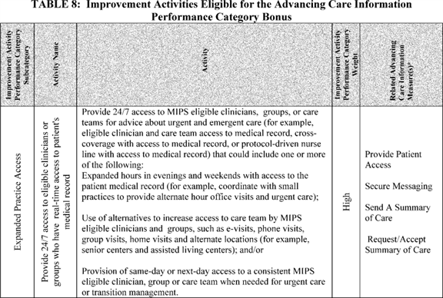

**[*77204]**



**[*77205]**

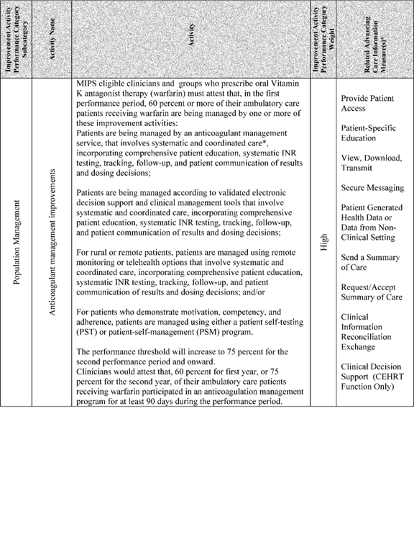

**[*77205]**



**[*77206]**

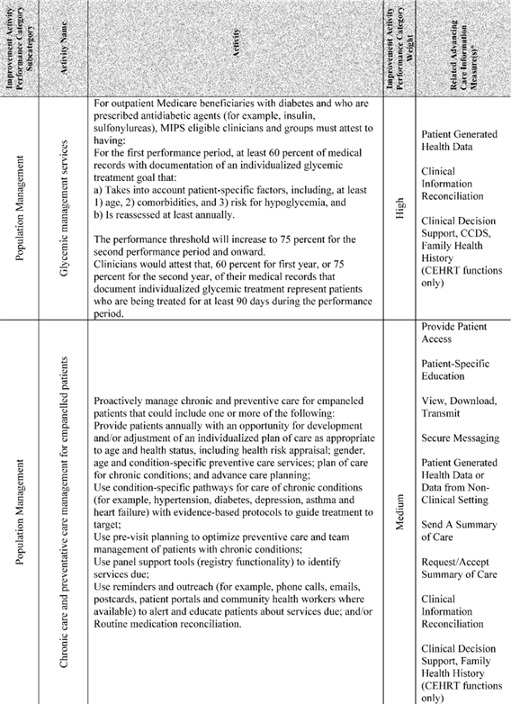

**[*77206]**



**[*77207]**

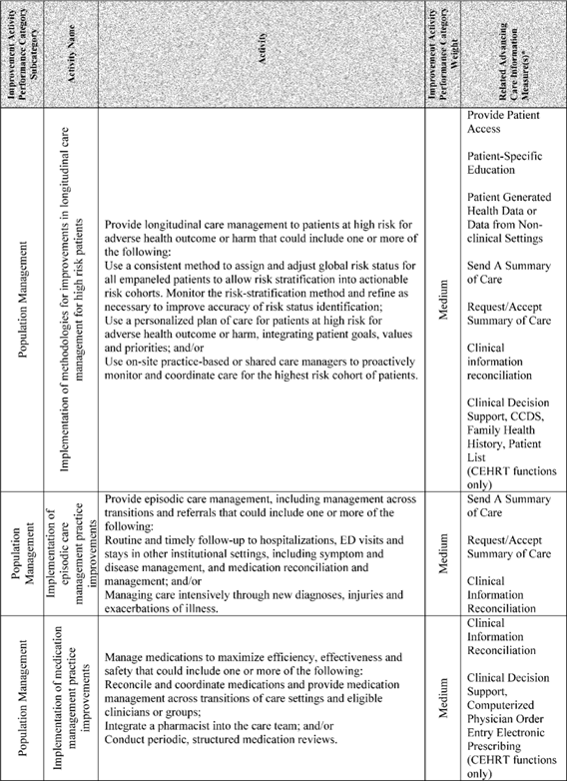

**[*77207]**



**[*77208]**

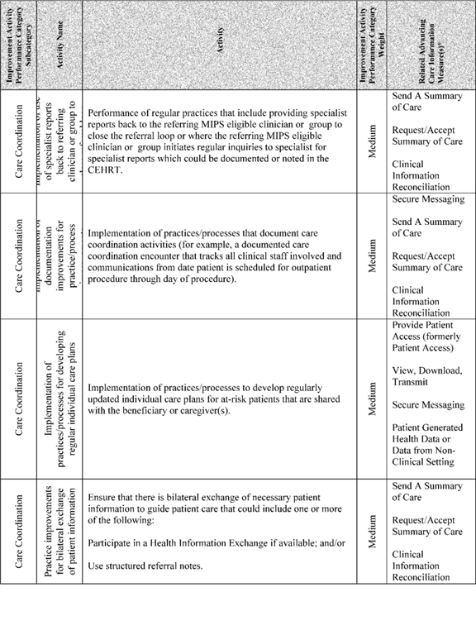

**[*77208]**



**[*77209]**

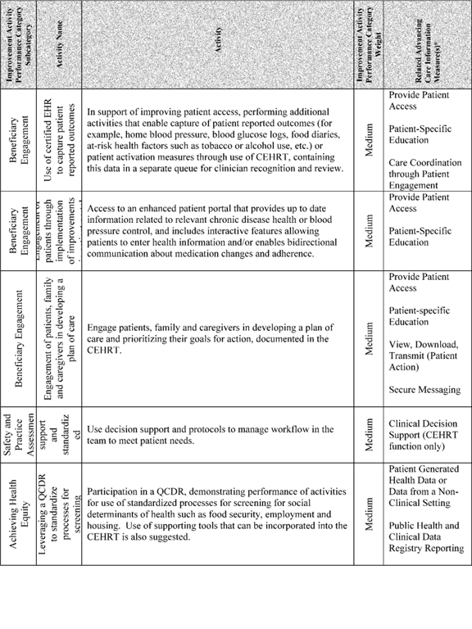

**[*77209]**

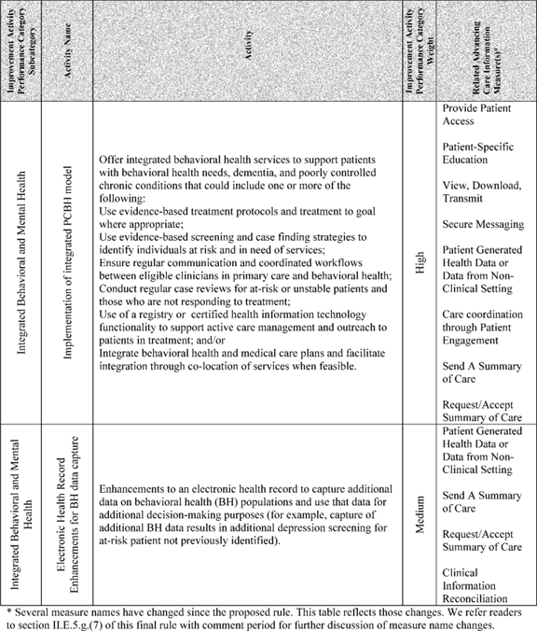

BILLING CODE 4120-01-C

After consideration of the comments, we will award a 10 percent bonus in the advancing care information performance category if a MIPS eligible clinician attests to completing at least one of the improvement activities specified in Table 8 using CEHRT. We note that 10 percent is the maximum bonus a MIPS eligible clinician will receive whether they attest to using CEHRT for one or more of the activities listed in the table. This bonus is intended to support progression toward holistic health IT use and measurement; attesting to even one improvement activity demonstrates that the MIPS eligible clinician is working toward this holistic approach to the use of their CEHRT. We additionally note that the weight of the improvement activity has no bearing on the bonus awarded in the advancing care information performance category.

We are seeking comment on this integration of the improvement activities with the advancing care information performance category, and other ways to further the advancement of health IT measurement. **[*77210]**

(3) Clinical Quality Measurement

Section 1848(o)(2)(A)(iii) of the Act requires the reporting of CQMs using CEHRT. Section 1848(q)(5)(B)(ii)(II) of the Act provides that under the methodology for assessing the total performance of each MIPS eligible clinician, the Secretary shall, for a performance period for a year, for which a MIPS eligible clinician reports applicable measures under the quality performance category through the use of CEHRT, treat the MIPS eligible clinician as satisfying the CQM reporting requirement under section 1848(o)(2)(A)(iii) of the Act for such year. We note that in the context and overall structure of MIPS, the quality performance category allows for a greater focus on patient-centered measurement, and multiple pathways for MIPS eligible clinicians to report their quality measure data. Therefore, we did not propose separate requirements for CQM reporting within the advancing care information performance category and instead would require submission of quality data for measures specified for the quality performance category, in which we encourage reporting of CQMs with data captured in CEHRT. We refer readers to section II.E.5.a.of the proposed rule [*(81 FR 28184-28196)*](https://advance.lexis.com/api/document?collection=administrative-codes&id=urn:contentItem:5JR6-TD50-006W-8163-00000-00&context=) for discussion of reporting of CQMs with data captured in CEHRT under the quality performance category.

Below is a summary of the comments received regarding CQM reporting for the advancing care information category:

*Comment:* Many commenters supported our proposal not to include the submission of CQMs in this category. Several noted that this elimination will reduce burden for MIPS eligible clinicians, streamline reporting and reduce overlap. Others supported the elimination of duplicative reporting that existed under PQRS and the EHR Incentive Programs.

*Response:* We appreciate commenters' support and note that the submission of CQMs is a requirement for the Medicare EHR Incentive Program. For the advancing care information performance category, we will require submission of quality data for measures specified for the quality performance category, in which we encourage reporting of CQMs with data captured in CEHRT. This approach helps to avoid unnecessary overlap and duplicative reporting. Therefore, we have not included separate requirements for clinical quality measurement in the advancing care information performance category, and direct readers to the quality performance category discussed in section II.E.5.b. of this final rule with comment period for information on clinical quality measurement.

(4) Performance Period Definition for Advancing Care Information Performance Category

In the Medicare and Medicaid Programs; Electronic Health Record Incentive Program--Stage 3 proposed rule, we proposed to eliminate the 90-day EHR reporting period beginning in 2017 for EPs who had not previously demonstrated meaningful use, with a limited exception for the Medicaid EHR Incentive Program [*(80 FR 16739-16740, 16774-16775).*](https://advance.lexis.com/api/document?collection=administrative-codes&id=urn:contentItem:5FMN-GHG0-006W-8311-00000-00&context=) We received many comments from respondents stating their preference for maintaining the 90-day EHR reporting period to allow first time participants to avoid payment adjustments. In addition, commenters indicated that the 90-day time period reduced administrative burden and allowed for needed time to adapt their EHRs to ensure they could achieve program objectives. As a result, we did not finalize our proposal and established a 90-day EHR reporting period for all EPs in 2015 and for new participants in 2016, as well as a 90-day EHR reporting period for new participants in 2015, 2016, and 2017 with regard to the payment adjustments [*(80 FR 62777-62779;*](https://advance.lexis.com/api/document?collection=administrative-codes&id=urn:contentItem:5H5B-72Y0-006W-851V-00000-00&context=) 62904-62906). In addition we have proposed a 90-day EHR reporting period in 2016 for the EHR Incentive Programs in a recent proposed rule, the Calendar Year (CY) 2017 Changes to the Hospital Outpatient Prospective Payment System (OPPS) and Ambulatory Surgical Center (ASC) [*(81 FR 45753).*](https://advance.lexis.com/api/document?collection=administrative-codes&id=urn:contentItem:5K79-SW00-006W-836J-00000-00&context=)

Moving forward, the implementation of MIPS creates a critical opportunity to align performance periods to ensure that quality, improvement activities, cost, and the advancing care information performance categories are all measured and scored based on the same period of time. We believe this would lower reporting burden, focus clinician quality improvement efforts and align administrative actions so that MIPS eligible clinicians can use common systems and reporting pathways.

Under MIPS, we proposed to align the performance period for the advancing care information performance category to the proposed MIPS performance period of one full calendar year and the intent of the proposal was to reduce reporting burden and streamline requirements so that MIPS eligible clinicians and third party intermediaries, such as registries and QCDRs, would have a common timeline for data submission to all performance categories [*(81 FR 28179-28181).*](https://advance.lexis.com/api/document?collection=administrative-codes&id=urn:contentItem:5JR6-TD50-006W-8163-00000-00&context=) Therefore, we noted there would not be a separate 90-day performance period for the advancing care information performance category and MIPS eligible clinicians would need to submit data based on performance period starting January 1, 2017, and ending December 31, 2017 for the first year of MIPS. We also stated that MIPS eligible clinicians that only have data for a portion of the year can still submit data, be assessed and be scored for the advancing care information performance category [*(81 FR 28179-28181).*](https://advance.lexis.com/api/document?collection=administrative-codes&id=urn:contentItem:5JR6-TD50-006W-8163-00000-00&context=) Under that proposal, MIPS eligible clinicians would need to possess CEHRT and report on the objectives and measures (without meeting any thresholds) during the calendar year performance period to achieve the advancing care information performance category base score. Finally, we stated that MIPS eligible clinicians would be required to submit all of the data they have available for the performance period, even if the time period they have data for is less than one full calendar year.

The following is a summary of the comments we received regarding our advancing care information performance period proposal.

*Comment:* The majority of commenters did not support our proposal for a performance period of one full calendar year. Instead they overwhelmingly recommended a 90-day performance period in 2017. Commenters noted the need for time and resources to understand and adjust to the new MIPS program. Others suggested that 90 days would give MIPS eligible clinicians flexibility to acquire and implement health IT products. A commenter noted that a shorter performance period would enable MIPS eligible clinicians to adopt innovative uses of technology as it would permit them to test new health IT solutions. Additionally with the final rule with comment period not expected until late in 2016, commenters noted there is not sufficient time to review and understand the rule and begin data collection on January 1, 2017.

Other commenters noted that MIPS eligible clinicians must perform improvement activities for the improvement activities performance category for at least a 90-day performance period, and suggested adopting the same for the advancing care information performance category as it would create alignment. Some commenters requested a performance period of 90-days for the first several years of the program. A few recommended a 90-day performance period every time a new edition of **[*77211]** CEHRT is required. Others suggested partial year reporting or reporting for a quarter. One recommended that solo practitioners report for 60 days. We note that only a few commenters supported our proposal.

*Response:* We understand the challenges of a full year performance period. As discussed in the proposed rule [*(81 FR 28179*](https://advance.lexis.com/api/document?collection=administrative-codes&id=urn:contentItem:5JR6-TD50-006W-8163-00000-00&context=) through 28181), MIPS eligible clinicians that only have data for a portion of the year can still submit data, be assessed and be scored for the advancing care information performance category, and thus, would not need to report for one full year, rather, they could report whatever data they had available even if that data represented less than a full-year period.

Additionally, we understand the commenters' concerns and rationale for requesting a 90-day performance period. As discussed in section II.E.4. of this final rule with comment period, for the first performance period of CY 2017, we will accept a minimum of 90 days of data within CY 2017, although we greatly encourage MIPS eligible clinicians to submit data for the full year performance period. Also in recognition of the switch from CEHRT certified to the 2014 Edition to CEHRT certified to the 2015 Edition, for the 2018 performance period we will also accept a minimum of 90 days of data within CY 2018. We refer readers to section II.E.4. of this final rule with comment period for further discussion about the MIPS performance period and the 90-day minimum.

*Comment:* One commenter encouraged CMS to extend the transition timeframe to performance periods under MIPS in 2017 and 2018. They indicated that their vendors struggle to provide budgetary estimates needed to plan staff and financial resources due to the lack of clarity on what would be required for the MIPS program.

*Response:* We recognize that vendors will require varying levels of effort to transition their technology to the MIPS reporting requirements. We note that our proposal to adopt substantively the same definition of CEHRT for the 2015 Edition under MIPS that was adopted in the 2015 EHR Incentive Programs final rule was intended to provide consistency for MIPS eligible clinicians, as well as to allow EHR vendors to begin development based on the specifications finalized in October of 2015 and released by ONC for testing beginning in 2016 unimpeded by the timeline related to any rulemaking for the MIPS program. This would allow vendors to work toward certification on a longer timeline and allow MIPS eligible clinicians to adopt an implement the technology in preparation for the performance period in 2018. The MIPS performance period in 2017 will serve as a transition year for MIPS eligible clinicians, vendors and others parties supporting MIPS eligible clinicians. Further, in section II.E.5.a. of this final rule with comment period, we have established multiple reporting mechanisms to allow MIPS eligible clinicians to report their advancing care information data in the event that their vendor is unable to support new submission requirements. We are adopting for MIPS the 2017 Advancing Care Information Transition objectives and measures (referred to in the proposed rule as Modified Stage 2 objectives and measures) and Advancing Care Information objectives and measures (referred to in the proposed rule as adapted from the Stage 3 objectives and measures) and allowing MIPS eligible clinicians and groups to use technology certified to either the 2014 Edition or the 2015 Edition or a combination of the two editions to support their selection of objectives and measures for 2017. We intend this consistency with prior programs to help ease the transition and reduce the development work needed to transition to MIPS. Finally, we will accept a minimum of any consecutive 90 days in the 2018 performance period for the advancing care information performance category to support eligible clinicians and groups as they transition to technology certified to the 2015 Edition for use in 2018. For these reasons, we believe a 1 year transition during the 2017 MIPS performance period is sufficient.

After consideration of the public comments received, we are finalizing our proposal to align the performance period for the advancing care information performance category with the MIPS performance period of one full calendar year. For the first performance period of MIPS (CY 2017), we will accept a minimum of 90 consecutive days of data in CY 2017, however, we encourage MIPS eligible clinicians to report data for the full year performance period. For the second performance period of MIPS (CY 2018), we will accept a minimum of 90 consecutive days of data in 2018, however, we encourage MIPS eligible clinicians to report data for the full year performance period. We refer readers to section II.E.4. of this final rule with comment period for further discussion of the MIPS performance period.

(5) Advancing Care Information Performance Category Data Submission and Collection

(a) Definition of Meaningful EHR User and Certification Requirements

In the 2015 EHR Incentive Programs final rule [*(80 FR 62873),*](https://advance.lexis.com/api/document?collection=administrative-codes&id=urn:contentItem:5H5B-72Y0-006W-851V-00000-00&context=) we outlined the requirements for EPs using CEHRT in 2017 for the Medicare and Medicaid EHR Incentive Programs as it relates to the objectives and measures they select to report. In the proposed rule, we proposed to adopt a definition of CEHRT at § 414.1305 for MIPS eligible clinicians that is based on the definition that applies in the EHR Incentive Programs under § 495.4.

We proposed for 2017, the first MIPS performance period, MIPS eligible clinicians would be able to use EHR technology certified to either the 2014 or 2015 Edition certification criteria as follows:

* A MIPS eligible clinician who only has technology certified to the 2015 Edition may choose to report: (1) On the objectives and measures specified for the advancing care information performance category in section II.E.5.g.(7) of the proposed rule [*(81 FR 28221*](https://advance.lexis.com/api/document?collection=administrative-codes&id=urn:contentItem:5JR6-TD50-006W-8163-00000-00&context=) through 28223), which correlate to Stage 3 requirements; or (2) on the alternate objectives and measures specified for the advancing care information performance category in section II.E.5.g.(7) of the proposed rule [*(81 FR 28223 and 28224),*](https://advance.lexis.com/api/document?collection=administrative-codes&id=urn:contentItem:5JR6-TD50-006W-8163-00000-00&context=) which correlate to modified Stage 2 requirements.

1. A MIPS eligible clinician who has technology certified to a combination of 2015 Edition and 2014 Edition may choose to report: (1) On the objectives and measures specified for the advancing care information performance category in section II.E.5.g.(7) of the proposed rule [*(81 FR 28221*](https://advance.lexis.com/api/document?collection=administrative-codes&id=urn:contentItem:5JR6-TD50-006W-8163-00000-00&context=) through 28223), which correlate to Stage 3; or (2) on the alternate objectives and measures specified for the advancing care information performance category as described in section II.E.5.g.(7) of the proposed rule [*(81 FR 28223 and 28224),*](https://advance.lexis.com/api/document?collection=administrative-codes&id=urn:contentItem:5JR6-TD50-006W-8163-00000-00&context=) which correlate to modified Stage 2, if they have the appropriate mix of technologies to support each measure selected.
2. A MIPS eligible clinician who only has technology certified to the 2014 Edition would not be able to report on any of the measures specified for the advancing care information performance category described in section II.E.5.g.(7) of the proposed rule [*(81 FR 28221*](https://advance.lexis.com/api/document?collection=administrative-codes&id=urn:contentItem:5JR6-TD50-006W-8163-00000-00&context=) through 28223) that correlate to a Stage 3 measure that requires the support of technology certified to the 2015 Edition. These MIPS eligible clinicians would be **[*77212]** required to report on the alternate objectives and measures specified for the advancing care information performance category as described in section II.E.5.g.(7) of the proposed rule [*(81 FR 28223 and 28224),*](https://advance.lexis.com/api/document?collection=administrative-codes&id=urn:contentItem:5JR6-TD50-006W-8163-00000-00&context=) which correlate to modified Stage 2 objectives and measures.

We proposed beginning with the performance period in 2018, MIPS eligible clinicians:

* Must only use technology certified to the 2015 Edition to meet the objectives and measures specified for the advancing care information performance category in section II.E.5.g.(7) of the proposed rule [*(81 FR 28222 and 28223),*](https://advance.lexis.com/api/document?collection=administrative-codes&id=urn:contentItem:5JR6-TD50-006W-8163-00000-00&context=) which correlate to Stage 3.

We welcomed comments on the proposals, which were intended to maintain consistency across MIPS, the Medicare EHR Incentive Program and the Medicaid EHR Incentive Program.

Finally, we proposed to define at § 414.1305 a meaningful EHR user under MIPS as a MIPS eligible clinician who possesses CEHRT, uses the functionality of CEHRT, and reports on applicable objectives and measures specified for the advancing care information performance category for a performance period in the form and manner specified by CMS.

The following is a summary of the comments we received regarding our proposal for EHR certification requirements.

*Comment:* Most commenters supported the proposal to allow MIPS eligible clinicians to use either technology certified to 2014 or 2015 Edition for the performance period in 2017. Many commenters urged CMS to allow MIPS eligible clinicians to continue to use either EHR technology certified to the 2014 or 2015 Edition in the performance period 2018 and beyond, citing concerns over the time required for health IT development and certification and MIPS eligible clinician readiness concerns that the 2015 Edition technology may not be available in time for the performance period or reporting timeframe. A few commenters suggested that flexibility in the form of a hardship exception to reporting to MIPS be offered to accommodate MIPS eligible clinicians who are unable to implement EHR technology certified to the 2015 Edition in time for the 2018 performance period. Other commenters found the requirement to use EHR technology certified to the 2015 Edition in 2018 unacceptable. Commenters noted that as of the comment due date there are zero products certified to the 2015 Edition and recommended that we allow the use of products certified to the 2014 Edition through 2020. Some commenters were also concerned that the small amount of products certified to the 2015 Edition would require MIPS eligible clinicians to find alternatives to meeting the advancing care information requirements and possibly limit those in APMs from utilizing the benefits of the new technology.

*Response:* We appreciate the comments and feedback we received, and the support of the proposal for performance periods in 2017 to allow the use of technology certified to the 2014 or 2015 Edition or a combination of the two. We believe this will allow MIPS eligible clinicians the flexibility to transition to EHR technology certified to the 2015 Edition for use for performance periods in 2018 in a manner that works best for their systems, workflows, and clinical needs. We additionally understand the concerns raised by commenters regarding the timeline to implement the 2015 Edition in time for use for performance periods in 2018. We note the requirements for technology certified to the 2015 Edition were established in October 2015 in ONC's final rule titled 2015 Edition Health Information Technology (Health IT) Certification Criteria, 2015 Edition Base Electronic Health Record (EHR) Definition, and ONC Health IT Certification Program Modifications [*(80 FR 62602-62759).*](https://advance.lexis.com/api/document?collection=administrative-codes&id=urn:contentItem:5H5B-72Y0-006W-851T-00000-00&context=) The EHR Incentive Programs final rule adopted the requirement that EPs, eligible hospitals, and CAHs use technology certified to the 2015 Edition beginning in 2018. We intend to maintain continuity for MIPS eligible clinicians and health IT vendors who may already have CEHRT or who have begun planning for a transition to technology certified to the 2015 Edition based on the definition of CEHRT finalized for the EHR Incentive Programs in the 2015 EHR Incentive Programs final rule [*(80 FR 62871*](https://advance.lexis.com/api/document?collection=administrative-codes&id=urn:contentItem:5H5B-72Y0-006W-851V-00000-00&context=) through 62889). Therefore, there are no new certification requirements in the definition we are finalizing for MIPS eligible clinicians participating in the advancing care information performance category of MIPS at § 414.1305 in order to maintain consistency with the EHR Incentive Programs CEHRT definition at [*42 CFR 495.4*](https://advance.lexis.com/api/document?collection=administrative-codes&id=urn:contentItem:5PP3-6WB0-008H-0221-00000-00&context=). Our proposal to adopt a substantively similar definition of CEHRT that was finalized in the 2015 EHR Incentive Programs final rule was intended to provide consistency for MIPS eligible clinicians and also to allow EHR vendors to begin development based on the specifications finalized in October of 2015 and released by ONC for testing beginning in 2016 unimpeded by the timeline related to any rulemaking for the MIPS program. This allows vendors to work toward certification on a longer timeline and allows MIPS eligible clinicians to adopt an implement the technology in preparation for the performance period in 2018. In addition, in order to allow eligible clinicians and groups adequate time to transition to EHR technology certified to the 2015 Edition for use in CY 2018, we will accept a minimum of 90 consecutive days of data within the CY 2018 performance period for the advancing care information performance category. In partnership with ONC, we are monitoring the development and certification process for health IT products certified to the 2015 Edition and will continue to gauge MIPS eligible clinician readiness for the 2018 performance period. At this time, we believe it is appropriate to require the use of EHR technology certified to the 2015 Edition for the performance period in 2018 and encourage MIPS eligible clinicians to work with their EHR vendors in the coming months to prepare for the transition to 2015 Edition in for the performance period in CY 2018.

*Comment:* One commenter suggested that the CEHRT definition be expanded to include requirements beyond those finalized for meeting the advancing care information performance category and commenters noted that vendors other than EHR vendors could support the criteria listed in the proposed rule, to include Health Information Exchanges (HIE) or Health Information Service Providers (HISPs).

*Response:* The definition of CEHRT does contain elements that are not included in the advancing care information performance category. As noted in the proposed rule [*(81 FR 28218-28219),*](https://advance.lexis.com/api/document?collection=administrative-codes&id=urn:contentItem:5JR6-TD50-006W-8163-00000-00&context=) and consistent with prior EHR Incentive Program policy, removing a measure from the reporting requirements does not remove the functions supporting that measure from the definition of CEHRT unless we make corresponding changes to that definition. Therefore, a MIPS eligible clinician must implement that function in their practice in order to have their system meet the technological specifications required for participation in the program. For example, in the 2015 EHR Incentive Programs final rule [*(80 FR 62786),*](https://advance.lexis.com/api/document?collection=administrative-codes&id=urn:contentItem:5H5B-72Y0-006W-851V-00000-00&context=) we noted that the Stage 1 "Record Demographics" measure was designated as topped out and no longer required for reporting, but CEHRT must still capture and record demographics as structured data using the appropriate standards. For MIPS, we did not propose to include the CPOE and CDS objectives and measures in the **[*77213]** advancing care information performance category although the technology functions supporting these measures were included in our proposed definition of CEHRT for MIPS.

*Comment:* Some commenters were encouraged by the CMS' commitment to collaborate with ONC on the 2015 Edition CEHRT requirements for MIPS to align with the evolving standards to support health IT capabilities.

*Response:* We appreciate these comments and will continue to collaborate with ONC on the alignment of MIPS requirements and CEHRT in future rulemaking.

*Comment:* A few commenters requested that the definitions of CEHRT incorporate the roles of non-physician practitioners, including Nurse Practitioners (NPs), Physician Assistants (PAs), Certified Registered Nurse Anesthetists (CRNAs) and Clinical Nurse Specialists (CNSs). They noted that current EHR vendor software usually does not allow non-physician practitioners to make entries or be identified. The commenters suggested that CEHRT vendors should be required include provisions so that non-physician practitioners can also utilize the CEHRT so that they can meet MIPS requirements.

*Response:* The requirements for the use of CEHRT do not specify the type of provider or clinician that can enter data, nor do ONC's certification criteria in any way limit the entry of data by non-physician practitioners. In some states, the MIPS eligible clinicians mentioned by the commenter may already be participating in the Medicaid EHR Incentive Programs as an EP and using CEHRT to support their clinical practice. In addition, many practices across a wide range of settings where EPs have participated in the Medicare EHR Incentive Programs have developed different workflows to meet their practice needs including the various staff beyond the eligible clinician that enter data. We encourage MIPS eligible clinicians and groups to work with their vendor, and with their own practice and clinical workflows to identify and establish best practices for data capture and data mapping to support their unique practice needs.

*Comment:* Some commenters recommended that CMS consider ways to measure possible clinical workflow disruptions caused by health IT (EHRs). The commenters suggested that CMS use Medicare beneficiary surveys, focus groups, patient reported outcome measures, and the CAHPS for MIPS survey; and to incorporate those results when designing health IT specifications and ***regulations*** to be used across settings.

*Response:* We appreciate the feedback and will take this suggestion into consideration in the future. We encourage MIPS eligible clinicians to work with their EHR vendor to improve the clinical workflow in a way that best suits their individual practice needs.

*Comment:* Other commenters noted that while patient access to data is important, MIPS eligible clinicians also need interoperable data from a variety of sources to integrate seamlessly into their work flow. The commenters believe that third party applications will play a major role in satisfying this need to ensure data "quality" so that physicians get the most relevant data in a useable format, when and where they need it.

*Response:* CMS and ONC agree with the comments that interoperability and the seamless integration of data and systems into clinical workflows is essential to improving health care quality. For this reason, the 2015 Edition certification criteria include testing and certification for API functionality as a certified health IT module [*(80 FR 62601-62759),*](https://advance.lexis.com/api/document?collection=administrative-codes&id=urn:contentItem:5H5B-72Y0-006W-851S-00000-00&context=) as well as criteria related to ensuring the ability to receive and consume electronic summary of care records from external sources into the provider's EHR and to developing a path for bi-directional exchange of immunization data with public health registries.

After consideration of the comments we received, we are finalizing our proposal regarding EHR certification requirements at § 414.1305 as proposed and encourage MIPS eligible clinicians to prepare for the migration to the 2015 Edition of CEHRT in 2018. In 2017, MIPS eligible clinicians may use EHR technology certified to the 2014 Edition or the 2015 Edition or a combination of the two. We note that a MIPS eligible clinician who only has technology certified to the 2014 Edition would not be able to report certain measures specified for the advancing care information performance category that correlate to a Stage 3 measure for which there was no Stage 2 equivalent. These MIPS eligible clinicians may instead report the objectives and measures specified for the advancing care information performance category which correlate to Modified Stage 2 objectives and measures. In 2018, MIPS eligible clinicians must use EHR technology certified to the 2015 Edition.

The following is a summary of the comments we received regarding our proposal for defining a meaningful EHR user under MIPS.

*Comment:* Many commenters expressed an overall desire to maintain a moderate to high level standard and category weight for the distinction of meaningful EHR user. These commenters noted that the definition of meaningful EHR user will have an important impact on heath IT adoption and that reducing the stringency or lowering the advancing care information performance category weight in the MIPS final score could hinder progress toward robust, person-centered use of health IT across the health care industry.

*Response:* We agree that defining a meaningful EHR user is critical for all of the reasons that the commenter raises; it is an important piece of health IT adoption and promoting interoperability. We seek to balance this critical aspect of EHR reporting with our desire to increase widespread adoption of health IT and clinical standards among MIPS eligible clinicians. We believe our final policies will encourage more widespread adoption and use of health IT in a practice setting. We are also dedicated to increasing the stringency of the measures specified for the advancing care information performance category in future years of the MIPS program to further the advancement of health IT use.

After consideration of the public comments we received, we are finalizing our proposal to define a meaningful EHR user for MIPS under § 414.1305 as a MIPS eligible clinician who possesses CEHRT, uses the functionality of CEHRT, and reports on applicable objectives and measures specified for the advancing care information performance category for a performance period in the form and manner specified by CMS.

(b) Method of Data Submission

Under the Medicare EHR Incentive Program, EPs attest to the numerators and denominators for certain objectives and measures, through a CMS Web site. For the purpose of reporting advancing care information performance category objectives and measures under the MIPS, we proposed at § 414.1325 to allow for MIPS eligible clinicians to submit advancing care information performance category data through qualified registry, EHR, QCDR, attestation and CMS Web Interface submission methods. Regardless of data submission method, all MIPS eligible clinicians must follow the reporting requirements for the objectives and measures to meet the requirements of the advancing care information performance category.

We note that under this proposal, 2017 would be the first year that EHRs (through the QRDA submission **[*77214]** method), QCDRs and qualified registries would be able to submit EHR Incentive Program objectives and measures (as adopted for the advancing care information performance category) to us, and the first time this data would be reported through the CMS Web Interface. We recognize that some Health IT vendors, QCDRs and qualified registries may not be able to conduct this type of data submission for the 2017 performance period given the development efforts associated with this data submission capability. However, we are including these data submission mechanisms in 2017 to support early adopters and to signal our longer-term commitment to working with organizations that are agile, effective and can create less burdensome data submission mechanisms for MIPS eligible clinicians. We believe the proposed data submission methods could reduce reporting burden by synchronizing reporting requirements and data submission, and systems, allow for greater access and ease in submitting data throughout the MIPS program. We note that specific details about the form and manner for data submission will be addressed by CMS in the future.

The following is a summary of the comments we received regarding our proposal to allow for multiple methods for data submission for the advancing care information performance category.

*Comment:* The majority of commenters supported the proposed data submission approach to allow for MIPS eligible clinicians to submit data for the advancing care information performance category through multiple submission methods, which includes, for example, via attestation, qualified registries, QCDRs, EHRs and CMS Web Interface. Many agreed that the proposal alleviates the need for individual MIPS eligible clinicians and groups to use a separate reporting mechanism to report data for different performance categories.

*Response:* We appreciate the supportive comments and reiterate that our goals include reducing the reporting burden, aligning reporting requirements across MIPS performance categories, and supporting efficient data submission mechanisms.

*Comment:* Some commenters expressed concern that many third party data submission entities do not have the necessary data submission functionality and will not have enough time to develop, distribute and adopt the needed functionality for a performance period in 2017. One commenter requested that CMS provide detailed guidance to vendors and QCDRs as they implement data submission functionality. Another commenter expressed concern about the potential for vendors and developers of QCDRs and registries to fail to fulfill the technical requirements for data submission and advised CMS to finalize a policy indicating that MIPS eligible clinicians would not be penalized for failure of data submission due to vendor issues. One commenter suggested offering bonus points for the use of QCDRs or registry adoption to recognize the investment needed to participate.

*Response:* We appreciate the concerns raised by commenters and note that we intend to provide detailed guidance for EHR vendors, as well as third party data intermediaries who submit data on behalf of MIPS eligible clinicians to help them be successful in data submission. However, we acknowledge that some EHRs, QCDRs and registry vendors may not be able to support data submission for the advancing care information performance category for 2017 due to the time needed to develop the technology and functionality to collect and submit these data. For this reason, as discussed in section II.E.5.a. of this final rule with comment period, we offer MIPS eligible clinicians several reporting mechanisms from which to choose. While we believe that in the long term, it is more convenient for MIPS eligible clinicians to submit data one time for all performance categories, we acknowledge that this may not be possible in the transition year for the aforementioned reasons. Therefore, we offer the option of attestation for those MIPS eligible clinicians who's CEHRT, QCDR or registry are not prepared to support advancing care information performance category data submission in 2017. For further discussion of MIPS submission methods, we refer readers to section II.E.5.a. of this final rule with comment period.

*Comment:* One commenter requested that CMS provide greater flexibility in the submission standards set forth for health IT vendors, particularly in the transition year of MIPS, including the ability to submit data via QCDR XML. The commenter stated that QCDR vendors often experience issues submitting data using the uniform standards in QRDA implementation guides and that many QRDA variables that are clinical in nature do not easily map to the variables in CEHRT.

*Response:* We note that our proposal does allow for submission of the advancing care information performance category data via QCDR, as well as registry, CEHRT, CMS Web Interface and attestation. We believe this flexibility allows MIPS eligible clinicians the ability to submit through their chosen submission mechanism that is most appropriate for their practice.

*Comment:* One commenter believed the attestation process is cumbersome and expensive for large groups and suggested that CMS develop a process that will allow larger groups to attest as a group.

*Response:* Because the EPs reporting under EHR Incentive Program reported using their individual NPIs, attestation and data submission was completed at the NPI level which was not conducive to groups combining their data and attesting for all of their NPIs together. We agree that this same approach under the MIPS would be cumbersome for group submission. Under the MIPS, groups will have the ability to attest or submit their advancing care information data through a qualified registry, QCDR, EHR, attestation, or CMS Web Interface as a group, meaning the data would be aggregated to the group level and submitted once on behalf of all MIPS eligible clinicians within the group. MIPS eligible clinicians will also have the ability to submit as individuals, if their group is not submitting using the group method. In these cases, the attestation or data submission would be done at the individual (TIN/NPI) level.

*Comment:* One commenter recommended the mandatory publication of EHR source code in order to reduce bias and errors.

*Response:* We appreciate the suggestion, however, we note that this is outside our authority under section 1848(q) of the Act and outside the scope of this rule.

We note that there were several other comments related to data submission for MIPS, and we direct readers to section II.E.5.a. of this final rule with comment period for discussion of those comments. After consideration of the comments we received, we are finalizing our policy as proposed.

(c) Group Reporting

Under the Medicare EHR Incentive Program, we adopted a reporting mechanism for EPs that are part of a group, to attest using one common form, or a batch reporting process. To determine whether those EPs meaningfully used CEHRT, under that batch reporting process, we assessed the individual performance of the EPs that made up the group, not the group as a whole.

The structure of the MIPS and our desire to achieve alignment across the MIPS performance categories appropriately necessitates the ability to assess the performance of MIPS eligible **[*77215]** clinicians at the group level for all MIPS performance categories. We believe MIPS eligible clinicians should be able to submit data as a group, and be assessed at the group level, for all of the MIPS performance categories, including the advancing care information performance category. For this reason, we proposed a group reporting mechanism for individual MIPS eligible clinicians to have their performance assessed as a group for all performance categories in section II.E.1.e. of the proposed rule [*(81 FR 28178 and 28179),*](https://advance.lexis.com/api/document?collection=administrative-codes&id=urn:contentItem:5JR6-TD50-006W-8163-00000-00&context=) consistent with section 1848(q)(1)(D)(i)(I) & (II) of the Act.

Under this option, we proposed that performance on advancing care information performance category objectives and measures would be assessed and reported at the group level, as opposed to the individual MIPS eligible clinician level. We note that the data submission criteria would be the same when submitted at the group-level as if submitted at the individual-level, but the data submitted would be aggregated for all MIPS eligible clinicians within the group practice. We believe this approach to data submission better reflects the team dynamics of the group, and would reduce the overall reporting burden for MIPS eligible clinicians that practice in groups, incentivize practice-wide approaches to data submission, and provide enterprise-level continuous improvements strategies for submitting data to the advancing care information performance category. Please see section II.E.1.e. of the proposed rule [*(81 FR 28178 and 28179)*](https://advance.lexis.com/api/document?collection=administrative-codes&id=urn:contentItem:5JR6-TD50-006W-8163-00000-00&context=) for more discussion of how to participate as a group under MIPS.

The following is a summary of the comments we received regarding our proposal to allow for group reporting starting in 2017.

*Comment:* The majority of commenters strongly support the allowance of group reporting in the advancing care information performance category. Reasons for support include the reduction in reporting burden, as well as alignment with other MIPS performance categories.

*Response:* We appreciate the supportive comments.

*Comment:* Many commenters expressed concern about allowing group reporting for the advancing care information performance category in 2017 given the short timeframe between the publication for this final rule with comment period and the start of the 2017 performance period. Commenters believe that this would offer too little time to implement group reporting capabilities in CEHRT, stating that report logic will require clear specifications and time for development and distribution of report updates.

*Response:* We recognize that the implementation of group reporting may require varying levels of effort for different practices and therefore may not be the best choice for all MIPS eligible clinicians for the 2017 performance period. However, we believe that making group reporting available for performance periods in CY 2017 offers a significant reduction in reporting burden for many group practices that have a large number of MIPS eligible clinicians, all of whom would otherwise have to report the MIPS requirements individually. We additionally note that groups and MIPS eligible clinicians have the ability to report through multiple reporting mechanisms providing flexibility should their CEHRT be unable to support group reporting in 2017.

*Comment:* Some commenters requested clarification on how group reporting of the base and performance scores will be calculated if one or more individual MIPS eligible clinicians within a group practice does not report on an objective or can claim an exclusion from reporting on an objective. In addition, a few commenters asked how to avoid counting more than once the unique patients seen by multiple MIPS eligible clinicians within the group practice. They also asked for detailed instructions for calculating the numerators and denominators of the measures reported.

*Response:* We understand that additional explanation is needed in order for groups to determine whether the group reporting option is best for their practice.

As with group reporting for the other MIPS performance categories, to report as a group, the group will need to aggregate data for all the individual MIPS eligible clinicians within the group for whom they have data in CEHRT. For those who choose to report as a group, performance on the advancing care information performance category objectives and measures would be reported and evaluated at the group level, as opposed to the individual MIPS eligible clinician level. For example, the group calculation of the numerators and denominators for each measure must reflect all of the data from all individual MIPS eligible clinicians that have been captured in CEHRT for the given advancing care information measure. If the group practice has CEHRT that is capable of supporting group reporting, they would submit the aggregated data produced by the CEHRT. If the group practice does not have CEHRT that is capable of or updated to support group reporting, the group would aggregate the data by adding together the numerators and denominators for each MIPS eligible clinician within the group for whom the group has data captured in their CEHRT. If an individual MIPS eligible clinician meets the criteria to exclude a measure, their data can be excluded from the calculation of that particular measure only.

We understand and agree that it can be difficult to identify unique patients across a group for the purposes of aggregating performance on the advancing care information measures, particularly when that group is using multiple CEHRT systems. We further recognize that for 2017, groups may be using systems which are certified to different CEHRT editions further adding to this challenge. We consider "unique patients" to be individual patients treated by the group who would typically be counted as one patient in the denominator of an advancing care information measure. This patient may see multiple MIPS eligible clinicians within the group, or may see MIPS eligible clinicians at multiple group locations. When aggregating performance on advancing care information measures for group reporting, we do not require that the group determine that a patient seen by one MIPS eligible clinician (or at one location in the case of groups working with multiple CEHRT systems) is not also seen by another MIPS eligible clinician in the group or captured in a different CEHRT system. While this could result in the same patient appearing more than once in the denominator, we believe that the burden to the group of identifying these patients is greater than any gain in measurement accuracy. Accordingly, this final policy will allow groups some flexibility as to the method for counting unique patients in the denominators to accommodate these scenarios where aggregation may be hindered by systems capabilities across multiple CEHRT platforms. We note that this is consistent with our data aggregation policy for providers practicing in multiple locations under the EHR Incentive Program [*(77 FR 53982).*](https://advance.lexis.com/api/document?collection=administrative-codes&id=urn:contentItem:56GV-SP50-006W-822R-00000-00&context=)

*Comment:* A few commenters voiced concerns that group reporting and many EHR systems, particularly hospital EHRs, mask who actually performs the service and may not recognize the ability of MIPS eligible clinicians who are not physicians to provide and document care. For example, non-physicians who are not considered MIPS eligible clinicians, such as nurse-midwives, physical or occupational **[*77216]** therapists and psychologists often perform services and complete their actions using CEHRT. However, the commenter notes that CEHRT functionality usually does not offer the ability to distinguish which clinician actually performed the action, thus making it difficult to calculate an accurate numerator and denominator for measures in the advancing care information performance category. One commenter requested that CMS require that CEHRT be able to identify which clinician is using the CEHRT, ensuring that clinicians other than physicians are able to make entries and actions are attributed to MIPS eligible clinicians.

*Response:* We appreciate the feedback and agree that there are issues related to group reporting that we will continue to monitor as the program develops. We note that the vast majority of commenters supported the group reporting option as it represents a reduction in reporting burden for MIPS eligible clinicians who choose to report as groups rather than as individuals. As we move forward with the advancing care information performance category we will be working with ONC to refine capabilities in CEHRT that could further support group reporting.

*Comment:* One commenter urged CMS to avoid issuing guidance that assigns nurses the role of scribe or data entry for physicians because this would adversely affect the quality of care delivered to patient.

*Response:* We do not intend to issue guidance that define or redefine the role of non-physician practitioners, such as nurse practitioners or nurse specialists.

After consideration of the comments, we are finalizing our proposal to allow group reporting for the advancing care information performance category with the additional explanation of data aggregation requirements for group reporting provided in our response above, particularly as it relates to aggregating unique patients seen by the group.

For our final policy, we considered and rejected imposing a threshold for group reporting. For example, in future years we may require that groups can only submit their advancing care information performance category data as a group if 50 percent or more of their eligible patient encounters are captured in CEHRT. While we considered this as an option for 2017, the transition year of MIPS, we chose not to institute such a policy at this time and will instead consider it for future years. We are seeking comment in this final rule with comment period on what would be an appropriate threshold for group reporting in future years.

We note that group reporting policies for the MIPS program, including the other performance categories, are discussed in section II.E.5.a. of this final rule with comment period, and we refer readers to that section for additional discussion of group reporting.

(6) Reporting Requirements & Scoring Methodology

(a) Scoring Method

Section 1848(q)(5)(E)(i)(IV) of the Act, as added by section 101(c) of the MACRA, states that 25 percent of the MIPS final score shall be based on performance for the advancing care information performance category. Therefore, we proposed at § 414.1375 that performance in the advancing care information performance category will comprise 25 percent of a MIPS eligible clinician's MIPS final score for payment year 2019 and each year thereafter. We received many comments in the MIPS and APMs RFI from stakeholders regarding the importance of flexible scoring for the advancing care information performance category and provisions for multiple performance pathways. We agree that this is the best approach moving forward with the adoption and use of CEHRT as it becomes part of a single coordinated program under the MIPS. For the reasons described here and previously in this preamble, we are proposing a methodology which balances the goals of incentivizing participation and reporting while recognizing exceptional performance by awarding points through a performance score. In this methodology, we proposed at § 414.1380(b)(4) that the score for the advancing care information performance category would be comprised of a score for participation and reporting, hereinafter referred to as the "base score," and a score for performance at varying levels above the base score requirements, hereinafter referred to as the "performance score".

The following is a summary of the comments we received regarding overall scoring for the advancing care information performance category.

*Comment:* Overall, most commenters found the scoring to be cumbersome, complex, and complicated and recommended that it be simplified. Suggestions included removing distinction between the base score and performance score. Others suggested removing objectives and measures or moving them to other MIPS performance categories, such as moving Public Health and Clinical Data Registry Reporting to the improvement activities performance category. One commenter suggested simplifying the assignment of points for each measure. For example, they suggested that 10 percent per measure be awarded for the following: 1. Patient Access; 2. Electronic Prescribing; 3. Computerized Provider Order Entry (CPOE); 4. Patient-Specific Education; 5. View, Download, Transmit; 6. Secure Messaging; 7. Patient-Generated Health Data; 8. Patient Care Record Exchange; 9. Request/Accept Patient Care Record; 10. Clinical Information Reconciliation.

*Response:* We appreciate the constructive feedback from commenters. Our priority is to finalize reporting requirements for the advancing care information performance category that incentivizes performance and reporting with minimal complexity and reporting burden. We have addressed many of these comments and concerns in our final scoring methodology outlined in section II.E.5.g.(6)(a) of this final rule with comment period.

*Comment:* Some commenters appreciated the split between base and performance scores in the advancing care information performance category, citing the flexibility offered compared to the EHR Incentive programs. Many commenters also praised the elimination of the requirement to meet measure thresholds.

*Response:* We appreciate commenters' support for our proposal. Our priority is to finalize a scoring methodology for the advancing care information performance category that promotes the use of CEHRT reporting requirements in an efficient, effective and flexible manner.

*Comment:* Some commenters did not support the elimination of measure thresholds. They believed that incorporating measure thresholds enables MIPS eligible clinicians to earn higher score for the advancing care information performance score and would encourage a higher level of success using CEHRT. Another commenter suggested replacing the base score requirement of at least one in the numerator with a requirement to meet a 5 percent threshold for each measure reported beginning for the performance period of CY 2019.

*Response:* We believe the scoring approach, as proposed and then as finalized in this final rule with comment period, promotes performance on the advancing care information performance category measures by rewarding high performance rather than requiring MIPS eligible clinicians to meet one threshold across the board. We agree that in future years of the program, we may consider higher minimum thresholds for reporting, however, we also seek to allow flexibility for MIPS **[*77217]** eligible clinicians to report on the measures that are most meaningful to their practice.

*Comment:* Most commenters supported the proposal to move away from the overall all-or-nothing scoring approach previously used in the EHR Incentive Programs. However, many commenters do not support the all-or-nothing approach proposed to earn the base score and subsequent points in the performance score, for the advancing care information performance category. More than one commenter recommended offering partial credit for each objective in the base score rather than an all-or-nothing approach. Other comments include removing the base score and only awarding points toward a performance score, as well as adding more measure exclusions. Some suggested awarding points toward the performance score even if the MIPS eligible clinician fails to meet a base score.

*Response:* In order to provide more flexibility for MIPS eligible clinicians, we have moved away from the all-or-nothing approach in our final policy. We note that certain measures under our final policy remain required measures in the base score. For example, section 1848(o)(2)(A) of the Act includes certain requirements that we have chosen to implement through measures such as e-Prescribing, Send Summary of Care (formerly Patient Care Record Exchange) and Request/Accept Patient Care Record, and thus, certain measures under our final policy remain required measures for the base score in the advancing care information performance category. In addition to those measures listed above, there are other measures such as Security Risk Analysis that are essential to protecting patient privacy, which we believe should be mandatory for reporting. We have addressed these comments further with our final scoring methodology outlined in section II.E.5.g.(6)(a) of this final rule with comment period. We have reduced the total number of required measures from 11 in the base score as proposed to only five in the final policy, which addresses some of the concerns raised by commenters while meeting our statutory requirements, as well as our commitment to patient privacy and access.

*Comment:* Many commenters requested that the distribution of points for the base score and performance score of the advancing care information performance category be reweighted. More than one commenter suggested reducing the weight of the base score and increasing the weight of the performance score over time. For example, some commenters requested that the base be worth 40 percent and the performance be 60 percent of the points. Another commenter believed the base score should initially be more heavily weighted, with the base score at 60 points, Protect Patient Health Information score at 10 points, and performance score at 80 points.

*Response:* Based on the overwhelming comments received, and our goal to simplify the scoring methodology wherever possible, we agree with commenters that the base and performance scores should be reconsidered for the final policy. We have outlined the final scoring methodology in section II.E.5.g.(6)(a) of this final rule with comment period, in which the performance score is reweighted and the total possible score for the advancing care information performance category is increased to 155 percent which would be capped at 100 percent when applied to the 25 possible points for the advancing care information performance category in the MIPS final score.

*Comment:* Many commenters disliked that no credit is awarded if the numerator for any measure is not at least one or the response is not "yes" for yes/no measures. Some commenters propose changing the policy to allow MIPS eligible clinicians to earn a performance score and bonus score even if they fail the base score. Others suggest reducing the number of objectives to report to earn the base score. For example, one commenter suggested requiring only the measures within the following objectives to achieve the base score: Protect Patient Health Information, Patient Electronic Access and Health Information Exchange.

*Response:* We appreciate the suggestions raised by commenters and have taken these comments into account for our final policy discussed in section II.E.5.g(6)(a) We note that for required measures in the base score, we would still require a one in the numerator or a "yes" response to yes/no measures. Section 1848(o)(2)(A) of the Act includes certain requirements that we have chosen to implement through three of the measures in the base score (e-Prescribing, Send a Summary of Care (formerly Patient Care Record Exchange) and Request/Accept Summary of Care (formerly Patient Care Record), and thus, we believe these measures should be required in order for a MIPS eligible clinician to earn any score in the advancing care information performance category. The other two required measures, Security Risk Analysis and Provide Patient Access (formerly Patient Access) are of paramount importance to CMS, and thus, we have maintained them as required measures in the base score.

*Comment:* Many commenters support the emphasis on health information exchange and patient engagement in both the base score and performance score. Some commenters recommended an even more weight given to these areas in the performance score.

*Response:* We appreciate this feedback. We agree that health information exchange and coordination of care through patient engagement are essential to improving the quality of care.

(b) Base Score

To earn points toward the base score, a MIPS eligible clinician must report the numerator and denominator of certain measures specified for the advancing care information performance category (see measure specifications in section II.E.5.g.(7) [*(81 FR 28226*](https://advance.lexis.com/api/document?collection=administrative-codes&id=urn:contentItem:5JR6-TD50-006W-8163-00000-00&context=) through 28228)), which are based on the measures adopted by the EHR Incentive Programs for Stage 3 in the 2015 EHR Incentive Programs final rule, to account for 50 percent (out of a total 100 percent) of the advancing care information performance category score. For measures that include a percentage-based threshold for Stage 3 of the EHR Incentive Program, we would not require those thresholds to be met for purposes of the advancing care information performance category under MIPS, but would instead require MIPS eligible clinicians to report the numerator (of at least one) and denominator (or a yes/no statement for applicable measures, which would be submitted together with data for the other measures) for each measure being reported. We note that for any measure requiring a yes/no statement, only a yes statement would qualify for credit under the base score. Under the proposal, the base score of the advancing care information performance category would incorporate the objective and measures adopted by the EHR Incentive Programs with an emphasis on privacy and security. We proposed two variations of a scoring methodology for the base score, a primary and an alternate proposal, which are outlined below. Both proposals would require the MIPS eligible clinician to meet the requirement to protect patient health information created or maintained by CEHRT to earn any score within the advancing care information performance category; failure to do so would result in a base score of zero, a performance score of zero (discussed in section II.E.5.g of the proposed rule [*(81 FR 28221),*](https://advance.lexis.com/api/document?collection=administrative-codes&id=urn:contentItem:5JR6-TD50-006W-8163-00000-00&context=) and an advancing care **[*77218]** information performance category score of zero.

The primary proposal at section II.E.5.g.(6)(b)(ii) of the proposed rule [*(81 FR 28221)*](https://advance.lexis.com/api/document?collection=administrative-codes&id=urn:contentItem:5JR6-TD50-006W-8163-00000-00&context=) would require a MIPS eligible clinician to report the numerator (of at least one) and denominator or yes/no statement (only a yes statement would qualify for credit under the base score) for a subset of measures adopted by the EHR Incentive Program for EPs in the 2015 EHR Incentive Programs final rule. In an effort to streamline and simplify the reporting requirements under the MIPS, and reduce reporting burden on MIPS eligible clinicians, we proposed that two objectives (Clinical Decision Support and Computerized Provider Order Entry) and their associated measures would not be required for reporting the advancing care information performance category. Given the consistently high performance on these two objectives in the EHR Incentive Program with EPs accomplishing a median score of over 90 percent for the last 3 years, we stated our belief that these objectives and measures are no longer an effective measure of EHR performance and use. In addition, we do not believe these objectives and associated measures contribute to the goals of patient engagement and interoperability, and thus, we believe these objectives can be removed in an effort to reduce reporting burden without negatively impacting the goals of the advancing care information performance category. We note that the removed objectives and associated measures would still be required as part of ONC's functionality standards for CEHRT, however, MIPS eligible clinicians would not be required to report the numerator and denominator or yes/no statement for those measures. In the 2015 EHR Incentive Programs final rule we also established that, for measures that were removed, the technology requirements would still be a part of the definition of CEHRT. For example, in that final rule, the Stage 1 Objective to Record Demographics was removed, but the technology and standard for this function in the EHR were still required [*(80 FR 62784).*](https://advance.lexis.com/api/document?collection=administrative-codes&id=urn:contentItem:5H5B-72Y0-006W-851V-00000-00&context=) This means that the MIPS eligible clinician would still be required to have these functions as a part of their CEHRT.

The alternate proposal at section II.E.5.g.(6)(b)(iii) of the proposed rule [*(81 FR 28222)*](https://advance.lexis.com/api/document?collection=administrative-codes&id=urn:contentItem:5JR6-TD50-006W-8163-00000-00&context=) would require a MIPS eligible clinician to report the numerator (of at least one) and denominator or yes/no statement (only a yes statement would qualify for credit under the base score) for all objectives and measures adopted for Stage 3 in the 2015 EHR Incentive Programs final rule to earn the base score portion of the advancing care information performance category, which would include reporting a yes/no statement for CDS and a numerator and denominator for CPOE objectives. We included these objectives in the alternate proposal as MIPS eligible clinicians may believe the continued measurement of these objectives is valuable to the continued use of CEHRT as this would maintain the previously established objectives under the EHR Incentive Program.

We stated our belief that both proposed approaches to the base score are consistent with the statutory requirements under HITECH and previously established CEHRT requirements as we transition to MIPS. We also believe both approaches, in conjunction with the advancing care information performance score, recognize the need for greater flexibility in scoring CEHRT use across different clinician types and practice settings by allowing MIPS eligible clinicians to focus on the objectives and measures most applicable to their practice.

*Comment:* Several commenters were disappointed that our proposals for the base score are so similar to the current meaningful use requirements. They requested a more streamlined approach as they believe the statute intended. Another commenter believed that advancing care information performance category should reflect a MIPS eligible clinician's use of digital clinical data to inform patient care and encourage bi-directional data interoperability.

*Response:* While we did draw on the meaningful use foundation in drafting the requirements for the advancing care information performance category, our proposals have lessened those requirements and provided additional flexibility as compared with all stages of the EHR Incentive Programs. We note that we have made significant revisions to the scoring methodology and reporting requirements in our final policy discussed in section II.E.5.g.(6)(a) in response to these comments. We would also welcome concrete proposals for new measures as we move forward with EHR reporting requirements under the MIPS. We are eager to improve interoperability and would welcome suggestions for improvement.

*Comment:* We received many comments on the allocation of points in the base score. Some commenters asked CMS to simplify the base score calculation and weight the base score higher. Alternatively commenters recommended that CMS reweight the base score to 75 percent of the total advancing care information performance category. Other commenters recommended that increasing the weight of the base score only occur if CMS also moves away from the pass-fail approach to scoring this section. Others suggested removing the base component of the scoring methodology, and instead just have a set amount of points that it is possible to achieve for each measure.

In regard to the base score calculation, most commenters requested that we remove the all-or-nothing scoring of the base score. Some asked that CMS give clinicians the option to report on a subset of measures to satisfy the base score. Many requested partial credit. Some commenters expressed concern that not reporting at least a numerator of one for the base measures will result in a score or zero for the entire category. A commenter proposed reporting a zero numerator or denominator on a measure would satisfy successfully submitting data, and thus, the clinician should achieve full points for the base score. Another recommended CMS grant credit for each reported measure under the base score and make clear that a physician will not fail the entire advancing care category if they fail to report all base score measures.

Commenters also suggested giving full credit in the advancing care information performance category if a MIPS eligible clinician attests to using technology certified to the 2014 or 2015 Edition for MIPS year 1, and 75 percent credit toward advancing care information performance category for subsequent years. Another asked that 50 percent in the base score be awarded to clinicians that implemented CEHRT for at least 90 days of the performance period to ease newer users into EHR. While most requested less stringent requirements, some thought that it is too easy to achieve the 50 percent base score. Others believed the "one patient threshold" for advancing care information performance category reporting for all measures in the base score is far too low.

*Response:* We have taken commenters' feedback into consideration as we have constructed our final policy as outlined in section II.E.5.g.(6)(a) of this final rule with comment period. While we appreciate commenters concerns about low thresholds, we believe that the reporting requirements we set (a one in the numerator for numerator/denominator measures, and a "yes' for yes/no measures) are appropriate as we transition to the MIPS. We note the definition of MIPS eligible clinician includes many practitioners that were not eligible under the EHR Incentive Programs and thus have little to no **[*77219]** experience with the objectives and measures. While the reporting requirements are lower than the thresholds established for Modified Stage 2 and Stage 3 of the EHR Incentive Programs, we believe they are appropriate for the first performance period of MIPS. Further we have tried to limit the composition of the base score so that MIPS eligible clinicians can distinguish themselves through reporting on the performance score measures. We are finalizing additional flexibilities to address the concern about an all-or-nothing approach and reduced the number of required measures from 11 in the proposed base score to five in our final policy. We note that certain measures which implement statutory requirements or that we consider high priority to protect patient privacy and access are required for reporting. MIPS eligible clinicians are required to report on all five of the required measures in the base score in order to earn any points in the advancing care information performance category. Considering this significant reduction in the number of required measures for the base score, we do not believe it is appropriate to increase the weight of the base score as some commenters suggested and will keep it at 50 percent in our final scoring methodology.

We are finalizing our policy that a MIPS eligible clinician must report either a one in the numerator for numerator/denominator measures, or a "yes" response for yes/no measures in order to earn points in the base score, and a MIPS eligible clinician must report all required measures in the base score in order to earn a score in the advancing care information performance category. We note that the remainder of a MIPS eligible clinician's score will be based on performance and/or meeting the requirements to earn a bonus score for Public Health and Clinical Data Registry Reporting or improvement activities as described in section II.E.5.g.(7)(b) and II.E.5.g.(2)(b) of this final rule with comment period.

(i) Privacy and Security; Protect Patient Health Information

In the 2015 EHR Incentive Programs final rule [*(80 FR 62832),*](https://advance.lexis.com/api/document?collection=administrative-codes&id=urn:contentItem:5H5B-72Y0-006W-851V-00000-00&context=) we finalized the Protect Patient Health Information objective and its associated measure for Stage 3, which requires EPs to protect electronic protected health information (ePHI, as defined in [*45 CFR 160.103*](https://advance.lexis.com/api/document?collection=administrative-codes&id=urn:contentItem:5S7T-7JH0-008H-034F-00000-00&context=)) created or maintained by the CEHRT through the implementation of appropriate technical, administrative, and physical safeguards. As privacy and security is of paramount importance and applicable across all objectives, the Protect Patient Health Information objective and measure would be an overarching requirement for the base score under both the primary proposal and alternate proposal, and therefore would be an overarching requirement for the advancing care information performance category. We proposed that a MIPS eligible clinician must meet this objective and measure to earn any score within the advancing care information performance category. Failure to do so would result in a base score of zero under either the primary proposal or alternate outlined proposal, as well as a performance score of zero (discussed in section II.E.5.g. of the proposed rule [*(81 FR 28215)*](https://advance.lexis.com/api/document?collection=administrative-codes&id=urn:contentItem:5JR6-TD50-006W-8163-00000-00&context=) and an advancing care information performance category score of zero.

The following is a summary of the comments we received regarding our proposal to require that a MIPS eligible clinician must meet the Protect Patient Health Information objective and measure to earn any score within the advancing care information performance category.

*Comment:* Many commenters supported the proposal requiring the Protect Patient Health Information objective and measure in order to receive the full base score and any performance score in the advancing care information performance category.

*Response:* We agree as we continue to believe that there are many benefits of safeguarding ePHI. Unintended and/or unlawful disclosures of ePHI puts EHRs, interoperability and health information exchange at risk. It is paramount that ePHI is properly protected and secured and we believe that requiring this objective and measure remains fundamental to this goal.

*Comment:* A few commenters expressed uncertainty about the effectiveness of the Protect Patient Health Information objective and measure in ensuring the security and privacy of patient health information, as well as maintaining doctor-patient confidentiality.

*Response:* We understand that in some cases this measure may not be enough to protect data as data breaches become more sophisticated. However we continue to believe that widespread performance of security risk analyses on a regular basis remains an important component of protecting ePHI. The measure is a foundation of protection and we expect that individuals and entities subject to HIPAA will also be meeting the requirements of HIPAA.

*Comment:* Some commenters believed that reporting the Protect Patient Health Information objective and measure is redundant and burdensome, as the security risk analysis and other privacy and security areas are already included under HIPAA requirements.

*Response:* Yes, we agree that a security risk analysis is included in the HIPAA rules. However, it is our experience that some EPs are not fulfilling this requirement under the EHR Incentive Programs. To reinforce its importance, we are including it as a requirement for MIPS eligible clinicians.

*Comment:* Some commenters expressed concern that meeting the Protect Patient Health Information objective and measure requirements presents a burden to small group practices, practices in rural settings, new adopters of CEHRT and some MIPS eligible clinicians who experience varying hardships.

*Response:* We disagree. The HIPAA Privacy and Security Rules, which are more comprehensive than the Advancing Care Information measure and with which certain entities must also comply, have been effective for over 10 years. In addition, the Department of Health and Human Services has produced a security risk assessment tool designed for use by small and medium sized providers and clinicians available at [*https://www.healthit.gov/providers-professionals/security-risk-assessment*](https://www.healthit.gov/providers-professionals/security-risk-assessment) and also [*http://www.hhs.gov/hipaa/for-professionals/security/index.html*](http://www.hhs.gov/hipaa/for-professionals/security/index.html). This tool should help providers and clinicians with compliance and additional resources are also available at [*http://www.hhs.gov/hipaa/for-professionals/security/guidance/index.html*](http://www.hhs.gov/hipaa/for-professionals/security/guidance/index.html). We understand that there are many sources of education available in the commercial market regarding HIPAA compliance.

*Comment:* Many commenters stated that EHR use could jeopardize patient confidentiality because personal information can be stolen. Some stated that EHRs are a violation of privacy. Others do not want their medical information accessible to the government or third party vendors. Several stated that the proposed rule is contrary to the HIPAA ***regulations***.

*Response:* We agree that it is important to address the unique risks and challenges that EHRs may present. We maintain that a focus on the protection of ePHI is necessary for all clinicians. We also note that a security risk analysis is required under the HIPAA ***regulations*** ([*45 CFR 164.308(a)(1)*](https://advance.lexis.com/api/document?collection=administrative-codes&id=urn:contentItem:5S7T-7J00-008H-04F7-00000-00&context=)).

*Comment:* A few commenters offered suggestions to modify the Protect Patient Health objective and measure, such as aligning the architecture of CEHRT with the Hippocratic Oath or **[*77220]** working with Office for Civil Rights (OCR) or the Office of the Inspector General (OIG) to develop additional guidance to physicians regarding privacy practices.

*Response:* We appreciate this feedback. We will continue to work with the OCR and ONC to develop and refine guidance.

We are finalizing the requirement that a MIPS eligible clinician must meet the Protect Patient Health Information objective and measure in order to earn any score within the advancing care information performance category.

(ii) Advancing Care Information Performance Category Base Score Primary Proposal

In the 2015 EHR Incentive Programs final rule [*(80 FR 62829-62871),*](https://advance.lexis.com/api/document?collection=administrative-codes&id=urn:contentItem:5H5B-72Y0-006W-851V-00000-00&context=) we finalized certain objectives and measures EPs would report to demonstrate meaningful use of CEHRT for Stage 3. Under our proposal for the base score of the advancing care information performance category, MIPS eligible clinicians would be required to submit the numerator (of at least one) and denominator, or yes/no statement as appropriate (only a yes statement would qualify for credit under the base score), for each measure within a subset of objectives (Electronic Prescribing, Patient Electronic Access to Health Information, Care of Coordination Through Patient Engagement, Health Information Exchange, and Public Health and Clinical Data Registry Reporting) adopted in the 2015 EHR Incentive Programs final rule for Stage 3 to account for the base score of 50 percent of the advancing care information performance category score. Successfully submitting a numerator and denominator or yes/no statement for each measure of each objective would earn a base score of 50 percent for the advancing care information performance category. As proposed in the proposed rule, failure to meet the submission criteria (numerator/denominator or yes/no statement as applicable) and measure specifications [*(81 FR 28226*](https://advance.lexis.com/api/document?collection=administrative-codes&id=urn:contentItem:5JR6-TD50-006W-8163-00000-00&context=) through 28230) for any measure in any of the objectives would result in a score of zero for the advancing care information performance category base score, a performance score of zero (discussed in section II.E.5.g. of the proposed rule [*81 FR 28215)*](https://advance.lexis.com/api/document?collection=administrative-codes&id=urn:contentItem:5JR6-TD50-006W-8163-00000-00&context=) and an advancing care information performance category score of zero.

For the Public Health and Clinical Data Registry Reporting objective there is no numerator and denominator to measure; rather, the measure is a "yes/no" statement of whether the MIPS eligible clinician has completed the measure, noting that only a yes statement would qualify for credit under the base score. Therefore we proposed that MIPS eligible clinicians would include a yes/no statement in lieu of the numerator/denominator statement within their submission for the advancing care information performance category for the Public Health and Clinical Data Registry Reporting objective. We further proposed that, to earn points in the base score, a MIPS eligible clinician would only need to complete submission on the Immunization Registry Reporting measure of this objective. Completing any additional measures under this objective would earn one additional bonus point in the advancing care information performance category score. For further information on this proposed objective, we direct readers to [*81 FR 28230.*](https://advance.lexis.com/api/document?collection=administrative-codes&id=urn:contentItem:5JR6-TD50-006W-8163-00000-00&context=)

(iii) Advancing Care Information Performance Category Base Score Alternate Proposal

Under our alternate proposal for the base score of the advancing care information performance category, a MIPS eligible clinician would be required to submit the numerator (of at least one) and denominator, or yes/no statement as appropriate, for each measure, for all objectives and measures for Stage 3 in the 2015 EHR Incentives Program final rule [*(80 FR 62829-62871)*](https://advance.lexis.com/api/document?collection=administrative-codes&id=urn:contentItem:5H5B-72Y0-006W-851V-00000-00&context=) as outlined in Table 7 of the proposed rule [*(81 FR 28223).*](https://advance.lexis.com/api/document?collection=administrative-codes&id=urn:contentItem:5JR6-TD50-006W-8163-00000-00&context=) Successfully submitting a numerator and denominator for each measure of each objective would earn a base score of 50 percent for the advancing care information performance category. Failure to meet the submission requirements, or measure specifications for any measure in any of the objectives would result in a score of zero for the advancing care information performance category base score, a performance score of 0 (discussed in section II.E.5.g. of the proposed rule), and an advancing care information performance category score of 0.

We proposed the same approach in the alternate proposal for the Public Health and Clinical Data Registry Reporting objective as for the primary outlined proposal. We direct readers to [*81 FR 28226*](https://advance.lexis.com/api/document?collection=administrative-codes&id=urn:contentItem:5JR6-TD50-006W-8163-00000-00&context=) through 28230 for further details on the individual objectives and measures.

The following is a summary of the comments we received regarding our base score primary and alternate proposals which differ based on whether reporting the CDS and CPOE objectives would be required.

*Comment:* Most commenters support the adoption of the base score primary proposal, which eliminates the objectives and associated measures for CPOE and CDS and agreed that most MIPS eligible clinicians already use CPOE and CDS and do very well on those measures. Several noted that measures require additional data entry and the pop-up alerts interfere with clinical workflow, and thus, removal of these measures could improve clinical workflow in the EHR.

*Response:* We agree and appreciate the support of these commenters. As we have done previously under the EHR Incentive Programs we will continue to monitor performance on objectives and measures and plan to propose to refine measures and add new measures in future years.

*Comment:* Since CPOE and CDS continue to be valuable to practices, many commenters support the alternate proposal to require the CPOE and CDS objectives in the base score for the advancing care information performance category. One commenter stated that maintaining these two objectives offers an opportunity for the development of important measures for specialists, including anesthesia-focused measures. Another commenter suggested including the CPOE objective in for the performance score of the advancing care information performance category to give more flexibility and offer an opportunity to MIPS eligible clinicians to earn more points, especially for those MIPS eligible clinicians who will be using an EHR technology certified to the 2014 Edition in 2017.

*Response:* While we agree that CPOE and CDS are valuable, we continue to believe that it is important to streamline and simplify the reporting requirements under MIPS. We note that the functionality supporting these objectives will continue to be required as part of CEHRT requirements.

*Comment:* One commenter urged CMS to clarify that even if the reporting of CPOE and CDS measures is eliminated under the primary proposal base score of the advancing care information performance category, MIPS eligible clinicians who utilize CPOE are still expected to utilize appropriately credentialed clinical staff to enter the orders and those who utilize CDS must have the required functionality turned on to receive credit in the advancing care information performance category base score.

*Response:* As for the functionality, even if the CPOE and CDS objectives and measures are not included for reporting under the advancing care information performance category, it is **[*77221]** still expected that MIPS eligible clinicians will continue to have the functionality enabled as a part of CEHRT.

*Comment:* Some commenters recommended retaining the CPOE and CDS objectives and associated measures, noting that while the two functionalities are widely adopted by those who were already participating in the Medicare and Medicaid EHR Incentive Programs, MIPS eligible clinicians include practitioners who were not eligible for those programs, many of whom have not yet adopted the functionalities and activities required for those objectives. Some commenters asked that, if retaining the CPOE objective and associated measures, that CMS include the low volume threshold exclusions.

*Response:* While we appreciate these concerns, we continue to believe that it is important to streamline and simplify the reporting requirements under MIPS. Practitioners who are not eligible to participate in the EHR Incentive Programs but are MIPS eligible clinicians will be subject to many new requirements and will have a considerable amount of learning to do in their initial years of the program, thus we do not believe it is necessary to add more to that list of requirements and also increase the reporting burden for clinicians with more experience using EHR who have historically had high performance on these measures in the past under the EHR Incentive Program. We note that the functionality supporting these objectives will continue to be required as part of certification requirements and available to new adopters of EHR technology.

*Comment:* One commenter expressed skepticism about the applicability of the objectives with special emphasis in the base score to specialists. For example, the commenter expressed concern that many anesthesiologists may have difficulty attesting to the Patient Electronic Access, Coordination of Care Through Patient Engagement and Health Information Exchange objectives. They suggested developing equally valuable substitute measures and objectives that focus on the use of CEHRT by specialists and MIPS eligible clinicians who work in settings that vary from traditional office-based practices.

*Response:* We understand that the practice settings of MIPS eligible clinicians vary and that meeting the proposed objectives and measures may require different levels of effort. We will consider the development of objectives and measures for specialists and other clinicians who do not work in office settings in future rulemaking.

*Comment:* We received many suggested changes to the measures included in our primary proposal. Some requested that we allow MIPS eligible clinicians to choose which measures are most relevant to their practice. Others recommended that the base score be streamlined and focus on three critical objectives of meaningful use: Protection of personal health information, patient electronic access to his/her health information, and health information exchange. Some commenters recommended including the smallest set of objectives in the base score required by statute and including any additional objectives in the performance score category.

*Response:* We appreciate the many suggested changes to measures and measure reporting requirements and will take them into consideration in this and future rules. We are also conscious of the need to balance complexity or reporting requirements with reporting goals. In our final policy, we have restructured our base score to reduce reporting burden, and limited the required measures keeping only those measures that implement certain requirements under section 1848(o)(2)(A) of the Act, which include e-Prescribing and two of the measures under the Health Information Exchange objective; as well as Security Risk Analysis, which we have previously stated is of paramount importance to protecting patient privacy; and Provide Patient Access which is critical to increasing patient engagement and allowing patients access to their personal health data. We note that this reduction of measures is responsive to the comments we received requesting that we move away from the all-or-nothing scoring methodology in the proposed base score. While we believe all measures under the advancing care information performance category are of upmost importance, we acknowledge that we must balance the need for these data with data collection and reporting burden. We refer readers to section II.E.5.g.(6)(a) for more discussion of our final scoring policy.

After consideration of the comments, we are finalizing our primary proposal with modifications described in section II.E.5.g.(6)(a) for the base score. This proposal does not require the reporting of the objectives and measures for CDS and CPOE. We note that the functionalities required for these objectives and associated measures are still required as part of ONC's certification criteria for CEHRT.

The following is a summary of the comments we received related to the bonus for Public Health and Clinical Data Registry Reporting.

*Comment:* The majority of commenters recommended that more bonus credit should be awarded to MIPS eligible clinicians for reporting to additional registries by either increasing the bonus to 5 or 10 percent or by offering a bonus for each additional registry to which the MIPS eligible clinician reports. One commenter specifically expressed concern that only awarding 1 percent downplays the importance and benefit of submitting data to multiple registries. Many commenters supported the proposal that Immunization Registry Reporting should be the only registry required for the base score, but encouraged CMS to provide more than 1 percent as a bonus for additional registry reporting. Another suggested that for CY 2017, CMS require two public health reporting measures in the Public Health and Clinical Data Registry Reporting objective for the base score, including mandatory reporting to immunization registries and any of the optional public health measures.

*Response:* The Public Health and Clinical Data Registry reporting objective focuses on the importance of the ongoing lines of communication that should exist between MIPS eligible clinicians and public health agencies and clinical data registries thus, we agree that a larger bonus should be awarded for reporting to additional registries under the Public Health and Clinical Data Registry Reporting objective. These registries play an important part in monitoring the health status of patients across the country and some, for example syndromic surveillance registries, help in the early detection of outbreaks which is critical to public health overall.

After consideration of the comments we received, and for the reasons mentioned above, we are increasing the bonus score to 5 percent in the advancing care information performance category score for reporting to one or more public health or clinical data registries beyond the Immunization Registry Reporting measure. We note that in our effort to reduce the number of required measures in the base score and simplify reporting requirements, the Immunization Registry Reporting measure is no longer required as part of the base score, however MIPS eligible clinicians can earn 10 percent in the performance score for reporting this measure. Additionally, if the MIPS eligible clinician reports to one or more additional registries under the Public Health and Clinical Data Registry Reporting objective, they will earn the 5 **[*77222]** percent bonus score. We note that the bonus is only available to MIPS eligible clinicians who earn a base score.

(iv) 2017 Advancing Care Information Transition Objectives and Measures (Referred to in the Proposed Rule as Modified Stage 2)

In the 2015 EHR Incentive Programs final rule [*(80 FR 62772),*](https://advance.lexis.com/api/document?collection=administrative-codes&id=urn:contentItem:5H5B-72Y0-006W-851V-00000-00&context=) we streamlined reporting for EPs by adopting a single set of objectives and measures for EPs regardless of their prior stage of participation. This was the first step in synchronizing the objectives and eliminating the separate stages of meaningful use in the EHR Incentive Program. In doing so, we also sought to provide some flexibility and to allow adequate time for EPs to move toward the more advanced use of EHR technology. This flexibility included alternate exclusions and specifications for EPs scheduled to demonstrate Stage 1 in 2015 and 2016 [*(80 FR 62788)*](https://advance.lexis.com/api/document?collection=administrative-codes&id=urn:contentItem:5H5B-72Y0-006W-851V-00000-00&context=) and allowed clinicians to select either the Modified Stage 2 Objectives or the Stage 3 Objectives in 2017 [*(80 FR 62772)*](https://advance.lexis.com/api/document?collection=administrative-codes&id=urn:contentItem:5H5B-72Y0-006W-851V-00000-00&context=) with all EPs moving to the Stage 3 Objectives in 2018. We note that in section II.E.5.g [*(81 FR 28218 and 28219)*](https://advance.lexis.com/api/document?collection=administrative-codes&id=urn:contentItem:5JR6-TD50-006W-8163-00000-00&context=) of the proposed rule, we proposed the requirements for MIPS eligible clinicians using various editions of CEHRT in 2017 as it relates to the objectives and measures they select to report.

In connection with that proposal, and in an effort not to unfairly burden MIPS eligible clinicians who are still utilizing EHR technology certified to the 2014 Edition certification criteria in 2017, we proposed at § 414.1380(b)(4) modified primary and alternate proposals for the base score for those MIPS eligible clinicians utilizing EHR technology certified to the 2014 Edition. We note that these modified proposals are the same as the primary and alternate outlined proposals in regard to scoring and data submission, but vary in the number of measures required under the Coordination of Care Through Patient Engagement and Health Information Exchange objectives as demonstrated in Table 8 of the proposed rule [*(81 FR 28224).*](https://advance.lexis.com/api/document?collection=administrative-codes&id=urn:contentItem:5JR6-TD50-006W-8163-00000-00&context=)

This approach allows MIPS eligible clinicians to continue moving toward advanced use of CEHRT in 2018, but allows for flexibility in the implementation of upgraded technology and in the selection of measures for reporting in 2017.

The following is a summary of the comments we received regarding the proposals for reporting on the Modified Stage 2 objectives and measures for the advancing care information performance category in 2017. We note that in this final rule with comment period we will refer to these measures as the 2017 Advancing Care Information Transition objectives and measures instead of Modified Stage 2, which is a term specific to the EHR Incentive Program.

*Comment:* Many commenters supported the proposal to allow MIPS eligible clinicians to report on the 2017 Advancing Care Information Transition objectives and measures in the 2017 performance period to meet the requirements of the advancing care information performance category. They stated that this approach offers flexibility to MIPS eligible clinicians who do not yet use a 2015 Edition CEHRT.

*Response:* We agree. We are aware that in 2017 many MIPS eligible clinicians might not yet have access to EHR technology certified to the 2015 Edition. Therefore, to accommodate these MIPS eligible clinicians we will allow the option for them to report for the 2017 performance period using EHR technology certified to the 2014 Edition or a combination of both 2014 and 2015 Editions.

*Comment:* A majority of commenters suggested retaining 2017 Advancing Care Information Transition objectives and measures beyond performance periods in 2017, citing vendor, as well as clinician readiness with implementing and using EHR technology certified to the 2015 Edition in time for the 2018 performance period. Additionally, some commenters believed that the 2017 Advancing Care Information Transition reporting requirements are less stringent, and therefore, more feasible for MIPS eligible clinicians to achieve, resulting in more MIPS eligible clinician success in the advancing care information performance category. One commenter suggested continuing to allow the reporting of 2017 Advancing Care Information Transition objectives and not requiring the reporting of Advancing Care Information objectives until a performance period in 2019.

*Response:* For the majority of measures in the EHR Incentive Programs, the difference between the Modified Stage 2 measures and the Stage 3 measures is the threshold required to successfully demonstrate meaningful use. For the advancing care information performance category, there are no thresholds and MIPS eligible clinicians are allowed to select the objectives and measures most applicable to their practice for reporting purposes. For this reason, we disagree that either set of measures for the advancing care information performance category is more stringent than the other. While we understand the commenters' concerns about readiness for subsequent years as it relates to adopting new technologies, we continue to believe that it is important to move forward with a single set objectives and measures focused on the top priorities of clinical effectiveness, patient engagement and health information exchange. We further maintain our belief that it reduces complexity and burden to have all MIPS eligible clinicians reporting on the same set of objectives and measures and the same specifications for those measures. We note that we will accept a minimum of 90 consecutive days of data within the CY 2018 performance period for the advancing care information performance category in order to support MIPS eligible clinicians and groups transitioning to technology certified to the 2015 Edition for use in 2018. At this time, we believe it is appropriate to require the use of EHR technology certified to the 2015 Edition for the CY 2018 performance period and encourage MIPS eligible clinicians to work with their EHR vendors in the coming months to prepare for the transition to 2015 Edition CEHRT.

*Comment:* A few commenters requested clarification of the objectives and measures to use for performance periods in CY 2017 if the MIPS eligible clinician uses a combination of technologies certified to the 2014 and 2015 Editions during the performance period. The commenters anticipate that many practices could begin the performance period using 2014 Edition and upgrade during the performance period to begin use of 2015 Edition. Others expect that MIPS eligible clinicians may use a combination of 2014 and 2015 Editions during the performance period. Commenters also requested clarification on how MIPS eligible clinicians will be scored if the objectives and measures to which they report only apply to part of the performance period and not the full calendar year.

*Response:* In 2017, a MIPS eligible clinician who has technology certified to a combination of 2015 Edition and 2014 Edition may choose to report on either the Advancing Care Information objectives and measures specified for the advancing care information performance category in section II.E.5.g.(7) of this final rule or the 2017 Advancing Care Information Transition objectives and measures specified for the advancing care information performance category as described in section II.E.5.g.(7) of this final rule if they have the appropriate mix of technologies to support each measure **[*77223]** selected. If a MIPS eligible clinician switches from 2014 Edition to 2015 Edition CEHRT during the performance period, the data collected for the base and performance score measures should be combined from both the 2014 and 2015 Edition of CEHRT.

After consideration of the comments we received, we are finalizing our proposal as proposed. We note that because we will accept a minimum of 90 consecutive days of data from the CY 2017 performance period, MIPS eligible clinicians who have EHR technology certified to the 2014 Edition and then transition to EHR technology certified to the 2015 Edition in 2017 have flexibility and may select which measures they want to report on for the 2017 performance period.

(c) Performance Score

In addition to the base score, which includes submitting each of the objectives and measures to achieve 50 percent of the possible points within the advancing care information performance category, we proposed to allow multiple paths to achieve a score greater than the 50 percentage base score. The performance score is based on the priority goals established by us to focus on leveraging CEHRT to support the coordination of care. A MIPS eligible clinician would earn additional points above the base score for performance in the objectives and measures for Patient Electronic Access, Coordination of Care through Patient Engagement, and Health Information Exchange. These measures have a focus on patient engagement, electronic access and information exchange, which promote healthy behaviors by patients and lay the ground work for interoperability. These measures also have significant opportunity for improvement among MIPS eligible clinicians and the industry as a whole based on adoption and performance data. We believe this approach for achievement above a base score in the advancing care information performance category would provide MIPS eligible clinicians a flexible and realistic incentive towards the adoption and use of CEHRT.

We proposed at § 414.1380(b)(4) that, for the performance score, the eight associated measures under these three objectives would each be assigned a total of 10 possible points. For each measure, a MIPS eligible clinician may earn up to 10 percent of their performance score based on their performance rate for the given measure. For example, a performance rate of 95 percent on a given measure would earn 9.5 percentage points of the performance score for the advancing care information performance category. This scoring approach is consistent with the performance score approach outlined for other MIPS categories in the proposed rule. Table 9 of the proposed rule [*(81 FR 28225),*](https://advance.lexis.com/api/document?collection=administrative-codes&id=urn:contentItem:5JR6-TD50-006W-8163-00000-00&context=) provided an example of the proposed performance score methodology.

We noted that in this methodology, a MIPS eligible clinician has the potential to earn a performance score of up to 80 percent, which, in combination with the base score would be greater than the total possible 100 percent for the advancing care information performance category. We stated that this methodology would allow flexibility for MIPS eligible clinicians to focus on measures which are most relevant to their practice to achieve the maximum performance category score, while deemphasizing concentration in other measures which are not relevant to their practice.

This proposed methodology recognizes the importance of promoting health IT adoption and standards and the use of CEHRT to support quality improvement, interoperability, and patient engagement. We invited comments on our proposal.

The following is a summary of the comments we received regarding our proposal.

*Comment:* A few commenters suggested removing the base score and instead scoring MIPS eligible clinicians solely on performance for the following measures: (1) Patient Electronic Access; (2) Electronic Prescribing; (3) Computer Provider-Order Entry; (4) Patient-Specific Education; (5) View, Download, Transmit; (6) Secure Messaging; (7) Patient-Generated Health Data; (8) Patient Care Record Exchange; (9) Request/Accept Patient Care Record; and (10) Clinical Information Reconciliation. Others requested that the patient engagement measures, View, Download or Transmit, Secure Messaging, and Patient-Generated Health Data be voluntary in order to provide flexibility.

*Response:* We appreciate the feedback and have significantly reduced the number of required measures in the base score which adds both flexibility and simplicity to the scoring methodology while addressing statutory requirements. We refer readers to section II.E.5.g.(6)(b) of this final rule with comment period for further discussion of our final policy.

*Comment:* A commenter suggested that the performance score measures should reflect the patient population because many MIPS eligible clinicians treat patients that are poor, elderly, or have limited English proficiency, and suggested that these factors strongly disadvantage MIPS eligible clinicians on measures as compared to MIPS eligible clinicians whose patient populations are better educated and better off financially. Another suggested the advancing care information performance category be renamed Health IT-related activities score and reflect the improvement activities performance category such that MIPS eligible clinicians select activities from a long list.

*Response:* While we understand that the demographics and education-level of patient populations of MIPS eligible clinicians may vary, we disagree that measures in the advancing care information performance category should be adjusted to accommodate for different patient populations. We believe MIPS eligible clinicians who have CEHRT have the ability to adequately use CEHRT to perform the actions required for the measures, regardless of their patient population. We also believe we have offered enough flexibility for MIPS eligible clinicians who are concerned about patient action requirements by not establishing measure thresholds and instead requiring a minimum of one in the numerator for numerator/denominator measures. We direct readers to the discussion of the advancing care information performance category scoring in section II.E.5.g.(6)(a) of this final rule with comment period. We look forward to continuing to refine the advancing care information performance category over time.

(d) Overall Advancing Care Information Performance Category Score

To determine the MIPS eligible clinician's overall advancing care information performance category score, we proposed to use the sum of the base score, performance score, and the potential Public Health and Clinical Data Registry Reporting bonus point. We note that if the sum of the MIPS eligible profession's base score (50 percent) and performance score (out of a possible 80 percent) with the Public Health and Clinical Data Registry Reporting bonus point are greater than 100 percent, we would apply an advancing care information performance category score of 100 percent. For example, if the MIPS eligible clinician earned the base score of 50 percent, a performance score of 60 percent and the bonus point for Public Health and Clinical Data Registry Reporting for a total of 111 percent, the MIPS eligible clinician's overall advancing care information performance category score would be 100 percent. The total percentage score (out of 100) **[*77224]** for the advancing care information performance category would then be multiplied by the weight (25 percent) of the advancing care information performance category and incorporated into the MIPS final score, as described at [*81 FR 28220*](https://advance.lexis.com/api/document?collection=administrative-codes&id=urn:contentItem:5JR6-TD50-006W-8163-00000-00&context=) through 28271 of the proposed rule. Table 10 of the proposed rule [*(81 FR 28226)*](https://advance.lexis.com/api/document?collection=administrative-codes&id=urn:contentItem:5JR6-TD50-006W-8163-00000-00&context=) provides an example of the calculation of the advancing care information performance category score based on these proposals. For our final policy, we revised the proposed scoring approach by reducing the number of required measures in the base score and adding measures to the performance score in an effort to address commenters' concerns (as described above) and add flexibility wherever possible. The base score and performance score are added together, along with any additional bonus score if applicable, to determine the overall advancing care information performance category score.

Under the final policy, a MIPS eligible clinician must report all required measures of the base score to earn any base score, and thus to earn any score in the advancing care information performance category. We understand that many commenters preferred that we do away entirely with the all-or-nothing approach to the base score and we have made adjustments to the base score to be responsive to those commenters' concerns. We note that section 1848(o)(2)(A) of the Act includes certain requirements that we have chosen to implement through certain measures such as e-Prescribing, Send a Summary of Care and Request/Accept Summary, and thus, we continue to require these measures in the advancing care information performance category base score. In addition, we have maintained the Security Risk Analysis measure as a required measure as we believe it is essential to protecting patient privacy as discussed in the proposed rule [*(81 FR 28221),*](https://advance.lexis.com/api/document?collection=administrative-codes&id=urn:contentItem:5JR6-TD50-006W-8163-00000-00&context=) and thus, we believe should be mandatory for reporting. We have also maintained Provide Patient Access as the fifth required measure under the base score because we believe it is essential for patients to have access to their health care information in order to improve health, provide transparency and drive patient engagement. To address commenters' concerns, we have reduced the total number of required measures in the base score to only these five, and moved other measures to the performance score where MIPS eligible clinicians can choose which measures to report based on their individual practice. While we believe all measures under the advancing care information performance category are of upmost importance, we acknowledge that we must balance the need for these data with data collection and reporting burden. Given the considerable reduction in required measures, we do not believe it is appropriate to increase the weight of the base score, and thus, it remains at 50 percent of the advancing care information performance category score.

The performance score builds upon the base score and is based on a MIPS eligible clinician's performance rate for each measure reported for the performance score (calculated using the numerator/denominator). A performance rate of 1-10 percent would earn 1 percentage point, a performance rate of 11-20 percent would earn 2 percentage points and so on. For example, if the clinician reports a numerator/denominator of 85/100 for the Patient-Specific Education measure, their performance rate would be 85 percent and they would earn 9 percentage points toward their performance score for the advancing care information performance category. With nine measures included in the performance score, a MIPS eligible clinician has the ability to earn up to 90 percentage points if they report all measures in the performance score.

We note that the measures under the Public Health and Clinical Data Registry Reporting objective are yes/no measures and do not have a numerator/denominator to calculate the performance rate. For the Immunization Registry Reporting measure, we will award 0 or 10 percentage points for the performance score (0 percent for a "no" response, 10 percent for a "yes" response). Active engagement with a public health or clinical data registry to meet any other measure associated with the Public Health and Clinical Data Registry Reporting objective will earn the MIPS eligible clinician a bonus of 5 percentage points as outlined in section II.E.5.g.(6)(b)f this final rule with comment period. MIPS eligible clinicians are not required to report the Immunization Registry Reporting measure in order to earn the bonus 5 percent for reporting to one or more additional registries.

Two of the measures in the base score are not included in the performance score. The Security Risk Analysis and e-Prescribing measures are required under the base score, but a MIPS eligible clinician will not earn additional points under the performance score for reporting these measures. Due to the critical nature of the Security Risk Analysis measure, and as we stated in the proposed rule, we believe this measure is of paramount importance and applicable across all objectives. Therefore, the Protect Patient Health Information objective and Security Risk Analysis measure are foundational requirements for the advancing care information performance category [*(81 FR 28221).*](https://advance.lexis.com/api/document?collection=administrative-codes&id=urn:contentItem:5JR6-TD50-006W-8163-00000-00&context=) For this reason, we are including it as a required measure in the base score, but are not awarding any additional score for performance. The e-Prescribing measure is one of the measures that fulfills a statutory requirement under section 1848(o)(2)(A) of the Act, and thus, we are requiring it as part of the base score. Given the historically high performance on this measure under the EHR Incentive Program with EPs achieving an average of 87 percent of all permissible prescriptions written and transmitted electronically using CEHRT in 2015, we are not including it in the performance score for the advancing care information performance category.

Under our final policy, MIPS eligible clinicians have the ability to earn an overall score for the advancing care information performance category of up to 155 percentage points, which will be capped at 100 percent when the base score, performance score and bonus score are all added together. We believe this addresses commenters' requests for additional opportunities to earn credit in all aspects of the advancing care information performance category including the base score, performance score and bonus score. In addition, we believe this scoring approach adds flexibility for MIPS eligible clinicians to choose measures that are most applicable to their practice and best represent their performance. While certain measures are still required for reporting, we have reduced this number from 11 required measures in the proposed base score to only five in this final policy. We have also increased the number of measures for which a MIPS eligible clinician has the ability to earn performance score credit from eight measures in the proposed performance score to nine in this final policy. We note that MIPS eligible clinicians can choose which of these measures to focus on for their performance score allowing clinicians to customize their reporting and score. **[*77225]**

| **Table 9--Advancing Care Information Performance Category Scoring Methodology** | | | | |
| --- | --- | --- | --- | --- |
| **Advancing Care Information Objectives and Measures** | | | | |
|  |  |  |  |  |
| **Advancing care** | **Advancing care** | **Required/** | **Performance** | **Reporting** |
| **information** | **information** | **not required** | **score** | **requirement** |
| **objective** | **measure \*** | **for base score** | **(up to 90%)** |  |
|  |  | **(50%)** |  |  |
| Protect Patient | Security Risk | Required | 0 | Yes/No |
| Health | Analysis |  |  | Statement. |
| Information |  |  |  |  |
| Electronic | e-Prescribing | Required | 0 | Numerator/ |
| Prescribing |  |  |  | Denominator. |
| Patient | Provide | Required | Up to 10 | Numerator/ |
| Electronic Access | Patient Access |  |  | Denominator. |
|  | Patient- | Not Required | Up to 10 | Numerator/ |
|  | Specific |  |  | Denominator. |
|  | Education |  |  |  |
| Coordination of | View, | Not Required | Up to 10 | Numerator/ |
| Care Through | Download, or |  |  | Denominator. |
| Patient | Transmit (VDT) |  |  |  |
| Engagement |  |  |  |  |
|  | Secure | Not Required | Up to 10 | Numerator/ |
|  | Messaging |  |  | Denominator. |
|  | Patient- | Not Required | Up to 10 | Numerator/ |
|  | Generated |  |  | Denominator. |
|  | Health Data |  |  |  |
| Health | Send a Summary | Required | Up to 10 | Numerator/ |
| Information | of Care |  |  | Denominator. |
| Exchange |  |  |  |  |
|  | Request/Accept | Required | Up to 10 | Numerator/ |
|  | Summary of |  |  | Denominator. |
|  | Care |  |  |  |
|  | Clinical | Not Required | Up to 10 | Numerator/ |
|  | Information |  |  | Denominator. |
|  | Reconciliation |  |  |  |
| Public Health and | Immunization | Not Required | 0 or 10 | Yes/No |
| Clinical Data | Registry |  |  | Statement. |
| Registry | Reporting |  |  |  |
| Reporting |  |  |  |  |
|  | Syndromic | Not Required | Bonus | Yes/No |
|  | Surveillance |  |  | Statement. |
|  | Reporting |  |  |  |
|  | Electronic | Not Required | Bonus | Yes/No |
|  | Case Reporting |  |  | Statement. |
|  | Public Health | Not Required | Bonus | Yes/No |
|  | Registry |  |  | Statement. |
|  | Reporting |  |  |  |
|  | Clinical Data | Not Required | Bonus | Yes/No |
|  | Registry |  |  | Statement. |
|  | Reporting |  |  |  |
|  |  |  |  |  |
| Bonus (up to 15) | | | | |
|  |  |  |  |  |
| Report to one or | 5 bonus | Yes/No |  |  |
| more additional |  | Statement. |  |  |
| public health and |  |  |  |  |
| clinical data |  |  |  |  |
| registries beyond |  |  |  |  |
| the Immunization |  |  |  |  |
| Registry |  |  |  |  |
| Reporting measure |  |  |  |  |
| Report | 10 bonus | Yes/No |  |  |
| improvement |  | Statement. |  |  |
| activities using |  |  |  |  |
| CEHRT |  |  |  |  |

* Several measure names have been changed since the proposed rule. This table reflects those changes. We refer readers to section II.E.5.g.fn7(a) of this final rule with comment period for further discussion of measure name changes.

*Comment:* In addition to the scoring comments we summarized in the above sections, many commenters expressed concerns related to the difference in scoring for the 2017 Advancing Care Information Transition objectives and measures (referred to in the proposed rule as the Modified Stage 2 Objectives and Measures). Commenters highlighted that for the proposed policy, there are eight available measures in the Advancing Care Information Objectives and Measures while there are only six available measures in the 2017 Advancing Care Information Transition objectives and measures for which MIPS eligible clinicians can earn credit in the performance score of the advancing care information performance category. Commenters believed this would pose a disadvantage to those MIPS eligible clinicians with EHR technology certified to the 2014 Edition who would only be able to report on 2017 Advancing Care Information Transition objectives and measures, and consequently have a lesser opportunity to earn credit in the performance score.

*Response:* We appreciate the comments and have outlined our final scoring methodology for the 2017 Advancing Care Information Transition objectives and measures in Table 10 to demonstrate that those MIPS eligible clinicians reporting the 2017 Advancing Care Information Transition objectives and measures will not be disadvantaged. MIPS eligible clinicians will have the ability to earn up to 155 percentage points for the advancing care information performance category, which will be capped at 100 percent, regardless of which set of measures they report. We note that in order to make up the difference in the number of measures included in the performance score for the two measure sets, we have increased the number of percentage points available for the performance weight of the Provide Patient Access and Health Information Exchange measures (up to 20 percent for each measure), as these measures are critical to our goals of patient engagement and interoperability.

| **Table 10--Advancing Care Information Performance Category Scoring Methodology** | | | | |
| --- | --- | --- | --- | --- |
| **for 2017 Advancing Care Information Transition--Objectives and Measures** | | | | |
|  |  |  |  |  |
| **2017 Advancing** | **2017 Advancing** | **Required/** | **Performance** | **Reporting** |
| **care information** | **care** | **not required** | **score** | **requirement** |
| **transition** | **information** | **for** | **(up to 90%)** |  |
| **objective** | **transition** | **base score** |  |  |
| **(2017 only)** | **measure \*** | **(50%)** |  |  |
|  | **(2017 only)** |  |  |  |
| Protect Patient | Security Risk | Required | 0 | Yes/No |
| Health | Analysis |  |  | Statement. |
| Information |  |  |  |  |
| Electronic | E-Prescribing | Required | 0 | Numerator/ |
| Prescribing |  |  |  | Denominator. |
| Patient | Provide | Required | Up to 20 | Numerator/ |
| Electronic Access | Patient Access |  |  | Denominator. |
|  | View, | Not Required | Up to 10 | Numerator/ |
|  | Download, or |  |  | Denominator. |
|  | Transmit (VDT) |  |  |  |
| Patient-Specific | Patient- | Not Required | Up to 10 | Numerator/ |
| Education | Specific |  |  | Denominator. |
|  | Education |  |  |  |
| Secure Messaging | Secure | Not Required | Up to 10 | Numerator/ |
|  | Messaging |  |  | Denominator. |
| Health | Health | Required | Up to 20 | Numerator/ |
| Information | Information |  |  | Denominator. |
| Exchange | Exchange |  |  |  |
| Medication | Medication | Not Required | Up to 10 | Numerator/ |
| Reconciliation | Reconciliation |  |  | Denominator. |
| Public Health | Immunization | Not Required | 0 or 10 | Yes/No |
| Reporting | Registry | Not Required | Bonus | Statement. |
|  | Reporting | Not Required | Bonus | Yes/No |
|  | Syndromic |  |  | Statement. |
|  | Surveillance |  |  | Yes/No |
|  | Reporting |  |  | Statement. |
|  | Specialized |  |  |  |
|  | Registry |  |  |  |
|  | Reporting |  |  |  |
|  |  |  |  |  |
| Bonus up to 15% | | | | |
|  |  |  |  |  |
| Report to one or | 5% bonus | Yes/No |  |  |
| more additional |  | Statement. |  |  |
| public health and |  |  |  |  |
| clinical data |  |  |  |  |
| registries beyond |  |  |  |  |
| the Immunization |  |  |  |  |
| Registry |  |  |  |  |
| Reporting measure |  |  |  |  |
| Report | 10% bonus | Yes/No |  |  |
| improvement |  | Statement. |  |  |
| activities using |  |  |  |  |
| CEHRT |  |  |  |  |

* Several measure names have been changed since the proposed rule. This table reflects those changes. We refer readers to section II.E.5.g.fn7(a) of this final rule with comment period for further discussion of measure name changes.

We are seeking comment on our final scoring methodology policies, and future enhancements to the methodology.

(e) Scoring Considerations

Section 1848(q)(5)(E)(ii) of the Act, as added by section 101(c) of the MACRA, provides that in any year in which the Secretary estimates that the proportion of EPs (as defined in section 1848(o)(5) of the Act) who are meaningful EHR users (as determined under section 1848(o)(2) of the Act) is 75 percent or greater, the Secretary may reduce the applicable percentage weight of the advancing care information performance category in the MIPS final score, but not below 15 percent, and increase the weightings of the other performance categories such that the total percentage points of the increase equals the total percentage points of the reduction. We note section 1848(o)(5) of the Act defines an EP as a physician, as defined in section 1861(r) of the Act. For purposes of applying section 1848(q)(5)(E)(ii) of the Act, we proposed to estimate the proportion of physicians as defined in section 1861(r) who are meaningful EHR users as those physician MIPS eligible clinicians who earn an advancing care information performance category score of at least 75 percent under our proposed scoring methodology for the advancing care information performance category for a performance period. This would require the MIPS eligible clinician to earn the advancing care information performance category base score of 50 percent, and an advancing care information performance score of at least 25 percent (or 24 percent plus the Public Health and Clinical Data Registry Reporting bonus point) for an overall performance category score of 75 percent for the advancing care information performance category. We are alternatively proposing to estimate the proportion of physicians as defined in section 1861(r) who are meaningful EHR users as those physician MIPS eligible clinicians who earn an advancing care information performance category score of 50 percent (which would only require the MIPS eligible clinician to earn the advancing care information performance category base score) under our proposed scoring methodology for the advancing care information performance category for a performance period, and we solicited comments on both of these proposed thresholds.

We proposed to base this estimation on data from the relevant performance period, if we have sufficient data available from that period. For example, if feasible, we would consider whether to reduce the applicable percentage weight of the advancing care information performance category in the MIPS final score for the 2019 MIPS payment year based on an estimation using the data from the 2017 performance period. We noted that in section II.E.5.g.(8) of the proposed rule [*(81 FR 28231-28232)*](https://advance.lexis.com/api/document?collection=administrative-codes&id=urn:contentItem:5JR6-TD50-006W-8163-00000-00&context=) we proposed to reweight the advancing care information performance category to zero for certain hospital-based physicians and other physicians. These physicians meet the definition of MIPS eligible clinicians, but would not be included in the estimation because the advancing care information performance category would be weighted at zero for them. We note that any adjustments of the performance category weights specified in section 1848(q)(5)(E) of the Act based on this policy would be established in future notice and comment rulemaking.

The following is a summary of the comments we received regarding our proposed definition of meaningful EHR user.

*Comment:* Commenters overwhelmingly supported the proposal to define meaningful EHR users as those MIPS eligible clinicians who earn a score of 75 percent in the advancing care information performance category. They believed that a lower score, such as 50 percent, would not be stringent enough and that the majority of MIPS eligible clinicians would achieve the meaningful EHR user status by simply reporting and attesting to just one patient encounter for each measure. Additionally, many commenters pointed out that this would result in a reduction of the applicable weight of the advancing care information performance category in the MIPS final score and would reduce the focus and emphasis on increased patient engagement and health information exchange.

*Response:* We appreciate this feedback and agree that 50 percent would be a very low threshold to be considered a meaningful EHR user in the advancing care information performance category.

*Comment:* A few commenters supported the alternate proposal to define meaningful EHR users as those MIPS eligible clinicians who earn a score of 50 percent in the advancing care information performance category. This approach would only require MIPS eligible clinicians to achieve the base score of 50 percent to achieve the meaningful EHR user status. They cited the overall complexity of the reporting requirements, as well as level of difficulty for small practices to score well in the performance category.

*Response:* We understand the commenters' concerns regarding the complexity of reporting requirements, and note that we have addressed this through our final scoring policy outlined in section II.E.5.g.(6)(d) of this final rule with comment period. We **[*77227]** believe the adjustments made in the scoring methodology address commenters' concerns by reducing the requirements to earn the base score, and thus, there is no need to lower the threshold for being considered a meaningful EHR user.

*Comment:* One commenter requested that the definition of a meaningful EHR user and the requirements to achieve this status in the MIPS be further clarified in this rule stating that it is important to clearly define expectations and set a higher standard in order to achieve interoperability and EHR-aided improved health outcomes for Medicare beneficiaries.

*Response:* We appreciate this feedback and reiterate that a meaningful EHR user under this policy is a physician, as defined in section 1861(r) of the Act who earns an advancing care information performance category overall score of 75 percent per our primary proposal outlined above. To earn a score of 75 percent in the advancing care information performance category, a physician would need to accomplish the base score, plus additional performance and/or bonus score for a total of 75 percent or 18.75 performance category points as they are applied to the MIPS final score.

After consideration of the comments we received, in combination with our final scoring methodology and its impact on this policy, we are finalizing as proposed our primary proposal for purposes of applying section 1848(q)(5)(E)(ii) of the Act, to estimate the proportion of physicians as defined in section 1861(r) of the Act who are meaningful EHR users as those physician MIPS eligible clinicians who earn an advancing care information performance category score of at least 75 percent for a performance period. We will base this estimation on data from the relevant performance period, if we have sufficient data available from that period. We will not include in this estimation physicians for whom the advancing care information performance category is weighted at zero percent under section 1848(q)(5)(F) of the Act.

(7) Advancing Care Information Performance Category Objectives and Measures Specifications

(a) Advancing Care Information Objectives and Measures Specifications (Referred to in the Proposed Rule as MIPS Objectives and Measures)

We proposed the objectives and measures for the advancing care information performance category of MIPS as outlined in the proposed rule. We noted that these objectives and measures have been adapted from the Stage 3 objectives and measures as finalized in the 2015 EHR Incentive Programs final rule [*(80 FR 62829*](https://advance.lexis.com/api/document?collection=administrative-codes&id=urn:contentItem:5H5B-72Y0-006W-851V-00000-00&context=) through 62871), however, we did not propose to maintain the previously established thresholds for MIPS. Any additional changes to the objectives and measures were outlined in the proposed rule. For a more detailed discussion of the Stage 3 objectives and measures, including explanatory material and defined terms, we refer readers to the 2015 EHR Incentive Programs final rule [*(80 FR 62829*](https://advance.lexis.com/api/document?collection=administrative-codes&id=urn:contentItem:5H5B-72Y0-006W-851V-00000-00&context=) through 62871).

*Objective:* Protect Patient Health Information.

*Objective:* Protect electronic protected health information (ePHI) created or maintained by the CEHRT through the implementation of appropriate technical, administrative, and physical safeguards.

*Security Risk Analysis Measure:* Conduct or review a security risk analysis in accordance with the requirements in [*45 CFR 164.308(a)(1)*](https://advance.lexis.com/api/document?collection=administrative-codes&id=urn:contentItem:5S7T-7J00-008H-04F7-00000-00&context=), including addressing the security (to include encryption) of ePHI data created or maintained by CEHRT in accordance with requirements in [*45 CFR164.312(a)(2)(iv)*](https://advance.lexis.com/api/document?collection=administrative-codes&id=urn:contentItem:5S7T-7J00-008H-04F9-00000-00&context=) and [*45 CFR 164.306(d)(3)*](https://advance.lexis.com/api/document?collection=administrative-codes&id=urn:contentItem:5S7T-7J00-008H-04H6-00000-00&context=), implement security updates as necessary, and correct identified security deficiencies as part of the MIPS eligible clinician's risk management process.

*Objective:* Electronic Prescribing.

*Objective:* Generate and transmit permissible prescriptions electronically.

*e-Prescribing Measure:* At least one permissible prescription written by the MIPS eligible clinician is queried for a drug formulary and transmitted electronically using CEHRT.

* *Denominator:* Number of prescriptions written for drugs requiring a prescription in order to be dispensed other than controlled substances during the performance period; or number of prescriptions written for drugs requiring a prescription in order to be dispensed during the performance period.

1. *Numerator:* The number of prescriptions in the denominator generated, queried for a drug formulary, and transmitted electronically using CEHRT.

For this objective, we note that the 2015 EHR Incentive Program final rule included a discussion of controlled substances in the context of the Stage 3 objective and measure [*(80 FR 62834),*](https://advance.lexis.com/api/document?collection=administrative-codes&id=urn:contentItem:5H5B-72Y0-006W-851V-00000-00&context=) which we understand from stakeholders has caused confusion. We therefore proposed for both MIPS and for the EHR Incentive Programs that health care providers would continue to have the option to include or not include controlled substances that can be electronically prescribed in the denominator. This means that MIPS eligible clinicians may choose to include controlled substances in the definition of "permissible prescriptions" at their discretion where feasible and allowable by law in the jurisdiction where they provide care. The MIPS eligible clinician may also choose not to include controlled substances in the definition of "permissible prescriptions" even if such electronic prescriptions are feasible and allowable by law in the jurisdiction where they provide care.

*Objective:* Clinical Decision Support (Alternate Proposal Only).

*Objective:* Implement clinical decision support (CDS) interventions focused on improving performance on high-priority health conditions.

*Clinical Decision Support (CDS) Interventions Measure:* Implement three clinical decision support interventions related to three CQMs at a relevant point in patient care for the entire performance period. Absent three CQMs related to a MIPS eligible clinician's scope of practice or patient population, the clinical decision support interventions must be related to high-priority health conditions.

*Drug Interaction and Drug-Allergy Checks Measure:* The MIPS eligible clinician has enabled and implemented the functionality for drug-drug and drug-allergy interaction checks for the entire performance period.

*Objective:* Computerized Provider Order Entry (Alternate Proposal Only).

*Objective:* Use computerized provider order entry (CPOE) for medication, laboratory, and diagnostic imaging orders directly entered by any licensed healthcare professional, credentialed medical assistant, or a medical staff member credentialed to and performing the equivalent duties of a credentialed medical assistant, who can enter orders into the medical record per state, local, and professional guidelines.

*Medication Orders Measure:* At least one medication order created by the MIPS eligible clinician during the performance period is recorded using CPOE.

* *Denominator:* Number of medication orders created by the MIPS eligible clinician during the performance period.

1. *Numerator:* The number of orders in the denominator recorded using CPOE.

*Laboratory Orders Measure:* At least one laboratory order created by the MIPS eligible clinician during the performance period is recorded using CPOE. **[*77228]**

* *Denominator:* Number of laboratory orders created by the MIPS eligible clinician during the performance period.

1. *Numerator:* The number of orders in the denominator recorded using CPOE.

*Diagnostic Imaging Orders Measure:* At least one diagnostic imaging order created by the MIPS eligible clinician during the performance period is recorded using CPOE.

* *Denominator:* Number of diagnostic imaging orders created by the MIPS eligible clinician during the performance period.

1. *Numerator:* The number of orders in the denominator recorded using CPOE.

*Objective:* Patient Electronic Access.

*Objective:* The MIPS eligible clinician provides patients (or patient-authorized representative) with timely electronic access to their health information and patient-specific education.

*Patient Access Measure:* For at least one unique patient seen by the MIPS eligible clinician: (1) The patient (or the patient-authorized representative) is provided timely access to view online, download, and transmit his or her health information; and (2) The MIPS eligible clinician ensures the patient's health information is available for the patient (or patient-authorized representative) to access using any application of their choice that is configured to meet the technical specifications of the Application Programing Interface (API) in the MIPS eligible clinician's CEHRT.

* *Denominator:* The number of unique patients seen by the MIPS eligible clinician during the performance period.

1. *Numerator:* The number of patients in the denominator (or patient authorized representative) who are provided timely access to health information to view online, download, and transmit to a third party and to access using an application of their choice that is configured meet the technical specifications of the API in the MIPS eligible clinician's CEHRT.

*Patient-Specific Education Measure:* The MIPS eligible clinician must use clinically relevant information from CEHRT to identify patient-specific educational resources and provide electronic access to those materials to at least one unique patient seen by the MIPS eligible clinician.

* *Denominator:* The number of unique patients seen by the MIPS eligible clinician during the performance period.

1. *Numerator:* The number of patients in the denominator who were provided electronic access to patient-specific educational resources using clinically relevant information identified from CEHRT during the performance period.

*Objective:* Coordination of Care Through Patient Engagement.

*Objective:* Use CEHRT to engage with patients or their authorized representatives about the patient's care.

*View, Download, Transmit (VDT) Measure:* During the performance period, at least one unique patient (or patient-authorized representatives) seen by the MIPS eligible clinician actively engages with the EHR made accessible by the MIPS eligible clinician. A MIPS eligible clinician may meet the measure by either--(1) view, download or transmit to a third party their health information; or (2) access their health information through the use of an API that can be used by applications chosen by the patient and configured to the API in the MIPS eligible clinician's CEHRT; or (3) a combination of (1) and (2).

* *Denominator:* Number of unique patients seen by the MIPS eligible clinician during the performance period.

1. *Numerator:* The number of unique patients (or their authorized representatives) in the denominator who have viewed online, downloaded, or transmitted to a third party the patient's health information during the performance period and the number of unique patients (or their authorized representatives) in the denominator who have accessed their health information through the use of an API during the performance period.

*Secure Messaging Measure:* For at least one unique patient seen by the MIPS eligible clinician during the performance period, a secure message was sent using the electronic messaging function of CEHRT to the patient (or the patient-authorized representative), or in response to a secure message sent by the patient (or the patient-authorized representative).

* *Denominator:* Number of unique patients seen by the MIPS eligible clinician during the performance period.

1. *Numerator:* The number of patients in the denominator for whom a secure electronic message is sent to the patient (or patient-authorized representative) or in response to a secure message sent by the patient (or patient-authorized representative), during the performance period.

*Patient-Generated Health Data Measure:* Patient-generated health data or data from a non-clinical setting is incorporated into the CEHRT for at least one unique patient seen by the MIPS eligible clinician during the performance period.

* *Denominator:* Number of unique patients seen by the MIPS eligible clinician during the performance period.

1. *Numerator:* The number of patients in the denominator for whom data from non-clinical settings, which may include patient-generated health data, is captured through the CEHRT into the patient record during the performance period.

*Objective:* Health Information Exchange.

*Objective:* The MIPS eligible clinician provides a summary of care record when transitioning or referring their patient to another setting of care, receives or retrieves a summary of care record upon the receipt of a transition or referral or upon the first patient encounter with a new patient, and incorporates summary of care information from other health care clinician into their EHR using the functions of CEHRT.

*Send a Summary of Care (formerly Patient Care Record Exchange) Measure:* For at least one transition of care or referral, the MIPS eligible clinician that transitions or refers their patient to another setting of care or health care clinician--(1) creates a summary of care record using CEHRT; and (2) electronically exchanges the summary of care record.

* *Denominator:* Number of transitions of care and referrals during the performance period for which the MIPS eligible clinician was the transferring or referring clinician.

1. *Numerator:* The number of transitions of care and referrals in the denominator where a summary of care record was created using CEHRT and exchanged electronically.

*Request/Accept Summary of Care (formerly Patient Care Record) Measure:* For at least one transition of care or referral received or patient encounter in which the MIPS eligible clinician has never before encountered the patient, the MIPS eligible clinician receives or retrieves and incorporates into the patient's record an electronic summary of care document.

* *Denominator:* Number of patient encounters during the performance period for which a MIPS eligible clinician was the receiving party of a transition or referral or has never before encountered the patient and for which an electronic summary of care record is available.

1. *Numerator:* Number of patient encounters in the denominator where an electronic summary of care record **[*77229]** received is incorporated by the clinician into the CEHRT.

*Clinical Information Reconciliation Measure:* For at least one transition of care or referral received or patient encounter in which the MIPS eligible clinician has never before encountered the patient, the MIPS eligible clinician performs clinical information reconciliation. The MIPS eligible clinician must implement clinical information reconciliation for the following three clinical information sets: (1) Medication. Review of the patient's medication, including the name, dosage, frequency, and route of each medication. (2) Medication allergy. Review of the patient's known medication allergies. (3) Current Problem list. Review of the patient's current and active diagnoses.

* *Denominator:* Number of transitions of care or referrals during the performance period for which the MIPS eligible clinician was the recipient of the transition or referral or has never before encountered the patient.

1. *Numerator:* The number of transitions of care or referrals in the denominator where the following three clinical information reconciliations were performed: Medication list, medication allergy list, and current problem list.

*Objective:* Public Health and Clinical Data Registry Reporting.

*Objective:* The MIPS eligible clinician is in active engagement with a public health agency or clinical data registry to submit electronic public health data in a meaningful way using CEHRT, except where prohibited, and in accordance with applicable law and practice.

*Immunization Registry Reporting Measure:* The MIPS eligible clinician is in active engagement with a public health agency to submit immunization data and receive immunization forecasts and histories from the public health immunization registry/immunization information system (IIS).

*Syndromic Surveillance Reporting Measure:* The MIPS eligible clinician is in active engagement with a public health agency to submit syndromic surveillance data from a non-urgent care ambulatory setting where the jurisdiction accepts syndromic data from such settings and the standards are clearly defined.

*Electronic Case Reporting Measure:* The MIPS eligible clinician is in active engagement with a public health agency to electronically submit case reporting of reportable conditions.

*Public Health Registry Reporting Measure:* The MIPS eligible clinician is in active engagement with a public health agency to submit data to public health registries.

*Clinical Data Registry Reporting Measure:* The MIPS eligible clinician is in active engagement to submit data to a clinical data registry.

(b) 2017 Advancing Care Information Transition Objectives and Measures Specifications (Referred to in the Proposed Rule as Modified Stage 2)

We proposed the 2017 Advancing Care Information Transition objectives and measures for the advancing care information performance category of MIPS as outlined in this section of the proposed rule. We note that these objectives and measures have been adapted from the Modified Stage 2 objectives and measures as finalized in the 2015 EHR Incentive Programs final rule [*(80 FR 62793-62825),*](https://advance.lexis.com/api/document?collection=administrative-codes&id=urn:contentItem:5H5B-72Y0-006W-851V-00000-00&context=) however, we have not proposed to maintain the previously established thresholds for MIPS. Any additional changes to the objectives and measures are outlined in this section of the proposed rule. For a more detailed discussion of the Modified Stage 2 objectives and measures, including explanatory material and defined terms, we refer readers to the 2015 EHR Incentive Programs final rule [*(80 FR 62793-62825).*](https://advance.lexis.com/api/document?collection=administrative-codes&id=urn:contentItem:5H5B-72Y0-006W-851V-00000-00&context=)

*Objective:* Protect Patient Health Information.

*Objective:* Protect electronic protected health information (ePHI) created or maintained by the CEHRT through the implementation of appropriate technical, administrative, and physical safeguards.

*Security Risk Analysis Measure:* Conduct or review a security risk analysis in accordance with the requirements in [*45 CFR 164.308(a)(1)*](https://advance.lexis.com/api/document?collection=administrative-codes&id=urn:contentItem:5S7T-7J00-008H-04F7-00000-00&context=), including addressing the security (to include encryption) of ePHI data created or maintained by CEHRT in accordance with requirements in [*45 CFR164.312(a)(2)(iv)*](https://advance.lexis.com/api/document?collection=administrative-codes&id=urn:contentItem:5S7T-7J00-008H-04F9-00000-00&context=) and [*45 CFR 164.306(d)(3)*](https://advance.lexis.com/api/document?collection=administrative-codes&id=urn:contentItem:5S7T-7J00-008H-04H6-00000-00&context=), and implement security updates as necessary and correct identified security deficiencies as part of the MIPS eligible clinician's risk management process.

*Objective:* Electronic Prescribing.

*Objective:* MIPS eligible clinicians must generate and transmit permissible prescriptions electronically.

*E-Prescribing Measure:* At least one permissible prescription written by the MIPS eligible clinician is queried for a drug formulary and transmitted electronically using CEHRT.

* *Denominator:* Number of prescriptions written for drugs requiring a prescription in order to be dispensed other than controlled substances during the performance period; or number of prescriptions written for drugs requiring a prescription in order to be dispensed during the performance period.

1. *Numerator:* The number of prescriptions in the denominator generated, queried for a drug formulary, and transmitted electronically using CEHRT.

*Objective:* Clinical Decision Support (alternate proposal only).

*Objective:* Implement clinical decision support (CDS) interventions focused on improving performance on high-priority health conditions.

*Clinical Decision Support (CDS) Interventions Measure:* Implement three clinical decision support interventions related to three CQMs at a relevant point in patient care for the entire performance period. Absent three CQMs related to a MIPS eligible clinician's scope of practice or patient population, the clinical decision support interventions must be related to high-priority health conditions.

*Drug Interaction and Drug-Allergy Checks Measure:* The MIPS eligible clinician has enabled and implemented the functionality for drug-drug and drug-allergy interaction checks for the entire performance period.

*Objective:* Computerized Provider Order Entry (alternate proposal only).

*Objective:* Use computerized provider order entry (CPOE) for medication, laboratory, and diagnostic imaging orders directly entered by any licensed healthcare professional, credentialed medical assistant, or a medical staff member credentialed to and performing the equivalent duties of a credentialed medical assistant, who can enter orders into the medical record per state, local, and professional guidelines.

*Medication Orders Measure:* At least one medication order created by the MIPS eligible clinician during the performance period is recorded using CPOE.

* *Denominator:* Number of medication orders created by the MIPS eligible clinician during the performance period.

1. *Numerator:* The number of orders in the denominator recorded using CPOE.

*Laboratory Orders Measure:* At least one laboratory order created by the MIPS eligible clinician during the performance period is recorded using CPOE.

* *Denominator:* Number of laboratory orders created by the MIPS eligible clinician during the performance period.

1. *Numerator:* The number of orders in the denominator recorded using CPOE. **[*77230]**

*Diagnostic Imaging Orders Measure:* At least one diagnostic imaging order created by the MIPS eligible clinician during the performance period is recorded using CPOE.

* *Denominator:* Number of diagnostic imaging orders created by the MIPS eligible clinician during the performance period.

1. *Numerator:* The number of orders in the denominator recorded using CPOE.

*Objective:* Patient Electronic Access.

*Objective:* The MIPS eligible clinician provides patients (or patient-authorized representative) with timely electronic access to their health information and patient-specific education.

*Patient Access Measure:* At least one patient seen by the MIPS eligible clinician during the performance period is provided timely access to view online, download, and transmit to a third party their health information subject to the MIPS eligible clinician's discretion to withhold certain information.

* *Denominator:* The number of unique patients seen by the MIPS eligible clinician during the performance period.

1. *Numerator:* The number of patients in the denominator (or patient authorized representative) who are provided timely access to health information to view online, download, and transmit to a third party.

*View, Download, Transmit (VDT) Measure:* At least one patient seen by the MIPS eligible clinician during the performance period (or patient-authorized representative) views, downloads or transmits their health information to a third party during the performance period.

* *Denominator:* Number of unique patients seen by the MIPS eligible clinician during the performance period.

1. *Numerator:* The number of unique patients (or their authorized representatives) in the denominator who have viewed online, downloaded, or transmitted to a third party the patient's health information during the performance period.

*Objective:* Patient-Specific Education.

*Objective:* The MIPS eligible clinician provides patients (or patient authorized representative) with timely electronic access to their health information and patient-specific education.

*Patient-Specific Education Measure:* The MIPS eligible clinician must use clinically relevant information from CEHRT to identify patient-specific educational resources and provide access to those materials to at least one unique patient seen by the MIPS eligible clinician.

* *Denominator:* The number of unique patients seen by the MIPS eligible clinician during the performance period.

1. *Numerator:* The number of patients in the denominator who were provided access to patient-specific educational resources using clinically relevant information identified from CEHRT during the performance period.

*Objective:* Secure Messaging.

*Objective:* Use CEHRT to engage with patients or their authorized representatives about the patient's care.

*Secure Messaging Measure:* For at least one patient seen by the MIPS eligible clinician during the performance period, a secure message was sent using the electronic messaging function of CEHRT to the patient (or the patient-authorized representative), or in response to a secure message sent by the patient (or the patient authorized representative) during the performance period.

* *Denominator:* Number of unique patients seen by the MIPS eligible clinician during the performance period.

1. *Numerator:* The number of patients in the denominator for whom a secure electronic message is sent to the patient (or patient-authorized representative) or in response to a secure message sent by the patient (or patient-authorized representative), during the performance period.

*Objective:* Health Information Exchange.

*Objective:* The MIPS eligible clinician provides a summary of care record when transitioning or referring their patient to another setting of care, receives or retrieves a summary of care record upon the receipt of a transition or referral or upon the first patient encounter with a new patient, and incorporates summary of care information from other health care clinicians into their EHR using the functions of CEHRT.

*Health Information Exchange Measure:* The MIPS eligible clinician that transitions or refers their patient to another setting of care or health care clinician (1) uses CEHRT to create a summary of care record; and (2) electronically transmits such summary to a receiving health care clinician for at least one transition of care or referral.

* *Denominator:* Number of transitions of care and referrals during the performance period for which the EP was the transferring or referring health care clinician.

1. *Numerator:* The number of transitions of care and referrals in the denominator where a summary of care record was created using CEHRT and exchanged electronically.

*Objective:* Medication Reconciliation.

*Medication Reconciliation Measure:* The MIPS eligible clinician performs medication reconciliation for at least one transition of care in which the patient is transitioned into the care of the MIPS eligible clinician.

* *Denominator:* Number of transitions of care or referrals during the performance period for which the MIPS eligible clinician was the recipient of the transition or referral or has never before encountered the patient.

1. *Numerator:* The number of transitions of care or referrals in the denominator where the following three clinical information reconciliations were performed: Medication list, medication allergy list, and current problem list.

*Objective:* Public Health Reporting.

*Objective:* The MIPS eligible clinician is in active engagement with a public health agency or clinical data registry to submit electronic public health data in a meaningful way using CEHRT, except where prohibited, and in accordance with applicable law and practice.

*Immunization Registry Reporting Measure:* The MIPS eligible clinician is in active engagement with a public health agency to submit immunization data.

*Syndromic Surveillance Reporting Measure:* The MIPS eligible clinician is in active engagement with a public health agency to submit syndromic surveillance data.

*Specialized Registry Reporting Measure:* The MIPS eligible clinician is in active engagement to submit data to a specialized registry.

We note that the 2017 Advancing Care Information Transition objectives and measures specifications that we proposed are for those MIPS eligible clinicians that are using 2014 Edition CEHRT. We are referring to this as the "2017 Advancing Care Information Transition objectives and measures" in this final rule with comment period, although it was referred to in the proposed rule as the "Modified Stage 2 objectives and measures" set. In addition, in this final rule with comment period, we refer to the measures specified for the advancing care information performance category described in section II.E.5.g.(7) of the proposed rule [*(81 FR 28221*](https://advance.lexis.com/api/document?collection=administrative-codes&id=urn:contentItem:5JR6-TD50-006W-8163-00000-00&context=) through 28223) that correlate to a Stage 3 as the "Advancing Care Information objectives and measures" although it was referred to in the proposed rule as "MIPS objectives and measures" set. We note that these terms more are more specific **[*77231]** to MIPS, and to the advancing care information performance category than the terms used in the proposed rule. We have also decided to re-name several of the proposed measures to use titles that we believe are more illustrative of the substance of the measures. We note that are not changing the names of the objectives associated with these measures. The measures being renamed are as follows:

| **Proposed title** | **Revised title** |
| --- | --- |
| Patient Access | Provide Patient Access. |
| Patient Care Record Exchange | Send a Summary of Care. |
| Request/Accept Patient Care Record | Request/Accept Summary of Care. |

We will be referring to these measures by their revised titles throughout the remainder of this final rule with comment period.

The following is a summary of the comments we received regarding the proposal to adopt the objectives and measures detailed at [*81 FR 28226-28230*](https://advance.lexis.com/api/document?collection=administrative-codes&id=urn:contentItem:5JR6-TD50-006W-8163-00000-00&context=) for the advancing care information performance category.

*Comment:* One commenter suggested the e-Prescribing measure be included in both the base score as well as the performance score of the advancing care information performance category to give more flexibility and offer an opportunity for MIPS eligible clinicians to earn more points, especially for those MIPS eligible clinicians who will be using a 2014 Edition CEHRT in 2017.

*Response:* As several commenters have stated, MIPS eligible clinicians should not be disadvantaged due to having to report on the 2017 Advancing Care Information Transition objectives and measures in 2017 and we agree. While we have not added the e-Prescribing measure to the performance score, we have added many other measures to give MIPS eligible clinicians the opportunity to increase their performance score under the advancing care information performance category. We refer readers to section II.E.5.g.(6)(a) of this final rule with comment period for further discussion of the scoring policy to see how we have equalized the opportunities for MIPS eligible clinicians reporting using technology certified to the 2014 Edition and those using technology certified to the 2015 Edition for the advancing care information performance category for 2017.

*Comment:* Many commenters supported the inclusion of the e-Prescribing measure in the base score of the advancing care information performance category. Some recommended modifications to the measure such as changing the threshold to yes/no. A commenter supported adoption of the e-Prescribing measure on the condition that it have no minimum threshold and no performance measurement.

*Response:* We disagree that the threshold should be yes/no as we continue to believe that reporting a numerator and denominator is more appropriate because it will provide us with the data necessary to monitor performance on this measure. Performance on the measure, under the EHR Incentive Programs, has been consistently much higher than the thresholds set. We believe that through e-Prescribing, errors from paper prescriptions are reduced, and therefore, inclusion in the base score is justified. We also disagree with commenters who recommended adding e-Prescribing to the performance score. Since historical performance on this measure under the EHR Incentive Program has been high, we do not believe that this measure will help MIPS eligible clinicians distinguish themselves from others in regard to performance, and thus we have not included it in the performance score.

*Comment:* A commenter urged CMS to take into account that measurement of e-Prescribing is often not a measurement of the physician's diligence or capability, but rather a measurement of factors completely outside the physician's control, such as the ability of nearby pharmacies to accept electronic prescriptions. Another commenter recommended an exception to e-Prescribing for MIPS eligible clinicians in rural areas where most pharmacies do not have capability to accept electronic prescriptions.

*Response:* While we understand these concerns, section 1848(o)(2)(A)(i) of the Act requires electronic prescribing as part of using CEHRT in a meaningful manner. We note that we proposed an exclusion for MIPS eligible clinicians who write fewer than 100 permissible prescriptions. Further, we believe the inclusion of the Electronic Prescribing objective in the base score is appropriate because, as noted in the Medicare and Medicaid Programs; Electronic Health Record Incentive Program; Final Rule [*(75 FR 44338),*](https://advance.lexis.com/api/document?collection=administrative-codes&id=urn:contentItem:50MW-YTT0-006W-820T-00000-00&context=) it is the most widely adopted form of electronic exchange occurring and has been proven to reduce medication errors.

*Comment:* For the e-Prescribing measure, a commenter requested clarification that MIPS eligible clinicians are permitted to optionally exclude from the denominator any "standing" or "protocol" orders for medications that are predetermined for a given procedure or a given set of patient characteristics.

*Response:* We disagree that the denominator should exclude "standing" prescriptions and continue to believe that the denominator should be the number of prescriptions written for drugs requiring a prescription in order to be dispensed other than controlled substances during the performance period; or number of prescriptions written for drugs requiring a prescription in order to be dispensed during the performance period.

*Comment:* One commenter stated that the e-Prescribing measure will be topped out by the time that MIPS is implemented and should be removed.

*Response:* While performance on the e-Prescribing measure may be high for EPs participating in the EHR Incentive Programs, the MIPS program includes many other clinicians who may have limited experience with this measure. Furthermore, as we have previously stated, section 1848(o)(2)(A)(i) of the Act requires electronic prescribing as part of using CEHRT in a meaningful manner, and thus, we have chosen to make it a required measure under the advancing care information performance category.

*Comment:* A commenter asked how e-Prescribing for the prescription of controlled substances should be measured for MIPS eligible clinicians who have not yet adopted the upgraded technology associated with the 2015 Edition.

*Response:* We proposed [*(81 FR 28227)*](https://advance.lexis.com/api/document?collection=administrative-codes&id=urn:contentItem:5JR6-TD50-006W-8163-00000-00&context=) that MIPS eligible clinicians would continue to have the option to include or not include controlled substances that can be electronically prescribed in the denominator of the e-Prescribing measure. This means that MIPS eligible clinicians may choose to include controlled substances in the definition of "permissible prescriptions" at their discretion where feasible and allowable by law in the jurisdiction where they provide care. The MIPS eligible clinician may also choose not to include controlled substances in the definition of "permissible prescriptions" even if such electronic prescriptions are feasible and allowable by law in the jurisdiction where they provide care. This policy is the same for MIPS eligible clinicians using EHR technology certified to the 2014 and the 2015 Editions.

*Comment:* Many commenters supported the inclusion of the Patient Electronic Access objective. Many commenters appreciated the emphasis on patient electronic access throughout the advancing care information performance category and agreed with **[*77232]** providing flexibility for MIPS eligible clinicians to provide information to patients.

*Response:* We appreciate the support and will require the Provide Patient Access measure of the Patient Electronic Access objective in the base score of the advancing care information performance category. We continue to believe that through providing access to information and increased patient engagement, health care outcomes can be improved.

*Comment:* Many commenters claimed that MIPS eligible clinicians will continue to struggle meeting the Patient Electronic Access objective. Some commenters believe the Patient Electronic Access objective holds MIPS eligible clinicians responsible for the actions of patients and other physicians outside of their control. A few noted that internet access issues will suppress small and rural MIPS eligible clinicians' performance scores in the advancing care information performance category, particularly in achieving success with Patient Electronic Access. Another commenter expressed concern regarding the Patient Electronic Access objective due to a lack of computers and electronic access among minority and non-English speaking patients. One commenter recommended that MIPS eligible clinicians be given 4 business days to provide this information, rather than 48 hours because MIPS eligible clinicians need time to review, correct and verify the accuracy of the information.

*Response:* While we understand these concerns, we believe providing patients' access to their health information is a critical step in improving patient care, increasing transparency and engaging patients. Under the Patient Electronic Access Objective, the Provide Patient Access measure only requires that patients are provided timely access to view online, download, and transmit his or her health information; and that the information is available to access using any application of their choice that is configured to meet the technical specifications of the Application Programing Interface (API) in the MIPS eligible clinician's CEHRT. This measure is required for the base score. The base score requirement is for MIPS eligible clinicians to report a numerator (of at least one) and a denominator, which we believe is reasonable and achievable by most MIPS eligible clinicians regardless of their practice circumstances or the characteristics of their patient population. This measure does not require that the patient take any action. (Note the View, Download or Transmit measure under the Coordination of Care Through Patient Engagement Objective depends on the actions of the patient but the measure is part of the performance score and is not required.) The other measure under the Patient Electronic Access Objective is the Patient-Specific Access measure which is part of the performance score and is not required.

We additionally note that we have increased flexibility of our scoring methodology allowing MIPS eligible clinicians to focus on measures that best represent their practice in the performance score, and thus this measure is optional for reporting as part of the performance score.

*Comment:* A few commenters suggested that both measures in the Patient Electronic Access objective be retired. They believe that CMS data shows most clinicians score very well on Patient-Specific Education and Provide Patient Access measures, and thus, should not have to report on them. One commenter suggests that the Patient-Specific education measure be considered "topped out" due to historically high performance and stated concern that the manner in which the Patient-Specific education measure is currently specified is overly constrained and limiting to providers who may prefer workflows to provide patient education beyond what is permitted by CMS and certification.

*Response:* We disagree. As we have indicated previously, we believe these measures are a critical step to improving patient health, increasing transparency and engaging patients in their care. We additionally note there are certain types of clinicians that were not eligible to participate under the EHR Incentive Programs but are considered MIPS eligible clinicians, and we believe that it is appropriate to include the Patient Electronic Access objective and its associated measures. We note that under the Stage 2 of the EHR Incentive Programs, EPs achieved an average of 91 percent on the Provide Patient Access measure. While under the EHR Incentive Programs EPs performed well, we will be gathering data on MIPS eligible clinicians to determine whether the Patient-Specific Education and Patient Electronic Access measures should be included in future MIPS performance periods. We welcome specific examples suggestions for changes to the existing measures and potential new measures to replace the existing ones.

*Comment:* A commenter sought clarification on the Patient Electronic Access objective around the API availability and the use of 2014 Edition CEHRT. Another commenter asked what is meant by the phrase "subject to the MIPS eligible clinician's discretion to withhold certain information" and asked why it was included.

*Response:* The specifications of the 2017 Advancing Care Information Transition Provide Patient Access measure do not require use of an API, and thus MIPS eligible clinicians who use EHR technology certified to the 2014 Edition and report this measure would not need to use an API for this measure. We refer readers to section II.E.5.g.(7) of this final rule with comment period for a description of the measure specifications. The Advancing Care Information Provide Patient Access measure is identical to the Patient Electronic Access measure that was finalized in the 2015 EHR Incentive Programs final rule for Stage 3. We maintain that MIPS eligible clinicians who provide electronic access to patient health information should have the ability to withhold any information from disclosure if the disclosure of the information is prohibited by federal, state or local laws or such information, if provided, may result in significant patient harm. We refer readers to the 2015 EHR Incentive Programs final rule [*(80 FR 62841-F*](https://advance.lexis.com/api/document?collection=administrative-codes&id=urn:contentItem:5H5B-72Y0-006W-851V-00000-00&context=)R 62852) for a discussion of the Stage 3 Patient Electronic Access measure.

*Comment:* A commenter suggested that the View, Download and Transmit and Secure Messaging measures be made optional and noted the previous reductions in thresholds as an indication that there are significant challenges to meeting these measures.

*Response:* While we understand that there are challenges with these measures we continue to believe that the measures in the Coordination of Care Through Patient Engagement objective is an essential component of improving health care. We note that under our revised scoring methodology, these measures will not be required in the base score of the advancing care information category.

*Comment:* One commenter believed that although it is a reasonable policy for CMS to require MIPS eligible clinicians to make information electronically available to their patients within a reasonable time frame, they are very concerned about numerator requirements of the View, Download, or Transmit measure that only takes into account the actions of patients. Some stated that MIPS eligible clinicians who are diligent in making information securely available to their patients should not be penalized simply because the patient is not interested in accessing the information.

*Response:* The View, Download, or Transmit measure is not required in the **[*77233]** base score of the advancing care information performance category under our final scoring policy. It is available for MIPS eligible clinicians who choose to report on the measure to increase their performance score.

*Comment:* A few commenters recommended removing the Send a Summary of Care measure (formerly named the Patient Care Record Exchange measure) under the Health Information Exchange objective from the base score because some specialists may not have any transitions of care. One suggested that a minimum exclusion be provided for MIPS eligible clinicians that do not transition care or refer patients during the performance period.

*Response:* We disagree with the recommendation to remove this measure from the base score. One of the primary focuses of the advancing care information performance category is to encourage the exchange of health information using CEHRT. The Send a Summary of Care measure encourages the incorporation of summary of care information from other health care providers and clinicians into the MIPS eligible clinician's EHR to support better patient outcomes. We believe that MIPS eligible clinicians, particularly specialists, have the opportunity to send or receive a summary of care record from another care setting or clinician at least once during a MIPS performance period. In addition, since meeting the requirements of this measure to earn the base score involves reporting a numerator and denominator of at least one rather than meeting a percentage threshold, we believe this offers enough flexibility for MIPS eligible clinicians who are concerned that they rarely exchange patient health information with other providers.

*Comment:* A commenter requested that the Patient-Specific Education measure under the Patient Electronic Access objective not be limited to educational materials identified by CEHRT as they believe many medical specialty societies have developed patient-facing Web sites and educational materials.

*Response:* We appreciate this suggestion and will consider in future years of MIPS. However, as finalized for the 2017 performance period, the Patient-Specific Education measure is limited to educational materials identified by CEHRT. We note that we have refined our proposal and in 2017, this measure is not required in the base score of the advancing care information category. MIPS eligible clinicians may choose whether to report this measure as part of the performance score.

*Comment:* One commenter asked for clarification about when the patient-specific education was to be provided. The 2017 Advancing Care Information Transition measure in the proposed rule (based on Modified Stage 2 measure of the EHR Incentive Program) requires that patient-specific education be provided during the performance period while the 2015 EHR Incentive Programs final rule allows patient education to be provided any time between the start of the EHR reporting period and the date of attestation to count toward the numerator.

*Response:* While the commenter is correct about the policy established for the EHR Incentive Programs, under the MIPS, the patient-specific education must be provided within the performance period. We additionally note for the commenter that we included a proposal for the EHR Incentive Programs related to measure calculations for actions outside the EHR reporting period in the recent hospital Outpatient Prospective Payment System Proposed Rule [*(81 FR 45745*](https://advance.lexis.com/api/document?collection=administrative-codes&id=urn:contentItem:5K79-SW00-006W-836J-00000-00&context=) through 45746) for reporting in CY 2017 for the EHR Incentive Program.

*Comment:* A commenter requested that we stay consistent with the Stage 3 measure exclusion for the Patient-Specific Education measure and allow MIPS eligible clinicians with no office visits during the performance period be permitted to report a "null value" and achieve full base and performance score credit.

*Response:* In our final scoring methodology for the advancing care information category, the Patient-Specific Education measure is not a required measure for reporting in the base score, and thus we do not believe it is necessary to provide an exclusion for this measure. Instead MIPS eligible clinicians may choose to report the measure to earn credit in the advancing care information performance score. We believe it is appropriate to require the reporting of a numerator and denominator to add to the performance score. We refer readers to section II.E.5.g.(6)(a) for more discussion of our final scoring policy. We additionally note that there are exclusions for MIPS eligible clinicians who are considered non-patient facing, and direct readers to section II.E.3. of this final rule with comment period for further discussion of this policy.

*Comment:* A commenter questioned whether the MIPS eligible clinician or the patient is responsible for the View, Download, and Transmit measure under the Coordination of Care Through Patient Engagement objective as the description states that the MIPS eligible clinician may meet the measure and does not reflect that the necessity of a patient viewing, downloading, and transmitting.

*Response:* We appreciate that the commenter brought this error to our attention. Our intention was that a MIPS eligible clinician may meet the measure if at least one unique patient viewed, downloaded, or transmitted to a third party their health information. We are revising the Advancing Care Information measure under the Coordination of Care Through Patient Engagement objective to reflect our intended policy.

*Comment:* Some commenters supported the inclusion of the Secure Messaging measure. A few recommended that it be converted into a yes/no measure. A commenter supported adoption of the proposed Secure Messaging measure, provided that the finalized measure have no minimum threshold and no performance measurement. A few commenters requested the removal of the requirement for secure messaging between patient and MIPS eligible clinician for nursing home residents and to patients who receive their primary care at home, since patients will not sign-up. A commenter recommended changing the numerator of the Secure Messaging measure to "responses to secure messages sent by patients," and the denominator to "all secure messages sent by patients," to address the misalignment between the numerator and denominator in the proposed measure.

*Response:* We appreciate the comments and the support for the Secure Messaging measure. In our revised scoring policy, we are finalizing our scoring methodology such that the Secure Messaging measure is not one of the required measures of the advancing care information performance category. MIPS eligible clinicians may still choose to report the measure to earn credit in the performance score, and thus have the option to determine whether this measure represents their practice. We refer readers to section II.E.5.g.(6)(a) of this final rule with comment period for further discussion of our final scoring policy.

We disagree with the suggestion to change Secure Messaging to a yes/no measure, or to change the numerator and denominator as this measure is meant to promote the sending of secure messages by the MIPS eligible clinician and not by patients. We believe that it is more appropriate for the numerator to consist of the number of patients found in the denominator to whom a secure electronic message is sent or in response **[*77234]** to a secure message sent by the patient (or patient-authorized representative), during the performance period.

*Comment:* Some commenters opposed the inclusion of the Health Information Exchange objective and the associated measures: Send a Summary of Care, Request/Accept Summary of Care, and Clinical Information Reconciliation. They noted that it holds MIPS eligible clinicians responsible for information over which they have no control and recommended the objective be removed. The commenters believed that the Health Information Exchange objective holds MIPS eligible clinicians responsible for the actions of patients and other physicians outside of their control. Other commenters opposed the measures included in the Health Information Exchange objective because those measures overestimate the interoperability of EHR technology. Commenters also expressed concern that this measure would emphasize quantity of information, rather the sharing of relevant information. A few commenters indicated that past experience with the Health Information Exchange objective in the EHR Incentive Programs has been challenging for EPs. Challenges include costs, lack of contacts at hospital systems to effective communicate where an electronic transition of care document should be sent, and inadequate training and understanding of how to use EHR functionality even if fully enabled.

*Response:* While we appreciate these concerns, we believe the benefits health information exchange outweigh the challenges. As we stated in the 2015 EHR Incentive Programs final rule [*(80 FR 62804),*](https://advance.lexis.com/api/document?collection=administrative-codes&id=urn:contentItem:5H5B-72Y0-006W-851V-00000-00&context=) we believe that the electronic exchange of health information between providers and clinicians would encourage the sharing of the patient care summary from one provider or clinician to another and important information that the patient may not have been able to provide. This can significantly improve the quality and safety of referral care and reduce unnecessary and redundant testing. EHRs and the electronic exchange of health information, either directly or through health information exchanges, can reduce the burden of such communication. Therefore, we believe it is appropriate to include the Health Information Exchange objective and include the Send the Summary of Care and the Request/Accept Summary of Care measures as required in the base score of the advancing care information performance category.

*Comment:* A commenter was concerned about MIPS eligible clinicians who do not have access to a health information exchange and in these cases, recommended a hardship exception option for this objective.

*Response:* We note that there is no requirement to have access to a health information exchange for the Health Information Exchange objective. Rather for the Request/Accept Summary of Care measure (formerly Patient Care Record measure), the summary of care record must be electronically exchanged. We note that the intent for flexibility around exchange via any electronic means is to promote and facilitate a wide range of options. We refer readers to the discussion of the Health Information Exchange objective at [*80 FR 62852*](https://advance.lexis.com/api/document?collection=administrative-codes&id=urn:contentItem:5H5B-72Y0-006W-851V-00000-00&context=) through 62862 as it provides a thorough discussion of transport mechanisms for the summary of care record.

*Comment:* Some commenters believe that internet access issues will stifle performance in the advancing care information performance category for MIPS eligible clinicians in small and rural settings, especially those with high staff turnover, in trying to satisfy the Health Information Exchange objective.

*Response:* We understand this concern and recognize that nationwide access to broadband is still a challenge for some MIPS eligible clinicians. If a MIPS eligible clinician does not have sufficient internet access, they may qualify for reweighting of the advancing care information performance category score. We refer readers to the discussion of MIPS eligible clinicians facing a significant hardship in section II.E.5.g.(8)(a)(ii) of this final rule with comment period.

*Comment:* A commenter stated that the Health Information Exchange objective does not adequately reflect EHR interoperability. They believe the metric is too focused on the quantity of information moved and not the relevance of these exchanges. They urged CMS to re-focus the advancing care information performance category on interoperability by developing specialty-specific interoperability use cases rather than the measuring the quantity of data exchanged.

*Response:* We are very interested in adopting measures that reflect interoperability. We urge interested parties to participate in our solicitation call for new measures that will be available in the next few months.

*Comment:* A commenter urged CMS to clarify whether the denominator of the Request/Accept Summary of Care measure under the Health Information Exchange objective includes the number of transitions of care sent to the MIPS eligible clinicians with CEHRT, and whether MIPS eligible clinicians are able to exclude referrals from this measure if the receiving clinician does not have CEHRT fully implemented.

*Response:* The calculation of the denominator for the 2017 Advancing Care Information Transition measure, Health Information Exchange, is different from that of the Advancing Care Information measure, Request/Accept Summary of Care. As we noted in the 2015 EHR Incentive Programs final rule [*(80 FR 62804-62806)*](https://advance.lexis.com/api/document?collection=administrative-codes&id=urn:contentItem:5H5B-72Y0-006W-851V-00000-00&context=) we did not adopt a requirement for the Modified Stage 2 Health Information Exchange measure (which correlates to the 2017 Advancing Care Information Transition measure) that the recipient to whom the EP sends a summary of care document possess CEHRT or even an EHR in order to be the recipient of an electronic summary of care document. However, measure 2 of the Stage 3 Health Information Exchange objective (which correlates to the Advancing Care Information measure, Request/Accept Summary of Care) was finalized such that the EP, as a recipient of a transition or referral, incorporates an electronic summary of care document into CEHRT. Therefore, as we proposed for MIPS, we are finalizing our policy such that transitions and referrals from recipients who do not possess CEHRT could be excluded from the denominator of the 2017 Advancing Care Information Transition measure, Health Information Exchange, but should be included for the denominator of the MIPS measure, Request/Accept Summary of Care.

We disagree that the Advancing Care Information measure should be limited to only include recipients who possess CEHRT for the Request/Accept Summary of Care measure, as that would limit support for MIPS eligible clinicians exchanging health information with providers and clinicians across a wide range of settings. We further note that, consistent with the policy set forth in the 2015 EHR Incentive Programs final rule [*(80 FR 62852-62862),*](https://advance.lexis.com/api/document?collection=administrative-codes&id=urn:contentItem:5H5B-72Y0-006W-851V-00000-00&context=) MIPS eligible clinicians and groups may send the electronic summary of care document via any electronic means so long as the MIPS eligible clinician sending the summary of care record is using the standards established for the creation of the electronic summary of care document.

*Comment:* Many commenters strongly supported the inclusion of the Health Information Exchange objective and associated measures. They noted benefits such as the incorporation and use of both non-clinical and patient-generated health data as well as supplementing medication reconciliation for transitions of care **[*77235]** with medication allergies and problems as part of the Health Information Exchange objective. They supported the prioritization of measures that promote the policy objectives of interoperability, care coordination, and patient engagement. They supported measures that incorporate the use of online access to health information and secure email, and the collection and integration of data from non-clinical sources.

*Response:* We agree and will continue to require the Health Information Exchange objective in the advancing care information performance category. In addition section 1848(o)(2)(A)(ii) of the Act requires the electronic exchange of health information.

*Comment:* A commenter noted that the definition of patient-generated health data inappropriately focuses on the device generating the data rather than the patient and recommended expanding the definition to include other more relevant data sources such as filling out forms and surveys, and by self-report. One commenter believed there should be a distinction between patient-generated and device-generated data and that MIPS eligible clinicians should have the ability to review data sources as part of the record similar to a track change function.

*Response:* For the Patient-Generated Health Data measure, the calculation of the numerator incorporates both health data from non-clinical settings, as well as health data generated by the patient. We will consider the suggestion for expanding the types of health data to include for this measure, such as some patient-reported information, in future rulemaking.

*Comment:* For the Clinical Information Reconciliation measure, specifically the medication reconciliation portion, the commenter believed the updated measure for Stage 3 adds further definition to the data that must be reviewed.

*Response:* We note that the Clinical Information Reconciliation measure under the Health Information Exchange objective, we are adopting for the advancing care information performance category is the same as the Stage 3 measure under the EHR Incentive Program with the threshold and exclusion removed.

*Comment:* For the Medication Reconciliation measure, the proposed 2017 Advancing Care Information Transition measure adds the medication allergy list and current problems list to the items that must be reconciled. One commenter indicated that this significantly expands the current Modified Stage 2 measure such that a change in workflow is required. In addition, functionality to reconcile medication allergies and problems are not included in the 2014 Edition of CEHRT.

*Response:* The 2017 Advancing Care Information Transition Medication Reconciliation measure is still limited to medication reconciliation as it was for the Modified Stage 2 measure. For the Advancing Care Information measure, we proposed to include medication list, medication allergy list and current problem list under the Clinical Information Reconciliation measure which aligns with the third measure under the Health Information Exchange objective for Stage 3 of the EHR Incentive Programs and requires technology certified to the 2015 Edition.

*Comment:* A few commenters requested, in addition to eliminating the requirement to report the CPOE and CDS objectives and associated measures that MIPS eligible clinicians only be required to report on the remaining objectives and measures that are relevant to their practice.

*Response:* In developing our final scoring methodology for the advancing care information performance category for a performance period in 2017, we have significantly reduced the number of required measures from 11 to five. We have moved more measures to the performance score so the MIPS eligible clinicians are able to tailor their participation by relevance to their practices. We refer readers to section II.E.5.g.(6)(a) for more discussion of our final scoring policy.

*Comment:* The majority of commenters supported the proposal to include the Public Health and Clinical Data Registry Reporting objective in the advancing care information performance category. Many commenters particularly praised the reduction in requirements of the objective by only requiring the reporting of the Immunization Registry Reporting measure while including the remaining measures as optional to earn a bonus point. However, some commenters expressed concern that by only requiring one measure to report, the importance of public health registry reporting is downplayed. Many commenters suggested MIPS eligible clinicians be encouraged and incentivized to report to registries beyond Immunization Registry Reporting.

Several commenters indicated that the Public Health Registry reporting objective would be better suited as an activity in the improvement activities performance category and public health registry reporting should be counted for points in that performance category rather than the advancing care information performance category.

*Response:* We appreciate the support of our proposal to reduce the reporting burden for the Public Health and Clinical Data Registry Reporting objective. We agree that given the importance and benefit to MIPS eligible clinicians of submitting data to multiple registries, that more points should be awarded for reporting to additional registries under the objective. As we have amended our proposal and the Immunization Registry Reporting measure is no longer a required measure in the base score, MIPS eligible clinicians may still choose to report the measure to increase their performance score. In addition, we are increasing the bonus to 5 percent for reporting one or more public health or clinical data registries.

We disagree that the Public Health and Clinical Data Registry reporting objective should be in the improvement activities performance category. The proposed measures in the Public Health and Clinical Data Registry Reporting objective focus on active, ongoing engagement with registries, as well as electronic submission of data, which we believe are within the scope of effectively using CEHRT to achieve the goals of the advancing care information performance category.

*Comment:* A commenter supported the proposal to include the Public Health and Clinical Data Registry reporting but encouraged CMS to require reporting to cancer registries, because accurate and detailed cancer information enables better public policy development.

*Response:* We have not created a separate cancer registry reporting measure for MIPS because we believe that such reporting is captured under existing public health registry reporting measures. If a MIPS eligible clinician is reporting under the 2017 Advancing Care Information Transition objectives and measures, they may report cancer registry data under the specialized registry measure. However, if the eligible clinician or group chooses to do so, they must use the 2014 Edition certification criteria specific to cancer case reporting in order to meet the measure. This measure is an exception to the flexible CEHRT requirements for the 2017 Advancing Care Information Transition objectives and measures Specialized Registry Reporting measure and for this reason we previously finalized a policy that if a participant has the CEHRT available and chooses to report to meet the measure they may do so but they are not required to consider a cancer registry in their specialized **[*77236]** registry selection [*(80 FR 62823).*](https://advance.lexis.com/api/document?collection=administrative-codes&id=urn:contentItem:5H5B-72Y0-006W-851V-00000-00&context=) If the MIPS eligible clinician is reporting under the MIPS advancing care information performance category measures, active engagement with a cancer registry would meet the Public Health Registry Reporting measure and would require the use of technology certified to the cancer case reporting criteria of the 2014 or 2015 Edition.

If a MIPS eligible clinician is reporting under the 2017 Advancing Care Information Transition objectives and measures, they may report cancer registry data under the Specialized Registry measure. If they are reporting under the Advancing Care Information objectives and measures, they would report under the Public Health Registry Reporting measure.

*Comment:* One commenter expressed concern that many of the measures under the Public Health and Clinical Registry Reporting objective do not apply to all practices, and for those to whom it does apply, the measures should not burden MIPS eligible clinicians by requiring them to join a registry in order to report.

*Response:* We appreciate the concern that different registries have different requirements for participation and they may not apply to a MIPS eligible clinician's practice. We note that we have amended our proposal and the Immunization Registry Reporting measure is no longer a required measure, but MIPS eligible clinicians may report the measure to earn credit in the performance score. In addition, we are only awarding a bonus score for reporting to additional public health or clinical data registries. We believe this offers enough flexibility for MIPS eligible clinician who may experience challenges engaging with a public health or clinical registry.

*Comment:* A commenter recommended that for performance period 2017, MIPS eligible clinicians be required to be in active engagement with two public health registries and to report on two public health registry reporting measures, for example, Immunization Registry Reporting and one optional public health registry reporting measure. Several commenters recommended that for performance periods in 2018 and beyond, MIPS eligible clinicians be required to be in active engagement with three public health registries and to report on three public health registry reporting measures, for example, Immunization Registry Reporting, Electronic Public Health Registry Reporting, and one specialized public health registry.

*Response:* While we appreciate these comments, we are not requiring Public Health and Clinical Data Registry Reporting in the base score of the advancing care information performance category. MIPS eligible clinicians can increase their performance score if they choose to report on the Immunization Registry Reporting measure in 2017. We are also finalizing as part of our scoring policy that MIPS eligible clinicians can earn a bonus score for reporting to additional public health registries.

*Comment:* A commenter stated that our proposal to only require Immunization Registry Reporting measure will likely result in a decrease in public health reporting. They urged CMS to retain the public health reporting requirements from the EHR Incentive Programs. While another noted that after putting significant effort into meeting EHR Incentive Program Stage 2 requirements of submitting to two public health registries, they were disappointed that the proposed MACRA rule would only require data submission to an immunization registry.

*Response:* While we understand these concerns, and we believe that the Public Health and Clinical Registry Reporting measures should not be included in the base score of the advancing care information performance category and have amended our proposal to specify that the Immunization Registry Reporting measure is no longer a required measure in the base score. We agree with the commenter that many EPs have successfully achieved active engagement with more than one clinical data registry over the past few years. However, we also know that many MIPS eligible clinicians are still working diligently toward meeting the requirements of this objective. We believe that an opportunity for growth and improvement continues to exist, especially among a large proportion of MIPS eligible clinicians who did not previously participate in the Medicare and Medicaid EHR incentive programs. Therefore, MIPS eligible clinicians may still choose to report the Immunization Registry Reporting measure to increase their performance score. In addition, MIPS eligible clinicians who choose to report on additional public health and clinical data registry reporting measures may increase their bonus score toward their advancing care information performance category score.

*Comment:* Some commenters supported the inclusion of the Immunization Registry Reporting measure. They noted that immunization registries are the most widely available and applicable public health registries and previously included for EPs in meaningful use. The continuation of the exclusions for MIPS eligible clinicians who do not administer immunizations, or whose local registries do not accept data according to the standards adopted in certification, ensures that MIPS eligible clinicians are not penalized for factors beyond their control.

*Response:* While we appreciate these comments, we are not requiring public health reporting in the base score of the advancing care information performance category. However, MIPS eligible clinicians may still choose to report the Immunization Registry Reporting measure to increase their advancing care information performance score.

*Comment:* A commenter recommended that there be a resource or listing of all available public health and clinical registries that MIPS eligible clinicians could engage with to meet the measures of the Public Health and Clinical Data Registry Reporting objective.

*Response:* We are planning a to develop a centralized public health registry repository to assist MIPS eligible clinicians in finding public health registries available and clinically relevant to their practice that are accepting electronic submissions.

*Comment:* A commenter questioned why we had modified the Stage 3 measure for syndromic surveillance from an "urgent care setting" to a "non-urgent" care setting under MIPS.

*Response:* This was an oversight on our part. As we noted in the 2015 final rule [*(80 FR 62866)*](https://advance.lexis.com/api/document?collection=administrative-codes&id=urn:contentItem:5H5B-72Y0-006W-851V-00000-00&context=) few jurisdictions accept syndromic surveillance from non-urgent care EPs. We are modifying the measure for MIPS so that it aligns with the Stage 3 measure that we finalized for the EHR Incentive Program and limit the surveillance data to be submitted to data from an urgent care setting.

After consideration of the comments, we are finalizing our proposal for the Advancing Care Information objectives and measures and the 2017 Advancing Care Information Transition objectives and measures as proposed with modifications to correct language in certain measures as noted as follows:

*For the 2017 Advancing Care Information Transition Medication Reconciliation measure:* We are maintaining the Modified Stage 2 numerator as follows: "Numerator: The number of transitions of care in the denominator where medication reconciliation was performed.

*For the Advancing Care Information View, Download, Transmit (VDT) measure:* During the performance period, at least one unique patient (or patient-authorized representatives) seen by the MIPS eligible clinician actively engages with the EHR made accessible **[*77237]** by the MIPS eligible clinician. An MIPS eligible clinician may meet the measure by a patient either--(1) viewing, downloading. or transmitting to a third party their health information; or (2) accessing their health information through the use of an API that can be used by applications chosen by the patient and configured to the API in the MIPS eligible clinician's CEHRT; or (3) a combination of (1) and (2).

*For the Advancing Care Information Syndromic Surveillance Reporting measure:* The MIPS eligible clinician is in active engagement with a public health agency to submit surveillance data from an urgent care ambulatory setting where the jurisdiction accepts syndromic data from such settings and the standards are clearly defined.

We note that we will consider new measures for future years of the program, and invite comment on what types of EHR measures and measurement should be considered for inclusion in the program. In addition we invite comments on how to make the measures that we are adopting in this final rule more stringent in the future, especially in light of the statutory requirements.

(c) Exclusions

In the 2015 EHR Incentive Programs final rule [*(80 FR 62829*](https://advance.lexis.com/api/document?collection=administrative-codes&id=urn:contentItem:5H5B-72Y0-006W-851V-00000-00&context=) through 62871) we outlined certain exclusions from the objectives and measures of meaningful use for EPs who perform low numbers of a particular action or activity for a given measure (for example, an EP who writes fewer than 100 permissible prescriptions during the EHR reporting period would be granted an exclusion for the Electronic Prescribing measure) or for EPs who had no office visits during the EHR reporting period. Moving forward, we believe that the proposed MIPS exclusion criteria as proposed at [*(81 FR 28173-28176)*](https://advance.lexis.com/api/document?collection=administrative-codes&id=urn:contentItem:5JR6-TD50-006W-8163-00000-00&context=) and as further discussed in section II.E.1. of this final rule with comment period, and advancing care information performance category scoring methodology together accomplish the same end as the previously established exclusions for the majority of the advancing care information performance category measures. By excluding from MIPS those clinicians who do not exceed the low-volume threshold (proposed in section II.E.3.c. of the proposed rule, as MIPS eligible clinicians who, during the performance period, have Medicare billing charges less than or equal to $ 10,000 and provide care for 100 or fewer Part B-enrolled Medicare beneficiaries), we believe exclusions for most of the individual advancing care information performance category measures are no longer necessary. The additional flexibility afforded by the proposed advancing care information performance category scoring methodology eliminates required thresholds for measures and allows MIPS eligible clinicians to focus on, and therefore report higher numbers for, measures that are more relevant to their practice.

We noted that EPs who write less than 100 permissible prescriptions during the EHR reporting period are allowed an exclusion for the e-Prescribing measure under the EHR Incentive Program [*(80 FR 62834),*](https://advance.lexis.com/api/document?collection=administrative-codes&id=urn:contentItem:5H5B-72Y0-006W-851V-00000-00&context=) which we did not propose for MIPS. We note that the Electronic Prescribing objective would not be part of the performance score under our proposals, and thus, MIPS eligible clinicians who write very low numbers of permissible prescriptions would not be at a disadvantage in relation to other MIPS eligible clinicians when seeking to achieve a maximum advancing care information performance category score. For the purposes of the base score, we proposed that those MIPS eligible clinicians who write fewer than 100 permissible prescriptions in a performance period may elect to report their numerator and denominator (if they have at least one permissible prescription for the numerator), or they may report a null value. This is consistent with prior policy which allowed flexibility for clinicians in similar circumstances to choose an alternate exclusion [*(80 FR 62789).*](https://advance.lexis.com/api/document?collection=administrative-codes&id=urn:contentItem:5H5B-72Y0-006W-851V-00000-00&context=)

In addition, in the 2015 EHR Incentive Programs final rule, we adopted a set of exclusions for the Immunization Registry Reporting measure under the Public Health and Clinical Data Registry Reporting objective [*(80 FR 62870).*](https://advance.lexis.com/api/document?collection=administrative-codes&id=urn:contentItem:5H5B-72Y0-006W-851V-00000-00&context=) We recognize that some types of clinicians do not administer immunizations, and therefore proposed to maintain the previously established exclusions for the Immunization Registry Reporting measure. We therefore proposed that these MIPS eligible clinicians may elect to report their yes/no statement if applicable, or they may report a null value (if the previously established exclusions apply) for purposes of reporting the base score.

We note that we did not propose to maintain any of the other exclusions established under the EHR Incentive Program, however, we solicited comment on whether other exclusions should be considered under the advancing care information performance category under the MIPS.

The following is a summary of the comments we received regarding our exclusion proposal.

*Comment:* Many commenters supported our proposal to provide an exclusion for the e-Prescribing measure to those MIPS eligible clinicians who write less than 100 permissible prescriptions during the performance period, and many commenters requested additional exclusions. Commenters disagreed with the removal of exclusions for other objectives, such as the transitions of care measure under the Health Information Exchange objective that existed under the EHR Incentive Programs. Many suggested continuing all EHR Incentive Programs Modified Stage 2 and Stage 3 exclusions under MIPS. Others suggested that exclusions be added to the Health Information Exchange measure under 2014 Edition CEHRT and the MIPS Clinical Information Reconciliation measure. Some suggested an exclusion for the Health Information Exchange Objective be added if a MIPS eligible clinician has fewer than 100 external referrals. Commenters also requested exclusions for clinicians who do not refer patients and those with insufficient broadband availability. Commenters recommended low-volume exclusions for various measures including e-Prescribing, Provide Patient Access, and the measures under the Coordination of Care Through Patient Engagement, and Health Information Exchange objectives. Commenters also urged the addition of an exclusion for MIPS eligible clinicians practicing in multiple locations because they may encounter specific hardships due to CEHRT availability. Some requested that any meaningful use exclusions for Public Health and Clinical Data Registry Reporting remain in effect for those using the 2014 CEHRT. Some requested an exclusion should exist for the Syndromic Surveillance Reporting measure for those physicians who do not directly or rarely diagnose or treat conditions related to syndromic surveillance. Another commenter requested that we maintain the meaningful use Stage 3 exclusion for the Patient-Specific Education and that MIPS eligible clinicians with no office visits during the performance period be permitted to report a "null value" and achieve full base and performance score credit.

*Response:* We note that we are finalizing fewer required measures for the base score of the advancing care information performance category than we had proposed. As there are now fewer required measures, we do not believe that it is necessary to create additional exclusions for measures which are now optional for reporting. In **[*77238]** addition, as we have moved the Immunization Registry Reporting measure from "required" in the base score to "not required" in the base score, we are not finalizing our proposal to provide an exclusion for those MIPS eligible clinicians who do not administer immunizations during the performance period. The exclusion is no longer necessary because MIPS eligible clinicians now have the option of whether or not to report on Immunization Registry Reporting to receive credit for this measure under the performance score of the advancing care information performance category.

*Comment:* A few commenters supported the elimination of exclusions and noted that the elimination of thresholds enable MIPS eligible clinicians to focus more on quality patient care and less on meeting thresholds.

*Response:* We appreciate the support of these commenters and agree that the fewer required measures and elimination of thresholds have enabled the removal of many of the exclusions that existed under the EHR Incentive Programs.

After consideration of the comments, we are finalizing our exclusion policy as proposed with the following modification. We are not finalizing the exclusions for the Immunization Registry Reporting measure under the Public Health and Clinical Data Registry Reporting objective for those MIPS eligible clinicians who do not administer immunizations as part of their practice.

(8) Additional Considerations

(a) Reweighting of the Advancing Care Information Performance Category for MIPS Eligible Clinicians Without Sufficient Measures Applicable and Available

As discussed in the proposed rule, section 101(b)(1)(A) of the MACRA amended section 1848(a)(7)(A) of the Act to sunset the meaningful use payment adjustment at the end of CY 2018. Section 1848(a)(7) of the Act includes certain statutory exceptions to the meaningful use payment adjustment under section 1848(a)(7)(A) of the Act. Specifically, section 1848(a)(7)(D) of the Act exempts hospital-based EPs from the application of the payment adjustment under section 1848(a)(7)(A) of the Act. In addition, section 1848(a)(7)(B) of the Act provides that the Secretary may exempt an EP who is not a meaningful EHR user for the EHR reporting period for the year from the application of the payment adjustment under section 1848(a)(7)(A) of the Act if the Secretary determines that compliance with the requirements for being a meaningful EHR user would result in a significant hardship, such as in the case of an EP who practices in a rural area without sufficient internet access. The MACRA did not maintain these statutory exceptions for the advancing care information performance category of the MIPS. Thus, the exceptions under sections 1848(a)(7)(B) and (D) of the Act are limited to the meaningful use payment adjustment under section 1848(a)(7)(A) of the Act and do not apply in the context of the MIPS.

Section 1848(q)(5)(F) of the Act provides, if there are not sufficient measures and activities applicable and available to each type of MIPS eligible clinician, the Secretary shall assign different scoring weights (including a weight of zero) for each performance category based on the extent to which the category is applicable to each type of MIPS eligible clinician, and for each measure and activity specified for each such category based on the extent to which the measure or activity is applicable and available to the type of MIPS eligible clinician.

We believe that under our proposals for the advancing care information performance category of the MIPS, there may not be sufficient measures that are applicable and available to certain types of MIPS eligible clinicians as outlined in the proposed rule, some of whom may have qualified for a statutory exception to the meaningful use payment adjustment under section 1848(a)(7)(A) of the Act. For the reasons stated in the proposed rule, we proposed to assign a weight of zero to the advancing care information performance category for purposes of calculating a MIPS final score for these MIPS eligible clinicians. We refer readers to section II.E.6. of the proposed rule for more information regarding how the quality, cost and improvement activities performance categories would be reweighted.

(i) Hospital-Based MIPS Eligible Clinicians

Section 1848(a)(7)(D) of the Act exempts hospital-based EPs from the application of the meaningful use payment adjustment under section 1848(a)(7)(A) of the Act. We defined a hospital-based EP for the EHR Incentive Program under § 495.4 as an EP who furnishes 90 percent or more of his or her covered professional services in sites of service identified by the codes used in the HIPAA standard transaction as an inpatient hospital or emergency room setting in the year preceding the payment year, or in the case of a payment adjustment year, in either of the 2 years before the year preceding such payment adjustment year. Under this definition, EPs that have 90 percent or more of payments for covered professional services associated with claims with Place of Service Codes 21 (inpatient hospital) or 23 (emergency department) are considered hospital-based [*(75 FR 44442).*](https://advance.lexis.com/api/document?collection=administrative-codes&id=urn:contentItem:50MW-YTT0-006W-820T-00000-00&context=)

We believe there may not be sufficient measures applicable and available to hospital-based MIPS eligible clinicians under our proposals for the advancing care information performance category of MIPS.

Hospital-based MIPS eligible clinicians may not have control over the decisions that the hospital makes regarding the use of health IT and CEHRT. These MIPS eligible clinicians therefore may have no control over the type of CEHRT available, the way that the technology is implemented and used, or whether the hospital continually invests in the technology to ensure it is compliant with ONC certification criteria. In addition, some of the specific advancing care information performance category measures, such as the Provide Patient Access measure under the Patient Electronic Access objective requires that patients have access to view, download and transmit their health information from the EHR which is made available by the health care clinician, in this case the hospital. Thus the measure is more attributable and applicable to the hospital and not to the MIPS eligible clinician, as the hospital controls the availability of the EHR technology. Further, the requirement under the Protect Patient Health Information objective to conduct a security risk analysis, would rely on the actions of the hospital, rather than the actions of the MIPS eligible clinician, as the hospital controls the access and availability and secure implementation of the EHR technology. In this case, the measure is again more attributable and applicable to the hospital than to the MIPS eligible clinician. Further, certain specialists (such as pathologists, radiologists and anesthesiologists) who often practice in a hospital setting and may be hospital-based MIPS eligible clinicians often lack face-to-face interaction with patients, and thus, may not have sufficient measures applicable and available to them under our proposals. For example, hospital-based MIPS eligible clinicians who lack face-to-face patient interaction may not have patients for which they could transfer or create an electronic summary of care record. **[*77239]**

In addition, we noted that eligible hospitals and CAHs are subject to meaningful use requirements under sections 1886(b)(3)(B) and (n) and 1814(l) of the Act, respectively, which were not affected by the enactment of the MACRA. Eligible hospitals and CAHs are required to report on objectives and measures of meaningful use under the EHR Incentive Program, as outlined in the 2015 EHR Incentive Programs final rule. We noted the objectives and measures of the EHR Incentive Programs for eligible hospitals and CAHs are specific to these facilities, and are more applicable and better represent the EHR technology available in these settings.

For these reasons, we proposed to rely on section 1848(q)(5)(F) of the Act to assign a weight of zero to the advancing care information performance category for hospital-based MIPS eligible clinicians. We proposed to define a "hospital-based MIPS eligible clinician" at § 414.1305 as a MIPS eligible clinician who furnishes 90 percent or more of his or her covered professional services in sites of service identified by the codes used in the HIPAA standard transaction as an inpatient hospital or emergency room setting in the year preceding the performance period, otherwise stated as the year 3 years preceding the MIPS payment year. For example, under this proposal, hospital-based determinations would be made for the 2019 MIPS payment year based on covered professional services furnished in 2016. We also proposed, consistent with the EHR Incentive Program, that we would determine which MIPS eligible clinicians qualify as "hospital-based" for a MIPS payment year. We invited comments on these proposals.

In addition, we sought comment on how the advancing care information performance category could be applied to hospital-based MIPS eligible clinicians in future years of MIPS, and the types of measures that would be applicable and available to these types of MIPS eligible clinicians.

We also sought comment on whether the previously established 90 percent threshold of payments for covered professional services associated with claims with Place of Service (POS) Codes 21 (inpatient hospital) or 23 (emergency department) is appropriate, or whether we should consider lowering this threshold to account for hospital-based MIPS eligible clinicians who bill more than 10 percent of claims with a POS other than 21 or 23. Although we proposed a threshold of 90 percent, we are considering whether a lower threshold would be more appropriate for hospital-based MIPS eligible clinicians. In particular, we are interested in what factors should be applied to determine the threshold for hospital-based MIPS eligible clinicians. We will continue to evaluate the data to determine whether there are certain thresholds which naturally define a hospital-based MIPS eligible clinician.

The following is a summary of the comments we received regarding our proposal for defining hospital-based MIPS eligible clinicians.

*Comment:* Many commenters supported our proposed definition of a hospital-based MIPS eligible clinician as those who furnish 90 percent or more of his or her covered professional services in either Place of Service 21 or 23. Many also supported the proposal to assign a weight of zero to the advancing care information performance category for hospital-based MIPS eligible clinicians, citing that health IT decisions for these MIPS eligible clinicians are often made at the hospital level and are out of their control.

*Response:* We thank commenters for their support of our proposal. For the reasons stated in the proposed rule, and based on the measures we are finalizing in this final rule with comment period, we agree that there may not be sufficient measures applicable and available to hospital-based MIPS eligible clinicians to report for the advancing care information performance category.

*Comment:* A few commenters disagreed with our proposal and provided alternate hospital-based thresholds. They recommended that the threshold be lowered to a majority (or more than 50 percent). Several commenters recommended a 75 percent threshold, while another suggested reducing the threshold to 60 percent. One commenter recommended that CMS adopt a flexible approach that accommodates eligible clinicians who work in multiple settings.

*Response:* Although commenters suggested alternate thresholds, they did not provide specific rationale to support the lowered thresholds or the factors that should be applied to determine the threshold for hospital-based MIPS eligible clinicians. With commenter feedback in mind, we have reevaluated the data and found that historical claims data support a lower threshold as suggested in these comments. With consideration of the comments and data we have reviewed, we are reducing the percentage of covered professional services furnished in certain sites of service to determine hospital-based MIPS eligible clinicians from 90 percent to 75 percent. The data analyzed supports the comments we received while still allowing MIPS eligible clinicians with 25 percent or more of their services in a settings outside of inpatient hospital, on-campus outpatient hospital (as referenced below) or emergency room settings to participate and earn points in the advancing care information performance category.

*Comment:* Many commenters proposed that CMS broaden the definition of "hospital-based clinician" to include those MIPS eligible clinicians who are employed by a hospital, but still bill outpatient services, as those MIPS eligible clinicians will not have input into the selection of the EHR, pointing out that facility-based clinicians in both inpatient and outpatient settings experience the similar difficulties in meeting the proposed objectives and measures in the advancing care information performance category. Another commenter believed that CMS should include other clinician settings, such as ambulatory surgery centers, with hospital inpatient and ED settings as clinicians in other settings may also lack control over EHR technology. Another urged CMS to revise the criteria to include care provided in hospital outpatient departments and ASCs, excluding evaluation and management services. One commenter supported our proposal for hospital-based MIPS eligible clinicians and recommended that CMS also include POS 22 (on-campus outpatient hospital) because many hospitalists provide care in both the inpatient setting, as well as on-campus outpatient hospital departments. Another commenter suggested that the definition of hospital-based MIPS eligible clinicians include observation services.

*Response:* We agree with commenters that there are MIPS eligible clinicians who bill using place of service codes other than POS 21 and POS 23 but who predominantly furnish covered professional services in a hospital setting and have no control over EHR technology. We believe these clinicians should be considered hospital-based for purposes of MIPS, and therefore, we are expanding our hospital-based definition to include POS 22, on-campus outpatient hospital.

*Comment:* One commenter recommended using the newly-introduced Medicare specialty billing code for hospitalists in the definition of "hospital-based."

*Response:* The official use of the Medicare specialty billing code for hospitals does not begin until after the start of the MIPS program, and therefore we have no historical data to support its **[*77240]** inclusion in the definition of hospital-based at this time. We will consider this recommendation for future rulemaking.

*Comment:* One commenter recommended that CMS describe this group of MIPS eligible clinicians as facility-based rather than hospital-based.

*Response:* We appreciate the comment although we continue to believe that hospital-based is the more appropriate term. We believe facility-based is too broad a term and could be misleading.

*Comment:* A commenter requested that CMS be transparent about the time period used for determining whether an MIPS eligible clinician is hospital-based.

*Response:* We proposed to use data from the year preceding the performance period, otherwise stated as the year that is 3 years preceding the MIPS payment year. We are adopting a modified final policy and will instead use claims with dates of service between September 1 of the calendar year 2 years preceding the performance period through August 31 of the calendar year preceding the performance period. For example, for the 2017 performance period (2019 MIPS payment year) we will use the data available at the end of October 2016 for Medicare claims with dates of service between September 1, 2015, through August 31, 2016, to determine whether a MIPS eligible clinician is considered hospital-based by our definition. In the event that it is not operationally feasible to use claims from this exact time period, we will use a 12-month period as close as practicable to September 1 of the calendar year 2 years preceding the performance period and August 31 of the calendar year preceding the performance period. We have adopted this change in policy in an effort to provide transparency to MIPS eligible clinicians; this change in timeline will allow us to notify MIPS eligible clinicians of their hospital-based status prior to the start of the performance period. By adopting this policy and notifying MIPS eligible clinicians of their hospital-based determination prior to the performance period, we enable MIPS eligible clinicians to better plan and prepare for reporting.

*Comment:* One commenter noted that specialists who meet the criteria for being considered a hospital-based MIPS eligible clinician may still have access and the ability to effectively use CEHRT, and may sufficiently meet the requirements of the advancing care information performance category, while those MIPS eligible clinicians who do not meet the hospital-based criteria as proposed would not be able to meet those requirements. The commenter suggested taking this into consideration and proposed allowing some MIPS eligible clinicians who are not hospital-based, but who still face the same hardships, to reweight and redistribute their advancing care information performance category score.

*Response:* We realize that some MIPS eligible clinicians face similar challenges around the inability to control their access to CEHRT even if they are not determined to be hospital-based. We refer readers to section II.E.5.g.(8)(a)(ii) of this final rule with comment period for further discussion of reweighting applications for those MIPS eligible clinicians who face a significant hardship.

*Comment:* Commenters recommended offering MIPS eligible clinicians or groups the option to petition for a change in their hospital-based status when there is a change in their organizational affiliation.

*Response:* We agree that circumstances change from year to year and MIPS eligible clinicians' hospital-based determination should be reevaluated for each MIPS payment year. We note that we are finalizing a policy to determine hospital-based status for each MIPS payment year by looking at a MIPS eligible clinician's covered professional services based on claims with dates of service between September 1 of the calendar year 2 years preceding the performance period through August 31 of the calendar year preceding the performance period. We appreciate the suggestion that MIPS eligible clinicians should have the ability to petition their hospital-based status. However, we believe this annual reevaluation in combination with our policy that hospital-based MIPS eligible clinicians may choose to report to the advancing care information performance category should they determine that there are applicable and available measures for them to submit allow sufficient flexibility for hospital-based MIPS eligible clinicians without the need to petition their hospital-based status.

After consideration of the public comments and the data we have available, we are finalizing our proposal for MIPS under § 414.1305 with the following modifications. Under the MIPS, a hospital-based MIPS eligible clinicians is defined as a MIPS eligible clinician who furnishes 75 percent or more of his or her covered professional services in sites of service identified by the Place of Service (POS) codes used in the HIPAA standard transaction as an inpatient hospital (POS 21), on campus outpatient hospital (POS 22), or emergency room (POS 23) setting, based on claims for a period prior to the performance period as specified by CMS. We intend to use claims with dates of service between September 1 of the calendar year 2 years preceding the performance period through August 31 of the calendar year preceding the performance period, but in the event it is not operationally feasible to use claims from this time period, we will use a 12-month period as close as practicable to this time period.

We note that this expanded definition of hospital-based MIPS eligible clinician will include a greater number of MIPS eligible clinicians than the previously proposed definition. We have expanded this definition because we believe it better represents hospital-based eligible clinicians and acknowledges the challenges they face with regard to EHR reporting as stated above. For the reasons stated in the proposed rule, our assumption remains that MIPS eligible clinicians who are determined hospital-based do not have sufficient advancing care information measures applicable to them, and thus we will reweight the advancing care information performance category to zero percent of the MIPS final score for the MIPS payment year in accordance with section 1848(q)(5)(F) of the Act. If a MIPS eligible clinician disagrees with our assumption and believes there are sufficient advancing care information measures applicable to them, they have the option to report the advancing care information measures for the performance period for the MIPS payment year for which they are determined hospital-based. However, if a MIPS eligible clinician who is determined hospital-based chooses to report on the advancing care information measures, they will be scored on the advancing care information performance category like all other MIPS eligible clinicians, and the performance category will be given the weighting prescribed by section 1848(q)(5)(E) of the Act regardless of their advancing care information performance category score.

(ii) MIPS Eligible Clinicians Facing a Significant Hardship

Section 1848(a)(7)(B) of the Act provides that the Secretary may exempt an EP who is not a meaningful EHR user for the EHR reporting period for the year from the application of the payment adjustment under section 1848(a)(7)(A) of the Act if the Secretary determines that compliance with the requirements for being a meaningful EHR user would result in a significant hardship. In the Stage 2 final rule [*(77 FR 54097-54100),*](https://advance.lexis.com/api/document?collection=administrative-codes&id=urn:contentItem:56GV-SP50-006W-822R-00000-00&context=) **[*77241]** we defined certain categories of significant hardships that may prevent an EP from meeting the requirements of being a meaningful EHR user. These categories include:

* Insufficient Internet Connectivity (as specified in [*42 CFR 495.102(d)(4)(i)*](https://advance.lexis.com/api/document?collection=administrative-codes&id=urn:contentItem:5RKF-XC60-008H-044T-00000-00&context=)).

1. Extreme and Uncontrollable Circumstances (as specified in [*42 CFR 495.102(d)(4)(iii)*](https://advance.lexis.com/api/document?collection=administrative-codes&id=urn:contentItem:5RKF-XC60-008H-044T-00000-00&context=)).
2. Lack of Control over the Availability of CEHRT (as specified in [*42 CFR 495.102(d)(4)(iv)(A)*](https://advance.lexis.com/api/document?collection=administrative-codes&id=urn:contentItem:5RKF-XC60-008H-044T-00000-00&context=)).
3. Lack of Face-to-Face Patient Interaction (as specified in [*42 CFR 495.102(d)(4)(iv)(B)*](https://advance.lexis.com/api/document?collection=administrative-codes&id=urn:contentItem:5RKF-XC60-008H-044T-00000-00&context=)).

We believe that under our proposals for the advancing care information performance category, there may not be sufficient measures applicable and available to MIPS eligible clinicians within the categories above. For these MIPS eligible clinicians, we proposed to rely on section 1848(q)(5)(F) of the Act to re-weight the advancing care information performance category to zero.

Sufficient internet access is fundamental to many of the measures proposed for the advancing care information performance category. For example, the e-Prescribing measure requires sufficient access to the Internet to transmit prescriptions electronically, and the Secure Messaging measure requires sufficient Internet access to receive and respond to patient messages. These measures may not be applicable to MIPS eligible clinicians who practice in areas with insufficient internet access. We proposed to require MIPS eligible clinicians to demonstrate insufficient internet access through an application process in order to be considered for a reweighting of the advancing care information performance category. The application would have to demonstrate that the MIPS eligible clinicians lacked sufficient internet access, during the performance period, and that there were insurmountable barriers to obtaining such infrastructure, such as a high cost of extending the internet infrastructure to their facility.

Extreme and uncontrollable circumstances, such as a natural disaster in which an EHR or practice building are destroyed, can happen at any time and are outside a MIPS eligible clinician's control. If a MIPS eligible clinician's CEHRT is unavailable as a result of such circumstances, the measures specified for the advancing care information performance category may not be available for the MIPS eligible clinician to report. We proposed that these MIPS eligible clinicians submit an application to include the circumstances by which the EHR technology was unavailable, and for what period of time it was unavailable, to be considered for reweighting of their advancing care information performance category.

In the Stage 2 final rule [*(77 FR 54100)*](https://advance.lexis.com/api/document?collection=administrative-codes&id=urn:contentItem:56GV-SP50-006W-822R-00000-00&context=) we discussed EPs who practice at multiple locations, and may not have the ability to impact their practices' health IT decisions. We noted the case of surgeons using ambulatory surgery centers or a physician treating patients in a nursing home who does not have any other vested interest in the facility, and may have no influence or control over the health IT decisions of that facility. If MIPS eligible clinicians lack control over the CEHRT in their practice locations, then the measures specified for the advancing care information performance category may not be available to them for reporting. To be considered for a reweighting of the advancing care information performance category, we proposed that these MIPS eligible clinicians would need to submit an application demonstrating that a majority (50 percent or more) of their outpatient encounters occur in locations where they have no control over the health IT decisions of the facility, and request their advancing care information performance category score be reweighted to zero. We noted that in such cases, the MIPS eligible clinician must have no control over the availability of CEHRT. Control does not imply final decision-making authority. For example, we would generally view MIPS eligible clinicians practicing in a large, group as having control over the availability of CEHRT, because they can influence the group's purchase of CEHRT, they may reassign their claims to the group, they may have a partnership/ownership stake in the group, or any payment adjustment would affect the group's earnings and the entire impact of the adjustment would not be borne by the individual MIPS eligible clinician. These MIPS eligible clinicians can influence the availability of CEHRT and the group's earnings are directly affected by the payment adjustment. Thus, such MIPS eligible clinicians would not, as a general rule, be viewed as lacking control over the availability of CEHRT and would not be eligible for their advancing care information performance category to be reweighted based on their membership in a group practice that has not adopted CEHRT.

In the Stage 2 final rule [*(77 FR 54099),*](https://advance.lexis.com/api/document?collection=administrative-codes&id=urn:contentItem:56GV-SP50-006W-822R-00000-00&context=) we noted the challenges faced by EPs who lack face-to-face interaction with patients (EPs that are non-patient facing), or lack the need to provide follow-up care with patients. Many of the measures proposed under the advancing care information performance category require face-to-face interaction with patients, including all eight of the measures that make up the three performance score objectives (Patient Electronic Access, Coordination of Care Through Patient Engagement and Health Information Exchange). Because these proposed measures rely so heavily on face-to-face patient interactions, we do not believe there would be sufficient measures applicable to non-patient facing MIPS eligible clinicians under the advancing care information performance category. We proposed to automatically reweight the advancing care information performance category to zero for a MIPS eligible clinician who is classified as a non-patient facing MIPS eligible clinician (based on the number of patient-facing encounters billed during a performance period) without requiring an application to be submitted by the MIPS eligible clinician. We refer readers to section II.E.1.b. of the proposed rule for further discussion of non-patient facing MIPS eligible clinicians. We also sought comment on how the advancing care information performance category could be applied to non-patient facing MIPS eligible clinicians in future years of MIPS, and the types of measures that would be applicable and available to these types of MIPS eligible clinicians.

We proposed that all applications for reweighting the advancing care information performance category be submitted by the MIPS eligible clinician or designated group representative in the form and manner specified by CMS. We proposed that all applications may be submitted on a rolling basis, but must be received by us no later than the close of the submission period for the relevant performance period, or a later date specified by us. For example, for the 2017 performance period, applications must be submitted no later than March 31, 2018 (or later date as specified by us) to be considered for reweighting the advancing care information performance category for the 2019 MIPS payment year. An application would need to be submitted annually to be considered for reweighting each year.

The following is a summary of comments received.

*Comment:* Most commenters supported the inclusion of something similar to a hardship exception under the EHR Incentive Program for the advancing care information performance category and the reweighting of the advancing care information score to zero. Other commenters expressed appreciation that CMS has moved away **[*77242]** from the 5 year limitation to hardship exceptions.

*Response:* We appreciate the support of our proposal, and note that we did not propose exceptions from reporting on the advancing care information performance category or from application of the MIPS payment adjustment factor based on hardship. Rather, we are recognizing that there may not be sufficient measures applicable and available under the advancing care information performance category to MIPS eligible clinicians who lack sufficient internet connectivity, face extreme and uncontrollable circumstances, lack control over the availability of CEHRT, or do not have face-to-face interactions with patients. For those MIPS eligible clinicians, we proposed to reweight the advancing care information performance category to zero percent in the MIPS final score.

*Comment:* We received many comments suggesting various additions to our proposal. One commenter suggested hardship exceptions under the advancing care information performance category for both 2017 and 2018 for practices that are experiencing transitional, infrastructural changes. One commenter suggested expanding the exceptions for unforeseen circumstances to a minimum of 5 years. Another requested that one of the hardship categories for the 2017 performance period include the lateness of the publication of the final rule with comment period, which will create a short timeline for adjustment to new requirements. A commenter strongly recommended that hospitalist be added to the list because they do the majority of their work in a hospital.

*Response:* We note that, in some cases, transitional infrastructure changes might be considered under the extreme and uncontrollable circumstances category, depending upon the particular circumstances of the clinician practice. We believe that it is necessary for MIPS eligible clinicians to submit an application to reweight their advancing care information performance category score to zero for each applicable year. We do not believe it is appropriate to automatically reweight to zero the advancing care information performance category score for a span of multiple years as circumstances change year to year. We believe that our policy to allow a minimum of 90-days data for the transition year of MIPS helps to address any issues related to the timing of the release of this final rule with comment period. We refer readers to section II.E.4. of this final rule with comment period for further discussion of the MIPS performance period. Finally we note that hospital medicine is not a clinician specialty that is identified through the Medicare enrollment process. Those MIPS eligible clinicians that are considered hospital-based by our definition would have their advancing care information performance category weighted at zero percent of the MIPS final score as was previously discussed in this final rule with comment period.

*Comment:* Many commenters suggested additional categories related to CEHRT. One commenter asked CMS to create hardship exceptions to ensure that clinicians are not unfairly punished for the failures of their CEHRT, citing concerns of past failures with technologies in meeting standards imposed by CMS and ONC. Yet another commenter recommended that we consider expanding the criteria for 2017 and 2018 to include specific clinician types that can prove that they would incur major administrative and financial burdens by adopting EHR technology for the first and second performance period. Another commenter suggested that exceptions be developed to avoid negative payment adjustments in 2019 for EHR migration difficulties. Other commenters suggested exception for switching CEHRT and providing hardships when CEHRT is decertified.

*Response:* We appreciate this input and understand that there may be many issues related to CEHRT that may result in a MIPS eligible clinician being unable to report on measures under the advancing care information performance category due to circumstances outside of their control. As we do not want to limit potential unforeseen circumstances we will consider issues with vendors and CEHRT under the "extreme and uncontrollable circumstances" category, but we note that not all issues may qualify as extreme and outside of control of the clinician.

*Comment:* One commenter supported continued hardship exceptions for clinicians who practice in settings such as skilled nursing facilities where they do not have control over availability of CEHRT, however they also believe this proposal does not go far enough. The commenter explained that without a hardship exception granted, these facilities will be encouraged to limit the number of patients seen by their clinicians so that they can avoid being eligible to participate in MIPS, which would adversely affect the access to care provided to this vulnerable population. They requested that skilled nursing facility visits (POS 31) and nursing facility visits (POS 32) (CPT codes 99304-99318) simply be exempt from meaningful use, and by extension the advancing care information performance category.

*Response:* While we acknowledge this issue, we believe that it is adequately addressed by the "lack of control over CEHRT" category and does not warrant the exemption of certain evaluation and management codes. As we have noted previously, this final rule with comment period only addresses policies related to MIPS eligible clinicians and not Medicaid EPs, eligible hospitals or CAHs under the Medicare and Medicaid EHR Incentive Programs.

*Comment:* Other commenters believed that CMS should continue a hardship exception for medical centers because the medical centers will have to monitor more programs requiring some but less of the same data. The commenters stated that the processes are confusing and time-consuming.

*Response:* We currently do not allow a hardship exception specific to medical centers under the EHR Incentive Program. Medical centers are not subject to the application of the MIPS payment adjustment factors and are not addressed in this rulemaking.

*Comment:* A few commenters requested that, as was included in the Medicare and Medicaid EHR Incentive Programs, an automatic hardship exception be granted to the following PECOS specialties: diagnostic radiology (30), nuclear medicine (36), interventional radiology (94), anesthesiology (05) and pathology (22).

*Response:* We disagree that we should reweight to zero the advancing care information performance category score based on specialty code, and note that our proposal and final policy for reweighting the advancing care information performance category is based on the number of patient-facing encounters billed during a performance period, not based on specialty type. In the EHR Incentive Programs, we offered an exception to the Medicare payment adjustments to certain specialties as designated in PECOS because we recognized that EPs within the specialties that lack face-to-face interactions and lack follow up with patients with sufficient frequency [*(77 FR 54099-54100).*](https://advance.lexis.com/api/document?collection=administrative-codes&id=urn:contentItem:56GV-SP50-006W-822R-00000-00&context=) Under the MIPS, we proposed to automatically reweight the advancing care information performance category to zero for any hospital-based MIPS eligible clinicians and/or non-patient facing MIPS eligible clinicians who may not have sufficient measures applicable and available to them. Some of the MIPS eligible clinicians in specialties referenced by the commenter may have sufficient patient encounters to report the measures under the advancing care information performance **[*77243]** category, and thus, the advancing care information performance category measures would be applicable to these MIPS eligible clinicians.

*Comment:* A commenter suggested that CMS publish an explanation of what constitutes "limited" internet access and list limited access areas per the Federal Communications Commission (FCC).

*Response:* We have stated that MIPS eligible clinicians located in an area without sufficient Internet access to comply with objectives requiring Internet connectivity, and faced insurmountable barriers to obtaining such Internet connectivity could be apply for significant hardship. The FCC's National Broadband Map allows MIPS eligible clinicians to search, analyze, and map broadband availability in their area: [*http://www.broadbandmap.gov/*](http://www.broadbandmap.gov/).

*Comment:* One commenter recommended a new option to allow applications to reweight advancing care information performance category to zero for MIPS eligible clinicians who did not previously intend to participate in meaningful use in CY 2017, and instead planned to obtain a significant hardship to avoid the Electronic Health Record Incentive Program 2019 payment adjustment.

*Response:* We note that under section 101(b)(1) of the MACRA, the payment adjustments under the Medicare EHR incentive program will end after the 2018 payment adjustment year, which is based on the EHR reporting period in 2016. Therefore, MIPS eligible clinicians are not required to participate in the Medicare EHR incentive programs in the 2017 EHR reporting period to avoid a 2019 payment adjustment. MIPS eligible clinicians may qualify for reweighting of their advancing care information performance category score if they meet the criteria outlined in our policy for reweighting under MIPS.

*Comment:* A commenter recommended that CMS explicitly clarify that the "lack of influence over the availability of CEHRT" option for reweighting advancing care information performance category to zero is not limited to multi-location/practice MIPS eligible clinicians.

*Response:* The "lack of control over the availability of CEHRT" is not limited to MIPS eligible clinicians who practice at multiple locations, instead, it is available to any MIPS eligible clinicians who may not have the ability to impact their practices' health IT decisions. We noted that in such cases, the MIPS eligible clinician must have no control over the availability of CEHRT. We further specified that a majority (50 percent or more) of their outpatient encounters must occur in locations where they have no control over the health IT decisions of the facility. Control does not imply final decision-making authority as demonstrated in the example given in our proposal.

*Comment:* A commenter recommended granting MIPS eligible clinicians that are eligible for Social Security benefits a hardship exception because of the considerable expenditures of both human and financial capital that would require several years to see a return on investment.

*Response:* While we understand this suggestion, we do not believe that it is appropriate to reweight this category solely on the basis of a MIPS eligible clinicians' age or Social Security status. We have analyzed EHR Incentive Program data, as well as provider feedback, and believe that while other factors such as the lack of access to CEHRT or unforeseen environmental circumstances may constitute a significant hardship, the age of an MIPS eligible clinician alone or the preference to not obtain CEHRT does not.

*Comment:* Commenters requested that application for reweighting not be burdensome for MIPS eligible clinicians to submit. One commenter requested that CMS clarify whether MIPS eligible clinicians will need to submit an annual application to be excluded from the advancing care information performance category or if this will occur automatically and the commenter preferred the latter.

*Response:* We noted that CMS would specify the form and manner that reweighting applications are submitted outside the rulemaking process. Additional information on the submission process will be available after the rule is published. We do note that if an application is required, it must be submitted annually.

*Comment:* Some commenters stated that MIPS eligible clinicians, who did not qualify for meaningful use, will need more time to familiarize themselves with EHR and could receive a low MIPS final score and negative payment adjustment due to lack of CEHRT. They believed that these MIPS eligible clinicians most likely serve high-disparity populations and that the most vulnerable patient populations could be negatively impacted.

*Response:* We acknowledge that under MIPS more clinicians will be subject to the requirements of EHR reporting than were previously eligible under the EHR Incentive Program and may not have advancing care information measures that are applicable or available for them to submit. For this reason, we have proposed to reweight the advancing care information performance category to zero for hospital-based MIPS eligible clinicians, NPs, PAs, CRNAs and CNSs. We have also allowed for MIPS eligible clinicians to apply for a reweighting of their advancing care information performance category score should the MIPS eligible clinician not have measures that are applicable or available to them for various reasons as discussed in section II.E.5.g. of this final rule with comment period. We do not agree that MIPS eligible clinicians who were not eligible for the EHR Incentive Programs are concentrated in high disparity populations, nor do we believe that serving such a population would limit a MIPS eligible clinician's ability to report on the advancing care information objectives and measures.

After consideration the comments, we are finalizing our policy to re-weight the advancing care information performance category to zero percent of the MIPS final score for MIPS eligible clinicians facing a significant hardships as proposed. For the reasons discussed in the proposed rule, we continue to assume that these clinicians may not have sufficient measures applicable and available to them for the advancing care information performance category. Should a MIPS eligible clinician apply for their advancing care information performance category to be reweighted under this policy but subsequently determine that their situation has changed such that they believe there are sufficient measures applicable and available to them for the advancing care information performance category, they may report on the measures. If they choose to report, they will be scored on the advancing care information performance category like any other MIPS eligible clinician, and the category will be given the weighting prescribed by section 1848(q)(5)(E) of the Act regardless of the MIPS eligible clinician's advancing care information performance category score.

(iii) Nurse Practitioners, Physician Assistants, Clinical Nurse Specialists, and Certified Registered Nurse Anesthetists

The definition of a MIPS eligible clinician under section 1848(q)(1)(C) of the Act includes certain non-physician practitioners, including Nurse Practitioners (NPs), Physicians Assistants (PAs), Certified Registered Nurse Anesthetists (CRNAs) and Clinical Nurse Specialists (CNSs)). CRNAs and CNSs are not eligible for the incentive payments under Medicare or **[*77244]** Medicaid for the adoption and meaningful use of CEHRT (sections 1848(o) and 1903(t) of the Act, respectively) or subject to the meaningful use payment adjustment under Medicare (section 1848(a)(7)(A) of the Act), and thus, they may have little to no experience with the adoption or use of CEHRT. Similarly, NPs and PAs may also lack experience with the adoption or use of CEHRT, as they are not subject to the payment adjustment under section 1848(a)(7)(A) of the Act. We further noted that only 19,281 NPs and only 1,379 PAs have attested to the Medicaid EHR Incentive Program. Nurse practitioners are eligible for the Medicaid incentive payments under section 1903(t) of the Act, as are PAs practicing in a FQHC or a RHC that is led by a PA, if they meet patient volume requirements and other eligibility criteria.

Because many of these non-physician clinicians are not eligible to participate in the Medicare and/or Medicaid EHR Incentive Program, we have little evidence as to whether there are sufficient measures applicable and available to these types of MIPS eligible clinicians under our proposals for the advancing care information performance category. The low numbers of NPs and PAs who have attested for the Medicaid incentive payments may indicate that EHR Incentive Program measures required to earn the incentive are not applicable or available, and thus, would not be applicable or available under the advancing care information performance category. For these reasons, we proposed to rely on section 1848(q)(5)(F) of the Act to assign a weight of zero to the advancing care information performance category if there are not sufficient measures applicable and available to NPs, PAs, CRNAs, and CNSs. We would assign a weight of zero only in the event that an NP, PA, CRNA, or CNS does not submit any data for any of the measures specified for the advancing care information performance category. We encourage all NPs, PAs, CRNAs, and CNSs to report on these measures to the extent they are applicable and available, however, we understand that some NPs, PAs, CRNAs, and CNSs may choose to accept a weight of zero for this performance category if they are unable to fully report the advancing care information measures. We believe this approach is appropriate for the first MIPS performance period based on the payment consequences associated with reporting, the fact that many of these types of MIPS eligible clinicians may lack experience with EHR use, and our current uncertainty as to whether we have proposed sufficient measures that are applicable and available to these types of MIPS eligible clinicians. We noted that we would use the first MIPS performance period to further evaluate the participation of these MIPS eligible clinicians in the advancing care information performance category and would consider for subsequent years whether the measures specified for this category are applicable and available to these MIPS eligible clinicians.

We invited comments on our proposal. We additionally sought comment on how the advancing care information performance category could be applied to NPs, PAs, CRNAs, and CNSs in future years of MIPS, and the types of measures that would be applicable and available to these types of MIPS eligible clinicians.

The following is a summary of the comments we received regarding our proposal.

*Comment:* Commenters generally supported our proposal to reweight the advancing care information performance category for those MIPS eligible clinicians without sufficient measures. Most commenters supported CMS' proposal that submission under the advancing care information performance category for NPs, PAs, CNSs, and CRNAs, would be optional in 2017 given these non-physicians' lack of past participation in meaningful use.

*Response:* We appreciate commenters for their support of this proposal and we agree for the reasons stated in the proposed rule that it is appropriate to assign a weight of zero only if the aforementioned practitioners do not submit data for any of the advancing care information performance category measures.

*Comment:* One commenter urged CMS to revise the proposed rule so that NPs and advanced practice nurses (APNs) can obtain EHR Incentive Program incentives.

*Response:* This final rule with comment period implements the MIPS as authorized under section 1848(q) of the Act. Eligibility for incentive payments under the EHR Incentive Program is determined under a separate section of the statute. Any change to the eligibility or extension of incentive payments under the EHR Incentive Program would require a change to the law and is not in the scope of this final rule with comment period.

*Comment:* One commenter requested CMS make advancing care information performance category participation optional for clinicians who primarily provide services in post-acute care settings, which have not been part of the EHR Incentive Program in the past. Several commenters supported excluding clinicians not eligible to participate in the Medicare/Medicaid EHR Incentive Programs.

*Response:* While we understand the concerns of the commenters, we disagree with their suggestions. Section 1848(q)(1)(C)(i) of the Act defines a MIPS eligible clinician to include specific types of clinicians and provides discretion to include other types of clinicians in later years. In the future, we expect additional clinician types will be added to the definition of MIPS eligible clinician.

*Comment:* A commenter noted that by allowing additional non-physician practitioners (NPs, PAs, and in the future, dietitians, etc.) to be eligible to participate in the advancing care information performance category, the number of eligible clinicians under MIPS will greatly increase from the number of eligible clinicians in the EHR Incentive Program. The increased number of eligible clinicians will cause an unnecessary burden for organizational support staff to track and report their data. Commenters recommend advancing care information performance category data reporting be rolled up to the clinicians that they bill under so that clinician reporting includes data representing their MIPS eligible clinicians.

*Response:* As we noted above, the definition of MIPS eligible clinician is broader than the definition of an EP in the EHR Incentive Program, and we intend to add additional clinician types to the definition of MIPS eligible clinician in future years. Under this program, we have added a group reporting option in which MIPS eligible clinicians who have reassigned their billing rights to a TIN may report at the group or TIN level instead of the individual level. We believe this addresses the administrative concerns raised by this comment and allows MIPS eligible clinicians to aggregate their data for reporting, therefore reducing reporting burden.

After consideration of the comments, we are finalizing our NPs, PAs, CRNAs, and CNSs policy as proposed. These MIPS eligible clinicians may choose to submit advancing care information measures should they determine that these measures are applicable and available to them; however, we note that if they choose to report, they will be scored on the advancing care information performance category like all other MIPS eligible clinicians and the performance category will be given the weighting prescribed by section 1848(q)(5)(E) of the Act regardless of **[*77245]** their advancing care information performance category score.

(iv) Medicaid

In the 2015 EHR Incentive Programs final rule we adopted an alternate method for demonstrating meaningful use for certain Medicaid EPs that would be available beginning in 2016, for EPs attesting for an EHR reporting period in 2015 [*(80 FR 62900).*](https://advance.lexis.com/api/document?collection=administrative-codes&id=urn:contentItem:5H5B-72Y0-006W-851V-00000-00&context=) Certain Medicaid EPs who previously received an incentive payment under the Medicaid EHR Incentive Program, but failed to meet the eligibility requirements for the program in subsequent years, are permitted to attest using the CMS Registration and Attestation system for the purpose of avoiding the Medicare payment adjustment [*(80 FR 62900).*](https://advance.lexis.com/api/document?collection=administrative-codes&id=urn:contentItem:5H5B-72Y0-006W-851V-00000-00&context=) However, as discussed in the proposed rule, section 101(b)(1)(A) of the MACRA amended section 1848(a)(7)(A) of the Act to sunset the meaningful use payment adjustment for Medicare EHR Incentive Program EPs at the end of CY 2018. This means that after the CY 2018 payment adjustment year, there will no longer be a separate Medicare EHR Incentive Program for EPs, and therefore Medicaid EPs who may have used this alternate method for demonstrating meaningful use cannot potentially be subject to a payment adjustment under the Medicare EHR Incentive Program at that time. Accordingly, there will no longer be a need for this alternate method of demonstrating meaningful use after the CY 2018 payment adjustment year.

Similarly, beginning in 2014, states were required to collect, upload and submit attestation data for Medicaid EPs for the purposes of demonstrating meaningful use to avoid the Medicare payment adjustment [*(80 FR 62915).*](https://advance.lexis.com/api/document?collection=administrative-codes&id=urn:contentItem:5H5B-72Y0-006W-851V-00000-00&context=) This form of reporting will also no longer need to continue with the sunset of the meaningful use payment adjustment for Medicare EHR Incentive Program EPs at the end of CY 2018. Accordingly, we proposed to amend the reporting requirement described at [*42 CFR 495.316(g)*](https://advance.lexis.com/api/document?collection=administrative-codes&id=urn:contentItem:5M4W-43W0-008H-0519-00000-00&context=) by adding an ending date such that after the CY 2018 payment adjustment year states would no longer be required to report on meaningful EHR users.

We noted that the Medicaid EHR Incentive Program for EPs was not impacted by the MACRA and the requirement under section 1848(q) of the Act to establish the MIPS program. We did not propose any changes to the objectives and measures previously established in rulemaking for the Medicaid EHR Incentive Program, and thus, EPs participating in that program must continue to report on the objectives and measures under the guidelines and ***regulations*** of that program.

Accordingly, reporting on the measures specified for the advancing care information performance category under MIPS cannot be used as a demonstration of meaningful use for the Medicaid EHR Incentive Programs. Similarly, a demonstration of meaningful use in the Medicaid EHR Incentive Programs cannot be used for purposes of reporting under MIPS.

Therefore, MIPS eligible clinicians who are also participating in the Medicaid EHR Incentive Programs must report their data for the advancing care information performance category through the submission methods established for MIPS in order to earn a score for the advancing care information performance category under MIPS and must separately demonstrate meaningful use in their state's Medicaid EHR Incentive Program in order to earn a Medicaid incentive payment. The Medicaid EHR Incentive Program continues through payment year 2021, with 2016 being the final year an EP can begin receiving incentive payments (§ 495.310(a)(1)(iii)). We solicited comments on alternative reporting or proxies for EPs who provide services to both Medicaid and Medicare patients and are eligible for both MIPS and the Medicaid EHR Incentive Payment.

The following is a summary of the comments we received regarding our proposal to separate the reporting requirements of MIPS and the Medicaid EHR Incentive Programs:

*Comment:* Many commenters stated the reporting burden imposed on MIPS eligible clinicians who also participate in the Medicaid EHR Incentive Programs, would have to report separately to achieve points in the advancing care information performance category, and to receive an incentive payment in the Medicaid EHR Incentive Programs. Some commenters urged CMS to align reporting requirements and submission methods across both programs to eliminate duplication in reporting effort. Some commenters requested that CMS eliminate the need to report duplicative quality measures by modifying its proposal to require that if quality is reported in a manner acceptable under MIPS or an APM, then it would not need to be reported under the Medicaid EHR Incentive Program. Other commenters expressed concern that varying reporting requirements for MIPS eligible clinicians, for hospitals and Medicaid EPs who participate in the EHR Incentive Programs will bring hardship to clinician staff, as well as EHR vendors.

*Response:* We understand that reporting burden is a concern to MIPS eligible clinicians and CMS remains committed to exploring opportunities for alignment when possible. However, MIPS and the Medicare and Medicaid EHR Incentive Program are two separate programs with distinct requirements. The reporting requirements and scoring methods of the Medicaid EHR Incentive Program and those finalized for the advancing care information performance category in the MIPS program differ significantly. For example, in the Medicaid EHR Incentive Programs, EPs must report on all objectives and meet measure thresholds finalized in the 2015 EHR Incentive Programs final rule. In the advancing care information performance category, MIPS eligible clinicians must report on objectives and measures, but are not required to meet measure thresholds to be considered a meaningful EHR user.

We remind commenters that while MIPS eligible clinicians would be required to meet the requirements of the advancing care information performance category to earn points toward their MIPS final score, there is no longer a requirement that EPs demonstrate meaningful use under the Medicaid EHR incentive program as a way to avoid the Medicare EHR payment adjustments. However, MIPS eligible clinicians who meet the Medicaid EHR Incentive Program eligibility requirements are encouraged to additionally participate in the Medicaid EHR Incentive Program to be eligible for Medicaid incentive payments through program year 2021.

*Comment:* A few commenters proposed that MIPS eligible clinicians who are participating in the Medicaid EHR Incentive Program be exempted from reporting to MIPS until after the completion of their final EHR performance period. Others proposed allowing clinicians to choose either to report in the Medicaid EHR Incentive Program or the advancing care information performance category of MIPS. One commenter suggested awarding MIPS eligible clinicians 30 points toward the advancing care information performance category score if they successfully attest to meaningful use in the Medicaid EHR Incentive Program.

*Response:* As previously mentioned, objective and measure requirements of the Medicaid EHR Incentive Program and those finalized for the advancing care information performance category in the MIPS program vary too greatly to enable one to serve as proxy for another.

We are finalizing our Medicaid policy as proposed. **[*77246]**

h. APM Scoring Standard for MIPS Eligible Clinicians Participating in MIPS APMs

Under section 1848(q)(1)(C)(ii) of the Act, as added by section 101(c)(1) of MACRA and as discussed in section II.F.5. of this final rule with comment period, Qualifying APM Participants (QPs) are not MIPS eligible clinicians and are thus excluded from MIPS payment adjustments. Partial Qualifying APM Participants (Partial QPs) are also not MIPS eligible clinicians unless they opt to report and be scored under MIPS. All other eligible clinicians participating in APMs who are MIPS eligible clinicians are subject to MIPS requirements, including reporting requirements and payment adjustments. However, most current APMs already assess their participants on cost and quality of care and require engagement in certain care improvement activities.

We proposed at § 414.1370 to establish a scoring standard for MIPS eligible clinicians participating in certain types of APMs ("APM scoring standard") to reduce participant reporting burden by eliminating the need for such APM eligible clinicians to submit data for both MIPS and their respective APMs. In accordance with section 1848(q)(1)(D)(i) of the Act, we proposed to assess the performance of a group of MIPS eligible clinicians in an APM Entity that participates in certain types of APMs based on their collective performance as an APM Entity group, as defined at § 414.1305.

In addition to reducing reporting burden, we sought to ensure that eligible clinicians in APM Entity groups are not assessed in multiple ways on the same performance activities. For instance, performance on the generally applicable cost measures under MIPS could contribute to upward or downward adjustments to payments under MIPS in a way that is not aligned with the strategy in an ACO initiative for reducing total Medicare costs for a specified population of beneficiaries attributed through the unique ACO initiative's attribution methodology. Depending on the terms of the particular APM, we believe similar misalignments could be common between the MIPS quality and cost performance categories and the evaluation of quality and cost in APMs. We believe requiring eligible clinicians in APM Entity groups to submit data, be scored on measures, and be subject to payment adjustments that are not aligned between MIPS and an APM could potentially undermine the validity of testing or performance evaluation under the APM. We also believe imposition of these requirements would result in reporting activity that provides little or no added value to the assessment of eligible clinicians, and could confuse eligible clinicians as to which CMS incentives should take priority over others in designing and implementing care activities.

We proposed to apply the APM scoring standard to MIPS eligible clinicians in APM Entity groups participating in certain APMs ("MIPS APMs") that meet the criteria listed below (and would be identified as "MIPS APMs" on the CMS Web site). In the proposed rule, we defined the proposed criteria for MIPS APMs, the MIPS performance period for APM Entity groups, the proposed MIPS scoring methodology for APM Entity groups, and other information related to the APM scoring standard [*(81 FR 28234-28247).*](https://advance.lexis.com/api/document?collection=administrative-codes&id=urn:contentItem:5JR6-TD50-006W-8163-00000-00&context=)

(1) Criteria for MIPS APMs

We proposed at § 414.1370 to specify that the APM scoring standard under MIPS would only be applicable to eligible clinicians participating in MIPS APMs, which we proposed to define as APMs (as defined in section II.F.4. of the proposed rule) that meet the following criteria: (1) APM Entities participate in the APM under an agreement with CMS; (2) the APM requires that APM Entities include at least one MIPS eligible clinician on a Participation List; and (3) the APM bases payment incentives on performance (either at the APM Entity or eligible clinician level) on cost/utilization and quality measures. We understood that under some APMs the APM Entity may enter into agreements with clinicians or entities that have supporting or ancillary roles to the APM Entity's performance under the APM, but are not participating under the APM Entity and therefore are not on a Participation List. We proposed not to consider eligible clinicians under such arrangements to be participants for purposes of the APM Entity group to which the APM scoring standard would apply. We also proposed that the APM scoring standard would not apply for certain APMs in which the APM Entities participate under statute or our ***regulations*** rather than under an agreement with us. We solicited comments on how the APM scoring standard should apply to those APMs as well.

The criteria for the identification of MIPS APMs are independent of the criteria for Advanced APM determinations discussed in section II.F.4. of this final rule with comment period, so a MIPS APM may or may not also be an Advanced APM. As such, it would be possible that an APM meets all three proposed criteria to be a MIPS APM, but does not meet the Advanced APM criteria described in section II.F.4. of this final rule with comment period. Conversely, it would be possible that an Advanced APM does not meet the criteria listed above because it does not include MIPS eligible clinicians as participants.

The APM scoring standard would not apply to MIPS eligible clinicians involved in APMs that include only facilities as participants. APMs that do not base payment on cost/utilization and quality measures also would not meet the proposed criteria for the APM scoring standard. Instead, MIPS eligible clinicians participating in these APMs would need to meet the generally applicable MIPS data submission requirements for the MIPS performance period, and their performance would be assessed using the generally applicable MIPS standards, either as individual eligible clinicians or as a group under MIPS.

As we explained in the proposed rule, we believe the proposed APM scoring standard would help alleviate certain duplicative, unnecessary, or ***competing*** data submission requirements for MIPS eligible clinicians participating in MIPS APMs. However, we were interested in public comments on alternative methods that could reduce MIPS data submission requirements to enable MIPS eligible clinicians participating in Advanced APMs to maximize their focus on the care delivery redesign necessary to succeed within the Advanced APM while maintaining the statutory framework that excludes only certain eligible clinicians from MIPS and reducing reporting burden on Advanced APM participants.

We proposed that the APM scoring standard would not apply to MIPS eligible clinicians participating in APMs that are not MIPS APMs. Rather, such MIPS eligible clinicians would submit data to MIPS and have their performance assessed either as an individual MIPS eligible clinician or group as described in section II.E.2 of this final rule with comment period. Some APMs may involve certain types of MIPS eligible clinicians that are affiliated with an APM Entity but not included in the APM Entity group because they are not participants of the APM Entity. We proposed that even if the APM meets the criteria to be a MIPS APM, MIPS eligible clinicians who are not included in the MIPS APM Participation List would not be considered part of the participating APM Entity group for purposes of the **[*77247]** APM scoring standard. For instance, MIPS eligible clinicians in the Next Generation ACO Model might be involved in the APM through a business arrangement with the APM Entity as "preferred providers" but are not directly tied to beneficiary attribution or quality measurement under the APM.

The following is a summary of the comments we received regarding our proposals for the criteria for an APM to be a MIPS APM, and for the APM scoring standard to apply only to MIPS eligible clinicians who are included in the APM Entity group on a MIPS APM Participation List.

*Comment:* A commenter sought clarity on the term "MIPS APM".

*Response:* The term "MIPS APM" is used to describe an APM that meets the three criteria for purposes of the APM scoring standard: (1) APM Entities participate in the APM under an agreement with CMS; (2) the APM requires that APM Entities include at least one MIPS eligible clinician on a Participation List; and (3) the APM bases payment incentives on performance (either at the APM Entity or eligible clinician level) on cost/utilization and quality measures. Individuals and groups that do not participate in MIPS APMs will be scored under the generally applicable MIPS scoring standards. We note that the APM scoring standard has no bearing on the QP determination for eligible clinicians in Advanced APMs.

*Comment:* Some commenters stated that the definition of MIPS APMs is too limiting and prevents eligible clinicians in APMs that are not considered MIPS APMs from reporting as APM Entities. Other commenters indicated that basing payment on quality measures should not be a MIPS APM criterion.

*Response:* We continue to believe the criteria we proposed for a MIPS APM will appropriately identify APMs in which the eligible clinicians would be subject to potentially duplicative and conflicting incentives and reporting requirements if they were required to report and be scored under the generally applicable MIPS standard. The eligible clinicians in a MIPS APM that is not also an Advanced APM are considered MIPS eligible clinicians and are subject to MIPS reporting requirements and payment adjustments (unless they are otherwise excluded). The eligible clinicians in a MIPS APM that is an Advanced APM are also considered MIPS eligible clinicians unless they meet the threshold to be a QP for a year. In any MIPS APM, whether or not it is also an Advanced APM, eligible clinicians may already be required to report on the quality, cost and other measures on which their performance is assessed as part of their participation in the APM, leading to potentially duplicative or conflicting reporting under MIPS. Additionally, eligible clinicians in these MIPS APMs already have payment incentives tied to performance on quality and cost/utilization measures, creating the potential for conflicting assessments based on the same or similar data. Although other APMs may have similar reporting requirements to the MIPS APMs such that there is some level of duplicative reporting, unless an APM includes performance metrics tied to payment incentives in the APM, we do not believe there is the same potential for duplication and conflict. We continue to believe that eligible clinicians in APMs that meet all three of the criteria to be MIPS APMs would face a substantial level of duplication and/or conflict between reporting and assessment under the APM and the generally applicable MIPS standard. In addition, the participants in other APMs may not be subject to MIPS at all because the participants are not MIPS eligible clinicians. To the extent that eligible clinicians do participate in APMs that are not MIPS APMs, we believe they would often be in a position to consider group reporting options under MIPS.

*Comment:* A few commenters suggested CMS simplify MIPS reporting and scoring by requiring no additional reporting requirements for any MIPS eligible clinicians in MIPS APMs to receive a MIPS final score. One commenter stated the APM Scoring Standard does not go far enough to reduce reporting burden because APM participants will still be required to report improvement activities and advancing care information.

*Response:* We believe the proposed policy included meaningful reductions in reporting burden for MIPS APM participants. The additional policies we are finalizing in this rule (such as assigning a MIPS APM improvement activities score) will reduce this burden further. However, we do not believe it would be feasible to fully eliminate reporting requirements for MIPS APM participants while adhering to the core goals and structure of MIPS.

*Comment:* A few commenters stated it is untenable to require physician groups to simultaneously pursue quality metrics, reduce costs, and build the infrastructure required to participate in APMs and MIPS. A few commenters indicated that the APM scoring standard may undermine the intent of the statute to have eligible clinicians join APMs by not providing sufficient reductions in burden under MIPS. Another commenter recommended that the third MIPS APM criterion be changed to "the APM bases payment incentives on performance on cost/utilization and/or quality measures" instead of requiring that the APM base payment incentives on both cost/utilization and quality measures. Several commenters recommended that CMS make QP determinations early enough so that eligible clinicians participating in Advanced APMs would know in advance of the MIPS submission period whether they are QPs for the year and, as such would not have to report to MIPS at all. One commenter did not support implementation of the APM scoring standard because the commenter stated that the proposal was confusing and may incentivize physicians to remain in the FFS program rather than progress towards APMs.

*Response:* We recognize that MIPS APM participants are diligently working to provide high quality, cost-effective care to their patients. We also recognize the burden of reporting to more than one CMS program. We proposed to adopt the APM scoring standard with the intent of reducing the reporting burden for eligible clinicians and alleviating duplicative and/or conflicting payment methodologies that could potentially distract eligible clinicians from the goals and objectives they agreed to as an APM participant, or provide incentives that conflict with those under the APM. We also acknowledge that some stakeholders may find the APM scoring standard requirements confusing, and we will continue to consider ways to further simplify the APM scoring standard in future rulemaking. We believe much of this confusion will be resolved through continued discussions with all of our stakeholders, participants, and patients, through CMS's planned technical assistance and education and outreach activities for the Quality Payment Program, and through experience with this new program in the first performance year. We also note that the finalized QP Performance Period, described in section II.F.5. of this final rule with comment period, modifies the proposed QP determination timeframe so that eligible clinicians who are QPs for a year will not need to report MIPS data. However, an eligible clinician that is in an Advanced APM but does not meet the QP threshold will still be subject to MIPS. Furthermore, eligible clinicians who are participants in a MIPS APM that is not an Advanced APM cannot be QPs and thus will be **[*77248]** subject to MIPS under the APM scoring standard.

*Comment:* A commenter recommended that CMS not reward low-value care. The commenter indicated that by reducing the cost performance category to zero and reducing the weight for the quality performance category to zero for MIPS APMs other than the Shared Savings Program and Next Generation ACO Model, CMS may allow such MIPS APMs to perform poorly on measures of efficiency and quality at the expense of other clinicians who are truly delivering high-value care. The commenter suggested that CMS either measure all MIPS eligible clinicians in the same way, or allow MIPS APM participants to elect a neutral score for the quality and cost MIPS performance categories.

*Response:* We do not believe the APM scoring standard rewards low-value care, but rather that it provides MIPS eligible clinicians in MIPS APMs a way to meet the requirements of the MIPS while focusing on the goals of the APM to improve quality and lower the cost of care. The terms and conditions of MIPS APMs themselves hold participants accountable for the cost and quality of care. In accordance with the statute, only Partial QPs have the option whether to report and be subject to a MIPS payment adjustment for a year, as described in section II.F.5. of this final rule with comment period. All MIPS eligible clinicians, including those subject to the APM scoring standard, will continue to receive final scores and MIPS payment adjustments.

*Comment:* A commenter indicated the creation of the APM scoring standard provides a large advantage to MIPS APM participants, disadvantaging other MIPS eligible clinicians.

*Response:* We acknowledge that eligible clinicians in MIPS APMs may achieve high scores in some MIPS performance categories. In some categories such as improvement activities, the statute encourages and credits participation in an APM. In others, MIPS eligible clinicians may perform well because of the requirements they meet by virtue of participating in MIPS APMs. However, we believe all MIPS eligible clinicians have the opportunity to score highly, and as such we do not believe the APM scoring standard will necessarily disadvantage other MIPS eligible clinicians. We believe MIPS eligible clinicians under the APM scoring standard have the potential to receive high MIPS payment adjustments because they successfully perform the requisite activities, not simply because they participate in an APM.

*Comment:* One commenter recommended CMS ensure that the APM scoring standard actually reduces administrative burden in order to allow MIPS APM participants to focus on APM efforts.

*Response:* We believe this final rule with comment period addresses many of the concerns expressed by commenters about the MIPS reporting burden for MIPS APM participants and we will continue to work to identify ways to ensure APMs and their participants can focus their efforts to achieve the care transformation goals of the APM.

*Comment:* Several commenters expressed support for the APM scoring standard as proposed and applauded CMS for its efforts to reduce reporting burden and allow MIPS APM participants to focus on the aims of those APMs without misaligning incentives or having redundant or conflicting requirements across programs. One commenter stated they supported the proposed APM scoring standard, but thought CMS should offer sufficient education and outreach to clinicians so they understand it, as it adds complexity to the program. Two commenters requested that CMS develop a flexible scoring methodology for MIPS APMs that would recognize the significant investments to transform healthcare made by APM participants. One commenter requested that the APM scoring standard incorporate all MIPS eligible clinicians in large multispecialty groups that may have some but not all MIPS eligible clinicians participating in MIPS APMs. Another commenter recommended that the APM scoring standard be retained in the future, allowing APM decisions to be made with clarity, while another commenter supported the APM scoring standard generally but thought it should be optional.

*Response:* We appreciate the general support for the proposed APM scoring standard. We will continue to consider future refinements to the APM scoring standard to ensure we are supporting eligible clinicians in their efforts to transform health care and participate in new payment and care delivery models. Although we understand that some organizations may have some members of their practices in APMs and others not in APMs, we do not believe that the APM scoring standards should apply more broadly than the identified group of actual participants in MIPS APMs, that is, the eligible clinicians included on an APM Entity's Participation List.

*Comment:* A few commenters disagreed with our statements in the proposed rule suggesting that APMs focused on hospitals do not have any MIPS eligible clinicians as participants, stating that surgeons will be involved in hip and knee replacements under CJR and CJR quality performance measures should count for them for purposes of MIPS. Another commenter stated that the MIPS APM criteria should be broader to include the BPCI Initiative, CJR, and other episode payment models. A few commenters stated that such APMs have been successful at reducing costs and improving quality and that not including them as MIPS APMs discourages clinicians from participation. A few commenters suggested that CMS should amend facility-based APMs to require Participation Lists. One commenter suggested that the APM scoring standard requirement that a MIPS APM must require APM Entities to include at least one eligible clinician on a Participation List should be delayed until more MIPS APMs are available. A few commenters suggested the criteria for a MIPS APM be expanded to include other APMs such as those APMs that have an agreement with another payer outside the Medicare program or those that have a CMS agreement to participate in an APM through another entity such as a convener. One commenter expressed concern that by not including all APMs as MIPS APMs some APM participants will be forced to report twice on quality.

*Response:* An APM that is hospital-based may be a MIPS APM if it meets all of the MIPS APM criteria, including the criterion that the APM must require APM Entities to include at least one MIPS eligible clinician on a Participation List. If this criterion is not met, the APM is not a MIPS APM and the APM scoring standard does not apply.

Particularly relevant to facility- or hospital-based APMs (because some do not require APM Entities to maintain Participation Lists), any MIPS eligible clinicians that do not qualify as QPs or Partial QPs, and are not included on a Participation List of an APM Entity that participates in the MIPS APM, would report to MIPS and be scored according to the generally applicable MIPS requirements for an individual or group. The APM scoring standard is intended to ensure that the MIPS eligible clinicians that are directly and collectively accountable for beneficiary attribution and quality and cost/utilization performance under the MIPS APM are able to focus their efforts on the care transformation objectives of the APM rather than on potentially duplicative reporting of measures. We note that the MIPS eligible clinicians that are subject to the APM scoring **[*77249]** standard are not necessarily the same as the eligible clinicians who could become QPs via participation in Advanced APMs, as described in section II.F.5. of this final rule with comment period. For instance, in certain circumstances, Affiliated Practitioners could become QPs, but because the Advanced APM does not base payment incentives for these eligible clinicians (either at the APM Entity or the eligible clinician level) on their performance on cost/utilization and quality measures we do not consider the APM requirements to be sufficiently related to MIPS reporting requirements such that the APM scoring standard should be applied. In other words, the QP determination for the APM incentive and the MIPS performance categories measure different aspects of performance that align differently with the roles of affiliated practitioners. The QP determination depends on the level of payments or patients furnished services through an Advanced APM. In contrast, MIPS payment adjustments depend on an assessment of performance on cost and quality in four categories. Whereas affiliated practitioners may furnish services through an Advanced APM, contributing to collective achievement under the APM, the QP threshold, in and of itself, does not assess or directly incentivize their performance based on cost and quality. Therefore, we do not believe there is the same potential for overlapping requirements under MIPS and APMs for such MIPS eligible clinicians. Under certain Advanced APMs such as CJR, Affiliated Practitioners may be the primary eligible clinicians receiving payment through the Advanced APM, but cost and quality measurement and reporting under the Advanced APM are the responsibility of participating hospitals rather than eligible clinicians. As such, there is minimal potential for overlap between requirements under MIPS and the APM for these MIPS eligible clinicians.

We agree with commenters that we should continue to consider whether there are opportunities for additional APMs, including existing episode payment models, to become MIPS APMs. As we work toward that goal we believe we should move forward with the policy to avoid potentially duplicative or conflicting reporting or incentives for MIPS eligible clinicians participating in APMs that currently meet the MIPS APM criteria. In the future, we may consider amending existing APMs to meet MIPS APM criteria. However, as stated in the previous response, we do not believe that application of the APM scoring standard should be expanded to include MIPS eligible clinicians such as Affiliated Practitioners whose roles are not directly linked to quality and cost/utilization measures under the APM, or that the MIPS APM criteria should be expanded to include APMs that do not tie payment incentives to performance on quality and cost/utilization measures or APMs (such as CJR) that do not require APM Entities to have at least one eligible clinician on a Participation List. In these instances, we do not believe the requirements of the APM are sufficiently connected to MIPS reporting requirements and scoring such that there is significant potential for duplicative reporting or conflicting incentives between the APM and MIPS, the avoidance of which is the underlying purpose of the APM scoring standard.

*Comment:* Two commenters requested that CMS clarify that the MIPS APM payment adjustments resulting from the MIPS APM scoring standard will not be included in the Shared Savings Program and Next Generation ACO Model expenditures for benchmark calculations.

*Response:* MIPS payment adjustments resulting from the APM scoring standard are the same as MIPS adjustments for all other MIPS eligible clinicians. There are no unique "MIPS APM payment adjustments." Rather, the APM scoring standard is only a particular scoring methodology for deriving a final score that results in a MIPS payment adjustment for an eligible clinician. Each APM has its own benchmarking methodology--benchmarking is not necessarily standard across APMs. Making a single determination with respect to the use of MIPS payment adjustments in APM benchmarking is outside the scope of this final rule with comment period.

*Comment:* One commenter suggested that CMS create an "Other Payer MIPS APM" category.

*Response:* We appreciate the idea of allowing MIPS scoring to be affected by participation in certain payment arrangements with other payers and we may consider the feasibility of doing so in the future in concert with the introduction of the All-Payer Combination Option.

After considering these comments, we are finalizing the criteria for an APM to be a MIPS APM as proposed with one modification to the first criterion in order to encompass APMs with terms defined through law or ***regulation***. MIPS APMs are APMs that meet the following criteria: (1) APM Entities participate in the APM under an agreement with CMS or by law or ***regulation***; (2) the APM requires that APM Entities include at least one MIPS eligible clinician on a Participation List; and (3) the APM bases payment incentives on performance (either at the APM Entity or eligible clinician level) on cost/utilization and quality measures.

Below we describe in detail how MIPS APM participants will be identified from an APM Participation List to be included in the APM Entity group under the APM scoring standard.

We are also finalizing the proposal that the APM scoring standard does not apply to MIPS eligible clinicians who are not on a Participation List for an APM Entity group in a MIPS APM. MIPS eligible clinicians who are not part of the APM Entity group to which the APM scoring standard applies may choose to report to MIPS as individuals or groups according to the generally applicable MIPS rules.

(2) APM Scoring Standard Performance Period

We proposed that the performance period for MIPS eligible clinicians participating in MIPS APMs would match the generally applicable performance period for MIPS proposed in section II.E.4. of the proposed rule. We proposed this policy would apply to all MIPS eligible clinicians participating in MIPS APMs (those that meet the criteria specified in section II.E.5.h.1. of the proposed rule) except in the case of a new MIPS APM for which the first APM performance period begins after the start of the corresponding MIPS performance period. In this instance, the participating MIPS eligible clinicians in the new MIPS APM would submit data to MIPS in the first MIPS performance period for the APM either as individual MIPS eligible clinicians or as a group using one of the MIPS data submission mechanisms for all four performance categories, and report to us using the APM scoring standard for subsequent MIPS performance period(s). Additionally, we anticipate that there might be MIPS APMs that would not be able to use the APM scoring standard (even though they met the criteria for the APM scoring standard and were treated as a MIPS APMs in the prior MIPS performance period) in their last year of operation because of technical or resource issues. For example, a MIPS APM in its final year may end earlier than the end of the MIPS performance period (proposed to be December 31). We might not have continuing resources dedicated or available to continue to support the MIPS APM activities under the APM scoring standard if the MIPS **[*77250]** APM ends during the MIPS performance period. Therefore, if we determine it is not feasible for the MIPS eligible clinicians participating in the APM Entity to report to MIPS using this APM scoring standard in an APM's last year of operation, the MIPS eligible clinicians in the MIPS APM would need to submit data to MIPS either as individual MIPS eligible clinicians or as a group using one of the MIPS data submission mechanisms for the applicable performance period. We proposed that the eligible clinicians in the MIPS APM would be made aware of this decision in advance of the relevant MIPS performance period.

The following is a summary of the comments we received regarding our proposal that the APM scoring standard performance period will be same as the MIPS performance period.

*Comment:* A few commenters recommended CMS maintain consistency between the reporting period for MIPS and MIPS APMs to reduce administrative burden, and a commenter supported the same 12-month performance period for use by MIPS and APMs. One commenter requested a 90-day reporting period for 2017.

*Response:* We agree with the commenters that aligning the performance periods reduces administrative burden. We will maintain the 12-month performance period for the APM scoring standard, but data submitted for the advancing care information and, if necessary, improvement activities performance categories will follow the generally applicable MIPS data submission requirements regarding the number of measures and activities required to be reported during the performance period in order to receive a score for these performance categories. The quality performance category data for MIPS APMs will be submitted in accordance with the specific reporting requirements of the APM, which for most MIPS APMs covers the same 12-month performance period that will be used for the APM scoring standard.

*Comment:* Two commenters requested CMS provide guidance for eligible clinicians in a MIPS APM that closes before the end of the performance period.

*Response:* We will post the list of MIPS APMs prior to the first day of the MIPS performance period for each year. If the APM would have qualified as a MIPS APM but the APM is ending before the end of the performance period, then the APM will not appear on this list. We will notify participants in any such APMs in advance of the start of the performance period if they will need to report to MIPS using the MIPS individual or group reporting option.

We are finalizing the APM scoring standard performance period to align with the MIPS performance period.

(3) How the APM Scoring Standard Differs From the Assessment of Groups and Individual MIPS Eligible Clinicians Under MIPS

We believe that establishing an APM scoring standard under MIPS will allow APM Entities and their participating eligible clinicians to focus on the goals and objectives of the MIPS APM to improve quality and lower costs of care while avoiding potentially conflicting incentives and duplicative reporting that could occur as a result of having to submit separate or additional data to MIPS. The APM scoring standard we proposed is similar to group assessment under MIPS as described in section II.E.3.d. of the proposed rule, but would differ in one or more of the following ways: (1) Depending on the terms and conditions of the MIPS APM, an APM Entity could be comprised of a sole MIPS eligible clinician (for example, a physician practice with only one eligible clinician could be considered an APM Entity); (2) the APM Entity could include more than one unique TIN, as long as the MIPS eligible clinicians are identified as participants in the APM by their unique APM participant identifiers; (3) the composition of the APM Entity group could include APM participant identifiers with TIN/NPI combinations such that some MIPS eligible clinicians in a TIN are APM participants and other MIPS eligible clinicians in that same TIN are not APM participants. In contrast, assessment as a group under MIPS requires a group to be comprised of at least two MIPS eligible clinicians who have assigned their billing rights to a TIN. It also requires that all MIPS eligible clinicians in the group use the same TIN.

In addition to the APM Entity group composition being potentially different than that of a group as generally defined under MIPS, we proposed for the APM scoring standard that we would generate a MIPS final score by aggregating all scores for MIPS eligible clinicians in the APM Entity that is participating in the MIPS APM to the level of the APM Entity. As we explained in the proposed rule, we believe that aggregating the MIPS performance category scores at the level of the APM Entity is more meaningful to, and appropriate for, these MIPS eligible clinicians because they have elected to participate in a MIPS APM and collectively focus on care transformation activities to improve the quality of care.

Further, depending on the type of MIPS APM, we proposed that the weights assigned to the MIPS performance categories under the APM scoring standard for MIPS eligible clinicians who are participating in a MIPS APM may be different from the performance category weights for MIPs eligible clinicians not participating in a MIPS APM for the same performance period. For example, we proposed that under the APM scoring standard, the weight for the cost performance category will be zero and that for certain MIPS APMs, the weight for the quality performance category will be zero for the 2019 payment year. Where the weight for the performance category is zero, neither the APM Entity nor the MIPS eligible clinicians in the MIPS APM would need to report data in these categories, and we would redistribute the weights for the quality and cost performance categories to the improvement activities and advancing care information performance categories to maintain a total weight of 100 percent.

To implement certain elements of the APM scoring standard, we need to use the Shared Savings Program (section 1899 of the Act) and CMS Innovation Center (section 1115A of the Act) authorities to waive specific statutory provisions related to MIPS reporting and scoring. Section 1899(f) of the Act authorizes waivers of title XVIII requirements as may be necessary to carry out the Shared Savings Program, and section 1115A(d)(1) of Act authorizes waivers of title XVIII requirements as may be necessary solely for purposes of testing models under section 1115A of the Act. For each section in which we proposed scoring methodologies and waivers to enable the proposed approaches, we described how the use of waivers is necessary under the respective waiver authority standards. The underlying purpose of APMs is for CMS to pay for care in ways that are unique from FFS payment and to test new ways of measuring and assessing performance. If the data submission requirements and associated adjustments under MIPS are not aligned with APM-specific goals and incentives, the participants receive conflicting messages from us on priorities, which could create uncertainty and severely degrade our ability to evaluate the impact of any particular APM on the overall cost and quality of care. Therefore, we explained our belief that, for the reasons stated in section II.E.5.h. of the proposed rule certain waivers are necessary for testing and operating **[*77251]** APMs and for maintaining the integrity of our evaluation of those APMs.

In the proposed rule we noted that for at least the first performance year, we do not anticipate that any APMs other than those under sections 1115A or 1899 of the Act would meet the criteria to be MIPS APMs. In the event that we do anticipate other types of APMs (demonstrations under section 1866C of the Act or required by federal law) will become MIPS APMs for a future year, we will address MIPS scoring for eligible clinicians in those APMs in future rulemaking.

The following is a summary of the comments we received regarding our proposals to use the Shared Savings Program (section 1899 of the Act) and CMS Innovation Center (section 1115A of the Act) authorities to waive specific statutory provisions related to MIPS reporting and scoring to implement the APM Scoring Standard for MIPS APMs and to apply the MIPS final score at the APM Entity level.

*Comment:* A few commenters expressed support for CMS' use of waiver authorities to establish the APM scoring standard. Several commenters also supported the proposal to calculate the final score at the APM Entity level. One commenter supported averaging scores for all clinicians in a MIPS APM Entity for purposes of the MIPS payment adjustment. A few commenters had concerns about aggregating all data for the clinicians linked to an APM Entity, and one commenter recommended that the APM scoring standard be optional.

*Response:* We continue to believe the final score derived at the APM Entity level should be the score used for purposes of determining the MIPS payment adjustment for each MIPS eligible clinician in that APM Entity group. As part of their participation in any MIPS APM, eligible clinicians should be working collaboratively and advancing shared care goals for aligned patients. We believe this collaboration toward shared goals under the MIPS APM differentiates these MIPS eligible clinicians from those in a MIPS group defined by a billing TIN, and supports our proposal to score these clinicians as a group.

The APM Entity final score is derived by aggregating the scores for each of the performance categories as applicable. For example, if the CPC+ model is determined to be a MIPS APM, participating MIPS eligible clinicians in CPC+ will not be evaluated in the cost and quality performance categories, which will have a zero weight for the first performance year. In this example, the final score will be calculated for MIPS eligible clinicians at the APM Entity level by adding the weighted advancing care information score and the assigned improvement activities score for the MIPS APM (see below for the final policies on the scoring for these performance categories). This same final score calculated at the APM Entity level will be applied to each MIPS eligible clinician TIN/NPI combination in the APM Entity as identified on the APM Entity's Participation List.

*Comment:* A commenter requested clarification on how reporting will be accomplished with groups where MIPS eligible clinicians participate in multiple APMs, especially multiple Advanced APMs.

*Response:* As finalized in section II.E.6. of this final rule with comment period, if a single TIN/NPI combination for a MIPS eligible clinician is in two or more MIPS APMs, we will use the highest final score to determine the MIPS payment adjustment for that MIPS eligible clinician. MIPS adjustments apply to the TIN/NPI combination, so to the extent that a MIPS eligible clinician (NPI) participates in multiple MIPS APMs with different TINs, each of those TIN/NPI combinations would be assessed separately under each respective APM Entity.

We are finalizing the proposal to use the Shared Savings Program and CMS Innovation Center authorities under sections 1899 and 1115A of the Act, respectively, to waive specific statutory requirements related to MIPS reporting and scoring in order to implement the APM scoring standard. We note that although we proposed to use our authority under section 1899(f) of the Act to waive these statutory requirements in order to implement the APM scoring standard for MIPS eligible clinicians participating in Shared Savings Program ACOs, we believe we could also use our authority under section 1899(b)(3)(D) of the Act to accomplish this result. Section 1899(b)(3)(D) of the Act allows us to incorporate reporting requirements under section 1848 of the Act into the reporting requirements for the Shared Savings Program, as we determine appropriate, and to use alternative criteria than would otherwise apply. Thus, we believe that section 1899(b)(3)(D) of the Act also provides authority to apply the APM scoring standard for MIPS eligible clinicians participating in a Shared Savings Program ACO rather than requiring these MIPS eligible clinicians to report individually or as a group using one of the MIPS data submission mechanisms.

We are also finalizing our proposal to score MIPS eligible clinicians in the MIPS APM at the APM Entity level. The final score calculated at the APM Entity level will be applied to each MIPS eligible clinician in the APM Entity group.

(4) APM Participant Identifier and Participant Database

To ensure we have accurately captured performance data for all of the MIPS eligible clinicians that are participating in an APM, we proposed to establish and maintain an APM participant database that would include all of the MIPS eligible clinicians who are part of the APM Entity. We would establish this database to track participation in all APMs, in addition to specifically tracking participation in MIPS APMs and Advanced APMs. We proposed that each APM Entity be identified in the MIPS program by a unique APM Entity identifier, and we also proposed that the unique APM participant identifier for a MIPS eligible clinician would be a combination of four identifiers including: (1) APM identifier established by CMS (for example, AA); (2) APM Entity identifier established by CMS (for example, A1234); (3) the eligible clinician's billing TIN (for example, 123456789); and (4) NPI (for example, 1111111111). The use of the APM participant identifier will allow us to identify all MIPS eligible clinicians participating in an APM Entity, including instances in which the MIPS eligible clinicians use a billing TIN that is shared with MIPS eligible clinicians who are not participating in the APM Entity. In the proposed rule, we stated that we would plan to communicate to each APM Entity the MIPS eligible clinicians who are included in the APM Entity group in advance of the applicable MIPS data submission deadline for the MIPS performance period.

Under the Shared Savings Program, each ACO is formed by a collection of Medicare-enrolled TINs (ACO participants). Under our ***regulation*** at [*42 CFR 425.118*](https://advance.lexis.com/api/document?collection=administrative-codes&id=urn:contentItem:5K1H-7J90-008H-03SV-00000-00&context=), all Medicare enrolled individuals and entities that have reassigned their rights to receive Medicare payment to the TIN of the ACO participant must agree to participate in the ACO and comply with the requirements of the Shared Savings Program. Because all providers and suppliers that bill through the TIN of an ACO participant are required to agree to participate in the ACO, all MIPS eligible clinicians that bill through the TIN of an ACO participant are considered to be participating in the ACO. For purposes of the APM scoring standard, the ACO **[*77252]** would be the APM Entity. The Shared Savings Program has established criteria for determining the list of eligible clinicians participating under the ACO, and we would use the same criteria for determining the list of MIPS eligible clinicians included in the APM Entity group for purposes of the APM scoring standard.

We recognize that there may be scenarios in which MIPS eligible clinicians may change TINs, use more than one TIN for billing Medicare, change their APM participation status, and/or change other practice affiliations during a performance period. Therefore, we proposed that only those MIPS eligible clinicians who are on the Participation List for the APM Entity in a MIPS APM on December 31 (the last day of the performance period) would be considered part of the APM Entity group for purposes of the APM scoring standard. Consequently, MIPS eligible clinicians who are not listed as participants of an APM Entity in a MIPS APM at the end of the performance period would need to submit data to MIPS through one of the MIPS data submission mechanisms and would have their performance assessed either as individual MIPS eligible clinicians or as a group for all four MIPS performance categories. For example, under the proposal, a MIPS eligible clinician who participates in the APM Entity on January 1, 2017, and leaves the APM Entity on June 15, 2017, would need to submit data to MIPS using one of the MIPS data submission mechanisms and would have their performance assessed either as an individual MIPS eligible clinician or as part of a group. This approach for defining the applicable group of MIPS eligible clinicians was consistent with our proposal for identifying eligible clinician groups for purposes of QP determinations outlined in section II.F.5.b. of the proposed rule; the group of eligible clinicians we use for purposes of a QP determination would be the same as that used for the APM scoring standard. This would be an annual process for each MIPS performance period.

The following is a summary of the comments we received regarding our proposals to establish an APM participant identifier, a CMS database to identify and track the APM participants, and the dates that we will use to determine if an MIPS APM eligible clinician will be included in the MIPS APM for purposes of MIPS reporting under the APM scoring standard.

*Comment:* A commenter suggested CMS use the current CMS enrollment infrastructure such as PECOS to identity and track APM participants to provide an incentive for eligible clinicians to update their Medicare enrollment information, which in turn would provide CMS with more accurate data on the MIPS eligible clinicians that are in a MIPS APM.

*Response:* We will be using existing systems to the extent feasible to ensure we have accurate data on MIPS eligible clinicians and APM participants. Depending on the results of our assessment of available data and systems, we may or may not include any particular system, such as PECOS.

*Comment:* A number of commenters supported the use of an APM participant identifier that includes the TIN and NPI for the MIPS APM eligible clinicians and urged collaboration with vendors to build a useful infrastructure. One commenter thought CMS should simplify this APM participant identifier. Two commenters encouraged CMS to make the APM participant identifiers available to stakeholders in real time via an Application Program Interface (API). One commenter indicated the APM participant identifier would add administrative complexity. Another commenter encouraged CMS to make sure there is a consistent approach to identifying both APM and MIPS participants.

*Response:* We believe the use of the APM participant identifier will ensure we use accurate information regarding MIPS eligible clinicians and their participation in APMs, and we believe that this will reduce administrative complexity by reducing ambiguity. We appreciate the suggestion to make the APM participant identifier available via an API, and we are exploring a variety of methods to communicate this information.

*Comment:* A few commenters were opposed to the December 31 date for determining if the APM Entity participant would be included in the MIPS APM for purposes of the APM scoring standard. A commenter did not support this proposal because MIPS eligible clinicians could be excluded if they were participating throughout the year but not on December 31st. One commenter suggested that the eligible clinician should be included in the group if they were in the MIPS APM for more than half of the performance period and another commenter suggested they be considered as participating in the group if they were in the MIPS APM for 90 days. Yet another commenter stated that CMS's proposed policy for determining who participates in a given APM does not sufficiently respond to the often complex billing relationships clinicians maintain across TINs, and that these complex billing relationships are especially true for academic medical center clinicians who often relocate due to changes in employment based on the academic year. The commenter suggested having a more flexible list of dates for updating the list of MIPS eligible clinicians participating in a MIPS APM (and therefore subject to the APM scoring standard) or looking at claims rather than Participation Lists.

*Response:* We agree with the commenters that only using the December 31 date to determine whether an eligible clinician is a MIPS APM participant could potentially impact a clinician's decision on whether or when to leave a MIPS APM and their ability to report to MIPS if they leave the MIPS APM prior to the end of the performance period. We also recognize that an eligible clinician who participates in a MIPS APM in the first 6 months of the performance period and then leaves the MIPS APM may have difficulty reporting to MIPS independent of the APM Entity. If the MIPS eligible clinician leaves the MIPS APM and joins a group or another APM that is not a MIPS APM, the individual would likely be included in the new group's MIPS reporting. But if the MIPS eligible clinician does not join another group, then they would need to report to MIPS as an individual. In such a case, the MIPS eligible clinician may not be able to meet one or more of the MIPS performance category reporting requirements. For example, a MIPS eligible clinician who used CEHRT in an APM Entity through July of a performance period may not have the CEHRT available to report the advancing care information performance category as an individual MIPS eligible clinician during the MIPS submission period. We are revising the points in time at which we will assess whether a MIPS eligible clinician is on a Participation List for purposes of the APM scoring standard. We will review the Participation Lists for MIPS APMs on March 31, June 30, and August 31. A MIPS eligible clinician on the Participation List for an APM Entity in a MIPS APM on at least one of these three dates will be included in the APM Entity group for the purpose of the APM scoring standard. For example, if the Oncology Care Model (OCM) is determined to be a MIPS APM, a MIPS eligible clinician who is identified on the Participation List of an APM Entity participating in OCM from January 1 through April 25 of the performance year would be included in the APM Entity group for purposes of the APM **[*77253]** scoring standard for that performance year.

*Comment:* A commenter requested clarification on whether a MIPS eligible clinician who participates in a MIPS APM for part of the year but leaves prior to the end of the performance period is allowed to submit a partial year of MIPS data for the time they were not in the MIPS APM.

*Response:* As discussed in section II.F.5. of this final rule with comment period, we are adopting a modified version of the proposed policy for defining the APM Entity group, which will be applicable to both QP determinations and the APM scoring standard. Under the final policy, if a MIPS eligible clinician is on the APM Participation List on at least one of the APM participation assessment (Participation List "snapshot") dates, the MIPS eligible clinician will be included in the APM Entity group for purposes of the APM scoring standard for the applicable performance year. If the MIPS eligible clinician is not on the APM Entity's Participation List on at least one of the snapshots dates (March 31, June 30, or August 31), then the MIPS eligible clinician will need to submit data to MIPS using the MIPS individual or group reporting option and adhere to all generally applicable MIPS data submission requirements to avoid a negative payment adjustment. Therefore, if the applicable data submission requirements include full-year reporting, the MIPS individual or group would need to report for the full year.

*Comment:* A commenter recommended that CMS: (1) Allow ACOs to report quality data and other information for MIPS on behalf of participating clinicians who join an ACO mid-performance year but are not included on the ACO Participation List until the following year, and (2) hold harmless from negative MIPS payment adjustments those clinicians who join the ACO mid-performance year but are not included on the ACO Participation List until the following year. Another commenter requested that MIPS APM participants who leave prior to the end of the performance period be exempt from MIPS reporting because this may hinder employment mobility. Some commenters suggested CMS indemnify clinicians who joined an ACO mid-year from any negative MIPS payment adjustments because the commenters believe these clinicians should not be penalized for the hard work they put into the APM during the year solely because they joined the APM Entity after the start of the performance year.

*Response:* Each APM has specific rules as to when participants can be added or removed from Participation Lists. If the MIPS eligible clinician is on the MIPS APM Participation List on at least one of the three snapshot dates (March 31, June 30, or August 31), then the MIPS eligible clinician will be included in the APM Entity group and scored according to the APM scoring standard for purposes of MIPS for that performance year. Once an eligible clinician is determined to be part of the APM Entity group in a MIPS APM at one of the snapshot dates, the eligible clinician will be part of the group for purposes of MIPS and the APM scoring standard for that performance period even if they leave the APM Entity at a later date.

*Comment:* A commenter requested clarification about whether the APM Entities will submit new Participation Lists for the purpose of MIPS or if CMS will use Participation Lists submitted for the MIPS APM. One commenter indicated it may be easier if the APM Entity provides CMS with the list of MIPS APM participants. Another commenter suggested that instead of using a Participation List CMS should design other approaches to discern which eligible clinicians are in an APM Entity.

*Response:* We will use the Participation Lists that the APM Entity provides to us in accordance with the particular MIPS APM's rules. Each APM has particular rules for how the Participation Lists may be updated during a performance year to reflect the APM Entities and their participating eligible clinicians, as identified by their TIN/NPI combinations. We will maintain these Participation Lists for each APM in a dedicated database, and we will use the same Participation Lists for operational purposes within the APM, for QP determinations, and to determine which MIPS eligible clinicians are in the APM Entity group for purposes of the APM scoring standard. Therefore, APM Entities such as ACOs would not be required to submit any additional Participant Lists for purposes of the Quality Payment Program.

*Comment:* A commenter requested CMS provide clear guidance as to how each eligible clinician would be scored if they are a QP in a MIPS APM so they can make informed decisions regarding APM participation.

*Response:* An eligible clinician who becomes a QP is exempt from MIPS reporting requirements and the payment adjustment for the applicable payment year. For example, if the eligible clinician is determined to be a QP for the 2019 payment year based on 2017 performance, then the clinician is exempt from a MIPS payment adjustment in 2019 and does not need to report data to MIPS data for the 2017 performance period.

We are finalizing the use of the proposed APM participant identifier to define the APM Entity group that is participating in a MIPS APM. The APM Participation List information will be stored in a database so that, among other uses, we can identify and include the appropriate MIPS eligible clinicians in an APM Entity group to which the APM scoring standard applies. We are revising our proposal to use December 31 as the date on which an eligible clinician must appear on the Participation List to be included in the APM Entity group for a MIPS APM. Instead of identifying MIPS eligible clinicians participating in a MIPS APM at a single point in time on December 31 of the performance year, we will review the MIPS APM Participation Lists on March 31, June 30 and August 31. All eligible clinicians who appear on an APM Entity's list for a MIPS APM on at least one of those three dates will be included in the APM Entity group for purposes of the APM scoring standard for the year. We describe the determination of the APM Entity group in full detail in section II.F.5. of this final rule with comment period.

(5) APM Entity Group Scoring for the MIPS Performance Categories

As mentioned previously, section 1848(q)(3)(A) of the Act requires the Secretary to establish performance standards for the measures and activities under the following performance categories: (1) Quality; (2) cost; (3) improvement activities; and (4) advancing care information. We proposed at § 414.1370 to calculate one final score that is applied to the billing TIN/NPI combination of each MIPS eligible clinician in the APM Entity group. Therefore, each APM Entity group (for example, the MIPS eligible clinicians in a Shared Savings Program ACO or an Oncology Care Model practice) would receive a score for each of the four performance categories according to the proposals described in the proposed rule, and we would calculate one final score for the APM Entity group. The APM Entity group score would be applied to each MIPS eligible clinician in the group, and subsequently used to develop the MIPS payment adjustment that is applicable to each MIPS eligible clinician in the group. Thus, the final score for the APM Entity group and the participating MIPS eligible clinician score are the same. For **[*77254]** example, in the Shared Savings Program, the MIPS eligible clinicians in each ACO would be an APM Entity group. That group would receive a single final score that would be applied to each of its participating MIPS eligible clinicians. Similarly, in the OCM, the MIPS eligible clinicians identified on an APM Entity's Participation List would comprise an APM Entity group. That group would receive a single final score that would be applied to each of the MIPS eligible clinicians in the group. We note that this APM Entity group final score is not used to evaluate eligible clinicians or the APM Entity for purposes of incentives within the APM, shared savings payments, or other potential payments under the APM, and we currently do not foresee APMs using the final score for purposes of evaluation within the APM. Rather, the APM Entity group final score would be used only for the purposes of the APM scoring standard under MIPS. It should be noted that although we proposed that the APM scoring standard would only apply to participants in MIPS APMs, MIPS eligible clinicians that participate in an APM (including but not limited to a MIPS APM) and submit either individual or group level data to MIPS earn a minimum score of 50 percent of the highest potential improvement activities performance category score as long as such MIPS eligible clinicians are on a list of participants for an APM and are identifiable by the APM participant identifier.

We explained in the proposed rule that we want to avoid situations in which different MIPS eligible clinicians in the same APM Entity group receive different MIPS scores. APM Entities have a goal of collective success under the terms of the APM, so having a variety of differing MIPS adjustments for eligible clinicians within that collective unit would undermine the intent behind the APM to test a departure from a purely FFS system based on independent clinician activity.

We proposed, for the first MIPS performance period, a specific scoring and reporting approach for the MIPS eligible clinicians participating in MIPS APMs, which would include the Shared Savings Program, the Next Generation ACO Model, and other APMs that meet the proposed criteria for a MIPS APM. In the proposed rule, we described the APM Entity data submission requirements and proposed a scoring approach for each of the MIPS performance categories for specific MIPS APMs (the Shared Savings Program, Next Generation ACO Model, and all other MIPS APMs).

The following is a summary of the comments we received regarding our proposal to calculate one final score per APM Entity group in a MIPS APM, and to apply that final score to each MIPS eligible clinician (identified by the billing TIN/NPI combination) in the APM Entity group and our proposal to give one-half of the maximum improvement activities score to any MIPS eligible clinicians who are on a list of participants and identified by the APM participant identifier, regardless of whether they participate in an Advanced APM, MIPS APM, or other APM.

*Comment:* A number of commenters supported our proposal. Another commenter was concerned that in a group, poor performance by some eligible clinicians may affect the final score for other eligible clinicians who perform better. A commenter suggested that CMS allow APM participants to receive the MIPS score that is the higher of the APM Entity group score and the group TIN score.

*Response:* As previously discussed, we are finalizing MIPS APM scoring at the APM Entity level, and the final score will be applied to each TIN/NPI combination in the APM Entity group. In any group reporting structure, the resulting final score reflects the collective performance of the group. Unless all APM Entity group members score exactly equally, some will receive higher or lower final scores than they would have achieved individually. We believe that, although some group members' lower final scores may offset the final score for higher performers in the APM Entity, the APM Entity level score appropriately reflects the aggregate performance of the eligible clinicians in the APM Entity. APMs are premised on a group of MIPS eligible clinicians working together to collectively achieve the goals of the APM, and providing different MIPS payment adjustments within an APM Entity is not consistent with those goals.

Under specific circumstances, described below, in which a Shared Savings Program ACO fails to report quality under the Shared Savings Program requirements, participant TINs of such ACOs would be considered the APM Entity groups for purposes of the APM scoring standard. Even under this exception, those TIN groups would still be scored as a cohesive unit, with no individual final score variation within the TIN.

*Comment:* A commenter supported allowing participants in other APMs, such as the Accountable Health Communities Model, to receive improvement activities credit. A few commenters requested that CMS clarify how eligible clinicians and groups participating in APMs that are not MIPS APMs would receive credit for APM participation in the improvement activities category.

*Response:* MIPS eligible clinicians that participate in an APM that is not a MIPS APM will need to be identified by their APM participant identifier on a CMS-maintained list during the MIPS performance year in order to receive one-half of the maximum improvement activities score for APM participation. This list may be a Participation List, an Affiliated Practitioner List, or another CMS-maintained list, as applicable. Such CMS-maintained lists define APM participation; therefore, MIPS eligible clinicians are not considered to be participating in an APM unless included on a CMS-maintained list. We will notify APM Entities in advance of the first day of the performance period if the APM utilizes such a list. If the specific APM does utilize such a list, then the MIPS eligible clinicians will be eligible for the improvement activities credit.

*Comment:* A commenter requested that CMS clarify in the final rule with comment period that a rheumatologist participating in other APMs not listed as an Advanced or MIPS APM in this rule would receive one-half of the maximum improvement activities score for such participation.

*Response:* As stated above, an eligible clinician that participates in an APM, even one that is not an Advanced APM or MIPS APM, would still receive one-half the maximum score for improvement activities through APM participation. CMS defines participation in APMs by presence on a CMS-maintained list associated with an APM. Therefore, we will use those lists to validate the APM participation improvement activities credit.

*Comment:* A number of commenters supported scoring MIPS eligible clinicians at the APM Entity level, and other commenters supported scoring MIPS eligible clinicians at the TIN level. A commenter stated that evaluating APM Entities, such as ACOs, at the APM Entity level reinforces the APM Entity purpose and avoids fractures within the APM Entity. Another commenter recommended CMS have all ACOs scored at the APM Entity level for the advancing care information performance category to recognize that the health information technology work in most APMs is best measured as a whole. A few commenters requested that the APM participants have a choice as to being scored at the APM Entity level or participant TIN level. A **[*77255]** commenter further suggested that scoring at the APM Entity level instead of the participant TIN level overstates the relationship between these clinicians. One commenter stated that the policies in which the primary TIN for an ACO reports the primary-care focused CMS Web Interface measures result in a double standard whereby specialists in ACOs are not held to the same individual level of accountability as those in small group or solo practices where reporting is done at the individual clinician level.

*Response:* We believe that APM Entities should be scored at the APM Entity level because the APM Entity is a group of eligible clinicians focused on achieving the collective goals of the APM, which include shared responsibility for cost and quality. That stated, we specifically recognize that there may be rare instances in which an ACO in the Shared Savings Program may fail to report quality as required by the Shared Savings Program, which would adversely impact the MIPS final score of all MIPS eligible clinicians billing under ACO participant TINs. Accordingly, in the event that a Shared Savings Program ACO does not report quality measures as required by the Shared Savings Program, scoring under the APM scoring standard would be calculated at the ACO participant TIN level for MIPS eligible clinicians in that ACO, and each of the ACO participant TINs would receive its own TIN-level final score instead of an APM Entity-level final score. We note, however, that our final policy would not cancel or mitigate any of the negative consequences associated with non-reporting on quality as required under the Shared Savings Program, including ineligibility for shared savings payments and/or potential termination of the ACO from the program.

We are finalizing our proposal to calculate one final score at the APM Entity level that will be applied to the billing TIN/NPI combination of each MIPS eligible clinician in the APM Entity group. We are also finalizing our policy to give one-half of the maximum improvement activities score to eligible clinicians who are APM participants, with the clarification that we would extend such improvement activities scoring credit to any MIPS eligible clinicians identified by an APM participant identifier on a Participation List, an Affiliated Practitioners List, or other CMS-maintained list of participants at any time during the MIPS performance period.

In the event that a Shared Savings Program ACO does not report quality measures as required under the Shared Savings Program ***regulations***, then scoring on all MIPS performance categories will be at the ACO participant TIN level, and the resulting TIN-level final score will be applied to each of its constituent TIN/NPI combinations. For purposes of both the Shared Savings Program quality performance requirement and the APM scoring standard, any "partial" reporting of quality measures through the CMS Web Interface that does not satisfy the quality reporting requirements under the Shared Savings Program will be considered a failure to report. We note that in this scenario, each ACO participant TIN would need to report quality data to MIPS according to MIPS group reporting requirements in order to avoid a score of zero for the quality performance category.

We believe that this exception for the Shared Savings Program recognizes the recommendations of several commenters that the APM scoring standard should apply at the TIN level and concerns that in some cases ACOs are not representative of the potentially widely-varying MIPS performance across ACO participant TINs. Although we maintain that the APM Entity-level scoring is generally appropriate to reflect the collective goals and responsibilities of the group, we believe that ACOs that fail to report quality as required under the Shared Savings Program do not necessarily represent the quality performance of their constituent TINs. Therefore, we believe it is appropriate in such cases to allow ACO participant TINs to avoid a score of zero in the quality performance category and to take responsibility for their own MIPS reporting and scoring independent of the ACO and other TINSs in the ACO. Further, this policy is generally consistent with similar policies that have been proposed for ACO participant TINs under PQRS and the Value Modifier program at [*(81 FR 46408-46409, 46426-46427).*](https://advance.lexis.com/api/document?collection=administrative-codes&id=urn:contentItem:5K7J-3Y90-006W-83BS-00000-00&context=)

Additionally, we recognize that there may be instances when an APM Entity's participation in the APM is terminated during the MIPS performance period. As we state in section II.F.5. of this final rule with comment period, we will not make the first assessment to determine whether a MIPS eligible clinician is on an APM Entity's Participation List until March 31 of the performance period. Therefore if an APM Entity group terminates its participation in the APM prior to March 31, the MIPS eligible clinicians would not be considered part of an APM Entity group for purposes of the APM scoring standard.

If an APM Entity's participation in the APM is terminated on or after March 31 of a performance period, the MIPS eligible clinicians in the APM Entity group would still be considered an APM Entity group in a MIPS APM for the year, and would report and be scored under the APM scoring standard.

(6) Shared Savings Program--Quality Performance Category Scoring Under the APM Scoring Standard

We proposed that beginning with the first MIPS performance period Shared Savings Program ACOs would only need to submit their quality measures to CMS once using the CMS Web Interface through the same process that they use to report to the Shared Savings Program to report quality measures to MIPS. These data would be submitted once but used for both the Shared Savings Program and for MIPS. Shared Savings Program ACOs have used the CMS Web Interface for submitting their quality measures since the program's inception, making this a familiar data submission process. The Shared Savings Program quality measure data reported to the CMS Web Interface would be used by CMS to calculate the MIPS quality performance category score at the APM Entity group level. The Shared Savings Program quality performance data that is not submitted to the CMS Web Interface, for example the CAHPS survey and claims-based measures, would not be included in the MIPS APM quality performance category score. The MIPS quality performance category requirements and performance benchmarks for quality measures submitted via the CMS Web Interface would be used to determine the MIPS quality performance category score at the ACO level for the APM Entity group. We stated that we believe this would reduce the reporting burden for Shared Savings Program MIPS eligible clinicians by requiring quality measure data to be submitted only once and used for both programs.

In the proposed rule, we explained that we believe that no waivers are necessary to adopt this approach because the quality measures submitted via the CMS Web Interface under the Shared Savings Program are also MIPS quality measures and would be scored under MIPS performance standards. In the event that Shared Savings Program quality measures depart from MIPS measures in the future, we would address such changes including whether further waivers are necessary at such a time in future rulemaking.

The following is a summary of the comments we received regarding our proposal to have Shared Savings Program ACOs report quality measures to MIPS using the CMS Web Interface as **[*77256]** they normally would under Shared Savings Program rules and our proposal to calculate the MIPS quality performance category score at the APM Entity group level based on the data reported by the ACO to the CMS Web Interface and using MIPS performance benchmarks.

*Comment:* A commenter wanted to know which set of APM scoring standard rules would apply to CPC+ practices that participate in both CPC+ and the Shared Savings Program. The commenter noted that if the reporting and scoring under the APM scoring standard for other MIPS APMs applies to the CPC+ practice, the quality performance category would be reweighted to zero. The commenter recommended that MIPS eligible clinicians who participate in both the CPC+ and the Shared Savings Program use the Shared Savings Program rules for reporting and scoring under the APM scoring standard.

*Response:* In May 2016, CMS announced that practices may participate in both a CPC+ model and in an ACO participating in the Shared Savings Program. More information about dual participation may be found in the CPC+ FAQs or RFA at [*https://innovation.cms.gov/Files/x/cpcplus-practiceapplicationfaq.pdf*](https://innovation.cms.gov/Files/x/cpcplus-practiceapplicationfaq.pdf) or [*https://innovation.cms.gov/Files/x/cpcplus-rfa.pdf*](https://innovation.cms.gov/Files/x/cpcplus-rfa.pdf)*.* For purposes of the APM scoring standard, MIPS eligible clinicians in CPC+ practices that are also participating in a Shared Savings Program ACO will be considered part of a Shared Savings Program ACO. CPC+ practices that are part of a Shared Savings Program ACO will report quality to CPC+ as required by the CPC+ model but will not receive the CPC+ performance-based incentive payment. As part of a Shared Savings Program ACO, CPC+ practices, along with the other ACO participants, will be subject to the payment incentives for cost and quality under the Shared Savings Program. Because CPC+ practices that participate in both the CPC+ model and the Shared Savings Program are not eligible to receive the performance-based incentive payment under the CPC+ model, responsibility for cost and quality is assessed more comprehensively under the Shared Savings Program. Therefore, we believe that the Shared Savings Program participation of these "dual participants" should determine the manner in which we assess them under the APM scoring standard.

*Comment:* A commenter agreed with the proposed approach of not including CAHPS or other non-CMS Web Interface quality data measures in the MIPS APM quality performance category score for ACOs in the Shared Savings Program. Alternately, a commenter recommended that CAHPS measures be included in Shared Savings Program ACO quality performance category scores.

*Response:* Because CAHPS survey responses are not submitted to the CMS Web Interface and may not be available in time for inclusion in the MIPS quality performance category scoring, we are not including these measures in the MIPS quality performance category score for the ACOs in the Shared Savings Program and the Next Generation ACO Model.

*Comment:* One commenter requested clarification as to which quality measures, specifically whether MIPS population health measures, would be included in the APM scoring standard for Shared Savings Program ACOs.

*Response:* The MIPS population health measures will not be included in the quality performance category score for eligible clinicians participating in the Shared Savings Program, the Next Generation ACO Model or other MIPS APMs under the APM scoring standard.

*Comment:* A commenter requested that CMS ensure that all the MIPS eligible clinicians billing under the TIN of an ACO participant in a Shared Savings Program ACO receive the APM Entity group final score even though most ACO quality measures are for primary care physicians.

*Response:* All eligible clinicians that bill through the TIN of a Shared Savings Program ACO participant and are included on the Participant List on at least one of the three Participation List snapshot dates will receive the APM Entity group final score.

*Comment:* A commenter requested that all ACOs be exempt from the MIPS quality performance category because they are already being assessed for quality under the APM and also requested that Shared Savings Program Track 1 participants have the option to be exempt from MIPS.

*Response:* All MIPS eligible clinicians participating in the Shared Savings Program are subject to MIPS unless they are determined to be a QP or a Partial QP whose APM Entity elects not to report under MIPS. This includes MIPS eligible clinicians who are not participating in Advanced APMs. Under the APM scoring standard, MIPS eligible clinicians participating in Shared Savings Program ACOs do not have to do any additional reporting to satisfy MIPS quality performance category reporting requirements.

We are finalizing our proposal that a Shared Savings Program ACO's quality data reported to the CMS Web Interface as required by Shared Savings Program rules will also be used for purposes of scoring the MIPS quality performance category using MIPS performance benchmarks. We note that for purposes of the Shared Savings Program quality reporting requirement and the APM scoring standard, any "partial" reporting of quality measures through the CMS Web Interface that does not satisfy the requirements under the Shared Savings Program will be considered a failure to report, triggering the exception finalized above in which we will separately assess each ACO participant TIN under the APM scoring standard.

(7) Shared Savings Program--Cost Performance Category Scoring Under the APM Scoring Standard

We proposed that for the first MIPS performance period, we would not assess MIPS eligible clinicians participating in the Shared Savings Program (the MIPS APM) under the cost performance category. We proposed this approach because: (1) Eligible clinicians participating in the Shared Savings Program are already subject to cost and utilization performance assessments under the APM; (2) the Shared Savings Program measures cost in terms of an objective, absolute total cost of care expenditure benchmark for a population of attributed beneficiaries, and participating ACOs may share savings and/or losses based on that standard, whereas the MIPS cost measures are relative measures such that clinicians are graded relative to their peers, and therefore different than assessing total cost of care for a population of attributed beneficiaries; and (3) the beneficiary attribution methodologies for measuring cost under the Shared Savings Program and MIPS differ, leading to an unpredictable degree of overlap (for eligible clinicians and for us) between the sets of beneficiaries for which eligible clinicians would be responsible that would vary based on unique APM Entity characteristics such as which and how many TINs comprise an ACO. We believe that with an APM Entity's finite resources for engaging in efforts to improve quality and lower costs for a specified beneficiary population, the population identified through an APM must take priority to ensure that the goals and program evaluation associated with the APM are as clear and free of confounding factors as possible. The potential for different, conflicting results across Shared Savings Program and MIPS assessments--due to the differences in attribution, the inclusion in MIPS of episode-based measures that do not **[*77257]** reflect the total cost of care, and the objective versus relative assessment factors listed above--creates uncertainty for MIPS eligible clinicians who are attempting to strategically transform their respective practices and succeed under the terms of the Shared Savings Program.

For example, Shared Savings Program ACOs are held accountable for expenditure benchmarks that reflect the total Medicare Parts A and B spending for their assigned beneficiaries, whereas many of the proposed MIPS cost measures focus on spending for particular episodes of care or clinical conditions. We consider it a programmatic necessity that the Shared Savings Program has the ability to structure its own measurement and payment for performance on total cost of care independent from other incentive programs such as the cost performance category under MIPS. Thus, we proposed to reduce the MIPS cost performance category weight to zero for all MIPS eligible clinicians in APM Entities participating in the Shared Savings Program.

Accordingly, under section 1899(f) of the Act, we proposed to waive--for MIPS eligible clinicians participating in the Shared Savings Program--the requirement under section 1848(q)(5)(E)(i)(II) of the Act that specifies the scoring weight for the cost performance category. With the proposed reduction of the cost performance category weight to zero, we believed it would be unnecessary to specify and use cost measures in determining the MIPS final score for these MIPS eligible clinicians. Therefore, under section 1899(f) of the Act, we proposed to waive--for MIPS eligible clinicians participating in the Shared Savings Program--the requirements under sections 1848(q)(2)(B)(ii) and 1848(q)(2)(A)(ii) of the Act to specify and use, respectively, cost measures in calculating the MIPS final score for such MIPS eligible clinicians.

Given the proposal to waive requirements under section 1848(q)(5)(E)(i)(II) of the Act in order to reduce the weight of the cost performance category to zero, we also needed to specify how that weight would be redistributed among the remaining performance categories in order to maintain a total weight of 100 percent. We proposed to redistribute the cost performance category weight to both the improvement activities and advancing care information performance categories as specified in Table 11 of this final rule with comment period. The MIPS cost performance category is proposed to have a weight of 10 percent for the first performance period. Because the MIPS quality performance category bears a relatively higher weight than the other three MIPS performance categories, and in accordance with section 1848(q)(5)(E)(i)(I) and (II) of the Act, the weight for this category will be reduced from 50 to 30 percent as of the 2021 MIPS payment period, we proposed to evenly redistribute the 10 percent cost performance category weight to the improvement activities and advancing care information performance categories so that the distribution does not change the relative weight of the quality performance category. Because the MIPS quality performance category weight is required under the statute to be reduced to 30 percent after the first 2 years of MIPS, we believe that increasing the quality performance category weight would be incongruous in light of the eventual balance of the weights set forth in the statute. The redistributed cost performance category weight of 10 percent would result in a 5 percentage point increase (from 15 to 20 percent) for the improvement activities performance category and a 5 percentage point increase (from 25 to 30 percent) for the advancing care information performance category. We invited comments on the proposed weights and specifically whether we should increase the MIPS quality performance category weight.

In the proposed rule we explained that as the MIPS cost performance category evolves over time, there might be greater potential for alignment and less potential duplication or conflict with MIPS cost measurement for MIPS eligible clinicians participating in APMs such as the Shared Savings Program. We will continue to monitor and consider how we might incorporate an assessment in the MIPS cost performance category into the APM scoring standard for MIPS eligible clinicians participating in the Shared Savings Program. We also understand that reducing the cost performance category weight to zero and redistributing the weight to the improvement activities and advancing care information performance categories could, to the extent that improvement activities and advancing care information scores are higher than the scores these MIPS eligible clinicians would have received under the cost performance category, would result in higher final scores on average for MIPS eligible clinicians participating in the Shared Savings Program. We solicited comment on the possibility of assigning a neutral score to the Shared Savings Program APM Entity groups for the cost performance category to moderate MIPS final scores for APM Entities participating in the Shared Savings Program. We also generally solicited comment on our proposed policy, and on whether and how we should incorporate the cost performance category into the APM scoring standard under MIPS for eligible clinicians participating in the Shared Savings Program for future years.

The following is a summary of the comments we received regarding our proposal to reduce the MIPS cost performance category weight to zero for APM Entity groups participating in the Shared Savings Program.

*Comment:* Several commenters supported our proposal not to assess cost for MIPS APMs and our efforts to reduce duplicative measurement. One commenter suggested we give a full score for the cost performance category instead of redistributing the 10 percent weight to other MIPS performance categories. A few commenters recommended the 10 percent weight for the cost performance category be redistributed entirely to the improvement activities performance category.

One commenter recommended that MIPS eligible clinicians in Shared Savings Program ACOs receive extra credit in the cost performance category if their ACO achieved expenditures below its benchmark. The commenter suggested that CMS consider having a sliding scale of cost category points awarded to MIPS eligible clinicians that participate in Shared Savings Program ACOs with benchmarks of less than $ 10,000 per beneficiary per year. One commenter proposed that CMS reward Shared Savings Program ACOs that score at or above the average on cost measures, and hold harmless Shared Savings Program ACOs scoring below average. One commenter was opposed to reducing the cost performance category weight to zero.

*Response:* We appreciate commenters' widespread support for this proposal to reduce the weight of the MIPS cost performance category to zero under the APM scoring standard for eligible clinicians participating in the Shared Savings Program. While we will continue to monitor and consider how we might in future years incorporate the MIPS cost performance category into the APM scoring standard for eligible clinicians participating in the Shared Savings Program, we believe that assessment in this category would conflict with the assessment of the financial performance of ACOs **[*77258]** participating in the Shared Savings Program at this time. Because ACOs in the Shared Savings Program are assessed through particular attribution and benchmarking methodologies for purposes of earning shared savings payments, we believe that adding additional and separate MIPS incentives around cost would be redundant, potentially confusing, and could undermine the incentives built into the Shared Savings Program.

We are finalizing our proposal to reduce the cost performance category to zero percent for APM Entity groups in the Shared Savings Program and to evenly redistribute the 10 percent cost performance category weight to the improvement activities and advancing care information performance categories. We note that this policy may seem unnecessary given that the MIPS policy for the initial performance year reduces the cost performance category weight to zero for all MIPS eligible clinicians. However, the zero weight for the cost performance category for APM Entity groups in the Shared Savings Program will remain in place for subsequent years unless we modify it through future notice and comment rulemaking, whereas the zero weight given to the cost performance category under the generally applicable MIPS scoring standard is limited to the first performance period, will increase to 10 percent in the second performance period, and will increase to 30 percent in the third performance period. We believe that setting this foundation from the outset of the Quality Payment Program will contribute to consistency and minimize uncertainty for MIPS APM participants at least until such a time as we might identify a means to consider performance in the MIPS cost performance category that is congruent with cost evaluation under the Shared Savings Program.

We further note that although we proposed to use our authority under section 1899(f) of the Act to waive the requirement under section 1848(q)(5)(E)(i)(II) of the Act to specify the scoring weight for the cost performance category because it was necessary to waive this requirement in order to ensure that the Shared Savings Program retains the ability to structure its own measurement and payment for performance on total cost of care independent of other incentive programs, we believe we could also use our authority under section 1899(b)(3)(D) of the Act to accomplish this result. Section 1899(b)(3)(D) of the Act allows us to incorporate reporting requirements under section 1848 into the reporting requirements for the Shared Savings Program, as we determine appropriate, and to use alternative criteria than would otherwise apply. Thus, we believe that section 1899(b)(3)(D) of the Act also provides authority to reduce the weight of the cost performance category to zero percent for eligible clinicians participating in Shared Savings Program ACOs and to redistribute the 10 percent weight to the improvement categories and advancing care information categories.

(8) Shared Savings Program--Improvement Activities and Advancing Care Information Performance Category Scoring Under the APM Scoring Standard

We proposed that MIPS eligible clinicians participating in the Shared Savings Program would submit data for the MIPS improvement activities and advancing care information performance categories through their respective ACO participant billing TINs independent of the Shared Savings Program ACO. Under section 1848(q)(5)(C)(ii) of the Act, all ACO participant group billing TINs would receive a minimum of one half of the highest possible score for the improvement activities performance category. Additionally, under section 1848(q)(5)(C)(i) of the Act, any ACO participant TIN that is determined to be a patient-centered medical home or comparable specialty practice will receive the highest potential score for the improvement activities performance category. The improvement activities and advancing care information scores from all the ACO participant billing TINs would be averaged to a weighted mean MIPS APM Entity group level score. We proposed to use a weighted mean in computing the overall improvement activities and advancing care information quality performance category score to account for difference in the size of each TIN and to allow each TIN to contribute to the overall score based on its size. Then all MIPS eligible clinicians in the APM Entity group, as identified by their APM participant identifiers, would receive that APM Entity score. The weights used for each ACO participant billing TIN would be the number of MIPS eligible clinicians in that TIN. Because all providers and suppliers that bill through the TIN of an ACO participant are required to agree to participate in the ACO, all MIPS eligible clinicians that bill through the TIN of an ACO participant are considered to be participating in the ACO. Any Shared Savings Program ACO participant billing TIN that does not submit data for the MIPS improvement activities and/or advancing care information performance categories would contribute a score of zero for each performance category for which it does not report; and that score would be incorporated into the resulting weighted average score for the Shared Savings Program ACO. All MIPS eligible clinicians in the ACO (the APM Entity group) would receive the same score that is calculated at the ACO level (the APM Entity level).

In the proposed rule, we recognized that the Shared Savings Program eligible clinicians participate as a complete TIN because all of the eligible clinicians that have reassigned their Medicare billing rights to the TIN of an ACO participant must agree to participate in the Shared Savings Program. This is different from other APMs, which may include APM Entity groups with eligible clinicians who share a billing TIN with other eligible clinicians who do not participate in the APM Entity. We solicited comment on a possible alternative approach in which improvement activities and advancing care information performance category scores would be applied to all MIPS eligible clinicians at the individual billing TIN level, as opposed to aggregated to the ACO level, for Shared Savings Program participants. We also indicated that if MIPS APM scores were applied to each TIN in an ACO at the TIN level, we would also likely need to permit those TINs to make the Partial QP election, as discussed elsewhere in this final rule with comment, at the TIN level. We proposed that under the APM scoring standard, the ACO-level APM Entity group score would be applied to each participating MIPS eligible clinician to determine the MIPS payment adjustment. We explained that we believe calculating the score at the APM Entity level mirrors the way APM participants are assessed for their shared savings and other incentive payments in the APM, but we understand there may be reasons why a group TIN, particularly one that believes it would achieve a higher score than the weighted average APM Entity level score, would prefer to be scored in the improvement activities and advancing care information performance categories at the level of the group billing TIN rather than the ACO (APM Entity level).

We solicited comment as to whether Shared Savings Program ACO eligible clinicians should be scored at the ACO level or the group billing TIN level for the improvement activities and advancing care information performance categories.

The following is a summary of the comments we received regarding our proposals for how to score and weight the improvement activities and **[*77259]** advancing care information performance categories for the Shared Savings Program under the APM scoring standard and on whether to score these two MIPS performance categories at the APM Entity or the ACO participant TIN level.

*Comment:* Several commenters suggested that all APM Entities should receive full credit for improvement activities because they are already performing these activities as a result of being a participant in an APM. A few commenters stated that all APM participants should get at least 80 percent of the maximum score for improvement activities. Some commenters suggested that ACOs are involved in many of the improvement activities on a daily basis in order to meet the stringent requirements of the Shared Savings Program and the Next Generation ACO Model and requested that CMS provide a simple and straightforward way for ACOs to attest that their eligible clinicians have been involved in improvement activities for at least 90 days in the performance year by being a part of an ACO initiative.

*Response:* We agree with the comments that eligible clinicians participating in the Shared Savings Program and other MIPS APMs are actively engaged in improvement activities by virtue of participating in an APM. In an effort to further reduce reporting burden for eligible clinicians in MIPS APMs and to better recognize improvement activities work performed through participation in MIPS APMs, we are modifying our proposal with respect to scoring for the improvement activities performance category under the APM scoring standard. Specifically, for APM Entity groups in the Shared Savings Program, Next Generation ACO Model and other MIPS APMs, we will assign a baseline score for the improvement activities performance category based on the improvement activity requirements under the terms of the particular MIPS APM. CMS will review the MIPS APM requirements as they relate to activities specified under the generally applicable MIPS improvement activities performance category and assign an improvement activities score for each MIPS APM that is applicable to all APM Entity groups participating in the MIPS APM. To develop the improvement activities score assigned to a MIPS APM and applicable to all APM Entity groups in the APM, CMS will compare the requirements of the MIPS APM with the list of improvement activities measures in section II.E.5.f. of this final rule with comment period and score those measures in the same manner that they are otherwise scored for MIPS eligible clinicians according to section II.E.5.f. of this final rule with comment period. Thus, points assigned to an APM Entity group in a MIPS APM under the improvement activities performance category will relate to documented requirements under the terms and conditions of the MIPS APM, such as in a participation agreement or ***regulation***. We will apply this improvement activities score for the MIPS APM to each APM Entity group within the MIPS APM. For example, points assigned in the improvement activities performance category for participation in the Next Generation ACO Model will relate to documented requirements under the terms of the model, as set forth in the model's participation agreement. In the event that a MIPS APM incorporates sufficient improvement activities to receive the maximum score, APM Entity groups or their constituent MIPS eligible clinicians (or TINs) participating in the MIPS APM will not need to submit data for the improvement activities performance category in order to receive that maximum improvement activities score. In the event that a MIPS APM does not incorporate sufficient improvement activities to receive the maximum potential score, APM Entities will have the opportunity to report and add points to the baseline MIPS APM-level score on behalf of all MIPS eligible clinicians in the APM Entity group for additional improvement activities that would apply to the APM Entity level improvement activities performance category score. The improvement activities performance category score we assign to the MIPS APM based on improvement activity requirements under the terms of the APM will be published in advance of the MIPS performance period on the CMS Web site.

*Comment:* A commenter generally agreed with the proposed reweighting of performance categories for MIPS APMs under the APM scoring standard but recommended the 10 percent for the cost performance category be reallocated to improvement activities instead of both improvement activities and advancing care information. Another commenter also agreed with the scoring and supported the weight for the improvement activities performance category. One commenter recommended that MIPS APM participants have the option of having the APM Entity report improvement activities in order to achieve group scores higher than the initial 50 percent. A few commenters requested that the MIPS APMs only be scored on the quality and improvement activities performance categories.

*Response:* After considering comments, we believe the reweighting of the improvement activities and the advancing care information performance categories should be finalized as proposed. We believe the proposed weights represent an appropriate balance between improvement activities and advancing care information, both of which are important goals of the MIPS program. Moreover, because the quality performance category weight will be reduced over time we believe that increasing the quality performance category weight in the first performance period would be incongruent the balance of the weights set forth in the statute.

For the Shared Savings Program we are finalizing the weights assigned to each of the MIPS performance categories as proposed for Shared Savings Program ACOs: Quality 50 percent; cost 0 percent; improvement activities 20 percent; and advancing care information 30 percent for purposes of the APM scoring standard. We are finalizing the proposal that for the advancing care information performance category, ACO participant TINs will report the category to MIPS, and the TIN scores will be aggregated and weighted in order to calculate one APM Entity score for the category. In the event a Shared Savings Program ACO fails to satisfy quality reporting requirements for measures reported through the CMS Web Interface, advancing care information group TIN scores will not be aggregated to the APM Entity level. Instead, each ACO participant TIN will be scored separately based on its TIN-level group reporting for the advancing care information performance category.

We are revising our proposal with respect to the scoring of the improvement activities performance category for the Shared Savings Program. We will assign an improvement activities score for the Shared Savings Program based on the improvement activities required under the Shared Savings Program. We consider all Shared Savings Program tracks together for purposes of assigning an improvement activities performance category score because the tracks all require the same activities of their participants. All APM Entity groups in the Shared Savings Program will receive that baseline improvement activities score. To develop the improvement activities score for the Shared Savings Program, we will compare the requirements of the Shared Savings Program with the list of improvement activities measures in section II.E.5.f. of **[*77260]** this final rule with comment period and score those measures in the same manner that they would otherwise be scored for MIPS eligible clinicians according to section II.E.5.f. of this final rule with comment period. We will assign points for improvement activities toward the score for the Shared Savings Program based on documented requirements for improvement activities under the terms of the Shared Savings Program. We will publish the assigned scores for Shared Savings Program on the CMS Web site before the beginning of the MIPS performance period. In the event that the assigned score represents the maximum improvement activities score, APM Entity groups will not need to report additional improvement activities. In the event that the assigned score does not represent the maximum improvement activities score, APM Entities will have the opportunity to report additional improvement activities that would apply to the APM Entity group score. Table 11 summarizes the finalized APM scoring standard rules for the Shared Savings Program.

| **Table 11--APM Scoring Standard for the Shared Savings Program--2017** | | | |
| --- | --- | --- | --- |
| **Performance Period for the 2019 Payment Adjustment** | | | |
|  |  |  |  |
| **MIPS** | **APM entity** | **Performance score** | **Performance** |
| **performance** | **submission** |  | **category** |
| **category** | **requirement** |  | **weight** |
|  |  |  | **%** |
| Quality | Shared Savings | The MIPS quality | 50 |
|  | Program ACOs | performance |  |
|  | submit quality | category |  |
|  | measures to the | requirements and |  |
|  | CMS Web Interface | benchmarks will be |  |
|  | on behalf of their | used to determine |  |
|  | participating MIPS | the MIPS quality |  |
|  | eligible | performance |  |
|  | clinicians | category score at |  |
|  |  | the ACO level |  |
| Cost | MIPS eligible | N/A | 0 |
|  | clinicians will |  |  |
|  | not be assessed on |  |  |
|  | cost |  |  |
| Improvement | ACOs only need to | CMS will assign | 20 |
| Activities | report if the | the same |  |
|  | CMS-assigned | improvement |  |
|  | improvement | activities score |  |
|  | activities scores | to each APM Entity |  |
|  | is below the | group based on the |  |
|  | maximum | activities |  |
|  | improvement | required of |  |
|  | activities score | participants in |  |
|  |  | the Shared Savings |  |
|  |  | Program. The |  |
|  |  | minimum score is |  |
|  |  | one half of the |  |
|  |  | total possible |  |
|  |  | points. If the |  |
|  |  | assigned score |  |
|  |  | does not represent |  |
|  |  | the maximum |  |
|  |  | improvement |  |
|  |  | activities score, |  |
|  |  | ACOs will have the |  |
|  |  | opportunity to |  |
|  |  | report additional |  |
|  |  | improvement |  |
|  |  | activities to add |  |
|  |  | points to the APM |  |
|  |  | Entity group score |  |
| Advancing Care | All ACO | All of the ACO | 30 |
| Information | participant TINs | participant TIN |  |
|  | in the ACO submit | scores will be |  |
|  | under this | aggregated as a |  |
|  | category according | weighted average |  |
|  | to the MIPS group | based on the |  |
|  | reporting | number of MIPS |  |
|  | requirements | eligible |  |
|  |  | clinicians in each |  |
|  |  | TIN to yield one |  |
|  |  | APM Entity group |  |
|  |  | score |  |

(9) Next Generation ACO Model--Quality Performance Category Scoring Under the APM Scoring Standard

We proposed that beginning with the first MIPS performance period, Next Generation ACOs would only need to submit their quality measures to CMS once using the CMS Web Interface through the same process that they use to report to the Next Generation ACO Model. These data would be submitted once but used for purposes of both the Next Generation ACO Model and MIPS. Next Generation ACO Model ACOs have used the CMS Web Interface for submitting their quality measures since the model's inception and would most likely continue to use the CMS Web Interface as the submission method in future years. The Next Generation ACO Model quality measure data reported to the CMS Web Interface would be used by CMS to calculate the MIPS APM quality performance score. The MIPS quality performance category requirements and performance benchmarks for reporting quality measures via the CMS Web Interface would be used to determine the MIPS quality performance category score at the ACO level for the APM Entity group. The Next Generation ACO Model quality performance data that are not submitted to the CMS Web Interface, for example the CAHPS survey and claims-based measures, would not be included in the APM Entity group quality performance score. The APM Entity group quality performance category score would be calculated using only quality measure data submitted through the CMS Web Interface and scored using the MIPS benchmarks, whereas the quality reporting requirements and performance benchmarks calculated for the Next Generation ACO Model would continue to be used to assess the ACO under the APM-specific requirements. We stated in the proposed rule that we believe this approach would reduce the reporting burden for Next Generation ACO Model participants by requiring quality measure data to be submitted only once and used for both MIPS and the Next Generation ACO Model.

In the proposed rule, we indicated that we believe that no waivers are necessary here because the quality measures submitted via the CMS Web Interface under the Next Generation ACO Model are MIPS quality measures and would be scored under MIPS performance standards. In the event that Next Generation ACO Model quality measures depart from MIPS measures in the future, we stated that we would address such changes, including whether further waivers are necessary, at such a time in future rulemaking.

The following is a summary of the comments we received regarding our proposal to have Next Generation ACOs report quality measures to MIPS using the CMS Web Interface as they normally would under Next Generation ACO Model rules and our proposal for CMS to calculate the MIPS quality performance category score at the APM Entity group level based on the data reported to the CMS Web Interface and using the MIPS performance standards.

*Comment:* A commenter requested clarification regarding whether the population-based quality measures and CAHPS would be included in the Next Generation ACO quality performance category score.

*Response:* The population-based quality measures and CAHPS will not be included in the quality scoring under the APM scoring standard. This final rule with comment period does not affect APM-specific measurement and incentives. **[*77261]**

We are finalizing the scoring policy for the quality performance category for the Next Generation ACO Model as proposed. We will use Next Generation ACO Model quality measures submitted by the ACO to the CMS Web Interface and MIPS benchmarks to score quality for MIPS eligible clinicians in a Next Generation ACO at the APM Entity level. An ACO's failure to report quality as required by the Next Generation ACO Model will result in a quality score of zero for the APM Entity group.

(10) Next Generation ACO Model--Cost Performance Category Scoring Under the APM Scoring Standard

We proposed that for the first MIPS performance period, we would not assess MIPS eligible clinicians in the Next Generation ACO Model participating in the MIPS APM under the cost performance category. We proposed this approach because: (1) MIPS eligible clinicians participating in the Next Generation ACO Model are already subject to cost and utilization performance assessments under the APM; (2) the Next Generation ACO Model measures cost in terms of an objective, absolute total cost of care expenditure benchmark for a population of attributed beneficiaries, and participating ACOs may share savings and/or losses based on that standard, whereas the MIPS cost measures are relative measures such that clinicians are graded relative to their peers and therefore different than assessing total cost of care for a population of attributed beneficiaries; and (3) the beneficiary attribution methodologies for measuring cost under the Next Generation ACO Model and MIPS differ, leading to an unpredictable degree of overlap (for eligible clinicians and for us) between the sets of beneficiaries for which eligible clinicians would be responsible that would vary based on unique APM Entity characteristics such as which and how many eligible clinicians comprise an ACO. We believe that with an APM Entity's finite resources for engaging in efforts to improve quality and lower costs for a specified beneficiary population, the population identified through the Next Generation ACO Model must take priority to ensure that the goals and model evaluation associated with the APM are as clear and free of confounding factors as possible. The potential for different, conflicting results across the Next Generation ACO Model and MIPS assessments--due to the differences in attribution, the inclusion in MIPS of episode-based measures that do not reflect the total cost of care, and the objective versus relative assessment factors listed above--creates uncertainty for eligible clinicians who are attempting to strategically transform their respective practices and succeed under the terms of the Next Generation ACO Model. For example, Next Generation ACOs are held accountable for expenditure benchmarks that reflect the total Medicare Parts A and B spending for their attributed beneficiaries, whereas many of the proposed MIPS cost measures focus on spending for particular episodes of care or clinical conditions. Therefore, we proposed to reduce the MIPS cost performance category weight to zero for all MIPS eligible clinicians participating in the Next Generation ACO Model. Accordingly, under section 1115A(d)(1) of the Act, we proposed to waive--for MIPS eligible clinicians participating in the Next Generation ACO Model--the requirement under section 1848(q)(5)(E)(i)(II) of the Act that specifies the scoring weight for the cost performance category. With the proposed reduction of the cost performance category weight to zero, we believe it would be unnecessary to specify and use cost measures in determining the MIPS final score for these MIPS eligible clinicians. Therefore, under section 1115A(d)(1) of the Act, we proposed to waive--for MIPS eligible clinicians participating in the Next Generation ACO Model--the requirements under sections 1848(q)(2)(B)(ii) and 1848(q)(2)(A)(ii) of the Act to specify and use, respectively, cost measures in calculating the MIPS final score for such eligible clinicians.

Given the proposal to waive requirements under section 1848(q)(5)(E) of the Act to reduce the weight of the cost performance category to zero, we must subsequently specify how that weight would be redistributed among the remaining performance categories to maintain a total weight of 100 percent. We proposed to redistribute the cost performance category weight to both the improvement activities and advancing care information performance categories as specified in Table 13 of the proposed rule. The MIPS cost performance category is proposed to have a weight of 10 percent. Because the MIPS quality performance category bears a relatively higher weight than the other three MIPS performance categories and the weight for this category will be reduced from 50 to 30 percent as of the 2021 payment year, we proposed to evenly redistribute the 10 percent cost weight to the improvement activities and advancing care information performance categories so that the distribution does not change the relative weight of the quality performance category in the opposite of the direction it will change in the future. Because the quality performance category weight is required under the statute to be reduced to 30 percent after the first 2 years of MIPS we believe that increasing the quality performance category weight is incongruous with the eventual balance of the weights set forth in the statute. The redistributed cost performance category weight of 10 percent would result in a 5 percentage point increase (from 15 to 20 percent) for the improvement activities performance category and a 5 percentage point increase (from 25 to 30 percent) for the advancing care information performance category. We invited comments on the proposed redistributed weights and specifically on whether we should also increase the MIPS quality performance category weight.

In the proposed rule, we explained that we understand that as the MIPS cost performance category evolves over time, there might be greater potential for alignment and less potential duplication or conflict with MIPS cost measurement for MIPS eligible clinicians participating in MIPS APMs such as the Next Generation ACO Model. We stated that we would continue to monitor and consider how we might incorporate an assessment in the MIPS cost performance category into the APM scoring standard for the Next Generation ACO Model. We also understand that reducing the cost weight to zero and redistributing the weight to the improvement activities and advancing care information performance categories could, to the extent that improvement activities and advancing care information performance category scores are higher than the scores MIPS eligible clinicians would have received under the cost performance category, result in higher final scores on average for MIPS eligible clinicians in APM Entity groups participating in the Next Generation ACO Model. We solicited comment on the possible alternative of assigning a neutral score to APM Entity groups participating in the Next Generation ACO model for the cost performance category in order to moderate APM Entity scores. We also generally sought comment on our proposed policy, and on whether and how we should incorporate the cost performance category into the APM scoring standard for MIPS eligible clinicians in APM Entity groups participating in the Next Generation ACO model for future years. **[*77262]**

The following is a summary of the comments we received regarding our proposal to reduce the MIPS cost performance category weight to zero for APM Entity groups in the Next Generation ACO Model.

*Comment:* Many commenters supported our proposal to not assess cost for MIPS APMs, including the Next Generation ACO Model.

*Response:* We appreciate commenters' widespread support for this proposal. While we will continue to monitor and consider how we might in future years incorporate the MIPS cost performance category into the APM scoring standard for participants in the Next Generation ACO Model, we believe that assessment in this category would conflict with Next Generation ACO Model assessment at this time. Participants in the Next Generation ACO Model are assessed through particular attribution and benchmarking methodologies for purposes of earning shared savings payments; adding additional and separate MIPS incentives around cost would be redundant, potentially confusing, and could undermine the incentives built into the Next Generation ACO Model.

We are finalizing our proposal to reduce the cost performance category weight to zero for MIPS eligible clinicians in APM Entity groups participating in the Next Generation ACO Model and to evenly redistribute the 10 percent cost weight to the improvement activities and advancing care information performance categories without changes.

(11) Next Generation ACO Model--Improvement Activities and Advancing Care Information Performance Category Scoring Under the APM Scoring Standard

We proposed that all MIPS eligible clinicians participating in the Next Generation ACO Model would submit data for the improvement activities and advancing care information performance categories. MIPS eligible clinicians participating in the Next Generation ACO Model may bill through a TIN that includes other MIPS eligible clinicians not participating in the APM. Therefore for both the improvement activities and advancing care information performance categories, we proposed that MIPS eligible clinicians participating in the Next Generation ACO Model would submit individual level data to MIPS and not group level data.

For both the improvement activities and advancing care information performance categories, the scores from all of the individual MIPS eligible clinicians in the APM Entity group would be aggregated to the APM Entity level and averaged for a mean score. Any individual MIPS eligible clinicians that do not report for purposes of the improvement activities performance category or the advancing care information performance category would contribute a score of zero for that performance category in the calculation of the APM Entity score. All MIPS eligible clinicians in the APM Entity group would receive the same APM Entity score.

Because the MIPS quality performance category bears a relatively higher weight than the other three MIPS performance categories, we proposed to evenly redistribute the 10 percent cost performance category weight to the improvement activities and advancing care information performance categories. Section 1848(q)(5)(C)(i) of the Act requires that MIPS eligible clinicians who are in a practice that is certified as a patient-centered medical home or comparable specialty practice, as determined by the Secretary, for a performance period shall be given the highest potential score for the improvement activities performance category. Accordingly, a MIPS eligible clinician participating in an APM Entity that meets the definition of a patient-centered medical home or comparable specialty practice will receive the highest potential improvement activities score. Additionally, section 1848(q)(5)(C)(ii) of the Act requires that MIPS eligible clinicians participating in APMs that are not patient-centered medical homes for a performance period shall earn a minimum score of one-half of the highest potential score for improvement activities.

For the APM scoring standard for the first MIPS performance period, we proposed to weight the improvement activities and advancing care information performance categories for the Next Generation ACO Model in the same way that we proposed to weight those categories for the Shared Savings Program: 20 percent and 30 percent for improvement activities and advancing care information, respectively. We solicited comment on our proposals for reporting and scoring the improvement activities and advancing care information performance categories under the APM scoring standard. In particular, we solicited comment on the appropriate weight distributions in the first performance year.

The following is a summary of the comments we received regarding our proposals to score and weight the improvement activities and advancing care information performance categories for APM Entity groups in the Next Generation ACO under the APM scoring standard.

*Comment:* Several commenters suggested that all APM Entities including ACOs in the Next Generation ACO Model should receive full credit for improvement activities because they are already performing these activities as a result of being a participant in an APM. Some commenters also indicated that improvement activities should be reported at the APM Entity level rather than at the individual level then averaged. A few commenters believed that CMS should allow reporting at the APM Entity level for all performance categories. Some commenters also believed that the advancing care information performance category should not be part of the APM scoring standard but rather incorporated into APM design through CEHRT requirements. One commenter indicated that the activities that lead to success in the Next Generation ACO Model directly overlap with the proposed improvement activities.

*Response:* We agree that we can streamline reporting and scoring for the improvement activities and advancing care information performance categories while recognizing the work Next Generation ACO Model participants do in pursuit of the APM goals. Therefore, as described below, for purposes of the APM scoring standard we will assign an improvement activities score to the Next Generation ACO Model based on the improvement activities required under the Model.

Regarding the advancing care information performance category, we do not believe that there is a compelling reason to exclude assessment in this performance category from the APM scoring standard in the same way that we are reducing the weight of the cost performance category. We do not see advancing care information measurement as duplicative or in conflict with Next Generation ACO Model goals and requirements. Participation in the Next Generation ACO Model is aligned with many MIPS improvement activities measures. This is why we are finalizing a policy that further reduces MIPS reporting burdens for Next Generation ACO Model participants and recognizes the similarities between MIPS improvement activities and the requirements of participating in the Next Generation ACO Model.

*Comment:* A commenter requested clarification of our proposal that MIPS eligible clinicians participating in the Next Generation ACO would submit data for the improvement activities **[*77263]** performance category to MIPS individually, and not as a group.

*Response:* The proposed policy involved individual reporting of improvement activities, which would be averaged across the ACO for one APM Entity group score. The finalized policy, described below, no longer requires individual reporting for purposes of the improvement activities performance category.

*Comment:* A commenter noted that Next Generation ACO participants who are determined to be Partial QPs for a year may be disadvantaged given the reweighting of MIPS categories under the APM scoring standard.

*Response:* We do not believe there is a disadvantage for Partial QPs who achieve that status through participation in any Advanced APM, including the Next Generation ACO Model to the extent it is determined to be an Advanced APM. As discussed in section II.F.5., the eligible clinicians who are Partial QPs can decide at the APM Entity group level to be subject to the MIPS reporting requirements and payment adjustment, in which case the eligible clinicians in the group would be scored under the APM scoring standard, or to be excluded from MIPS for the year.

In response to comments, we are revising our proposal with respect to the scoring of the improvement activities performance category for the Next Generation ACO Model. CMS will assign all APM Entity groups in the Next Generation ACO Model the same improvement activities score based on the improvement activities required by the Next Generation ACO Model. To develop the improvement activities score assigned to all APM Entity groups in the Next Generation ACO Model, CMS will compare the requirements under the Next Generation ACO Model with the list of improvement activities measures in section II.E.5.f. of this final rule with comment period and score those measures in the same manner that they are otherwise scored for MIPS eligible clinicians according to section II.E.5.f. of this final rule with comment period. Thus, points assigned for participation in the Next Generation ACO Model will relate to documented requirements under the terms of the Next Generation ACO Model. We will publish the assigned improvement activities performance category score for the Next Generation ACO Model, based on the APM's improvement activity requirements, prior to the start of the performance period. In the event that the assigned score does not represent the maximum improvement activities score, APM Entities will have the opportunity to report additional improvement activities that would be applied to the baseline APM Entity group score. In the event that the baseline assigned score represents the maximum improvement activities score, APM Entities will not need to report additional improvement activities.

In order to further reduce reporting burden and align with the generally applicable MIPS group reporting option, we are revising the advancing care information scoring policy for the Next Generation ACO Model. A MIPS eligible clinician may receive a score for the advancing care information performance category either through individual reporting or through group reporting based on a TIN according to the generally applicable MIPS reporting and scoring rules for the advancing care information performance category, described in section II.E.5.g of this final rule with comment period. We will attribute one advancing care information score to each MIPS eligible clinician in an APM Entity by looking at both individual and group data submitted for a MIPS eligible clinician and using the highest reported score. Thus, instead of only using individual scores to derive an APM Entity-level advancing care information score as proposed, we will use the highest score attributable to each MIPS eligible clinician in an APM Entity group in order to determine the APM Entity group score based on the average of the highest scores for all MIPS eligible clinicians in the APM Entity group.

Like the proposed policy, each MIPS eligible clinician in the APM Entity group will receive one score, weighted equally with that of the other clinicians in the group, and CMS will calculate a single APM Entity-level advancing care information performance category score. Also like the proposed policy, for a MIPS eligible clinician who has no advancing care information performance category score--if the individual's TIN did not report as a group and the individual did not report--that MIPS eligible clinician will contribute a score of zero to the aggregate APM Entity group score.

In summary, we will attribute one advancing care information performance category score to each MIPS eligible clinician in an APM Entity group, which will be averaged with the scores of all other MIPS eligible clinicians in the APM Entity group to derive a single APM Entity score. In attributing a score to an individual, we will use the highest score attributable to the TIN/NPI combination of a MIPS eligible clinician. Finally, if there is no group or individual score, we will attribute a zero to the MIPS eligible clinician, which will be included in the aggregate APM Entity score.

We have revised this policy for the advancing care information performance category for Next Generation ACOs under the APM scoring standard because we recognize that individual reporting in the advancing care information performance category for all MIPS eligible clinicians in an APM Entity group may be more burdensome than allowing some degree of group reporting where applicable, and we believe that requiring individual reporting on advancing care information in the Next Generation ACO Model context will not supply a meaningfully greater amount of information regarding the use of EHR technology as prescribed by the advancing care information performance category. We believe that this revised policy maintains the alignment with the generally applicable MIPS reporting and scoring requirements under the advancing care information performance category while responding to commenters' desires for reduced reporting requirements for MIPS APM participants. Therefore, we believe that the revised policy, relative to the proposed policy, has the potential to substantially reduce reporting burden with little to no reduction in our ability to accurately evaluate the adoption and use of EHR technology. We also believe this final policy balances the simplicity of TIN-level group reporting, which can reduce burden, with the flexibility needed to address partial TIN scenarios common among Next Generation ACOs in which a TIN may have some MIPS eligible clinicians participating in the ACO and some MIPS eligible clinicians not in the ACO. Table 12 summarizes the final APM scoring standard rules for the Next Generation ACO Model. **[*77264]**

| **Table 12--APM Scoring Standard for the Next Generation ACO Model--2017** | | | |
| --- | --- | --- | --- |
| **Performance Period for the 2019 Payment Adjustment** | | | |
|  |  |  |  |
| **MIPS** | **APM Entity** | **Performance score** | **Performance** |
| **Performance** | **submission** |  | **category weight** |
| **category** | **requirement** |  | **%** |
| Quality | ACOs submit | The MIPS quality | 50 |
|  | quality measures | performance |  |
|  | to the CMS Web | category |  |
|  | Interface on | requirements and |  |
|  | behalf of their | benchmarks will be |  |
|  | participating MIPS | used to determine |  |
|  | eligible | the MIPS quality |  |
|  | clinicians | performance |  |
|  |  | category score at |  |
|  |  | the ACO level |  |
| Cost | MIPS eligible | N/A | 0 |
|  | clinicians will |  |  |
|  | not assessed on |  |  |
|  | cost |  |  |
| Improvement | ACOs only need to | CMS will assign | 20 |
| Activities | report improvement | the same |  |
|  | activities data if | improvement |  |
|  | the CMS-assigned | activities score |  |
|  | improvement | to each APM Entity |  |
|  | activities scores | group based on the |  |
|  | is below the | activities |  |
|  | maximum | required of |  |
|  | improvement | participants in |  |
|  | activities score | the Next |  |
|  |  | Generation ACO |  |
|  |  | Model |  |
|  |  | This minimum score |  |
|  |  | is one half of the |  |
|  |  | total possible |  |
|  |  | points. If the |  |
|  |  | assigned score |  |
|  |  | does not represent |  |
|  |  | the maximum |  |
|  |  | improvement |  |
|  |  | activities score, |  |
|  |  | ACOs will have the |  |
|  |  | opportunity to |  |
|  |  | report additional |  |
|  |  | improvement |  |
|  |  | activities to add |  |
|  |  | points to the APM |  |
|  |  | Entity group score |  |
| Advancing Care | Each MIPS eligible | CMS will attribute | 30 |
| Information | clinician in the | one score to each |  |
|  | APM Entity group | MIPS eligible |  |
|  | reports advancing | clinician in the |  |
|  | care information | APM Entity group. |  |
|  | to MIPS through | This score will be |  |
|  | either group | the highest score |  |
|  | reporting at the | attributable to |  |
|  | TIN level or | the TIN/NPI |  |
|  | individual | combination of |  |
|  | reporting | each MIPS eligible |  |
|  |  | clinician, which |  |
|  |  | may be derived |  |
|  |  | from either group |  |
|  |  | or individual |  |
|  |  | reporting. The |  |
|  |  | scores attributed |  |
|  |  | to each MIPS |  |
|  |  | eligible |  |
|  |  | clinicians will be |  |
|  |  | averaged to yield |  |
|  |  | a single APM |  |
|  |  | Entity group score |  |

(12) MIPS APMs Other Than the Shared Savings Program and the Next Generation ACO Model--Quality Performance Category Scoring Under the APM Scoring Standard

For MIPS APMs other than the Shared Savings Program and the Next Generation ACO Model, we proposed that eligible clinicians or APM Entities would submit APM quality measures under their respective MIPS APM as usual, and those eligible clinicians or APM Entities would not also be required to submit quality information under MIPS for the first performance period. Current MIPS APMs have requirements regarding the number of quality measures, measure specifications, as well as the measure reporting method(s) and frequency of reporting, and have an established mechanism for submission of these measures to us. We believe there are operational considerations and constraints that would prevent us from being able to use the quality measure data from some MIPS APMs for the purpose of satisfying the MIPS data submission requirements for the quality performance category in the first performance period. For example, some current APMs use a quality measure data collection system or vehicle that is separate and distinct from the MIPS systems. We do not believe there is sufficient time to adequately implement changes to the current APM quality measure data collection timelines and infrastructure to conduct a smooth hand-off to the MIPS system that would enable use of APM quality measure data to satisfy the MIPS quality performance category requirements in the first MIPS performance period. As we have noted, we are concerned about subjecting MIPS eligible clinicians who participate in MIPS APMs to multiple performance assessments--under MIPS and under the APMs--that are not necessarily aligned and that could potentially undermine the validity of testing or performance evaluation under the APM. As stated in the proposed rule, our goal is to reduce MIPS eligible clinician reporting burden by not requiring APM participants to report quality data twice to us, and to avoid misaligned performance incentives. Therefore, we proposed that, for the first MIPS performance period only, for MIPS eligible clinicians participating in APM Entity groups in MIPS APMs (other than the Shared Savings Program or the Next Generation ACO Model), we would reduce the weight for the quality performance category to zero. As we explained in the proposed rule, we believe it is necessary to do this because we require additional time to make adjustments in systems and processes related to the submission and collection of APM quality measures to align APM quality measures with MIPS and ensure APM quality measure data can be submitted in a time and manner sufficient for use in assessing quality performance under MIPS and under the APM. Additionally, due to the implementation of a new program that does not account for non-MIPS measures sets, the operational complexity of connecting APM performance to valid MIPS quality performance category scores in the necessary timeframe, as well as the uncertainty of the validity and equity of scoring results could unintentionally undermine the quality performance assessments in MIPS APMs. Finally, for purposes of performing valid evaluations of MIPS APMs, we must reduce the number of confounding factors to the extent feasible, which, in this case, would include reporting and assessment on non-APM quality measures. Thus, we proposed to waive certain requirements of section 1848(q) of the Act for the first MIPS performance year to avoid risking adverse operational or program evaluation consequences for MIPS APMs while we work toward incorporating MIPS APM quality measures into MIPS scoring for future MIPS performance periods.

Accordingly, under section 1115A(d)(1) of the Act, we proposed to waive--for MIPS eligible clinicians participating in MIPS APMs other than the Shared Savings Program or the Next Generation ACO Model--the requirement under section 1848(q)(5)(E)(i)(I) of the Act that specifies the scoring weight for the quality performance category. With the proposed reduction of the quality performance category weight to zero, we believe it would be unnecessary to establish an annual final list of quality measures as required under section 1848(q)(2)(D) of the Act, or to specify **[*77265]** and use quality measures in determining the MIPS final score for these MIPS eligible clinicians. Therefore, under section 1115A(d)(1) of the Act, we proposed to waive-- for MIPS eligible clinicians participating in MIPS APMs other than the Shared Savings Program or the Next Generation ACO Model--the requirements under sections 1848(q)(2)(D), 1848(q)(2)(B)(i) and 1848(q)(2)(A)(i) of the Act to establish a final list of quality measures (using certain criteria and processes); and to specify and use, respectively, quality measures in calculating the MIPS final score, for these MIPS eligible clinicians.

We anticipated that beginning in the second MIPS performance period, the APM quality measure data submitted to us during the MIPS performance period would be used to derive a MIPS quality performance score for APM Entities in all APMs that meet criteria for application of the APM scoring standard. We also anticipated that it may be necessary to propose policies and waivers of different requirements of the statute--such as one for section 1848(q)(2)(D) of the Act, to enable the use of non-MIPS quality measures in the quality performance category score--through future rulemaking. We indicated that we expect that by the second MIPS performance period we will have had sufficient time to resolve operational constraints related to use of separate quality measure systems and to adjust quality measure data submission timelines. Therefore, beginning with the second MIPS performance period, we anticipated that through use of the waiver authority under section 1115A(d)(1) of the Act, the quality measure data for APM Entities for which the APM scoring standard applies would be used for calculation of a MIPS quality performance score in a manner specified in future rulemaking. We solicited comment on this transitional approach to use of APM quality measures for the MIPS quality performance category for purposes of the APM scoring standard under MIPS in future years.

The following is a summary of the comments we received regarding our proposal to, for the first MIPS performance period, reweight the quality performance category to zero for APM Entity groups in MIPS APMs other than the Shared Savings Program or the Next Generation ACO Model.

*Comment:* A commenter supported exempting MIPS APMs that are not using the CMS Web Interface to report quality from reporting for purposes of the MIPS quality performance category in the first performance year. One commenter was concerned that these MIPS APMs will not receive a quality score for the first performance year and another commenter recommended revising the performance category weights so that quality is included.

*Response:* We agree that it would be ideal to include performance on quality for all MIPS APMs in the first MIPS performance year. As noted, we are only reweighting the quality performance category to zero for the first performance year due to operational limitations. APM Entities in MIPS APMs are, under the policies adopted in this final rule with comment period, required to base payment incentives on cost/utilization and quality measure performance. As such they will continue to report quality as required under the APM, and are not truly exempt from quality assessment for the year. We are finalizing the inclusion of a MIPS quality performance category score under the APM scoring standard for the 2018 performance year at § 414.1370(f), and will develop additional scoring policies for that year through future notice-and-comment rulemaking.

We are finalizing as proposed the policy to reweight the MIPS quality performance category to zero percent for APM Entity groups in MIPS APMs other than the Shared Savings Program or the Next Generation ACO Model for the first performance year.

(13) MIPS APMs Other Than the Shared Savings Program and Next Generation ACO--Cost Performance Category Scoring Under the APM Scoring Standard

For the first MIPS performance period, we proposed that, for MIPS eligible clinicians participating in MIPS APMs other than the Shared Savings Program or the Next Generation ACO Model, to reduce the weight of the cost performance category to zero. We proposed this approach because: (1) APM Entity groups are already subject to cost and utilization performance assessments under MIPS APMs; (2) MIPS APMs usually measure cost in terms of total cost of care, which is a broader accountability standard that inherently encompasses the purpose of the claims-based measures that have relatively narrow clinical scopes, and MIPS APMs that do not measure cost in terms of total cost of care may depart entirely from MIPS measures; and (3) the beneficiary attribution methodologies differ for measuring cost under APMs and MIPS, leading to an unpredictable degree of overlap (for eligible clinicians and for CMS) between the sets of beneficiaries for which eligible clinicians would be responsible that would vary based on unique APM Entity characteristics such as which and how many eligible clinicians comprise an APM Entity. We believe that with an APM Entity's finite resources for engaging in efforts to improve quality and lower costs for a specified beneficiary population, the population identified through an APM must take priority to ensure that the goals and model evaluation associated with the APM are as clear and free of confounding factors as possible. The potential for different, conflicting results across APM and MIPS assessments creates uncertainty for MIPS eligible clinicians who are attempting to strategically transform their respective practices and succeed under the terms of an APM. Accordingly, under section 1115A(d)(1) of the Act, we proposed to waive--for MIPS eligible clinicians participating in MIPS APMs other than the Shared Savings Program or the Next Generation ACO Model--the requirement under section 1848(q)(5)(E)(i)(II) of the Act that specifies the scoring weight for the cost performance category.

With the proposed reduction of the cost performance category weight to zero, we believed it would be unnecessary to specify and use cost measures in determining the MIPS final score for these MIPS eligible clinicians. Therefore, under section 1115A(d)(1) of the Act, we proposed to waive--for MIPS eligible clinicians participating in MIPS APMs other than the Shared Savings Program or the Next Generation ACO Model--the requirements under section under sections 1848(q)(2)(B)(ii) and 1848(q)(2)(A)(ii) of the Act to specify and use, respectively, cost measures in calculating the MIPS final score for such eligible clinicians.

Given the proposal to waive requirements of section 1848(q) of the Act to reduce the weight of the quality and cost performance categories to zero, we also needed to specify how those weights would be redistributed among the remaining improvement activities and advancing care information categories in order to maintain a total weight of 100 percent. We proposed to redistribute the quality and the cost performance category weights as specified in Table 14 of the proposed rule.

We understand that as the cost performance category evolves, the rationale we discussed in the proposed rule for establishing a weight of zero for this performance category might not be applicable in future years. We solicited comment on whether and how we should incorporate the cost performance category into the APM scoring standard **[*77266]** under MIPS. We also understand that reducing the quality and cost performance category weight to zero and redistributing the weight to the improvement activities and advancing care information performance categories could, to the extent that improvement activities and advancing care information scores are higher than the scores MIPS eligible clinicians would have received under the cost performance category, would result in higher final scores on average for MIPS eligible clinicians in APM Entity groups participating in MIPS APMs. We solicited comment on the possible alternative of assigning a neutral score to MIPS eligible clinicians in APM Entity groups participating in MIPS APMs for the quality and cost performance categories in order to moderate APM Entity scores.

The following is a summary of the comments we received regarding our proposal to establish a MIPS cost performance category weight of zero for all MIPS eligible clinicians in APM Entities participating in the MIPS APMs other than the Shared Savings Program and the Next Generation ACO model.

*Comment:* The majority of commenters supported not assessing cost for MIPS APMs by reducing the weight for the cost performance category to zero.

*Response:* We appreciate commenters' widespread support for this proposal. While we will continue to monitor and consider how we might in future years incorporate the MIPS cost performance category into the APM scoring standard for all MIPS APMs, we believe that inclusion of this category would conflict with the assessment of cost made within MIPS APMs at this time. Participants in MIPS APMs are assessed through particular attribution and benchmarking methodologies for purposes of incentives and penalties; adding additional and separate MIPS incentives around cost would be redundant, potentially confusing, and could undermine the incentives built into these MIPS APMs.

We are finalizing the proposal to reduce the cost performance category weight to zero percent for APM Entity groups in MIPS APMs other than the Shared Savings Program or the Next Generation ACO Model.

(14) MIPS APMs Other Than the Shared Savings Program and Next Generation ACO Model--Improvement Activities and Advancing Care Information Performance Category Scoring Under the APM Scoring Standard

We proposed that all MIPS eligible clinicians participating in a MIPS APM other than the Shared Savings Program or the Next Generation ACO Model would submit data for the improvement activities and advancing care information performance categories as individual MIPS eligible clinicians. MIPS eligible clinicians in these other APMs may bill through a TIN that includes MIPs eligible clinicians that do not participate in the APM. Therefore for both the improvement activities and the advancing care information performance categories, we proposed that these MIPS eligible clinicians submit individual level data to MIPS and not group level data. For both the improvement activities and advancing care information performance categories, the scores from all of the individual MIPS eligible clinicians in the APM Entity group would be aggregated to the APM Entity level and averaged for a mean score. Any individual MIPS eligible clinicians that do not submit data for the improvement activities performance category or the advancing care information performance category would contribute a score of zero for that performance category in the calculation of the APM Entity score. All MIPS eligible clinicians in the APM Entity group would receive the same APM Entity group score.

Section 1848(q)(5)(C)(i) of the Act requires that MIPS eligible clinicians who are in a practice that is certified as a patient-centered medical home or comparable specialty practice, as determined by the Secretary, for a performance period shall be given the highest potential score for the improvement activities performance category. Accordingly, a MIPS eligible clinician in an APM Entity group that meets the definition of a patient-centered medical home or comparable specialty practice will receive the highest potential score. Additionally, section 1848(q)(5)(C)(ii) of the Act requires that MIPS eligible clinicians participating in APMs that are not patient-centered medical homes for a performance period shall earn a minimum score of one-half of the highest potential score for improvement activities. We acknowledged that using this increased weight for improvement activities may make it easier in the first performance period for eligible clinicians in a MIPS APM to attain a higher MIPS score. We do not have historical data to assess the range of scores under improvement activities because this is the first time such activities are being assessed in such a manner.

For the advancing care information performance category, we explained our belief that MIPS eligible clinicians participating in MIPS APMs would be using certified health IT and other health information technology to coordinate care and deliver better care to their patients. Most MIPS APMs encourage participants to use health IT to perform population management, monitor their own quality improvement activities and, better coordinate care for their patients in a way that aligns with the goals of the advancing care information performance category. In the proposed rule, we indicated that we want to ensure that where we proposed reductions in weights for other MIPS performance categories, such weights are appropriately redistributed to the advancing care information performance category.

Therefore, for the first MIPS performance period, we proposed that the weights for the improvement activities and advancing care information performance categories would be 25 percent and 75 percent, respectively. We solicited comment on our proposals for reporting and scoring the improvement activities and advancing care information performance categories under the APM scoring standard. In particular, we solicited comment on the appropriate weight distributions in the first performance year and subsequent years when we anticipate incorporating assessment in the quality performance category for all MIPS eligible clinicians participating in MIPS APMs.

The following is a summary of the comments we received regarding our proposals to score and weight the improvement activities and advancing care information performance categories for MIPS eligible clinicians participating in APM Entity groups in MIPS APMs other than the Shared Savings Program and the Next Generation ACO Model under the APM scoring standard.

*Comment:* Some commenters were concerned that if eligible clinicians in MIPS APMs would be scored only on the advancing care information and improvement activities performance categories, clinicians in those MIPS APMs could disproportionately receive upward MIPS payment adjustments because they would not be assessed in the quality or cost performance categories. Commenters believed that it may be easier for clinicians to perform well in the improvement activities and advancing care information performance categories than in the quality and cost performance categories. Although a few commenters supported the proposed performance category weights, other commenters suggested alternatives. Two commenters were concerned about the performance category scoring weights **[*77267]** for MIPS APMs under the APM scoring standard and suggested that the weights for the advancing care information and improvement activities performance categories should be similar to the ones proposed for the Shared Savings Program and Next Generation ACO Model. Two other commenters suggested assigning greater weight to the improvement activities performance category instead of redistributing so much of the weight to the advancing care information performance category. A few commenters suggested redistributing the weights from the quality and cost performance categories to the improvement activities and advancing care information performance categories differently--for example, 50 percent for improvement activities and 50 percent for advancing care information. One commenter indicated they understood the need to reweight the improvement activities and advancing care information for MIPS APMs other than the Shared Savings Program and the Next Generation ACO Model but requested that, in making reweighting decisions, CMS give consideration to ensuring a "level playing field." A few commenters expressed concern that the proposed APM scoring standard for MIPS APMs increases the advancing care information category weight to 75 percent, and a commenter stated that performance in this category could be challenging for many clinicians, particularly those with little control over the IT choices and decisions made by their employers. A commenter recommended basing performance in this category on the adoption and use of EHR technology tailored to a specialty-appropriate assessment of meaningful use and urged CMS to work closely with physician societies.

*Response:* We understand that an APM Entity group's final score under the proposed weights for the APM scoring standard could differ from the final score such APM Entity groups could receive if they were subject to both the quality and cost performance categories. However, for reasons discussed above, reweighting the quality performance category to zero percent is necessary for operational and programmatic reasons only for the first performance year, and we anticipate being able to incorporate performance under MIPS APM quality measures beginning in the second year of the Quality Payment Program, subject to future rulemaking. Also, in light of the MIPS scoring policies we are finalizing for the first performance year, we do not believe that this will cause a material adverse impact on MIPS scoring because the impact on MIPS payment adjustments for an eligible clinician will be affected more by meeting the minimum reporting requirements than by the weighting of performance categories. In subsequent years, we intend to incorporate assessments in the quality performance category into the APM scoring standard for all MIPS APMs, and the performance category weights will no longer so heavily emphasize advancing care information. For the first performance year, we believe that the proposed balance between improvement activities and advancing care information is appropriate, especially given the possibility that MIPS APM participants may be assigned the maximum improvement activities score under our final policy, as described below.

*Comment:* A commenter stated that improvement activities reporting should be done by the APM Entity and that advancing care information should not be part of the APM scoring standard. Several commenters suggested that all APM Entities should receive full credit for improvement activities because they are already performing these activities as a result of being a participant in an APM. Other commenters suggested that both advancing care information and improvement activities be reported and scored at the individual level instead of being aggregated to the APM Entity level. A few commenters believed that CMS should allow reporting at the APM Entity level for all performance categories.

*Response:* In contrast to the cost performance category, we do not find a compelling reason to reduce the weight of the advancing care information performance category because we do not believe it would potentially conflict with or duplicate assessments that are made within the MIPS APM.

We agree with commenters that reporting in the improvement activities performance category could be more efficient if done by an APM Entity on behalf of the APM Entity group. In order to further reduce reporting burden on all parties and to better recognize improvement activities work performed through participation in MIPS APMs, we are modifying our proposal with respect to scoring for the improvement activities performance category under the MIPS APM scoring standard. As described above, we will assign an improvement activities performance category score at the MIPS APM level based on the requirements of participating in the particular MIPS APM. The baseline score will be applied to each APM Entity group in the MIPS APM. In the event that the assigned score is less than the maximum score, we would allow the APM Entity to report additional activities to add points to the APM Entity group score. With regards to the comment suggesting scoring improvement activities at the individual level, we believe that reporting and scoring improvement activities at the APM Entity level support the goals of APM participation, which focus on collective responsibility for the cost and quality of care for beneficiaries. Similarly, we agree with the comments pointing out that eligible clinicians participating in MIPS APMs are actively engaged in improvement activities by virtue of participating in the APM.

*Comment:* A commenter sought clarification regarding how a subgroup of MIPS eligible clinicians that is not participating in a MIPS APM will be treated when other MIPS eligible clinicians in the same large multispecialty practice participate in a MIPS APM.

*Response:* We maintain lists of participants that are in the MIPS APM using the APM participant identifier, and those MIPS eligible clinicians will be scored as an APM Entity group under the APM scoring standard. The non-APM participants in the practice will report to MIPS under the generally applicable MIPS requirements for reporting as an individual or group. If the practice decides to report to MIPS as a group under its TIN, then its reporting may include some data from the MIPS APM participants, even though those TIN/NPI combinations will receive their MIPS final score based on the APM Entity group according to the scoring hierarchy in section II.E.6. of this final rule with comment period.

We are revising the proposed improvement activities scoring policy for MIPS APMs other than the Shared Savings Program or the Next Generation ACO Model. CMS will assign a score for the improvement activities performance category to each MIPS APM, and that score will be applied to each APM Entity group in the MIPS APM. To develop the improvement activities score for a MIPS APM, CMS will compare the requirements of the MIPS APM with the list of improvement activities measures in section II.E.5.f. of this final rule with comment period and score those measures in the same manner that they are otherwise scored for MIPS eligible clinicians according to section II.E.5.f. of this final rule with comment period. Thus, points assigned to an APM Entity group in a MIPS APM under the improvement activities performance category will relate to **[*77268]** documented requirements under the terms and conditions of the MIPS APM. We will publish the assigned improvement activities scores for each MIPS APM on the CMS Web site prior to the beginning of the MIPS performance period. In the event that the assigned score does not represent the maximum improvement activities score, APM Entities will have the opportunity to report additional improvement activities that would apply to the APM Entity group score. In the event that the assigned score represents the maximum improvement activities score, APM Entity groups will not need to report additional improvement activities.

In order to further reduce reporting burden and align with the generally applicable MIPS group reporting option, we are also revising the proposed advancing care information scoring policy for MIPS APMs other than the Shared Savings Program and the Next Generation ACO Model.

A MIPS eligible clinician may receive a score for the advancing care information performance category either through individual reporting or through group reporting based on a TIN according to the generally applicable MIPS reporting and scoring rules for the advancing care information performance category, described in section II.E.5.g. of this final rule with comment period. We will attribute one score to each MIPS eligible clinician in an APM Entity group by looking for both individual and group data submitted for a MIPS eligible clinician and using the highest score. Thus, instead of only using individual scores to derive an APM Entity-level advancing care information score as proposed, we will use the highest score attributable to each MIPS eligible clinician in an APM Entity group in order to create the APM Entity group score based on the average of the highest scores for all MIPS eligible clinicians in the APM Entity group.

Like the proposed policy, each MIPS eligible clinician in the APM Entity group will receive one score, weighted equally with that of the other clinicians in the group, and we will calculate a single APM Entity-level advancing care information score. Also like the proposed policy, for a MIPS eligible clinician who has no advancing care information score attributable to the individual--the individual's TIN did not report as a group and the individual did not report--that MIPS eligible clinician will contribute a score of zero to the aggregate APM Entity group score.

In summary, we will attribute one advancing care information score to each MIPS eligible clinician in an APM Entity group, which will be averaged with the scores of all other MIPS eligible clinicians in the APM Entity group to derive a single APM Entity score. In attributing a score to an individual, we will use the highest score attributable to the TIN/NPI combination of a MIPS eligible clinician. Finally, if there is no group or individual score, we will attribute a zero to the MIPS eligible clinician, which will be included in the aggregate APM Entity score.

We have revised the proposed policy for the advancing care information performance category for MIPS APM participants under the APM scoring standard because we recognize that individual reporting in the advancing care information performance category for all MIPS eligible clinicians in an APM Entity group may be more burdensome than allowing some degree of group reporting where applicable, and we believe that requiring individual reporting on advancing care information in the MIPS APM context will not supply a meaningfully greater amount of information regarding the use of EHR technology as prescribed by the advancing care information performance category. We believe that this revised policy maintains the alignment with the generally applicable MIPS reporting and scoring requirements under the advancing care information performance category while responding to commenters' desires for reduced reporting requirements for MIPS APM participants. Therefore, we believe that the revised policy, relative to the proposed policy, has the potential to substantially reduce reporting burden with little to no reduction in our ability to accurately evaluate the adoption and use of EHR technology. We also believe this final policy balances the simplicity of TIN-level group reporting, which can reduce burden, with the flexibility needed to address partial TIN scenarios common among APM Entities in MIPS APMs in which a TIN may have some MIPS eligible clinicians participating in the APM Entity and some MIPS eligible clinicians not in the APM Entity. Table 13 summarizes the finalized APM scoring standard rules for MIPS APMs other than the Shared Savings Program and Next Generation ACO Model.

| **Table 13--APMs Scoring Standard for MIPS APMs Other Than the Shared Savings** | | | |
| --- | --- | --- | --- |
| **Program and Next Generation ACO Model--2017 Performance Period for the 2019** | | | |
| **Payment Adjustment** | | | |
|  |  |  |  |
| **MIPS** | **APM Entity** | **Performance score** | **Performance** |
| **Performance** | **submisson** |  | **category weight** |
| **category** | **requirement** |  | **%** |
| Quality | The APM Entity | N/A | 0 |
|  | group will not be |  |  |
|  | assessed on |  |  |
|  | quality under MIPS |  |  |
|  | in the first |  |  |
|  | performance |  |  |
|  | period. The APM |  |  |
|  | Entity will submit |  |  |
|  | quality measures |  |  |
|  | to CMS as required |  |  |
|  | by the APM |  |  |
| Cost | MIPS eligible | N/A | 0 |
|  | clinicians will |  |  |
|  | not be assessed on |  |  |
|  | cost |  |  |
| Improvement | APM Entities only | CMS will assign | 25 |
| Activities | need to report | the same |  |
|  | improvement | improvement |  |
|  | activities data if | activities score |  |
|  | the CMS-assigned | to each APM Entity |  |
|  | improvement | group based on the |  |
|  | activities scores | activities |  |
|  | is below the | required of |  |
|  | maximum | participants in |  |
|  | improvement | the MIPS APM. The |  |
|  | activities score | minimum score if |  |
|  |  | one half of the |  |
|  |  | total possible |  |
|  |  | points. If the |  |
|  |  | assigned score |  |
|  |  | does not represent |  |
|  |  | the maximum |  |
|  |  | improvement |  |
|  |  | activities score, |  |
|  |  | APM Entities will |  |
|  |  | have the |  |
|  |  | opportunity to |  |
|  |  | report additional |  |
|  |  | improvement |  |
|  |  | activities to add |  |
|  |  | points to the APM |  |
|  |  | Entity group score |  |
| Advancing Care | Each MIPS eligible | CMS will attribute | 75 |
| Information | clinician in the | one score to each |  |
|  | APM Entity group | MIPS eligible |  |
|  | reports advancing | clinician in the |  |
|  | care information | APM Entity group. |  |
|  | to MIPS through | This score will be |  |
|  | either group | the highest score |  |
|  | reporting at the | attributable to |  |
|  | TIN level or | the TIN/NPI |  |
|  | individual | combination of |  |
|  | reporting | each MIPS eligible |  |
|  |  | clinician, which |  |
|  |  | may be derived |  |
|  |  | from either group |  |
|  |  | or individual |  |
|  |  | reporting. The |  |
|  |  | scores attributed |  |
|  |  | to each MIPS |  |
|  |  | eligible clinician |  |
|  |  | will be averaged |  |
|  |  | to yield a single |  |
|  |  | APM Entity group |  |
|  |  | score |  |

(15) APM Entity Data Submission Method

Presently, we require APM Entities in MIPS APMs to either use the CMS Web Interface or another data submission mechanism for submitting data on the quality measures for purposes of the APM. We are not currently proposing to change the method used by APM Entities to submit their quality measure data to CMS. Therefore, we expect that APM Entities like the Shared Savings Program ACOs will continue to submit their data on quality measures using the CMS Web Interface data submission mechanism. Similarly, in the event that the Comprehensive ESRD Care (CEC) Initiative is determined to be a MIPS APM, APM Entities in the CEC would continue to submit their quality measures to CMS using the Quality Measures Assessment Tool (QMAT) for purposes of the CEC quality performance assessment under the APM. We proposed that all MIPS eligible clinicians in APM Entities participating in MIPS APMs would be required to use one of the proposed MIPS data submission mechanisms to submit data for the advancing care information performance category.

The following is a summary of the comments we received regarding the method used by APM Entities to submit quality data for purposes of MIPS.

*Comment:* One commenter requested that all APM Entities be required to use the QRDA III data submission method because many EHRs now support this standard. Another commenter supported retaining the CMS Web Interface as the submission method for quality data for APM Entities participating in the Shared Savings Program. One commenter suggested that the improvement activities information could be collected via the CMS Web Interface. Another commenter suggested that all MIPS performance categories be submitted via web-based reporting. Some commenters communicated that MIPS eligible clinicians participating in APMs should not have to report quality data separately to both APMs and MIPS and another commenter suggested that MIPS APM participants only be required to submit data for the quality and improvement activities performance categories.

*Response:* We appreciate the commenter's support and suggestions. We believe the policies that we are adopting in this final rule regarding data submission minimize reporting burden and disruption to APM participants and we will continue to consider new reporting methods in the future.

*Comment:* A commenter recommended that the data collection processes be standardized and data submission be minimized to the extent that data can be used for various purposes within the Medicare program because rural practices often have human and IT infrastructure resource limitations.

*Response:* We thank the commenters for their input and believe that the finalized policies for the APM scoring standard represent further reductions in reporting burden and reflect our commitment to streamline submissions wherever possible. We will continue to look for ways to reduce reporting burdens without compromising the robustness of our assessments.

We are finalizing without changes our proposal regarding APM Entity data submission for the quality performance category in all MIPS APMs and the advancing care information performance category in the Shared Savings Program. APM Entity groups will not submit data for the improvement activities performance category unless the improvement activities performance category score we assign at the MIPS APM level is less than the maximum score. In this instance, the APM Entities in the MIPS APM would use one of the MIPS data submission mechanisms if they opt to report additional improvement activities in order to increase their score for the improvement activities performance category. MIPS eligible clinicians in APM Entity groups participating in MIPS APMs other than the Shared Savings Program may report advancing care information performance category to MIPS using a MIPS data submission mechanism for either group reporting at the TIN level or individual reporting. Table 14 describes data submission methods for the MIPS performance categories under the APM scoring standard.

| **Table 14--APM Entity Submission Method for Each MIPS Performance Category** | |
| --- | --- |
|  |  |
| **MIPS performance** | **APM Entity eligible clinician submission method** |
| **category** |  |
| Quality | The APM Entity group submits quality measure data to CMS |
|  | as required under the APM. |
| Cost | No data submitted by APM Entity group to MIPS. |
| Improvement | No data submitted by APM Entity group to MIPS unless the |
| Activities | assigned score at the MIPS APM level does not represent |
|  | the maximum improvement activities score, in which case |
|  | the APM Entity may report additional improvement |
|  | activities using a MIPS data submission mechanism. |
| Advancing Care | Shared Savings Program ACO participant TINs submit data |
| Information | using a MIPS data submission mechanism. Next Generation |
|  | ACO Model and other MIPS APM eligible clinicians submit |
|  | data at either the individual level or at the TIN level |
|  | using a MIPS data submission mechanism. |

**[*77270]**

(16) MIPS APM Performance Feedback

For the first MIPS performance feedback specified under section 1848(q)(12) of the Act to be published by July 1, 2017, we proposed that all MIPS eligible clinicians participating in MIPS APMs would receive the same historical information prepared for all MIPS eligible clinicians except the report would indicate that the historical information provided to such MIPS eligible clinicians is for informational purposes only. MIPS eligible clinicians participating in APMs have been evaluated for performance only under the APM. Thus, historical information may not be representative of the scores that these MIPS eligible clinicians would receive under MIPS.

For MIPS eligible clinicians participating in MIPS APMs, we proposed that the MIPS performance feedback would consist only of the scores applicable to the APM Entity group for the specific MIPS performance period. For example, the MIPS eligible clinicians participating in the Shared Savings Program and Next Generation ACO Model would receive performance feedback for the quality, improvement activities, and advancing care information performance categories for the 2017 performance period. Because these MIPS eligible clinicians would not be assessed for the cost performance category, information on MIPS performance scores for the cost performance category would not be applicable to these MIPS eligible clinicians.

We also proposed that, for the Shared Savings Program, the performance feedback would be available to the eligible clinicians participating in the Shared Savings Program at the group billing TIN level. For the Next Generation ACO Model we proposed that the performance feedback would be available to all MIPS eligible clinicians participating in the MIPS APM Entity.

We proposed that in the first MIPS performance period, the MIPS eligible clinicians participating in MIPS APMs other than the Shared Savings Program or the Next Generation ACO Model would receive performance feedback for the improvement activities and advancing care information performance categories only, as they would not be assessed under the quality or cost performance categories. The information such as MIPS measure score comparisons for the quality and cost performance categories would not be applicable to these MIPS eligible clinicians because no such comparative data would exist. We proposed the performance feedback for MIPS eligible clinicians participating in these other APMs would be available for each MIPS eligible clinician that submitted MIPS data for these performance categories under their respective APM Entities. We invited comment on these proposals.

The following is a summary of the comments we received regarding our proposals to provide the same historical information as those participating in MIPS, provide feedback on scores for applicable performance categories to the APM Entity group for the specific MIPS performance period, and provide feedback for those participating in the Shared Savings Program at the group TIN level and feedback for those participating in the Next Generation ACO Model and all other MIPS APMs at the individual level.

*Comment:* One commenter recommended that CMS deliver feedback to clinicians or organizations by no later than October 1 of the reporting year to allow the organization to make appropriate changes in care improvement. One commenter stated that eligible clinicians participating in APMs need timely feedback to provide a clear understanding of patient attribution and performance measurement, and several commenters requested that CMS give feedback more frequently than annually during the first few years of the program.

*Response:* We appreciate that MIPS eligible clinicians participating in MIPS APMs would prefer to receive feedback as early and often as possible in order to succeed in the Quality Payment Program and continue to improve, and we will continue to explore opportunities to provide more frequent feedback in the future.

We are revising the proposed policy in order to maintain alignment with the generally applicable MIPS performance feedback policies. As noted in section II.E.8.a. of this final rule with comment period, the September 2016 QRUR will be used to satisfy the requirement under section 1848(q)(12)(A)(i) of the Act to provide MIPS eligible clinicians performance feedback on the quality and cost performance categories beginning July 1, 2017. We are finalizing a policy that all MIPS eligible clinicians scored under the APM scoring standard will also receive this performance feedback to the extent applicable, unless they did not have data included in the September 2016 QRUR. MIPS eligible clinicians without data included in the September 2016 QRUR will not receive performance feedback until CMS is able to use data acquired through the Quality Payment Program for performance feedback.

6. MIPS Final Score Methodology

By incentivizing quality and value for all MIPS eligible clinicians, MIPS creates a new mechanism for calculating MIPS eligible clinician payments. To implement this vision, we proposed a scoring methodology that allows for accountability and alignment across the performance categories and minimizes burden on MIPS eligible clinicians. Further, we proposed a scoring methodology that is meaningful, understandable and flexible for all MIPS eligible clinicians. Our proposed methodology would allow for multiple pathways to success with flexibility for the variety of practice types and reporting options. First, we proposed multiple ways that MIPS eligible clinicians may submit data to MIPS for the quality performance category. Second, we provided greater flexibility in the reporting requirements and scoring for MIPS. Third, we proposed that bonus points would be available for reporting high priority measures and electronic reporting of quality data. Recognizing that MIPS is a new program, we also outlined proposals which we believed are operationally feasible for us to implement in the transition year, while maintaining our longer-term vision.

Section 1848(q) of the Act requires the Secretary to: (1) Develop a methodology for assessing the total performance of each MIPS eligible clinician according to performance standards for a performance period for a year; (2) using the methodology, provide a final score for each MIPS eligible clinician for each performance period; and (3) use the final score of the MIPS eligible clinician for a performance period to determine and apply a MIPS payment adjustment factor (and, as applicable, an additional MIPS payment adjustment factor) to the MIPS eligible clinician for the MIPS payment year. In section II.E.5 of the proposed rule [*(81 FR 28181),*](https://advance.lexis.com/api/document?collection=administrative-codes&id=urn:contentItem:5JR6-TD50-006W-8163-00000-00&context=) we proposed the measures and activities for each of the four MIPS performance categories: Quality, cost, improvement activities, and advancing care information. This section of the final rule with comment period discusses our proposals of the performance standards for the measures and activities for each of the four performance categories under section 1848(q)(3) of the Act, the methodology for determining a score for each of the four performance categories (referred to as a "performance category score"), and the methodology for determining a final score under section 1848(q)(5) of the Act based on the scores determined for each of the four performance categories. We proposed to **[*77271]** define the performance category score in section II.E.6 of the proposed rule [*(81 FR 28247)*](https://advance.lexis.com/api/document?collection=administrative-codes&id=urn:contentItem:5JR6-TD50-006W-8163-00000-00&context=) as the assessment of each MIPS eligible clinician's performance on the applicable measures and activities for a performance category for a performance period based on the performance standards for those measures and activities. In section II.E.7 of the proposed rule [*(81 FR 28271),*](https://advance.lexis.com/api/document?collection=administrative-codes&id=urn:contentItem:5JR6-TD50-006W-8163-00000-00&context=) we included proposals for determining the MIPS adjustments factors based on the final score.

As noted in section II.E.2 of the proposed rule [*(81 FR 28176),*](https://advance.lexis.com/api/document?collection=administrative-codes&id=urn:contentItem:5JR6-TD50-006W-8163-00000-00&context=) we proposed to use multiple identifiers to allow MIPS eligible clinicians to be measured as individuals, or collectively as part of a group or an APM Entity group (an APM Entity participating in a MIPS APM). Further, in section II.E.5.a.(2) of the proposed rule [*(81 FR 28182),*](https://advance.lexis.com/api/document?collection=administrative-codes&id=urn:contentItem:5JR6-TD50-006W-8163-00000-00&context=) we proposed that data for all four MIPS performance categories would be submitted using the same identifier (either individual or group) and that the final score would be calculated using the same identifier. Section II.E.5.h of the final rule with comment period describes our policies in the event that an APM Entity scored through the APM scoring standard fails reporting. The scoring proposals in section II.E.6 of the proposed rule [*(81 FR 28247),*](https://advance.lexis.com/api/document?collection=administrative-codes&id=urn:contentItem:5JR6-TD50-006W-8163-00000-00&context=) would be applied in the same manner for either individual submissions, proposed as TIN/NPI, or for the group submissions using the TIN identifier. Unless otherwise noted, for purposes of this section on scoring, the term "MIPS eligible clinician" will refer to clinicians that are reporting and are scored at either the individual or group level, but will not refer to clinicians participating in an APM Entity scored through the APM scoring standard.

Comments related to APM Entity group reporting and scoring for MIPS eligible clinicians participating in MIPS APMs are summarized in section II.E.5.h of this final rule with comment period. All eligible clinicians that participate in APMs are considered MIPS eligible clinicians unless and until they are determined to be either QPs or Partial QPs who elect not to report under MIPS, and are excluded from MIPS, or unless another MIPS exclusion applies. We finalize at § 414.1380(d) that MIPS eligible clinicians in APM Entities that are subject to the APM scoring standard are scored using the methodology under § 414.1370, as described in II.E.5.h of this final rule with comment period.

MIPS eligible clinicians who participate in APMs that are not MIPS APMs as defined in section II.E.5.h of the proposed rule [*(81 FR 28234)*](https://advance.lexis.com/api/document?collection=administrative-codes&id=urn:contentItem:5JR6-TD50-006W-8163-00000-00&context=) would report to MIPS as an individual MIPS eligible clinician or group. Unless otherwise specified, the proposals in section II.E.6.a of the proposed rule [*(81 FR 28247)*](https://advance.lexis.com/api/document?collection=administrative-codes&id=urn:contentItem:5JR6-TD50-006W-8163-00000-00&context=) that relate to reporting and scoring of measures and activities do not affect the APM scoring standard.

Our rationale for our scoring methodology is grounded in the understanding that the MIPS scoring system has many components and numerous moving parts. Thus, we believe it is necessary to set up key parameters around scoring, including requiring MIPS eligible clinicians to report at the individual or group level across all performance categories and generally, to submit information for a performance category using a single submission mechanism. Too many different permutations would create additional complexities that could create confusion amongst MIPS eligible clinicians as to what is or is not allowed.

We have heard from stakeholders about our MIPS proposals. There are some major concerns, particularly for the transition year (MIPS payment year 2019), about program complexity, not having sufficient time to understand the program before being measured, and potentially receiving negative adjustments. Based on stakeholder feedback discussed in this section, we are adjusting multiple parts of our proposed scoring approach to enhance the likelihood MIPS eligible clinicians who may have not had time to prepare can succeed under the program. We believe that these adjustments will enable more robust and thorough engagement with the program over time. Specifically, we have modified performance standards for the performance categories used to evaluate the measures and activities as well as the methodology to create a final score, and we lowered the performance threshold. Thus, we have created a transition year scoring methodology that does the following:

* Provides a negative 4 percent payment adjustment to MIPS eligible clinicians who do not submit any data to MIPS;

1. Ensures that MIPS eligible clinicians who submit data and meet program requirements under any of the three performance categories for which data must be submitted (quality, improvement activities, and advancing care information) for at least a 90-day period, n20 and have low overall performance in the performance category or categories on which they choose to report may receive a final score at or slightly above the performance threshold and thus a neutral to small positive adjustment, and

n20 We note there are special circumstances in which MIPS eligible clinicians may submit data for a period of less than 90 days and avoid a negative MIPS payment adjustment. For example, in some circumstances, MIPS eligible clinicians may meet data completeness criteria for certain quality measures in less than the 90-day period. Also, in instances where MIPS eligible clinicians do not meet the data completeness criteria for quality measures submitted, we will provide partial credit for submission of these measures.

* Ensures that MIPS eligible clinicians who submit data and meet program requirements under each of the three performance categories for which data must be submitted (quality, improvement activities, and advancing care information) for at least a 90-day period, and have average to high overall performance across the three categories may receive a final score above the performance threshold and thus a higher positive adjustment, and, for those MIPS eligible clinicians who receive a final score at or above the additional performance threshold, an additional positive adjustment.

a. Converting Measures and Activities Into Performance Category Scores

(1) Policies That Apply Across Multiple Performance Categories

The detailed policies for scoring the four performance categories are described in section II.E.6.a of the proposed rule [*(81 FR 28248).*](https://advance.lexis.com/api/document?collection=administrative-codes&id=urn:contentItem:5JR6-TD50-006W-8163-00000-00&context=) However, as the four performance categories collectively create a single MIPS final score, there are some cross-cutting policies that we proposed to apply to multiple performance categories.

(a) Performance Standards

Section 1848(q)(3)(A) of the Act requires the Secretary to establish performance standards for the measures and activities in the four MIPS performance categories. Section 1848(q)(3)(B) of the Act requires the Secretary, in establishing performance standards for measures and activities for the four MIPS performance categories, to consider historical performance standards, improvement, and the opportunity for continued improvement. We proposed to define the term, performance standards, at § 414.1305 as the level of performance and methodology that the MIPS eligible clinician is assessed on for a MIPS performance period at the measures and activities level for all MIPS performance categories. We defined the term, MIPS payment year, at § 414.1305 as the calendar year in which MIPS payment adjustments are applied. Performance **[*77272]** standards for each performance category were proposed in more detail in section II.E.6 of the proposed rule [*(81 FR 28247).*](https://advance.lexis.com/api/document?collection=administrative-codes&id=urn:contentItem:5JR6-TD50-006W-8163-00000-00&context=) MIPS eligible clinicians would know the actual performance standards in advance of the performance period, when possible. Further, each performance category is unified under the principle that MIPS eligible clinicians would know, in advance of the performance period, the methodology for determining the performance standards and the methodology that would be used to score their performance. Table 16 of the proposed rule [*(81 FR 28249),*](https://advance.lexis.com/api/document?collection=administrative-codes&id=urn:contentItem:5JR6-TD50-006W-8163-00000-00&context=) summarizes the proposed performance standards.

The following is a summary of the comments we received regarding our performance standard proposals.

*Comment:* Multiple commenters were concerned that the performance standards may not be available in advance of the performance period, or that the performance standards methodologies would only be available "when possible". Commenters requested that CMS publish the performance standards with as much advance notice as possible so that MIPS eligible clinicians will be able to plan and know the standards against which they will be measured.

*Response:* The performance standard methodology will be known in advance so that MIPS eligible clinicians can understand how they will be measured. For improvement activities and advancing care information, the performance standards are known prior to the performance period and are delineated in this final rule with comment period. For the quality performance category, benchmarks are known prior to the performance period when benchmarks are based on the baseline period. For new measures in the quality performance category, for quality measures where there is no historical baseline data to build the benchmarks, and for measures in the cost performance category, the benchmarks will be based on performance period data and therefore, will not be known prior to the performance period.

When performance standards for certain quality measures are not known prior to the performance period, we are implementing protections for MIPS eligible clinicians who ultimately perform poorly on these measures. For example, as discussed in section II.E.6.a.(2)(b) of this final rule with comment period, we have added quality performance floors for the transition year to protect MIPS eligible clinicians against unexpectedly low performance scores. For cost measures, the benchmarks will be based on performance period data and cannot be published in advance. However, we do plan to provide feedback on performance so that MIPS eligible clinicians can understand their performance and improve in subsequent years. We will provide feedback before the performance period based on prior period data, illustrating how MIPS eligible clinicians might perform on these measures and we will provide feedback after the performance period based on performance period data, illustrating how MIPS eligible clinicians actually performed on these measures.

In addition, as discussed in section II.E.5.e.(2) of this final rule with comment period, we are also lowering the weight of the cost performance category to 0 percent of the final score for the transition year.

Finally, as discussed in section II.E.7.c of this final rule with comment period, we are lowering the performance threshold for this transition year.

*Comment:* One commenter stated that the government should not decide on definitions of quality and financial rewards or penalties for meeting such standards.

*Response:* Section 1848(q)(3)(A) of the Act requires the Secretary to establish performance standards for the measures and activities in the four MIPS performance categories, including quality, and section 1848(q)(1)(A) of the Act generally requires us to develop a scoring methodology for assessing the total performance of each MIPS eligible clinician according to those standards and to use such scores to determine and apply MIPS payment adjustment factors and, as applicable, additional MIPS adjustments. We believe our proposals are consistent with these statutory requirements.

After consideration of the comments, we are finalizing the term, performance standards, at § 414.1305 as the level of performance and methodology that the MIPS eligible clinician is assessed on for a MIPS performance period at the measures and activities level for all MIPS performance categories. We are finalizing at § 414.1380(a) that MIPS eligible clinicians are scored under MIPS based on their performance on measures and activities in four performance categories. MIPS eligible clinicians are scored against performance standards for each performance category and receive a final score, composed of their scores on individual measures and activities, and calculated according to the final score methodology. We are also finalizing at § 414.1380(a)(1) that measures and activities in the four performance categories are scored against performance standards.

MIPS eligible clinicians will know, in advance of the performance period, the methodology for determining the performance standards and the methodology that will be used to score their performance. MIPS eligible clinicians will know the numerical performance standards in the quality performance category in advance of the performance period, when possible. A summary of the performance standards per performance category is provided in Table 15. As discussed in section II.E.6.a.(2) of this final rule with comment period, we are finalizing at § 414.1380(a)(1)(i) that for the quality performance category, measures are scored between zero and 10 points. Performance is measured against benchmarks. Bonus points are available for both submitting specific types of measures and submitting measures using end-to-end electronic reporting. As discussed in section II.E.6.a.(3) of this final rule with comment period, we are finalizing at § 414.1380(a)(1)(ii) that for the cost performance category, that measures are scored between one and 10 points. Performance is also measured against benchmarks. As discussed in section II.E.6.a.(4), we are also finalizing at § 414.1380(a)(1)(iii) that for the improvement activities performance category each improvement activity is worth a certain number of points. The points for each reported activity are summed and scored against a total potential performance category score of 40 points as discussed in section. As discussed in section II.E.6.a.(5) of this final rule with comment period, we are finalizing at § 414.1380(a)(1)(iv), that for the advancing care information performance category, the performance category score is the sum of a base score, performance score, and bonus score.

As discussed in section II.E.6.a.(2) of this final rule with comment period, we are making changes to the quality performance category in response to comments received and are providing a minimum floor for all submitted measures to provide additional safeguards in the transition year. As discussed in section II.E.6.a.(4) of this final rule with comment period, we are making a minor modification to the improvement activities standard to provide additional clarification on improvement activities scoring and to align with comments received. Further, as discussed in section II.E.5.f of this final rule with comment period, we are making additional changes to the advancing care information performance category to align with comments **[*77273]** received. We are also finalizing our definition of performance category score as defined in § 414.1305 as the assessment of each MIPS eligible clinician's performance on the applicable measures and activities for a performance category for a performance period based on the performance standards for those measures and activities. Additionally, we are finalizing the definition of the term, MIPS payment year with a modification for further consistency with the statute. Specifically, MIPS payment year is defined at § 414.1305 as a calendar year in which the MIPS payment adjustment factor, and if applicable the additional MIPS payment adjustment factor, are applied to Medicare Part B payments.

| **Table 15--Performance Category Performance Standards for the 2017 Performance** | | |
| --- | --- | --- |
| **Period** | | |
|  |  |  |
| **Performance** | **Proposed performance standard** | **Final performance standard** |
| **category** |  |  |
| Quality | Measure benchmarks to assign | Measure benchmarks to assign |
|  | points, plus bonus points | points, plus bonus points with |
|  |  | a minimum floor for all |
|  |  | measures. |
| Cost | Measure benchmarks to assign | Measure benchmarks to assign |
|  | points | points. |
| Improvement | Based on participation in | Based on participation in |
| Activities | activities that align with the | activities listed in Table H |
|  | patient-centered medical home | of the Appendix final rule |
|  |  | with comment period. |
|  | Number of points from reported | Based on participation as a |
|  | activities compared against a | patient-centered medical home |
|  | highest potential score of 60 | or comparable specialty |
|  | points | practice. |
|  | Based on participation in the | Based on participation as an |
|  | CMS study on improvement | APM. |
|  | activities and measurement; |  |
|  | Number of points from reported |  |
|  | activities or credit from |  |
|  | participation in an APM |  |
|  | compared against a highest |  |
|  | potential score of 40 points |  |
| Advancing | Based on participation (base | Based on participation (base |
| Care | score) and performance | score) and performance |
| Information | (performance score) | (performance score). |
|  | Base score: Achieved by | Base score: Achieved by |
|  | meeting the Protect Patient | meeting the Protect Patient |
|  | Health Information objective | Health Information objective |
|  | and reporting the numerator | and reporting the numerator |
|  | (of at least one) and | (of at least one) and |
|  | denominator or yes/no | denominator or yes/no |
|  | statement as applicable (only | statement as applicable (only |
|  | a yes statement would qualify | a yes statement would qualify |
|  | for credit under the base | for credit under the base |
|  | score) for each required | score) for each required |
|  | measure | measure. |
|  | Performance score: Decile | Performance score: Between |
|  | scale for additional | zero and 10 or 20 percent per |
|  | achievement on measures above | measure (as designated by CMS) |
|  | the base score requirements, | based upon measure reporting |
|  | plus 1 bonus point | rate, plus up to 15 percent |
|  |  | bonus score. |

(b) Unified Scoring System

Section 1848(q)(5)(A) of the Act requires the Secretary to develop a methodology for assessing the total performance of each MIPS eligible clinician according to performance standards for applicable measures and activities in each performance category applicable to the MIPS eligible clinician for a performance period. While MIPS has four different performance categories, we proposed a unified scoring system that enables MIPS eligible clinicians, beneficiaries, and stakeholders to understand what is required for a strong performance in MIPS while being consistent with statutory requirements. We sought to keep the scoring as simple as possible, while providing flexibility for the variety of practice types and reporting options. We proposed to incorporate the following characteristics into the scoring methodologies for each of the four MIPS performance categories:

* For the quality and cost performance categories, all measures would be converted to a 10-point scoring system which provides a framework to universally compare different types of measures across different types of MIPS eligible clinicians. We noted that a similar point framework has been successfully implemented in several other CMS quality programs including the Hospital VBP Program.

1. The measure and activity performance standards would be published, where feasible, before the performance period begins, so that MIPS eligible clinicians can track their performance during the performance period. This transparency would make the information more actionable to MIPS eligible clinicians.
2. Unlike the PQRS or the EHR Incentive Program, we proposed that we generally would not include "all-or-nothing" reporting requirements for MIPS. The methodology would score measures and activities that meet certain standards defined in section II.E.5 of the proposed rule [*(81 FR 28181*](https://advance.lexis.com/api/document?collection=administrative-codes&id=urn:contentItem:5JR6-TD50-006W-8163-00000-00&context=) through 28247) and this section of the final rule with comment period. However, section 1848(q)(5)(B)(i) of the Act provides that under the MIPS scoring methodology, MIPS eligible clinicians who fail to report on an applicable measure or activity that is required to be reported shall be treated as receiving the lowest possible score for the measure or activity. Therefore, MIPS eligible clinicians that fail to report specific measures or activities would receive zero points for each required measure or activity that they do not submit to MIPS.
3. The scoring system would ensure sufficient reliability and validity by only scoring the measures that meet certain standards (such as the required case minimum). The standards are described later in this section.
4. The scoring proposals provide incentives for MIPS eligible clinicians to invest and focus on certain measures and activities that meet high priority policy goals such as improving beneficiary health, improving care coordination through health information exchange, or encouraging APM Entity participation.
5. Performance at any level would receive points towards the performance category scores.

We noted that we anticipated scoring in future years would continue to align and simplify. We requested comment on the characteristics of the proposed unified scoring system.

We also proposed at § 414.1325 that MIPS eligible clinicians and groups may elect to submit information via multiple mechanisms; however, they must use the same identifier for all performance categories and they may only use one **[*77274]** submission mechanism per performance category. For example, a MIPS eligible clinician could use one submission mechanism for sending quality measures and another for sending improvement activities data, but a MIPS eligible clinician could not use two submission mechanisms for a single performance category, such as submitting three quality measures via claims and three quality measures via registry. We did intend to allow flexibility, for example, in rare situations where a MIPS eligible clinician submits data for a performance category via multiple submission mechanisms (for example, submits data for the quality performance category through a registry and QCDR), we would score all the options (such as scoring the quality performance category with data from a registry, and also scoring the quality performance category with data from a QCDR) and use the highest performance category score for the MIPS eligible clinician final score. We would not however, combine the submission mechanisms to calculate an aggregated performance category score.

In carrying out MIPS, section 1848(q)(1)(E) of the Act requires the Secretary to encourage the use of QCDRs under section 1848(m)(3)(E) of the Act. In addition, section 1848(q)(5)(B)(ii) of the Act provides that under the methodology for assessing the total performance of each MIPS eligible clinician, the Secretary shall encourage MIPS eligible clinicians to report on applicable measures under the quality performance category through the use of CEHRT and QCDRs. To encourage the use of QCDRs, we proposed opportunities for QCDRs to report new and innovative quality measures. In addition, several improvement activities emphasize QCDR participation. Finally, we proposed under section II.E.5.a of the proposed rule [*(81 FR 28181)*](https://advance.lexis.com/api/document?collection=administrative-codes&id=urn:contentItem:5JR6-TD50-006W-8163-00000-00&context=) for QCDRs to be able to submit data on all MIPS performance categories. We believe these flexible options would allow MIPS eligible clinicians to meet the submission criteria for MIPS in a low burden manner, which in turn may positively affect their final score. We further believe these flexibilities encourage use of end-to-end electronic data extraction and submission where feasible today, and foster further development of methods that avoid manual data collection where automation is a valid, reliable option and that promote the goal of capturing data once and re-using it for multiple appropriate purposes.

In addition, section 1848(q)(5)(D) of the Act lays out the requirements for incorporating performance improvement into the MIPS scoring methodology beginning with the second MIPS performance period, if data sufficient to measure improvement is available. Section 1848(q)(5)(D)(ii) of the Act also provides that achievement may be weighted higher than improvement. Stated generally, we consider achievement to mean how a MIPS eligible clinician performs relative to performance standards, and improvement to mean how a MIPS eligible clinician performs compared to the MIPS eligible clinician's own previous performance on measures and activities in a performance category. Improvement would not be scored for the transition year of MIPS, but we solicited comment on how best to incorporate improvement scoring for all performance categories.

The following is a summary of the comments we received regarding our proposal for a unified scoring system.

*Comment:* Some commenters expressed support for the unified scoring system and agreed with having a unified and simplified scoring system, but some believed the proposed scoring methodology for MIPS is confusing and requires more alignment across performance categories. Commenters noted that physicians will not be able to understand how CMS calculated their score and would not know if appeals to CMS would be needed in order to correct information or plan for the future. Several commenters requested one single score, or fewer than four separate performance category scores, rather than aggregating individual scores for the four performance categories. Others noted the need for feedback prior to scoring. Others recommended simplifying the scoring system by aligning it across performance categories, and one commenter expressed concern about the total number of measures and activities across the four performance categories adding complexity to the scoring.

*Response:* Despite our efforts to create a transparent and standardized scoring system, we understand that some stakeholders may be concerned about the scoring complexity and may want more alignment across categories. We also understand stakeholders' requests for feedback prior to scoring. Several of our core objectives for MIPS are to promote program understanding and participation through customized communication, education, outreach and support, and to improve data and information sharing to provide accurate, timely, and actionable feedback to MIPS eligible clinicians. Prior to receiving a payment adjustment, MIPS eligible clinicians will receive timely confidential feedback on their program performance as discussed in section II.E.8.a of this final rule with comment period.

We have simplified the overall scoring approach for MIPS eligible clinicians in the transition year. Under this scoring approach, MIPS eligible clinicians who report measures/activities with minimal levels of performance will not be subject to negative payment adjustments if their final score is at or above the performance threshold. We believe having scores for individual performance categories aligns with the statute; however, we have provided numerous examples within section II.E.6.a.(2)(g) of this final rule with comment period to provide transparency as to how we will calculate MIPS eligible clinicians' scores and help MIPS eligible clinicians to understand how to succeed in the program. Further, we will continue to provide additional materials to create a transparent and standardized scoring system.

*Comment:* Commenters expressed concern that the unified scoring system may not allow consumers and payers to make meaningful comparisons across MIPS eligible clinicians. The commenters' reasons for concern include the varied reporting options and different score denominators.

*Response:* We have taken a patient-centered approach toward implementing our unified scoring system, which does allow for special circumstances for certain types of practices such as non-patient facing professionals, as well as small practices, rural practices and those in HPSA geographic areas. We believe our approach balances the interests of patients and payers while also providing flexibility for the variety of MIPS eligible clinician practices and encourages more collaboration across practice types.

*Comment:* Multiple commenters requested clarification on evaluating group performance within each of the four performance categories; specifically, whether it is CMS's intent to evaluate each individual within a group and somehow aggregate that performance into a composite group score or to evaluate the group as a single entity.

*Response:* Evaluation of group practices and individual practices is discussed under each performance category in sections II.E.5.b., II.E.5.e., II.E.5.f., and II.E.5.g. of this final rule with comment period.

*Comment:* One commenter requested that CMS explain the benefit of **[*77275]** reporting via QCDR and why this method is emphasized in the proposed rule.

*Response:* QCDRs have more flexibility to collect data from different data sources and to rapidly develop innovative measures that can be incorporated into MIPS. Therefore, we believe that QCDRs provide an opportunity for innovative measurement that is both relevant to MIPS eligible clinicians and beneficial to Medicare beneficiaries. In addition, section 1848(q)(1)(E) of the Act requires us to encourage the use of QCDRs.

*Comment:* Some commenters supported the removal of "all-or-nothing" scoring. One commenter encouraged CMS to create more partial-scoring opportunities.

*Response:* We appreciate the comment on the removal of "all-or-nothing" scoring. We will take these comments into consideration when considering additional recommendations for partial credit in future rulemaking

*Comment:* One commenter expressed concern that CMS cannot measure physician "performance" accurately. The commenter cited multiple sources that supported this statement.

*Response:* We recognize the challenges in measuring clinician performance and continue to work with stakeholders to address concerns.

After consideration of these comments, we are finalizing all of our policies related to unified scoring as proposed, except we are modifying our proposed policy on scoring quality measures.

We list below all policies we are finalizing related to our proposed unified scoring system.

* For the quality and cost performance categories, all measures will be converted to a 10-point scoring system which provides a framework to universally compare different types of measures across different types of MIPS eligible clinicians.

1. The measure and activity performance standards will be published, where feasible, before the performance period begins, so that MIPS eligible clinicians can track their performance during the performance period.
2. MIPS eligible clinicians who fail to report specific measures or activities would receive zero points for each required measure or activity that they do not submit to MIPS.
3. The scoring policies provide incentives for MIPS eligible clinicians to invest and focus on certain measures and activities that meet high priority policy goals such as improving beneficiary health, improving care coordination through health information exchange, or encouraging APM Entity participation.
4. Performance at any level would receive points towards the performance category scores.

We also are finalizing at § 414.1325 that MIPS eligible clinicians and groups may elect to submit information via multiple mechanisms; however, they must use the same identifier for all performance categories and they may only use one submission mechanism per performance category. For example, a MIPS eligible clinician could use one submission mechanism for sending quality measures and another for sending improvement activities data, but a MIPS eligible clinician could not use two submission mechanisms for a single performance category, such as submitting three quality measures via claims and three quality measures via registry. We did intend to allow flexibility, for example, in rare situations where a MIPS eligible clinician submits data for a performance category via multiple submission mechanisms (for example, submits data for the quality performance category through a registry and QCDR), we will score all the options (such as scoring the quality performance category with data from a registry, and also scoring the quality performance category with data from a QCDR) and use the highest performance category score for the MIPS eligible clinician final score. We will not however, combine the submission mechanisms to calculate an aggregated performance category score. The one exception to this policy is CAHPS for MIPS, which is submitted using a CMS-approved survey vendor. CAHPS for MIPS can be scored in conjunction with other submission mechanisms.

With regard to the above policy, we note that some submission mechanisms allow for multiple measure types, such as a QCDR could submit data on behalf of an eligible clinician for a mixture of MIPS eCQMs and non-MIPS measures. However, we recognize that the scoring of only one submission mechanism in the transition year may influence which measures a MIPS eligible clinician selects to submit for the performance period. For example, a MIPS eligible clinician or group may only be able to report a limited number of measures relevant to their practice through a given submission mechanism, and therefore they may elect to choose a different submission mechanism through which a more robust set of measures relevant to their practice is available. We are seeking comment on whether we should modify this policy to allow combined scoring on all measures submitted across multiple submission mechanisms within a performance category. Specifically, we are seeking comment on the following questions:

* Would offering a combined performance category score across submissions mechanisms encourage electronic reporting and the development of more measures that effectively use highly reliable, accurate clinical data routinely captured by CEHRT in the normal course of delivering safe and effective care? If so, are there particular approaches to the performance category score combination that would provide more encouragement than others?

1. What approach should be used to combine the scores for quality measures from multiple submission mechanisms into a single aggregate score for the quality performance category? For example, should CMS offer a weighted average score on quality measures submitted through two or more different mechanisms? Or take the highest scores for any submitted measure regardless of how the measure is submitted?
2. What steps should CMS and ONC consider taking to increase clinician and consumer confidence in the reliability of the technology used to extract, aggregate, and submit electronic quality measurement data to CMS?
3. What enhancements to submission mechanisms or scoring methodologies for future years might reinforce incentives to encourage electronic reporting and improve reliability and comparability of CQMs reported by different electronic mechanisms?

We are modifying our proposed policy on scoring quality measures. Specifically, as discussed in section II.E.6.a.(2)(b) of this final rule with comment period, for the transition year, we are providing a global minimum floor of 3 points for all quality measures submitted. As discussed in section II.E.6.a.(2)(c) of the final rule with comment period, we are also modifying our proposed policy in which we would only score the measures that meet certain standards (such as required case minimum). For the transition year, we are automatically providing 3 points for quality measures that are submitted, regardless of whether they lack a benchmark or do not meet the case minimum or data completeness requirements. Finally, as discussed in section II.E.6.h of this final rule with comment period, we intend to propose options for scoring based on improvement through future rulemaking. **[*77276]**

Various policies related to scoring the four performance categories are finalized at § 414.1380(b) and described in more detail in sections II.E.6.a.(2), II.E.6.a.(3), II.E.6.a.(4), and II.E.5.g.(6) of this final rule with comment period.

(c) Baseline Period

In other Medicare quality programs, such as the Hospital VBP Program, we have adopted a baseline period that occurs prior to the performance period for a program year to measure improvement and to establish performance standards. We view the MIPS Program as necessitating a similar baseline period for the quality performance category. We intend to establish a baseline period for each performance period for a MIPS payment year to measure improvement for the quality performance category and to enable us to calculate performance standards that we can establish and announce prior to the performance period. As with the Hospital VBP Program, we intend to adopt one baseline period for each MIPS payment year that is as close as possible in duration to the performance period specified for a MIPS payment year. In addition, evaluating performance compared to a baseline period may enable other payers to incorporate MIPS benchmarks into their programs. For each MIPS payment year, we proposed at section II.E.6.a.(1)(c) of the proposed rule [*(81 FR 28250)*](https://advance.lexis.com/api/document?collection=administrative-codes&id=urn:contentItem:5JR6-TD50-006W-8163-00000-00&context=) that the baseline period would be the 12-month calendar year that is 2 years prior to the performance period for the MIPS payment year. Therefore, for the first MIPS payment year (CY 2019 payment adjustments), for the quality performance category, we proposed that the baseline period would be CY 2015 which is 2 years prior to the proposed CY 2017 performance period. As discussed in section II.E.6.a.(2)(a) of the proposed rule [*(81 FR 28251),*](https://advance.lexis.com/api/document?collection=administrative-codes&id=urn:contentItem:5JR6-TD50-006W-8163-00000-00&context=) we proposed to use performance in the baseline period to set benchmarks for the quality performance category, with the exception of new measures for which we would set the benchmarks using performance in the performance period and an exception for CMS Web Interface reporters, which will use the benchmarks associated with Shared Savings Program. For the cost performance category, we proposed to set the benchmarks using performance in the performance period and not the baseline period, as discussed in section II.E.6.a.(3) of the proposed rule [*(81 FR 28259).*](https://advance.lexis.com/api/document?collection=administrative-codes&id=urn:contentItem:5JR6-TD50-006W-8163-00000-00&context=) For the cost performance category, we also made an alternative proposal to set the benchmarks using performance in the baseline period. We proposed to define the term "measure benchmark" for the quality and cost performance categories [*(81 FR 28250)*](https://advance.lexis.com/api/document?collection=administrative-codes&id=urn:contentItem:5JR6-TD50-006W-8163-00000-00&context=) as the level of performance that the MIPS eligible clinician will be assessed on for a performance period at the measures and activities level.

The following is a summary of the comments we received regarding our proposal to define the baseline period.

*Comment:* One commenter expressed concern that baseline scoring may be misaligned when using benchmarks from 1 year for the cost performance category and a different year for measures in the quality performance category. Multiple commenters believe all categories should use the same year to determine benchmarks. Some commenters requested that CMS measure MIPS eligible clinicians as close as possible to the performance period, ideally, less than 2 years from the performance period. Others noted concern about the ability of a clinician to correct actions with 2-year old data.

*Response:* Ideally, we would like to have data sources for our benchmarks aligned across the quality and cost performance categories. However, we have purposefully chosen different periods for the quality and cost performance categories. We proposed to use the baseline period for benchmarks for the quality performance category so that MIPS eligible clinicians can know quality performance category benchmarks in advance; however, we believe there are disadvantages to benchmarking cost measures to a previous year. For example, development of a new technology or a change in payment policy could result in a significant change in typical cost from year to year. Therefore, for more accurate data, it is better to build cost benchmarks from performance period data than the baseline period. We believe there is more value in the advance notice for quality performance measures so that MIPS eligible clinicians can benchmark themselves for quality measures when historical data is available. In contrast, for the cost performance category, we believe it is more beneficial to base benchmarks on the performance period. After considering comments, we are finalizing that the baseline period will be the 12-month calendar year that is 2 years prior to the performance period for the MIPS payment year. We believe that 2 years is the most recent data we can use to develop benchmarks prior to the performance period.

We will use performance in the baseline period to set benchmarks for the quality performance category, with the exception of new quality measures, or quality measures that lack historical data, for which we would set the benchmarks using performance in the performance period, and an exception for CMS Web Interface reporters which we will use the benchmarks associated with the Shared Savings Program. For the cost performance category, we will set the benchmarks using performance in the performance period and not the baseline period. We are defining the term "measure benchmark" for the quality and cost performance categories at § 414.1305 as the level of performance that the MIPS eligible clinician is assessed on for a specific performance period at the measures and activities level.

(2) Scoring the Quality Performance Category

In section II.E.5.b.(3) of the proposed rule, we proposed multiple ways that MIPS eligible clinicians may submit data for the quality performance category to MIPS; however, we proposed that the scoring methodology would be consistent regardless of how the data is submitted. In summary, we proposed at § 414.1380(b)(1) to assign 1-10 points to each measure based on how a MIPS eligible clinician's performance compares to benchmarks. Measures must have the required case minimum to be scored. We proposed that if a MIPS eligible clinician fails to submit a measure required under the quality performance category criteria, then the MIPS eligible clinician would receive zero points for that measure. We proposed that MIPS eligible clinicians would not receive zero points if the required measure is submitted (meeting the data completeness criteria as defined in section II.E.5.b.(3)(b) of the proposed rule [*(81 FR 28188)*](https://advance.lexis.com/api/document?collection=administrative-codes&id=urn:contentItem:5JR6-TD50-006W-8163-00000-00&context=) but is unable to be scored for any of the reasons listed in section II.E.6.a.(2) of the proposed rule [*(81 FR 28250),*](https://advance.lexis.com/api/document?collection=administrative-codes&id=urn:contentItem:5JR6-TD50-006W-8163-00000-00&context=) such as not meeting the required case minimum or a measure lacks a benchmark. We described in section II.E.6.a.(2)(d) of the proposed rule [*(81 FR 28254),*](https://advance.lexis.com/api/document?collection=administrative-codes&id=urn:contentItem:5JR6-TD50-006W-8163-00000-00&context=) examples of how points would be allocated and how to compute the overall quality performance category score under these scenarios. Bonus points would be available for reporting high priority measures, defined as outcome, appropriate use, efficiency, care coordination, patient safety, and patient experience measures.

As discussed in section II.E.6.a.(2)(g) of the proposed rule [*(81 FR 28256),*](https://advance.lexis.com/api/document?collection=administrative-codes&id=urn:contentItem:5JR6-TD50-006W-8163-00000-00&context=) the quality performance category score would be the sum of all the points assigned for the scored measures required for the quality performance category plus the bonus points (subject **[*77277]** to the cap) divided by the sum of total possible points. Examples of the calculations were provided in the proposed rule [*(81 FR 28256).*](https://advance.lexis.com/api/document?collection=administrative-codes&id=urn:contentItem:5JR6-TD50-006W-8163-00000-00&context=)

In section II.E.6.b of the proposed rule [*(81 FR 28269),*](https://advance.lexis.com/api/document?collection=administrative-codes&id=urn:contentItem:5JR6-TD50-006W-8163-00000-00&context=) we discussed how we would score MIPS eligible clinicians who do not have any scored measures in the quality performance category. The details of the proposed scoring methodology for the quality performance category are described below.

(a) Quality Measure Benchmarks

For the quality performance category, we proposed at section II.E.6.a.(2)(a) of the proposed rule [*(81 FR 28251)*](https://advance.lexis.com/api/document?collection=administrative-codes&id=urn:contentItem:5JR6-TD50-006W-8163-00000-00&context=) that the performance standard is measure-specific benchmarks. Benchmarks would be determined based on performance on measures in the baseline period. For quality performance category measures for which there are baseline period data, we proposed to calculate an array of measure benchmarks based on performance during the baseline period, breaking baseline period measure performance into deciles. Then, a MIPS eligible clinician's actual measure performance during the performance period would be evaluated to determine the number of points that should be assigned based on where the actual measure performance falls within these baseline period benchmarks. If a measure does not have baseline period information (for example, new measures), or if the measure specifications for the baseline period differ substantially from the performance period (for example, when the measure requirements change due to updated clinical guidelines), then we proposed to determine the array of benchmarks based on performance on the measure in the performance period, breaking the actual performance on the measure into deciles. In addition, we proposed to create separate benchmarks for submission mechanisms that do not have comparable measure specifications. For example, several eCQMs have specifications that are different than the corresponding measure from registries. We proposed to develop separate benchmarks for EHR submission mechanisms, claims submission mechanisms, and QCDRs and qualified registry submission mechanisms.

For CMS Web Interface reporting, we proposed to use the benchmarks from the Shared Savings Program as described at [*https://www.cms.gov/Medicare/Medicare-Fee-for-Service-Payment/sharedsavingsprogram/Quality-Measures-Standards.html*](https://www.cms.gov/Medicare/Medicare-Fee-for-Service-Payment/sharedsavingsprogram/Quality-Measures-Standards.html), which were finalized in previous rulemaking. n21 We proposed to adopt the Shared Savings Program performance year benchmarks for measures that are reported through the CMS Web Interface for the MIPS performance period, but proposed to apply the MIPS method of assigning 1 to 10 points to each measure as an alternative to calculating separate MIPS benchmarks. Because the Shared Savings Program does not publicly post or use benchmarks below the 30th percentile, we proposed to assign all scores below the 30th percentile a value of 2 points, which is consistent with the mid-cluster approach we proposed for topped out measures. We believed using the same benchmarks for MIPS and the Shared Savings Program for the CMS Web Interface measures would be appropriate because, as is discussed in the proposed rule [*(81 FR 28237*](https://advance.lexis.com/api/document?collection=administrative-codes&id=urn:contentItem:5JR6-TD50-006W-8163-00000-00&context=) through 28243), we proposed to use the MIPS benchmarks to score MIPS eligible clinicians in the Shared Savings Program and the Next Generation ACO Model on the quality performance category and believe it is important to not have conflicting benchmarks. We would post the MIPS CMS Web Interface benchmarks with the other MIPS benchmarks.

n21 Shared Saving Program quality performance benchmarks and scoring methodology ***regulations***: Medicare Program; Medicare Shared Savings Program: Accountable Care Organizations; Final Rule, [*76 FR 67802*](https://advance.lexis.com/api/document?collection=administrative-codes&id=urn:contentItem:545C-SJV0-006W-84K3-00000-00&context=) (Nov. 2, 2011). Medicare Program; Revisions to Payment Policies under the Physician Fee Schedule, Clinical Laboratory Fee Schedule & Other Revisions to Part B for CY 2014; Final Rule, [*78 FR 74230*](https://advance.lexis.com/api/document?collection=administrative-codes&id=urn:contentItem:5B1K-Y3X0-006W-84Y8-00000-00&context=) (Dec. 10, 2013). Medicare Program; Revisions to Payment Policies under the Physician Fee Schedule, Clinical Laboratory Fee Schedule & Other Revisions to Part B for CY 2015; Final Rule, [*79 FR 67907*](https://advance.lexis.com/api/document?collection=administrative-codes&id=urn:contentItem:5DKG-59V0-006W-84FN-00000-00&context=) (Nov. 13, 2014). Medicare Program; Revisions to Payment Policies under the Physician Fee Schedule, Clinical Laboratory Fee Schedule & Other Revisions to Part B for CY 2016; Final Rule, [*80 FR 71263*](https://advance.lexis.com/api/document?collection=administrative-codes&id=urn:contentItem:5HCY-PC70-006W-831M-00000-00&context=) (Nov. 16, 2015).

As an alternative approach, we considered creating CMS Web Interface specific benchmarks for MIPS instead of using the Shared Savings Program benchmarks. This alternative approach for MIPS benchmarks would be restricted to CMS Web Interface reporters and would not include other MIPS data submission methods or other data sources which are currently used to create the Shared Saving Program benchmarks. This alternative would also apply the topped out cluster approach if any measures are topped out. While we see benefit in having CMS Web Interface methodology match the other MIPS benchmarks, we are also concerned about the Shared Saving Program and the Next Generation ACO Model participants having conflicting benchmark data. We requested comments on building CMS Web Interface specific benchmarks.

We proposed that all MIPS eligible clinicians, regardless of whether they report as an individual or group, and regardless of specialty, that submit data using the same submission mechanism would be included in the same benchmark. We proposed to unify the calculation of the benchmark by using the same approach as the VM of weighting the performance rate of each MIPS eligible clinician and group submitting data on the quality measure by the number of beneficiaries used to calculate the performance rate so that group performance is weighted appropriately [*(77 FR 69321*](https://advance.lexis.com/api/document?collection=administrative-codes&id=urn:contentItem:572F-NKV0-006W-84MT-00000-00&context=) through 69322). We would also include data from APM Entity submissions in the benchmark but would not score APM Entities using the MIPS scoring methodology. For APM scoring, we refer to section II.E.5.h. of the proposed rule [*(81 FR 28234).*](https://advance.lexis.com/api/document?collection=administrative-codes&id=urn:contentItem:5JR6-TD50-006W-8163-00000-00&context=)

To ensure that we have robust benchmarks, we proposed that each benchmark must have a minimum of 20 MIPS eligible clinicians who reported the measure meeting the data completeness requirement defined in section II.E.5.b.(3) of the proposed rule [*(81 FR 28185),*](https://advance.lexis.com/api/document?collection=administrative-codes&id=urn:contentItem:5JR6-TD50-006W-8163-00000-00&context=) as well as meeting the required case minimum criteria for scoring that is defined later in this section. We proposed a minimum of 20 because, as discussed below, our benchmarking methodology relies on assigning points based on decile distributions with decimals. A decile distribution requires at least 10 observations. We doubled the requirement to 20 so that we would be able to assign decimal point values and minimize cliffs between deciles. We did not want to increase the benchmark sample size requirement due to concerns that an increase could limit the number of measures with benchmarks.

We also proposed that MIPS eligible clinicians who report measures with a performance rate of 0 percent would not be included in the benchmarks. In our initial analysis, we identified some measures that had a large cluster of eligible clinicians with a 0 percent performance rate. We were concerned that the 0 percent performance rate represents clinicians who are not actively engaging in that measurement activity. We did not want to inappropriately skew the distribution. We solicited comment on whether or not to include 0 percent performance in the benchmark.

We proposed at § 414.1380(b)(1)(i) to base the benchmarks on performance in the baseline period when possible. We **[*77278]** proposed to publish the numerical benchmarks when possible, prior to the start of the performance period. In those cases, where we do not have comparable data from the baseline period, we proposed to use information from the performance period to establish benchmarks. While the benchmark methodology would be established in a final rule in advance of the performance period, we proposed that the actual numerical benchmarks would not be published until after the performance period for quality measures that do not have comparable data from the baseline period. The methodology for creating the benchmarks was discussed in the proposed rule [*(81 FR 28251).*](https://advance.lexis.com/api/document?collection=administrative-codes&id=urn:contentItem:5JR6-TD50-006W-8163-00000-00&context=)

We considered not scoring measures that either are new to the MIPS program or do not have a historical benchmark based on performance in the baseline period. This policy would be consistent with the VM policy in which we do not score measures that have no benchmark [*(77 FR 69322).*](https://advance.lexis.com/api/document?collection=administrative-codes&id=urn:contentItem:572F-NKV0-006W-84MT-00000-00&context=) However, in the proposed rule [*(81 FR 28252),*](https://advance.lexis.com/api/document?collection=administrative-codes&id=urn:contentItem:5JR6-TD50-006W-8163-00000-00&context=) we expressed concerned that such a policy could stifle reporting on innovative new measures because it would take several years for the measure to be incorporated into the performance category score. We also believed that any issues related to reporting a new measure would not disproportionately affect the relative performance between MIPS eligible clinicians.

We also considered a variation on the scoring methodology that would provide a floor for a new MIPS measure. Under this variation, if a MIPS eligible clinician reports a new measure under the quality performance category, the MIPS eligible clinician would not score lower than 3 points for that measure. This would encourage reporting on new measures, but also prevent MIPS eligible clinicians from receiving the lowest scores for a new measure, while still measuring variable performance. Finally, we also considered lowering the weight of a new measure, so that new measures would contribute relatively less to the score compared to other measures. In the end, we did not propose the alternatives we considered, because we wanted to encourage adoption and measured performance of new measures, however, we did request comment on these alternatives, including comments on what the lowest score should be for MIPS eligible clinicians who report a new measure under the quality performance category and protections against potential gaming related to reporting of new measures only. We also sought comments on alternative methodologies for scoring new measures under the quality performance category, which would assure equity in scoring between the methodology for measures for which there is baseline period data and for new measures which do not have baseline period data available.

Finally, we clarified that some PQRS reporting mechanisms have limited experience with all-payer data. For example, under PQRS, all-payer data was permitted only when reporting via registries for measure groups; reporting via registries for individual measures was restricted to Medicare only. Under MIPS, however, we proposed to have more robust data submissions, as described in section II.E.5.b.(3) of the proposed rule [*(81 FR 28188).*](https://advance.lexis.com/api/document?collection=administrative-codes&id=urn:contentItem:5JR6-TD50-006W-8163-00000-00&context=) We recognized that comparing all-payer performance to a benchmark that is built, in part, on Medicare data is a limitation and noted we would monitor the benchmarks to see if we need to develop separate benchmarks. We also noted that this data issue would resolve in a year or two, as new MIPS data becomes the historical benchmark data in future years.

The following is a summary of the comments we received regarding our proposals for quality measure benchmarks.

*Comment:* Commenters generally supported our proposed approach: some commenters supported the establishment of separate benchmarks for submission mechanisms that do not have comparable measure specifications, and another supported using national benchmarks and linear-based scoring in the MIPS performance scoring methodology.

*Response:* We agree with commenters and are finalizing at § 414.1380(b)(1)(iii) the establishment of separate benchmarks for the following submission mechanisms: EHR submission options; QCDR and qualified registry submission options; claims submission options; CMS Web Interface submission options; CMS-approved survey vendor for CAHPS for MIPS submission options; and administrative claims submission options. We note that the administrative claims benchmarks are for measures derived from claims data, such as the readmission measure. As discussed below, the CMS Web Interface submission benchmarks will be the same as the Shared Savings Program benchmarks for the corresponding Shared Savings Program performance period. We note that assigning separate benchmarks in this manner creates opportunities for clinicians to achieve higher quality scores by selectively choosing submission mechanisms; as discussed in section II.E.5.a.(2) in this final rule with comment period, we intend to monitor for such activity and to report back on any findings from our monitoring in future rulemaking.

*Comment:* Commenters requested that CMS provide each measure's benchmarks in advance, with one recommending that CMS do so in the final rule and in future proposed rules so that MIPS eligible clinicians know their target goals or, alternatively, that CMS hold a listening session for input on benchmarks for each measure. The commenters stated that they did not want to be held accountable for performance if benchmarks cannot be provided in advance. One commenter noted that it would be difficult to gauge performance and areas for improvement since benchmarks would not be released in time and real time feedback is needed.

*Response:* We agree with commenters that quality benchmarks should be made public and should be known in advance when possible so that MIPS eligible clinicians can understand how they will be measured. We are finalizing that measure benchmarks are based on historical performance for the measures based on a baseline period. Those benchmarks will be known in advance of the performance period. We finalize this approach with one exception. The CMS Web Interface will use benchmarks from the corresponding performance year of the Shared Savings Program and not the baseline year. Those benchmarks are also known in advance of the performance period.

When no comparable data exists from the baseline period, then we finalize that we will use information from the performance period (CY 2017 for the transition year, during which MIPS eligible clinicians may report for a minimum of any continuous 90-day period, as discussed in section II.E.4 of this final rule with comment period) to assess measure benchmarks. In this case, while the benchmark methodology is being finalized in this final rule with comment period, the numerical benchmarks will not be known in advance of the performance period. However, as discussed throughout this final rule with comment period, we have added protections to protect MIPS eligible clinicians from poor performance, particularly in the transition year.

*Comment:* Some commenters did not support the use of 2015 data or other historical data to set the 2017 benchmarks, with one commenter stating that CMS would be using data from periods during which MIPS did not exist and requesting that CMS establish an adequate foundation for **[*77279]** benchmarks based on MIPS data. One commenter recommended that CMS not set benchmarks or hold clinicians accountable for performance until it has established an adequate foundation based on MIPS data. Another emphasized using reliable and valid patient sample sizes or adequate foundation of data to determine benchmarks even if only for limited number of measures.

*Response:* In establishing the performance standards, we had to choose between two feasible alternatives: Either develop benchmarks based on historical data and provide the numerical benchmarks in advance of the performance period; or use more current data for benchmarks and not provide the numerical benchmarks in advance of the performance period. We believe there is more value in providing advance notice for quality performance category measures so that MIPS eligible clinicians can set a clear performance goal for these measures, provided that historical data is available. In many cases, MIPS quality measures are the same as those available under PQRS, so we believe that using PQRS data is appropriate for a MIPS benchmark. In contrast, we do not believe there is more value in providing advance notice for cost performance category measures since the claims data for the cost performance category can vary due to payment policies, payment rate adjustment and other factors. Therefore, we believe having the cost performance category measures based on performance period data will be more beneficial to MIPS eligible clinicians given that it is based on more current data. For the cost performance category, we believe it is more beneficial to base performance on the performance period.

*Comment:* A few commenters opposed our benchmarking approach, with some opposing our proposal to separate benchmarks solely by submission mechanism given that medical groups vary by size, location, specialty and other factors which should be built into developing the benchmarks. Commenters recommended specialty-specific benchmarks, benchmarking by region, and benchmarks based on group size (for example, groups with 10-50 clinicians, 51-100 clinicians, 101-500 clinicians, 501-1,000 clinicians, and >1,000 clinicians). In other words, commenters did not believe in one overall benchmark but rather that groups should be compared only to other similar groups (for example, APM entities to APM entities, individuals to individuals, clinicians by specialty and groups to groups, small practices to small practices, or region by region).

*Response:* We want the benchmarks to be as broad and inclusive as possible and to establish a single performance standard whenever the measure specifications are comparable. We finalized separate benchmarks by submission mechanism only when the differences in specifications make comparisons less valid. We do not believe differences in specialty, group size, and region create an inherent need for separate benchmarks as the specifications are comparable across each of these categories. Furthermore, we do not expect differences in location, practice size, and other characteristics to impact the quality of care provided. We also want to keep robust sample sizes in each benchmark, and stratifying a benchmark by different characteristics would risk fragmenting the sample size in such a manner that we do not have a valid benchmark for some measures.

We estimated quality performance scores by practice size based on historical data and did not see a systematic difference in performance by practice among MIPS eligible clinicians that submitted complete and reliable data to require a need for separate benchmarks. However, as we monitor the MIPS program, we will continue to evaluate whether we need to further refine and stratify the benchmarks.

*Comment:* One commenter recommended that CMS should analyze the quality performance data by looking at Medicare and non-Medicare populations separately, and should also examine whether stratifying the performance data by specialty code, site-of-service code, or both will result in more accurate measurement and fair adjustments for physicians who treat the sickest patients.

*Response:* We want accurate and fair measurement in the MIPS program. We have incorporated measures that have gone through public review. In many cases, we believe the measure developers have considered scenarios where risk adjustment is required to consider mix of patient population and site-of-service and do not believe we need a separate universal policy to further stratify performance by patient mix, specialty, or site of service for all measures. As we move through the transition year, however, we will continue to evaluate the need for additional adjustments or stratification for informational purposes and would make any proposed adjustments through future rulemaking.

*Comment:* One commenter expressed their belief that integrating data from MIPS eligible clinicians participating in MIPS APMs with data from MIPS eligible clinicians who do not participate in APMs will skew the universe of reported data toward better performance, as MIPS APM participants tend to be more advanced and well resourced, putting MIPS eligible clinicians who do not participate in APMs at a disadvantage in scoring. The commenter recommended segregating such data for purposes of setting MIPS benchmarks for 2019 payment adjustments.

*Response:* As discussed above, we believe in having inclusive and robust datasets as possible for benchmarks. We note that we are building benchmarks by comparable submission mechanism and not all submission mechanisms will have APM data; however, we believe it is important to include APM participants when comparable information is available because the benchmark represents the true distribution of performance. We do not want to establish separate, potentially lower, standards of care for clinicians who are not in APMs. In addition, as more MIPS eligible clinicians transition to APMs, we may not have sufficient volume to create benchmark based on MIPS eligible clinicians alone.

*Comment:* A few commenters believed CMS should not allow a "new" physician's quality measure performance to count against the practice under Quality Payment Program if they have not been with that practice greater than 6 months. Another commenter recommended that CMS allow physicians who practice less than 12 months to self-identify so that their scoring can take into account the physician's limited data.

*Response:* We appreciate the commenter's feedback and will restrict the data for the benchmarks to MIPS eligible clinicians and, as discussed above, the benchmarks will include comparable APM data, including data from QPs and Partial QPs. We believe these steps will help ensure that the validity and completeness of the benchmark data.

*Comment:* Some commenters expressed concern regarding the comparability of measures from different EHR vendor systems. One commenter noted that data submitted from different EHR vendor systems may use different methodologies, as well as inconsistent numerators and denominators, and will therefore not be comparable across systems and clinicians. This commenter recommended that CMS work with ONC to standardize data submitted to Medicare across a number of vendor systems. Another commenter requested **[*77280]** that CMS incorporate work by medical societies to implement guides to ensure eCQM calculations and benchmarks are accurate and that different EHRs are accurately capturing eCQMs. Another commenter cautioned that in the case of EHRs, eCQMs are also not uniformly calculated across EHRs, as several different administrative code sets are used. This commenter recommended that CMS create standards and mapping tools to facilitate working across these different codes, ensure consistency when EHR data is exchanged, and ensure eCQM calculations and benchmarks are accurate. The commenter also noted that different EHRs are more accurate at capturing eCQMs.

*Response:* To date, there have been issues with EHR data accuracy and consistency. We have worked with ONC to address these issues through public feedback mechanisms, the availability of tools to support eCQM testing and value set uploads, and by encouraging vendors to consume the health quality measure format (HQMF) measure specifications directly. As these improvements penetrate to all systems in use by providers, we expect to see improvements in eCQM consistency. We will continue to work with ONC to continue considering the elimination of transitional code systems to further improve alignment of the eCQM data elements, and we will continue to engage with sites and stakeholder organizations to identify methods to further ensure consistency across sites and systems.

*Comment:* Commenters generally supported our proposal to use the Shared Savings benchmarks for CMS Web Interface. One commenter supported our alternative approach of building our own benchmarks for CMS Web Interface measures.

*Response:* We appreciate the commenters support and are finalizing our proposal to use the Shared Savings benchmarks for the CMS Web Interface. However, as we discuss in more detail below, we are adding a floor of 3 points for each measure for the transition year. Therefore, any values that are below the 30th percentile will receive a score of 3 points.

*Comment:* Some commenters agreed that 0 percent performance rates should be excluded from benchmark calculations. One commenter suggested including 0 percent performance rates in benchmark calculations but distinguishing the data that was intentionally submitted from data that was unintentionally submitted from EHR reporting. Another commenter suggested rewarding clinicians that reported on a measure if more than 50 percent of MIPS eligible clinicians reported zero on that measure and removing zeroes would artificially increase the benchmark for any given measure.

*Response:* We appreciate that in some circumstances a 0 performance rate may be a valid score; however, we are also concerned about skewing the distribution with potentially inaccurate scores. We are finalizing the policy to exclude 0 percent scores from the benchmarks for the transition year. We will continue to evaluate the impact of 0 percent scores on benchmarks. However, as described below, we are adding a floor for the transition year of MIPS, which will limit the effect of this adjustment on MIPS eligible clinicians' scores.

*Comment:* One commenter did not agree with our proposal to use the Value Modifier approach to weight the performance of individuals and groups by the number of beneficiaries to create a single set of benchmarks. The commenter was concerned about combining both individuals and groups into one set of benchmarks. The commenter recommended simplifying the performance standards and incorporating aspects of the Shared Savings Program and VM into this MIPS category.

*Response:* As discussed above, we believe that both individuals and groups reporting through the same submission mechanism are comparable, as the measure specifications are similar. In the proposed rule, we proposed to combine the group and individual data into a single benchmark by using the VM approach of patient weighting. However, after further analysis, we do not believe this approach is appropriate for the MIPS program.

The VM defines relative performance as statistical difference from the mean for a measure, and weights each clinician's performance rate by the number of beneficiaries to identify the average score for a measure, a single unit. However, unlike the VM, in MIPS, we are not defining relative performance by using a single point, but rather a percentile distribution of the reliable clinician summary performance scores. We have taken steps to ensure that each clinician or group score meets certain standards to promote reliability at the group or individual clinician level. For example, the group or individual reporter must meet certain case volume and data completeness standards to be included in the MIPS benchmark. In MIPS, weighting individual or group values by the number of patients is similar to cloning or replicating that individual or group score in the percentile distribution. In a distribution benchmark, weighting will not have an impact in the following cases: When the distribution of scores is highly compressed (low variance); the distribution of cases is highly compressed (such as, all practices have fairly similar numbers of cases); or when the number of practices is large relative to the typical number of eligible cases for any practice for the measure. However, the difference between unweighted and weighted benchmarks is more likely to have an impact is when the number of eligible cases and corresponding performance scores vary widely across practices. The difference will be exacerbated if there are relatively few practices and/or if practices with especially high or low scores also have a disproportionately large number of cases. For example, assume a given benchmark has one large group and several smaller groups and individual reporters. The large group cares for 20 percent of the beneficiaries represented in the benchmark. If we weight the benchmark by patient weight, then another MIPS eligible clinician with a score just above or just below that performance rate will have a score that is different by a point or two, not because of differences in performance but because of differences in the number of beneficiaries cared for by the group or individual MIPS eligible clinician.

Therefore, we are not finalizing our proposal to patient weight the benchmarks. Instead, we will count each submission, either by individual or group, as a single data point for the benchmark. We believe this data is reliable and the revision simplifies the combination of group and individual performance.

*Comment:* Some commenters did not agree with our proposal to use performance period data to set benchmarks in instances where the measure is a new measure or there is a change to an existing measure. Instead, the commenter recommended just giving credit for reporting the measure. Another commenter recommended that new measures receive a score equal to the 90th percentile if the reporting rates are met. Another commenter supported not scoring new quality measures until 2 years after introduction. Another commenter recommended that MIPS eligible clinicians reporting new measures be held harmless from negative scoring.

*Response:* To encourage meaningful measurement, we want to score all available measures for performance, including new measures. However, **[*77281]** because new measures would not have a benchmark available prior to the start of the performance period; we are creating a 3-point new measure floor specifically for new measures and measures without a benchmark based on baseline period data. This floor would be available annually to any measure without a published benchmark. Generally, we would expect new measures to have the 3-point floor for the first 2 years until we get baseline data for that measure. This approach helps to ensure that the MIPS eligible clinicians are protected from a poor performance score that they would not be able to anticipate. As we discussed in section II.E.6.a.(2)(b) below, we are also setting a global 3-point floor for all submitted measures during the transition year. We would like to note that the global 3-point floor for all measures is a policy for the transition year of MIPS. In contrast, the new measure 3-point floor for measures without a previously published benchmark, such as new measures, would be available in future years of MIPS and not just the transition year. We also note that the new measure 3-point floor for measures without a previously published benchmark, is different than class 2 measures, as defined later in section II.E.6.a.(2)(c) of this rule and summarized in Table 17, that lack a benchmark because we do not have a minimum of 20 MIPS eligible clinicians who reported the measure meeting the case minimum and data completeness requirements. The new measure 3-point floor allows MIPS eligible clinicians to be scored on performance in which the lowest score possible for a measure will be 3 points, and the highest possible score is 10 points assuming the new measure has a benchmark and the MIPS eligible clinician has met the case minimum and data completeness criteria. However, the class 2 measures, as defined in Table 17, is not a floor but rather an automatic score of 3 points, in which MIPS eligible clinicians are not scored on performance and would only receive 3 points for that measure.

We considered giving a set number of points for submitting a new measure, rather than measuring performance. We do not think it is equitable to give the maximum performance score (a score equal to the 90th percentile or the top decile) when other eligible clinicians may receive fewer points based on performance.

*Comment:* Many commenters expressed support for our alternative approach that if a MIPS eligible clinician reports a new measure under the quality performance category, the MIPS eligible clinician will not score lower than 3 points for that measure. One commenter agreed with the assessment that this would encourage clinicians to report new measures, prevent clinicians from gaming the system by reporting only on new measures to avoid being compared to a benchmark, and still incentivize better performance on the new measure. This commenter also expressed support for the alternative to weight new measures less than measures with existing benchmark data, stating that this will also accomplish the above goals. Two commenters recommended that CMS apply this minimum floor proposal both to the transition year in which the measure is available in MIPS and to the first time the eligible clinician reports on the measure. One commenter noted that this will encourage reporting on new measures and help mitigate potential unintended consequences.

*Response:* We are finalizing the alternative approach for the scoring of new measures, or measures without a comparable historical benchmark, to have a floor of 3 points until baseline data can be utilized. We note that the floor only applies when the new measure does not have a benchmark based on baseline data and not the first time the eligible clinician reports on the measure in subsequent years.

In addition, for the transition year (first year) only, we are also implementing a global floor of 3 points for all submitted quality measures, not only new measures. This floor, along with changes in the performance threshold, affords MIPS eligible clinicians the ability to learn about MIPS and be protected from a negative adjustment in the transition year for any level of performance.

*Comment:* One commenter noted that, while ensuring that an eligible clinician reporting a new measure would not receive a score lower than three points may incentivize reporting of new measures, the commenter was concerned that doing so may artificially inflate the measure's benchmark, and adversely affect clinicians reporting the measure in year 2, during which time scoring would no longer be based on an inflated benchmark. This commenter recommended that CMS establish measure benchmarks based only on true measure performance instead of potentially inflated, incentivized performance.

*Response:* We would like to note that the benchmarks are based on the performance rates for the measures, not on the assigned points. Therefore, the floor for new measures should not affect future benchmarks. Table 16 has an example of how the floor would work.

| **Table 16--Example of Using Benchmarks for a Single Measure To Assign Points** | | | |
| --- | --- | --- | --- |
| **With a Floor of 3 Points** | | | |
|  |  |  |  |
| **Benchmark decile** | **Sample quality** | **Possible points** | **Possible points** |
|  | **measure** | **with 3-point floor** | **without 3-point** |
|  | **benchmarks** |  | **floor** |
|  | **(%)** |  |  |
| Benchmark Decile 1 | 0.0-9.5 | 3.0 | 1.0-1.9 |
| Benchmark Decile 2 | 9.6-15.7 | 3.0 | 2.0-2.9 |
| Benchmark Decile 3 | 15.8-22.9 | 3.0-3.9 | 3.0-3.9 |
| Benchmark Decile 4 | 23.0-35.9 | 4.0-4.9 | 4.0-4.9 |
| Benchmark Decile 5 | 36.0-40.9 | 5.0-5.9 | 5.0-5.9 |
| Benchmark Decile 6 | 41.0-61.9 | 6.0-6.9 | 6.0-6.9 |
| Benchmark Decile 7 | 62.0-68.9 | 7.0-7.9 | 7.0-7.9 |
| Benchmark Decile 8 | 69.0-78.9 | 8.0-8.9 | 8.0-8.9 |
| Benchmark Decile 9 | 79.0-84.9 | 9.0-9.9 | 9.0-9.9 |
| Benchmark Decile | 85.0-100 | 10 | 10 |
| 10 |  |  |  |

In this example, we still create an array of percentile distributions for benchmarks and decile breaks. However, where we would normally assign between 1.0-2.9 points for MIPS eligible clinicians with performance in the first or second deciles (in this example, performance between 0 and 15.7 percent), we will now assign 3.0 **[*77282]** points. In future years, however, as baseline data becomes available for new measures, we would remove the floor and assign points less than 3, as illustrated above. For example, a performance rate of 9.6 percent (start of the 2nd decile), would receive 3.0 points with the floor and only 2.0 points without the floor. This methodology will not affect the scoring for MIPS eligible clinicians with performance in the third decile or higher. In addition, this methodology will not affect the calculation of future benchmarks. We do note, however, that if a MIPS eligible clinician consistently has poor performance, then by the time the baseline data can be used, the MIPS eligible clinician may receive fewer points because the floor has been removed.

After consideration of the comments on quality measure benchmarks, we are finalizing many policies as proposed. Specifically:

* For quality measures for which baseline period data is available, we are establishing at § 414.1380(b)(1)(i) measure benchmarks are based on historical performance for the measure based on a baseline period. Each benchmark must have a minimum of 20 individual clinicians or groups who reported the measure meeting the data completeness requirement and minimum case size criteria and performance greater than zero. We will restrict the benchmarks to data from MIPS eligible clinicians, and, as discussed above, comparable APM data, including data from QPs and Partial QPs.

We will publish the numerical baseline period benchmarks prior to the start of the performance period (or as soon as possible thereafter).

* For quality measures for which there is no comparable data from the baseline period, we are establishing at § 414.1380(b)(1)(ii) that CMS will use information from the performance period to create measure benchmarks. We will publish the numerical performance period benchmarks after the end of the performance period. In section II.E.4 of this final rule with comment period, we are finalizing that for the transition year, the performance period will be a minimum of any continuous 90-day period within CY 2017. Therefore, for MIPS payment year 2019, we will use data submitted for performance in CY 2017, during which MIPS eligible clinicians may report for a minimum of any continuous 90-day period.

1. We are establishing at § 414.1380(b)(1)(iii) separate benchmarks are used for the following submission mechanisms: EHR submission options; QCDR and qualified registry submission options; claims submission options; CMS Web Interface submission options; CMS-approved survey vendor for CAHPS for MIPS submission options, and administrative claims submission options. As discussed above, we are not stratifying benchmarks by other practice characteristics, such as practice size. For the reasons discussed above, we do not believe that there is a compelling rationale for such an approach, and we believe that stratifying could have unintended negative consequences for the stability of the benchmarks, equity across practices, and quality of care for beneficiaries. However, we continue to receive feedback that small practices should have a different benchmark, so we seek comment on any rationales for or against stratifying by practice size we may not have considered.
2. We are establishing at § 414.1380(b)(1)(ii)(A) that the CMS Web Interface submission will use benchmarks from the corresponding reporting year of the Shared Savings Program. We will post the MIPS CMS Web Interface benchmarks in the same manner as the other MIPS benchmarks. We are not building CMS Web Interface-specific benchmarks for the MIPS. We will apply the MIPS scoring methodology to each measure. Measures below the 30th percentile will be assigned a value of 3 points during the transition year to be consistent with the global floor established in this rule for other measures. We will revisit this global floor for future years.

We are modifying our proposed policy with regards to patient weighting. Based on public comments, we are not finalizing our proposal to weight the performance rate of each MIPS eligible clinician and group submitting data on the quality measure by the number of beneficiaries used to calculate the performance rate. Instead, we will count each submission, either by an individual or group, as a single data point for the benchmark. We believe the original proposal could create potential unintended distortions in the benchmark. Therefore we believe it is more appropriate to use a distribution of each individual or group submission that meets our criteria to ensure reliable and valid data.

We are also modifying our proposed policy for scoring new measures. Based on public comments, for the transition year and subsequent years of MIPS, we are adding protection against being unfairly penalized for poor performance on measures without benchmarks by finalizing a 3-point floor for new measures and measures without a benchmark. As discussed in more detail in the next section, for the transition year of MIPS we are also finalizing a 3-point floor for all submitted measures. We will revisit this policy in future years.

(b) Assigning Points Based on Achievement

We proposed in § 414.1380(b)(1)(x) of the proposed rule [*(81 FR 28251)*](https://advance.lexis.com/api/document?collection=administrative-codes&id=urn:contentItem:5JR6-TD50-006W-8163-00000-00&context=) to establish benchmarks using a percentile distribution, separated into deciles, because it translates measure-specific score distributions into a uniform distribution of MIPS eligible clinicians based on actual performance values. For each set of benchmarks, we proposed to calculate the decile breaks for measure performance and assign points for a measure based on the benchmark decile range in which the MIPS eligible clinician's performance rate on the measure falls. For example, MIPS eligible clinicians in the top decile would receive 10 points for the measure, and MIPS eligible clinicians in the next lower decile would receive points ranging from 9 to 9.9. We proposed to assign partial points to prevent performance cliffs for MIPS eligible clinicians near the decile breaks. The partial points would be assigned based on the percentile distribution.

Table 17 of the proposed rule [*(81 FR 28252)*](https://advance.lexis.com/api/document?collection=administrative-codes&id=urn:contentItem:5JR6-TD50-006W-8163-00000-00&context=) illustrated an example of using decile points along with partial points to assign achievement points for a sample quality measure. We noted in the proposed rule [*(81 FR 28252)*](https://advance.lexis.com/api/document?collection=administrative-codes&id=urn:contentItem:5JR6-TD50-006W-8163-00000-00&context=) that any MIPS eligible clinician who reports some level of performance would receive a minimum of one point for reporting if the measure has the required case minimum, assuming the measure has a benchmark.

We did not propose to base scoring on decile distributions for the same measure ranges as described in Table 17 of the proposed rule when performance is clustered at the high end (that is, "topped out" measures), as true variance cannot be assessed. MIPS eligible clinicians report on different measures and may elect to submit measures on which they expect to perform well. For MIPS eligible clinicians electing to report on measures where they expect to perform well, we anticipated many measures would have performance distributions clustered near the top. We proposed to identify "topped out" measures by using a definition similar to the definition used in the Hospital VBP Program: Truncated **[*77283]** Coefficient of Variation n22 is less than 0.10 and the 75th and 90th percentiles are within 2 standard errors; n23 or median value for a process measure that is 95 percent or greater [*(80 FR 49550).*](https://advance.lexis.com/api/document?collection=administrative-codes&id=urn:contentItem:5GPH-H7W0-006W-83P1-00000-00&context=) n24

n22 The 5 percent of MIPS eligible clinicians with the highest scores, and the 5 percent with lowest scores are removed before calculating the Coefficient of Variation.

n23 This is a test of whether the range of scores in the upper quartile is statistically meaningful.

n24 This last criterion is in addition to the HVBP definition.

Using 2014 PQRS quality reported data measures, we modeled the proposed benchmark methodology and identified that approximately half of the measures proposed under the quality performance category are topped out. Several measures have a median score of 100 percent, which makes it difficult to assess relative performance needed for the quality performance category score.

However, we did not believe it would be appropriate to remove topped out measures at this time. As not all MIPS eligible clinicians would be required to report these measures under our proposals for the quality performance category in section II.E.5.b. of the proposed rule [*(81 FR 28184),*](https://advance.lexis.com/api/document?collection=administrative-codes&id=urn:contentItem:5JR6-TD50-006W-8163-00000-00&context=) it would be difficult to determine whether a measure is truly topped out or if only excellent performers are choosing to report the measure. We also believed removing such a large volume of measures would make it difficult for some specialties to have enough applicable measures to report. At the same time, we did not believe that the highest values on topped out measures convey the same meaning of relative quality performance as the highest values for measures that are not topped out. In other words, we did not believe that eligible clinicians electing to report topped out process measures should be able to receive the same maximum score as eligible clinicians electing to report preferred measures, such as outcome measures.

Therefore, we proposed to modify the benchmark methodology for topped out measures. Rather than assigning up to 10 points per measure, we proposed to limit the maximum number of points a topped out measure can achieve based on how clustered the scores are. We proposed to identify clusters within topped out measures and would assign all MIPS eligible clinicians within the cluster the same value, which would be the number of points available at the midpoint of the cluster. That is, we proposed to take the midpoint of the highest and lowest scores that would pertain if the measure was not topped out and the values were not clustered. We proposed to only apply this methodology for benchmarks based on the baseline period. When we develop the benchmarks, we would identify the clusters and state the points that would be assigned when the measure performance rate is in a cluster. We proposed to notify MIPS eligible clinicians when those benchmarks are published with regard to which measures are topped out.

We proposed this approach because we wanted to encourage MIPS eligible clinicians not to report topped out measures, but to instead choose other measures that are more meaningful. We also sought feedback on alternative ways and an alternative scoring methodology to address topped out measures so that topped out measures do not disproportionately affect a MIPS eligible clinician's quality performance category score. Other alternatives could include placing a limit on the number of topped out measures MIPS eligible clinicians may submit or reducing the weight of topped out measures. We also considered whether we should apply a flat percentage in building the benchmarks, similar to the Shared Savings Program, where MIPS eligible clinicians are scored on their percentage of their performance rate and not on a decile distribution and requested comment on how to apply such a methodology without providing an incentive to report topped out measures. Under the Shared Savings Program, [*42 CFR 425.502*](https://advance.lexis.com/api/document?collection=administrative-codes&id=urn:contentItem:5S1D-40S0-008H-02MX-00000-00&context=), there are circumstances when benchmarks are set using flat percentages. For some measures, benchmarks are set using flat percentages when the 60th percentile was equal to or greater than 80.00 percent, effective beginning with the 2014 reporting year [*(78 FR 74759-74763).*](https://advance.lexis.com/api/document?collection=administrative-codes&id=urn:contentItem:5B1K-Y3X0-006W-84Y8-00000-00&context=) For other measures benchmarks are set using flat percentages when the 90th percentile was equal to or greater than 95.00 percent, effective beginning in 2015 [*(79 FR 67925).*](https://advance.lexis.com/api/document?collection=administrative-codes&id=urn:contentItem:5DKG-59V0-006W-84FN-00000-00&context=) Flat percentages allow those with high scores to earn maximum or near maximum quality points while allowing room for improvement and rewarding that improvement in subsequent years. Use of flat percentages also helps ensure those with high performance on a measure are not penalized as low performers. We also noted that we anticipate removing topped out measures over time, as we work to develop new quality measures that will eventually replace these topped out measures. We requested feedback on these proposals.

The following is a summary of the comments we received regarding our proposal to assign points based on achievement.

*Comment:* Many commenters supported the use of the decile scoring method for non-topped-out measures, including the partial point allocation, but some cautioned that without stronger clarification, the scoring complexity would create considerable confusion among MIPS eligible clinicians. One commenter wanted to know how CMS would capture partial credit in the quality performance category. The commenter also wanted to know if there is a standardized grading scale used to determine where a clinician/practice might fall between 0-10 points.

*Response:* We appreciate the support for the decile scoring. We are finalizing the decile scoring method for assigning points, but for the transition year, we are also adding a 3-point floor for all submitted measures, as well as for the readmission measure (if the readmission measure is applicable). This means that MIPS eligible clinicians will receive between 3 and 10 points per reported measure. We note that this scoring method allows partial credit because the MIPS eligible clinician can still achieve points even if the MIPS eligible clinician does not submit all the required measures. For example, if the MIPS eligible clinician has six applicable measures yet only submits two measures, then we will score the two submitted measures. However, the MIPS eligible clinician will receive a 0 for every required measure that is not submitted.

*Comment:* A few commenters requested that CMS not use quality-tiering in MIPS given that regardless of the investment in quality, most MIPS eligible clinicians will receive an average score.

*Response:* We are not using the quality-tiering methodology in MIPS. We are shifting to the decile scoring system, and, unlike quality tiering, we expect performance to be along a continuum.

*Comment:* Other commenters were concerned about the scoring criteria, which they believed would not offer guaranteed success just for reporting. Commenters stated that benchmarks and performance standards remain undefined and return on investment is uncertain and requested that CMS revise the quality scoring so that half of the quality score is granted to any practice that just attempts to report.

*Response:* We would like to note that MACRA requires us to measure performance, not reporting. During this transition year, though, we believe it is important for MIPS eligible clinicians to **[*77284]** learn to participate in MIPS, be rewarded for good performance, and be protected from being unfairly subjected to negative payment adjustments. Therefore, in addition to scoring measures on performance, we will give at least 3 points for each quality measure that is submitted under MIPS, as well as for the readmission measure (if the readmission measure is applicable). With the lowered performance threshold described in section II.E.7.c. of this final rule with comment period, this will ensure that MIPS eligible clinicians that submit quality data will receive at least a neutral payment adjustment or a small positive payment adjustment.

*Comment:* A few commenters did not support the decile approach. One commenter proposed that CMS model quality scoring on the advancing care information performance category scoring with a target point total and the ability to exceed that total, and another commenter recommended using flat percentages. One commenter opposed using percentiles, deciles or any other rank-based statistics for performance ranking used for payment adjustments because it does not generate information on statistically significant performance at either end of the performance spectrum and hides real differences that could lead to effective quality improvement. The commenter also believed the proposed approach will always penalize a certain proportion of clinicians. This commenter recommended a methodology which uses some basis of statistical significance or classification based on the underlying spread of the distribution.

*Response:* All scoring systems have limitations, but we believe the proposed scoring system is appropriate for MIPS. For measures for which there is baseline data, our scoring system bases the benchmarks on this data. This structure aligns with the HVBP and creates benchmarks that are achievable. In addition, we were striving for simplicity, and we believe that comparison to these benchmarks is well aligned. This approach brings attention to measure performance and focuses on quality improvement. We did not propose the flat percentage option as not all measures are structured as a percentage. Finally, we elected not to base the benchmark distribution on statistical significance because those methods can be more difficult to explain, monitor and track. We note also that relative performance is embedded in the MIPS payment adjustment, which is applied to the final score on a linear scale. We are finalizing at § 414.1380(b)(1)(ix) to score performance using a percentile distribution, separated by decile categories.

*Comment:* One commenter encouraged CMS to incorporate health equity into a clinician's quality achievement score in future years.

*Response:* We will consider this feedback in future rulemaking.

*Comment:* On commenter requested clarification on how the CAHPS for MIPS survey would be scored. The commenter asked if CMS intended to create a single CAHPS for MIPS overall mean score roll-up or if CMS would score each summary survey measure (SSM) individually to create a CAHPS for MIPS average score.

*Response:* Each SSM will have an individual benchmark. We will score each SSM individually and compare it against the benchmark to establish the number of points. The CAHPS score will be the average number of points across SSMs.

*Comment:* Many commenters supported retaining topped out measures and allowing topped out measures to be awarded the maximum number of points. Commenters emphasized that topped out measures allow more specialties to report and that the proposed lower point assignment to topped out measures put clinicians that have limited ability to report and track performance over time at a distinct disadvantage. For this reason, commenters recommended awarding equal points for topped out and non-topped out measures by maintaining the 10-point maximum value, at least in the transition year. Commenters also cited a lack of transparency in how topped out measures are identified, the existing complexity in the quality scoring approach, the fact that measures that are recognized as topped out nationally might not be topped out regionally or locally, and a belief that topped out measures are only reported by a small percentage of eligible physicians for any particular measure. Commenters recommend not removing topped out measures for at least 3 years since it takes that timeframe for new measures to be developed to replace topped out measures and because some topped out measures are critical to clinical care; however, other commenters recommended removing topped out measures since such measures will not appropriately reward high performance. Another commenter requested a year's notice prior to removal.

*Response:* We agree that MIPS eligible clinicians should understand which measures are topped out. Therefore, we are not going to modify scoring for topped out measures until the second year the measure has been identified as topped out. The first year that any measure can be identified as topped out is the transition year, that is, the CY 2017 performance period. Thus, we will not modify the benchmark methodology for any topped out measures for the CY 2017 performance period. We will modify the benchmark methodology for topped out measures beginning with the CY 2018 performance period, provided that it is the second year the measure has been identified as topped out. We seek comment on whether, for the second year a measure is topped out, to use a mid-cluster scoring approach, flat rate percentage approach or to remove topped out measures at this time.

*Comment:* Some commenters recommended that if topped out measures are to be scored differently, we should use the Shared Savings Program approach, not the Hospital VBP approach. One commenter suggested that CMS review these measures after the first performance period to re-evaluate topped out designations. One commenter noted that the methodology for distinguishing topped out measures is flawed since a narrow performance gap only means that performance is high for the cohort of reporting providers and does not reflect the performance of the rest of the population to whom the measure may be applicable. This commenter stated that many of the measures CMS that had deemed topped out were not implemented in PQRS long enough for robust data to have been collected to confirm that designation and thus requested that CMS remove the topped out designation.

*Response:* As noted above, we are not creating a separate scoring system for topped out measures until the second year that the measure has been identified as topped out based on the baseline quality scores (for example, 2015 performance for the 2017 performance year). Our methodology for selecting topped out measures uses all information available to us. Because we offer the flexibility for most MIPS eligible clinicians to select the measures most relevant to their practice, we generally cannot assess the performance of clinicians on measures that the clinicians do not elect to submit. However, we can assess the performance of clinicians for the readmission measure which is not submitted but which is calculated from administrative claims data. We note that we are not removing topped out measures and that the designation can change if data collection practices and results change. We recognize that the MIPS scoring algorithm may not work as **[*77285]** well for topped out measures; however, for the transition year, we have added protections in place to ensure that MIPS eligible clinicians who report at least one quality measure are protected from being unfairly subjected to a negative adjustment. We also intend to reduce the number of topped out measures in MIPS in future years.

*Comment:* Commenters requested more transparency in how topped out measures were identified and stressed the importance of identifying topped out measures and the benchmarks for each of before finalizing a separate scoring system for such measures. Some commenters recommended listing them in the final rule with comment period, defining the rationale for maintaining them, and that if advance notice is not possible, topped out measure points should not be reduced. One commenter recommended that we allow the public to provide feedback before designating a measure as topped out to explain why it might appear as such. Another commenter noted that insufficient data is available to determine whether a measure is truly topped out or whether only high performers might have chosen to report a given measure.

*Response:* We agree that MIPS eligible clinicians should understand which measures are topped out. We will take these comments into consideration for future rulemaking. As discussed above, we are not going to modify scoring for topped out measures until the second year the measure has been identified as topped out.

We plan to identify topped out measures for benchmarks based on the baseline period when we post the detailed measures specifications and the measure benchmarks prior to the start of the performance period. This will count as the first year a measure is identified as topped out. The second year the same measure is topped out, we will apply a topped out measure scoring standard beginning in performance periods occurring in 2018. We note as reflected above we are seeking comment on the topped out measure scoring standard. We also plan to identify topped out measures for benchmarks based on the performance period.

*Comment:* Most commenters recommended not limiting the number of topped out measures clinicians can submit, with one commenter asking for clarification on whether reporting additional topped out measures would allow a clinician to reach the maximum quality performance category score. Another commenter supported limiting MIPS eligible clinicians to reporting no more than two topped out measures to avoid potential "gaming".

*Response:* For the transition year of MIPS, we are not going to limit the number of topped out measures a clinician can submit. Thus, reporting topped out measures could potentially allow a clinician to reach the maximum quality performance category score since the MIPS eligible clinician could receive 10 points for each topped out measure submitted. We will continue to monitor and evaluate the impact of topped out measures and should we deem it necessary, we would propose a limitation of how many topped out measures could be reported through future rulemaking.

*Comment:* One commenter recommended that CMS reweight topped out measures so as not to impose an unavoidable penalty on specialists. Another commenter suggested CMS re-evaluate and consider expanding its criteria for topped out measures to ensure clinicians' relative quality performance is fairly and accurately tied to payment, while still ensuring that specialists have a sufficient number of measures to select from under MIPS.

*Response:* We share the concerns that topped out measures may disproportionately affect different specialties. We plan to publicly post which measures are topped out so that commenters will be able to plan accordingly. In addition, for the transition year of MIPS, we are not modifying the scoring for topped out measures. Instead, scoring for topped out measures will be the same as scoring for all other measures. We will continue to monitor and evaluate the impact of topped out measures by various MIPS eligible clinician practice characteristics. We will propose any additional policy changes through future rulemaking. Further, we encourage stakeholders to create new measures that can be used in the MIPS program to replace any topped out measures.

*Comment:* One commenter recommended removing topped out measures from the CMS Web Interface measures.

*Response:* We are not proposing to remove topped out measures for MIPS in the transition year, and we do not believe it would be appropriate to remove topped out measures from the CMS Web Interface. The CMS Web Interface measures are used in MIPS and in APMs such as the Shared Savings Program. We have aligned policies where possible, including using the Shared Savings Program benchmarks for the CMS Web Interface measures. We believe any modifications to the CMS Web Interface measures should be coordinated with Shared Savings Program and go through rulemaking.

*Comment:* One commenter was concerned about our comment in the proposed rule that approximately half of the MIPS quality measures are topped out and that several have a median score of 100 percent.

*Response:* We share the commenter's concerns that so many measures are topped out and show little variation in performance. It is unclear if this result is truly due to lack of variation in performance or clinicians are only submitting measures for which they have a good performance. We believe that MIPS eligible clinicians generally should have the flexibility to select measures most relevant to their practice, but one trade-off is not all MIPS eligible clinicians are reporting the same measure. Because removing such a large volume of measures would make it difficult for some specialties to have enough applicable measures to submit, we are not removing these measures from MIPS. As discussed above, we will identify these measures for year 1, but we will not modify the scoring of topped out measures until the second year they have been identified.

*Comment:* One commenter recommended that CMS identify topped out measures as measures with a median performance rate over 95 percent because the definition is easier to understand. Another commenter requested further clarification on the definition of topped out measures.

*Response:* We agree that, for process measures that are scored between 0 and 100 percent, using a median greater than 95 percent is a simple way to identify topped out measures. For process measures, we are modifying our proposal to identify topped out measures as those with a median performance rate of 95 percent or higher. For other measures, we are finalizing our proposal to identify topped out measures by using a definition similar to the definition used in the Hospital VBP Program: Truncated Coefficient of Variation is less than 0.10 and the 75th and 90th percentiles are within 2 standard errors.

*Comment:* One commenter recommended that CMS use historical data to analyze whether allowing clinicians to choose an unrestricted combination of six quality measures out of hundreds of measures would lead to a topped out effect among final scores, and to devise an alternative MIPS measure selection methodology should it find that average final scores are universally inflated. Commenter also recommended that CMS remove topped out measures from the list of quality **[*77286]** measures that MIPS eligible clinicians have to choose from, as measures that generate universally high performance scores fail to appropriately reward performance with higher payment.

*Response:* We plan to continue evaluating the impact of topped out measures in the MIPS program. Because removing such a large volume of measures would make it difficult for some specialties to have enough applicable measures to report, we are not removing these measures from MIPS in year 1. As discussed above, we will identify these measures for year 1, but we will not modify the scoring of topped out measures until the second year they have been identified.

After consideration of the comments, we are not finalizing all of our policies as proposed.

We are establishing that the performance standard with respect to the quality performance category is measure-specific benchmarks. Specifically, we are finalizing at § 414.1380(b)(1) that, for the 2017 performance period, MIPS eligible clinicians receive three to ten achievement points for each scored quality measure in the quality performance category based on the MIPS eligible clinician's performance compared to measure benchmarks. A MIPS quality measure must have a measure benchmark to be scored based on performance. MIPS quality measures that do not have a benchmark will not be scored based on performance. Instead, these measures will receive 3 points for the 2017 performance period.

We are finalizing at § 414.1380(b)(1)(ix), that measures submitted by MIPS eligible clinicians are scored using a percentile distribution, separated by decile categories. As discussed below, for MIPS payment year 2019, topped out quality measures are not scored differently than quality measures that are not considered topped out. At § 414.1380(b)(1)(x), we finalize that for each set of benchmarks, CMS calculates the decile breaks for measure performance and assigns points based on which benchmark decile range the MIPS eligible clinician's measure rate is between. At § 414.1380(b)(1)(xi) we assign partial points based on the percentile distribution. In § 414.1380(b)(1)(xii) MIPS eligible clinicians are required to submit measures consistent with § 414.1335.

Based on public comments, we are finalizing a modification to our proposal for the benchmark methodology for topped out measures. Specifically, we will not modify the benchmark methodology for topped out measures for the first year that the measure has been identified as topped out. Rather, for the first year the measure has been identified as topped out we will score topped out measures in the same manner as other measures until the second year the measure has been identified as topped out. The first year that any measure can be identified as topped out is the transition year, that is, the CY 2017 performance period. Thus, we will not modify the benchmark methodology for any topped out measures for the CY 2017 performance period. We will modify the benchmark methodology for topped out measures beginning with the CY 2018 performance period, provided that it is the second year the measure has been identified as topped out. We seek comment on how topped out measures would be scored provided that it is the second year the measure has been identified as topped out. One option would be to score the measures using a mid-cluster approach. Under this approach, beginning with the CY 2018 performance period, we would limit the maximum number of points a topped out measure can achieve based on how clustered the scores are. We would identify clusters within topped out measures and assign all MIPS eligible clinicians within the cluster the same value, which will be the number of points available at the midpoint of the cluster. That is, we would take the midpoint of the highest and lowest scores that would pertain if the measure were not topped out and the values were not clustered. We would only apply this methodology for measures with benchmarks based on the baseline period. When we develop the benchmarks, we would identify the clusters and state the points that would be assigned when the measure performance rate is in a cluster. We would notify MIPS eligible clinicians when those benchmarks are published with regard to which measures are topped out. Another approach would be to remove topped out measures in the CY 2018 performance period, provided that it is the second year the measure has been identified as topped out. In this instance, we would not score these measures. Finally, a third approach would be to apply a flat percentage in building the benchmarks for topped out measures, similar to the Shared Savings Program, where MIPS eligible clinicians are scored on the performance rate rather than their place in the performance rate distribution. We request comment on how to apply such a methodology without providing an incentive to report topped out measures. Under the Shared Savings Program, [*42 CFR 425.502*](https://advance.lexis.com/api/document?collection=administrative-codes&id=urn:contentItem:5S1D-40S0-008H-02MX-00000-00&context=), there are circumstances when benchmarks are set using flat percentages. For some measures, benchmarks are set using flat percentages when the 60th percentile was equal to or greater than 80.00 percent, effective beginning with the 2014 reporting year [*(78 FR 74759-74763).*](https://advance.lexis.com/api/document?collection=administrative-codes&id=urn:contentItem:5B1K-Y3X0-006W-84Y8-00000-00&context=) For other measures benchmarks are set using flat percentages when the 90th percentile was equal to or greater than 95.00 percent, effective beginning in 2015 [*(79 FR 67925).*](https://advance.lexis.com/api/document?collection=administrative-codes&id=urn:contentItem:5DKG-59V0-006W-84FN-00000-00&context=) Flat percentages allow those with high scores to earn maximum or near maximum quality points while allowing room for improvement and rewarding that improvement in subsequent years. Use of flat percentages also helps ensure those with high performance on a measure are not penalized as low performers. We seek comment on each of these three options. Finally, we also note that we anticipate removing topped out measures over time, as we work to develop new quality measures that will eventually replace these topped out measures. We seek comment on at what point in time should measures that are topped out be removed from the MIPS.

We are modifying our proposed approach to identify topped out measures. We had proposed to identify all topped out measures by using a definition similar to the definition used in the Hospital VBP Program: Truncated Coefficient of Variation n25 is less than 0.10 and the 75th and 90th percentiles are within 2 standard errors; n26 or median value for a process measure that is 95 percent or greater [*(80 FR 49550).*](https://advance.lexis.com/api/document?collection=administrative-codes&id=urn:contentItem:5GPH-H7W0-006W-83P1-00000-00&context=) n27 However, for process measures, we are defining at § 414.1305 topped out process measures as those with a median performance rate of 95 percent or higher. For other measures, we are defining at § 414.1305 topped out non-process measures using a definition similar to the definition used in the Hospital VBP Program: Truncated Coefficient of Variation is less than 0.10 and the 75th and 90th percentiles are within 2 standard errors.

n25 The 5 percent of MIPS eligible clinicians with the highest scores, and the 5 percent with lowest scores are removed before calculating the Coefficient of Variation.

n26 This is a test of whether the range of scores in the upper quartile is statistically meaningful.

n27 This last criterion is in addition to the HVBP definition.

In addition, as discussed in section II.E.6.a.(2)(a) of this final rule with comment period, we will add a global 3-point floor for all submitted measures for the transition year by assigning the decile breaks for measure performance between 3 and 10 points. We will revisit **[*77287]** this policy in future years. Adding this floor responds to public comments for protections against being unfairly penalized for low performance. Table 16 in section II.E.6.a.(2)(a) illustrates an example of using decile points along with the addition of the 3-point floor to assign achievement points for a sample quality measure. The methodology in this example could apply to measures where the benchmark is based on the baseline period or for new measures where the benchmark is based on the performance period, assuming the measures meet the case minimum requirements and have a benchmark. We will continue to apply the new measure 3-point floor for measures without baseline period benchmarks for performance years after the first transition year. As discussed in section II.E.6.a.(2)(g)(ii) of this final rule with comment period, CMS Web Interface measures below the 30th percentile will be assigned a value of 3 points during the transition year to be consistent with other submission mechanisms. For the transition year, the 3-point floor will apply for all submitted measures regardless of whether they meet the case minimum requirements or have a benchmark, with the exception of measures submitted through the CMS Web Interface, which must still meet the case minimum requirements and have a benchmark in order to be scored. All submitted measures, regardless of submission mechanism, must meet the case minimum requirements, data completeness requirements, and have a benchmark in order to be awarded more than 3 points. We will revisit this policy in future years.

We provide some examples below of the total possible points that MIPS eligible clinicians could receive under the quality performance category under our revised methodology. As described in section II.E.5.b. of this rule, MIPS eligible clinicians are required to submit six measures or measures from a specialty measure set, and we would also score MIPS eligible clinicians on the all-cause hospital readmission measure for groups of 16 or more with sufficient case volume (200 cases). The total possible points for the quality performance category would be 70 points for groups of 16 or more clinicians (6 submitted measures x 10 points + 1 all-cause hospital readmission measure x 10 points = 70). Further, the total possible points for small practices of 15 or fewer clinicians and solo practitioners and MIPS individual reporters (or for groups with less than 200 cases for the readmission measure) would be 60 points (6 submitted measures x 10 points = 60) because the all-cause hospital readmissions measure would not be applicable.

However, for groups reporting via CMS Web Interface and that have sufficient case volume for the readmission measure, the total possible points for the quality performance category would vary between 120-150 points as discussed in Table 24 in section II.E.6.a.(2)(g)(ii) of this rule. If all measures are reported, then the total possible points is 120 points: (11 measures x 10 points) + (1 all-cause hospital readmission measures x 10 points) = 120; for those groups with sufficient case volume (200 cases) to be measured on readmissions. We discuss in section II.E.6.a.(2)(g)(ii) why the total possible points vary based on whether measures without a benchmark are reported. For other CMS Web Interface groups without sufficient volume for the readmissions measure, the readmission measure will not be scored, and the total possible points for the quality performance category would vary between 110-140 points, instead of 120-150 as discussed in section II.E.6.a.(2)(g)(ii).

(c) Case Minimum Requirements and Measure Reliability and Validity

We seek to ensure that MIPS eligible clinicians are measured reliably; therefore, we proposed at § 414.1380(b)(1)(iv) to use for the quality performance category measures the case minimum requirements for the quality measures used in the 2018 VM (see § 414.1265): 20 cases for all quality measures, with the exception of the all-cause hospital readmissions measure, which has a minimum of 200 cases. We referred readers to Table 46 of the CY 2016 PFS final rule [*(80 FR 71282),*](https://advance.lexis.com/api/document?collection=administrative-codes&id=urn:contentItem:5HCY-PC70-006W-831M-00000-00&context=) which summarized our analysis of the reliability of certain claims-based measures used for the 2016 VM payment adjustment. MIPS eligible clinicians that report measures with fewer than 20 cases (and the measure meets the data completeness criteria) would receive recognition for submitting the measure, but the measure would not be included for MIPS quality performance category scoring. Since the all-cause hospital readmissions measure does not meet the threshold for what we consider to be moderate reliability for solo practitioners and groups of less than ten MIPS eligible clinicians for purposes of the VM (see Table 46 of the CY 2016 PFS final rule, referenced above), for consistency, we proposed to not include the all-cause hospital readmissions measure in the calculation of the quality performance category for MIPS eligible clinicians who individually report, as well as solo practitioners or groups of two to nine MIPS eligible clinicians.

We also proposed that if we identify issues or circumstances that would impact the reliability or validity of a measure score, we would also exclude those measures from scoring. For example, if we discover that there was an unforeseen data collection issue that would affect the integrity of the measure information, we would not include that measure in the quality performance category score. If a measure is excluded, we would recognize that the measure had been submitted and would not disadvantage the MIPS eligible clinicians by assigning them zero points for a non-reported measure.

The following is a summary of the comments we received regarding our proposal to score measures with minimum case volume and validity.

*Comment:* Several commenters were generally supportive of the 20 case minimum requirement.

*Response:* We appreciate the support from these commenters and are finalizing our proposed approach of the 20 case minimum requirement for all measures except the all-cause hospital readmission measure. We are keeping the 200 case minimum for the all-cause readmission measure; however, as we are defining small groups as those with 15 or fewer clinicians, we are revising our proposal to not apply the readmission measure to solo practices or to groups with 2-9 clinicians. Rather, for consistency, we will not apply the readmission measure to solo practices or small groups (groups with 15 or fewer clinicians) or MIPS individual reporters.

*Comment:* One commenter noted that clinicians attempting to participate, even if they are unable to meet the minimum case requirements, should still be acknowledged for making the attempt, especially if they are showing year-over-year improvement.

*Response:* We agree that MIPS eligible clinicians should receive acknowledgement for participating; however, we also have to balance this with the ability to accurately measure performance. For the transition year, we are modifying our proposed approach on how we will score submitted measures that are unreliable because, for example, they are below the case minimum requirements. These measures will not be scored based on performance against a benchmark, but will receive an automatic score of three points. We believe this policy will simplify quality scoring in that it ensures that every clinician that submits quality data will receive a quality score. **[*77288]** This is particularly important in the transition year because with a minimum 90-day performance period, we anticipate more MIPS eligible clinicians will submit measures below the case minimum requirements. We selected three points because we did not want to provide more credit for reporting a measure that cannot be reliably scored against a benchmark than for measures for which we can measure performance against a benchmark. In Table 17, we summarize two classes of measures: "class 1" are those measures for which performance can be reliably scored against a benchmark, and "class 2" are measures for which performance cannot be reliably scored against a benchmark. Additionally, we seek comment on whether we should remove non-outcomes measures for which performance cannot reliably be scored against a benchmark (for example, measures that do not have 20 reporters with 20 cases that meet the data completeness standard) for 3 years in a row. We believe it would be appropriate to remove outcomes measures under a separate timeline as we expect reporting of such measures to increase more slowly; further, we want to encourage the availability of outcomes measures.

*Comment:* One commenter wanted to know whether a MIPS eligible clinician will receive credit for reporting a measure even if the MIPS eligible clinician's measure data indicates that the measure activity was never performed. Another commenter supported the proposal to allow MIPS eligible clinicians to receive credit for any measures that they report, regardless of whether the MIPS eligible clinician meets the quality performance category submission criteria.

*Response:* As summarized in Table 17, for the transition year, measures that are submitted with a 0 percent performance rate (indicating that the measure activity was never performed) will receive 3 points. Measures that are below the case minimum requirement, or lack a benchmark (as discussed in section II.E.6.a (2)(a) or do not meet the data completeness requirements will also receive 3 points. However, we acknowledge that these policies do not reflect our goals for MIPS eligible clinicians' performance under this program. Rather, we aim for complete and accurate reporting that reflects meaningful efforts to improve the quality of care patients receive; we do not believe that a 0 percent performance rate or reporting of measures that do not meet data completeness requirements achieves that aim. As such, we intend to revisit these policies and apply more rigorous standards moving forward. We will revisit these policies in future years.

*Comment:* One commenter requested that CMS ensure that all claims measures meet a reliability threshold of 0.80 at the individual physician level.

*Response:* We believe that measures with a reliability of 0.4 with a minimum attributed case size of 20 meet the standards for being included as quality measures within the MIPS program. We aim to measure quality performance for as many clinicians as possible, and limiting measures to reliability of 0.7 or 0.8 would result in fewer individual clinicians with quality performance category measures. In addition, a 0.4 reliability threshold ensures moderate reliability for most MIPS eligible clinicians or group practices that are being measured on quality.

*Comment:* One commenter also opposed limiting the number of measures that MIPS eligible clinicians can submit that are not able to be scored due to not meeting the required case minimum, since certain specialties may not have sufficient measures to report due to the few that are applicable and available to them.

*Response:* We will not be limiting the number of measures that MIPS eligible clinicians can submit that are below the case minimum requirement in the transition year. We may revisit this approach in future years.

*Comment:* One commenter recommended that CMS finalize the proposal whereby physicians are not penalized in scoring when they report measures but do not have the required case minimum.

*Response:* We are modifying our proposed approach. Under our proposed approach, measures that were below the case minimum requirement, would have not been scored. Our revised approach is that, for the transition year, measures that do not meet the case minimum requirement, lack a benchmark or do not meet the data completeness criteria will not be scored and instead, MIPS eligible clinicians will receive 3 points for submitting the measure.

After consideration of the comments, we are finalizing case minimum policies for measures at § 414.1380(b)(1)(iv) and (v). For the quality performance category measures, we will use the following case minimum requirements: 20 cases for all quality measures, with the exception of the all-cause hospital readmissions measure, which has a minimum of 200 cases. We reiterate that we will only apply the all-cause readmission measure to groups of 16 or more MIPS eligible clinicians that meet the case minimum requirement.

Based on public comments, we are revising our proposed policy for all measures, except CMS Web Interface measures and administrative claims-based measures, that are submitted but for which performance cannot be reliably measured because the measures do not meet the required case minimum, do not have a benchmark, or do not meet the data completeness requirement, benchmark or is below the data completeness requirement, it will receive a floor of 3 points. At § 414.1380(b)(1)(vii), for the transition year, we finalize that if the measure is submitted but is unable to be scored because it does not meet the required case minimum, does not have a benchmark, or does not meet the data completeness requirement, the measure will receive a score of 3 points.

We are finalizing our proposed policy for CMS Web Interface measures that are submitted but for which performance cannot be reliably measured because the measures do not meet the required case minimum or do not have a benchmark. At § 414.1380(b)(1)(viii), we are finalizing that the MIPS eligible clinician will receive recognition for submitting such measures, but the measure will not be included for MIPS quality performance category scoring. CMS Web Interface measures that do not meet the data completeness requirement will receive a score of 0. We are also finalizing our proposed policy for administrative claims-based measures for which performance cannot be reliably measured because the measures do not meet the required case minimum or do not have a benchmark. For the transition year, this policy would only apply to the readmission measure since the only administrative claims-based quality measure is the readmission measure. However, this policy will apply to additional administrative claims-based measures that are added in future years. At § 414.1380(b)(1)(viii), we are finalizing that such measures will not be included in the MIPS eligible clinician's quality performance category score. We note that the data completeness requirement does not apply to administrative claims-based measures. Overall, at § 414.1380, we will provide points for all submitted **[*77289]** measures, but only a subset of measures receive points based on performance against a benchmark. Table 17 summarizes our scoring rules and identifies two classes of measures for scoring purposes. n28

n28 We classified the measures for simplicity in discussing results. Name of classification subject to change.

| **Table 17--Quality Performance Category: Scoring Measures Based on Performance** | | |
| --- | --- | --- |
| **for Performance Period 2017** | | |
|  |  |  |
| **Measure type** | **Description** | **Scoring rules** |
| Class 1--Measure can | Measures that were submitted or | . Receive 3 to 10 |
| be scored based on | calculated that met the | points based on |
| performance | following criteria: | performance compared |
|  | (1) The measure has a | to the benchmark. |
|  | benchmark;(29M) |  |
|  | (2) Has at least 20 cases; and |  |
|  | (3) Meets the data completeness |  |
|  | standard (generally 50 |  |
|  | percent.) |  |
| Class 2--Measure | Measures that were submitted, | . Receive 3 points. |
| cannot be scored | but fail to meet one of the | . Note: This Class 2 |
| based on performance | class 1 criteria. Measures | measure policy does |
| and is instead | either | not apply to CMS Web |
| assigned a 3-point | (1) Do not have a benchmark, | Interface measures |
| score. | (2) Do not have at least 20 | and administrative |
|  | cases, or | claims-based |
|  | (3) Measure does not meet data | measures. |
|  | completeness criteria. |  |

Generally, if we identify issues or circumstances that impact the reliability or validity of a class 1 measure score, we will recognize that the measure was submitted, but exclude that measure from scoring. Instead, MIPS eligible clinicians will receive a flat 3 points for submitting the measure. However, if we identify issues or circumstances that impact the reliability or validity of a class 1 measure that is a CMS Web Interface or administrative claims-based measure, we will exclude the measure from scoring. For Web Interface measures, we will recognize that the measure had been submitted. For Web Interface measures, as discussed in section II.E.6.a.(2)(g)(ii) of the final rule with comment period, and administrative claims-based measures, we will not score these measures. For the transition year, we note that the readmission measure is the only administrative claims-based quality measure. However, this policy will apply to additional administrative claims-based measures that are added in future years.

n29 Benchmarks needed 20 reporters with at least 20 cases meet data completeness and performance greater than 0 percent.

We provide below examples of our new scoring approach. For simplicity, the examples not only explain how the to calculate the quality performance category score, but also how the quality performance category score contributes to the final score as described in section II.E.6.b of this final rule with comment period, assuming a quality performance category weight of 60 percent. We use the term weighted score to represent a performance category score that is adjusted for the performance category weight.

If the MIPS eligible clinician, as a solo practitioner, scored 10 out of 10 on each of five measures submitted, one of which was an outcome measure, and had one measure that was below the required case minimum, the MIPS eligible clinician would receive the following weighted score for the quality performance category: (5 measures x 10 points) + (1 measure x 3 points) or 53 out of 60 possible points x 60 (weight of quality performance category) = 53 points toward the final score. Similarly, if the MIPS eligible clinician, as a solo practitioner, scored 10 out of 10 on each of five measures submitted, one of which was an outcome measure, but failed to submit a sixth measure even though there were applicable measures that could have been submitted, the MIPS eligible clinician would receive the following weighted score in the quality performance category: (5 measures x 10 points) + (1 measure x 0 points) or 50 out of 60 possible points x 60 (weight of quality performance category) = 50 points toward the final score.

We also provide examples of instances where MIPS eligible clinicians either do not have 6 applicable measures or the applicable specialty set has less than six measures.

For example, if a specialty set only has 3 measures or if a MIPS eligible clinician only has 3 applicable measures, then, in both instances, the total possible points for the MIPS eligible clinician is 30 points (3 measures x 10 points). If the MIPS eligible clinician scored 8 points on each of the 3 applicable measures submitted, one of which was an outcome measure, then the MIPS eligible clinician would receive the following weighted score in the quality performance category: (3 measures x 8 points) or 24 out of 30 possible points x 60 (weight of quality performance category) = 48 points toward the final score.

(d) Scoring for MIPS Eligible Clinicians That Do Not Meet Quality Performance Category Criteria

Section II.E.5.b. of the proposed rule outlined our proposed quality performance category criteria for the different reporting mechanisms. The criteria vary by reporting mechanism, but generally we proposed to include a minimum of six measures with at least one cross-cutting measure (for patient facing MIPS eligible clinicians) (Table C of the proposed rule at [*81 FR 28447)*](https://advance.lexis.com/api/document?collection=administrative-codes&id=urn:contentItem:5JR6-TD50-006W-8163-00000-00&context=) and an outcome measure if available. If an outcome measure is not available, then we proposed that the eligible clinician would report one other high priority measure (appropriate use, patient safety, efficiency, patient experience, and care coordination measures) in lieu of an outcome measure. We proposed that MIPS eligible clinicians and groups would have to select their measures from either the list of all MIPS Measures in Table A of the Appendix in the proposed rule [*(81 FR 28399)*](https://advance.lexis.com/api/document?collection=administrative-codes&id=urn:contentItem:5JR6-TD50-006W-8163-00000-00&context=) or a set of specialty specific measures in Table E of the Appendix in the proposed rule [*(81 FR 28460).*](https://advance.lexis.com/api/document?collection=administrative-codes&id=urn:contentItem:5JR6-TD50-006W-8163-00000-00&context=) As discussed in section II.E.5.b.(3) of this final rule with comment period, we are not finalizing the requirement for a cross-cutting measure. As discussed in II.E.5.b.(6) of this final rule with comment period, we are also not including two of the three population measures in the scoring.

We noted that there are some special scenarios for those MIPS eligible clinicians who select their measures from the Specialty Sets (Table E of the **[*77290]** Appendix in the proposed rule at [*81 FR 28460)*](https://advance.lexis.com/api/document?collection=administrative-codes&id=urn:contentItem:5JR6-TD50-006W-8163-00000-00&context=) as discussed in section II.E.5.b. of the proposed rule [*(81 FR 28186).*](https://advance.lexis.com/api/document?collection=administrative-codes&id=urn:contentItem:5JR6-TD50-006W-8163-00000-00&context=)

For groups using the CMS Web Interface and MIPS APMs, we proposed to have different quality performance category criteria described in sections II.E.5.b. and II.E.5.h. of the proposed rule [*(81 FR 28187*](https://advance.lexis.com/api/document?collection=administrative-codes&id=urn:contentItem:5JR6-TD50-006W-8163-00000-00&context=) and [*81 FR 28234).*](https://advance.lexis.com/api/document?collection=administrative-codes&id=urn:contentItem:5JR6-TD50-006W-8163-00000-00&context=) Additionally, as described in section II.E.5.b of the proposed rule, we also proposed to score MIPS eligible clinicians on up to three population-based measures.

Previously in PQRS, EPs had to meet all the criteria or be subject to a negative payment adjustment. However, we proposed that MIPS eligible clinicians receive credit for measures that they report, regardless of whether or not the MIPS eligible clinician meets the quality performance category submission criteria. Section 1848(q)(5)(B)(i) of the Act provides that under the MIPS scoring methodology, MIPS eligible clinicians who fail to report on an applicable measure or activity that is required to be reported shall be treated as receiving the lowest possible score for the measure or activity; therefore, for any MIPS eligible clinician who does not report a measure required to satisfy the quality performance category submission criteria, we proposed that the MIPS eligible clinician would receive zero points for that measure. For example, a MIPS eligible clinician who is able to report on six measures, yet reports on four measures, would receive two "zero" scores for the missing measures. However, we proposed that MIPS eligible clinicians who report a measure that does not meet the required case minimum would not be scored on the measure but would also not receive a "zero" score.

We also noted that if MIPS eligible clinicians are able to submit measures that can be scored, we want to discourage them from continuing to submit the same measures year after year that cannot be scored due to not meeting the required case minimum. Rather, to the fullest extent possible, MIPS eligible clinicians should select measures that would meet the required case minimum. We sought comment on any safeguards we should implement in future years to minimize any gaming attempts. For example, if the measures that a MIPS eligible clinician submits for a performance period are not able to be scored due to not meeting the required case minimum, we sought comment on whether we should require these MIPS eligible clinicians to submit different measures with sufficient cases for the next performance period (to the extent other measures are applicable and available to them).

We proposed that MIPS eligible clinicians who report a measure where there is no benchmark due to less than 20 MIPS eligible clinicians reporting on the measure would not be scored on the measure but would also not receive a "zero" score. Instead, these MIPS eligible clinicians would be scored according to the following example: A MIPS eligible clinician who submits six measures through a group of 10 or more clinicians, with one measure lacking a benchmark, would be scored on the five remaining measures and the three population-based measures based on administrative claims data

We stated our intent to develop a validation process to review and validate a MIPS eligible clinician's inability to report on the quality performance requirements as proposed in section II.E.5.b. of the proposed rule. We anticipate that this process would function similar to the Measure Applicability Validity (MAV) process that occurred under PQRS, with a few exceptions. First, the MAV process under PQRS was a secondary process after an EP was determined to not be a satisfactory reporter. Under MIPS, we intend to build the process into our overall scoring approach to reduce confusion and burden on MIPS eligible clinicians by having a separate process. Second, as the requirements under PQRS are different than those proposed under MIPS, the process must be updated to account for different measures and different quality performance requirements. More information on the MAV process under PQRS can be found at [*http://www.cms.gov/Medicare/Quality-Initiatives-Patient-Assessment-Instruments/PQRS/Downloads/2016_PQRS_MAV_ProcessforClaimsBasedReporting_030416.pdf*](http://www.cms.gov/Medicare/Quality-Initiatives-Patient-Assessment-Instruments/PQRS/Downloads/2016_PQRS_MAV_ProcessforClaimsBasedReporting_030416.pdf). We requested comments on these proposals.

The following is a summary of the comments we received regarding our proposal to score MIPS eligible clinicians that do not meet quality performance category criteria.

*Comment:* Commenters recommended that we clarify the proposed process to identify whether groups have fewer than 6 applicable measures to report and wanted real time notification of whether they passed. One commenter requested clarification on how proposed specialty sets will be scored, given that many have less than the required number of measures and do not include a required outcome or high priority measure. A few commenters recommended reinstating the MAV process. A few commenters recommended that CMS should engage the public in developing the MAV process and provide the public with a formal opportunity to provide input into proposed clusters and the overall MAV algorithm. One commenter recommended that CMS consider both the availability of measures based on subspecialty or patient condition and also submission mechanism. The commenter was concerned that due to the requirement to use only one submission mechanism per performance category, a MIPS eligible clinician or group may be prevented from achieving all measure requirements. The commenter believed CMS should not penalize a clinician for failing to report a measure because it is unavailable via the submission mechanism selected. Another commenter requested that CMS compare the scores of primary care and specialty care clinicians and assess whether the difference is due to a lack of available measures.

*Response:* The MIPS validation process will vary by submission mechanism. For claims and registry submissions, we plan to use the cluster algorithms from the current MAV process under PQRS to identify which measures an MIPS eligible clinician is able to report. For QCDRs, we do not intend to establish a validation process. We expect MIPS eligible clinicians that enroll in QCDRs have sufficient meaningful measures that the MIPS eligible clinician is able to report. For the EHR submissions, we know that MIPS eligible clinicians may not have six measures relevant within their EHR. If there are not sufficient EHR measures to meet the full specialty set requirements or meet the requirement to submit 6 measures, the MIPS eligible clinician should select a different submission mechanism in order to meet the quality performance category requirements of submitting measures in a specialty set or six applicable measures. MIPS eligible clinicians should work with their EHR vendors to incorporate applicable measures as feasible. As discussed in section II.E.6.a.(1) of this final rule with comment period, if a MIPS eligible clinician submits via multiple mechanisms we would calculate two quality performance category scores and take the highest score. For the CMS Web Interface, MIPS eligible clinicians are attributed beneficiaries on a defined population that is appropriate for the measures, so there is no need for additional validation. Given the number of choices for submitting quality data, we anticipate MIPS eligible clinicians will be able to find a submission mechanism that meets the MIPS **[*77291]** submission requirements. We strongly encourage MIPS eligible clinicians to select the submission mechanism that has 6 measures that are available and appropriate to their specialty and practice type.

*Comment:* Several commenters made recommendations on our request for comments on preventing gaming. Some commenters recommended an attestation or statement of explanation when a practice or provider chooses to submit a quality measure that does not meet the required case minimum. One commenter recommended that CMS require attestation from physicians who claim they are unable to report on quality performance requirements and that CMS provide very clear directions about the requirements in order to prevent confusion and inadvertent wrongdoing. Another commenter encouraged CMS to implement a strict validation and review process and to establish safeguards, such as a limit on the amount of measures that can be reported below the case minimum. One commenter requested clarification on whether CMS will allow clinicians to remain within their applicable measure set in such a scenario (that is, not force clinicians to report measures outside of their applicable measure set just to meet case minimum thresholds) and was concerned about the idea of prohibiting subsequent reporting on measures that did not meet case minimums. One commenter objected to our request for comments on how to prevent 'gaming' stating that for CMS to give such time and consideration to potential gaming of the system is insulting to America's physicians. The commenter believed that such focus on gaming leads to unnecessarily complicated programs. The commenter recommended that CMS acknowledge in the final rule with comment period that the vast majority of Medicare physicians are not intending to "game" the system or avoid meeting CMS program requirements and are instead attempting to learn about a new payment system that could go into effect in less than 6 months. The commenter also recommended that the resources currently earmarked for the purpose of identifying potential gaming should be directed towards helping MIPS eligible clinicians, from both large and small practices, understand the regulatory requirements, correctly report data, and identify areas and methods in which they can improve their scores.

*Response:* For the transition year, we are encouraging participation in MIPS and will not be finalizing any policies to prevent gaming. We agree with the commenter in that we believe the vast majority of MIPS eligible clinicians do not intend to game the system. Rather, we believe that clinicians are interested in working with us to learn the details of the new payment system established under the Quality Payment Program and to provide high quality care to Medicare beneficiaries. We must ensure, however, that payment under this new system is based on valid and accurate measurement and scoring, and identify ways to prevent any potential gaming that could occur in the program. We will continue to monitor MIPS eligible clinician submissions and may propose additional policies through future rulemaking as appropriate.

*Comment:* Commenters recommended that we hold EHR vendors accountable for EHR certification and measure availability and take this into account when scoring a MIPS eligible clinician on low case volume.

*Response:* We do currently require that EHR vendors be certified to a minimum of 9 eCQMs as is required for reporting under the current PQRS and EHR Incentive Programs. In the 2015 EHR Incentive Programs final rule, CMS required EPs, eligible hospitals, and CAHs to use the most recent version of an eCQM for electronic reporting beginning in 2017 [*(80 FR 62893).*](https://advance.lexis.com/api/document?collection=administrative-codes&id=urn:contentItem:5H5B-72Y0-006W-851V-00000-00&context=) We are maintaining this policy for the electronic reporting bonus under MIPS and encourage MIPS eligible clinicians to work with their EHR vendors to ensure they have the most recent version of the eCQM. CMS will not accept an older version of an eCQM for a submission for the MIPS program for the quality category or the end-to-end electronic reporting bonus within that category. Additionally, measures that are submitted below the required case minimum will receive 3 points but will not be scored on performance for the 2017 performance period

After consideration of the comments, we are finalizing at § 414.1380(b)(1)(vi) that MIPS eligible clinicians who fail to report a measure that is required to satisfy the quality performance category submission criteria will receive zero points for that measure. Further, we are finalizing implementation of a validation process for claims and registry submissions to validate whether MIPS eligible clinicians have six applicable and available measures, whether an outcome measure is available or another other high priority measure if an outcome measure is not available.

However, we are not finalizing our proposal that MIPS eligible clinicians who report a measure that does not meet the required case minimum, the data completeness criteria, or for which there is no benchmark due to less than 20 MIPS eligible clinicians reporting the measure, would not receive any points for submission and would not be scored on performance against a benchmark. Rather, as discussed in section II.E.6.a.(2)(c) of this final rule with comment period, for "class 2" measure, as defined in Table 17, that are submitted, but unable to be scored, we will add a 3-point floor for all submitted measures for the transition year. That is, if a MIPS eligible clinician submits a "class 2" measure, as defined in Table 17 we will assign 3 points to the MIPS eligible clinician for submitting that measure regardless of whether the measure meets the data completeness requirement or required case minimum requirement or whether the measure has a benchmark for the transition year. For example, a MIPS eligible clinician who is a solo practitioner could submit 6 measures as follows: 2 measures (one of which is an outcome measure) with high performance, scoring 10 out of 10 on each of these measures, 1 measure that lacks minimum case size, 1 measure that lacks a benchmark, 1 measure that does not meet the data completeness requirement and 1 measure with low performance. In this case, the MIPS eligible clinician would receive 32 out of 60 possible points in the quality performance category (2 measures x 10 points plus 4 measures x 3 points). We will revisit this policy in future years.

(e) Incentives To Report High Priority Measures

Consistent with other CMS value-based payment programs, we proposed that MIPS scoring policies would emphasize and focus on high priority measures that impact beneficiaries. These high priority measures are defined as outcome, appropriate use, patient safety, efficiency, patient experience and care coordination measures; see Tables A through D of the Appendix in the proposed rule [*(81 FR 28399-28460)*](https://advance.lexis.com/api/document?collection=administrative-codes&id=urn:contentItem:5JR6-TD50-006W-8163-00000-00&context=) for these measures. We proposed these measures as high priority measures given their critical importance to our goals of meaningful measurement and our measure development plan. We note that many of these measures are grounded in NQS domains. For patient safety, efficiency, patient experience and care coordination measures, we refer to the measures within the respective NQS domains and measure types. For outcomes measures, we include both outcomes measures and intermediate outcomes measures. For appropriate use measures, we have noted which measures fall within this category in Tables A through D and provided **[*77292]** criteria for how we identified these measures in section II.E.5.b. of the proposed rule. For non-MIPS measures reported through QCDRs, we proposed to classify which measures are high priority during the measure review process.

We proposed scoring adjustments to create incentives for MIPS eligible clinicians to submit high priority measures and to allow these measures to have more impact on the total quality performance category score.

We proposed to create an incentive for MIPS eligible clinicians to voluntarily report additional high priority measures. We proposed to provide 2 bonus points for each outcome and patient experience measure and 1 bonus point for other high priority measures reported in addition to the one high priority measure (an outcome measure, but if one is not available, then another high priority measure) that would already be required under the proposed quality performance category criteria. For example, if a MIPS eligible clinician submitted 2 outcome measures, and two patient safety measures, the MIPS eligible clinician would receive 2 bonus points for the second outcome measure reported and 2 bonus points for the two patient safety measures. The MIPS eligible clinician would not receive any bonus points for the first outcome measure submitted since that is a required measure. We selected 2 bonus points for outcome measures given the statutory requirements under section 1848(q)(2)(C)(i) of the Act to emphasize outcome measures. We selected 2 bonus points for patient experience measures given the importance of patient experience measures to our measurement goals. We selected 1 bonus point for all other high priority measures given our measurement goals around each of those areas of measurement. We believe the number of bonus points provides extra credit for submitting the measure, yet would not mask poor performance on the measure. For example, a MIPS eligible clinician with poor performance receives only 3 points for performance for a particular high priority measure. The bonus points would increase the MIPS eligible clinician's points to 4 (or 5 if the measure is an outcome measure or patient experience measure), but that amount is far less than the 10 points a top performer would receive. We noted that population-based measures would not receive bonus points.

We noted that a MIPS eligible clinician who submits a high priority measure but had a performance rate of 0 percent would not receive any bonus points. MIPS eligible clinicians would only receive bonus points if the performance rate is greater than zero. Bonus points are also available for measures that are not scored (not included in the top 6 measures for the quality performance category score) as long as the measure has the required case minimum and data completeness. We believe these qualities would allow us to include the measure in future benchmark development.

Groups submitting data through the CMS Web Interface, including MIPS APMs that report through the CMS Web Interface, are required to submit a set of predetermined measures and are unable to submit additional measures (other than the CAHPS for MIPS survey). For that submission mechanism, we proposed to apply bonus points based on the finalized set of measures. We would assign two bonus points for each outcome measure (after the first required outcome measure) and for each patient experience measure. We would also have one additional bonus point for each other high priority measure (patient safety, efficiency, appropriate use, care coordination). We believe MIPS eligible clinicians or groups should have the ability to receive bonus points for reporting high priority measures through all submission mechanisms, including the CMS Web Interface. In this final rule with comment period, we will publish how many bonus points the CMS Web Interface measure set would have available based on the final list of measures (See Table 21).

We proposed to cap the bonus points for the high priority measures (outcome, appropriate use, patient safety, efficiency, patient experience, and care coordination measures) at 5 percent of the denominator of the quality performance category score. Tables 19 and 20 of the proposed rule [*(81 FR 28257-28258)*](https://advance.lexis.com/api/document?collection=administrative-codes&id=urn:contentItem:5JR6-TD50-006W-8163-00000-00&context=) illustrated examples of how to calculate the bonus cap. We also proposed an alternative approach of capping bonus points for high priority measures at 10 percent of the denominator of the quality performance category score. Our rationale for the 5 percent cap was that we do not want to mask poor performance by allowing a MIPS eligible clinician to perform poorly on a measure but still obtain a high quality performance category score by submitting numerous high priority measures in order to obtain bonus points; however, we were also concerned that 5 percent may not be enough incentive to encourage reporting. We requested comment on the appropriate threshold for this bonus cap.

The following is a summary of the comments we received regarding our proposal to provide bonus points for high priority quality measures.

*Comment:* Several commenters supported our proposal to award two bonus points for reporting additional outcome or patient experience measures and one bonus point for reporting any other high priority measure, indicating that rewarding bonus points would provide an additional incentive to report on measures which were of higher value to patients.

*Response:* We appreciate the support of the commenters for our proposals. We are finalizing the proposal to assign two bonus points for reporting additional outcome or patient experience measures and one bonus point for reporting any other high priority measure.

*Comment:* Some commenters recommended that outcome, patient experience, and other high priority measures not be required for reporting but should be awarded bonus points if they are reported, including the first high priority measure reported.

*Response:* Our long term goal for the Quality Payment Program is to move reporting towards high priority measures. We believe that our proposal to require an outcome measure or another high priority measure if an outcome measure is not available presents a balanced approach that will encourage more reporting of these measures. We are concerned that the use of these measures would be much more limited and selective if reporting of one of these measures were not required.

*Comment:* A number of commenters expressed concern with the proposal to award bonus points for the reporting of additional high priority measures because many specialties do not have sufficient outcome, patient experience or other high priority measures to receive bonus points. Some commenters expressed concern about the future development of outcome measures due to lack of available clinical evidence and poor risk adjustment.

*Response:* By awarding bonus points for the reporting of additional high priority measures, we are encouraging a movement towards stronger development of measures that are aligned with our measurement goals. We encourage stakeholders who are concerned about a lack of high priority measures to consider development of these measures and submit them for future use within the program. In addition, our strategy for identifying and developing meaningful outcome measures are in the MACRA quality measure development plan, authorized by section 102 of the MACRA (*https://* ***[*77293]***[*www.cms.gov/Medicare/Quality-Initiatives-Patient-Assessment-Instruments/Value-Based-Programs/MACRA-MIPS-and-APMs/Final-MDP.pdf*](http://www.cms.gov/Medicare/Quality-Initiatives-Patient-Assessment-Instruments/Value-Based-Programs/MACRA-MIPS-and-APMs/Final-MDP.pdf)). The plan references how we plan to consider evidence-based research, risk adjustment, and other factors to develop better outcome measures.

*Comment:* A commenter recommended that CMS identify a small number of high priority measures including patient-reported outcome measures that would be tested on a regional scale before being implemented nationally. This commenter recommended that these proposed high priority measures should be vetted with other stakeholders.

*Response:* We believe that our proposed measure set provides flexibility for clinicians in determining which measures to report. All measures go through a review process that includes public comment as part of the rulemaking process, and most measures are reviewed by the NQF-convened MAP as part of CMS' pre-rulemaking process.

*Comment:* A commenter recommended that CMS move toward establishing core sets of high priority measures by specialty or subspecialty. This would enable consumers and purchasers to make direct comparisons of similar clinicians with assurance that they are all being assessed against a consistent and standardized set of important quality indicators.

*Response:* As part of this rule, we have finalized specialty measure sets that may simplify the measure selection process. We continue to encourage the development of outcome and other high priority measures that may be reported and relevant to all specialties of medicine.

*Comment:* A commenter supported the concept of incentivizing clinicians to submit high priority measures given that they can be more challenging; however, this commenter sought clarification on which measures submitted by QCDRs would be considered high priority. This same commenter indicated that QCDRs should be allowed to determine the most appropriate classification for each of its measures, including which measures should be considered high priority, subject to the QCDR measure approval process.

*Response:* We define high priority to measures as those based on the following criteria: outcome, appropriate use, patient safety, efficiency, patient experience and care coordination measures. For non-MIPS measures reported through QCDRs, we proposed to classify which measures are high priority during the measure review process [*(81 FR 28186).*](https://advance.lexis.com/api/document?collection=administrative-codes&id=urn:contentItem:5JR6-TD50-006W-8163-00000-00&context=) If the measure is endorsed by NQF as an outcome measure, we will take that designation into consideration. If we decide to assign these domains to QCDR measures, we will add the high priority designation to QCDR measures accordingly. Although we may enlist the assistance and consultation of the QCDR in assessing high priority measures, we would still make the final high priority designation.

*Comment:* One commenter requested clarity on measures which are identified as a high priority and noted that, based on past reporting statistics, certain high-priority measures may be classified as topped out. The commenter requested clarification on what this means for the MIPS eligible clinician's score.

*Response:* Any high priority measure that is topped out will still be eligible for bonus points. We think incentives should remain to report high priority measures, even topped out measures, as additional reporting makes for a more comprehensive benchmark and can help confirm that the measure is truly topped out. Also, as discussed in section II.E.6.a.(2)(c) of this final rule with comment period, we are not implementing any special scoring for topped out measures in year 1 of MIPS. Thus, the score for that measure will not be reduced by our proposed mid-cluster approach for topped out measures in CY 2017. We will not modify the benchmark methodology for any topped out measures for the CY 2017 performance period. We will modify the benchmark methodology for topped out measures beginning with the CY 2018 performance period, provided that it is the second year the measure has been identified as topped out. We will propose options for scoring topped out measures through future rulemaking.

*Comment:* One commenter supported our proposal to award 2 bonus points for outcome measures but recommended that only 1 bonus point be awarded for the reporting of patient experience measures.

*Response:* We believe that patient experience measures align with our measurement goals and for that reason should be awarded the same number of bonus points as outcome measures.

*Comment:* One commenter requested clarification as to whether a MIPS eligible clinician can earn bonus points if the MIPS eligible clinician does not report all 6 measures due to lack of available measures.

*Response:* The MIPS eligible clinician can receive bonus points on all high priority measures submitted, after the first required high priority measure submitted, assuming these measures meet the minimum case size and data completeness requirements even if the MIPS eligible clinician did not report all 6 required measures due to lack of available measures.

*Comment:* One commenter recommended that CMS pursue additional approaches to the quality performance category to advance health equity and reward MIPS eligible clinicians who promote health equity including: adding measures stratified by race and ethnicity or other disparity variable, and developing and adding a stand-alone health equity measure as a high priority measure for which clinicians can receive a bonus point.

*Response:* Eliminating racial and ethnic disparities to achieve an equitable health care system is one of the four foundational principles listed in the CMS Quality Strategy. We refer readers to the MACRA quality measure development plan, authorized by section 102 of the MACRA ([*https://www.cms.gov/Medicare/Quality-Initiatives-Patient-Assessment-Instruments/Value-Based-Programs/MACRA-MIPS-and-APMs/Final-MDP.pdf*](https://www.cms.gov/Medicare/Quality-Initiatives-Patient-Assessment-Instruments/Value-Based-Programs/MACRA-MIPS-and-APMs/Final-MDP.pdf)). The plan outlines the many ways we look to identify, measure and reduce disparities. We will consider in future rulemaking the commenter's proposed options to advance health equity and reward MIPS eligible clinicians who promote health equity.

After consideration of the comments, we are finalizing at § 414.1380(b)(1)(xiii) our proposal to award 2 bonus points for each outcome or patient experience measure and 1 bonus point for each other high priority measure that is reported in addition to the 1 high priority measure that is already required to be reported under the quality performance category submission criteria. We will revisit this policy in future years. High priority measures are defined as outcome, appropriate use, patient safety, efficiency, patient experience and care coordination measures, as identified in Tables A through D in the Appendix of this final rule with comment period. For the CMS Web Interface, we will apply bonus points based on the finalized set of measures reportable through that submission mechanism. MIPS eligible clinicians will only receive bonus points if they submit a high priority measure with a performance rate that is greater than zero, provided that the measure meets the case minimum and data completeness requirements. We believe that this will encourage stronger reporting of those measures that are **[*77294]** more closely aligned to our measurement goals.

The following is a summary of the comments we received regarding our proposal for establishing a cap on bonus points awarded for the reporting of additional high priority measures:

*Comment:* Some commenters opposed our proposal to cap bonus points for high priority measures. Others recommended that the cap be increased from 5 percent of the denominator as proposed to 10 percent of the denominator as in our alternative option. Those who opposed the cap on bonus points at 5 percent of the denominator believe that the 5 percent cap was too low to encourage the reporting of high-priority measures. One commenter requested that CMS share a data analysis demonstrating the necessity for a cap. Others cautioned that quality measures and the available bonus points may be selected, not for the benefit of the clinician or patient, but only to obtain the bonus points, and that this defeats the purpose of true quality measurement for quality patient care.

*Response:* After consideration of the comments, we believe increasing the cap on bonus points to 10 percent of the quality score denominator for high priority measures provides a strong incentive to report these measures while still providing a necessary safeguard to avoid masking poor performance. While our long term goals for the program are to move towards the use of outcome and other high priority measures as much as possible, we also acknowledge the important role that other measures play at this time. We remain concerned, however, that without a cap in place, or with a cap that is too high, we could incentivize the reporting of additional measures over a focus on performance in relevant clinical areas, and mask poor performance with higher bonus points. We understand commenters' concern that quality measures and the available bonus points may be selected, not for the benefit of the clinician or patient, but only to obtain the bonus points. We have identified high priority measures to encourage meaningful measurement in each of the high priority areas and believe MIPS eligible clinicians who report on these measures will continue to work to improve their performance in these areas accordingly. At the same time, we will continue to monitor reporting trends and revisit our policies on bonus points for high priority measures as the program develops in future years.

*Comment:* Some commenters were concerned that at a 5 percent cap, CMS may be incentivizing the reporting of a high priority measure over high performance on another measure. Some commenters recommended that CMS defer awarding bonus points for high priority measures to reduce the complexity of the scoring methodology within the quality performance category.

*Response:* We do not believe that raising the bonus cap of 10 percent will mask poor performance. Instead, we believe it will encourage additional reporting of these outcome and high priority measures. We note that we will not assign bonus points if an additional high priority measure is reported with a zero performance rate or if the reported measure does not meet the case minimum or data completeness requirements. We believe that this approach will avoid the issue that the commenters have identified. We will closely monitor reporting trends to ensure that this balance is maintained.

*Comment:* One commenter recommended that we cap the bonus points that CMS Web Interface users can earn as the CMS Web Interface includes several high priority measures.

*Response:* We believe the bonus points should be applied consistently across all submission mechanisms. Groups who report via the CMS Web Interface submit data on a pre-defined set of measures and do not have the ability to report on additional measures through another submission mechanism (other than the CAHPS for MIPS survey). We note that CMS Web Interface users are subject to the same 10 percent cap that all other MIPS eligible clinicians have, so CMS Web Interface users will not receive any additional credit compared to other MIPS eligible clinicians. We will closely monitor reporting trends to address commenter's concern that Web Interface users do not receive an unfair advantage by having more high priority measures available to them than other MIPS eligible clinicians.

After consideration of the comments, we are finalizing at § 414.1380(b)(1)(xiii) a modification to the proposed high priority measure cap. Specifically, we are increasing the cap for high priority measures from 5 percent to 10 percent of the denominator (total possible points the MIPS eligible clinician could receive in the quality performance category) n30 of the quality performance category for the first 2 years. We believe that this cap protects against rewarding reporting over performance while still encouraging reporting of the types of measures which will form the foundation of the future of the program. In future years, we plan to decrease this cap over time.

n30 For example, the denominator for a MIPS eligible clinician who is a solo practitioner would be 60 points if the clinician has six applicable measures (6 measures x 10 points). If the MIPS eligible clinician, who is a solo practitioner, only has 5 applicable measures, then the denominator would be 50 points (5 measures x 10 points). A group of 16 or more would have a denominator of 70 points assuming the group had 6 applicable measures and enough cases to be scored on the readmission measure (7 measures x 10 points).

(f) Incentives To Use CEHRT To Support Quality Performance Category Submissions

Section 1848(q)(5)(B)(ii) of the Act provides that under the methodology for assessing the total performance of each MIPS eligible clinician, the Secretary shall: (1) Encourage MIPS eligible clinicians to report on applicable measures under the quality performance category through the use of CEHRT and QCDRs; and (2) for a performance period for a year, for which a MIPS eligible clinician reports applicable measures under the quality performance category through the use of CEHRT, treat the MIPS eligible clinician as satisfying the CQMs reporting requirement under section 1848(o)(2)(A)(iii) of the Act for such year. To encourage the use of CEHRT for quality improvement and reporting on measures under the quality performance category, we proposed a scoring incentive to MIPS eligible clinicians who use their CEHRT systems to capture and report quality information.

We proposed to allow one bonus point for each measure under the quality performance category score, up to a maximum of 5 percent of the denominator of the quality performance category score if:

* The MIPS eligible clinician uses CEHRT to record the measure's demographic and clinical data elements in conformance to the standards relevant for the measure and submission pathway, including but not necessarily limited to the standards included in the CEHRT definition proposed in § 414.1305;

1. The MIPS eligible clinician exports and transmits measure data electronically to a third party using relevant standards or directly to us using a submission method as defined at § 414.1325; and
2. The third party intermediary (for example, a QCDR) uses automated software to aggregate measure data, calculate measures, perform any filtering of measurement data, and submit the data electronically to us using a submission method as defined at § 414.1325. **[*77295]**

These requirements are referred to as "end-to-end electronic reporting."

We note that this bonus would be in addition to the bonus points for reporting high priority measures. MIPS eligible clinicians would be eligible for both this bonus option and the high priority bonus option with separate bonus caps for each option. We also proposed an alternative approach of capping bonus points for this option at 10 percent of the denominator of the quality performance category score. Our rationale for the 5 percent cap was that we do not want to mask poor performance by allowing a MIPS eligible clinician to perform poorly on a measure but still obtain a high quality performance category score; however, we were also concerned that 5 percent may not be enough incentive to encourage end-to-end electronic reporting. We sought comment on the appropriate threshold for this bonus cap. We proposed the CEHRT bonus would be available to all submission mechanisms except claims submissions. This incentive would also be available for MIPS APMs reporting through the CMS Web Interface (except in cases where measures are entered manually into the CMS Web Interface). Specifically, MIPS eligible clinicians who report via qualified registries, QCDRs, EHR submission mechanisms, and CMS Web Interface in a manner that meets the end-to-end reporting requirements may receive one bonus point for each reported measure with a cap as described. We did not propose to allow this option for claims submission, because there is no mechanism for MIPS eligible clinicians to identify the information was pulled using an EHR. This approach supports and encourages innovative approaches to measurement using the full array of standards ONC adopts, and the data elements MIPS eligible clinicians capture and exchange, to support patient care. Thus, approaches where a qualified registry or QCDR obtains data from a MIPS eligible clinician's CEHRT using any of the wide range of ONC-adopted standards and then uses automated electronic systems to perform aggregation, calculation, filtering, and reporting would qualify each such measure for the CEHRT bonus point. In addition, measures submitted using the EHR submission mechanism or the EHR submission mechanism through a third party would also qualify for the CEHRT bonus.

We requested comment on this proposed approach.

The following is a summary of the comments we received regarding our proposal to award CEHRT bonus points for end-to-end electronic submissions.

*Comment:* Commenters questioned whether the 5 percent cap would provide a worthwhile incentive. One commenter noted that the potential bonus points are so diluted that physicians will not be motivated to navigate the additional complexity of earning a bonus point. Others supported the higher cap.

*Response:* We agree with commenters that capping the bonus available at 5 percent would not provide a sufficient incentive to utilize CEHRT for reporting in the initial years of the program; Accordingly, we are finalizing our alternative option that a provider may receive bonus points up to 10 percent of the denominator of the quality performance category score for the first 2 years of the program. We intend to decrease these cap in future years through future notice and comment rulemaking.

*Comment:* One commenter recommended giving 2 points, not 1, for the CEHRT incentive.

*Response:* We agree with the commenter that the proposed bonus would not provide a sufficient incentive for MIPS eligible clinicians. Although we are not increasing the points per-measure that a clinician can earn by conducting electronic end-to-end reporting, we are finalizing our alternate option which would cap the bonus a clinician may earn at 10 percent instead of 5 percent of the denominator of the quality performance category score.

*Comment:* A few commenters wanted bonus incentives for use of QCDRs. Currently, many QCDRs, including specialty registries, cannot obtain data from CEHRT or support the standards for data submission. The commenters believed that clinicians should still receive bonus points if they transfer data from an EHR into their own registry. One commenter recommended that CMS encourage EHRs to embrace interoperability so that data transfer can occur between EHR and QCDRs. Another commenter stated that CMS should also offer bonus points to clinicians who use a QCDR (regardless of its ties to CEHRT) since QCDRs in and of themselves represent robust electronic data submission for a growing number of clinicians.

*Response:* We appreciate commenters' support for the use of QCDRs. Under the policy we are finalizing, MIPS eligible clinicians who capture their data using CEHRT and electronically export and transmit this data to a QCDR which uses automated software to aggregate measure data, calculate measures, perform any filtering of measurement data, and submit the data electronically via a submission method defined at § 414.1325, would be able to earn a bonus point. Any submission pathway that involves manual abstraction and re-entry of data elements that are captured and managed using certified health IT is not end-to-end electronic quality reporting and is *not* consistent with the goal of the bonus. It is, however, important to note that end-to-end electronic submission is a goal for which bonus points are available, and not a requirement to achieve maximum performance in the quality performance category.

*Comment:* Some commenters supported the proposed bonus points for the use of certified EHR technology. One commenter agreed with the inclusion of bonus points to encourage reporting via QCDR and CEHRT, but was concerned that giving bonus points for reporting via the CMS Web Interface and via Qualified Registry would not encourage use of QCDRs and CEHRT, and that giving bonuses for all of these methods would function as a penalty for those who submit via claims. This commenter encouraged either only giving bonus points to CEHRT or QCDR-based submissions or attaching more bonus points to these mechanisms. Another commenter recommended that CMS encourage the continued uptake of CEHRT and QCDRs by awarding bonus points for use of those technologies and not by unfairly penalizing MIPS eligible clinicians that have not yet adopted them. One commenter appreciated the optional bonus points that can be awarded for the use of CEHRT, as this is foundational to the functionality needed for a quality program of this magnitude.

*Response:* We appreciate commenters' support for the proposed bonus for use of CEHRT. We want to encourage increased usage of CEHRT and believe this functionality should be available for qualified registries and CMS Web Interface as well as EHR and QCDR submission.

*Comment:* Commenters wanted clarification on how to determine which measures qualify for end-to-end electronic reporting, as measures reported through the CMS Web Interface and QCDR may or may not involve "end-to-end" electronic reporting. Commenters requested that CMS consider any measures coming from an electronic source to an electronic source, following relevant standards, as eligible for the electronic reporting bonus points. One commenter proposed clarifying our requirement for "end-to-end reporting" as follows: "in conformance to the standards relevant for the measure and submission pathway allows the manner in which **[*77296]** the specific registry requires the data submission, such as data derived from an electronic source, which might not be CEHRT, and the destination is electronic. One commenter noted that many clinicians will not have end-to-end electronic capability by 2018 for reasons outside of their control.

*Response:* The end-to-end electronic reporting bonus point is not specific to certain CQMs, but would apply in any case where the submission pathway maintains fully electronic management and movement of patient demographic and clinical data once it is initially captured in the eligible clinician's certified health IT. Where a registry is calculating and submitting the Quality Payment Program-accepted measures on the MIPS eligible clinician's behalf, this means that: (1) The MIPS eligible clinician uses certified health IT to capture and electronically provide to the registry clinical data for the measures, using appropriate electronic means (for example, through secure access via API or by electronic submission of QRDA documents); and (2) the registry uses verifiable software to process the data, calculate, and report measure results to CMS (in CMS-specified electronic submission format). In order to qualify for a bonus point, submission via a QCDR or the CMS Web Interface would need to adhere to these principles. Any submission pathway that involves manual abstraction and re-entry of data elements that are captured and managed using certified health IT is not end-to-end electronic quality reporting and is *not* consistent with the goal of the bonus. We understand that not all clinicians may have end-to-end electronic capabilities immediately, and note that end-to-end electronic submission is a goal for which bonus points are available, and not a requirement to successfully participate in MIPS. We are finalizing policies that offer MIPS eligible clinicians substantial flexibility and sustain proven pathways for successful participation across all of the performance categories. As noted by the commenter, we have, included some pathways to which the end-to-end electronic reporting bonus points may not apply in 2017. For example, if a MIPS eligible clinicians submits electronic data to a registry, but the electronic data is not captured from certified health IT or if a MIPS eligible clinician uses CEHRT to capture data, but then calculates measures using chart abstraction and submits the resulting measures to CMS, then the MIPS eligible clinician would not be eligible for the end-to-end electronic reporting bonus points. Those MIPS eligible clinicians who are already successfully reporting quality measures meaningful to their practice via one of these pathways may continue to do so, or may of course choose a different pathway, if they believe the different pathway will offer them a better avenue for success in MIPS.

*Comment:* Several commenters requested that CMS create incentives to make CEHRT more flexible because many registries rely on both automated and manual data entries. Commenters were concerned that most EHRs do not support all the necessary data elements for advanced quality measures or analytics and require hybrid approaches to data collection, but that other electronic submissions have that data. The commenters believed that CMS should reward eligible clinicians for utilizing registries, leveraging electronic capture, reporting where it is feasible, and using alternative methods including manual data entry. One commenter wanted to incorporate use of an EHR with a registry system to minimize double reporting and documentation.

*Response:* We are finalizing policies that offer MIPS eligible clinicians substantial flexibility and sustain proven pathways for successful participation. For purposes of the end-to-end electronic reporting bonus point, the pathway should maintain fully electronic management and movement of data once it is initially captured in the MIPS eligible clinician's health IT. Standards-based, interoperable methods for managing quality measurement data are essential for improving the value of measures to MIPS eligible clinicians while reducing these clinicians' data-handling burdens. We would expect the elements of a hybrid measure that use essential patient demographic and clinical data normally managed in CEHRT or other certified health IT for care delivery and documentation (for example, Common Clinical Data Set elements) could be made available to the registry using electronic means. Electronic means would include transmission in any Clinical Document Architecture format supported by the CEHRT, or an appropriately secure API.

We recommend and encourage all registries to pursue standards-based, fully electronic methods for accurately extracting and importing data from other electronic sources, in addition to data supported by CEHRT and other ONC-Certified Health IT, as appropriate to their measures. However, we recognize that for some types of measures some supplementation of the data normally recorded in EHRs in the course of care may in the near future still require registries to continue alternate, including manual, means of harvesting the data elements not yet practically available using electronic means. In future years, we anticipate evolving data standards and data aggregation and management services infrastructure, including robust registries capable of seamlessly aggregating and analyzing data across multiple electronic types and sources, will eventually eliminate the burden of manual processes including abstraction.

*Comment:* One commenter noted that utilizing the CMS Web Interface would involve abstraction and therefore not truly be completely electronic, and recommended that the bonus point for "end to end" quality measure submission be applied only when data is submitted from the CEHRT to CMS. Another commenter noted the proposed rule does not address whether data scrubbing is allowed when the MIPS eligible clinician is receiving bonus points for using these methods. The commenter believed data scrubbing is necessary to improve the accuracy of quality measures and recommends that CMS clarify that data scrubbing does not nullify bonus points for data submission.

*Response:* We are finalizing our proposed policy that the CEHRT bonus would be available for groups using CMS Web Interface for measures submitted in a manner that meets the end-to-end reporting requirements. CMS Web Interface users may receive one bonus point for each reported measure with a cap of 10 percent of the denominator of the quality performance category. For CMS Web Interface users, we define end-to-end electronic reporting as cases where users upload data that has been electronically exported or extracted from EHRs, electronically calculated, and electronically formatted into a CMS-specified file that is then electronically uploaded via the Web Interface as opposed to cases where measures are entered manually into the CMS Web Interface.

Any submission pathway that involves manual abstraction and re-entry of data elements that are captured and managed using certified health IT is not end-to-end electronic quality reporting and is not consistent with the goal of bonus. Thus, the bonus points would not apply to measures entered manually into the CMS Web Interface, though those measurements would be included in the MIPS eligible clinician's scoring for the performance category.

We do not believe limiting the bonus points to the relatively small number of measures that we will be able to accept directly from CEHRT for the 2017 **[*77297]** performance period would be the best way to recognize and encourage development of other standards-based, interoperable methods for managing quality measurement data. If a MIPS eligible clinician finds the measures most meaningful to their practice in a registry, and makes patient clinical and demographic data captured and managed using certified health IT available to the registry for use in calculating a measure, that is consistent with the goals of end-to-end electronic reporting, stimulating innovation in the use of standards to re-use data captured in the course of care to advance more timely and affordable availability of meaningful measure measurements to help drive continuous improvement.

*Comment:* Others were concerned that limiting data sources to CEHRT alone would eliminate the potential for obtaining bonus points for many specialties and practice types. Commenters expressed concern that their electronic data sources cannot be certified or that financial constraints make these resources unavailable.

*Response:* Bonus points apply both to measures that can be captured, calculated, and reported only using CEHRT and to measures for which only some of the data elements needed for the measure are currently supported by CEHRT. For purposes of the end-to-end electronic reporting bonus points, the pathways for those patient demographic and clinical data that are initially captured in the eligible clinician's certified health IT (including but not necessarily limited to those modules required to meet the CEHRT definition for MIPS) should maintain fully electronic management and movement from the clinician through measure submission to CMS. For example, where a registry is calculating and submitting MIPS-accepted measures that each use one or more data elements captured and managed for care delivery and documentation using certified health IT (such as, but not limited to, elements included in the Common Clinical Data Set), this means that: (1) The eligible clinician uses certified health IT to capture and electronically provide to the registry those clinical data using appropriate electronic means; and (2) the registry uses verifiable software to process the data, calculate, and report measure results to CMS using appropriate electronic means. Appropriate electronic means for getting data from the certified health IT to the registry would include secure access via API or by electronic submission of QRDA or other Clinical Document Architecture documents, and appropriate electronic means of measure submission from the registry to CMS would be the CMS-specified electronic submission format.

*Comment:* One commenter disagreed with the decision to award bonus points to MIPS eligible clinicians who report using their CEHRT since their EHR vendor is charging a high fee by compiling the data and reporting the measures themselves instead of directly from the EHR.

*Response:* We appreciate the commenter's concerns. We believe the awarding of bonus points for use of CEHRT is important to incentivize solutions, which ultimately reduces cost and burden to MIPS eligible clinicians. Our approach also encourages clinicians to consider a range of options to determine which health IT systems and submission mechanisms will provide the best value to their practice. We expect that over time, as the technology to support electronic reporting evolves and more options become available, the cost and administrative burden on participants leveraging these technologies will continue to decrease.

*Comment:* One commenter wanted the CEHRT bonus for claims based reporting.

*Response:* The CEHRT bonus is designed for submission of data captured utilizing CEHRT. We did not propose to allow this option for claims submission because there is no mechanism for MIPS eligible clinicians to identify the information included in the claims submission was pulled using CEHRT.

*Comment:* One commenter was concerned that there are fewer EHR products available that can provide the reporting functionality necessary to carry out the MIPS requirements. One commenter noted that CEHRT standards fall short of providing QRDA or appropriate functionality without errors.

*Response:* ONC's 2014 Edition and 2015 Edition Health IT Certification criteria n31 do align with the Quality Payment Program requirements. Specifically, the 2015 Edition, while not required for 2017, offers rigorous testing for more features and functionality than have prior editions of certification. Each developer will need to decide how best to support the needs of its users, but we expect that between now and 2018, when the MIPS requirements to use technology certified to the 2015 Edition will be in full effect, that more products will be certified to the 2015 Edition in order to support their users' needs for MIPS program participation. As CMS and ONC assess the impact of our policies and learn from the transition year of the Quality Payment Program (along with health IT vendors and MIPS eligible clinicians and groups) we will continue advancing health IT certification infrastructure and support in parallel to the needs of developers, clinicians, and other care providers to encourage the continued development, adoption and use of certified health IT including quality measurement standards to increase the availability of standards-based, interoperable data management and aggregation technology.

n31 [*45 CFR 170.314(c)(1)*](https://advance.lexis.com/api/document?collection=administrative-codes&id=urn:contentItem:5JCK-P4D0-008H-01K6-00000-00&context=) through (3) and 170.315(c)(1) through (3) and optionally (c)(4).

After consideration of the comments, we are finalizing at § 414.1380(b)(1)(xiv) one bonus point is available for each measure submitted with end-to-end electronic reporting for a quality measure under certain criteria described in this section. We are modifying the CEHRT bonus cap. Specifically, we are increasing the cap for using CEHRT for end-to-end reporting from 5 percent to 10 percent of the denominator of the quality performance category (total possible points for the quality performance category) for the first 2 years. We intend to decrease this cap in future years through future notice and comment rulemaking. MIPS eligible clinicians will be eligible for both the CEHRT bonus option and the high priority bonus option with separate bonus caps for each option. The CEHRT bonus will be available to all submission mechanisms except claims submissions.

We are finalizing that the CEHRT bonus would be available to all submission mechanisms except claims submissions. Specifically, MIPS eligible clinicians who report via qualified registries, QCDRs, EHR submission mechanisms, and CMS Web Interface in a manner that meets the end-to-end reporting requirements may receive one bonus point for each reported measure with a cap as described. For Web Interface users, we define end-to-end electronic reporting as cases where users upload data that has been electronically exported or extracted from EHRs, electronically calculated, and electronically formatted into a CMS-specified file that is then electronically uploaded via the Web Interface as opposed to cases where measures are entered manually into the CMS Web Interface.

Due to requests from many commenters that we provide more clarity around the various options for a MIPS eligible clinician to satisfy the "end-to-end electronic" requirements and to earn the CEHRT bonus points, we are providing additional explanation regarding the final policy. **[*77298]**

There are several key steps common across all of the submission pathways for end-to-end electronic reporting: (1) The collection of data at the point of care; (2) calculation of CQM performance as a numerator/denominator ratio; and (3) submission of the data to CMS using a standard format. ONC's certification ***regulations*** ([*45 CFR 170.315(c)(1)*](https://advance.lexis.com/api/document?collection=administrative-codes&id=urn:contentItem:5JCK-P4D0-008H-01K7-00000-00&context=) through (3) in the 2015 edition) have established several independent but complementary quality measurement capability criteria to which health IT modules can be certified because some health IT may not support all of the steps in the measurement process. For example, one application may support capturing the clinical data at the point of care (step 1), but not the calculation of measure results (step 2) or reporting of them to payers like CMS (step 3). Instead, that application may be built to export the measurement data in standard format to another application that performs the calculation and reporting functions but may not support initial data capture provide that feature. Some health IT applications are capable of performing each step necessary from data capture to CMS submission.

Although certification for each of these steps helps to ensure accurate calculation and reporting measures, our final policy seeks to offer MIPS eligible clinicians the opportunity to earn bonus points for a wider array of measurement pathways rather than the EHR submission method currently available only for eCQMs for which a health IT product, service, or registry could be certified under ONC's Health IT Certification Program as being in conformance with CMS-published specifications. At this time, we believe it is important to ensure incentives are tied to a wider array of submission pathways that facilitate automated, electronic reporting.

However, we continue to believe that standards-based, interoperable methods for managing quality measurement data are essential for both improving the value of measures to eligible clinicians while reducing these clinicians' data-handling burdens.

In a 2014 concept paper, *Connecting Health and Care for the Nation: A 10-Year Vision to Achieve an Interoperable Health IT Infrastructure*, n32 ONC described how interoperability is necessary for a "learning health system" in which health information flows seamlessly and is available to the right people, at the right place, at the right time to better inform decision making to improve individual health, community health, and population health. The vision that ONC and CMS share for health IT in the learning health system is that it will integrate seamlessly with efficient, clinical care processes, while sustaining strong protections for the security and integrity of the data. Within that infrastructure, quality improvement support functions are increasingly expected to enable and rely upon the seamless aggregation, routine analysis, and automated electronic management of data needed to deliver meaningful, actionable feedback on clinician performance and treatment efficacy while minimizing data-related burdens on clinicians. As we implement, observe, and learn from the transition year of the Quality Payment Program, CMS and ONC will continue working in close partnership to enable ONC to continue advancing health IT certification infrastructure in parallel to the needs of clinicians, other providers, consumers, purchasers, and payers who will increasingly rely on standards-based, interoperable data management and aggregation technology to better measure and continuously improve safety, quality, and value of care.

n32 [*https://www.healthit.gov/sites/default/files/ONC10yearInteroperabilityConceptPaper.pdf*](https://www.healthit.gov/sites/default/files/ONC10yearInteroperabilityConceptPaper.pdf).

Table 18, summarizes at a high level several pathways we expect to be widely available to MIPS eligible clinicians in 2017 and 2018 for quality performance reporting and which of these pathways would earn bonus points for use of CEHRT to report quality measures electronically from capture to CMS ("end-to-end").

| **Table 18--Examples Illustrating How End-to-End Electronic Reporting** | | |
| --- | --- | --- |
| **Requirements Work** | | |
|  |  |  |
| **MIPS Eligible clinician** | **Actions taken** | **Then meets** |
| **scenario** |  | **end-to-end** |
|  |  | **reporting bonus** |
| (1) Uses health IT | MIPS eligible clinician | Yes. |
| certified to § 170.314 or | uses their |  |
| § 170.315(c)(1) through | e-measure-certified health |  |
| (3)--that is, the MIPS | IT to submit MIPS eCQM to |  |
| eligible clinician's system | CMS via EHR data submission |  |
| is certified capable of | mechanism (described at 42 |  |
| capturing, calculating, and | CFR 414.1325) |  |
| reporting MIPS eCQMs |  |  |
| (2) Uses health IT | The third-party | Yes. |
| certified to § 170.314 or | intermediary is certified |  |
| § 170.315(c)(1) to capture | to be in conformance with |  |
| data and export MIPS eCQM | § 170.415(c)(2-3) (import |  |
| data electronically to a | data/calculate, report |  |
| third-party intermediary | results) for each measure; |  |
|  | and calculates and submits |  |
|  | MIPS eCQMs |  |
| (3) Uses health IT | QCDR uses automated, | Yes. |
| certified to § 170.314 or | verifiable software to |  |
| § 170.315(c)(1) to capture | process data, calculate and |  |
| data and export a MIPS eCQM | electronically report to a |  |
| electronically to a QCDR | MIPS eCQM to CMS consistent |  |
|  | with CMS-vetted protocols |  |
| (4) Uses certified health | QCDR uses automated, | Yes. |
| IT, including but not | verifiable software to |  |
| necessarily limited to that | process data, calculate and |  |
| needed to satisfy the | electronically report to |  |
| definition of CEHRT at § | MIPS approved non-MIPS |  |
| 414.1305, to capture | measures consistent with |  |
| demographic and clinical | CMS-vetted protocols |  |
| data and transmit it to a |  |  |
| QCDR using appropriate |  |  |
| Clinical Document |  |  |
| Architecture standard (such |  |  |
| as QRDA or C-CDA) |  |  |
| (5) Uses certified health | The third-party | Yes. |
| IT, including but not | intermediary uses |  |
| necessarily limited to that | automated, verifiable |  |
| needed to satisfy the | software to process data, |  |
| definition of CEHRT at § | calculate and |  |
| 414.1305, to capture | electronically report to |  |
| demographic and clinical | MIPS approved non-MIPS |  |
| data. Makes data available | measures consistent with |  |
| to a third-party | CMS-vetted protocols |  |
| intermediary via secure |  |  |
| application programming |  |  |
| interface (API) |  |  |
| (6) Uses certified health | The eligible clinician or | No; manual entry |
| IT, including but not | group, or a third-party | interrupted data |
| necessarily limited to that | intermediary uses | flow and |
| needed to satisfy the | automated, verifiable | electronic |
| definition of CEHRT at § | software to process data, | calculation is not |
| 414.1305, to capture | calculate and reports to | verified. |
| demographic and clinical | MIPS approved measures |  |
| data and transmit it to the | through manual entry, or |  |
| third-party intermediary | manual manipulation of an |  |
| using appropriate standard | uploaded file, into a CMS |  |
| or method (QRDA, C-CDA, | web portal |  |
| API) |  |  |
| (7) Uses certified health | The third-party | No; manual |
| IT to support patient care | intermediary uses | abstraction |
| and capture data but | automated, verifiable | interrupted data |
| abstracts it manually into | software to process data, | flow. |
| a web portal or | calculate and report |  |
| abstraction-input app | measure |  |

In the first example in Table 18, for MIPS eCQMs, when a MIPS eligible clinician wishes to use CEHRT for the entire process of data capture to CMS submission, the health IT solution must be certified to § 170.315(c)(1) through (3) in order to achieve the bonus point.

In the second and third examples, the MIPS eligible clinician has chosen to participate in a registry or QCDR and report eCQMs. This MIPS eligible clinician sends quality data electronically from CEHRT to the registry, and the registry calculates the measure results and eventually submits the eCQMs data to CMS on the eligible clinician's behalf. In the second case, the registry uses health IT that is certified to § 170.315(c)(2) through (3) in order for the MIPS eligible clinician to earn the bonus points for end-to-end electronic reporting. In the third case, the QCDR does not use health IT that is certified to a particular standard, but uses automated, verifiable software to process data, calculate and electronically report a MIPS eCQM to MIPS consistent with CMS-vetted protocols. In both of these cases, a MIPS eligible clinician or group would earn a bonus point for each measure submitted in this manner, up to a 10 percent cap.

In both the fourth and fifth examples, the MIPS eligible clinician has chosen to participate in a QCDR and report on the MIPS-accepted non-MIPS (registry) measures. The MIPS eligible clinician uses CEHRT, and perhaps some additional certified health IT modules, in the normal course of clinical documentation and this certified health IT captures clinical data needed for the MIPS eligible clinician's selected registry measures. In both the fourth and fifth examples, the QCDR has satisfied the MIPS criteria, including obtaining CMS' approval of the non-MIPS measures this MIPS eligible clinician is using. In these cases, the QCDR processes the clinical data to calculate measure results and reports the MIPS-approved non-MIPS measures consistent with CMS-vetted protocols. The only difference between these two examples is how the data gets from the MIPS eligible clinician's certified health IT to the QCDR. In the fourth example, the MIPS eligible clinician's certified health IT transmits quality data documents to the registry in QRDA or other Clinical Document Architecture standard format. In the fifth example, the MIPS eligible clinician has made appropriate arrangements to grant the registry access to the quality measurement information via a secure application programming interface (API). We have presented both examples to emphasize that the MIPS eligible clinician would receive the bonus point under each scenario. Either the secure transmission of data within CDA documents or a secure API is an electronic method of managing and moving the quality measurement data to where it is needed.

In the sixth example, the group, or a third party submitting data on their behalf, may use the CMS Web Interface to submit electronic data for quality measure submissions. However, such a submission would only be awarded the bonus for end-to-end reporting if the submission included uploading an electronic file without modification. This is to preserve the electronic flow of data end-to-end and provide a verifiable method to ensure that manual abstraction, manual calculation, or subsequent manual correction or manipulation of the measures using abstraction did not occur.

Finally, in the last example, the MIPS eligible clinician initially captures data electronically, but manually abstracts the data for analysis and keys it into a web portal used by a registry. The registry then calculates and submits the measure results to CMS electronically. In this case, no bonus point would be given as the manual abstraction process interrupted the complete end-to-end electronic data flow.

(g) Calculating the Quality Performance Category Score

The next two subsections provide a detailed description of how the quality performance category score would be calculated under our finalized policies.

(i) Calculating the Quality Performance Category Score for Non-APM Entity, Non-CMS Web Interface Reporters

To calculate the quality performance category score, we proposed to sum the weighted points assigned for the measures required by the quality performance category criteria plus the bonus points and divide by the weighted sum of total possible points. [*(81 FR 28256)*](https://advance.lexis.com/api/document?collection=administrative-codes&id=urn:contentItem:5JR6-TD50-006W-8163-00000-00&context=)

If a MIPS eligible clinician elects to report more than the minimum number of measures to meet the MIPS quality performance category criteria, then we would only include the scores for the measures with the highest number of assigned points. In the proposed rule [*(81 FR 28257),*](https://advance.lexis.com/api/document?collection=administrative-codes&id=urn:contentItem:5JR6-TD50-006W-8163-00000-00&context=) we provided an example for how this logic would work. The quality performance category score would be capped at 100 percent.

We proposed that if a MIPS eligible clinician has met the quality performance category submission criteria for reporting quality information, but does not have any scored measures as discussed in section II.E.6.b.(2) of the proposed rule, then a quality performance category score would not be calculated. Refer to section II.E.6.a.2.d. of the proposed rule [*(81 FR 28254)*](https://advance.lexis.com/api/document?collection=administrative-codes&id=urn:contentItem:5JR6-TD50-006W-8163-00000-00&context=) for details on how we proposed to address scenarios where a quality performance category score is not calculated for a MIPS eligible clinician. We requested comment on our proposals to calculate the quality performance category score.

The following is summary of the comments we received on our proposals to calculate the quality performance category score.

*Comment:* Several commenters expressed concern about the complexity of the scoring approach. One commenter **[*77300]** recommended taking an average of the performance percentages as an alternative.

*Response:* We have simplified our methodology for scoring the quality performance category. For example, during the transition year, we are adding a floor of 3 points for any submitted measure (class 1 or class 2 measures as defined in Table 17, as discussed in section II.E.6.a.(2)(c) of this final rule with comment period). This adjustment will minimize the number of measures that are not scored and stabilize the denominator of the MIPS quality performance category score. This also ensures that all MIPS eligible clinicians will have a quality performance category score. As discussed in the Web Interface scoring section in section II.E.6.a.(2)(g)(ii), we are not scoring measures that lack a benchmark or are below case minimum if the measure meets data completeness criteria.

*Comment:* Several commenters supported our proposal to use the top six scored measures.

*Response:* We appreciate the support and we are finalizing the proposal to score the top six scored measures for all submission mechanisms except CMS Web Interface. The required number of measures for CMS Web Interface is discussed in section II.E.5.b.(3)(a)(ii) of this final rule with comment period.

*Comment:* One commenter disagreed with the ability to report more than 6 measures because not all groups had the same option to report additional measures given the availability of measures.

*Response:* With the exception of the CMS Web Interface submission mechanism (other than the CAHPS for MIPS survey), groups are allowed to report additional measures. We note that groups, outside of the MIPS APM scoring standard, have the option to choose whether they will report via the CMS Web Interface or another submission mechanism. With regard to the availability of measures, we will continue to monitor trends to identify areas where further measure development is needed.

After consideration of the comments, we are finalizing our policy at § 414.1380(b)(1)(xv) to calculate the quality performance category score as proposed. We will sum the points assigned for the measures required by the quality performance category criteria plus the bonus points and divide by the weighted sum of total possible points. The quality performance category score cannot exceed the total possible points for the quality performance category. If a MIPS eligible clinician elects to report more than the minimum number of measures to meet the MIPS quality performance category criteria, then we will only include the scores for the measures with the highest number of assigned points, once the first outcome measure is scored, or if an outcome measure is not available, once another high priority measure is scored.

We are finalizing our proposal that if a MIPS eligible clinician does not have any scored measures, then a quality performance category score will not be calculated. However, we also note that during the transition year, with the implementation of the 3-point floor for class 2 measures as described in Table 17 that all MIPS eligible clinicians who are non-CMS Web Interface users, that submit some quality data will have a quality performance category score in year 1 of MIPS. The MIPS eligible clinician will receive:

* 3 points for submitted measures that do not meet the minimum case size, do not have a benchmark or do not meet data completeness criteria, even if the measure is reported with a 0 percent performance rate.

1. 3 points or more for submitted or calculated measures that meet the minimum case size, have a benchmark and meet data completeness criteria, even if the measure is reported with a 0 percent performance rate.

However, as we will illustrate below, because we have changed the performance standards, submission criteria, and other scoring elements, we believe the scoring system will be simpler to understand and that it will reduce burden on MIPS eligible clinicians trying to achieve a higher quality performance category score. Thus, based on public comments, we are adjusting multiple parts of our proposed scoring approach to ensure that we do not unfairly penalize MIPS eligible clinicians who have not had time to prepare adequately to succeed under our proposed approach while still rewarding high performers.

For example, we are no longer requiring a cross-cutting measure for patient facing MIPS eligible clinicians, as discussed in section II.E.5.(b)(3) of this final rule with comment period. Additionally, we are no longer requiring two of the 3 population health measures and are only requiring the all-cause hospital readmission measure for groups of 16 or more clinicians instead of our proposed approach of groups of 10 or more, assuming the case minimum of 200 cases has been met, as discussed in section II.E.5.b.(6) of this final rule with comment period. If the case minimum of 200 cases has not been met, we will not score this measure. Thus, the MIPS eligible clinician will not receive a zero for this measure, but rather this measure will not apply to the MIPS eligible clinician's quality performance category score.

We also note that if a group of 16 or more, does not report any quality performance category data, the group would be scored on the all-cause readmission measure (assuming the group meets the readmission measure minimum case size requirements) even if they did not submit any other quality performance category measures if they submitted information in other performance categories. If a group of 16 or more did not report any information in any of the performance categories, then the readmission measure would not be scored.

We are now capping both the high priority bonus and the CEHRT bonus at 10 percent instead of 5 percent of the denominator of the quality performance category score. Further, all measures reported can now be scored with a floor of 3 points even if the measure is below the case minimum, lacks a benchmark or is below the completeness requirement. We believe that all of these modified elements, when combined, will significantly increase participation in the MIPS, will reduce burden and confusion on MIPS eligible clinicians and will allow MIPS eligible clinicians to gain experience under the MIPS while penalties are smaller in nature.

For example, a MIPS eligible clinician who is in a group of 20 practitioners that reports as a group, and reports 4 quality measures instead of the required 6 measures. Of the 4 measures submitted, which include an outcome measure, each measure has a performance rate that is low. The clinician is also scored on an additional measure, the all-cause hospital readmission measure, but has a poor performance rate on this measure as well. Under this revised scoring approach, we allow all MIPS eligible clinicians who submit quality measures to receive a 3-point floor per measure in the quality performance category. Under this scenario, the MIPS eligible clinician receives the 3-point floor for each of the 4 submitted measures and the all-cause hospital readmission measure. The MIPS eligible clinician's quality performance category weighted score is calculated as follows: 5 measures x 3 points each/total possible points of 70 points x (quality performance category weight of 60) = 12.9 points towards the final score.

In another example, a MIPS eligible clinician who is a solo practitioner reports all 6 measures, including an outcome measure, although all are **[*77301]** below the required case minimum. The eligible clinician receives a floor of 3 points for all 6 measures in the quality performance category even though the measures are below the 20 case size minimum. Under this scenario, the MIPS eligible clinician's quality performance category weighted score is calculated as follows: 6 measures x 3 points each/total possible points of 60 points x (quality performance category weight of 60), or 18/60 x 60 = 18 points towards the final score. We note that we did not include the all-cause hospital readmissions measure in the above quality performance category calculation since it is not applicable to groups of 15 or fewer clinicians and solo practitioners and MIPS individual reporters due to reliability concerns.

In another example, a MIPS eligible clinician is in a group of 25 that reports as a group via registry 3 process measures, 1 outcome measure, 1 other high priority (for example, patient safety) measure and 1 process measure that is below the case minimum requirement. Two of the process measures and one outcome measure qualify for the CEHRT bonus. Measures that do not meet the required case minimum or do not have a benchmark or fall below the data completeness requirement will be given 3 points. We emphasize that these measures are treated differently than a required measure that is not reported. Any required measure that is not reported would receive a score of zero points and be considered a scored measure. Table 19 illustrates the example.

| **Table 19--Quality Performance Category Example With High Priority and CEHRT** | | | | | | |
| --- | --- | --- | --- | --- | --- | --- |
| **Bonus Points** | | | | | | |
|  |  |  |  |  |  |  |
| **Measure** | **Measure type** | **Number of** | **Points** | **Total** | **Quality** | **Quality** |
|  |  | **cases** | **based** | **possible** | **bonus** | **bonus** |
|  |  |  | **on** | **points** | **points for** | **points** |
|  |  |  | **perform-** |  | **high** | **for** |
|  |  |  | **ance** |  | **priority** | **CEHRT** |
| Measure 1 | Outcome | 20 | 4.1 | 10 | 0 | 1 |
|  | Measure using |  |  |  | (required) |  |
|  | CEHRT |  |  |  |  |  |
| Measure 2 | Process using | 21 | 9.3 | 10 | N/A | 1 |
|  | CEHRT |  |  |  |  |  |
| Measure 3 | Process using | 22 | 10 | 10 | N/A | 1 |
|  | CEHRT |  |  |  |  |  |
| Measure 4 | Process | 50 | 10 | 10 | N/A | N/A |
| Measure 5 | High Priority | 43 | 8.5 | 10 | 1 | N/A |
|  | (Patient |  |  |  |  |  |
|  | Safety) |  |  |  |  |  |
| Measure 6 | Process below | 10 | 3 | 10 | N/A | N/A |
|  | case minimum |  |  |  |  |  |
| All-Cause | Claims | 205 | 5 | 10 | N/A | N/A |
| Hospital |  |  |  |  |  |  |
| Readmission |  |  |  |  |  |  |
| Total | All Measures | N/A | 49.9 | 70 | 1 | 3 |
| Points |  |  |  |  |  |  |

The total possible points for the MIPS eligible clinician is 70 points. The eligible clinician has 49.9 points based on performance. The MIPS eligible clinician also qualifies for 1 bonus point for reporting an additional high priority patient safety measure and 3 bonus points for end-to-end electronic reporting of quality measures. The bonus points for high priority measures and CEHRT reporting are subject to two separate caps, which are each 10 percent of 70 possible points or 7 points. The quality performance category score for this MIPS eligible clinician is (49.9 points + 4 bonus points = 53.9)/70 total possible points x 60 (quality performance category weight) = 46.2 points towards the final score. The quality performance category score would be capped at 100 percent.

The example in Table 20 illustrates how to calculate the bonus cap for the high priority measure bonus and the CEHRT bonus. In this scenario, the MIPS eligible clinician is a solo practitioner who has submitted 6 measures, as an individual, all above the case minimum requirement. Since the MIPS eligible clinician is a solo practitioner, the all-cause hospital readmission measure does not apply. The MIPS eligible clinician below successfully submitted six quality measures using end-to-end electronic reporting, and therefore, qualifies for the CEHRT bonus of one point for each of those measures. In addition to CEHRT bonus points, the MIPS eligible clinician reported 4 outcome measures (6 bonus points), a patient experience measure (2 bonus points) and a care coordination measure (1 bonus point) for 9 total high priority bonus points. The MIPS eligible clinician receives 2 bonus points for the second, third and fourth outcome measures, given that no bonus points are given for the first required measure. However, the number of high priority measure bonus points (9 points) is over the cap (which is 10 percent of 60 possible points or 6 points), and the number of CEHRT bonus points (6 points) is at the cap (which is 10 percent of 60 possible points or six points). The quality performance category score for this MIPS eligible clinician is 50.8 + 6 CEHRT bonus points + 6 high priority bonus points/60 points = 62.8/60 or 100 percent since the overall number of points is capped at 60 or 100 percent score. Note, in section II.E.5.b.(2) of this final rule with comment period, we proposed to weight the quality performance category at 60 percent of the MIPS final score, so a 100 percent quality performance category score would account for 60 percent of the final score.

| **Table 20--Quality Performance Category Bonus Cap Example** | | | | | |
| --- | --- | --- | --- | --- | --- |
|  |  |  |  |  |  |
| **Measure** | **Measure type** | **Points based** | **Total** | **Quality** | **Quality** |
|  |  | **on** | **possible** | **bonus** | **bonus** |
|  |  | **performance** | **points** | **points for** | **points for** |
|  |  |  |  | **high** | **CEHRT** |
|  |  |  |  | **priority** |  |
| Measure 1 | Outcome Measure | 4.1 | 10 | * 0 | 1 |
|  | using CEHRT |  |  |  |  |
| Measure 2 | Outcome Measure | 9.3 | 10 | 2 | 1 |
|  | using CEHRT |  |  |  |  |
| Measure 3 | Patient | 10 | 10 | 2 | 1 |
|  | Experience |  |  |  |  |
|  | using CEHRT |  |  |  |  |
| Measure 4 | High Priority | 10 | 10 | 1 | 1 |
|  | (Care |  |  |  |  |
|  | Coordination) |  |  |  |  |
|  | measure using |  |  |  |  |
|  | CEHRT |  |  |  |  |
| Measure 5 | Outcome measure | 9 | 10 | 2 | 1 |
|  | using CEHRT |  |  |  |  |
| Measure 6 | Outcome measure | 8.4 | 10 | 2 | 1 |
|  | using CEHRT |  |  |  |  |
| Total |  | 50.8 | 60 | 9 | 6 |
| Cap applied to |  |  | 6 | 6 |  |
| Bonus Categories |  |  |  |  |  |
| 10% x total |  |  |  |  |  |
| possible points |  |  |  |  |  |
| to calculate the |  |  |  |  |  |
| high priority |  |  |  |  |  |
| bonus cap and |  |  |  |  |  |
| 10% x total |  |  |  |  |  |
| possible points |  |  |  |  |  |
| to calculate the |  |  |  |  |  |
| CEHRT bonus cap |  |  |  |  |  |
| Total with high | * * 60 |  |  |  |  |
| priority and |  |  |  |  |  |
| CEHRT Bonus |  |  |  |  |  |

* Required.

* * Given we cap the quality performance category score at 60.

(ii) Calculating the Quality Performance Category for CMS Web Interface Reporters

CMS Web Interface reporters have different quality performance category submission criteria; therefore, we proposed to modify our scoring logic slightly to accommodate this submission mechanism. CMS Web Interface users report on the entire set of measures specified for that mechanism. Therefore, rather than scoring the top six reported measures, we proposed to score all measures. If a group does not meet the reporting requirements for one of the measures, then the group would receive 0 points for that measure. We note that since groups reporting through the CMS Web Interface are required to report on all measures, and since some of those measures are "high priority," these groups would always have some bonus points for the quality performance category score if all the measures are reported. That is, the group would either report on less than all CMS Web Interface measures, in which case the group would receive zeroes for unreported measures, or the group would report on all measures, in which case the group would automatically be eligible for bonus points. The other proposals for scoring discussed in section II.E.6.a.2.(g)(i) of the proposed rule, including bonus points, would still apply for CMS Web Interface. We requested comment on this proposal.

The following is a summary of the comments we received regarding our proposal to score CMS Web Interface.

*Comment:* Some commenters requested that we apply the policy of scoring only the six highest scoring measures to the CMS Web Interface.

*Response:* For other submission mechanisms, MIPS eligible clinicians are required to report 6 measures; therefore, we are scoring 6 required measures. In contrast, in the transition year, the CMS Web Interface reporters are required to report 13 individual measures, and a 2-component diabetes composite measure. We believe it would be appropriate to score all the required measures. However, we note that 3 measures do not have a benchmark in the Shared Saving Program; therefore, we will only score those measures with a benchmark. For the transition year, measures with a benchmark include 10 individual measures and the 2-component diabetes composite measure for a total of 11 measures with benchmarks. CMS Web Interface reporters are required to report on more than 6 measures; they are required to report on 13 individual measures and the 2-component diabetes composite measure, but are only scored in the transition year on 11 (10 individual measures and the 2-component diabetes composite measure) of the total 14 required measures given that only 11 measures have a benchmark. Therefore, we believe we have a comparable number of measures scored in CMS Web Interface (11measures with benchmarks) compared to other reporting mechanisms (6 measures). In addition, we think this policy to not score measures without a benchmark is consistent with Shared Savings Program and NextGen ACO programs which do not measure performance on selected measures. Table 21 shows the number of CMS Web Interface measures and indicates which have benchmarks and which are high priority measures that would be eligible for bonus points. The first required outcome measure would not receive bonus points. For the two-component diabetes composite measure, both components of the measure would need to be submitted to qualify as a high priority measure.

| **Table 21--Finalized Quality Measures Available for MIPS Web Interface** | | | | | |
| --- | --- | --- | --- | --- | --- |
| **Reporting in 2017** | | | | | |
|  |  |  |  |  |  |
| **Count** | **NQF/Q #** | **ACO #** | **Measure title &** | **High** | **2017 Shared** |
|  |  |  | **description** | **priority** | **savings** |
|  |  |  |  | **designation** | **program** |
|  |  |  |  |  | **benchmark** |
|  |  |  |  |  | **(yes/no)** |
| 1 | 0059/001 | ACO-27 | 2- Component Diabetes | * | Yes, |
|  |  |  | Composite Measure: |  | diabetes |
|  |  |  | Diabetes: Hemoglobin |  | composite |
|  |  |  | A1c (HbA1c) Poor |  | benchmark |
|  |  |  | Control (>9%): |  | only. |
|  |  |  | Percentage of patients |  |  |
|  |  |  | 18-75 years of age with |  |  |
|  |  |  | diabetes who had |  |  |
|  |  |  | hemoglobin A1c > 9.0% |  |  |
|  |  |  | during the measurement |  |  |
|  |  |  | period |  |  |
|  | 0055/117 | ACO-41 | Diabetes: Eye Exam: |  |  |
|  |  |  | Percentage of patients |  |  |
|  |  |  | 18-75 years of age with |  |  |
|  |  |  | diabetes who had a |  |  |
|  |  |  | retinal or dilated eye |  |  |
|  |  |  | exam by an eye care |  |  |
|  |  |  | professional during the |  |  |
|  |  |  | measurement period or a |  |  |
|  |  |  | negative retinal or |  |  |
|  |  |  | dilated eye exam (no |  |  |
|  |  |  | evidence of |  |  |
|  |  |  | retinopathy) in the 12 |  |  |
|  |  |  | months prior to the |  |  |
|  |  |  | measurement period |  |  |
| 2 | 0097/046 | ACO-12 | Medication | * | No. |
|  |  |  | Reconciliation Post- |  |  |
|  |  |  | Discharge: The |  |  |
|  |  |  | percentage of |  |  |
|  |  |  | discharges from any |  |  |
|  |  |  | inpatient facility |  |  |
|  |  |  | (e.g. hospital, skilled |  |  |
|  |  |  | nursing facility, or |  |  |
|  |  |  | rehabilitation |  |  |
|  |  |  | facility) for patients |  |  |
|  |  |  | 18 years and older of |  |  |
|  |  |  | age seen within 30 days |  |  |
|  |  |  | following discharge in |  |  |
|  |  |  | the office by the |  |  |
|  |  |  | physician, prescribing |  |  |
|  |  |  | practitioner, |  |  |
|  |  |  | registered nurse, or |  |  |
|  |  |  | clinical pharmacist |  |  |
|  |  |  | providing on-going care |  |  |
|  |  |  | for whom the discharge |  |  |
|  |  |  | medication list was |  |  |
|  |  |  | reconciled with the |  |  |
|  |  |  | current medication list |  |  |
|  |  |  | in the outpatient |  |  |
|  |  |  | medical record |  |  |
|  |  |  | This measure is |  |  |
|  |  |  | reported as three rates |  |  |
|  |  |  | stratified by age |  |  |
|  |  |  | group: |  |  |
|  |  |  | . Reporting Criteria |  |  |
|  |  |  | 1: 18-64 years of age |  |  |
|  |  |  | . Reporting Criteria |  |  |
|  |  |  | 2: 65 years and older |  |  |
|  |  |  | . Total Rate: All |  |  |
|  |  |  | patients 18 years of |  |  |
|  |  |  | age and older. |  |  |
| 3 | 0041/110 | ACO-14 | Preventive Care and |  | Yes. |
|  |  |  | Screening: Influenza |  |  |
|  |  |  | Immunization: |  |  |
|  |  |  | Percentage of patients |  |  |
|  |  |  | aged 6 months and older |  |  |
|  |  |  | seen for a visit |  |  |
|  |  |  | between October 1 and |  |  |
|  |  |  | March 31 who received |  |  |
|  |  |  | an influenza |  |  |
|  |  |  | immunization OR who |  |  |
|  |  |  | reported previous |  |  |
|  |  |  | receipt of an influenza |  |  |
|  |  |  | immunization |  |  |
| 4 | 0043/111 | ACO-15 | Pneumonia Vaccination |  | Yes. |
|  |  |  | Status for Older |  |  |
|  |  |  | Adults: Percentage of |  |  |
|  |  |  | patients 65 years of |  |  |
|  |  |  | age and older who have |  |  |
|  |  |  | ever received a |  |  |
|  |  |  | pneumococcal vaccine |  |  |
| 5 | 2372/112 | ACO-20 | Breast Cancer |  | Yes. |
|  |  |  | Screening: Percentage |  |  |
|  |  |  | of women 50 through 74 |  |  |
|  |  |  | years of age who had a |  |  |
|  |  |  | mammogram to screen for |  |  |
|  |  |  | breast cancer |  |  |
| 6 | 0034/113 | ACO-19 | Colorectal Cancer |  | Yes. |
|  |  |  | Screening: Percentage |  |  |
|  |  |  | of patients 50--75 |  |  |
|  |  |  | years of age who had |  |  |
|  |  |  | appropriate screening |  |  |
|  |  |  | for colorectal cancer |  |  |
| 7 | 0421/128 | ACO-16 | Preventive Care and |  | Yes. |
|  |  |  | Screening: Body Mass |  |  |
|  |  |  | Index (BMI) Screening |  |  |
|  |  |  | and Follow-Up Plan: |  |  |
|  |  |  | Percentage of patients |  |  |
|  |  |  | aged 18 years and older |  |  |
|  |  |  | with a BMI documented |  |  |
|  |  |  | during the current |  |  |
|  |  |  | encounter or during the |  |  |
|  |  |  | previous six months AND |  |  |
|  |  |  | with a BMI outside of |  |  |
|  |  |  | normal parameters, a |  |  |
|  |  |  | follow-up plan is |  |  |
|  |  |  | documented during the |  |  |
|  |  |  | encounter or during the |  |  |
|  |  |  | previous six months of |  |  |
|  |  |  | the current encounter |  |  |
|  |  |  | Normal Parameters: Age |  |  |
|  |  |  | 18-64 years BMI >/= |  |  |
|  |  |  | 18.5 and < 25 kg/m fn2 |  |  |
|  |  |  | . |  |  |
| 8 | 0418/134 | ACO-18 | Preventive Care and |  | Yes. |
|  |  |  | Screening: Screening |  |  |
|  |  |  | for Depression and |  |  |
|  |  |  | Follow-Up Plan: |  |  |
|  |  |  | Percentage of patients |  |  |
|  |  |  | aged 12 years and older |  |  |
|  |  |  | screened for depression |  |  |
|  |  |  | on the date of the |  |  |
|  |  |  | encounter using an age |  |  |
|  |  |  | appropriate |  |  |
|  |  |  | standardized depression |  |  |
|  |  |  | screening tool AND if |  |  |
|  |  |  | positive, a follow-up |  |  |
|  |  |  | plan is documented on |  |  |
|  |  |  | the date of the |  |  |
|  |  |  | positive screen |  |  |
| 9 | 0068/204 | ACO-30 | Ischemic (IVD): Use of |  | Yes. |
|  |  |  | Aspirin or Another |  |  |
|  |  |  | Antiplatelet: |  |  |
|  |  |  | Percentage of patients |  |  |
|  |  |  | 18 years of age and |  |  |
|  |  |  | older who were |  |  |
|  |  |  | diagnosed with acute |  |  |
|  |  |  | myocardial infarction |  |  |
|  |  |  | (AMI), coronary artery |  |  |
|  |  |  | bypass graft (CABG) or |  |  |
|  |  |  | percutaneous coronary |  |  |
|  |  |  | interventions (PCI) in |  |  |
|  |  |  | the 12 months prior to |  |  |
|  |  |  | the measurement period, |  |  |
|  |  |  | or who had an active |  |  |
|  |  |  | diagnosis of ischemic |  |  |
|  |  |  | vascular disease (IVD) |  |  |
|  |  |  | during the measurement |  |  |
|  |  |  | period and who had |  |  |
|  |  |  | documentation of use of |  |  |
|  |  |  | aspirin or another |  |  |
|  |  |  | antiplatelet during the |  |  |
|  |  |  | measurement period |  |  |
| 10 | 0028/226 | ACO-17 | Preventive Care and |  | Yes. |
|  |  |  | Screening: Tobacco Use: |  |  |
|  |  |  | Screening and Cessation |  |  |
|  |  |  | Intervention: |  |  |
|  |  |  | Percentage of patients |  |  |
|  |  |  | aged 18 years and older |  |  |
|  |  |  | who were screened for |  |  |
|  |  |  | tobacco use one or more |  |  |
|  |  |  | times within 24 months |  |  |
|  |  |  | AND who received |  |  |
|  |  |  | cessation counseling |  |  |
|  |  |  | intervention if |  |  |
|  |  |  | identified as a tobacco |  |  |
|  |  |  | user |  |  |
| 11 | 0018/236 | ACO-28 | Controlling High Blood | * | Yes. |
|  |  |  | Pressure: Percentage of |  |  |
|  |  |  | patients 18-85 years of |  |  |
|  |  |  | age who had a diagnosis |  |  |
|  |  |  | of hypertension and |  |  |
|  |  |  | whose blood pressure |  |  |
|  |  |  | was adequately |  |  |
|  |  |  | controlled (<140/90 |  |  |
|  |  |  | mmHg) during the |  |  |
|  |  |  | measurement period |  |  |
| 12 | 0101/318 | ACO-13 | Falls: Screening for | * | Yes. |
|  |  |  | Fall Risk: Percentage |  |  |
|  |  |  | of patients 65 years of |  |  |
|  |  |  | age and older who were |  |  |
|  |  |  | screened for future |  |  |
|  |  |  | fall risk at least once |  |  |
|  |  |  | during the measurement |  |  |
|  |  |  | period |  |  |
| 13 | 0710/370 | ACO-40 | Depression Remission at | * | No. |
|  |  |  | Twelve Months: Patients |  |  |
|  |  |  | age 18 and older with |  |  |
|  |  |  | major depression or |  |  |
|  |  |  | dysthymia and an |  |  |
|  |  |  | initial Patient Health |  |  |
|  |  |  | Questionnaire (PHQ-9) |  |  |
|  |  |  | score greater than nine |  |  |
|  |  |  | who demonstrate |  |  |
|  |  |  | remission at twelve |  |  |
|  |  |  | months (+/- 30 days) |  |  |
|  |  |  | after an index visit |  |  |
|  |  |  | defined as a PHQ-9 |  |  |
|  |  |  | score less than five. |  |  |
|  |  |  | This measure applies to |  |  |
|  |  |  | both patients with |  |  |
|  |  |  | newly diagnosed and |  |  |
|  |  |  | existing depression |  |  |
|  |  |  | whose current PHQ-9 |  |  |
|  |  |  | score indicates a need |  |  |
|  |  |  | for treatment |  |  |
| 14 | N/A/438 | ACO-42 | Statin Therapy for the |  | No. |
|  |  |  | Prevention and |  |  |
|  |  |  | Treatment of |  |  |
|  |  |  | Cardiovascular Disease: |  |  |
|  |  |  | Percentage of the |  |  |
|  |  |  | following patients--all |  |  |
|  |  |  | considered at high risk |  |  |
|  |  |  | of cardiovascular |  |  |
|  |  |  | events--who were |  |  |
|  |  |  | prescribed or were on |  |  |
|  |  |  | statin therapy during |  |  |
|  |  |  | the measurement period: |  |  |
|  |  |  | . Adults aged >/= 21 |  |  |
|  |  |  | years who were |  |  |
|  |  |  | previously diagnosed |  |  |
|  |  |  | with or currently have |  |  |
|  |  |  | an active diagnosis of |  |  |
|  |  |  | clinical |  |  |
|  |  |  | atherosclerotic |  |  |
|  |  |  | cardiovascular disease |  |  |
|  |  |  | (ASCVD); OR |  |  |
|  |  |  | . Adults aged >/= 21 |  |  |
|  |  |  | years with a fasting or |  |  |
|  |  |  | direct low-density |  |  |
|  |  |  | lipoprotein cholesterol |  |  |
|  |  |  | (LDL-C) level >/= 190 |  |  |
|  |  |  | mg/dL; OR |  |  |
|  |  |  | . Adults aged 40-75 |  |  |
|  |  |  | years with a diagnosis |  |  |
|  |  |  | of diabetes with a |  |  |
|  |  |  | fasting or direct LDL-C |  |  |
|  |  |  | level of 70-189 mg/dL |  |  |

Note: High priority measures are noted with an asterisk (*).

*Comment:* One commenter opposed the approach in which groups not able to report on all measures would receive a score of zero for omitting measures, as it limits the use of this technology.

*Response:* Section 1848(q)(5)(B)(i) of the Act requires us to give the lowest possible score to a MIPS eligible clinician that fails to report a required measure or activity. As all measures in the CMS Web Interface are required to be submitted, we have to score zeros for those who do not report.

*Comment:* Commenter recommended that CMS give extra points when specialists utilizing the CMS Web Interface participate in specialty registries.

*Response:* We offer CMS Web Interface users the ability to receive bonus points for reporting more than one high priority measure and for end-to-end electronic reporting. We did not propose to offer bonuses for participation in specialty registries. We do not think it is appropriate to offer a special bonus for one particular submission mechanism; however, if we revisit the issue of new bonus point categories in the future, we would do so through proposed rulemaking in future years.

After considering all comments, we are finalizing our policy as proposed with regard to scoring CMS Web **[*77305]** Interface measures for all elements except for the following scenarios.

We also highlight that unless otherwise noted, this section on CMS Web Interface scoring will not apply to clinicians participating in an APM Entity scored through the APM scoring standard. APM Entity group reporting and scoring for MIPS eligible clinicians participating in MIPS APMs are summarized in section II.E.5.h. of this final rule with comment period. All eligible clinicians that participate in APMs are considered MIPS eligible clinicians unless and until they are determined to be either QPs or Partial QPs who elect not to report under MIPS, and are excluded from MIPS, or unless another MIPS exclusion applies.

We are finalizing the following modifications for our CMS Web Interface scoring policies. First, we will be providing a global floor of 3 points for all CMS Web Interface measures submitted in the transition year, even with measures at 0 percent performance rate, assuming that these measures have met the data completeness criteria, have a benchmark and meet the case minimum requirements. However, measures with performance below the 30th percentile will be assigned a value of 3 points during the transition year to be consistent with the floor established in this rule for other measures and because the Shared Savings Program does not publish benchmarks below the 30th percentile. We will reassess scoring for measures below the 30th percentile in future years. Table 22 illustrates how the decile score works for Shared Saving Program benchmarks. For example, a performance rate of 9.6 percent (below 30th percentile), would receive 3.0 points. This methodology will not affect the scoring for MIPS eligible clinicians with performance in the third decile or higher. In addition, this methodology will not affect the calculation of future benchmarks.

| **Table 22--Example of Using Shared Saving Program Benchmarks * for a Single** | | |
| --- | --- | --- |
| **Measure To Assign Points With a Global Floor of 3 Points** | | |
|  |  |  |
| **Benchmark decile** | **Sample quality** | **Possible** |
|  | **measure** | **points** |
|  | **benchmarks** | **with 3-point** |
|  | **for web** | **floor** |
|  | **interface** |  |
|  | **(%)** |  |
| Benchmark Deciles 1-3 (starts at 0 and ends | N/A | 3.0 |
| before the 30th percentile) |  |  |
| Benchmark Decile 4 (starts at the 30th | 23.0-35.9 | 4.0-4.9 |
| percentile) |  |  |
| Benchmark Decile 5 | 36.0-40.9 | 5.0-5.9 |
| Benchmark Decile 6 | 41.0-61.9 | 6.0-6.9 |
| Benchmark Decile 7 | 62.0-68.9 | 7.0-7.9 |
| Benchmark Decile 8 | 69.0-78.9 | 8.0-8.9 |
| Benchmark Decile 9 | 79.0-84.9 | 9.0-9.9 |
| Benchmark Decile 10 | 85.0-100 | 10 |

* Data is illustrative and does not represent an actual Shared Savings Program Benchmark.

We will not score CMS Web Interface measures that do not meet the case minimum requirement or lack a benchmark unless that measure is not submitted. We believe that this policy is appropriate since, unlike with non-CMS Web Interface users where MIPS eligible clinicians can report additional measures beyond the required six to ensure that there are sufficient measures to be scored on performance, CMS Web Interface users are limited to reporting the 14 measures (13 individual measures and the 2-component diabetes composite measure) listed in Table 21. Given that these CMS Web Interface users cannot report additional measures in instances where a measure does not have a benchmark or is below the case minimum, we have decided not to score these measures.

However, measures that are not reported and measures reported below the data completeness requirements will receive a 0 score. We have decided to give a zero to measures that are below the data completeness requirements for CMS Web Interface users because we believe that these users generally have more experience in reporting measures than the non-CMS Web Interface users and therefore should not have any challenges in meeting the data completeness criteria. Table 23 summarizes the scoring approach for Web Interface and Non-Interface Measures.

| **Table 23--Comparison of Scoring Approach of Web Interface and Non-Web** | | |
| --- | --- | --- |
| **Interface Measures** | | |
|  |  |  |
| **Data completeness, with/without case** | **Range of** | **Range possible scores** |
| **minimum criteria met/benchmark** | **possible** | **per measure for CMS** |
|  | **scores** | **web interface users** |
|  | **per** |  |
|  | **measure** |  |
|  | **for** |  |
|  | **non-CMS** |  |
|  | **web** |  |
|  | **interface** |  |
|  | **users** |  |
| No measures reported regardless of case | 0 | 0 |
| minimum criteria met |  |  |
| No measures reported regardless of whether | 0 | 0 |
| there is a benchmark |  |  |
| Partial data (below data completeness | 3 | 0 |
| criteria requirement) without case minimum |  |  |
| criteria met, regardless of whether the |  |  |
| measure is at 0% performance rate or not |  |  |
| Partial data (below data completeness | 3 | 0 |
| criteria requirement) without a benchmark, |  |  |
| regardless of whether the measure is at 0% |  |  |
| performance rate or not |  |  |
| Complete data (data completeness criteria | 3 | Null: The measures |
| met) without case minimum criteria met, |  | will not be scored. |
| regardless of whether the measure is at 0% |  |  |
| performance rate or not |  |  |
| Complete data (data completeness criteria | 3 | Null: The measure |
| met) without a benchmark, regardless of |  | will not be scored. |
| whether the measure is at 0% performance |  |  |
| rate or not |  |  |
| Complete data (data completeness criteria | 3 | 3 |
| met) with case minimum criteria met, the |  |  |
| measure has a benchmark, and the measure is |  |  |
| at 0% performance rate |  |  |
| Complete data (data completeness criteria | 3-10 | 3-10 * |
| met) with case minimum criteria met, the |  |  |
| measure has a benchmark, and the |  |  |
| performance rate is greater than 0% |  |  |
| performance rate** |  |  |

* SSP benchmark's start at the 30th percentile

** Given the global 3-point floor for low performance, a measure that would have received 1 point or 2 points will now receive a score of 3 points.

We provide in Table 24 examples of this scoring approach. For example, for each measure that lacks a benchmark that is not reported, a zero will be added to the numerator and 10 points will be added to the denominator. This is because normally these measures are not scored but since these measures were not reported, the group will be penalized with a lower quality performance category score accordingly. For each measure that does not lack a benchmark that is not reported, then a zero will be added to the numerator but no points will be added to the denominator since these measures are normally scored so the denominator is static. We are finalizing the policy to score measures with benchmarks because CMS Web Interface reporters have to report on more than 6 measures, so we believe we have a comparable number of measures compared to other reporting mechanisms. In addition, we believe this policy to not score measures without a benchmark is consistent with Shared Savings Program and NextGen ACO programs which do not measure performance on selected measures.

| **Table 24--Scoring Examples: Groups Reporting via Web Interface With the** | | | | | |
| --- | --- | --- | --- | --- | --- |
| **Readmission Measure \*** | | | | | |
|  |  |  |  |  |  |
| **Examples** | **Reported 14** | **Number of** | **Number of** | **Quality** | **Quality** |
|  | **measures** | **measures not** | **measures not** | **performance** | **performance** |
|  | **yes/no** | **reported** | **scored * \*** | **category** | **category** |
|  |  |  |  | **numerator/** | **score** |
|  |  |  |  | **denominator** | **numerator/** |
|  |  |  |  | **(assume all** | **denominator** |
|  |  |  |  | **measures** | **x (weight of** |
|  |  |  |  | **reported** | **quality** |
|  |  |  |  | **received 10** | **performance** |
|  |  |  |  | **points and** | **category of** |
|  |  |  |  | **the score** | **60) = points** |
|  |  |  |  | **for the** | **toward the** |
|  |  |  |  | **readmission** | **final score** |
|  |  |  |  | **measure * is** |  |
|  |  |  |  | **3 points)** |  |
| Reported 14 | Yes | N/A | 3 | 11 measures | 113/120 x 60 |
| measures |  |  |  | x 10 points | = 56.5. |
|  |  |  |  | + 1 measures |  |
|  |  |  |  | x 3 |  |
|  |  |  |  | points/120 |  |
| Reported 11 | No | 3 measures | 0 | 11 measures | 113/150 x 60 |
| measures, |  | lacking a |  | x 10 points | = 45.2. |
| did not |  | benchmark |  | + 1 measure |  |
| report 3 |  |  |  | x 3 |  |
| measures |  |  |  | points/150 |  |
| without a |  |  |  |  |  |
| benchmark |  |  |  |  |  |
| Reported 13 | No | 1 measure | 3 | 10 measures | 103/120 x 60 |
| measures, |  | with a |  | x 10 points | = 51.5. |
| did not |  | benchmark |  | + 1 measure |  |
| report |  |  |  | x 3 |  |
| measure with |  |  |  | points/120 |  |
| a benchmark |  |  |  |  |  |

Note: * For CMS Web Interface groups without sufficient volume for the readmissions measure (below the 200 case minimum), as well as Shared Saving Program and NextGen ACOs, the readmission measure will not be scored.

* * Measures are not scored if the measure is reported but the case minimum criteria is not met or if the measure lacks a benchmark.

(h) Measuring Improvement

Section 1848(q)(3)(B) of the Act requires the Secretary, in establishing performance standards for measures and activities for the MIPS performance categories, to consider: historical performance standards; improvement; and the opportunity for continued improvement. In addition, under section 1848(q)(5)(D) of the Act, beginning with the second year of the MIPS, if data sufficient to measure improvement are available, the final score methodology shall take into account improvement of the MIPS eligible clinician in calculating the performance score for the quality and cost performance categories and may take into account improvement for the improvement activities and advancing care information performance categories.

We solicited public comments on potential ways to incorporate improvement into the scoring methodology moving forward. We were especially interested in feedback on the following three options, with the assumption that eligible clinicians would report the same measures year-to-year (where possible). We were also interested in feedback on how to score improvement given that a MIPS eligible clinician can change measures and submission mechanisms from year-to-year. In addition, a MIPS eligible clinician can elect to report as an individual or a member of a group and that election can vary from year to year. Finally, we sought feedback on whether to score improvement where MIPS eligible clinicians do not have the required case minimum for measures to be scored.

*Option 1:* In the proposed rule, we presented an option in which we could adopt the approach for assessing improvement currently used for the HVBP, where we assign from 1-10 points for achievement and from 1-9 points for improvement for each measure. We would compare the achievement and improvement points for each measure in the quality performance category and score whichever is greater. Specifically, we would determine two scores for a MIPS eligible clinician at the measure level for the quality performance category. First, we would assess the MIPS eligible **[*77307]** clinician's achievement score, which measures how the MIPS eligible clinician performed compared to benchmark performance scores for each applicable measure in the quality performance category. Second, we would assess the MIPS eligible clinician's improvement score, which measures how much a MIPS eligible clinician has improved compared to the MIPS eligible clinician's own previous performance during a baseline period for each applicable measure in the quality performance category. Under this methodology, we would compare the achievement and improvement scores for each measure and only use whichever is greater, but only those eligible clinicians with the top achievement would be able to receive the maximum number of points. If a MIPS eligible clinician's practice was not open during the baseline period but was open during the performance period, points would be awarded based on achievement only for that performance period. For a more detailed description of the Hospital VBP Program methodology, we refer readers to §§ 412.160 and 412.165.

*Option 2:* In the proposed rule, we presented an option where we could adopt the approach for assessing improvement currently used in the Shared Savings Program, where MIPS eligible clinicians or groups would receive a certain number of bonus points for the quality performance category for improvement, although the total points received for the performance may not exceed the maximum total points for the performance category in the absence of the quality improvement points. Under this methodology, we would score individual measures and determine the corresponding number of points that may be earned based on the MIPS eligible clinician's performance. We would add the points earned for the individual measures within the quality performance category and divide by the total points available for the performance category to determine the quality performance category score. MIPS eligible clinicians that demonstrate quality improvement on established quality measures from year-to-year would be eligible for up to 4 bonus points for the quality performance category. Bonus points would be awarded based on a MIPS eligible clinician's net improvement in measures within the quality performance category, which would be calculated by determining the total number of significantly improved measures and subtracting the total number of significantly declined measures. Up to 4 bonus points would be awarded based on a comparison of the MIPS eligible clinician's net improvement in performance on the measures to the total number of individual measures in the quality performance category. When bonus points are added to points earned for the quality measures in the quality performance category, the total points received for the quality performance category may not exceed the maximum total points for the performance category in the absence of the quality improvement points. For a more detailed description of the Shared Savings Program methodology, we refer readers to § 425.502, as well as CY 2015 PFS final rule with comment period [*(79 FR 67928*](https://advance.lexis.com/api/document?collection=administrative-codes&id=urn:contentItem:5DKG-59V0-006W-84FN-00000-00&context=)--67931) for a discussion of how CMS will determine whether the improvement or decline is significant.

*Option 3:* In the proposed rule, we presented an option where we could adopt the approach similar to that for assessing improvement for the Medicare Advantage 5-star rating methodology. Under this approach, we would identify an overall "improvement measure score" by comparing the underlying numeric data for measures from the prior year with the data from measures for the performance period. To obtain an "improvement measure score" MIPS eligible clinicians would need to have data for both years in at least half of the required measures for the quality performance category. The numerator for the overall "improvement measure" would be the net improvement, which is a sum of the number of significantly improved measures minus the number of significantly declined measures. The denominator is the number of measures eligible for improvement since to qualify for use in the "improvement measure" calculation, a measure must exist in both years and not have had a significant change in its specification. This "improvement measure" would be included in the quality performance category. We recognize that high performing MIPS eligible clinicians may have less room for improvement and consequently may have lower scores on the overall "improvement measure". Therefore, under this option we would apply the following rule, which is similar to how the Medicare Advantage 5-star rating methodology treats highly rated plans within the Medicare Star Quality Rating System, in connection with the improvement measure to avoid penalizing consistently high-performing eligible clinicians: We would calculate a MIPS eligible clinician's score with the "improvement measure" and without, and use the MIPS eligible clinician's best score. We requested comments on these proposals.

*Comment:* Numerous commenters wrote in support of Options 1, 2, and 3, with the majority supporting Option 1. Those who supported Option 1 recognized that this approach presented challenges if the clinician changes measures from year to year or changes between group and individual reporting. One commenter was concerned about improvement points for year 2, where a clinic performing highly would not be able to receive as many points as another lower performing clinic even though both had improved. One commenter expressed concern with how CMS intends to measure and score quality improvement in the years following the first performance period. In particular, this commenter sought clarity on scoring process measures versus outcome measures. The commenter requested that specific examples of how each measure will be scored be included in the final rule with comment period. One commenter requested that CMS release an RFI outlining the three options in detail before finalizing any proposal. Another commenter recommended postponing measuring improvement and instead focusing on a successful MIPS launch. Another commenter cautioned that no methodology should be finalized without testing and significant outreach to, and input from the medical community to ensure clinicians understand and trust what they are being scored on. One commenter recommended that CMS determine the feasibility for each of the 3 proposed strategies. The concern is that due to fluidity of physician groups, payment adjustment applied 2 years later may never reach the physicians that earned it. This is due to the physician leaving their group. Also if a physician achieves success and moves to a lower performing group they will be penalized. This commenter recommended not committing to a single approach in incorporating improvements into MIPS scores.

*Response:* We thank commenters for their feedback. We are not finalizing any policies related to improvement in this rule, but will consider comments for future rulemaking.

*Comment:* One commenter recommended measuring improvement in advancing care information and cost. One commenter suggested that all Shared Savings Program participants for which CY 2015 was their first year of ACO participation be able to choose the timeline that becomes the baseline for their performance improvement score as **[*77308]** these providers were only being evaluated on reporting and not performance, and to use CY 2015 for the baseline would be misleading. Commenter strongly believed that CMS should work on securing a successful launch of the program and encouraging participation before it begins to evaluate future improvement. One commenter supported CMS' proposals to reward improvement.

*Response:* We are open to measuring improvement for all performance categories. We are not finalizing any policies related to improvement in this rule, but will consider comments for future rulemaking.

*Comment:* One commenter expressed concern that practices that are high performers may be penalized because they do not have the opportunity for large increases in performance.

*Response:* We note that we are required to measure achievement, and in addition to measuring achievement, may measure improvement in Year 2, if data sufficient to measure improvement is available. MIPS eligible clinicians will not be penalized if they are high performers.

We appreciate the comments regarding the three proposed options to score improvement; however, we are not proposing an approach for scoring improvement at this time. We will consider these comments and outline a proposal in future rulemaking.

(3) Scoring the Cost Performance Category

As we described in the proposed rule [*(81 FR 28259),*](https://advance.lexis.com/api/document?collection=administrative-codes&id=urn:contentItem:5JR6-TD50-006W-8163-00000-00&context=) we proposed to align scoring across the MIPS performance categories. For the cost performance category, we proposed to score the cost measures similarly to the quality performance category. Specifically, we proposed at § 414.1380(b)(2) to assign one to ten points to each cost measure based on a MIPS eligible clinician's performance compared to a benchmark [*(81 FR 28260).*](https://advance.lexis.com/api/document?collection=administrative-codes&id=urn:contentItem:5JR6-TD50-006W-8163-00000-00&context=) However, we proposed that for the cost performance category (unlike the quality performance category), the benchmark would be based on the performance period, rather than the baseline period. The details of the scoring for cost measures are described below.

(a) Cost Measure Benchmarks

For the cost performance category, we proposed at § 414.1380(b)(2) that the performance standard is measure-specific benchmarks [*(81 FR 28259).*](https://advance.lexis.com/api/document?collection=administrative-codes&id=urn:contentItem:5JR6-TD50-006W-8163-00000-00&context=) We would calculate an array of measure benchmarks based on performance. Then, a MIPS eligible clinician's actual performance on the cost measure during the performance period would be evaluated to determine the number of points that should be assigned based on where the clinician's actual performance falls within these benchmarks.

We proposed at § 414.1380(b)(2) to create benchmarks for the cost measures based on the performance period [*(81 FR 28260).*](https://advance.lexis.com/api/document?collection=administrative-codes&id=urn:contentItem:5JR6-TD50-006W-8163-00000-00&context=) Changes in payment policies, including changes in relative value units, and changes that affect how hospitals, clinicians and other health care providers are paid under Medicare Parts A and B, can make it challenging to compare performance on cost measures in a performance period with a historical baseline period. In addition, for the Hospital VBP Program and the VM, we use the performance period to establish the benchmarks for scoring Hospital VBP Program's efficiency measures and the VM's cost measures [*(80 FR 49562, 80 FR 71280).*](https://advance.lexis.com/api/document?collection=administrative-codes&id=urn:contentItem:5GPH-H7W0-006W-83P1-00000-00&context=) We proposed that if we use the performance period, we would publish the benchmark methodology in a final rule, but would not be able to publish the actual numerical benchmarks in advance of the performance period. We stated we believe that it is important for MIPS eligible clinicians to know in advance how they might be scored so we would continue to provide performance feedback with information on the MIPS eligible clinician's relative performance.

We considered an alternative to base the cost performance category measure benchmarks on the baseline period proposed rather than the performance period [*(81 FR 28259).*](https://advance.lexis.com/api/document?collection=administrative-codes&id=urn:contentItem:5JR6-TD50-006W-8163-00000-00&context=) This option would further align the cost performance category benchmark methodology with the quality performance category benchmark methodology. This option would also allow us to publish the numerical benchmarks before the performance period ends; however, we believe the benefits of earlier published benchmarks are more limited for cost measures. MIPS eligible clinicians would not be able to track their daily progress because they would not have all the necessary information to determine the attribution, price standardization, and other adjustments to the measures. We believe the relative performance that we provide through performance feedback would provide MIPS eligible clinicians the information they need to track performance and to learn about their resource utilization. In addition, we believe that using benchmarks based in the performance period is a better approach than using benchmarks based in the baseline period because different payment policies could apply during the baseline period than during the performance period which could affect the cost of care for patients treated by MIPS eligible clinicians. We would also have to identify the baseline benchmark and trend it forward so that the dollars in the baseline period are comparable to the performance period, whereas we would not have to make a trending adjustment for benchmarks based on the performance period. For these reasons, we elected to propose to base the benchmarks on the performance period rather than the baseline period.

We proposed to create a single set of benchmarks for each measure specified for the cost performance category. We proposed that all MIPS eligible clinicians that are attributed sufficient cases for the measure would be included in the same benchmark. In addition, we proposed that a minimum of 20 MIPS eligible clinicians or groups must be attributed the case minimum in order to develop the benchmark. If a measure does not have enough MIPS eligible clinicians or groups that are attributed enough cases to create a benchmark, then we proposed not including that measure in the scoring for the cost performance category.

We requested comment on the proposal to establish cost measure benchmarks based on the performance period as well as the alternative proposal.

The following is a summary of the comments we received regarding our proposals on the benchmarking of cost measures:

*Comment:* Several commenters supported our proposal to benchmark cost measures on the performance period, noting that clinicians do not have control of the payment rate for individual services and could be subject to inappropriate adjustments to payments if a previous year was used as a benchmark.

*Response:* We agree with commenters and will be finalizing our proposal at § 414.1380(b)(2)(i) to establish cost measure benchmarks based on the performance period. As discussed further below, cost measures must have a benchmark to be scored.

*Comment:* A number of commenters opposed our proposal to benchmark cost measures on the basis of the performance period and instead supported our alternative proposal to benchmark cost measures on the basis of a previous year. These commenters supported the alternative benchmarking proposal because they believed it would support alignment with the benchmarking period used for quality scoring, allow clinicians to be aware of **[*77309]** cost targets in advance, and be more consistent with the approach used in the Medicare Shared Savings Program. A few commenters recommended using regional trend factors, similar to the Shared Savings Program, to update historical data. Some commenters suggested a benchmark period that was less than a year.

*Response:* For quality measurement, we believe that providing a benchmark from previous years provides a helpful target that can support the overall goal of improvement. However, we believe that cost measures have important differences that make using a previous year as a benchmark period problematic, such as changes in Medicare payment policies over time and the development of new therapies and technology. We will continue to provide feedback to clinicians on the cost of care associated with cost measures to which they would have patients attributed and believe that this will be helpful information as they address potential improvements to make in future years. Because we are using performance period data, not historical data, we do not require a trend factor to update the benchmark. We believe that benchmarking to a period of less than 1 year could reduce the reliability of our measures. By benchmarking to the current performance period, we are not making clinicians responsible for differences in costs of care that occur as a result of changes in payment policy over time.

*Comment:* Some commenters opposed our proposal to establish a single national benchmark for each cost measure and instead recommended that clinicians only be compared to those that practice in the same specialty, subspecialty, or region of the country, or which have a similar practice sizes or mix of patients.

*Response:* The measures used within the cost performance category are constructed to identify the differences in patients as much as possible as opposed to the different specialties of the individual clinicians. We considered the option of peer compatibility grouping during the development of the VM. At that time, we found that there were difficulties in defining which groups were similar enough to be considered peers. We believe that this difficulty is increased by attributing patients to individual clinicians as identified by TIN/NPI rather than TINs as in the VM. We will continue to use a specialty adjustment for the total per capita cost measure to accommodate the different circumstances by which patients are often treated by specialists but will not otherwise adjust or limit comparison based on the specialty of the clinician. In section II.E.5.e.(3) of this final rule with comment period, we provide additional responses on comparing cost measures based on other characteristics based on practice size or the types of patients served.

We also believe that it is appropriate to have a national versus regional benchmark. The cost measures are price standardized to remove geographic adjustments such as wage indices and cost of living adjustments, so that measures would reflect the same payment rate for a particular service regardless of the region in which it is provided. Other CMS performance programs such as VM and HVBP use national benchmarks and we believe it is appropriate to continue that policy for MIPS. After considering the comments, we are finalizing our proposals at § 414.1380(b)(2) to establish a single benchmark for each cost measure and to base those benchmarks on the performance period. We are finalizing the methodology proposed at § 414.1380(b)(2) to assign one to ten points to each cost measure attributed to the MIPS eligible clinician based on the MIPS eligible clinician's performance compared to the measure benchmark. Because we are basing the benchmarks on the performance period, we will not be able to publish the actual numerical benchmarks in advance of the performance period, as indicated in the proposed rule [*(81 FR 28259).*](https://advance.lexis.com/api/document?collection=administrative-codes&id=urn:contentItem:5JR6-TD50-006W-8163-00000-00&context=)

While we understand there are some opportunities associated with benchmarking to a previous year, we believe they are overwhelmed by the disadvantages. This is particularly true as we continue to develop episode-based measures in which the development of a new technology or a change in payment policy could result in a significant change in typical cost of care from year to year. This could potentially result in the majority of clinicians being found to perform well above or well below the benchmark, even if they did not change their practice patterns in relation to their peers. While we did not receive any comments on our proposal to only develop a benchmark for a measure if a minimum 20 MIPS eligible clinicians or groups are attributed the case minimum, we are finalizing that proposal incorporating the changes made to the attribution methodology used for cost measures discussed in II.E.5.e.(3) of this final rule with comment period. We will develop a benchmark for a measure only if at least 20 groups (for those MIPS eligible clinicians participating in MIPS as a group practice) or TIN/NPI combinations (for those MIPS eligible clinicians participating in MIPS as an individual) can be attributed the case minimum for the measure. We are also finalizing our proposal that if a benchmark is not developed, the measure is not scored or included in the performance category.

(b) Assigning Points Based on Achievement

For each set of benchmarks, we proposed to calculate the decile breaks based on measure performance during the performance period and assign points for a measure based on which benchmark decile range the MIPS-eligible clinician's performance on the measure is between. We proposed that for cost measures, lower costs represent better performance. In other words, MIPS-eligible clinicians in the top decile would have the lowest cost of care. We proposed to use a methodology generally consistent with the methodology proposed for the quality performance category. We refer readers to Tables 21 and 22 of the proposed rule [*(81 FR 28260*](https://advance.lexis.com/api/document?collection=administrative-codes&id=urn:contentItem:5JR6-TD50-006W-8163-00000-00&context=) through 28261), for details on assigning points based on decile distribution. We requested comments on the methodology for assigning points based on performance period deciles for the cost performance category and solicited comments on alternative methodologies for assigning points for performance under this performance category for future rulemaking.

For clarity, we have reproduced Table 21 from the proposed rule in Table 25. Table 25 illustrates an example of using decile points along with partial points to assign achievement points for a sample cost measure.

| **Table 25--Example of Using Benchmarks for One Sample Measure To Assign Points** | | |
| --- | --- | --- |
|  |  |  |
| **Decile** | **Average cost** | **Possible** |
|  |  | **points** |
| Benchmark Decile 1 | $ 100,000 or more | 1.0-1.9 |
| Benchmark Decile 2 | $ 75,893-$ 99,999 | 2.0-2.9 |
| Benchmark Decile 3 | $ 69,003-$ 75,892 | 3.0-3.9 |
| Benchmark Decile 4 | $ 56,009-$ 69,002 | 4.0-4.9 |
| Benchmark Decile 5 | $ 50,300-$ 56,008 | 5.0-5.9 |
| Benchmark Decile 6 | $ 34,544-$ 50,299 | 6.0-6.9 |
| Benchmark Decile 7 | $ 27,900-$ 34,543 | 7.0-7.9 |
| Benchmark Decile 8 | $ 21,656-$ 27,899 | 8.0-8.9 |
| Benchmark Decile 9 | $ 15,001-$ 21,655 | 9.0-9.9 |
| Benchmark Decile 10 | $ 1,000-$ 15,000 | 10 |

Note: The numbers provided in this table are for illustrative purposes only.

The following is summary of the comments we received regarding our proposal to assign points for a measure based on performance period deciles for the cost performance category.

*Comment:* A commenter expressed concern with the use of the decile scoring system for the cost performance category, noting that the wide variation in spending demonstrated in Table 21 of the proposed rule indicated that the cost measures are not properly risk adjusted. Another commenter expressed concern that the decile approach was not reliable.

*Response:* We noted that Table 21 in the proposed rule was provided for illustrative purposes only and was not created on the basis of any particular data analysis. We believe that the decile approach is appropriate to measure relative performance for the cost performance category and is consistent with the approach taken for the quality performance category of MIPS.

*Comment:* Some commenters recommended that the cost performance category be scored on both achievement and improvement. Commenters indicated that MACRA requires improvement to be considered in calculating this performance category.

*Response:* Section 1848(q)(5)(D) of the Act requires us to consider both achievement and improvement in assessing the cost performance category beginning with the second year of MIPS if data sufficient to measure improvement is available. We will discuss how to incorporate improvement in future rulemaking.

After considering the comments, we are finalizing our proposal to assign 1 to 10 achievement points for each measure based on which benchmark decile range the MIPS eligible clinician's performance on the measure is between.

(c) Case Minimum Requirements

We seek to ensure that MIPS eligible clinicians are measured reliably; therefore, we proposed in section II.E.5.e.(3) [*(81 FR 28198)*](https://advance.lexis.com/api/document?collection=administrative-codes&id=urn:contentItem:5JR6-TD50-006W-8163-00000-00&context=) of the proposed rule, to establish a 20 case minimum for each cost measure. We noted that this would include the MSPB measure. In the CY 2016 PFS final rule, we finalized a policy that increases the required case minimum for MSPB from 20 to 125 cases [*(80 FR 71295*](https://advance.lexis.com/api/document?collection=administrative-codes&id=urn:contentItem:5HCY-PC70-006W-831M-00000-00&context=) through 71296). As discussed further in section II.E.5.e.(3)(a)(ii) of this final rule with comment period, after considering the comments and reviewing additional data sources, we finalized a higher case minimum of 35 for a MIPS eligible clinician or group to be attributed the MSPB cost measure. This newly established case minimum of 35 will ensure that the measure meets our reliability threshold for both groups and individual clinicians. We finalized a case minimum of 20 for all other cost measures and finalized at § 414.1380(b)(2)(ii) that MIPS eligible clinicians and groups must meet the minimum case volume specified by CMS to be scored on a cost measure for the cost performance category for the clinician or group.

(d) Calculating the Cost Performance Category Score

To calculate the cost performance category score, we proposed at § 414.1380(b)(2)(iii) to average all the scores of all the cost measures attributed to the MIPS eligible clinician. All measures in the cost performance category as described in section II.E.5.e. of the proposed rule would be weighted equally. If a MIPS eligible clinician has only one cost measure with a required case minimum to be scored, we proposed to score that measure accordingly, and the MIPS eligible clinician's cost performance category score would consist of the score for that one measure. We noted that MIPS eligible clinicians cannot receive a zero score for any cost measure for failure to submit the measure since none of the cost performance category measures are submitted by MIPS eligible clinicians. Rather, these measures are attributed to MIPS eligible clinicians through claims data. However, if a MIPS eligible clinician is not attributed any cost measures (for example, because the case minimum requirements have not been met for any measure or there is not a sufficient number of MIPS eligible clinicians to create a benchmark for any measure), then a cost performance category score would not be calculated. Refer to section II.E.6.b.(2) of this final rule with comment period for details on how we address scenarios where a performance category score is not calculated for a MIPS eligible clinician. MIPS eligible clinicians would receive performance feedback as required under section 1848(q)(12) of the Act and discussed in section II.E.8.a. of this final rule with comment period. Over time, performance feedback may include a list of attributed cases for each measure by MIPS eligible clinician. We requested comment on our proposals to calculate the cost performance category score.

Table 22 of the proposed rule illustrated a sample scoring methodology for a limited set of measures [*(81 FR 28261).*](https://advance.lexis.com/api/document?collection=administrative-codes&id=urn:contentItem:5JR6-TD50-006W-8163-00000-00&context=) Measures that do not meet the required case minimum are not used for scoring. Unlike the quality performance category score, we did not propose bonus points as part of the cost performance category score. The following is summary of the comments we received regarding our proposed calculation of the cost performance category score:

*Comment:* One commenter opposed our proposal to weigh all cost measures equally, indicating that the total per capita cost measure should be weighed more heavily due to a lack of experience with other measures. Some commenters suggested that cost measures be weighted on the basis of the volume of attributed patients for each of the individual measures that are scored, rather than weighted equally regardless of patient volume.

*Response:* We are making two important changes to the cost performance category that are relevant to these comments. First, we are reducing the number of cost measures **[*77311]** from the proposed rule to only include those which have previously been used in the VM or the 2014 sQRUR. Secondly, we are reducing the weight of the cost performance category to zero in the MIPS final score for the 2019 MIPS payment year to allow clinicians and groups to better understand the different attribution and scoring approach used in this category as compared with the approach to cost measures for the VM. Given that we are reducing the weight of the category to zero, we do not believe it is necessary for the 2019 MIPS payment year to create differential weighting for individual measures, whether it is by weighting measures based on an individual clinician or group patient volume, charges, or establishing a static weight that always weights a particular measure higher or lower for all clinicians or groups. We encourage clinicians to review performance feedback to become more familiar with the measures and the scoring for this category. We will continue to review the cost performance category and consider changes as we develop and include additional cost measures in the future.

*Comment:* Some commenters opposed our proposal to include all measures for which a clinician or group meets the case minimum in calculating a cost performance score and recommended that scoring be limited to a certain number of measures. Some commenters expressed concern that cost for a particular patient could be captured within multiple measures and encouraged CMS to only use the measures with the highest scores.

*Response:* Our goal in the cost performance category of MIPS is to include as broad a collection of measures as possible to measure costs for many different patients. Some clinicians or groups may have a larger number of cost measures attributed to them, particularly as we continue to develop new episode-based measures, but we believe that this larger number of attributed measures reflects a breadth of care provided by a clinician or group. Given that there is no additional reporting burden associated with cost measures, we do not believe it is appropriate to limit the number of measures that apply once the case minimums are met.

We also understand that there are cases in which an individual clinician or group might have the same individual patient costs attributed for multiple cost measures. However, we do not believe that this justifies limiting the number of measures in the cost performance category score for a particular clinician or group. In the quality performance category, if a clinician submits more measures than required, we will only include those with the highest score in the performance category score. We do this in part to encourage quality reporting on new and diverse measures. Because cost measures do not require reporting, we do not believe this rationale applies for the cost performance category. We will use all cost measures that meet the case minimums in calculating the cost performance category score, as long as those measures have also met our standards for the minimum number of attributed clinicians or groups needed to calculate a benchmark.

After consideration of the comments, we are finalizing our proposal at § 414.1380(b)(2)(iii) that a MIPS eligible clinician's cost performance category score is the equally-weighted average of all scored costs measures. We are also finalizing our proposal to not calculate a cost performance category score if a clinician or group is not attributed any cost measures, because the clinician or group has not met the case minimum requirements for any of the cost measures or a benchmark has not been created for any of the cost measures that would otherwise be attributed to the clinician or group. As described in section II.E.5.e.(2) of this final rule with comment period, we are finalizing a 0 percent weight for the cost performance category for the transition year of MIPS, a 10 percent weight for MIPS payment year 2020. For MIPS payment year 2021 and beyond, the cost performance category will be 30 percent. This reduced weighting provides an opportunity for MIPS eligible clinicians to become familiar with the scoring in the cost performance category of MIPS.

(4) Scoring the Improvement Activities Performance Category

Section 1848(q)(5)(C) of the Act outlines specific scoring rules for the improvement activities performance category. Section 1848(q)(5)(C)(i) of the Act provides that a MIPS eligible clinician who is in a practice that is a certified patient-centered medical home or comparable specialty practice for a performance period shall receive the highest potential score for the improvement activities performance category for such period. Section 1848(q)(5)(C)(ii) of the Act provides that MIPS eligible clinicians participating in an APM for a performance period shall earn a minimum score of one-half of the highest potential score for the improvement activities performance category for such period. We refer readers to section II.E.5.h. of this final rule with comment period for a description of the APM scoring standard for MIPS APMs. Section 1848(q)(5)(C)(iii) of the Act states that MIPS eligible clinicians are not required to perform activities in each subcategory or participate in an APM to receive the highest possible score for the improvement activities performance category. Based on these criteria, we proposed a scoring methodology that assigns points for the improvement activities performance category (based on certified patient-centered medical home participation and the improvement activities reported by the MIPS eligible clinician). A MIPS eligible clinician's performance would be evaluated by comparing the reported improvement activities to the highest possible score.

(a) Assigning Points to Reported Improvement Activities

Improvement activities is a new performance category that has not been implemented in our previous programs. Therefore, in the transition year, we cannot assess how well the MIPS eligible clinician has performed on the activity against data from a baseline year. We can only assess whether the MIPS eligible clinician has participated sufficiently to receive credit in the improvement activities performance category. Therefore, we proposed at § 414.1380(b)(3) to assign points for each reported activity within two categories: Medium-weighted and high-weighted activities [*(81 FR 28261).*](https://advance.lexis.com/api/document?collection=administrative-codes&id=urn:contentItem:5JR6-TD50-006W-8163-00000-00&context=) Medium-weighted activities are worth 10 points. High-weighted activities are worth 20 points. Table 26 under section II.E.6.a(4)(a) of this final rule with comment period lists all of the improvement activities that are high-weighted. All other activities not listed as high-weighted activities are considered medium activities. Table H in the Appendix of this final rule with comment period provides the Improvement Activities Inventory of all activities, both medium-weighted and high-weighted. Consistent with our unified scoring system principles, MIPS eligible clinicians would know in advance how many potential points they could receive for each improvement activity.

Activities are proposed to be weighted as high based on the extent to which they align with activities that support the certified patient-centered medical home, since that is the standard under section 1848(q)(5)(C)(i) of the Act for achieving the highest potential score for the improvement activities performance category, as well as with our priorities for transforming clinical practice. Additionally, activities that require **[*77312]** performance of multiple actions, such as participation in the Transforming Clinical Practice Initiative, participation in a MIPS eligible clinician's state Medicaid program, or an activity identified as a public health priority (such as emphasis on anticoagulation management or utilization of prescription drug monitoring programs) are justifiably weighted as high. We solicited comment on which activities should receive a high weight as opposed to a medium weight.

We also considered an approach of equal weighting for all improvement activities. We solicited comment on a multi-tier weighting approach such as low, medium and high activity categories for future years of MIPS.

The following is a summary of the comments we received regarding our proposal on the assigning of points to reported improvement activities.

*Comment:* A number of commenters requested a reduction in the number of activities or a reduction in the reporting threshold from 60 to 30 points to meet 100 percent of scoring for this performance category, citing reporting burden and the limited amount of time that clinicians will have to prepare to begin reporting improvement activities for this new performance category. Some commenters requested a requirement of a maximum of three activities and other commenters suggested four activities.

*Response:* After consideration of the comments, we are modifying our proposal to reduce the number of activities so that no more than four medium-weighted activities, or no more than two high-weighted activities, or an equivalent combination (that is, 1 high and 2 medium) are required in order to achieve the highest possible improvement activities performance category score. The comments we received support this modification as commenters expressed concerns about the limited amount of time MIPS eligible clinicians will have to start preparing for these activities and also the burden associated with reporting additional activities.

After consideration of the comments, we are finalizing our proposals at § 414.1380(b)(3) to assign points for improvement activities according to two weightings: Medium-weighted; and high-weighted activities. Each medium-weighted activity is worth 10 points toward the total category score, and each high-weighted activity is worth 20 points toward the total category score of 40 points. These points are doubled for small practices, rural practices, or practices located in geographic health professional shortage areas (HPSAs), and non-patient facing MIPS eligible clinicians. We refer readers to section II.E.6.a.(4)(d) of this final rule with comment period for further detail on improvement activities scoring.

We are finalizing Table 23 of the proposed rule [*(81 FR 28263)*](https://advance.lexis.com/api/document?collection=administrative-codes&id=urn:contentItem:5JR6-TD50-006W-8163-00000-00&context=) with modifications that include clarifying language for one of the existing PDMP activities that is assigned the highest points for an activity (20 points), revising the description of one existing activity under the Emergency Response and Preparedness Subcategory that is also assigned the highest points for an activity (20 points) and changing the period for this activity to be performed from a minimum of 6 months to 60 days, which is better aligned with the new overall performance period for the Quality Payment Program of a 90-day reporting period, and we are changing the weighting of one existing activity in the Population Management subcategory from medium-weighted and instead assigning it the highest points for an activity (20 points). We are changing this existing activity from a medium to a high-weighted activity to incentivize caring for these vulnerable populations. These modifications are reflected in Table 26, which lists the improvement activities that are assigned the highest points for an activity (high-weighted activities are double-weighted to 40 points for MIPS eligible clinicians that are small practices, practices located in rural areas, geographic HPSAs, or non-patient facing MIPS eligible clinicians and 20 points for all other MIPS eligible clinicians). Table H in the Appendix to this final rule with comment period provides the Improvement Activities Inventory of all activities, both medium-weighted and high-weighted.

| **Table 26--Finalized Improvement Activities Assigned the Highest Points** | |
| --- | --- |
|  |  |
| **Subcategory** | **Activity** |
| Expanded Practice Access | Provide 24/7 access to MIPS eligible |
|  | clinicians, eligible groups, or care |
|  | teams for advice about urgent and |
|  | emergent care (e.g., eligible |
|  | clinician and care team access to |
|  | medical record, cross-coverage with |
|  | access to medical record, or |
|  | protocol-driven nurse line with access |
|  | to medical record) that could include |
|  | one or more of the following: |
|  | Expanded hours in evenings and |
|  | weekends with access to the patient |
|  | medical record (for example, |
|  | coordinate with small practices to |
|  | provide alternate hour office visits |
|  | and urgent care); |
|  | Use of alternatives to increase access |
|  | to care team by MIPS eligible |
|  | clinicians and groups, such as |
|  | e-visits, phone visits, group visits, |
|  | home visits and alternate locations |
|  | (for example, senior centers and |
|  | assisted living centers); and/or |
|  | Provision of same-day or next-day |
|  | access to a consistent MIPS eligible |
|  | clinician, group or care team when |
|  | needed for urgent care or transition |
|  | management. |
| Population Management | Participation in a systematic |
|  | anticoagulation program (coagulation |
|  | clinic, patient self-reporting |
|  | program, patient self-management |
|  | program) for 60 percent of practice |
|  | patients in the transition year and 75 |
|  | percent of practice patients in year 2 |
|  | who receive anti-coagulation |
|  | medications (warfarin or other |
|  | coagulation cascade inhibitors). |
| Population Management | MIPS eligible clinicians and MIPS |
|  | eligible clinician and groups who |
|  | prescribe oral Vitamin K antagonist |
|  | therapy (warfarin) must attest that, |
|  | in the first performance period, 60 |
|  | percent or more of their ambulatory |
|  | care patients receiving warfarin are |
|  | being managed by one or more of these |
|  | improvement activities: |
|  | Patients are being managed by an |
|  | anticoagulant management service, that |
|  | involves systematic and coordinated |
|  | care, incorporating comprehensive |
|  | patient education, systematic INR |
|  | testing, tracking, follow-up, and |
|  | patient communication of results and |
|  | dosing decisions; |
|  | Patients are being managed according |
|  | to validated electronic decision |
|  | support and clinical management tools |
|  | that involve systematic and |
|  | coordinated care, incorporating |
|  | comprehensive patient education, |
|  | systematic INR testing, tracking, |
|  | follow-up, and patient communication |
|  | of results and dosing decisions; |
|  | For rural or remote patient, patients |
|  | are managed using remote monitoring or |
|  | telehealth options that involve |
|  | systematic and coordinated care, |
|  | incorporating comprehensive patient |
|  | education, systematic INR testing, |
|  | tracking, follow-up, and patient |
|  | communication of results and dosing |
|  | decisions; and/or |
|  | For patients who demonstrate |
|  | motivation, ***competency***, and adherence, |
|  | patients are managed using either a |
|  | patient self-testing (PST) or |
|  | patient-self-management (PSM) program. |
|  | The performance threshold will |
|  | increase to 75 percent for the second |
|  | performance period and onward. |
|  | Clinicians would attest that, 60 |
|  | percent for the transition year, or 75 |
|  | percent in future years, of their |
|  | ambulatory care patients receiving |
|  | warfarin participated in an |
|  | anticoagulation management program for |
|  | at least 90 days during the |
|  | performance period. |
| Population Management | For outpatient Medicare beneficiaries |
|  | with diabetes and who are prescribed |
|  | antidiabetic agents (for example, |
|  | insulin, sulfonylureas), MIPS eligible |
|  | clinicians and MIPS eligible clinician |
|  | groups must attest to having: |
|  | For the first performance period, at |
|  | least 60 percent of medical records |
|  | with documentation of an |
|  | individualized glycemic treatment goal |
|  | that: |
|  | (a) Takes into account |
|  | patient-specific factors, including, |
|  | at least age, comorbidities, and risk |
|  | for hypoglycemia; and |
|  | (b) Is reassessed at least annually. |
|  | The performance threshold will |
|  | increase to 75 percent for the second |
|  | performance period and onward. |
|  | Clinicians would attest that, 60 |
|  | percent for the transition year, or 75 |
|  | percent in future years, of their |
|  | medical records that document |
|  | individualized glycemic treatment |
|  | represent patients who are being |
|  | treated for at least 90 days during |
|  | the performance period. |
| Population Management | Participating in a Rural Health Clinic |
|  | (RHC), Indian Health Service (IHS), or |
|  | Federally Qualified Health Center in |
|  | ongoing engagement activities that |
|  | contribute to more formal quality |
|  | reporting, and that include receiving |
|  | quality data back for broader quality |
|  | improvement and benchmarking |
|  | improvement which will ultimately |
|  | benefit patients. |
|  | Participation in Indian Health |
|  | Service, as an improvement activity, |
|  | requires MIPS eligible clinicians and |
|  | groups to deliver care to federally |
|  | recognized American Indian and Alaska |
|  | Native populations in the U.S. and in |
|  | the course of that care implement |
|  | continuous clinical practice |
|  | improvement including reporting data |
|  | on quality of services being provided |
|  | and receiving feedback to make |
|  | improvements over time. |
| Population Management | Use of a Qualified Clinical Data |
|  | Registry to generate regular |
|  | performance feedback that summarizes |
|  | local practice patterns and treatment |
|  | outcomes, including for vulnerable |
|  | populations. |
| Care Coordination | Participation in the CMS Transforming |
|  | Clinical Practice Initiative. |
| Beneficiary Engagement | Collection and follow-up on patient |
|  | experience and satisfaction data on |
|  | beneficiary engagement, including |
|  | development of improvement plan. |
| Patient Safety and Practice Assessment | Clinicians would attest that, 60 |
|  | percent for the transition year, or 75 |
|  | percent in the second year, of |
|  | consultation of prescription drug |
|  | monitoring program prior to the |
|  | issuance of a Controlled Substance |
|  | Schedule II (CSII) opioid prescription |
|  | that lasts for longer than 3 days. |
| Patient Safety and Practice Assessment | Participation in the Consumer |
|  | Assessment of Healthcare Providers and |
|  | Systems Survey or other supplemental |
|  | questionnaire items (e.g., Cultural |
|  | ***Competence*** or Health Information |
|  | Technology supplemental item sets). |
| Achieving Health Equity | Seeing new and follow-up Medicaid |
|  | patients in a timely manner, including |
|  | individuals dually eligible for |
|  | Medicaid and Medicare. |
| Emergency Response and Preparedness | Participation in domestic or |
|  | international humanitarian volunteer |
|  | work. Activities that simply involve |
|  | registration are not sufficient. MIPS |
|  | eligible clinicians and groups attest |
|  | to domestic or international |
|  | humanitarian volunteer work for a |
|  | period of a continuous 60 days or |
|  | greater. |
| Integrated Behavioral and Mental | Integration facilitation, and |
| Health | promotion of the colocation of mental |
|  | health and substance use disorder |
|  | services in primary and/or non-primary |
|  | clinical care settings. |
| Integrated Behavioral and Mental | Offer integrated behavioral health |
| Health | services to support patients with |
|  | behavioral health needs, dementia, and |
|  | poorly controlled chronic conditions |
|  | that could include one or more of the |
|  | following: |
|  | Use evidence-based treatment protocols |
|  | and treatment to goal where |
|  | appropriate; |
|  | Use evidence-based screening and case |
|  | finding strategies to identify |
|  | individuals at risk and in need of |
|  | services; |
|  | Ensure regular communication and |
|  | coordinated workflows between eligible |
|  | clinicians in primary care and |
|  | behavioral health; |
|  | Conduct regular case reviews for |
|  | at-risk or unstable patients and those |
|  | who are not responding to treatment; |
|  | Use of a registry or other certified |
|  | health information technology |
|  | functionality to support active care |
|  | management and outreach to patients in |
|  | treatment; and/or |
|  | Integrate behavioral health and |
|  | medical care plans and facilitate |
|  | integration through co-location of |
|  | services when feasible. |

**[*77314]**

(b) Improvement Activities Performance Category Highest Potential Score

Although there is likely to be variability in the level at which each MIPS eligible clinician may perform improvement activities, we currently do not have a standard way of measuring that variability. In future years, we plan to capture data to begin to develop a baseline for measuring improvement in performing improvement activities. Because we cannot measure variable performance within an improvement activity at this time, we proposed at § 414.1380(b)(3)(v) to compare the points associated with the reported activities against the highest potential score [*(81 FR 28265).*](https://advance.lexis.com/api/document?collection=administrative-codes&id=urn:contentItem:5JR6-TD50-006W-8163-00000-00&context=) We proposed the highest potential score to be 60 points for the transition year performance period based on the following rationale.

Based on discussions with several high performing organizations, we believed that MIPS eligible clinicians would be able to report on as many as six activities of medium weight. Examples of these organizations include one that led a major redesign of patient workflow after Hurricane Katrina, implementing clinical practice improvements to ensure patients receive faster treatment in the event of future disasters, ranked nationally in six adult specialties and high-performing in six adult specialties; n33 a second that was recognized by a leading medical association that achieved: 6.7 percent 30-day all cause readmissions, 42 percent fewer ED visits with implementation of a 60-day intensive home care program, costs of 15-28 percent below regional average and significant improvement in patient surveys from CAHPS; n34 and a third recognized as a leader in rural health with the highest award for excellence from the National Rural Primary Care Association.

n33 U.S. News and World Report 2015-2016 Best Hospitals Ranking. Retrieved from [*https://www.ochsner.org/patients-visitors/about-us/outcomes-and-honors/us-news-and-world-report*](https://www.ochsner.org/patients-visitors/about-us/outcomes-and-honors/us-news-and-world-report).

n34 California Association of Physicians Groups in Medicare Advantage (2014). Retrieved from [*http://www.ehcca.com/presentations/capgma1/cohen_b2.pdf*](http://www.ehcca.com/presentations/capgma1/cohen_b2.pdf).

We also believed that a top performing small practice or practice in a rural area or geographic HPSA, or a non-patient facing MIPS eligible clinician would be able to report on at least two activities. In consideration of special circumstances for these small practices, as well as practices located in rural areas and in HPSAs or non-patient facing MIPS eligible clinicians, we proposed that the weight for any activity selected would be 30 points. For any MIPS eligible clinician, the maximum total points achievable in this performance category is 60 points. Based on the above rationale, we believed it was reasonable to expect all MIPS eligible clinicians to be able to report improvement activities, and as such, a MIPS eligible clinician reporting no improvement activities would receive a zero score for the improvement activities performance category. We believed this proposal would allow us to capture variation in reporting the improvement activities performance category.

Section 414.1355(a) of the proposed rule presented the CMS Study on Improvement Activities and Measurement [*(81 FR 28214).*](https://advance.lexis.com/api/document?collection=administrative-codes&id=urn:contentItem:5JR6-TD50-006W-8163-00000-00&context=) Given the burden for participants completing the year-long study and the value of collectively examining innovation and practice activities to improve clinical quality data submissions and further reduce time requirements for eligible clinicians and groups to report, we proposed that MIPS eligible clinicians and groups that successfully participate and submit data to fulfill study requirements would receive the highest potential score of 60 points for the improvement activities performance category.

The following is a summary of the comments we received regarding our proposal on the methodology for achieving the highest score.

*Comment:* Commenters supported considerations for small, rural, HPSA and non-patient facing MIPS eligible clinicians, but recommended that CMS allow these entities to report on two medium-weighted improvement activities or one high-weighted improvement activity in order to achieve 100 percent of the total possible score, and to report on one medium-weighted improvement activity to achieve 50 percent of the total possible score.

*Response:* As discussed in section II.E.5.f.(2) of this final rule with comment period, we are reducing the number of activities for these types of clinicians. Rather than selecting any two activities, these practices may select either two medium-weighted activities, or one high-weighted activity, to achieve the highest score.

*Comment:* Other commenters recommended that CMS use a uniform weighting for all the activities, and that scoring for this category be aligned with the other performance categories.

*Response:* We justify the weighting of high for specific activities based on our priorities for specific programs/activities and alignment with activities that would be performed by a clinician in a certified patient-centered medical home or comparable specialty practice. For weighting of a high, we focused on areas with activities that promote CMS public health priorities and support the patient centered medical home. We are retaining the two weights, medium and high for activities.

*Comment:* Commenters also requested general clarification about how credit for meeting improvement activities participation requirements will be determined, and questioned how groups will be scored.

*Response:* Scoring is based on the number of different weighted activities selected from the broad list in Table H in the Appendix to this final rule with comment period. As discussed in section II.E.6.a.(4)(a) of this final rule with comment period, small practices, practices located in rural areas or geographic health professional shortage areas or non-patient facing MIPS eligible clinicians receive 20 points by selecting one medium-weighted activity and receive 40 points by selecting two medium-weighted activities, or alternatively may select one high-weighted activity to receive 40 points. If a MIPS eligible clinician, other than a MIPS APM or APM, does not select any activity, they will receive zero points in the improvement activities performance category.

All other MIPS eligible clinicians, other than a MIPS APM, will receive 10 points by selecting one medium-weighted activity (a medium-weighted activity is double-weighted for small practices, practices located in rural areas and geographic HPSAs, and non-patient facing MIPS eligible clinicians); 20 points by selecting two medium-weighted activities; 30 points by selecting three medium activities; and 40 points by selecting four medium-weighted activities. An APM, other than a MIPS APM, only needs to select two medium or one high-weighted activity to add to their automatic score of at least one-half of the highest score. Alternatively, these same MIPS eligible clinicians may receive 20 points by selecting one high-weighted activity (a high-weighted activity is double-weighted for small practices, practices located in rural areas and geographic HPSAs, and non-patient facing MIPS eligible clinicians), or 40 points by selecting two high-weighted activities. With the exception of small practices, practices in rural areas and geographic HPSAs and non-patient facing MIPS eligible clinicians, a combination of one medium-weighted activity and one high-weighted activity would achieve 30 points and two medium- and one high-weighted activity would achieve 40 points. MIPS eligible clinicians or **[*77315]** groups, other than APMs, who do not select any activity would receive zero points.

*Comment:* Commenters recommended that practices participating in APMs should receive more than 50 percent of the total possible score and recommended that participants receive up to 100 percent of the total possible score. One commenter recommended that alternatively, activity reporting be allowed at the APM entity level to reduce reporting burden.

*Response:* We are finalizing our proposal that APM participants will receive at least one-half of the highest possible score. However, we recognize that participating in an APM requires significant effort from practices and eligible clinicians, and with that in mind, we are revising the improvement activities performance category scoring policy for MIPS APMs. To develop the improvement activities score assigned to all MIPS APMs, CMS will compare the requirements of the specific APM with the list of activities in the Improvement Activities Inventory in Table H in the Appendix to this final rule with comment period and score those activities in the same manner that they are otherwise scored for MIPS eligible clinicians according to section II.E.6.a.(4) of this final rule with comment period. For further explanation of how MIPS APMs scores will be calculated, we refer readers to section II.E.5.h of this final rule with comment period.

After consideration of the comments, we are not finalizing our proposal at § 414.1380(b)(3)(v) to compare the points associated with the reported activities against the highest potential score of 60 points but are using 40 points instead as the total points possible to achieve the highest score for the transition year performance period [*(81 FR 28265).*](https://advance.lexis.com/api/document?collection=administrative-codes&id=urn:contentItem:5JR6-TD50-006W-8163-00000-00&context=) For small practices, rural and geographic HPSA practices and non-patient facing MIPS eligible clinicians, the weight for any activity selected would be doubled so that these practices only need to select one high- or two medium-weighted activities to achieve the highest score of 40 points. We are finalizing our proposal that MIPS eligible clinicians participating in APMs will automatically receive one-half of the highest score for improvement activities and in addition, MIPS APMs may receive a higher score based on the improvement activities performance category score that CMS assigns for each MIPS APM based on the extent to which the requirements of the specific model meet the list of activities in the Improvement Activities Inventory. We note that one-half of the highest score for improvement activities is the minimum amount that eligible clinicians participating in APMs could achieve, in accordance with the statute. We refer readers to section II.E.5.h of this final rule with comment period for additional information about how a MIPS APM can achieve the highest score.

The following is a summary of the comments we received regarding our proposal to conduct the CMS Study on Improvement Activities and Measurement.

*Comment:* One commenter agreed that improvement activities performance category study participants should receive full credit for improvement activities performance category and that those participants that do not meet study guidelines should be removed and be subject to typical improvement activities performance category requirements. This commenter recommended that CMS provide a final date by which it plans to make these exclusion determinations and that after this date, CMS can work with the ex-participant to help them complete the year. They also recommended that all participants who get excluded from the study not be allowed to participate in the study the following year.

*Response:* We will continue to work with stakeholders to further define future participation requirements as this study evolves.

After consideration of the comments, we are finalizing our proposal that MIPS eligible clinicians and groups that successfully participate and submit data to fulfill study requirements will receive the highest score for the improvement activities performance category.

(c) Points for Certified Patient-Centered Medical Home or Comparable Specialty Practice

Section 1848(q)(5)(C)(i) of the Act specifies that a MIPS eligible clinician who is in a practice that is certified as a patient-centered medical home or comparable specialty practice, as determined by the Secretary, for a performance period must be given the highest potential score for the improvement activities performance category for the performance period. We proposed that certified patient-centered medical home practices are those that have received accreditation from any of the following four nationally recognized accreditation organizations the Accreditation Association for Ambulatory Health Care, the National Committee for Quality Assurance (NCQA), The Joint Commission, and the Utilization Review Accreditation Commission (URAC); n35 or are a Medicaid Medical Home Model or Medical Home Model. We proposed that our proposed comparable specialty practices are those that include the NCQA Patient-Centered Specialty Recognition. We refer readers to II.E.5.g.(5) of this final rule with comment period for a description of the Medical Home Model and the Medicaid Medical Home Model. The four accreditation organizations listed above all have evidence of being used by a large number of medical organizations as the model for their patient-centered medical home and are national in scope. No other criteria are required for receiving recognition as a certified patient-centered medical home or comparable specialty practice except for being recognized by one of the above organizations.

n18 The name was officially shortened to URAC in 1996.

We outlined at § 414.1355(b) of the proposed rule the policy for certified patient-centered medical homes [*(81 FR 28209).*](https://advance.lexis.com/api/document?collection=administrative-codes&id=urn:contentItem:5JR6-TD50-006W-8163-00000-00&context=) The organizations identified above maintain a list of certified patient-centered medical homes, including the Medical Home Models and the Medicaid Medical Home Models, that would be used to determine whether a MIPS eligible clinician qualifies for the highest potential score for the improvement activities performance category because the MIPS eligible clinician is in a certified patient-centered medical home. The NCQA maintains a list of practices that have received the Patient-Centered Specialty Recognition which would be used to determine whether a MIPS eligible clinician qualifies for the highest potential score for the improvement activities performance category because the MIPS eligible clinician is in a comparable specialty practice.

We proposed at § 414.1380(b)(3) that a MIPS eligible clinician who is in a practice that is certified as a patient-centered medical home, including a Medical Home Model, Medicaid Medical Home Model or comparable specialty practice in accordance with those proposals would receive the highest potential score (in accordance with section 1848(q)(5)(C)(i) of the Act) of 60 points for the improvement activities performance category [*(81 FR 28210).*](https://advance.lexis.com/api/document?collection=administrative-codes&id=urn:contentItem:5JR6-TD50-006W-8163-00000-00&context=)

The following is summary of the comments we received regarding our proposal to provide practices defined as certified patient-centered medical homes with the highest score for the improvement activities performance category. We address comments **[*77316]** regarding the specifics of this definition in section II.E.5.f.(3)(b) of this final rule with comment period.

*Comment:* One commenter strongly recommended a flexible approach to quality assessment that emphasizes outcomes of care and that favors continuous quality improvement methodologies rather than rigid, process-oriented patient-centered medical home certification models, believing that relying on patient-centered medical home certification as a means of quality assessment runs the risk of practices not actually realigning efforts to produce higher quality and more cost effective care.

*Response:* Our policy on this topic is required by the statute, which specifically identifies MIPS eligible clinicians who practice in a certified patient-centered medical home or comparable specialty practices as receiving the highest score for the improvement activities performance category; this policy does not apply to the quality category.

*Comment:* Several commenters supported certified patient-centered medical homes and supported MIPS eligible clinicians who practice in these entities receiving full credit for the improvement activities category. One commenter suggested that patient-centered medical homes stratify data by disparity variables and implement targeted interventions to address health disparities. These commenters believed that the presentation of the information in this way will allow MIPS eligible clinicians to better understand the patient-centered medical home model and decide how to best deliver care under MIPS. Additional commenters suggested including activities under the improvement activities category that are associated with actions conducted by a certified patient-centered medical home. The commenters recommended the following subcategories of activities be associated with elements of a patient-centered medical home: expanded practice access, population management, care coordination, beneficiary engagement, and patient safety and practice assessment.

*Response:* We do not believe the commenter is suggesting these elements should be a requirement for being approved to receive full credit as a certified patient-centered medical home. Stratification of data to address health disparities is something we will consider encouraging in the future. Reorganizing and expanding the existing Improvement Activities Inventory is something we look forward to working with stakeholders on in future years.

After consideration of these comments we are finalizing our proposal at § 414.1380(b)(3) that a MIPS eligible clinician who is in a practice that is certified as a patient-centered medical home, including a Medicaid Medical Home, Medical Home Model, or comparable specialty practice, will receive the highest potential score (in accordance with section 1848(q)(5)(C)(i) of the Act) for the improvement activities performance category [*(81 FR 28210).*](https://advance.lexis.com/api/document?collection=administrative-codes&id=urn:contentItem:5JR6-TD50-006W-8163-00000-00&context=) However, as noted in section II.E.5.f.(3)(b) of this final rule with comment period, we are not finalizing our proposal at § 414.1380(b)(3)(v) to compare the points associated with the reported activities against the highest potential score of 60 points [*(81 FR 28210),*](https://advance.lexis.com/api/document?collection=administrative-codes&id=urn:contentItem:5JR6-TD50-006W-8163-00000-00&context=) but instead are using 40 points as the total points required to achieve the highest score for the transition year performance period. We also are not finalizing our proposal at § 414.1355(b) to only define certified patient-centered medical home practices as those that have received accreditation from four nationally recognized accreditation organizations (the Accreditation Association for Ambulatory Health Care, the National Committee for Quality Assurance (NCQA), The Joint Commission, and the Utilization Review Accreditation Commission (URAC)); or comparable specialty practices as those that are a Medicaid Medical Home Model or Medical Home Model or from the NCQA Patient-Centered Specialty Recognition [*(81 FR 26210),*](https://advance.lexis.com/api/document?collection=administrative-codes&id=urn:contentItem:5JNS-13C0-006W-809D-00000-00&context=) rather we are finalizing an expanded definition of these practices at section II.E.5.f.(3)(b) of this final rule with comment period, and we refer readers to the specifics of this definition in section II.E.5.f.(3)(b) of this final rule with comment period.

(d) Calculating the Improvement Activities Performance Category Score

To determine the improvement activities performance category score, we proposed to sum the points for all of the MIPS eligible clinician's reported activities and divide by the proposed improvement activities performance category highest potential score of 60. A perfect score would be 60 points divided by 60 possible points, which equals 100 percent. If MIPS eligible clinicians have more than 60 improvement activities points, then we proposed to cap the resulting improvement activities performance category score at 100 percent.

Table 24 of the proposed rule illustrated a sample scoring methodology for the improvement activities performance category for a MIPS eligible clinician that is not an APM participant [*(81 FR 28267).*](https://advance.lexis.com/api/document?collection=administrative-codes&id=urn:contentItem:5JR6-TD50-006W-8163-00000-00&context=) For example, the MIPS eligible clinician was not an APM participant and did not immediately earn the minimum score of one-half of the highest potential score or 30 points that are available for APM participation. The MIPS eligible clinician completed two high-weighted activities worth 20 points each and two medium-weighted activities for 10 points each to receive the maximum 60 points available in the improvement activities performance category score of 100 percent.

Alternatively, the MIPS eligible clinician could have selected three high-weighted activities for 20 points each, six medium-weighted activities for ten points each, or some combination to reach 60 points. The score however is capped at 100 percent (60/60). This means that a MIPS eligible clinician who selects four high-weight activities (80 possible points) would still be given a score of 100 percent (60/60). Please refer to Table 24 of the proposed rule for the illustration of the proposed methodology [*(81 FR 28267).*](https://advance.lexis.com/api/document?collection=administrative-codes&id=urn:contentItem:5JR6-TD50-006W-8163-00000-00&context=)

Section 1848(q)(2)(B)(iii) of the Act requires the Secretary to give consideration to the circumstances of small practices and practices located in rural areas and in geographic HPSAs (as designated under section 332(a)(1)(A) of the Public Health Service Act) in defining activities. Section 1848(q)(2)(C)(iv) of the Act also requires the Secretary to give consideration to non-patient facing MIPS eligible clinicians. Further, section 1848(q)(F)(5) of the Act allows the Secretary to assign different scoring weights for measures, activities, and performance categories, if there are not sufficient measures and activities applicable and available to each type of eligible clinician.

For MIPS eligible clinicians and groups that are small practices, practices located in rural areas, practices located in geographic HPSAs, or non-patient facing MIPS eligible clinicians or non-patient facing MIPS eligible clinician groups, we proposed alternative scoring requirements for the improvement activities performance category. The rationale for this alternative scoring is grounded in the resource constraints these MIPS eligible clinicians face which was further discovered during listening sessions with small, rural and geographic HPSAs and medical societies for non-patient facing MIPS eligible clinicians and groups. We believe that while non-patient facing MIPS eligible clinicians and non-patient facing groups could select activities from some sub-categories (such as care coordination and patient safety), for other sub-categories (such as beneficiary engagement and population **[*77317]** management) non-patient facing MIPS eligible clinicians and groups will need to consider novel practice activities that are within their scope and can improve beneficiary care. We will continue to work with non-patient facing MIPS eligible clinician professional organizations to further develop activities relevant for these clinicians in future years. Our rationale for small practices and practices located in rural areas and in HPSAs is grounded in the resource constraints that these MIPS eligible clinicians face. This rationale is especially compelling given that each activity requires at least 90 days and may not necessarily be conducted in parallel, with time allocated to pre-planning and post-planning, which would impact the practice's limited resources.

All MIPS eligible clinicians would be allowed to self-identify as a certified patient-centered medical home or comparable specialty practice, a non-patient facing MIPS eligible clinician, a small practice, a practice located in a rural area, or a practice in a geographic HPSA or any combination thereof as applicable during attestation following the performance period. We refer readers to [*https://innovation.cms.gov/Medicare-Demonstrations/Medicare-Medical-Home-Demonstration.html*](https://innovation.cms.gov/Medicare-Demonstrations/Medicare-Medical-Home-Demonstration.html) for more information on the Medical Home Model.

We would validate these self-identifications as appropriate. We proposed that the following scoring would apply to MIPS eligible clinicians who are a non-patient facing MIPS eligible clinician, a small practice (consisting of 15 or fewer professionals), a practice located in a rural area, or practice in a geographic HPSA or any combination thereof:

* Reporting of one medium-weighted or high-weighted activity would result in 50 percent of the highest potential score.

1. Reporting of two medium-weighted or high-weighted activities would result in 100 percent of the highest potential score.

In future years, we may adjust the weighting of activities at the MIPS eligible clinician level based on initial patterns of improvement activities reporting. For example, if a MIPS eligible clinician reports on the same medium-weighted activity over several performance periods, in a subsequent year that MIPS eligible clinician may not be allowed to continue to select that same activity. This is because section 1848(q)(2)(C)(v)(III) of the Act provides that the intent of the improvement activities performance category is to demonstrate improvement over time and not just demonstrate same benefit from year to year. Specifically, the statute defines that an activity is expected, when effectively executed, to result in improved outcomes, which would be demonstrated over time. If a MIPS eligible clinician reports on the same activity from year to year that does not show improved outcomes, it would not be in line with the spirit of statute.

For example, continuing to provide expanded practice access year after year would not demonstrate improved outcomes over time. Further, should the weighting of activities change in future years, we may also adjust the improvement activities performance category point target accordingly. We requested comment on our proposed approach to score the improvement activities performance category, and solicited comment on alternative methodologies for the improvement activities performance category. We sought to assure equity in scoring MIPS eligible clinicians while still considering activity variation, impact and burden.

The following is summary of the comments we received regarding our proposal to calculate the improvement activities performance score.

*Comment:* Commenters requested that CMS reduce the complexity in scoring, especially since improvement activities is a new performance category. One commenter disagreed with the complexity of the MIPS final score methodology, including for the improvement activities performance category, because it is difficult for physicians to understand, and to plan for the future.

*Response:* To address confusion regarding our proposal for calculating the improvement activities performance category score, we first explain in section II.E.5.f.(3) of this final rule with comment period, the number of activities that a MIPS eligible clinician or group must select to achieve the highest score. Under this same section, section II.E.5.f.(3), we also explain the number of activities that a small practice, a practice located in a rural area or geographic health professional shortage area, and non-patient facing MIPS eligible clinicians must select in order to achieve the highest score. Under section II.E.6.a.(4)(a) of this final rule with comment period, we explain the number of points that a medium-weighted activity and a high-weighted activity are worth for a MIPS eligible clinician or group, and we also explain the number of points that a medium-weighted activity and a high-weighted activity are worth for a small practice, a practice located in a rural area or geographic health professional shortage area, and non-patient facing MIPS eligible clinicians. In section II.E.6.a.(4)(d) of this final rule with comment period, we explain that the total number of points achievable for the improvement activities performance category are now 40 points since the maximum number of improvement activities a MIPS eligible clinician or group would have to report to achieve the highest score for improvement activities is four. This means that 40 points is the denominator for the improvement activities performance category. If a medium-weighted activity is worth 10 points and a MIPS eligible clinician reported four activities that would result in a total of 40 points (4 activities x 10 points each). A medium-weighted activity and a high-weighted activity are doubled for a small practice, a practice located in a rural area or geographic health professional shortage area, and non-patient facing MIPS eligible clinicians. We arrive at 40 points for a practice located in a rural area or geographic health professional shortage area, and non-patient facing MIPS eligible clinicians because the most these practices need to select are two medium-weighted activities that are double weighted (20 points x 2) which is equal to 40 points or one high-weighted activity that is double weighted (40 points x 1) which is equal to 40 points.

*Comment:* Some commenters requested that CMS specify how many MIPS eligible clinicians in each group must participate in each project in order to provide the points for the entire group. Other commenters were confused as to whether everyone in the group or TIN had to be a certified patient-centered medical home to receive the highest score.

*Response:* For the transition year of the MIPS program, there are no minimum participation thresholds established at the group level. There are also no thresholds for the number of practice sites within the same TIN that must be certified as a patient-centered medical home to receive the highest score. We anticipate that as we gain experience with the improvement activities category this may be modified in future years.

*Comment:* One commenter requested that bonus points be applied to the calculated score for prior year awards.

*Response:* We will not award bonus points for the improvement activities performance category in the transition year but will continue to monitor trends in the program to determine the need for a bonus in the future. We also clarify that we cannot give bonus points for an **[*77318]** activity or award given outside of the program performance.

*Comment:* Several commenters supported the proposal that non-patient facing MIPS eligible clinicians select two activities, recognizing that the MIPS statute requires consideration of special circumstances for these types of clinicians. One commenter did not support the proposed policy allowing "non-patient facing" providers to perform a single activity in the improvement activities category to achieve one-half of the total points toward the improvement activities score and recommended that we hold all clinicians to the same standard.

*Response:* We believe there are several subcategories such as beneficiary engagement and expanded practice access that may limit a non-patient facing MIPS eligible clinician from having access to the broader list of activities more than other types of practices and believe it is reasonable to limit the number of activities for non-patient facing MIPS eligible clinicians.

*Comment:* Commenters generally expressed their support for the approach of reducing improvement activities category requirements for non-patient facing MIPS eligible clinicians and groups, as well as clinicians practicing in rural areas or health professional shortage areas. One commenter disagreed with our proposed approach, however, noting that non-patient facing MIPS clinicians should be able to obtain the highest potential score for the improvement activities performance category without special modifications to improvement activities scoring. Another commenter suggested increasing the number of clinicians for small practices to 25 for purposes of the improvement activities category.

*Response:* We agree with commenters that supported reducing the improvement activities category requirements for non-patient facing MIPS eligible clinicians to two medium-weighted activities, or one high-weighted activity, and this policy is consistent with the statute, which states that the Secretary shall give consideration to the circumstances of professional types who typically furnish services that do not involve face-to-face interaction with the patient. We are finalizing our proposal to allow for either two medium or one high-weighted activity for these types of practices.

*Comment:* Commenters requested clarification regarding the need to self-identify during attestation following the performance period as a MIPS eligible clinician or group participating in an APM, certified patient-centered medical home or comparable specialty practice.

*Response:* We clarify that for MIPS eligible clinicians or groups participating in an APM, self-identification by attestation following the performance period is not necessary. For eligible clinicians or groups participating in a certified patient-centered medical home or comparable specialty practice, however, self-identification will be required.

After consideration of the comments, we are not finalizing our proposal to require achievement of 60 points to receive the highest score for the improvement activities performance category. Rather, we are only requiring a total of 40 points to receive the highest score for the improvement activities performance category. In alignment with the reduction in total points required, we are finalizing that the following scoring that will apply to MIPS eligible clinicians who are a non-patient facing clinician, a small practice, a practice located in a rural area, or practice in a geographic HPSA or any combination thereof:

* Reporting of one medium-weighted activity would result in 20 points or one-half of the highest score.

1. Reporting of two medium-weighted activities would result in 40 points or the highest score.
2. Reporting of one high-weighted activity would result in 40 points or the highest score.

In alignment with the reduction in total points required, we are finalizing the following scoring that will apply to MIPS eligible clinicians who are not a non-patient facing clinician, a small practice, a practice located in a rural area, or a practice in a geographic HPSA:

* Reporting of one medium-weighted activity would result in 10 points which is one-fourth of the highest score.

1. Reporting of two medium-weighted activities would result in 20 points which is one-half of the highest score.
2. Reporting of three medium-weighted activities would result in 30 points which is three-fourths of the highest score.
3. Reporting of four medium-weighted activities would result in 40 points which is the highest score.
4. Reporting of one high-weighted activity would result in 20 points which is one-half of the highest score.
5. Reporting of two high-weighted activities would result in 40 points which is the highest score.
6. Reporting of a combination of medium-weighted and high-weighted activities where the total number of points achieved are calculated based on the number of activities selected and the weighting assigned to that activity (number of medium-weighted activities selected x 10 points + number of high-weighted activities selected x 20 points).

The most any MIPS eligible clinician or group can achieve for the improvement activities performance category is 40 points, so if more activities are selected than, for example, 4 medium-weighted activities, the total points that could be achieved is still 40 points. We refer readers to section II.E.5.g. of this final rule with comment period, regarding activities in the improvement activities performance category that would also qualify for a bonus under the advancing care information performance category. This bonus would be calculated under the Advancing Care Information Performance Category and not under the improvement activities Performance Category.

We also are not finalizing Table 24 of the proposed rule which provided an example of the scoring methodology based on a highest potential score of 60 points for the improvement activities performance category [*(81 FR 28267).*](https://advance.lexis.com/api/document?collection=administrative-codes&id=urn:contentItem:5JR6-TD50-006W-8163-00000-00&context=) We are instead finalizing Tables 27 and 28 that illustrate the sample scoring methodology for the improvement activities performance category based on a policy of a highest potential score of 40 points, which we are finalizing in this final rule with comment period. The first example in Table 27 illustrates a sample scoring methodology for the improvement activities category for a MIPS eligible clinician that is not an APM participant or certified patient-centered medical home or comparable specialty practice or Medical Home Model and does not qualify as a small practice or a practice located in a rural or HPSA and is not a non-patient facing MIPS eligible clinician. **[*77319]**

| **Table 27--Improvement Activities Performance Category Scoring Example 1** | | | | |
| --- | --- | --- | --- | --- |
|  |  |  |  |  |
| **Activity** | **Subcategory** | **Total possible** | **Relative** | **Total score** |
|  |  | **points** | **weight** |  |
|  |  |  | **(based on** |  |
|  |  |  | **whether a** |  |
|  |  |  | **small, rural,** |  |
|  |  |  | **geographic** |  |
|  |  |  | **HPSA or** |  |
|  |  |  | **non-patient** |  |
|  |  |  | **facing MIPS** |  |
|  |  |  | **eligible** |  |
|  |  |  | **clinician)** |  |
| For Midsize Practice (not rural, HPSA or non-patient facing) | | | | |
|  |  |  |  |  |
| Activity 1 | Population | 10 | 1 |  |
| (Medium | Management |  |  |  |
| Weighted) |  |  |  |  |
| Activity 2 | Expanded | 20 | 1 | 30/40 points. |
| (High | Practice |  |  |  |
| Weighted) | Access |  |  |  |
| Total | 30 | | |  |

The next example in Table 28 illustrates two examples of the scoring methodology for MIPS eligible clinicians that are small, rural or geographic HPSA practices or are a non-patient facing MIPS eligible clinician.

| **Table 28--Improvement Activities Performance Category Scoring Example 2** | | | | |
| --- | --- | --- | --- | --- |
|  |  |  |  |  |
| **Activity** | **Subcategory** | **Total possible** | **Relative** | **Total score** |
|  |  | **points** | **weight** |  |
|  |  |  | **(based on** |  |
|  |  |  | **whether a** |  |
|  |  |  | **small, rural,** |  |
|  |  |  | **geographic** |  |
|  |  |  | **HPSA or** |  |
|  |  |  | **non-patient** |  |
|  |  |  | **facing MIPS** |  |
|  |  |  | **eligible** |  |
|  |  |  | **clinician)** |  |
| For Small, Rural, HPSA Practice or Non-Patient Facing Clinician | | | | |
|  |  |  |  |  |
| Clinician #1: |  |  |  |  |
| Activity 1 | Population | 10 | 2 | 20 points. |
| (Medium | Management |  |  |  |
| Weighted) |  |  |  |  |
| Activity 2 | Integrated | 10 | 2 | 20 points. |
| (Medium | Behavioral and |  |  |  |
| Weighted) | Mental Health |  |  |  |
| Total |  |  |  | 40/40 points |
| Clinician #2: |  |  |  |  |
| Activity 1 | Patient Safety | 20 | 2 | 40 points. |
| (High | and Practice |  |  |  |
| Weighted) | Assessment |  |  |  |
| Total |  |  |  | 40/40 points |

We also finalize our proposal to calculate a score of zero points for any MIPS eligible clinician, except for an APM, if they do not report at least one activity. We further finalize that MIPS eligible clinicians or groups participating in APMs are not required to self-identify as part of an APM, but all MIPS eligible clinicians will be required to self-identify as part of a certified patient-centered medical home or comparable specialty practice, a non-patient facing MIPS eligible clinician, a small practice, a practice located in a rural area, or a practice in a geographic HPSA or any combination thereof to self-identify as applicable during attestation following the performance period. We will validate these self-identifications as appropriate.

(5) Scoring the Advancing Care Information Performance Category

We refer readers to section II.E.5.g.(6) of this final rule with comment period, for our final methodology for scoring the advancing care information performance category.

b. Calculating the Final Score

Section II.E.6.a. of the proposed rule describes our proposed methodology for assessing and scoring MIPS eligible clinician performance for each of the four performance categories [*(81 FR 28248-28268).*](https://advance.lexis.com/api/document?collection=administrative-codes&id=urn:contentItem:5JR6-TD50-006W-8163-00000-00&context=) In this section, we proposed the methodology to determine the composite performance score (now called final score) based on the scores for each of the four performance categories. We proposed to define at § 414.1305 the final score as a composite assessment (using a scoring scale of 0 to 100) for each MIPS eligible clinician for a specific performance period determined using the methodology for assessing the total performance of each MIPS eligible clinician according to the performance standards for the applicable measures and activities for each applicable performance category. The final score is the sum of the products of each performance category score and each performance category's assigned weight multiplied by 100.

(1) Formula To Calculate the Final Score

Section 1848(q)(5)(A) of the Act requires the Secretary to develop a methodology for assessing the total performance of each MIPS eligible clinician according to the performance standards for the applicable measures and activities for each performance category applicable to such clinician for a performance period, and using the methodology, provide for a final score (using a scoring scale of 0 to 100) for **[*77320]** each MIPS eligible clinician for the performance period. Additionally, sections 1848(q)(5)(E) and (F) of the Act address the weights for each of the performance categories in the final score.

To create a final score from 0-100 based on the individual performance category scores, we proposed to multiply the score for each performance category by the assigned weight for the performance category. We provided in Table 25 of the proposed rule [*(81 FR 28269),*](https://advance.lexis.com/api/document?collection=administrative-codes&id=urn:contentItem:5JR6-TD50-006W-8163-00000-00&context=) the weights for each performance category for the 2019, 2020 and 2021 MIPS payment years. The resulting weighted performance category scores would be summed to create a single final score. As described in section II.E.2. of the proposed rule [*(81 FR 28176-28177),*](https://advance.lexis.com/api/document?collection=administrative-codes&id=urn:contentItem:5JR6-TD50-006W-8163-00000-00&context=) we proposed that the identifier for MIPS performance would be the same for all four performance categories, and therefore, the methodology to calculate a final score would be the same for both individual and group performance.

The following equation summarizes the proposed final score calculation at § 414.1380(c): Final score = [(quality performance category score x quality performance category weight) + (cost performance category score x cost performance category weight) + (improvement activities performance category score x improvement activities performance category weight) + (advancing care information performance category score x advancing care information performance category weight)] x 100.

We did not receive comments on our proposal to define at § 414.1305 the final score as a composite assessment (using a scoring scale of 0 to 100) for each MIPS eligible clinician for a specific performance period.

We did receive several comments on our proposal to define at § 414.1380(c) the MIPS final score calculation.

*Comment:* A few commenters stated the proposed scoring standards are confusing and complex and suggested that CMS revise the standards to produce a scoring formula that is streamlined and easier to understand. Several commenters simply believe the final score scoring approach is "too complex". Several commenters noted that the scoring formula for the MIPS final score should be streamlined and scoring across the performance categories should be more integrated. Commenters raised concern that due to the complexity of the formulas, there would be an increased risk that scoring would lack accuracy and not reflect the philosophy behind this rule.

*Response:* We address performance category scoring standards in section II.E.6.a.(2), II.E.6.a.(3), II.E.6.a.(4), and II.E.6.a.(5) of this final rule with comment period. We address our approach to a unified scoring system in MIPS at II.E.6.a.(1)(b) of this final rule with comment period. The weights of the MIPS performance categories to determine the final score are specified in section 1848(q)(5)(E) of the Act. Therefore, we must establish a formula for calculating the final score based upon the differing category weights as prescribed by the statute. To properly calculate a weighted score for each performance category, we must first calculate the performance category scores and then apply the statutory weights before adding the weighted scores together to determine the final score. The approach we have proposed meets the statutory requirements and will accurately reflect an eligible clinician's performance.

We have aligned the approach to scoring across the performance categories. Measures in the quality, cost, and the advancing care information performance categories are scored based on a point scale between 0 and 10. The measures and activities within each performance category are designed to measure performance on different aspects of high value healthcare within each performance category, therefore the performance requirements and scoring calculations within the performance categories are differentiated as appropriate.

*Comment:* Other commenters believed that there is no standard for quality care to form the basis for a MIPS final score. The commenters also stated that the quality care standards should be specific within a specialty.

*Response:* We believe the performance standards we are adopting represent appropriate standards of quality care for MIPS eligible clinicians to strive to meet. We will take the commenter's views on MIPS scoring methodology under advisement as we continue its development.

After consideration of the comments, we are codifying our final score definition and final score formula with minor changes for accuracy and to change the labeling of composite performance score to final score. At § 414.1305, final score means a composite assessment (using a scoring scale of 0 to 100) for each MIPS eligible clinician for a performance period determined using the methodology for assessing the total performance of a MIPS eligible clinician according to performance standards for applicable measures and activities for each performance category. The final score is the sum of each of the products of each performance category score and each performance category's assigned weight, multiplied by 100. At § 414.1380(c), we finalize that each MIPS eligible clinician receives a final score of 0 to 100 points equal to the sum of each of the products of each performance category score and each performance category's assigned weight, multiplied by 100.

(a) Accounting for Risk Factors

Section 1848(q)(1)(G) of the Act requires us to consider risk factors in our scoring methodology. Specifically, that section provides that the Secretary, on an ongoing basis, shall, as the Secretary determines appropriate and based on individuals' health status and other risk factors, assess appropriate adjustments to quality measures, cost measures and other measures used under MIPS and assess and implement appropriate adjustments to payment adjustments, final scores, scores for performance categories or scores for measures or activities under the MIPS. In doing this, the Secretary is required to take into account the relevant studies conducted under section 2(d) of the IMPACT Act of 2014 and, as appropriate, other information, including information collected before completion of such studies and recommendations. ASPE is conducting studies on the issue of risk adjustment for socioeconomic status on quality measures and cost measures as required by section 2(d) of the IMPACT Act and expects to issue a report to Congress in October 2016. We will closely examine the ASPE studies when they are available and incorporate findings as feasible and appropriate through future rulemaking. We also note that several MIPS measures, as appropriate, include risk adjustment in their measure specifications. For example, outcome measures in the quality performance category generally have risk adjustment embedded in the measure calculation specification, while process measures generally do not. Similarly, in the cost performance category, the proposed total per capita costs for all attributed beneficiaries measure is adjusted for demographic and clinical factors. That measure also has a specialty adjustment that is applied after the measure calculation to account for differences in specialty mix within a practice. The MSPB measure and other cost measures have different risk adjustments that are specific to the individual measure. For the transition year of MIPS (MIPS payment year 2019), for the quality and cost performance categories, we proposed to use the measure-specific **[*77321]** risk adjustment for all measures (where applicable), as well as the additional specialty adjustment for the total per capita costs for all attributed beneficiaries.

We invited public comments on this proposal. For discussion of comments specific to risk adjustment for sociodemographic and/or socioeconomic factors we refer readers to section II.E.5.b.(6) of this final rule with comment period.

The following is summary of the comments we received regarding our proposal to use the measure-specific risk adjustment for all measures (where applicable), as well as the additional specialty adjustment for the total per capita costs for all attributed beneficiaries.

*Comment:* Several commenters suggested that CMS undertake additional specialty adjustments to compare specialists and similarly situated eligible clinicians. These commenters believe CMS should group and compare MIPS eligible clinicians by patient profile rather than comparing all eligible clinicians to one another.

*Response:* We have previously reviewed the option to segment eligible clinicians' measurement and scoring across geography, specialty, patient mix and other criteria. Such an approach may provide an advantage to certain eligible clinician types who historically have scored lower on performance measures. However, we are promoting and incentivizing high performance and identified the scoring approach as best suited for this purpose. Additionally, because we have aimed to make MIPS scoring simple to understand, we decided not to implement a complex system with multiple benchmarks for sub-groups.

*Comment:* Many commenters expressed concern that under MIPS, eligible clinicians caring for poor and/or clinically complex patients will be unfairly penalized when compared with physicians caring for healthier patients. As with socioeconomic status, commenters believe MIPS eligible clinicians with higher risk patients should not be penalized for poor outcomes due to factors outside of their control. These commenters recommended that CMS risk adjust for clinical severity and complex patients.

*Response:* We have incorporated specialty adjustment into the total per capita cost measure under the cost performance category, which will account for specialties focused on high-cost procedures. While we agree certain patients with additional comorbidities often require additional care, we are concerned additional adjustment for clinical severity may have a tendency to mask poor performance. We will closely examine the ASPE studies when they are available and incorporate findings, along with additional sources of valid information, and incorporate them as feasible and appropriate through future rulemaking.

*Comment:* Several commenters recommended that CMS adjust for specifically rural-relevant socio-demographic factors. One commenter referenced the 2014 Update of Rural-Urban Chartbook that provides data on rural areas and riskier behaviors and pointed out that the Congress provides cost based reimbursement in rural settings in recognition of the additional costs of providing low volume services.

*Response:* We appreciate commenter feedback on the role of rural relevant socio-demographic factors and will consider this information for future rulemaking. MIPS is intended to support the larger objective of ensuring excellent care for patients regardless of their geographic area. We will engage in further study to gauge the appropriateness of risk adjusting for sociodemographic factors, including those specific to rural populations, by reviewing the findings of the ASPE studies when they are available, along with other sources of information. In addition, we will actively monitor MIPS scoring outcomes to provide fair treatment for MIPS eligible clinicians serving rural areas.

*Comment:* One commenter believes CMS should release the actual variables, coefficients and equations used for risk adjustment.

*Response:* We have and will continue to publicly release information regarding our approach to risk adjustment for measures. However; as the variables and coefficients are frequently revised to improve system accuracy and efficiency, it would not be practical to provide this information of this type in a ***regulation***.

*Comment:* One commenter recommended that CMS require reporting mechanisms that allow stratification by demographic characteristics; and also add age to the list of demographic factors.

*Response:* Calculation of performance by subgroup may be one way to identify and measure disparities, and could potentially help meet the objectives under the improvement activities subcategory "Achieving Health Equity". We may consider such an approach in future rulemaking as we review approaches and recommendations, such as those from ASPE, for including sociodemographic evaluation in CMS programs.

After consideration of the comments, we are finalizing our proposal for the quality and cost performance categories to use the measure-specific risk adjustment for all measures (where applicable), as well as the additional specialty adjustment for the total per capita costs measure. Cost measures in the cost performance category are risk adjusted as previously discussed in detail at [*77 FR 69317*](https://advance.lexis.com/api/document?collection=administrative-codes&id=urn:contentItem:572F-NKV0-006W-84MT-00000-00&context=) through 69318 and referenced in section II.E.5.e.(3). Measures finalized for MIPS (see Tables A through D in the Appendix) may be risk adjusted as described in the measure specification using statistical processes to identify and adjust for extraneous variables not associated with care. However, many quality measures are process measures for which the measure outcome is not subject to influence by factors outside the eligible clinicians' control.

(2) Final Score Performance Category Weights

(a) General Weights

Section 1848(q)(5)(E)(i) of the Act specifies weights for the performance categories included in the MIPS final score: in general, 30 percent for the quality performance category, 30 percent for the cost performance category, 25 percent for the advancing care information performance category, and 15 percent for the improvement activities performance category. However, that section also specifies different weightings for the quality and cost performance categories for the first and second years for which the MIPS applies to payments. Section 1848(q)(5)(E)(i)(II)(bb) of the Act specifies that for year 1, not more than 10 percent of the final score will be based on the cost performance category and for year 2, not more than 15 percent will be based on cost performance category. Under section 1848(q)(5)(E)(i)(I)(bb) of the Act, the weight of the quality performance category for each of the first 2 years will increase by the difference of 30 percent minus the weight specified for the cost performance category for the year.

We have proposed the performance category weights for the first MIPS payment year of 2019. In section II.E.5.e.(2) of the proposed rule [*(81 FR 28198),*](https://advance.lexis.com/api/document?collection=administrative-codes&id=urn:contentItem:5JR6-TD50-006W-8163-00000-00&context=) we proposed to set the cost performance category weight at 10 percent for the 2019 payment year and 15 percent for the 2020 payment year. Correspondingly, in section II.E.5.b.(2), we proposed to set the quality performance category weight to 50 percent for the 2019 payment year and 45 percent for the 2020 payment [*(81 FR 28185).*](https://advance.lexis.com/api/document?collection=administrative-codes&id=urn:contentItem:5JR6-TD50-006W-8163-00000-00&context=) The quality performance category weight proposal is based on the 30 percent required by statute for the quality performance category plus 30 percent minus the weight of the cost performance category, as required by section 1848(q)(5)(E)(i)(I)(bb) of the Act. As specified in section 1848(q)(5)(E)(i) of the Act, the weights for the other performance categories are 25 percent for the advancing care information performance category; and 15 percent for the improvement activities performance category. Section 1848(q)(5)(E)(ii) of the Act provides that in any year in which the Secretary estimates that the proportion of EPs (as defined in section 1848(o)(5) of the Act) who are meaningful EHR users (as determined under in section 1848(o)(2) of the Act) is 75 percent or greater, the Secretary may reduce the applicable percentage weight of the advancing care information performance category in the final score, but not below 15 percent, and adjust the weighting of the other performance categories. We refer readers to our policies concerning section 1848(q)(5)(E)(ii) of the Act in section II.E.5.g.(6)(e) of this final rule with comment period.

We received comments on the proposed weights of the MIPS performance categories which are addressed in section II.E.5.b.(2) for quality, section II.E.5.e.(2) for cost, section II.E.5.f.(2) for improvement activities and section II.E.5.g.(2) for advancing care information. As noted in those sections, many commenters expressed concern regarding the proposed weight for the cost performance category. After consideration of the comments and for the reasons stated in those sections, we are adjusting our proposed category weights for the first 2 years of MIPS. We are finalizing that for the first MIPS payment year (2019), the quality performance category will account for 60 percent of the final score and the cost performance category will account for 0 percent of the final score. We are also finalizing that for the second MIPS payment year (2020), the quality performance category will account for 50 percent of the final score and the cost performance category will account for 10 percent of the final score. The final score weights for the improvement activities and advancing care information performance categories are specified in section 1848(q)(5)(E)(i) of the Act, and we did not propose to deviate from those values.

Table 29 summarizes the weights specified for each performance category under section 1848(q)(5)(E)(i) of the Act and in accordance with our final policies which are summarized at § 414.1380(c)(1) and detailed at §§ 414.1330(b), 414.1350(b), 414.1355(b), and 414.1375(a).

| **Table 29--Final Weights by Performance Category** | | | |
| --- | --- | --- | --- |
|  |  |  |  |
| **Performance category** | **2019 MIPS** | **2020 MIPS** | **2021 MIPS** |
|  | **payment year** | **payment year** | **payment year** |
|  | **(%)** | **(%)** | **and beyond** |
|  |  |  | **(%)** |
| Quality | 60 | 50 | 30 |
| Cost | 0 | 10 | 30 |
| Improvement Activities | 15 | 15 | 15 |
| Advancing Care Information* | 25 | 25 | 25 |

* The weight for advancing care information could decrease (not below 15 percent) if the Secretary estimates that the proportion of physicians who are meaningful EHR users is 75 percent or greater. The remaining weight would then be reallocated to one or more of the other performance categories.

(b) Flexibility for Weighting Performance Categories

Under section 1848(q)(5)(F) of the Act, if there are not sufficient measures and activities applicable and available to each type of MIPS eligible clinician involved, the Secretary shall assign different scoring weights (including a weight of zero) for each performance category based on the extent to which the category is applicable and for each measure and activity based on the extent to which the measure or activity is applicable and available to the type of MIPS eligible clinician involved.

In section II.E.6.a [*(81 FR 28248-28268)*](https://advance.lexis.com/api/document?collection=administrative-codes&id=urn:contentItem:5JR6-TD50-006W-8163-00000-00&context=) and section II.E.5.g.(8) [*(81 FR 28230-28234)*](https://advance.lexis.com/api/document?collection=administrative-codes&id=urn:contentItem:5JR6-TD50-006W-8163-00000-00&context=) of the proposed rule, we describe scenarios where certain MIPS eligible clinicians might not receive a performance category score in the quality, cost, or advancing care information performance categories. We proposed that in such scenarios we would use the authority under section 1848(q)(5)(F) of the Act to assign a weight of zero to the performance category and redistribute the weight for that performance category or categories as described in the next section.

Below we summarize these scenarios from the proposed rule. However, our transition year policies and modifications in this final rule to simplify scoring affect many of these scenarios, so we describe both the proposed scenario and how our final policies have impacted that scenario.

For the quality and cost performance categories, in the proposed rule [*(81 FR 28269-28270),*](https://advance.lexis.com/api/document?collection=administrative-codes&id=urn:contentItem:5JR6-TD50-006W-8163-00000-00&context=) we stated our belief that having sufficient measures applicable and available meant that we are able to reliably calculate a score for the measures that adequately captures and reflects the performance of the MIPS eligible clinician. For the quality and cost performance categories, we proposed in sections II.E.6.a.(2)(d) [*(81 FR 28254-28255),*](https://advance.lexis.com/api/document?collection=administrative-codes&id=urn:contentItem:5JR6-TD50-006W-8163-00000-00&context=) II.E.6.a.(3)(a) [*(81 FR 28259-28260),*](https://advance.lexis.com/api/document?collection=administrative-codes&id=urn:contentItem:5JR6-TD50-006W-8163-00000-00&context=) and II.E.6.a.(3)(d) [*(81 FR 28260-28261)*](https://advance.lexis.com/api/document?collection=administrative-codes&id=urn:contentItem:5JR6-TD50-006W-8163-00000-00&context=) of the proposed rule that we would not calculate a performance category score if a MIPS eligible clinician does not have any measures with the required case minimum or any measures with a sufficient number of MIPS eligible clinicians to create a benchmark. We had proposed that measures that do not meet the required case minimum or a sufficient number of MIPS eligible clinicians to create a benchmark would be excluded from scoring, and the MIPS eligible clinician would not receive a quality or cost performance category score. (Note, this situation is different from a MIPS eligible clinician who elects not to submit any quality measures. A MIPS eligible clinician who elects not to submit any quality measures would receive a quality performance category score of zero.) In our segment II.E.6.a.(2). of the final rule with comment period, we noted that this policy has changed for the quality performance category. We established a policy to assign 3 points for scenarios where a MIPS eligible clinician has quality measures that do not meet case minimum thresholds, do not meet data completeness criteria, or do not have a benchmark. As we noted in those sections we believe that in the initial **[*77323]** years of MIPS providing a set number of points for these types of measures rather than not scoring these measures will further incentivize clinicians' participation in the MIPS. We continue to believe MIPS eligible clinicians who would have no scored measures for a performance category under our proposals would not have sufficient measures applicable and available for that performance category; however, with the new measure scoring policy in the quality performance category, we do not anticipate as many MIPS eligible clinicians not having scored measures. Therefore, in almost all cases, we anticipate a MIPS eligible clinician would receive a quality performance category score. The only exception would be the rare circumstance that a MIPS eligible clinician does not have any measures that are relevant to the clinician's practice.

In the proposed rule, we anticipated that most MIPS eligible clinicians would select the measures for the quality performance category that are most relevant to their practice and that in most cases, the measures they select would meet the required case minimum. We planned to monitor measure selection trends under the performance category and would revise this policy if it appears MIPS eligible clinicians are reporting measures that are not relevant to their practice or measures that do not meet the required case minimum. With the new 3-point policy, we do not believe MIPS eligible clinicians would purposefully select measures with low case volume in order to avoid a score. Rather, we believe that the overwhelming majority of MIPS eligible clinicians aim to meet our performance criteria in the most straightforward manner possible. As described in II.E.5.b.(3)(a)(i) and II.E.6.a.(2)(d) of this final rule with comment period, we will continue to monitor the selection of measures and may adjust policies if we determine MIPS eligible clinicians are not reporting measures for which they can be scored.

In the cost performance category, we believe MIPS eligible clinicians who are not attributed enough cases to be reliably measured should not be scored for the performance category. We have finalized in section II.E.5.e. of this final rule with comment period, the measures for the cost performance category; however, if a MIPS eligible clinician is not attributed a sufficient number of cases for a measure (in other words, has not met the required case minimum for the measure) or if a measure does not have a benchmark, then the measure will not be scored for that clinician in accordance with the final policy in section II.E.6.(a)(3) of this final rule with comment period. However, while we are scoring cost measures in the transition year of MIPS (MIPS payment year 2019), they are not contributing to transition year final scores as we have set the cost performance category weight to 0 percent in the transition year.

We refer readers to section II.E.5.g.(8) of this final rule with comment period for a detailed discussion of the scenarios in which a MIPS eligible clinician may not have sufficient measures applicable and available under the advancing care information performance category. For the improvement activities performance category, however, we envision that all MIPS eligible clinicians would have sufficient activities applicable and available and did not propose any scenario where a MIPS eligible clinician would not receive an improvement activities performance category score.

In addition to scenarios where a MIPS eligible clinician would have no scored measures for a performance category, we stated in the proposed rule that we believe there may be scenarios in which a MIPS eligible clinician would have too few scored measures under the quality performance category for us to reliably calculate a performance category score that is worth half the weight of the final score for the 2019 MIPS payment year. We proposed that if a MIPS eligible clinician has fewer than three scored quality measures (either submitted measures or measures calculated from administrative claims data) for a performance period, we would consider the MIPS eligible clinician not to have a sufficient number of measures applicable and available for the 2019 MIPS payment year quality performance category weight and would therefore lower the weight of the quality performance category. In this situation, we stated in the proposed rule that the MIPS eligible clinician has a quality performance category score, but has data for only one or two scored measures, which is not a sufficient number of measures for the quality performance category because the quality performance category would constitute half of the final score for the 2019 MIPS payment year. In addition, as described in the next section, for MIPS eligible clinicians that are not scored on the cost or advancing care information performance category, we proposed to increase the weight of the quality performance category. For these reasons, we proposed that for the transition year of MIPS (MIPS payment year 2019), the quality performance category requires a sufficient number of measures to justify its weight in the final score. We noted we would reconsider this policy in future years as the weights for the performance categories change. We proposed that we would consider implementing a similar policy for the cost performance category for future years, but not for the transition year of MIPS based upon the lower weighting of the cost performance category.

In the proposed rule [*(81 FR 28186),*](https://advance.lexis.com/api/document?collection=administrative-codes&id=urn:contentItem:5JR6-TD50-006W-8163-00000-00&context=) we proposed for the quality performance category, generally, that MIPS eligible clinicians submit a minimum of six measures for scoring in MIPS. In addition, we proposed to include up to three population-based measures derived from claims data. As described in section II.E.6.a.(2) of the proposed rule [*(81 FR 28250-28259),*](https://advance.lexis.com/api/document?collection=administrative-codes&id=urn:contentItem:5JR6-TD50-006W-8163-00000-00&context=) a MIPS eligible clinician may submit a measure that is not scored, either because the measure did not meet the required case minimum to be reliably measured or because fewer than 20 MIPS eligible clinicians with sufficient volume submitted a measure through a similar reporting mechanism and a benchmark could not be created for the performance or baseline period. We reiterated that a measure that is not scored due to not meeting the required case minimum or lack of a measure benchmark, is different than a required measure that is not reported. Any required measure that is not reported or reported with in a way that does not meet the data completeness requirements would receive a score of zero points and would be considered a scored measure. In section II.E.5.b.(6), we have modified our final policies to reflect that only one of the three population-based measures is being finalized. Additionally, in section II.E.6.a.(2)(d), we have modified our approach for quality measures that fall below case minimum requirements, data completeness thresholds and measures without a benchmark to include a 3-point measure floor.

We stated in the proposed rule that we are concerned that if a large percentage of the expected measures are not able to be scored due to not meeting the required case minimums or a missing benchmark, then just one or two measures would contribute disproportionately to the final score because the quality performance category score is worth 30 to 50 percent (depending on the year) of the final score under section 1848(q)(5)(E)(i) of the Act. We did not believe a score for one or two quality measures can capture all the elements of quality performance during a performance period. We believed the lack of a sufficient number of measures for scoring limits the value of quality performance measurement toward the final score. Therefore, we **[*77324]** proposed that if a MIPS eligible clinician has only two scored measures (including both submitted measures and measures derived from administrative claims data) to reduce the weight of the quality performance category by one-fifth (for example, from 50 percent to 40 percent in year 1) and redistribute the weight (for example, 10 percent in year 1) proportionately to the other performance categories for which the MIPS eligible clinician did receive a performance category score. If a MIPS eligible clinician has only one scored quality measure, then we proposed to reduce the weight of the quality performance category by two-fifths (for example, from 50 percent to 30 percent in year 1) and redistribute the weight (for example, 20 percent in year 1) proportionately to the other performance categories for which the MIPS eligible clinician did receive a performance category score. Lowering the weight of the quality performance category would be consistent with the relatively low percentage of expected quality measures that are able to be scored.

We requested comment on these proposals to identify MIPS eligible clinicians without sufficient measures and activities applicable and available and our proposals to reweight those performance categories. We also sought comment on alternative methods for reweighting performance categories for MIPS eligible clinicians without sufficient measures and activities in certain performance categories. We seek to ensure that reweighting would not cause an eligible clinician to be either advantaged or disadvantaged due to a lack of sufficient measures and activities applicable and available, and a corresponding inability to generate a score for a certain performance category.

The following is summary of the comments we received regarding our proposal to consider MIPS eligible clinicians with fewer than three scored quality measures as having insufficient measures applicable and available for the 2019 MIPS payment year quality performance category and to, therefore, lower the weight of the quality performance category.

*Comment:* Several commenters were opposed to our proposal to reduce the weight of the quality performance category because they were concerned how this might impact specialty clinicians with only one or two measures available to report. For example, these commenters were concerned that continuous shifts in the weights for calculating their final score will make it more difficult to determine goals as they transition to subsequent reporting periods.

*Response:* We understand the commenters' concerns with reducing the weight of the quality category for those MIPS eligible clinicians who may lack a sufficient number of applicable and available quality measures. Our proposal considered the potential downside of basing at least half of the final score on less than three measures when other performance categories with additional measures were applicable to these MIPS eligible clinicians. After consideration of these comments and other final policies in this final rule with comment period, we are seeking to simplify our approach in the initial years of MIPS to ensure clarity and to encourage eligible clinicians to participate in MIPS and report their quality data. As a result, we intend to maintain a consistent weight for the quality performance category and will score all measures that are submitted or calculated for the MIPS eligible clinician. Required measures that are not submitted will receive a score of zero points.

We will not finalize our proposed policy to reduce and redistribute the weight of the quality performance category if only one or two measures are scored. We will finalize with modification our proposed policy to reduce and redistribute the quality performance category weight if a MIPS eligible clinician has no scored measures for the quality performance category for the transition year (MIPS payment year 2019), although we believe this scenario will be unlikely. We have modified our approach because, under our policies for the quality performance category for the transition year, we believe it is less likely that a MIPS eligible clinician will have only 1 or 2 scored measures. As discussed in section II.E.6.a.(2), all quality performance category measures that are submitted receive at least 3 points. In addition, any required measure that is not submitted receives a score of 0 points. Therefore, a MIPS eligible clinician submitting data as an individual, who has at least 6 measures applicable and available, who submits one measure is still scored on six measures. One measure receives a score of at least 3 points and the other five measures receive zero points. With this adjustment in the quality scoring, we believe the number of instances where a MIPS eligible clinician has fewer than 3 scored measures will be reduced. Eliminating the proposed reduction and redistribution of the weight of the quality performance category if only one or two measures are scored further simplifies scoring for the transition year. We refer readers to section II.E.6.b.(2)(c) of this final rule with comment period for discussion of how the quality performance category weight will be redistributed in instances where a MIPS eligible clinician is not scored on any quality measures and receives a null score in the quality performance category.

In Table 17 in section II.E.6.a.(2)(c), we summarize two classes of quality measures for the quality performance category: "Class 1" are those measures for which performance can be reliably scored against a benchmark and "class 2" are measures for which performance cannot be reliably scored against a benchmark. For the transition year (MIPS payment year 2019), we have modified our proposed approach on how we will score measures submitted that are unreliable because they are below the case minimum requirements, or lack a benchmark or do not meet data completeness criteria. These measures will not be scored based on performance against a benchmark, but will receive an automatic three points. We believe this policy will simplify quality performance category scoring. We want to ensure that every clinician that submits quality data will receive a quality performance category score, even if the quality data submitted is class 2 measures. This is particularly important in the transition year because with a minimum 90-day performance period, we anticipate more MIPS eligible clinicians will submit measures below the case minimum requirements. We selected three points because we did not want to provide more credit for reporting a measure than cannot be reliably scored against a benchmark than for measures for which we can measure performance against a benchmark. Again, any measure that was not submitted would also receive a zero score.

As noted in this final rule with comment period, we have decided not to finalize our proposed approach to reduce the weight of the quality performance category in the final score if only one or two measures are scored for the following reasons. First, we want to create an opportunity for all MIPS eligible clinicians to participate and succeed in MIPS through minimal quality performance category measure submission during the transition year. Second, we want to create a thoughtful "ramp" into the program for participants that is sensitive to stakeholder concerns. Many commenters in section II.E.6.a.(2)(c) requested that we provide "credit" for measures that were submitted that did not meet the quality submission criteria. **[*77325]** In addition to scoring measures on performance, we will give at least 3 points for each measure that is submitted to MIPS, even if these measures are class 2 measures. Measures that are not submitted receive a score of zero. As a result of this policy, we think the number of MIPS eligible clinicians with only one or two scored measures will decrease and that removing the proposed reduction and redistribution of the weight of the quality performance category if only one or two measures are scored further simplifies the MIPS scoring for the transition year. As we gain experience with the MIPS, we will revisit these approaches in future rulemaking. For clarity we refer readers once again to section II.E.6.b.(2)(c) of this final rule with comment period for discussion of how the quality performance category weight will be redistributed in instances where a MIPS eligible clinician is not scored on any quality measures and receives a null score in the quality performance category.

*Comment:* Commenters requested clarification on how we plan to identify MIPS eligible clinicians without sufficient measures and activities and whether reweighting will still allow for a maximum final score.

*Response:* We note that the reweighting policies ensure that all MIPS eligible clinicians will receive a final score between 0 and 100 points. The only difference is how much the individual performance category scores contribute to the final score.

In response to the request for clarification on how we would identify clinicians without sufficient measures and activities, we refer readers to section II.E.5.b.(3)(a)(i) and II.E.6.a.(2)(d) of this rule for a discussion of our validation process to assess whether measures for the quality performance category are applicable and available, section II.E.5.g.(8) of this rule for a discussion of when measures for the advancing care information performance category may not be applicable and available, and section II.E.6.a.(3) of this rule for a discussion of when measures for the cost performance category may not be are applicable and available. As we stated in the proposed rule, we believe the activities specified for the improvement activities performance category will always be applicable and available to all MIPS eligible clinicians.

*Comment:* A commenter stated they did not believe the quality category should be reweighted when a MIPS eligible clinician has fewer than three quality measures because the commenter believes that all MIPS eligible clinicians should be required to report six measures and that specialists could find at least six quality measures by using cross-cutting measures.

*Response:* We share the commenter's goal to have MIPS eligible clinicians report at least six measures. However, we also recognize that not every MIPS eligible clinician may have six measures relevant to their practice. We note that if a MIPS eligible clinician is able to report six measures, yet submits fewer measures, then the MIPS eligible clinicians would receive a zero for the measures that were not submitted.

*Comment:* Multiple commenters supported our proposal for lowering the weight of the quality performance category for MIPS eligible clinicians with fewer than three applicable and available scored measures.

*Response:* We appreciate the support from commenters; however, as discussed in this final rule with comment period, in a desire to simplify the scoring process, we are not finalizing the proposal to reduce and redistribute the quality performance category weight for MIPS eligible clinicians with only one or two scored measures. As discussed in section II.E.6.b.(2)(c) of this final rule with comment period, we will only reduce and redistribute the weight of the quality performance category when a MIPS eligible clinician has no scored quality measures, which we believe will be rare.

*Comment:* Other commenters disagreed with our proposal to redistribute weight from the quality performance category to other performance categories when fewer than three scored measures are available because these commenters believed that the intent of the MACRA was to limit the weight given to cost and that any redistribution should not include an increase in the weight of cost in the final score.

*Response:* As a result of other final policies, the cost category is weighted to zero percent in the final score for the transition year as detailed in section II.E.6.a.(3)(d), therefore its weight is not eligible for redistribution to the other performance categories. We also believe section 1848(q)(5)(F) of the Act gives the Secretary discretion to redistribute weight to the cost performance category and thus disagree with commenters that weight should never be redistributed to that category.

After consideration of the comments, and for the reasons explained in our responses above, we are not finalizing our proposal to reduce and redistribute the weight of the quality performance category when a MIPS eligible clinician has only one or two scored quality measures. Maintaining a consistent quality performance category weight whenever at least one measure can be scored will increase simplicity and predictability of scoring for MIPS eligible clinicians. We may revisit this policy at a future date through rulemaking. See section II.E.6.b.(2)(c) of this final rule with comment period for discussion of how we will reduce and redistribute the weight of the quality performance category to other performance categories when a MIPS eligible clinician has no scored measures in the quality performance category.

(c) Redistributing Performance Category Weights

We proposed at § 414.1380(c)(2) to redistribute the weights of the performance categories for MIPS eligible clinicians when there are not sufficient measures and activities applicable and available to them. We proposed to redistribute the weights of the performance categories in the following situations.

If the MIPS eligible clinician does not receive a cost or advancing care information performance category score, and has at least three scored measures (either submitted measures or those calculated from administrative claims) in the quality performance category, then we proposed to reassign the weights of the performance categories without a score to the quality performance category. We believed this policy was appropriate for several reasons. First, section 1848(q)(5)(E)(i)(I)(bb) of the Act redistributes weight from the cost performance category to the quality performance category in the first 2 years of MIPS. This proposal is consistent with that redistribution logic. In addition, MIPS eligible clinicians have experience reporting quality measures through the PQRS program, and measurement in this performance category is more mature. Finally, for the 2019 MIPS payment year, quality performance would be worth at least half of the final score. By requiring the MIPS eligible clinician to have at least three scored quality measures, we believe the quality performance category would be robust enough to support more weight reassigned to it than other performance categories. We stated that we may revisit this policy in future years as the weight for the cost performance category increases and the weight for the quality performance category decreases.

We also proposed an alternative that does not reassign all the weight to the quality performance category, but rather **[*77326]** reassigns the weight proportionately to each of the other performance categories for which the MIPS eligible clinician has received a performance category score.

We requested public comments on the proposal to reassign the weights to the quality performance category, as well as the alternate proposal to redistribute proportionately to other performance categories.

If the MIPS eligible clinician has fewer than three scored measures in the quality performance category score, then we proposed to reassign the weights for the performance categories without scores proportionately to the other performance categories for which the MIPS eligible clinician has received a performance category score. We requested comment on this proposal.

Finally, because the final score is a composite score, we stated in the proposed rule that we believe the intention of section 1848(q)(5) of the Act is for MIPS eligible clinicians to be scored based on multiple performance categories. Basing a final score on a single performance category, even a robust and familiar performance category like quality, would frustrate that intent. In our proposals, improvement activities is the only performance category which would always have a performance category score. We were particularly concerned about the possibility that a MIPS eligible clinician might, for the reasons discussed above, not have sufficient measures applicable and available for the quality, cost, and advancing care information performance categories, and would only receive a score for the improvement activities performance category. The improvement activities performance category is based on activities that are reported by attestation, not on measured performance. In addition, because the improvement activities performance category is not as mature as the other performance categories, each of which include certain aspects of existing CMS programs, we were unsure how much variation we will have in the improvement activities performance category. We did not believe it would be equitable to allow MIPS eligible clinicians that attest to receive the maximum points for that performance category and then base the final score solely on the improvement activities performance category. Such a scenario may result in higher final score and MIPS adjustment factors for some MIPS eligible clinicians based solely on the improvement activities performance category, while other MIPS eligible clinicians are measured based on their performance under the other performance categories. Therefore, we proposed that if a MIPS eligible clinician receives a score for only one performance category, we would assign the MIPS eligible clinician a final score that is equal to the performance threshold described in section II.E.7.c of the proposed rule [*(81 FR 28273),*](https://advance.lexis.com/api/document?collection=administrative-codes&id=urn:contentItem:5JR6-TD50-006W-8163-00000-00&context=) which means the eligible clinician would receive a MIPS payment adjustment factor of 0 percent for the year. We anticipated this proposal would affect very few MIPS eligible clinicians in year 1 and even fewer in future years as more eligible clinicians are able to report on and receive scores for more of the performance categories.

We requested public comment on this proposal.

The following is summary of the comments we received regarding our proposal to reassign performance category weights to the quality performance category when an eligible clinician cannot be scored in a category and has at least three scored measures in the quality performance category.

*Comment:* Multiple commenters supported CMS' proposal to distribute the weights for the advancing care information and cost performance categories to the quality performance category in cases where the category is not scored for an eligible clinician.

*Response:* We agree with the commenters. By redistributing weight to the quality performance category, we are providing a clear scoring approach for eligible clinicians who do not receive a score in another performance category. This approach is also in line with section 1848(q)(5)(E)(i) of the Act, which requires that we redistribute weight from the cost category to the quality category during the first 2 years of MIPS. We would like to note, that the cost performance category is weighted at 0 percent for the transition year (MIPS payment year 2019), so the cost performance category weight will not need to be redistributed.

*Comment:* Several commenters recommended that CMS implement the alternate reweighting proposal (the proportional reassignment of weights to the remaining performance categories) for MIPS eligible clinicians that receive a zero weight in the advancing care information and cost performance categories and have at least three scored quality measures. Commenters who supported this approach did so because they were concerned about disproportionate weighting in the quality performance category.

*Response:* MIPS eligible clinicians have prior experience with quality reporting through PQRS and VM. Also, as discussed in section II.E.6.a.(3)(d) of this final rule with comment period, we are weighting the cost performance category at zero percent for the transition year of MIPS (MIPS payment year 2019) and assigning its weight to the quality performance category. As a result, for the transition year, there will be no need to redistribute the weight of the cost performance category if there are not sufficient measures applicable and available under that category. In the event that an eligible clinician does not receive a score for advancing care information, it would not be appropriate to allocate substantial additional weight to improvement activities in the transition year of MIPS before we have gained additional experience with the improvement activities performance category. While we understand commenter concerns about placing additional weight in the quality category, section 1848(q)(5)(E)(i) of the Act seems to favor an approach where quality is given substantial weight in the final score during the first 2 years of MIPS.

*Comment:* Several commenters expressed concern that both options for reweighting the remaining performance categories would increase the importance of the quality performance category in determining the final score. These commenters were concerned that allocating additional weight within the final score to the quality performance category could become detrimental to eligible clinicians who do not have a sufficient number of quality measures applicable to their practice.

*Response:* While we understand commenter concerns about allocating additional weight to the quality category, we believe our approach of redistributing the weight to quality is consistent with section 1848(q)(5)(E)(i) of the Act, which gives quality substantial weight in the final score during the first 2 years of MIPS. In addition, many eligible clinicians will have prior experience reporting quality measures to PQRS; while, on the other hand, improvement activities is a new performance category without any reporting history. With our transition year policies, we anticipate that the advancing care information performance category will be the one performance category that may need to be reweighted if there are not sufficient measures applicable and available to some MIPS eligible clinicians, as discussed in section II.E.5.g.(8) of this final rule with comment period. Therefore, reallocating additional weight to the quality performance category presents a clear option for rebalancing the final score when the advancing care information **[*77327]** performance category is weighted at zero percent.

*Comment:* Several commenters suggested that CMS work with affected physicians who have insufficient measures and activities and with physician organizations to determine the best method of reweighting to accommodate the unique needs of various practices.

*Response:* We appreciate that developing a single reweighting approach may not satisfy all stakeholders. However, we are not prepared to develop specialty-specific reweighting schema at this time, and doing so prematurely would impair our ability to maintain simplicity and clearly articulate scoring expectations to MIPS eligible clinicians. We may reassess our approach in future years and do intend to continue our engagement with physician organizations and other stakeholders to incorporate their feedback as appropriate in future rulemaking.

*Comment:* Multiple commenters recommended that MIPS eligible clinicians who are unable to report performance categories other than improvement activities should have the option to increase the weight of the improvement activities performance category. These commenters believed that this approach would provide greater flexibility for MIPS eligible clinicians to be measured on activities relevant to their practice.

*Response:* The weights for the performance categories are prescribed by statute in section 1848(q)(5)(E) of the Act or determined by the Secretary in accordance with section 1848(q)(5)(F) of the Act. The statute, as written, would not allow for an approach such as the commenters suggest.

*Comment:* Many commenters stated that when there are not sufficient measures and activities applicable and available for a MIPS eligible clinician in a performance category, the most appropriate action would be to score the physician as "meets performance standard", and that the MIPS eligible clinician should be assigned the median score for the performance category. These commenters believed that reweighting may ultimately disadvantage MIPS eligible clinician types who may tend not to have an advancing care information performance category score.

*Response:* While we recognize the simplicity of the approach proposed by commenters, it would not be permissible under statute. Section 1848(q)(5)(F) of the Act stipulates the Secretary shall assign different scoring weights (including a weight of 0) if there are not sufficient measures and activities applicable and available to the MIPS eligible clinicians. We do not believe that assigning a MIPS eligible clinician a score of "meets performance standard" would be consistent with that statutory requirement. Redistributing final score weight to performance categories in which a MIPS eligible clinician has engaged allows us to produce a composite assessment between 0 and 100 and maintains and eligible clinician's ability to reach 100 percent of the final score even when they cannot be scored in all categories.

*Comment:* We received comments from hospital-based eligible clinicians who did not agree with our proposal to reweight their advancing care information performance category to zero in their final score and to reallocate the performance category weight to the quality performance category based upon the Secretary's authority under section 1848(q)(5)(F) of the Act. These commenters did not believe the resulting final score would be representative of their performance in MIPS. The commenters further stated that, in combination with reweighting the cost performance category to zero, doing so for the advancing care information performance category would shift a large and disproportionate amount of weight to the quality performance category. This would result in significant difference in total quality performance category scores for minor variances in quality measure performance, making it very difficult to earn a high score in the category and in the final score. For example, a score of 99.9 percent versus 100 percent for a quality measure would make a larger difference in the overall quality performance category score if the weight of that performance category is larger than for those MIPS eligible clinicians who also have the opportunity earn points in the advancing care information performance category. The commenter suggested that an alternate method of reweighting and redistributing the advancing care information performance category score be considered. For example, the commenter suggested that the score distribution be across multiple performance categories and not just quality.

*Response:* As discussed in section II.E.5.g.(8)(a)(i) of this final rule with comment period, we believe there may not be sufficient measures applicable and available to hospital-based MIPS eligible clinicians under the advancing care information performance category of MIPS.

The cost performance category is weighted at zero percent in the final score under our transition year policies. As discussed earlier in this section, we believe it would not be appropriate to allocate substantial additional weight to improvement activities in the transition year of MIPS before we have gained additional experience with the improvement activities performance category. Therefore, while we understand the commenters concerns about placing additional weight in the quality category, section 1848(q)(5)(E)(i) of the Act seems to favor an approach where quality is given substantial weight in the final score during the first 2 years of MIPS. We may revisit this policy in future years.

After consideration of the comments, we are codifying at § 414.1380(c)(2) that we will assign different weights than the ones listed in § 414.1380(c)(1) when we determine that there are not sufficient measures and activities applicable and available to MIPS eligible clinicians.

For the transition year (MIPS payment year 2019), we are codifying with modification our proposal to redistribute the weight of the cost and advancing care information performance categories to the quality performance category when there are not sufficient measures applicable and available to a MIPS eligible clinician under the cost and advancing care information performance categories and thus the clinician does not receive a score for those performance categories. We are not finalizing the requirement that the quality performance category have a minimum of three scored measures in order to redistribute the weight of the cost and advancing care information performance categories to the quality performance category. Maintaining a consistent quality performance category weight whenever at least one measure can be scored will increase simplicity and predictability of scoring for MIPS eligible clinicians while learning the program.

The following is a summary of the comments regarding our proposal to reduce the weight of the quality performance category and redistribute the amount by which it is reduced to the other performance categories, in the event a MIPS eligible clinician has fewer than three scored measures in the quality performance category.

*Comment:* Several commenters stated that if a MIPS eligible clinician lacks sufficient measures to report into the quality performance category, then CMS should assign a neutral final score that meets the performance threshold and thus a 0 percent update. **[*77328]**

*Response:* If there are not sufficient measures applicable and available under the quality performance category, section 1848(q)(5)(F) of the Act directs the Secretary to assign different scoring weights for the performance categories. As stated above, we are not finalizing our proposal to reduce and redistribute the quality performance category weight to other categories if a MIPS eligible clinician has only one or two scored quality measures. We believe our final policies will reduce the instances where a MIPS eligible clinician does not receive any quality performance category score by applying a 3-point minimum score for all quality measures reported in the quality performance category (see section II.E.6.a.(2)(b) of this final rule with comment period). In event that a MIPS eligible clinician is not scored in the quality performance category because there are not sufficient measures applicable and available, for the transition year (MIPS payment year 2019), we will redistribute the 60 percent weight of the quality performance category so that the performance category weights are 50 percent for advancing care information and 50 percent for improvement activities.

*Comment:* Multiple commenters recommended that CMS simplify the final score scoring methodology and our proposals for reweighting to make it easier for MIPS eligible clinicians to understand how to maximize their score. Commenters recommended that CMS balance the value of requiring MIPS eligible clinicians to understand various reweighting scenarios versus clearly laying out the results for MIPS eligible clinicians reporting the data they have available. Commenters also recommended that CMS maintain the weight of the quality category at 50 percent, as MIPS eligible clinicians may be unfamiliar with the improvement activities and advancing care information performance categories. Finally, commenters believed that a streamlined weighting methodology will improve fairness in the absence of greater historical data for certain performance categories.

*Response:* We understand the commenters' concerns with complexity in our approach to reweighting performance category weights when a MIPS eligible clinician cannot be scored in one or more categories. In response to these comments and other finalized policies, we are simplifying our approach in the first 2 years of MIPS to ensure clarity and to encourage MIPS eligible clinicians to report their quality data. As discussed in section II.E.5.e.(2) of this final rule with comment period, we are reducing the cost performance category weight to zero percent for the transition year (MIPS payment year 2019) only. We are also making adjustments to quality scoring by providing a 3-point floor for all reported quality measures (see II.E.6.a.(2) of this final rule with comment period). We are also not finalizing our proposal to reduce and redistribute the weight of the quality performance category if MIPS eligible clinicians have only one or two scored quality measures. For the transition year (MIPS payment year 2019), we will redistribute the 60 percent weight of the quality performance category so that the performance category weights are 50 percent for advancing care information and 50 percent for improvement activities in the event that a MIPS eligible clinician is not scored in the quality performance category because there are not sufficient measures applicable and available. All of these modifications will help provide stability and predictability in the MIPS final score methodology.

After consideration of the comments, and for the reasons discussed in our responses above, we are finalizing a modification of our proposal to reduce the weight of the quality performance category and redistribute the amount by which it is reduced to the other performance categories if the eligible clinician has fewer than three scored quality measures. MIPS eligible clinicians will receive a quality performance category score as long as they are scored on at least one quality measure. We believe it is unlikely that a MIPS eligible clinician will not receive a score for at least one quality measure as a result of our final policy for the transition year to provide a 3-point floor for all reported quality measure in the quality performance category (see II.E.6.a.(2) of this final rule with comment period). In the event a MIPS eligible clinician is not scored on at least one measure in the quality performance category because there are not sufficient measures applicable and available, for the transition year (MIPS payment year 2019), we will redistribute the 60 percent weight of the quality performance category so that the performance category weights are 50 percent for advancing care information and 50 percent for improvement activities. We are finalizing this policy for the MIPS payment year 2019 and will revisit this approach for later years through future rulemaking. With the 3-point floor policy, we anticipate almost all MIPS eligible clinicians will have a quality performance category score. We believe that only in rare circumstances would a MIPS eligible clinician have no applicable and available quality measures. This approach is similar to our proposal but takes into account our final policy to weight the cost performance category at 0 percent in the transition year of MIPS and responds to commenter requests for additional simplicity in our policies for reweighting the performance categories. Table 30 summarizes these final policies.

The following is summary of the comments we received regarding our proposal to assign MIPS eligible clinicians with only one scored performance category a final score that is equal to the performance threshold.

*Comment:* Several commenters expressed agreement with CMS' proposal to assign a final score that is equal to the performance threshold, resulting in a zero percent adjustment, to MIPS eligible clinicians who receive a score for only one performance category.

*Response:* We agree with commenters and will finalize the proposal to define a final score as more than one performance category and to assign a final score at the performance threshold to a MIPS eligible clinician who has only one performance category score.

*Comment:* A few commenters suggested that the minimum number of performance categories for a final score should be based on the assumption that most participants will complete the improvement activities performance category and the advancing care information performance category, and will be able to report on at least one of the remaining cost and quality performance categories.

*Response:* We agree that a large number of MIPS eligible clinicians will be able to participate in all performance categories. However, there are instances we have identified when MIPS eligible clinicians would not receive an advancing care information performance category score, or a cost performance category score; therefore, we believe it would be inappropriate to not have policies in place for those MIPS eligible clinicians that do not have measures applicable and available in all performance categories.

After consideration of the comments, we are finalizing our proposal to assign MIPS eligible clinicians with only one scored performance category a final score that is equal to the performance threshold. We note that with the scoring changes to the quality performance category, we do anticipate that almost all MIPS eligible clinicians will have **[*77329]** performance category scores for both quality and improvement activities.

Based upon the policies we are finalizing; we summarize in Table 30 the potential reweighting scenarios for the transition year of MIPS (MIPS payment year 2019):

| **Table 30--Performance Category Redistribution Policies for the Transition** | | | |
| --- | --- | --- | --- |
| **Year** | | | |
| **[MIPS payment year 2019]** | | | |
|  |  |  |  |
| **Performance** | **Weighting for 2019** | **Reweight** | **Reweight** |
| **category** | **MIPS payment year** | **scenario if no** | **scenario if no** |
|  | **(%)** | **advancing care** | **quality** |
|  |  | **information** | **performance** |
|  |  | **performance** | **category score** |
|  |  | **category score** | **(%)** |
|  |  | **(%)** |  |
| Quality | 60 | 85 | 0 |
| Cost | 0 | 0 | 0 |
| Improvement | 15 | 15 | 50 |
| Activities |  |  |  |
| Advancing Care | 25 | 0 | 50 |
| Information |  |  |  |

We do not include a scenario where a MIPS eligible clinician does not receive an improvement activities performance category score. MIPS eligible clinicians that do not submit any improvement activities data receive a zero percent score for that performance category.

7. MIPS Payment Adjustments

a. MIPS Payment Adjustment Identifier and Final Score Used in the MIPS Payment Adjustment Calculation

i. MIPS Payment Adjustment Identifier

As we described in section II.E.2. of the proposed rule [*(81 FR 28271),*](https://advance.lexis.com/api/document?collection=administrative-codes&id=urn:contentItem:5JR6-TD50-006W-8163-00000-00&context=) we proposed to allow MIPS eligible clinicians to measure performance as an individual, as a group defined by TIN, or as an APM Entity group using the APM scoring standard. However, for purposes of the application of the MIPS payment adjustment factors to payments in accordance with section 1848(q)(6)(E) of the Act (referred to as the MIPS payment adjustment), we proposed to use a single identifier, TIN/NPI, for all MIPS eligible clinicians, regardless of whether the TIN/NPI was measured as an individual, group or APM Entity group. In other words, a TIN/NPI may receive a final score based on individual, group, or APM Entity group performance, but the MIPS payment adjustment would be applied at the TIN/NPI level.

We proposed to use the single identifier, TIN/NPI, for the MIPS payment adjustment for several reasons. First, the final eligibility status of some clinicians would not be known until after the performance period ends. For example, the calculations determining which clinicians would be excluded from MIPS, such as identifying clinicians that are QPs or are below the low-volume threshold, occur after the performance period ends. Using TIN/NPI would allow us to correctly identify which TIN/NPIs are still MIPS eligible clinicians after the exclusion criteria have been applied.

Second, the identifiers for quality measurement are not mutually exclusive, and using TIN/NPI to apply the MIPS payment adjustment would allow us to resolve any inconsistencies that arise from the measurement identifiers. For example, a TIN may have 40 percent of its eligible clinicians participating in a MIPS APM and the remaining 60 percent are not participating in any APM. The TIN elects to submit performance information for all the eligible clinicians in the TIN, including those that are participating in the MIPS APM, so that it can ensure all of its eligible clinicians are being measured in MIPS. We cannot simply use the APM Entity and TIN identifiers because in this case, we either have eligible clinicians with duplicative data and overlapping scores, or we have portions of the measurement identifier carved out if we eliminate the overlap. In our example, the eligible clinicians participating in the MIPS APM would have data for two final scores (one based on the APM Entity group performance and one based on the group TIN performance). The eligible clinicians not participating in the MIPS APM would have only one final score (one based on the group TIN performance). Applying the MIPS payment adjustment at the TIN/NPI level provides us the flexibility to correctly identify and resolve the conflicts emerging when measurement identifiers overlap. The TIN/NPI identifier is mutually exclusive on all of our measurement identifier options; therefore, we believe this identifier can be consistently used for individual, group, or APM scoring standard identifiers. We refer readers to [*81 FR 28271*](https://advance.lexis.com/api/document?collection=administrative-codes&id=urn:contentItem:5JR6-TD50-006W-8163-00000-00&context=) for a discussion of identifiers and our proposals related to them.

The following is summary of the comments we received regarding our proposal to use the TIN/NPI combination as the MIPS payment adjustment identifier.

*Comment:* Some commenters opposed using the TIN/NPI as the MIPS payment adjustment identifier. They are concerned that TIN/NPI promotes individual achievement and undercuts a practice's ability to incentivize quality improvement behaviors through group or teamwork. Other commenters noted the administrative burden for group practices because they would have to track multiple MIPS payment adjustments within their TIN. They recommended applying the MIPS payment adjustment uniformly for each TIN.

*Response:* We want the MIPS to encourage teamwork and coordination. We have finalized measurement at the group level (TIN) and the APM entity level to help encourage that goal. Generally, all TIN/NPIs that are measured as a group or an APM entity will have the same final score, and therefore have the same MIPS payment adjustment. We believe it would be challenging to apply the MIPS payment adjustment uniformly at the TIN level, because as noted earlier, we need to account for individuals who are excluded from MIPS and to resolve scenarios where there are overlapping or duplicative final scores. For MIPS eligible clinicians that report as a group, the low-volume threshold will be determined based on the group as a whole--in this case, the low volume threshold would be determined based on considering the volume across all NPIs billing within that TIN regardless of MIPS eligibility. Other exclusions, **[*77330]** however, such as newly enrolled and QP, are applied at the NPI level. Therefore, some NPIs within a TIN may be excluded from MIPS individual reporting requirements and payment adjustments; however, if the TIN chooses to participate in MIPS as a group, data for those NPIs would be included when determining the group's performance. We refer readers to section II.E.3 of this final rule with comment period for the list of MIPS statutory exclusions. In response to concerns on administrative burden, we intend to work with stakeholders to develop tools to minimize the potential burden of tracking numerous MIPS eligible clinician's payment status.

*Comment:* One commenter believed that applying the MIPS payment adjustment at the TIN level also closes potential loopholes that would otherwise allow avoidance of payment reductions through switching NPIs. Another commenter expressed significant concerns related to our proposal to use multiple identifiers when assessing participation and performance in MIPS while relying solely on an eligible clinician's TIN/NPI for the purpose of the MIPS payment adjustment under certain circumstances, and requested clarification on how MIPS eligible clinicians would be scored across performance categories when they are a part of a group, whether this score is based on individual or group data, and whether the process is consistent across performance categories.

*Response:* The NPI is meant to be a lasting identifier, and is expected to remain unchanged even if a health care provider changes his or her name, address, provider taxonomy, or other information that was furnished as part of the original NPI application process. Assignment of a unique NPI to each clinician is managed by the National Plan and Provider Enumeration System (NPPES) which only assigns a single NPI to each individual clinician. We will use the individual NPI, which cannot be changed when the clinician reassigns payment to a different TIN.

Eligible clinicians will be scored across the four performance categories either as an individual or through their group. It is our intent that an eligible clinician reporting through a group will be scored as part of that group for all performance categories, or conversely, that an eligible clinician reporting as an individual will be scored on their individual data for all performance categories.

We would also like to note that all TIN/NPIs participating in a group practice or APM Entity will have the same final score and the same MIPS payment adjustment. The only time the TIN/NPIs will vary across a group practice will be when a TIN/NPI: (1) Is excluded from MIPS; (2) has multiple possible final score submissions (for example an APM Entity final score and a TIN final score); or (3) the TIN/NPI is new to a TIN or a TIN is new and therefore does not have historical data associated with the TIN/NPI.

*Comment:* Several commenters supported the TIN/NPI proposal. Reasons for support included that the TIN/NPI: Holds MIPS eligible clinicians accountable for their own performance; could simplify how the MIPS payment adjustment is applied and creates a consistent set of rules. Commenters cautioned, however, that failing to ensure TIN accuracy and completeness and having a complicated and inaccessible process for rectifying errors undermines trust in the program.

*Response:* We agree with commenters that TIN/NPI simplifies how the MIPS payment adjustment is applied. We also note that MIPS eligible clinicians will have an opportunity to request a targeted review of their MIPS payment adjustment factor(s) for a year, which is described in more detail in section II.E.8, and we believe that process to be responsive to the commenters' requests.

After consideration of these comments, we are finalizing our proposal to adopt the TIN/NPI combination as the MIPS payment adjustment identifier.

ii. Final Score Used in MIPS Payment Adjustment Calculation

Because we proposed to use only TIN/NPI to apply the MIPS payment adjustments and because there is a gap between the performance period and the MIPS payment year, we believe we should assign the historical final score to each TIN/NPI that is subject to MIPS for the payment year.

In general, we proposed to use the final score associated with the TIN/NPI combination in the performance period. For groups submitting data using the TIN identifier, we proposed to apply the group final score to all the TIN/NPI combinations that bill under that TIN during the performance period. For individual MIPS eligible clinicians submitting data using TIN/NPI, we proposed to use the final score associated with the TIN/NPI that is used during the performance period. For eligible clinicians in MIPS APMs, we proposed to assign the APM Entity group's final score to all the APM Entity Participant Identifiers that are associated with the APM Entity. We refer readers to section II.E.5.h. of this final rule with comment period for more information about the process to identify participating APM Entities. For eligible clinicians that participate in APMs for which the APM scoring standard does not apply, we proposed to assign a final score using either the individual or group data submission assignments described above.

In the case where a MIPS eligible clinician starts working in a new practice or otherwise establishes a new TIN that did not exist during the performance period, there would be no corresponding historical performance information or final score for the new TIN/NPI. Because we want to connect actual performance to the individual MIPS eligible clinician as often as possible, in cases where there is no final score associated with a TIN/NPI from the performance period, we proposed to use the NPI's performance for the TIN(s) the NPI was billing under during the performance period. If the MIPS eligible clinician has only one final score associated with the NPI from the performance period, then we proposed to use that final score. For example, if a MIPS eligible clinician worked in one practice (TIN A) in the performance period, but is working at a new practice (TIN B) during the payment year, then we would use the final score for the old practice (TIN A/NPI) to apply the MIPS payment adjustment for the NPI in the new practice (TIN B/NPI). This proposal most closely linked the MIPS eligible clinician's performance during the performance period to the MIPS payment adjustment. It also ensured that MIPS eligible clinicians that qualify for a positive MIPS payment adjustment are able to keep it, even if they change practices. For those who have a negative MIPS payment adjustment, this proposal also ensured MIPS eligible clinicians are still accountable for their performance.

In scenarios where the MIPS eligible clinician billed under more than one TIN during the performance period, and the MIPS eligible clinician starts working in a new practice or otherwise establishes a new TIN that did not exist during the performance period, we proposed to use a weighted average final score based on total allowed charges associated with the NPI from the performance period. This proposal would provide a final score that is based on all the services the NPI billed to Medicare during the performance period. Table 26 of the proposed rule [*(81 FR 28272),*](https://advance.lexis.com/api/document?collection=administrative-codes&id=urn:contentItem:5JR6-TD50-006W-8163-00000-00&context=) presents an example of how the weighted average proposed approach would work. If an NPI did not have any allowed charges in the performance period, then the clinician **[*77331]** would not be included in MIPS due to the low-volume exclusion.

We also proposed an alternative policy where in lieu of taking the weighted average, we take the highest final score from the performance period. We believe the alternative approach rewards MIPS eligible clinicians for their prior performance and may be easier to implement in the transition year of MIPS. Our concern with this approach is that the highest final score may represent a relatively small portion of the MIPS eligible clinician's practice during the performance period.

We requested comment on the proposal to use the final score associated with the TIN(s) the NPI was billing under during the performance period when the TIN/NPI does not have a final score from the performance period. We also requested comment on our proposal to use a weighted average, and the alternative proposal to select the highest final score from the performance period.

We also considered, but did not propose, a policy to have the performance follow the group (TIN) rather than the individual (NPI). In other words, the MIPS eligible clinician's performance would be based on the historical performance of the new TIN that the MIPS eligible clinician moved to after the performance period, even though the MIPS eligible clinician was not part of this group during the performance period. This policy is consistent with the VM and would create incentives for MIPS eligible clinicians to move to higher performing practices [*(77 FR 69308).*](https://advance.lexis.com/api/document?collection=administrative-codes&id=urn:contentItem:572F-NKV0-006W-84MT-00000-00&context=) We also believe this policy would provide a lower burden for practice administrators as all MIPS eligible clinicians in the TIN would have the same MIPS payment adjustment. On the other hand, having performance follow the TIN creates some challenges. We are concerned that MIPS eligible clinicians who earned a positive MIPS payment adjustment based on their performance during the performance period would not retain the positive MIPS payment adjustment if the new TIN had a lower final score. Finally, we believe that having performance follow the TIN could create some unanticipated issues with budget neutrality if high-performing TINs expand. For all of these reasons, we did not propose to have performance follow the TIN, but rather have performance follow the NPI; however, we solicited comment on this option.

In some cases, a TIN/NPI could have more than one final score associated with it from the performance period, if the MIPS eligible clinician submitted duplicative data sets. In this situation, the MIPS eligible clinician has not changed practices, rather for example, a MIPS eligible clinician has a final score for an APM Entity and a final score for a group TIN. If a MIPS eligible clinician has multiple final scores, we proposed a multi-pronged approach to select the final score that would be used to determine the MIPS payment adjustment. First, we proposed that if a MIPS eligible clinician is a participant in MIPS APM, then the APM Entity final score would be used instead of any other final score (such as a group TIN final score or individual final score). We proposed that if a MIPS eligible clinician has more than one APM Entity final score for the same TIN (by participating in multiple MIPS APMs), we would apply the highest APM Entity final score to the MIPS eligible clinician. Second, if a MIPS eligible clinician reports as a group and as an individual, we would calculate a final score for the group and individual identifier and use the highest final score for the TIN/NPI. We requested comment on this proposed approach.

The following is summary of the comments we received regarding our proposals for the final score used in the MIPS payment adjustment calculation.

*Comment:* Some commenters did not support applying MIPS payment adjustments based on a previous employer's performance or use of prior TIN/NPI combinations if there is no historical information for the current TIN/NPI. Commenters noted it is unfair to base payments on the previous TIN/NPI combinations and supported awarding a neutral score when a MIPS eligible clinician comes to a new practice. Commenters also expressed concerns about placing undue burden on the hiring entity and the potential to influence hiring decisions based on data that are 2 years old. Finally, some commenters expressed concerns that a new TIN would be adversely affected by having to accept a negative MIPS payment adjustment for a MIPS eligible clinician that was hired into that TIN after the performance period. These commenters also imply that calculating the MIPS payment adjustment for the individual based on their performance for that corresponding payment year does not recognize that the clinician may learn better compliance at the new practice. Many of these commenters recommended having the NPI inherit the final score of the TIN they moved to after the performance period, if that TIN was an existing TIN during the performance period, even though that NPI was not part of that TIN during that performance period.

*Response:* In the case where a MIPS eligible clinician starts working in a new practice or otherwise bills Medicare under a new TIN, we have no historical performance data for the TIN/NPI. We examined using either the TIN's historical performance or the NPI's historical performance. However, we do not always have a TIN's historical performance. For example, in cases where a TIN elected to have its MIPS eligible clinicians submit individual data, then we would not have a TIN score, only individual scores. In contrast, we would always have NPI historical performance if the TIN/NPI is subject to MIPS. Therefore, we proposed, and will finalize, using the NPI's performance for the TIN(s) the NPI was billing under during the performance period.

We do not believe it would be appropriate to assign a neutral score when performance data for the NPI is available.

In response to concerns that an undue burden would be placed on the hiring entity, we are not asking TINs to perform any of the calculations. We will apply the specific MIPS payment adjustment that needs to be applied for that specific TIN/NPI for the payment year. We seek feedback on ways to provide the necessary information to practices to minimize burden for them.

In response to concerns about the adverse effect on a new TIN that hires an individual that had a lower final score in the performance period, we want to reiterate that the MIPS payment adjustment is only being applied to that individual TIN/NPI and not all NPIs in that same hiring TIN and that in some cases the MIPS payment adjustment is positive. We believe that our policy tracks accountability to the clinician and will actually encourage all clinicians to seek high performance.

*Comment:* Some commenters generally supported our proposal that the score follows the clinician to the new practice if there is a change after performance period to a new practice in the payment year, acknowledging that this holds clinicians accountable, but questioned the reasonableness of tracking this for the new receiving practice. One commenter encouraged CMS to consider how to mitigate these problems.

*Response:* We will work with stakeholders to develop strategies to minimize the burden of tracking adjustments for MIPS eligible clinicians that change practices over time.

*Comment:* Some commenters supported CMS' proposal to use a weighted final score average of TIN/NPI combinations and apply it to a new TIN/ **[*77332]** NPI that did not exist during the performance period. One of these commenters stated this was a straightforward approach for handling MIPS eligible clinicians who have changed practice mid-year. Commenters that supported the TIN/NPI combination also supported using the final score associated with each TIN/NPI combination (not weighting across each TIN/NPI) if the clinician was in those TIN/NPIs in the performance period and still in those TINs/NPIs in the payment year. Some commenters supported the approach to use the highest TIN score in instances where a clinician has multiple MIPS scores rather than a weighted average. One commenter supported CMS's alternative approach for eligible clinicians who bill under more than one TIN.

*Response:* We agree that performance should follow the clinician's NPI. We believe that a weighted average final score would provide a more accurate picture of the NPI's performance. We believe it is easier to communicate and operationalize a methodology that selects the highest final score available for a MIPS eligible clinician, particularly for the transition year. Therefore, we are finalizing our alternative policy to use the highest final score associated with an NPI from the performance period. We may revisit this policy in future rulemaking and consider whether we should require a certain percentage of billings by an NPI under a TIN before attributing the TIN's final score to the NPI.

*Comment:* One commenter proposed that CMS give eligible clinicians practicing in multiple TINs the option of being scored based on their performance across all TINs and did not recommend that CMS simply calculate a weighted average across all TINs.

*Response:* We are finalizing the policy that compares scores across all practices and takes the highest final score.

*Comment:* Some commenters did not support CMS' proposal to calculate a final score for both a group and individual identifier, taking the higher final score, in cases where a MIPS eligible clinician reported as both a group and as an individual. One commenter recommended CMS use a weighted final score average based on total allowed charges associated with the NPI because this approach takes into account the eligible clinician's entire performance during the period. One commenter specifically stated they did not support CMS' proposal to apply the highest APM entity final score to the eligible clinician in cases where a MIPS clinician has more than one APM entity final score for the same TIN.

*Response:* We are unclear as to how we would calculate a weighted score for the same TIN/NPI during the same performance period. For simplicity, we have elected to take the highest final score.

*Comment:* Another commenter stated the proposed process to determine which final score takes precedence (APM entity, group, or individual) for eligible clinicians is confusing and unnecessarily complicated, as it is currently possible for MIPS eligible clinicians to earn multiple final scores based on their unique reporting experience. The commenter suggested CMS assign only one score to each TIN/NPI.

*Response:* Each TIN/NPI will receive only one final score for purposes of the MIPS payment adjustment determination. However, since we allow each MIPS eligible clinician to decide how they want to report, either individually, through a group, or through an APM as a MIPS APM participant, we cannot completely control the number of submissions that one TIN/NPI may have. To address these types of circumstances, we have established policies in this section to clearly articulate the hierarchy for which of the final scores will take precedence for the MIPS payment adjustment.

After consideration of these comments, we are finalizing our policy to use the TIN/NPI's historical performance from the performance period associated with the MIPS payment adjustment, regardless of whether that NPI is billing under a new TIN after the performance period. In the event that an NPI bills under multiple TINs in the performance period and bills under a new TIN in the MIPS payment year, we are finalizing our alternative policy of taking the highest final score associated with that NPI in the performance period.

b. MIPS Payment Adjustment Factors

Section 1848(q)(6)(A) of the Act requires the Secretary to specify a MIPS adjustment factor (referred to as a MIPS payment adjustment factor) for each MIPS eligible clinician for a year determined by comparing the final score of the MIPS eligible clinician for such year to the performance threshold established under paragraph (D)(i) for such year, in a manner such that the adjustment factors specified for a year result in differential payments. Section 1848(q)(6)(A)(iii) of the Act provides that MIPS eligible clinicians with a final score at or above the performance threshold receive a zero or positive MIPS adjustment factor on a linear sliding scale such that a MIPS adjustment factor of 0 percent is assigned for a final score at the performance threshold and a MIPS adjustment factor of the applicable percent is assigned for a final score of 100. Positive MIPS adjustment factors may be increased or decreased by a scaling factor (not to exceed 3.0) to ensure the budget neutrality requirement is met.

Section 1848(q)(6)(A)(iv) of the Act provides that MIPS eligible clinicians with a final score below the performance threshold receive a negative MIPS adjustment factor on a linear sliding scale such that a MIPS adjustment factor of 0 percent is assigned for a final score at the performance threshold and a MIPS adjustment factor of the negative of the applicable percent is assigned for a final score of 0; further, MIPS eligible clinicians with final scores that are equal to or greater than zero, but not greater than one-fourth of the performance threshold, receive a negative MIPS adjustment factor that is equal to the negative of the applicable percent. Section 1848(q)(6)(B) of the Act defines the applicable percent for each year as follows: (i) For 2019, 4 percent; (ii) for 2020, 5 percent; (iii) for 2021, 7 percent; and (iv) for 2022 and subsequent years, 9 percent.

Section 1848(q)(6)(C) of the Act provides for an additional positive MIPS payment adjustment factor for exceptional performance (referred to as an additional MIPS payment adjustment factor), for each of the years 2019 through 2024, for each MIPS eligible clinician with a final score for a year at or above the additional performance threshold under paragraph (D)(ii) for such year. The additional MIPS payment adjustment factor shall be in the form of a percent and determined in a manner such that MIPS eligible clinicians having higher final scores above the additional performance threshold receive higher additional MIPS payment adjustment factors.

We are codifying these requirements as follows:

At § 414.1405(a), we are codifying that each MIPS eligible clinician receives a MIPS payment adjustment factor, and if applicable an additional MIPS payment adjustment factor for exceptional performance, for a MIPS payment year determined by comparing their final score to the performance threshold and additional performance threshold for the year.

At § 414.1405(b)(1), we are codifying that MIPS eligible clinicians with a final score at or above the performance threshold receive a zero or positive **[*77333]** MIPS payment adjustment factor on a linear sliding scale such that an adjustment factor of 0 percent is assigned for a final score at the performance threshold and an adjustment factor of the applicable percent is assigned for a final score of 100.

At § 414.1405(b)(2), we are codifying that MIPS eligible clinicians with a final score below the performance threshold receive a negative MIPS payment adjustment factor on a linear sliding scale such that an adjustment factor of 0 percent is assigned for a final score at the performance threshold and an adjustment factor of the negative of the applicable percent is assigned for a final score of 0; further, MIPS eligible clinicians with final scores that are equal to or greater than zero, but not greater than one-fourth of the performance threshold, receive a negative MIPS payment adjustment factor that is equal to the negative of the applicable percent.

At § 414.1405(c), we are codifying the applicable percent.

c. Determining the Performance Thresholds

(1) Establishing the Performance Threshold

Under section 1848(q)(6)(D)(i) of the Act, for each year of the MIPS, the Secretary shall compute a performance threshold for which the final scores of MIPS eligible clinicians are compared for purposes of determining the MIPS payment adjustment factors under section 1848(q)(6)(A) of the Act for a year. The performance threshold for a year must be either the mean or median (as selected by the Secretary, and which may be reassessed every 3 years) of the final scores for all MIPS eligible clinicians for a prior period specified by the Secretary. Section 1848(q)(6)(D)(iii) of the Act outlines a special rule for the initial 2 years of MIPS, which requires the Secretary, prior to the performance period for such years, to establish a performance threshold for purposes of determining the MIPS payment adjustment factors under section 1848(q)(6)(A) of the Act and an additional performance threshold for purposes of determining the additional MIPS payment adjustment factors under section 1848(q)(6)(C) of the Act, each of which shall be based on a period prior to the performance periods and take into account data available for performance on measures and activities that may be used under the performance categories and other factors determined appropriate by the Secretary.

We are codifying the definition of the term "performance threshold" at § 414.1305 as the numerical threshold for a MIPS payment year against which the final scores of MIPS eligible clinicians are compared to determine the MIPS payment adjustment factors. Final scores above the performance threshold receive a positive MIPS payment adjustment factor and final scores below the performance threshold receive a negative MIPS payment adjustment factor. Final scores that are equal to or greater than 0, but not greater than one-fourth of the performance threshold receive the maximum negative MIPS payment adjustment factor for the MIPS payment year. Final scores at the performance threshold receive a neutral MIPS payment adjustment factor.

To establish the performance threshold for the 2019 MIPS payment year, we proposed to model 2014 and 2015 Medicare Part B allowed charges, 2014 and 2015 PQRS data submissions, 2014 and 2015 QRUR and sQRUR feedback data, and 2014 and 2015 Medicare and Medicaid EHR Incentive Program data to inform where the performance threshold should be. We would use this data to estimate the impact of the quality and cost scoring proposals. We would also use the EHR Incentive Program information to estimate which MIPS eligible clinicians are likely to receive points for the advancing care information performance category. Because of the lack of historical data for the improvement activities performance category, we would apply some sensitivity analyses to help inform where the performance threshold should be.

For the 2019 MIPS payment year, we proposed to set the performance threshold at a level where approximately half of the eligible clinicians would be below the performance threshold and half would be above the performance threshold, which we believe is consistent with the intent of section 1848(q)(6)(D)(i) of the Act which requires the performance threshold in year 3 and beyond to be equal to the mean or median of final scores from a prior period. We also considered other policy options when setting the performance threshold. For example, we considered setting the performance threshold so that the scaling factor (which is described in section II.E.7.b. of the proposed rule [*(81 FR 28273)*](https://advance.lexis.com/api/document?collection=administrative-codes&id=urn:contentItem:5JR6-TD50-006W-8163-00000-00&context=) is 1.0. We could set the performance threshold based on policy goals to ensure a minimum number of points are earned before an eligible clinician is able to receive a positive MIPS adjustment factor and potentially an additional adjustment factor for exceptional performance. We solicited comment on the policy options for setting the performance threshold.

The following is summary of the comments we received regarding our proposals for setting the performance threshold for the 2019 MIPS payment year.

*Comment:* One commenter stated that it is unreasonable to punish nearly half of clinicians in MIPS. Several commenters requested that CMS seek to establish a performance threshold that would ease the transition to MIPS by minimizing penalties under the program. One of those commenters noted that section 1848(q)(6)(D)(iii) of the Act provides the Secretary with a level of discretion in establishing the MIPS performance threshold during the first 2 years of the program and requested CMS adopt a threshold methodology for years 1 and 2 that would ease the transition to MIPS by minimizing penalties under the program. Several commenters recommended setting the performance threshold at a modest level for the initial performance year such that it would be readily attainable through data reporting alone (for example, no downward adjustment for those who report measures during the first 2 years). These same commenters suggested that if CMS insists upon setting the performance threshold such that the distribution of penalties and bonuses under MIPS would be expected to be roughly equal, then commenters recommended that CMS adopt the lower-bound estimate of the final score that would be needed to establish such a performance threshold. In other words, CMS should take the lowest possible performance threshold value from the different estimates it generates. According to one commenter, such an approach would be justified because (1) CMS has admitted that it is unclear how MIPS will impact small and solo practices and should therefore go with the threshold that is least likely to have negative impacts, (2) the scaling factor will help ensure budget neutrality in a case where the threshold is set too low, (3) the additional performance threshold will reward true exceptional performance even in cases where the threshold is too low. Other commenters recommended exercising caution in setting the initial performance threshold under MIPS.

One commenter referred to the estimate that half of eligible clinicians would fall below the performance threshold and recommended that CMS create a structure whereby fewer clinicians are penalized during the **[*77334]** transition year of the program. Some commenters suggested various approaches to setting the performance threshold lower. One commenter suggests pushing a greater number of physicians into the category where no MIPS payment adjustment is made as one possible solution. Another commenter proposed identifying a threshold range, at least for 2017 performance, to hold clinicians harmless falling in that range. And another commenter suggested to "flatten the curve" of negative MIPS payment adjustments and positive MIPS payment adjustments in the transition year so that more eligible clinicians fall in the middle of the curve and there will be fewer negative MIPS payment adjustments.

*Response:* We heard significant concern, as summarized above, that MIPS eligible clinicians will not have time to prepare for MIPS, that there is confusion about MIPS, and that the performance threshold should be set low so that the majority of MIPS eligible clinicians are not subject to a negative MIPS payment adjustment. Given the numerous concerns, we agree that year 1 of MIPS should be a transition year, and we have determined that it would be inappropriate to set a performance threshold that would result in downward adjustments to payments for many clinicians who may not have had time to prepare adequately to succeed under the MIPS. By providing a pathway for many clinicians to succeed under MIPS, we believe that we will encourage early participation in the program, which would enable more robust and thorough engagement with the program over time. We agree with the commenters that setting the performance threshold at an appropriately low number will provide MIPS eligible clinicians an opportunity to achieve a minimum level of success under the program, while gaining experience with reporting on the measures and activities and becoming familiar with other program policies and requirements. By contrast, if we set the threshold too high, using a new formula that is unfamiliar and confusing to clinicians, many could be discouraged from participating in the first year of the program, which may lead to lower participation rates in future years. We believe that active participation of MIPS eligible clinicians in MIPS will improve the overall quality, cost, and care coordination of services provided to Medicare beneficiaries.

Section 1848(q)(6)(D)(iii) of the Act includes a special rule to establish the performance threshold and the additional performance threshold for the first 2 years of MIPS. Specifically, the Secretary shall, prior to the performance period for such years, establish a performance threshold for purposes of determining the MIPS payment adjustment factors under section 1848(q)(6) (A) of the Act and an additional performance threshold for purposes of determining the additional MIPS payment adjustment factors under section 1848(q)(6)(C) of the Act, each of which shall be based on a period prior to the performance periods and take into account data available for performance on measures and activities that may be used under the performance categories and other factors determined appropriate by the Secretary.

We are relying on the special rule under section 1848(q)(6)(D)(iii) of the Act to establish the performance threshold and the additional performance threshold for the 2019 MIPS payment year to create a transition year policy that encourages participation and provides an opportunity for MIPS eligible clinicians to become familiar with MIPS and other aspects of the Quality Payment Program.

We considered available data regarding performance on measures and activities that may be used under the MIPS performance categories. With regard to the quality performance category, we took several steps to identify PQRS participation rates for MIPS eligible clinicians. First, we identified the TIN/NPIs who billed a Medicare Part B service in 2015. We used clinician type and specialty information from NPPES to establish a subset of those clinician types who are eligible for MIPS as described in section II.E.1 of this rule. We then used 2015 Part B data to exclude those who did not exceed the low-volume threshold as defined in section II.E.3 of this rule. We used 2015 PQRS data to assess whether to apply the low-volume at the individual (TIN/NPI) or group (TIN) level. We assumed all Shared Savings Program participants would exceed the low volume threshold because the Shared Savings Program has a requirement that the ACOs be attributed a minimum number of patients.

Due to data limitations, we had to proxy new enrollment by identifying NPIs who billed PFS services in 2015 and not in 2014. We also excluded 2015 Pioneer ACO participants and CPC participants as we estimated they might represent QPs in the future. We were not able to specifically identify the exact number of QPs or Partial QPs. We refer readers to the regulatory impact analysis in section V.C. of this final rule with comment period for more details on this analysis. We estimate between 592,119-642,119 MIPS eligible clinicians, but due to the model limitations to identify QP and Partial QPs, we included 676,722 MIPS eligible clinicians in our model.

We used the 2015 PQRS data to create benchmarks for our model based on our final policies and assign points under the quality performance category based on performance. For the readmission measure we used the 2014 VM analytic file, which was the most recent data available. We then estimated final scores using the quality performance category scores. We did not include cost measures because the cost performance category has 0 percent weight in the 2019 final score. We did not include data for improvement activities or advancing care information because we did not have detailed performance data available for all MIPS eligible clinicians. While we have some performance data for the Medicare EHR Incentive Program, we do not have detailed performance data for the Medicaid EHR Incentive Program. Having performance data for only a portion of MIPS eligible clinicians would have skewed the analysis; therefore, we restricted our analysis to the quality performance data only.

Using 2015 PQRS data, we determined which of these MIPS eligible clinicians participated and calculated participation rates for the MIPS quality performance category, the performance category that accounts for a minimum of 60 percent of the transition year final score. For our participation counts, we did not include other data files because 2015 information was either not available or would not have impacted the participation score. We noted that 87.2 percent of the estimated MIPS eligible clinicians submitted data to PQRS, but the participation rate is lower for solo practitioners and practices with 2-9 clinicians at 58.2 percent. As mentioned in this final rule with comment period, we want to create a scenario where many MIPS eligible clinicians have the ability to participate while transitioning to the MIPS.

We are setting the performance threshold at 3 points for the 2019 MIPS payment year taking into account the data available as described above, but also based on other factors we believe are appropriate, such as encouraging participation in the first year of MIPS. We want to ensure that MIPS eligible clinicians are allowed time to gain understanding of the MIPS and pick their pace as they report on the MIPS performance categories. We believe that setting the performance threshold at 3 points will encourage more MIPS **[*77335]** eligible clinicians to participate in the MIPS during the transition year and provide a structure for eligible clinicians to gain experience in order to successfully participate in the future years of the MIPS. With a 3 point performance threshold, an eligible clinician could meet or exceed the performance threshold through a minimal level of performance during the transition year. For example, under the quality performance category, the 3-point floor for any submitted quality measure would result in a neutral or positive MIPS payment adjustment for most MIPS eligible clinicians submitting a single measure. A MIPS eligible clinician, including solo practitioner or small practice, that submits one quality measure with low performance, and no improvement activities or measures specified for the advancing care information performance category (assuming advancing care information performance category measures are available and applicable to the MIPS eligible clinician) would have the following performance category scores: The quality performance category score is 3 points out of a possible 60 points (the total possible points is 10 points for each of the six required measures) or 5 percent; improvement activities is 0 points out of a possible 40 points or 0 percent; and advancing care information is 0 percent out of 100 percent. The final score would equal the performance category scores times the performance category weights (([5 percent*60 percent] + [0 percent*15 percent] + [0 percent*25 percent]) *100), which totals 3 points. This MIPS eligible clinician would receive a neutral MIPS payment adjustment because the performance threshold is set at 3 points. Similarly, any MIPS eligible clinician reporting as a group of 16 or more clinicians would receive at least 3.75 points for submitting at least one improvement activity (10 points out of a possible 40 points x 15 percent (improvement activities performance category weight)). Solo practitioner clinicians and those in groups of 15 or less would receive at least 7.5 points (20 points out of a possible 40 points x 15 percent (improvement activities performance category weight)). We provide further details of these calculations in the examples listed at the end of this section. The exception that should be noted is under the advancing care information performance category. For a MIPS eligible clinician to receive a neutral or positive MIPS payment adjustment based solely on the advancing care information performance category, the MIPS eligible clinician must report on all of the measures in the base score, for the reasons discussed in section II.E.5.g.(6)(b) of this final rule with comment period. Finally, we note that if a group of 16 or more, does not report any quality performance category data, the group would be scored on the all-cause readmission measure (assuming the group meets the readmission measure minimum case size requirements) even if they did not submit any other quality performance category measures if they submitted information in other performance categories. If a group of 16 or more did not report any information in any of the performance categories, then the readmission measure would not be scored. A group will never have a final score based on the readmission measure alone.

As commenters note above, the lower performance threshold will "flatten the curve" in that relatively fewer MIPS eligible clinicians would receive a negative MIPS payment adjustment which would lower the scaling factor required by budget neutrality. In other words, the amount of the positive MIPS payment adjustment from the adjustment factor on a per-clinician basis will be less than under our initial proposal as more MIPS eligible clinicians would qualify for a positive MIPS payment adjustment; however, we believe this is necessary in order to achieve our transition year goals.

While we have lowered the performance threshold as part of our transition year policies, we do not think it would be appropriate to lower the additional performance threshold, as the additional performance threshold is the point at which MIPS eligible clinicians can receive an additional adjustment factor for exceptional performance. As we discuss in the next section, we will decouple the performance threshold and the additional performance threshold and set the additional performance threshold at 70 points. The lower performance threshold of 3 points will meet our policy goal to increase participation in the first year of MIPS and transparency in the scoring methodology; however, we believe that MIPS eligible clinicians must demonstrate exceptional performance to receive an additional adjustment factor.

We intend to increase the performance threshold in year 2 and beginning in year 3 we will use the mean or median final score from a prior period as required by section 1848(q)(6)(D)(i) of the Act. The performance threshold and other transition year policies provide an opportunity for MIPS eligible clinicians to pick their pace in participation. This encourages MIPS eligible clinicians to participate and become familiar with the MIPS requirements.

Also, while we are finalizing a performance threshold of 3 and an additional performance threshold of 70 in this rule, in future years we may not publish the numerical performance threshold and additional performance threshold in a final rule. We would finalize our methodology for calculating these thresholds via notice and comment rulemaking and then utilize that methodology to calculate and announce the performance threshold and additional performance threshold for a MIPS payment year on a Web site prior to the performance period, rather than publishing the numerical thresholds within a final rule.

*Comment:* Several commenters expressed support for our proposal to set the performance threshold as the median of all expected final scores. Another commenter expressed support for CMS' proposal to set the performance threshold for 2019 such that half of eligible clinicians would be below the performance threshold and half would be above it.

*Response:* As described in this final rule with comment period, we are not finalizing our proposal to set the performance threshold at a level where approximately half of the MIPS eligible clinicians would be below the threshold and half would be above the performance threshold; rather, we are relying on the special rule under section 1848(q)(6)(D)(iii) to set the performance threshold at 3 points for the 2019 MIPS payment year to encourage participation by MIPS eligible clinicians. We will take these commenter's support into consideration as we monitor the MIPS scoring system over time.

*Comment:* One commenter requested CMS to clarify in the final rule with comment period how the performance thresholds will be set each year. Another commenter questioned the use of the term "approximately" in defining the performance threshold, asking why it would be approximate, rather than precise. One commenter recommended that CMS allow stakeholders to provide input on how the methodology is applied to calculate the 2019 performance threshold, since the description in the proposed rule on the proposed methodology, and alternative methodologies, is not sufficiently detailed. Another commenter is concerned that performance data from 2019 could yield a less equal distribution if CMS chooses to move towards a mean for the performance threshold because if half of MIPS eligible clinicians are above and half are **[*77336]** below the performance threshold, this could lead to MIPS eligible clinicians receiving a penalty in 2021 after 2 years of increases, even if their performance did not objectively change. One commenter advised the creation of a policy to mitigate instability in MIPS payment adjustments as the MIPS transitions to its own data. Another commenter expressed concern that CMS' proposal to set the performance threshold at the 50th percentile of national MIPS eligible clinician performance could have disparate impacts on different types of clinicians, particularly those in small practices.

*Response:* To inform our policies we performed data modeling based on available data. Please see description of our model to assess participation described earlier in this section. We took into account this data to set the additional performance threshold, which we have decoupled from the performance threshold and will set at 70 points. As we noted in this final rule with comment period, for future MIPS payment years, we intend to publish the numerical performance threshold and additional performance threshold on a Web site prior to the performance period. These thresholds will be specific numbers, not approximations.

Beginning with the third MIPS payment year (2021), we must set the performance threshold according to section 1848(q)(6)(D)(i) of the Act at the mean or median of the final scores for all MIPS eligible clinicians for a prior period.

*Comment:* Several commenters opposed the use of pre-MACRA data for setting performance thresholds. One commenter did not favor using non-MIPS historical data to set performance thresholds during the first 2 years of MIPS. Another commenter did not support CMS proposal to use existing quality and cost data to set MIPS performance thresholds as this data did not align exactly with MIPS. Another commenter proposed withdrawing the use of 2014 data and using 2016 data in the establishment of the thresholds and noted that using 2016 data will more accurately reflect clinical practice improvements as a result of PQRS. A commenter requested, to the extent that CMS is using 2014 and 2015 PQRS data submissions in setting the initial performance threshold, that CMS exclude data submitted via Measure Groups reporting, which requires only a non-random sample of 20 patients per measure. Additionally, one commenter suggested that thresholds should be determined by clinicians and clinician practices in MIPS. Another commenter requested that CMS devise an approach to use 2017 data to set thresholds for both 2017 and 2018 performance periods. One commenter recommended that CMS not rely only on existing data, but to apply lessons learned from previous legacy reporting programs and changes that have been incorporated into MIPS and build those into future performance thresholds.

*Response:* We disagree with commenters on using prior data from PQRS, VM, and the EHR Incentive program. Section 1848(q)(6)(D)(iii)(II)(aa) of the Act requires us to consider data available with respect to performance on measures and activities that may be used under the performance categories and we believe this data to be the most comparable. As described earlier in this section, we have used data from 2015 PQRS and the 2014 Physician Feedback Program and VM to inform our models, which is the most recent data available. We excluded the PQRS measures group submissions as that option is no longer available in MIPS. In addition, we have used 2015 CMS enrollment files and administrative claims to estimate who is a MIPS eligible clinician.

*Comment:* One commenter recommended CMS conduct additional analyses assessing the differences in requirements between the preexisting reporting programs and the MIPS performance categories, and use this analysis as the basis for adjusting performance thresholds in the MIPS performance categories.

*Response:* PQRS, VM, and EHR Incentive Program are different programs than MIPS; however, many of the measures used in the MIPS performance categories are drawn from these programs. In addition, we are unaware of other data sources that would be more appropriate. We have used the source data and tried to replicate the MIPS requirements to create the most informed models possible. For example, we created benchmarks using PQRS data based on the finalized MIPS policies. We created group scores for PQRS group practice reporting options and individual scores for individual submissions. The VM and QRUR data from the Physician Feedback Program data is only available at the TIN level, so we applied the group score to individuals when individuals were reporting. While this is not an exact replication of the MIPS methodology, we believe this is a close approximation and we used these data to inform our policies. The performance threshold is set at 3 points to encourage MIPS eligible clinicians to pick their pace as they participate under the Quality Payment Program.

*Comment:* One commenter requested that CMS clarify how it plans to calculate the MIPS performance threshold for the 2019 payment year by providing detail about the "sensitivity analyses" used to account for the improvement activities performance category. Another commenter recommended that CMS publish this methodology and include a public comment period prior to the start of MIPS.

*Response:* We elected to not use sensitivity analyses for the creation of the performance threshold. Rather, we used PQRS data to estimate participation and our scoring policies to set the performance threshold at 3 points, and the additional performance threshold at 70 points. As noted above we intend to finalize our methodology for calculating these thresholds for future years via notice and comment rulemaking.

*Comment:* A commenter disagreed with CMS's alternative proposal that would require a clinician to earn a minimum number of points above the performance threshold before receiving a positive MIPS adjustment factor, and believed clinicians performing above the established threshold have shown a high level of performance and should be able to immediately begin earning incentives.

*Response:* We are explaining that our alternative proposal would not have required a MIPS eligible clinician to earn a minimum number of points above the performance threshold to achieve a positive MIPS payment adjustment. Rather, we would set the performance threshold where clinicians would be required to meet a certain number of points. As described above, we believe it is important to set transition year policies that encourage participation while allowing the flexibility for MIPS eligible clinicians to pick their pace with the MIPS and other provisions of the Quality Payment Program. Therefore, we are establishing the performance threshold at 3 points.

*Comment:* A commenter did not believe MIPS eligible clinicians should be rewarded or penalized for scores that do not reflect significant statistical differences from their peers. One commenter stated that given that previous CMS performance analyses were unable to distinguish between large majorities of clinicians, the commenter recommended that performance adjustments be made only the high and low end with clinicians in the middle areas receiving adjustments of a de minimis amount. The commenter understood there were statutory questions involved in this **[*77337]** decision by CMS, but the commenter believed that CMS can operate within the text of the statute and employ an adjusted linear structure that recognized the reality that most physicians' performance will be indistinguishable from one another. One commenter suggested incentivizing high-performers and suggested that eligible clinicians under the national performance threshold that improve score by a certain percentage would be eligible to have their penalty decreased by 0.5 percent. Another commenter suggested that CMS apply MIPS payment adjustments based on aggregated MIPS scores that are one standard deviation above (incentive) or one standard deviation below (penalty) the mean or median.

*Response:* We would like to emphasize that the MIPS payment adjustment a MIPS eligible clinician receives is determined by the final score and how it relates to the performance threshold. Once the linear sliding scale that is described in section II.E.7.b. of this final rule with comment period is established, we will not modify the amount of the MIPS payment adjustment based on factors such as improvement or standard deviations. In our scoring policies described in section II.E.6. of this final rule with comment period, we have discussed in detail how we are differentiating performance for the different performance categories and how those performance categories scores are combined into a final score. All MIPS eligible clinicians with the same final score will receive the same MIPS payment adjustment. We also note that with our transition policies that we anticipate most MIPS eligible clinicians that submit data will receive a neutral to small positive MIPS payment adjustment in the transition year. We anticipate the slope of the positive MIPS payment adjustment due to budget neutrality to be relatively flat, which will minimize differences based on the adjustment factor, although there will be more MIPS payment adjustments for the additional adjustment factor for exceptional performance.

*Comment:* Numerous commenters expressed concern about the negative impact the Quality Payment Program would have on small and rural practices. One commenter recommended that small practices have lower reporting thresholds and adjusted scoring mechanisms throughout the MIPS program. Another commenter recommended that CMS set the performance threshold at 15 points in the transition year of implementation to reduce the negative impact on small practices. One commenter noted that CMS estimates that 87 percent of solo practices will face a negative MIPS payment adjustment in 2019, causing them disproportionate hardship as a result of this system of evaluation.

*Response:* We recognize the particular challenges faced by small and rural practices. We agree with the commenter that a reduced performance threshold should ease participation burden for small practices, therefore as noted above we are lowering the performance threshold for the transition year to 3 points. We did consider creating different performance criteria for small practices, but determined that these different performance criteria levels would create additional confusion and additional burden for administrators to have to track towards. Rather we believe our approach of modifying the low volume threshold exclusion in combination with the modified performance threshold has created a path for solo and small practices to participate in MIPS. In addition, we will provide additional technical assistance to these practices.

*Comment:* Several commenters disagreed with the MIPS negative MIPS payment adjustment proposal because they believed it will penalize small practices while subsidizing larger practices. Another commenter requested that small physician practices be exempted from negative MIPS payment adjustments so that they can continue to participate in Medicare. One commenter recommended that CMS reduce the proposed MIPS payment adjustments for 2019, which would result from the 2017 performance period, especially for small practices of 2-9 clinicians. Another commenter hoped there was a reasonable penalty for zero percent compliance for small FFS practices. A few commenters expressed concern that the adjustment factors would exacerbate distortions between well-resourced and less resourced practices. Another commenter requested that CMS take into consideration practice size and location in determining overall MIPS incentives or payment reductions, so that rural clinicians and practices are not penalized at greater levels than urban clinicians and practices. One commenter stated the adverse effects to small and solo practices of the estimated negative MIPS payment adjustments would jeopardize patient care.

*Response:* We appreciate the commenters concerns and want MIPS to be an equitable program regardless of practice size. We do recognize that many solo and small practices did not participate in the sunsetting programs and therefore have less experience with the requirements under the MIPS. To ease the participation burden, we have reduced the performance threshold to 3 points for year 1, which provides a pathway for solo and small practices to engage in MIPS. We do not have the statutory authority to exempt solo practitioners and small practices from MIPS. We have however increased the low-volume exclusion to exclude groups and individuals with less than or equal to $ 30,000 in Part B charges or less than or equal to 100 beneficiaries, which will exclude more small groups and solo practices from being MIPS eligible clinicians. Lastly, we note the applicable percent for the MIPS payment adjustments are established in section 1848(q)(6)(B) of the Act and we are not able to modify that amount.

*Comment:* Several commenters suggested that the scoring system may need special rules for IHS, Tribal, and Urban Indian health programs. These commenters suggested that these clinicians should have their own performance threshold that accounts for the government's responsibility to provide quality health care to AI/ANs and the chronic underfunding of their health care systems.

*Response:* We appreciate the unique challenges that face MIPS eligible clinicians that are part of IHS, Tribal, and Urban Indian health programs. We considered creating different performance criteria for certain types of clinicians, however, we believe that approach would create more confusion and burden than a cohesive set of criteria. Rather, to ease the participation burden, we have reduced the performance threshold to 3 points for the transition year only, which provides a pathway for MIPS eligible clinicians to engage in MIPS. We are also committed to continuing to work with IHS and its partners to streamline and coordinate programs where possible.

*Comment:* A few commenters were concerned with the proposed notification of the performance threshold. One commenter was concerned that the threshold for the MIPS final score had not been identified, which would make it difficult for a practice to assess what changes may need to occur. Another commenter was concerned clinicians will not know where they stand relative to the performance threshold on an annual basis until after the close of the reporting period. A commenter proposed that CMS make the MIPS adjustment information available to each eligible clinician at least 2 months prior to when the MIPS payment adjustment is applied each year.

*Response:* We will publish the performance threshold in advance of **[*77338]** each performance period. We also intend to provide performance feedback as discussed in section II.E.8.a. of the final rule with comment period to provide eligible clinicians with meaningful information regarding their performance trends. We also intend to develop toolkits and educational materials which will allow MIPS eligible clinicians to estimate their total score and the associated adjustment percentage they could receive.

*Comment:* Another commenter believed the development of more "real-time" feedback mechanisms would greatly increase the impact of the published performance threshold.

*Response:* We appreciate the desire for "real-time" feedback and the impact it may have on eligible clinicians' performance. We refer readers to section II.E.8.a. of this final rule with comment period for detailed policies on the performance feedback. We have also established performance standards so that MIPS eligible clinicians will be able to estimate their performance throughout the performance period.

After consideration of the public comments, we are finalizing at § 414.1405(b) that a performance threshold will be specified for each MIPS payment year. Specifically, we are finalizing a performance threshold of 3 points for the 2019 MIPS payment year in accordance with the special rule set forth in section 1848(q)(6)(D)(iii) of the Act. We believe this approach to establishing the performance threshold will enable more robust and thorough engagement with the program over time consistent with our goal for a transition year. As noted above, however, we intend to increase the performance threshold in year 2, and beginning in year 3 we will use the mean or median final score from a prior period as required by section 1848(q)(6)(D)(i) of the Act.

(2) Additional Performance Threshold for Exceptional Performance

In addition to the performance threshold, section 1848(q)(6)(D)(ii) of the Act requires the Secretary to compute, for each year of the MIPS, an additional performance threshold for purposes of determining the additional MIPS payment adjustment factors for exceptional performance under paragraph (C). For each such year, the Secretary shall apply either of the following methods for computing the additional performance threshold: (1) The threshold shall be the score that is equal to the 25th percentile of the range of possible final score above the performance threshold determined under section 1848(q)(6)(D)(i) of the Act; or (2) the threshold shall be the score that is equal to the 25th percentile of the actual final score for MIPS eligible clinicians with final score at or above the performance threshold for the prior period described in section 1848(q)(6)(D)(i) of the Act.

For each year of the MIPS, we will compute an additional performance threshold for purposes of determining the additional MIPS payment adjustment factors under section 1848(q)(6)(C) of the Act. We proposed at § 414.1405(e) the following methods for computing the additional performance threshold: The threshold shall be equal to the 25th percentile of the range of possible final score above the performance threshold; or it shall be equal to the 25th percentile of the actual final score for MIPS eligible clinicians with final scores at or above the performance threshold for the prior period used to determine the performance threshold.

As discussed above, section 1848(q)(6)(D)(iii) of the Act outlines a special rule for establishing the additional performance threshold for the initial 2 years of MIPS. Because 2019 is the first MIPS payment year, we do not have any actual final score for MIPS eligible clinicians to use for purposes of defining an additional performance threshold under the methodology proposed above. Therefore, we proposed to establish the additional performance threshold at the 25th percentile of the range of possible final scores above the performance threshold. For example, if the performance threshold is 60, then the range of possible final scores above the performance threshold would be 61-100. The 25th percentile of those possible values is 70. We intended to publish the additional performance threshold with the performance threshold prior to the performance period.

The following is a summary of the comments we received regarding our proposal to establish the additional performance threshold at the 25th percentile of the range of possible final scores above the performance threshold for exceptional performance.

*Comment:* One commenter expressed support for CMS's proposal to set the additional performance threshold in 2019 at the 25th percentile of the range of possible scores above the performance threshold.

*Response:* As we discussed in section II.E.7.c.(1) of this final rule with comment period, we are relying on the special rule under section 1848(q)(6)(D)(iii) of the Act to establish the performance threshold at 3 points for the transition year of MIPS (2019 MIPS payment year). As a result, we are not finalizing our proposal to establish the additional performance threshold at the 25th percentile of the range of possible final scores above the performance threshold. With a performance threshold set at 3 points, the range of total possible points above the performance threshold is 4 to 100 points. The 25th percentile of that range is 27.3 points, which is less than one third of the possible 100 points in the MIPS final score. We do not believe it would be appropriate to lower the additional performance threshold to 27.3 points, as we do not believe a final score of 27.3 points demonstrates exceptional performance by a MIPS eligible clinician. Under section 1848(q)(6)(C) of the Act, a MIPS eligible clinician with a final score at or above the additional performance threshold will receive an additional MIPS payment adjustment factor and may share in the $ 500,000,000 available for the year under section 1848(q)(6)(F)(iv) of the Act. We believe these additional incentives should only be available to those clinicians with very high performance on the MIPS measures and activities. Therefore, we are relying on the special rule under section 1848(q)(6)(D)(iii) of the Act to set the additional performance threshold at 70 points for the transition year (MIPS payment year 2019), which is higher than the 25th percentile of the range of the possible final scores above the performance threshold as proposed. We took into account the data available and the modeling described in section II.E.7.c.(1) to estimate final scores based on 2015 PQRS data and used the distribution of quality performance category scores to determine an appropriate additional performance threshold for the transition year (MIPS payment year 2019). In our model using historical 2015 PQRS participation, a final score of 70 points was higher than the mean, but less than the median final score. We believe 70 points is appropriate because it requires a MIPS eligible clinician to submit data for and perform well on more than one performance category (except in the event the advancing care information measures are not applicable and available to a MIPS eligible clinician). Generally, a MIPS eligible clinician could receive a maximum score of 60 points for the quality performance category, which is below the 70-point additional performance threshold. In addition, 70 points is at a high enough level that MIPS eligible clinicians have to submit quality data in order to **[*77339]** achieve this target. For example, if a MIPS eligible clinician gets a perfect score for the improvement activities and advancing care information performance categories, but does not submit quality measures data, then the MIPS eligible clinician will only receive 40 points (0 points for quality + 15 points for improvement activities + 25 points for advancing care information), which is below the additional performance threshold. We believe the additional performance threshold at 70 points maintains the incentive for excellent performance while keeping the focus on quality performance.

*Comment:* One commenter requested clarification on how IHS/Tribally-operated facilities can qualify for an additional positive MIPS payment adjustment for exceptional performance.

*Response:* MIPS eligible clinicians that are part of IHS/Tribally-operated facilities are able to earn an additional MIPS payment adjustment factor if their final score is at or above the additional performance threshold of 70 points. These clinicians are subject to the same rules for MIPS participation that apply to other MIPS eligible clinicians.

*Comment:* One commenter recommended that CMS provide exceptional performance bonuses to MIPS eligible clinicians who demonstrate improvement, not just high achievement, in subsequent performance periods after the first performance period.

*Response:* We do not have authority to distribute the $ 500 million available under section 1848(q)(6)(F)(iv) of the Act for exceptional performance for any reason other than for final scores at or above the additional performance threshold.

After consideration of the public comments, we are codifying at § 414.1305 the definition of additional performance threshold as the numerical threshold for a MIPS payment year against which the final scores of MIPS eligible clinicians are compared to determine the additional MIPS payment adjustment factors for exceptional performance. We are also finalizing at § 414.1405(d) that an additional performance threshold will be specified for each of the MIPS payment years 2019 through 2024. Specifically, the additional performance threshold for the 2019 MIPS payment year is 70 points.

d. Scaling/Budget Neutrality

Section 1848(q)(6)(F)(i) of the Act provides, for positive MIPS payment adjustment factors for MIPS eligible clinicians whose final score is above the performance threshold under paragraph (D)(i) for such year, the Secretary shall increase or decrease such adjustment factors by a scaling factor (not to exceed 3.0) to ensure that the budget neutrality requirement of clause (ii) is met. Stated generally, budget neutrality as required by section 1848(q)(6)(F)(ii) of the Act means the estimated increase in the aggregate allowed charges resulting from the application of positive MIPS payment adjustment factors under section 1848(q)(6)(A) of the Act (after application of the scaling factor) is equal to the estimated decrease in the aggregate allowed charges resulting from the application of negative MIPS payment adjustment factors under section 1848(q)(6)(A) of the Act. Under section 1848(q)(6)(F)(iii) of the Act, budget neutrality requirements shall not apply if all MIPS eligible clinicians receive final scores for a year that are below the performance threshold under paragraph (D)(i) for such year, or if the maximum scaling factor (3.0) is applied for a year. We are codifying at § 414.1405(b)(3) that a scaling factor not to exceed 3.0 may be applied to positive MIPS payment adjustment factors to ensure budget neutrality such that the estimated increase in aggregate allowed charges resulting from the application of the positive MIPS payment adjustment factors for the MIPS payment year equals the estimated decrease in aggregate allowed charges resulting from the application of negative MIPS payment adjustment factors for the MIPS payment year.

e. Additional Adjustment Factors

Section 1848(q)(6)(C) of the Act requires, for each of the years 2019 through 2024, the Secretary to specify an additional MIPS payment adjustment factor for each MIPS eligible clinician whose final score for a year is at or above the additional performance threshold established under paragraph (D)(ii) for that year. This additional adjustment factor is required to take the form of a percentage and to be determined by the Secretary such that MIPS eligible clinicians with higher final scores above the additional performance threshold receive higher additional MIPS payment adjustment factors. Section 1848(q)(6)(F)(iv)(I) of the Act provides, in specifying the additional adjustment factors under paragraph (C) for each applicable MIPS eligible clinician for a year, the Secretary shall ensure that the estimated aggregate increase in payments under Medicare Part B resulting from the application of such additional adjustment factors shall be equal to $ 500,000,000 for each year beginning with 2019 and ending with 2024. We refer to the $ 500,000,000 increase in payments as aggregate incentive payments. Section 1848(q)(6)(F)(iv)(II) of the Act provides that the additional adjustment factor for each applicable MIPS eligible clinician shall not exceed 10 percent, which may result in an aggregate increase in payments that is less than $ 500,000,000 as described in subclause (I).

To be consistent with the MIPS payment adjustment factors under section 1848(q)(6)(A) of the Act, we proposed to apply a linear sliding scale where MIPS eligible clinicians with a final score at the additional performance threshold would receive 0.5 percent additional adjustment factor and MIPS eligible clinicians with a final score equal to 100 would receive a 10 percent maximum additional adjustment factor. Similar to the adjustment factor, we would apply a scaling factor that is greater than 0 and less than or equal to 1.0 if needed to ensure distribution of the $ 500,000,000 increase in payments. The scaling factor must be greater than 0 to ensure that MIPS eligible clinicians with higher final scores receive a higher additional adjustment factor. The scaling factor cannot exceed 1.0; the 10 percent maximum additional adjustment factor could only decrease and not increase because section 1848(q)(6)(F)(iv)(II) of the Act provides that the additional adjustment factor shall not exceed 10 percent. We proposed the starting point for the additional adjustment factor at 0.5 percent for a final score at the additional performance threshold because this would provide a large enough incentive for MIPS eligible clinicians to strive for the additional performance threshold, while still providing the opportunity for a positive slope on the linear sliding scale. If we are unable to achieve a linear sliding scale starting at 0.5 percent (because the estimated aggregate increase in payments for a year would exceed $ 500 million), then we proposed to lower the starting percentage for a final score at the additional performance threshold until we are able to create the linear sliding scale with a scaling factor greater than 0 and less than or equal to 1.0. A MIPS eligible clinician with a final score that is below the additional performance threshold would not be eligible for an additional adjustment factor. We requested comments on these proposals.

The following is summary of the comments we received regarding the additional adjustment factor.

*Comment:* One commenter expressed support for CMS's proposal to set the starting point for the additional adjustment factor at 0.5 percent; **[*77340]** however, a couple commenters did not believe this should be considered a large enough incentive for eligible clinicians to strive to reach the additional threshold, particularly for physicians without a significant amount of Medicare business. One of the commenters requested an explanation for why CMS would use a 0.5 percent adjustment factor for MIPS clinicians above the additional performance threshold.

*Response:* We would like to note that the additional adjustment factor could range from 0.5 percent up to 10 percent, depending on the scaling factor. As the final score increases, the additional adjustment factor increases. We started at 0.5 percent as that is the annual update for the PFS for 2019 and we believed this was a reasonable starting point that would allow a positive slope for the additional adjustment factor.

*Comment:* One commenter was concerned with funding bonuses for the Quality Payment Program given that the program needs to be budget neutral.

*Response:* Under section 1848(q)(6)(F) of the Act, budget neutrality is only required with respect to the MIPS payment adjustment factors under section 1848(q)(6)(A), not the additional MIPS payment adjustment factors for exceptional performance under section 1848(q)(6)(C) of the Act.

After consideration of the public comments, we are finalizing our proposal at § 414.1405(d)(1), MIPS eligible clinicians with a final score at or above the additional performance threshold receive an additional MIPS payment adjustment factor for exceptional performance on a linear sliding scale such that an additional adjustment factor of 0.5 percent is assigned for a final score at the additional performance threshold and an additional adjustment factor of 10 percent is assigned for a final score of 100, subject to the application of a scaling factor as determined by CMS, such that the estimated aggregate increase in payments resulting from the application of the additional MIPS payment adjustment factors for the MIPS payment year shall not exceed $ 500,000,000 for each of the MIPS payment years 2019 through 2024.

f. Application of the MIPS Payment Adjustment Factors

Section 1848(q)(6)(E) of the Act provides that for items and services furnished by a MIPS eligible clinician during a year (beginning with 2019), the amount otherwise paid under Part B for such items and services and MIPS eligible clinician for such year, shall be multiplied by 1 plus the sum of the MIPS payment adjustment factor determined under section 1848(q)(6)(A) of the Act divided by 100, and as applicable, the additional MIPS payment adjustment factor determined under section 1848(q)(6)(C) of the Act divided by 100. We would apply the adjustment factors in accordance with section 1848(q)(6)(E) of the Act.

We requested comment on our proposals.

The following is summary of the comments we received regarding our proposal to apply the MIPS payment adjustment factors for items and services furnished by a MIPS eligible clinician during a year in accordance with section 1848(q)(6)(E) of the Act.

*Comment:* One commenter requested clarification as to how the MIPS payment adjustment will be made, either in a lump sum at the end of the year or reflected in each claim paid. Another commenter suggested the payment be one lump sum.

*Response:* MIPS payments will not be made in a lump sum, but applied as an adjustment on a per claim basis.

*Comment:* A few commenters requested further clarification on whether the base rate factored into the MIPS adjustment calculation includes the MIPS adjustment rate.

*Response:* The adjustment will be based upon the amount otherwise paid for the item or service under Part B.

*Comment:* One commenter requested that CMS clarify whether Part B drug payments will be affected by MIPS payment adjustments. Commenter observed that in previous programs (PQRS, EHR Incentive Program (Meaningful Use), and Value-based Payment Modifier) the payment adjustments were only made to the services paid under the Medicare PFS, which included administration of Part B drugs, but not the cost of the actual drugs. Commenter would like verification that this policy will continue under the Quality Payment Program.

*Response:* We appreciate the comment and note that we did not address this issue in the proposed rule. We will consider this issue and intend to provide clarification in the future.

*Comment:* Commenter requested guidance on whether Medicare Advantage plans would build in MIPS adjustments to their payment rates to non-contracted providers, as MA plans are currently required to pay non-contracted providers the same rates as they receive under FFS. Commenter stated that if adjustments must be factored in to non-contracted provider payment rates, it will be critical for CMS to provide plans with timely and complete data on adjustments to ensure payment accuracy.

*Response:* Medicare Advantage rates are set through a separate process, and payment policies will be addressed in the Advance Notice and Rate Announcement for that program.

After consideration of the public comments, we are finalizing our proposed application of the MIPS payment adjustment factors at § 414.1405(e). For each MIPS payment year, the MIPS payment adjustment factor, and if applicable the additional MIPS payment adjustment factor, are applied to Medicare Part B payments for items and services furnished by the MIPS eligible clinician during the year.

g. Example of Adjustment Factors

Figure A of the proposed rule, provided an example of how various final scores would be converted to an adjustment factor and potentially an additional adjustment factor, using the statutory formula. We direct readers to [*81 FR 28276*](https://advance.lexis.com/api/document?collection=administrative-codes&id=urn:contentItem:5JR6-TD50-006W-8163-00000-00&context=) for an illustration of the proposed policies.

Figure A in this final rule with comment period shows an illustrative picture based on the final policies. In Figure A, the performance threshold is 3 points. The applicable percentage is 4 percent for 2019. The adjustment factor is determined on a linear sliding scale from zero to 100, with zero being the lowest negative applicable percentage (negative 4 percent for 2019), and 100 being the highest positive applicable percentage. However, there are two modifications to this linear sliding scale. First, there is an exception for a final score between 0 and 1/4 of the performance threshold (0 and 0.75 for the 2019 payment year). All MIPS eligible clinicians with a final score in this range would receive the lowest negative applicable percentage (negative 4 percent for 2019). Second, the linear sliding scale line for the positive MIPS adjustment factor is adjusted by the scaling factor (which is determined by the formula described in section II.E.7.d. of this final rule with comment period.). If the scaling factor is greater than 0 and less than or equal to 1.0, then the adjustment factor for a final score of 100 would be less than or equal to 4 percent. If the scaling factor is above 1.0, but less than or equal to 3.0, then the adjustment factor for a final score of 100 would be higher than 4 percent. Only those MIPS eligible clinicians with a final score equal to 3 points (which is the performance threshold in this example) would receive a neutral MIPS payment adjustment. Because our final policies have set the performance threshold at 3 points, we anticipate that the scaling **[*77341]** factor would be less than 1.0 and the payment adjustment for MIPS eligible clinicians with a final score of 100 points would be less than 4 percent.

Figure A of this final rule with comment period illustrates an example slope. In this example, the scaling factor for the adjustment factor is 0.214, which is much lower than 1.0. MIPS eligible clinicians with a final score equal to 100 would have an adjustment factor of 0.856 percent (4.0 percent x 0.214).

The additional performance threshold is 70 points. An additional adjustment factor of 0.5 percent starts at the additional performance threshold and increases on a linear sliding scale up to 10 percent times a scaling factor that is greater than 0 and less than or equal to 1.0. In Figure A of this final rule with comment period, the example scaling factor for the additional adjustment factor is 0.1523. Therefore, MIPS eligible clinicians with a final score of 100 would have an additional adjustment factor of 1.523 percent (10 percent x 0.1523). The total adjustment for a MIPS eligible clinician with a final score equal to 100 would be 1 + 0.00856 + 0.01523 = 1.02379, for a total positive MIPS payment adjustment of 2.379 percent. Note that in calculating payment adjustments, we will not round any numbers until the final step of the process. After we have calculated the total adjustment for a MIPS eligible clinician, we will round the percentage upward or downward to one decimal point. Thus, a total adjustment of 1.02379 will be rounded to a positive payment adjustment of 2.4 percent.

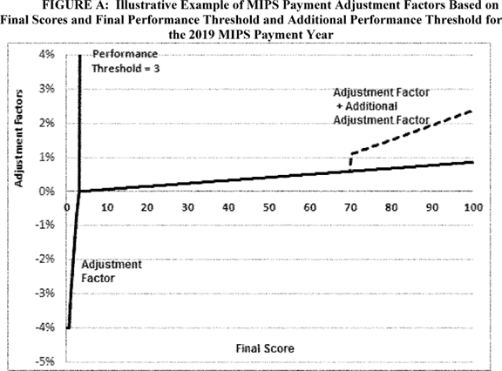

**Note:** The adjustment factor for final score values above the performance threshold is illustrative. For MIPS eligible clinicians with a final score of 100, the adjustment factor would be 4 percent times a scaling factor greater than 0 and less than or equal to 3.0. The scaling factor is intended to ensure budget neutrality, but cannot be higher than 3.0. The additional adjustment factor is also illustrative. The additional adjustment factor starts at 0.5 percent and cannot exceed 10 percent. MIPS eligible clinicians at or above the additional performance threshold will receive the amount of the adjustment factor plus the additional adjustment factor.

The final MIPS payment adjustments would be determined by the distribution of final scores across MIPS eligible clinicians and the performance threshold. More MIPS eligible clinicians above the performance threshold means the scaling factors would decrease because more MIPS eligible clinicians receive a positive MIPS payment adjustment. More MIPS eligible clinicians below the performance threshold means the scaling factors would increase because more MIPS eligible clinicians would have negative MIPS payment adjustments and relatively fewer MIPS eligible clinicians receive positive MIPS payment adjustments.

We requested comment on these examples, but we did not receive any comments on them. We have however provided in Table 31 a summary of the MIPS payment adjustments based on different final scores. **[*77342]**

| **Table 31--Illustration of Point System and Associated Adjustments in** | |
| --- | --- |
| **Transition Year** | |
|  |  |
| **Final score** | **MIPS adjustment** |
| **points** |  |
| 0-0.75 | Negative 4 percent |
|  | (Note: We anticipate that this range will comprise mostly |
|  | of MIPS eligible clinicians with a final score of 0.) |
| 0.76-2.9 | Negative MIPS payment adjustment greater than negative 4 |
|  | percent and less than 0 percent on a linear sliding scale. |
|  | (Note: We do not anticipate many MIPS eligible clinicians |
|  | to fall into this range.) |
| 3.0 | 0 percent adjustment. |
| 3.1-69.9 | Positive MIPS payment adjustment ranging from greater than |
|  | 0 percent to 4 percent x a scaling factor to preserve |
|  | budget neutrality, on a linear sliding scale. |
| 70.0-100 | Positive MIPS payment adjustment AND additional MIPS |
|  | payment adjustment for exceptional performance. |
|  | (Additional MIPS payment adjustment starting at 0.5 |
|  | percent and increasing on a linear sliding scale to 10 |
|  | percent multiplied by a scaling factor.) |

We have provided the following examples to demonstrate to readers how the MIPS calculations and performance threshold of 3 points will operate for various performance scenarios.

*Example 1:* A solo practitioner is a low performer who reports one measure/activity in each performance category. For quality scoring, the MIPS eligible clinician submits 1 quality measure instead of the required 6 measures. Under our finalized scoring approach, we allow all MIPS eligible clinicians to receive a three-point floor per measure in the quality performance category. Under this scenario, the MIPS eligible clinician receives the three-point floor for the one measure submitted and the quality performance category is weighted at 60 percent of the final score. The MIPS eligible clinician's total quality performance category score is 3: (1 measure x 3 points each/total possible points of 60 points) x 60 = 3. We note that we did not include the all-cause hospital readmissions measure in the above quality performance category calculation since it is not applicable to groups of 15 or fewer clinicians, nor to MIPS eligible clinicians reporting as individuals due to reliability concerns.

As discussed in section II.E.6.a.(4) of this final rule with comment period, different improvement activities scoring rules apply to a solo practitioner (or small group) than apply to groups of 16 or more clinicians. Under these special scoring rules, a solo practitioner who performs one medium-weighted activity receives 20 out of 40 potential points in the improvement activities performance category score, and one who performs one high-weighted activity receives 40 out of 40 of the improvement activities performance category score. The improvement activities performance category score is weighted as 15 percent of the final score. In this example, the MIPS eligible clinician that is a solo practitioner who performs only one medium-weighted activity, which equals 20 out of the 40 possible points, or 50 percent, for the improvement activities performance category score, which has a weight of 15 percent of the final score. The MIPS eligible clinician's total improvement activities performance category score is 7.50 (50 percent x 15 =7.50).

For advancing care information performance category scoring, the eligible clinician submits the required elements of the base for advancing care information only which is worth 50 percent of the advancing care information performance category score. The advancing care information performance category is worth 25 percent of the final score. In this scenario, the eligible clinician would receive an advancing care information score of (50 percent x 25) =12.5.

As a result, the total final score = 3 +7.5+12.5= 23.0 points which is above the performance threshold of 3 points.

*Example 2:* A MIPS eligible clinician, who is a solo practitioner, receives a 0 for all performance categories except the quality performance category. The MIPS eligible clinician submits four quality measures, instead of the required six measures. Under the finalized scoring approach, we allow all MIPS eligible clinicians to receive a three-point floor per submitted measure in the quality performance category. Under this scenario, the MIPS eligible clinician receives the three-point floor for each of the four measures submitted and the quality performance category is weighted at 60 percent of the final score. Since the MIPS eligible clinician has received 0 in each of the other categories. The MIPS eligible clinician's total final score is: (four measures x 3 points each/total possible points of 60 points) x 60 percent performance category weight = 12 points. The final score = 12 points (12 points for quality + 0 points for improvement activities + 0 points advancing care information) which is above the performance threshold. We note that we did not include the all-cause hospital readmissions measure in the above calculation since it is not applicable to groups 15 or fewer clinicians, nor MIPS eligible clinicians reporting as individuals due to reliability concerns.

*Example 3:* A MIPS eligible clinician, a high performer who is a solo practitioner, performs two medium-weighted activities in improvement activities and submits five measures with high performance and one measure with slightly above average performance. This clinician does not report in the advancing care information performance category and receives a 0 score for the category. For quality scoring, under this scenario, we assume for purposes of illustration and ease of understanding that the MIPS eligible clinician receives 10 points for each of the measures submitted with high performance, and 6 points for the other measure submitted. The quality performance category is weighted at 60 percent of the final score. The MIPS eligible clinician's quality score is: (five measures x 10 points each + 1 measure x 6 points each/total possible points of 60 points) x 60 = 56 points. We note that we did not include the all-cause hospital readmissions measure in the above calculation since it is not applicable to groups with 15 or fewer clinicians and MIPS eligible clinicians reporting as individuals due to reliability concerns.

As discussed in section II.E.6.a.(4) of this final rule with comment period, different improvement activities scoring rules apply to a solo practitioner (or small group) than apply to groups of 16 or more clinicians. Under these special scoring rules, a solo practitioner who performs one medium-weighted activity receives 20 out of 40 potential points in the improvement activities performance category score, and one who performs one high-weighted activity receives 40 out of 40 of the improvement activities performance category score. The improvement activities performance category score is weighted as 15 percent of the final score. In this example, the MIPS eligible clinician performs two medium-weighted activities, which **[*77343]** equals 40 out of 40 points or 100 percent for the improvement activities performance category score, which has a weight of 15 percent of the final score. The MIPS eligible clinician's total improvement activities performance category score is 15 (40/40 x 15=15).

Under this scenario, the MIPS eligible clinician's final score is 56 for the quality performance category score +15 for the improvement activities performance category score + 0 for advancing care information performance category score = 71 points which is above the additional performance threshold of 70.

*Example 4:* A MIPS eligible clinician in a group with 20 MIPS eligible clinicians, reports as a group, and only submits data for the improvement activities performance category. This group also has sufficient case volume to be measured for the readmission measure and in our hypothetical example, has poor performance and receives 3 points for the readmission measure. In this scenario, the improvement activities special scoring rules do not apply since the MIPS eligible clinician is in a group of 20 MIPS eligible clinicians and is reporting as a group. The MIPS eligible clinician performs only one high activity for the improvement activities performance category. For improvement activities scoring for groups of more than 15 clinicians, all groups who perform one medium activity receive 10 out of 40 points for the improvement activities score, and those who perform each high activity receive 20 points toward the improvement activities score. The improvement activities score is weighted as 15 percent of the final score. In this example, the MIPS eligible clinician performs only one high activity, achieves 20 out of 40 possible points of the improvement activities score, which has a weight of 15 percent of the final score. In addition, even though the group did not submit quality measures to the quality performance category information, the group is measured on the readmission measure because the group has submitted improvement activities as a group. As explained above, the group achieves only 3 points on the readmission measure and therefore has a quality score equal to 3 out 70 points. The group has 0 for the advancing care information category. The eligible clinician's total final score is (3/70 quality performance category score x 60 percent for quality performance category weight) + (20/40 improvement activities performance category score x 15 percent improvement activities performance category weight) + (0 advancing care information quality score x 25 percent advancing care information performance category weight) = [(4.3 percent x 60 percent) + (50 percent x 15 percent) + (0 percent x 25 percent)] x 100 = 10.1 points, which is above the performance threshold of 3.

We cannot guarantee that establishing the performance threshold of 3 for the transition year will always provide a positive MIPS payment adjustment for MIPS eligible clinicians; however, it does provide more opportunities for MIPS eligible clinicians to participate and become familiar with MIPS. In addition, the additional adjustment factor provides incentives for MIPS eligible clinicians to strive for good performance.

8. Review and Correction of MIPS Final Score

a. Feedback and Information to Improve Performance

Through the MIPS and APMs RFI, we solicited comment on various questions related to performance feedback under section 1848(q)(12) of the Act, such as what type of information should be contained in the performance feedback data, how often the feedback should be made available, and who should be able to access the data. Several commenters stated that it would be beneficial if the performance feedback under MIPS contained all the data that contributes to an EP's final score and any MIPS adjustment. Further, several commenters suggested that performance feedback allow for interactive use of the data. Commenters supported frequent availability of such data and many noted that a minimum of quarterly feedback data would be preferred. Commenters also noted that access to PQRS feedback reports currently was a challenge and some suggested that the EPs should be able to control who can access the feedback reports.

(1) Performance Feedback

(a) MIPS Eligible Clinicians

Under section 1848(q)(12)(A)(i) of the Act, as added by section 101(c)(1) of the MACRA, we are at a minimum required to provide MIPS eligible clinicians with timely (such as quarterly) confidential feedback on their performance under the quality and cost performance categories beginning July 1, 2017, and we have discretion to provide such feedback regarding the improvement activities and advancing care information performance categories.

Beginning July 1, 2017, we proposed to include information on the quality and cost performance categories in the performance feedback. Within these performance categories, we proposed to use fields similar (that is, quality and cost) to those currently available in the Quality and Resource Use Reports (QRURs). Since the QRURs already provide information on quality and cost we believe this is a good starting point for the data fields to be included in the performance feedback. Additional information on the current QRURs can be found at [*https://www.cms.gov/Medicare/Medicare-Fee-for-Service-Payment/PhysicianFeedbackProgram/2015-QRUR.html*](https://www.cms.gov/Medicare/Medicare-Fee-for-Service-Payment/PhysicianFeedbackProgram/2015-QRUR.html).

The first performance feedback is due on July 1, 2017. As this is prior to us having received any MIPS data, we proposed to initially provide feedback to MIPS eligible clinicians who are participating in MIPS using historical data set(s), as available and applicable. For example, these historical data set(s) could be a baseline report, using data based off performance that occurred in CY 2015 or CY 2016 for applicable and available quality and cost data. Since 2017 is the first MIPS performance period (as finalized in section II.E.8.a.), we do not anticipate receiving the first set of data for MIPS until 2018 (see [*81 FR 28181).*](https://advance.lexis.com/api/document?collection=administrative-codes&id=urn:contentItem:5JR6-TD50-006W-8163-00000-00&context=) At a minimum for the transition year, we proposed to provide performance feedback on an annual basis since the first performance feedback, required on July 1, 2017 would be based on historic data set(s). As the program evolves, and we can operationally assess/analyze the MIPS data, we may consider in future years providing performance feedback on a more frequent basis, such as quarterly. Section 1848(q)(12)(A)(i) of the Act requires the performance feedback to be provided "timely" (such as quarterly), which is our goal as MIPS evolves. In addition, we solicited comments on whether we should include first year measures in the performance feedback, meaning new measures that have been in use for less than 1 year, regardless of submission methods. The reasoning behind first-year measures potentially not being reported is we need to review the data from the measures before these data are incorporated into performance feedback, as we want to ensure the data we are providing in the performance feedback is useful and actionable for our stakeholders. We requested comments on these proposals.

In future years and as the program evolves, we intend to seek comment on the template, including but not limited to the data fields, for performance feedback. While section 1848(q)(12)(A)(i) of the Act only requires us to provide performance feedback for the quality and cost performance categories, we understand **[*77344]** that the improvement activities and advancing care information performance categories are important MIPS data. Commenters to the MIPS and APMs RFI noted that CMS should consult with stakeholders to ensure this performance feedback is useful before these data are provided to MIPS eligible clinicians. Therefore, we may consider including feedback on the performance categories of improvement activities and advancing care information in future years. Further, before we consider adding improvement activities and advancing care information data to the performance feedback we would like to engage in stakeholder outreach to understand what data fields might be helpful and actionable for MIPS eligible clinicians. Regarding the MIPS final score, this is something we are targeting to provide annually as part of the performance feedback as the program evolves. As technically feasible, we are also planning to provide data fields such as the final score and each of the four performance categories in future performance feedback once MIPS data become available. In addition, we plan to explore the possibility of including the MIPS payment adjustment factor (and, as applicable, the additional MIPS payment adjustment factor) in future performance feedback. We solicited comment on the frequency with which this performance feedback should be provided, considerations for including improvement activities and advancing care information, and data fields that should be included in the performance feedback as this program evolves.

The following is a summary of the comments we received regarding our proposal to provide annual performance feedback on the quality and cost performance categories starting July 1, 2017, which would be based on historic/baseline information and include fields similar to QRURs.

*Comment:* Some commenters were not in support of providing performance feedback. However, the majority of commenters supported providing performance feedback. Some commenters agreed with the proposal to provide initial feedback starting on July 1, 2017 based on historical data for the quality and cost performance categories.

With regard to the frequency of providing performance feedback, commenters' suggestions ranged from annually to 6 weeks of the performance period. The majority of commenters stated that annual feedback would not provide timely information or frequent feedback, due to the long look-back periods hindering the ability for improvements of care. Many commenters supported real-time feedback to eligible clinicians and groups, and suggested making feedback available during the performance periods so clinicians could correct errors in a timely fashion. The majority of comments supported quarterly feedback from CMS, some commenters noting this should begin in 2017. One commenter requested that CMS adopt a requirement that eligible clinicians be furnished quarterly feedback on the advancing care information performance category during the performance period.

One commenter stated that 6 months is the ideal target to provide feedback, to allow for unavoidable claim run-out and review processes. While some commenters supported a monthly performance feedback so adjustments could be made in workflow to improve performance. Another commenter noted that performance feedback should be provided no later than 45 days following the end of a performance period. One commenter requested that performance feedback be available and accessible upon request. One commenter recommended that CMS allow eligible clinicians to choose if they want to receive more current feedback, such as quarterly.

Another commenter recommended that performance feedback be provided prior to the end of the performance period. Other commenters suggested that the final performance feedback is provided no later than October 1 of the reporting year. Another commenter expressed that performance feedback to eligible clinicians would only be effective if it would come in time to make meaningful changes to the practice, and that subsequently July 1 was too late in the year for feedback.

Some commenters believed there is value in submitting data more frequently (for example, an iterative process where practices and vendors submit data routinely); but if CMS intends to provide feedback after eligible clinicians submit their data and not on a frequent basis, then eligible clinicians should not be required to submit data more frequently.

Another commenter recommended an approach that allows for timely, actionable feedback, such as the Bundled Payments for Care Improvement (BPCI) model, which offers monthly data files and quarterly reconciliation reports with subsequent true-ups.

*Response:* As we indicated in the proposed rule, our goal is to provide even more timely feedback under MIPS as the program evolves. We do note that there are a number of challenges with providing feedback more frequently than annually, namely that for the MIPS performance period, under our final policies in this rule data will be received on an annual basis for the majority of submission mechanisms. However, as noted in section II.E.4., we will, if technically feasible, allow for submissions during the performance period. In that section we note that having more frequent data submissions is a preliminary step on being able to issue more timely feedback. We will provide the first performance feedback on the quality and cost performance categories by July 1, 2017. We believe that additional steps need to be taken both internally by CMS and through external stakeholder outreach/engagement to move towards a more frequent data submission process, which will enable CMS to provide more timely or real-time feedback. Additionally, we do not currently have the ability to provide feedback more frequently than annually as data will be submitted to CMS by clinicians and their third party intermediaries on an annual basis. However we will take this comment into future consideration as we develop the processes to provide more frequent feedback, including what frequency requirements should be placed around the submission requirements.

*Comment:* Some commenters requested clarification on whether CMS would provide clinician and/or TIN specific feedback about quality during the reporting year.

*Response:* We can only provide feedback on performance as often as data are reported to us; for MIPS, this will be an annual basis for all quality submission mechanisms except for claims and administrative claims. As noted in section II.E.4. we will, if technically feasible, allow the submission of data more frequently throughout the year which would allow us to enable the generation of additional feedback that is accurate and meaningful to MIPS eligible clinicians.

*Comment:* One commenter requested that CMS expand the type of data available to clinicians on the cost performance category. One commenter believed that cost data should be provided to eligible clinicians on a rolling quarterly basis. A few commenters requested more frequent performance feedback for cost, and that cost information be available to clinicians as soon as possible during the performance period, and to keep the attribution process transparent.

One commenter noted that clinicians need real-time information, including attribution for cost to perform well and achieve the Quality Payment Program's goals. One commenter requested that **[*77345]** CMS provide attributed cost beneficiary lists and other data to eligible clinicians that can provide timely and actionable insights to organizations on a quarterly basis. Another commenter recommended making available information about cost in local specialists in performance feedback to inform referral decisions which can impact the cost measure performance. Some commenters recommended CMS to provide patient-level claims data for each cost performance measure so clinicians can understand specific care pathways and referral patterns that drive unnecessary expenditures. Another commenter suggested allowing clinicians to drill down to the un-aggregated patient level for performance feedback for cost.

Some commenters recommended that CMS provide the ability for eligible clinicians and organizations to run real-time cost measure reports on the CMS Web site, as waiting for CMS to publish mid-year or even quarterly reports does not provide sufficient time to design and implement improvement interventions.

One commenter encouraged CMS to provide cost performance feedback that makes it possible for the data to be incorporated into other reporting and analytics tools the clinician might be using and allows the clinician to monitor their scores throughout the reporting period.

*Response:* We do intend to provide performance feedback on cost measures, as further described in section II.E.5.e. of this final rule with comment period. As technically feasible, we will provide performance feedback on the measures specified for the cost performance category. We also plan to provide feedback on episode-based measures, as we believe this information will be useful to eligible clinicians, even though some of these episode-based measures have not been adopted for the cost performance category for the CY 2017 performance period, but could be used in future years if proposed through rulemaking (see II.E.5.e. of this rule). Additionally, some of these measures will be released in the 2015 S-QRURs that will be available in October 2016. We are still determining the formatting and details of that data. We will publish the cost measures specifications and attribution methodology on our Web site. We also agree the goal of performance feedback will be to provide as frequently-as-is-meaningful feedback to MIPS eligible clinicians regarding the cost performance category, and this is what we are working toward in the future as we build the web-based application for performance feedback distribution.

Additionally, section 1848(q)(12)(B)(i) of the Act, states that beginning July 1, 2018, the Secretary shall make available to MIPS eligible clinicians information about the items and services for which payment is made under Title 18 that are furnished to individuals who are patients of MIPS eligible clinicians by other suppliers and providers of services. This information may be made available through mechanisms determined appropriate by the Secretary. We agree this information would be useful to eligible clinicians, and are therefore targeting to include this information in the performance feedback beginning July 1, 2018.

*Comment:* One commenter indicated that CMS needs to create performance feedback that shows quality and cost at the measure level and change in performance over time in order for information to be used in performance improvement. Another commenter suggested that CMS provide transparency on quality measurement data at both the individual and group level.

*Response:* We agree providing performance feedback that shows quality and cost at the measure level would be useful to MIPS eligible clinicians, and we plan to include this data beginning July 1, 2018. As technically feasible we intend to incorporate improvement information into the performance feedback, when available.

*Comment:* One commenter requested clarification on if the QRUR would still be utilized under MIPS in the same way it is being utilized for PQRS now. Some commenters were concerned about using the QRURs as the template for MIPS performance feedback, expressing their belief that QRURs were not clear in the feedback being provided, actionable on the eligible clinician's behalf, or inclusive of data that would allow the eligible clinician to compare and improve against the performance thresholds. One commenter recommended improvements to the content and accessibility of supplemental QRURs to encourage familiarity with cost performance data and the clinical episodes that will be attributed to a clinician or group. One commenter suggested the QRUR be supplemented with additional information on topics such as beneficiary attribution characteristics. Another commenter requested that CMS encourage clinicians to access performance feedback to supplement the information they receive from CMS on their Medicare Fee for Services claims.

One commenter requested that CMS continue to provide timely mid-year and end-of-year QRURs to eligible clinicians in order for them to receive timely feedback about their performance and payment adjustments under MIPS. Some commenters supported quicker and broader access to performance scores and "feedback reports" such as those provided to clinicians as part of the Physician Feedback Program (QRURs), and the Medicare Shared Savings Program for ACOs for quality improvement purposes. One commenter suggested the QRURs be provided on a quarterly basis moving forward with the Quality Payment Program so the information is timely for performance feedback.

One commenter noted concerns with the implementation feasibility of getting performance feedback out for mid-year performance given past experience with the PQRS and QRURs, and urged CMS to make the investments needed in resources and systems to ensure timely feedback.

*Response:* Under section 1848(n)(11) of the Act, as added by section 101(d)(3) of the MACRA, reports under the Physician Feedback Program (in other words, the QRURs) shall not be provided after December 31, 2017, and will be succeeded by the MIPS performance feedback under section 1848(q)(12) of the Act. The QRURs have provided information on quality and cost measure performance as well as the beneficiary and clinician-level data underlying and driving the measures; therefore, while we believe this is a good starting point for performance feedback under the MIPS, we do not anticipate using the same format as the QRURs for future years of the Quality Payment Program. We will continue to engage in user research with front-line clinicians and other stakeholders to ensure we are providing the performance feedback data in a user-friendly format, and that we are including the data most relevant to clinicians.

*Comment:* Many commenters suggested feedback be included on all four performance categories, so eligible clinicians could know how they are doing in each performance category. Some commenters recommended that CMS use its discretion to expand the performance feedback to relay information on improvement activities and advancing are information.

*Response:* We agree that all four performance categories may be beneficial to include in performance feedback. For the first performance **[*77346]** feedback, as we proposed, only quality and cost will be provided. We will continue to work with stakeholders on the best way to include all four performance categories in performance feedback. A summary of comments received regarding future considerations for including improvement activities and advancing care information, and data fields that should be included in the performance feedback as this program evolves can be found below in section II.E.8.a.(7) of this final rule with comment period.

*Comment:* One commenter expressed support for providing more frequent real-time feedback to eligible clinicians on administrative claims-based measures. Another commenter believed that CMS should make claim-level data for all potential beneficiaries available to practices with MIPS eligible clinicians.

*Response:* We will be providing performance feedback on these types of measures, as applicable. We also agree the goal of performance feedback will be to provide as frequently-as-is-meaningful feedback to clinicians, and this is what we are working toward in the future as we build the web-based application and work with registries, EHRs, and QCDRs for performance feedback.

*Comment:* One commenter believed that CMS does not need to create a new feedback reporting system, but should instead focus on improving the current system.

*Response:* We agree, and will continue working with stakeholders to improve the future performance feedback for the Quality Payment Program.

*Comment:* Some commenters requested that eligible clinicians who are not required, but who report voluntarily, receive the same access to performance feedback as MIPS eligible clinicians.

One commenter requested that CMS expedite the performance feedback process so that partial-year data on performance in the transition year of the MIPS is available to physicians prior to July 1, 2018--and preferably prior to January 1, 2018.

*Response:* We have considered the comments received and will take them into consideration in the future development of performance feedback through separate notice-and-comment rulemaking.

After consideration of the comments, we are finalizing that we will use the QRUR released on September 26, 2016 (referred to as the 2015 Annual QRUR) as the first MIPS performance feedback provided under section 1848(q)(12)(A)(i) of the Act, which will contain quality and cost data. The September 2016 QRURs are available and can be accessed at [*https://portal.cms.gov/wps/portal/unauthportal/home/*](https://portal.cms.gov/wps/portal/unauthportal/home/). We encourage physicians and physician groups to access their report and review the quality and cost information to prepare for the Quality Payment Program. To note, this report will not contain data regarding the final score or payment adjustment for the Quality Payment Program, that information is not yet available and therefore will be provided in future performance feedback. Further, we may have MIPS eligible clinicians that will not have historical data available, through the September 2016 QRUR, to produce performance feedback. For those eligible clinicians we will not be able to produce performance feedback, until these eligible clinicians submit data through the Quality Payment Program. Additionally, to note for MIPS eligible clinicians and groups, the Quality Payment Program will produce performance feedback as long as quality data is submitted or at least one patient and is attributed to a MIPS eligible clinician or group for cost or quality measurement.

Lastly, we note that these QRURs are produced at the TIN level, which is the level for applying adjustments under the VM program. We recognize that assessments under MIPS may be conducted at either the individual or group level, and that payment adjustments will be made at the TIN/NPI level; therefore, QRURs may not provide sufficient detail for those clinicians who are currently assessed at the TIN level under the VM, but who may choose to be assessed at the individual level under the Quality Payment Program. To address this issue, we intend, prior to the 2018 performance period, to provide as much feedback as technically possible to clinicians at the individual level. Since at this time CMS will not have performance data for the 2017 performance period (as that data is not yet available), we will not be able to provide feedback on that data. We intend to look into providing feedback to clinicians on the data it does have available, for instance, on claims based cost data or claims based outcome measures.

The September 26, 2016 QRURs show how physician groups and physician solo practitioners performed in 2015 on quality and cost measures relative to national benchmarks and indicate whether physicians will receive an upward, neutral or downward adjustment under the VM in 2017. The QRURs also contain important information about care delivered to Medicare beneficiaries that can be used to better understand and improve quality and cost performance under the VM including information about hospitalizations and other providers that can be used to improve quality and better coordinate care.

By utilizing an already existing report, that provides quality and resource use (for example, cost) feedback, we intend to focus resources on continued user testing with front-line clinicians and other stakeholders and development of new and improved methods and mechanisms for performance feedback, including but not limited to those suggested in these comments. We are utilizing an existing report because it does not make sense for us to create a duplicative report containing the same information and provide it to clinicians beginning July 1, 2017, which would only confuse clinicians by continuing to use the same data as provided in the September 26, 2016 QRUR. Additionally, no clinicians would have submitted data for the Quality Payment Program to us before July 1, 2017. Therefore, we intend to invest our resources in creating an easy to understand and meaningful performance feedback for the Quality Payment Program beginning July 1, 2018.

We note, however, that we expect to provide the 2016 annual QRUR in early fall 2017 that will show how groups and solo practitioners performed in 2016 on the quality and cost measures used to calculate the 2018 VM, as well as their 2018 VM payment adjustment. The 2016 annual QRUR will be the last annual QRUR provided to groups and solo practitioners, as the VM program is sunsetting. We believe the 2016 annual QRUR is important to provide ongoing feedback to clinicians and groups to support their successful transition to the Quality Payment Program.

Further we note that in the next performance feedback, we intend to provide performance feedback for MIPS data collected in 2017. This data could potentially include all applicable data reflecting CY 2017 performance, including data on the quality and cost performance categories; as well as, data regarding the final score and payment adjustment. This reflects our commitment to providing as timely information as possible to eligible clinicians in order to help them predict their performance in MIPS. CMS intends for this performance feedback to be available in the new format for the 2017 performance period by summer 2018, after the 2017 reporting closes. **[*77347]** For updates and more information, please see *QualityPaymentProgram.cms.gov.*

In addition, we solicited comments on whether we should include first year measures in the performance feedback, meaning new measures that have been in use for less than 1 year, regardless of submission methods. We also solicited comments on including the final score in performance feedback as the program evolves. The following is a summary of the comments we received.

*Comment:* Some commenters encouraged CMS to provide information on its performance feedback on first year MIPS measures, so that eligible clinicians can determine their performance on these measures before they are scored on them. The commenter stated that whether or not feedback on first year QCDR measures should be reported may have to take into consideration such factors as the number of clinicians reporting on a measure and other concerns, and should be resolved in conjunction with the QCDR sponsor. Another commenter noted that while CMS may be unsure how to analyze first year measures, it is important for CMS to provide as much data as possible in the performance feedback, as long as such data are not shared publically or used to evaluate performance.

*Response:* We understand the rationale that by providing first year measures in performance feedback, MIPS eligible clinicians may get a better sense of how they are performing on those measures. We need to review the data from the first year measures before these data are incorporated into performance feedback, as we want to ensure the data we are providing in the performance feedback is useful and actionable for our stakeholders. After reviewing data submitted for the first MIPS performance period and working with stakeholders on user experience testing, we will consider including first year measures in the performance feedback.

For detailed information regarding first year measures and public reporting on Physician Compare, we refer commenters to section II.E.10. of this final rule with comment period.

*Comment:* One commenter believes that CMS should provide feedback every 45 days instead of every 6 months in regard to negative, zero, or positive MIPS payment adjustment status.

*Response:* As noted in the proposed rule [*(81 FR 28277),*](https://advance.lexis.com/api/document?collection=administrative-codes&id=urn:contentItem:5JR6-TD50-006W-8163-00000-00&context=) regarding the MIPS final score, this is something we are targeting to provide annually as part of the performance feedback as the program evolves. As technically feasible, we are also planning to provide data fields such as the final score and each of the four performance categories in future performance feedback once MIPS data becomes available. We note that we have not committed to providing feedback every 6 months, though we are working to increase the frequency of feedback we can provide.

We have considered the comments received and will take them into consideration in the future development of performance feedback through separate notice-and-comment rulemaking.

(b) MIPS APM Entities

In the proposed rule, we proposed that MIPS eligible clinicians who participate in MIPS APM Entities would receive performance feedback, as technically feasible [*(81 FR 28247).*](https://advance.lexis.com/api/document?collection=administrative-codes&id=urn:contentItem:5JR6-TD50-006W-8163-00000-00&context=) A summary of comments on those proposals can be found in section II.E.5.h.(16) of this final rule with comment period.

(2) Mechanisms

Under section 1848(q)(12)(A)(ii) of the Act, the Secretary may use one or more mechanisms to make performance feedback available, which may include use of a web-based portal or other mechanisms determined appropriate by the Secretary. For the quality performance category, described in section 1848(q)(2)(A)(i) of the Act, the feedback shall, to the extent an eligible clinician chooses to participate in a data registry for purposes of MIPS (including registries under sections 1848(k) and (m) of the Act), be provided based on performance on quality measures reported through the use of such registries. For any other performance category (that is, cost, improvement activities, or advancing care information), the Secretary shall encourage provision of feedback through qualified clinical data registries (QCDRs) as described in sections 1848(m)(3)(E) of the Act.

We understand that the PQRS and VM programs have employed various communication strategies to notify health care clinicians of the availability of their PQRS feedback reports and QRURs, respectively, through the CMS portal. However, many health care clinicians are still unaware of these reports and/or have difficulty accessing their reports in the portal. Further, we are aware that some health care clinicians perceive the current reports as complex and often difficult to understand; while others find the QRURs, and the drill down data included in them on the Medicare beneficiaries they serve, very useful. We are continuing to work with stakeholders to improve the usability of these reports. As we transition to MIPS, we are committed to ensuring that eligible clinicians are able to access their performance feedback, and that the data are easy to understand while providing information that will help drive quality improvement. We proposed to initially make performance feedback available using a CMS designated system, such as a web-based portal; and if technically feasible perhaps an interactive dashboard. As further discussed in the proposed rule [*(81 FR 28280),*](https://advance.lexis.com/api/document?collection=administrative-codes&id=urn:contentItem:5JR6-TD50-006W-8163-00000-00&context=) we also proposed to leverage additional mechanisms such as health IT vendors, registries, and QCDRs to help disseminate data/information contained in the performance feedback to eligible clinicians, where applicable. At this time, we believe that these additional mechanisms will only be able to provide information on the quality performance category for MIPS in regard to performance feedback.

We plan to coordinate with third party intermediaries such as health IT vendors and QCDRs as MIPS evolves to enable additional feedback to be sent on the cost, advancing care information and improvement activities performance categories. We solicited comment on this for future rulemaking.

Comments received through the MIPS and APMs RFI noted issues associated with access to the current feedback reports for PQRS. Specifically, comments were received noting issues with Enterprise Identity Management (EIDM) and access to the portal to view PQRS feedback reports. Commenters also noted the need for a mechanism to be put in place to notify EPs when their PQRS feedback report is available. We proposed to use the information contained in the provider or supplier's Medicare enrollment records, and stored in the Provider Enrollment, Chain, and Ownership System (PECOS), as the system of records for eligible clinicians' contact information that should be used when the MIPS performance feedback is available. It is therefore critical that eligible clinicians ensure that their Medicare enrollment records (especially in regard to phone and email contact information) are updated, meaning current, on a consistent basis in PECOS. If more than one email address is listed, then the email address that should be used for communication should be designated. We also intend to provide education and outreach on how to access performance feedback. We solicited comment on additional means that could be used to notify or contact MIPS eligible clinicians and groups **[*77348]** when their performance feedback is available.

The following is a summary of the comments we received regarding our proposal to provide performance feedback through a CMS designated system (such as a web-based portal or interactive dashboard), and to leverage additional mechanisms such as health IT vendors, registries, and QCDRs to help disseminate data/information contained in the performance feedback to eligible clinicians, where applicable.

*Comment:* Commenters stated the feedback should be easy/clear to understand and easy to access, with helpful education and outreach. Some commenters suggested the process to access feedback should be streamlined and less complicated.

Many commenters recommended an interactive web-based dashboard for feedback delivery that provides data in real-time to eligible clinicians, at least on a quarterly basis. Some commenters recommended the display of such a dashboard show performance feedback through graphics. A few commenters recommended to not implement performance feedback for the quality and cost performance categories until CMS has had a chance to bring online a web portal where MIPS eligible clinicians can log in and see their final score. The commenters explained that without understanding how they are scoring versus their peers under MIPS, many may fall inadvertently to the bottom of the quality or cost performance categories.

One commenter recommended that CMS work with health IT vendors to develop a real-time feedback dashboard that can be incorporated into health IT products, such as EHRs, as eligible clinicians will not know where they are relative to the performance threshold on an annual basis until after the close of the performance period. While another commenter recommended that, to the extent it is feasible, CMS consider partnering with registry vendors to integrate reports in registry interfaces, enabling those eligible clinicians reporting via an EHR or QCDR to view performance feedback in a dashboard setting that is familiar to them.

Some commenters suggested that CMS create an electronic interactive tool for eligible clinicians to quickly gauge their progress by calculating scores, which can help eligible clinicians identify measures that are applicable to their practice. Another commenter noted that an important aspect for clinicians and groups in small, rural and underserved areas are intuitive tools to easily calculate their MIPS score, whether this tool is embedded within the health IT vendor, registry, or available on the CMS Web site. The commenter also stated that this must be a robust tool which would allow clinicians and groups the ability to securely visualize external data such as aggregate claims data used to calculate episode measures.

One commenter recommended performance feedback be available online and in a timely fashion, ideally in the way that the same information would be available to the public, but well in advance of publication. One commenter suggested CMS leverage the My Quality Net Web site to provide performance feedback to clinicians, since hospitals and other clinicians are already accustomed to using it for federal quality reporting programs.

Another commenter recommended that CMS create a clinician portal that will allow eligible clinicians and other clinicians to estimate their payment adjustment.

Some commenters requested that performance feedback provide the ability to drill down for use by individual physicians.

*Response:* We agree performance feedback should be clear, easy to understand, and provided to eligible clinicians in a user-friendly format (for example, web-based interactive dashboard). In the future, we intend to provide functionality for an interactive experience for performance feedback. As we build the web-based application for performance feedback, we will continue working with stakeholders (for example, as part of usability testing) to ensure the user experience is accounted for when building this system. If technically feasible, we will work toward incorporating a means to drill down by individual clinicians for performance feedback. We will take all of these commenters' recommendations into consideration as we develop performance feedback mechanisms. While we cannot speak to the plans of health IT vendors, registries, or other third party intermediaries; we expect to continue working with them, as well as clinicians, specialty organizations, and other stakeholders to promote continued growth in the availability of timely, easy-to-use performance feedback for clinicians through these mechanisms in complement to the feedback that will be available from CMS. Further, since we have not required advance registration for reporting, we note that participation in MIPS will be at the level at which data is submitted to CMS. Thus, if individual data is submitted, feedback will be on the individual level; if group data is submitted, feedback will be at the group level.

*Comment:* Some commenters suggested a process be included for physicians to request and implement revisions when performance feedback data are incorrect. Another commenter suggested being allowed to resubmit claims that were incorrectly submitted, as by the time feedback was provided historically in the PQRS and VM programs it was too late and the practice was subject to downward adjustments to payments.

*Response:* We intend to build in a process for updates/revisions needed for performance feedback, which would be separate from the targeted review process as described in further detail in section II.E.8.c. of this final rule with comment period. We note that as described in section II.E.5. of this rule we do not have the ability to allow for claims to be resubmitted only for the reason of appending a quality data code.

*Comment:* One commenter recognized that while the goal is to provide quarterly performance feedback, the feedback might not be issued until the first half of a year because historically in the PQRS program most registries do not open or accept data submission until the second quarter of the performance period.

Another commenter agreed with utilizing vendors, such as registries, to communicate performance feedback in real-time so that performance can be monitored at any time. While another commenter recommended that CMS continue to evaluate and work with vendors to determine how health IT vendors and QCDRs can be leveraged to provide more ongoing performance feedback to clinicians, as the goal being an agile method of analyzing performance without manual entry or mistake. One commenter requested that CMS leverage advanced electronic reporting mechanisms to reduce the long feedback turnaround time in claims-based systems and to provide performance data on improvement activities and advancing care information in addition to quality and cost.

One commenter recommended that CMS provide third party intermediaries access to clinician performance feedback for the clinicians for whom they are submitting information for in order to allow third party intermediaries to validate and troubleshoot any issues with the data.

One commenter suggested that CMS allow clinicians to elect to receive their performance feedback through a Regional Healthcare Innovative Collaborative (RHIC) that are able to provide a multi-payer perspective. **[*77349]**

*Response:* In future years of the program, we plan to leverage additional pathways such as collaborative efforts with health IT vendors, registries, and QCDRs to help disseminate data/information contained in the performance feedback to eligible clinicians, where applicable. We will look to increase feedback to third party intermediaries in the Quality Payment Program; and will continue working with stakeholders as we move toward implementing this functionality. We also direct these commenters to the third party data submission section (II.E.9.) of this final rule with comment period.

*Comment:* Some commenters suggested individual eligible clinicians should be able to access their performance feedback independently, instead of having to access through a group. One commenter suggested performance feedback also be available to practice administrators (to view all NPIs at the TIN level, as opposed to each individual eligible clinician) and related staff. Some commenters suggested that the performance feedback also be available to practice staff designated by the eligible clinician. Some commenters believed that the EIDM process to access performance feedback should be re-evaluated, noting practices of all sizes (solo and 2+ for eligible clinicians) only should need one EIDM account to view performance feedback, as well as, be allowed to submit data for the practice. Another commenter requested that CMS make the log-in process for accessing performance feedback more user-friendly; as currently it is overly complicated with cumbersome password requirements that reset at short intervals; which limit access to the current PQRS feedback reports and QRURs.

One commenter agreed with offering clinicians the option to receive performance feedback through one channel, and requested that CMS make this a priority for future performance feedback years. The commenter also recommended that as part of this initiative, CMS work with stakeholders toward creating a channel for eligible clinicians to view their performance on both quality and cost measures across all (or multiple) payers. The commenter also noted that it is critical for eligible clinicians to have access to a resource that provides them with a complete picture of their practice across all payers.

Other commenters stated that many clinicians are unaware of the current QRURs or have had trouble accessing them, noting difficulty with the login process which they believed was being unnecessarily complicated, not always clear who has access, and those that have access are not usually front-line clinicians. The commenter strongly encouraged CMS to push performance feedback out to clinicians as opposed to waiting for clinicians to access the feedback.

*Response:* We agree the process to access performance feedback should be easy and streamlined. While we have taken steps to streamline the current PQRS feedback reports and QRURs, more could be done. We intend for MIPS eligible clinicians to be able to access their performance feedback independently through a web-based application. Since performance feedback will contain secure data, we recognize the need to balance access with maintaining security. We intend to continue the efforts made under the VM program, to engage physicians and encourage and assist them to access their performance feedback. We will take the comments into account and continue working with stakeholders as we build the CMS designated system for performance feedback.

*Comment:* One commenter requested that performance feedback data be provided without charge.

*Response:* As is done currently with the PQRS feedback reports and QRURs, performance feedback will also be provided through a CMS designated system, with no charge to the eligible clinician.

After consideration of the comments we are finalizing these polices as proposed. In future years of the program, performance feedback will continue to be available through a CMS designated system, which we intend to be a web-based application. The intent is that in the next performance feedback, anticipated to be released around July 1, 2018, this feedback will be the first in the anticipated new dashboard format. It will be provided via the new Quality Payment Program portal and we intend to leverage additional mechanisms such as health IT vendors, registries, and QCDRs to help disseminate data/information contained in the performance feedback to eligible clinicians, where applicable. As we have stated previously, we will continue to engage in user research with front-line clinicians to ensure we are providing the performance feedback data in a user-friendly format, and that we are including the data most relevant to clinicians. For updates and more information, please see QualityPaymentProgram.cms.gov.

Additionally, we did not receive comments on our proposal to use the information contained in the provider or supplier's Medicare enrollment records, and stored in the Provider Enrollment, Chain, and Ownership System (PECOS), as the system of records for eligible clinicians' contact information that should be used when the MIPS performance feedback is available. Therefore, we are finalizing this policy as proposed.

We also sought comment for future rulemaking on coordinating with third party intermediaries such as health IT vendors and QCDRs as MIPS evolves to enable additional feedback to be sent on the cost, advancing care information and improvement activities performance categories. We did not receive comments on additional feedback that could be sent through third party intermediaries. We plan to work with third party intermediaries as we continue to develop the mechanisms for performance feedback, to see where we may be able to develop and implement efficiencies for the Quality Payment Program. Any regulatory changes would be made through future notice-and-comment rulemaking.

(3) Use of Data

Under section 1848(q)(12)(A)(iii) of the Act, for purposes of providing performance feedback, the Secretary may use data, for a MIPS eligible clinician, from periods prior to the current performance period and may use rolling periods in order to make illustrative calculations about the performance of such professional. We believe "illustrative calculations" means an interim, snap shot in time of performance, or perhaps a "dry-run" of the data including measure rates. This would provide an indication of how a MIPS eligible clinician might be performing, but would not be conclusive. Since MIPS will not likely have comparable data until year 3 of the program, these "illustrative calculations" could be based on historical data sets available to CMS until actual data for MIPS is available.

We did not request comments in this section, but did receive a comment which is summarized below.

*Comment:* One commenter believes that if CMS is able to make "illustrative calculations" in advance of a performance year, then CMS should be able to provide eligible clinicians with performance feedback quarterly in advance of the performance year for all four performance categories.

*Response:* As we noted in the proposed rule [*(81 FR 28277-28278),*](https://advance.lexis.com/api/document?collection=administrative-codes&id=urn:contentItem:5JR6-TD50-006W-8163-00000-00&context=) we believe "illustrative calculations" means an interim, snap shot in time of performance, or perhaps a "dry-run" of **[*77350]** the data including measure rates, based on historical data available. This would provide an indication of how a MIPS eligible clinician might be performing, but would not be conclusive. Since MIPS will not likely have comparable data until year 3 of the program, these "illustrative calculations" could be based on historical data sets available to us until actual data for MIPS is available. Also, as noted previously in this section of this final rule with comment period the goal is to provide future performance feedback on a quarterly basis, and once technically feasible to include all four performance categories in the performance feedback.

We have considered the comments received and will take them into consideration in the future development of performance feedback through separate notice-and-comment rulemaking.

(4) Disclosure Exemption

As stated under section 1848(q)(12)(A)(iv) of the Act, feedback made available under section 1848(q)(12)(A) of the Act shall be exempt from disclosure under *5 U.S.C. 552* (the Freedom of Information Act) (FOIA).

We did not request comments in this section, but we received the following comment:

*Comment:* One commenter expressed support for the disclosure exemption for MIPS performance feedback under the Freedom of Information Act.

*Response:* As noted in the proposed rule [*(81 FR 28278),*](https://advance.lexis.com/api/document?collection=administrative-codes&id=urn:contentItem:5JR6-TD50-006W-8163-00000-00&context=) section 1848(q)(12)(A)(iv) of the Act provides that feedback made available under section 1848(q)(12)(A) of the Act shall be exempt from disclosure under FOIA.

(5) Receipt of Information

Section 1848(q)(12)(A)(v) of the Act, states that the Secretary may use the mechanisms established under section 1848(q)(12)(A)(ii) of the Act to receive information from professionals. This allows for expanded use of the feedback mechanism to not only provide feedback on performance to eligible clinicians, but to also receive information from professionals.

We intend to explore the possibility of adding this feature to the CMS designated system, such as a portal, in future years under MIPS. This feature could be a mechanism where MIPS eligible clinicians can send their feedback (that is, if they are experiencing issues accessing their data, technical questions about their data, etc.) to us. We appreciate that MIPS eligible clinicians may have questions regarding the information contained in their performance feedback. To assist MIPS eligible clinicians, we intend to establish resources, such as a helpdesk or offer technical assistance, to help address questions with the goal of linking these resource features to the CMS designated system, such as a portal.

Additionally, we solicited comment on the types of information eligible clinicians would like to send to us via this mechanism.

The following is a summary of the comments we received.

*Comment:* Some commenters recommended a prompt and transparent notification process when errors or inconsistencies are identified on the performance feedback so that errors can be remedied or targeted review requests may occur in a timely manner. Another commenter suggested that a mechanism would be created for eligible clinicians to receive comprehensive periodic feedback or updates from CMS as to how they are performing before each performance period ends.

Other commenters requested that CMS guarantee firm turnaround times for performance feedback, and offer teleconferences to work with eligible clinicians in reviewing the patient data. While some commenters urged CMS to devote the necessary resources, including staff, to help clinicians and administrators interpret the performance feedback (for example, helpdesk).

One commenter recommended that CMS provide technical assistance to eligible clinicians to help understand performance feedback (for example, more practical and specific tips in the help documents for education and outreach, especially as this is a new program).

*Response:* We appreciate that MIPS eligible clinicians may have questions regarding the information contained in their performance feedback. To assist MIPS eligible clinicians, we intend to establish resources, such as the Quality Payment Program Service Center (for example, helpdesk) or offer technical assistance, to help address questions with the goal of linking these resource features to the CMS designated system, such as a web-based application. We also intend to explore the possibilities of adding a mechanism to receive information from eligible clinicians, to a web-based application. These suggestion will be taken into consideration for the future development of performance feedback.

*Comment:* Some commenters suggested using the IHS/Tribal/Urban Indian list serve to notify MIPS eligible clinicians and groups when their performance feedback is available.

*Response:* We agree and will implement this suggestion into the education and outreach planned for performance feedback.

We have considered the comments received and will take them into consideration in the future development of performance feedback through separate notice-and-comment rulemaking.

(6) Additional Information--Type of Information

Section 1848(q)(12)(B)(i) of the Act, states that beginning July 1, 2018, the Secretary shall make available to MIPS eligible clinicians information about the items and services for which payment is made under Title 18 that are furnished to individuals who are patients of MIPS eligible clinicians by other suppliers and providers of services. This information may be made available through mechanisms determined appropriate by the Secretary, such as the proposed CMS designated system that would also provide performance feedback. Section 1848(q)(12)(B)(ii) of the Act specifies that the type of information provided may include the name of such providers, the types of items and services furnished, and the dates items and services were furnished. Historical data regarding the total, and components of, allowed charges (and other figures as determined appropriate by the Secretary) may also be provided. We solicited comment on the type of information MIPS eligible clinicians would find useful and the preferred mechanisms to provide such information, as well as, arrangements that should be in place regarding these data (that is, eligible clinicians sharing data). We also solicited comment as to whether additional information regarding beneficiaries attributed to a MIPS eligible clinician under the cost performance category or information about which MIPS eligible clinician(s) beneficiaries to whom a given MIPS eligible clinician provides services were attributed would be useful feedback in regards to quality improvement efforts.

The following is a summary of the comments we received.

*Comment:* Some commenters suggested performance feedback should include patient-level data in order to aid eligible clinicians to improve quality and cost. One commenter stated it would be easier to provide timely performance feedback to eligible clinicians if smaller statistically relevant sample sizes were reported instead of all Medicare patient data. **[*77351]**

*Response:* As stated above, section 1848(q)(12)(B) of the Act does require patient information to be made available to MIPS eligible clinicians starting July 1, 2018. These suggestions will be taken into consideration as we implement this provision through future rulemaking.

We have considered the comments received and will take them into consideration in the future development of performance feedback through separate notice-and-comment rulemaking.

(7) Performance Feedback Template

The performance feedback under section 1848(q)(12)(A) of the Act is meant to be meaningful and usable to eligible clinicians. In an effort to ensure these data are tailored to the needs of eligible clinicians, we solicited comment through the MIPS and APMs RFI and received numerous comments regarding overall format of the performance feedback template. Suggestions were made on what this feedback should include for MIPS. We intend to collaborate with stakeholders outside of notice-and-comment rulemaking on how the performance feedback should look for MIPS; as well as, what data elements would be useful for eligible clinicians.

We solicited comment on the fields that should be included in the performance feedback template for MIPS eligible clinicians. The following is a summary of the comments we received.

*Comment:* Some commenters supported the idea of a standardized performance feedback template, and encouraged CMS to engage with stakeholders and non-physician practitioners to obtain feedback about the template. One commenter suggested that CMS should consider a number of mechanisms to receive input from stakeholders and provide opportunities to learn about the performance feedback tools in development--for example, the Agency should consider hosting Open Door Forums (ODFs), and ensuring that detailed, comprehensive instructional materials are easily available online. One commenter suggested CMS revisit the MIPS LEAN Design Team materials from the CMS Quality Summit in December 2015. Commenters also suggested that CMS should include clear disclaimers about the limitations of the data.

One commenter suggested that other information could be used in performance feedback by providing data on alternatives to the items or services provided that would have been more cost effective while delivering the same quality of care. Some commenters requested that CMS provide individual eligible clinician and group performance feedback in order to help eligible clinicians determine whether to continue reporting with the group or change to individual reporting.

Another commenter recommended that performance feedback include improved transparency, and additional data points for each reported measure. One commenter recommended that the performance feedback would show both scoring and decile placement for individual eligible clinicians across the areas scored. One commenter believes that all reported measures should be included in performance feedback, and every field that contributed to the score should be included as well. Some commenters suggested performance feedback include data fields that would assist with identification of patients served, costs, outcomes, where and what type of care was provided, quality of care for patients, and care coordination activities and needs; and functionality to compare (for example, regionally and nationally) directly against other eligible clinicians. One commenter suggested more relevant non-patient facing specialties be included in performance feedback.

Some commenters suggested performance feedback include the place of service (POS) codes, geography (including state and Medicare locality), health system NPI, the subpart NPI where the services were delivered, and the NPI of the entity receiving assignment for professional services; as well as the ability to include additional identifiers if needed in the future to account for specialties. While another commenter recommended performance feedback include information for suggested areas where the eligible clinician can improve, which promotes quality and helps eligible clinicians avoid penalties. Other commenters recommended that the cause for a penalty be clearly articulated.

Some commenters suggested performance feedback include as much data as possible as long as it is easy to understand, and recommended options for the format of performance feedback. Some commenters recommended a basic report containing the following information: performance threshold to date, where the clinician stands in performance, current possible payment adjustments (with exact reasoning for negative payment adjustment in order to improve for future reporting), and a roadmap to improve performance and avoid a downward adjustment. Some commenters recommended CMS use one comprehensive document for the MIPS performance feedback. Some commenters suggested a second report be included in the performance feedback on a more granular level, and contain MIPS specific components. Commenters also suggested that CMS put certain data in supplemental materials (for example, advancing care information) or appendices so that it does not detract from the main report for performance feedback.

One commenter suggested that CMS issue an advancing care information experience report similar to the annual PQRS Experience Report with as much information as possible, including reporting experiences by specialty. The commenter noted that CMS could include information on whether each objective was met/not met for the base score; performance data on the objectives being assessed for the performance score; and whether an eligible clinician or group earned bonus points for each measure reported under the Public Health and Clinical Data Registry Reporting objective other than the Immunization Registry Reporting measure. Another commenter recommended that feedback for the advancing care information category include the objectives in which the practice attested for the previous reporting period and the points attributed to those objectives for purposes of calculating the composite score.

A commenter recommended that CMS provide aggregate information by specialty to medical societies, as specialty societies do not have access to QRUR information at the individual clinician level or in aggregate, so they cannot provide meaningful analysis of current cost measures and assistance to clinician members. Another commenter requested that CMS provide additional data to support performance improvement efforts, because while the QRUR provides some ability to drill down into the data, the reports only provide patient-level expenditure data at the aggregate level compared to national benchmarks. While another commenter noted that performance feedback should include sufficient details on what patients and care have been attributed to the clinician and what other clinicians have partnered in that care.

One commenter requested detailed performance feedback highlighting options for improvement activities, discussing incorrect reporting, and include geographical components to allow eligible clinicians to review geographical variations in care processes to acclimate eligible clinicians to this new reporting category. Another commenter recommended that **[*77352]** performance feedback for improvement activities categories be provided as soon as possible, and that the feedback from CMS should confirm that eligible clinicians have met the requirement by using a nationally accredited, certified patient-centered medical home or the degree to which they have met the improvement activities requirement through high- and medium-weighted improvement activities. One commenter believed that for improvement activities performance feedback, CMS could include information on how many and which activities were completed; the method of data submission used to submit improvement activities information; and, in the future, information on improvement relative to prior years. In addition, the commenter suggested that CMS should provide cumulative data about which improvement activities are being reported across MIPS as well as within each specialty designation. Another commenter recommended that electing to receive the performance feedback should also count as an improvement activity.

Some commenters suggested that CMS should make available performance feedback to eligible clinicians on their high-utilization patients in as close to real time as possible or provide practices with reports similar to the Hospital Readmission Reductions Program. Another commenter requested that CMS provide files to clinician practices similar to what are provided to hospitals for the Medicare Spend Per Beneficiary measure that is part of Hospital Value-Based Purchasing.

Some commenters suggested that performance feedback be available via paper reports. Another commenter suggested that performance feedback be provided in an importable form such as a worksheet as opposed to a PDF file, which would allow the eligible clinician more options when reviewing with other tools already in use by the eligible clinician. While other commenters noted performance feedback should be provided in a format that allows eligible clinicians to sort, analyze, and review.

*Response:* We agree with commenters about continually improving the usability of performance feedback, and will continue doing stakeholder outreach with the goal that the template for performance feedback will be available in a usable and user-friendly format, and different options are considered before the performance feedback is displayed in a web-based application to MIPS eligible clinicians. We will work with stakeholders to consider the best means for providing improvement activities and advancing care information in future performance feedback.

We intend to do as much as we can of the development of the template for performance feedback by working with the stakeholder community in a transparent manner. We think this will both encourage stakeholder commentary and make sure we end up with the best possible format(s) for feedback. CMS intends for this performance feedback to be available in the new format on the 2017 performance period by summer 2018, after the 2017 reporting closes.

We have considered the comments received and will take them into consideration in the future development of performance feedback through separate notice-and-comment rulemaking.

b. Announcement of Result of Adjustments

Section 1848(q)(7) of the Act requires that under the MIPS, the Secretary shall, not later than 30 days prior to January 1 of the year involved, make available to MIPS eligible clinicians the MIPS payment adjustment factor (and, as applicable, the additional MIPS payment adjustment factor) applicable to the MIPS eligible clinician for items and services furnished by the professional for such year. The Secretary may include such information in the confidential feedback under section 1848(q)(12) of the Act.

If technically feasible, we proposed to include the MIPS payment adjustment factor and, as applicable, the additional MIPS payment adjustment factor (collectively referred to as the "MIPS payment adjustment factors") in the performance feedback for eligible clinicians provided under section 1848(q)(12)(A) of the Act. If it is not technically feasible to provide this information in the performance feedback, we proposed to make it available through another mechanism as determined appropriate by the Secretary (such as a portal or a CMS designated Web site) and solicited comment on mechanisms that might be appropriate. The first announcement will be available no later than December 1, 2018 to meet statutory requirements. We requested comment on these proposals.

The following is summary of the comments we received regarding our proposal to include the MIPS payment adjustment factors in the performance feedback, if technically feasible.

*Comment:* One commenter suggested that performance feedback should include a potential MIPS payment adjustment factor based on current performance or alternatively a tool to run "what if" scenarios regarding the clinician's adjustment.

*Response:* If technically feasible, we proposed [*(81 FR 28164)*](https://advance.lexis.com/api/document?collection=administrative-codes&id=urn:contentItem:5JR6-TD50-006W-8163-00000-00&context=) to include the MIPS payment adjustment factors in the performance feedback for eligible clinicians. We appreciate these suggestions, and we will take this into consideration in the development of performance feedback.

*Comment:* A few commenters expressed concern that 30 days would not be enough time to respond to the announcement of the result of adjustments. One commenter requested a minimum of 90 days instead, while other comments suggested a 120 day notice to allow clinicians the ability to plan financially.

*Response:* We agree with the commenters and would like to publish this information as early as possible to allow clinicians more time to review and understand the adjustments that will be applied to their payments. We will take this into consideration as we plan for the first announcement, which will be available no later than December 1, 2018 to meet statutory requirements.

*Comment:* One commenter recommended that CMS notify clinicians as soon as feasible regarding payment adjustments to allow practices to prepare for downward adjustments to payments. Commenter recommended that CMS consider providing the adjustment results via letter and through the performance feedback if possible, especially in the beginning years of the program.

*Response:* As noted in the proposed rule [*(81 FR 28278),*](https://advance.lexis.com/api/document?collection=administrative-codes&id=urn:contentItem:5JR6-TD50-006W-8163-00000-00&context=) the first announcement will be available no later than December 1, 2018 to meet statutory requirements. We will take these suggestions into consideration as we prepare for the first announcement for the adjustment factors.

After consideration of the comments we are finalizing the policy as proposed that if technically feasible we will include the MIPS payment adjustment factors in the performance feedback. If it is not technically feasible to include the MIPS payment adjustment factors in the performance feedback, we will notify MIPS eligible clinicians through guidance documents or other program communication channels as to when and how this information will be announced prior to the statutory deadline of December 1, 2018. As discussed above, in future years of the program, performance feedback will be available via a CMS designated system, which we intend to be a web-based application. We also anticipate the announcement of the adjustment factors will be available via a web-based **[*77353]** application as well. Additionally, please see section II.E.8.c. for final polices for requesting a targeted review.

c. Targeted Review

Section 1848(q)(13)(A) of the Act requires the establishment of a process under which a MIPS eligible clinician or group may seek an informal review of the calculation of the MIPS payment adjustment factor (or factors) applicable to such MIPS eligible clinician or group for a year.

We recognize that a principled approach to requesting and conducting a targeted review is required under the MACRA to minimize burdens on MIPS eligible clinicians or groups and ensure transparency under MIPS. We also believe it is important to retain the flexibility to modify MIPS eligible clinicians' or groups' final score or MIPS payment adjustment based on the results of targeted review. This will lend confidence to the determination of the final score and MIPS payment adjustments, as well as, providing finality for the MIPS eligible clinician or group after the targeted review is completed. It will also minimize the need for claims reprocessing. We proposed an approach below that outlines the factors that we would use to determine if a targeted review may be conducted. In keeping with the statutory direction that this process be "informal," we have attempted to minimize the associated burden on the MIPS eligible clinician to the extent possible.

In accordance with section 1848(q)(13)(A) of the Act, we proposed at § 414.1385 to adopt a targeted review process under MIPS wherein a MIPS eligible clinician or group may request we review the calculation of the MIPS payment adjustment factor under section 1848(q)(6)(A) of the Act and, as applicable, the calculation of the additional MIPS payment adjustment factor under section 1848(q)(6)(C) of the Act applicable to such MIPS eligible clinician or group for a year. Because this review will be limited to the calculation of the MIPS payment adjustment factor and, as applicable, the additional MIPS payment adjustment factor, we anticipate we may find it necessary to review data related to the measures and activities and the calculation of the final score according to the defined methodology. The following are examples of circumstances under which a MIPS eligible clinician or group may wish to request a targeted review. This is not a comprehensive list of circumstances:

* The MIPS eligible clinician or group believes that measures or activities submitted to us during the submission period and used in the calculations of the final score and determination of the adjustment factors have calculation errors or data quality issues. These submissions could be with or without the assistance of a third party intermediary; or

1. The MIPS eligible clinician or group believes that there are certain errors made by us, such as performance category scores were wrongly assigned to the MIPS eligible clinician or group (for example, the MIPS eligible clinician or group should have been subject to the low-volume threshold exclusion and should not have received a performance category score).

We believe that a fair targeted review request process requires accessibility to all MIPS eligible clinicians or groups within a reasonable period of time and provides electronic and telephonic communication for questions regarding the targeted review process, as well as for the actual request for review and receipt of the decision on that request. The targeted review process will use the same Quality Payment Program Service Center (referred to as the "help desk" in the proposed rule) support mechanism as is provided for MIPS as a whole.

We further proposed at § 414.1385 to adopt the following general process for targeted reviews under section 1848(q)(13)(A):

* A MIPS eligible clinician or group electing to request a targeted review may submit their request within 60 days (or a longer period specified by us) after the close of the data submission period. All requests for targeted review must be submitted by July 31 after the close of the data submission period or by a later date that we specify in guidance.

1. We will provide a response with our decision on whether or not a targeted review is warranted. If a targeted review is warranted, the timeline for completing that review may be dependent on the number of reviews requested (for example, multiple reviews versus a single review by one MIPS eligible clinician or group) and general nature of the review.
2. As this process is informal and the statute does not require a formal appeals process, we will not include a hearing process. The MIPS eligible clinician or group may submit additional information to assist in their targeted review at the time of request. If we or our contractors request additional information from the MIPS eligible clinician or group, the supporting information must be received from the MIPS eligible clinician or group by us or our contractors within 10 calendar days of the request. Non-responsiveness to the request for additional information will result in the closure of that targeted review request, although another review request may be submitted if the targeted review submission deadline has not passed.
3. Since this is an informal review process and given the limitations on review under section 1848(q)(13)(B) of the Act, decisions based on the targeted review will be final, and there will be no further review or appeal.

If a request for targeted review is approved, the outcome of such review may vary. For example, we may determine that the clinician should have been excluded from MIPS, re-distribute the weights of certain performance categories within the final score (for example, if a performance category should have been weighted at zero), or recalculate a performance category score in accordance with the scoring methodology for the affected category, if technically feasible.

We requested comments on these proposals.

The following is summary of the comments we received regarding our proposals for a targeted review process.

*Comment:* Several commenters supported the inclusion of a targeted review process for MIPS eligible clinicians and groups who believe that CMS has assigned them an incorrect final score or MIPS payment adjustment. Another commenter believed that it is critical that MIPS eligible clinicians have a means to request a review of their MIPS payment adjustment factor. The commenter suggested that CMS put into place a process that is physician friendly and does not automatically assume that the physician is incorrect.

*Response:* We agree with the commenters that the process should be "physician friendly." To accomplish this, we have worked to make our process for submitting a targeted review simple and not overly burdensome on the MIPS eligible clinician and groups or their practices. The request for a targeted review will be based on the MIPS eligible clinician's or group's MIPS payment adjustment factor(s) for a year. We recommend that MIPS eligible clinicians and groups review this information prior to submitting a request for targeted review. For CMS to perform a full review, supporting documentation from the MIPS eligible clinician or group demonstrating why they believe their MIPS payment adjustment factor(s) is inaccurate is critical.

*Comment:* A few commenters requested that CMS provide a mechanism where a MIPS eligible **[*77354]** clinician or group can contest a negative MIPS payment adjustment if the MIPS eligible clinician believes he or she was inappropriately scored under any given MIPS performance category.

*Response:* We agree with the commenter and note that for instances where a MIPS eligible clinician believes the underlying data used to calculate a performance category score is inaccurate due to data quality or calculation errors, a targeted review may be requested. MIPS eligible clinicians and groups may submit a request for targeted review if they believe their negative MIPS payment adjustment factor for a year is inaccurate.

*Comment:* A few commenters requested that CMS establish a meaningful review and appeals processes. One commenter noted that the proposed targeted review process does not include a hearing or an opportunity for reconsideration.

*Response:* We agree and believe the targeted review process we proposed and are finalizing would allow for meaningful review. We note however that section 1848(q)(13)(A) of the Act describes the review process as "targeted" and "informal," and on that basis, we do not believe a hearing or a second level of review/appeals process is warranted; therefore all decisions under the targeted review process will be final.

*Comment:* A few commenters proposed that CMS should establish an appeals process through which MIPS eligible clinicians or groups can challenge measures' applicability if the MIPS eligible clinician or group does not agree that the measures identified by CMS as being applicable to their practice are appropriate.

*Response:* We intend to provide detailed performance feedback to the MIPS eligible clinicians or groups that will identify which measures were calculated as part of their final score, as well as which measures were calculated for informational purposes only. We do not anticipate that MIPS eligible clinicians or groups would have their final score derived based on measures that were not applicable to them, however in circumstances where, after reviewing the feedback provided, if the MIPS eligible clinician or group believes there is an error made by CMS they may file a targeted review request. We refer the commenter to the performance feedback section at section II.E.8.a. of this final rule with comment period, and the MIPS final score methodology in section II.E.6. of this final rule with comment period for more information related to our final policies.

*Comment:* One commenter requested an improved targeted review process under MIPS as compared to the current informal review processes under PQRS. The commenter also noted that the communication from CMS notifying clinicians and practices of their payment adjustments under PQRS has been vague and needs to be customized to each MIPS eligible clinician and group. The commenter recommended that notifications informing MIPS eligible clinicians and groups of a MIPS payment adjustment or low final score should also contain information on the reason for the determination. Another commenter requested that CMS work with stakeholders to identify ways to improve the timeliness of the review process by automating processes, providing additional guidance, and seeking additional resources if necessary.

One commenter stated that clinician experiences with the informal review processes in PQRS and the physician value-based payment modifier have been frustrating. Further, it has been difficult to understand why requests for review were denied. The commenter suggested that CMS create a transparent, effective review process.

*Response:* We agree with the commenters that to the fullest extent possible the communications to MIPS eligible clinicians or groups should be customized to each MIPS eligible clinician or group wherever possible. We also agree that the targeted review process should be as streamlined and automated as possible. We do note however that all targeted review determinations will be made on a case by case basis, which significantly limits the potential automation of the process. We appreciate the recommendation for improvements to the targeted review process and will take the recommendations into consideration as we further develop the targeted review processes.

Additionally, we regret the frustrations stakeholders have had under the PQRS and VM informal review processes. Under those processes, we provided reasons for our decisions about the requests for informal review we received. Under the MIPS targeted review process, we intend to continue to provide MIPS eligible clinicians or groups with our reasons for granting or denying a request for review, and we will make an effort to provide additional clarifications of our reasons, if needed.

*Comment:* One commenter noted that improvements in Quality Payment Program Service Center support must be made for high quality support. The commenter stated that under PQRS the Help Desk was responsive; however, often times they could not provide comprehensive information as they had limited data available. Commenters also requested that CMS adequately staff the Quality Payment Program Service Center during the review period to respond to questions and direct MIPS eligible clinicians and groups through the process. Another commenter requested providing a mechanism other than calling the Quality Payment Program Service Center to obtain answers to potential targeted review questions in order to reduce the number of targeted reviews that will be filed.

*Response:* We appreciate requests for improvements to the Quality Payment Program Service Center. We would also like to note that we will continuously review and implement improvements in the future, such as the commenters' recommendations for increases in staffing levels during surge periods such as the targeted review timeframe. In addition to contacting the Quality Payment Program Service Center, we anticipate that the Quality Payment Program Web site (QualityPaymentProgram.cms.gov) will allow MIPS eligible clinicians or groups to received additional information concerning their targeted reviews such as the ability to receive status updates. Lastly, in regard to other mechanisms available to obtain additional information, we would encourage the commenter to review all applicable information available on the Quality Payment Program Web site QualityPaymentProgram.cms.gov (for example, contact information for the Quality Payment Program Service Center, FAQs for targeted review, etc.), as well as join relevant education and outreach meetings, such as the National Provider Calls.

*Comment:* Several commenters suggested that CMS increase the time period for MIPS eligible clinicians or groups to respond to CMS's or its contractors' requests for additional information. The commenters noted the current 10 calendar day proposal does not account for the time it takes to process such a request, understand the required actions, and gather requested supporting evidence. Further the commenters noted that it does not provide room for error and would result in a closed targeted review request. Several commenters suggested that CMS give MIPS eligible clinicians or groups at least 60 days to respond to requests if CMS or its contractors request additional information from the MIPS eligible clinician. A few commenters recommended that CMS allow at least **[*77355]** 20 business days for submission of additional information. While another commenter requested CMS allow 30 business days to respond to requests for additional information. One commenter requested that exceptions be allowed where this timeline may not be feasible. The commenter acknowledged CMS may not be able to broaden these timelines for the first performance period if CMS implements a later start date, but requested that CMS consider if other program modifications--such as lowering the data submission thresholds, removing certain problematic measures, assessing the number of appeals, and streamlining program requirements--will help reduce the number of delays in processing requests for targeted review.

*Response:* We note that when we refer to "days," we generally mean "calendar days" unless otherwise indicated. We appreciate the commenters' concerns and based on public comments received we will modify this timeframe from 10 days to 30 days. This response timeframe is designed to create open communication between us and the MIPS eligible clinician or group during the targeted review period, while ensuring that we receive all appropriate supporting documentation available to ensure a timely decision can be rendered. We would like to note that this 30 day timeframe for responding to requests for additional information from CMS is not intended for clarifying questions between CMS and the requestor, rather this response timeframe is for requests for additional supporting documentation such as copies of claims, supporting extracts from the MIPS eligible clinicians' EHR, etc. We also may grant extensions for responding to requests for additional information on a case by case basis if we believe there are extenuating circumstances.

*Comment:* A few commenters asked for more information to be made available for the targeted review process. The commenters requested a timeframe in which CMS would complete these reviews. One commenter requested clarity on whether these reviews would be completed on a rolling basis, as requests were received, or whether all reviews would take place after the July 31 deadline. The commenters recommended the process for MIPS eligible clinicians or groups to dispute the MIPS final score attributed to them should be straightforward including a point of contact, rubric for reviewing performance, supporting documentation to facilitate reviews, estimated timeframes, and identification of the responsibilities of each party. Further, the commenters stated the burden on MIPS eligible clinicians or groups to collect and present the information needed to dispute a final score should be mitigated. Another commenter also suggested CMS explore multiple strategies for disseminating this information, including FAQs, flowcharts and dedicated Quality Payment Program Service Center personnel.

*Response:* We appreciate the request for more information. Requests for targeted reviews will be processed on a first come first served basis as requests are received. We agree with the commenters that the process for filing a request for targeted review should be a straightforward process. We intend to publish additional materials such as timelines and toolkits to ease the burden on the targeted review process. Additional information on the targeted review process will be available at QualityPaymentProgram.cms.gov.

*Comment:* One commenter recommended that MIPS eligible clinicians or groups have a formalized mechanism by which they can dispute erroneous information in areas such as reported data for measures, performance scores for MIPS categories, and the final score.

*Response:* The targeted review process is the mechanism whereby MIPS eligible clinicians can request a review of their MIPS payment adjustment factor, and as applicable their additional MIPS payment adjustment factor. The MIPS payment adjustment factor is determined based on the final score, which includes the scores for each of the MIPS performance categories. Perceived errors related to the MIPS payment adjustment factor calculations can be addressed in the request for targeted review.

*Comment:* A few commenters suggested that CMS provide a fair and transparent process for MIPS eligible clinicians or groups to appeal findings in performance feedback. One commenter noted that in general, the power is far greater for CMS to audit and potentially recover money than it is for a MIPS eligible clinician or group to seek an informal review. The commenter believed there should be a more equal power balance between CMS and MIPS eligible clinicians with regard to targeted review.

*Response:* We refer readers to section II.E.8.a. of this final rule with comment period for information on policies we are finalizing in regard to performance feedback. We believe the relative performance that we provide through performance feedback will provide MIPS eligible clinicians the fair and transparent process and information they need to track performance and to learn about their quality and resource utilization performance. Our goal is to provide stakeholders with a fair and transparent process for requesting a targeted review. The Quality Payment Program Web site, QualityPaymentProgram.cms.gov, will allow MIPS eligible clinicians or groups to get additional information concerning their targeted reviews.

Furthermore, we would like to note that for the MIPS, targeted review, data validation, and audits are separate and distinct processes. Request for targeted reviews are an optional process available to MIPS eligible clinicians and groups, and a request for targeted review has no bearing on the initiation of a data validation and audit request. Lastly, data validation and audit requests do not initiate targeted reviews.

*Comment:* Commenters recommended CMS and its contractors coordinate with third party intermediaries when contacting MIPS eligible clinicians or groups for information under a targeted review. Commenters recommended that CMS continue to allow MIPS eligible clinicians and groups to submit information for informal review without the fear of an additional penalty by CMS or its contractors.

*Response:* We agree with the commenters that if a MIPS eligible clinician or group uses a third party intermediary for data submission, the third party intermediary should be able to provide any necessary supporting documentation with the consent of the MIPS eligible clinician or group. We also would like to note that MIPS eligible clinicians or groups will not be penalized for filing a request for targeted review. Depending on the findings of the targeted review, it is possible that MIPS eligible clinicians' or groups' final score may be adjusted, which could potentially lead to a modification to their MIPS payment adjustment.

*Comment:* One commenter requested that CMS clarify that a representative of a group may request a targeted review for the entire group and that reviews do not need to be evaluated at the MIPS eligible clinician or group level since MIPS eligible clinicians reporting under the MIPS group reporting option will have the same final score and adjustment factors.

*Response:* We agree with the commenter. Authorized representatives of groups may file targeted reviews on behalf of their group members.

*Comment:* One commenter requested that CMS, through the notice and comment rulemaking process, work with MIPS eligible clinicians or groups **[*77356]** to define what other circumstances would merit a targeted review.

*Response:* In the proposed rule [*(81 FR 28279),*](https://advance.lexis.com/api/document?collection=administrative-codes&id=urn:contentItem:5JR6-TD50-006W-8163-00000-00&context=) we have provided examples of instances where a MIPS eligible clinician or groups may want to request a targeted review, but as we noted, it was not a comprehensive list of circumstances. We would encourage all MIPS eligible clinicians or groups who believe a targeted review of their MIPS payment adjustment factor or additional MIPS payment adjustment factor is warranted to submit a request for review.

*Comment:* A few commenters requested that for the first few years of MIPS the scope of what would be considered an appropriate issue for targeted review should be broadened, and recommended that requests for targeted reviews should be approved for all MIPS eligible clinicians or groups who request them. Another commenter suggested that CMS should not have the ability to deny requests for targeted review.

*Response:* Section 1848(q)(13)(A) of the Act constrains the scope of the targeted review process to the calculation of the MIPS payment adjustment factor and the additional MIPS payment adjustment factor. We will not broaden the scope of review beyond what is described in the statute. Additionally, we cannot automatically approve targeted review requests, we must review each request to make a decision based on the information received. We may also deny requests for targeted review if the request is duplicative of another request or if the request for targeted review is outside the statutory parameters or limitations mentioned in this rule.

*Comment:* One commenter recommended that CMS provide MIPS eligible clinicians or groups who request a targeted review and are denied a justification for the denial. The commenter further recommended that there should be a second level of review for requests that are denied, and information regarding the number of reviews requested and the number of reviews that are granted each year should be made public.

*Response:* If a request for review is denied, we intend to provide a reason for the denial in our communication to the MIPS eligible clinician or group who submitted the request. An example of why a request may be denied is if it is filed after the close of the targeted review period. Section 1848(q)(13)(A) of the Act describes the review process as "targeted" and "informal," and on that basis, we do not believe a second level of review or an appeals process is warranted. Additionally, since this is a targeted review process and given the limitations on review under section 1848(q)(13)(B) of the Act, decisions based on the targeted review will be final, and there will be no further review or appeal.

Additionally, we will continue to review the consideration to publically post information regarding the number of reviews requested and number of reviews that are granted each year.

*Comment:* One commenter noted that while MIPS eligible clinicians or groups are able to request a targeted review of their MIPS reporting, it is entirely up to CMS's discretion as to whether such a request is granted. The commenter stated that this discretion should not be permitted, especially since, according to the proposed rule, if a MIPS eligible clinician or group is found to have submitted inaccurate data, CMS would reopen, revise, and recoup any resulting overpayment.

*Response:* Section 1848(q)(13)(A) of the Act constrains the scope of targeted review to the calculation of the MIPS payment adjustment factor and the additional MIPS payment adjustment factor. We will not grant requests for review outside of the scope specified by the statute. As previously mentioned in this section of the final rule with comment, for the MIPS, targeted review, data validation, and audits are separate and distinct processes. We refer readers to sections II.E.8.e. and II.E.9.f. of this final rule with comment period for more information regarding data validation and audits and auditing of third party intermediaries submitting MIPS data, respectively.

*Comment:* One commenter recommended that CMS adjust its appeals process for organizations that serve underserved populations.

*Response:* We assume that the commenter is referring to the targeted review process and appreciate the recommendation to adjust the targeted review process for organizations that serve underserved populations. We also recognize that many of the MIPS eligible clinicians or groups who service these populations may have limited resources.

*Comment:* Numerous commenters believe a formal appeals process is needed because an informal review process may not be protective enough to ensure MIPS eligible clinicians and groups have the opportunity to correct misinformation that may adversely impact their Medicare payments. One commenter noted that an appeals process is needed in situations where MIPS eligible clinicians or groups are unfavorably scored at no fault of their own. Another commenter requested that CMS institute a formal appeals process through which MIPS eligible clinicians can submit information to a contractor during a 30-day window. Commenters also recommended an appeals process with two levels of appeal, an expedited informal review and a final reconsideration. Commenters urged CMS to develop automated and streamlined appeals process.

*Response:* We believe the targeted review process affords MIPS eligible clinicians a sufficient opportunity to identify errors related to the calculation of their MIPS payment adjustment factor. Section 1848(q)(13)(A) of the Act describes the review process as "targeted" and "informal," and on that basis, we do not believe a second level of review or an appeals process is warranted. Additionally, as noted previously we agree with the commenters that the MIPS targeted review process should be as streamlined and automated as possible. We do note however that all targeted review determinations will be made on a case by case basis, which significantly limits the potential automation of the process. Lastly, in regards to the commenters' request for two levels of review, while we can appreciate the advantages that a two-level review process provides, we believe that the two-level review process would significantly delay the timing of decisions rendered to MIPS eligible clinicians.

*Comment:* Several commenters requested clarification on the time period for informal review and receipt of scores. The commenters stated that 60 days is too short to review, understand, and test/audit the data. Some commenters noted that within 60 days after the close of the data submission period, most MIPS eligible clinicians will not know if they should request a review until they receive information about what their MIPS payment adjustment will be. Instead, the commenters recommended a minimum of 90 days after the close of the data submission period.

Several commenters proposed that the timeframe to request a targeted review should be based on when the MIPS eligible clinician or group receives performance feedback and MIPS payment adjustment factors from CMS, not 60 days from the close of the data submission period. Another commenter suggested that most MIPS eligible clinicians or groups would prefer to request targeted reviews after performance feedback is released or at the beginning of a MIPS payment adjustment year. The commenter further suggested that CMS develop a timeline for targeted review that anticipates the **[*77357]** needs of MIPS eligible clinicians or groups.

A few commenters noted that the 60-day deadline to submit a targeted review request may be inadequate, because MIPS eligible clinicians or groups may not have the data necessary to determine whether a targeted review is needed until performance feedback is received and analyzed. One commenter requested that MIPS eligible clinicians or groups get as much time as needed to submit to the targeted review process.

Several commenters had concerns about the targeted review process timeline and urged CMS to allow for review requests on rolling basis from data submission deadline until a minimum 90 days after performance feedback and MIPS payment adjustment information is provided. Another commenter believed that CMS should allow MIPS eligible clinicians or groups at least 45 days to review its reports before requesting a targeted review. In addition, the commenter stated that CMS should allow test submissions in order for MIPS eligible clinicians or groups and third party intermediaries to identify any issues prior to final submission.

*Response:* Based on numerous commenters' feedback we are modifying our proposed July 31st deadline for submission of a targeted review request. We are finalizing a 60-day period to submit a request for targeted review, which begins on the day CMS makes available the MIPS payment adjustment factor, and if applicable the additional MIPS payment adjustment factor, for the MIPS payment year and ends on September 30 of the year prior to the MIPS payment year or a later date specified by CMS. We agree with the commenters that prior to submitting a request for targeted review, MIPS eligible clinicians should have the opportunity to review their MIPS payment adjustment factor(s), their performance feedback, and make an informed decision about whether they want to request a targeted review. As noted prior, we intend to publish additional information such as timelines and toolkits on the targeted review process at QualityPaymentProgram.cms.gov.

In regards to the request to allow for "test submissions," as noted in section II.E.9. of this final rule with comment period, we intend to provide testing tools prior to the beginning of the submission process to reduce any data errors associated with data submissions.

*Comment:* A few commenters stated that CMS should provide MIPS eligible clinicians or groups with two separate deadlines for informal review requests: an initial deadline whereby MIPS eligible clinicians can submit the request in time to have the error corrected before it affects payments, as well as a February 28th final deadline, which would both provide MIPS eligible clinicians or groups with an incentive to resolve a majority of payment issues in advance of claims processing, while still allowing MIPS eligible clinicians or groups adequate time to correct any inaccurate adjustments noticed in the first few payment periods of a new calendar year. Another commenter recommended that CMS give MIPS eligible clinicians or groups as much time as possible to submit targeted review requests since the adjustments will take time to understand and MIPS eligible clinicians or groups will simultaneously be working to report data for the subsequent performance period. Further, CMS should amend the informal review request forms to include fields that allow MIPS eligible clinicians to provide unique situational details, as well as upload supporting documentation. No requests for review should be rejected "automatically." Rather, CMS should consider all review requests on a case-by-case basis, taking into account the unique circumstances of each request. Finally, the agency should make the targeted review decisions in a much more transparent manner.

*Response:* We appreciate the detailed suggestions for modifications to any request forms and will incorporate as feasible and appropriate. We do note however, that it is not feasible to allow for two targeted review periods, nor is it feasible to allow for the period to occur through February 28 of the MIPS payment year. We are required to begin adjusting MIPS eligible clinicians or groups' claims for items and services furnished beginning January 1 of the MIPS payment year and cannot hold claims processing, nor is it desirable to re-process a large volume of claims. If we were to have multiple reviews, it would mean significant amounts of claims re-processing for MIPS eligible clinicians and ultimately disrupts their practice and creates confusion to their patients. Rather, as discussed above, we believe that a 60-day period to request targeted review is sufficient. We also appreciate the recommendations to provide as much time as possible for MIPS eligible clinicians or groups submitting targeted review requests. We believe that the targeted review period of 60 days after the MIPS payment factors are available provides sufficient opportunities for MIPS eligible clinicians or groups to request a targeted review.

*Comment:* Several commenters noted that MIPS eligible clinicians or groups should not be penalized due to data errors outside their control. Further, commenters stated that circumstances when third party intermediaries fail to successfully submit data completely or accurately need to be considered, and MIPS eligible clinicians should not be penalized. Commenters also stated, based on previous informal review processes, MIPS eligible clinicians or groups were unfairly penalized due to third party intermediary errors. Commenters urged consideration for a two-fold approach to allow groups and MIPS eligible clinicians, who in good faith tried to submit data but were unsuccessful due to third party intermediary issue, to participate in MIPS. The two-fold approach includes: (1) The ability to resubmit correct data within a reasonable timeframe with evidence of good faith attempt; and (2) if resubmission is not feasible, a hold harmless policy from any penalty. Another commenter suggested that MIPS eligible clinicians or groups should not be unfairly penalized due to inactions or errors of external parties, including third party intermediaries and CMS itself, and should have the right to file an informal review request for reasons beyond their control at any point throughout the payment year and be retroactively reimbursed for all improper adjustments.

*Response:* We understand the concerns regarding third party intermediaries. As a general matter, the contractual agreement or other arrangement between a MIPS eligible clinician or groups and a third party intermediary is not within our control. We suggest that MIPS eligible clinicians or groups work with their third party intermediaries to ensure data is submitted timely and accurately. MIPS eligible clinicians or groups may be able to seek recourse against their third party intermediaries if significant issues or problems arise. We would like to note that at this time, we do not allow for resubmission of data. Rather, we use the original submitted data to evaluate a request for targeted review. We continue to express that MIPS eligible clinicians or groups are ultimately responsible for the data that are submitted by their third party intermediaries and expect that MIPS eligible clinicians or groups are ultimately holding their third party intermediaries accountable for accurate reporting. We will continue to explore the operational feasibility of allowing data resubmissions for subsequent years **[*77358]** of the MIPS through future notice and comment rulemaking.

After consideration of the comments, we are finalizing policies as proposed, except for changes specifically discussed to reflect the modified policy for the submission deadline to request a targeted review from July 31 to September 30 of the year prior to the MIPS payment year or a later date specified by CMS, as well as the change for the timeframe whereby MIPS eligible clinician or group may submit additional information to assist in their targeted review at the time of request from 10 days to 30 days.

Specifically, we are finalizing at § 414.1385(a) that MIPS eligible clinicians or groups may request a targeted review of the calculation of the MIPS payment adjustment factor under section 1848(q)(6)(A) of the Act and, as applicable, the calculation of the additional MIPS payment adjustment factor under section 1848(q)(6)(C) of the Act applicable to such MIPS eligible clinician or group for a year. The process for targeted reviews is:

(1) MIPS eligible clinicians and groups have a 60-day period to submit a request for targeted review, which begins on the day CMS makes available the MIPS payment adjustment factor, and if applicable the additional MIPS payment adjustment factor, for the MIPS payment year and ends on September 30 of the year prior to the MIPS payment year or a later date specified by CMS.

(2) CMS will respond to each request for targeted review timely submitted and determine whether a targeted review is warranted.

(3) The MIPS eligible clinician or group may include additional information in support of their request for targeted review at the time the request is submitted. If CMS requests additional information from the MIPS eligible clinician or group, it must be provided and received by CMS within 30 days of the request. Non-responsiveness to the request for additional information may result in the closure of the targeted review request, although the MIPS eligible clinician or group may submit another request for targeted review before the deadline.

(4) Decisions based on the targeted review are final, and there is no further review or appeal.

d. Review Limitation

Section 1848(q)(13)(B) of the Act, as added by section 101(c)(1) of the MACRA, provides there shall be no administrative or judicial review under sections 1869 and 1878 of the Act, or otherwise of the following:

* The methodology used to determine the amount of the MIPS payment adjustment factor and the amount of the additional MIPS payment adjustment factor and the determination of such amounts;

1. The establishment of the performance standards and the performance period;
2. The identification of measures and activities specified for a MIPS performance category and information made public or posted on the Physician Compare Internet Web site of the CMS; and
3. The methodology developed that is used to calculate performance scores and the calculation of such scores, including the weighting of measures and activities under such methodology.

We proposed at § 414.1385 to implement these provisions as written in the statute.

We would reject any requests for targeted review under section 1848(q)(13)(A) of the Act that focus on the areas precluded from review under section 1848(q)(13)(B) of the Act. We requested but did not receive any comments on this proposal.

Therefore, we are finalizing § 414.1385 as proposed.

e. Data Validation and Auditing

Our experience with the PQRS, VM and Medicare EHR Incentive Programs, has demonstrated the value of data validation and auditing as an important part of program integrity, which is necessary to ensure valid, reliable data. The current voluntary data validation process for PQRS and the audit process for the Medicare EHR Incentive Program are multi-step processes. We communicate the types of data elements that may be included for data validation across multiple Web sites and our documents. This includes defining specific data that may be abstracted from the CEHRT, as well as other documented records.

As we begin the MIPS, our strategy is to combine our past program integrity processes of the data validation process used in PQRS, and the auditing process used in the Medicare EHR Incentive Program into one set of requirements for MIPS eligible clinicians and groups, which we refer to as "data validation and auditing." Based on our need for valid and reliable data on which to base a MIPS eligible clinician's or group's payment, we proposed certain requirements for MIPS eligible clinicians and groups submitting data for the 2017 performance period (see section II.E.4. of the proposed rule) under MIPS. Further, we proposed at § 414.1390 to selectively audit MIPS eligible clinicians on a yearly basis, and that if a MIPS eligible clinician or group is selected for audit, the MIPS eligible clinician or group would be required to do the following in accordance with applicable law:

* Comply with data sharing requests, providing all data as requested by us or our designated entity. All data must be shared with us or our designated entity within 10 business days or an alternate timeframe that is agreed to by us and the MIPS eligible clinician or group. Data would be submitted via email, facsimile, or an electronic method via a secure Web site maintained by us.

1. Provide substantive, primary source documents as requested. These documents may include: Copies of claims, medical records for applicable patients, or other resources used in the data calculations for MIPS measures, objectives and activities. Primary source documentation also may include verification of records for Medicare and non-Medicare beneficiaries where applicable.

We proposed that we would monitor MIPS eligible clinicians and groups on an ongoing basis for data validation, auditing, program integrity issues and instances of non-compliance with MIPS requirements. If a MIPS eligible clinician or group is found to have submitted inaccurate data for MIPS, we proposed that we would reopen, revise, and recoup any resulting overpayments in accordance with the rules set forth at §§ 405.980 (re-opening rules), 450.982 and 450.984 (revising rules); and 405.370 and 405.373 (recoupment rules). It is important to note that at § 405.980(b)(3) there is an exception whereby we have the authority to re-open at any time for fraud or similar fault. If we re-open the initial determination we must revise it, and send out a notice of the revised determination under § 450.982. We also proposed that we would recoup any payments from the MIPS eligible clinician by the amount of any debts owed to us by the MIPS eligible clinician and likewise, we would recoup any payments from the group by the amount of any debts owed to us by the group. We also note that we would need to limit each such data validation and audit request to the minimum data necessary to conduct validation.

We proposed all MIPS eligible clinicians and groups that submit data to us electronically must attest to the accuracy and completeness to the best of their knowledge of any data submitted to us. This attestation would occur prior to any electronic data submissions, via a Web site maintained by us. **[*77359]**

We requested comments on these proposals, and the following is a summary of the comments we received.

*Comment:* CMS received several comments regarding the details for audit. Commenters believed the proposed rule provided insufficient detail regarding payer responsibility and recommended that CMS provide greater detail and clarity around the auditing of contracts and any obligations or responsibilities payers will have as part of the auditing process. Other commenters requested that CMS, through the rulemaking process, address additional details about audits such as how audit contractors are compensated, how samples are chosen, and frequency of audits.

*Response:* We appreciate the requests to address details of the audit process; however, the process will be addressed through subregulatory guidance and, as noted in the proposed rule, we will selectively audit on an annual basis.

*Comment:* Commenters supported CMS' adding an independent audit with an appeals process to ensure due process is upheld.

*Response:* We appreciate commenters' support. However, we do want to note that there will not be a separate appeals for MIPS eligible clinicians outside of the targeted review process described in the preceding section of this final rule with comment period.

*Comment:* One commenter believed that it is important to institute rigorous independent (third party) validation and verification procedures to ensure accuracy and completeness of self-reported data. The commenter requested that validation requirements be similar to the requirements placed on Medicare Advantage plans and other government healthcare programs.

*Response:* Validation requirements will be provided to a MIPS eligible clinician or group in advance of an audit.

*Comment:* One commenter expressed concern that data validation processes will not address key systematic flaws in medical data collection reporting and evaluation such as honest data entry errors or intentional misrepresentation of a MIPS eligible clinician's performance. The commenter further recognized that the volume of data in MIPS may make it difficult to achieve accuracy in the data collection and reporting processes as well.

*Response:* We are concerned about data entry errors and its contribution to MIPS eligible clinicians' performance. We intend to thoroughly review all errors that are identified during data validation with careful consideration given to inadvertent and episodic data entry errors.

*Comment:* Commenters supported CMS's proposal to use only one set of auditing requirements for the MIPS program, as commenters believed this would reduce administrative burden and provide a unified approach to MIPS. Commenters also stated support for streamlining the auditing process.

*Response:* We thank the commenters and appreciate the support for a singular set of audit requirements and streamlining the auditing process.

*Comment:* Commenters believed that direct onsite auditing would be too burdensome for single MIPS eligible clinicians, small, and many midsize primary care organizations. Commenters proposed that no onsite auditing be performed for the first 2 performance periods until CEHRT developers and CMS can publish the details of how such audits will be conducted. Commenter suggested that: (1) Within these first 2 years, MIPS eligible clinicians or groups could volunteer to participate in 'beta' site testing of the proposed audit methodology and be given 'bonus' MIPS points added to their final score; or (2) Single solo practitioner organizations could be exempt from the onsite auditing requirement indefinitely, providing they show they have current support contracts in effect with both the CEHRT developer and/or third party quality organizations that assist the MIPS eligible clinician or group in maintaining compliance within the MIPS program requirements.

*Response:* Consistent with upholding the public trust in stewarding the Medicare Trust Fund, all MIPS eligible clinicians and groups that are scored under MIPS are required to respond to all audit requests and audit requirements will be provided in advance to selected MIPS eligible clinicians and groups. Since exemptions and other testing or audit methodologies suggested by the commenters are not consistent with equitable scoring, CMS has identified distinct audit requirements for third party entities and auditing of eligible clinicians and groups. The audits of third party entities or intermediaries, if employed by an eligible clinician or group, are defined separately at § 414.1400(j). MIPS eligible clinicians or groups will be audited on the provisions of care that contributed to their ability to report on an activity or measure. CMS will further make every effort to reduce reporting burdens for MIPS eligible clinicians and groups during audits.

*Comment:* A few commenters suggested that CMS clarify whether it or another entity will be the primary lead on data validation and auditing and the specific documents and data that must be available to pass an audit. Further, commenters requested CMS provide additional details regarding their methods for conducting audits, including what instructions or requirements other entities conducting the audits will be provided.

*Response:* Data validation and auditing remain under our control and authority, although as we have done for other programs, we may engage a contractor for certain aspects of the data validation and audit processes. Additional information identifying CMS contracted auditing entities and instructions regarding data validation and auditing will be provided through subregulatory guidance.

*Comment:* One commenter strongly recommended that CMS provide significant education to physicians about how the program operates, including the review and auditing procedures.

*Response:* We appreciate the recommendation and will provide education to MIPS eligible clinicians or groups about the data validation and audit processes. We will provide audit notices, audit instructions, and examples of data and charts needed for the validation of the provision of care attributable to the measures, objectives, and activities on which the MIPS eligible clinicians or group submitted data.

*Comment:* One commenter stated that they share provider concerns related to validation of data from other payers.

*Response:* We appreciate the concern about data from other payers. Please note that validating data will be reviewed on a case by case basis and additional information will be provided through subregulatory guidance. During the transition year, data from other payers will be used for informational purposes to improve future validation efforts. Data from other payers will not be the only source of data used to make final determinations on whether an eligible clinician or group passes or fails an audit in the transition year. As noted previously, data sources for validation and audits include any primary source documents such as medical charts and other documents that are attributable to any measure or activity reported by an eligible clinician or group.

*Comment:* One commenter agreed that reporting patient data across all payers is important and believes that more time should be given to clinicians to synchronize data for non-Medicare patients. **[*77360]**

*Response:* We appreciate comments identifying time needed to synchronize data and the potential reporting burden it may have on MIPS eligible clinicians or groups. We will review time requirements and extensions on a case by case basis for MIPS eligible clinicians or groups that require additional time during audits covering non-Medicare patients.

*Comment:* One commenter encouraged CMS to be consistently transparent in communicating with groups and in verification of their status. The commenter recommended that groups be able to address any inaccuracies or other issues in a transparent, timely fashion.

*Response:* Any MIPS eligible clinicians or groups that are subject to data validation and audits will have the ability to have any questions regarding their status addressed. We will make every effort to communicate the status of any audits conducted with the affected MIPS eligible clinician or group in a transparent, and timely fashion.

*Comment:* One commenter supported attestation of data submission accuracy and completeness and suggested that attestation be incorporated into the submission process, rather than through a separate portal.

*Response:* We proposed all MIPS eligible clinicians and groups that submit data to us electronically must, to the best of their knowledge, attest to the accuracy and completeness of any data submitted to us [*(81 FR 28280).*](https://advance.lexis.com/api/document?collection=administrative-codes&id=urn:contentItem:5JR6-TD50-006W-8163-00000-00&context=) We also proposed that this attestation would occur prior to any electronic data submissions, via a Web site maintained by us [*(81 FR 28280).*](https://advance.lexis.com/api/document?collection=administrative-codes&id=urn:contentItem:5JR6-TD50-006W-8163-00000-00&context=) However, after review of the comments, we are not finalizing this policy as proposed. We agree with the commenter and intend to build any attestation requirements related to data accuracy into the submission process, as technically feasible. We believe building any attestation requirements into the submission process will ease the burden for the MIPS eligible clinicians and groups to submit this type of data to us.

*Comment:* One commenter agreed with the strategy to combine the data validation process used in PQRS and the auditing process used in the Medicare EHR Incentive Program. The commenter agreed that MIPS eligible clinicians and groups must attest to the accuracy and completeness of any data submitted to CMS prior to any electronic data submissions to CMS.

*Response:* Thank you for your support to combine the data validation process used in PQRS and the auditing process used in the Medicare EHR Incentive Program. We intend to establish a unified data validation process across the performance categories for MIPS to conserve time and efforts for eligible clinicians and groups.

*Comment:* Several commenters requested that CMS release an audit guide to create more specific guidance prior to the beginning of the performance period so that MIPS eligible clinicians or groups know what documents and what formats would be required for auditing purposes. Further, commenters requested that CMS provide detailed information about how to be prepared for an audit, with descriptions of evidence. Commenters also recommended that CMS have sufficient resources to staff a Quality Payment Program Service Center and develop support materials to guide MIPS eligible clinicians and practice administrators through the review and audit process.

One commenter expressed concern that audit documentation requirements are not specified in the proposed rule because commenter believed such requirements in the past were not published until after the beginning of the performance year.

*Response:* Audit specifications will be provided through subregulatory guidance and MIPS eligible clinicians or groups selected for data validation and audits will be provided instructions and examples of documents required. Please note that documents that should be retained for data validation and audit would be primary source data and files, such as medical records and charts, demonstrating the provision of care consistent with what is reported during the performance period that is being validated or audited. Written communication documents that identify CMS contracted auditing entities, and audit response instructions will be provided through subregulatory guidance to assist eligible MIPS eligible clinicians and groups through the review and audit process. Please note, the Quality Payment Program Service Center is not the appropriate resource for MIPS eligible clinicians, groups or any staff, such as practice administrators, undergoing data validation and audits. CMS intends to utilize contracted auditing entities with sufficient staff to support and assist any eligible clinician, group, or staff, responding to an audit.

*Comment:* Commenters suggested a clear delineation of the expected audit and oversight of the program for both MIPS eligible clinicians or groups and third party intermediaries to ensure that everyone is prepared with the proper documentation for audits. Commenters were not able to identify how specifications on reporting are to be conducted.

*Response:* Specifications for reporting requirements during the audit will be provided to MIPS eligible clinicians and groups in advance of an audit. Please note that audits of third party intermediaries, if employed by an eligible clinician or group, are defined separately at § 414.1400(j). MIPS eligible clinicians or groups will be audited on the provisions of care that contributed to their ability to report on an activity or measure.

*Comment:* A few commenters requested that CMS clearly define audit documentation for each of the MIPS measures and provide specific guidance regarding what data will be required and acceptable for attestation and audit purposes. The commenters suggested that specific audit guidelines and audit preparation instructions be a part of this implementation.

*Response:* Since the MIPS measures and activities have numerous and well defined requirements, we do not believe specific audit documentation requirements for each measure and activity would be useful. Audit documentation will be addressed with MIPS eligible clinicians and groups that are selected for audit. Instructions for completing the audit and examples of documents required, such as medical charts and files and other primary source documents, will be provided to the MIPS eligible clinicians and groups during the initial notice. MIPS eligible clinicians and groups should retain copies of medical records, charts, reports and any electronic data utilized to determine which measures and activities were applicable and appropriate for their scope of practice and patient population for reporting under MIPS for up 10 years after the conclusion of the performance period to prepare for verification in the event they are selected for an audit. This record retention timeframe aligns with the record retention timeframes already in place for APMs either established in ***regulation*** or included in participation agreements. CMS may request any records or data retained for the purposes of MIPS for up to 6 years and 3 months.

*Comment:* Commenters requested that CMS specify in the final rule with comment period what type of audit requests a MIPS eligible clinician will have to respond to and specifically requested clarification on what would be needed to show they have implemented improvement activities.

*Response:* We assume that the commenters' request for clarification on "type of audit requests" is seeking clarification on what mode of **[*77361]** communication we will use for audit requests. We will use varying mechanisms, which may include mail, email or phone calls. MIPS eligible clinicians or groups will have to respond to all data validation and audit requests. Please note data validation and audits of the quality performance category for the transition year will examine a set of medical charts to verify that the encounters were reported accurately and meet quality measurement requirements. Data validation and audits of the other performance categories will be conducted in future years and additional information on data validation and audits of such categories will be provided through subregulatory guidance.

*Comment:* Commenters requested that prior to performing any audit for data validation, CMS provide MIPS eligible clinicians, facilities, and Medicare Administrative Contractors with guidance on how MIPS eligible clinicians or groups and facilities should document MIPS eligible clinicians' performance in source documents.

*Response:* Guidance on how primary source documents will be used in data validation and audits will be provided to selected MIPS eligible clinicians or groups in advance of an audit.

*Comment:* Several commenters supported auditing, but suggested that CMS set clear deadline expectations on both sides, and suggested that a 10-business day deadline for MIPS eligible clinicians or groups may not be feasible in all circumstances. The commenters suggested limiting burden on MIPS eligible clinicians or groups by allowing 30 days after a request is made and identifying the methodology to select MIPS eligible clinicians or groups for audit. Another commenter requested 45 days to respond to audit requests. While another commenter recommended 20 business days for a MIPS eligible clinician and 30 business days for a group. One commenter noted that this would prevent practices from being inadvertently penalized and remove the possibility that additional data requests would be inappropriately used by contractors as a tool to "manage" their workload. Another commenter recommended that absent any suspicion of wrongdoing, the timeframe for audits should be extended to 30 days, and CMS should consider reimbursement for time and effort required to meet the data submission requirements.

*Response:* We appreciate the commenters' concerns and recommendations and note that we are revising the proposed 10 business day timeframe for compliance with data sharing requests to a 45-day timeframe. We note that when we refer to "days," we generally mean "calendar days," unless otherwise specified. We believe this timeframe is sufficient as this aligns with the post-payment audit timeframe employed by the Center for Program Integrity at CMS. We note that the timeframe applies equally to MIPS eligible clinicians and groups to maintain program consistency and the 45 day timeframe extends beyond any recommended dates from public responses provided. We believe that a more generous timeframe will enable both MIPS eligible clinicians or groups to satisfactorily comply with data sharing requests and to fully complete an audit in a manner that is consistent with the practices already established in the Medicare program. Please note that those subject to data validation and audits for the transition year will be based on a random selection from both MIPS eligible clinicians and groups, without consideration for suspicions of wrongdoing. We will take the commenter's suggestion to provide reimbursement for time and effort required to meet data submission requirements into consideration. Details regarding any reimbursement will be communicate through subregulatory guidance.

*Comment:* Commenters urged CMS to initially take an educational as opposed to a punitive approach to audits and reviews, allowing CMS to collect and analyze "common errors" and publish "lessons learned" about the MIPS program so MIPS eligible clinicians, medical societies, and others can improve the chances of success under MIPS. Another commenter suggested that CMS approach auditing of this new program as an education tool to correct past mistakes.

*Response:* We appreciate the recommendation for a gradual audit process and enhanced education for MIPS eligible clinicians or groups. We also appreciate the recommendation to publish common errors and lessons learned from data validation and audits. We will provide examples of correct and incorrect documentation needed to educate and instruct MIPS eligible clinicians or groups identified and selected for audits and data validation and we will consider publishing additional documents in future years as the program matures. We also appreciate the feedback to use data validation and audits as an educational tool. Please note that during the transition year, the data validation and audit process will include education and support for MIPS eligible clinicians and groups selected for an audit.

*Comment:* Commenters had concerns with the proposal to "reopen, revise, and recoup any resulting overpayments" if a MIPS eligible clinician or group is found to have submitted inaccurate data for MIPS. Further, several commenters stated that audits and reviews should encourage education and the ability to learn from past mistakes rather than penalizing and recouping payments.

*Response:* We acknowledge the request to not make audits punitive. However, the proposal to pursue reopening and recoupment of payments is supported by our current authority to reopen and revise payment determinations, and to recoup any Medicare overpayments resulting from the submission of inaccurate data that is submitted. We note that any recoupments of funds are not penalties; they are payment corrections. We routinely pursue recoupments based on identified overpayments that have been made.

*Comment:* One commenter recommended that CMS create an audit report that would detail areas in which MIPS eligible clinicians and groups did well and those where improvement was needed. The commenter further suggested that the report be organized by medical specialty and practice size.

*Response:* We cannot determine if the commenter is requesting a public audit report or a private audit report created for those MIPS eligible clinicians or groups that are selected for the audit. In the latter scenario, we intend to provide a report of specific feedback to those MIPS eligible clinicians or groups that are selected for an audit based on the result of the audit and our findings. In the former scenario, we appreciate the benefit of a public audit report and will therefore take this recommendation into consideration. We will further consider organizing the report, if provided, in a manner that most appropriately informs MIPS eligible clinicians and groups and will consider organizing the information by specialty and practice size.

*Comment:* One commenter suggested that CMS allow any group which, upon audit, has submitted inaccurate data to correct and resubmit the data before any revisions or recoupments would occur.

*Response:* We appreciate the request for groups selected for audit to have the ability to resubmit. However, please note that resubmission of data for recalculation during an audit is not technically feasible at this time. Furthermore, requests for recalculation for data errors would require a targeted review request, which will operationally **[*77362]** occur before any audit and data validation processes begin. Since data validation and audits occur separately and after the completion of the performance period, the reporting period, and the targeted review period, we expect any MIPS eligible clinician or group to provide the most accurate and complete data as possible to CMS.

*Comment:* Commenters supported a process whereby the MIPS scoring and penalties levied accurately reflect the true practice environment, but still had questions about the audit process.

*Response:* Thank you for your support of the scoring process and penalties under MIPS. We recognize commenters have questions about the audit process. Please note that audit notification, materials, examples and instructions will be provided to any MIPS eligible clinician or group selected by CMS for data validation and audit.

After consideration of the comments, we are finalizing the data validation policies as revised in this final rule with comment period. Specifically, we are finalizing § 414.1390 as proposed to selectively audit MIPS eligible clinicians and groups on a yearly basis, and that if a MIPS eligible clinician or group is selected for audit, the MIPS eligible clinician or group will be required to do the following in accordance with applicable law and timelines CMS establishes:

* Comply with data sharing requests, providing all data as requested by CMS or our designated entity. All data must be shared with CMS or our designated entity within 45 days of the data sharing request, or an alternate timeframe that is agreed to by CMS and the MIPS eligible clinician or group. Data will be submitted via email, facsimile, or an electronic method via a secure Web site maintained by CMS.

1. Provide substantive, primary source documents as requested. These documents may include: copies of claims, medical records for applicable patients, or other resources used in the data calculations for MIPS measures, objectives and activities. Primary source documentation also may include verification of records for Medicare and non-Medicare beneficiaries where applicable.

We are also finalizing that we will perform ongoing monitoring of MIPS eligible clinicians and groups on an ongoing basis for data validation, auditing, program integrity issues and instances of non-compliance with MIPS requirements. If a MIPS eligible clinician or group is found to have submitted inaccurate data for MIPS, we are finalizing that we would reopen and revise the determination in accordance with the rules set forth at §§ 405.980 (re-opening rules), 450.982 and 450.984 (revising rules); and we would collect any overpayment in accordance with §§ 405.370 and 405.373 (recoupment rules). It is important to note that at § 405.980(b)(3) there is an exception whereby we have the authority to re-open at any time for fraud or similar fault. If we re-open the initial determination we must revise it, and send out a notice of the revised determination under § 450.982. We also are finalizing our approach to recoup improper payments from the MIPS eligible clinician by the amount of any debts owed to us by the MIPS eligible clinician and likewise, we would recoup any payments from the group by the amount of any debts owed to us by the group. We also note that we would limit each data validation and audit request to the minimum data necessary to conduct validation. Based on comments received, we intend to use data validation and audits as an educational opportunity for MIPS eligible clinicians and groups; therefore, during the transition year, the data validation and audit process will include education and support for MIPS eligible clinicians and groups selected for an audit.

Lastly, we are finalizing that all MIPS eligible clinicians and groups that submit data to us electronically must attest to the best of their knowledge that the data submitted to us is accurate and complete.

9. Third Party Data Submission

One of our strategic goals in developing MIPS includes developing a program that is meaningful, understandable, and flexible for participating MIPS eligible clinicians. One way we believe this will be accomplished is through flexible reporting options to accommodate different practices and make measurement meaningful. We believe this goal can be accomplished by allowing MIPS eligible clinicians the flexibility of using third party intermediaries to collect or submit data on their behalf. In this section, we are specifying the criteria that must be met to be approved by CMS as a third party intermediary. For purposes of this section, the use of the term "third party" refers to a qualified registry, a QCDR, a health IT vendor that obtains data from a MIPS eligible clinician's CEHRT, or a CMS-approved survey vendor.

In the PQRS program, quality measures data may be collected or submitted by third party vendors on behalf of an individual EP or group by: (1) A registry; (2) a QCDR; or (3) an EHR vendor that obtains data from an EP's CEHRT; or (4) a CMS-approved survey vendor. We proposed at § 414.1400(a)(1) that MIPS data may be submitted by third party intermediaries on behalf of a MIPS eligible clinician or group by: (1) A qualified registry; (2) a QCDR; (3) a health IT vendor; or (4) a CMS-approved survey vendor. Furthermore, we proposed at § 414.1400(a)(3) that third party intermediaries must meet all the criteria designated by us as a condition of their qualification or approval to participate in MIPS as a third party intermediary. As proposed at § 414.1400(a)(3)(ii), all submitted data must be submitted in the form and manner specified by us.

The following is a summary of the comments we received regarding our proposed definition of third party data intermediaries.

*Comment:* Some commenters suggested that registries are foundational to population health management, as registries foster care improvement, inform participants on needed focus areas, highlight performance areas for improvement, and identify which patients require interventions. The commenters also stated that registries are already in use by ACOs, and that under the proposal, MIPS eligible clinicians may satisfy the proposal's quality data reporting criteria by using data that is already being submitted to a clinical registry or to an ACO. Thus, the commenters expressed support for QCDR use under the proposal, as this reporting mechanism enhances the importance of existing registries that already seek to deliver high quality and high value care, and additionally streamlines reporting criteria for MIPS eligible clinicians.

*Response:* We appreciate the commenters' support for inclusion of qualified registries.

*Comment:* Some commenters requested that CMS recognize that changes to QCDRs, registries, and EHRs require significant financial resources and time to plan, incorporate, and test. The commenters added there must be ample notice in the rulemaking process for QCDRs, registries, and developers to plan and adequately meet these changes. The commenters encouraged CMS to establish a program update calendar to identify annual data management updates or reprogramming that is recurring and make an effort to adjust regulatory implementation dates to spread out the data collection, modifications, or updates so that they do not all occur during the last quarter of the calendar year. **[*77363]**

*Response:* We aim to minimize changes to criteria whenever possible because we understand that implementing these changes can in certain instances be a lengthy process. However, at this time, we cannot provide a specific update calendar. We will adopt changes to the criteria through future rulemaking as necessary. We anticipate that as we gain experience under the MIPS, we will be able to establish a schedule or cycle of updates through future rulemaking.

*Comment:* Another commenter recommended that small practices be allowed to use PPRNET (Primary Care Practice Research Network--a practice based research network and QCDR) to help them submit measures for MIPS, and possibly other metrics.

*Response:* MIPS eligible clinicians may choose from several data submission mechanisms. If PPRNET satisfies the QCDR criteria and is approved by CMS as a third party intermediary, then it will be a data submission option available for those MIPS eligible clinicians who choose to use it.

After consideration of the comments, we are finalizing our policies as proposed. Specifically, we are finalizing at § 414.1400(a)(1) that MIPS data may be submitted by third party intermediaries on behalf of a MIPS eligible clinician or group by: (1) A qualified registry; (2) a QCDR; (3) a health IT vendor; or (4) a CMS-approved survey vendor. Additionally, we are finalizing at § 414.1400(a)(3) that third party intermediaries must meet all the criteria designated by CMS as a condition of their qualification or approval to participate in MIPS as a third party intermediary. Lastly, we are finalizing at § 414.1400(a)(3)(ii), all submitted data must be submitted in the form and manner specified by CMS.

a. Qualified Clinical Data Registries (QCDRs)

Section 1848(q)(1)(E) of the Act requires the Secretary to encourage the use of QCDRs under section 1848(m)(3)(E) of the Act in carrying out MIPS. Section 1848(q)(5)(B)(ii)(I) of the Act requires the Secretary, under the final score methodology, to encourage MIPS eligible clinicians to report on applicable measures for the quality performance category through the use of certified EHR technology and QCDRs. Section 1848(q)(2)(B)(iii)(II) of the Act requires that the improvement activities subcategories specified by the Secretary include population management, such as monitoring health conditions of individuals to provide timely health care interventions or participation in a QCDR. Section 1848(q)(12)(A)(ii) of the Act requires the Secretary to encourage the provision of performance feedback through QCDRs.

Section 1848(m)(3)(E)(i) of the Act requires the Secretary to establish requirements for an entity to be considered a QCDR, which must include a requirement that the entity provide the Secretary with such information, at such times, and in such manner, as the Secretary determines necessary to carry out section 1848(m) of the Act. Section 1848(m)(3)(E)(iv) of the Act requires the Secretary to consult with interested parties in carrying out section 1848(m)(3)(E) of the Act.

Currently, the QCDR reporting mechanism provides a method to satisfy PQRS requirements based on satisfactory participation. We proposed that entities interested in becoming a QCDR for MIPS go through a qualification process. This includes the QCDR meeting the definition of a QCDR, self-nomination criteria, and the criteria of a QCDR, including the deadlines listed below. This qualification process allows us to ensure that the entity has the capability to successfully report MIPS eligible clinicians' data to us and allows for review and approval of the QCDR's proposed non-MIPS quality measures. We intend to compile and post a list of entities that we "qualify" to submit data to us as a QCDR for purposes of MIPS on a Web site maintained by us.

Section 1848(q)(1)(E) of the Act encourages the use of QCDRs in carrying out the MIPS. Although section 1848(q)(5)(B)(ii)(I) of the Act specifically requires the Secretary to encourage MIPS eligible clinicians to use QCDRs to report on applicable measures for the quality performance category and section 1848(q)(12)(A)(ii) of the Act requires the Secretary to encourage the provision of performance feedback through QCDRs, the statute does not specifically address usage of QCDRs for the other MIPS performance categories. Although we could limit the usage of QCDRs to assessing the quality performance category under MIPS and providing performance feedback, we believe it would be less burdensome for MIPS eligible clinicians if we expand the QCDRs capabilities. By allowing QCDRs to report on the quality, advancing care information, and improvement activities performance categories we would alleviate the need for individual MIPS eligible clinicians and groups to use a separate mechanism to report data for these performance categories. It is important to note that no data will need to be reported for the cost performance category since these measures are administrative claims-based. Therefore, we proposed at § 414.1400(a)(2) to expand QCDRs' capabilities by allowing QCDRs to submit data on measures, activities, or objectives for any of the following MIPS performance categories:

* Quality;

1. Improvement activities; or
2. Advancing care information, if the MIPS eligible clinician or group is using CEHRT.

We believe this approach would permit a single QCDR to report on the quality, advancing care information, and improvement activities performance category requirements for MIPS and should mitigate the risks, costs, and burden of MIPS eligible clinicians having to report multiple times to meet the requirements of MIPS.

We proposed to define a QCDR at § 414.1305 as a CMS-approved entity that has self-nominated and successfully completed a qualification process to determine whether the entity may collect medical or clinical data for the purpose of patient and disease tracking to foster improvement in the quality of care provided to patients. Examples of the types of entities that may qualify as QCDRs include, but are not limited to, regional collaboratives and specialty societies using a commercially available software platform, as appropriate.

The following is a summary of the comments we received regarding our proposals on the definition of a QCDR and the performance categories for which a QCDR is allowed to submit data on behalf of MIPS eligible clinicians.

*Comment:* Several commenters agreed with the proposal to allow third party entities, such as QCDRs, to submit data for the categories of quality, advancing care information, and improvement activities. The commenters believed allowing MIPS eligible clinicians to use a single, third party data submission method reduces the administrative burden on MIPS eligible clinicians, facilitates consolidation, and standardization of data from disparate EHRs and other systems, and enables the third parties to provide timely, actionable feedback to MIPS eligible clinicians on opportunities for improvement in quality and value. Some commenters requested that CMS quickly release additional guidance to QCDRs regarding the capabilities that would be necessary to report the range of performance categories for the transition year of MIPS. One commenter believed this would allow for streamlined data submission and more complete feedback to MIPS eligible clinicians through QCDRs. **[*77364]**

*Response:* We intend to finalize our proposal that QCDRs will have the flexibility to submit data on behalf of any of the following performance categories: Quality, improvement activities, and advancing care information. In addition, we intend to release additional guidance to third party intermediaries regarding the submission standards that QCDRs would need to comply with for data submissions across the performance categories. We will publish this information at *QualityPaymentProgram.cms.gov* prior to the beginning on the performance period.

*Comment:* Another commenter was pleased that CMS understood the potential and value of QCDRs and included QCDRs as a reporting option across several of the MIPS components and improvement activities. For those performance categories where QCDR reporting is an option, such as improvement activities and advancing care information performance categories, the commenter requested that CMS outline specifics as soon as possible to ensure registry technology vendors can meet the needs of MIPS eligible clinicians selecting the MIPS pathway.

*Response:* We thank the commenter for their support of our proposals. In addition, we intend to release additional guidance to third party intermediaries regarding the submission standards that QCDRs would need to comply with for data submissions across the performance categories. We will publish this information at *QualityPaymentProgram.cms.gov* prior to the beginning of the performance period.

*Comment:* A few commenters did not support the criterion that QCDRs must have the capability to submit for all performance categories. The commenters believed that while this could reduce burden for MIPS eligible clinicians, choosing to support one or more performance categories is a business decision and should not be regulated and would limit the MIPS eligible clinician's choice of QCDRs in the early years of MIPS, as not all third party entities would necessarily be able to meet the criteria for submittal for all three performance categories.

*Response:* We would like to explain that we did not propose to require that QCDRs must have the capability to submit data for all performance categories, rather we proposed that they would have the option to do so. We agree with the commenters that requiring all QCDRs to be able to submit data for all performance categories is premature until stakeholders such as third party entities gain experience under the MIPS.

*Comment:* Another commenter agreed with and requested that CMS reinforce its definition of a QCDR as one that collects medical or clinical data for the purpose of patient and disease tracking to foster improvement in the quality care provided to patients. The commenter requested that CMS notify QCDRs are soon as possible if a non-MIPS QCDR measure will not be renewed in future years for other reason.

*Response:* We appreciate the commenters' support for our proposed definition of a QCDR. We would like to explain that QCDRs that have been previously approved under the PQRS program will need to self-nominate and confirm their ability to meet the requirements of a QCDR under the MIPS. We are not able to "grandfather" any existing QCDRs over from the PQRS program to the MIPS program. We do anticipate however that the overwhelming majority of QCDRs that were able to meet the requirements under PQRS will be able to meet the requirements under MIPS. Furthermore, we anticipate that the non-PQRS measures that QCDRs had approved under PQRS, would in most instances be approved as non-MIPS measures, if the QCDR chooses to submit these measures for approval to CMS.

After consideration of the comments received, we are finalizing the QCDR policies as proposed. Specifically, we are finalizing at § 414.1400(a)(2) to expand QCDRs' capabilities by allowing QCDRs to submit data on measures, activities, or objectives for any of the following MIPS performance categories:

* Quality;

1. Improvement activities; or
2. Advancing care information, if the MIPS eligible clinician or group is using CEHRT.

Additionally, we are finalizing to define a QCDR at § 414.1305 as a CMS-approved entity that has self-nominated and successfully completed a qualification process to determine whether the entity may collect medical or clinical data for the purpose of patient and disease tracking to foster improvement in the quality of care provided to patients. Examples of the types of entities that may qualify as QCDRs include, but are not limited to, regional collaboratives and specialty societies using a commercially available software platform, as appropriate.

(1) Establishment of an Entity Seeking To Qualify as a QCDR

We proposed at § 414.1400(c) the establishment of a QCDR entity is required as follows: for an entity to become qualified for a given performance period as a QCDR, the entity must be in existence as of January 1 of the performance period for which the entity seeks to become a QCDR (for example, January 1, 2017, to be eligible to participate for purposes of performance periods beginning in 2017). The QCDR must have at least 25 participants by January 1 of the performance period. These participants do not need to be using the QCDR to report MIPS data to us; rather, they need to be submitting data to the QCDR for quality improvement.

The following is a summary of the comments we received regarding the establishment of an entity seeking to qualify as a QCDR.

*Comment:* Some commenters proposed that in lieu of having an establishment requirement that aligns with the start of the performance period that CMS should consider options for making other aspects of the eligibility criteria more flexible.

*Response:* We believe that a QCDR should be established and collecting quality data at the time of self-nomination. Having a process to accept data and report it by the time the entity self-nominates reduces the chance that the entity will not be able to successfully submit their MIPS eligible clinician's data during the data submission period.

*Comment:* One commenter supported the proposal for the establishment of a QCDR entity, particularly that participants do not need to be using the QCDR to report MIPS data to CMS, but need to be submitting data to the QCDR for quality improvement. The commenter believed this would allow registries hosted by non-physician clinician groups to obtain QCDR certification despite lack of inclusion of such clinicians in the definition of a MIPS eligible clinician in the initial years of MIPS.

*Response:* We agree and thank the commenter for their support. We note that registries hosted by non-physician clinician groups may satisfy the QCDR criteria and be approved by CMS as a third party intermediary.

*Comment:* Some commenters requested clarification regarding what defines a participant (for example, reporting entity (group or clinician) or individual clinicians) in the requirement that a QCDR needs to have 25 participants by January 1 of the performance period.

*Response:* We would like to note that a "participant" is a MIPS eligible clinician. Therefore, we require the QCDR to have 25 MIPS eligible **[*77365]** clinicians by January 1 of the performance period to become qualified for a given performance period as a QCDR.

*Comment:* Other commenters stated that the expectations for QCDR self-nomination may be unrealistic for new endeavors. Specifically, requiring a QCDR to have at least 25 participants by January 1 of the performance period assumes the existence of the registry prior to self-nominating as a QCDR. Consequently, a registry would have to be in existence, based on its own structural requirements and specifications, before it could self-nominate. The commenter appreciated the decision to require self-nomination on an annual basis and supports the information criteria that CMS proposes for self-nomination. The commenter believed the data submission criteria outside the self-nomination process are too restrictive and should be revised and that the final rule with comment period should include appeals, grievance, and corrective action processes.

*Response:* We require at least 25 participants in an effort to ensure that potential QCDRs have experience in data collection and calculation capabilities. For appeals, MIPS has a targeted review process please refer to section II.E.8.c. of this final rule with comment period for more information

*Comment:* One commenter requested that CMS consider potential approval of the Scientific Registry of Transplant Recipients (SRTR) as a QCDR. The commenter also requested CMS work with the transplant community and assist in overcoming current barriers related to QCDR technical requirements. Other commenters requested that when CMS compiles the list of entities qualified to submit data as a QCDR, that CMS accept the Indian Health Service (IHS) Resource and Patient Management System (RPMS) as a qualified entity. The commenter requested CMS work with IHS to ensure that the RPMS is capable of meeting MIPS reporting criteria.

*Response:* We would like to explain that while we will consider all entities that seek to qualify as a QCDR, we cannot conclude that a particular entity is capable of meeting our criteria in advance of the qualification process. It is important to note that an entity must meet the criteria in § 414.1400(c) and be approved by CMS to qualify as a QCDR. We will develop further subregulatory guidance, including through tribal consultation to address issues raised by entities that want to be QCDRs.

After consideration of the comments received on the establishment of an entity seeking to qualify as a QCDR we are finalizing the policies as proposed. Specifically, we are finalizing at § 414.1400(c) the establishment of a QCDR entity is required as follows: for an entity to become qualified for a given performance period as a QCDR, the entity must be in existence as of January 1 of the performance period for which the entity seeks to become a QCDR (for example, January 1, 2017, to be eligible to participate for purposes of performance periods beginning in 2017). The QCDR must have at least 25 participants by January 1 of the performance period. These participants do not need to be using the QCDR to report MIPS data to us; rather, they need to be submitting data to the QCDR for quality improvement.

(2) Self-Nomination Period

For the 2017 performance period we proposed at § 414.1400(b) a self-nomination period from November 15, 2016 until January 15, 2017. For future years of the program, starting with the 2018 performance period, we proposed to establish the self-nomination period from September 1 of the prior year until November 1 of the prior year. Entities that desire to qualify as a QCDR for the purposes of MIPS for a given performance period would need to self-nominate for that year and provide all information requested by us at the time of self-nomination. Having qualified as a QCDR in a prior year does not automatically qualify the entity to participate in MIPS as a QCDR in subsequent performance periods. For example, a QCDR may choose not to continue participation in the program in future years, or the QCDR may be precluded from participation in a future year due to multiple data or submission errors as noted below. Finally, QCDRs may want to update or change the measures or services or performance categories they intend to provide. As such, we believe an annual self-nomination process is the best process to ensure accurate information is conveyed to MIPS eligible clinicians and accurate data is submitted to MIPS.

We proposed to require other information (described below) of QCDRs at the time of self-nomination. If an entity becomes qualified as a QCDR, they will need to sign a statement confirming this information is correct prior to listing it on their Web site. Once we post the QCDR on our Web site, including the services offered by the QCDR, we will require the QCDR to support these services or measures for its clients as a condition of the entity's qualification as a QCDR for purposes of MIPS. Failure to do so will preclude the QCDR from participation in MIPS in the subsequent year.

The following is a summary of the comments we received regarding the self-nomination period.

*Comment:* A few commenters agreed with the self-nomination period for the 2017 performance period.

*Response:* We appreciate the support from the commenters.

*Comment:* Some commenters opposed the proposed deadlines for QCDR self-nomination of January 15, 2017 for the 2017 performance period and November 1 for the 2018 performance period and beyond. Specifically, the commenters stated that if CMS finalizes a performance period for the 2019 MIPS payment adjustment of January 1, 2017 through December 31, 2017, the commenters requested that CMS extend the QCDR self-nomination deadline to March 31, 2017. Other commenters opposed the data proposed for QCDR self-nomination given the timing that ***regulations*** will be finalized and recommended extending the deadline to 3 months following the start of the performance period for the 2019 MIPS payment adjustment. Another commenter requested that CMS extend the self-nomination deadline to February 28, 2017. The commenter stated that QCDRs need additional time to determine that their systems will work with or can be updated to accommodate new MIPS requirements.

*Response:* We acknowledge the short timeline, but our intention was to complete the QCDR approval process as early as possible to allow MIPS eligible clinicians the most time in choosing the QCDR they intend to use. We note, that while QCDRs that have previously been approved under the PQRS program do need to self-nominate for consideration under the MIPS, we anticipate that the overwhelming majority of the existing QCDRs will be able to meet the requirements finalized here. The requirements to qualify as a QCDR have been fairly consistent since we started using QCDRs under the PQRS program.

After consideration of the comments received on the self-nomination period we are finalizing the policies as proposed. Specifically, for the 2017 performance period we are finalizing at § 414.1400(b) a self-nomination period from November 15, 2016 until January 15, 2017. For future years of the program, starting with the 2018 performance period, the self-nomination period must occur from September 1 of the prior year until November 1 of the prior year. Entities that desire to qualify as a QCDR for the purposes of MIPS for a given performance period would need to self-nominate for that year and **[*77366]** provide all information requested by us at the time of self-nomination.

We are finalizing our proposal to require other information (described below) of QCDRs at the time of self-nomination. All self-nomination information must be submitted to [*MIPS_SelfNominations@cms.hhs.gov*](mailto:MIPS_SelfNominations@cms.hhs.gov). If technically feasible we will accept self-nomination information via a web-based tool we will provide any further information on the web-based tool at QualityPaymentProgram.cms.gov. If an entity becomes qualified as a QCDR, they will need to sign a statement confirming this information is correct prior to listing it on their Web site. Once we post the QCDR on our Web site, including the services offered by the QCDR, we will require the QCDR to support these services or measures for its clients as a condition of the entity's qualification as a QCDR for purposes of MIPS. Failure to do so will preclude the QCDR from participation in MIPS in the subsequent year.

(3) Information Required at the Time of Self-Nomination

We proposed that a QCDR must provide the following information to us at the time of self-nomination to ensure that QCDR data is valid:

* Organization Name (Specify Sponsoring Organization name and software vendor name if the two are different. For example, a specialty society in collaboration with a software vendor).

1. MIPS performance categories (that is, categories for which the entity is self-nominating. For example, quality, advancing care information, or improvement activities).
2. Performance Period.
3. Vendor Type (for example, qualified clinical data registry).
4. Provide the method(s) by which the entity obtains data from its customers for each performance category for which it is approved: claims, web-based tool, practice management system, CEHRT, other (please explain). If a combination of methods (Claims, web-based tool, Practice Management System, CEHRT, or other) is utilized, the entity should state which method(s) it utilizes to collect data (for example, performance numerator and denominator).
5. Indicate the method the entity will use to verify the accuracy of each TIN/NPI it is intending to submit (for example, National Plan and Provider Enumeration System (NPPES), CMS claims, tax documentation).
6. Describe the method that the entity will use to accurately calculate performance rates for quality measures based on the appropriate measure type and specification. For composite measures or measures with multiple performance rates, the entity must provide us with the methodology the entity uses to calculate these composite measures and measures with multiple performance rates. The entity should be able to report to us a calculated composite measure rate if applicable.
7. Describe the method that the entity will use to accurately calculate performance data for improvement activities and advancing care information based on the appropriate parameters or activities.
8. Describe the process that the entity will use for completion of a randomized audit of a subset of data prior to the submission to us (for all performance categories the QCDR is submitting data on, that is, quality, improvement activities, and advancing care information, as applicable). Periodic examinations may be completed to compare patient record data with submitted data or ensure MIPS quality measures or other performance category (improvement activities, advancing care information) activities were accurately reported and performance calculated based on the appropriate measure specifications (that is, accuracy of numerator, denominator, and exclusion criteria) or performance category requirements.
9. Provide information on the entity's process for data validation for both individual MIPS eligible clinicians and groups within a data validation plan. For example, for individuals it is encouraged that 3 percent of the TIN/NPIs submitted to us by the QCDR be sampled with a minimum sample of 10 TIN/NPIs or a maximum sample of 50 TIN/NPIs. For each TIN/NPI sampled, it is encouraged that 25 percent of the TIN/NPI's patients (with a minimum sample of five patients or a maximum sample of 50 patients) should be reviewed for all measures applicable to the patient.
10. Provide the results of the executed data validation plan by May 31 of the year following the performance period. If the results indicate the QCDR's validation reveals inaccuracy or low compliance provide to CMS an improvement plan. Failure to implement improvements may result in the QCDR being placed in a probationary status or disqualification from future participation.
11. For non-MIPS quality measures, if the measure is risk-adjusted, the QCDR is required to provide details to us on their risk adjustment methodology (risk adjustment variables, and applicable calculation formula) at the time of the QCDR's self-nomination. The QCDR must submit the risk adjusted results to us when submitting a risk-adjusted measure on behalf of the QCDR's MIPS eligible clinicians for the performance period.

The following is a summary of the comments we received regarding information required at the time of self-nomination for QCDRs.

*Comment:* A few commenters stated that the self-nomination process for QCDRs does not allow flexibility to update or change information in response to a CMS review or a previous years' experience. The commenters believed that CMS should review measures and the validation strategy after the prior year's measure submission or CMS should have a process for allowing submission of modifications.

*Response:* We agree that timely feedback regarding the possible elimination of non-MIPS measures is important and are committed to providing this information to QCDRs as early as possible. We cannot wait for the data to be sent in for the prior year's submissions before finalizing QCDR information for the next performance period as doing so would mean that we could not publish the list of qualified QCDRs before the performance period. For example, this would mean that for the 2018 year, we would not be able to publish the list of QCDRs until summer 2018, which we believe is too late within the performance period for MIPS eligible clinicians to make their selection. That is, half of the performance period would have transpired before the list of qualified entities was publically posted.

*Comment:* One commenter requested that CMS remove the requirement for annual self-nomination when significant changes have not been made to the QCDR.

*Response:* We will take this under consideration as we develop the criteria for QCDRs in future years.

*Comment:* One commenter sought clarification from CMS regarding any changes to the QCDR self-nomination criteria for 2017 and beyond.

*Response:* Any changes to the self-nomination criteria for QCDRs would be addressed in future rulemaking.

*Comment:* Several commenters believed it was important to note that QCDR criteria for data validation plans are sufficient to ensure accuracy of data.

*Response:* We agree with the commenters' input.

*Comment:* Another commenter supported the criterion to have QCDRs submit risk-adjusted measure results.

*Response:* We appreciate the commenters' support. **[*77367]**

*Comment:* One commenter stated that MIPS eligible clinicians should not be held responsible for errors or delays by third party intermediaries. The commenters stated CMS should require testing and provide data validation on data submitted to EHR vendors and QCDRs that is submitted to CMS. The commenters stated CMS should then inform MIPS eligible clinicians about any errors found through the data validation process.

*Response:* We are in the process of refining the testing process to facilitate accurate reporting. However, we note that MIPS eligible clinicians are ultimately responsible for the data that are submitted by their third party intermediary and we expect that they are holding their third party intermediary accountable for accurate reporting. Additionally, we plan to have a probation and disqualification process for QCDRs with high error rates, as discussed below, in this final rule with comment period, in the section entitled "Probation and Disqualification of a Third Party Intermediary." While we do not want to remove any QCDRs from participation, it is imperative that we (and MIPS eligible clinicians) receive accurate and actionable data.

*Comment:* Another commenter stated May 31 is too soon to provide the results of the executed data validation plan of the year following the performance period. A June 30 timeframe would be better.

*Response:* We appreciate the commenter's concerns. However, we believe it is important to allow MIPS eligible clinicians time to select a QCDR before the performance period. Part of continued participation in the program for QCDRs is for CMS to review the data validation execution reports. As such, this date is needed for earlier publication of the following program year's QCDRs.

*Comment:* Another commenter stated it is critical that CMS work with QCDRs to ensure that CMS can accept formats that allow each registry to demonstrate the unique features of its data, especially embedded risk adjustment.

*Response:* We encourage all non-MIPS measures be risk-adjusted (where appropriate) but it is up to the QCDR and measure developer or owner to define the risk-adjustment elements and methodology for the measure.

*Comment:* One commenter requested that CMS: (1) Disclose publicly that the criteria for non-MIPS measures must meet to be approved; (2) articulate the circumstances under which a QCDR may be approved, but not its specialty-specific measures; and (3) delineate the practical implications for a QCDR that is approved through the self-nomination process when its non-MIPS measures are not.

*Response:* Approval of non-MIPS measures is part of the QCDR approval process. In cases where NO non-MIPS measures are approved but the QCDR is approved, the QCDR can elect to participate in the program reporting any MIPS measures the QCDR so chooses. We have included, in this final rule with comment period, in the section below entitled "Identifying Non-MIPS Quality Measures" the elements that will factor into CMS' non-MIPS measure approval process.

*Comment:* Some commenters recommended that CMS allow a 3-year period of automatic measure approval through the QCDR self-nomination process.

*Response:* We do not believe that measures should be automatically approved for use by a QCDR for 3 years. As the science changes or the evidence evolves, measures may need to be updated or changed altogether. Additionally, we do not guarantee that a QCDR will be a qualified entity for 3 years. The QCDR's tenure in the program is dependent on the QCDR's desire to continue participating in the program and meeting the criteria for the program (including submitting accurate data and measure results).

After consideration of the comments received on the information required at the time of self-nomination for QCDRs we are finalizing the policies as proposed. Specifically, a QCDR must provide the information described above to us at the time of self-nomination to ensure that the QCDR data is valid.

(4) QCDR Criteria for Data Submission

In addition, we proposed that a QCDR must perform the following functions:

* For measures under the quality performance category and as proposed at § 414.1400(a)(4)(i), if the data is derived from CEHRT, the QCDR must be able to indicate this data source.

1. QCDRs must provide complete quality measure specifications including data elements to us for non-MIPS quality measures intended for reporting from CEHRT.
2. QCDRs must provide a plan to risk adjust (if appropriate for the measure) the non-MIPS quality measures data for which it collects and intends to transmit to us and must submit the risk-adjusted results (not the non-risk adjusted rates), to CMS. The risk adjustment methodology (formula and variables) must be integrated with the complete quality measure specifications. Specifically, for risk-adjusted non-MIPS quality measures, a QCDR is required to provide details to us on their risk adjustment methodology. The data elements used for risk adjustment may vary by measure and measure type. The risk adjustment methodology, including the risk adjustment variables, must be posted along with the measure's specifications on the QCDR's Web site. We believe risk-adjustment for certain outcomes measures is important to account for the differences in the complexities of care provided to different patients. That is, some patients may have additional comorbidities which could affect their response to treatment and subsequently their outcome. Risk adjustment will help offset potential poorer outcomes for those MIPS eligible clinicians caring for sicker patients.
3. QCDRs submitting MIPS quality measures that are risk-adjusted (and have the risk-adjusted variables and methodology listed in the measure specifications) must submit the risk-adjusted measure results to CMS when submitting the data for these measures.
4. Submit quality, advancing care information, or improvement activities data and results to us in the applicable MIPS performance categories for which the QCDR is providing data.
5. A QCDR must have in place mechanisms for the transparency of data elements and specifications, risk models, and measures. That is, we expect that the non-MIPS measures and their data elements (that is, specifications) comprising these measures be listed on the QCDR's Web site unless the measure is a MIPS measure, in which case the specifications will be posted by us.
6. Submit to us data on measures, activities, and objectives for all patients, not just Medicare patients.
7. Provide timely feedback, at least 6 times a year, on all of the MIPS performance categories that the QCDR will report to us. That is, if the QCDR will be reporting on data for the improvement activities, advancing care information, or quality performance category, all results as of the performance feedback date should be included in the information sent back to the MIPS eligible clinician. The feedback should be given to the individual MIPS eligible clinician or group (if participating as a group) at the individual participant level or group level, as applicable, for which the QCDR reports. The QCDR is only required to provide feedback based on the MIPS eligible clinician's data that is available at the time the performance feedback is generated.
8. Possess benchmarking capability (for non-MIPS quality measures) that **[*77368]** compares the quality of care a MIPS eligible clinician provides with other MIPS eligible clinicians performing the same quality measures. For non-MIPS measures the QCDR must provide us, if available, data from years prior (for example, 2015 data for the 2017 MIPS performance period) before the start of the performance period. In addition, the QCDR must provide us, if available, with the entire distribution of the measure's performance broken down by deciles. As an alternative to supplying this information to us, the QCDR may post this information on their Web site prior to the start of the performance period, to the extent permitted by applicable privacy laws.
9. QCDRs must comply with any request by us to review the data submitted by the QCDR for purposes of MIPS in accordance with applicable law. Specifically, data requested would be limited to the minimum necessary for us to carry out, for example, health care operations or health oversight activities.
10. Mandatory participation in ongoing support conference calls hosted by us (approximately one call per month), including an in-person QCDR kick-off meeting (if held) at our headquarters in Baltimore, MD. More than one unexcused absence could result in the QCDR being precluded from participation in the program for that year. If a QCDR is precluded from participation in MIPS, the individual MIPS eligible clinician or group would need to find another QCDR or utilize another data submission mechanism to submit their MIPS data.
11. Agree that data inaccuracies including (but not limited to) TIN/NPI mismatches, formatting issues, calculation errors, data audit discrepancies affecting in excess of 3 percent of the total number of MIPS eligible clinicians submitted by the QCDR may result in notations on our qualified QCDR posting of low data quality and would place the QCDR on probation (if they decide to self-nominate for the next program year). If the QCDR does not reduce their data error rate below 3 percent in the subsequent year, they would continue to be on probation and have their listing on the CMS Web site continue to note the poor quality of the data they are submitting for MIPS. Data errors affecting in excess of 5 percent of the MIPS eligible clinicians submitted by the QCDR may lead to the disqualification of the QCDR from participation in the following year's program. As we gain additional experience with QCDRs, we intend to revisit and enhance these thresholds in future years.
12. Be able to submit results for at least six quality measures including one cross-cutting measure and one outcome measure. If an outcome measure is not available, be able to submit results for at least one other high priority measure (appropriate use, patient safety, efficiency, patient experience, and care coordination measures). If no outcome measure is available, then the QCDR must provide a justification for not including an outcome measure.
13. QCDRs may request to report on up to 30 quality measures not in the annual list of MIPS quality measures. Full specifications will need to be provided to us at the time of self-nomination. We will review the quality measures and determine if they are appropriate for QCDR reporting.
14. Enter into and maintain with its participating MIPS eligible clinicians an appropriate Business Associate agreement that provides for the QCDR's receipt of patient-specific data from an individual MIPS eligible clinician or group, as well as the QCDR's disclosure of quality measure results and numerator and denominator data or patient specific data on Medicare and non-Medicare beneficiaries on behalf of MIPS eligible clinicians and groups.
15. Obtain and keep on file signed documentation that each holder of an NPI whose data are submitted to the QCDR, has authorized the QCDR to submit quality measure results, improvement activities measure and activity results, advancing care information objective results and numerator and denominator data or patient-specific data on Medicare and non-Medicare beneficiaries to CMS for the purpose of MIPS participation. This documentation should be obtained at the time the MIPS eligible clinician or group signs up with the QCDR to submit MIPS data to the QCDR and must meet the requirements of any applicable laws, ***regulations***, and contractual business associate agreements. Groups participating in MIPS via a QCDR may have their group's duly authorized representative grant permission to the QCDR to submit their data to us. If submitting as a group, each individual MIPS eligible clinician does not need to grant their individual permission to the QCDR to submit their data to us.
16. Not be owned and managed by an individual locally owned single specialty group (for example, single specialty practices with only one practice location or solo practitioner practices are prohibited from self-nominating to become a qualified QCDR).
17. Be able to separate out and report on all payers including Medicare Part B FFS patients and non-Medicare patients.
18. Provide the measure numbers for the MIPS quality measures on which the QCDR is reporting.
19. Provide the measure title for the MIPS quality measures and improvement activities (if applicable) on which the QCDR is reporting.
20. Report the number of eligible instances (reporting denominator).
21. Report the number of instances a quality service is performed (performance numerator).
22. Report the number of performance exclusions, meaning the quality action was not performed for a valid reason as defined by the measure specification.
23. Comply with a CMS-specified secure method for data submission, such as submitting the QCDR's data in an XML file.
24. Sign a document verifying the QCDR's name, contact information, cost for MIPS eligible clinicians or groups to use the QCDR, services provided, and the measures and specialty-specific measure sets the QCDR intends to report. Once posted, on the QCDR's or CMS Web site, the QCDR will need to support the measures or measure sets confirmed by the QCDR. Failure to do so will preclude the QCDR from participation in MIPS in the subsequent year.
25. Must provide attestation statements during the data submission period that all of the data (quality measures, improvement activities, and advancing care information measures and objectives, if applicable) and results are accurate and complete.
26. For purposes of distributing performance feedback to MIPS eligible clinicians, collect a MIPS eligible clinician's email addresses and have documentation from the MIPS eligible clinician authorizing the release of his or her email address.
27. Be able to calculate and submit measure-level reporting rates or, upon request, the data elements needed to calculate the reporting and performance rates by TIN/NPI and/or TIN.
28. Be able to calculate and submit, by TIN/NPI and/or TIN, a performance rate (that is the percentage of a defined population who receive a particular process of care or achieves a particular outcome based on a calculation of the measures' numerator and denominator specifications) for each measure on which the TIN/NPI or TIN reports or, upon request the Medicare beneficiary data elements needed to calculate the performance rates.
29. Provide the performance period start date the QCDR will cover. **[*77369]**
30. Provide the performance period end date the QCDR will cover.
31. Report the number of reported instances, performance not met, meaning the quality actions was not performed for no valid reason as defined by the measure specification.
32. For data validation purposes, provide information on the entity's sampling methodology. For example, it is encouraged that 3 percent of the MIPS eligible clinicians be sampled with a minimum sample of 10 MIPS eligible clinicians or a maximum sample of 50 MIPS eligible clinicians. For each MIPS eligible clinicians sampled, it is encouraged that 25 percent of the MIPS eligible clinicians' patients (with a minimum sample of five patients or a maximum sample of 50 patients) should be reviewed for all measures applicable to the patient.
33. Submit all of the measures (MIPS measures and non-MIPS measures) including specifications for the non-MIPS measures to us on a designated Web page. The measures must address a gap in care. Outcome or other high priority types of measures are preferred. Simple documentation or "check box" measures are discouraged.

The following is a summary of the comments we received regarding QCDR criteria for data submission.

*Comment:* A few commenters stated that some QCDRs were not designed to collect cross-cutting measures. Another commenter requested that CMS remove the requirement that MIPS eligible clinicians reporting the quality performance category via a QCDR must report on one cross-cutting measure and an outcome measure. The commenter believed CMS should provide flexibly in light of the QCDR's specialty focus. Another commenter was concerned that extending the cross-cutting measure requirement to QCDRs would lessen the utility of QCDRs for specialties that do not have directly applicable measures on the cross-cutting measure list, and noted that only one proposed (and problematic) cross-cutting measure was applicable to emergency medicine. Further, the commenter was concerned that the cross-cutting measure requirement threatened to undermine QCDR's original goal of providing specialties flexibility to report on truly meaningful measures that were not tethered to a traditional measure set.

*Response:* As discussed in section II.E.5.b.(3) of this final rule with comment period, we have modified our proposal for the quality performance category for the transition year of MIPS. We are removing the requirement to report a cross-cutting measure and finalizing that for the applicable performance period, the MIPS eligible clinician or group would report at least six measures including at least one outcome measure. Due to this modification of criteria in the quality performance category, we are not finalizing the requirement that QCDRs must be able to report on a cross-cutting measure. We do strongly encourage, however, that where appropriate to their clients' scope of practice, these measures be incorporated. It is our expectation that QCDRs would be able to report program measures and their own non-program measures.

*Comment:* Several commenters disagreed with the following QCDR criteria for data submission due to privacy concerns: (1) Submit to CMS data on measures, activities, and objectives for all patients, not just Medicare patients; and (2) be able to separate out and report on all payers including Medicare Part B FFS patients and non-Medicare patients. Another commenter sought clarification on why CMS wanted the submission of measures and activities on all patients from QCDRs, not just CMS beneficiaries. The commenters had concerns regarding HIPAA requirements.

*Response:* We desire all-payer data for all submission mechanisms, to create a more comprehensive picture of the practice performance. Section 1848(q)(5)(H) of the Act authorizes the Secretary to include, for purposes of quality measurement and performance analysis, data submitted by MIPS eligible clinicians with respect to items and services furnished to individuals who are not Medicare beneficiaries. As discussed in section II.E.5.b. of this final rule with comment period, we are finalizing our proposal to require MIPS eligible clinicians to report all-payer data on quality measures where possible. We would like to explain that QCDRs should be able to supply sufficient information such that CMS, as well as the QCDR, can determine whether a given non-MIPS measure is "topped out," as discussed in section II.E.5.c. of this final rule with comment period. Additionally, the information received by us is in the aggregate. That is, no personally identifiable health data is provided to CMS by registries or QCDRs.

*Comment:* One commenter supported CMS' proposal to use all-payer data for the QCDRs, qualified registry, and EHR submission mechanisms. The commenter recommended that CMS work with RHICs to incorporate multi-payer claims and clinical data into reporting mechanisms, and support regional data aggregators engaged in measurement and public or private reporting. In addition, the commenter recommended that CMS do more to incorporate all-payer data, including enabling data sharing through regional intermediaries.

*Response:* We appreciate the commenters' support and will consider the suggestions in future rulemaking.

*Comment:* Some commenters stated they are concerned about administrative burden of data collection and measure reporting, especially the infrastructure changes that are necessary to be identified as a QCDR.

*Response:* We recognize that for those organizations that choose to become a QCDR there are certain requirements that must be met, which may be construed as burdensome. We would like to explain, however, that there is no requirement for any individual or organization to become or report via a QCDR. We will continue to work with stakeholders to ensure that any of our requirements do not become overly burdensome, but instead provide flexibilities both to the entities seeking to become a QCDR as well as to MIPS eligible clinicians.

*Comment:* Several commenters supported CMS' proposal to allow QCDRs to submit data for the quality, advancing care information, and improvement activities performance categories but noted that many QCDRs may only be able to submit data on the quality performance category. One commenter encouraged CMS to retain reporting in the three categories optional for QCDRs in the future. This commenter opposed the proposal to allow health IT vendors and qualified registries to submit data for all the MIPS categories, expressing concerns that this would be an unintended disincentive for these entities to become interoperable and that health IT vendors would have access to enormous amounts of data. Another commenter recommended that CMS provide significant flexibility with timelines to allow translating data into non-MIPS measures for inclusion in QCDRs. The commenter believed requiring QCDRs to submit data for all non-claims based MIPS performance categories will add to the value that they provide, although additional specifics related to submissions for the three categories are needed.

*Response:* We appreciate the commenters' support to allow QCDRs to submit data for the quality, improvement activities, and advancing care information performance categories. To explain, we did not propose to require that QCDRs must have the capability to submit data for all performance categories, rather we **[*77370]** proposed that they would have the option to do so. We intend to provide flexibility to allow translating data into non-MIPS measures for inclusion in QCDRs.

*Comment:* Some commenters were concerned about expanding QCDRs' capabilities by allowing them to submit data on measures, activities, or objectives from quality, improvement activities, and advancing care information performance categories. The commenters were concerned that QCDRs would provide quality measure specifications including data elements for non-MIPS quality measures intended for reporting from CEHRT, thus allowing CMS to collect any data CMS wants by collecting it as a non-MIPS measure.

*Response:* We do not specify what measures QCDRs should develop, nor do we require that a specific QCDR be used by MIPS eligible clinicians or even a specific measure within the QCDR be submitted by a particular MIPS eligible clinician. Please reference the criteria for approval of non-MIPS measures discussed in section II.E.9.a.(6) entitled "Identifying Non-MIPS Quality Measures" of this final rule with comment period.

*Comment:* Other commenters requested that CMS continue to recognize QCDR-related activities on this list and to allow QCDRs to define specific improvement activities for MIPS eligible clinicians through the already-established QCDR approval process for measures and activities.

*Response:* We agree with this comment and will consider this in future program years as we gain more experience with the improvement activities performance category.

*Comment:* Several commenters did not endorse mandatory participation in the support calls, nor do they endorse mandatory in-person attendance at the QCDR kick-off meeting in Baltimore, MD, or the proposal that more than one unexcused absence could result in the QCDR or registry being precluded from participation in the program. The commenters believed the proposed data submission, validation, and ongoing auditing criteria are sufficient motivators to encourage QCDRs and qualified registries to utilize the support resources provided.

*Response:* We respectfully disagree. We believe mandatory participation in support calls and attendance at the QCDR kick-off meeting are important to help improve the reliability of the data CMS receives for scoring in MIPS. As the number of QCDRs increases and the complexity of the program grows, it may be necessary to have an in-person meeting at CMS central office in Baltimore, MD to convey the necessary information to QCDRs. As such, CMS wants assurance from potential QCDRs that they will attend an in-person meeting yearly if needed.

*Comment:* Another commenter requested clarification in the final rule with comment period on whether or not a MIPS eligible clinician's email address and release documentation is a requirement when metrics are being reported at the group level instead of the individual level.

*Response:* When reporting at the group level, we require that the QCDR or qualified registry obtain permission to submit data to CMS from the person authorized by the group to make decisions regarding participation in the Quality Payment Program. The QCDR or registry should maintain this documentation for 6 years and 3 months but does not need to send it to CMS unless requested. Similarly, the email of the group's representative should also be collected by the QCDR or qualified registry.

*Comment:* A few commenters agreed with the proposal that once the QCDR elects to submit specific measures, they must support those services or measures. The commenters requested that CMS provide clarification that throughout the performance period, QCDRs should be able to add MIPS measures to their lists of available services or measures as they have time to build those throughout the year. The commenters noted that they do not want to be limited to only supporting MIPS measures signed up for in November prior to the performance period, as final lists of available MIPS measures will not be available to the QCDR until that same November prior to the performance period. The commenters further noted that QCDRs will need time to include additional measures released by CMS in the final list of MIPS measures available for the performance period.

*Response:* We agree with the commenters and will allow for this flexibility to the fullest extent feasible. QCDRs are still required to submit their MIPS and non-MIPS measures to us by the deadlines of January 15th for the first performance period and by November 1 prior to the performance period for future years for review and approval by us. We will however on a case-by-case basis allow QCDRs and qualified registries to request review and approval for additional MIPS measures throughout the performance period. Any new measures that are approved by us will be added to the information related to the QCDR or qualified registry on the CMS Web site, as technically feasible. We anticipate only being able to update this information on the Web site on a quarterly basis, as technically feasible. We would like to explain that this flexibility would only apply for MIPS measures; QCDRs will not be able to request additions of any new non-MIPS measures throughout the performance period. Lastly, we note that QCDRs will not be able to retire any measures they are approved for during the performance period. Any measures QCDRs wish to retire would need to be retained until the next annual self-nomination process and applicable performance period.

*Comment:* Some commenters recommended that CMS further incentivize the creation of specialty-wide registries that ensure data collection efforts are not limited to data from individual EHRs; QCDRs must support whole specialties or disease categories.

*Response:* There are no provisions in the statue that expressly allow for this specialty-specific incentive. Furthermore, we believe that specialists should determine if there is a need for a specialty specific QCDR.

*Comment:* Other commenters requested that when a QCDR measure steward licenses a measure to another QCDR, the licensed measure does not count toward the 30 non-MIPS QCDR measure limit of the license. The commenters requested CMS provide adequate protections to safeguard any intellectual property associated with a measure steward's risk adjustment methodology, especially in regard to posting non-MIPS QCDR measure specifications.

*Response:* It is to the responsibility of the measure owner to address intellectual property safeguard concerns for non-MIPS measure specifications. Licensed non-MIPS measures will still be considered in the total non-MIPS measures allowed for each QCDR that utilizes the measure. The work to incorporate the non-MIPS measure into the CMS system does not change if the measure is reported by one QCDR or more QCDRs.

*Comment:* A few commenters stated that CMS should allow QCDRs to give other QCDRs permission to use its measures. The commenters believed sharing measures across QCDRs allows similar types of MIPS eligible clinicians (for instance, those in a particular subspecialty) to report the same measure regardless of their TIN structure. In addition, the commenters stated CMS should request that when sharing these measures, QCDRs collaborate to establish benchmarks. **[*77371]**

*Response:* We agree with this comment and currently allow and encourage the sharing of non-MIPS measures including benchmarking data, if desired, between QCDRs.

*Comment:* Another commenter stated CMS can improve the QCDR submission process by providing more guidance during the validation process, giving feedback on submission accuracy (and making the vendor responsible for submitting corrected data), and providing validation on calculated reporting and performance rates as data submitted (including flagging errors).

*Response:* We provide aggregate data issues information to each QCDR, that is, number and types of errors for individual QCDRs each year. We agree with the commenter that providing these additional data elements is beneficial. We are currently exploring ways to determine the operational feasibility of this under the MIPS.

*Comment:* A few commenters did not support the proposal to require performance feedback at least six times a year. Rather, the commenter encouraged four performance feedback instead, to allow a greater sample size in each report and additional time to risk-adjust measures. Another commenter stated four performance feedback would allow a greater sample size in each report and additional time to risk-adjust measures.

*Response:* While we believe "real-time" feedback should be the goal for QCDRs, we acknowledge the extra burden six performance feedback will place on some entities and, as such, will modify the requirement to four performance feedback per year for the transition year of MIPS. However, please note we intend to increase the number of required performance feedback to six by MIPS payment year 2020 and will propose to require "real time" feedback as soon as it is technically feasible.

*Comment:* Some commenters stated that if a QCDR or other entity does not submit accurate data, then the MIPS eligible clinicians using that reporting mechanism should not be penalized and instead should be assessed as "average" for the impacted performance category(ies).

*Response:* We do not guarantee that QCDRs will be successful in submitting data to us. MIPS eligible clinicians should carefully consider the reputation of the entity when making their vendor selection. We note that practices are ultimately responsible for the data that are submitted by their third party intermediaries and expect that they are ultimately holding their third party intermediaries accountable for accurate reporting. We are planning to note entities with high data errors on the published list of QCDRs in the future. Please refer to section II.E.6. of this final rule with comment period for further information on scoring.

*Comment:* Other commenters stated it would be helpful for CMS to inform stakeholders of calculation errors and anything that does not comply with specifications, such as zero rates, as early as possible. The commenters stated that if testing requires any type of practice audit or request for information from practices for data validation purposes, CMS should inform vendors of any communication to practices so that vendors can work with CMS to ensure that practices understand the purpose of the validation request. In addition, the commenters stated that in advance of, or concurrent with, updates to quality measures, CMS should clearly identify a timeline when testing tools will be available and at what point the version will be "static." Finally, the commenters stated that suggested milestones should be made available so that health IT vendors can incorporate measure testing into their product's timeline.

*Response:* We currently report many types of errors to the submitting entity at the time of submission. Additionally, timelines are reviewed on each support call (monthly leading up to and during the submission window) as well as notification of specifications and the availability of the testing tool.

*Comment:* A few commenters stated while CMS provides proposals for third party intermediaries to be disqualified due to data errors, the commenters believed it was important to establish a standardized testing process in the beginning, prior to the data submission period, so the data was as accurate as possible as they are analyzed for the purpose of scoring MIPS eligible clinicians and groups. The commenters stated CMS should offer a voluntary testing window each quarter. The commenters added that vendors that opt to take advantage of this testing window should receive feedback on whether files are transmitted appropriately.

*Response:* We currently offer pre-submission testing for QCDRs under PQRS and intend to continue to offer a similar function under MIPS. We cannot currently provide a timeline for availability of this testing function but we do note that it will be made available to QCDRs prior to the submission period. We envision that this testing function will mimic the submission process as closely as technically feasible. We will provide additional details on this testing process through QCDR support calls and at the QualityPaymentProgram.cms.gov.

*Comment:* Another commenter requested additional clarity regarding the requirement to provide information on the entity's process for data validation for both individual MIPS eligible clinicians and groups within a data validation plan. While the commenter believed it was reasonable to expect vendors who are also registries to perform quality assurance testing to confirm that calculations are correct and based on the data in the fields being sampled, the proposal suggests a more detailed review of individual patients' charts, which the commenter believed would be impossible for vendors who are receiving only an extract of the fields necessary to calculate measures and not extracting the entire record.

*Response:* We do not mandate the specifics of the data validation strategy; rather, we suggest examples of previously accepted plans. It is the responsibility of the entity to ensure the data given to them by the MIPS eligible clinician is both accurate and complete. The attestation statement required at the time of submission requires the entities to stand behind the data they submit. Entities may need to work with their MIPS eligible clinicians to have the needed chart access for data verification.

*Comment:* Some commenters supported CMS' efforts to ensure the integrity of data and appreciated the proposal to provide an initial probationary period where the entity is given the opportunity to correct identified issues. However, immediate disqualification could adversely affect entities, such as a QCDR, that, because of lack of experience or an unintentional error, failed to meet data integrity standards. The commenter noted it would also adversely impact the MIPS eligible clinicians who rely on these entities to satisfy federal quality reporting mandates.

*Response:* We appreciate the comment and do not want QCDRs to be eliminated from the program, however, we must balance our goal of QCDR inclusion with the need to receive accurate and usable data. Neither the MIPS eligible clinicians nor the MIPS program will benefit from inaccurate data as known inaccurate data cannot be used in the program for payment or calculation of benchmarks. We refer readers to section II.E.9.e. entitled "Probation and Disqualification of a Third Party Intermediary" of this final rule with comment period for more information on probation and disqualification of third party intermediaries. **[*77372]**

*Comment:* Other commenters requested more transparency concerning the review of non-MIPS measures in QCDRs. The commenters noted that in the past the review of these measures has been conducted with limited input from the measure owners, and with less than 24 hours to formulate a response. The commenters believed with clearer guidance, this process could be more effective at identifying gaps in care.

*Response:* We have provided additional clarification, in this final rule with comment period in section II.E.9.a.(6) entitled "Identifying Non-MIPS Quality Measures," for the criteria we will use in considering measures and their suitability for the MIPS program. As the measures are expected to be fully developed prior to self-nomination, the additional requested information should be readily available to the QCDR. Additionally, QCDRs will not be given less than 24 hours to respond to CMS when initially being asked for measure clarification.

*Comment:* A few commenters supported the proposal allowing QCDRs to submit either XML or QRDA formats. The commenters believed that these format determinations were best made by each individual QCDR. The commenters appreciated that CMS is not proposing to require QCDRs to use only QRDA for capturing and transmitting data. The commenters stated that CMS should work with registries and other stakeholders to identify emerging standards that support a more scalable and flexible data reporting format.

*Response:* We appreciate the commenters' support. We will continue to work with QCDRs and other stakeholders to identify and improve our data transmission formats and methods.

*Comment:* Other commenters supported CMS' proposals to allow QCDRs to define specific improvement activities for specialty and non-patient facing MIPS eligible clinicians through the existing QCDR approval process for measures and activities.

*Response:* We appreciate the support.

*Comment:* Some commenters opposed the proposal that the QCDR must be able to indicate the data source if the data was derived from CEHRT because it would be difficult to require QCDRs to parse out which data fields are populated from EHRs.

*Response:* This information is necessary to give MIPS eligible clinicians additional credit for using CEHRT for the quality performance category. These bonus points are described in more detail in section II.E.6.a.(2)(f) of this final rule with comment period.

*Comment:* Other commenters did not believe QCDRs should be held responsible for TIN/NPI mismatches, as QCDRs rely on the MIPS eligible clinicians to provide accurate TIN/NPI information. Rather, the commenters requested that CMS allow QCDRs to run tests similar to SEVT testing, ideally in the middle of the performance period, to allow QCDRs to determine whether TIN/NPI inaccuracies exist.

*Response:* We are exploring the technical feasibility of allowing this type of testing under the MIPS.

*Comment:* Some commenters supported the requirement for vendors to complete CMS-sponsored submission testing and requests that CMS include in its testing tools and Submission Engine Validation Tool (SEVT) process, validation of data content as well as format.

*Response:* We support the commenter's sentiment. As noted previously, we intend to offer a pre-submission testing process that will mimic as closely as possible the MIPS submission process QCDRs would experience.

*Comment:* A few commenters stated they supported: (1) Allowing flexible reporting options, such as contracting with third party submitters to report on behalf of QCDR owners and agreed with CMS that third party intermediaries should meet all criteria designated by CMS as a condition of their qualification or approval to participate in MIPS; (2) agreed that requiring the use of the QRDA could continue to be a reporting impediment for XML-based third party submitters; (3) concurred that CMS should be cautious in too quickly moving entities to a probationary phase because of difficulties encountered while making good faith efforts to comply with CMS' complex processes; and (4) believed that aligning CMS processes with ONC certification requirements would be highly preferable to adding an additional CMS process to assure CMS form and manner requirements are met. Other commenters generally agreed with the proposal to require data submission vendors to submit data in the form and manner approved by CMS. In addition, they agreed with the proposal to allow the vendor to submit data for three performance categories through the third party intermediary.

*Response:* We agree and appreciate the support. We will monitor readiness, explore areas to streamline, and align electronic clinical quality measure (eCQM) development, testing, certification of products to the eCQM specifications and use of these measures in CEHRT and in reporting. Some QCDRs may choose to certify and may be working toward eCQM development, and CMS and ONC are committed to supporting this effort; however, we recognize that readiness among QCDRs even for MIPS eCQM certification is varied. We recognize that QCDRs may use data other than or in addition to that available from CERHT for their measures. In addition, some QCDRs are already successfully collecting and reporting measures for CMS programs without use of standards-based formats. Therefore, we are not requiring QCDRs be, use, or connect to CEHRT in order to report data under any MIPS performance category.

*Comment:* A few commenters supported the proposal regarding QCDRs and other intermediaries providing feedback to participants on quality measures.

*Response:* We appreciate the commenters support.

*Comment:* Another commenter strongly supported CMS maintaining its current policy for reporting criteria in which QCDRs have a choice regarding public reporting strategies.

*Response:* We appreciate the commenters' support. We refer readers to section II.E.10. of this final rule with comment period for final policies regarding public reporting on Physician Compare.

*Comment:* Other commenters suggested providing flexibility for QCDRs. The commenters appreciated the proposals to foster the growing acceptance of QCDRs in clinical care, but stated it can only be achieved if CMS recognizes that QCDRs need the flexibility to incorporate measures into the registry as each specialty or clinician field sees fit for its patient population.

*Response:* We appreciate the comment, however there are basic criteria for quality measures to be included in our program. These are outlined in section II.E.5.c. of this final rule with comment period.

*Comment:* Some commenters requested clarification as to why CMS is proposing to measure requirements that may not be relevant to the data the registry collects, especially when QCDR measures will be held to such a high threshold of review.

*Response:* QCDR measures are expected to at least meet the regular MIPS measures requirements. Measures included in MIPS also undergo scrutiny including having to go through the MUC/MAP process. If the commenter is questioning why we require certain data elements such as the source of the data (that is, EHR, web portal, claims, etc.), this is needed to provide bonus points, **[*77373]** when applicable, to MIPS eligible clinicians who are using certified EHR technology to collect and manage quality measures data.

*Comment:* Some commenters recommended extending the deadline for QCDR submission of measures to April 30th following the performance year because American College of Surgeons (ACS) registries used as QCDRs generally have a lock date of 90 days past the date of surgery to allow ample time to track outcomes in which no data is received. Following the 90-day lock data, time is needed for data analysis and risk adjustment. The commenters indicated that the current submission deadline would not permit the submission of data for October, November or December, which is a high-volume period for surgery.

*Response:* We acknowledge the commenter's concern, but we cannot extend the data submission timeframe and still have adequate time to process the information and make the appropriate calculations for accurate scoring for the MIPS.

*Comment:* Other commenters requested that CMS provide clearer guidance on what specific criteria must be met for a measure to fall into each specific high priority measures well in advance of the QCDR self-nomination process.

*Response:* The measures that are considered high priority are outcomes, appropriate use, patient safety, efficiency, patient experience, and care coordination.

*Comment:* One commenter encouraged CMS work with QCDR applicants to provide them feedback on measures that are submitted in the application process.

*Response:* We have held calls with potential QCDRs in the past to discuss measure issues and potential measures. In addition, we have worked and will continue to work with potential QCDRs and provide feedback on self-nominated measures.

*Comment:* Other commenters were very disappointed with CMS's decision not to adopt new policies or procedures to implement section 105(b) of MACRA (*Pub. L. 114-10*) which requires CMS to provide QCDRs with access to Medicare data for purposes of linking such data with clinical outcomes data and performing scientifically valid analysis or research to support quality improvement or patient safety. The commenters believed that CMS also ignored the fact that section 105(b) of MACRA is intended to provide QCDRs with access to Medicare data for quality improvement purposes, not just research, and that the broad and continuous access needed for quality improvement purposes is fundamentally different than the access to Medicare data for research purposes provided by Research Data Assistance Center (ResDAC). The commenters stated that CMS's decision not to issue a rule implementing section 105(b) of MACRA violates the black letter principles of statutory construction. The commenters believed CMS should match Medicare claims data with Social Security Death Master File (SSDMF) death data before providing it to QCDRs to greatly enhance the accuracy and robustness the Medicare claims data. Some commenters stated that the Secretary should match Medicare claims data with SSDMF data before providing it to QCDRs. Because the commenters believed that the ultimate purpose for accessing death data was to enhance the accuracy of patient outcomes information, including verification of patient life status and date of death, and not the acquisition of the actual death data set itself, QCDRs would greatly benefit from the Secretary matching Medicare claims data with SSDMF death data to verify patient death status, and sharing the matched data set with QCDRs.

*Response:* We recently finalized ***regulations*** at [*42 CFR 401.722*](https://advance.lexis.com/api/document?collection=administrative-codes&id=urn:contentItem:5K7J-S1K0-008H-04T1-00000-00&context=) to implement section 105(b) of MACRA. As discussed in the Medicare Program; Expanding Uses of Medicare Data by Qualified Entities final rule published in the July 7, 2016 **Federal Register** [*(81 FR 44471),*](https://advance.lexis.com/api/document?collection=administrative-codes&id=urn:contentItem:5K5V-3CM0-006W-82GH-00000-00&context=) we recognize that the research request pathway may not be consistent with the types of analyses QCDRs envision conducting using the CMS data. As a result, we finalized ***regulations*** to allow QCDRs to serve as quasi-qualified entities. The qualified entity program, which was created by section 10332 of the Affordable Care Act and modified by section 105 of MACRA, authorizes us to provide standardized extracts of Medicare Parts A and B claims data and Part D event data to approved qualified entities. Qualified entities must combine the Medicare data with claims data from other sources and use the combined data to produce public performance reports on providers and suppliers. Qualified entities may use the combined data to conduct non-public analyses and provide or sell these analyses to certain authorized users. They may also provide or sell the combined data or provide the Medicare claims data alone at no cost to providers, suppliers, hospital associations, and medical societies.

Under the ***regulations*** at § 401.722, QCDRs are allowed to serve as quasi qualified entities, provided the QCDR agrees to meet all the requirements of the program with the exception of the requirement at § 401.707(d) that the organization submit information about the claims data it possesses from other sources. In addition, for the purposes of QCDRs serving as quasi qualified entities, we defined combined data as, at a minimum, CMS claims data combined with clinical data or a subset of clinical data. We believe that the requirements of the qualified entity program create an appropriate framework for QCDRs to conduct analyses to support quality improvement and patient safety and to work directly with providers and suppliers on issues related to quality improvement and patient safety.

With regard to the SSDMF, we recognize that death information is a key aspect of analyses of patient outcomes, but we do not have the authority to disclose the SSDMF to QCDRs. However, we have the date of death information for Medicare patients and we include this date of death information on the data files that are shared with qualified entities and those that are shared with QCDRs who are approved as quasi qualified entities.

*Comment:* One commenter requested that CMS clarify whether QCDR quality data can be submitted through the QRDA standard and whether QCDRs may report eCQMs.

*Response:* QCDRs may elect to report any MIPS measures, including eCQMs. Additionally, if the data required for a non-MIPS measures is captured electronically in the proper manner as defined in CEHRT, the data can be sent to the QCDR electronically and used as a non-MIPS eCQM. QCDRs will be able to use the data submission standard when submitting their MIPS eCQMs. Additional details will be provided on the Quality Payment Program data submission standard via QCDR support calls and at *QualityPaymentProgram.cms.gov.*

*Comment:* Some commenters recommended that CMS provide MIPS eligible clinicians with cost estimates for electronic data submissions through registries and EHRs, as well as time estimates for submission of attestations through the CMS Web Interface to assist MIPS eligible clinicians in determining which submission method would be the least burdensome and most cost-effective.

*Response:* We have information related to the burden of participation in section III.B.12. of this final rule with comment period. Additionally, we will post cost data for registries and QCDRs on the qualified posting list. **[*77374]**

*Comment:* A few commenters stated that the proposal should emphasize the role of QCDRs to ensure reporting and data submission are flexible, meaningful, and useful. The proposed QCDR data completeness requirement increasing from 50 to 90 percent would require reassuring MIPS eligible clinicians of the value of QCDR participation and reporting. One commenter requested Medicare claims data access to QCDRs be considered in future rulemaking.

*Response:* Based on the overwhelming feedback received, we do not intend to finalize the data completeness thresholds as proposed. The numerous details the commenters cited on the increased burden the data completeness thresholds will impose on MIPS eligible clinicians is not intended. We want to ensure that an appropriate, yet achievable, level of data completeness is applied to all MIPS eligible clinicians. Based on stakeholder feedback for the transition year of MIPS, as discussed in section II.E.5.b.(3)(b) of this final rule with comment period, we will finalize a 50 percent data completeness threshold for claims, registry, QCDR, and EHR submission mechanisms. Additionally, we will take the commenter's request for access to Medicare claims data into consideration for future rulemaking.

*Comment:* Some commenters stated that March 31 is a welcome extension from the Feb 28 submission deadline. They also stated that bi-annual and quarterly reporting would be advantageous only if CMS intends to provide timely quarterly feedback to MIPS eligible clinicians. The commenter stated that because of the added burden of submission throughout the reporting year, this reporting option would only be useful when CMS can provide feedback that quickly. Additionally, if quarterly reporting would be required going forward, EHR vendors would need to have additional notice regarding measure additions and updates in order to prepare for a sooner submission period than had been required under annual reporting. Finally, the commenters stated that a January 1 submission deadline seems unnecessary since most practices are closed for the New Year holiday. Further MIPS eligible clinicians need several days to compile their data after the last day of the performance period. The commenters suggested that CMS consider delaying the data submission period to January 15-April 15 so that reports could be compiled and tested for submission prior to the open of submission. Additionally, the submission portal should have fewer down times during the 1st quarter to compensate for MIPS eligible clinicians submitting their files. The commenters suggested limiting the maintenance in the first quarter to only have two scheduled downtimes, one in January and one in February, leaving all of March, when heavy data submission is occurring.

*Response:* We cannot extend the submission period to April 15 and still process the data, calculate the final score and perform the other necessary tasks in time to make MIPS payment adjustments for the upcoming payment year. With respect to the downtime of our system, the system is shared by multiple components and programs at CMS and thus maintenance weekends must occur regularly throughout the year. We do note that we publish the scheduled maintenance weekends in advance so QCDRs have the ability to build these downtimes into their schedules for data submission.

*Comment:* One commenter noted that they could not measure MIPS eligible clinicians by individual patient outcomes, but could measure and accredit team-based performance. The commenter's outcomes registry cannot be a qualified reporting registry for MACRA as currently proposed, because its outcomes are not and could never be physician--specific. The commenter suggested that CMS take advantage of commenter's Center for International Bone Marrow Transplant Research registry, not only for evaluating team-based quality outcomes for hematopoietic SCT (HCT) patients but for assistance in helping other specialties with team-based care enhance their outcomes reporting.

*Response:* CMS allows group reporting by qualified registries and QCDRs. If the "team" referred to in the comment practices under one tax identification number (TIN), the measures (if reported by a QCDR and approved by CMS) could be reported for all of the MIPS eligible clinicians under the particular TIN.

After consideration of the comments received on the QCDR criteria for data submission we are finalizing our policies as proposed, with the following exceptions: Specifically, we have decided to alter the requirement to provide timely feedback to MIPS eligible clinicians six times a year. Rather based on feedback from stakeholders we will finalize the requirement as follows: Provide timely feedback, at least four times a year, on all of the MIPS performance categories that the QCDR will report to us. That is, if the QCDR will be reporting on data for the improvement activities, advancing care information, or quality performance category, all results as of the performance feedback date should be included in the information sent back to the MIPS eligible clinician. The feedback should be given to the individual MIPS eligible clinician or group (if participating as a group) at the individual participant level or group level, as applicable, for which the QCDR reports. The QCDR is only required to provide feedback based on the MIPS eligible clinician's data that is available at the time the performance feedback is generated.

Additionally, based on our policies finalized in section II.E.5.b.(3) of this final rule with comment period, we are not requiring MIPS eligible clinicians to submit data on cross-cutting measures. Therefore, we are finalizing the requirement at § 414.1335(a)(1)(i) for QCDRs as follows: Be able to submit results for at least six quality measures including one outcome measure. If an outcome measure is not available, be able to submit results for at least one other high priority measure (appropriate use, patient safety, efficiency, patient experience, and care coordination measures). If no outcome measure is available, then the QCDR must provide a justification for not including an outcome measure.

(5) QCDR Measure Specifications Criteria

A QCDR must provide specifications for each measure, activity, or objective the QCDR intends to submit to CMS. We proposed at § 414.1400(f) the QCDR must provide the following information:

* Provide descriptions and narrative specifications for each measure activity, or objective for which it will submit to us by no later than January 15 of the applicable performance period for which the QCDR wishes to submit quality measures or other performance category (improvement activities and advancing care information) data. In future years, starting with the 2018 performance period, those specifications must be provided to us by no later than November 1 prior to the applicable performance period for which the QCDR wishes to submit quality measures or other performance category (improvement activities and advancing care information) data.

1. For non-MIPS quality measures, the quality measure specifications must include: name or title of measures, NQF number (if NQF-endorsed), descriptions of the denominator, numerator, and when applicable, denominator exceptions, denominator exclusions, risk adjustment variables, and risk adjustment algorithms. The narrative **[*77375]** specifications provided must be similar to the narrative specifications we provide in our measures list. CMS will consider all non-MIPS measures submitted by the QCDR but the measures must address a gap in care and outcome or other high priority measures are preferred. Documentation or "check box" measures are discouraged. Measures that have very high performance rates already or address extremely rare gaps in care (thereby allowing for little or no quality distinction between MIPS eligible clinicians) are also unlikely to be approved for inclusion.
2. For MIPS measures, the QCDR only needs to submit the MIPS measure numbers and the specialty-specific measure sets (if applicable).
3. The QCDR must publicly post the measure specifications (no later than 15 days following our approval of these measure specifications) for each non-MIPS quality measure it intends to submit for MIPS. The QCDR may use any public format it prefers. Immediately following posting of the measures specification information, the QCDR must provide us with the link to where this information is posted. We would then post this information when it provides its list of QCDRs for the year.

The following is a summary of the comments we received regarding QCDR measure specifications criteria.

*Comment:* A few commenters opposed CMS' proposal to have measures specifications submitted by January 15, as they do not believe this gives enough time for QCDRs to determine which measures would be appropriate for the MIPS following the issuance of the final rule with comment period, which is expected to be released in November 2016. Another commenter suggested QCDRs should be given until March 31 of the applicable performance period (that is March 31, 2017 for the 2019 MIPS payment adjustment) to submit this information.

*Response:* We thank the commenters for their feedback. We appreciate the concerns raised regarding the timelines for measure submission. We believe, however, that it is important that MIPS eligible clinicians can make their selection of measures prior to or at the onset of the performance period to ensure they can build these measures into their quality workflow.

After consideration of the comments regarding the proposal on the QCDR measure specifications criteria we are finalizing the policies as proposed at § 414.1400(f).

(6) Identifying Non-MIPS Quality Measures

To explain the definition of a non-MIPS quality measures for purposes of QCDRs submitting data for the MIPS quality performance category, we proposed at § 414.1400(e) to consider the following types of quality measures to be non-MIPS quality measures:

* A measure that is not contained in the annual list of MIPS quality measures for the applicable performance period.

1. A measure that may be in the annual list of MIPS quality measures but has substantive differences in the manner it is submitted by the QCDR. For example, if a MIPS quality measure is only reportable via the CMS Web Interface and a QCDR wishes to report this quality measure on behalf of its MIPS eligible clinicians, the quality measure would be considered a non-MIPS quality measure. This is because we would have only extracted the data collected from this quality measure using the CMS Web Interface, in which we utilize a claims-based assignment and sampling methodology to inform the groups on which patients they are to report, and the reporting of this quality measure would require changes to the way that the quality measure is calculated and reported to us via a QCDR instead of through the CMS Web Interface. Therefore, due to the substantive changes needed to report this quality measure via a QCDR, this CMS Web Interface quality measure would be considered a non-MIPS quality measure. CMS would not be able to directly compare MIPS eligible clinicians submitting the quality measure using the CMS Web Interface to those submitting the quality measure using the QCDR. Thus, this would be considered a non-MIPS quality measure.
2. In addition, the CAHPS for MIPS survey currently could be submitted only using a CMS-approved survey vendor. Although the CAHPS for MIPS survey is proposed for inclusion in the MIPS measure set, we consider the changes that will need to be made available for reporting by individual MIPS eligible clinicians (and not as a part of a group) significant enough as to treat the CAHPS for MIPS survey as a non-MIPS quality measure for purposes of reporting the CAHPS for MIPS survey via a QCDR. To the extent that further clarification on the distinction between a MIPS and a non-MIPS measure is necessary, we will provide additional guidance on our Web site.

The following is a summary of the comments we received regarding identifying non-MIPS quality measures.

*Comment:* A few commenters requested that CMS increase the number of allowed non-MIPS measures to be well above 30, potentially incrementally on an annual basis. One commenter believed doing so would limit the flexibility that QCDRs need to support MIPS eligible clinician reporting, particularly for MIPS eligible clinicians that have few MIPS measures available to report. Another commenter strongly recommended that CMS increase the cap of 30 measures within any given QCDR because increasing the cap will allow multi-specialty groups comprised of diagnostic radiologists and interventional radiologists to report via the same QCDR.

*Response:* We appreciate the suggestion and will evaluate the feasibility of this request for future program years.

*Comment:* One commenter supported the proposal for non-MIPS quality measure specifications for QCDRs.

*Response:* We appreciate the support.

*Comment:* Some commenters stated they strongly recommend that QCDRs maintain the authority to make an initial determination about how best to classify each of their measures, including whether it falls into a high priority category.

*Response:* We will accept the QCDR's recommendation if the measure has been endorsed by NQF in a particular category. We reserve the right to not accept non-MIPS QCDR measures or the suggested category designated for the measure.

*Comment:* One commenter requested more transparency to the non-MIPS quality measure approval process. The commenter requested rather than going through a rigorous approval process, CMS should require each QCDR to have a transparent, clearly-defined process for developing and updating the data elements and quality measures utilized in their measures. The commenter believed these processes should include an opportunity for public input, timelines for review and approval of new measures or changes to existing measures, a peer-review process, and adequate patient protections and consent procedures. The commenter believed QCDRs should identify data collection methods, including opportunities to collect patient-reported outcomes, and risk-adjustment strategies. The commenter stated that CMS should not dictate how each QCDR registry implements the standards, as flexibility is needed to respond to the evolving standard of care and the rigors and challenges of collecting data. In addition, the commenter encouraged CMS to work to incorporate these **[*77376]** recommendations through future rulemaking.

*Response:* We will take these suggestions into consideration in future rulemaking.

*Comment:* One commenter requested clarification on whether QCDRs can report non-MIPS measures using the XML format with, data extracted from an EHR electronically using applicable interoperability standards, and if these measures would meet CMS' proposed end-to-end electronic reporting requirement, to qualify for the electronic reporting bonus point.

*Response:* We would like to explain that QCDRs will be able to report non-MIPS measures using the CMS-specified data submission standard. More specific details, including the full technical specifications for submitting non-MIPS measures to CMS for the 2017 performance period, will be issued via subregulatory guidance at QualityPaymentProgram.cms.gov. We refer readers to the quality performance category scoring discussion in section II.E.6.a.(2) of this final rule with comment period for more details.

*Comment:* A few commenters noted that there are quality measures that do not require certification and sought clarity from CMS on their specific certification requirements. The commenters specifically questioned if a registry would need to be certified to § 170.315(c)(1) through (3) to submit quality measures electronically or if the use of QRDA data structure requires certification. Some commenters recommended that the reporting mechanism requirements include discussion about third party intermediaries with incomplete measure certification and recommended that clinicians only be required to exhaust measures that are MIPS certified.

*Response:* While a registry, QCDR, or other third party intermediary is not required to certify to submit MIPS eCQMs or non-MIPS measures to meet the requirements to qualify for the electronic reporting bonus, a registry may obtain certification to the CQM related certification criteria at § 170.315(c)(1) through (3) to support the accuracy and standardization of clinician reporting. Registries are encouraged to seek certification to § 170.315(c)(4) (clinical quality measures--filter) if their services include reporting measures results to CMS or providing performance feedback to their participants at various levels of aggregation, such as individual clinician, patient, group, or population. We note that certification for the § 170.315(c) criteria is measure-specific and includes only those CQM for which eCQM specifications have been published by CMS; however, these measures may use value sets and specifications that overlap with MIPS eCQMs. A registry may submit a submit a MIPS eCQM using either health IT certified to import and calculate (§ 170.315(c)(2)) and report (§ 170.315(c)(3)) those MIPS measures, or using an automated, verifiable software to process data, calculate and electronically report to the Quality Payment Program-accepted non-MIPS or registry measures consistent with CMS-vetted protocols. In either case, the registry's participating eligible clinicians would in turn need to record the clinical data for those CMS-published measures in their CEHRT and export to the registry in the required standard HQMF or QRDA using health IT certified to record and export (§ 170.315(c)(1)).

The MIPS measures for which eCQM specifications are available can be readily identified by presence of a CMS e-Measure ID and by inclusion of "EHR" in the "Data Submission Method" column for that measure in the Appendix Table A: Individual Quality Measure Available for MIPS Reporting in 2017 of this final rule with comment period. Specifications and additional information relevant to submitting eCQMs to CMS are available at *QualityPaymentProgram.cms.gov.*

A QCDR that is submitting non-MIPS measures is not required to use HQMF or QRDA, and may choose to use an API or other relevant standards supported by its participants' health IT to achieve standards-based access to quality measurement data. Because the HQMF and QRDA standards are familiar to many health IT vendors and EHR vendors, a registry might choose to use one or both of these standards to implement non-MIPS measures. In this case, we would encourage the registry to use the development and testing tools available via the CMS-ONC eCQI Resource Center Web site ([*https://ecqi.healthit.gov/*](https://ecqi.healthit.gov/)), to the extent applicable to their measure development and implementation approaches.

*Comment:* Other commenters recommended that QCDR measures, particularly those focused on the improvement activities performance category, should be used to satisfy some requirements for improvement activities since there are no MIPS measures which are relevant to many subspecialists. The commenters stated that QCDR measures are not among the 200 measures that CMS has identified as being able to contribute to the quality performance category reporting score. The commenters stated that it appears that if MIPS eligible clinicians use QCDR measures as one of the six required measures, the method of scoring will penalize MIPS eligible clinicians for using non-standard measures.

*Response:* The MACRA legislation requires four performance categories of the MIPS program. We cannot count the reporting of QCDR measures which would count in the quality performance category of the program to also count for the improvement activities performance category. If a MIPS eligible clinician uses a QCDR outcome measure as one of their six measures for the quality performance category, this would still count toward satisfying the reporting requirement. However, there are specific instances in which one improvement activity may be applicable to two performance categories. For example, the CAHPS for MIPS survey is included under the quality performance category, as well as the improvement activities performance category as a high weighted activity in the Beneficiary Engagement subcategory noted in Table H of the Appendix in this final rule with comment period. In addition, certain improvement activities may count for bonus points in the advancing care information performance category if the MIPS eligible clinician uses CEHRT. Reporting extra outcome or other high priority measures would still earn the MIPS eligible clinician bonus points, as discussed in section II.E.6.a.(2)(e) of this final rule with comment period. Regarding adding improvement activities to the improvement activities inventory for future years we refer readers to section II.E.5.f.(8)(b) of this final rule with comment period for the discussion on the annual call for activities.

*Comment:* One commenter recommended that as part of the call for quality measures, contributions be entered into a single pool of eCQM definitions that get reviewed to ensure the measure is able to be derived from CEHRT data and reported on using CEHRT. They noted that the past practice of allowing various organizations to have different definitions, measure, and reporting formats has created unnecessary difficulty for clinicians and their CEHRT to effectively collect and report on the measure. The commenter further recommended that we arrive on a single definition for a measure for anybody to use with an interest in that measure and a single report format to make it easier to report to various organizations (CMS, registries, etc.) based on the same underlying data from the CEHRT. The commenter specifically recommended **[*77377]** that eCQMs be that single definition for a measure and that the QRDA be the single report format.

*Response:* We thank the commenter for their suggestion. We refer the commenter to section II.E.5.c.(2) of this final rule with comment period for more detail on our requirements for the MIPS call for quality measures. We agree that there is value in trying to streamline the measure specification standards and data submission standards. We do not believe however that the eCQM measure specification standard, specifically the Health Quality Measure Format (HQMF) or that the QRDA data submission format can be that unified format for the transition year of MIPS. We will continue to evaluate this issue and address any changes in future notice and comment rulemaking.

After consideration of the comments regarding the proposal regarding identifying non-MIPS quality measures we are finalizing the policies as proposed at § 414.1400(e).

(7) Collaboration of Entities To Become a QCDR

In the CY 2016 PFS final rule [*(80 FR 71136*](https://advance.lexis.com/api/document?collection=administrative-codes&id=urn:contentItem:5HCY-PC70-006W-831M-00000-00&context=) through 71138) we finalized our proposal to allow collaboration of entities to become a QCDR based on our experience with the qualifying entities wishing to become QCDRs for performance periods. We received feedback from organizations who expressed concern that the entity wishing to become a QCDR may not meet the criteria of a QCDR solely on its own. We believe this policy supporting entity collaboration should be continued under MIPS. Therefore, we proposed at § 414.1400 that an entity that may not meet the criteria of a QCDR solely on its own but could do so in conjunction with another entity, would be eligible for qualification through collaboration with another entity.

We proposed to allow that an entity that uses an external organization for purposes of data collection, calculation, or transmission may meet the definition of a QCDR provided the entity has a signed, written agreement that specifically details the relationship and responsibilities of the entity with the external organization effective as of September 1 the year prior to the year for which the entity seeks to become a QCDR (for example, September 1, 2016, to be eligible to participate for purposes of the 2017 performance period). Entities that have a mere verbal, non-written agreement to work together to become a QCDR by September 1 the year prior to the year for which the entity seeks to become a QCDR would not fulfill this proposed requirement. We requested comments on these proposals.

The following is a summary of the comments we received regarding collaboration of entities to become a QCDR.

*Comment:* Some commenters recommended the deadline for a written agreement between entities collaborating to become a QCDR be November 1 rather than September 1 to align with the November 1 deadline to self-nominate.

*Response:* We require this element to be completed at the beginning of the self-nomination period to enable and encourage QCDRs to self-nominate as early as possible.

*Comment:* Some commenters were not in favor of allowing entities that do not meet the QCDR criteria to collaborate with external organizations to qualify as QCDRs. The commenters were concerned that the language of this provision is so broad that it would allow health IT vendors and other commercial entities to become QCDRs without any participation of MIPS eligible clinician-led professional organizations that are focused on quality improvement relating to specific medical procedures, conditions, or diseases. The commenters believed language should be clarified to state that QCDRs that involve multiple organizations must be led and controlled by MIPS eligible clinician-led professional organizations or similar entities that are focused on quality improvement relating to particular types of medical procedures, conditions, or diseases.

*Response:* Many specialty societies including subspecialty groups may not have the resources to develop the software platform needed to be a QCDR and thus partner with outside entities to support their QCDR. We believe that prohibiting specialty groups from partnering with outside entities would only serve to harm smaller societies and possibly prevent their participation in MIPS or at least limit their ability to measure and report data meaningful to their practice.

After consideration of the comments received on the collaboration of entities to become a QCDR we are finalizing the policies as proposed. Specifically, we are finalizing at § 414.1400 that an entity that may not meet the criteria of a QCDR solely on its own but could do so in conjunction with another entity, would be eligible for qualification through collaboration with another entity.

b. Health IT Vendors and Other Third Parties That Obtain Data From MIPS Eligible Clinician's CEHRT

Currently, clinicians seeking to meet CMS quality program technology requirements must use EHR technology that is certified and meets the CEHRT definition established under the EHR Incentive Programs at [*42 CFR 495.4*](https://advance.lexis.com/api/document?collection=administrative-codes&id=urn:contentItem:5PP3-6WB0-008H-0221-00000-00&context=). The Office of the National Coordinator for Health Information Technology (ONC) health IT certification program has established standards and other criteria for structured data that EHRs must use in order to be successfully tested and certified. We proposed to maintain this standard and require EHR-based data submission (whether transmitted directly from the EHR or from a data intermediary) to be CEHRT to submit quality measures, advancing care information, and improvement activities data for MIPS. In addition, we proposed at § 414.1400(a)(4) that health IT vendors that obtain data from a MIPS eligible clinician's CEHRT, like other third party intermediaries, would have to meet all criteria designated by us as a condition of their qualification or approval to participate in MIPS as a third party intermediary. This includes submitting data in the form and manner specified by us as proposed at § 414.1400(a)(4)(ii). We anticipate that for the initial years of MIPS the form and manner requirements would be similar to what was used in the PQRS program. However, at a minimum these will be modified to address the four performance categories under MIPS and MIPS data calculation needs. As we gain experience under MIPS we anticipate that these form and manner requirements may change in future years to ease reporting burden. Historical form and manner requirements under the PQRS program are available at [*https://www.qualitynet.org/imageserver/pqrs/registry2015/index.htm*](https://www.qualitynet.org/imageserver/pqrs/registry2015/index.htm) or [*https://www.cms.gov/****Regulations****-and-Guidance/Legislation/EHRIncentivePrograms/Downloads/QRDA_2016_CMS_IG.pdf*](https://www.cms.gov/Regulations-and-Guidance/Legislation/EHRIncentivePrograms/Downloads/QRDA_2016_CMS_IG.pdf). In addition, health IT vendors must comply with our QRDA Implementation Guides if submitting data from a CEHRT, which we anticipate will be similar to the one noted above. We anticipate providing further subregulatory guidance that would identify the CEHRT data formats that clinicians must submit. In addition, we proposed at § 414.1325(b)(2) and (c)(2) to allow individual MIPS eligible clinicians and groups to submit data using CEHRT for the quality, improvement activities, or advancing **[*77378]** care information performance categories.

Although section 1848(q)(5)(B)(ii)(I) of the Act specifically requires the Secretary to encourage MIPS eligible clinicians to report on applicable measures using EHR technology with respect to the quality performance category, the statute does not specifically address allowing a third party intermediary--such as a health IT vendor--to submit on a MIPS eligible clinician's behalf for the other performance categories. Although we could limit the usage of health IT vendors assessing the quality performance category under MIPS, we believe it would be less burdensome for MIPS eligible clinicians if we expand the health IT vendors' capabilities. By allowing health IT vendors to report on the quality, advancing care information, and improvement activities performance categories we would alleviate the need for individual MIPS eligible clinicians and groups to use a separate mechanism to report data for these performance categories. Our intention is to encourage health IT vendors to design systems that are able to support new types of EHR reporting (for example, improvement activities and advancing care information) from MIPS eligible clinicians and groups--this would be in addition to the quality measure data that we already can accept. Therefore, we proposed at § 414.1400(a)(2) to expand health IT vendors' capabilities by allowing health IT vendors to submit data on measures, activities, or objectives for any of the following MIPS performance categories:

* Quality;

1. Improvement activities; or
2. Advancing care information.

As proposed at § 414.1400(a)(1), health IT vendors submitting data on behalf of a MIPS eligible clinician or group would be required to obtain data from the MIPS eligible clinician's CEHRT. We believe this approach would permit a single health IT vendor to report on quality, advancing care information, and improvement activities performance category requirements for MIPS on behalf of multiple eligible clinicians or groups and should mitigate the risks, costs, and burden of MIPS eligible clinicians having to report multiple times to meet the requirements of MIPS.

Health IT Vendors Data Criteria

We further proposed that health IT vendors must be able to do the following:

* For measures, activities, and objectives under the quality, advancing care information, and improvement activities performance categories, and as proposed at § 414.1400(a)(4)(i); if the data is derived from CEHRT, the health IT vendor must be able to indicate this data source.

1. Either transmit data from the certified EHR technology or through a data intermediary in the CMS-specified form and manner, or have the ability for the individual MIPS eligible clinician and group to be able to submit data directly from their CEHRT, in the CMS-specified form and manner.

For MIPS eligible clinicians who choose to electronically submit quality, advancing care information, and improvement activities data extracted from their CEHRT to an intermediary, the intermediary would then submit the measure and activity data to us in a CMS-specified form and manner on the MIPS eligible clinician's behalf for the respective performance period. In addition to meeting the appropriate data submission criteria for the quality, advancing care information, and improvement activities performance categories for the MIPS EHR submission mechanism, MIPS eligible clinicians who choose the EHR submission mechanism would be required to have CEHRT meeting the proposed definition at § 414.1305. We requested comments on these proposals.

The following is a summary of the comments we received regarding health IT vendors and other third parties that obtain data from an eligible clinician's CEHRT, referred to throughout this section as "health IT vendors."

*Comment:* Some commenters disagreed with the following health IT vendors' data criterion: Either transmit data from the CEHRT or through a data intermediary in the CMS-specified form and manner, or have the ability for the individual MIPS eligible clinician and group to be able to submit data directly from their CEHRT, in the CMS-specified form and manner. The commenters stated that they believed this requirement would be an intrusion the privacy of their patients.

*Response:* The standards for submission for MIPS do not vary significantly from the existing standards and privacy protections in place for programs such as PQRS, and the EHR Incentive Programs. We intend to maintain these important privacy protections for patients in any new system designed for MIPS reporting. However, we would like to explain that the policy outlined here is only a requirement for health IT vendors or other authorized third parties submitting data on behalf of an MIPS eligible clinician or group for participation in MIPS. In order to do such a submission, the health IT vendor or third party must meet the form and manner requirements which include privacy and security standards. Additional details will be provided on the Quality Payment Program data submission standard at QualityPaymentProgram.cms.gov.

*Comment:* A few commenters recommended making a requirement for health IT vendors to build and maintain products that meet federal specifications rather than forcing MIPS eligible clinicians to purchase and constantly upgrade expensive often-bulky systems. Another commenter encouraged standards developers to introduce accelerated cycle times for updating standards, especially new and modified standards required to support automation of quality reporting along with incorporating a degree of flexibility to accommodate the needs of a rapidly changing health IT landscape.

*Response:* We thank the commenters for their feedback and note that our intent is to align the adoption of the key health IT standards across CMS quality reporting programs. That is to say, the standards we adopted for the use of certified health IT are industry standards which are first reviewed, analyzed, and adopted by the Secretary and are a part of ONC's Health IT Certification Program. These standards include key language for capturing structured data and document formats which are used by CMS programs and within the wider health care arena. In order to accommodate new standards and modifications as they arise, ONC periodically releases a new Edition of certification criteria which includes important updates as well as new functions to support clinicians leveraging health IT for patient care. CMS maintains a definition of CEHRT which requires clinicians to transition to new Editions over time in a consistent manner across our programs referencing certified health IT. These updates are essential to ensuring clinicians are using standards with high efficacy, accuracy, and the appropriate patient safety and security protocols.

We established the definition of CEHRT to set the federal specifications for clinicians using certified health IT within our programs. For a certified health IT product or products to meet the CEHRT definition they must include Health IT Modules which are certified to certification criteria under the ONC Health IT Certification Program and are related to certain CMS program reporting. These include the ability to calculate the advancing care information measures, as well as the ability to accurately capture and export **[*77379]** CMS eCQMs. Further, the CEHRT definition includes functions which reference a wide range of file transport standards including the CCDA and QRDA formats as well as the API functionality. CMS and ONC then work together to further develop and publish specifications for health IT vendors which meet the form and manner requirements for reporting to our programs. For the Quality Payment Program, CMS and ONC will work to ensure that similar processes and testing of specifications is completed to support accurate and efficient CEHRT-based reporting for program participants. Additional details will be provided on the Quality Payment Program data submission standard at QualityPaymentProgram.cms.gov. For further information on the CEHRT definition adopted for the Quality Payment Program at § 414.1305, we direct readers to section II.E.5.g. of this final rule with comment period.

*Comment:* A few commenters believed that based on the proposal, it is difficult to determine if health IT vendors and third party data submission vendors are held to the same standards. The commenters requested that health IT vendors be held to the same criteria as QCDRs under MIPS. This includes providing regular feedback to participants and explaining methodologies. The commenters were concerned that the proposal was too broad and that health IT vendors and other entities could become QCDRs without MIPS eligible clinician-led professional organization participation. Several commenters requested that CMS reduce or eliminate the criteria related for third party intermediaries.

*Response:* Health IT vendors and QCDRs are distinct submission mechanisms that have differing requirements and capabilities under MIPS. Generally, QCDRs which are engaged in quality measurement activities are held to standards related to these services. Health IT vendors provide services related to the development, implementation, and support of health IT systems. Some health IT vendors offer data submission services to CMS programs as a part of their support of health IT services. Other health IT vendors maintain a range of data transmission, aggregation, and calculation services or functions separate from the EHR immediately installed in the practice location, for example those operating a cloud-based system. Still other health IT vendors offer certified health IT products which allow a health care provider to autonomously manage their EHR system and electronically extract or export and report data to CMS programs directly from their CEHRT using functions which meet CMS form and manner requirements. Still other scenarios and potential options related to other authorized third parties not involved in the direct provision of EHR systems may be available to support MIPS participation. For example, some HIE organizations are exploring the option of supporting provider data submission by establishing partnerships with health IT vendors to submit data on behalf of their customers. The policies noted in this section which apply to health IT vendors apply to other authorized third parties and across each of these circumstances and other potential related scenarios. In this section of the final rule with comment period, we are explaining only that health IT vendors are accountable to ensure that their products and services meet the form and manner required regardless of which scenario or submission method is applicable when submitting on behalf of a MIPS eligible clinician or group.

We note that form and manner requirements for the submission are related to the requirements defined for the measures and activities in each performance category within this final rule with comment period. Therefore, we note that while there is no specific standard or certification requirement for a health IT vendor or other authorized third party submitting data on behalf of an eligible clinician or group beyond the form and manner specifications for the submission mechanism, the eligible clinician or group must still meet the category or measure specific requirements. For example, within the quality performance category there are different requirements for CQMs which must be met depending on the measures an MIPS eligible clinician or group chooses to report, and the form and manner must be used for the submission mechanism appropriate for reporting those selected measures. This is consistent with prior CMS policy for PQRS and the EHR Incentive Programs, and is reflected in the CEHRT definition for the quality payment programs at § 414.1305 for MIPS eligible clinicians or groups supported by these services. For example, the CQM submission requirement within that CEHRT definition states at paragraph (1)(ii)(B)(*3*) that a CQM submission meets certain certification criteria and can be electronically accepted by CMS if the data is submitted electronically. We reiterate that there are no certification criteria associated with measurement for the improvement activities performance category. For further information on how the CEHRT definition applies for MIPS eligible clinicians and groups under the quality performance category, we direct readers to the end-to-end electronic reporting bonus in section II.E.6. of this final rule with comment period. For further information on how the use of CEHRT is applicable for MIPS eligible clinicians and groups for the advancing care information performance category, we direct readers to section II.E.5.g. of this final rule with comment period. Finally, for information on how the use of CEHRT is applicable for APM Entities, we direct readers to section II.F.4.b. of this final rule with comment period.

We appreciate the commenter's concern however on health IT vendors becoming a QCDR without the sponsorship or governance of a professional organization and would like to refer the commenter above to section II.E.9.a.(7) of this final rule with comment period, where we discuss the requirements of allowable partnerships between IT vendors and specialty organizations. We further disagree with setting no requirements for any third party intermediary as these policies ensure both that the MIPS eligible clinician is provided appropriate supports and protections and that CMS is able to accept and use the data submitted on their behalf.

*Comment:* A few commenters stated the qualification requirements for companies in the general health IT vendor category (in contrast to requirements for PQRS submitters) are unclear. Many commenters requested CMS clarify what constituted a submission method that would need to be certified and requested clarification and additional details regarding what third party submission must do regarding submitting data for all performance categories. While some believed that EHR vendors can add improvement activities criteria into their systems fairly easily. Other commenters stated there is no current certification for improvement activities data and it is unclear how a MIPS eligible clinician could use CEHRT to submit improvement activities data without criteria for how to record or transmit such data. Some commenters requested an interim rule defining the specific requirements to become certified for MIPS data submission.

Some commenters agreed with the health IT vendor criteria at § 414.1400(a)(2). However, the commenters were concerned about the ability of health IT vendors to incorporate mechanisms for reporting the new advancing care information and improvement activities performance **[*77380]** categories into QRDAs under the current reporting deadlines and without new implementation guides. Second, commenters noted that the most recent draft of the HL7 Quality Reporting Document Architecture (QRDA) had not incorporated these new performance categories as of the publication of the MIPS proposed rule and noted that this would be essential for facilitating vendor efforts to make software modifications. Third, once the QRDA is updated to accommodate the MIPS, it will be important for CMS to test and validate the reporting standards related to the inclusion of these new performance categories.

*Response:* In our proposal, we stated our intent to encourage health IT vendors to design systems that are able to accept new types of EHR data (for example, improvement activities and advancing care information performance categories) from MIPS eligible clinicians and groups--would be in addition to the quality measure data that we already can accept directly through electronic reporting from CEHRT. Therefore, we proposed at § 414.1400(a)(2) to expand health IT vendors' capabilities by allowing health IT vendors to submit data on measures, activities, or objectives for the quality, improvement activities, or advancing care information performance categories. We also proposed to require that EHR-based data submission (whether transmitted directly from the EHR or from a data intermediary) meet the CEHRT definition before it can submit quality measures, advancing care information, and improvement activities performance category data for MIPS. However, as noted in public comments, no certification criteria currently exists which is specific to the improvement activities performance category of MIPS and while there are criteria required for the calculation of measures within the advancing care information performance category, there is not a submission format certification requirement. We do not intend to add new burden on developers who are already working toward certification to the 2015 Edition certification criteria, nor do we intend to require MIPS eligible clinicians to obtain new certified Health IT Modules beyond the current CEHRT definition. For these reasons, we are finalizing a modified version of our proposal to require use of CEHRT for EHR-based data submission purposes for the 2017 performance period. We will continue to require the use of CEHRT for those items that the MIPS eligible clinician or group is reporting where that criterion is part of the current CEHRT definition for the 2014 Edition and 2015 Edition certification criteria for CY 2017 and the 2015 Edition only for CY 2018 and subsequent years, as defined for the Quality Payment Program at § 414.1305. For instance, CEHRT may be required when submitting CMS eCQMs for which certification criteria exist for use depending on the selected submission mechanism (see section II.E.6. of this final rule with comment period for further details on end-to-end electronic reporting). The CEHRT definition also includes certification criteria for calculating advancing care information performance category objectives and measures included in the certification criteria (see section II.E.5.g. of this final rule with comment period for further details on the advancing care information performance category objectives and measures). We direct readers to section II.E.5.g. of this final rule with comment period for further discussion of the CEHRT definition adopted for the Quality Payment Program at § 414.1305.

However, we do agree with the commenters who note that the inclusion of improvement activities performance category reporting should be allowed for health IT vendors and we intend to allow MIPS eligible clinicians and groups the option to submit improvement activities performance category data in a manner similar to current reporting. In this way, we maintain our intent to encourage health IT vendors to design systems to be able to accept and support new types of data reporting within EHR systems. We further note that for MIPS, we are maintaining the requirement that submissions be reported in the form and manner specified by CMS. That form and manner will be specified by CMS for each available submission method through subregulatory guidance consistent with prior CMS quality reporting programs.

We appreciate the commenter's feedback regarding the use of the QRDA and note than in prior years the CMS Implementation Guide (IG) included updated specifications for the QRDA that are similar to the types of updates that could potentially be included for reporting on advancing care information and improvement activities performance categories in MIPS. We do, however, understand and acknowledge the commenters concern on the timing of development to the IG as well as the need for adequate time for development, testing, and verification of any future updates to the QRDA Implementation Guide. We note that we will provide additional details related to the Quality Payment Program data submission standard at *QualityPaymentProgram.cms.gov.* We will continue to engage the vendor community as we implement MIPS in order to ensure that developers are aware of applicable criteria pertaining to the advancing care information, quality, and improvement activities performance categories and to obtain feedback and input on potential timing and development requirements to support reporting. We refer reader to section II.E.5.g. of this final rule with comment period for further discussion on CEHRT in the MIPS program.

*Comment:* Some commenters recommended CMS collaborate more with health IT vendors. The commenters acknowledged that groups have a very difficult time finding a vendor that knows the requirements and can assist the groups. Other commenters stated they are concerned that allowing the health IT vendors use intermediaries to submit data to CMS would result in cost, waste, and risk of security breaches.

*Response:* We thank the commenters for their suggestions and note that we will continue to engage the vendor and health IT vendor community as we implement MIPS. We appreciate the commenters expressing the concern and recognize that health IT vendors provide varying types of functions. We encourage MIPS eligible clinicians and groups to review the types of functions and services health IT vendors would be able to provide before selecting a health IT vendor in order to ensure that needs of the MIPS eligible clinician or group would be able to be met. For MIPS eligible clinicians, groups, or the supporting health IT vendors that do not have the functionality to submit data to CMS, the use of intermediaries may be necessary and beneficial. However, we note that any entity providing submission services on behalf of an MIPS eligible clinician or group must be authorized by the MIPS eligible clinician or group as a surrogate or proxy to submit data to CMS on their behalf. In addition, when an MIPS eligible clinician (a HIPAA covered entity) or health IT vendor (a HIPAA business associate) shares ePHI with an intermediary (another business associate) to perform a function for the covered entity all these entities must comply and abide by the HIPAA Privacy, Security, and Breach Notification Rules and all CMS policies pertaining to privacy and security.

*Comment:* Some commenters were concerned that they believed CMS was moving away from the use of ONC-certified health IT products for calculating measures and requested that **[*77381]** CMS work with ONC to clarify in the final rule with comment period what the expectations/requirements are for third party calculation and submission. The commenters noted that it was unclear if a third party submitting on behalf of an MIPS eligible clinician or group will be receiving raw data from CEHRT and would be required to calculate numerators and denominators, or if they would be receiving already calculated data from CEHRT where the third party intermediary could pass the already calculated data electronically to CMS.

*Response:* First, our goal is to encourage flexibility for the MIPS eligible clinician and the health IT vendors that support the MIPS eligible clinician. We, therefore, note that either scenario described where the third party performs calculations or where that third party submits already calculated data, would be acceptable for MIPS eligible clinicians and groups reporting to MIPS. We note that in either case, the third party would not be required to also be separately certified; however, the third party may test the calculations or certify to the calculations if there is an applicable certification criterion defined in the CEHRT definition for the Quality Payment Program at § 414.1305. While testing and certification is optional, we do strongly encourage this action to support accurate measurement where certification is available for the measure. In either case, the data must be appropriately electronically exported or extracted from the MIPS eligible clinicians' CEHRT. This means that if the MIPS eligible clinician is performing an export of raw data, the appropriate CEHRT function must be used if applicable for that data transmission, and if the MIPS eligible clinician is calculating and then exporting the data, the appropriate CEHRT function must be used if applicable for that calculation and data transmission. We refer readers to section II.E.5.g. of this final rule with comment period for further information specific to the capture, calculation, and submission of CQMs related to the end-to-end electronic reporting bonus within the quality performance category.

We note that it is not our intent to move away from the use of certified health IT for calculating measures, but rather our intent is to recognize and accommodate the variability among MIPS eligible clinicians in technology use and adoption. Through these policies, we are seeking to reduce the burden and remove entry barriers to participation where possible for those MIPS eligible clinicians who may be engaging with CEHRT, meaningful use, quality measurement, and improvement activities for the first time as an individual MIPS eligible clinician or group. By allowing for greater flexibility in the first few years of the program, we are establishing a guide path to move toward expanded adoption, implementation, use, and innovation of certified health IT. In this way, we are allowing for adequate time for MIPS eligible clinicians, health IT vendors, and other third party entities like QCDRs to develop, test, implement, and monitor health IT systems designed to support participation in MIPS. However, where relevant standards have been established as part of the certification program, we believe that applying these standards will support more reliable, accurate quality measurement, and we will work with Quality Payment Program participants and the health IT vendor community to continue to expand the availability and applicability of these tools. Finally, we are maintaining our focus on electronic reporting that is standards-based. We also believe this approach encourages increased adoption and use within the health care industry of advanced health IT amongst MIPS eligible clinicians and APM entities. We intend to publish specific standards that third party intermediaries will need to follow for data submission through subregulatory guidance and will work with health IT vendors to develop, test, and verify that guidance for MIPS data submission.

*Comment:* A few commenters sought clarification on the statement that EHR-based systems are required to be certified for multiple programs. Other commenters stated that beyond what is already required for CEHRT certification, they did not believe that CMS should force third party intermediaries to implement reporting capabilities that may be outside of their organizational and client priorities.

*Response:* First, the CEHRT definition is what MIPS eligible clinicians and groups must use to meet certain requirements of MIPS related to the use of certified health IT. The CEHRT definition is not applicable to a QCDR, registry, or other third party providing health IT support services to an MIPS eligible clinician or group, although these groups may choose to develop or adopt certain elements of certified health IT in order to support reliable standards based measurement where relevant certification criteria exist.

Second, there are not separate CEHRT requirements for separate CMS programs which reference CEHRT. The ONC-established certification criteria which are included in the CEHRT definition for the Quality Payment Program at § 414.1305 and required for MIPS are not specific to a single component of CMS programs. Instead, ONC certifies individual Health IT Modules to perform specific functions using specific standards and implementation specifications that are part of the ONC Editions of certification criteria which are required only for those health IT vendors which are seeking to have their health IT certified. CMS then defines a package or collection of those certified Health IT Modules which an MIPS eligible clinician or group must possess to meet the CMS definition of CEHRT. The definition of CEHRT is currently substantively the same for MIPS, the EHR Incentive Programs, and Advanced Alternate Payment Models. This means that if an MIPS eligible clinician has an EHR system that meets the CEHRT definition, that system can support participation in each program (MIPS, EHR Incentive Program of AAPM) for which that clinician is eligible. The MIPS eligible clinician, or a health IT vendor submitting on their behalf, can report using data from that CEHRT for any such program without any additional certification as long as the submission meets the form and manner requirements established by CMS.

Finally, there are multiple data submission methods available to MIPS eligible clinicians and groups. These multiple paths for reporting are designed to allow for flexibility to select the method most relevant for their practice, processes, and available features. For each of these submission methods, any submission on behalf of an MIPS eligible clinician or group must meet the form and manner requirements for data submission to us for that method. We understand a third party may offer a wide range of services to an MIPS eligible clinician or group beyond data submission to us. However, if that third party is offering data submission services for MIPS eligible clinicians, they must meet the form and manner specifications related to the chosen submission method. It is essential to maintain form and manner requirements specific to each of those methods in order to ensure the data can be accurately received, validated, and used to establish the appropriate payment adjustment for the performance period. We believe the flexibility of multiple paths will help to minimize burden on MIPS eligible clinicians, groups, and authorized third party intermediaries submitting on their behalf.

*Comment:* Some commenters believed that since the final list of quality measures will not be published until the end of the year, it will be impossible to make any EHR configuration changes **[*77382]** that may be necessary for the reporting of the measures. In addition, a few commenters noted that EHR vendors will not have sufficient time to develop dashboards for tracking quality and advancing care information performance in MIPS before January 1, 2017. The commenters believed that EHR vendors will have to develop measurement logic for tracking and reporting group reporting of advancing care information before March 1, 2018 and several improvement activities rely on the use of EHRs may also create a need for system changes.

*Response:* We recognize and can appreciate the concerns raised by the commenters. We have instituted numerous flexibilities in the transition year of MIPS to account for additional time needed for development and implementation. In addition, CMS and ONC will work together with health IT vendors on development, testing, and verification pathways for measure calculation and group reporting to support MIPS data reporting.

*Comment:* Some commenters were concerned about the complexity of how CEHRT interacts with other products and registries and what capabilities should be certified. Other commenters recommended that new ONC EHR certifying criteria require meaningful data flow into registries and QCDRs, and that formats be amenable for the CMS Web Interface to reduce data burden. One commenter requested ongoing adoption of data interoperability standards for clinical data registry so they become interoperable with structured EHR clinical data.

*Response:* At present, the definition of CEHRT established by CMS for MIPS at § 414.1305 aligns with ONC certification criteria and includes requirements for a range of document formats which could be leveraged to engage with third parties such as registries, HIE organizations, and even with other health care providers who may not yet have access to certified health IT. In this way, technology that meets the definition of CEHRT supports the interoperable electronic exchange of data among varied settings across multiple platforms. CMS and ONC are working together to continue to advance the health IT infrastructure and support interoperability. We recognize that in the present environment, not all data received and used by qualified registries is derived from EHRs and readiness for certified health IT adoption among QCDRs varies greatly within the industry. While we agree that electronic transmission of the data elements needed to calculate quality measures would reduce burden on MIPS eligible clinicians and be potentially beneficial, we do not think it is appropriate for qualified registries to be required at this time to adopt a potentially costly change to their data collection model without adequate time to plan, test, implement, and ensure the efficacy of any such transition. We will continue to review and analyze readiness and engage with stakeholders to consider future development and needs.

After consideration of the comments regarding health IT vendors that obtain data from MIPS eligible clinician's CEHRT, we are finalizing that the MIPS eligible clinicians who choose the EHR submission mechanism would be required to have certified EHR technology meeting the CEHRT definition for the quality payment program at § 414.1305 as proposed. In addition, we are finalizing the proposed policies for submission with modifications as follows.

We are not finalizing a requirement for any certification criteria related to the submission of data beyond those which are currently defined within the CEHRT definition for the quality payment programs at § 414.1305.

In addition, we are further noting that the requirements within the CEHRT definition apply to the MIPS eligible clinician or group, not to the health IT vendor or other third party intermediary supporting that MIPS eligible clinician with data submission. We are finalizing at § 414.1325(b)(2) and (c)(2) to allow MIPS eligible clinicians and groups to submit data for the improvement activities performance category, and data exported or extracted from CEHRT for the quality and advancing care information performance categories, either directly to CMS or with the support of a third party intermediary such as a health IT vendor or other authorized third party.

Additionally, we are finalizing modifications to our proposal at § 414.1400(a)(1) and (a)(2) that a health IT vendor or other authorized third party intermediary may submit data for the improvement activities performance category, and data exported or extracted from CEHRT for the quality and advancing care information performance categories, on behalf of an MIPS eligible clinician or group.

We are finalizing at § 414.1400(a)(4) that health IT vendors and other authorized third party intermediaries that obtain data exported or extracted from a MIPS eligible clinician's CEHRT would have to meet all criteria designated by us as a condition of their qualification or approval to participate in MIPS as a third party intermediary. As noted, this would include authorization by the MIPS eligible clinician or group to submit on their behalf and also includes submitting data in the form and manner specified at § 414.1400(a)(4)(ii).

Finally, we are finalizing a modification to the proposed policy regarding the requirements for health IT vendors to state that health IT vendors or other authorized third party intermediary that are submitting on behalf of an MIPS eligible clinician or group must be able to do the following to submit MIPS data to us:

* For measures, activities, and objectives under the quality, advancing care information, and improvement activities performance categories, and as proposed at § 414.1400(a)(4)(i); if the data is exported or extracted from certified EHR technology, the health IT vendor or third party must be able to indicate this data source; and

1. Transmit the data electronically exported or extracted from the CEHRT to us directly or through a data intermediary in the CMS-specified form and manner.

c. Qualified Registries

We proposed to define a qualified registry at § 414.1305 as a medical registry, a maintenance of certification program operated by a specialty body of the American Board of Medical Specialties or other data intermediary that, with respect to a particular performance period, has self-nominated and successfully completed a vetting process (as specified by CMS) to demonstrate its compliance with the MIPS qualification criteria specified by CMS for that performance period. The registry must have the requisite legal authority to submit MIPS data (as specified by CMS) on behalf of a MIPS eligible clinician or group to CMS. In addition, we proposed at § 414.1400(a)(2) to expand a qualified registry's capabilities by allowing qualified registries to submit data on measures, activities, or objectives for any of the following MIPS performance categories:

* Quality;

1. Improvement Activities; or
2. Advancing care information, if the MIPS eligible clinician or group is using certified EHR technology.

The following is a summary of the comments we received regarding the proposed qualified registry definition and expanded capabilities proposal.

*Comment:* Some commenters agreed with the proposed definition of a qualified registry.

*Response:* We appreciate the commenters support. **[*77383]**

*Comment:* Several commenters agreed with the proposal to allow third party intermediaries, such as qualified registries, to submit data for the performance categories of quality, advancing care information, and improvement activities. The commenters believed allowing MIPS eligible clinicians to use a single, third party submission method reduces the administrative burden on MIPS eligible clinicians, facilitates consolidation, and standardization of data from disparate EHRs and other systems, and enables the third parties to provide timely, actionable feedback to MIPS eligible clinicians on opportunities for improvement in quality and value.

*Response:* We thank the commenters for their support.

*Comment:* A few commenters did not support the criteria that qualified registries must have the capability to submit for all performance categories. The commenters believed that while this could reduce burden for MIPS eligible clinicians, choosing to support one or more performance categories is a business decision and should not be regulated. In addition, the commenters stated this would limit the MIPS eligible clinician's choice in the early years of MIPS, as not all third party entities would necessarily be able to meet the criteria for submittal for all three performance categories.

*Response:* While we do encourage qualified registries to be able to support for all performance categories we do not require that all MIPS performance categories be reported by a qualified registry. Rather we require that a qualified registry be able to report the quality performance category and note that it is the registry's choice to be qualified to the advancing care information and improvement activities performance categories.

After consideration of the comments on the qualified registry policies above we are finalizing the policies at §§ 414.1305 and 414.1400(a)(2) as proposed.

(1) Establishment of an Entity Seeking To Qualify as a Registry

We proposed at § 414.1400(h) that in order for an entity to become qualified for a given performance period as a qualified registry, the entity must be in existence as of January 1 of the performance period for which the entity seeks to become a qualified registry (for example, January 1, 2017, to be eligible to participate for purposes of performance periods beginning in 2017). The qualified registry must have at least 25 participants by January 1 of the performance period. These participants do not necessarily need to be using the qualified registry to report MIPS data to us; rather, they need to be submitting data to the qualified registry for quality improvement. We also proposed a qualified registry must provide attestation statements from the qualified registry/MIPS eligible clinicians during the data submission period that all of the data (quality measures, improvement activities, and advancing care information measures and objectives, if applicable) and results are accurate and complete.

The following is a summary of the comments we received regarding our proposal for the establishment of an entity seeking to qualify as a registry.

*Comment:* A few commenters expressed concern for the proposed 25-participant minimum for qualified registries for an entity to become qualified for a given performance period as the commenters believed the criteria were arbitrary. Further, the commenters stated that participants should be required to be in place on January 1 as they did not believe registries would have the potential to pull historical data from the performance period.

*Response:* As the MIPS program relies on the ability of CMS to receive accurate data for MIPS eligible clinicians, we believe it is important to approve established entities who have demonstrated their ability to collect and calculate data. We require a 25 participant minimum for entities to self-nominate as a qualified registry because we have found in past programs that 25 participants is an adequate number of participants that will prevent small clinical practices from attempting to be their own registry. We are concerned that potentially smaller practices may not have the IT expertise to report their data and there is no intermediary to validate the submitted data. Additionally, having existing registry members will help to ensure that the entity has at least some experience collecting and calculating quality measure data.

After consideration of the comments received regarding our proposal for the establishment of an entity seeking to qualify as a registry, we are finalizing the policies at § 414.1400(h) as proposed.

(2) Self-Nomination Period

For the 2017 performance period, we proposed at § 414.1400(g) a self-nomination period from November 15, 2016 until January 15, 2017. For future years of the program, starting with the 2018 performance period, we proposed to establish the self-nomination period from September 1 of the prior year until November 1 of the year in which the qualified registry seeks to be qualified. Entities that desire to qualify as a qualified registry for purposes of MIPS for a given performance period would need to provide all requested information to us at the time of self-nomination and would need to self-nominate for that performance period. Having qualified as a qualified registry does not automatically qualify the entity to participate in subsequent MIPS performance periods. For example, a qualified registry may choose not to continue participation in the program in future years, OR the qualified registry may be precluded from participation in a future year, due to multiple data or submission errors as noted below. As such, we believe an annual self-nomination process is the best process to ensure accurate information is conveyed to MIPS eligible clinicians and accurate data is submitted to MIPS.

We proposed to require further information of qualified registries at the time of self-nomination. All self-nomination information must be submitted to [*MIPS_SelfNominations@cms.hhs.gov*](mailto:MIPS_SelfNominations@cms.hhs.gov). If technically feasible we will accept self-nomination information via a web-based tool; we will provide any further information on the web-based tool at *QualityPaymentProgram.cms.gov.* If an entity becomes qualified as a qualified registry, they would need to sign a statement confirming this information is correct prior to us listing their qualifications on their Web site. Once we post the qualified registry on our Web site, including the services offered by the qualified registry, we would require the qualified registry to support these services/measures for its clients as a condition of the entity's qualification as a qualified registry for purposes of MIPS. Failure to do so will preclude the qualified registry from participation in MIPS in the subsequent performance year.

We did not receive any comments regarding our proposals for the qualified registry self-nomination period. Therefore, we are finalizing the policies at § 414.1400(g) as proposed.

(3) Information Required at the Time of Self-Nomination

We proposed that a qualified registry must provide the following information to us at the time of self-nomination:

* Organization Name (Specify Sponsoring Organization name and software vendor name if the two are different. For example, a specialty society in collaboration with a software vendor). **[*77384]**

1. MIPS performance categories (that is, categories for which the entity is self-nominating to report. For example, quality measures, advancing care information, or improvement activities).
2. Performance Period.
3. Vendor Type (for example, qualified registry).
4. Provide the method(s) by which the entity obtains data from its customers for each performance category for which it is approved: Claims; web-based tool; practice management system; CEHRT; other (please explain). If a combination of methods (Claims, web-based tool, Practice Management System, CEHRT, or other) is utilized, please state which method(s) the entity utilizes to collect data (performance numerator and denominator).
5. Indicate the method the entity will use to verify the accuracy of each TIN/NPI and/or TIN it is intending to submit (for example; National Plan and Provider Enumeration System (NPPES), CMS claims, tax documentation).
6. Describe the method the entity will use to accurately calculate performance rates for quality measures based on the appropriate measure type and specification. For composite measures or measures with multiple performance rates, the entity must provide us with the methodology the entity uses to calculate these composite measures and measures with multiple performance rates. The entity should be able to report to us a calculated composite measure rate, if applicable.
7. Describe the method that the entity will use to accurately calculate performance data for improvement activities and advancing care information performance categories based on the appropriate parameters or activities.
8. Describe the process that the entity will use for completion of a randomized audit of a subset of data prior to the submission to us (for all performance categories the qualified registry is submitting data on; that is, quality, improvement activities, and advancing care information, as applicable). Periodic examinations may be completed to compare patient record data with submitted data or ensure MIPS quality measures or other performance category (improvement activities and advancing care information) activities, measures, or objectives were accurately reported and performance calculated based on the appropriate measure specifications (that is, accuracy of numerator, denominator, and exclusion criteria) or performance category criteria.
9. Provide information on the entity's process for data validation for both individual MIPS eligible clinicians and groups within a data validation plan. For example, for individuals, it is encouraged that 3 percent of the MIPS eligible clinicians submitted to CMS by the qualified registry be sampled with a minimum sample of 10 TIN/NPIs or a maximum sample of 50 MIPS eligible clinicians. For each MIPS eligible clinician sampled, it is encouraged that 25 percent of the MIPS eligible clinicians' patients (with a minimum sample of five patients or a maximum sample of 50 patients) should be reviewed for all measures applicable to the patient.
10. Provide the results of the executed data validation plan by May 31st of the year following the performance period. If the results indicate the qualified registry's validation reveals inaccuracy or low compliance provide to us an improvement plan. Failure to implement improvements may result in the qualified registry being placed in a probationary status or disqualification from future participation.

We did not receive any comments on the proposal regarding information required at the time of self-nomination for a qualified registry. Therefore, we are finalizing the above policies as proposed.

(4) Qualified Registry Criteria for Data Submission

Further, we proposed that a qualified registry must perform the following functions:

* For measures, activities, and objectives under the quality, advancing care information, and improvement activities performance categories and as proposed at § 414.1400(a)(4)(i); if the data is derived from CEHRT, the qualified registry must be able to indicate this data source.

1. A qualified registry submitting MIPS quality measures that are risk-adjusted (and have the risk-adjusted variables and methodology listed in the measure specifications) must submit the risk-adjusted measure results to CMS when submitting the data for these measures.
2. Submit to us, quality measures and activities data on all patients, not just Medicare patients.
3. Submit quality measures, advancing care information, or improvement activities performance categories data and results to us in the applicable MIPS performance categories for which the qualified registry is providing data.
4. Provide timely feedback, at least four times a year, on all of the MIPS performance categories that the qualified registry will report to us. That is, if the qualified registry will be reporting on data for the improvement activities, advancing care information, or quality performance category, all results as of the performance feedback date should be included in the information sent to the MIPS eligible clinician. The feedback should be given to the individual MIPS eligible clinician or group (if participating as a group) at the individual participant level or group level, as applicable, for which the qualified registry reports. The qualified registry is only required to provide feedback based on the MIPS eligible clinician's data that is available at the time the performance feedback is generated.
5. A qualified registry must comply with any request by us to review the data submitted by the qualified registry for purposes of MIPS in accordance with applicable law. Specifically, data requested would be limited to the minimum necessary for us to carry out, for example, health care operations or health oversight activities.
6. Mandatory participation in ongoing support conference calls hosted by us (approximately one call per month), including an in-person qualified registry kick-off meeting (if held) at our headquarters in Baltimore, MD. More than one unexcused absence could result in the qualified registry being precluded from participation in the program for that year. If a qualified registry is precluded from participation in MIPS, the individual MIPS eligible clinician or group would need to find another entity to submit their MIPS data.
7. Agree that data inaccuracies including (but not limited to) TIN/NPI mismatches, formatting issues, calculation errors, data audit discrepancies affecting in excess of 3 percent of the total number of MIPS eligible clinicians submitted by the qualified registry may result in notations on our qualified registry posting of low data quality and would place the qualified registry on probation (if they decide to self-nominate for the next program year). If the qualified registry does not reduce their data error rate below 3 percent in the subsequent year, they would continue to be on probation and have their listing on the CMS Web site continue to note the poor quality of the data they are submitting for MIPS. Data errors affecting in excess of 5 percent of the MIPS eligible clinicians submitted by the qualified registry may lead to the disqualification of the qualified registry from participation in the following year's program. As we gain additional experience with qualified registries, we **[*77385]** intend to revisit and enhance these thresholds in future years.
8. Be able to report at least six quality measures including one cross-cutting measure and one outcome measure. If an outcome measure is not available, be able to report another high priority measure (appropriate use, patient safety, efficiency, patient experience, and care coordination measures).
9. Enter into and maintain with its participating MIPS eligible clinicians an appropriate Business Associate agreement that provides for the qualified registry's receipt of patient-specific data from an individual MIPS eligible clinician or group, as well as the qualified registry's disclosure of quality measure results and numerator and denominator data and/or patient specific data on Medicare and non-Medicare beneficiaries on behalf of MIPS eligible clinicians or group.
10. Obtain and keep on file signed documentation that each holder of an NPI whose data are submitted to the qualified registry, has authorized the qualified registry to submit quality measure results, improvement activities measure and activity results, advancing care information objective results and numerator and denominator data or patient-specific data on Medicare and non-Medicare beneficiaries to us for the purpose of MIPS participation. This documentation should be obtained at the time the MIPS eligible clinician or group signs up with the qualified registry to submit MIPS data to the qualified registry and must meet any applicable laws, ***regulations***, and contractual business associate agreements. Groups participating in MIPS via a qualified registry may have their group's duly authorized representative grant permission to the qualified registry to submit their data to us. If submitting as a group each individual MIPS eligible clinician does not need to grant their individual permission to the qualified registry to submit their data to us.
11. Not be owned and managed by an individual locally-owned single specialty group (for example, single specialty practices with only one practice location or solo practitioner practices are prohibited from self-nominating to become a MIPS qualified registry).
12. Be able to separate out and report on all payers, including Medicare Part B FFS patients and non-Medicare patients.
13. Provide the measure numbers for the MIPS quality measures on which the qualified registry is reporting.
14. Provide the measure title (and specialty-specific measure set title, if applicable) for the MIPS quality measures and improvement activities (if applicable) on which the qualified registry is reporting.
15. Indicate if the qualified registry will be reporting the advancing care information component measures and objectives.
16. Report the number of eligible instances (reporting denominator).
17. Report the number of instances a quality service is performed (performance numerator).
18. Report the number of performance exclusions, meaning the quality action was not performed for a valid reason as defined by the measure specification.
19. Comply with a CMS-specified secure method for data submission, such as submitting the qualified registry's data in an XML file.
20. Sign a document verifying the qualified registry's name, contact information, cost for MIPS eligible clinicians or groups to use the qualified registry, services provided, and the specialty-specific measure sets the qualified registry intends to report. Once posted on the qualified registry's CMS Web site, the qualified registry will need to support the measures or measure sets confirmed by the qualified registry. Failure to do so will may preclude the qualified registry from participation in MIPS in the subsequent year.
21. Must provide attestation statements during the data submission period that all of the data (quality measures, improvement activities, and advancing care information measures and objectives, if applicable) and results are accurate and complete.
22. For purposes of distributing performance feedback to MIPS eligible clinicians, collect a MIPS eligible clinician's email address(es) and have documentation from the MIPS eligible clinician authorizing the release of his or her email address.
23. Be able to calculate and submit measure-level reporting rates or, upon request, the data elements needed to calculate the reporting and performance rates by TIN/NPI and/or TIN.
24. Be able to calculate and submit, by TIN/NPI or TIN, a performance rate (that is the percentage of a defined population who receive a particular process of care or achieves a particular outcome based on a calculation of the measures' numerator and denominator specifications) for each measure on which the TIN/NPI and/or TIN reports or, upon request the Medicare and non-Medicare level data elements needed to calculate the performance rates.
25. Provide the performance period start date the qualified registry will cover.
26. Provide the performance period end date the qualified registry will cover.
27. Report the number of instances in which the applicable submission criteria were not met, for example, the quality measure was not reported and a performance exclusion did not apply.
28. For data validation purposes, provide information on the entity's sampling methodology. For example, if is encouraged that 3 percent of the MIPS eligible clinicians be sampled with a minimum sample of 10 MIPS eligible clinicians or a maximum sample of 50 MIPS eligible clinicians. For each MIPS eligible clinician sampled, it is encouraged that 25 percent of the MIPS eligible clinicians' patients (with a minimum sample of five patients or a maximum sample of 50 patients) should be reviewed for all measures applicable to the patient.

The following is a summary of the comments we received regarding our proposal for the qualified registry criteria for data submission.

*Comment:* One commenter requested assurance that Immunization Registries and Immunization Information Systems (IIS) did not fall into the category of a qualified registry.

*Response:* We would like to explain that any organization that would like to become a qualified registry for the MIPS must self-nominate and meet the requirements of qualified registries described within this final rule with comment period.

*Comment:* One commenter recommended the Quality Markers program (qualified vendor and a qualified registry under PQRS) as a reporting tool.

*Response:* We would like to explain that any organization that would like to become a qualified registry for the MIPS must self-nominate and meet the requirements of qualified registries described within this rule. MIPS eligible clinicians and groups have the option to choose whatever data submission method best suits their practice.

*Comment:* A few commenters agreed that a qualified registry must provide attestation statements from the qualified registry or MIPS eligible clinicians during the data submission period that all the data and results are accurate and complete.

*Response:* We appreciate the support and are working to streamline this process for registries by allowing the attestation at the time of actual data submission.

*Comment:* One commenter was concerned about the cost of the qualified registries and questioned if CMS could provide a qualified registry or EHR at low cost. **[*77386]**

*Response:* We will take the commenters suggestion under consideration of creating a CMS registry or EHR for future rulemaking.

After consideration of the comments regarding qualified registry criteria for data submission we are finalizing the above policies as proposed with one modification. Based on our policies finalized in section II.E.5.b.(3) of this final rule with comment period, we are not requiring MIPS eligible clinicians to submit data on cross-cutting measures. Therefore, we are finalizing at § 414.1335(a)(1)(i) the requirement for registries as follows: Be able to submit results for at least six quality measures including one outcome measure. If an outcome measure is not available, be able to submit results for at least one other high priority measure (appropriate use, patient safety, efficiency, patient experience, and care coordination measures). If no outcome measure is available, then the registry must provide a justification for not including an outcome measure.

d. CMS-Approved Survey Vendors

As discussed in the proposed rule [*(81 FR 28188),*](https://advance.lexis.com/api/document?collection=administrative-codes&id=urn:contentItem:5JR6-TD50-006W-8163-00000-00&context=) we proposed to allow groups to report CAHPS for MIPS survey measures. We proposed the data collected on the CAHPS for MIPS survey measures would be transmitted to us via a CMS-approved survey vendor.

For purposes of MIPS, we proposed to define a CMS-approved survey vendor at § 414.1305 as a survey vendor that is approved by us for a particular performance period to administer the CAHPS for MIPS survey and transmit survey measures data to us. We proposed at § 414.1400(i) that vendors are required to undergo the CMS approval process for each year in which the survey vendor seeks to transmit survey measures data to us. We anticipate retaining the same policies and procedures we currently follow for a CMS-approved survey vendor for PQRS and apply them to a MIPS CMS-approved survey vendor. We proposed the following criteria for a CMS-approved survey vendor for the CAHPS for MIPS survey. A CMS-approved survey vendor for CAHPS for MIPS must:

(1) Comply with and complete the Vendor Participation Form--We anticipate retaining the same application process and Vendor Participation Form that was required for the CAHPS for PQRS survey. Please refer to [*http://www.pqrscahps.org/en/participation-form/*](http://www.pqrscahps.org/en/participation-form/) for further details. Therefore, we proposed at § 414.1400(i) that all CMS-approved survey vendor applications and materials will be due April 30 of the performance period. However, we sought comments on whether the deadline for CMS-approved survey vendor applications and materials should be earlier, such as prior to the beginning of the performance period. In addition, we proposed the following items will be required for your organization to be a CMS-approved survey vendor of the CAHPS for MIPS survey:

* Meet all of the Minimum Survey Vendor Business Requirements at the time of the submission of the Vendor Participation Form; and

1. Complete the Vendor Participation Form.

(2) Comply with the Minimum Survey Vendor Business Requirements--We anticipate retaining the same minimum survey business requirements that were required for the CAHPS for PQRS survey. Please refer to [*http://www.pqrscahps.org/en/business-requirements/*](http://www.pqrscahps.org/en/business-requirements/) for further details. We proposed Applicant Organizations (survey vendor and subcontractors) must possess all required facilities and systems to implement the CAHPS for MIPS survey. Subcontractors will be subject to the same requirements as the applicant vendor. Organizations that are approved to administer the CAHPS for MIPS s-Survey must conduct all their CAHPS for MIPS business operations within the United States. This requirement applies to all staff and subcontractors. In addition, we proposed to request information regarding:

* Relevant organization and survey experience.

1. Survey capability and capacity.
2. Adherence to quality assurance guidelines and participation in quality assurance activities.
3. Documentation requirements.
4. Adhere to all protocols and specifications, and agree to participate in training sessions

Specifically, to obtain our approval, we proposed that survey vendors would be required to undergo training, meet our standards on how to administer the survey, and submit a quality assurance plan. We would provide the identified survey vendor with an appropriate sample frame of beneficiaries from each group that has contracted with the survey vendor and elected to participate in the CAHPS for MIPS survey. The survey vendor would also be required to administer the survey according to established protocols to ensure valid and reliable results. More information on quality assurance and protocols can be reviewed at [*http://www.pqrscahps.org/en/quality-assurance-guidelines/*](http://www.pqrscahps.org/en/quality-assurance-guidelines/). CMS-approved survey vendors would be supplied with mail and telephone versions of the survey in electronic form, and text for beneficiary pre-notification and cover letters. CAHPS for MIPS surveys can be administered in English, Spanish, Cantonese, Mandarin, Korean, Russian and/or Vietnamese. Survey vendors would be required to use appropriate quality control and security (to include encryption and backup) procedures to maintain survey response data. The data would then be securely sent back to us for scoring and/or validation in accordance with applicable law. To ensure that a survey vendor possesses the ability to transmit survey measures data for a particular performance period, we propose to require survey vendors to undergo this approval process for each year in which the survey vendor seeks to transmit survey measures data to us. We requested comments on this proposal.

The following is a summary of the comments we received regarding the CMS-approved survey vendors.

*Comment:* One commenter recommended that CMS-approved survey vendors should have 2 years of prior experience selecting random samples based on specific eligibility criteria, work with their contracted client medical group(s) or MIPS eligible clinician(s) to obtain patient data for sampling via HIPAA compliant electronic data transfer processes, and adequately document the sampling process.

*Response:* We will take these comments into consideration in future rulemaking.

After consideration of the comments regarding CMS-approved survey vendors we are finalizing §§ 414.1305 and 414.1400(i) and the above policies as proposed.

e. Probation and Disqualification of a Third Party Intermediary

We proposed at § 414.1400(k) a process for placing third party intermediaries on probation and for disqualifying such entities for failure to meet certain standards established by CMS. Specifically, we proposed that if at any time we determine that a third party intermediary (that is, a QCDR, health IT vendor, qualified registry, or CMS-approved survey vendor) has not met all of the applicable criteria for qualification, we may place the third party intermediary on probation for the current performance period and/or the following performance period, as applicable.

In addition, we proposed that we require a corrective action plan from the **[*77387]** third party intermediary to address any deficiencies or issues and prevent them from recurring. We proposed the corrective action plan must be received and accepted by us within 14 days of the CMS notification to the third party intermediary of the deficiencies or probation. Failure to comply with this would lead to disqualification from MIPS for the subsequent performance period.

We proposed probation to mean that, for the applicable performance period, the third party intermediary would not be allowed to miss any meetings or deadlines and would need to submit a corrective action plan for remediation or correction of deficiencies identified that resulted in the probation.

In addition, we proposed that if the third party intermediary has data inaccuracies including (but not limited to) TIN/NPI mismatches, formatting issues, calculation errors, data audit discrepancies affecting in excess of 3 percent (but less than 5 percent) of the total number of MIPS eligible clinicians or groups submitted by the third party intermediary, we would annotate on the CMS qualified posting that the third party intermediary furnished data of poor quality and would place the entity on probation for the subsequent MIPS performance period with the opportunity to go on probation for a year to correct their deficiencies.

Further, we proposed if the third party intermediary does not reduce their data error rate below 3 percent for the subsequent performance period, the third party intermediary would continue to be on probation and have their listing on the CMS Web site continue to note the poor quality of the data they are submitting for MIPS for one additional performance year. After 2 years on probation, the third party intermediary would be disqualified for the subsequent performance year. Data errors affecting in excess of 5 percent of the MIPS eligible clinicians or groups submitted by the third party intermediary may lead to the disqualification of the third party intermediary from participation for the following performance period. In placing the third party intermediary on probation; we would notify the third party intermediary of the identified issues, at the time of discovery of such issues.

Finally, we proposed if the third party intermediary does not submit an acceptable corrective action plan within 14 days of notification of the deficiencies and correct the deficiencies within 30 days or before the submission deadline--whichever is sooner, we may disqualify the third party intermediary from participating in MIPS for the current performance period and/or the following performance period, as applicable. We requested comments on these proposals.

The following is a summary of the comments we received regarding probation and disqualification of a third party intermediary.

*Comment:* A few commenters agreed that CMS should implement a process for placing third party intermediaries on probation for disqualifying such entities for failure to meet certain standards.

*Response:* We appreciate the commenters' support.

*Comment:* Some commenters expressed concern about the potential for qualified QCDRs and registries to subsequently fail to fulfill their reporting criteria and advised CMS to finalize language holding MIPS eligible clinicians harmless in the event of a vendor data failure.

*Response:* CMS cannot ensure that third party intermediaries will meet the applicable submission criteria in all instances. We can, however, monitor the success of these entities and preclude their participation in the program in future years. Further, we note that MIPS eligible clinicians are ultimately responsible for the data that is submitted by their third party intermediaries and expect that MIPS eligible clinicians are ultimately holding their third party intermediaries accountable for accurate reporting. We refer readers to section II.E.8.c. of this final rule with comment period for more information on the targeted review process.

*Comment:* A few commenters supported CMS' proposal to provide an initial probationary period where a third party intermediary can correct identified issues, and recommends that if a QCDR is found not able to submit accurate data, then CMS should assess MIPS eligible clinicians who used that QCDR as "average" for the MIPS quality performance category. The commenters recommended that CMS change the corrective action plan deadline to 21 days or any timeline as agreed upon by both CMS and the submitter, as depending on the issue and the entity, 14 days may not be reasonable. Another commenter believed that 14 days is too short to properly diagnose a problem and 30 days is too short to solve it. The commenter requested 30 days for diagnosis and 45 for the implementation of the solution, to prevent hasty coding that may cause future errors.

Some commenters proposed that at least 30 days be allowed for the corrective action plan and an additional 45 days to deploy the solution; the imminence of a reporting deadline should not limit the time available to deploy a solution; such haste could create additional problems for clinicians and CMS. The commenters also recommended that CMS have provisions in place to use updated data submitted after the reporting deadline. The commenters stated that 14 days could be much too little time to properly diagnose a problem and propose and test a solution. Similarly, 30 days could be much too little time to deploy a solution that could require patching software and changes in clinician workflows.

Other commenters stated that timeframes in this section are unreasonably short and recommended they be extended. They believed that it is unreasonable for CMS to expect that a health IT vendor would be able to verify that a problem exists, identify and troubleshoot the source of the problem, and present a precise solution for correcting the problem, within 14 days. The commenters requested that CMS extend this to 30 days, at a minimum. The commenters believed for the correcting deficiencies, 30 days may be unreasonably short and depending on the nature of the problem, believed it can take anywhere from a week to several months to program a software patch, and even longer to correct the problem through a software upgrade. The commenters requested that CMS extend this to 90 days, at a minimum.

*Response:* We acknowledge the challenges of a 14 day time period for correction of errors by qualified registries and QCDRs, however we believe that the data should be submitted early in the submission window which would allow for a longer correction timeframe. Additionally, we encourage the qualified entity to run their results through a quality assurance check before submission. The requested time extension would affect CMS' ability to calculate and report final score to MIPS eligible clinicians and their ability to question the results before any MIPS payment adjustments are made the following year.

*Comment:* A few commenters did not believe QCDRs should be placed on probation if they submit data with inaccuracies. The commenters believed this should be consistent across document and measurement criteria.

*Response:* We want the MIPS eligible clinicians using QCDRs and qualified registries to be able to have confidence that their data is collected, analyzed, and reported accurately. We provide QCDRs and qualified registries a report of the data issues discovered from each previous participation year so that the **[*77388]** entities have an opportunity to correct any identified problems. Accordingly, we believe the best way to ensure we receive accurate data from QCDRs and qualified registries and to protect participating MIPS eligible clinicians is to place entities with high data issue rates on probation or disqualify them from participating in future program years. At the same time, we note that TINs are ultimately responsible for the data that are submitted by their third party intermediaries and expect that TINs are ultimately holding their third party intermediaries accountable for accurate reporting.

*Comment:* A few commenters expressed concern with the disqualification process and the resulting financial impact to MIPS eligible clinicians and groups. The commenters stated that the third party intermediaries have limited financial risk and burden if they are disqualified, and that financial burden rests on the MIPS eligible clinicians and groups.

*Response:* We note that MIPS eligible clinicians and groups are ultimately responsible for the data that are submitted by their third party intermediaries and expect that MIPS eligible clinicians and groups should ultimately hold their third party intermediaries accountable for accurate reporting. We believe that operational and policy protections that we are putting in place through this final rule with comment period will significantly limit the number of third party intermediaries from being disqualified during the performance period.

*Comment:* Some commenters stated that they support CMS' proposal for probation and disqualification of third party intermediaries.

*Response:* We appreciate the commenters' support.

*Comment:* Other commenters stated that if a QCDR, qualified registry, or EHR vendor is not submitting correct and valid data (after testing, validation and the opportunity to correct), then the QCDR should be placed on a corrective action plan. The commenters added that if after the probationary period the QCDR is still not adequately submitting data, the QCDR should be excluded from future performance periods until such time that it could show through testing that it is able to submit valid data.

*Response:* We appreciate the comment. If the QCDR or qualified registry has a large percent of their participants whose final data is inaccurate and not usable, then the entity may be excluded from future program years.

*Comment:* Some commenters suggested that to help resolve potential and on-going issues, CMS should develop a root-cause analysis toolkit that vendors could use to help self-identify issues.

*Response:* We agree with this suggestion and will look at the feasibility of doing this for future program years.

*Comment:* A few commenters stated that if a vendor is incapable of submitting accurate data, then the MIPS eligible clinicians who used that vendor should be held harmless from any penalties. Another commenter noted the absence of "hold harmless" provisions to ensure MIPS eligible clinicians would not be subject to penalties under MIPS if a third party intermediary were to have any error rate, and particularly if the intermediary were disqualified, or if they pull out of the market at any point during the reporting period. Similar provisions are included as part of CMS' EHR Incentive Program in the form of hardship exceptions. Specifically, CMS grants hardship exceptions when clinicians faced extreme and uncontrollable circumstances in the form of issues with the certification of the EHR product or products such as delays or decertification. The commenters stated CMS must include such provisions in the final rule with comment period.

*Response:* We note that MIPS eligible clinicians are ultimately responsible for the data that are submitted by their third party intermediaries and expect that MIPS eligible clinicians and groups should ultimately hold their third party intermediaries accountable for accurate reporting. We will consider cases of vendors leaving the marketplace during the performance period on a case by case basis. We would, however, need proof that the MIPS eligible clinician had an agreement in place with the vendor at the time of their withdrawal from the marketplace.

*Comment:* One commenter requested that CMS revisit thresholds in regards to data errors as they believed the strict thresholds for corrective action may be counterproductive.

*Response:* We believe it is necessary to give QCDRs and qualified registries fair notice of the expectation for their performance (as a QCDRs and qualified registries). Data errors affecting in excess of 5 percent of the MIPS eligible clinicians or groups submitted by the third party intermediary may lead to the disqualification of the third party intermediary from participation for the following performance period. We chose a 5 percent data error rate because from past experience under the PQRS program we have found that a 5 percent error rate increases the confidence interval for third party intermediary scoring under MIPS. If the third party intermediaries data is incomplete or inaccurate, this can adversely affect the program as a whole and all MIPS eligible clinicians may suffer from inaccurate or missing data. The QCDR or qualified registry is responsible for ensuring accurate data calculation and submission.

*Comment:* Some commenters expressed appreciation of the critical importance of accuracy of submitted data. The commenters believed, however, that the proposed error thresholds are too stringent (for example, data audit discrepancies affecting in excess of 3 percent but less than 5 percent of the MIPS eligible clinicians or groups submitted); and that these thresholds as proposed do not take into account the materiality of the errors, or whether they are concentrated in specific clinicians, which could occur due to interactions between workflows and measure logic. The commenters stated there would also need to be exclusions for data calculation errors that could be attributed to poorly or inadequately specified measures. In addition, the commenters stated that until we have mature, well-vetted and error-free measures, this potential will continue to exist and should not result in probation or suspension.

Another commenter believed it would be virtually impossible for most QCDRs to meet the 3 percent error rate criteria to avoid the low data quality notation and threatened probation. The commenter recommended that CMS review the proposal for a 3 percent error rate and adopt an error rate that is more feasible for QCDRs to achieve at this early stage in their development. A few commenters stated it will be important not to penalize submitters with errors in calculations in excess of the three to five percent in the proposed rule if the calculation error is due to a different interpretation of an imprecisely-specified measure.

*Response:* We established the thresholds of data errors affecting in excess of 5 percent of the MIPS eligible clinicians or groups submitted by the third party intermediary may lead to the disqualification of the third party intermediary from participation for the following performance period. We chose a 5 percent data error rate based on past experience under the PQRS program we have found that a 5 percent error rate increases the confidence interval for third party intermediary scoring under MIPS. In addition, third party **[*77389]** intermediaries are considered have experience with handling and calculating data and are experts in quality reporting. The data they submit not only affects the MIPS eligible clinicians and groups for whom they report but can affect other MIPS clinicians as the overall program (MIPS payment incentives vs. MIPS payment adjustments) is budget neutral. Accurate data is therefore imperative for the program as a whole.

*Comment:* One commenter recommended that CMS establish a process for notifying MIPS eligible clinicians ahead of terminating or placing an entity on probation. This would provide the MIPS eligible clinician time to research an alternative submission mechanisms or vendor.

*Response:* We agree with the commenter. We intend to notify MIPS eligible clinicians when a third party intermediary is terminated or placed on probation via the qualified posting.

*Comment:* Another commenter requested a 2-year grace period for implementing of CMS' proposal for probation and disqualification of third party intermediaries, as QCDRs will need to gain experience with these new performance categories.

*Response:* We would like to note that registry reporting has occurred since 2008, and QCDRs have been in use since 2014. We believe this is an adequate time for qualified registries and QCDRs to be able to report data with few or no errors.

After consideration of the comments regarding auditing of third party intermediaries submitting MIPS data, we are finalizing the proposal at § 414.1400(k) to include that if at any time we determine that a third party intermediary (that is, a QCDR, health IT vendor, qualified registry, or CMS-approved survey vendor) has not met all of the applicable criteria for qualification, we may place the third party intermediary on probation for the current performance period and/or the following performance period, as applicable. In addition, we are finalizing that we require a corrective action plan from the third party intermediary to address any deficiencies or issues and prevent them from recurring. We are finalizing the corrective action plan must be received and accepted by us within 14 days of the CMS notification to the third party intermediary of the deficiencies or probation. Failure to comply with this would lead to disqualification from MIPS for the subsequent performance period. In addition, we are finalizing that probation means for the applicable performance period, the third party intermediary would not be allowed to miss any meetings or deadlines and would need to submit a corrective action plan for remediation or correction of deficiencies identified that resulted in the probation. Further, we are finalizing that if the third party intermediary has data inaccuracies including (but not limited to) TIN/NPI mismatches, formatting issues, calculation errors, data audit discrepancies affecting in excess of 3 percent (but less than 5 percent) of the total number of MIPS eligible clinicians or groups submitted by the third party intermediary, we would annotate on the CMS qualified posting that the third party intermediary furnished data of poor quality and would place the entity on probation for the subsequent MIPS performance period with the opportunity to go on probation for a year to correct their deficiencies. In addition, we are finalizing that if the third party intermediary does not reduce their data error rate below 3 percent for the subsequent performance period, the third party intermediary would continue to be on probation and have their listing on the CMS Web site continue to note the poor quality of the data they are submitting for MIPS for one additional performance year. After 2 years on probation, the third party intermediary would be disqualified for the subsequent performance year. Data errors affecting in excess of 5 percent of the MIPS eligible clinicians or groups submitted by the third party intermediary may lead to the disqualification of the third party intermediary from participation for the following performance period. In placing the third party intermediary on probation; we would notify the third party intermediary of the identified issues, at the time of discovery of such issues. Further, we are finalizing that if the third party intermediary does not submit an acceptable corrective action plan within 14 days of notification of the deficiencies and correct the deficiencies within 30 days or before the submission deadline--whichever is sooner, we may disqualify the third party intermediary from participating in MIPS for the current performance period and/or the following performance period, as applicable.

(f) Auditing of Third Party Intermediaries Submitting MIPS Data

We proposed at § 414.1400(j) that any third party intermediary (that is, a QCDR, health IT vendor, qualified registry, or CMS-approved survey vendor) must comply with certain auditing criteria as a condition of their qualification or approval to participate in MIPS as a third party intermediary. Specifically, we proposed the entity must make available to us the contact information of each MIPS eligible clinician or group on behalf of whom it submits data. The contact information would include, at a minimum, the MIPS eligible clinician or group's practice phone number, address, and, if available, email. Further, we proposed the entity must retain all data submitted to us for MIPS for a minimum of 10 years. We requested comments on this proposal.

The following is a summary of the comments we received regarding auditing of third party intermediaries submitting MIPS data.

*Comment:* A few commenters noted that CMS proposed that an entity must retain all data submitted to CMS for MIPS for a minimum of 10 years. The commenters stated that they believe this amount of time is excessive and is an invasion of privacy. Another commenter recommended using a lesser time period similar to other health record criteria. Other commenters requested that CMS maintain the current criteria to obtain and keep on file signed documentation for 7 years as is currently required under PQRS.

Another commenter stated that CMS should only require a QCDR to obtain and keep on file signed documentation that each holder of an NPI whose data is submitted to the QCDR and who has authorized the QCDR to submit quality measure results, improvement activities (if applicable), advancing care information objective results and numerator and denominator data (if applicable) and/or patient-specific data on Medicare and non-Medicare beneficiaries to CMS for the purpose of MIPS participation for 3 years beyond each reporting year for which a user participates via the QCDR.

*Response:* We believe that a 10-year record retention, as proposed, for third party intermediaries is appropriate. We are creating a policy that is intended to align across the various components of the Quality Payment Program and is consistent with the record retention requirement for APMs. This consistency will provide a streamline transition between the MIPS program and the APM program. We are requiring third party intermediaries to retain copies of the contact information and permission to submit data on behalf of a MIPS eligible clinician or group and the aggregated data submitted by the third party intermediary for up to 10 years after the performance year to prepare for verification in the event they are selected for an audit. For the purposes of auditing we reserve the right to **[*77390]** lookback 6 years and 3 months. Refer to section II.E.8.e. of this final rule with comment period for information on record retention requirements for MIPS eligible clinicians and groups.

*Comment:* Some commenters requested that CMS provide important clarification that the audits called for in this section are focused on the accuracy of the health IT vendor and their products and not on the MIPS eligible clinician or group. The commenters further requested that any findings related to the audit of the third party intermediary would be focused on the third party intermediary only and would not lead to actions affecting the MIPS eligible clinician.

*Response:* We would like to explain that as a condition of their qualification or approval to participate in MIPS, third party intermediaries are required to comply with certain auditing criteria, which include a request for an audit, from us or the federal government. Specifically, an applicant or current third party intermediary must consent to and agree to comply with an audit by us or the federal government of all related documentation and data they stored or submitted on behalf of any MIPS eligible clinicians or groups. Those who fail to comply with audit requests will be considered for non-qualified status. This clarification is consistent with the same approach in the auditing provision for addressing MIPS eligible clinicians found in section II.E.8.e. of this final rule with comment period. Data inaccuracies on the part of the third party vendor will be considered when the third party intermediary requests to continue participation in the Quality Payment Program in subsequent years (self-nomination). Data inaccuracies discovered during an audit of a third party intermediary and occurring due to inaccurate data submitted by the MIPS eligible clinician or group, could result in the MIPS eligible clinician or group's data being reviewed as well.

*Comment:* Other commenters stated that the third party intermediary should not be held responsible for the accuracy of data provided or stored by MIPS eligible clinicians or groups when the third party intermediary would not be in a position to assess the validity of the data.

*Response:* We appreciate the concern regarding third party intermediaries' responsibility for data accuracy and validity. We would like to explain that the primary purpose of auditing third party intermediaries is to ensure that accurate data is submitted and to maintain the integrity of MIPS payment adjustments made in accordance with program determinations and scoring that are based on data submitted by third party intermediaries. Thus, as part of the qualification and approval requirement to comply with auditing criteria third party intermediaries must ensure that the data they submit to us on behalf of MIPS eligible clinicians and groups is accurate. To meet this requirement, third party intermediaries must have a data validation plan in place, they must execute this plan after they submit data to us, and they must send us the results of their data validation execution report. Please note we also expect third party intermediaries to notify us if their data validation results include a finding that data submitted by a MIPS eligible clinician or group is invalid. Those third party intermediaries who fail to comply with these data validation requirements, as part of their auditing compliance, will be considered non-qualified or non-approved for future MIPS program years.

*Comment:* Some commenters stated that any negative findings from an audit under this section should not impact the MIPS eligible clinician or group and that they should be "held harmless" from any negative MIPS adjustments or other civil monetary penalties (CMPs) under the False Claims Act.

*Response:* We understand the concerns regarding the impact audits under this section have on MIPS eligible clinicians and groups. As a general matter, the contractual agreement or other arrangement between a MIPS eligible clinician or groups and a third party intermediary is not within our authority to control and we are not a party to such agreements or arrangements. However, we note that MIPS eligible clinicians and groups may be able to seek recourse against their third party intermediary if significant issues or problems arise. Notwithstanding, MIPS eligible clinicians and groups are ultimately responsible for the data submitted by their third party intermediary on their behalf and we expect MIPS eligible clinicians and groups to hold their third party intermediary accountable for accurate data submissions. Moreover, we suggest that MIPS eligible clinicians and groups work with their third party intermediary to ensure data is submitted timely and accurately.

*Comment:* A few commenters requested that CMS provide data validation of calculated reporting and performance rates while data is submitted by third party intermediaries including flagging any errors on both format and values.

*Response:* We are working on increasing the data checks beyond formatting issues in the submission engine validation tool which can be used for testing prior to data submission. Additionally, we are looking at incorporating additional data checks in the portal to be used at the time a file is submitted. This is an on-going process.

After consideration of the comments regarding auditing of third party intermediaries submitting MIPS data, we are modifying the proposal at § 414.1400(j) to include the proposed policies that any third party intermediary (that is, a QCDR, health IT vendor, qualified registry, or CMS-approved survey vendor) must comply with the following procedures as a condition of their qualification and approval to participate in MIPS as a third party intermediary: (1) The entity must make available to CMS the contact information of each MIPS eligible clinician or group on behalf of whom it submits data. The contact information will include, at a minimum, the MIPS eligible clinician or group's practice phone number, address, and, if available, email; and (2) the entity must retain all data submitted to CMS for MIPS for a minimum of 10 years. In addition, we are adding that for the purposes of auditing, CMS may request any records or data retained for the purposes of MIPS for up to 6 years and 3 months.

10. Public Reporting on Physician Compare

This section contains the approach for public reporting on Physician Compare for the MIPS, APM, and other information as required by the MACRA.

Physician Compare draws its operating authority from section 10331(a)(1) of the Affordable Care Act. As required, by January 1, 2011, we developed a Physician Compare Internet Web site with information on physicians enrolled in the Medicare program under section 1866(j) of the Act, as well as information on other EPs who participate in the PQRS under section 1848 of the Act. More information about Physician Compare can be accessed on the Physician Compare Initiative Web site at [*https://www.cms.gov/medicare/quality-initiatives-patient-assessment-instruments/physician-compare-initiative/*](https://www.cms.gov/medicare/quality-initiatives-patient-assessment-instruments/physician-compare-initiative/)*.*

The first phase of Physician Compare was launched on December 30, 2010 ([*http://www.medicare.gov/physiciancompare*](http://www.medicare.gov/physiciancompare)). Since the initial launch, Physician Compare has been continually improved and more **[*77391]** information has been added. Currently, Web site users can view information about approved Medicare professionals, such as name, Medicare primary and secondary specialties, practice locations, group affiliations, hospital affiliations that link to the hospital's profile on Hospital Compare as available, Medicare Assignment status, education, residency, and American Board of Medical Specialties (ABMS), American Osteopathic Association (AOA), and American Board of Optometry (ABO) board certification information. For group practices, users can view group practice names, specialties, practice locations, Medicare assignment status, and affiliated professionals. In addition, Medicare professionals and group practices that satisfactorily or successfully participated in a CMS quality program have a green check mark on their profile page to indicate their commitment to quality.

Consistent with section 10331(a)(2) of the Affordable Care Act, Physician Compare also phased in public reporting of information on physician performance that provides comparable information on quality and patient experience measures for reporting periods beginning January 1, 2012. To the extent that scientifically sound measures are developed and are available, Physician Compare is required to include, to the extent practicable, the following types of measures for public reporting, for example: Measures collected under PQRS and an assessment of efficiency, patient health outcomes, and patient experience, as specified. The first set of quality measures were publicly reported on Physician Compare in February 2014. Currently, Physician Compare publicly reports 14 group practice level measures collected through the Web Interface for groups of 25 or more EPs participating in 2014 under the PQRS and for ACOs participating in the Shared Savings Program or Pioneer ACO program, and six individual level measures collected through claims for individual EPs participating in 2014 under the PQRS. A complete history of public reporting on Physician Compare is detailed in the CY 2016 PFS final rule [*(80 FR 71117*](https://advance.lexis.com/api/document?collection=administrative-codes&id=urn:contentItem:5HCY-PC70-006W-831M-00000-00&context=) through 71122).

As finalized in the CY 2015 and CY 2016 PFS final rules *(79 FR 67547* and [*80 FR 70885)*](https://advance.lexis.com/api/document?collection=administrative-codes&id=urn:contentItem:5HCY-PC70-006W-831K-00000-00&context=) Physician Compare will expand public reporting over the next several years. This expansion includes publicly reporting both individual EP (now referred to as clinician) and group practice level QCDR measures starting with 2015 individual clinician measures on Physician Compare in late 2016, and expanding public reporting of group practice QCDR measures in late 2017 [*(80 FR 71125).*](https://advance.lexis.com/api/document?collection=administrative-codes&id=urn:contentItem:5HCY-PC70-006W-831M-00000-00&context=)

Section 1848(q)(9)(A) and (D) of the Act facilitates the continuation of the phased approach to public reporting by requiring the Secretary to make available on the Physician Compare Web site, in an easily understandable format, individual MIPS eligible clinician and groups performance information, including:

* The MIPS eligible clinician's final score;

1. The MIPS eligible clinician's performance under each MIPS performance category (quality, cost, improvement activities, and advancing care information);
2. Names of eligible clinician's in Advanced APMs and, to the extent feasible, the names of such Advanced APMs and the performance of such models; and
3. Aggregate information on the MIPS, posted periodically, including the range of final scores for all MIPS eligible clinician's and the range of the performance of all MIPS eligible clinician's for each performance category.

The proposals related to each of these requirements are addressed below.

Section 1848(q)(9)(B) of the Act also requires that this information indicate, where appropriate, that publicized information may not be representative of the eligible clinician's entire patient population, the variety of services furnished by the eligible clinician, or the health conditions of individuals treated. The information mandated for Physician Compare under section 1848(q)(9) of the Act will generally be publicly reported consistent with section 10331(a)(2) and 10331(b) of the Affordable Care Act, and like all measure data included on Physician Compare, will be comparable. In addition, section 10331(b) of the Affordable Care Act requires that we include, to the extent practicable, processes to ensure that data made public are statistically valid, reliable, and accurate, including risk adjustment mechanisms used by the Secretary. In addition to the public reporting standards identified in the Affordable Care Act--statistically valid and reliable data that are accurate and comparable--we have established a policy that, as determined through consumer testing, the data we disclose generally should resonate with and be accurately interpreted by consumers to be included on Physician Compare profile pages. Together, we refer to these conditions as the Physician Compare public reporting standards [*(80 FR 71118*](https://advance.lexis.com/api/document?collection=administrative-codes&id=urn:contentItem:5HCY-PC70-006W-831M-00000-00&context=) through 71120). Section 10331(d) of the Affordable Care Act also requires us to consider input from multi-stakeholder groups, consistent with sections 1890(b)(7) and 1890A of the Act. We also continue to receive general input from stakeholders on Physician Compare through a variety of means, including rulemaking and different forms of stakeholder outreach (for example, Town Hall meetings, Open Door Forums, webinars, education and outreach, Technical Expert Panels, etc.).

In addition, section 1848(q)(9)(C) of the Act requires the Secretary to provide an opportunity for MIPS eligible clinicians to review the information that will be publicly reported prior to such information being made public. This is generally consistent with section 10331(a)(2) of the Affordable Care Act, under which we have established a 30-day preview period for all measurement performance data that allows physicians and other eligible clinicians to view their data as it will appear on the Web site in advance of publication on Physician Compare [*(80 FR 71120).*](https://advance.lexis.com/api/document?collection=administrative-codes&id=urn:contentItem:5HCY-PC70-006W-831M-00000-00&context=) Section 1848(q)(9)(C) of the Act also requires that MIPS eligible clinicians be able to submit corrections for the information to be made public. We proposed that this extension of the current Physician Compare 30-day preview period will be implemented starting with data from the 2017 MIPS performance period. We proposed a 30-day preview period in advance of the publication of data on Physician Compare [*(81 FR 28290).*](https://advance.lexis.com/api/document?collection=administrative-codes&id=urn:contentItem:5JR6-TD50-006W-8163-00000-00&context=) We proposed to coordinate efforts between Physician Compare and the four performance categories of MIPS in terms of data review and any relevant data resubmission or correction. All data available for public reporting--measure rates, scores, and attestations--would be available for review and correction during the targeted review process [*(81 FR 28278).*](https://advance.lexis.com/api/document?collection=administrative-codes&id=urn:contentItem:5JR6-TD50-006W-8163-00000-00&context=) The process would begin at least 30 days in advance of the publication of new data. Data under review will not be publicly reported until the review is complete. All corrected measure rates, scores, and attestations submitted would be available for public reporting. The technical details of the process would be communicated directly to affected MIPS eligible clinicians and groups and detailed outside of rulemaking.

As with the current process, the details would be made public on the Physician Compare Initiative page on cms.gov and communicated through Physician Compare and other CMS listservs.

The following is a summary of the comments we received regarding our proposal to implement a 30-day preview **[*77392]** period in advance of the publication of data on Physician Compare.

*Comment:* Some commenters requested that CMS extend the preview period from 30 days to 45, 60, or 90 days. Some commenters noted 30 days was too short, and others more specifically indicated more time was needed to fully review their data.

*Response:* Finalizing a 30-day preview period for MIPS eligible clinicians is consistent with the preview period we have adopted for Physician Compare for other types of data [*(80 FR 71120),*](https://advance.lexis.com/api/document?collection=administrative-codes&id=urn:contentItem:5HCY-PC70-006W-831M-00000-00&context=) and has proven sufficient to fully review the data currently publicly reported. We will explore the preview period duration to assess it is providing adequate time for review and data resubmission, when necessary, once the Quality Payment Program begins to receive a higher volume of data on a more frequent basis, which will be done through separate notice-and-comment rulemaking.

*Comment:* Commenters requested that data being contested is not published on Physician Compare.

*Response:* We will coordinate efforts between Physician Compare and the four performance categories of MIPS in terms of targeted review and any relevant data resubmission or correction. All data available for public reporting--measure rates, scores, and attestations--will be available for review and correction during the targeted review process (see II.E.8.c. of this final rule with comment period). The process will begin at least 30 days in advance of the publication of new data. Data under a review will not be publicly reported until the review is complete. As proposed, all corrected measure rates, scores, and attestations submitted will be available for public reporting. The technical details of the process will be communicated directly to affected MIPS eligible clinicians and groups and detailed outside of rulemaking.

After consideration of the comments, we are finalizing our policy as proposed. As consistent with current practice [*(80 FR 71120),*](https://advance.lexis.com/api/document?collection=administrative-codes&id=urn:contentItem:5HCY-PC70-006W-831M-00000-00&context=) we are adopting a 30-day preview period in advance of the publication of data on Physician Compare.

In addition, section 1848(q)(9)(D) of the Act requires that aggregate information on the MIPS be periodically posted on the Physician Compare Web site; including the range of final scores for all MIPS eligible clinicians and the range of performance for all MIPS eligible clinicians for each performance category.

Lastly, section 104(e) of the MACRA requires the Secretary to make publicly available, on an annual basis (beginning with 2015), in an easily understandable format, information for physicians and other eligible clinician's on items and services furnished to Medicare beneficiaries, and to include, at a minimum:

* Information on the number of services furnished under Part B, which may include information on the most frequent services furnished or groupings of services;

1. Information on submitted charges and payments for Part B services; and
2. A unique identifier for the physician or other eligible clinician that is available to the public, such as an NPI.

The information would further be required to be made searchable by at least specialty or type of physician or other eligible clinician; characteristics of the services furnished (such as, volume or groupings of services); and the location of the physician or other eligible clinician.

Therefore, at § 414.1395(a) we proposed public reporting of an eligible clinician's MIPS data; in that for each program year, we would post on a public Web site, in an easily understandable format, information regarding the performance of MIPS eligible clinicians or groups under the MIPS. This proposal and related public comments are addressed in detail below.

Furthermore, in accordance with section 104(e) of the MACRA, we finalized a policy in the CY 2016 PFS final rule [*(80 FR 71130)*](https://advance.lexis.com/api/document?collection=administrative-codes&id=urn:contentItem:5HCY-PC70-006W-831M-00000-00&context=) to add utilization data to the Physician Compare downloadable database. Utilization data is currently available at [*http://www.cms.gov/Research-Statistics-Data-and-Systems/Statistics-Trends-and-Reports/Medicare-Provider-Charge-Data/Physician-and-Other-Supplier.html*](http://www.cms.gov/Research-Statistics-Data-and-Systems/Statistics-Trends-and-Reports/Medicare-Provider-Charge-Data/Physician-and-Other-Supplier.html)*.* This information will be integrated on the Physician Compare Web site via the downloadable database using the most current data starting with the 2016 data, targeted for initial release in late 2017 [*(80 FR 71130).*](https://advance.lexis.com/api/document?collection=administrative-codes&id=urn:contentItem:5HCY-PC70-006W-831M-00000-00&context=) Not all available data will be included. The specific HCPCS codes included will be determined based on analysis of the available data, focusing on the most used codes. Additional details about the specific HCPCS codes that will be included in the downloadable database will be provided to stakeholders in advance of data publication. And, all data available for public reporting--on the consumer-facing Web site pages or in the downloadable database--will be available for review during the 30-day preview period.

We believe section 10331 of the Affordable Care Act supports our overarching goals of the MACRA by providing consumers with quality information that will help them make informed decisions about their health care, while encouraging clinicians to improve the quality of care they provide to their patients. In accordance with section 10331 of the Affordable Care Act, section 1848(q)(9) of the Act, and section 104(e) of the MACRA, we plan to continue to publicly report performance information on Physician Compare. As a result, we proposed inclusion of the following information on Physician Compare [*(81 FR 28291*](https://advance.lexis.com/api/document?collection=administrative-codes&id=urn:contentItem:5JR6-TD50-006W-8163-00000-00&context=) through 28293).

a. Final Score, Performance Categories, and Aggregate Information

As noted, section 1848(q)(9)(A) and (D) of the Act requires that we publicly report on Physician Compare the final score for each MIPS eligible clinician, performance of each MIPS eligible clinician for each performance category, and periodically post aggregate information on the MIPS, including the range of final scores for all MIPS eligible clinicians and the range of performance of all the MIPS eligible clinicians for each performance category. We proposed that these data would be added to Physician Compare for each MIPS eligible clinician or group, either on the profile pages or in the downloadable database, as technically feasible. Statistical testing and consumer testing, as well as consultation of the Physician Compare Technical Expert Panel (TEP), would determine how and where these data are reported on Physician Compare. We requested comments on these proposals.

The following is a summary of the comments we received regarding our proposal to publicly report on Physician Compare the final score for each MIPS eligible clinician, performance of each MIPS eligible clinician for each performance category, and periodically post aggregate information on the MIPS, including the range of final scores for all MIPS eligible clinicians and the range of performance of all the MIPS eligible clinicians for each performance category.

*Comment:* Commenters suggested that CMS limit initial public reporting on MIPS clinicians to their final score and performance category participation and not publicly report any of the specific measures within any of the performance categories at this time. Some commenters, however, expressed concern with public posting of the final score for clinicians because they believe it does not fully represent quality and **[*77393]** may be misleading regarding the quality of care provided. There was also concern it may lead to comparisons across different specialties. Some of these and other commenters encouraged CMS to report the specific measures within performance categories instead of the final score. Another commenter opposed publishing the final score for groups with fewer than ten eligible clinicians. Other commenters recommended that CMS delay publishing final scores and performance by category until it has been further tested to ensure it is fully understood by consumers and truly represents quality care, and to ensure clinicians have time to learn from and improve on their early performance.

Some commenters believe all category scores should be visible on Physician Compare rather than just the final score noting the final score oversimplifies performance without taking into consideration things like higher costs. Another commenter recommended that in the first few years of MIPS data be shared only with clinicians and after this period consider all MIPS data for public reporting.

Other commenters suggested that CMS implement precautions before releasing certain information (for example, quality, cost, and utilization data) on Physician Compare as individualized data without explanation could be misleading, and instead encouraged CMS to release this information only to professional societies. Another commenter encouraged CMS to include contextual information to clarify which eligible clinicians could and could not submit data in the first 2 years of MIPS so lack of reporting is not misinterpreted by consumers.

Additional commenters encouraged CMS to obtain ample feedback from patients and clinicians prior to posting information to Physician Compare to ensure that public reporting standards are upheld, including the requirement that all data resonate with and be accurately interpreted by consumers. Another commenter stated it is important for CMS to determine the accuracy of the data posted on Physician Compare.

*Response:* Data for the final score and performance categories will be added to Physician Compare for each MIPS eligible clinician or group, either on the profile pages or in the downloadable database. Statistical testing and consumer testing, as well as consultation of the Physician Compare TEP, will determine how, where, and when these data are best reported on Physician Compare. Publicly reporting MIPS data continues the ongoing phased approach to public reporting we have been engaging in since the release of the 2012 PQRS data, allowing us to continue this public reporting process and therefore continue to provide helpful information valued by consumers in their health care decision-making process.

The statistical and consumer testing done ensures the data are accurate, they represent quality of care, and they are well understood and correctly interpreted by consumers. The nature of how clinicians and groups are searched on Physician Compare facilitates comparison within specialty, not across. And, language is currently available on the site to explain that lack of data does not mean lack of quality care, and this concept has been well understood in previous consumer testing. Previous testing has also shown that consumers not only accurately interpret but need aggregate scoring, such as composite scores and star ratings, to best understand what are often complex data. These aggregations are not oversimplifications, but beneficial tools for the average consumer to use to best interpret the data. And, although we appreciate the request to have more time to learn from and improve on the data collected, as a continuation of the existing public reporting plan, we believe clinicians have had the opportunity to benefit from previous years of data submission as public reporting was slowly phased in under the PQRS and the data under MIPS are well timed for public reporting.

*Comment:* Commenters believe CMS should include MIPS information in the downloadable database as they supported making public all statistically valid and reliable data, but appreciated the importance of not overwhelming consumers with too much information on profile pages. Some commenters stated that they would like all information added to the profile pages, including basic demographic and descriptive information, to be proposed for public comment along with results of statistical and consumer testing for measure data.

*Response:* Again, as noted, typically data considered for public reporting on public profile pages must meet all public reporting criteria. Summary reports of TEP meetings are shared publicly on the Physician Compare Initiative Web site on CMS.gov. This documentation provides an overview of the statistical and consumer testing conducted as part of the measure review process for Physician Compare. To fulfill the purpose of the Web site and ensure consumers have the information they need to make informed health care decisions it is important to continue to include quality information on the profile pages in addition to making data available in the downloadable database, as appropriate.

*Comment:* One commenter objected to the public reporting of zeroes on the Physician Compare Web site; indicating this could misrepresent physicians who choose not to share data.

*Response:* We will take this into consideration as we analyze data for public reporting on Physician Compare. However, it is important to note that if a measure is not submitted, there is no performance rate publicly reported. If a measure is reported and the performance rate is zero, this is available for public reporting.

*Comment:* One commenter expressed concern about public reporting, generally, noting that without virtual groups by specialty, the consequences for many specialties will be inaccurate scoring. They will be unable to report correct measures.

*Response:* Only those groups and eligible clinicians with measure data will be scored and have measure data included on Physician Compare. The data reported will be at the clinician and group level respectively. The absence of Virtual Groups will not impact the data consumers see for clinicians and groups. As Virtual Groups are implemented we will take this feedback into consideration for public reporting on Physician Compare.

*Comment:* One commenter recommended that CMS thoroughly explain Physician Compare data to the consumers. The commenter agreed that some of the performance categories were difficult to understand for both consumers and clinicians.

*Response:* As noted, all data included on the Physician Compare profile pages is tested with consumers to ensure that the information is accurately interpreted and meaningful to consumers. In addition to consumer testing, we are also engaging in increasing consumer outreach around Physician Compare and MACRA data, specifically, to ensure this information is clear and useful to consumers. This process will be ongoing.

After consideration of the comments and for the reasons we explained previously, we are finalizing our proposal to report on Physician Compare the final score for each MIPS eligible clinician, performance of each MIPS eligible clinician for each performance category, and to periodically post aggregate information of such data. Accordingly, we are finalizing § 414.1395(a), which provides **[*77394]** that for public reporting of an eligible clinician's MIPS data in that for each program year, we will post on a public Web site, in an easily understandable format, information regarding the performance of MIPS eligible clinicians or groups under the MIPS. As we discussed in this final rule with comment period, such data will be posted on Physician Compare, as required by MACRA; however, we will use statistical and consumer testing for purposes of determining how and where such data will be reported on Physician Compare. A detailed discussion of comments for each performance category of MIPS data is included below.

In addition, we solicited comment on the advisability and technical feasibility of including data voluntarily reported by eligible clinicians and groups that are not subject to MIPS payment adjustments, such as those practicing through RHCs, FQHCs, etc., on Physician Compare, which would be addressed through separate notice-and-comment rulemaking.

The following is a summary of the comments we received regarding our solicitation of comments for including data voluntarily reported by eligible clinicians and groups that are not subject to MIPS payment adjustments.

*Comment:* One commenter supported giving FQHCs who voluntarily submit data under MIPS, appropriately adjusted for patients' social determinants of health, the option to have the data published on Physician Compare. Another commenter also generally supported allowing any eligible clinician or group that voluntarily reported data to have the data publicly reported on Physician Compare. One commenter did caution against publicly reporting RHC data noting concern around the assumptions that could be drawn from the data.

*Response:* We may consider these suggestions in future notice-and-comment rulemaking.

b. Quality

As detailed in the proposed rule, consistent with the current policy that makes all current PQRS measures available for public reporting, we proposed to make all measures under the MIPS quality performance category [*(81 FR 28184)*](https://advance.lexis.com/api/document?collection=administrative-codes&id=urn:contentItem:5JR6-TD50-006W-8163-00000-00&context=) available for public reporting on Physician Compare [*(81 FR 28291).*](https://advance.lexis.com/api/document?collection=administrative-codes&id=urn:contentItem:5JR6-TD50-006W-8163-00000-00&context=) This would include all available measures reported via all available submission methods, and applies to both MIPS eligible clinicians and groups. Also consistent with current policy, although all measures will be available for public reporting not all measures will be made available on the consumer-facing Web site profile pages. As explained in the proposed rule [*(81 FR 28291),*](https://advance.lexis.com/api/document?collection=administrative-codes&id=urn:contentItem:5JR6-TD50-006W-8163-00000-00&context=) providing too much information can overwhelm consumers and lead to poor decision making. Therefore, consistent with section 1848(q)(9)(A)(i)(II) of the Act, we proposed that all measures in the quality performance category that meet the statistical public reporting standards would be included in the downloadable database, as technically feasible. We also proposed that a subset of these measures would be publicly reported on the Web site's profile pages, as technically feasible, based on consumer testing. Statistical testing and consumer testing would determine how and where measures are reported on Physician Compare. In addition, we proposed to apply our existing policy of not publicly reporting first year measures, meaning new measures that have been in use for less than 1 year, regardless of submission methods. After a measure's first year in use, we would evaluate the measure to see if and when the measure is suitable for pubic reporting [*(81 FR 28291).*](https://advance.lexis.com/api/document?collection=administrative-codes&id=urn:contentItem:5JR6-TD50-006W-8163-00000-00&context=)

Currently, there is a minimum sample size requirement of 20 patients for performance data to be included on the Web site. As part of the MIPS and APMs RFI we asked for comment on moving away from this requirement and moving to a reliability threshold for public reporting. In general, commenters supported a minimum reliability threshold. As a result, we proposed to institute a minimum reliability threshold for public reporting this data on Physician Compare [*(81 FR 28291).*](https://advance.lexis.com/api/document?collection=administrative-codes&id=urn:contentItem:5JR6-TD50-006W-8163-00000-00&context=)

The reliability of a measure refers to the extent to which the variation in measure is due to variation in quality of care as opposed to random variation due to sampling. Statistically, reliability depends on performance variation for a measure across entities, the random variation in performance for a measure within an entity's panel of attributed beneficiaries, and the number of beneficiaries attributed to the entity. High reliability for a measure suggests that comparisons of relative performance across entities, in this case groups or eligible clinicians, are likely to be stable and consistent, and that the performance of one entity on the quality measure can confidently be distinguished from another. Conducting analysis to determine reliability of the data collected will allow us to calculate the minimum reliability threshold for those data. Once an appropriate minimum reliability threshold is determined, the reporting of reporters' performance rates for a given measure can be restricted to only those meeting the minimum reliability threshold.

We proposed to also include the total number of patients reported on per measure in the downloadable database to facilitate transparency and more accurate understanding and use of the data. We requested comments on these proposals [*(81 FR 28291).*](https://advance.lexis.com/api/document?collection=administrative-codes&id=urn:contentItem:5JR6-TD50-006W-8163-00000-00&context=)

We also solicited comment on the types of data that should be reported on Physician Compare as the MIPS program evolves, specifically in regard to the quality performance category. Any regulatory changes would be made in separate notice-and-comment rulemaking.

The following is a summary of the comments we received regarding our proposal related to public reporting data from the MIPS quality performance category [*(81 FR 28291).*](https://advance.lexis.com/api/document?collection=administrative-codes&id=urn:contentItem:5JR6-TD50-006W-8163-00000-00&context=)

*Comment:* Several commenters agreed with the proposal that all measures in the quality performance category that meet the public reporting standards should be included in the downloadable database, as technically feasible. Some noted it was beneficial because then QCDRs and qualified registries can use this data to report back to eligible clinicians and groups on how they compare to others. Other commenters noted that the quality performance category measures should only be reported if there were clear measure descriptions that allowed consumers to understand the measures in context and individual measures were reported along with benchmark and score ranges. Some commenters cautioned against publicly reporting measures for specific specialties that may be more difficult for consumers to understand.

*Response:* In this final rule, we are finalizing our proposal that all measures in the quality performance category that meet the statistical public reporting standards will be included in the downloadable database, as technically feasible. Per suggestions that commenters made regarding consumer understanding of the quality performance category measure data, only those measures that also test well with consumers will be included on the public facing profile pages. This includes testing plain language measure descriptions that provide the information in an easy-to-understand format and in context, to ensure measures are fully explained and accurately understood. We also plan to include, as feasible, the individual measures in addition to the aggregate information as consumers and clinicians find value in both.

*Comment:* Some commenters recommended not publicly reporting on **[*77395]** new measures for as many as 3 years so that clinicians and groups had more time to learn from the measures and their performance in early years of reporting.

*Response:* We are finalizing our proposal to continue to not publicly report first year measures, meaning new measures that have been in use for less than 1 year, regardless of submission methods. After a measure's first year in use, we will evaluate the measure to see if and when the measure is suitable for public reporting and will take into consideration concerns expressed around publishing newer data during that review process. However, experience with public reporting to date has shown that 1 year is generally sufficient and provides adequate time to assess the measure and to provide clinicians and groups an opportunity to gain experience collecting the measure as well as provide feedback to help them improve on the measure before the data are made public.

*Comment:* Commenters supported the use of a minimum reliability threshold for measures, and agreed with the use of Physician Compare public reporting standards, because together these will ensure accurate data that are statistically comparable. One commenter also noted it was important to ensure adequate sample sizes in addition to the reliability threshold.

*Response:* We appreciate this support and agree and will move forward with the reliability threshold in conjunction with our existing public reporting standards and minimum sample size of 20 to ensure confidentiality and sufficient data.

*Comment:* One commenter stated that data needed to be properly vetted for accuracy and multiple commenters noted data should be risk-adjusted prior to being posted on Physician Compare.

*Response:* We agree data should be vetted prior to being publicly reported on Physician Compare. As stated previously, data from the quality performance category must meet our statistical public reporting standards to be publicly reported on Physician Compare. As explained in section II.E.5.b. of this final rule with comment period, under the IMPACT Act, ASPE has been conducting studies on the issue of risk adjustment for sociodemographic factors on quality measures and cost, as well as other strategies for including SDS evaluation in CMS programs. We will closely examine the ASPE studies when they are available and incorporate findings as feasible and appropriate through future rulemaking.

After consideration of the comments and for the reasons we discussed in this final rule with comment period, we are finalizing our policies as proposed.

c. Cost

As detailed in the proposed rule, we proposed, consistent with section 1848(q)(9)(A)(i)(II) of the Act, to make all measures under the MIPS cost performance category (see [*81 FR 28196)*](https://advance.lexis.com/api/document?collection=administrative-codes&id=urn:contentItem:5JR6-TD50-006W-8163-00000-00&context=) available for public reporting on Physician Compare. This includes all available measures reported via all available submission methods, and applies to both MIPS eligible clinicians and groups.

We have found that cost data do not resonate with consumers and can instead lead to significant misinterpretation and misunderstanding. Therefore, we proposed to include a sub-set of cost measures, that meet the aforementioned public reporting standards, on Physician Compare, either on profile pages or in the downloadable database, if technically feasible [*(81 FR 28291*](https://advance.lexis.com/api/document?collection=administrative-codes&id=urn:contentItem:5JR6-TD50-006W-8163-00000-00&context=) through 28292). Statistical testing and consumer testing would determine how and where measures are reported on Physician Compare. In addition, we proposed not to publicly report first year measures, meaning new measures that have been in use for less than 1 year, regardless of submission methods. After a measure's first year in use, we would evaluate the measure to see if and when the measure is suitable for pubic reporting [*(81 FR 28292).*](https://advance.lexis.com/api/document?collection=administrative-codes&id=urn:contentItem:5JR6-TD50-006W-8163-00000-00&context=) We requested comments on these proposals.

We also solicited comment on the types of data that should be reported on Physician Compare as the MIPS program evolves, specifically in regard to the cost performance category. Any regulatory changes would be made in separate notice-and-comment rulemaking.

The following is a summary of the comments we received regarding our proposal related to public reporting of data from the MIPS cost performance category.

*Comment:* Some commenters recommended that CMS not publicly report cost measures. One commenter mentioned that cost data requires other information such as specifics about the patient population served and needs to be reported in the context of other quality measures. Similarly, another commenter recommended the cost measures not be publicly reported without being risk adjusted and without more information about what portion of a clinician's total patient population is included in the data. Another commenter recommended that cost information not be displayed until CMS develops better, more applicable measures for cost. Other commenters opposed publication because the data do not resonate with consumers and can be misinterpreted and therefore recommended consumer testing on this category to ensure the necessary context is provided so consumers fully understand the information.

Another commenter appreciated the proposal to limit public reporting on the Physician Compare Web site to a subset of cost measures that meet the public reporting standards, and to include the total number of patients reported on per measure in the downloadable database so that quality data is accurately interpreted per practice size.

*Response:* We appreciate the commenters' concerns. As explained in this final rule with comment period, we are awaiting ASPE's report on risk adjustment and will evaluate that report with the concerns raised here about patient population variation in mind. The cost measures will be reported in conjunction with performance information for all MIPS performance categories, as technically feasible, which will provide additional context for this information. And, as with all data publicly reported, the measures will only be included on public facing pages if consumer testing shows the measures are accurately interpreted and in fact resonate with consumers. Therefore, as technically feasible, and based on our statistical public reporting standards and consumer testing we will publicly report cost measures on Physician Compare. We note that we intend to make cost data publicly available in the downloadable database, regardless of consumer testing performance, for use in research if it meets our other public reporting standards.

*Comment:* Some commenters recommended not publicly reporting on new measures for 3 years, noting the data should first be shared only with eligible clinicians and groups before being considered for public reporting so that they could learn from the data in the early years of reporting.

*Response:* As explained in our discussion about the quality performance category in this final rule with comment period, our experience with public reporting to date has shown that 1 year is generally sufficient and provides adequate time to assess the measure and to provide clinicians and groups an opportunity to gain experience collecting the measure as well as provide feedback to help them improve on the measure before the data are made public. So we do not believe 3 years is needed. Accordingly, we are **[*77396]** finalizing a policy not to publicly report first year measures, meaning new measures that have been in use for less than 1 year, regardless of submission methods and performance category as we have generally found 1 year to be sufficient to evaluate new measures. After a measure's first year in use, we will evaluate the measure to see if and when the measure is suitable for pubic reporting appreciating the concerns raised.

After consideration of the comments and for the reasons we discussed in this final rule with comment period, we are finalizing our policies as proposed. Based on the policies being finalized in II.E.5.e. of this final rule with comment period we may not have data for public reporting in year 1, the transition year, of MIPS for the cost performance category.

d. Improvement Activities

As detailed in the proposed rule, we proposed, consistent with section 1848(q)(9)(A)(i)(II) of the Act, to make all activities under the MIPS improvement activities performance category [*(81 FR 28209)*](https://advance.lexis.com/api/document?collection=administrative-codes&id=urn:contentItem:5JR6-TD50-006W-8163-00000-00&context=) available for public reporting on Physician Compare [*(81 FR 28292).*](https://advance.lexis.com/api/document?collection=administrative-codes&id=urn:contentItem:5JR6-TD50-006W-8163-00000-00&context=) This includes all available improvement activities reported via all available submission methods, and applies to both MIPS eligible clinicians and groups.

We proposed to include a subset of improvement activities data that meet the aforementioned public reporting standards, on Physician Compare, either on the profile pages or in the downloadable database, if technically feasible [*(81 FR 28292).*](https://advance.lexis.com/api/document?collection=administrative-codes&id=urn:contentItem:5JR6-TD50-006W-8163-00000-00&context=) For those eligible clinicians that successfully meet the improvement activities performance category requirements this may be posted on Physician Compare as an indicator. The improvement activities performance category is a new field of data for Physician Compare so concept and consumer testing will be needed to ensure these data are understood by consumers. Therefore, we proposed that statistical testing and consumer testing would determine how and where improvement activities are reported on Physician Compare. In addition, since we do not publicly report first year measures, we proposed to also apply this policy to improvement activities, meaning new improvement activities that have been in use for less than 1 year, regardless of submission methods. After an improvement activity's first year in use, we would evaluate the activity to see if and when the activity is suitable for pubic reporting [*(80 FR 71118).*](https://advance.lexis.com/api/document?collection=administrative-codes&id=urn:contentItem:5HCY-PC70-006W-831M-00000-00&context=) We requested comments on these proposals.

We also solicited comment on the types of data that should be reported on Physician Compare as the MIPS program evolves, specifically in regard to the improvement activities performance category. Any regulatory changes would be made in separate notice-and-comment rulemaking.

The following is a summary of the comments we received regarding our proposal related to public reporting of data from the MIPS improvement activities performance category.

*Comment:* One commenter recommended that CMS gain experience with the improvement activities category before adding that information to Physician Compare. Other commenters recommended that improvement activities not be reported on Physician Compare until we performed consumer and statistical testing to validate the category as accurate and ensured the data were being publicly reported with enough context so that consumers accurately interpreted the data. One commenter recommended only including a subset of the improvement activities data on Physician Compare.

*Response:* We do acknowledge that the improvement activities performance category is a new field of data for Physician Compare so, as noted, concept and consumer testing will be needed to ensure these data are understood by consumers and presented in a way that is easy to understand and with appropriate context. Prior to any data being released on Physician Compare, statistical testing and consumer testing will determine how and where improvement activities are publicly reported and if it is most appropriate to publicly report all available data or only a subset as suggested.

*Comment:* Some commenters recommended not publicly reporting on new improvement activities for as many as 3 years so there was an opportunity to learn from the measures in the early years of reporting, while other commenters recommended improvement activities data only be shared with eligible clinicians and groups and not be considered for public reporting for at least the first few years if at all.

*Response:* We are finalizing a policy not to publicly report first year activities, meaning new improvement activities that have been in use for less than 1 year, regardless of submission methods, will not be considered for public reporting. After an improvement activity's first year in use, we will evaluate the activity to see if and when the activity is suitable for pubic reporting. As 1 year has proven sufficient to understand if quality measures are appropriate and accurate and has provided sufficient time for clinicians and groups to learn from these data, we believe the same will be true for performance activities. However, again, after the first year, we will further review to ensure more time is not needed.

After consideration of the comments and for the reasons we articulated previously, we are finalizing our policies as proposed.

e. Advancing Care Information

Since the beginning of the EHR Incentive Programs in 2011, participant performance data has been publicly available in the form of public use files on the CMS Web site. In the 2015 EHR Incentive Programs final rule, we addressed comments requesting that we not only continue this practice but also include a wider range of information on participation and performance. In that rule, we stated our intent to publish the performance and participation data on Stage 3 objectives and measures of meaningful use in alignment with quality programs which utilize publicly available performance data such as Physician Compare [*(80 FR 62901).*](https://advance.lexis.com/api/document?collection=administrative-codes&id=urn:contentItem:5H5B-72Y0-006W-851V-00000-00&context=) At this time there is only a green check mark on Physician Compare profile pages to indicate that an eligible clinician successfully participated in the current Medicare EHR Incentive Program for eligible clinicians.

As MIPS will now include advancing care information as one of the four MIPS performance categories, we proposed, consistent with section 1848(q)(9)(i)(II) of the Act, to include more information on an eligible clinician's performance on the objectives and measures of meaningful use on Physician Compare [*(81 FR 28292).*](https://advance.lexis.com/api/document?collection=administrative-codes&id=urn:contentItem:5JR6-TD50-006W-8163-00000-00&context=) An important consideration is that to meet the aforementioned public reporting standards, the data added to Physician Compare must resonate with the average Medicare consumer and their caregivers. Consumer testing to date has shown that people with Medicare value the use of certified EHR technology and see EHR use as something that if used well can improve the quality of their care. In addition, we believe the inclusion of indicators for clinicians who achieve high performance in key care coordination and patient engagement activities provide significant value for consumers.

We therefore proposed to include an indicator for any eligible clinician or group who successfully meets the advancing care information performance category, as detailed in the proposed **[*77397]** rule [*(81 FR 28215),*](https://advance.lexis.com/api/document?collection=administrative-codes&id=urn:contentItem:5JR6-TD50-006W-8163-00000-00&context=) as technically feasible on Physician Compare [*(81 FR 28292).*](https://advance.lexis.com/api/document?collection=administrative-codes&id=urn:contentItem:5JR6-TD50-006W-8163-00000-00&context=) Also, as technically feasible, we proposed to include additional indicators [*(81 FR 28292),*](https://advance.lexis.com/api/document?collection=administrative-codes&id=urn:contentItem:5JR6-TD50-006W-8163-00000-00&context=) including but not limited to the indicators specified in section II.E.5.g. of this final rule with comment period such as, identifying if the eligible clinician or group scores high performance in patient access, care coordination and patient engagement, or health information exchange; as further specified in the proposed rule [*(81 FR 28215).*](https://advance.lexis.com/api/document?collection=administrative-codes&id=urn:contentItem:5JR6-TD50-006W-8163-00000-00&context=) We also proposed that any advancing care information objectives or measures would need to meet the public reporting standards applicable to data posted on Physician Compare, either on the profile pages or in the downloadable database. This would include all available objectives or measures reported via all available submission methods, and would apply to both MIPS eligible clinicians and groups. Statistical testing and consumer testing would determine how and where objectives and measures are reported on Physician Compare. In addition, we proposed to apply our policy of not publicly reporting first year measures [*(80 FR 71118),*](https://advance.lexis.com/api/document?collection=administrative-codes&id=urn:contentItem:5HCY-PC70-006W-831M-00000-00&context=) meaning new measures that have been in use for reporting for less than 1 year, regardless of submission methods. After a measure's first year in use, we would evaluate the measure to see if and when the measure is suitable for pubic reporting [*(81 FR 28292).*](https://advance.lexis.com/api/document?collection=administrative-codes&id=urn:contentItem:5JR6-TD50-006W-8163-00000-00&context=) We requested comment on these proposals.

We also solicited comment on potentially including an indicator to show low performance in the advancing care information performance category, as well as, the types of data that should be reported on Physician Compare as the MIPS program evolves, specifically in regard to the advancing care information performance category. Additionally, we would need to perform consumer testing and evaluate the feasibility of potentially including an indicator to show low performance in the advancing care information performance category to ensure this is understood by consumers. Any regulatory changes would be made in separate notice-and-comment rulemaking.

The following is a summary of the comments we received regarding our proposal related to public reporting of data from the MIPS advancing care information performance category.

*Comment:* A commenter recommended that CMS designate physician performance in the advancing care information category with a green check mark as it has done for the EHR Incentive Program, while some commenters recommended against publicly reporting an indicator for this performance category. One commenter suggested limiting information publicly reported on this category to an indicator showing use of certified EHR technology, generally.

*Response:* As technically feasible, and based on consumer testing, we will include indicators for the advancing care information performance category on Physician Compare as this is an extension of our existing public reporting related to EHR Incentive Program participation and this information is deemed valuable by consumers and their caregivers. We will use the statistical and consumer testing methods we have adopted for Physician Compare to determine the final presentation and timing of data reported on the Web site.

*Comment:* Some commenters recommended not showing low performance in the advancing care information category, which one commenter stated would be confusing to consumers without adequate context. Other commenters recommended not adding an indicator of high performance until the performance score is more refined. Some commenters disagreed with CMS' proposal to include additional indicators, including but not limited to, identifying if the eligible clinician or group scores high performance in patient access, care coordination and patient engagement, or health information exchange. Other commenters noted that continued indication of performance category success is acceptable, but publicly reporting individual metrics within the advancing care information performance category is not. Additional commenters raised concerns about publicly reporting the advancing care information because performance in this category is not solely under the control of the eligible clinician, especially for hospital-based clinicians.

*Response:* Viewing this as a continuation of our current public reporting, and based on consumer testing, we will include indicators for the advancing care information performance category, as technically feasible. Part of testing is ensuring that the appropriate context is provided for consumers to understand not only all the data points or indicators included, but also the factors that impact performance. This means we will ensure that consumers fully understand individual metrics versus a simple mention of participation success prior to including individual metrics. And, we will evaluate understanding of attribution to ensure certain types of clinicians, specifically hospital-based clinicians, are not unfairly measured. All of these considerations, and the additional concerns raised, will be taken into account and statistical and consumer testing will be done to determine the final presentation and timing of data reported on the Web site.

*Comment:* Some commenters recommended not publicly reporting on new measures for as many as 3 years, and first only sharing this information with the eligible clinicians and groups until they gain experience with the measures and learn from the measures in the early years of public reporting.

*Response:* As previously noted, under existing programs 1 year has proven sufficient for evaluating the measure for public reporting, so we do not believe using a longer time frame of 3 years is necessary. Accordingly, we are finalizing a decision not to publicly report first year measures or indicators, meaning new measures or indicators that have been in use for reporting for less than 1 year, regardless of submission methods. After a measure or indicator's first year in use, we will evaluate the measure or indicator to see if and when the measure or indicator is suitable for pubic reporting.

*Comment:* One commenter requested that CMS indicate a disclaimer on the clinician's profile if they were exempt from participating in the advancing care information performance category.

*Response:* We will evaluate the need for including disclaimers based on the final data available for public reporting and consumer testing.

After consideration of the comments and for the reasons we discussed in this final rule with comment period, we are finalizing our policies as proposed.

f. Utilization Data

We previously finalized a policy to include utilization data in the Physician Compare downloadable database in late 2017 using the most currently available data [*(80 FR 71130)*](https://advance.lexis.com/api/document?collection=administrative-codes&id=urn:contentItem:5HCY-PC70-006W-831M-00000-00&context=) to meet section 104(e) of the MACRA. As there are thousands of Healthcare Common Procedure Coding System (HCPCS) codes in use, not all available data will be included. The specific HCPCS codes included will be determined based on analysis of the available data, focusing on the most used codes. The goal will be to include counts that can facilitate a greater understanding and more in-depth analysis of the other measure and performance data being made available. We proposed to continue to include utilization data in the Physician Compare downloadable database [*(81 FR 28292).*](https://advance.lexis.com/api/document?collection=administrative-codes&id=urn:contentItem:5JR6-TD50-006W-8163-00000-00&context=) We requested comment on this proposal. **[*77398]**

The following is a summary of the comments we received regarding our proposal to continue to include utilization data in the Physician Compare downloadable database.

*Comment:* Some commenters supported including utilization data in the downloadable database, though one commenter suggested CMS make the specific HCPCS codes included available for public comment. One commenter recommended that CMS implement precautions such as including only aggregated data in the downloadable database or making this information available only to professional societies, citing concern that without explanation this data could be misleading. Other commenters recommended CMS only publicly report data suitable for an eligible clinicians profile page noting that if it can be misinterpreted by consumers, it may be misused by other stakeholders. Another commenter recommends that CMS provide a disclaimer regarding the limits of utilization data.

*Response:* To satisfy section 104(e) of the MACRA, we implemented a policy to begin to include utilization data in the Physician Compare downloadable database in late 2017 using the most currently available data, and previously finalized the specific codes to be included would be determined via data analysis, and reported at the eligible clinician level [*(80 FR 71130).*](https://advance.lexis.com/api/document?collection=administrative-codes&id=urn:contentItem:5HCY-PC70-006W-831M-00000-00&context=) We proposed to continue this policy of reporting utilization data. Given that section 104 of the MACRA requires the utilization data to be searchable by specialty, characteristics of services, and location of eligible clinician, we believe it is necessary to report the data un-aggregated. Aggregated data are available at [*https://www.cms.gov/Research-Statistics-Data-and-Systems/Statistics-Trends-and-Reports/Medicare-Provider-Charge-Data/Physician-and-Other-Supplier2014.html*](https://www.cms.gov/Research-Statistics-Data-and-Systems/Statistics-Trends-and-Reports/Medicare-Provider-Charge-Data/Physician-and-Other-Supplier2014.html)*.* Given the audience of the downloadable database is predominantly the professional community and third-party data users, we believe the data are appropriate for inclusion in the downloadable database. The audience for the public facing profile pages and the use of the information on those pages is significantly different. We will take recommendations to add additional context and disclaimers around the use and limits of the utilization to the downloadable database data dictionary under consideration.

After consideration of the comments and for the reasons we articulated, we are finalizing the policy as proposed.

g. APM Data

As discussed above, section 1848(q)(9)(A)(ii) of the Act requires us to publicly report names of eligible clinicians in Advanced APMs and, to the extent feasible, the names and performance of Advanced APMs. We see this as an opportunity to continue and build on reporting we are now doing of ACO data on Physician Compare. At this time, if a clinician or group submitted quality data as part of an ACO, there is an indicator on the clinician's or group's profile page indicating this. In this way, it is known which clinicians and groups took part in an ACO. Also, currently, all ACOs have a dedicated page on the Web site to showcase their data. If technically feasible, we proposed to use this model as a guide as we add APM data to Physician Compare. We proposed to indicate on eligible clinician and group profile pages when the eligible clinician or group is participating in an APM [*(81 FR 28293).*](https://advance.lexis.com/api/document?collection=administrative-codes&id=urn:contentItem:5JR6-TD50-006W-8163-00000-00&context=) We also proposed to link eligible clinicians and groups to their APM's data, as relevant and possible, through Physician Compare. Data posting would be considered for both Advanced APMs and APMs that are not considered Advanced APMs.

At the outset, APMs will be very new concepts for consumers. Testing shows that at this time, ACOs are not a familiar concept to the average Medicare consumer. It is very easy for consumers to misunderstand an ACO as just a type of group. We expect at least the same lack of familiarity when introducing the broader concept of APM, of which ACOs comprise only one type. In these early years, indicating who participated in APMs and testing language to accurately explain that to consumers provides useful and valuable information as we continue to evolve Physician Compare. As we come to understand how to best explain this concept to consumers, we can continue to assess how to most fully integrate these data on the Web site. We requested comment on these proposals.

The following is a summary of the comments we received regarding our proposal to publicly report names of eligible clinicians in Advanced APMs and, to the extent feasible, the names and performance of Advanced APMs.

*Comment:* Commenters supported CMS' proposal to use the current approach for reporting ACO involvement as a model for reporting APM involvement, and one commenter supported publicly reporting APM data at the individual eligible clinician level. Another commenter noted the importance of gradually integrating the APM data onto Physician Compare agreeing this is a new concept for consumers that will need to be fully explained. Some commenters did express concern that APM information may be difficult for consumers to understand, and one commenter suggested CMS provide additional contextual information including how the APM is structured and how APM structure influences comparability.

*Response:* We agree using the ACO reporting model is a beneficial approach, and we support the gradual integration of the APM data onto Physician Compare as informed by consumer testing. This will ensure the information is presented in a way that is accurately interpreted and most beneficial to consumers. We will take recommendations to add additional contextual information into consideration as we work to include this information on the Web site.

*Comment:* One commenter asked for clarification as to how CMS will prevent the display of APM data on Physician Compare from giving APM participants an advantage over MIPS participants.

*Response:* We do not believe that one type of data provides an advantage over the other based on consumer understanding of the information currently available. Testing shows that consumers do prefer data at the individual eligible clinician level over data aggregated to the group or ACO level, but they find value in all data presented. We will keep this concern in mind as we continue to test APMs with consumers, however.

After consideration of the comments and for the reasons we set forth, we are finalizing this policy as proposed.

h. Miscellaneous Comments

Some of the comments received did not specifically relate to the public reporting proposals in the proposed rule. The following is a summary of these miscellaneous comments.

*Comment:* A commenter supported including the number of patients reported per measure in the downloadable database. Another commenter stated that if QCDRs are going to take on a more important role in the Quality Payment Program, CMS should set better standards with regard to the public reporting of QCDR data and the issue of non-MIPS quality measures. One commenter recommended that Physician Compare have quality measures that reflect the physicians' specific contributions to patient care and outcomes, which emphasize the team-based approach that certain specialties take, such as palliative care. One commenter **[*77399]** recommended publicly reporting performance information only if eligible clinicians can have an assurance that their reported data is normalized and comparable. This commenter opposed publicly reporting performance information otherwise. One commenter recommended providing educational tools for patients viewing Physician Compare. This commenter believed that this will enable patients who view eligible clinicians on Physician Compare to note when a physician could not participate in a specific performance category listed.

One commenter supported the inclusion of ABMS board certification and participation in Maintenance of Certification (MOC) Programs on Physician Compare. Another commenter recommended MOC participation as a measure in future rulemaking as part of quality performance data publicly reported on Physician Compare.

One commenter believed that payers, providers, large group purchasers, and consumers should be fully empowered to access, use, share, contribute, and benefit from data that improve their health care decision making. Another commenter recommended including Medicare Advantage plan quality information that is comparable to FFS information on Physician Compare. One commenter recommended that Physician Compare provide comparative quality information and comparative pricing data across services; estimated costs for in network and out of network costs; allow consumer to customize the provider information to highlight the most relevant information; expand provider information to include the most relevant topics for consumers, such as patient-reported outcome measures; online decision-support tools, as well as assistive and cognitive technology tools.

One commenter recommended CMS provide a method for comparing IHS, Tribal, and urban Indian providers. The commenter also recommended that CMS remain aware of these providers as distinct when collecting and reporting data.

One commenter recommended providing a disclaimer that publicly reported final scores are not admissible judicially. Another commenter recommended a disclaimer on Physician Compare that performance information should not be used to determine whether an act of medical negligence has occurred.

One commenter recommended that CMS provide a disclaimer where insufficient performance data exists on Physician Compare which explains why certain eligible clinicians do not have data publicly reported. Another commenter recommended that CMS indicate whether an eligible clinician has been excluded from reporting data so consumers do not potentially misinterpret limited performance data on the eligible clinicians profile page.

*Response:* We appreciate the points, concerns, and suggestions raised by commenters and, if feasible and appropriate under the statute, we may possibly consider these issues in future rulemaking.

*Comment:* One commenter supported allowing QCDRs to publicly report their performance data on their Web site. One commenter asked whether CMS will post all QCDR performance data on Physician Compare or allow QCDRs to post their performance data on their Web site. Another commenter recommended that QCDRs be able to provide a link to an external site that publicly reports information on clinicians associated with that QCDR.

*Response:* To note current policies that will be carried forward under MIPS, QCDRs can choose to report their unique measures on their own Web site and provide a link for Physician Compare to include or on Physician Compare profile pages. All data that meet public reporting standards are included in the downloadable database, however.

*Comment:* One commenter asked CMS to clarify the process for how partial data submission during a performance period is publicly reported on Physician Compare. Another commenter recommended publicly reporting eligible clinicians who report fewer than the required number of quality measures along with their reasoning for doing so. This commenter believes this will increase transparency.

*Response:* To note current policies that will be carried forward under MIPS if feasible and appropriate, each measure submitted is evaluated on a measure-by-measure basis. If the specific measure meets all public reporting standards, it will be publicly reported even if the eligible clinician, for example, is not a satisfactory reporter under PQRS (for example, the clinician did not satisfactorily report 9 measures across 3 domains). As a result, clinicians that report partial data do have data included on Physician Compare.

*Comment:* One commenter recommended CMS provide a method for comparing IHS, Tribal, and urban Indian clinicians. The commenter also recommended that CMS remain aware of these clinicians as distinct when collecting and reporting data.

*Response:* We appreciate the points, concerns, and suggestions raised by the commenter and, if feasible and appropriate under the statute, we may possibly consider these issues in future rulemaking and will conduct tribal consultation with tribes and tribal officials, as feasible and appropriate.

*Comment:* Many commenters supported information that is publicly reported be statistically valid, reliable, scientifically based, and/or meaningful to consumers and eligible clinicians and request CMS focus on ensuring the data on Physician Compare are as accurate, reliable, and representative as possible. They also requested adequate disclaimers when there are limitations to the available data or questions about their completeness. Commenters also encouraged CMS to ensure the data included on Physician Compare are clear and useful to consumers. One commenter was concerned with inaccurate data being reported on Physician Compare, and recommended publishing MIPS data with an adequate description of the program including eligibility rules. Another commenter expressed some concern with the accuracy of the information and its usefulness for consumers.

One commenter recommended a principal focus be on providing reliable and useful data rather than expediency.

*Response:* We appreciate your comments and remain dedicated to publicly reporting data that generally meet public reporting standards.

*Comment:* One commenter recommended that updates in PECOS be updated on Physician Compare within a short time frame, such as 30 days.

*Response:* Data are refreshed on Physician Compare bi-weekly. Edits to PECOS do take longer to be reflected on the site as a result of the time it takes for MACs to review and verify information as needed. We are continually working to improve this timeline.

*F. Overview of Incentives for Participation in Advanced Alternative Payment Models*

Section 1833(z) of the Act, as added by section 101(e)(2) of the MACRA, requires that an incentive payment be made to Qualifying APM Participants (QPs) for participation in eligible alternative payment models (referred to as Advanced APMs). Key statutory elements of the incentives for participation in Advanced APMs under the Quality Payment Program addressed in the proposed rule include:

* Beginning in 2019, if an eligible clinician participates in a certain type of APM (an Advanced APM), that eligible **[*77400]** clinician may become a QP. Eligible clinicians who become QPs are excluded from MIPS.

1. For years from 2019 through 2024, QPs receive a lump sum incentive payment equal to 5 percent of their prior year's payments for Part B covered professional services, and beginning in 2026, QPs receive a higher update under the PFS than non-QPs.
2. For 2019 and 2020, eligible clinicians may become QPs only through participation in Advanced APMs.
3. For 2021 and later, eligible clinicians may become QPs through a combination of participation in Advanced APMs and Other Payer Advanced APMs.

This section of the rule discusses public comments and finalizes the definitions, requirements, procedures, and thresholds of participation that will govern this program.

1. Policy Principles

Several core policy principles are derived from both the MACRA law and the Department's broad vision for better care, smarter spending, and healthier people. These principles drive many of our decisions in developing the overall framework for making APM Incentive Payments to QPs and for approaching interactions between MIPS and APMs discussed in the proposed rule. In addition to increasing the quality and efficiency of care delivered in the Medicare program and across the health system, these principles include the following seven goals:

* To the greatest extent possible, continue to build a portfolio of APMs that collectively allows participation for a broad range of physicians and other practitioners. We believe finding better ways to deliver care across settings and specialties can lead to improved health outcomes and more efficient health care spending. Doing this requires active CMS engagement with stakeholders, as well as input from those stakeholders to refine ideas in ways that meet statutory and delivery system reform goals.

1. Design the program such that the APM Incentive Payment is attainable by increasing numbers of Advanced APM participants over time, yet remains reserved for those eligible clinicians participating in organizations that are truly engaged in care transformation. We believe the structure of the law is clear in that the APM Incentive Payments are earned through participation in APMs that are designed to be challenging and involve rigorous care improvement activities. In general, we believe eligible clinicians that receive incentives should be those who: take on financial risk for potential losses under an APM; are accountable for performance based on meaningful quality metrics; and use certified EHR technology.
2. Maximize participation in both Advanced APMs and other APMs. Although we want to maintain high standards for eligible clinicians to earn the APM Incentive Payment, we also want to enable and encourage high levels of participation in a broad range of APMs, including those that are not Advanced APMs. We believe participation in any APM offers eligible clinicians and beneficiaries significant benefits.
3. Create policies that allow for flexibility in future innovative Advanced APMs. We do not want to constrain the robust development of new Advanced APMs by framing standards only in terms of today's APMs but rather in ways that allow many avenues for meeting the Advanced APM criteria.
4. Support multi-payer models and participation in innovative models in Medicaid and commercial markets in order to promote high quality and efficient care across the health care market.
5. Minimize burden on organizations and professionals. Between APM participation and MIPS reporting, we hope to coordinate administrative processes, minimize overall reporting burden, and make transitioning between being a QP and being subject to MIPS as seamless as possible.
6. We do not intend to create additional performance assessments or audits beyond those specified under an APM. Rather, we believe the process for determining whether an eligible clinician receives the APM Incentive Payment should focus on the relative degree of participation by eligible clinicians in Advanced APMs, not on their performance within the APM. The Quality Payment Program does not alter how each particular APM measures and rewards success within its design. Rather, it rewards a substantial degree of participation in certain APMs.

2. Overview of Proposed APM Policies

The incentives for Advanced APM participation established by the statute include several sets of related requirements that must be met. Three distinct roles play important parts in the program structure: (1) The Advanced Alternative Payment Model (Advanced APM), which is a health care payment and/or delivery model that includes payment arrangements and other design elements as part of a particular approach to care improvement and that by its design satisfies the criteria set forth in section 1833(z) of the Act; (2) the Advanced APM Entity, which is the entity participating in the Advanced APM; and (3) the eligible clinician, who is the individual physician or practitioner, or group of physicians or practitioners, who is a participant of the Advanced APM Entity and may be determined to be a QP.

In this final rule with comment period, we describe a series of steps that result in the determination of certain eligible clinicians as QPs for a particular year (the payment year). QPs will receive the APM Incentive Payment as specified in section 1833(z) of the Act for each of the years they qualify from 2019 through 2024, and the differential update incentive in section 1848(d)(20) of the Act for each of the years they qualify beginning in 2026. Per section 1833(z)(1)(A) of the Act, the APM Incentive Payment that an eligible clinician receives as a QP for a year between 2019 and 2024 is a lump sum payment equal to 5 percent of the QP's estimated aggregate payments for Medicare Part B covered professional services (services paid under or based on the Medicare PFS) for the prior year. Eligible clinicians who are QPs for a year are also excluded from MIPS for that year. In addition, beginning in 2026, QPs receive a higher Medicare PFS update (the "qualifying APM conversion factor") than non-QPs. This QP determination is made for one calendar year at a time.

The steps that will result in a QP determination can be summarized as follows: (1) We determine whether the design of an APM meets three specified criteria for it to be deemed an Advanced APM; (2) an entity (the Advanced APM Entity) with a group of individual eligible clinicians participates in the Advanced APM; (3) we determine whether, during a performance period (the QP Performance Period), the eligible clinicians in the Advanced APM Entity collectively have at least a specified percentage of their aggregate Medicare Part B payments for covered professional services, or patients who received covered professional services, through the Advanced APM; (4) all of the eligible clinicians in the Advanced APM Entity are designated QPs for the payment year associated with that QP Performance Period. Those QPs would receive the 5 percent lump-sum APM Incentive Payments mentioned above for the payment year. This QP determination process would occur each year following the QP Performance Period, with the first payment year being 2019. Figure B illustrates the **[*77401]** stages of determinations that result in QP determinations.

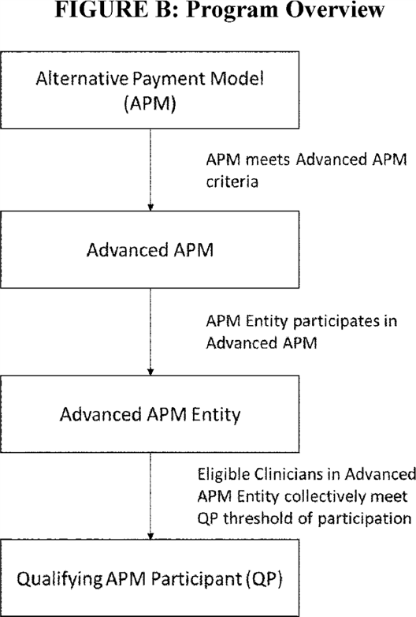

The following is a summary of the comments we received generally regarding the incentives for participation in Advanced APMs.

*Comment:* Some commenters expressed support for the policy principles and goals for Advanced APMs. Many commenters expressed a desire for more opportunities to participate in Advanced APMs. Many commenters specifically called for new Advanced APMs that focus on small or rural practices or specialty practices such as surgery, emergency medicine, dentistry, or long-term care. Some commenters suggested focusing on specific beneficiary populations. Other commenters expressed support for transitional pathways to Advanced APM participation, and changes to existing APMs both in order to change them into Advanced APMs and make them more accessible to new participants.

Some commenters appreciated that the inception of this part of the Quality Payment Program will serve as a catalyst for more Advanced APMs and an acceleration of the movement from volume- to value-based payment. One commenter expressed concern that the process used to create and approve new Advanced APMs is too slow. One commenter expressed concern that because QPs in an Advanced APM Entity can earn the 5 percent APM Incentive Payment without demonstrating improved quality, controlled cost, or both, there will be no change to health care delivery, and that clinicians would not have a strong incentive to change their practice patterns. One commenter recommended CMS evaluate its overall approach and perhaps abandon Advanced APMs.

*Response:* We agree with commenters that it is paramount for us to develop and offer more Advanced APM opportunities in the future. In order to increase participation in both APMs and Advanced APMs, we recognize that we must strive to create offerings for clinicians across the entire care continuum and across geographic regions.

We plan to achieve these goals in the immediate and long-term future by expanding opportunities for clinicians to participate in existing Advanced APMs, changing certain existing APMs to meet the Advanced APM criteria, and developing new Advanced APMs, especially based on recommendations from the PTAC. The PTAC is discussed in section II.F.10. of this final rule with comment period. We note that not all models that are derived from PTAC recommendations must be Advanced APMs.

The incentives for Advanced APM participation, as specified under section 1833(z) of the Act, do not provide for consideration of eligible clinicians' performance in terms of quality, cost, or other factors in making determinations as to whether eligible clinicians are QPs for a year. However, we believe the performance requirements that are applicable to eligible clinicians under each Advanced APM will incentivize participants to make improvements in care delivery so as to improve quality of care and reduce expenditures. Additionally, the Transforming Clinical Practice Initiative (TCPI) is a $ 685 million CMS Innovation Center initiative designed to support 140,000 clinicians in sharing, adopting, and further developing comprehensive quality improve strategies, which are expected to lead to greater improvements in patient health and reduction in health care costs.

In regard to the request for transitional pathways to Advanced APM participation, section 1848(q)(11) of the Act provides $ 100 million in funding over 5 years for CMS to provide technical assistance to help clinicians develop the capabilities to be successful **[*77402]** in the Quality Payment Program. These technical assistance efforts will target eligible clinicians in individual or small group practices of 15 or fewer, focusing on those practicing in rural areas, health professional shortage areas (HPSAs), and medically underserved areas (MUAs), as well as practices with low composite scores under the MIPS.

The planned technical assistance will support small practices by helping them think through what they need to be successful under the Quality Payment Program, such as what quality measures and/or EHR may be appropriate for their practices' needs. The planned technical assistance would also educate clinicians about clinical practice improvement activities and how these activities could fit into their practices' workflow, or help practices evaluate their options for joining an APM. We believe this technical assistance, combined with our continued outreach and education efforts, will provide substantial support to eligible clinicians in their transition into APMs and Advanced APMs.

3. Terms and Definitions

The APM track of the Quality Payment Program uses a set of interrelated defined terms. The basis for some core terms are set forth at sections 1833(z)(3) and 1848(q)(1)(C)(iii) of the Act, and others we will define in this final rule with comment period.

We use the statutory text as a foundation to develop definitions for other key terms used in this final rule with comment period. The terms cover three primary topics: (1) The different types of APMs and their participating entities and clinicians; (2) the timing, process and thresholds for determining QPs and Partial Qualifying APM Participants (Partial QPs); and (3) the payment of the 5 percent lump sum incentive (APM Incentive Payment) to QPs.

We are finalizing definitions for the following terms specific to incentives for participation in Advanced APMs, which are located at § 414.1302 of new subpart O:

* Affiliated Practitioner.

1. APM Entity.
2. APM Incentive Payment.
3. Attributed beneficiary.
4. Attribution-eligible beneficiary.
5. Alternative Payment Model (APM).
6. Advanced Alternative Payment Model (Advanced APM).
7. Advanced APM Entity.
8. Eligible clinician.
9. Episode payment model.
10. Incentive Payment Base Period.
11. Medicaid APM.
12. Medicaid Medical Home Model.
13. Medical Home Model.
14. Other Payer Advanced APM.
15. Other payer arrangement.
16. Partial Qualifying APM Participant (Partial QP).
17. Partial QP Patient Count Threshold.
18. Partial QP Payment Amount Threshold.
19. Qualifying APM Participant (QP).
20. QP Patient Count Threshold.
21. QP Payment Amount Threshold.
22. QP Performance Period.
23. Threshold Score.

a. Definitions of APM Entity and Advanced APM Entity

The MACRA uses the term "Eligible APM" in the heading for section 1833(z) of the Act, in section 1848(q)(9)(A)(ii) of the Act, and indirectly defines it at section 1833(z)(3)(D) of the Act as the APM in which "eligible alternative payment entities" participate. We have decided to use the term "Advanced" in lieu of "Eligible," for those APMs defined by section 1833(z)(3)(C) of the Act that meet the criteria under section 1833(z)(3)(D) of the Act. Rather than referring indirectly, as is done in section 1833(z)(3)(D)(i) of the Act, to the APM in which an eligible alternative payment entity participates, we believe it is essential to the understanding of this final rule with comment period to be able to identify and finalize requirements directly for an Advanced APM.

Similarly, we proposed to use the term "Advanced APM Entity" instead of "alternative payment entity" because it highlights the connected but different roles of the Advanced APM (for example, a CMS Innovation Center ACO model meeting specified criteria) and the Advanced APM Entity (for example, a specific ACO participating in that ACO model). We also believed that it was important to the clarity of the proposed rule to define "APM Entity" in addition to "Advanced APM Entity" so that we can easily distinguish between the two under both MIPS and the APM incentives. We proposed that an APM Entity is an entity that participates in an APM or Other Payer APM through a direct agreement with CMS or a non-Medicare other payer, respectively. These APM Entities will be primarily responsible for the cost and quality of care provided to beneficiaries through the APM. The term "eligible alternative payment entity" (which we refer to as an "Advanced APM Entity") is defined under section 1833(z)(3)(D) of the Act. We proposed that an Advanced APM Entity is an APM Entity that participates in an Advanced APM that, through terms of a direct agreement with CMS or through federal law or ***regulation***, meets the criteria finalized in this rule.

The following is a summary of the comments we received regarding our proposed definitions of the terms APM Entity and Advanced APM Entity.

*Comment:* Commenters noted that a direct CMS agreement is not necessarily the operative legal instrument for entities to participate in APMs. They were concerned that the proposed definition would inadvertently prevent APM Entities from being considered Advanced APM Entities. One commenter stated concern that hospitalists would not be included under this definition of APM Entity and supported a more inclusive definition. One commenter disliked the set of terms related to APMs, such as Advanced APMs, APM Entities, and Other Payer Advanced APMs, and believed they were unclear. Another commenter stated that the definition of APM Entity was too restrictive, and requested that CMS expand it to include any entity that executed a Participation Agreement. One commenter criticized the use of the term Advanced APM and suggested that we use either Qualifying APM or Eligible APM.

*Response:* We appreciate the attention to the definitions and agree that the definitions of APM Entity and Advanced APM Entity should not be a barrier to eligible clinicians becoming QPs, but rather descriptors of the entities that are participating in APMs and Advanced APMs, respectively. We believe that the proposed terms clearly distinguish each while showing the relationship between the terms, such as how an APM Entity participates in an APM. We understand that "qualifying" or "eligible" could also have been used in the definitions because these are used in the statute. However, we chose "Advanced APM" because we believe it reflects the element of additional rigor relative to APMs, allowing the term to serve as a meaningful descriptor of a certain type of APM.

We are modifying our proposed definition of APM Entity to no longer require a direct agreement with CMS in all cases. Instead, we are defining APM Entity to mean an entity that participates in an APM or payment arrangement with CMS or another payer, respectively, through a direct agreement with CMS or the other payer, or through federal or state law or ***regulation***. We are also finalizing the definition of Advanced APM Entity to mean an APM Entity that participates in an Advanced APM or Other Payer Advanced APM with CMS or a non-Medicare other payer, respectively, through a direct agreement with CMS or **[*77403]** the payer or through federal or state law or ***regulation***. We note that we determine whether an APM is an Advanced APM or a payment arrangement is an Other Payer Advanced APM consistent with the criteria finalized in this final rule with comment period.

These changes are important because some APMs define participation through a voluntarily signed agreement whereas other APMs may define participation through rulemaking or based on federal or state statutory requirements. For example, the CJR model defines participant hospitals (the APM Entities) in ***regulation*** based on their geographic location in specified Metropolitan Statistical Areas (MSAs). These definitions ensure that entities participating in APMs and Advanced APMs by various binding legal means are included in the definitions of APM Entity and Advanced APM Entity, respectively.

b. Definitions of Medical Home Model and Medicaid Medical Home Model

We also proposed to define the terms "Medical Home Model" and "Medicaid Medical Home Model" as subsets of APMs and Other Payer APMs, respectively. The MACRA does not define "medical homes" but sections 1848(q)(5)(C)(i), 1833(z)(2)(B)(iii)(II)(cc)(BB), 1833(z)(2)(C)(iii)(II)(cc)(BB), and 1833(z)(3)(D)(ii)(II) of the Act make medical homes an instrumental piece of the law.

We note that medical homes would be the APM Entities in an APM, not the APM itself. The requirements in the MACRA and in this final rule with comment period actually relate to the disposition of the APM, not the participating APM Entities. For instance, as described in section II.F.4.b.(6) of this final rule with comment period, section 1115A(c) of the Act relates to the expansion of models (APMs), not the participants (APM Entities) of such models. APM participants are not expanded under section 1115A(c) of the Act. Therefore, we discuss medical homes in terms of the Medical Home Model, which is the concept to which the MACRA and this final rule with comment period actually refer. Although the definitions are identical but for their payer context, we distinguish Medicaid Medical Home Models because there are specific requirements for them under the determination of Other Payer Advanced APMs as described in section II.F.7.b.(3) of this final rule with comment period.

We proposed that a Medical Home Model must have the following elements:

* Model participants include primary care practices or multispecialty practices that include primary care physicians and practitioners and offer primary care services.

1. Empanelment of each patient to a primary clinician.

In addition to these elements, we proposed that a Medical Home Model must have at least four of the following elements:

* Planned coordination of chronic and preventive care.

1. Patient access and continuity of care.
2. Risk-stratified care management.
3. Coordination of care across the medical neighborhood.
4. Patient and caregiver engagement.
5. Shared decision-making.
6. Payment arrangements in addition to, or substituting for, FFS payments (for example, shared savings or population-based payments).

The two required elements are consistent with the fundamental characteristics of medical homes in the various incarnations and accreditation standards across the health care market. Therefore, we believe that an APM cannot be a Medical Home Model unless it has a primary care focus with an explicit relationship between patients and their practitioners. To determine that an APM has a primary care focus, we proposed that the Medical Home Model will have to involve specific design elements related to eligible clinicians practicing under one or more of the following Physician Specialty Codes: 01 General Practice; 08 Family Medicine; 11 Internal Medicine; 37 Pediatric Medicine; 38 Geriatric Medicine; 50 Nurse Practitioner; 89 Clinical Nurse Specialist; and 97 Physician Assistant. We solicited comment on whether this proposal for determining that an APM has a primary care focus is sufficiently specified.

We believe the optional elements should be present in Medical Home Models, but individually, each is less definitive of a characteristic than the two required elements. We also want to adhere to our principle of supporting future flexibility of APM design. Extensive rigid Medical Home Model criteria would not serve the purpose of promoting the development of new and potentially better ways of managing patient care through primary care.

We solicited comment on these elements and which of the elements should be required as opposed to optional. Our proposed definition of Medicaid Medical Home Model is identical to Medical Home Model, except that it specifically describes a payment arrangement operated by a State under title XIX. It is important to separate the terms because Medicaid Medical Home Models have distinct implications in the Other Payer Advanced APM determination and the QP determination under the All-Payer Combination Option.

The following is a summary of the comments we received regarding our proposed definitions of the terms Medical Home Model and Medicaid Medical Home Model.

*Comment:* Several commenters addressed the terms used to describe Medical Home Models, and supported the proposed definitions. One commenter supported CMS' classification of a medical home as an "entity" rather than as a "model." One commenter recommended that CMS alter the term "medical home" to "medical home entity" to clarify that it is a TIN or collection of TINs that is an accountable unit within the Medical Home Model. This same commenter also suggested creating two new terms: "Advanced Medicaid Medical Home Model" and "Other Payer Advanced Medical Home Model." One commenter suggested it makes more sense to name Medical Home Models "Primary-Care Focused Models" and incorporate the term in the proposed required elements.

*Response:* We thank commenters for their attention to this definition. We believe that the term "Medical Home Model" best reflects the intent of the statute's use of the term medical homes expanded under section 1115A(c) of the Act as specified in section 1833(z) of the Act. We believe it makes the most sense, in context, to read the statutory references to "medical home" to identify a specific type of APM that potentially could be expanded, rather than to refer to an entity made up of eligible clinicians and other health care providers that would participate in an APM. That is why we proposed to define "Medical Home Model" as the APM and "APM Entity" as the participants in APMs. We use the term APM Entity as a general term to describe all entities that are participants in APMs and, except when it is expedient to implement statutory requirements, we do not believe we should create additional terms to describe subcategories of APM Entities as multiple terms could create confusion. Similarly, we believe that the terms Medical Home Model and Medicaid Medical Home Model provide sufficient clarity for purposes of implementing the statute, and that creating additional definitions may create confusion. **[*77404]**

*Comment:* Several commenters addressed how we define primary care as part of a Medical Home Model and a Medicaid Medical Home Model. One commenter agreed with our proposal to require a primary care focus as an essential requirement for Medical Home Models and encouraged CMS to additionally require that Medical Home Model participants be primary care medical home practices or multi-specialty practices that offer primary care, and empanelment of each patient to a primary care physician. The same commenter encouraged CMS to include in the optional elements for a Medical Home Model: Whole person orientation, quality and safety.

In addition, the commenter expressed concern with our proposal to include certain eligible clinicians within Medical Home Models, as they are not always primary care practitioners, that is, 50 Nurse Practitioner; 89 Clinical Nurse Specialist; and 97 Physician Assistant. One commenter wanted more information on the licensing description for each category of eligible clinician and more information on the list of physician specialty codes. Another commenter sought clarification on whether or not the code for Nurse Practitioners includes all Nurse Practitioner codes or if the APM should specify codes for certain primary care certifications, and another commenter recommended that codes for family nurse practitioners, geriatric nurse practitioners, adult nurse practitioners, and others be included. A few other commenters recommended that CMS add code "16 Obstetrics and Gynecology" to the list of specialties that we would use to determine a primary care focus in a Medical Home Model. One commenter requested that occupational therapists to be considered a required component of any Medical Home Model. Another commenter suggested that behavioral health organizations be included in the definition of Medical Home Model. Some commenters requested clarification regarding the definition of "parent organization" and "empanelment" as it relates to Medical Home Models.

A few commenters recommended CMS to broaden its definition of a Medical Home Model to include APMs that focus on specialty care. Another commenter suggested CMS to include specialist-focused Medical Home Models as a viable option for qualifying as an Advanced APM regardless of risk, much like it proposed for primary care-focused Medical Home Models. One commenter appreciated that CMS provided for elements such as continuity of care, coordination of chronic and preventive care, and coordination across the medical neighborhood, which will assist multispecialty practices when seeking to participate in an Advanced APM, but believed the definition we proposed for a Medical Home Model would largely exclude specialty-focused models. An additional commenter requested CMS to consider adding additional specialties to the approved list of Physician Specialty Codes to whom the patient may be assigned within the Medical Home Model. Another commenter expressed concern that Medicaid Medical Home Models might be prohibited from empaneling patients to any specialists, and one other commenter suggested that we add to the definition of Medical Home Models as a requirement the attribution of patients to specialists. One commenter suggested we address the special needs of children as a requirement in our definition. Another commenter requested information clarifying the relationship between the Medical Home Model definition and certified patient-centered medical home, and asked whether patient-centered medical home certification is a requirement to be considered a Medical Home Model.

*Response:* We appreciate commenters' input and will consider the suggestions for future rulemaking applicable to performance periods after 2017. We believe that the proposed definition is sufficient to identify Medical Home Models that might be in place for the 2017 QP Performance Period. However, we are modifying the proposed definition to emphasize the primary care focus. We note that because a Medical Home Model is a type of APM, having a primary care focus means that there are specific design elements that target eligible clinicians with the specified specialty codes. We are also adding code "16 Obstetrics and Gynecology" to the list of specialty codes that we will use to determine primary care focus because we agree with the commenter that these physicians often coordinate primary care services for women.

We clarify that the definition of Medical Home Model does not include a requirement for patient-centered medical home certification. A certified patient-centered medical home is a practice-level designation, whereas a Medical Home Model is a type of APM (a payment model) defined in this final rule with comment period.

We believe that empanelment is a commonly understood term used in existing APMs and primary care practices that does not need to be defined in this rulemaking. We believe that empanelment methodologies are specific to each Medical Home Model, and we do not want to unduly restrict APM design flexibility by prescribing how and to whom empanelment may be done. Although we note that Medical Home Models must have a primary care focus, we do not specify that empanelment in a Medical Home Model must be only to primary care practitioners. Finally, we discuss the meaning of "parent organization" in section II.F.4.b.(4) of this final rule with comment period in the context of the Advanced APM financial risk criterion.

*Comment:* One commenter encouraged CMS to move towards measuring whether meaningful shared decision-making has occurred, specifically through patient-reported measures. This commenter also requested that CMS establish clear standards for practices to ensure that clinicians have the skills and training to furnish shared decision-making services at a high level of quality and to effectively use shared decision making tools. In addition, commenters recommended that shared decision-making be re-framed as an integral part of "shared care planning" which occurs across a patient's lifespan rather than in a single episode of care and consisted of two key elements: (1) Patients faced with a treatment decision must be informed about all the reasonable options, including doing nothing, and told what is known about the potential risks, benefits and alternatives to those options; and (2) patients must be meaningfully involved in the decision making process. A few commenters suggested CMS require that all seven criteria must be met for an APM to be a Medical Home Model or a Medicaid Medical Home Model, and one of these commenters suggested CMS should define activities that demonstrate how those criteria can be satisfied. The same commenter also recommended adding an eighth element related to coordinating delivery of care with other services that address social determinants of health.

*Response:* We thank the commenters for their suggestions. We believe that the suggestions may prove to be too prescriptive when setting standards that apply across many APMs, and we are concerned that imposing additional requirements would contradict our principle of supporting APM flexibility. For instance, we could develop an APM that addresses social determinants of health, but requiring social determinants of health to be an element of an APM in order for it to be considered a Medical Home Model **[*77405]** would be so strict as to exclude as Medical Home Models APMs that are widely available or focused on discrete care improvement goals. Therefore, we continue to believe that defining Medical Home Model to require a small set of core characteristics of medical home homes, along with a flexible set of additional characteristics, is the appropriate approach to maintain our principle to support APM flexibility. Defining Medical Home Model this way will allow for the inclusion of additional elements when actually creating a Medical Home Model to customize the APM for testing particular ways to improve the cost and quality of care.

We are finalizing the definitions of Medical Home Model and Medicaid Medical Home Model with modifications to emphasize the requirement that the APM have a primary care focus, clarify the required versus additional elements, and add Obstetrics and Gynecology (specialty code 16) as a primary care specialty. We are finalizing the definitions as follows:

A Medical Home Model or Medicaid Medical Home Model is an APM or payment arrangement under title XIX, respectively that we determine to have the following required elements:

* Primary care focus with participants that include primary care practices or multispecialty practices that include primary care physicians and practitioners and offer primary care services. For the purposes of this provision, primary care focus means involving specific design elements related to eligible clinicians practicing under one or more of the following Physician Specialty Codes: 01 General Practice; 08 Family Medicine; 11 Internal Medicine; 16 Obstetrics and Gynecology; 37 Pediatric Medicine; 38 Geriatric Medicine; 50 Nurse Practitioner; 89 Clinical Nurse Specialist; and 97 Physician Assistant.

1. Empanelment of each patient to a primary clinician.

In addition to these required elements, a Medical Home Model or Medicaid Medical Home Model must have at least four of the following additional elements:

* Planned coordination of chronic and preventive care.

1. Patient access and continuity of care.
2. Risk-stratified care management.
3. Coordination of care across the medical neighborhood.
4. Patient and caregiver engagement.
5. Shared decision-making.
6. Payment arrangements in addition to, or substituting for, FFS payments (for example, shared savings, population-based payments).

c. Other Definitions

We believe that the proposed terms and definitions are sufficient to clearly implement the Quality Payment Program. These terms cover all steps of the APM Incentive Payment process, from participation in Advanced APMs to QP determinations and payment of incentives. We are aware that this is a complex program and that we propose to define a significant number of terms. We believe that, in general, it is preferable to use more, distinctive terms than to use fewer broader terms that could overlap and convey different meanings in different contexts. For instance, Partial QP Patient Count Threshold is a highly specific term, but we believe that it is necessary in context because there are differences between QPs and Partial QPs, and there are differences between the payment amount and patient count thresholds used to determine whether an eligible clinician becomes a QP or a Partial QP.

We sought comment on these terms, including our proposed definitions, the relationship between terms, any additional terms that we should formally define to clarify the explanation and implementation of this program, and potential conflicts with other terms used by CMS in similar contexts. We also sought comment on the naming of the terms and whether there are ways to name or describe their relationships to one another that make the definitions more distinct and easier to understand. For instance, we wanted to know if commenters believe there are more intuitive or efficient terms than those proposed that would still adhere to the statutory language and the intended purposes of the terms. In particular, we indicated that we would consider options for a framework of definitions that might more intuitively distinguish between APMs and Other Payer APMs and between APMs and Advanced APMs.

We also sought comment on alternative terms or definitions that could be useful in the calculations described in the proposed ***regulations*** in §§ 414.1430, 414.1435, 414.1440, and 414.1445 of this final rule with comment period and easily understood by stakeholders.

*Comment:* Some commenters expressed concern that non-physician practitioners are not included in the Advanced APM considerations and should be more explicitly represented in APM design. Some commenters requested that the Advanced APM CEHRT criterion should be waived for APMs that include non-physician practitioners because such clinicians were not eligible for incentive payments or subject to reduced Medicare payments related to the meaningful use of CEHRT under the Medicare EHR Incentive Program. Other commenters simply inquired about whether PTs, OTs, and SLPs are eligible to become QPs. One commenter found it confusing to use the term "professional" instead of the term "clinician."

*Response:* We appreciate that commenters expressed concern about the inclusion of non-physician practitioners in Advanced APMs. We believe it is important to clarify that physicians are not the only eligible clinicians who can become QPs. The list of eligible clinicians is defined in section 1833(z)(3)(B) of the Act (by cross-reference to the definition of "eligible professional" in section 1848(k)(3)(B)), and includes: physicians, physician assistants, nurse practitioners, clinical nurse specialists, certified registered nurse anesthetists, certified nurse-midwives, clinical social workers, clinical psychologists, registered dietitians or nutrition professionals, physical or occupational therapists, qualified speech-language pathologists, and qualified audiologists; and a group that includes these professionals.

Therefore, any of those eligible clinicians who participate in Advanced APMs can become QPs for a year and receive the associated APM Incentive Payment. Each APM has its own focus, and many offer opportunities for non-physician practitioners to be participants. Although altering the design of existing or future APMs is beyond the scope of this final rule with comment, we welcome ideas on how to further engage underrepresented clinicians as we work hard to develop more APM opportunities. Finally, we do not believe it would be appropriate to waive the Advanced APM CEHRT requirement for APM Entities that may comprise non-physician practitioners. We believe it is also important to note that, as described in full in section II.F.4.b.(1) of this final rule with comment period, the Advanced APM criteria describe requirements that apply within APMs, but not necessarily to all APM Entities or eligible clinicians in the APM. Under the finalized policy in section II.F.4.b.(1), an APM does not necessarily have to specify that all non-physician practitioners use CEHRT in order to be an Advanced APM.

We are finalizing the definition of "eligible clinician" as proposed. Eligible clinician has the meaning of the term "eligible professional" as defined in section 1848(k)(3) of the Act, is **[*77406]** identified by a unique NPI and includes any of the following: A physician; a practitioner described in section 1842(b)(18)(C) of the Act; a physical or occupational therapist or a qualified speech-language pathologist.; a qualified audiologist (as defined in section 1861(ll)(3)(B) of the Act) or a group that includes these professionals.

We received no comments in response to our other proposed terms and definitions.

We are finalizing all other definitions listed in this section as proposed.

4. Advanced APMs

This section defines and outlines the proposed criteria for Advanced APMs, APMs through which eligible clinicians would have the opportunity to become QPs as specified in section 1833(z)(3)(C) and (D) of the Act. Other Payer Advanced APMs, types of alternative payment arrangements related to the All-Payer Combination Option, are addressed in section II.F.7. of this final rule with comment period.

An Advanced APM must, by statute, meet certain requirements, and we are finalizing policies for these requirements within this section. First, the broad category of APMs is defined at section 1833(z)(3)(C) of the Act, which states that an APM is any of the following: (i) A model under section 1115A (other than a health care innovation award); (ii) the Shared Savings Program under section 1899; (iii) a demonstration under section 1866C; or (iv) a demonstration required by federal law.

We believed it was necessary to propose additional clarification around the requirements as defined in section 1833(z)(3)(C)(iv) of the Act given the broad scope of programs and demonstrations required by federal legislation that are administered by the Department. We proposed that in order to be an APM as a "demonstration required by Federal law," the demonstration must meet the following 3 criteria: (1) The demonstration must be compulsory under the statute, not just a provision of statute that gives the agency authority, but one that requires the agency to undertake a demonstration; (2) there must be some "demonstration" thesis that is being evaluated; and (3) the demonstration must require that there are entities participating in the demonstration under an agreement with CMS or under a statute or ***regulation***. We solicited comments on our proposal for these criteria defining a demonstration required under federal law.

We received no comments regarding our proposal that these three criteria must be satisfied in order for a demonstration to be considered an APM as a "demonstration required by Federal law."

We are finalizing our proposal that an APM that is considered a demonstration required by Federal law is one that meets the following 3 criteria: (1) The demonstration must be compulsory under the statute, not just a provision of statute that gives the agency authority, but one that requires the agency to undertake a demonstration; (2) there must be some "demonstration" thesis that is being evaluated; and (3) the demonstration must require that there are entities participating in the demonstration under an agreement with CMS or under a statute or ***regulation***.

Second, to be considered an Advanced APM, an APM must meet all three of the following criteria, as required under section 1833(z)(3)(D) of the Act. The criteria are:

* The APM must require participants to use CEHRT;

1. The APM must provide for payment for covered professional services based on quality measures comparable to those in the quality performance category under MIPS;
2. The APM must either require that participating APM Entities bear risk for monetary losses of a more than nominal amount under the APM, or be a Medical Home Model expanded under section 1115A(c) of the Act. For a discussion of Medical Home Models under this criterion, see section II.F.4.b.(6) of this final rule with comment period.

In some cases, APMs offer multiple options or tracks with variations in the level of financial risk, or multiple tracks designed for different types of organizations, and we proposed to assess the eligibility of each such track or option within the APM independently. For instance, the Shared Savings Program has three distinct tracks, the Comprehensive ESRD Care Initiative (CEC) consists of a two-sided track for large dialysis organizations and a one-sided track for non-large dialysis organizations with the option for non-large dialysis organizations to elect to participate in the two-sided risk track beginning in 2017, and the Next Generation ACO Model has two risk arrangement options that feature different levels of financial risk.

Significant distinctions between the design of different tracks or options may mean that some tracks or options within an APM would meet the Advanced APM criteria while other tracks or options would not. For example, APM Entities may have the option to assume two-sided risk (meaning that they bear a portion of the losses when spending exceeds expectations and share in the savings when spending is below expectations) or one-sided risk (meaning that they share in the savings when spending is below expectations, but do not bear a portion of the losses when spending exceeds expectations) under an APM. If the one-sided risk track does not meet the standard for financial risk as discussed in section II.F.4.b.(3) of this final rule with comment period, APM Entities in this track would not be Advanced APM Entities, whereas those in the two-sided risk track could be Advanced APM Entities. In these instances, we would distinguish that the APM is only an Advanced APM for specific options or tracks.

The following is a summary of the comments we received regarding our proposal to make Advanced APM determinations for each individual track or option within in APM when applicable.

*Comment:* Commenters expressed general agreement that in cases where APMs offer multiple options or tracks, we should evaluate each option or track against the Advanced APM criteria independently.

*Response:* We thank the commenters for their responses and agree that this proposal is logical.

We are finalizing the proposal to consider different tracks or options within an APM separately for purposes of making Advanced APM determinations. All entities participating in Advanced APMs are Advanced APM Entities, and distinguishing between the model and the participating entities allows us to directly identify and discuss the requirements unique to each. This approach to identifying Advanced APMs and Advanced APM Entities is also consistent with our finalized proposals for determining QPs, described in section II.F.5. of this final rule with comment period, at the Advanced APM Entity level.

a. Advanced APM Determination

To determine Advanced APMs and to support transparency for the Quality Payment Program, we proposed to establish a process by which we identify and notify the public of the APMs (including specific APM tracks or options) that would be considered Advanced APMs for a QP Performance Period. We indicated that we would post an initial notification to our Web site prior to the beginning of the first QP Performance Period and update the information on a rolling basis as explained below. We believed that making this information available in a timely and accessible format is **[*77407]** important for stakeholders to understand how we apply the Advanced APM criteria to existing APMs and to be informed as early as possible about whether an APM they are considering joining is an Advanced APM.

We proposed two phases of Advanced APM determinations and notice. First, we proposed to release an initial set of Advanced APM determinations no later than January 1, 2017, for APMs that will be operating during the first QP Performance Period. Second, for new APMs announced after January 1, 2017, we would include its Advanced APM determination in conjunction with the first public notice of the APM, such as the Request for Applications (RFA) or final rule. In preliminary discussions of potential APMs, such as proposed rules, we will provide a non-binding determination based on the proposed APM design. We proposed that determinations of Advanced APMs would be posted on our Web site and updated on an ad hoc basis to the extent feasible, but no less frequently than annually, as new APMs become available and others end or change. Both the initial and ad hoc notifications would contain descriptions of whether each track or option within an APM would have in different Advanced APM statuses. We believe that this proposal incorporates both the interest in immediate dissemination of Advanced APM determinations for the existing APM portfolio following finalization of this rule and the structure for making the Advanced APM status a regular part of the development and release of new APMs in the future.

We solicited comment on the proposals for both the initial and ad hoc notices of Advanced APM determinations. In particular, we solicited comments on optimal times, locations, formats, and other methods of notice of Advanced APM determinations to promote clarity and consistency as to which APMs are considered Advanced APMs for a particular QP Performance Period.

The following is a summary of the comments we received regarding our proposed process to make and notify the public of Advanced APM determinations.

*Comment:* Some commenters requested that we develop a transparent public process for determining which APMs are Advanced APMs. For example, some commenters stated there should be a public comment process before each APM is determined to be an Advanced APM. Other commenters stated that the public should have public input into how we determine which APMs are Advanced APMs. Other commenters simply stated that they want timely information necessary to be able to make educated decisions about the APM participation.

*Response:* We agree with the commenters that transparency is important to the future development and determination of Advanced APMs. This rulemaking process is part of that public input process and gives stakeholders and the public an opportunity to provide input into the criteria and process by which we make and announce Advanced APM determinations, as well as develop new APMs. Our proposal described how we would make Advanced APM determinations publicly available as new models are announced. We also publish Requests for Information (RFIs) and proposed rules for purposes of developing certain APMs, which are further opportunities for public input as we make Advanced APM determinations. In addition, the PTAC, as described in section II.F.10. of this final rule with comment period, represents a significant new pathway for the public to offer new ideas for implementation as APMs.

However, we do not find it practical or meaningful to hold a public comment process regarding each Advanced APM determination. These determinations will be factual applications of the Advanced APM criteria, as prescribed by statute and established in this final rule, to the design of a particular APM. The opportunities for meaningful input are in the development of the criteria and the APMs, but not in the administrative task of determining whether the APM meets the Advanced APM criteria. Soliciting input on Advanced APM determinations for individual models could also significantly delay when stakeholders would know whether an APM is an Advanced APM.

*Comment:* Several commenters urged us to make the first round of official Advanced APM determinations either in this final rule or as soon as possible after this final rule is published with subsequent updates in a timely manner that allows for APM participation decisions based on those determinations. The commenters expressed that knowing the Advanced APM status of an APM is very important to decisions regarding participation. Some commenters expressed frustration that for 2017 they had to make APM participation decisions prior to the publication of this final rule with comment period. Commenters also stated that the expiration of the APM Incentive Payment after 6 years puts additional pressure on clinicians to join Advanced APMs as soon as possible, and expressed a wish for a greater number of immediate opportunities to participate in Advanced APM.

*Response:* We appreciate the comments and support for our proposed policy regarding the timeliness of Advanced APM determinations, and we agree that it is essential going forward that we provide determinations as soon as practicable in order to support decision making by eligible clinicians and entities. Following publication of this final rule with comment period, we will release the 2017 list of Advanced APMs as soon as possible but no later than January 1, 2017. Then, we will update this list with each material APM amendment or new APM release.

We understand the difficulties of a notice and comment rulemaking process when eligible clinicians and entities are trying to make business decisions that can be impacted by policy decisions in a final rule. The proposed rule offered our early thoughts as to which APMs might be considered Advanced APMs in 2017. We encourage stakeholders keep in mind that the designs of APMs themselves offer substantial rewards, and we believe that those design elements should be the primary considerations for eligible clinicians and entities in deciding whether or not to participate in a given APM. Also, in sections II.F.1. and II.F.10. of this final rule with comment period we discuss how we plan to increase the number of Advanced APM opportunities each year.

Some concerns expressed by commenters about Advanced APM determinations are closely linked with our policies on the QP Performance Period and the MIPS performance period, and the interaction between these policies. We encourage commenters to see the discussion of the QP Performance Period in section II.F.5.a. of this final rule with comment period, which describes the operational relationships that address the need to make QP determinations in time for their exclusion from MIPS.

*Comment:* Some commenters suggested that we collaboratively develop and vet the format and style of Advanced APM notifications with stakeholders to make them as helpful as possible to potential participants.

*Response:* Although the development of education and outreach materials regarding the Quality Payment Program is a subregulatory activity, we agree with commenters and plan to actively engage relevant stakeholders in the development of our messages and materials. Materials related to particular APMs are outside the scope of this final rule with comment period. **[*77408]**

We are finalizing the process for determining Advanced APMs and notifying the public of those determinations as proposed. We will release an initial set of Advanced APM determinations as soon as possible but no later than January 1, 2017. For new APMs that are announced after the release of our initial set of Advanced APM determinations, we will include Advanced APM determinations in conjunction with the first public notice of the APM, such as the Request for Applications (RFA) or final rule. Likewise, if we make changes to an APM that change the determination of whether the APM is an Advanced APM, we will include public notice with the announcement. All determinations of Advanced APMs will be posted on our Web site and updated on an ad hoc basis, but no less frequently than annually, as new APMs become available and others end or change. Both the initial and ad hoc determinations will include descriptions of whether each track or option within an APM is or is not an Advanced APM.

In section II.F.7. of this final rule with comment period, we finalize how we would identify Other Payer Advanced APMs. The Other Payer Advanced APM identification process goes into effect starting in the third QP Performance Period (applicable for payment year 2021) and aligns with the availability of the All-Payer Combination Option for QP determinations.

b. Advanced APM Criteria

Under the statute, for an APM to be an Advanced APM it must meet the criteria set forth in sections 1833(z)(3)(C) and (D) of the Act and discussed below. An Advanced APM must be an APM that:

* Requires its participants to use certified EHR technology (CEHRT), as described in section II.F.4.b.(1) of this final rule with comment period;

1. Provides for payment for covered professional services based on quality measures comparable to measures under the quality performance category under MIPS, as described in section II.F.4.b.(2) of this final rule with comment period; and
2. Either (a) requires its participating Advanced APM Entities to bear financial risk for monetary losses that are in excess of a nominal amount, as described in section II.F.4.b.(3) of this final rule with comment period, or (b) is a Medical Home Model expanded under section 1115A(c) of the Act, as described in section II.F.4.b.(4) of this final rule with comment period.

These requirements as set forth in the statute and as proposed must be met through the design of the APM. Whether an APM is an Advanced APM depends solely upon how the APM is designed, rather than on assessments of participant performance within the APM. Some stakeholders have suggested that actual performance (for example, on CQMs or on whether the Advanced APM Entity generates savings) be considered in the determination of QPs. However, the incentives for Advanced APM participation, as specified under section 1833(z) of the Act, do not provide for consideration of actual performance in making such determinations. Performance assessments are already part of APMs, and we believe it is important and consistent with the statutory framework to continue to foster flexibility in structuring the specific rewards and consequences of performance within each APM.

For example, an APM that ties payments to performance on quality measures comparable to those under MIPS may be an Advanced APM regardless of an Advanced APM Entity's actual performance on those quality measures. If an Advanced APM Entity fails to meet quality performance standards under the Advanced APM, it would face consequences within the Advanced APM, such as financial penalties, loss of access to data or certain waivers, or termination of its participation agreement. The termination scenario would have the downstream effect of terminating Advanced APM Entity status and the eligible clinicians' potential eligibility for the APM Incentive Payment because the entity would no longer be participating in the Advanced APM. As another example, an Advanced APM Entity that bears more than nominal financial risk for monetary losses in accordance with the standards set forth in section II.F.4.b.(3) of this final rule with comment period would be an Advanced APM Entity regardless of whether it actually earns savings or generates losses under the Advanced APM. This would work similarly for an Other Payer Advanced APM.

We do not intend to add additional performance assessments on top of existing Advanced APM standards. As stated in the discussion of policy principles at the beginning of section II.F.1. of this final rule with comment period, the proposed QP determination process assesses the relative degree of participation of the Advanced APM Entity and eligible clinician in Advanced APMs, not their performance as assessed under the APM. The Quality Payment Program would not alter how each particular APM measures and rewards success within its design. Rather, the APM incentive track of the Quality Payment Program rewards a substantial degree of participation in Advanced APMs.

The following is a summary of the comments we received generally regarding our Advanced APM criteria proposals.

*Comment:* Many commenters stated their belief that the Advanced APM criteria are generally too complex and restrictive and that they should be simpler and more flexible in order to: (1) Reflect the current level of clinician readiness for quality measurement, EHR use, and risk arrangements; (2) allow more APMs to meet the criteria; and (3) encourage broad participation in APMs. Some commenters believe that the most popular APMs should be Advanced APMs, and that if APMs are not Advanced APMs, clinicians will be deterred from participation in a way that could reverse recent progress towards greater APM participation. Some commenters stated that all Innovation Center models should be considered Advanced APMs, regardless of whether or not they meet the criteria. Other commenters suggested that we reward clinicians for demonstrating movement toward APMs or Advanced APMs or that we consider APMs that move toward meeting the Advanced APM criteria in the future to be deemed Advanced APMs in the interim. One commenter recommended that there should be two paths: One that most clinicians should strive for, and a more difficult path restricted to 20 percent of all clinicians. One commenter recommended that CMS allow small practices that report quality via a QCDR to be considered as participants in the Advanced APMs.

*Response:* We understand that commenters consider the Advanced APM criteria too complex or too demanding. We agree with commenters that, all else equal, less complex criteria are preferable, regardless of the underlying difficulty for APMs to meet the criteria. Accordingly, in finalizing this rule, we have made several policy changes in order to simplify the Advanced APM criteria--for the CEHRT criterion by not changing over time the percentage of use an APM must require; and for the financial risk criterion by eliminating the marginal risk components of the nominal amount standard.

Regarding the stringency of the criteria, we agree with some of the concerns raised by commenters. In particular, we agree in that the magnitude of the proposed requirements for the financial risk criterion was too **[*77409]** high, and we are modifying our final policies accordingly. On the other hand, it has never been our expectation that all or most clinicians will participate in Advanced APMs immediately, nor do we believe that was the statutory intent. As such, we do not believe the fact that not all APMs qualify as Advanced APMs in itself implies that the criteria are overly stringent. We worked within the statutory structure to define the Advanced APM criteria, which inherently are meant to distinguish between APMs with more and less challenging terms. That said, we believe that all APMs offer meaningful opportunities and benefits to clinicians, particularly as on-ramps to eventual participation in Advanced APMs.

Finally, it is important for commenters and stakeholders to keep in mind that no eligible clinicians or APM Entities are directly subject to these Advanced APM criteria. These are standards used to determine which APMs are Advanced APMs. The APM designs contain the terms under which APM Entities participate, and many Advanced APMs will have requirements that far exceed the Advanced APM criteria set in this final rule. Changing the Advanced APM criteria will not affect the requirements for participants in any particular Advanced APM.

*Comment:* Some commenters stated that the Advanced APM criteria should be wholly different from those proposed. For instance, some commenters expressed that we should synchronize the criteria with the APM Framework developed by the Health Care Payment Learning and Action Network (LAN) APM Framework and Progress Tracking Work Group, which classified four categories of APMs.

Some commenters were supportive of the Advanced APM framework but expressed support for additional criteria for determining Advanced APMs, such as demonstrating that the payment approach will reinforce the delivery of coordinated patient- and family-centered care; requiring a clinical care model that reinforces a strong primary care foundation; a focus on care coordination; shared care planning; health IT infrastructure development; population health management; risk management; emphasis on consumer experience; and several more. One commenter suggested that we remove the Advanced APM designation from Advanced APMs that fail to demonstrate successful outcomes.

*Response:* We appreciate the input on how Advanced APMs should be determined and designed, and we agree that these concepts are important in the design of particular APMs. However, the statute specifies the criteria we must use to determine Advanced APMs, and we are implementing the statutory criteria in this rulemaking process. Although the comments on additional specifications for Advanced APMs are beyond the scope of this final rule with comment period, we remind the commenters of the PTAC, as described in section II.F.10. of this final rule with comment period, and note that commenters can submit ideas for APM designs directly to the Innovation Center.

(1) Use of Certified EHR Technology

The first criterion an APM must meet to be considered an Advanced APM is that it requires participants in the APM to use certified EHR technology (as defined in section 1848(o)(4) of the Act), as specified in section 1833(z)(3)(D)(i)(I) of the Act.

(a) Definition of Certified EHR Technology

For this Advanced APM criterion, we proposed to adopt the definition of CEHRT proposed for MIPS under § 414.1305. In the 2015 EHR Incentive Programs final rule [*(80 FR 62872*](https://advance.lexis.com/api/document?collection=administrative-codes&id=urn:contentItem:5H5B-72Y0-006W-851V-00000-00&context=) through 62873), we established the definition of CEHRT that must be used by EPs to meet the Meaningful Use objectives and measures in specific years. This definition is similar to the definition that applies to eligible hospitals, CAHs, and EPs in the Medicare EHR Incentive Programs. The definition includes the certification criteria for a wide range of standards for use in capturing patient health information like vital signs, medications and medication allergies, problem list, and lab results among other data elements included in the common clinical data set (CCDS). It also includes the certification criteria and standards for functions related to information exchange, patient engagement, quality reporting, and protecting the privacy of electronic protected health information. For further information on the certification criteria, see the 2015 Edition Certification Criteria final rule [*(80 FR 62602*](https://advance.lexis.com/api/document?collection=administrative-codes&id=urn:contentItem:5H5B-72Y0-006W-851T-00000-00&context=) through 62759) and for example Table 8: "Common Clinical Data Set" [*(80 FR 62696).*](https://advance.lexis.com/api/document?collection=administrative-codes&id=urn:contentItem:5H5B-72Y0-006W-851T-00000-00&context=)

This approach aligns the APM health IT certification requirements for Advanced APMs with those used by MIPS eligible clinicians. We understand this proposed CEHRT definition may include some EHR functionality used by MIPS eligible clinicians which may be less relevant for an APM participant, and likewise APM participants may use additional functions that are not required for MIPS participation. However, we observe that APM participants often work in the same office space, group, entity, or organization with eligible clinicians that are not APM participants. At times they might share common resources, such as the same EHR system. Using the same CEHRT definition for both MIPS and Advanced APMs would allow eligible clinicians to continue to use shared EHR systems and give eligible clinicians flexibility of participation as a MIPS eligible clinician or an eligible clinician in an Advanced APM without needing to change or upgrade EHR systems. Although updates to the certified health IT for APM participants, MIPS participants, or both may be necessary in future years, we believe that aligning the APM and MIPS definition for CEHRT is appropriate at this time.

We solicited comment on the proposed definition of CEHRT for Advanced APMs.

The following is a summary of the comments we received regarding our proposal to adopt the same definition of CEHRT for Advanced APMs as proposed for MIPS.

*Comment:* Many commenters expressed strong support for aligning the definition of CEHRT for Advanced APMs with the definition of CEHRT used in MIPS. Several commenters suggested this alignment would reduce administrative costs and reduce confusion among clinicians. One commenter suggested the CEHRT definition be more specific and rigorous. Some commenters suggested specific features and functionality (for example, empanelment of patients, stratification of the patient population, display of eCQM results by clinician and practice site) should be included as required components of the CEHRT definition. One commenter indicated that all Advanced APMs will have different HIT needs; therefore, specific HIT features should not be required for all Advanced APMs.

*Response:* We appreciate the commenters' suggestions and support for the proposed definition of CEHRT for Advanced APMs. Although a few commenters suggested the CEHRT definition include additional health IT capabilities not included in the CEHRT definition, we believe it is more important to maintain consistency across programs at this time. We also note that, although Advanced APMs must require eligible clinicians in Advanced APM Entities to use systems that at least meet the CEHRT definition, APMs have the flexibility to set additional health IT requirements as necessary to support specific criteria or goals under the APM. **[*77410]**

*Comment:* A commenter suggested that the care plan criterion finalized in the 2015 Edition Certification Criteria should also be included in the CEHRT definition.

*Response:* The ONC health IT certification program defines the testing and certification criteria for a wide range of potential standards and functions for certified health IT beyond those used for the meaningful use objectives and measures. In some cases, these criteria support other specific CMS program needs; in other cases, they may relate to public quality improvement initiatives in the health care industry. For example, the filtering criteria for eCQMs may support advanced electronic clinical quality measurement by APMs, and the care plan certification criterion may support care coordination especially in chronic disease management. Both of these new functions are available for clinicians within the 2015 Edition, and clinicians may use health IT modules certified to these criteria to support quality measurement, clinical practice improvement activities and participation in an APM or other payer arrangement.

The CEHRT definition merely sets the baseline requirements that eligible clinicians must have to meet the meaningful use objectives and measures, which are designed to be applicable for a wide range of clinician types in a diverse range of settings. These requirements are not intended to limit clinicians electing to use more advanced functions or to use health IT in other ways. Rather, the CEHRT definition is intended to ensure that a user has the tools needed to succeed in meeting the objectives and measures, without creating additional burden to obtain health IT unrelated to their practice. As stated in the proposed rule at [*81 FR 28299,*](https://advance.lexis.com/api/document?collection=administrative-codes&id=urn:contentItem:5JR6-TD50-006W-8163-00000-00&context=) we intend to maintain continuity for APM participants with the definition recently finalized for the eligible clinicians participating in the MIPS advancing care information performance category, described at § 414.1305. This is also consistent with the EHR Incentive Program's CEHRT definition at [*42 CFR 495.4*](https://advance.lexis.com/api/document?collection=administrative-codes&id=urn:contentItem:5PP3-6WB0-008H-0221-00000-00&context=). Therefore, we are finalizing the same definition of CEHRT under the Advanced APM CEHRT use criterion as we have finalized for MIPS at § 414.1305. We will consider whether to include the care plan and other potentially new or advanced certified health IT modules in future rulemaking.

*Comment:* One commenter believes that a strong, broad Health IT infrastructure should be a key element used to identify Advanced APMs rather than the narrow proposed CEHRT criteria. This commenter defined this as the adoption of EHRs, patient registries, or an alternative IT architecture that allows for timely exchange of health data with other clinicians involved in a patient's care and generation of meaningful data analytics. One commenter recommended that CMS engage the health IT community before introducing additional APMs that rely heavily upon IT products and services, especially if those models have unique or specialized technology requirements.

*Response:* We agree that Advanced APMs need a strong health IT infrastructure as a foundation for communicating and delivering comprehensive and coordinated care to their patients. However, we also believe that it is important to leave flexibility for individual models to tailor their health IT requirements to the needs of their particular population and goals. Section 1833(z)(3)(D)(i)(I) of the Act requires that Advanced APMs require their APM participants to use CEHRT (as defined in section 1848(o)(4) of the Act), and we continue to believe the definition we proposed meets this criterion while maintaining flexibility for individual APMs to set broader health IT requirements.

We are finalizing the definition of CEHRT for Advanced APMs as proposed. We believe the CEHRT definition for Advanced APMs aligns the APM health IT certification requirements for Advanced APMs with those used by MIPS eligible clinicians and will permit eligible clinicians using shared systems to participate in both programs without requiring changes to their health IT systems.

(b) Requiring the Use of CEHRT

The statute does not specify the number of eligible clinicians who must use CEHRT or how CEHRT must be used in an Advanced APM. We believe we have discretion to define the ways in which an Advanced APM requires the use of CEHRT. In accordance with section 1833(z)(3)(D)(i)(I) of the Act, we proposed that an Advanced APM must require at least 50 percent of eligible clinicians (or each hospital if hospitals are the APM participants) to use the certified health IT functions outlined in the proposed definition of CEHRT to document and communicate clinical care with patients and other health care professionals. Communicating clinical care means that other eligible clinicians and/or the patient can view the clinical care information. We also proposed an alternative set of criteria that would be applicable to the Shared Savings Program to demonstrate the use of CEHRT by eligible clinicians participating in ACOs to allow the Shared Savings Program to be an Advanced APM, as discussed further below. We proposed the 50 percent CEHRT use threshold would be confined to the first QP Performance Period (proposed to be 2017, as discussed later in this final rule with comment period). That is, only in 2017 could APMs use the 50 percent threshold for eligible clinicians in each participating entity to meet the use of CEHRT requirement. We proposed that the threshold requirement for use of CEHRT would increase to 75 percent beginning for the second QP Performance Period (proposed to be 2018). The CEHRT requirement for Advanced APMs in which hospitals are the participants would remain the same over time because it is an all-or-nothing requirement of the hospital as a single entity.

We believe there are a few reasons why having a lower threshold requirement for the use of CEHRT by the eligible clinicians participating in an APM Entity in the first year is appropriate. First, we wanted to ensure that APMs have sufficient time to alter their terms and conditions to meet this standard. We also acknowledge that eligible clinicians would be expected to upgrade from technology certified to the 2014 Edition to technology certified to the 2015 Edition for use in 2018, and some eligible clinicians who have not yet adopted CEHRT may wish to delay acquiring CEHRT products until a 2015 Edition certified product is available.

This CEHRT requirement would be based on the requirements that an APM places on its participating APM Entities. In determining whether an APM meets this criterion, we did not propose to assess the level of use of each APM Entity or individual eligible clinician participating in the APM but rather whether the APM requirements meet the standard set forth in the proposed rule.

We invited comment on whether the proposed thresholds for use of CEHRT for APM Entities that are not hospitals (50 percent for the first QP Performance Period (proposed 2017) and 75 percent for the second QP Performance Period (proposed 2018) and later are appropriate, or if we should consider additional options such as a higher or lower percentage in 2018, or an additional incremental increase for 2019. We also invited comment on whether we should consider higher thresholds for APMs that target eligible clinician populations with higher-than-average adoption of certified health IT, such as eligible clinicians in patient-centered medical homes. Finally, we **[*77411]** invited comment on whether we should explore ways to set lower thresholds for those APMs targeting eligible clinician populations that may have lower average adoption of certified health IT, such as specialty-focused APMs.

The following is a summary of the comments we received regarding the proposed thresholds for use of CEHRT for APM Entities that are not hospitals.

*Comment:* Numerous commenters supported the proposed criterion for the 2017 QP Performance Period. However, the majority of those commenters stated that CMS should not raise the CEHRT use requirement to 75 percent in 2018 and later. A few commenters requested that CMS provide more time to meet the 50 percent requirement, that CMS should have lower thresholds for certain specialties, or that any increase be gradual. Many commenters indicated that raising the threshold in 2018 to 75 percent would be unattainable for some APM Entities. Some commenters also suggested that this criterion not apply if their MIPS advancing care information performance category weight is reduced to zero (for example, because they are hospital-based, have insufficient internet coverage, are non-patient facing, or were not previously included as an Eligible Professional in the Meaningful Use program). Another commenter supported the threshold but indicated some specialties should be excluded.

*Response:* We appreciate the support for the proposed CEHRT use threshold of 50 percent for Advanced APMs for the 2017 performance period. We believe that setting the threshold at 50 percent of eligible clinicians allows APMs sufficient room to meet this requirement even if the APM includes some participants who do not have internet access, lack face-to-face interactions, or are hospital-based. We understand the commenters' concerns that raising the threshold to 75 percent in 2018 may create an overly rigorous standard for Advanced APMs and agree that it would be prudent to wait until we have more information on how the threshold would impact specific APMs, such as specialty APMs, before increasing the threshold, if at all. As a result, we are not finalizing our proposal to increase the requirement of APMs to require 75 percent CEHRT use after the first QP Performance Period.

*Comment:* Alternatively, a few commenters supported raising the threshold for CEHRT, especially for APMs with above average health IT adoption among participants, and another commenter supported increasing the threshold for CEHRT use in Advanced APMs over time. Some commenters indicated that the requirement to use CEHRT should not be based on any threshold but instead be based only on an attestation of CEHRT adoption by the Advanced APM eligible clinicians. One commenter requested CEHRT use be limited to a 90-day period in 2017.

*Response:* We agree with the commenter that certain APMs have APM Entities that may be able to meet a higher CEHRT use threshold. We note that some current APMs include CEHRT use requirements that exceed a 50 percent threshold. Since we expect many, widely varied APMs to be developed and implemented over the next few years, we believe we should use this time to gather more information on which APMs would be able to meet a higher Advanced APM CEHRT use requirement. We do not believe a 90-day period of use is a meaningful standard because the CEHRT is used by eligible clinicians principally as a medical record to document and communicate the clinical care they provide to their patients. Medical record documentation of clinical care is an ongoing activity and therefore we see no reason to limit the criterion of this activity to a 90 day period. We want to clarify for commenters that the requirement for CEHRT use in order for an APM to be an Advanced APM is applicable to the APM, not necessarily to all of the APM participants. The Advanced APM itself could have more stringent requirements and require the use of CEHRT in a variety of ways so long as it requires at least 50 percent of the eligible clinicians in each APM Entity use CEHRT. We do not discount the value of the commenters' suggestions but rather believe that they could or should be incorporated into APM design rather than adopted as the minimum requirement for an APM to be considered an Advanced APM. We appreciate the commenter's suggestion for a process to ascertain whether the CEHRT criterion is met by having the eligible clinicians who are participating in Advanced APMs attest that they have adopted CEHRT rather than including the use of the 50 percent threshold, but we believe the use of a threshold best defines how an Advanced APM must require its participants to use CEHRT in accordance with the statutory CEHRT use criterion.

*Comment:* One commenter recommended that a different threshold regarding the adoption of certified HIT should apply to any potential pathology-focused APM because laboratory information systems are not considered certified HIT or EHR technology.

*Response:* Presently, CMS does not have an Advanced APM that includes individual pathologists as participants of the APM. We will monitor this issue for new APMs and consider the applicability of the CEHRT requirement for APMs in which the majority of the eligible clinicians do not use CEHRT due to lack of certified systems for a particular specialty.

*Comment:* A few commenters stated agreement with a uniform CEHRT use threshold for all Advanced APMs other than the Shared Savings Program.

*Response:* We thank commenters for their support, and agree that the same thresholds should be consistent across APMs other than the Shared Savings Program for which we are finalizing a different use of CEHRT requirement.

*Comment:* A few commenters urged CMS to provide flexibility so that an APM would meet the EHR criterion to be an Advanced APM if it allowed eligible clinicians working in a facility such as a hospital that has CEHRT to be deemed to be using CEHRT. A commenter requested that CMS consider models such as BPCI and CJR as meeting this criterion if participating hospitals are using CEHRT. A commenter also indicated that as a medical group participating in BPCI Model 2, it uses CEHRT and thus should meet this criterion. Another commenter stated that use of any technology within an APM should not imply ownership, control, or the ability of any single user to meet overarching, explicit criteria. The commenter stated that over 90 percent of the nation's hospitals have achieved Meaningful Use, but hospitalists are unlikely to be counted in the 50 percent threshold of "use" as currently proposed by CMS.

*Response:* We reiterate that the use of CEHRT criterion applies to APMs and the requirements they impose on participating APM Entities, not to the individual APM Entities participating in APMs. For instance, the use of CEHRT criterion would be applied to the design of an APM to assess whether it has a requirement that its participants use CEHRT in a prescribed manner that meets this Advanced APM criterion. We assess the APM's requirements to determine whether an APM meets the Advanced APM CEHRT criterion. A participant cannot meet this criterion simply by using CEHRT; the APM must require the use of CEHRT in its terms and conditions, or a ***regulation*** or other legal vehicle through which APM Entities are held accountable. Conversely, an Advanced APM Entity that fails to meet the requirement to use CEHRT under the Advanced APM would have consequences under the **[*77412]** terms of the Advanced APM, but such failure to meet the requirement has no bearing on whether or not the APM itself is an Advanced APM. Therefore, it would not be appropriate or practical to build in specific policies around attestation of CEHRT use by eligible clinicians or APM Entities, or to carve out policies for specific clinician types or settings. We further note that, as proposed, the 50 percent CEHRT use threshold pertains only to the requirements that the APM imposes on eligible clinicians within its participating APM Entities. However, if the APM is one in which hospitals are the main participants, then we proposed that the APM must require hospitals to maintain CEHRT in order for the APM to be an Advanced APM. We do not believe that the use of CEHRT requirement implies that the physicians or other participants must invest in duplicative technology to participate in the APM, but rather that the APM must require a certain threshold level of CEHRT use to document and communicate clinical care for their patient population. As is noted above, the use of CEHRT criterion for an Advanced APM is based on the requirements that an APM places on its participating APM Entities. Therefore, in APMs where an APM Entity may use CEHRT in its operations and participation in the APM, but the APM does not explicitly require the use of CEHRT by the APM Entity, the APM would not meet the use of CEHRT criterion for an Advanced APM.

*Comment:* One commenter recommended that CMS require clinicians participating in the CJR and Bundled Payment for Care Improvement (BPCI) models report data for the advancing care information MIPS performance category and allow that reporting to meet the CEHRT requirement.

*Response:* We appreciate the suggestion. We believe the proposals for CEHRT use can be applied to these APMs as proposed and therefore there is no need to establish additional detail for the mechanism of requiring CEHRT. As previously stated above it is the APM that must require the use of CEHRT in order to meet this Advanced APM requirement, and not individual entities or clinicians. Consequently, reporting advancing care information to MIPS is not a substitute for the APM to meet this Advanced APM requirement. We also considered these comments in developing proposed amendments to CJR (see [*81 FR 50793).*](https://advance.lexis.com/api/document?collection=administrative-codes&id=urn:contentItem:5KCC-BWR0-006W-802T-00000-00&context=)

*Comment:* One commenter recommended that the Advanced APM use of CEHRT criterion be aligned with advancing care information in MIPS.

*Response:* The definition of CEHRT for MIPS and Advanced APMs will be the same. However, to require that CEHRT use requirements in Advanced APMs be aligned with the MIPS advancing care information performance category would go beyond what the statute requires, and as we have stated, we generally want APMs to retain the flexibility to require activities performed using CEHRT that may vary from those prescribed under the advancing care information performance category in MIPS.

*Comment:* Some commenters sought additional clarity in how APMs would identify their respective denominator of eligible clinicians. Commenters suggested that CMS represent the method for calculating the denominator of eligible clinicians using a mathematical expression, as well as how the level of proof required would translate to an entity-level percentage-based measurement.

*Response:* We will assess for each APM whether the requirements for CEHRT use meet the threshold for an Advanced APM. We will require that each APM have procedures in place to ensure that its requirements for the use of CEHRT are met. Additionally, the methods used to ascertain whether the 50 percent CEHRT use threshold is met may be unique to each APM. We do not intend to prescribe for APMs the mechanism for enforcement of their CEHRT use requirement.

We are finalizing our proposal that an Advanced APM must require at least 50 percent of eligible clinicians in each APM Entity to use the certified health IT functions outlined in the proposed definition of CEHRT to document and communicate clinical care with patients and other health care professionals. However, we are not finalizing our proposal to increase the requirement of Advanced APMs to require 75 percent CEHRT use in the subsequent year. We will maintain the 50 percent CEHRT use requirement for the second performance year and beyond and consider making any potential changes through future rulemaking. If the APM has hospitals as its APM Entities, the APM would need to require the hospitals to use CEHRT in order to be an Advanced APM, and the 50 percent threshold does not apply. We will monitor the level of CEHRT use that is required in current APMs and assess the applicability of this criterion to new APMs. We will continue to consider additional changes to the CEHRT use criterion for Advanced APMs in future rulemaking, particularly considering Other Payer Advanced APMs.

(c) Requiring Use of CEHRT in the Shared Savings Program

We also proposed an alternative criterion for determining whether an APM meets the CEHRT use requirement, exclusively for the Shared Savings Program. We believe this method is appropriate for the Shared Savings Program because although the Shared Savings Program requires ACOs to encourage and promote the use of enabling technologies (such as EHRs) to coordinate care for assigned beneficiaries, a specific level of CEHRT use is not required for participation in the program. Instead, the Shared Savings Program includes an assessment of EHR use as part of the quality performance standard which directly impacts the amount of shared savings/losses generated by the Shared Savings Program ACO. In contrast to APMs authorized by section 1115A of the Act, we would have to undertake significant rulemaking to adopt an eligibility standard for the Shared Savings Program that is consistent with the criterion for other APMs. Following such rulemaking, we would have to collect additional information from each existing and applying ACO outside the routine application process in the weeks prior to the start of the 2017 performance year. We believed this process could introduce uncertainty and burden for CMS, ACOs, and participating eligible clinicians. Moreover, we stated that we believed that the proposed alternative criterion would build on established Shared Savings Program rules and incentives that directly tie the level of CEHRT use to the ACO's financial reward which in turn has the effect of directly incentivizing ever-increasing levels of CEHRT use among eligible clinicians. We believe that the proposed alternative criterion for the Shared Savings Program is consistent with the goals of the APM incentive and reduces burden and uncertainty for the Shared Savings Program participants. Therefore, because most other APMs can accommodate a new CEHRT use requirement for eligible clinicians without modification to our ***regulations***, we proposed to restrict this method to the Shared Savings Program. We proposed that this alternative would allow the Shared Savings Program to meet the criterion if it holds APM Entities accountable for their eligible clinicians' use of CEHRT by applying a financial penalty or reward based on the degree of CEHRT use (such as the percentage of eligible clinicians that use **[*77413]** CEHRT or the engagement in care coordination or other activities using CEHRT). One of the quality measures used in the Shared Savings Program's quality performance standard assesses the degree to which certain eligible clinicians in the ACO successfully meet the requirements of the EHR Incentive program, which requires the use of CEHRT. Successful reporting of the measure for a performance year gives the ACO points toward its overall quality score, which in turn affects the amount of shared savings or shared losses an ACO could earn or be liable for, respectively. Because of this, ACOs in the Shared Savings Program actively promote and seek to improve upon the EHR measure annually, leading to greater use of CEHRT among eligible clinicians participating in Shared Savings Program ACOs. We explained that we believe our proposed criteria for APMs, generally, and our alternative for the Shared Savings Program, would satisfy requirements under the statute, as both hinge upon the Advanced APM requiring that its participants use CEHRT with consequences for failure to meet the APM's standards. We solicited comment on our proposed methods for the Shared Savings Program to meet the Advanced APM CEHRT use criterion.

*Comment:* Commenters supported using the proposed alternative criterion to determine whether the Shared Savings Program meets the CEHRT use requirement.

*Response:* We thank the commenters for their support.

We are finalizing this alternative criterion exclusively for the Shared Savings Program as proposed. This alternative criterion would allow the Shared Savings Program to meet the criterion if it holds APM Entities accountable for their eligible clinicians' use of CEHRT by applying a financial penalty or reward based on the degree of CEHRT use.

The Shared Savings Program meets this criterion by tying performance on ACO-11, a quality measure that assesses the meaningful use of EHR technology by certain eligible clinicians in the ACO, to the amount of shared savings earned or shared losses incurred by an ACO. We will use data submitted to us through the MIPS advancing care information performance category for purposes of assessing performance on ACO-11 under all tracks of the Shared Savings Program.

Eligible clinicians who become QPs by participating in an Advanced APM will be exempt from reporting in the advancing care information performance category for purposes of MIPS. However, under § 425.500(c) of our ***regulations***, Shared Savings Program ACOs must submit data on ACO quality performance measures according to the method of submission established by CMS. Thus, certain eligible clinicians, as designated in the specifications of ACO-11, participating in ACOs under all tracks of the Shared Savings Program must report for purposes of the advancing care information performance category according to MIPS specifications, regardless of whether they are excluded from MIPS for the year, in order for the Shared Savings Program to assess the ACO's performance on ACO-11, as required by the Advanced APM CEHRT use criterion. As discussed above, we will establish our final policies with respect to the specifications of ACO-11 in the forthcoming CY 2017 PFS final rule with comment period.

We also note that in the CY 2017 PFS Proposed Rule, we propose certain modifications to the EHR measure under the Shared Savings Program [*(81 FR 46429*](https://advance.lexis.com/api/document?collection=administrative-codes&id=urn:contentItem:5K7J-3Y90-006W-83BS-00000-00&context=) through 46430). We will establish our final policies for the specifications of ACO-11 that will be used to assess ACO performance on this measure in 2017 and subsequent years as finalized in the forthcoming CY 2017 PFS final rule.

In addition to the previous proposals, we were interested in what other health IT functionalities APM participants might need to effectively provide care to their patients and how the use of interoperable health IT can strengthen and encourage higher quality patient care and more effective care coordination across all APMs. Recent research and input from experts, practitioners, and the public have identified priority health IT capabilities that would be important for participants in APMs but are not yet widely available in current health IT systems, such as the ability to manage and track status of referrals and create and maintain electronic shared care plans for team-based care management. More information about this research is available at [*https://www.healthit.gov/facas/sites/faca/files/HITPC_AHMWG_Meeting_Slides_Final_Version_9_2015-11-10.pdf*](https://www.healthit.gov/facas/sites/faca/files/HITPC_AHMWG_Meeting_Slides_Final_Version_9_2015-11-10.pdf).

We believe that all patients, families, and healthcare professionals should have consistent and timely access to health information in a standardized format that can be securely exchanged between these parties (See HHS August 2013 Statement, "Principles and Strategies for Accelerating Health Information Exchange"). The secure, appropriate exchange of health information can help health care professionals improve quality of care through more robust care coordination, and improve the efficiency of care through access to patient information across settings. Interoperability is a key priority for the healthcare industry. HHS recently received pledges from companies that provide 90 percent of the EHRs used by hospitals nationwide, available at [*https://www.healthit.gov/commitment*](https://www.healthit.gov/commitment), as well as the top five largest health care systems in the country, to help consumers easily and securely access their electronic health information; help clinicians share individuals' health information for care with other clinicians and their patients whenever permitted by law and not block electronic health information; and implement federally recognized, national interoperability standards, policies, guidance, and practices for electronic health information.

A growing number of organizations across the country are now focused on facilitating health information exchanges (HIEs) among healthcare professionals at the national, state, and community levels. There were 267 organizations providing HIE services operating in the U.S. in 2014, including community-based organizations, statewide efforts, and other healthcare delivery entities supporting exchange, according to [*https://ehi-rails-app.s3.amazonaws.com/uploads/article/file/476/2014_eHI_Data_Exchange_Survey_Results_Webinar_Slides.pdf*](https://ehi-rails-app.s3.amazonaws.com/uploads/article/file/476/2014_eHI_Data_Exchange_Survey_Results_Webinar_Slides.pdf). While representing a wide variety of stakeholders, services and structures, these organizations play an important role in facilitating care coordination and data sharing for many health care professionals across the country. We encourage the growth of these services and encourage health care professionals to explore partnering with organizations offering HIE services.

We solicited comment on how requirements for the use of CEHRT within APMs could evolve to support expanded participation in organizations supporting HIEs. The following are the comments received in response to our request for comment related to advancing participation in HIE through the use of CEHRT in Advanced APMs.

*Comment:* Regarding the future incorporation of HIE participation into the health IT requirements for APMs, a commenter supported recognition for this participation, but suggested that CMS also determine whether a clinician has achieved better care coordination. One commenter recommended that participation in HIEs be required as part of CEHRT standards. Several commenters suggested that CMS identify interoperability measures or standards that easily align with the use **[*77414]** of health IT and the achievement of interoperability goals, perhaps focused on specialty-specific use cases. Another commenter suggested that interoperability goals could be achieved through focusing on specialty-specific use cases rather than data quantity evaluations, and that these use cases should be developed in consultation with stakeholders. One commenter supported additional emphasis on usability and compatibility of electronic data collected by HIEs, but the commenter was concerned that HIE data are not always readable by EHR systems. The commenter stated that meaningful health information exchange requires sending the information, receiving the information, and being able to use the information for patient care. Another commenter urged CMS to state its goals before asking how the use of interoperable health IT strengthens and encourages higher quality patient care and more effective care coordination across all APMs. One commenter did not believe new health IT standards and certification criteria are needed; rather, the existing standards need to be recognized and adopted in a consistent manner that does not vary by vendor. Implementation guides promulgated by standards organizations may be helpful in this regard. The commenter also urged more research on how EHRs affect workflows, both positively and negatively, particularly as workflows are changing due to reporting requirements.

*Response:* We thank commenters for supporting the idea of recognizing participation in an organization facilitating HIE as part of future CEHRT requirements for APMs, and agree that care coordination through the secure, electronic exchange of health information is an important capability for providers participating in an Advanced APM. We note that while Advanced APMs are required to base payment on quality measures comparable to those in MIPS, in order to encourage flexibility and innovation for APMs, CMS is not identifying the specific measures which APMs must use. In future rulemaking, we will consider how to incorporate participation in an organization facilitating HIE into the Advanced APM CEHRT requirement.

*Comment:* Commenters provided a variety of recommendations regarding the health IT capabilities that APM participants will need to effectively provide care to patients. Commenters focused on improved capabilities to manage and incorporate data, including improved capacity to manage and present interoperable health information in usable workflow and more standardization around how data is extracted from different systems. Commenters also suggested further work on health IT capabilities to improve referral processes, such as the ability to look up information about other clinicians, including specialty, commitment to care coordination, patient preference, and alignment with the patient's health plan network; ability to cross-reference the organization's preferred providers and preferred providers identified by the patient or plan; and better integration of preferred provider lists into document templates used in the referral process.

*Response:* We thank the commenters for their responses and will take these recommendations into consideration in the future as we continue to examine the CEHRT use requirement for Advanced APMs.

(2) Comparable Quality Measures

The second criterion for an APM to be an Advanced APM is that it provides for payment for covered professional services based on quality measures comparable to measures under the performance category described in section 1848(q)(2)(B)(i) of the Act, which is the MIPS quality performance category. We interpret this criterion to require the APM to incorporate quality measure results as a factor when determining payment to participants under the terms of the APM.

Our proposed policy for this criterion was informed by our proposed policy for the MIPS quality performance category. Quality measures under the MIPS quality performance category are discussed in section II.E.3.b. of this final rule with comment period. In that section, we discuss our proposal for eligible clinicians to select quality measures from the MIPS measures list for the first MIPS performance period. We indicated that we would publish a list of quality measures annually, through notice and comment rulemaking, from which MIPS eligible clinicians may choose measures for assessment under the MIPS quality performance category. The measures included in the annual list of MIPS measures must adhere to specific criteria that include the following: (1) Measures must have an evidence-based focus if the measures are not endorsed by a consensus-based entity as described in section 1848(q)(2)(D)(v) of the Act; and (2) new measures and the method for developing and selecting such measures, including clinical and other data supporting such measures, must be submitted to a specialty-appropriate, peer-reviewed journal prior to inclusion of the measure in MIPS as described in section 1848(q)(2)(D)(iv) of the Act.

The statute also established priorities for both the quality domains of measures to be developed and the types of measures to be prioritized in the measure development plan, which are located, respectively, at sections 1848(s)(1)(B) and (D) of the Act. The priority measure types include outcome, patient experience, care coordination, and measures of appropriate use of services such as measures of overuse.

We wanted to ensure that APMs have the latitude to base payment on quality measures that meet the goals of the APM and assess the quality of care provided to the population of patients that the APM participants are serving. It is important to note that many APMs include some common measures that are proposed for inclusion in MIPS. For example, many of the quality measures used in the Shared Savings Program and the Next Generation ACO Model are also proposed for inclusion in MIPS.

However, APMs that focus on patients with specific clinical conditions such as end-stage renal disease (ESRD), or on patients undergoing specific surgical procedures, would have valid reasons for including different quality measures than those that target more general populations. Similarly, some APMs may focus on specialist eligible clinicians for whom there may be only a small number of valid and relevant quality measures. Lastly, we cannot predict the specific care goals and payment designs of future PFPMs and other APMs. Consequently, we did not want to impose measure requirements that would prevent us from including quality measures that may be better suited to the specific aims of new innovative APMs.

We proposed that the quality measures on which the Advanced APM bases payment must include at least one of the following types of measures provided that they have an evidence-based focus, and are reliable, and are valid:

(1) Any of the quality measures included on the proposed annual list of MIPS quality measures;

(2) Quality measures that are endorsed by a consensus-based entity;

(3) Quality measures developed under section 1848(s) of the Act;

(4) Quality measures submitted in response to the MIPS Call for Quality Measures under section 1848(q)(2)(D)(ii) of the Act; or

(5) Any other quality measures that CMS determines to have an evidence-based focus and be reliable and valid.

We believe that quality measures that are endorsed by the National Quality **[*77415]** Forum (NQF) would meet these criteria. Because each APM Entity is different, there needs to be the flexibility to determine which measures are most appropriate for use in their respective APM for the purpose of linking those measures to payment under the APM. Measures that could be used in both MIPS and APMs are beneficial to eligible clinicians who may switch from one program to the other, but we also do not want to restrict APMs from including new innovative measures that may not be included in MIPS initially, or until later years of the program.

We also proposed to establish an Innovation Center quality measure review process for those measures that are not NQF-endorsed or included on the final MIPS measure list to assess whether the quality measures have an evidence-based focus, and are reliable and valid. For example, the Comprehensive ESRD Care Model includes NQF# 0226 Influenza Immunization for the ESRD Population which is not a measure included for reporting in MIPS but meets the proposed criteria for MIPS-comparable quality measures. We stated that we believe, under the proposed categories, MIPS-comparable quality measures could include measures that are fully developed after being tested in an APM and found to be reliable and valid. Similarly, we indicated that we believe MIPS-comparable quality measures could include QCDR measures provided that the QCDR measures used by the Advanced APM for payment have an evidence-based focus and are reliable and valid.

The statute identifies outcome measures as a priority measure type, and we wanted to encourage the use of outcome measures for quality performance assessment in APMs. Therefore, we proposed that in addition to the general comparable quality measure requirements proposed, an Advanced APM must include at least one outcome measure if an appropriate measure (that is, the measure addresses the specific patient population and is specified for the APM participant setting) is available on the MIPS list of measures for that specific QP Performance Period, determined at the time when the APM is first established. If there is no such measure available on the MIPS list at the time the APM is established, then we would not require an outcome measure be included after APM implementation.

We also noted that under the statute and in this proposal, not all quality measures under which an APM is assessed are required to be "comparable" and not all payments under the APM must be based on comparable measures. However, at least some payments must be tied to measures comparable to MIPS, regardless of whether those comparable measures are the only ones the APM uses. Under this proposal, APMs retain sufficient freedom to innovate in paying for services and measuring quality. For instance, an APM may have incentive payments related to quality, total cost of care, participation in learning activities, and adoption of health IT. The existence of all of the payments associated with non-quality aspects does not preclude the APM from meeting this Advanced APM criterion. In other words, this criterion only sets standards for payments tied to quality measurement, not other methods of payment. Conversely, an APM may, as current models at the CMS Innovation Center currently do, test new quality measures that do not fall into the MIPS-comparable standard. So long as the APM meets the requirements set forth in this criterion, there is no additional prescription for how the APM tests additional measures that may or may not meet the standards under this criterion.

We indicated that we believe this framework would provide the flexibility needed to ensure APM quality performance metrics meet the APM's goals. We invited comments on whether measures to be considered comparable to MIPS should all be reliable and valid and have an evidenced-based focus.

The following is a summary of the comments we received regarding our proposed Advanced APM quality measures criterion.

*Comment:* The majority of commenters support CMS' proposal. Commenters sought additional insight and specificity on the types of quality measures that would be tied to Advanced APM payments and also suggested CMS seek stakeholder input regarding what measures are included in Advanced APMs. One commenter stated that while they support the proposed requirement that MIPS-comparable measures for the Advanced APM criteria be evidence-based, reliable and valid, they believe a minimum number of 10 measures should be required to be included in the Advanced APM.

*Response:* Examples of measures that would meet the proposed criterion for MIPS-comparable measures include almost any quality measure that is NQF endorsed, or measures included in the final list of MIPS quality measures, provided that the measure has an evidence-based focus, is reliable, and is valid. The Advanced APM criterion to include measures comparable to MIPS does not require CMS seek stakeholder input on the measure(s) used in Advanced APMs, but we do welcome stakeholder input on our selected measures for inclusion in Advanced APMs through other vehicles, for example, RFIs or subsequent proposed rules. With respect to the number of measures for performance assessment included in Advanced APMs, there is no statutory requirement that a specific number of measures need to be included in order for the APM to provide for payment for covered professional services based on MIPS-comparable quality measures, and we believe Advanced APMs generally should retain flexibility to require the appropriate number of measures for its goals.

*Comment:* One commenter supported principles that left selection of quality measures to the Advanced APM in our reference to "any other quality measures that CMS determines to have an evidence-based focus and be reliable and valid." However, the commenter urged CMS to always have the goal that any measure that has an evidence-based focus and is reliable and valid would also either: (1) Be on the annual list of MIPS measures; (2) be endorsed by an consensus-based entity; (3) be a quality measure developed under section 1848(s) of the Act; or (4) be a quality measure submitted in response to the MIPS Call for Quality Measures. The commenter recommended that CMS clarify its intent to have no measure qualify as MIPS-comparable for more than 2 years based solely on meeting the specifications as "any other quality measures that CMS determines to have an evidence-based focus and be reliable and valid."

*Response:* We thank the commenters for their support and suggestion regarding the types of measures that we consider MIPS-comparable. We proposed that the quality measures on which the Advanced APM bases payment must include at least one of the following types of measures provided that they have an evidence-based focus, and are reliable and valid: (1) Any of the quality measures included on the proposed annual list of MIPS quality measures; (2) quality measures that are endorsed by a consensus-based entity; (3) quality measures developed under section 1848(s) of the Act; (4) quality measures submitted in response to the MIPS Call for Quality Measures under section 1848(q)(2)(D)(ii) of the Act; or (5) any other quality measures that CMS determines to have an evidence-based focus and be reliable and valid. We believe the fifth "principle" above provides us the flexibility to view a **[*77416]** measure that is submitted to a consensus-based entity for endorsement as comparable to MIPS quality measures, even if the measure has not received endorsement at the time it is proposed for inclusion in the Advanced APM. We do not believe we need to combine principle number 5 with one of the other principles as long as the measure is reliable, valid and has an evidenced-based focus. We do not believe it is necessary to place a time limit on the use of a MIPS-comparable measure that does not already meet one of the four other principles. However, we would strongly encourage stakeholders to submit measures for inclusion on the MIPS measure list once they have been tested in an APM.

*Comment:* One commenter was opposed to the proposed definition of measures that are comparable to MIPS. The commenter did not agree with the proposed measure types for the MIPS-comparable set of quality measures, stating that CMS should not include quality measures that have merely "an evidence-based focus." The commenter is concerned that CMS in the past has pressed for a quality measure that incentivizes lower quality care, under the guise of evidence and suggested it would be better for CMS to add additional considerations such as whether the measure has achieved its purpose to affect physicians' behavior.

*Response:* The proposal to include an evidence-based focus as one of the requirements for measures to be comparable to MIPS measures is consistent with the statutory requirement for MIPS measures, except for those measures originating from a QCDR. While we believe that measures that qualify as MIPS-comparable under our proposed criteria can include measures that also have a demonstrable track record of influencing physician behavior, we do not believe it would be consistent with the MIPS statute to include this as a consideration.

*Comment:* A commenter recommended that CMS put in place a more robust framework to ensure that Advanced APMs utilize quality measures that accurately and reliably reflect the care an individual patient receives under these models. The commenter believes that, as Advanced APM participants bear financial risk for monetary losses that are in excess of a nominal amount, the quality measures in place are all the more important as a protection for patients against a narrow focus on cost-containment. The commenter was also concerned that CMS' proposed framework is not sufficient to ensure that Advanced APMs utilize robust quality measure sets, and that framework skews too much toward providing flexibility to these APMs. Another commenter encouraged CMS to continually look at measures that monitor for any perverse incentives that may occur as CMS experiments with Advanced APMs. For example, stinting on, or forgoing, care to save costs in the short term is a risk not usually prevalent in FFS, but could be a risk in certain Advanced APMs. In developing all APMs, the commenter stated that CMS should always ensure that they contain a quality component that meets the proposed criteria and that the measures in the APM reflect monitoring for the desired outcomes of the model.

*Response:* We assess all APM designs for possible perverse incentives and the potential for care stinting activities prior to implementation. We agree that we should continually monitor for perverse incentives and behaviors such as care stinting, and we actively perform these assessments now. We believe that both the inclusion of payment based on performance on quality measures in the Advanced APMs and the ongoing monitoring and evaluations conducted on all APMs are mechanisms for identifying whether appropriate care is withheld to save costs. The Advanced APM requirement for inclusion of MIPS-comparable measures does not represent a quality measure strategy for Advanced APMs. It is a statutory requirement that an APM must meet in order to be an Advanced APM. Rather, the Advanced APM quality strategy typically includes quality and/or utilization measures that correspond with the key payment and practice transformation activities being tested in the APM. This is why the majority of APMs include more than just one quality measure and many different types of quality performance measures (for example, process, clinical outcome, patient experience of care or patient reported outcome measures) to assess the clinical care provided by eligible clinicians under the APM. Our goal in developing APMs is to ensure that all patients realize better care, improved clinical outcomes and more efficient cost-effective care. We believe our existing quality standards and strategies promote these goals and the statutory requirement to include MIPS-comparable measures to be an Advanced APM further reinforces these goals.

*Comment:* One commenter requested additional transparency regarding the quality measures that an individual Advanced APM includes, and suggested that CMS should establish a Web page on which Advanced APMs will identify the quality measures they include and how these measures meet the "similar to" standard. This information should include: details of how the measure is calculated; its limitations; whether the measure is included in the current (or any former) MIPS measure sets; how the measure was developed, and by whom; and whether it is endorsed by a national standards-setting organization (for example, NQF).

*Response:* We appreciate this suggestion. Many, if not all, APMs include their quality measures list on either the CMS or Innovation Center Web site. Because the Advanced APM MIPS-comparable quality measure requirement is a new requirement, we will assess the need to develop a public-facing site with the information the commenter suggests.

*Comment:* Some commenters suggested CMS provide additional flexibility to Advanced APMs in the selection of outcome measures and measures used for specialty APMs. One commenter requested that CMS not require any outcome measures for 2 to 3 years. Yet another commenter agreed that all measures should have an evidence-based focus to be included in the Advanced APM.

*Response:* We believe the proposed criteria for inclusion of measures that are comparable to MIPS provides CMS and Advanced APMs the flexibility the commenter recommends. The measure(s) included to meet this criterion can be a measure on the MIPS measure list or can be selected from another program or source such as the list of consensus-endorsed measures maintained by the NQF. We believe that outcome measures should be included in all APMs wherever possible and that there is no need to wait 2 to 3 years before including outcome measures in Advanced APMs. Presently, many APMs include one or more outcome measures in their quality measure set; therefore, we do not anticipate that this policy will prevent any APMs from being Advanced APMs in the first QP Performance Period.

*Comment:* One commenter expressed concern that providing Advanced APMs with the proposed degree of flexibility will allow quality performance to slip, and stated that current quality measures used by Advanced APMs fall short of providing useful information.

*Response:* Most APMs are designed to include quality and cost/utilization measures that are aligned with the goals of the APM, and that address the populations and clinical care delivered by the APM participants to their patients. However, there may be new APMs for which CMS would have limited quality measures to choose from **[*77417]** that are reliable, valid and have an evidence-based focus. For example, models that target specific patient populations or a subset of services may have few relevant measures available. We believe the flexibility included in our proposed criteria will allow us to include measures that meet this requirement and continue to develop and implement new APMs in support of HHS' goals. Furthermore, most APMs include many types of measures that meet several of the criteria we proposed for Advanced APM "comparable to MIPS measures." These measures come from a variety of sources including other CMS programs, and the NQF list of endorsed measures and in some instances were vetted by external stakeholders and technical expert panels to ensure they were suitable for use in the APM.

*Comment:* One commenter asked for clarification as to whether non-MIPS measures approved for use in a QCDR qualify as MIPS comparable quality measures. A few commenters supported the use of QCDR measures for Advanced APMs.

*Response:* Yes, measures that are already approved by CMS for use in a QCDR may also be used to meet this Advanced APM criterion as long as the non-MIPS QCDR measure is reliable, valid, and has an evidence-based focus.

*Comment:* One commenter requested clarification regarding submission methods available to APMs and Advanced APMs because the commenter believes that QCDRs and qualified registries should be available for submission of quality data. The commenter noted that the CMS Web Interface uses a sample of patients that represents a fraction of the APM Entity's overall patient population whereas QCDRs and qualified registries would be able to consolidate and submit a statistically relevant population of patients, that is, up to 90 percent of all patients across all payers. The commenter believes this would allow Advanced APMs and eligible clinicians in Advanced APMs to more accurately report on their population and compare themselves to MIPS eligible clinicians for purposes of finding actionable areas for quality improvement. The commenter also believes that QCDRs would be able to assist with development of measures specific to the goals of APMs and Advanced APMs.

*Response:* As proposed, QCDR measures are considered to be MIPS-comparable measures as long as the QCDR measure used in the APM is also evidence-based, reliable and valid. There may be some QCDR measures that do not meet the requirements to be reliable, valid, or have an evidence-based focus, and therefore, would not be considered comparable to MIPS quality measures for purposes of identifying Advanced APMs. When CMS designs new APMs, we must select specific submission method(s) for quality data within the policy and operational context of a given APM as well as the resources and systems available at CMS. Historically, this has included registry submission for some APMs. We hope that QCDRs will continue to develop new measures that both MIPS and other CMS programs can use to assess quality performance and appreciate their efforts to expand the inventory of measures available to our programs.

*Comment:* One commenter stated concern that the proposal creates an additional process for assessing quality measures when there are already other established processes that determined whether measures are evidence-based, reliable, and valid, such as the National Quality Forum (NQF) Measures Application Partnership (MAP).

*Response:* This proposal does not change the processes that are used by CMS to adopt measures for use in CMS programs. Rather the inclusion of an Innovation Center internal review process is to assess whether the measure meets the criteria to be a MIPS-comparable measure for purposes of identifying Advanced APMs. For example, there may be instances where CMS may elect to use a quality measure in the design of an APM to meet the MIPS-comparable measure criterion, and that measure is not currently included in the final list of MIPS measures for use in MIPS. Our proposed policy provides CMS the flexibility to identify a measure used in an APM as MIPS-comparable even if the measure is not used in MIPS as long as it meets the requirement that it is reliable, valid and has an evidence-based focus.

*Comment:* One commenter encouraged CMS to urge private payers to also adopt core measure sets, and other commenters requested that CMS consider appropriate Medicare Advantage quality measures. Commenters urged CMS to streamline and standardize its quality measures to focus on a core set of measures that are nationally endorsed and not overly burdensome to administer, and another commenter suggested that CMS have one process to determine acceptability of both APM measures and QCDR measures. Another commenter encouraged CMS to seek guidance from NQF in order to maintain a rigorous level of measure assessment. Several commenters suggested that CMS use measures developed by other entities, including the Core Quality Measure Collaborative, Qualified Clinical Data Registries (QCDRs) and NQF. One commenter indicated that measures in APMs vary widely and that there is no consistency across APMs in obtaining stakeholder feedback on the quality measure sets; the commenter suggested the Measure Application Partnership (MAP) might be such a venue for obtaining stakeholder feedback in the future.

*Response:* We believe the proposed criteria for the MIPS-comparable measures used in Advanced APMs does not prevent an APM from using a core measure set or using measures developed and included in other CMS programs, but instead provides the criteria for what constitutes a MIPS-comparable measure to meet the Advanced APM requirement. As noted above, not all quality measures upon which an APM bases payment are required to be MIPS-comparable, and not all payments under the APM must be based on MIPS-comparable measures. However, at least some payments must be tied to MIPS-comparable measures, regardless of whether those measures are the only ones the APM uses. We agree with the commenters that the Core Quality Measure Collaborative, led by America's Health Insurance Plans (AHIP) is an excellent source of measures for inclusion in Advanced APMs and other CMS programs. We also agree that identifying a core set of measures to be used in Advanced APMs would have advantages, but recognize the need to allow for inclusion of measures that are appropriate to assess performance for the specific patient population, for which the Advanced APM participants are providing care. We have heard repeatedly from clinicians that they need specific measures that address their patient population and a single core set used by all Advanced APMs may not meet that goal. Because CMS typically identifies measures that are appropriate for use in APMs by first looking at measures used in other CMS programs we do not believe there needs to be a separate process for identifying measures for use in APMs that there is the need to obtain additional input from other entities such as the MAP. Consequently, we do not believe we need to establish additional reviews by external organizations to vet MIPS-comparable measures as these processes are already established for measures used in MIPS and other CMS programs, and not all measures used in the Advanced APM need to be MIPS-comparable measures.

*Comment:* Several commenters supported measurement innovation and **[*77418]** recommended engaging stakeholders in the development of quality measures. One commenter suggested that meeting measure requirements should not be tied to reporting a certain number of metrics. Some commenters also addressed specific types of APMs or potential APMs. For example, two commenters urged that CMS make modifications to BPCI so that it could become an Advanced APM. One commenter urged CMS to broaden the definition of how payments can be based on quality measures, which would allow for additional Advanced APMs. Specifically, the commenter referred to the CMS fact sheet that CMS is "committed to ensuring beneficiaries receiving care from providers participating in BPCI receive high quality care," which supports the case that BPCI meets this criterion. Some commenters suggested new APMs and the development of relevant measures, such as palliative and end-of-life care and anesthesia.

*Response:* We appreciate the commenters' support for emphasizing innovation in the development of quality measures and have already included this type of innovation in some of our new APMs, such as the Comprehensive Primary Care Plus (CPC+) model. We plan to develop one or more patient-reported outcome measures in CPC+ after it is implemented in 2017. We agree with the commenter that there is no need to specify the number of measures, and our proposed criteria for MIPS-comparable measures do not specify that a particular number of measures be used. We thank the commenters for their specific APM and measure suggestions, and remind readers of the PTAC, as described in section II.F.10. of this final rule with comment period. We also note that ideas for new APMs can be submitted directly to the CMS Innovation Center. Regarding BPCI, episode payments are based solely on episode spending performance, although we expect that reductions in spending would generally be linked to improved quality through reductions in hospital readmissions and complications. Building on the BPCI initiative, the Innovation Center is considering new episode payment models that could meet the Advanced APM criteria, including the requirement to provide for payment based on MIPS-comparable quality measures, potentially including a new voluntary bundled payment model for CY 2018. The following is a summary of the comments we received regarding our proposal to establish an Innovation Center quality measure review process for those measures that are not NQF-endorsed or included on the final MIPS measure list to assess whether the quality measures have an evidence-based focus, are reliable, and are valid.

*Comment:* A few commenters supported the proposal to create an Innovation Center quality measure review process for measures that are not NQF-endorsed or on the final MIPS measure list.

*Response:* We appreciate the commenters' support of the proposal to create an Innovation Center quality measure review process for measures that are not NQF-endorsed or on the final MIPS measure list.

*Comment:* One commenter requested that, to the extent that CMS moves forward with the proposed Innovation Center quality measure review process, the Agency should identify the details of the process (for example, timelines, standards for consideration/approval, and opportunities for stakeholder input), and allow stakeholders the chance to comment on those details before the process is finalized.

*Response:* We do not believe a formal mechanism for public input is necessary or appropriate in this case. We note that this process is intended merely to make a factual determination of whether a measure meets the Advanced APM criterion articulated in this final rule. This process will not determine which measures are included in APMs, nor will it determine how these measures will be linked to payment under an APM. Those determinations will be made and communicated through APM documents. In the case of APMs that are mandatory for participants, these decisions will continue to be made through rulemaking with opportunity for public comment.

The following is a summary of the comments we received regarding our proposal to require that an Advanced APM must include at least one outcome measure if an appropriate measure is available on the MIPS list of measures for that specific QP Performance Period, as determined at the time when the APM is first established.

*Comment:* Commenters generally supported the proposal to require at least one outcome measure. One commenter requested we delay this requirement until future years of the program. One commenter supported flexibility in allowing those designing the Advanced APM to select and/or design the most appropriate outcome measures for that Advanced APM. Another commenter expressed support for not requiring an outcome measure if no applicable measures are available at the time an Advanced APM is established. Alternatively, two commenters suggested that at least one outcome measure be included even if there was no applicable outcome measure on the MIPS final list of measures.

*Response:* We thank commenters for their support of the proposal to include the requirement for one outcome measure in the Advanced APM if an appropriate measure is available on the MIPS list of measures for that specific QP Performance Period at the time the APM is first established. We proposed that if no appropriate outcome measure is available on the MIPS list at the time the APM is established, the APM does not need to include an outcome measure. Furthermore, if there is a MIPS outcome measure available on the MIPS list for that specific QP Performance Period, but CMS determines there is another more appropriate non-MIPS outcome measure, the non-MIPS outcome measure can be used. Given the dearth of appropriate outcome measures for some specialties, we believe it is reasonable at this time to maintain the policy as proposed requiring inclusion of an outcome measure in Advanced APMs only if there is an appropriate measure included on the MIPS final measure list at the time the APM is first established.

We are finalizing as proposed that to be an Advanced APM, an APM must base payment on quality measures that are evidence-based, reliable, and valid; and that at least one such measure must be an outcome measure unless there is not an applicable outcome measure on the MIPS quality measure list at the time the APM is developed. The required outcome measure does not have to be one of those on the MIPS quality measure list. We are also finalizing the proposal to establish an internal Innovation Center quality measure review process for measures that are not NQF-endorsed or on the final MIPS measure list in order to assess whether the measures meet these criteria.

(3) Financial Risk for Monetary Losses

(a) Overview

The third criterion that an APM must meet to be an Advanced APM is that it must either be a Medical Home Model expanded under section 1115A(c) of the Act as described below, or the APM Entities under the APM must bear financial risk for monetary losses under such APM that are in excess of a nominal amount. We refer to the latter criterion as the "financial risk criterion." The correlating financial risk criterion for Other Payer Advanced **[*77419]** APMs is described in section II.F.7. of this final rule with comment period along with the requirements for consideration under the All-Payer Combination Option that is applicable in payment years 2021 and later.

The financial risk criterion we proposed for Advanced APMs would apply to the design of the APM financial risk arrangement between CMS and the participating APM Entity. If the structure of the arrangement meets the proposed financial risk requirements, then this criterion would be met. This proposal would not impose any additional performance criteria related to bearing financial risk. For example, eligible clinicians under the Advanced APM Entity would not need to bear financial risk under the APM so long as the APM Entity bears that risk. Furthermore, an APM Entity would not need to actually achieve savings or other metrics for success under the APM in order for the APM to meet this criterion.

In describing our proposal, we divided the discussion into two main topics: (1) what it means for an APM Entity to bear financial risk for monetary losses under an APM; and (2) what levels of risk we would consider to be in excess of a nominal amount. In developing our proposed policies we prioritized keeping these standards consistent across different types of APMs, including Other Payer Advanced APMs as described in section II.F.7.b.(6) of this final rule with comment period. We believe that keeping these standards consistent to the extent possible would make it easier for stakeholders, APM Entities, and eligible clinicians to understand the type of financial risk required for an APM to be an Advanced APM. However, we proposed to specify small variations in the requirements to accord with the differing characteristics of certain types of APMs.

(b) Bearing Financial Risk for Monetary Losses

We proposed a generally applicable financial risk standard for Advanced APMs and a unique standard that would apply only for Advanced APMs that are identified as Medical Home Models.

(i) Generally Applicable Advanced APM Standard

First, we proposed that the generally applicable financial risk standard for Advanced APMs would be that an APM must include provisions that, if actual expenditures for which the APM Entity is responsible under the APM exceed expected expenditures during a specified performance period, we can:

* Withhold payment for services to the APM Entity and/or the APM Entity's eligible clinicians;

1. Reduce payment rates to the APM Entity and/or the APM Entity's eligible clinicians; or
2. Require the APM Entity to owe payment(s) to CMS.

The proposed financial risk standard for Advanced APMs reflected our interpretation of the statutory requirement that Advanced APM Entities must bear financial risk for monetary losses to encompass "losses" that could be incurred through either direct repayments to CMS or reductions in payments for services. The former would cover two-sided risk arrangements such as shared savings initiatives in which an Advanced APM Entity may receive shared savings or be liable for shared losses. The latter would cover a range of alternative methods for linking performance to payment, such as payment withholds subject to successful performance, or discounts in payment rates retrospectively applied at reconciliation similar to those in many episode-based bundled payment models.

We solicited comments on how we could potentially create an objective and meaningful financial risk criterion that would define financial risk for monetary losses differently.

The following is a summary of the comments we received regarding our proposal for the generally applicable Advanced APM financial risk standard.

*Comment:* Many commenters expressed support for the proposed generally applicable Advanced APM financial risk standard as meaningful and appropriate. In particular, commenters supported that the standard only captures APMs with downside financial risk. Some commenters believe that all APMs should have downside risk or capitation-style payment arrangements in order to spur greater transformation and better value to consumers. Other commenters agreed with that sentiment, but believed that movement to downside risk takes time and requires an on-ramp or path for clinicians to move to greater levels of risk. Some commenters also supported our proposal to focus the financial relationship between CMS and the APM Entity, rather than downstream risk relationships between the APM Entity and its participants, when assessing whether an APM satisfies the financial risk standard.

Some commenters suggested that we increase the rigor of the financial risk standard so that Advanced APM performance is considered in addition to its financial risk design. For instance, an Advanced APM would have to demonstrate that its payment model is driving care delivery improvements for better outcomes and patient experience. They also suggested design changes for APMs such as enhancing consumer protections as APMs expand in scope or allowing sharing savings with beneficiaries.

*Response:* We appreciate the general support for the design of the generally applicable financial risk standard. We agree that downside risk is an important distinction and an aspect of APM design that can contribute to improved costs and outcomes for beneficiaries. We also recognize that developing risk-bearing capacity is a long-term undertaking and that entities are currently at different states of readiness for bearing risk. Therefore, as we discuss throughout this final rule, we have emphasized technical assistance for small and rural practices and intend to offer an array of APMs and Advanced APMs so that clinicians can find the right fit for their practice now and in the future.

For suggestions that we add more layers of requirements for an APM to become an Advanced APM, we do not believe that is the purpose of the APM incentive. In particular, as stated in our principles under section II.F.1. of this final rule with comment period, we believe the APM Incentive Payment is a time-limited incentive (with the combination of the favorable fee schedule update and the potential rewards inherent to APMs being the long-term incentives) intended to encourage movement into the most challenging and potentially most rewarding APMs available as defined by the three Advanced APM criteria described in this section. Each APM has many unique characteristics other than those involving CEHRT use, quality measurement, and financial risk, and we believe that it is important to support rather than constrain flexibility in APM design to the extent feasible. Additionally, we assess all of our APMs continuously, and the measurable success of an APM will determine our ability to expand it in the future, not whether the APM is determined to be an Advanced APM. Moreover, the ultimate evaluation of APM success is: (1) Retrospective in nature, so that if Advanced APM status were to hinge on such results, an APM's status would be uncertain until several years after its launch; and (2) distinct from the challenge of participating in a model with CEHRT use requirements, payment based on MIPS-comparable quality measures, and more than nominal financial risk. **[*77420]**

Regarding the comments on consumer protections, just as each APM has its own set of requirements and rewards, it also has its own set of program integrity protections, in addition to those for the overall Medicare program, in which we operate rigorous monitoring programs for each APM.

*Comment:* Conversely, other commenters expressed their desire for CMS to consider costs not explicitly part of the financial risk arrangement of an APM as financial risk for purposes of this standard. The APM status of Track 1 of the Shared Savings Program was particularly salient for commenters in this respect. For instance, two commenters believe that CMS should consider Track 1 ACOs that have demonstrated high quality of care with quality performance scores of 86 percent or greater and generated cost savings that exceed their minimum savings rate to be participating in an Advanced APM. Many commenters cited up-front costs or investments in infrastructure and care redesign related to the pursuit of success under the APM incurred by ACOs participating under Track 1. Some of these "business risk" costs can include IT acquisition, hiring of care coordination and case management personnel, business and clinical process development, population management analytics, and other administrative costs. Some commenters believe that any operational costs related to APM participation should be considered risk. One commenter suggested that CMS consider Track 1 ACOs in Maryland that are subject to the Maryland All-Payer Model to be bearing downside risk.

Some commenters similarly suggested that uncompensated care costs be considered financial risk. Other commenters suggested that we use the Medical Home Model financial risk standard for all APMs, such that the Track 1 adjustment to shared savings based on quality scores would be considered financial risk. Another commenter recommended that APMs that do not have downside risk be considered Advanced APMs for the first 2 years of the Quality Payment Program.

One commenter submitted research suggesting that there is limited uptake and performance in ACOs with downside risk in comparison to Track 1 of the Shared Savings Program, and recommended that CMS recognize the shortcomings of the current two-sided ACO risk models and develop a new APM that includes more appropriate levels of risk. One commenter believes the proposed financial risk standard is inconsistent with the statutory intent to encourage proliferation of, and participation in, Advanced APMs. One commenter suggested that the focus of the financial risk standard should be on the motivation of APM participants to reduce costs rather than whether or not they bear financial risk.

*Response:* We appreciate the comments suggesting broadening the scope of the Advanced APM financial risk standard, which appear to be largely driven by the desire to identify Track 1 of the Shared Savings Program as an Advanced APM. We recognize the substantial time and money commitments that APM Entities invest to become successful APM participants. However, we disagree with commenters that costs not encompassed by an APM's financial risk arrangements should be considered when assessing financial risk under the APM. First, we do not believe we can objectively and accurately assess business risk without exceptional administrative burden on both CMS and APM Entities to quantify such expenditures and verify that they were made solely for participation in a particular APM. Any such assessment would be at risk of being methodologically unsound because we do not believe we could set simple, clear standards for which expenditures would be included as "business risk" for the purposes APM participation and not also of benefit to other activities that a practice may engage in.

Second, although the cited activities and investments may be geared toward success in an APM, we believe the same activities and investments are likely to be aligned with success under any value-based payment system such as MIPS.

Third, business risk is generally a sunk cost that is unrelated to performance-based payment under an APM. No matter how well or poorly an APM Entity performs, those costs are not reduced or increased correspondingly. Therefore, business "risk" is not analogous to performance risk in the APM context because those activities and investments are simply costs that are not incorporated into the financial calculations of an APM. In fact, we believe the placement of any objective monetary standard for how much investment could be considered more than nominal would inherently offer an incentive for excessive or wasteful investment that might be unrelated to performance.

We also believe that maintaining a clear distinction between APMs and Advanced APMs is consistent with the statute, which did not envision that all APMs would meet this standard. We believe that section 1833(z) of the Act recognizes that not all APMs would meet this criterion. We believe the purpose of the APM incentives is to provide a boost for participation in the most challenging APMs, not to provide funding for infrastructure support for participation in any APM. Several APMs such as the ACO Investment Model, Next Generation ACO Model, and CPC+ model have those investment funds built into the APM.

In addition, we have a stated interest in encouraging movement from one-sided risk arrangements to two-sided risk arrangements, that is, for example from Track 1 to Track 2 or 3 of the Shared Savings Program. Designating a Track 1 ACO as an Advanced APM by permitting business risk to meet the financial risk standard would provide no additional incentive for Track 1 ACOs to transition to two-sided risk models.

With respect to uncompensated care, we do not wish to downplay the financial impact of uncompensated care, but we believe that addressing such costs in the context of APMs is beyond the scope of this final rule with comment period. We do not believe that such costs can be considered as financial risk under an APM in any systematic, quantifiable manner. Even more than with business risk, we do not believe uncompensated care can be considered "monetary losses under such alternative payment model" as stated in section 1833(z)(3)(D)(ii)(I) of the Act. Further, we do not believe that an APM Entity that provides uncompensated care and also participates in an APM that does not meet the financial risk criterion should be considered to be participating in an Advanced APM. Losses resulting from the provision of uncompensated care would be unrelated to the performance requirements under the APM.

With respect to the Medical Home Model financial risk standard, we believe that it is important to maintain the distinction between Medical Home Models and other APMs because we believe that Medical Home Models are categorically different than other types of APMs, as supported by specific provisions in the statute enabling unique treatment of Medical Home Models. Also, Medical Home Model participants tend to be smaller in size and have lower Medicare revenues relative to total Medicare spending than other APM Entities, which affects their ability to bear substantial risk, especially in relation to total cost of care. We believe that the meaning of nominal financial risk varies according to context, and that smaller practices participating in Medical Home Models, as a category, experience risk differently than much larger, multispecialty- **[*77421]** focused organizations do. To date, Medical Home Model participants have not been required to bear financial risk, which means the assumption of any financial risk presents a new challenge for these entities. We are providing special standards for Medical Home Models that are exceptions to the generally applicable standards because of these unique characteristics.

*Comment:* Many commenters suggested two additional interrelated policies to improve access to Advanced APMs. First, many commenters requested that we amend the Shared Savings Program ***regulations*** so that ACOs may move from Track 1 to either Track 2 or Track 3 prior to the completion of their 3-year agreement period in order to allow ACOs to accept downside risk and participate in an Advanced APM sooner than they otherwise would be able. Some commenters suggested that this be a one-time opportunity in order to allow ACOs the chance to move "up" to a higher track. Other commenters requested an extension of the application cycle for 2017 participation in the Shared Savings Program.

Several commenters suggested that we create a new Shared Savings Program track that closely aligns with the finalized Advanced APM nominal amount standard in this final rule so that there is an option for ACOs, particularly ACOs with relatively low revenue or small numbers of participating eligible clinicians, to participate in an Advanced APM without accepting the higher degrees of risk involved in Tracks 2 and 3. Commenters believe this would be an attractive and meaningful middle path between Tracks 1 and 2 and would be a viable on-ramp for assuming greater amounts of risk in the future. Commenters suggested this opportunity should be coupled with the ability for Track 1 ACOs to move into this new "Track 1.5" before the end of their current agreement periods. Another commenter specifically suggested an asymmetrical ACO model with a low marginal risk rate for losses, such as 25-30 percent of shared losses, and a higher marginal risk rate for savings, such as 70-75 percent of shared savings, with no minimum savings rate or minimum loss ratio.

*Response:* We thank the commenters for their suggestions and comments regarding how to align the Shared Savings Program rules with the Quality Payment Program and enhance the opportunities for ACOs to participate in an Advanced APM. In the November 2011 final rule establishing the Shared Savings Program [*(76 FR 67909)*](https://advance.lexis.com/api/document?collection=administrative-codes&id=urn:contentItem:545C-SJV0-006W-84K3-00000-00&context=) as updated in the June 2015 final rule [*(80 FR 32692),*](https://advance.lexis.com/api/document?collection=administrative-codes&id=urn:contentItem:5G5T-JV00-006W-810C-00000-00&context=) we have created three tracks in which ACOs can choose to participate: A one-sided risk model (Track 1) that incorporates the statutory payment methodology under section 1899(d) of the Act; and two, two-sided models (Tracks 2 and 3) that are also based on the payment methodology under section 1899(d) of the Act but incorporate performance-based risk using the authority under section 1899(i)(3) of the Act to use other payment models. We explained that offering a choice of tracks would create an "on-ramp" for the program to attract both providers and suppliers that are new to value-based purchasing, as well as more experienced entities that are ready to share performance-based risk. We stated our belief that the one-sided model would have the potential to attract a large number of participants to the program and introduce value-based purchasing broadly to providers and suppliers, many of whom may never have participated in a value-based purchasing initiative before. Another reason we included the option for a one-sided track with no downside risk was that this model would be accessible to and attract small, rural, safety net, and physician-only ACOs.

However, we also noted that although a one-sided model could provide incentives for participants to improve quality, it might not be sufficient incentive for participants to improve the efficiency and cost of health care delivery [*(76 FR 67904*](https://advance.lexis.com/api/document?collection=administrative-codes&id=urn:contentItem:545C-SJV0-006W-84K3-00000-00&context=) and [*80 FR 32759).*](https://advance.lexis.com/api/document?collection=administrative-codes&id=urn:contentItem:5G5T-JV00-006W-810C-00000-00&context=) Therefore, we have used our authority under section 1899(i)(3) of the Act to create two performance-based risk options, Track 2 and Track 3, where ACOs are not only eligible to share in savings, but also must share in losses. We believe performance-based risk options have the advantage of providing more experienced ACOs an opportunity to enter a sharing arrangement that provides greater reward for greater responsibility, and we have designed our policies for the Shared Savings Program to offer a pathway for ACOs to transition from the one-sided model to performance risk-based arrangements. Therefore, we require that ACOs that elect to enter the Shared savings Program under Track 1 can remain in Track 1 for no longer than 2 agreement periods, and must transition to Track 2 or Track 3 for all subsequent agreement periods. We believe this approach increases interest in the Shared Savings Program by providing a gentler on-ramp while maintaining the flexibility for more advanced ACOs to take on greater performance-based risk in return for a greater share of savings immediately upon entering the program.

Many of the program requirements that apply to ACOs in Tracks 1, 2, and 3 are the same but there are some significant differences that encourage progression along the risk continuum. For example, the financial reconciliation methodology was designed so that ACOs that accept performance-based risk under Track 2 or Track 3 have the opportunity to earn a greater share of savings, in exchange for their willingness to accept performance-based risk. Specific differences between the tracks are summarized in the June 2015 final rule at [*(80 FR 32811*](https://advance.lexis.com/api/document?collection=administrative-codes&id=urn:contentItem:5G5T-JV00-006W-810C-00000-00&context=) through 32812).

In June 2016, we issued a final rule [*(81 FR 37950)*](https://advance.lexis.com/api/document?collection=administrative-codes&id=urn:contentItem:5K03-4V70-006W-84WD-00000-00&context=) to incorporate regional FFS expenditures into the methodology for establishing, adjusting, and updating the benchmarks of ACOs that continue their participation in the Shared Savings Program after an initial 3-year agreement period. In an effort to continue to provide a pathway to increasing performance-based risk, the June 2016 final rule also added a participation option to encourage ACOs to transition to performance-based risk arrangements. Specifically, in the June 2016 final rule, we finalized a policy to give ACOs that participate in Track 1 for their first agreement period an additional option when they apply to renew for a second agreement period under a two-sided model (Track 2 or Track 3). If the ACO's renewal request is approved, the ACO may request that its initial participation agreement under Track 1 be extended for an additional year (that is, the ACO would enter a fourth performance year under Track 1). As a result of this deferral, we will also defer rebasing the ACO's benchmark for 1 year. At the end of this fourth performance year under Track 1, the ACO will transition to the selected performance-based risk track for a three-year agreement period. This option became available beginning with the 2017 application cycle.

However, even with this pathway to performance-based risk, we have heard from stakeholders, as exemplified by the comments above, that we should consider offering ACOs an even more gradual transition to performance-based risk. In the June 2016 final rule, we signaled that we are committed to facilitating entry and continued participation in the Shared Savings Program by ACOs with varying levels of experience with accountable care models and differing degrees of readiness to take on performance-based risk, and to encourage ACOs to transition to performance-based risk **[*77422]** tracks. Given that the overwhelming majority of ACOs still participate in the one-sided model, we continue to explore how to move ACOs to performance-based risk more quickly.

Therefore, we are considering using our authority under section 1115A of the Act to develop and test a "Medicare ACO Track 1+ Model" starting for the 2018 performance year. The Track 1+ Model would test a payment model that incorporates more limited downside risk than is currently present in Tracks 2 or 3 of the Shared Savings Program in order to encourage more rapid progression to performance-based risk. In other words, this potential Track 1+ Model is envisioned as an on-ramp to Tracks 2 or 3. The model could be open to Track 1 ACOs that are within their current agreement period, initial applicants to the Shared Savings Program, and Track 1 ACOs renewing their agreement that meet model eligible criteria. The model would be voluntary for organizations currently participating in Track 1 or seeking to participate in the Shared Savings Program. For Track 1 ACOs that have renewed their agreements, the benchmark that would apply under the model could also incorporate a regional benchmark adjustment consistent with the timing and phase-in of the regional benchmark adjustment as outlined in the June 2016 final rule for the Shared Savings Program. We will announce additional information about the Track 1+ Model in the future.

We are finalizing the Advanced APM financial risk standard as proposed. To be an Advanced APM, an APM must provide that, if actual expenditures for which an APM Entity is responsible under the APM exceed expected expenditures during a specified performance period, CMS can:

* Withhold payment for services to the APM Entity and/or the APM Entity's eligible clinicians;

1. Reduce payment rates to the APM Entity and/or the APM Entity's eligible clinicians; or
2. Require the APM Entity to owe payment(s) to CMS.

We note that this generally applicable financial risk standard does not include reductions in otherwise guaranteed payments made under the terms of the APM--such as care management fees that vary based on quality performance--whereas, as described below, the Medical Home Model financial risk standard does take into consideration reductions in otherwise guaranteed payments under certain circumstances. As such, one-sided risk arrangements would not meet this financial risk criterion.

(ii) Medical Home Model Financial Risk Standard

We proposed to adopt a slightly different financial risk standard for Medical Home Models. For a Medical Home Model to be an Advanced APM, it must include provisions that CMS:

* Withhold payment for services to the APM Entity and/or the APM Entity's eligible clinicians;

1. Reduce payment rates to the APM Entity and/or the APM Entity's eligible clinicians;
2. Require the APM Entity to owe payment(s) to CMS; or
3. Cause the APM Entity to lose the right to all or part of an otherwise guaranteed payment or payments, if either:

++ Actual expenditures for which the APM Entity is responsible under the APM exceed expected expenditures during a specified performance period; or

++ APM Entity performance on specified performance measures does not meet or exceed expected performance on such measures for a specified performance period.

With regard to the proposed financial risk standard for Medical Home Models, we believe that the Medical Home Model is a unique type of APM that is treated differently under both the MIPS and APM programs. For example, under the MIPS clinical practice improvement activity performance category, as described in section II.E.3.f. of this final rule with comment period, eligible clinicians participating in medical homes receive an automatic 100 percent score, whereas eligible clinicians participating in other APM Entities receive a minimum of a 50 percent score. Additionally, Medical Home Models are distinct from other APMs in that, if they are models tested under section 1115A of the Act, there is the possibility of having an alternate pathway to meet the financial risk criterion through expansion under section 1115A(c) of the Act; and the presence of Medicaid Medical Home Models in a state can affect whether Medicaid payments or patients are excluded in the All-Payer Combination Option for QP determinations (see sections 1833(z)(2)(B)(ii)(I)(bb) and (iii)(II)(cc)(BB), 1833(z)(2)(C)(ii)(I)(bb) and (iii)(II)(cc)(BB), 1833(z)(3)(C)(ii)(II), and 1848(q)(5)(C)(i) of the Act). Medical Home Models and their participating APM Entities (medical homes) are different from other APMs and their respective APM Entities in that: (1) Medical homes tend to be smaller in size and have lower Medicare revenues relative to total Medicare spending than other APM Entities, which affects their ability to bear substantial risk, especially in relation to total cost of care; and (2) to date, neither publicly nor commercially-sponsored medical homes have been required to bear the risk of financial loss, which means the assumption of any financial risk presents a new challenge for medical homes. For example, a common group practice in the Comprehensive Primary Care (CPC) initiative may consist of less than 20 individuals, including physicians, non-physician practitioners, and administrative staff. Making large lump sum loss payments or going without regular payment for a substantial period of time could put such practices out of business, whereas large ACOs may comprise an entire integrated delivery system with sufficient financial reserves to weather direct short-term losses.

We therefore believe that the unique characteristics of Medical Home Models warrant the application of a financial risk standard that reflects these differences to provide incentives for participation in the most advanced financial risk arrangements available to medical homes practitioners.

The proposed financial risk standard for Medical Home Models is similar to the generally applicable Advanced APM standard in its first three conditions. The difference is in the inclusion of the fourth condition for the proposed financial risk standard for Medical Home Models, which would allow a performance-based forfeiture of part or all of a payment under an APM to be considered a monetary loss. For example, a Medical Home Model would meet this standard if it conditions the payment of some or all of a regular care management fee to APM Entities upon meeting specified performance standards. Because the APM does not require any direct payment or repayment to us, a medical home penalized in such a manner would not necessarily be in a weaker financial position than it had been prior to the decreased payment; however, it would be in a comparatively worse position in the future than it otherwise would have been had it met performance standards. We believe that this financial risk standard respects the unique challenges of medical homes in bearing risk for losses while maintaining a more rigorous standard than business risk.

We solicited comment on the proposed standards set forth for both Advanced APM Medical Home Models and for all other APMs, including any comments on alternative standards suggested by the public that could achieve our stated goals and the **[*77423]** statutory requirements. We also solicited comment on types of financial risk arrangements that may not be clearly captured in this proposal.

The following is a summary of the comments we received regarding our proposal for a unique Advanced APM financial risk standard for Medical Home Models.

*Comment:* Many commenters believe that Medical Home Models should not have any financial risk requirement in order to be an Advanced APM. As with the generally applicable financial risk standard, commenters cited up-front costs related to participation. Some commenters also stated a belief that the proposed rule inappropriately imposes financial risk upon clinicians and could have unintended consequences for those serving vulnerable populations. Other commenters believe that instead of a separate risk standard for Medical Home Models, we should more generally focus on developing APMs for small organizations and consider targeted accommodations for rural practices.

*Response:* As with the comments suggesting that we consider expenses and investments related to the APM, we appreciate the desire to expand the availability of Advanced APMs but ultimately believe that considering these as financial risk would not respect the statutory distinction between APMs and Advanced APMs. However, the Medical Home Model financial risk standard acknowledges that risk under the terms of an APM can be structured uniquely for smaller entities participating in Medical Home Models in a way that offers the potential for losses without threatening their financial viability.

We disagree with comments stating that the statute supports no financial risk for Medical Home Model participants. Section 1833(z)(3)(D)(ii)(II) of the Act is clear that a Medical Home Model must be actually expanded under section 1115A(c) of the Act to meet the financial risk criterion without requiring APM Entities to bear more than nominal financial for monetary losses. The expanded Medical Home Model aspect of the financial risk criterion is described in full below in section II.F.4.(b) of this final rule with comment period.

We also disagree that our financial risk criterion for Medical Home Models to be Advanced APMs imposes undue risk on clinicians. This financial risk requirement only pertains to how a Medical Home Model must generally be structured in order to be an Advanced APM. There is no requirement that all Medical Home Models be Advanced APMs, and, to date, we have not created any mandatory Medical Home Models. Clinicians receive substantial credit under MIPS in the improvement activities performance category for participation in Medical Home Models or receiving certain certified patient-centered medical home certifications, regardless of whether they participate in an Advanced APM.

In fact, the financial risk policy that we finalize here for Medical Home Models is an exception to the generally applicable rule in recognition that Medical Home Models are categorically different than other types of APMs. However, we do not have the authority to dispense with the statutory requirement that an Advanced APM is one in which participating APM Entities bear more than nominal financial risk for monetary losses unless the APM is a Medical Home Model expanded as permitted under section 1115A(c).

Lastly, we agree with commenters that we should focus on improving APM and Advanced APM participation opportunities for small and rural practices. However, we do not believe that pursuing those goals is mutually exclusive with creating Advanced APM participation opportunities through the Medical Home Model financial risk standard.

*Comment:* Some commenters expressed their support for the separate Medical Home Model financial risk standard as placing a high value on the provision of primary care, and offered suggestions for further improvements such as improving the Relative Value Unit system that undergirds payment under the PFS even as we move away from entirely FFS payment. Other commenters supported the Medical Home Model financial risk standard but suggested that the entire financial risk criterion not apply to Medical Home Models until the 2018 QP Performance Period.

*Response:* We thank the commenters for their support of the proposed policy, but note that modifying the RVU system under the PFS is beyond the scope of this final rule with comment period. We also appreciate the suggestion to delay the application of the financial risk criterion but do not believe that we have the authority to set aside the statutory criterion. Nevertheless, a delay in the assessment of the financial risk criterion for Medical Home Models to be considered Advanced APMs would not change any risk requirements imposed by the Medical Home Models. Risk is a component of the design of the APMs themselves, not something imposed by the Quality Payment Program. For instance, the financial risk for participants under the CPC+ model will be the same regardless of whether or not the model meets the Advanced APM financial risk criterion.

We are finalizing the Advanced APM financial risk standard for Medical Home Models as proposed. For a Medical Home Model to be an Advanced APM, it must include provisions such that CMS could:

* Withhold payment for services to the APM Entity and/or the APM Entity's eligible clinicians;

1. Reduce payment rates to the APM Entity and/or the APM Entity's eligible clinicians;
2. Require the APM Entity to owe payment(s) to CMS; or
3. Cause the APM Entity to lose the right to all or part of an otherwise guaranteed payment or payments,

if either:

* Actual expenditures for which the APM Entity is responsible under the APM exceed expected expenditures during a specified performance period; or

1. APM Entity performance on specified performance measures does not meet or exceed expected performance on such measures for a specified performance period.

(4) Nominal Amount of Risk

If the APM risk arrangement meets the proposed financial risk standard, we would then consider whether the amount of the risk is in excess of a nominal amount in order for this Advanced APM criterion to be met. We believe the statutory requirement that an APM Entity bear risk under an APM in excess of a nominal amount (which we would term the "nominal amount standard") relates to a particular quantitative risk value at which we would consider the risk arrangement to involve potential losses of more than a nominal amount. Similar to the financial risk portion of this assessment, we proposed to adopt a generally applicable nominal amount standard for Advanced APMs and a unique nominal amount standard for Medical Home Models. Under the proposed generally applicable nominal amount standard, the total risk percentages are of the APM Entity benchmark or, in the case of episode payment models, the target price, which is the amount of Medicare expenditures (which can vary as to the involvement of Parts A and B depending on the APM) above which an APM Entity owes losses and below which an APM Entity earns savings. In the case of Medical Home Models, the proposed risk percentages for Medical Home Models are based on Medicare Parts A and B revenue. As an alternative, we considered assessing total risk under the generally applicable nominal amount **[*77424]** standard (for APMs other than episode payment models) in relation to the APM Entity's Parts A and B revenue instead of in relation to the APM benchmark. We note that the ratio between entity revenue and the expenditures reflected in an APM's benchmark may vary across different types of entities, such as when the APM benchmark is based on total cost of care. We did not propose, but we sought comment on, the alternative of basing the generally applicable standard on Parts A and B revenue. We were concerned that assessing total risk based on an APM Entity's revenue instead of the APM benchmark could require case-by-case determinations at the APM Entity level that could change from year to year, and would set meaningfully different standards for different types of entities regarding the extent to which they must be held financially responsible if expenditures exceed the benchmark. That said, we understand that setting the total risk standard too high could create challenges for smaller organizations for which a total cost of care benchmark represents more risk in relation to revenue than it does for larger organizations.

(a) Advanced APM Nominal Amount Standard

In general, we believe that the meaning of "nominal" is, as plain language implies, minimal in magnitude. However, in the context of financial risk arrangements, we do not believe it to be a mere formality. For instance, we do not believe the law was intended to consider one dollar of risk to be more than nominal. That would create an arbitrary distinction between an APM that has only upside reward potential and one that has the same upside reward potential with a fractional and relatively meaningless downside risk. Therefore, in arriving at the proposed values, we sought amounts that would be meaningful for the entity but not excessive. As reference points to anchor the proposed values, we used the percentage amounts of MIPS adjustments in the MACRA and surveyed current APM risk arrangements, including those in Tracks 2 and 3 of the Shared Savings Program, the Pioneer ACO Model, and the Bundled Payments for Care Improvement (BPCI) Initiative. We considered the potential losses and marginal risk rates of those initiatives to be optimal in that they have been vetted through the APM development process and determined to be the appropriate amount of risk for each initiative such that, in the context of the APM, it is anticipated that the amount of risk would motivate the desired changes in care patterns to reduce costs and improve quality. As stated previously, we believe that the term "nominal" is clearly an amount that is lower than optimal but substantial enough to drive performance. In other words, we are confident that risk levels in current APMs with downside risk are sufficient for a wide variety of providers and suppliers, but in certain circumstances, we would want to encourage participation in APMs with slightly lower levels of risk, though not levels of risk that are so low that an APM becomes no more effective at motivating desired changes than APMs with no downside risk.

Except for risk arrangements described under section II.F.4.b.(4) of this final rule with comment period, we proposed to measure three dimensions of risk described in this section to determine whether an APM meets the nominal amount standard: (a) Marginal risk, which is a common component of risk arrangements--particularly those that involve shared savings--that refers to the percentage of the amount by which actual expenditures exceed expected expenditures for which an APM Entity would be liable under the APM; (b) minimum loss rate (MLR), which is a percentage by which actual expenditures may exceed expected expenditures without triggering financial risk; and (c) total potential risk, which refers to the maximum potential payment for which an APM Entity could be liable under the APM. Except for risk arrangements described under section II.F.4.b.(3) of this final rule with comment period, we proposed that for an APM to meet the nominal amount standard the specific level of marginal risk must be at least 30 percent of losses in excess of expected expenditures, and a minimum loss rate, to the extent applicable, must be no greater than 4 percent of expected expenditures, and total potential risk must be at least 4 percent of expected expenditures. As described in greater detail in section II.F.7. of this final rule with comment period, the proposed Other Payer Advanced APM nominal amount standard paralleled the proposed standard described here for Advanced APMs. In general, we proposed to define expected expenditures to be the level of expenditures reflected in the APM benchmark. However, for episode payment models, we proposed to define expected expenditures to be the level of expenditures reflected in the target price.

To determine whether an APM satisfies the marginal risk portion of the nominal amount standard, we would examine the payment required under the APM as a percentage of the amount by which actual expenditures exceeded expected expenditures. We proposed that we would require that this percentage exceed the required marginal risk percentage regardless of the amount by which actual expenditures exceeded expected expenditures. APM arrangements with less than 30 percent marginal risk would not meet the nominal amount standard. We believed that meaningful risk arrangements can be designed with marginal risk rates of greater than 30 percent. We believed that any marginal risk below 30 percent could create scenarios in which the total risk could be very high, but the average or likely risk for an APM Entity could actually be very low. We also proposed that the payment required by the APM could be smaller when actual expenditures exceed expected expenditures by enough to trigger a payment greater than or equal to the total risk amount required under the nominal amount standard. This was essentially an exception to the marginal risk requirement so that the standard would not effectively require APMs to incorporate total risk greater than the amount required by the total risk portion of the standard.

We proposed a maximum allowable "minimum loss rate" (MLR) of 4 percent in which the payment required by the APM could be smaller than the nominal amount standard would otherwise require when actual expenditures exceed expected expenditures by less than 4 percent; this exception accommodates APMs that include zero risk with respect to small losses but otherwise satisfy the marginal risk standard. If actual expenditures exceed expected expenditures by an amount exceeding the MLR, then all excess expenditures (including excess expenditures within the MLR) would be subject to the marginal risk requirements. For example, ACOs participating in performance-based risk arrangements under Tracks 2 and 3 of the Shared Savings Program are permitted to choose their own minimum savings rate (MSR) and MLR between zero and 2.0 percent or a variable MSR and MLR up to 3.9 percent based on the number of assigned beneficiaries as long as the MSR and MLR are symmetrical. If losses do not exceed the chosen MLR, the ACO is not held responsible for losses. If the ACO has a very large MLR, there may be little to no risk with respect to losses below a certain percentage of the benchmark. Therefore, we believed it was appropriate to propose a maximum allowable MLR. We **[*77425]** recognize that there may be instances where an APM could satisfy the marginal risk portion of the nominal amount standard even with a high MLR. Therefore, we also proposed a process through which we could determine that a risk arrangement with an MLR higher than 4 percent could meet the nominal amount standard, provided that the other portions of the nominal amount standard are met. In determining whether such an exception would be appropriate, we proposed to consider: (1) whether the size of the attributed patient population is small; (2) whether the relative magnitude of expenditures assessed under the APM is particularly small; and (3) in the case of a test of limited size and scope, whether the difference between actual expenditures and expected expenditures would not be statistically significant even when actual expenditures are 4 percent above expected expenditures. We noted that we would grant such exceptions rarely, and we would expect APMs considered for such exceptions to demonstrate that a sufficient number of APM Entities are likely to incur losses in excess of the higher MLR. In other words, the potential for financial losses based on statistically significant expenditures in excess of the benchmark must remain meaningful for participants.

To determine whether an APM satisfies the total risk portion of the nominal amount standard, we would identify the maximum potential loss an APM Entity could be required to incur as a percentage of expected expenditures under the APM. If that percentage exceeded the required total risk percentage, then the APM would satisfy the total risk portion of the nominal amount standard.

In evaluating both the total and marginal risk portions of the nominal amount standard, we would not include any payments the APM Entity or its eligible clinicians would make to us under the APM if actual expenditures exactly matched expected expenditures. In other words, payments made to us outside the risk arrangement related to expenditures would not count toward the nominal amount standard. This requirement ensures that perfunctory or pre-determined payments do not supersede incentives for improving efficiency. For example, an APM that simply requires an APM Entity to make a payment equal to 5 percent of the APM benchmark at the end of the year, regardless of actual expenditure performance, would not satisfy the nominal amount standard.

In particular, the financial risk an Advanced APM Entity would bear under an Advanced APM need not take a shared savings structure in which the financial risk increases smoothly based on the amount by which an Advanced APM Entity's actual expenditures exceed expected expenditures. Examples of a risk arrangement based on shared savings are Tracks 2 and 3 of the Shared Savings Program, where the greater the losses in relation to the expenditure benchmark, the greater the potential amount of shared losses an ACO would be required to repay us. On the other hand, an Advanced APM could require APM Entities to pay a penalty based on expenditure targets, regardless of the degree to which the APM Entity actually exceeded those expenditure targets, provided that the payments are otherwise structured in a way that satisfies both the marginal and total risk requirements under the nominal amount standard.

We solicited comment on appropriate levels for the allowable minimum loss rate and the parameters we should consider when determining whether a risk arrangement should warrant an exception from the minimum loss rate portion of the nominal amount standard.

We solicited comment on the Advanced APM nominal amount standard. In particular, we solicited comment on whether the Advanced APM benchmark or the Advanced APM Entity revenue is a more appropriate basis for assessing total risk and on the proposed amounts of total potential risk, marginal risk, and maximum allowable minimum loss rate. In particular, we solicited comment on whether 30 percent is a sufficient level of marginal risk to be considered "more than nominal." We also solicited comment on whether there could be a meaningful standard that we could adopt that only includes total and marginal risk without the minimum loss rate component. Finally, we solicited comment on a tiered nominal risk structure in which different levels of marginal risk could be paired with different levels of total risk.

In commenting on possible alternatives, we encouraged commenters to refer to the policy principles articulated in section II.F.1. of this final rule with comment period and to consider the extent to which their proposed alternatives would be more or less consistent with those principles.

The following is a summary of the comments we received regarding our proposal to set the generally applicable nominal amount standard such that, to be an Advanced APM, an APM must have total risk of at least 4 percent of expected expenditures, marginal risk of at least 30 percent, and, if applicable, a minimum loss rate (MLR) of no more than 4 percent, for which we would also have a process to determine whether a higher MLR is appropriate for particular APMs.

*Comment:* The comments on the nominal amount standard split into three main themes--complexity, magnitude of risk, and basis of the percentage of risk--but all three elements are closely related. Most commenters expressed their belief that the generally applicable nominal amount standard is excessively complex and should be simplified. In particular, several commenters thought the inclusion of marginal risk and minimum loss ratio components to be especially complicated.

Many commenters also believe that the proposed standard's amount of risk was too high because 4 percent of total cost of care could equate to upwards of 20 percent of an entity's revenue depending on the composition of the APM Entity, and discourages all but the most highly-resourced organizations from Advanced APM participation. Some commenters suggested starting at a lower amount of total risk and increasing over time. Many commenters believe that between 1 and 3 percent of Parts A and B revenue would be a reasonable definition of "more than nominal," particularly in light of not including up-front or investment costs in the determination. Some commenters recommended tailoring risk standards based on various factors or adjusting marginal risk and total risk in relation to one another to the degree that marginal risk could be paired with lower total risk. One commenter stated that level of risk is too high because clinicians would not have access to information on the expenditures outside an APM Entity until the end of a given year. One commenter was concerned that the nominal amount standard would be burdensome for rural practices and potentially reduce access to care in rural settings. Some commenters requested that CMS make the generally applicable nominal risk definition more like that proposed for medical homes.

Finally, many commenters stressed that basing the nominal amount standard on APM Entity revenue, rather than expected expenditures as proposed, would be a more meaningful standard that allows for tailoring risk to the size of APM Entities. Several commenters suggested values of between 2 and 15 percent of eligible clinician or APM Entity revenue would be an appropriate standard. Some commenters noted that this would also make the standard more comparable to MIPS. **[*77426]**

*Response:* We appreciate the response to this proposed policy. With respect to the marginal risk and MLR portions of the standard, we understand commenters' concerns that, despite being technically robust, these aspects of the standard are complex enough to require additional time to understand. For that reason, we are not finalizing the marginal risk and MLR requirements as proposed for year 1. We also believe that marginal risk and MLR components are not necessary to explicitly include in the nominal amount standard because we are committed to creating Advanced APMs with strong financial risk designs that incorporate risk adjustment, benchmark methodologies, sufficient stop-loss amounts, and sufficient marginal risk; and that all APMs involving financial risk that we operate now or in the future will meet or exceed the proposed marginal risk and MLR requirements. In section II.F.7.b.(6) of this final rule with comment, we are finalizing these marginal risk and MLR requirements with respect to Other Payer Advanced APMs for QP Performance Period in 2019 and later, as we believe such requirements are important to preventing possible engineering of the nominal amount standard for payment arrangements designed by other payers via manipulation of marginal risk, MLRs, or attribution methodologies in order to make the possibility of reaching a stop-loss cap very unlikely. We believe that this additional time will help mitigate commenters' concerns about complexity.

Regarding the total risk portion of the proposed standard, we agree with commenters that the meaning of "nominal" can be relative and that for many APM Entities, 4 percent of a total cost of care benchmark could represent a significant fraction of an APM Entity's revenue. We believe such amounts of risk would be more than nominal for all APM Entities, but much more substantial for some APM Entities. We recognize that a revenue-based standard would provide an alternative approach under the nominal amount standard that would be particularly meaningful to practices of certain sizes. However, we caution that a revenue-based standard is not easily applied to most current APMs, which tend to base risk arrangements on expenditure benchmarks that are unrelated to a particular APM Entity's revenue. We believe that total cost of care benchmarks are optimal for many APMs, and those will continue to represent the preferred standard for assessing performance in terms of cost. We also caution that, under a revenue-based standard, certain types of APM Entities may have a significant probability of incurring losses outside the stop loss and thus bear no responsibility for increases in expected expenditures beyond that point, which may undermine the ability of such APMs to drive performance for those APM Entities. In seeking a risk standard that is meaningful but not excessive, we sought to balance these considerations.

In deciding on the policy that we finalize below, we considered several alternatives. For instance, we considered setting the revenue-based standard at up to 15 percent of revenue or setting the revenue-based standard at 10 percent so long as risk is at least equal to 1.5 percent of expected expenditures for which an APM Entity is responsible under an APM. While we are finalizing lower revenue-based standards for the first two QP Performance Periods in 2017 and 2018, we intend to increase the standard to one of the alternatives discussed above for the QP Performance Period in 2019 and later years. We will weigh public comments on this final rule with comment period and assess the impact of this standard, particularly on the design of Other Payer Advanced APMs by non-Medicare payers, in establishing the nominal amount standard for the QP Performance Period in 2019 and later. We particularly seek comments on a standard that tailors the level of risk to particular APM Entities' circumstances while also ensuring that APMs include strong incentives to improve performance and coordinate care across clinician types. In addition, we will consider the amount of risk taken in APM contracts (with Medicare and other payers) and seek comment on trends in those amounts and other factors that may inform the nominal risk standard for 2019.

Finally, although we are finalizing a policy that is responsive to these comments in that we are not finalizing marginal risk components and we are generally reducing the requisite total risk for an APM to be an Advanced APM, we encourage commenters and other stakeholders to understand that, based on our preliminary analysis, all APMs that could be Advanced APMs for 2017 would have higher levels of risk than would be required under the proposed or the finalized standard. We also point out that reducing the standard for what constitutes a more than nominal amount of risk for losses for purposes of deciding whether an APM is an Advanced APM would not reduce the level of risk under any particular APM, nor is it likely to change the list of Advanced APMs in 2017. Rather, it opens the opportunity for future APMs to be considered Advanced APMs with lower levels of risk than those currently identified as potential Advanced APMs. However, as discussed above, we intend that such future APMs will meet the proposed marginal risk and minimum loss rate standards.

*Comment:* Some commenters supported the proposed nominal amount standard but also suggested that we develop a more thorough strategy for helping practices develop the tools and capacity to manage risk and move into higher levels of risk over time. One commenter requested clarification as to when the nominal risk definition applies.

*Response:* We appreciate these comments and agree that in addition to offering more Advanced APM opportunities, we also need to guide clinicians in being successful in APMs and Advanced APMs. We refer commenters to the discussion of technical assistance for APM adoption in section II.F.2. of this final rule with comment period. Regarding timing, we will publish a list of APMs that meet the finalized Advanced APM standards, as described in section II.F.4.a. of this final rule with comment. To be clear, the nominal amount standard we are finalizing in this final rule with comment period is the standard we will use in determining whether an APM is an Advanced APM. The actual risk participants bear is defined through the APM itself according to the APM's unique terms and timeframe.

*Comment:* Some commenters asked whether or not PPS and bundled payments were considered in calculating risk.

*Response:* To determine the amount of risk borne by an APM Entity in an APM, we will look at the specific risk arrangement under the APM, which may include bundled payments that are prospective or retrospective in nature, but would not include regular methods of Medicare payments for services. We will only assess financial risk that is under the APM; in other words, only risk arrangements that are part of the terms and conditions of the APM itself, not the underlying payment system or systems that the APM may modify. As expressed in the proposed rule and the finalized policy, we will assess total potential losses in relation to the target price for episode payment models.

*Comment:* Some commenters requested clarification of what we meant in the proposed rule by stating that any payments made by an APM Entity to CMS outside the risk **[*77427]** arrangement would not be counted toward the nominal amount consideration.

*Response:* Payments made "outside" of a risk arrangement mean that the payments are not related to cost performance under the terms of the APM. For instance, an APM Entity could be required to pay CMS a flat fee of $ 1,000 or take a 1 percent discount on payments. No matter how well the APM Entity performs, those amounts are fixed under the APM. It is those types of payments that would not be considered at risk but rather a cost of APM participation.

We are finalizing two ways that an APM can meet the Advanced APM nominal amount standard. An APM would meet the nominal amount standard if, under the terms of the APM, the total annual amount that an APM Entity potentially owes us or foregoes is equal to at least: (1) For QP Performance Periods in 2017 and 2018, 8 percent of the average estimated total Medicare Parts A and B revenues of participating APM Entities (the "revenue-based standard"); or (2) for all QP Performance Periods, 3 percent of the expected expenditures for which an APM Entity is responsible under the APM (the "benchmark-based standard"). For episode payment models, expected expenditures means the target price for an episode. We note that we are only finalizing the amount of the revenue-based nominal amount standard for the first two QP Performance Periods at this time. However, we intend to increase the revenue-based nominal amount standard for the third and subsequent QP Performance Periods. We seek comment on the amount and structure of the revenue-based nominal amount standard for QP Performance Periods in 2019 and later. Specifically, we seek comment on: (1) Setting the revenue-based standard for 2019 and later at up to 15 percent of revenue; or (2) setting the revenue-based standard at 10 percent so long as risk is at least equal to 1.5 percent of expected expenditures for which an APM Entity is responsible under an APM.

The standard we are finalizing for the 2017 and 2018 QP Performance Periods is a change from the proposed nominal amount standard. Under this final standard, we would not assess marginal risk or MLRs. Additionally, instead of replacing the proposed benchmark-based total risk standard with the revenue-based standard, we are adopting the revenue-based standard as an additional option. Therefore, if an APM's financial design meets either of the two nominal amount standards, we would consider the nominal amount standard to be met. This makes the finalized standard more accommodating of the increasing variety of financial designs in APMs. For instance, current APMs that have total cost of care benchmarks, such as the Next Generation ACO Model, would be easily assessed as to whether they meet the benchmark-based standard because the standard and the APM design use the same metric. Other potential APM designs might be more easily assessed under the revenue-based standard. The nominal amount standard we are finalizing for the 2017 and 2018 QP Performance Periods further increases flexibility because, in the event that an APM using a total cost of care benchmark does not meet the benchmark-based standard, we would still assess it under the revenue-based standard by calculating the total potential risk as a percentage of the average estimated Medicare Parts A and B revenue of the participating APM Entities.

Although we are finalizing a standard based in part on revenue, for episode payment models we believe the standard based on the target price is most relevant, as target price is the focal point for risk under such APMs. Using a revenue-based standard for episode payment models would likely disqualify most potential episode payment models from becoming Advanced APMs because their relatively narrow scope makes the amount at risk a smaller percentage of APM Entity revenue when compared to APMs like ACO initiatives.

As discussed above, our intention in setting a revenue-based nominal amount standard is to tailor the level of risk an APM Entity must bear relative to the resources available to it. In instances where an APM Entity is one component of a larger health care provider organization, we believe that the revenue of the larger organization is a more accurate measure of the resources available to the APM Entity and should be the basis for setting the revenue-based nominal amount standard, even if only a portion of the organization is participating in the APM Entity.

However, we believe that it will not be operationally feasible to apply the nominal amount standard in this fashion during the first two QP Performance Periods, so this final rule sets the revenue-based nominal amount standard based solely on the revenue of the APM Entity. Nevertheless, ideally, the nominal amount standard would take into consideration the resources available to an APM Entity using a measure such as revenue for the parent organization. We are evaluating the feasibility of implementing such a measure in lieu of APM Entity revenue for the third year of the program and later years. Under such an approach, we would anticipate basing the revenue-based nominal amount standard on the total Medicare Parts A and B revenues across the APM Entity, any parent organizations, any subsidiary organizations, and any subsidiaries of parent organizations for all eligible clinicians and groups who are participants of an APM Entity. We seek comment on this approach and how such an approach could be implemented while minimizing burden on participants.

(b) Medical Home Model Standard

We proposed that for Medical Home Models, the total annual amount that an Advanced APM Entity potentially owes us or foregoes under the Medical Home Model must be at least the following amounts in a given performance year:

* In 2017, 2.5 percent of the APM Entity's total Medicare Parts A and B revenue.

1. In 2018, 3 percent of the APM Entity's total Medicare Parts A and B revenue.
2. In 2019, 4 percent of the APM Entity's total Medicare Parts A and B revenue.
3. In 2020 and later, 5 percent of the APM Entity's total Medicare Parts A and B revenue.

We believe the statute's explicit discussion of medical homes gives us unique latitude to separately set financial risk and nominal amount standards for Medical Home Models that fall below an amount we consider sufficient to be "more than nominal" in the context of other types of APMs. We also believe that the meaning of the term "nominal" depends on the situation in which it is applied, so we believe it is appropriate to consider the characteristics of the APM Entities in Medical Home Models in setting the nominal amount standard for Medical Home Models. As we noted in discussing the financial risk standard, few APM Entities in Medical Home Models have had experience with financial risk, and many would be financially unable to provide sufficient care or even remain a viable business in the event of substantial disruptions in revenue. As such, we believe we should base the nominal amount standard on the APM Entity's total Medicare Parts A and B revenues and also avoid a potentially excessive level of risk for such entities. Our proposal set forth a gradually increasing but achievable long-term amount of risk that would apply in subsequent years. In general, we believe that this scheme allows **[*77428]** Medical Home Models to craft incentive designs that allow participants in Medical Home Models to succeed through care transformation and the provision of high-value care while not threatening the ability of small practices to function.

Even more than for participants in non-Medical Home Models, basing the Medical Home Model nominal amount standard on percentage of risk in relation to a total cost of care benchmark would mean that participants would be required to bear greater total risk in relation to their revenues than other entities, which we believe would be undesirable in light of the special characteristics of Medical Home Models.

For the Medical Home Model nominal amount standard, we solicited additional comment on the length of the proposed multi-year "ramp up period" and the magnitude of the total risk amounts during such a period. We also solicited comment on the potential addition of a marginal risk amount to the extent applicable and on whether the Advanced APM benchmark or Advanced APM Entity revenue is the most appropriate standard for measuring total risk.

In commenting on possible alternatives, we encouraged commenters to refer to the policy principles articulated in section II.F.1. of this final rule with comment period and to consider the extent to which their proposed alternatives would be more or less consistent with those principles.

The following is a summary of the comments we received regarding our proposal for the Advanced APM nominal amount standard for Medical Home Models.

*Comment:* Several commenters stated that 2.5 percent of Medicare Parts A and B revenue is an appropriate standard for the minimum total risk a Medical Home Model must require to be an Advanced APM and believe that we should not increase that requirement to 5 percent over time. Some commenters note that such a quick increase, set prospectively, is unwise because there is little experience with risk in the Medical Home Model context for all stakeholders involved. Some commenters expressed concern that this standard is too limiting in that too few clinicians will have access to an Advanced APM in 2017 or 2018.

*Response:* We understand commenters' concerns that a programmed increase from 2.5 percent to 5 percent of revenue over several years is too great in magnitude and premature. However, we believe that an ultimate Medical Home Model nominal amount standard of 5 percent is appropriate, and that setting the standard at 5 percent of Parts A and B revenue strikes the appropriate balance to reflect the meaning of "nominal" in the Medical Home Model context. We do not believe the proposed increase in risk over time would be unmanageable. Instead, we consider the incremental increases in the standard over several years from 2.5 percent to 5 percent to be a recognition that the earliest adopters of risk in the Medical Home Model context might initially consider any losses to be substantial while acclimating to bearing risk, but with successive years of experience, gain comfort and confidence in assuming higher risk levels.

We also reiterate, as we note for the generally applicable nominal amount standard, that the terms and conditions in the particular APM govern the actual risk that participants experience; the nominal amount standard we are setting in this final rule with comment period merely sets a floor on the level of risk required to be an Advanced APM. Therefore, we do not believe that this nominal amount standard for Medical Home Models will in itself limit Advanced APM participation opportunities. Rather, we believe that developing more APMs, amending existing APMs, expanding successful APMs, and reopening applications for certain APMs could result in increased opportunities to participate in Advanced APMs in the near future.

We are finalizing the Medical Home Model nominal amount standard as proposed.

To be an Advanced APM, a Medical Home Model must require that the total annual amount that an Advanced APM Entity potentially owes us or foregoes under the Medical Home Model be at least the following amounts in a given performance year:

* In 2017, 2.5 percent of the APM Entity's total Medicare Parts A and B revenue.

1. In 2018, 3 percent of the APM Entity's total Medicare Parts A and B revenue.
2. In 2019, 4 percent of the APM Entity's total Medicare Parts A and B revenue.
3. In 2020 and later, 5 percent of the APM Entity's total Medicare Parts A and B revenue.

Also, parallel with the generally applicable nominal amount standard, if the financial risk arrangement under the Medical Home Model is not based on revenue (for example, it is based on total cost of care or a per beneficiary per month dollar amount), we will make a determination for the APM based on the risk under the Medical Home Model compared to the average estimated Parts A and B revenue of its participating APM Entities using the most recently available data.

We believe that, given the unique financial risk and nominal amount standards we proposed for Medical Home Models, it would be appropriate to impose size and composition limits for the Medical Home Models to which the unique standards would apply to ensure that the focus is on organizations with a limited capacity for bearing the same magnitude of financial risk as larger APM Entities do. We proposed that, beginning in the second QP Performance Period (proposed to be 2018), the Medical Home Model financial risk standard and nominal amount standard, described in section II.F.4.b.(4) of this final rule with comment period, would only apply to APM Entities that participate in Medical Home Models and that have 50 or fewer eligible clinicians in the organization through which the APM Entity is owned and operated. Thus, in a Medical Home Model that meets the criteria to be an Advanced APM, the proposed Medical Home Model financial risk and nominal amount standards would only apply to those APM Entities owned and operated by organizations with 50 or fewer eligible clinicians. We believe it is appropriate to use the number of eligible clinicians as the basis, rather than physicians, for this threshold because the number of eligible clinicians reflects organizational resources and capacity, and also may fluctuate widely around a specific number of physicians. We also believe that the size threshold of 50 eligible clinicians is appropriate because organizations of that size have demonstrated the capacity and interest in taking on higher levels of two-sided risk either by themselves or by joining with other organizations. In the event that a Medical Home Model happens to meet the generally applicable financial risk and nominal amount standards, this organizational size limitation would not be applicable. We proposed the same restriction on Medicaid Medical Home Models as discussed in section II.F.7 of this final rule with comment period.

Measuring organizational size based on the size of the "parent organization" differs from measuring it based on the size of the APM Entity. Collecting accurate information on the number of eligible clinicians affiliated with a parent organization would require additional, but we believe achievable, reporting by APM Entities. We believe that size of the organization is generally a better indication of risk-bearing **[*77429]** capacity than APM Entity size. For instance, an APM Entity may be very small if it represents one practice site, but that practice site may be one of many affiliated with a health system or independent physician association of substantial size. We believe that the proposed limits on the types and sizes of entities that can be Advanced APM Entities under Medical Home Models would encourage larger organizations to move into Advanced APMs with greater levels of risk than the smaller levels that could enable Medical Home Models to become Advanced APMs. This is consistent with our goals that the incentives for Advanced APM participation should reward commitment to challenging models. However, we do not intend to imply that participation in Medical Home Models is necessarily inappropriate for larger organizations. We recognize that Medical Home Models differ from other APMs, such as ACO initiatives, because Medical Home Models focus on improving primary care through much more targeted and intensive interventions than those commonly found in other APMs. We hope to encourage participation in Medical Home Models for all organizations that can derive value from their designs, not just those that are too small to join ACO initiatives and other higher risk APMs.

We proposed to implement this size limitation for Advanced APMs that are Medical Home Models beginning in the second year of the Quality Payment Program (2018 QP Performance Period) because we understand that applications for many APMs would be due to us prior to this final rule, precluding APM Entities from having time to substantially adjust their APM participation strategies for the 2017 QP Performance Period. We proposed that we would make a determination of whether an APM Entity meets the size limitation prospectively before a QP Performance Period, and that the determinations would not subsequently change based on changes in organizational size during or after the QP Performance Period (although changes in organizational size would, as applicable, affect determinations for subsequent QP Performance Periods).

We solicited comment on this proposal, particularly with regard to the use of the count of eligible clinicians in the parent organization of the APM Entity as the metric of organizational size for Medical Home Models, and whether setting the limit at 50 for the number of eligible clinicians in the organization would constitute a reasonable threshold to distinguish between organizations that we could expect to have the financial capability to join APMs, such as ACO initiatives, that have two-sided risk. We also solicited comment on an alternative option to establish the size limitation based on the number of eligible clinicians in the entire Medical Home Model, rather than on number of eligible clinicians in a particular APM Entity's organization.

The following is a summary of the comments we received regarding our proposal to, starting in the second QP Performance Period, restrict the Medical Home Model financial risk and nominal amount standards applicable only to APM Entities with 50 or fewer eligible clinicians in their parent organizations. Comments regarding our proposal to apply the same restriction on Medicaid Medical Home Models are also included.

*Comment:* Many commenters expressed opposition to this policy. Commenters cited deterrence of participation by larger organizations in Medical Home Models that are Advanced APMs because of the inability to earn the APM Incentive Payment, difficulties in creating attractive multispecialty Medical Home Models, and disadvantages for large organizations ***competing*** for eligible clinicians. They believe that the APM Incentive Payment is a strong incentive, and that the presence or absence of the opportunity to earn it will be a driving factor in eligible clinician and APM Entity decision-making.

Some commenters believe that our proposed size criterion of 50 eligible clinicians in the organization is an arbitrary cutoff that does not accurately represent a distinction between organizations that can and cannot reasonably assume downside risk, and some asked for clarification for why the cutoff was set at 50. Some suggested that if we do not eliminate the size limit, we should increase it to 100 or 200 clinicians. Other clinicians suggested that the limit be applied to APM Entities rather than parent organizations.

*Response:* We appreciate the many comments on this topic, and understand that the organization size limit creates an additional consideration for entities looking to participate in an Advanced APM. In many ways, it is consistent with our goal that entities move toward robust, performance-based APMs. Creating a unique Medical Home Model financial risk criterion reflects what we believe is a reasonable goal for smaller entities' risk-bearing capacity. We also believe that organization size is a meaningful proxy for potential risk-bearing capacity. In arriving at the magnitude of the limit, we compared the sizes of Shared Savings Program ACOs across tracks of the program to the organizational sizes of CPC practices and found that the vast majority of CPC practices fell below this number and the vast majority of ACOs were above this number. We believe that this supports using eligible clinician counts as a proxy for risk-bearing capacity and for selecting 50 as the cutoff that differentiates between use of the Medical Home Model or the generally applicable financial risk criterion. Therefore, we believe that our proposed policy is sound, especially because there is no limit in the first year, and organizations will have the time to consider their options accordingly.

We also believe that a Medical Home Model such as CPC+ offers many inherent benefits to its participants regardless of the opportunity to earn the APM Incentive Payment. The 5 percent APM Incentive Payment will be one benefit to certain Advanced APM participants, but the opportunities within APMs themselves should be the primary drivers of participation decisions because those risks and rewards within the APMs can outweigh the 5 percent APM Incentive Payment. Therefore, we encourage organizations with both greater and fewer than 50 clinicians to consider the ability of Medical Home Models such as CPC+ to help develop care infrastructure and transform practices to be more patient-centered and value-oriented.

*Comment:* Some commenters suggested that instead of using the number of eligible clinicians we use clinician revenue or the size of the APM Entity's patient panel or attributed beneficiary list in order to draw a distinction between organizations' risk-bearing capacity.

*Response:* We appreciate the idea of using alternative methods of setting the size limit for a Medical Home Model Advanced APM such as patient panel size or revenue. Attribution and revenue have much greater variability across APM Entities than number of eligible clinicians, which would make the setting of a meaningful number more challenging. Further, for any APM Entity, attribution numbers can vary significantly from year to year, partly in relation to the number of eligible clinicians, but also due in part to uncontrollable factors such as beneficiary behavior and the presence of multiple APM Entities in the same region that vie for the attribution of a similar pool of beneficiaries. Finally, several APMs require that an APM Entity have a minimum number of attributed beneficiaries in order to be eligible to participate. We have data on APM Entity attribution numbers, but **[*77430]** because we are pursuing an appropriate proxy for the risk-bearing capacity of a parent organization, we do not believe that we could accurately obtain patient panel data for entire organizations without imposing a substantial administrative burden of such organizations. Therefore, we continue to believe that the best metric available to us at this time is the number of eligible clinicians in the organization.

*Comment:* Some commenters expressed concern that the Medical Home Models that are Advanced APMs offer an incentive for clinicians to enter Advanced APMs with lower levels of risk than they would otherwise bear. A commenter stated that this could cause the Advanced APMs to ***compete*** with one another, and that the lowest risk option that is an Advanced APM will be the most attractive to many clinicians.

*Response:* The concern expressed by these commenters is what led us to propose this policy. We believe that organizations capable of taking on significant downside risk should have the incentives align to encourage them to assume the amount of risk that matches their capabilities. However, for many smaller organizations, a high degree of risk such as that required in the ACO initiatives is not a viable option. We believe participation in a Medical Home Model such as CPC+ represents the most risk some smaller organizations can handle at this time, and such APMs offer invaluable support for transforming practices to achieve our delivery system reform goals. That is, the balance we try to strike in this policy is to provide incentives for participation in Advanced APMs but also encouragement for each APM Entity to participate in the best "fit" APM for them.

We are finalizing as proposed the limitation on applicability of the Medical Home Model financial risk and nominal amount standard to APM Entities with fewer than 50 eligible clinicians in their parent organizations. This limitation would not apply to the first QP Performance Period that begins in 2017. Therefore, any APM Entity participating in a Medical Home Model that meets the unique Medical Home Model Advanced APM standards will be considered to be participating in an Advanced APM and have the opportunity to become a QP for purposes of payment year 2019. Starting in the QP Performance Period that begins in 2018, the Medical Home Model Advanced APM financial risk standard would not apply for APM Entities that are owned and operated by organizations with greater than 50 eligible clinicians. As such, participation in a Medical Home Model Advanced APM by such an Advanced APM Entity would not offer the opportunity to attain QP status through that Medical Home Model unless the Medical Home Model meets the generally applicable Advanced APM financial risk criterion. Beginning for the QP Performance Period starting in 2018, we will make this size limit determination for APM Entities in relevant Medical Home Models prior to a QP Performance Period using the most recently available information from the year prior to the QP Performance Period. Therefore, the first determinations of organization size will take place in 2017 using information gathered in 2017. We intend to collect the necessary information through the Medical Home Model operations and will issue guidance on how and when we will do so.

(5) Capitation

We proposed that full capitation risk arrangements would meet the Advanced APM financial risk criterion. We proposed that, for purposes of this rulemaking, a capitation risk arrangement means a payment arrangement in which a per capita or otherwise predetermined payment is made to an APM Entity for all items and services furnished to a population of beneficiaries, and no settlement is performed for the purpose of reconciling or sharing losses incurred or savings earned by the APM Entity. We also reiterated that Medicare Advantage and other private plans paid to act as insurers on the Medicare program's behalf are not Advanced APMs.

We believe that capitation risk arrangements, as defined here, involve full risk for the population of beneficiaries covered by the arrangement, recognizing that it might require no services whatsoever or could require exponentially more services than were expected in calculating the capitation rate. The APM Entity bears the full downside and upside risk in this regard. Thus, we believe capitation arrangements inherently require an APM Entity to bear financial risk for monetary losses in excess of a nominal amount. We proposed that, where payment is made to participating entities in an APM using a capitation risk arrangement, the APM and participating entities would meet the criterion under section 1833(z)(3)(D)(ii)(I) of the Act.

In implementing this proposed policy, it is important to distinguish capitation as a risk arrangement from capitation as only a cash flow mechanism. A capitation risk arrangement adheres to the idea of a global budget for all items and services to a population of beneficiaries during a fixed period of time. Cash flow mechanisms that make payments in predetermined amounts that are later reconciled or adjusted based on actual services are not necessarily a full risk arrangement. For example, an APM Entity has a capitation arrangement under an APM that pays $ 1,000 per beneficiary per month for a population of 100 beneficiaries, totaling $ 1.2 million per year. If expenditures for services actually furnished to these beneficiaries would have totaled $ 1.3 million if paid on a FFS basis, a payment mechanism without risk might make a reconciliation payment of $ 100,000 to the entity. In that case, the APM Entity is not bearing any financial risk for monetary losses under the APM. If there is partial reconciliation, the arrangement would not meet the proposed capitation risk arrangement definition but still may meet the financial risk and nominal amount standards through the assessments described in this section above. In contrast, if this arrangement is a capitation risk arrangement, there would be zero reconciliation for those losses. Under our proposal, we would categorically accept that a capitation risk arrangement under an APM would meet the Advanced APM financial risk criterion.

We solicited comment on our proposal for the categorical acceptance of capitation risk arrangements as satisfying the Advanced APM financial risk criterion and on our proposed definition of a capitation risk arrangement. We also solicited comment on other types of arrangements that may be suitable for such treatment for purposes of this financial risk criterion. Finally, we solicited comment on potential limits or qualifications to the capitation standard to prevent potential abuse or incentives that are not consistent with the provision of high value care.

The following is a summary of the comments we received regarding our proposal to consider full capitation risk arrangements to meet the Advanced APM financial risk criterion.

*Comment:* Several commenters expressed support for considering full capitation payment arrangements to meet the Advanced APM financial risk criterion. Some commenters requested that we further clarify what we would consider full capitation and how we would treat partial capitation arrangements. In particular, we received suggestions that full capitation be in reference to all "agreed upon items and **[*77431]** services" rather than "all items and services." Finally, some commenters requested that we not limit this policy to arrangements without reconciliation for savings or losses. One commenter cautioned that an over-abundance of capitation arrangements in a market could fuel consolidation and restrict the diversity of practice types and sizes, and one commenter wanted assurance that capitation would be accompanied by appropriate quality measurement to mitigate a focus only on cost.

*Response:* We appreciate the general support for this policy. With respect to defining full capitation, we believe that the structure as proposed is neither too broad nor too narrow. In our preamble language, we described full capitation as a "global budget for all items and services to a population of beneficiaries during a fixed period of time." We believe that that is a key distinction between full and partial capitation. An "agreed upon" set of items and services could be relatively small compared to all items and services in the payment arrangement between parties. Therefore, we believe that this standard should only apply to "full" capitation. Similarly, as described in the proposed rule, reconciliation of settlement of savings and losses mitigates and removes the risk aspect of capitation. This is the difference between a risk arrangement, in which there is no reconciliation, and a cash flow mechanism, in which the ultimate payment amount is adjusted after the fact to account for variations in utilization.

For payment arrangements that do not meet this definition of full capitation, we would still assess the arrangement under the applicable financial risk criterion. Therefore, partial capitation arrangements could meet the criterion so long as the magnitude of the payments at risk involved in the arrangement meets the nominal amount standard and the arrangement is actually a risk arrangement rather than a cash flow mechanism.

Finally, we appreciate the commenter's concern that a high prevalence of capitation arrangements without sufficient quality performance requirements could misplace incentives for delivering high value care. We will monitor the impact of Advanced APMs with capitation arrangements in the future, especially as the All-Payer Combination Option becomes available beginning in payment year 2021. We also believe that this concern is mitigated in part by the Advanced APM MIPS-comparable quality measure requirement, described earlier in this section, because Advanced APMs must also base payment at least in part on meaningful quality measures instead of entirely on cost performance.

We are finalizing the policy that full capitation arrangements would meet the Advanced APM financial risk criterion. All other payment arrangements would be assessed against the applicable nominal amount standards set forth in this final rule.

(6) Medical Home Expanded Under Section 1115A(c) of the Act

Section 1833(z)(3)(D)(ii)(II) of the Act states that an Advanced APM must either meet the financial risk criterion or be a Medical Home Model expanded under section 1115A(c) of the Act. We refer to the latter criterion as the expanded Medical Home Model criterion. We proposed that a Medical Home Model that has been expanded under section 1115A(c) of the Act would meet the expanded Medical Home Model criterion and thus would not need to meet the Advanced APM financial risk criterion as described above. Under this proposal, an APM would have to both be determined to be a Medical Home Model as defined in this rulemaking and in fact be expanded using the authority under section 1115A(c) of the Act. Such expansion is contingent upon whether, for an APM tested under section 1115A(b) of the Act:

* The Secretary determines that such expansion is expected to reduce spending under the applicable title without reducing the quality of care; or improve the quality of patient care without increasing spending;

1. CMS' Chief Actuary certifies that such expansion would reduce (or would not result in any increase in) net program spending under the applicable titles; and
2. The Secretary determines that such expansion would not deny or limit the coverage or provision of benefits under the applicable title for applicable individuals. In determining which models or demonstration projects to expand under the preceding sentence, the Secretary shall focus on models and demonstration projects that improve the quality of patient care and reduce spending.

We note that the expanded Medical Home Model criterion cannot be met unless a Medical Home Model has been expanded under section 1115A(c). Merely satisfying expansion criteria would not be sufficient to meet this Advanced APM criterion. This expanded Medical Home Model criterion is directly related to a similar criterion addressed in the proposed rule for Medicaid Medical Home Models, which addresses how such APMs can meet the Other Payer Advanced APM financial risk criterion by having criteria comparable to an expanded Medical Home Model. We requested comments on the proposed requirements for this and all proposed Advanced APM criteria.

The following is a summary of the comments we received regarding our proposal that Medical Home Models that are expanded under section 1115A(c) of the Act would meet the Advanced APM financial risk criterion.

*Comment:* Several commenters urged us to assess the Comprehensive Primary Care (CPC) initiative in order to expand it under section 1115A(c) authority as soon as possible. Some commenters also stated that this criterion was very narrow and limits the future Medical Home Model opportunities for Advanced APM participation. Some commenters believe that this is not aligned with Congressional intent to enable Medical Home Models to become Advanced APMs without meeting the financial risk criteria.

*Response:* Expansion of the CPC initiative is outside the scope of this final rule with comment period. We will continue to consider whether CPC meets the statutory expansion criteria. As with CPC, we will closely monitor the results of CPC+ in order to determine whether it meets the statutory criteria for expansion in the future.

With respect to the narrowness of this policy, we believe that we do not have the statutory authority to broaden the standard to include Medical Home Models that have not actually been expanded. Section 1833(z)(3)(D)(ii)(II) of the Act is quite clear in its reference to expansion under section 1115A(c) of the Act.

We are finalizing the expanded Medical Home Model policy as proposed. An APM that is determined to be a Medical Home Model and has in fact been expanded using the authority under section 1115A(c) of the Act meets the Advanced APM financial risk criterion.

(7) Application of Criteria to Current and Recently Announced APMs

In the proposed rule, we used the proposed Advanced APM criteria to identify the current APMs that we anticipate would be Advanced APMs for the first QP Performance Period. The list of proposed Advanced APMs was based on the application of criteria in the proposed rule and did not preclude any changes to the list based on: (1) any changes made to the proposed criteria or their application in this final rule; (2) any modifications to the design of **[*77432]** current APMs; or (3) any new APMs announced after publication of the proposed rule. Consistent with our finalized policy to post an official determination of which APMs would meet the final Advanced APM criteria prior to the beginning of the first QP Performance Period, we will publish such materials on the CMS Web site following the publication of this final rule with comment period.

The following is a summary of the comments we received on the preliminary assessment of which current APMs meet the Advanced APM criteria.

*Comment:* Many commenters responded to the publication of the preliminary list of Advanced APMs by suggesting additional candidates to be Advanced APMs. Several commenters supported the indication that certain APMs, such as Shared Savings Program Tracks 2 and 3, the Oncology Care Model, and the Next Generation ACO Model, would be Advanced APMs based on the proposed criteria. Other commenters stated their belief that the Shared Savings Program Track 1, BPCI, and the proposed Part B Drug Payment Model should be Advanced APMs as well. Some commenters suggested that the current Maryland All-Payer Model should be classified as an Advanced APM, and that participating Maryland hospitals and hospital-based clinicians should be considered Advanced APM Entities because they will be primarily responsible for the cost and quality of care provided to beneficiaries. Commenters cited that participants in such APMs currently represent some of the most innovative and dedicated organizations interested in driving delivery system reform goals. Other commenters generally stated that the current list of Advanced APMs is quite limited and that there should be more Advanced APMs, specifically for hospitals and specialties.

*Response:* We thank the commenters for their thoughts on which APMs should or should not be Advanced APMs. We are finalizing criteria and discuss the rationale for such decisions earlier in this section, and we highlighted the many ways in which we are planning to expand the opportunities for Advanced APM participation. For instance, concurrent with the release of this rule, we explain our strategy to: (1) Reopen certain APMs for additional application rounds; (2) amend the design of certain APMs so that they meet the Advanced APM criteria; (3) and engage in development of new APMs that could be Advanced APMs, potentially including APMs based on recommendations from the PTAC. Finally, we encourage the commenters to examine the final Advanced APM determinations for 2017 that we will publish no later than January 1, 2017. These determinations will identify which Advanced APM criteria each APM meets or does not meet.

*Comment:* Some commenters responded to the proposed list of APMs by submitting ideas for the design of new APMs.

*Response:* We thank the commenters for providing input on the design of potential future APMs. We note that soliciting comment on the design of potential future APMs is outside of the scope of this final rule with comment period. However, we remind commenters of the PTAC, as described in section II.F.10. of this final rule with comment period, and note that commenters can submit proposals for the design of new APMs directly to the Innovation Center.

*Comment:* Some commenters urged CMS to identify a Medical Home Model that would be an Advanced APM and stated their belief that it was Congress' intent to have a Medical Home Model that is an Advanced APM.

*Response:* We thank the commenters for emphasizing the importance of making Medical Home Models available as Advanced APMs. As stated in section II.F.4.6. of this final rule with comment period, the unique statutory path specified for Medical Home Models to become Advanced APMs explicitly requires expansion under section 1115A(c) of the Act, which is something that has not yet occurred for any Medical Home Model. In the absence of a Medical Home Model that has been expanded under section 1115A(c) of the Act, the Medical Home Model financial risk criterion could allow a Medical Home Model to be an Advanced APM without meeting the expansion pathway set forth in the law.

In the proposed rule, we noted that the CJR model did not meet the proposed Advanced APM criteria. We solicited comment on how we might change the design of CJR through future rulemaking to make it an Advanced APM, and we solicited comment on how to include eligible clinicians in CJR for purposes of the QP determination as described in section II.F.5. of this final rule with comment period.

The following is a summary of the comments we received regarding our request for comments on how to redesign the CJR model to make it an Advanced APM.

*Comment:* Many commenters urged CMS to modify existing programs, such as the CJR model, Track 1 of the Shared Savings Program, and BPCI, to make them meet the criteria for Advanced APMs and to create an Advanced APM "on-ramp" for interested participants. Specifically, many commenters recommended that CJR and BPCI be modified to require the use of CEHRT, and that steps be taken to enable BPCI to include quality measures that will satisfy the Advanced APM quality criterion. One commenter expressed the view that CJR currently meets the requirements of an Advanced APM. Commenters recommended rewarding clinicians with improvement activities credit for participating in CJR and BPCI programs that satisfy the Advanced APM criteria. Some commenters suggested that CMS either allow all tracks of the CEC model to be an Advanced APM or to offer an option for non-Large Dialysis Organization (LDO) participations in the CEC model to assume downside risk to be in an Advanced APM. One commenter suggested that CMS consider the Maryland All-Payer Model to be an Advanced APM.

*Response:* To be considered an Advanced APM, an APM must meet the three criteria described in this section through the terms of its arrangement with APM Entities. It is not sufficient that an APM Entity, independent of an obligation under the APM, meets the standards.

We agree with commenters that one way for CMS to encourage more participation in Advanced APMs is to assess and modify existing APMs to meet the criteria for Advanced APMs. We considered this in developing proposed amendments to CJR [*(81 FR 50793),*](https://advance.lexis.com/api/document?collection=administrative-codes&id=urn:contentItem:5KCC-BWR0-006W-802T-00000-00&context=) and we are considering implementing a new voluntary bundled payment APM for CY 2018 that could meet the Advanced APM criteria.

*Comment:* One commenter requested that any APM in which CMS takes a direct discount off of FFS payments, such as CJR, regardless of whether or not it meets the Advanced APM criteria outlined in the Proposed Rule, should qualify for the APM Incentive Payment. Another commenter requested that we deem CJR an Advanced APM regardless of modifications to the model.

*Response:* We believe we have defined the statutory criteria appropriately, consistent with the terms of the statute. As such, Advanced APMs are limited to those that meet the final criteria.

*Comment:* A few commenters suggested that CMS make the following changes to CJR: (1) Restructure CJR by replacing the hospital as the APM Entity with MIPS eligible clinicians; (2) replace CJR's retrospective **[*77433]** reimbursement with a prospective payment; and (3) include outpatient services in CJR. Another commenter recommended that CMS use its own data to determine which CJR hospitals meet the Meaningful Use requirements and relay this information to affiliated clinicians, or, in the alternative, add a measure similar to the Shared Savings Program measure that assesses the use of CEHRT by certain eligible clinicians. Another commenter suggested that CMS ask CJR hospitals to voluntarily provide a list of eligible clinicians who treat patients in the hospital for any of the CJR procedures to satisfy the Advanced APM Participation List requirement. Also, to satisfy the CEHRT requirement, commenter suggested that CMS either use the Advancing Care Information domain data submitted by eligible clinicians in CJR to assess whether the eligible clinicians are meaningful users of CEHRT or count a hospital's participation in the EHR Incentive Program. Another commenter suggested the following changes to CJR: (1) Make physician assumption of risk mandatory, rather than place the risk on hospitals; and (2) include medical device manufacturers in the pool of CJR collaborators.

*Response:* We thank the commenters for their ideas. We considered these comments informally in developing proposed amendments to CJR (see [*81 FR 50793).*](https://advance.lexis.com/api/document?collection=administrative-codes&id=urn:contentItem:5KCC-BWR0-006W-802T-00000-00&context=) We will consider public comments on these proposed amendments in the separate rulemaking process for those proposed amendments.

5. Qualifying APM Participant (QP) and Partial QP Determination

The QP determination process is specified under section 1833(z)(2) of the Act, in which QPs are defined as those eligible clinicians who meet the specified threshold(s). We proposed a process for determining which eligible clinicians would be QPs or Partial QPs for a given payment year through their participation in Advanced APMs during a corresponding QP Performance Period. Per sections 1833(z)(2) and 1848(q)(1)(C)(ii)(I) and (II) of the Act, an eligible clinician would become a QP or Partial QP for a payment year if they are determined at the end of the performance period to be eligible clinicians in an Advanced APM Entity that collectively meets the threshold values for participation in an Advanced APM during the corresponding QP Performance Period, and starting in 2021, the threshold values for participation in an Other Payer Advanced APM as proposed here. We proposed to determine each year whether an eligible clinician achieved the threshold level of participation to become a QP or Partial QP during the corresponding QP Performance Period. We would make this assessment independent of QP or Partial QP determinations made in previous years and accounting for Advanced APMs that begin or end on timeframes that do not align precisely with the QP Performance Period. The following would apply to an eligible clinician whom CMS determines to be a QP for a particular year:

* For payment years 2019-2024, the QP will receive a lump sum payment equal to 5 percent of the estimated aggregate payment amounts for Medicare Part B covered professional services for the prior year, as described in section II.F.8. of this final rule with comment period;

1. The QP will be excluded from MIPS payment adjustments, as described in section II.E.3. of this final rule with comment period; and
2. For payment years 2026 and later, payment rates under the Medicare PFS for services furnished by the eligible clinician will be updated by the 0.75 percent qualifying APM conversion factor as specified in sections 1848(d)(1)(A) and (d)(20) of the Act.

Through the APM Entity group determination described in section II.F.5.b. of this final rule with comment period, we would identify eligible clinicians who do not meet the QP Threshold but reach the Partial QP Threshold for a year to be Partial QPs. Partial QPs would not be eligible for the 5 percent APM Incentive Payment for years from 2019 through 2024 or, beginning for 2026, the qualifying APM conversion factor. However, Partial QPs would have an opportunity to decide whether they wish to be subject to a MIPS payment adjustment, which could be positive or negative.

The statute requires that we use two options to determine whether an eligible clinician is a QP or a Partial QP for a payment year--one is the Medicare Option and, beginning in 2021, the other is the All-Payer Combination Option. While these are the terms based on statutory language that we have chosen to use for the purposes of describing the process by which we can calculate an eligible clinician's Threshold Score, we note that the use of the word "option" does not imply that an eligible clinician will have the ability to choose between the two. We further outlined in the proposed rule our proposed process by which we will assess eligible clinicians under both options (beginning in 2021) to the extent that sufficient data is submitted to us.

The Medicare Option focuses on participation in Advanced APMs, and we would make determinations under this option based on Medicare Part B covered professional services attributable to services furnished through an Advanced APM Entity. The Medicare Option is the only option available for QP determinations during the first 2 years of this program (payment years 2019-2020). The All-Payer Combination Option, described in section II.F.7. of this final rule with comment period, is applicable beginning in the third payment year (2021) and would allow us to make determinations based on participation in both Advanced APMs and Other Payer Advanced APMs. The All-Payer Combination Option would not replace or supersede the Medicare Option; instead, it would allow eligible clinicians to become QPs by meeting a relatively lower threshold based on Medicare Part B covered professional services through Advanced APMs and an overall threshold based on services through both Advanced APMs and Other Payer Advanced APMs. With our QP Threshold Score methodologies finalized in this rule, we generally interpret payments "through" an Advanced APM Entity to mean payments made by us for services furnished to attributed beneficiaries, who are the beneficiaries for whose costs and quality of care an Advanced APM Entity is responsible under the Advanced APM. Under section 1848(q)(1)(C)(iii) of the Act, the calculations used for Partial QP determinations are the same, but the threshold percentages to be a Partial QP for each year are lower than those required to be a QP.

The QP and Partial QP Thresholds under the Medicare Option are shown in Tables 32 and 34 of this final rule with comment period. The QP and Partial QP Threshold values under the All-Payer Combination Option are shown in Tables 33 and 35 of this final rule with comment period. We will determine an eligible clinician's QP status for a payment year by calculating an eligible clinician's Threshold Score, and comparing the eligible clinician's Threshold Score (either based on payment amounts or patient counts) to the relevant QP Threshold or Partial QP Threshold. In addition, we discussed our proposal to make QP determinations at a group level based on an entire Advanced APM Entity in section II.F.5.b of the proposed rule [*(81 FR 28319-28321).*](https://advance.lexis.com/api/document?collection=administrative-codes&id=urn:contentItem:5JR6-TD50-006W-8163-00000-00&context=)

According to section 1833(z)(2)(D) of the Act, the Secretary may base the determination of whether an eligible **[*77434]** clinician is a QP or a Partial QP by using counts of patients in lieu of using payment amounts and using the same or similar percentage criteria as those used for the payment amount method, as the Secretary determines is appropriate. For QP and Partial QP determinations using patient count calculations, we proposed to use the percentage values displayed in Tables 34 and 35 of this final rule with comment period. The purpose of the proposed design of the Medicare patient count method is to make QP determinations accessible to entities and individuals who are clearly and significantly engaged in delivering value-based care through participation in Advanced APMs.

By performing preliminary analyses using our proposed QP determination methodologies with historical APM data, we found that the proposed QP and Partial QP Patient Count Thresholds are similar in magnitude and trajectory to those specified in the statute for the payment-based calculations. Due to varying attribution and organizational characteristics, we anticipate that using our proposed thresholds, the method--payment amount or patient count--that results in the most favorable QP status will likely vary across different Advanced APMs and Advanced APM Entities. We believe that each eligible clinician should have every opportunity to reach the QP threshold for each year, and do not intend to limit this opportunity by preemptively selecting one method over another.

| **Table 32--QP Payment Amount Thresholds--Medicare Option** | | | | | | |
| --- | --- | --- | --- | --- | --- | --- |
| **Medicare Option--Payment Amount Method** | | | | | | |
|  |  |  |  |  |  |  |
| **Payment year** | **2019** | **2020** | **2021** | **2022** | **2023** | **2024 and** |
|  | **(percent)** | **(percent)** | **(percent)** | **(percent)** | **(percent)** | **later** |
|  |  |  |  |  |  | **(percent)** |
| QP Payment Amount | 25 | 25 | 50 | 50 | 75 | 75 |
| Threshold |  |  |  |  |  |  |
| Partial QP | 20 | 20 | 40 | 40 | 50 | 50 |
| Payment Amount |  |  |  |  |  |  |
| Threshold |  |  |  |  |  |  |

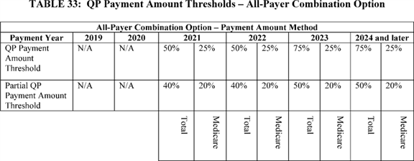

| **Table 34--QP Patient Count Thresholds--Medicare Option** | | | | | | |
| --- | --- | --- | --- | --- | --- | --- |
|  |  |  |  |  |  |  |
| **Medicare Threshold Option--Patient Count Method** | | | | | | |
|  |  |  |  |  |  |  |
| **Payment year** | **2019** | **2020** | **2021** | **2022** | **2023** | **2024 and** |
|  | **(percent)** | **(percent)** | **(percent)** | **(percent)** | **(percent)** | **later** |
|  |  |  |  |  |  | **(percent)** |
| QP Patient Count | 20 | 20 | 35 | 35 | 50 | 50 |
| Threshold |  |  |  |  |  |  |
| Partial QP | 10 | 10 | 25 | 25 | 35 | 35 |
| Patient Count |  |  |  |  |  |  |
| Threshold |  |  |  |  |  |  |

**[*77436]**

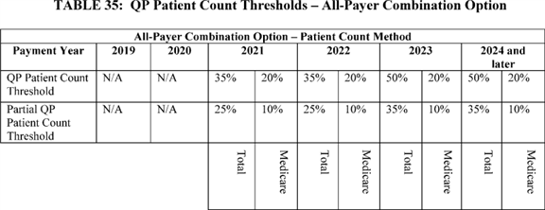

We solicited comment on the proposed QP Patient Count Threshold and Partial QP Patient Count Threshold percentage values for both the Medicare Option and the All-Payer Combination Option.

The following is a summary of the comments we received regarding our proposed QP Patient Count Thresholds and Partial QP Patient Count Thresholds.

*Comment:* A few commenters did not support the proposed QP Patient Count Thresholds because they are lower than the correlating QP Payment Amount Thresholds. They stated that this would increase the number of QPs in the absence of a strong connection between performance and reward.

*Response:* We believe that what appear to be the lower QP Patient Count Thresholds actually represent a parallel to the QP Payment Amount Thresholds and that both reflect increasing rigor over time. We believe the QP Patient Count and Payment Amount Thresholds represent the same overall level of rigor by taking into account factors that cause the payment amount and patient count Threshold Scores to vary for an Advanced APM Entity group. These factors include, in addition to the obvious patient counts or payment amounts, characteristics of the markets in which APM Entities operate, the APMs' attribution methodologies, and the participation of different types of eligible clinicians such as specialists and non-physician practitioners. In addition to excluding payment amounts and patient counts that are categorically impossible to be in the numerator from the denominator of Threshold Score calculations, we believe that the thresholds (payment amount and patient count) should have the same overall level of rigor in order to effectuate the intent of the law to have thresholds that reward committed participation in Advanced APMs. Regarding the concern that a lower QP Patient Count Threshold would increase the number of eligible clinicians who are QPs without a connection between performance and reward, we believe that the Advanced APMs themselves are the drivers of cost and quality performance through their unique incentive designs. The QP thresholds are not replacements for those performance measurements in Advanced APMs. However, we believe that having a sufficient amount of payments or patients flowing through an Advanced APM contributes to ensuring eligible clinicians have a meaningful incentive to deliver high-value care across their entire practice. We also do not believe that we should aim to produce a particular number of QPs by calibrating the QP Patient Count Threshold. We want the QP thresholds to be meaningful and attainable independent of how many eligible clinicians ultimately become QPs.

*Comment:* Many commenters supported the proposed QP Patient Count Thresholds, although some expressed a degree of concern about the difficulty of meeting the higher percentage thresholds we proposed for future performance periods.

*Response:* We thank the commenters for their support. We believe that the higher thresholds in future years will be challenging but attainable for eligible clinicians in Advanced APMs. We also believe it is appropriate for increases in the QP Patient Count Threshold over the next several performance periods to parallel those for the QP Payment Amount Threshold.

*Comment:* Some commenters stated their belief that in order to become QPs, participants in Advanced APMs should be held to a high performance standard--for instance, demonstrated cost and quality improvements in the Advanced APM--that increases over time. Conversely, other commenters believe that becoming a QP should be based upon participation in Advanced APMs and not on the actual performance within the Advanced APMs.

*Response:* We thank commenters for their input on how to achieve QP status. We do not believe that we have the legal authority to tie QP status to performance within the Advanced APMs. The statute specifies that becoming a QP is based on reaching the QP thresholds, which are based on the percentage of payments or patients provided services through an Advanced APM, not on other performance metrics such as cost and quality.

*Comment:* Many commenters stated that the QP thresholds--both payment amount and patient count--were too high, especially for certain types of Advanced APM Entities that have high ratios of specialists or act as referral centers, resulting in substantial amounts of care delivered to non-attributed beneficiaries. Some commenters stated that if such Advanced APM Entities cannot meet the QP thresholds, we would essentially be discouraging participation and penalizing them for fulfilling their missions of treating a wide range of beneficiaries and for utilizing their expertise as broadly as possible. Therefore, several commenters suggested that CMS further reduce the QP thresholds, both payment amount and patient count, to ensure participation is appropriately incentivized. Other commenters suggested that the QP thresholds be reduced differentially depending on the Advanced APM in order to tailor the thresholds to the particular context of an Advanced APM. Some commenters **[*77437]** requested that we monitor the issue in the early years of implementation so that we can adjust our thresholds or methodologies for the later years if necessary.

*Response:* We thank the commenters for their thoughts on the QP thresholds. First, we reiterate that the payment amount thresholds are set by the statute and that we do not have the authority to change them in this final rule. Second, based on our preliminary analyses of historical participation in APMs, we believe that QP thresholds in the first years under both the payment amount and patient count thresholds are highly attainable by Advanced APM participants. We will closely monitor the results and consider whether the finalized patient count thresholds accurately represent participants' level of commitment to Advanced APMs in a manner similar to the payment amount thresholds. We understand that there may be some natural differences in Threshold Scores depending on the characteristics of a particular Advanced APM or its participants, but we believe the statute contemplates a single QP threshold for each performance period, and that it is preferable to have a single, simple set of QP thresholds applicable to all Advanced APM participants. We believe our proposed set of QP Patient Count Thresholds adhere to the statutory directive that we use percentage criteria for the QP Patient Count Thresholds that are similar to those for the QP Payment Amount Threshold.

After considering the public comments, we are finalizing the QP Patient Count Thresholds and Partial QP Patient Count Thresholds as proposed, and we are finalizing the QP Payment Amount Threshold and Partial QP Payment Amount Thresholds as specified in statute.

We proposed that, beginning with payment year 2021, we would conduct the QP determination sequentially so that the Medicare Option is applied before the All-Payer Combination Option. We proposed to apply the All-Payer Combination Option only to an Advanced APM Entity group of eligible clinicians or eligible clinicians who do not meet either the QP Payment Amount or Patient Count Threshold under the Medicare Option but who do meet the lower Medicare threshold for the All-Payer Combination Option. This process is illustrated in Figures C and D of this final rule with comment period, which show that the first assessment is whether the Medicare QP Threshold has been met under either the Medicare Option or the All-Payer Combination Option.

Because in addition to being a standalone path to QP status, the Medicare Option (either based on payment amounts or patient counts) is also a component of the All-Payer Combination Option, and because all eligible clinicians must reach at least a minimum Threshold Score through Advanced APMs to be QPs, we believe that this sequential approach streamlines the analytic and operational requirements to make QP determinations under the All-Payer Combination Option. Figure C illustrates the proposed process for making QP determinations under the Medicare Option for 2019 and 2020. Figure D illustrates the process proposed for making QP determinations under both the Medicare and All-Payer Combination Options for payment years 2021-2024. Figure E provides an example of the proposed process for making QP determinations in payment years 2023-2024. Figures C, D, and E only illustrate the payment amount method, but a similar process would apply for the patient count method.

**[*77438]**

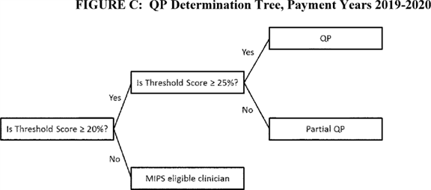

**[*77438]**

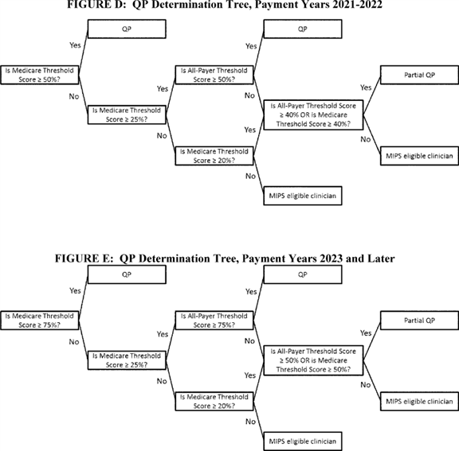

The following is a summary of the comments we received regarding our proposal to assess Advanced APM Entities sequentially under the Medicare Option and, only if necessary, under the All-Payer Combination Option.

*Comment:* A few commenters expressed support for the sequential determination of QPs and Partial QPs in the Medicare Option and then the All-Payer Combination Option.

*Response:* We thank the commenters for their support.

We are finalizing the policy as proposed. Beginning with payment year 2021, we will conduct the QP determination sequentially so that the Medicare Option is applied before the All-Payer Combination Option. We will apply the All-Payer Combination Option only to an Advanced APM Entity group of eligible clinicians who do not meet either the QP Payment Amount or Patient Count Thresholds under the Medicare Option but who do meet the lower Medicare threshold for the All-Payer Combination Option.

The following is a summary of comments regarding the QP determination process generally.

*Comment:* A few commenters expressed that the QP determination is too complex and that clinicians will not understand what is required to attain QP status. They recommended that we establish a more transparent and simple approach. Other commenters suggested that any level of participation in an Advanced APM should suffice for receiving the APM Incentive Payment. One commenter requested that CMS be more flexible in granting QP status.

*Response:* We are required by statute to apply payment amount or patient count thresholds in order to identify which eligible clinicians receive the APM Incentive Payment and are excluded from MIPS adjustments. We understand that this is a new process with certain inherent complexities, but we believe that in our proposed policies we have balanced the interests of simplicity and the need to accurately apply standards to an increasingly diverse array of Advanced APMs now and in the future. We will be providing education and technical assistance to **[*77439]** help eligible clinicians understand the requirements to attain QP status.

*Comment:* Some commenters believe that the QP determination process discourages participation in Advanced APMs due to the uncertainty of the results of the Threshold Score. Similarly, one commenter suggested that those eligible clinicians and entities that have already invested heavily and currently participate in Advanced APMs should have an easier path to QP determination that those who are new participants.

*Response:* We take seriously any potential incentives that could work against this program's purpose of increasing Advanced APM participation. Although we do not agree that our proposed and final QP determination policies will discourage participation, we intend to provide information and preliminary assessments based on historical data to help Advanced APM participants understand what their Threshold Scores would likely be in order to mitigate uncertainty about their likely QP status.

We disagree with the commenter that current APM participants should have an easier path to QP status than APM participants who have never previously participated in APMs. While we greatly appreciate the early adopters of Advanced APMs, we find no policy justification for making it relatively more difficult for those who have never participated in an Advanced APM to achieve QP status because, as stated above, a core purpose of this program is to increase Advanced APM participation.

a. Group Determination and Lists

(1) Group Determination

The statute consistently refers to an eligible clinician throughout section 1833(z) of the Act and clearly identifies that the QP determinations are to be made for an eligible clinician, whom we identify by a unique NPI. Thus, an eligible clinician is a person who may have multiple TIN/NPI combinations but only one NPI. In section 1833(z)(3)(B) of the Act, the definition of an eligible clinician includes a group of such clinicians.

We proposed, in general, to make the QP determination at a group level. As a result, the QP determination for the group would apply to all the individual eligible clinicians who are identified as part of an Advanced APM Entity. If that eligible clinician group's collective Threshold Score meets the relevant QP threshold, all eligible clinicians in that group would receive the same QP determination, applied to their NPI, for the relevant year. The QP determination calculations described in the proposed rule would be aggregated using data for all eligible clinicians participating in the Advanced APM Entity during the QP Performance Period.

We believe that this policy promotes administrative simplicity and collaboration among group members instead of promoting barriers, and while many beneficiaries are attributed to an APM Entity based on the services rendered by one eligible clinician, many of the eligible clinicians participating in the APM Entity may play a role in the actual diagnosis, treatment, and management of many beneficiaries in the APM Entity population. Each of these individual eligible clinicians could potentially view themselves as being instrumental in providing quality care to the beneficiary that is in line with the objectives of the APM, regardless of whether their individual services are counted towards APM-specific attribution methods.

An Advanced APM Entity faces the risks and rewards of participation in an Advanced APM as a single unit, and is responsible for performance metrics that are aggregated to the level of that entity. This policy is based on the premise that positive change occurs when entire organizations commit to participating in an Advanced APM and focusing on its cost and quality goals as a whole. It also mitigates situations in which individual eligible clinicians who practice together in an Advanced APM Entity receive different QP determinations and thus are treated differently for purposes of APM Incentive Payments, MIPS payment adjustments, and eventually, differential fee schedule updates under the PFS. We believe that such discrepancies could potentially lead to confusion and lack of cohesion among eligible clinicians and Advanced APM Entities and place additional burdens on eligible clinicians and organizations to track these differences. Additionally, we wish to avoid any additional burden, confusion, and operational difficulties for both eligible clinicians and CMS that would result from allowing eligible clinicians or Advanced APM Entities to elect whether to be assessed at the Advanced APM Entity level. We believe that a simple, overarching rule is preferable to adding extra variables to the already complex processes under this program.

The following is a summary of the comments we received regarding our proposal to make the QP determination at the Advanced APM Entity group level.

*Comment:* Most commenters expressed support for performing the Threshold Score calculations in this section at a group level defined by the Advanced APM Entity. Commenters stated that this was supportive of care coordination, organization cohesiveness, and the different clinician types supporting an Advanced APM Entity regardless of whether or not their services are tied directly to attribution. Some commenters were supportive but cautioned that this approach might be difficult to apply in certain Advanced APMs with Advanced APM Entities that have partial TINs or span multiple TINs.

*Response:* We thank the commenters for their support of this approach and agree that it aligns with the goals of Advanced APMs. We believe that this accommodates the various organizational structures across Advanced APMs because it relies upon the lists maintained under each APM and its particular rules.

*Comment:* One commenter stated that the exclusionary criteria under MIPS (first year of Medicare participation and low-volume threshold) should also apply to QP eligibility.

*Response:* We disagree with the commenter. Although the statute specified exclusionary criteria for MIPS, we find no statutory basis or policy rationale to exclude such eligible clinicians from QP determinations.

*Comment:* A few commenters recommended that the QP determinations be made at the TIN or NPI level instead of the Advanced APM Entity level. One commenter favored TIN level assessment in order to parallel the MIPS group reporting option and enable a greater degree of accuracy in a group's financial estimates.

*Response:* We appreciate the potential advantages in certain scenarios for QP determinations to be made at TIN or NPI levels, but we continue to believe that QP determination at the Advanced APM Entity group level aligns with the goals of the Advanced APMs themselves and ultimately is more beneficial for a wider range of eligible clinicians who might not have an opportunity to be QPs individually or in smaller groups. We want to reinforce the collective responsibility of an Advanced APM Entity. However, as outlined below, we finalize two exceptions for situations in which we believe it is more appropriate to make the QP determination at the individual NPI level: (1) For individuals participating in multiple Advanced APM Entities, none of which meet the QP threshold as a group, and (2) for eligible clinicians on an Affiliated Practitioner List when that list is used for the QP determination because there are no eligible clinicians on a Participation List for the Advanced **[*77440]** APM Entity. For the former exception, we believe that participation in multiple Advanced APMs demonstrates particular commitment to Advanced APMs. We believe it will be rare that all of an eligible clinician's multiple Advanced APM Entities would fail to meet the QP thresholds, but in such cases, the Threshold Scores of those Advanced APM Entities may not be indicative of the degree to which the eligible clinician has dedicated his or her practice to Advanced APMs. For the latter exception, eligible clinicians on an Affiliated Practitioner List, particularly those in episode payment models, do not necessarily have the same organizational relationship with one another as eligible clinicians who are on a Participation List. Unlike APM Entities that are defined as a group of eligible clinicians, affiliated practitioners may have no common connection to each other aside from their mutual relationship with a facility.

*Comment:* One commenter did not support the proposal to apply QP status to an eligible clinician's NPI rather than the TIN/NPI combination associated with an Advanced APM Entity.

*Response:* We disagree with the commenter and believe that applying QP status at the TIN/NPI level instead of at the NPI level as proposed would do a disservice to QPs. An eligible clinicians identified by an NPI may have reassigned billing to multiple TINs, resulting in multiple TIN/NPI combinations being associated with one eligible clinician (NPI). If QP status was only applied to one of an eligible clinician's multiple TIN/NPI combinations, an eligible clinician who is a QP for only one TIN/NPI combination might still have to report under MIPS for another TIN/NPI combination. Further, under that approach, the APM Incentive Payment would be based on only a fraction of the eligible clinician's covered professional services instead of, as we believe is the most logical reading of the statute, all those services furnished by the individual eligible clinician, as represented by an NPI. Therefore, we do not believe that applying QP status only to a specific TIN/NPI combination is supportive of the program's goals to reward individuals for commitment to Advanced APM participation.

Except as explained further below, we are finalizing the proposed policy to make QP determinations collectively using the group of eligible clinicians in an Advanced APM Entity. We are finalizing two exceptions to this policy. First, if the eligible clinicians are identified on an Affiliated Practitioner List rather than a Participation List, as described in this section below, we will perform the QP determination individually for each eligible clinician on the Affiliated Practitioner List. We believe that eligible clinicians on Affiliated Practitioner Lists are unlike eligible clinicians on Participation Lists because, although they may have similar relationships with the Advanced APM Entity, they may not have any relationship with one another and do not represent a single organization unified in APM-related goals. Therefore, we believe considering these eligible clinicians individually is the most appropriate approach. We finalize the other exception regarding eligible clinicians participating in multiple Advanced APMs in section II.F.5.a.3. of this final rule with comment period.

We understand that, as with any group assessment, there will be some situations in which individual Threshold Scores would differ from group Threshold Scores if assessed separately. This could lead to some eligible clinicians becoming QPs when they would not have met the QP Threshold individually (a "free-rider" scenario) or, conversely, some eligible clinicians not becoming QPs within an Advanced APM Entity when they might have qualified individually (a dilution scenario). We believe that through the methodology we are finalizing for QP determinations in this final rule, the magnitude of such discrepancies will be relatively small compared to the value of maintaining Advanced APM Entity cohesion.

(2) Groups Used for QP Determination

We proposed that the group of eligible clinicians used for a collective QP determination would consist of all the eligible clinicians participating in an Advanced APM Entity during a QP Performance Period. This would be defined by an Advanced APM Entity's Participation List provided to CMS. We proposed that the Participation List for each Advanced APM Entity would be compiled from CMS-maintained lists that identify each eligible clinician by a unique TIN/NPI combination attached to the identifier of the Advanced APM Entity.

We proposed two exceptions to this rule. One exception is for Advanced APMs that do not identify eligible clinicians on a Participation List. In certain Advanced APMs, a Participation List may not include eligible clinicians. For example, in an APM where all Advanced APM Entities are hospitals, the Advanced APM Entity may not have eligible clinicians identified by a unique TIN/NPI combination attached to the identifier of the Advanced APM Entity on a Participation List. On the other hand, in certain Advanced APMs, an Advanced APM Entity may have a list (Affiliated Practitioner List) of other entities, including eligible clinicians, who are affiliated with and support the Advanced APM Entity in its participation in the Advanced APM but are not on the Participation List. For example, an Affiliated Practitioner List comprised of gainsharers under an APM might include eligible clinicians whereas a Participation List may only include hospitals.

Where there is a Participation List that can be used to identify eligible clinicians, we proposed that it be the only list that is considered for the QP determination. We proposed that for Advanced APMs where the Participation List does not identify eligible clinicians, but there is an Affiliated Practitioners List of eligible clinicians who have a contractual relationship with the Advanced APM Entity based at least in part on supporting the Advanced APM Entity's quality or cost goals under the Advanced APM, we would use the eligible clinicians on the Affiliated Practitioner List for purposes of the QP determination. Where there is both a Participation List and an Affiliated Practitioner List that can be used to identify eligible clinicians under an Advanced APM, we proposed to only use the Participation List for purposes of the QP determination.

This proposed policy was developed to capture the group or groups of eligible clinicians who are the most closely associated with the performance of the Advanced APM Entity under an Advanced APM and to recognize their role in supporting the Advanced APM Entity. We believe this policy provides for flexibility in the design of Advanced APMs while providing the APM Incentive Payment to those eligible clinicians who are the most engaged in the Advanced APM.

We solicited comment on our proposals to define the eligible clinician group for QP determination based on the Participation List and the exception to use the Affiliated Practitioners List for Advanced APMs in which there are not eligible clinicians on the Participation List. We also solicited comment on whether to limit the proposed policy to the Medicare Option, as it may be less likely that Affiliated Practitioners support the Advanced APM Entity in Other Payer Advanced APMs and may be more difficult for us to distinguish based on information submitted to CMS by Advanced APM Entities. Because there may be Advanced APMs in the future that have **[*77441]** multiple lists of Affiliated Practitioners, we sought comment on approaches for grouping those separate lists for purposes of the QP determination.

The following is a summary of the comments we received regarding our proposals pertaining to defining the eligible clinician groups for QP determination.

*Comment:* Several commenters requested clarification on which list, the Participation List or Affiliated Practitioner List, would be used when an Advanced APM has both. One commenter requested clarification of the definition of the Participation List and another commenter requested clarification regarding the definition of Affiliated Practitioner, specifically if the definition varies by Advanced APM. Several commenters recommended that when an Advanced APM has both a Participation List and an Affiliated Practitioner List, the lists should be reconciled in order to include a broader group of eligible clinicians for purposes of the QP determination. Some commenters supported the distinction between participants on a Participation List and Affiliated Practitioners on an Affiliated Practitioner List for purposes of the QP determination.

A few commenters made specific comments on how the proposed policy relates to episode payment models. Some commenters suggested that if BPCI or CJR become Advanced APMs, CMS should accept a hospital's Affiliated Practitioner List for the QP determination. A commenter suggested that CMS create a process for APM Entities in episode payment models to report their Affiliated Practitioners out of concern that ACOs will exclude specialists so that their primary care physicians will as a group be QPs.

*Response:* A Participation List is a CMS-maintained list that includes the most central participants in an APM. Affiliated Practitioners are eligible clinicians who are more loosely affiliated with an Advanced APM Entity than those on a Participation List, and have a contractual relationship with the Advanced APM Entity based at least in part on supporting the Advanced APM Entity's quality or cost goals under the Advanced APM. The definitions of Participation List and Affiliated Practitioner List are located at § 414.1305. If the terms of an Advanced APM do not require a Participation List to identify eligible clinicians but do allow for eligible clinicians to be identified on an Affiliated Practitioner List, we would use the Affiliated Practitioner List for purposes of the QP determination. If an Advanced APM has both a Participation List and an Affiliated Practitioner List, we will only look at the Participation List for purposes of the QP determination, with the following exception.

In response to the comment requesting that we identify Affiliated Practitioners for the QP determination in BPCI, we are finalizing an exception that would allow for the appropriate identification of eligible clinicians in APMs that, like BPCI, have multiple types of participating APM Entities. Under this exception, we will use either the Participation List or the Affiliated Practitioner List depending on the type of APM Entity. This exception applies to Advanced APMs, such as some episode payment models, in which different types of APM Entities participate and some Advanced APM Entities may identify eligible clinicians on a Participation List, and others may have only an Affiliated Practitioner List. For these models, we will identify the eligible clinicians for QP determinations based on the composition of the Advanced APM Entity instead of at the Advanced APM level. Specifically, for these episode payment model Advanced APMs, we will determine which eligible clinicians will be included in the QP determination as follows: (1) For Advanced APM Entities that include and identify eligible clinicians on a Participation List, that Participation List will be used to define the Advanced APM Entity group, regardless of whether or not there is also an Affiliated Practitioner List or other list of eligible clinicians, and we will make QP determinations at the APM Entity group level; (2) for Advanced APM Entities that do not include and identify eligible clinicians on a Participation List and there is an Affiliated Practitioner List that identifies eligible clinicians, that Affiliated Practitioner List will be used to identify the eligible clinicians for purposes of QP determination, and those eligible clinicians will be assessed individually. The structure of BPCI serves as a useful example to show how we would apply this policy. In a model like BPCI, when the APM Entity is a physician group practice that identifies eligible clinicians on a Participation List, we would use that list for purposes of the QP determination, even if there is also an Affiliated Practitioner List. When the APM Entity is a hospital that does not identify eligible clinicians on a Participation List, but it identifies eligible clinicians on an Affiliated Practitioner List, we would use that list for purposes of identifying eligible clinicians for the QP determination, and those eligible clinicians would be evaluated individually. While this policy is responsive to comments about APMs like BPCI, this policy does not change the design of the models within BPCI. We are also considering implementing a new voluntary APM that is an episode payment model for CY 2018 that could meet the criteria for this exception [*(81 FR 50793).*](https://advance.lexis.com/api/document?collection=administrative-codes&id=urn:contentItem:5KCC-BWR0-006W-802T-00000-00&context=)

We believe this exception to making QP determinations at a group level appropriately identifies the eligible clinicians with the closest supporting role to the Advanced APM Entity in episode payment models. We would assess affiliated practitioners individually because affiliated practitioners do not necessarily have the same organizational relationship with one another as eligible clinicians on a Participation List have with one another. Unlike APM Entities that are defined as a group of eligible clinicians, affiliated practitioners may have no common connection to each other aside from their mutual relationship with a facility. Therefore, we believe that the rationale for group assessments does not apply to these individual eligible clinicians.

*Comment:* Several commenters requested that CMS develop a way to identify individual eligible clinicians who are employed by an Advanced APM Entity in an episode payment model and involved in episodes of care or require that the Advanced APM Entity provide CMS with a list of such clinicians. One commenter recommended that in addition to using Participation Lists and Affiliated Practitioner Lists for purposes of QP determination, CMS should also use all eligible clinicians under a single TIN as a group of eligible clinicians, regardless of inclusion on one of these lists. Another commenter suggested that it may be preferable to only count eligible clinicians who can be used for beneficiary attribution in the Advanced APM. Another commenter suggested that eligible clinicians working with a partner teaching hospital that is an Advanced APM Entity should receive credit for participation in the Advanced APM, even if they do not have a formal arrangement with the Advanced APM Entity.

*Response:* We believe that the policy to use Participation Lists and Affiliated Practitioner Lists, when applicable, for purposes of the QP determination, captures the eligible clinicians who are most closely associated with the performance of the Advanced APM Entity under the Advanced APM. We do not believe that including clinicians for whom we have no other record of participation in an Advanced APM would be an accurate and equitable **[*77442]** representation of the eligible clinicians that could become QPs through an Advanced APM. CMS defines an eligible clinician's role in an APM through his or her inclusion on specific CMS-maintained lists defined in each APM's terms and conditions or ***regulation*** or law, and we cannot verify relationships for which we do not maintain records. Further, we do not believe it would be useful to merge the Participation Lists with Affiliated Practitioner Lists to identify eligible clinicians for QP determinations because the clinicians on these lists have different relationships with an Advanced APM Entity.

The policy we are finalizing addresses which eligible clinicians, those on a Participation List or those on an Affiliated Practitioner List, will be considered for the QP determination. We believe that we should only capture those eligible clinicians affirmatively identified as the most central participants supporting an Advanced APM Entity for purposes of the QP determination. Many APMs have multiple "tiers" of eligible clinicians who may play different roles for an APM Entity, and the policy we are finalizing reflects those tiers so that only the eligible clinicians most responsible for the requirements of the Advanced APM relative to other tiers of eligible clinicians will be considered the central participants of an Advanced APM Entity. Where Advanced APM Entities have eligible clinicians identified on a Participation List, those eligible clinicians are the most central participants. Where Advanced APM Entities do not have eligible clinicians identified on a Participation List, but they do have eligible clinicians on an Affiliated Practitioner List, those eligible clinicians are the most central participants.

*Comment:* One commenter suggested that CMS provide some protections, flexibility, or an appeals process for those eligible clinicians who find themselves to be on what they believe to be the wrong list, especially during the first few years of adjusting to the Quality Payment Program.

*Response:* We understand that ensuring list accuracy can be a difficult process for organizations and clinicians to manage. List management takes place with the APMs themselves, and we are not developing any universal standards for how each APM collects, updates, and maintains its lists. However, because of the important implications in list management, we will closely monitor this issue in the first years of the Quality Payment Program, and on an ongoing basis.

We are finalizing the proposed policy with certain modifications, as follows:

* For Advanced APMs for which there is a Participation List that identifies eligible clinicians, that Participation List will be used to define the Advanced APM Entity group, regardless of whether there is also an Affiliated Practitioner List or other list of eligible clinicians associated with the Advanced APM. QP determinations will be made at the Advanced APM Entity group level.

1. For Advanced APMs for which there is not a Participation List that identifies eligible clinicians and there is an Affiliated Practitioner List that identifies eligible clinicians, that Affiliated Practitioner List will be used to identify the eligible clinicians for purposes of QP determinations. Eligible clinicians on an Affiliated Practitioner List will be assessed individually, unlike eligible clinicians on a Participation List who are assessed as a group.
2. For Advanced APMs, such as episode payment models, in which there are some Advanced APM Entities that include eligible clinicians on a Participation List and other Advanced APM Entities that identify eligible clinicians only on an Affiliated Practitioner List, we will identify eligible clinicians for QP determinations based on the composition of the Advanced APM Entity: (1) For Advanced APM Entities that include and identify eligible clinicians on a Participation List, that Participation List will be used to define the Advanced APM Entity group, regardless of whether or not there is also an Affiliated Practitioner List or other list of eligible clinicians, and those eligible clinicians will be assessed as a group; (2) for Advanced APM Entities that do not include and identify eligible clinicians on a Participation List and there is an Affiliated Practitioner List that identifies eligible clinicians, that Affiliated Practitioner List will be used to identify the eligible clinicians for purposes of QP determinations, and those eligible clinicians will be assessed individually.

As discussed in our response to comments above, we believe the relationship between eligible clinicians and APM Entities in APMs such as episode payment models can vary and that eligible clinicians on an Affiliated Practitioner List can be engaged in the goals of the Advanced APM in a similar manner as eligible clinicians on a Participation List depending on the characteristics of the Advanced APM Entity.

We are finalizing these policies on the identification of eligible clinicians for purposes of QP determinations only for the Medicare Option. We did not receive public comment on whether to extend this policy to the All-Payer Combination Option and believe it is prudent to first apply this policy in the Medicare Option before considering whether to apply it in the All-Payer Combination Option through future rulemaking.

(3) Exception for Participation in Multiple Advanced APMs

We proposed an exception to making QP determinations at the group level. Some eligible clinicians may participate in multiple Advanced APMs. For instance, an eligible clinician could participate in an ACO under the Shared Saving Program and an episode payment model with another entity, both of which have been determined to be Advanced APM Entities. In such a case, we proposed the following [*(81 FR 28320):*](https://advance.lexis.com/api/document?collection=administrative-codes&id=urn:contentItem:5JR6-TD50-006W-8163-00000-00&context=)

* Consistent with the general policy proposed above, if one or more of the Advanced APM Entities in which the eligible clinician participates meets the QP threshold, the eligible clinician becomes a QP.

1. If none of the Advanced APM Entities in which the eligible clinician participates meet the QP threshold, CMS proposes to assess the eligible clinician individually, using combined information for services associated with that individual's NPI and furnished through all such eligible clinician's Advanced APM Entities during the QP Performance Period. We would adjust to assure that services are not double-counted (for example, a surgeon participating in an episode payment model, in which some of the procedures are performed on patients affiliated with an ACO that the surgeon is also a part of, would only have payments or patients from those procedures count once towards the QP determination).

We believe that this policy maintains the general simplicity of the Advanced APM Entity-level QP determination while acknowledging individual eligible clinicians who are participating in multiple advanced initiatives that support CMS goals. This also complements the policy described under the All-Payer Combination Option for QP determinations in which an eligible clinician may submit information on participation in Other Payer Advanced APMs to be assessed as an individual under that option in the event that the APM Entity or Entities in which the eligible clinician participates do not submit sufficient information. **[*77443]**

We solicited comment on the proposal for exceptions to making QP determinations at the Advanced APM Entity level. In particular, we solicited comment on the merits of making all determinations at the individual eligible clinician level versus through some alternative grouping methodology. We also solicited comment on our proposal to assess an eligible clinician who participates in multiple Advanced APM Entities, and any other potential exceptions to the proposed general policy to make QP determinations at the Advanced APM level.

The following is a summary of the comments we received regarding our proposal to assess an eligible clinician individually for purposes of a QP determination in the event that the eligible clinician participates in multiple Advanced APM Entities, none of which meet the QP thresholds as a group.

*Comment:* Many commenters supported our proposal to evaluate the individual eligible clinician participating in multiple Advanced APMs if the individual is not determined to be a QP based on participation in any single Advanced APM. Some commenters suggested that for at least the first year, we allow any individuals or TINs within an Advanced APM Entity to be QPs if they reach the QP threshold independent of their Advanced APM Entities in order to ensure that as many eligible clinicians become QPs as possible.

*Response:* With respect to the alternative of allowing individual TINs or NPIs within an Advanced APM Entity to be assessed separately and to apply the most favorable result, we do not believe that approach would best reflect the collective participation toward shared goals that is fostered under APMs, and in particular, Advanced APMs. Like the APM Entity's performance under the APM, we believe group level determinations in the APM context involve collective and consistent responsibility for results, including QP determinations. We will have instances in which eligible clinicians are assessed as a group and instances in which they are assessed as individuals, but we believe individual evaluation should be used only to address exceptional circumstances. The approach suggested by the commenters would effectively apply an individual assessment with a floor determined by the group performance. Such an alternative would erode the cooperative purpose of a group determination, and we continue to believe, as stated in the proposed rule, that APM participation is focused on collective responsibility for the cost and quality of care for Medicare beneficiaries.

*Comment:* One commenter requested clarification on how we would average or weight participation across multiple Advanced APMs.

*Response:* We appreciate the questions regarding how individuals would be assessed in the case of an eligible clinician participating in multiple Advanced APMs. Because we will make QP determinations using claims analyses, which enables us to connect services for beneficiaries to an eligible clinician's NPI, we would only need to add the numerator and denominator values together, and adjust for any duplication in the numerator or denominator. The formulas would be the same as if calculated for the group but based on the individual eligible clinician's activity at the NPI level.

We are finalizing the policy as proposed. If an eligible clinician participates in multiple Advanced APM Entities during a QP Performance Period, and is not determined to be a QP based on participation in any of those Advanced APM Entities, then we will assess the eligible clinician individually using combined information for services associated with that individual's NPI and furnished through all the eligible clinician's Advanced APM Entities during the QP Performance Period. This includes all Advanced APM Entities for which the eligible clinician is represented on either a Participation List or Affiliated Practitioner List that CMS uses for QP determinations in accordance with the identification policies described in this section of the final rule with comment period. We will make adjustments to ensure that patients and payments for services that may be counted in the QP calculations for multiple Advanced APM Entities (for example, payments for services furnished to a beneficiary attributed to an ACO that are also part of an episode in an episode payment model) are not double-counted for the individual.

We believe that this policy maintains the general principles behind Advanced APM Entity-level QP determinations while acknowledging the broader commitment of individual eligible clinicians who are participating in multiple Advanced APMs. We believe considering these eligible clinicians individually is the most reasonable approach to capturing the multiple potential permutations of participation in Advanced APMs and providing eligible clinicians an equitable opportunity to become a QP.

(4) Timing of Group Identification for Eligible Clinicians

We proposed that we would identify the eligible clinician group for each Advanced APM Entity at a specified point in time for each QP Performance Period. We proposed that this point-in-time assessment will occur on December 31 of each QP Performance Period.

We solicited comments on our proposal to define the Advanced APM Entity group based on the Participation List for each Advanced APM Entity at a specified point in time during the QP Performance Period. We also solicited comment on the proposed date of the Participation List assessment, and whether this date should be earlier in the QP Performance Period or should instead be a range of time [*(81 FR 28320).*](https://advance.lexis.com/api/document?collection=administrative-codes&id=urn:contentItem:5JR6-TD50-006W-8163-00000-00&context=)

The following is a summary of the comments we received regarding our proposal to define the Advanced APM Entity group for purposes of the QP determination by take a point-in-time snapshot of eligible clinicians in an Advanced APM Entity according to Participation Lists on December 31 of the QP Performance Period.

*Comment:* Many commenters expressed concerns with the proposed policy of a December 31 snapshot of Participation Lists in order to determine the Advanced APM Entity group for QP determinations and, if applicable, MIPS reporting and scoring under the APM scoring standard. Some commenters stated that December 31 captures APMs that start or allow additions to Participation Lists during the calendar year, but for APMs such as the Next Generation ACO Model in which Participation Lists are set at the beginning of the year and can only be reduced during the year, December 31 does not necessarily capture the entity as it operates throughout the year. Similarly, commenters noted that the proposed policy both does not incentivize participation during the early part of a year and is not fair to eligible clinicians who may have been part of the Advanced APM Entity for large portions of the QP Performance Period but not on the Participation List on the last day of the year. Finally, many commenters stressed that because not being on an Advanced APM Entity's Participation List means that the eligible clinician must make arrangements for MIPS reporting for the services furnished under the TIN/NPI combination associated with the Advanced APM Entity, and learning that late in the year would make the necessary preparations to perform well under MIPS in a limited amount of time very difficult. **[*77444]**

*Response:* We agree with commenters that a single snapshot on December 31 or the last day of the QP Performance Period may create some potentially inequitable or burdensome situations. Therefore, as described in this section, we are finalizing a policy that moves away from a single, end of year snapshot to instead use several snapshots through the year that we believe better represent eligible clinician participation in Advanced APMs over the course of a year for purposes of QP determinations.

*Comment:* A few commenters suggested that we use a range of time during which presence on a Participation List would be sufficient to be included in the group. Similarly, some commenters suggested that presence on the list for a certain number of consecutive days (that is, on the Participation List for 60 days) should result in inclusion in the group.

*Response:* We thank the commenters for the suggestion. These ideas both have merit, and we considered them carefully. We are finalizing a different policy because, under these suggested options, we believe APM list management will be more difficult. We want the list used for purposes of an APM and for purposes of the Quality Payment Program to be as consistent as possible so that APM Entities may easily understand how list changes have impacts across programs. Under the commenters' proposals, at any single point in time, there will likely be inconsistencies between the APM Entity's Participation List and the list we would use for QP determinations, which would be very challenging to explain and to manage for both CMS and Advanced APM Entities. Specifically with regard to the proposal to have a range of time during which anyone on the Participation List would be included in the APM Entity group, many APM Entities make changes to their Participation Lists at certain times of the year, especially during the first quarter, and we do not want to include eligible clinicians in the APM Entity group if they were only on a list fleetingly during a period of administrative transitions. We believe that the minimum length of time proposal ensures that eligible clinicians participate sufficiently before being included in an APM Entity group, but APM Entities would not have the ability on a given date to know which eligible clinicians will be included in the group because some may leave at staggered points in time prior to participating for the necessary number of days.

*Comment:* Several commenters suggested that we allow each Advanced APM Entity to submit a list, which may vary from the one used under the Advanced APM, for purposes of the QP determination in order to accurately reflect what the entity believes is the most recent and salient representation of its group of eligible clinicians participating in the Advanced APM Entity. Other commenters suggested that each Advanced APM select its own snapshot based on its particular operations or change its Participation List rules to allow adjustments in preparation for this snapshot date. On the other hand, several commenters expressed a desire for as much automation as possible, such as through claims analyses and use of PECOS data, to avoid administratively burdensome list submission and avoid potential list inaccuracies and inconsistencies.

*Response:* We thank the commenters for their suggestions. We understand that allowing a distinct list submission solely for QP determinations purposes or selecting a snapshot date would maximize the control an Advanced APM Entity has over the group's Threshold Score. However, we believe these options would be ripe for potential gaming and could result in inconsistencies between the group of eligible clinicians actually responsible for performance under the Advanced APM according to CMS records and the list the Advanced APM might identify for the QP determination. We believe it is most appropriate to align QP determinations with records of participation under the Advanced APMs themselves. Although changing how any particular APM manages participation by eligible clinicians and APM Entities is beyond the scope of this final rule with comment period, we understand how certain changes could be made in Advanced APMs to help Advanced APM Entities sync up with the Quality Payment Program goals. Finally, we agree with commenters in principle that automation of the identification process for eligible clinicians in Advanced APMs is a valuable goal. We do not want to create additional administrative tasks, such as maintaining and submitting a unique Participation List, when we can use available information in CMS systems.

*Comment:* Many commenters expressed support for a December 31 snapshot date because the fluid nature of participation during a year may result in eligible clinicians joining and leaving an Advanced APM Entity in relatively short periods of time during the year.

*Response:* We thank the commenters for their support of the proposed policy, but because of the issues raised by other commenters, we are finalizing a policy that we believe retains many of the benefits of an end-of-year or end-of-QP Performance Period snapshot while trying to provider greater certainty earlier in the year.

To address the comments we received, especially the concerns regarding eligible clinicians not knowing whether they are part of an Advanced APM Entity for purposes of QP determinations until the end of the calendar year, we are finalizing a modified process for identifying the APM Entity group (individual eligible clinicians in the case of an Affiliated Practitioner List) to use a series of three "snapshots" of an APM Entity's Participation List (or Affiliated Practitioner List) during the QP Performance Period. Each snapshot may add eligible clinicians to the APM Entity group or capture new affiliated practitioners who were not previously identified as part of the group or as individuals in the Advanced APM, but once determined to be a participant in an APM Entity for the QP Performance Period at any of the three snapshots, an eligible clinician will be considered by CMS for QP determinations as part of an APM Entity group, or as an individual, as appropriate, regardless of whether they are included on a Participation List or Affiliated Practitioner List in later snapshots. The first snapshot will be on March 31 of the QP Performance Period, the second snapshot will be on June 30 of the QP Performance Period, and the third snapshot will be on the August 31, which will be the last day of the QP Performance Period.

Each of these snapshots will establish and then add to the APM Entity group used for purposes of the QP determinations made for the QP Performance Period described in this section. In the event that the APM Entity participates in a MIPS APM and is not excluded from MIPS, the final APM Entity group after the third snapshot will be also be the APM Entity group used for purposes of MIPS group reporting and scoring under the APM scoring standard described in section II.e.3.h. of this final rule with comment period.

We believe that this final policy accommodates the variety of policies in different models regarding the adding or dropping of APM participants so that we capture the eligible clinicians who have meaningfully participated in an Advanced APM Entity during a QP Performance Period. Most importantly, we believe that, in combination with the final policy on the QP Performance Period, this policy allows for substantially greater certainty at an earlier point in time of an eligible clinician's status, first as a participant or **[*77445]** affiliated practitioner in an Advanced APM or MIPS APM, and then as a QP or MIPS eligible clinician, as compared to the proposed policy. Figure F illustrates the three additive snapshots we will use to identify the participants in an APM Entity.

We acknowledge that use of point-in-time snapshots may result in some eligible clinicians being captured on Participation Lists or Affiliated Practitioner Lists when they have only been on such a list for a short period of time. Although we believe that most APMs have list management rules to inhibit potential manipulation and that large numbers of additions to a Participation List may reduce an Advanced APM Entity's Threshold Score, we will monitor whether APM Entities systematically construct their lists in a manner that inappropriately affects the assessment of participation in Advanced APMs. In response, we may modify our policy through future rulemaking to address any such issues.

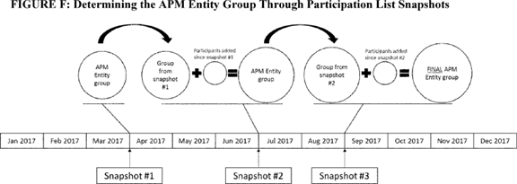

b. QP Performance Period

According to section 1833(z)(2) of the Act, we are required to determine QP and Partial QP status based on payment amounts or patient counts during the most recent period for which data are available, which may be less than a year. We proposed that the QP Performance Period is the full calendar year that aligns with the MIPS performance period (for instance, 2017 would be the QP Performance Period for the 2019 payment year). We believe that having a QP Performance Period that concludes 1 year and one day before the payment year would enable us to provide all eligible clinicians participating in Advanced APMs the best opportunity to monitor their performance through the Advanced APM and make the most informed decisions regarding their decision whether to not to be subject to MIPS in the event that they become a Partial QP. We solicited comment on this proposal and any alternative QP Performance Period timeframes that would both enable meaningful QP assessment and ensure operational alignment with MIPS.

The following is a summary of the comments we received regarding our proposal that the QP Performance Period would be the full calendar year 2 years prior to the payment year.

*Comment:* Many commenters expressed concern that under the proposed QP Performance Period, participants in Advanced APMs would not know their QP status until after the end of the MIPS submission period. As a result, prudent Advanced APM participants would proactively report to MIPS in order to ensure that, in the event they do not reach the QP thresholds, they have an opportunity to fare well under MIPS. Most of these commenters suggested that QP determinations be made earlier so that QPs know their status in sufficient time to avoid unnecessary MIPS reporting. Whereas most of these commenters agreed generally that the determinations should be completed during the QP Performance Period in order to avoid the administrative task of reporting to MIPS, some commenters suggested that QP determinations be made as early as the spring of the QP Performance Period in order to prevent as much unnecessary MIPS-related activity as possible, such as the performance necessary for the improvement activities and advancing care information performance categories. Other commenters went further and stated that QP determinations should be completed prior to or at the very beginning of the QP Performance Period. To enable these very early determinations, commenters recognized that the calculations would have to be made using historical data from 2016 or by issuing presumptive determinations with MIPS adjustment accommodations in the event that actual results differed from those predicted. Several commenters requested that we at least mitigate the issue by providing as much preliminary data as possible so that Advanced APM participants may clearly understand their possible and likely outcomes.

*Response:* Although we designed the APM scoring standard in section II.E.3.h. of this final rule with comment period to reduce the reporting burden, we agree with commenters that it is only part of the solution. We disagree with commenters who recommended using 2016 as the QP Performance Period or implied that we should use 2016 data by suggesting that we make QP determinations for 2019 at the beginning of 2017. First, such a proposal would further remove the performance timeframe from the corresponding reward; second, the purpose of a performance period is to base a determination on actual participation in Advanced APMs during that period, and the applicable "performance" to attain QP status is participation in Advanced APMs; third, a performance period of 2016 would severely restrict access to QP status because there were fewer opportunities to participate in APMs that could be considered Advanced APMs in 2016 than in 2017; and fourth, it is very important to base these determinations on robust, reliable data **[*77446]** instead of historical abstractions or future predictions.

That said, we agree in principle that earlier notification of QP status is optimal and would prevent wasted time and resources. Our analyses indicate that one calendar quarter's data is sufficiently reliable and consistent with full year results to make early final QP determinations using those data. Thus, we are modifying our proposed policy in this final rule, as explained more fully below, to incorporate QP determinations during the calendar year based on data from less than the full QP Performance Period. Any such QP determination made during the QP Performance Period will be considered final. QP determinations may be rescinded in the event that an Advanced APM Entity is terminated from an Advanced APM, voluntarily or involuntarily, prior to August 31 of the QP Performance Period, or in the event of eligible clinician or Advanced APM Entity program integrity violations, as described in section II.F.9. of this final rule with comment period. We also intend to provide preliminary information to eligible clinicians participating in an Advanced APM early in the QP Performance Period in order to help participants assess their likelihood of becoming a QP for a year. For the first performance year, we will calculate hypothetical Threshold Scores based on historical claims data and current attribution data that represent an approximation of QP status as if the eligible clinicians had participated in an Advanced APM in 2016.

*Comment:* Many commenters suggested that CMS include a later time period for the QP Performance Period so that there is a smaller gap in time between the QP Performance Period and the payment year (for example, 2018 Advanced APM participation would determine QP status for the 2019 payment year). Commenters expressed a desire to have an opportunity following the publication of this final rule with comment period to join an Advanced APM and receive the first APM Incentive Payment. Some commenters suggested keeping the QP Performance Period as proposed but adjusting the Participation List snapshot date to January 1 of the year after the QP Performance in order to capture new participants in Advanced APMs for inclusion in the QP determination. Other commenters generally urged us to use 2018 Advanced APM participation to make QP determinations for the 2019 payment year.

*Response:* In isolation, we agree that a QP Performance Period during the calendar year immediately prior to the payment year would provide certain advantages over one that is during the calendar year 2 years prior to the payment year. However, using 2018 Advanced APM participation information to make QP determinations for the 2019 payment year would raise several significant complications. First, we do not believe we should "double-count" performance for two different payment years because we believe the APM Incentive Payment is intended to reflect and reward Advanced APM participation for a specific, delineated period that should logically align with common APM operational functions and timelines. Crossing calendar years would lead to highly unreliable and disjointed data because Participation Lists often change substantially between calendar years, and we cannot assume that the performance of a previous year's group of participants would be replicated in a new year with different participants and different attributed beneficiaries. Second, as stated in the previous response regarding a 2016 QP Performance Period for the 2019 payment year, we believe it is paramount that we use actual Advanced APM participation information rather than proxies for participation, which would be the case for new entrants into an Advanced APM on January 1 under the first commenter's proposal. We also believe that we need data from at least one calendar quarter of activity in order to consider the data reliable, so we do not believe that one day of Advanced APM participation is sufficient to reliably calculate a Threshold Score for eligible clinicians; any 2017 data would be derived from performance while such new Advanced APM participants were not Advanced APM participants. Finally, the relationship between QP determinations and MIPS reporting drives the need for determinations based on an earlier timeframe, and earlier QP determinations rather than later determinations. At the very latest, we need to ensure that all QPs for a year are removed from the MIPS eligible clinician cohort in sufficient time for us to make the requisite budget neutrality calculations, which in turn drives the calculation of MIPS payment adjustments for a year. We are also modifying our proposals to be responsive to many commenters who want to know as early as possible whether or not they will need to report under MIPS, and if so, which groups and reporting mechanisms they will use for reporting.

*Comment:* One commenter requested that the first QP Performance Period start on July 1, 2017 instead of January 1, 2017, because of the close proximity of January 1 to the publication of this final rule with comment period.

*Response:* We disagree with the commenter and note that the QP determination described in this section is different in nature from MIPS. Unlike with MIPS, the QP determination requires no reporting or directed activity by Advanced APM participants beyond what is required in the Advanced APMs themselves. We believe that starting the QP Performance Period later in 2017 would actually do a disservice to Advanced APM participants because they potentially would not be able to receive due credit for their participation early in the year. We also do not believe a later start for the QP Performance Period would provide a meaningfully greater opportunity to eligible clinicians to join an Advanced APM in the event that they were not part of one at the beginning of 2017.

We are modifying our proposals for the QP Performance Period and the timing of QP determinations. Instead of the proposed policy, we are finalizing a QP Performance Period that runs from January 1 through August 31 of the calendar year that is 2 years prior to the payment year. During that QP Performance Period, we will make QP determinations at three separate times, each of which would be a final determination for the eligible clinicians who are determined to be QPs. The QP Performance Period and the three separate QP determinations apply similarly for both the group of eligible clinicians on a Participation List and the individual eligible clinicians on an Affiliated Practitioner List.

The first QP determination of the QP Performance Period will be made for all eligible clinicians who are identified as Advanced APM participants eligible to be QPs, either through a Participation List or Affiliated Practitioner List as described above, as of March 31 using data for that Advanced APM Entity group from January 1 through March 31 of that year. If the APM Entity group meets the QP threshold under this first assessment, then all eligible clinicians in the Advanced APM Entity group will be QPs for purposes of the respective payment year unless the Advanced APM Entity's participation in the Advanced APM is voluntarily or involuntarily terminated prior to the end of the QP Performance Period, or in the event of eligible clinician or Advanced APM Entity program integrity violations, as described in section II.F.9. of this final rule with comment period. These same procedures apply to the first QP determination made for individual eligible clinicians on an Advanced APM **[*77447]** Entity's Affiliated Practitioner List or individual eligible clinicians in multiple Advanced APMs whose Advanced APM Entity groups did not meet the QP threshold.

In the event that the Advanced APM Entity group did not meet the QP threshold at the first QP determination, or if the Advanced APM Entity group includes eligible clinicians who were not part of the Advanced APM Entity group at the first QP determination, we will make a second QP determination for all eligible clinicians in the Advanced APM Entity at the first QP determination plus any additional eligible clinicians who are on the Participation List as of June 30 using data for that Advanced APM Entity group from January 1 through June 30 of that QP Performance Period. If the Advanced APM Entity group meets the QP threshold, then all eligible clinicians in the Advanced APM Entity group will be QPs for the payment year unless the Advanced APM Entity's participation in the Advanced APM is voluntarily or involuntarily terminated prior to the end of the QP Performance Period, or in the event of eligible clinician or Advanced APM Entity program integrity violations, as described in section II.F.9. of this final rule with comment period. If the Advanced APM Entity group does not meet the QP threshold at the second determination but did meet the QP threshold at the first determination, CMS would not revise the QP status of the eligible clinicians who were previously determined to be QPs, but any additional eligible clinicians who were in the Advanced APM Entity group at the second determination would not be QPs for the payment year through the group determination. If an Advanced APM Entity group meets the threshold in both the first and second determination, but some eligible clinicians no longer remain on the Participation List for the second determination, those eligible clinicians will still be considered QPs. These same procedures apply to the second QP determination made for individual eligible clinicians on the Advanced APM Entity's Affiliated Practitioner List or individual eligible clinicians in multiple Advanced APMs whose Advanced APM Entity groups did not meet the QP threshold.

In the event that the Advanced APM Entity group did not meet the QP threshold under the first or second QP determination or if the Advanced APM Entity group includes eligible clinicians who were not part of the Advanced APM Entity group at the second QP determination, we will make a third QP determination for all eligible clinicians on the Advanced APM Entity's Participation List from the first and second QP determinations plus any additional eligible clinicians who are on the Participation List as of August 31 using data for that Advanced APM Entity group from January 1 through August 31 of that QP Performance Period. If the Advanced APM Entity group meets the QP thresholds, then all eligible clinicians in the Advanced APM Entity group will be QPs for the payment year unless the Advanced APM Entity's participation in the Advanced APM is voluntarily or involuntarily terminated prior to the end of the QP Performance Period. If the Advanced APM Entity group does not meet the QP threshold at the third determination but did meet the QP threshold at a previous determination, CMS would not revise the QP status of the eligible clinicians who were previously determined to be QPs, but any additional eligible clinicians who were only in the Advanced APM Entity group at the third QP determination would not be QPs for the payment year. If an Advanced APM Entity group meets the QP threshold in both the third determination and a previous determination, but some eligible clinicians no longer remain in the Advanced APM Entity at the third determination, those eligible clinicians will still be considered QPs. These same procedures apply to the third QP determination made for individual eligible clinicians on the Advanced APM Entity's Affiliated Practitioner List or individual eligible clinicians in multiple Advanced APMs whose Advanced APM Entity groups did not meet the QP threshold.

For each of the three QP determinations, we will allow for 3 months' claims run-out before calculating the Threshold Scores so that the three QP determinations will be made approximately 4 months after the end of that determination time period. Therefore, the last of these three QP determinations will take place on or around January 1 of the subsequent calendar year, which is the year immediately prior to the payment year. This way, eligible clinicians will know of their QP status prior to or near the beginning of the MIPS data submission period and know whether they should report to MIPS for the applicable year. Additionally, for purposes of this policy, we do not consider the ending of an Advanced APM's operations to be the voluntary or involuntary termination of an Advanced APM Entity. We consider an Advanced APM's end to be the natural and scheduled close rather than a "dropping out" of participants from the Advanced APM.

Figure G illustrates the three QP determinations during a QP Performance Period and the associated period of claims data used for QP determination (A), the Participation List or Affiliated Practitioner List snapshot date (B), the claims run-out period (C), and the estimated completion date of the QP determination (D).

**[*77448]**

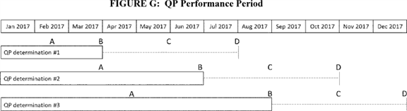

**[*77448]**



c. Partial QP Election To Report to MIPS

Section 1848(q)(1)(C)(ii)(II) of the Act excludes from the definition of MIPS eligible clinician an eligible clinician who is a Partial QP for a year. However, under section 1848(q)(1)(C)(vii) of the Act, an eligible clinician who is a Partial QP for a year and reports on applicable measures and activities as required under the MIPS is considered to be a MIPS eligible clinician for the year. To carry out these provisions, we proposed to require that each Advanced APM Entity must make an election each year on behalf of all of its identified participating eligible clinicians on whether to report under MIPS in the event that the eligible clinicians participating in the Advanced APM Entity are determined as a group to be Partial QPs for a year. We proposed that the Advanced APM Entity could change its election for a year at any time during the QP Performance Period, but the election would become permanent at the close of the QP Performance Period. We believe that this is consistent with our proposed general policy to make QP determinations at the Advanced APM Entity level, and with related MIPS policies described in section II.E.3.h. of this final rule with comment period, under which we proposed that each APM Entity would be considered a group for purposes of MIPS reporting. Therefore, we believe that the decision of whether to report and subsequently be subject to MIPS adjustments should also be made at the group level. We solicited comment on whether the Advanced APM Entity or each individual eligible clinician should make the Partial QP MIPS reporting election.

As discussed in section II.E.3.h. of this final rule with comment period, we recognize that the Shared Savings Program eligible clinicians participate as a complete TIN such that all of the eligible clinician participants in the participant billing TIN participate in the Shared Savings Program. Therefore, we also solicited comment on an alternative approach for Shared Savings Program APM Entities in which each individual billing TIN participating in the APM Entity would make the Partial QP election on behalf of its individual eligible clinicians and that election would be applied to all eligible clinicians in that individual billing TIN, as opposed to having the APM Entity (ACO) make the Partial QP election. We stated that we would only undertake this alternative paired with determining a MIPS final score for each TIN within an APM Entity (ACO) at the TIN level, an alternative discussed under the APM scoring standard in the proposed rule.

Our proposal that Partial QPs may choose whether to report to MIPS has two additional interactions with other proposed policies. First, because we proposed unique MIPS scoring policies for MIPS eligible clinicians participating in certain APMs, the election by the APM Entity not to report under MIPS is in effect a decision to tell us not to score the information submitted by the APM Entity under MIPS. Under our proposal, that decision would be made at the APM Entity level. APM Entities and eligible clinicians would continue to report to their respective APMs as required under the terms of their participation agreements with us.

Second, given the proposed timeframe for QP determinations under section II.F.5.a. of the proposed rule [*(81 FR 28313),*](https://advance.lexis.com/api/document?collection=administrative-codes&id=urn:contentItem:5JR6-TD50-006W-8163-00000-00&context=) our proposed treatment of claims run-out, claims adjustments, supplemental service payments, and alternative payment methods for purposes of QP determination (further detailed in section II.F.8 of the proposed rule [*(81 FR 28339)),*](https://advance.lexis.com/api/document?collection=administrative-codes&id=urn:contentItem:5JR6-TD50-006W-8163-00000-00&context=) and the and subsequent notification of QP determinations proposed under section II.F.5.d. of the proposed rule [*(81 FR 28322),*](https://advance.lexis.com/api/document?collection=administrative-codes&id=urn:contentItem:5JR6-TD50-006W-8163-00000-00&context=) eligible clinicians who become Partial QPs would not receive notification of this status until after the proposed timeframe for the MIPS reporting period will have closed. Although the information necessary for MIPS reporting would already be prepared in our systems by the time the Partial QP determination is made, a prospective election by the Advanced APM Entity to not be scored under MIPS and receive a MIPS payment adjustment would signal us to not transfer information from our reporting system to the MIPS scoring system in the event of a Partial QP determination, and that any submitted information is not to be used for purposes of a MIPS assessment or payment adjustment. Thus, by choosing not to report under MIPS, those Advanced APM Entities and eligible clinicians determined to be Partial QPs would be exempted from the MIPS payment adjustment for that year. We solicited comment on the timing and process for Advanced APM Entities to elect whether to be subject to MIPS in the event of a Partial QP determination.

The following is a summary of the comments we received regarding our proposal for Advanced APM Entities to determine whether or not to be subject to MIPS in the event that their eligible clinicians are determined to be Partial QPs.

*Comment:* Several commenters expressed opinions about the level at which the Partial QP decision is made of whether or not to report to MIPS. Most of these commenters stated strong support for the proposed policy that the decision be made at the APM Entity level in order to reinforce the collective nature of APM participation, and, in the event the group is subject to MIPS through a Partial QP election or missing the Partial QP and QP thresholds, the use of the APM Entity as the defining group for MIPS scoring. Other commenters stated support for QPs to make the decision at a TIN level in order to align with billing, other activities outside the APM context, and the TIN-based structure of the Shared Savings Program. A few commenters expressed that the decision should be made individually by each eligible clinician.

*Response:* We agree that although there could be some advantages to TIN-level Partial QP decisions, it is most appropriate to retain consistency within the Quality Payment Program in which eligible clinicians in APMs are primarily assessed at the APM Entity level. In the cases for which we make the Partial QP determination at the individual eligible clinician level, those individual eligible clinicians would accordingly make the Partial QP election of whether to be subject to MIPS payment adjustments at an individual level.

*Comment:* Some commenters expressed general support for the Partial QP election policy because it enables a degree of flexibility and choice to recognize those who participate in Advanced APMs to some extent, despite the fact that the eligible clinicians did not reach the QP threshold.

*Response:* We thank the commenters for their support.

*Comment:* Several commenters expressed concern about the timing of the Partial QP determinations. They stated that, as proposed, Partial QPs would not be able to make a fully-informed decisions because they would make their decision of whether or not to be subject to MIPS prior to knowing their ultimate QP status; therefore, Partial QP determinations should be made earlier to avoid prospective decisions.

*Response:* We agree with commenters that Partial QP decisions regarding MIPS should not be made without any information regarding a group's QP status. We believe that we resolve this issue through the finalized QP Performance Period policy so that all Advanced APM participants will know if they are Partial QPs by the beginning **[*77449]** of the MIPS submission period and will not need to make MIPS decisions as Partial QPs prior to that point in time.

*Comment:* Some commenters were concerned that Partial QPs would not have enough information to made decisions about whether to report to MIPS.

*Response:* We note that no eligible clinicians, regardless of whether they are Partial QPs, will be able to know their MIPS payment adjustments until they are actually announced just before the payment year, so a Partial QP decision to report to MIPS does carry with it some unavoidable uncertainty. Each Advanced APM Entity will need to weigh its options of the burden of reporting and likelihood of positive MIPS adjustments with the certainty of choosing exclusion from MIPS payment adjustments, which could be upward, neutral, or downward adjustments for the payment year.

*Comment:* Some commenters suggested alternatives to the consequences of Partial QP status. One commenter recommended that Partial QPs receive a partial bonus payment. Another commenter recommended that Partial QPs who report MIPS data should receive the higher amount of the MIPS adjustments or the neutral payment adjustment. In other words, the commenter suggested that MIPS adjustments should apply if positive but not apply if negative.

*Response:* We appreciate the ideas for Partial QP policies, but we do not believe the statute provides for the kinds of Partial QP incentives suggested by the commenter.

In consideration of the comments and the modifications we are making to the proposed QP Performance Period policies, we are not finalizing the proposed policy that Advanced APM Entities would make prospective elections regarding whether or not to score their MIPS data in the event that they are determined to be Partial QPs. Instead, we are finalizing a modified policy such that, following a final determination that eligible clinicians in an Advanced APM Entity group are Partial QPs for a year, the Advanced APM Entity will make an election whether to report to MIPS, thus making all eligible clinicians in the Advanced APM Entity group subject to MIPS reporting requirements and payment adjustments for the year; if the Advanced APM Entity elects not to report, all eligible clinicians in the APM Entity group will be excluded from MIPS adjustments. In the cases where the QP determination is made at the individual eligible clinician level, if the eligible clinician is determined to be a Partial QP, the eligible clinician will make the election whether to report to MIPS and then be subject to MIPS reporting requirements and payment adjustments.

A Partial QP who elects not to report to MIPS, whether based on the decision of the APM Entity or the individual eligible clinician, similar to QPs, is excluded from MIPS across all TINs associated with that Partial QP's NPI. Partial QPs do not under any circumstance receive the APM Incentive Payment.

Under this finalized policy, only Partial QPs must make this election after the Partial QP determination is made. The finalized QP Performance Period and QP determination policies apply to Partial QP determinations and enable Partial QP determinations to be made in a timeframe that makes the proposed prospective elections unnecessary. This means that Advanced APM Entities do not make a Partial QP decision on behalf of their constituent eligible clinicians unless and until that group actually is determined to be a Partial QP. Similarly, eligible clinicians for whom we make individual QP determinations do not elect whether to report to MIPS unless and until the eligible clinician is determined to be a Partial QP for the year.

We also clarify how we consider the absence of an explicit election. For situations in which the APM Entity is responsible for making the determination on behalf of all eligible clinicians in the APM Entity group, the group of Partials QPs will not participate in MIPS unless the APM Entity opts the group into MIPS participation so that no actions other than the APM Entity's election for the group to participate in MIPS would result in MIPS participation. We believe that this default minimizes the possibility of unexpected participation in MIPS and also recognizes that most APM Entity groups in this situation would be scored collectively under the APM scoring standard in MIPS, thus necessitating group decision-making.

For situations in which an eligible clinician is determined to be a Partial QP individually, we will use the eligible clinician's actual reporting activity to determine whether to exclude the Partial QP from MIPS in the absence of an explicit election. Therefore, if an eligible clinician determined as an individual to be Partial QP submits information to MIPS (which does not include information automatically populated or calculated by CMS on the Partial QP's behalf), we will consider the Partial QP to have reported and thus be participating in MIPS. Likewise, if an eligible clinician determined as an individual to be a Partial QP does not take any action to submit information to MIPS, then we will consider the Partial QP to have elected to be excluded from MIPS.

We anticipate that there will be relatively few Partial QPs, especially in the first few years of the Quality Payment Program; therefore, we believe that this finalized policy will reduce administrative burden on Advanced APM participants and operate most smoothly with our finalized policies for QP determinations.

d. Notification of QP Determination

We proposed to notify both Advanced APM Entities and their participating eligible clinicians of their QP or Partial QP status as soon as we have made the determination and performed all necessary validation of the results. We proposed that this notification would be made directly to the Advanced APM Entity and eligible clinician, and made in combination with a general public notice on the CMS Web site that such determinations have been completed for the applicable QP Performance Period. We proposed that this notification would also contain other necessary and useful information, such as what actions, if any, an Advanced APM Entity or eligible clinician may or should take with respect to MIPS.

We solicited comment on our proposals to make the QP and Partial QP status notifications. We also solicited comment on other methods and media for the notification of QP and Partial QP status. We also solicited comment on the content of such notifications so that they may be as clear and useful as possible.

The following is a summary of the comments we received regarding our proposal to make notifications regarding the results of QP and Partial QP determinations.

*Comment:* Many commenters suggested that CMS notify Advanced APM participants of their QP status as soon as possible so that they can know whether or not they should report to MIPS. Several commenters specifically stated that notification should be made during the QP Performance Period or by February 1 or March 1 of the year following the QP Performance Period.

*Response:* We agree that timely notification is important, and we understand that much of the concern for receiving timely notifications is related primarily to the QP Performance Period timeframe. We can only notify Advanced APM participants of their QP status as soon as such status is finalized, and as proposed, that notification could **[*77450]** not have occurred prior to April or May of the year following the QP Performance Period. However, under the finalized QP determination timeframe, we will be able to complete QP determinations at three separate times during the QP Performance Period, thus enabling significantly earlier notifications than proposed.

*Comment:* Several commenters stated the need for clear communication and offered suggestions on the types of content that should be contained in the notifications. Some commenters recommended that we provide Advanced APM participants with comprehensive information on their Threshold Scores using both the payment amount and patient count methods so that they can see precisely where they stand in relation to the QP thresholds. Other commenters stated that we should send preliminary information to Advanced APM participants before the actual QP determinations so that they can predict their QP status. Finally, some commenters requested that we send reports with data sufficient for Advanced APM Entities to replicate and verify the Threshold Score calculations. Finally, one commenter requested that we include an appeals process following notification of the QP determinations.

*Response:* We agree that supplying useful information about Threshold Scores under the different methods in concert with the QP determination is a valuable goal. We will take all of these comments into account as we develop the notification format and content. We also plan to supply Advanced APM participants with preliminary analyses based on their historical claims to help them understand their likelihood of meeting the QP thresholds were they to practice in the Advanced APM similarly to how they have done previously. Finally, section 1833(z)(4) of the Act explicitly excludes administrative or judicial review of the QP determinations, but we will ensure that the calculations undergo a rigorous quality assurance process prior to finalization.

*Comment:* Some commenters provided suggestions as to which parties should receive notifications of QP status. One commenter suggested that we send notifications to the Advanced APM Entity and the eligible clinicians in writing or via email and that we publicly post the determinations on the CMS Web site. One commenter stated that the Advanced APM Entity should receive the notification instead of TINs that may be part of the Advanced APM Entity.

*Response:* We thank the commenters for their suggestions, and we agree that it is important to ensure that the appropriate parties are properly notified of their status. We will take these comments into consideration when developing our notification processes.

We are finalizing the proposal to notify Advanced APM Entities and eligible clinicians of their QP or Partial QP status as soon as we have made the determination and performed all necessary validation of the results. This notification process will occur for each of the three QP determinations that we will perform during a QP Performance Period. We will provide additional information on the format of such notifications and the data we will include as part of our public communications following this final rule with comment period.

6. Qualifying APM Participant Determination: Medicare Option

a. In General

Under the Medicare Option, we proposed to calculate a Threshold Score for an Advanced APM Entity--or eligible clinician in the cases of an exception described in section II.F.5.b. of the proposed rule [*(81 FR 28319)*](https://advance.lexis.com/api/document?collection=administrative-codes&id=urn:contentItem:5JR6-TD50-006W-8163-00000-00&context=)--based on participation in an Advanced APM by analyzing claims for Medicare Part B covered professional services. Under the alternative calculation using patient counts in lieu of payments (patient count method), we proposed to similarly calculate a Threshold Score for the Advanced APM Entity based on patient attribution as described in the proposed rule. Under either the payment amount or patient count method, only Medicare Part B covered professional services under the PFS will count toward the numerator and denominator of the Threshold Score calculation.

Section 1833(z)(2)(A), (B)(i) and (C)(i) of the Act describes the QP determination using the Medicare payment method as follows: A QP is an eligible clinician whose payments under this part for covered professional services furnished by such professional during the most recent period for which data are available (which may be less than a year) were attributable to such services furnished under this part through an Advanced APM Entity. Section 1833(z)(2)(D) of the Act describes the basis for the patient count method.

(1) Attributed Beneficiaries

In section II.F.3. of the proposed rule [*(81 FR 28295),*](https://advance.lexis.com/api/document?collection=administrative-codes&id=urn:contentItem:5JR6-TD50-006W-8163-00000-00&context=) we proposed two definitions that would apply specifically for the purposes of QP determination: Attributed beneficiary and attribution-eligible beneficiary. Each term describes a particular relationship between an Advanced APM Entity and the beneficiaries for whose cost and quality of care the participating eligible clinicians are held accountable. These terms are the foundation for how we propose to count services furnished through an Advanced APM Entity.

We proposed that "attributed beneficiary" be defined as a beneficiary attributed to the Advanced APM Entity on the latest available list of attributed beneficiaries during the QP Performance Period based on each APM's respective attribution rules. There are some natural advantages to using this term for the purposes of QP determination because it is consistent with how many APMs--including the Shared Savings Program (assigned beneficiaries), Next Generation ACO Model (aligned beneficiaries), and BPCI Model (attributed beneficiaries)--identify the beneficiaries whose outcomes and costs are included in an APM Entity's assessment. We believe that using the same construct also coordinates the incentives under the Advanced APM with the incentives under the MACRA by addressing the same beneficiary population.

In most episode payment models, such as the CJR Model, attribution is defined by the beneficiaries who trigger the defined episode of care under the model, often by presenting with a specific condition at the location of a participating APM Entity. In many attribution-based APMs, such as ACO initiatives or the Comprehensive Primary Care Initiative, CMS attributes beneficiaries to APM Entities through claims-based algorithms that identify the APM Entity with the plurality of evaluation and management visits for a beneficiary. In addition, most APMs do not allow beneficiaries to be attributed to more than one APM Entity. This means that the greater the APM Entity density in a market, the lower the attributed population for a given APM Entity will be as a percent of its total beneficiaries. We solicited comment on the proposed methodology for defining the attributed beneficiary population, including comment on alternative methods for capturing the most meaningful cohort of attributed beneficiaries. **[*77451]**

Under these plurality-based approaches, typically only 30-50 percent of an Advanced APM Entity's total population of beneficiaries for whom its eligible clinicians furnish services are actually attributed to the Advanced APM Entity for a performance period. These percentages reflect a combination of CMS' design decisions, beneficiaries' underlying care patterns, and the fact that beneficiaries in Medicare FFS retain freedom of choice to select clinicians. These percentages reflect conditions that are not entirely under the control of the APM Entity or its eligible clinicians. Thus, we recognize that because Advanced APMs have different attribution methodologies, using the specific Advanced APM attributed beneficiary as the definition may create a standard that advantages or disadvantages participation in certain Advanced APMs relative to others simply based on the specific attribution policies.

We proposed to use the attributed beneficiaries on Advanced APM attribution lists generated by each Advanced APM in making QP determinations. We also proposed that the attributed beneficiary list would be taken from the Advanced APM's latest available list at the end of the QP Performance Period prior to making the QP determinations. For episode payment models, attributed beneficiaries would be those beneficiaries who trigger episodes of care under the terms of the APM.

We believe that this approach to attribution lists maintains consistency with the panel of beneficiaries for whom Advanced APM Entities are responsible under their respective Advanced APMs during the QP Performance Period. Therefore, we believe that such lists would be appropriate for use in QP determinations. Advanced APM Entities are already accustomed to providing care for the panel of beneficiaries represented by their APM Entity-specific list. We believe that our proposal to link attribution for QP determination to Advanced APM attribution lists further strengthens the goals of the Advanced APMs in which these Advanced APM Entities participate. By using the same beneficiary population for QP determination purposes, Advanced APM Entities may continue focusing on the care they furnish to the same panel of attributed beneficiaries, instead of shifting focus and changing practice patterns to reach a QP threshold. As stated in our principles in section II.F.1. of the proposed rule [*(81 FR 28293),*](https://advance.lexis.com/api/document?collection=administrative-codes&id=urn:contentItem:5JR6-TD50-006W-8163-00000-00&context=) we intend for the QP determination process to seamlessly reward participation in Advanced APMs, not to create a new set of performance standards distinct from the goals of APMs.

We solicited comment on our proposal for determining which beneficiaries are considered attributed to an Advanced APM Entity.

The following is a summary of the comments we received regarding our proposal to define the attributed beneficiary population based on actual Advanced APM attribution and to use the latest available attribution list at the end of the QP Performance Period for QP determinations.

*Comment:* We received several comments related to attribution more generally, such as how to improve attribution in APMs, enable attribution across multiple entities or APMs, allow for review and modification of attribution lists, and requests for clarification of how attribution is performed in APMs.

*Response:* We thank the commenters for their input. However, these issues are beyond the scope of this final rule with comment period.

We are finalizing the definition of attributed beneficiary as proposed. We are finalizing that we would identify the attributed beneficiaries for an Advanced APM Entity based on the latest available attribution list at the time of a QP determination. This differs slightly from the proposed policy in order to align with the finalized QP Performance Period policies in this section and enable QP determinations to be made earlier in the QP Performance Period.

(2) Attribution-Eligible Beneficiaries

Consistent with our proposed definition of attributed beneficiary, our proposed definition for an attribution-eligible beneficiary would allow us to be consistent across Advanced APMs in how we consider the population of beneficiaries served by an Advanced APM Entity for the purposes of QP determination. To be attributed to an Advanced APM Entity in an Advanced APM, a beneficiary is first required to meet certain eligibility criteria. Specifically, for purposes of QP determinations, we propose that an attribution-eligible beneficiary would be one who:

(1) Is not enrolled in Medicare Advantage or a Medicare cost plan.

(2) Does not have Medicare as a secondary payer.

(3) Is enrolled in both Medicare Parts A and B.

(4) Is at least 18 years of age.

(5) Is a United States resident.

(6) Has a minimum of one claim for evaluation and management services by an eligible clinician or group of eligible clinicians within an APM Entity for any period during the QP Performance Period.

An attribution-eligible beneficiary may or may not be an attributed beneficiary. Attributed beneficiaries are a subset of attribution-eligible beneficiaries. Much like the term "attributed beneficiary," the term attribution-eligible beneficiary is generally consistent with the attribution methodologies used in most current APMs to identify the beneficiaries who could potentially be attributed to an APM Entity. Although the factors we proposed for the definition of an attribution-eligible beneficiary in this context would only apply for the purposes of QP determinations, and would not change APM-specific methodologies, we believe that the factors in the proposed definition are representative of the methodologies most current APMs use to perform attribution. Therefore, we believe it would serve as a practical common set to apply in QP threshold calculations.

The purpose of using the attribution-eligible construct is to ensure that the denominator of QP determination calculations described in this section only includes payments for services furnished to patients who could potentially be attributed to an Advanced APM Entity under the Advanced APM, and thus could also appear in the numerator of the QP determination calculations. We believe that including amounts in the denominator that could not possibly be included in the numerator would be arbitrarily punitive toward certain Advanced APM Entities that furnish services to a substantial population of non-attribution-eligible beneficiaries.

We note that specialty-focused or disease-specific APMs may have attribution methodologies that are not based on evaluation and management services. Therefore, we anticipate needing targeted exceptions, especially related to the sixth factor of the definition of attribution-eligible beneficiary, for such APMs so that the attributed beneficiary population is truly a subset of the attribution-eligible population. Such exceptions would be made either through rulemaking or using available waiver authority and would be announced when the APM is announced.

For example, under the CEC Model, one criterion, among others, to be an aligned beneficiary requires that the beneficiary receive maintenance dialysis services. In the event that the CEC Model were determined to be an Advanced APM, we would consider **[*77452]** attribution-eligible beneficiaries for the APM Entities participating in the CEC Model to be beneficiaries that meet the first five criteria outlined above and that have had at least one maintenance dialysis service billed through the Advanced APM Entity during the QP Performance Period. We would make this exception for the CEC Model to ensure that the denominator of QP determination calculations described in this section only includes payments for services furnished to patients who could potentially be attributed to an Advanced APM Entity under the Advanced APM.

Although the availability of such exceptions, as outlined above, would create multiple standards for the beneficiaries that are attribution-eligible, we believe this slightly more complex approach is more appropriate and equitable because it is consistent with the design of APMs. An alternative approach could be to have a simple standard that includes in the denominator all beneficiaries who are furnished any Medicare Part B covered professional service by eligible clinicians participating in the Advanced APM Entity.

We solicited comment on the proposed general definition of attribution-eligible beneficiary and on our proposal to use of APM-specific standards as necessary to fulfill our expressed goals for specialty- or disease-focused APMs that may use alternative attribution methodologies.

The following is a summary of the comments we received regarding our proposal to define attribution-eligible beneficiaries.

*Comment:* Many commenters stated support for altering the definition of attribution-eligible in circumstances when an Advanced APM does not base attribution on evaluation and management services in order to support disease- and specialty-focused APMs, such as BPCI, CJR, OCM, and CEC, with the assumption that these APMs would be Advanced APM. Some commenters requested that we explain how such exceptions will be made and that stakeholders have input in defining the rules.

*Response:* We do not believe that there should be a formal application process for these exceptions because we operate both the Quality Payment Program and Advanced APMs. Therefore, we will make assessments appropriate to the interactions between programs. As we explained, we would for the CEC Model, consider whether the evaluation and management service basis for the definition of attribution-eligible beneficiary is appropriate for assessing eligible clinicians' participation in an Advanced APM. If evaluation and management services are significantly at odds with actual attribution and the evaluation of performance on the cost and quality of beneficiary care under an Advanced APM, we may consider a different basis for the attribution-eligible beneficiary definition that takes into consideration attribution within the Advanced APM. In that case, we would make an exception either through rulemaking or by using available waiver authority that would be announced in connection with notifications for the APM.

*Comment:* In direct response to our solicitation on defining attribution-eligible beneficiaries in the context of the CEC initiative, several commenters suggested that only patients on dialysis be included in the attribution-eligible definition, which would exclude those patients with CKD or a kidney transplant unless and until the CEC initiative expands to include responsibility for CKD or kidney transplant patients.

*Response:* We appreciate the detailed input commenters offered in response to our solicitation regarding the CEC initiative and agree that these are important components to appropriately defining the attribution-eligible population. We will take these responses into account as needed to develop the basis for attribution-eligible beneficiaries for CEC.

We are finalizing the definition of attribution-eligible to mean a beneficiary who:

* Is not enrolled in Medicare Advantage or a Medicare cost plan.

1. Does not have Medicare as a secondary payer.
2. Is enrolled in both Medicare Parts A and B.
3. Is at least 18 years of age.
4. Is a United States resident.
5. Has a minimum of one claim for evaluation and management services by an eligible clinician or group of eligible clinicians within an APM Entity for any period during the QP Performance Period.

We are also finalizing that, for Advanced APMs that do not base attribution on evaluation and management services and for which attributed beneficiaries are not, in fact, a subset the attribution-eligible beneficiary population based on the requirement to have at least one claim for evaluation and management services furnished by an eligible clinician who is in the APM Entity for any period during the QP Performance Period, then we will modify the definition of attribution-eligible beneficiary for that Advanced APM only in order to identify the appropriate attribution-eligible population based upon the attribution methodology of the Advanced APM (for example, a combination of evaluation and management services and/or other Part B covered professional services). We will announce these exceptions to the extent applicable in a manner consistent with the Advanced APM notification process under section II.F.4. of this final rule with comment period.

For example, we would develop such an exception for the CEC Model to the extent it is determined to be an Advanced APM to ensure that the denominator of QP determination calculations described in this section only includes payments for services furnished to patients who could potentially be attributed to ESRD Seamless Care Organizations (ESCOs).

b. Payment Amount Method

This section describes how we will calculate a Threshold Score for the eligible clinician group in an Advanced APM Entity--or individual eligible clinician in the exception situations under section II.F.6. of this final rule with comment period--using the payment amount method, which would then be compared to the relevant QP Payment Amount Threshold and Partial QP Payment Amount Threshold to determine if the eligible clinician meets the QP status for a payment year.

(1) Claims Methodology and Adjustments

For the payment amount method, sections 1833(z)(2)(A), (B)(i) and (C)(i) of the Act requires that we use payments for Medicare Part B covered professional services to make QP determinations. Covered professional services are defined under section 1848(k)(3)(A) of the Act as services for which payment is made under, or based on, the PFS. The payment amounts discussed in this proposal only include payments for Medicare Part B services under, or based on, the PFS, even if an Advanced APM bases attribution and/or financial risk on payments other than or in addition to Medicare Part B payments.

We proposed to use all available Medicare Part B claims information generated during the QP Performance Period. Additionally, we propose that CMS will treat claims run-out, claims adjustments, supplemental service payments, and alternative payment methods in the same manner for purposes of calculating both the Threshold Score and for determining the APM Incentive Payment amount. We further detailed our proposals to account for claims run-out, claims **[*77453]** adjustments, non-claims-based payments, and alternative payment methods in section II.F.8. of the proposed rule [*(81 FR 28339).*](https://advance.lexis.com/api/document?collection=administrative-codes&id=urn:contentItem:5JR6-TD50-006W-8163-00000-00&context=)

We believe it is appropriate to maintain consistency across the QP determination and the incentive payment calculation in order to support internal CMS operational consistencies. It also ensures that any unique payment mechanisms within an Advanced APM do not affect the opportunity for an eligible clinician to reach the QP threshold.

We solicited comment on whether the claims methodology we use under the Medicare payment method should align with the proposed claims methodology for purposes of calculating the estimated aggregate payment amount for the APM Incentive Payment.

The following is a summary of the comments we received regarding our proposal for the QP payment amount method to use all available claims information for Medicare Part B covered professional services during the QP Performance Period and to treat claims run-out, claims adjustments, supplemental service payments, and alternative payment methods in the same manner as that used for the APM Incentive Payment calculation.

*Comment:* Several commenters expressed general support for the QP determination methodologies in this section, including our interpretation of which payments and patients are considered "through" an Advanced APM and that we will use the same treatment of claims for calculating the Threshold Scores in this section and the APM Incentive Payment in section II.F.8. of this final rule with comment period.

*Response:* We thank the commenters for their support of our approach to QP determination methodologies.

*Comment:* Some commenters were uncertain about how "incident to" items and services would be considered in QP calculations.

*Response:* We would consider "incident to" billing for covered professional services to be covered professional services when calculating the Threshold Scores, as long as the NPI billing for the "incident to" claims is identified as a participant in the Advanced APM Entity. We further clarify that this would exclude "incident to" payment for drugs, biologics, and devices covered under Medicare Part B because those are not covered professional services.

*Comment:* One commenter requested that we use the Medicare paid amount instead of the allowed amount when calculating the Threshold Score.

*Response:* We do not believe it would be appropriate to use the Medicare paid amount instead of the allowed amount when calculating Threshold Scores. The Medicare paid amount reflects any reductions from the Medicare PFS amount for beneficiary co-payments or coinsurance requirements, and also reflects any payment adjustments that are applied to fee schedule payments, such as positive or negative payment adjustments from the PQRS, MU, VM, or MIPS programs. Including these adjustments is inconsistent with our proposal to exclude payment adjustments from these programs that we finalized in section II.F.8. of this final rule with comment period.

We are finalizing that for the QP payment amount method we will use all available claims information for Medicare Part B covered professional services during the applicable QP determination period as described in this section of the final rule with comment period.

(2) Threshold Score Calculation

In general, our method for deriving a Threshold Score for an Advanced APM Entity is to divide the value described under paragraph (a) in this section by the value described under paragraph (b) of this section. This calculation will result in a percent value that CMS will compare to the QP Payment Amount Threshold and the Partial QP Payment Amount Threshold to determine the QP status for all eligible clinicians in the Advanced APM Entity for the payment year.

(a) Numerator

We proposed that the numerator for this calculation would be the aggregate of all payments for Medicare Part B covered professional services furnished by the eligible clinicians in the Advanced APM Entity to attributed beneficiaries during the QP Performance Period.

We believe that this method is the most logical reading of the statute and is reflective of the population of beneficiaries for whom an Advanced APM Entity is responsible for cost and quality. Therefore, we believe that counting payments for covered professional services furnished to attributed beneficiaries is the most suitable metric for payments that are attributable to services furnished "through" an Advanced APM Entity. In episode payment models, because a beneficiary is considered attributed during the course of an episode, the payments included in the numerator for this calculation are those for Medicare Part B covered professional services furnished to an attributed beneficiary by eligible clinicians in the Advanced APM Entity during the course of an episode.

One program integrity concern is that an Advanced APM Entity might meet the higher QP Payment Amount Threshold in later years by providing substantially disproportionate amounts of care for attributed beneficiaries relative to all others. However, because of the financial risk an Advanced APM Entity bears, which is usually based on expenditures, we believe that the relatively large potential loss under the Advanced APM would outweigh the advantage of any overutilization geared toward abusing Threshold Score calculations. We solicited comment on any alternative numerators we could use for purposes of the Medicare payment method that meaningfully meet statutory requirements, are understandable, and operationally feasible.

The following is a summary of the comments we received regarding our proposal to calculate the numerator of the Threshold Score under the QP payment amount method using the aggregate of all payments for Medicare Part B covered professional services furnished by the eligible clinicians in the Advanced APM Entity to attributed beneficiaries during the QP Performance Period.

*Comment:* We received few comments regarding the numerators for QP determinations, but most commenters were generally supportive of its basis in services furnished to an Advanced APM Entity's attributed beneficiary population. One commenter suggested that we essentially include all physician payments in the numerator for which a physician is listed as an attending physician because the commenter stated that hospitalists are ultimately responsible for all spending for a patient.

*Response:* We thank the commenters for their general support of our approach. We do not believe it is meaningful or consistent with the statute to design numerators that are mathematically the same as, or potentially larger than, denominators. Although we understand that Advanced APM participation may have valuable spillover effects into other aspects of clinical practice, we must base the calculations in terms of direct Advanced APM participation, not any activity that appears similar in nature to Advanced APM activity.

We are finalizing the numerator of the Threshold Score under the QP payment amount method to be the aggregate of all payments for Medicare Part B covered professional services furnished by the **[*77454]** eligible clinicians in the Advanced APM Entity to attributed beneficiaries during the timeframe used for QP determination.

This is identical to the proposed policy except that the applicable range of service dates will vary depending on which of the three QP determinations during a QP Performance Period is being performed in accordance with the finalized QP Performance Period policy in this section and illustrated in Figure G.

(b) Denominator

We proposed that the denominator in the Medicare payment method would be the aggregate of all payments for Medicare Part B covered professional services furnished by the eligible clinicians in the Advanced APM Entity to attribution-eligible beneficiaries during the QP Performance Period. We proposed that when the QP determination is made at the eligible clinician level as described in section II.F.5. of the proposed rule [*(81 FR 28313),*](https://advance.lexis.com/api/document?collection=administrative-codes&id=urn:contentItem:5JR6-TD50-006W-8163-00000-00&context=) the denominator would be the total of all payments for Medicare Part B covered professional services furnished to attribution-eligible beneficiaries by the eligible clinician. In episode payment models, the payments included in the denominator for this calculation as proposed would be those for Medicare Part B covered professional services furnished to any attribution-eligible beneficiary by eligible clinicians in the Advanced APM Entity. This would include all such services to all attribution-eligible beneficiaries whether or not such services occur during the course of an episode under the Advanced APM.

Including payment for services furnished only to attribution-eligible beneficiaries standardizes the denominator to ensure fairness across types of eligible clinicians and geographic regions. By using the attribution-eligible population, the denominator will not penalize entities for furnishing services to beneficiaries who could not possibly be in the numerator through attribution under an Advanced APM. For example, an ACO's eligible clinicians may furnish services to a large population of beneficiaries with Medicare as a secondary payer. Those beneficiaries may not be eligible for attribution to the ACO, and could never be included in the numerator. Therefore, we believe that this methodology focuses on factors for which Advanced APM Entities have some control rather than those for which they may have no control or that disadvantage certain organizational structures or types of APMs. We solicited comment on alternative methods that are consistent with the statutory language.

The following is a summary of the comments we received regarding our proposal to calculate the denominator of the Threshold Score for the QP payment amount method using the aggregate of all payments for Medicare Part B covered professional services furnished by the eligible clinicians in the Advanced APM Entity to attribution-eligible beneficiaries during the QP Performance Period.

*Comment:* Several commenters expressed support for the basis of the denominator being tied to attribution-eligible beneficiaries because it meaningfully limits the denominator to those beneficiaries that could potentially be in the numerator. Some commenters recommended that we consider adjusting the denominator to ensure that episodes are treated appropriately in the numerator and the denominator. For instance, one commenter suggested that the last element of the attribution-eligible definition be tied to all beneficiaries with the specific disease, condition, or episode to whom the Advanced APM Entity eligible clinicians furnished services for Medicare Part B covered professional services.

*Response:* We thank the commenters for their support and agree that the attribution-eligible construct is a meaningful way to define the denominator. We also believe that evaluation and management services remain a consistent standard that identifies the population of beneficiaries whom eligible clinicians can consider their patients, even though some APMs base attribution on services other than evaluation and management services. The narrow focus of some APMs, primarily episode payment models, may make it relatively difficult for participants to reach the QP thresholds in comparison to APMs that are based upon a more comprehensive assessment of beneficiary care. Nonetheless, we believe that the QP thresholds will still be attainable by episode payment model participants who have a significant portion of their practice focused on the services upon which the APM is based. Customizing the denominator to the particular services upon which an APM is focused could, in many cases, reduce the denominator so much that it would not be meaningfully representative of an eligible clinician's business under Medicare Part B. Under such an approach, the 5 percent APM Incentive Payment, which is based on an eligible clinician's payments for Part B covered professional services, could exceed the entire denominator value in many cases. Therefore, we continue to believe that the proposed policy as applied to episode payment models is appropriate and representative of an eligible clinician's degree of Part B-related participation in an Advanced APM.

*Comment:* A few commenters expressed concern that the denominator will be difficult for APM participants to estimate, thus causing uncertainty about their likely QP status. Most APMs currently provide APM Entities only with an attributed beneficiary list, not an attribution-eligible beneficiary list.

*Response:* We appreciate the feedback on the inability to precisely predict an Advanced APM Entity's Threshold Score because this is a new calculation without historical scores or readily available information on beneficiaries considered attribution-eligible. Each APM manages the beneficiary attribution rules and lists provided to participants. However, we believe that the preliminary Threshold Score information we plan to send to Advanced APM participants near the beginning of a QP Performance Period will mitigate these concerns. We welcome input for the future on particular types of data that Advanced APM participants would find helpful in their analyses.

*Comment:* Several commenters expressed concern about the potential difficulty of attaining high Threshold Scores based on the proposed denominator. In particular, commenters cited specialists, who in most cases may participate in only one ACO but often see a broad range of patients across many networks, most of whom are not attributed to the specialist's particular ACO. Commenters stated that this could result in a dilution of the denominator and be detrimental to the entire APM Entity's ability to meet the higher QP thresholds, creating an inadvertent incentive to remove specialists from Participation Lists in the future. Some commenters requested that we find a way other than attribution to define the denominator or to separately evaluate non-primary care practitioners so that the relative breadth of their practices is not a detriment to the Threshold Score. One commenter suggested that we extend the QP threshold increases so that the higher thresholds are further in the future. One commenter stated that it is unfair to have a metric for which attaining a 100 percent score is often not possible, particularly for specialty practice groups. Another commenter suggested that we simply use attributed beneficiaries in the denominator instead of attribution-eligible beneficiaries, acknowledging that this would **[*77455]** essentially give a 100 percent score to all Advanced APM Entities. Some commenters suggested that we exclude from attribution-eligible category any beneficiaries who are actually attributed to other Advanced APM Entities in order to address the issue of attribution ***competition*** over beneficiaries in regions with a high density of Advanced APM Entities. Finally, some commenters recommended that we include service area adjustments to account for mobile beneficiary populations that may only reside in an area for a portion of a year.

*Response:* We understand the commenters' concerns about the denominator being a key factor in reaching the higher QP thresholds. We agree and have developed the attribution-eligible definition in response to otherwise unrealistic thresholds for many organizations. That said, we do not believe it is necessary to make a 100 percent Threshold Score attainable to all Advanced APM participants because this is, as the name implies, a metric based on reaching a threshold. Once the threshold is met, no additional benefit accrues to those with higher Threshold Scores. With respect to the suggestion of removing beneficiaries attributed to other Advanced APM Entities from the denominator, we appreciate the idea and agree that it would have the effect of shrinking the denominator. However, we believe it is important to provide an incentive for Advanced APM Entities to strive to expand their attributed population. It is consistent with our goals that, within their capabilities, Advanced APM Entities are responsible for the cost and quality of as many beneficiaries as possible. With respect to service area adjustments, we believe that this would add a high degree of complexity to this calculation with very minimal positive impact on Threshold Scores.

We will closely monitor Threshold Scores, particularly with respect to the impact of specialist participation, the fragmentation of where beneficiaries seek their care, or circumstances such as high rates of "snowbird" patients affecting the denominator. We will monitor Threshold Scores at both the APM Entity and individual levels to understand how group Threshold Scores may vary based on characteristics of attributed beneficiary populations and the eligible clinicians in an Advanced APM Entity.

We believe that ACOs, which on average have specialist representation on their Participation Lists approximately representative of the specialist distribution nationally, will generally be able to meet the QP thresholds. We also believe that participation in any episode payment models that are Advanced APMs could be an opportunity, consistent with the relatively narrow scope of many episode payment models, for eligible clinicians to become a QP.

*Comment:* A few commenters believe that the attribution-eligible construct for the denominator could inadvertently create an incentive to not provide necessary services or to select patients for purposes of meeting the QP thresholds.

*Response:* We appreciate the consideration for program integrity concerns. We take these concerns seriously, and, as described in section II.F.9. of this final rule with comment period, we will be monitoring the program for patterns of behavior with unintended negative consequences.

We are finalizing the denominator of the Threshold Score under the QP payment amount method to be the aggregate of all payments for Medicare Part B covered professional services furnished by the eligible clinicians in the Advanced APM Entity to attribution-eligible beneficiaries during the timeframe used for QP determination. This is identical to the proposed policy except that the applicable range of service dates will vary depending on which of the three QP determinations during a QP Performance Period is being performed in accordance with the finalized QP Performance Period policy in this section.

c. Patient Count Method

Similar to the Medicare payment amount method, this section describes our proposal for calculating a Threshold Score for the eligible clinicians participating in an Advanced APM Entity--or eligible clinician in situations under section II.F.6. of this final rule with comment period--using the Medicare patient count method, which would then be compared against the relevant QP Patient Count Threshold and Partial QP Patient Count Threshold to determine the QP status of an eligible clinician for the year. Given our authority under section 1833(z)(2)(D) of the Act to use patient counts in lieu of payments "as the Secretary determines appropriate," we are interpreting the patient count method to offer a more flexible alternative to the payment method. As previously mentioned, the purpose of the proposed design of the Medicare patient count method is to make QP status determinations accessible to entities and individuals who are clearly and significantly engaged in delivering value-based care through participation in Advanced APMs.

(1) Unique Beneficiaries

We proposed that when counting the number of beneficiaries under this method, we may count a given beneficiary in the numerator and denominator for multiple different Advanced APM Entities or eligible clinicians.

We proposed that we would not count any beneficiary more than once for any single Advanced APM Entity or eligible clinician. In other words, for each Advanced APM Entity or eligible clinicians, we would count each unique beneficiary no more than one time in the numerator and one time in the denominator.

We believe that counting beneficiaries this way retains the integrity of the Threshold Scores by preventing double counting of beneficiaries within an Advanced APM Entity while recognizing the reality that beneficiaries often have relationships with multiple different organizations.

To be consistent with the Medicare payment method, we proposed that beneficiary counts would be based on any beneficiary for whom the eligible clinicians within an Advanced APM Entity receive payments for Part B covered professional services, or professional services furnished at an RHC or FQHC as described in this section, even if an Advanced APM bases its attribution and/or financial risk on both Parts A and B. We proposed that for this Threshold Score calculation, we would use any and all available Part B claims information generated during the QP Performance Period. We received no specific comments regarding our proposals to enable a beneficiary to be counted for multiple APM Entities but to count a beneficiary no more than once per APM Entity.

We are finalizing the policy for the Medicare patient count method to enable a beneficiary to be counted in the numerator and denominator for multiple APM Entities or eligible clinicians but to count a beneficiary no more than once in the numerator and once in the denominator per APM Entity or eligible clinician. We are also finalizing the policy to base patient counts on any beneficiary for whom the eligible clinicians within an Advanced APM Entity receive payments for Part B covered professional services, or professional services furnished at an RHC or FQHC as described in this section, and to use any and all available Part B claims information generated during the QP Performance Period. **[*77456]**

(2) Threshold Score Calculation

We proposed that the Threshold Score would be calculated under the Medicare patient count method as a percent by dividing the value described under paragraph (a) of this section by the value described under paragraph (b) of this section. We include the formula and examples in the summary equation below.

(a) Numerator

We proposed that the numerator would be the number of unique attributed beneficiaries to whom eligible clinicians in the Advanced APM Entity furnish Medicare Part B covered professional services during the QP Performance Period. For episode payment models, this would include the number of attributed beneficiaries furnished Medicare Part B covered professional services, or professional services at an RHC or FQHC as described in this section, by eligible clinicians in the Advanced APM Entity during the course of an episode under the Advanced APM.

We did not receive any comments uniquely responding to our proposal for the numerator in the patient count method that were not also applicable to the payment amount method. Therefore, relevant comments were addressed in the payment amount numerator section.

We are finalizing the policy that the numerator of the Threshold Score for the QP patient count method will be the number of unique attributed beneficiaries to whom eligible clinicians in the Advanced APM Entity furnish Medicare Part B covered professional services, or professional services at an RHC or FQHC as described in this section, during the QP determination timeframe. For episode payment models, the numerator will be the number of attributed beneficiaries furnished Medicare Part B covered professional services by eligible clinicians in the Advanced APM Entity during the course of an episode under the Advanced APM. This policy is identical to the proposed policy except that the applicable range of service dates will vary depending on which of the three QP determinations during a QP Performance Period is being performed in accordance with the finalized QP Performance Period policy in this section.

(b) Denominator

We proposed that the denominator would be the number of attribution-eligible beneficiaries to whom eligible clinicians in the Advanced APM Entity furnish covered professional services during the QP Performance Period. For episode payment models, this would include the number of attribution-eligible beneficiaries furnished Medicare Part B covered professional services by eligible clinicians in the Advanced APM Entity group at any point during the QP Performance Period, irrespective of whether such services occur during the course of an episode.

We solicited comment on alternative approaches to the patient count method that would achieve our goal of a simple and meaningful Threshold Score calculation.

We did not receive any comments uniquely responding to our proposal for the denominator in the patient count method that were not also applicable to the payment amount method. Therefore, relevant comments were addressed in the payment amount denominator section.

We are finalizing the denominator of the Threshold Score under the QP patient count method to be the number of attribution-eligible beneficiaries to whom eligible clinicians in the Advanced APM Entity furnish covered professional services during the timeframe used for QP determination.

This is identical to the proposed policy except that the applicable range of service dates will vary depending on which of the three QP determinations during a QP Performance Period is being performed in accordance with the finalized QP Performance Period policy in this section. In general, we believe that through consistency with the payment amount method, this approach balances our interests of relative simplicity and having a meaningful standard that recognizes the common aspects of attribution and accountability under Advanced APMs. Similar to the payment amount method, the patient count method represents a proportion of the patients for whom an Advanced APM Entity is accountable under the Advanced APM with respect to all patients who could potentially be attributed to the Advanced APM Entity under the Advanced APM.

(3) APM Entity Participation in Multiple Advanced APMs

We proposed that if the same Advanced APM Entity participates in multiple Advanced APMs and if at least one of those Advanced APMs is an episode payment model, we would add the number of unique beneficiaries in the numerator of the episode payment model Advanced APM Entity to the numerator(s) for non-episode payment models in which the Advanced APM Entity participates. For example, if an Advanced APM Entity is an ACO in Track 3 of the Shared Savings Program and also in the OCM (assuming these are both Advanced APMs for purposes of this example), we would add the entity's unique attributed beneficiaries in OCM to the numerator for its Shared Savings Program Track 3 Threshold Score calculation. We proposed that for purposes of the APM incentive, Advanced APM Entities would be considered the same if we determine that the eligible clinician Participation Lists are the same or substantially similar, or if the Advanced APM Entity participating in one Advanced APM is the same as, or is a subset of, the other.

The purpose of this proposal was to allow the logical combination of activities under multiple Advanced APMs where appropriate. We believe that the purpose of the incentives for Advanced APM participation is to capture the degree of Advanced APM participation generally, not simply the degree of participation within a single Advanced APM. Where relevant and operationally feasible, we want this program to encourage participation in multiple Advanced APMs. The counterfactual where we would not account for a single Advanced APM Entity's participation in multiple Advanced APMs could be seen as punitive. For instance, an Advanced APM Entity could serve the vast majority of its beneficiaries through several Advanced APMs, but unless that participation is aggregated, the entity could end up with several lower Threshold Scores that are below the QP Patient Count Threshold and not indicative of its broader participation.

We understand the difficulty associated with determining whether two Advanced APM Entities are in fact the same organization. It is highly unlikely that their Participation Lists would be exactly the same. Therefore, we solicited comment on how best to make a determination of substantial similarity, which includes, for example, matching organizational information, aligning TINs, and comparing Participation Lists. We also solicited comment on percentages of Participation List or TIN similarity that would be sufficient for APM Entities to be considered under this policy.

The following is a summary of the comments we received regarding our proposal that if the same Advanced APM Entity participates in multiple Advanced APMs and if at least one of those Advanced APMs is an episode payment model, we would add the number of unique beneficiaries in the numerator of the episode payment model Advanced APM Entity to the **[*77457]** numerator(s) for non-episode payment models in which the Advanced APM Entity participates.

*Comment:* Several commenters supported this proposed policy, and one commenter suggested that we define "substantially similar" so that either of the Advanced APM Entity Participation Lists must have at least a specified percentage of the eligible clinicians participating in the other Advanced APM Entity.

*Response:* We agree that it would be optimal to have a clear percentage of similarity standard that could apply across all APMs and APM Entities. However, many episode payment models construct Participation Lists or Affiliated Practitioner Lists differently than those in other APMs so the amount by which the individual eligible clinicians overlap is highly variable rates depending upon the entities.

After considering the comments and the difficulty of implementing this policy as proposed, we are not finalizing the proposed policy to combine the numerators of Advanced APM Entities that participate in multiple Advanced APMs with substantially similar Participation Lists. We do not believe that we have a reliable, precise mechanism for determining substantial similarity of Participation Lists. Further, we believe that the policy we finalized earlier in this section regarding how we would assess eligible clinicians who are in multiple Advanced APMs serves the intended purpose of this proposed policy because it gives an eligible clinician the opportunity to become a QP in the event that the eligible clinician does not become a QP through any one of the multiple Advanced APMs in which the eligible clinician participates. Therefore, we do not believe that our reconsideration of this policy will limit the opportunity of eligible clinicians to become QPs, and we believe that not finalizing this policy will promote operational and conceptual simplicity.

d. Use of Methods

We proposed that we would calculate Threshold Scores for eligible clinicians in an Advanced APM Entity under both the payment amount and patient count methods for each QP Performance Period. We also proposed that we would assign QP status using the more advantageous of the Advanced APM Entity's two scores.

We believe that both the payment amount and patient count methods produce valid Threshold Scores, even as there may be cases in which Threshold Scores vary enough that different QP determinations could result depending on which is used. In such an event, we do not believe that prioritizing the Threshold Score using one calculation over the other would yield an appropriate, non-arbitrary result. By using the more advantageous of the Threshold Scores achieved, we hope to promote simplicity in QP determinations and to maximize the number of eligible clinicians that attain QP status each year. We solicited comment on the use of the payment and patient count methods for the Medicare Option.

The following is a summary of the comments we received regarding our proposal to calculate for each Advanced APM Entity of eligible clinician the Threshold Score using both the payment amount and patient count methods and use the more advantageous of the two scores.

*Comment:* Many commenters expressed support for the use of the patient count method, for not double-counting beneficiaries, and for using the more favorable of the payment amount or patient count methods for each Advanced APM Entity because it reduces potential variations in Threshold Scores across practice patterns, certain specialty types, and the costs of services. Some supportive commenters recommended that we monitor results to potentially take action to ensure year-to-year stability in Threshold Scores. One commenter was concerned that the patient count methodology might be easier to game to meet the QP thresholds and encouraged CMS to consider whether this might create problematic incentives.

*Response:* As commenters suggest, we will monitor the results of QP determinations to see if there are cases of large disparities between the two methods that may indicate gaming.

We are finalizing the policy as proposed. We will calculate Threshold Scores for each Advanced APM Entity or eligible clinician using both the payment amount and patient count methods and apply the more advantageous QP result.

To clarify the meaning of "more advantageous," we mean that a QP determination takes precedence over a Partial QP determination, which takes precedence over not meeting either threshold. Therefore, if one method results in a QP determination and the other results in a Partial QP determination, we would apply the QP determination and disregard the Partial QP determination. We note that this is distinct from the numerical score, which is not directly comparable across the payment amount and patient count methods due to the different percentage thresholds for the respective methods. A lower numerical patient count Threshold Score may actually result in a more advantageous QP result than a relatively higher numerical payment amount Threshold Score.

e. Services Furnished Through CAHs, FQHCs, and RHCs

(1) Critical Access Hospitals (CAHs)

We proposed that professional services billed by CAHs under section 1834(g)(2)(B) of the Act (Method II CAH professional services) would count towards the QP determination threshold calculations for both the Medicare payment amount and patient count methods in both the numerator and the denominator, as applicable. These services would constitute "covered professional services" under section 1848(k)(3) of the Act because they are furnished by an eligible clinician and payment is based on the Medicare PFS. This policy is consistent with our treatment of payments for Method II CAH professional services for purposes of the EHR Incentive Program and PQRS adjustments under sections 1848(a)(7) and (8) of the Act, respectively. Under section 1848(a)(7) and (8) of the Act, the PQRS and EHR Incentive Program adjustments are applied to payments for covered professional services furnished by an eligible clinician in a Method II CAH.

CAHs were established under the Balanced Budget Act (BBA) of 1997 as a separate provider type with a distinct set of Medicare Conditions of Participation and their own payment methodology. CAHs are not subject to the Medicare Inpatient Prospective Payment System (IPPS) or the Medicare Outpatient Prospective Payment System (OPPS). Instead, CAHs are generally paid based on 101 percent of reasonable costs for inpatient services and are paid for outpatient services under one of two methods: the Standard Payment method outlined in section 1834(g)(1) of the Act (Method I), or the Optional Payment Method outlined in section 1834(g)(2) of the Act (Method II). A CAH is paid under Method I unless it elects to be paid under Method II.

Under Method I, for cost reporting periods beginning on or after January 1, 2004, payments to CAHs are made for outpatient CAH facility services at 101 percent of reasonable costs. Physicians and practitioners receive payment for professional services under the Medicare PFS. A CAH may elect Method II billing, under which the CAH bills Medicare for both facility services and professional services furnished to its outpatients by a physician or **[*77458]** practitioner who has reassigned his or her billing rights to the CAH. Even if a CAH makes this election, each physician or practitioner who furnishes professional services to CAH outpatients can choose to either: (1) reassign his or her billing rights to the CAH, agree to be included under the Method II billing, attest in writing that he or she will not bill Medicare for professional services furnished in the CAH outpatient department, and receive payment from the CAH for the professional services; or (2) elect to file claims for his or her professional services with Medicare for standard payment under the Medicare PFS.

As of January 1, 2004, payment for a physician's professional services provided at a CAH billing under Method II is 115 percent of the allowed amount, after applicable deductions, under the Medicare PFS. For a non-physician practitioner's professional services, the payment amount is 115 percent of the amount that otherwise would be paid for the practitioner's professional services, after applicable deductions, under the Medicare PFS.

(2) Rural Health Clinics (RHCs) and Federally Qualified Health Centers (FQHCs)

RHCs and FQHCs are facilities that furnish services that are typically furnished in an outpatient clinic setting. They are located in areas that have been designated as underserved or health professional shortage areas (HPSAs), and meet other requirements.

Under section 1833(a)(3) of the Act, RHCs are paid an all-inclusive rate (AIR) based on reasonable costs, subject under section 1833(f) of the Act to a maximum payment per visit that is established by Congress and updated annually based on the percentage change in the Medicare Economic Index (MEI) and subject to annual reconciliation. The per-visit limit does not apply to RHCs determined to be an integral and subordinate part of a hospital with fewer than 50 beds. Laboratory tests (excluding venipuncture) and technical components of RHC services are paid separately. The RHC payment limit per visit for CY 2016 is $ 81.32, effective January 1, 2016, through December 31, 2016.

The FQHC Medicare benefit was added when section 1861(aa) of the Act was amended by section 4161 of the Omnibus Budget Reconciliation Act of 1990. FQHCs are paid according to the FQHC PPS set out under section 1834(o) of the Act, in which Medicare pays a national encounter-based rate per beneficiary per day, with some adjustments. The unadjusted 2016 PPS rate is $ 160.60.

We proposed that professional services furnished at RHCs and FQHCs that participate in ACOs, and are reimbursed under the RHC AIR or FQHC PPS (respectively), be counted towards the QP determination calculations under the patient count method but not under the payment amount method.

In certain Medicare ACO APMs, RHC and FQHC services can be counted for purposes of attributing beneficiaries to an ACO. Therefore, we proposed to include beneficiaries attributed to an Advanced APM Entity in full or in part because of services furnished by RHCs or FQHCs in the patient counts used for QP determination calculations.

As previously stated, section 1833(z)(2)(D) of the Act permits us to use patient counts in lieu of payments when determining whether an eligible clinician is a QP "as the Secretary determines appropriate." Our proposal to include the professional services furnished by eligible clinicians at RHCs and FQHCs in the QP threshold calculations for the patient count method is essential to assure consistency with this program and existing APM attribution methodologies. An Advanced APM Entity is responsible for the cost and quality of care for all beneficiaries attributed to an APM Entity, including all professional services furnished to such beneficiaries, regardless of whether or not attribution was based on services furnished by an eligible clinician or by an RHC or FQHC. We believe such beneficiaries are clearly served through the Advanced APM Entity, and it would be potentially confusing to eligible clinicians and Advanced APM Entities to track this distinction strictly for purposes of QP determination. We also believe that it would be unduly burdensome and impractical for us to develop and maintain a separate list of beneficiaries aligned to each Advanced APM Entity from the full list of beneficiaries for whom an Advanced APM Entity is responsible under an Advanced APM.

Because professional services furnished by eligible clinicians at RHCs and FQHCs are not reimbursed under, or based on, the Medicare PFS, professional services furnished in these settings do not constitute "covered professional services" under section 1848(k)(3)(A) of the Act. In the Medicare Payment Amount Method, where payments for specified covered professional services are summed, only payments for covered professional services can be included.

We believe that our proposal will continue to encourage the development of APMs that span rural and/or underserved areas. We solicited comment on this proposal.

The following is a summary of the comments we received regarding our proposal to (1) include payments for Method II CAH professional services furnished by eligible clinicians in an Advanced APM Entity in the numerator of the Threshold Score for the payment amount method and (2) to allow Method II CAH professional services furnished by eligible clinicians in an Advanced APM Entity and professional services furnished by eligible clinicians in an Advanced APM Entity at RHCs and FQHCs to place a beneficiary in the numerator of the Threshold Score for the patient count method.

*Comment:* A few commenters expressed support for the treatment of CAH, RHC, and FQHC services to enable them to be a factor in the patient count method. One commenter stated that FQHC clinicians should be eligible for the APM Incentive Payment.

*Response:* If clinicians in RHCs or FQHCs meet the definition of eligible clinician set forth in section II.F.3. of this final rule with comment period and participate in an Advanced APM, then they will be considered for QP determination as part of the Advanced APM Entity along with all the other eligible clinicians in the group. The calculation of the APM Incentive Payment amount for an eligible clinician that practices at an RHC or FQHC will be subject to the specific criteria, which are based on Part B covered professional services, for calculating the APM Incentive Payment amounts outlined in section II.F.8.c. of this final rule with comment period.

We are finalizing the policy as proposed. We will include payments for Method II CAH professional services furnished by eligible clinicians in an Advanced APM Entity in the numerator of the Threshold Score for the payment amount method. We will also count a beneficiary in the numerator of the Threshold Score for the patient count method if the beneficiary receives Method II CAH professional services furnished by eligible clinicians in an Advanced APM Entity and professional services furnished by eligible clinicians in an Advanced APM Entity at RHCs and FQHCs. **[*77459]**

7. Combination All-Payer and Medicare Payment Threshold Option

a. Overview

Beginning in 2021, in addition to the Medicare Option, eligible clinicians may alternatively become QPs through the All-Payer Combination Option, described under section 1833(z)(2)(B)(ii) and (C)(ii) of the Act as the Combination All-Payer and Medicare Payment Threshold Option. Thus, there will be two avenues for eligible clinicians to become QPs--the Medicare Option and the All-Payer Combination Option. An eligible clinician need only meet the QP threshold under one of the two options to be a QP for the payment year. The All-Payer Combination Option provides an incentive for eligible clinicians to participate in payment arrangements with payers other than Medicare Part B that have payment designs similar to Advanced APMs. The All-Payer Combination Option uses both the methods described in the Medicare Option and methods that calculate payments for all services from all payers, with certain exceptions, that are attributable to participation in both Advanced APMs and Other Payer Advanced APMs.

Although the statutory QP threshold for an eligible clinician to be a QP (the QP Payment Amount Threshold) under the Medicare Option increases from 25 percent in 2019 and 2020 under section 1833(z)(2)(A) of the Act, to 50 percent in 2021 and 2022 under section 1833(z)(2)(B)(i) of the Act, to 75 percent beginning in 2023 under section 1833(z)(2)(C)(i) of the Act, the All-Payer Combination Option allows eligible clinicians with lower levels of participation in Advanced APMs to become QPs through sufficient participation in Other Payer Advanced APMs with payers such as State Medicaid programs and commercial payers, including Medicare Advantage plans. Section 1833(z)(2)(D) of the Act also allows the QP determination to be based on payment amount or on counts of patients in lieu of payments using the same or similar percentage criteria. These QP thresholds are presented in Tables 36 and 37 of this final rule with comment, and the process for the payment amount method is shown in Figures H and I of this final rule with comment. We may reassess the QP Patient Count Thresholds in future years based on the experience gained during the first years of operations.

In summary, in addition to becoming QPs through the Medicare Option, eligible clinicians may alternatively become QPs through the All-Payer Combination Option if the following steps occur as described in the associated sections of the proposed rule: (1) the eligible clinician submits to CMS sufficient information on all relevant payment arrangements with other payers; (2) based upon that information CMS determines that at least one of those payment arrangements is an Other Payer Advanced APM; (3) the eligible clinician meets the relevant QP thresholds by having sufficient payments or patients attributed to a combination of participation in Other Payer Advanced APMs and Advanced APMs. **[*77460]**

**[*77461]**

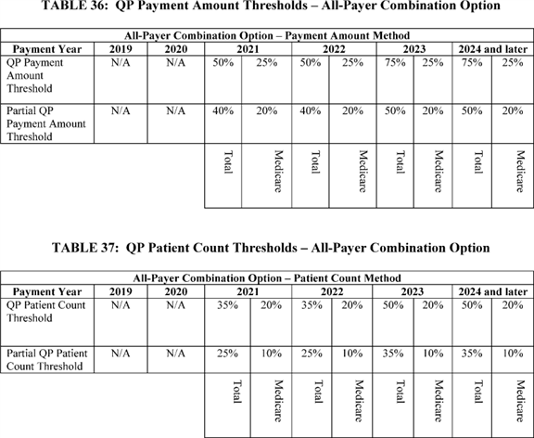

**[*77461]**

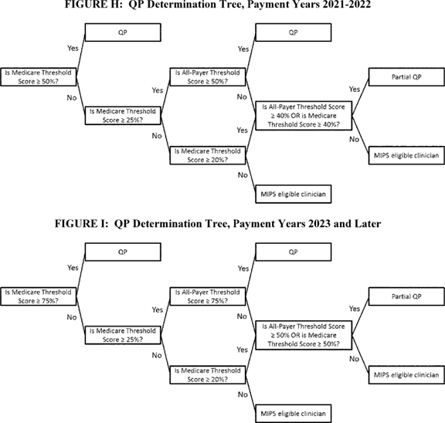

Sections 1833(z)(2)(B)(ii) and (C)(ii) of the Act describe the payment amount method for making the QP determination under the All-Payer Combination Option. For purposes of making a QP determination under this option, a QP is an eligible clinician for whom it is determined that items and services furnished by such a professional during the most recent period for which data are available (which may be less than a year) and where the specified percent of the sum of combined Medicare payments and all other payments regardless of payer are through Advanced APMs and Other Payer Advanced APMs that meet the criteria set forth in this section.

The following is a summary of the comments we received regarding our overall approach to the All-Payer Combination Option.

*Comment:* Several commenters supported aligning policies for the All-Payer Combination Option with those for the Medicare Option and emphasized the value of consistent models, measures, and reporting mechanisms across payers. One commenter appreciated our recognition of eligible clinicians engaging in APMs with payers other than Medicare and recommended that CMS minimize administrative burdens associated with such eligible clinicians demonstrating their participation in Other Payer Advanced APMs. Another commenter supported the proposal to implement the All-Payer Combination Option beginning in 2021.

By contrast, one commenter expressed concern about extending Advanced APMs to other payer arrangements by identifying Other Payer Advanced APMs. Another commenter noted we have historically emphasized the importance of engaging multiple payers in payment reform, but has never suggested that commercial payers must offer identical arrangements to those CMS offers or replicate CMS payment models. One commenter opposed using the same criteria to determine both Advanced APM and Other Payer Advanced APMs, noting that these criteria would require large-scale renegotiation of payer contracts, which may not be within an organization's control. One commenter recommended CMS abandon the All-Payer **[*77462]** Combination Option. Two commenters suggested that the All-Payer Combination Option be made effective earlier than payment year 2021, preferably payment year 2019. Another commenter encouraged CMS to accept risk-based non-Medicare contracts as Other Payer Advanced APMs beginning in payment year 2019. The commenter stated that clinicians who have invested in the transition to value-based care with many of their payers should not have to wait until 2021 to be rewarded.

*Response:* We appreciate the support for our proposed approach. We recognize that the All-Payer Combination Option will require adjustments and transitions. However, the All-Payer Combination Option is required by the statute, and we believe that it represents a promising opportunity for those participating in certain other payer arrangements to participate in the Advanced APM framework. The statute specifies the criteria for Other Payer Advanced APMs, and that those criteria generally mirror the Advanced APM criteria. However, the Other Payer Advanced APM criteria only address certain aspects of payment arrangements, leaving substantial room for flexibility. Just as they do for Advanced APMs, the criteria allow for exploration and testing of alternative payment arrangements that can improve quality and reduce cost. Finally, the statute does not allow us to make the All-Payer Combination Option effective prior to payment year 2021.

*Comment:* A commenter suggested CMS clearly define the process for determining whether a payment arrangement is an Other Payer Advanced APM. One commenter encouraged CMS to be flexible in the application of Other Payer Advanced APM criteria in order to encourage other payers to innovate. One commenter noted that among the 24 APMs reviewed by CMS, only six met all of the proposed criteria to be an Advanced APM, and that given these limitations, the commenter did not believe CMS has the flexibility to bring as many physicians as possible into Advanced APMs. As a result, this commenter believes Other Payer Advanced APMs and PFPMs might become more important to CMS goals, and recommended offering flexibility in the Other Payer Advanced APM criteria. One commenter recommended CMS provide additional flexibility to recognize as Other Payer Advanced APMs private payer reimbursement arrangements that accomplish high quality and efficient care but may not meet the Other Payer Advanced APM criteria. Another commenter recommended that the approach to assessing whether a payment arrangement will qualify as an Other Payer Advanced APM should be phased in so that initially, participation in any payment arrangement that meets some of the criteria could be considered an Other Payer Advanced APM, and then all three criteria would apply at a later time.

*Response:* We appreciate the comments and the widespread desire to make as many Other Payer Advanced APMs available as possible. The statute requires us to use the three criteria discussed in section II.F.7.b. of this final rule with comment period as the basis for determining whether a payment arrangement is an Other Payer Advanced APM. We believe our proposed and final policies adhere to the statute as well as to our principles and reflect the commenters' suggestions to allow substantial flexibility in the design of payment arrangements when implementing the Quality Payment Program.

*Comment:* Several commenters stated that CMS should include a thorough proposal of the criteria for Other Payer Advanced APMs in the CY 2018 PFS and/or issue subregulatory guidance.

*Response:* We appreciate the comments. We are not sure at this time the exact vehicles through which we will establish policies and publish more information in the future, but we intend to inform the public regarding developments in the All-Payer Combination Option and Other Payer Advanced APM criteria through future rulemaking and subregulatory guidance.

*Comment:* One commenter believes that the inclusion of all-payer data in APMs was the most important provision of the proposed rule and stated that the number of different measures and incentives across all payers created unnecessary burden and would be difficult to compare across APMs and payers. The same commenter recommended a standardized attribution model to ensure equitable treatment of models across payers. Some commenters requested to have additional guidance on the data collection requirements and the determination of Other Payer Advanced APMs as soon as practicable. Another commenter expressed concern that the proposed All-Payer Combination Option extends the CMS collection of, and access to, data beyond those of Medicare patients. One commenter supported multi-payer engagement but was concerned about the willingness of commercial payers to support value-based arrangements. This commenter implored CMS to mandate that commercial payers share full claims data sets to allow clinicians to manage risk and patient populations.

*Response:* We do not believe that we are creating an unnecessary burden, but rather that we are proposing an approach to implementing the statute that is clear and flexible enough to be applicable to the diversity of payment arrangements. We do not believe a standardized attribution model is appropriate at this stage given the breadth of payment arrangements across payers. We are not sure at this time the exact vehicles through which we will establish policies and publish more information in the future, but we intend to inform the public regarding developments in the All-Payer Combination Option and Other Payer Advanced APM criteria through future rulemaking and subregulatory guidance.

*Comment:* Several commenters requested that some flexibility be provided to states in assessing their models. One commentator said that the three Other Payer Advanced APM criteria are broadly reflective of the direction states are seeking to move. One commenter noted that states and clinicians are at different points along a continuum towards their ability to meet the criteria, and states are implementing changes in a manner that reflects local health care markets and the Medicaid populations they serve. The commenter stated that recognition of the variation among states in the development and implementation of APMs is essential to accommodate Medicaid APMs, given the unique needs of Medicaid beneficiaries, different health care provider risk-bearing capacity, and health care provider infrastructure issues that states may confront. Specifically, the commenter recommended that there should be a clear optional pathway for states to contact CMS in order to have Other Payer Advanced APMs be identified or deemed as such. Some commenters suggested that Medicaid APMs developed under the CPC+ model or the State Innovation Models (SIM) should be considered Other Payer Advanced APMs.

Another commenter recommended that CMS establish a process to approve state-operated APMs so that clinicians can be aware of which payment arrangements will be Other Payer Advanced APMs. One commenter believes CMS needs to clearly articulate a process for how it will determine Other Payer Advanced APMs in states that are engaged with CMS in the development of Other Payer Advanced APMs. **[*77463]**

*Response:* We acknowledge that there is variation among Medicaid programs in the development and implementation of alternative payment models, which is in part due to varying state circumstances. We seek comment and input on the potential creation of a separate pathway to determine whether Medicaid APMs are Other Payer Advanced APMs prior to a QP Performance Period for the All-Payer Combination Option.

*Comment:* One commenter supported the proposed definition for Medicaid APMs stating that it provides some flexibility for states to implement new payment models and align core requirements for Medicaid APMs with the broader Advanced APM and Other Payer Advanced APM criteria. One commenter requested additional flexibility and consideration for state models, such as population-based payment models.

One commenter supported the proposal to assess Medicaid APMs under the Other Payer Advanced APM criteria and to include the Medicaid APM as part of the All-Payer Combination Option. This commenter agreed that CMS should generally defer to states in their design of these payment arrangements. The commenter also agreed with the proposal that if a state does not offer a Medicaid APM that meets the Other Payer Advanced APM criteria, then Medicaid payments and patients would be excluded from the All-Payer Combination Option calculations. Another commenter supported the criteria for Other Payer Advanced APMs and recommended including Medicare Advantage and state programs created through the Medicaid Health Home State Plan Option in the All-Payer Combination Option calculations.

*Response:* We appreciate the comments and support for our proposals. We believe that the Other Payer Advanced APM criteria allow for flexibility in the design of Medicaid APMs that can be considered Other Payer Advanced APMs. However, as discussed in this section, we are interested in conducting further analysis and seeking further comment on the appropriate criteria for certain payers.

*Comment:* One commenter encouraged CMS to work with stakeholders in creating and streamlining a process for assessing Other Payer Advanced APMs given the inherent complexity of these arrangements. Some commenters also encouraged CMS to work with state Medicaid agencies on a parallel process to approve state-supported models, whether through their FFS program or managed care arrangements. Another commenter believes that clinicians will have difficulty determining which of their contracts count as Other Payer Advanced APMs in time for them to know if they should try to alter a contract to make it an Other Payer Advanced APM. To resolve this, the commenter suggested that CMS have a process whereby payers submit models to CMS for basic approval of the specifications as Other Payer Advanced APMs in advance of parties finalizing contracts. Two commenters suggested CMS work with the Health Care Payment Learning and Action Network (LAN) to support this process.

*Response:* We appreciate the comments. We seek public comment on the possibility of establishing a process to prospectively engage in design and review of payment arrangements to determine if they meet the criteria for being Other Payer Advanced APMs, particularly regarding the assessment of Medicaid APMs. In addition, we will continue to communicate our work to the LAN.

After considering public comments, we are finalizing our overall approach to the All-Payer Combination Option as proposed. We are seeking additional comments on the creation of an optional pathway for states to seek a determination from CMS on whether a Medicaid payment arrangement is an Other Payer Advanced APM. We are also seeking additional comments on the overall process for reviewing payment arrangements in order to determine whether they are Other Payer Advanced APMs.

b. Other Payer Advanced APM Criteria

(1) In General

According to section 1833(z)(2)(B)(iii) of the Act, a payment arrangement is an Other Payer Advanced APM if it meets three criteria:

* CEHRT is used;

1. Quality measures comparable to measures under the MIPS quality performance category apply; and
2. The payment arrangement either: (1) requires APM Entities to bear more than nominal financial risk if actual aggregate expenditures exceed expected aggregate expenditures; or (2) for beneficiaries under title XIX, is a Medicaid Medical Home Model that meets criteria comparable to Medical Home Models expanded under section 1115A(c) of the Act.

Payment arrangements under any payer other than traditional Medicare, including Medicare Advantage and other Medicare-funded private plans, will be Other Payer Advanced APMs if they meet all three criteria.

(2) Medicaid APMs

We proposed to define a Medicaid APM as a payment arrangement under title XIX that meets the criteria to be an Other Payer Advanced APM as proposed. States can choose from different authorities in title XIX when implementing new payment models. We believe this proposal would provide some flexibility for States but align the core requirements for Medicaid APMs with the broader Advanced APM and Other Payer Advanced APM criteria. Otherwise, we intend to generally defer to states in their design of payment arrangements.

(3) Medicaid Medical Home Models

We proposed that a Medicaid Medical Home Model is a Medical Home Model that is operated under title XIX instead of under section 1115A of the Act. We specifically identified Medicaid Medical Home Models because section 1833(z) of the Act mentions both medical homes generally and medical homes for beneficiaries under title XIX several times, but does not define the terms. Medicaid Medical Home is also not defined in title XIX or in Medicaid laws or ***regulations***. Therefore, we needed to define the terms because of their importance in the Quality Payment Program. This definition of Medicaid Medical Home Model applies only for the purposes of the Quality Payment Program. We proposed that a Medicaid Medical Home Model must have the following elements at a minimum:

* Model participants include primary care practices or multispecialty practices that include primary care physician and practitioners and offer primary care services, and

1. Empanelment of each patient to a primary clinician.

In addition to these elements, we proposed that a Medicaid Medical Home Model must have at least four of the following elements:

* Planned chronic and preventive care.

1. Patient access and continuity.
2. Risk-stratified care management.
3. Coordination of care across the medical neighborhood.
4. Patient and caregiver engagement.
5. Shared decision-making.
6. Payment arrangements in addition to, or substituting for, FFS payments (for example, shared savings, population-based payments).

This definition of Medicaid Medical Home Model applies only for the purposes of the Quality Payment Program, and could be defined differently for other purposes. To define these terms, we reviewed existing and **[*77464]** past Medical Home Models CMS developed under section 1115A of the Act, including the Comprehensive Primary Care Initiative (CPC). In addition, we reviewed a variety of other sources including several from the National Committee for Quality Assurance, the Joint Principles of the Patient-Centered Medical Home (a joint statement by the American Academy of Family Physicians, the American Academy of Pediatrics, the American College of Physicians, and the American Osteopathic Association), and the Agency for Healthcare Research and Quality. Our proposed definition of Medicaid Medical Home Model uses common elements from these sources. We believe that using a common set of elements ensures general comparability between Medical Home Models and Medicaid Medical Home Models while maintaining flexibility for the states under title XIX. We did not propose adhering to any particular organization's accreditation process for Medical Home Models or Medicaid Medical Home Models. We believe that such a policy would provide limited additional benefit while unnecessarily restricting state innovation. However, it is possible that accredited models, such as those certified by the National Committee on Quality Assurance, may also meet the definition of a Medicaid Medical Home Model. Medicaid Medical Home Models can be Other Payer Advanced APMs if they meet the criteria.

We solicited comment on the proposed definitions of Medicaid APMs and Medicaid Medical Homes Models.

The following is a summary of the comments we received regarding our definitions of Medicaid APMs and Medicaid Medical Home Models. Additional comments on the definition of Medicaid Medical Home Models were considered as part of the response to the definition of Medical Home Models in section II.F.3. of this final rule with comment period.

*Comment:* One commenter applauded CMS for developing an appropriate, physician-friendly, and patient-centered framework for Medicaid Medical Home Models, and agreed with CMS' proposal not to mandate a specific method or accreditation process for recognizing Medicaid Medical Home Models. Another commenter supported the proposal regarding Medicaid Medical Home Models.

Several commenters believed CMS should provide states flexibility in designing and implementing their Medicaid Medical Home Models. One commenter suggested the rule should enable states to deem and define their own patient-centered medical home programs and determine if it is a Medicaid Medical Home Model. Another commenter recommended that Other Payer Advanced APMs should include state-sponsored patient-centered medical home models that have demonstrated improvements in cost, quality, and patient experience through an evaluative process. Another commenter recommended CMS permit greater flexibility in enabling Medicaid Medical Home Models to qualify as Other Payer Advanced APMs. One commenter recommended state-based medical homes models should be considered Other Payer Advanced APMs.

One commenter recommended CMS recognize robust regional programs when assigning credit for nationally recognized medical home models. Another commenter recommended that the proposed Medicaid Medical Home Model definition be expanded to include partnerships across sectors designed to improve population health and achieve health equity.

One commenter recommended that CMS require Other Payer Advanced APMs to meet all of the proposed primary care practice criteria and characteristics required of Medical Home Models.

*Response:* We appreciate these comments. We believe the proposed definition of Medicaid Medical Home Model provides states with significant flexibility for implementation. Nothing in the definition precludes states from deeming and defining their own medical home programs. As proposed, the rule does not endorse any specific certification process for Medicaid Medical Home Models. However, we retain the authority to determine whether any payment model under title XIX meets our criteria to be a Medicaid Medical Home Model or Other Payer Advanced APMs. We do not believe at this time that it is appropriate to create additional criteria for Other Payer Advanced APMs beyond those set forth in the statute. We are adopting a definition for Medicaid Medical Home Model because it is necessary to interpret an undefined term used in the statute and identifies a subset of payment arrangements that are treated slightly different under the Other Payer Advanced APM criteria.

*Comment:* Some commenters requested CMS consider options for categorizing IHS, Tribal, and Urban Indian health programs as Other Payer Advanced APMs. One commenter questioned how the financial risk requirement will impact IHS, Tribal, and Urban Indian facilities.

*Response:* We support the pursuit of developing Other Payer Advanced APMs under a variety of health care payment programs. Payment arrangements not included under Medicare Part B could potentially qualify as Other Payer Advanced APMs for QP Performance Periods in 2019 and later.

(4) Use of Certified Electronic Health Record Technology

To be an Other Payer Advanced APM, as described under section 1833(z)(2)(B)(iii)(II)(bb) and (z)(2)(C)(iii)(II)(bb) of the Act, payments must be made under arrangements in which CEHRT is used. This requirement is slightly different than the requirement for Advanced APMs that "requires participants in such model to use certified EHR technology (as defined in section 1848(o)(4) of the Act)," as specified in section 1833(z)(3)(D)(i)(I) of the Act. Although the statutory requirements are phrased slightly differently, we believe that there is value in keeping the two standards--for Advanced APMs and Other Payer Advanced APMs--as similar as possible.

We proposed that payment arrangements would meet this Other Payer Advanced APM criterion under sections 1833(z)(2)(B)(iii)(II)(bb) and (z)(2)(C)(iii)(II)(bb) of the Act by requiring participants to use CEHRT as defined for MIPS and APMs under § 414.1305. This approach is consistent with the approach for Advanced APMs as described in section II.F.4.b.(1) of this final rule with comment period. In the 2015 EHR Incentive Programs final rule [*(80 FR 62872*](https://advance.lexis.com/api/document?collection=administrative-codes&id=urn:contentItem:5H5B-72Y0-006W-851V-00000-00&context=) through 62873), we established the definition of CEHRT for EHR technology that must be used by eligible clinicians to meet the meaningful use objectives and measures in specific years. In the proposed rule, we proposed to adopt the specifications from within the current definition of CEHRT in our ***regulation*** at § 414.1305 for eligible clinicians participating in MIPS or in APMs. This definition is identical to the definition for use by eligible hospitals and CAHs and Medicaid eligible clinicians in the EHR Incentive Programs.

In accordance with section 1833(z)(2)(C)(iii)(II) of the Act, we proposed that an Other Payer Advanced APM must require at least 75 percent of eligible clinicians in each participating APM Entity (or each hospital if hospitals are the APM participants) to use the certified health IT functions outlined in the proposed definition of CEHRT to document and communicate **[*77465]** clinical care with patients and other health care professionals.

We solicited comment on the proposed definition of CEHRT for Advanced APMs and Other Payer Advanced APMs and whether they should be the same for both. We solicited comment on the proposed method for Other Payer Advanced APMs to meet the CEHRT use criterion.

The following is a summary of the comments we received regarding our proposal to require a payment arrangement to use CEHRT in order to become an Other Payer Advanced APM.

*Comment:* One commenter agreed with the importance of leveraging EHRs and clinical data to improve the coordination of care and improved outcomes through APMs. The same commenter encouraged CMS to use the full extent of its regulatory authority to build on existing efforts to support adoption and use of HIT among behavioral health and Long Term Support Service (LTSS) providers. The commenter appreciated the steps CMS has already taken to encourage investment in the HIT infrastructure for key Medicaid providers and suppliers, including behavioral health and LTSS providers.

An additional commenter stated CMS should not dictate which edition of CEHRT must be included in a third party contract. Likewise, the commenter stated that CMS should not lock in a level of participation at this time, but instead monitor the performance and make a determination in a later rule. Another commenter expressed concern about an increased EHR burden on clinicians because of the cost of implementing the technology. One commenter recommended a requirement that Other Payer Advanced APMs meet all measures that currently exist in Meaningful Use standards, including access to discrete records, reference disease registries, receive care alerts, provide decision support, have access to lab results, and support a patient portal.

*Response:* We appreciate the comments. Sections 1833(z)(2)(B)(iii)(II)(bb) and (z)(2)(C)(iii)(II)(bb) of the Act specifies that to be an Other Payer Advanced APM, the arrangement must be one in which CEHRT is used. By aligning this requirement with the CEHRT requirements in the advancing care information and Advanced APM sections of this rule, this criterion avoids adding different EHR-related requirements that Other Payer Advanced APMs must place on their participants. Under this CEHRT criterion, we believe there is significant flexibility for other payers to tailor HIT requirements to their particular populations and goals. We do not believe any additional requirements are warranted.

*Comment:* One commenter agreed the definitions for CEHRT should be the same for both Advanced APMs and Other Payer Advanced APMs. One commenter supported CMS' proposal to align the definition of CEHRT for purposes of MIPS, Advanced APMs, and other payer arrangements so as not to place undue burden on eligible clinicians participating in Other Payer Advanced APMs. The commenter requested CMS clarify the proposed method for Other Payer Advanced APMs to meet the CEHRT use criterion. The commenter also requested confirmation that, as with Advanced APMs, the requirements relate to the terms of the payment arrangement, not directly to the performance of each APM Entity or eligible clinician. One commenter suggested that other payers should be able to require that clinicians in any APM Entity using CEHRT use the functionality of the CEHRT so that they can report on applicable objectives and measures specified for the advancing care information performance category under MIPS. Another commenter expressed that EHR systems generally do not communicate well between physicians, laboratories, and hospitals, and believes that eligible clinicians should not be penalized for these system problems.

*Response:* We appreciate the comments and support for alignment of criteria between Advanced APMs and Other Payer Advanced APMs. Regarding the method for meeting this criterion, we confirm for commenters that the CEHRT requirement in this final rule--like all Other Payer Advanced APM criteria--is of the payment arrangement. Payment arrangements, not clinicians or entities, are determined to be Other Payer Advanced APMs. Therefore, a payer retains the flexibility to specify the use of CEHRT in a variety of ways that may be more stringent that this criterion requires, and would still meet this criterion to be an Other Payer Advanced APM so long as it ascertains that the required percentage of eligible clinicians in each APM Entity use CEHRT. Accordingly, we do not penalize individual clinicians for performance under this criterion. These requirements exist only to determine whether the structure of a payment arrangement meets the Other Payer Advanced APM criteria. These topics are discussed in more depth in section II.F.4.b.(1) of this final rule with comment.

*Comment:* One commenter objected to our proposal to require a threshold for CEHRT use as is required for Advanced APMs, and thought that a threshold for CEHRT use was supported less by the statute in the case of the Other Payer Advanced APMs. Another commenter recommended that CMS relax the requirement that 75 percent of the clinicians use CEHRT to instead allow for glide paths that are tailored to each Other Payer Advanced APM's particular needs and capabilities. For example, the commenter suggested that payers should be required to reach 75 percent within the first 3 to 6 years of implementation. One commenter requested that states have the ability to set the CEHRT use percent criterion that defines participation in Other Payer Advanced APMs. They believed that a 75 percent threshold is too high given the lack of CEHRT uptake among key Medicaid clinicians.

*Response:* We appreciate the comments. As part of the alignment with CEHRT requirements across the Quality Payment Program, we are reducing the level of CEHRT use that an Other Payer Advanced APM must require of eligible clinicians in each APM Entity from 75 percent to 50 percent.

After considering public comments, we are modifying our proposal and finalizing that to be an Other Payer Advanced APM, a payment arrangement must require at least 50 percent of participating eligible clinicians in each APM Entity to use CEHRT to document and communicate clinical care.

(5) Application of Quality Measures Comparable to Those Under the MIPS Quality Performance Category

Sections 1833(z)(2)(B)(ii)(II)(aa) and (C)(iii)(II)(aa) of the Act specify that, to be an Other Payer Advanced APM, a payment arrangement must apply quality measures comparable to those under the MIPS quality performance category. We proposed that the quality measures on which the Other Payer Advanced APM bases payment must include at least one of the following types of measures provided that they have an evidence-based focus and are reliable and valid:

(1) Any of the quality measures included on the proposed annual list of MIPS quality measures;

(2) Quality measures that are endorsed by a consensus-based entity;

(3) Quality measures developed under section 1848(s) of the Act;

(4) Quality measures submitted in response to the MIPS Call for Quality Measures under section 1848(q)(2)(D)(ii) of the Act; or **[*77466]**

(5) Any other quality measures that CMS determines to have an evidence-based focus and are reliable and valid.

We proposed that not all quality measures in an APM are required to be "MIPS comparable" and not all payments under the APM must be based on comparable measures. This approach is similar to the requirement for Advanced APMs as described in section II.F.4.b.(2) of this final rule with comment period. We believe that under the proposed policy, Other Payer Advanced APMs would retain sufficient freedom to innovate in paying for services and measuring quality. In other words, this criterion only sets standards for payments tied to quality measurement, not other methods of payment. Conversely, a payment arrangement may test new quality measures that do not fall into the MIPS-comparable standard. So long as the payment arrangement meets the requirements set forth in this criterion, there is no additional prescription for how the payment arrangement tests additional measures that may or may not meet the standards under this criterion.

We want to encourage the use of outcome measures for quality performance assessment in Other Payer Advanced APMs, so we also proposed that an Other Payer Advanced APM must include at least one outcome measure if an appropriate measure (that is, the measure addresses the specific patient population and is specified for the participants' clinical setting) is available on the MIPS list of measures for that specific QP Performance Period.

We believe that this framework will provide other payers the flexibility needed to ensure that their quality performance metrics meet their unique goals. We solicited comment on this proposed criterion.

The following is a summary of the comments we received regarding our proposal that an Other Payer Advanced APM must provide for payment for covered professional services to include quality measures comparable to MIPS measures under the performance category.

*Comment:* One commenter agreed with the proposed flexibility in selecting quality measures that are evidence-based, reliable and valid. One commenter supported the proposal for Other Payer Advanced APMs to require eligible clinicians to report at least one quality measure comparable to measures included in the MIPS measures list. Another commenter stated CMS should consider Medicaid Core Measures to be MIPS-comparable and incorporate a review of private payer measures. The same commenter stated CMS should require an outcome measure, regardless of whether it is a measure included in the MIPS measure list. Another commenter also stated that an outcome measure should be required regardless of whether an appropriate measure included in the MIPS measure list. A different commenter opposed an approach that would require physicians to report on a complex set of measures that do not impact or influence the quality of care provided to patients. The commenter believes all measures used in MIPS and APMs must be clinically relevant, harmonized among all public and private payers, and minimally burdensome to report. In addition, commenters recommended CMS use the core measure sets by the multi-stakeholder Core Quality Measures Collaborative.

*Response:* We believe that the proposal provides a balance between the flexibility for implementing payment arrangements that payers need while also ensuring that the statutory requirement for MIPS-comparable quality measures is met. For example, based on our review, we believe the proposed criteria for an Other Payer Advanced APM allows for the use of Medicaid Core Measures because they are comparable to MIPS quality measures. We also agree with the commenters that the Core Quality Measure Collaborative, may be a valuable source of measures for inclusion in Other Payer Advanced APMs. We continue to believe that the requirement for an outcome measure is appropriate. Given the dearth of appropriate outcome measures for some specialties, we believe it is reasonable at this time to maintain the policy as proposed, which only requires the use of an outcome measure if there is an applicable one available on the MIPS list of quality measures. In addition, we believe that when quality measures are tied to payments, they do have an impact on the quality of care patients receive. Further discussion of quality measures and their comparability to MIPS can be found in section II.F.4.b.(2) of this final rule with comment period.

After considering public comments, we are finalizing our proposal without changes. To be an Other Payer Advanced APM, a payment arrangement must base payment on quality measures that are evidence-based, reliable, and valid. At least one such measure must be an outcome measure unless there is not an applicable outcome measure on the MIPS quality measure list for the QP Performance Period. The outcome measure used does not have to be one of those on the MIPS quality measure list.

(6) Financial Risk for Monetary Losses

As described in sections 1833(z)(2)(B)(iii)(II)(cc) and (C)(iii)(II)(cc) of the Act, the third criterion that a payment arrangement must meet to be an Other Payer Advanced APM is that under the arrangement, the APM Entity must either bear more than nominal financial risk if actual aggregate expenditures exceed expected aggregate expenditures or the arrangement is a Medicaid Medical Home Model that meets criteria comparable to Medical Home Models expanded under section 1115A(c) of the Act.

The financial risk standard under this criterion is similar to the criterion we are finalizing for Advanced APMs. For purposes of determining whether the payment arrangement is an Other Payer Advanced APM, this proposal does not impose any additional performance criteria, such as actual achievement of savings, on APM Entities in other payer arrangements. As with all of the Advanced APM criteria, this requirement pertains to the payment arrangement structure, not to the performance of the participants within the payment arrangement.

This section is divided into two main parts: (1) What it means for an APM Entity to bear financial risk if actual aggregate expenditures exceed expected aggregate expenditures under a payment arrangement; and (2) what amounts of risk are considered to be more than nominal.

(a) Bearing Financial Risk for Monetary Losses

We proposed a generally applicable standard for Other Payer Advanced APMs and a slightly different standard for Medicaid Medical Home Models. We want to be consistent with and comparable to the Advanced APM financial risk standard within the limits of the statute.

(i) Generally Applicable Other Payer Advanced APM Financial Risk Standard

We proposed that the generally applicable financial risk standard for Other Payer Advanced APMs would be that a payment arrangement must, if APM Entity actual aggregate expenditures exceed expected aggregate expenditures during a specified performance period:

* Withhold payment for services to the APM Entity and/or the APM Entity's eligible clinicians; **[*77467]**

1. Reduce payment rates to the APM Entity and/or the APM Entity's eligible clinicians; or
2. Require direct payments by the APM Entity to the payer.

We believe this financial risk criterion best distinguishes most payment arrangements from those that are focused on challenging physicians and practitioners to assume risk and provide high value care. We expect that an increasing proportion of other payer arrangements will meet that bar over time. This proposal is based on the statutory requirement that the APM Entity bear risk if aggregate actual expenditures exceed aggregate expected expenditures under the model, and is consistent with our proposal for the corresponding criterion proposed for Advanced APMs. We understand that many stakeholders believe that business risk should be sufficient to meet this Advanced APM criterion. We do not intend to minimize the substantial time and financial commitments that APM Entities invest to become successful APM participants. We note that there is also difficulty in creating an objective and enforceable standard for determining whether an entity's business risk exceeds a nominal amount, and that the statutory framework for the APM Incentive Payment recognizes that not all alternative payment arrangements will meet the criteria to be considered for purposes of the QP determination. We solicited comments regarding the proposed standard and whether there are other types of arrangements that should be incorporated into the standard.

The following is a summary of the comments we received regarding our proposal to set a generally applicable Other Payer Advanced APM financial risk standard.

*Comment:* One commenter supported using similar criteria to those proposed for Advanced APM criteria to assess the financial risk in the payment arrangement. A few commenters recommended CMS consider broad financial risk requirements so that clinicians can meet the Other Payer Eligible APM criteria. One commenter noted that it may be difficult to design Other Payer Advanced APMs that both meet the proposed financial risk standards and are attractive to eligible clinicians, and requested CMS to consider adding flexible arrangements that meet the spirit of the statute while not necessarily meeting the exact criteria that eligible clinicians share risk. Another commenter recommended that CMS give Other Payer Advanced APMs more flexibility in defining risk standards and not require complete alignment of risk definitions, as payers need a period of flexibility in tailoring risk arrangements depending on the type or maturity of the APM model, its population characteristics, and unique market conditions. Specifically, the commenter recommended that CMS give other payers the same flexibility to align, not match perfectly, their risk models under Other Payer Advanced APMs as under the Comprehensive Primary Care Plus (CPC+) model. Another commenter opposed the proposed financial risk standard for Other Payer Advanced APMs because the commenter stated that it places an arbitrary imposition of financial risk upon clinicians and violates the intent of the law.

*Response:* We appreciate the comments. We believe that in order to implement the statute, it is important to have a meaningful financial risk standard. We believe the proposed elements are well established. And while they are intended to be challenging, they also provide for flexibility in the design of Other Payer Advanced APMs. We also believe that the financial risk standard provides flexibility to states and private payers in the design of their payment arrangements.

*Comment:* Another commenter said there are opportunities and challenges with a federally-set benchmark for risk that would be applied to Medicaid APMs, and further understanding of these issues is needed before the rule is finalized. This commenter opined states are working to incorporate shared accountability for quality and outcomes with eligible clinicians through both FFS and capitated managed care models. However, there are both merits and challenges in setting a federal benchmark for the level of risk that Medicaid APMs must assume to be considered Other Payer Advanced APMs.

*Response:* We appreciate the comments. We agree that further research and analysis on the level of nominal risk would be appropriate, particularly for Medicaid APMs, which is why we are seeking additional comments on setting specific levels for nominal risk as discussed in section II.F.7.(b) of this final rule with comment period.

After considering public comments, we are finalizing our proposal to set a generally applicable Other Payer Advanced APM financial risk standard, as proposed, without changes. The generally applicable financial risk standard for Other Payer Advanced APMs is that, if the APM Entity's actual aggregate expenditures exceed expected aggregate expenditures during a specified performance period, the payer will:

* Withhold payment for services to the APM Entity and/or the APM Entity's eligible clinicians;

1. Reduce payment rates to the APM Entity and/or the APM Entity's eligible clinicians; or
2. Require direct payments by the APM Entity to the payer.

(ii) Medicaid Medical Home Model Financial Risk Standard

We proposed that for a Medicaid Medical Home Model to be an Other Payer Advanced APM if the APM Entity's actual aggregate expenditures exceed expected aggregate expenditures, the Medicaid Medical Home Model must:

* Withhold payment for services to the APM Entity and/or the APM Entity's eligible clinicians;

1. Reduce payment rates to the APM Entity and/or the APM Entity's eligible clinicians;
2. Require direct payment by the APM Entity to the Medicaid program; or
3. Require the APM Entity to lose the right to all or part of an otherwise guaranteed payment or payments.

For instance, a Medicaid Medical Home Model would meet our proposed financial risk criterion if it conditions the payment of some or all of a regular care management fee to medical home APM Entities upon expenditure performance in relation to a benchmark. Because the arrangement would require no direct payment as a consequence for failure to meet expenditure standards, such a medical home would not necessarily be worse off than it had been prior to the decreased payment. However, it would be worse off in the future than it otherwise would have been had it met expenditure standards. Similarly, a Medicaid Medical Home Model that offers expenditure and quality performance payments in addition to payment withholds that can be earned back for meeting minimum requirements would also meet this criterion. Consistent with the treatment of Medical Home Models under the statute, this proposal acknowledges the unique challenges of medical homes in bearing risk for losses while maintaining a more rigorous standard than mere business risk.

We believe that because Medicaid Medical Home Models are unique types of Medicaid APMs and because they are identified and treated differently under the statute, it is appropriate to establish a unique standard for bearing financial risk that reflects these differences and **[*77468]** remains consistent with the statutory scheme, which is to provide incentives for participation by eligible clinicians in advanced APMs.

Similar to Medical Home Model standards for Advanced APMs, which are discussed in II.F.4.b.(3) of this final rule with comment period, we believe that it would be appropriate to impose size and composition limits for Medicaid Medical Home Models to ensure that the focus is on organizations with a limited capacity for bearing the same magnitude of financial risk as larger organizations do, namely, small primary care-focused organizations. We proposed that this limit would only apply to APM Entities that participate in Medicaid Medical Home Models and that have 50 or fewer eligible clinicians in the organization through which the APM Entity is owned and operated. Thus, in a Medicaid Medical Home Model that is an Other Payer Advanced APM, only those APM Entities that are part of a parent organization with 50 or fewer eligible clinicians would be APM Entities. We believe it is appropriate to use eligible clinicians, rather than physicians, when setting this threshold as the number of eligible clinicians both reflects organizational resources and capacity and also may differ substantially across organizations with the same number of physicians.

We also believe that this size threshold of 50 eligible clinicians is appropriate as organizations of that size have demonstrated the capacity and interest in taking on risk, and organizations may also join together to take on risk collectively, for example, in an ACO. In the event that a Medicaid Medical Home Model happens to have criteria that meet the Advanced APM financial risk criterion that is generally applicable to all Other Payer Advanced APMs, this organizational size limitation would be moot.

There are several unique aspects of Medicaid Medical Home Models, which statute specifically singles out for unique treatment, and their participating APM Entities (medical homes) that support the need for a separate standard to assess financial risk if actual expenditures exceed expected expenditures. Medical homes are generally more limited in their ability to bear financial risk than other entities because they tend to be smaller and predominantly include primary care practitioners, whose revenues are a smaller fraction of the beneficiaries' total cost of care than those of other eligible clinicians. Moreover, Medicaid medical home practices serve low income populations and those with significant health disparities; due to the method of payment for care for these populations, Medicaid medical home practices often have relatively low revenues. Lastly, Medicaid Medical Home Models to date have not required participants to bear substantial downside risk, and including such a requirement under this program would create a significant challenge for medical homes to serve their patients.

We solicited comment on the proposed financial risk standard set forth for Medicaid Medical Home Models and on alternative standards that would be consistent with the statute and could achieve our stated goals. We also solicited comment on types of financial risk arrangements that may not be clearly captured in this proposal.

The following is a summary of the comments we received regarding our proposal for the Medicaid Medical Home Model financial risk standard. Comments on the 50 eligible clinician size limit are aggregated in the comments on the correlating Medical Home Model financial risk criterion in section II.F.4. of this final rule with comment period.

*Comment:* One commenter agreed with our proposed approach. One commenter believed CMS should remove the proposed financial risk standard from the proposed rule and that APM Entities in Medicaid Medical Home Models should not be subject to any financial risk requirement.

Another commenter recommended that Medicaid Medical Home Models not be subjected to downside risk unless and until it can be clearly demonstrated generally that they are capable or caring for patients without any decrease in access or quality under the limited payments provided by Medicaid in most states. An additional commenter recommended CMS eliminate the nominal risk requirements for Medicaid Medical Home Models. By definition, physicians who treat Medicaid and dual eligible patients are assuming more than nominal financial risk, given the very low reimbursement rates.

One commenter stated that the financial risk standard needs to be revised to ensure that Medicaid medical homes serving vulnerable populations are not forced to assume financial risks that would jeopardize patients' access to care. Another commenter agreed that APM Entities should bear the financial risk, but noted that special considerations may be appropriate for Medicaid Medical Home Models depending on size as some FQHCs, RHCs, and Tribal 638 safety net clinics may be smaller with more diverse group of primary care practitioners. The same commenter noted that CMS has historically allowed states to implement APMs for FQHC/RHCs from the traditional PPS method, and requested CMS specifically address how states' models that include FQHCs and RHCs would be assessed to meet the Other Payer Advanced APM criteria.

*Response:* We appreciate the comments and concerns about applying the financial risk standard to Medicaid Medical Home Models. Section 1833(z)(2)(B)(iii) of the Act requires that in order to meet the Other Payer Advanced APM criteria, the APM Entities must bear more than nominal financial risk if actual aggregate expenditures exceed expected aggregate expenditures or be in a Medicaid Medical Home Model that meets criteria comparable to Medical Home Models expanded under section 1115A(c) of the Act. Because there are currently no expanded Medical Home Models, we do not believe there is a way to evaluate whether a Medicaid Medical Home Model meets criteria comparable to expanded Medical Home Models. As such, in order to be determined an Other Payer Advanced APM, a Medicaid Medical Home Model must require its participating APM Entities to bear more than nominal financial risk. If a Medical Home Model is expanded in the future under section 1115A(c) of the Act, we will address how Medicaid Medical Home Models that have comparable criteria will meet the financial risk portion of this criterion. We are already providing special consideration for the risk that Medicaid Medical Home Models must bear by proposing separate financial risk and nominal amount standards.

We are also finalizing certain provisions at section II.F.6.d. of this final rule with comment period to ensure that CAH, RHC and FQHC participation in Advanced APMs is considered to the extent applicable when calculating Threshold Scores under the patient count method.

After considering public comments, we are finalizing our proposal for the Medicaid Medical Home Model financial risk standard without changes. The Medicaid Medical Home Model financial risk standard is that, if the APM Entity's actual aggregate expenditures exceed expected aggregate expenditures during a specified performance period, the payer will:

* Withhold payment for services to the APM Entity and/or the APM Entity's eligible clinicians;

1. Reduce payment rates to the APM Entity and/or the APM Entity's eligible clinicians; **[*77469]**
2. Require direct payment by the APM Entity to the Medicaid program; or
3. Require the APM Entity to lose the right to all or part of an otherwise guaranteed payment or payments.

(b) Nominal Amount of Risk

When an other payer risk arrangement meets the proposed financial risk standard, we would then consider whether the risk is of a more than nominal amount such that it meets this nominal amount standard. Similar to the financial risk portion of this assessment, we proposed to adopt a generally applicable nominal amount standard for Other Payer Advanced APMs and a unique nominal amount standard for Medicaid Medical Home Models.

We proposed to measure three dimensions of risk to determine whether a payment arrangement meets the nominal amount standard: (a) Marginal risk, which is a common component of risk arrangements--particularly those that involve shared savings--that refers to the percentage of the amount by which actual expenditures exceed expected expenditures for which an APM Entity would be liable under a payment arrangement; (b) minimum loss rate (MLR), which is a percentage by which actual expenditures may exceed expected expenditures without triggering financial risk; and (c) total potential risk, which refers to the maximum potential payment for which an APM Entity could be liable under a payment arrangement. An example of marginal risk is an ACO that has a sharing rate, or marginal risk, of 50 percent and exceeds its benchmark (expected expenditures) by $ 1 million, the ACO would be liable for $ 500,000 of those losses. The marginal risk could also vary with the amount of losses.

To determine whether a payment arrangement satisfies the total risk portion of the nominal amount standard, we would identify the maximum potential payment an APM Entity could be required to make as a percentage of the expected expenditures under the payment arrangement. If that percentage exceeded the required total risk percentage, then the arrangement would satisfy the total risk portion of the nominal amount standard.

To determine whether a payment arrangement satisfies the marginal risk portion of the nominal amount standard, we would examine the payment required under the payment arrangement as a percentage of the amount by which actual expenditures exceeded expected expenditures. We proposed that we would require that this percentage exceed the required marginal risk percentage regardless of the amount by which actual expenditures exceeded expected expenditures, with two exceptions.

First, we proposed a maximum allowable "minimum loss rate" (MLR) of 4 percent in which the payment required by the payment arrangement could be smaller than the nominal amount standard would otherwise require when actual expenditures exceed expected expenditures by less than 4 percent; this exception accommodates payment arrangements that include zero risk for small losses but otherwise satisfy the marginal risk standard. We also proposed a process through which we could determine that a risk arrangement with an MLR higher than 4 percent could meet the nominal amount standard, provided that the other portions of the nominal amount standard are met. In determining whether such an exception would be appropriate, we would consider: (1) Whether the size of the attributed patient population is small; (2) whether the relative magnitude of expenditures assessed under the payment arrangement is particularly small; and (3) in the case of test of limited size and scope, whether the difference between actual expenditures and expected expenditures would not be statistically significant even when actual expenditures are 4 percent above expected expenditures. We note that we would grant such exceptions rarely, and we would expect APMs considered for such exceptions to demonstrate that a sufficient number of APM Entities are likely to incur losses in excess of the higher MLR. In other words, the potential for financial losses based on statistically significant expenditures in excess of the benchmark remains meaningful for participants.

Second, we proposed that the payment required by the payer could be smaller when actual expenditures exceed expected expenditures by enough to trigger a payment greater than or equal to the total risk amount required under the nominal amount standard. This exception ensures that the marginal risk requirement does not effectively require payers to incorporate total risk greater than the amount required by the total risk portion of the standard to become Other Payer Advanced APMs.

In evaluating both the total and marginal risk portions of the nominal amount standard, we would not include any payments the APM Entity or its participating eligible clinicians would make to the other payer if actual expenditures exactly matched expected expenditures. In other words, payments made to a payer outside the risk arrangement related to expenditures would not count toward the nominal amount standard. This requirement ensures that perfunctory or pre-determined payments do not supersede incentives for improving efficiency. For example, a payment arrangement that simply requires an APM Entity to make a payment equal to 5 percent of the payment arrangement benchmark at the end of the year, regardless of actual expenditure performance, would not satisfy the nominal amount standard.

Finally, we proposed that the amounts described in this section need not take a shared savings structure in which financial risk increases smoothly based on the amount by which an APM Entity's actual expenditures exceed expected expenditures. The risk arrangement must be tied to expenditures, but the amount of that risk would not have to be directly proportional to expenditures. For instance, an APM Entity could be required to pay the payer a flat amount or an amount tied to the number of attributed beneficiaries in the case of exceeding an expenditure benchmark, provided that these amounts are otherwise structured in a way that satisfies the nominal amount standard.

(i) Generally Applicable Other Payer Advanced APM Nominal Amount Standard

Except for risk arrangements described under the Medicaid Medical Home Model Standard, we proposed that for a payment arrangement to meet the nominal amount standard the specific level of marginal risk must be at least 30 percent of losses in excess of the expected expenditures and total potential risk must be at least four percent of the expected expenditures.

In establishing the proposed criteria for Other Payer Advanced APMs, we kept the approach to nominal risk as consistent as possible with the approach for the proposed Advanced APM criteria. The statute specifies that the Advanced APM Entity must bear more than nominal financial risk if actual aggregate expenditures exceed expected aggregate expenditures. We believe it is important, to the extent possible and consistent with the statute, to adopt consistent financial risk standards with the Advanced APM standard as described in section II.F.4.a of the proposed rule, so that eligible clinicians can base their decisions on participation in these Other Payer Advanced APMs on a consistent set of criteria. The Advanced APM nominal amount standard section of the proposed rule, **[*77470]** II.F.4.a, describes the process by which we arrived at the proposed values.

For Medicaid APMs we proposed the same standard as for Other Payer Advanced APMs. However, we recognize that Medicaid practitioners may be less able to bear substantial financial risk because they serve low-income populations and those with significant health disparities. Therefore, we solicited comment and supporting evidence on whether the proposal offered identifies the appropriate amounts of nominal risk for Medicaid APMs.

The following is a summary of the comments we received regarding our proposal to set a generally applicable Other Payer Advanced APM nominal amount standard.

*Comment:* Several commenters believed the nominal amount standard is overly complicated and encouraged CMS to simplify the standard. One suggested CMS include only the MLR and total potential risk requirement proposed in the ***regulation***. This commenter further requested that CMS modify the total potential risk to include an entity's Part A and B revenue to provide the assurance that an entity is not assuming more risk than their potential revenues. One commenter requested clarification regarding what those participating in the All-Payer Combination Option will have to do in order to satisfy the nominal amount standard.

An additional commenter requested that the nominal amount standard initially mirror the medical home approach so that it is assessed through APM Entity revenue or a choice between APM Entity revenue and Advanced APM benchmarks, and has low requirements with phased increases mirroring the approach taken with Medicaid Medical Home Models.

*Response:* As we noted in the section of the rule discussing the nominal amount standard for Advanced APMs, we understand commenters' concerns that these aspects of the standard are complex enough to require additional time to understand. We note, however that these standards will not take effect until QP Performance Periods beginning in 2019 and later; we believe that this time will help mitigate commenters' concerns about complexity. Moreover, we believe that using these measures of risk will ensure the program integrity of the All-Payer Combination Option so that payment arrangements between other payers and APM Entities cannot be engineered in such a way as to provide an avenue to QP status that meets the financial risk criterion but makes the actual likelihood of losses based on performance very low. This could potentially result in payment of the APM Incentive Payment to APM Entities in payments arrangements that do not adhere to our principles of setting meaningful financial risk standards.

We put these protections in place for Other Payer Advanced APMs and not Advanced APMs because we have direct control over the design of Advanced APMs but not of payment arrangements of other payers We must act in the interest of the Medicare Trust Funds when designing Advanced APMs, but other payers do not have the same obligation and thus may be interested in assisting APM Entities to receive the APM Incentive Payment. Although states design and implement Medicaid APMs that are generally subject to federal approval processes such as state plan amendment approvals, we have no direct or indirect control over the payment arrangements of private payers. Including marginal risk as a component of the nominal amount standard prevents the consideration of payment arrangement designs that could contribute to the attainment of QP status through arrangements far less rigorous than those in Advanced APMs. There may be other ways of achieving the same program integrity goals and we seek comment on this policy. For instance, we are considering ways to issue guidance or design federal approval processes to promote Medicaid APMs focused on high value care to Medicaid beneficiaries that also align with our program integrity objectives.

*Comment:* A few commenters expressed concern that, if not set correctly, the level of risk under the nominal amount standard might jeopardize Medicaid clinicians' abilities to provide effective care. One commenter, in commenting on the nominal amount standard for Advanced APMs, stated that practices should be encouraged to serve Medicaid and dual eligible patients, but the risk requirements are likely to have the opposite effect. The commenter stated that simply providing care to Medicaid and dual eligible patients could be considered to involve more than nominal risk for monetary losses due to the very low payment rates in most Medicaid programs. Another commenter expressed concern about ongoing cuts states are making in Medicaid reimbursement rates, and believed CMS should promulgate rules that prevent damaging reimbursement and encourage exploration of innovative care delivery options. Another commenter said that any adjustment in payments must take into account socio-demographic factors such as income, race and educational attainment.

*Response:* We understand that Medicaid clinicians may have less risk-bearing capacity than other clinicians, particularly in cases in which they serve a relatively high proportion of high-risk patients. We believe the proposed nominal amount standard allows Medicaid APMs and Medicaid Medical Home Models to create meaningful incentives for improving the care for their populations. However, we seek additional comments on the structure and levels of risk in the nominal amount standard as applied to Medicaid APMs.

*Comment:* One commenter stated that there are both merits and challenges in setting a standard for the level of risk that Medicaid payment arrangements must meet to be considered Medicaid APMs. This commenter said there is significant variation among Medicaid clinicians' ability and willingness to assume risk, especially given the vulnerable and complex population Medicaid clinicians serve. The commenter also stated that state Medicaid directors are cautious to apply risk where it seems inappropriate or premature. However, the commenter also stated that a federal risk standard might support movement toward risk-based models in many states. The commenter expressed that this is a critical aspect of the ***regulation*** that warrants further engagement with states and urged CMS to evaluate state-specific situations where Medicaid clinicians are assuming risk and to further engage states on this issue.

*Response:* We acknowledge the potential benefits and challenges of setting a nominal amount standard that applies to other payers, including state Medicaid programs, and believe we have taken the considerations into account in our finalized policy. We have engaged with stakeholders on this issue and will continue to do so. We realize that although the All-Payer Combination Option does not go into effective until the 2019 QP Performance Period for the 2021 payment year, Medicaid programs and other payers may begin their work developing payment arrangements that meet the Other Payer Advanced APM criteria. For this reason, we believe it is important to establish these policies now, even though there may be subsequent modifications through future rulemaking.

*Comment:* One commenter generally supported the proposal regarding standards for nominal risk, but stated that the standard for Medicaid APMs that are not Medicaid Medical Home Models be set lower, at 3 percent. Another commenter supports the **[*77471]** simplification of the nominal risk amount and requested CMS lower the proposed loss sharing limit for Other Payer Advanced APMs from 4 percent to a more reasonable threshold, such as 10 percent of physicians' payments for covered Part B professional services, or 1 percent of total Parts A and B target costs, whichever is lower.

One commenter recommended that CMS use risk corridors across programs to allow APMs to align their operations and financial approach, while reducing administrative overhead. One commenter suggested a 30 percent marginal risk threshold, with a 1-2 percent minimum loss rate, and recommended that CMS consider using the full-risk structure within the Next Generation ACO model as a framework when assessing nominal risk.

*Response:* We believe that the meaning of "nominal" can be relative and that for many APM Entities, 4 percent of a total cost of care benchmark could be substantially more than nominal. We discuss the nominal amount standard in depth in section II.F.4.a of this final rule with comment period. Depending on the size and clinician composition of an APM Entity, a total risk cap of 4 percent of a total cost of care benchmark could mean risk for losses that are up to or greater than 100 percent of some APM Entities' revenue from a payer. Therefore, we recognize that a revenue-based standard would provide an alternative approach under the nominal amount standard that is particularly meaningful to practices of certain sizes. However, we caution that a revenue-based standard is not easily applied to many current payment arrangements, which tend to base risk arrangements on expenditure benchmarks that are unrelated to a particular APM Entity's revenue. We believe that total cost of care benchmarks are optimal for many APMs, and those will continue to represent the preferred standard for assessing performance in terms of cost. We also caution that, under a revenue-based standard, certain types of APM Entities may have a significant probability of incurring losses outside the stop loss and thus bear no responsibility for increases in expected expenditures beyond that point, which may undermine the ability of such APMs to drive performance for those APM Entities. In seeking a risk standard that is meaningful but not excessive, we sought to balance these considerations.

After considering the comments, we are finalizing the proposed policy with modifications. First, we are finalizing the marginal risk and MLR components as proposed. To meet the Other Payer Advanced APM nominal amount standard, a payment arrangement's level of marginal risk must be at least 30 percent of losses in excess of the expected expenditures, and the maximum allowable MLR must be 4 percent. We seek additional comments on this approach for Other Payer Advanced APMs and additional information on other approaches that ensure payment arrangements are not engineered to meet the financial risk criterion but avoid the likelihood of APM Entities experiencing losses based on their performance.

Second, we are finalizing that a payment arrangement must require APM Entities to bear financial risk for at least 3 percent of the expected expenditures for which an APM Entity is responsible under the payment arrangement. For episode payment models, expected expenditures means the target price for an episode. We also note that we intend to establish through future rulemaking a total risk standard based on the revenue of the APM Entity from the payer in a manner that would parallel the standard we are finalizing in the Advanced APM nominal amount standard under section II.F.4.b.(4) of this final rule with comment period. Therefore, we seek comment for future consideration on the amount and structure of the revenue-based nominal amount standard for QP Performance Periods in 2019 and later. Specifically, we seek comment on: (1) Setting the revenue-based standard for 2019 and later at up to 15 percent of revenue; or (2) setting the revenue-based standard at 10 percent so long as risk is at least equal to 1.5 percent of expected expenditures for which an APM Entity is responsible under an APM. We expect to apply the same percentage standards for Other Payer Advanced APMs as for Advanced APMs; however, we seek comment on how and why this standard could differ for Medicaid APMs relative to the generally applicable Other Payer Advanced APM standard.

Our intention in setting a revenue-based nominal amount standard is to tailor the level of risk an APM Entity must bear relative to the resources available to it. In instances where an APM Entity is one component of a larger health care provider organization, we believe that the revenue of the larger organization is a more accurate measure of the resources available to the APM Entity and should be the basis for setting the revenue-based nominal amount standard, even if only a portion of the organization is participating in the APM Entity.

However, we do not believe that applying the nominal amount standard at a level other than the APM Entity is operationally feasible at this point in time, and doing so in the other payer context may pose unique challenges relative to those we face under Medicare. Nevertheless, ideally, the nominal amount standard would take into consideration the resources available to an APM Entity using a measure such as revenue for the parent organization. We are evaluating the feasibility of implementing such a measure in lieu of APM Entity revenue for the third year of the program and later years. Under such an approach, we would anticipate basing the revenue-based nominal amount standard on the total revenues from a payer across the APM Entity, any parent organizations, any subsidiary organizations, and any subsidiaries of parent organizations for all eligible clinicians and groups who are participants of an APM Entity. We seek comment on this approach and how such an approach could be implemented while minimizing burden on participants.

(ii) Medicaid Medical Home Model Nominal Amount Standard

For Medicaid Medical Home Models, we proposed that the minimum total annual amount that an APM Entity must potentially owe or forego to be considered an Other Payer Advanced APM must be at least:

* In 2019, 4 percent of the APM Entity's total revenue under the payer.

1. In 2020 and later, 5 percent of the APM Entity's total revenue under the payer.

We believe that because few Medicaid Medical Home Model participants have experience with financial risk, and because they tend to be smaller in size, both in terms of the number of clinicians and revenue, than other APM Entities, we should not include a potentially excessive nominal amount for such entities in the first year of the program. We have also taken into account that the statute explicitly highlights Medical Home Models for special treatment under the Quality Payment Program. We generally have less information on Medicaid Medical Home Models and their performance to date compared to our information on Medical Home Models. Medicaid Medical Home Models are still developing, and we believe the introduction of a nominal amount standard that is not currently widely represented in the marketplace should be approached in a measured manner. We therefore believe that the unique characteristics of Medicaid Medical Home Models warrant the application of **[*77472]** a nominal amount standard that reflects these differences.

We solicited comment on the proposed nominal amount standard. We also solicited comment on the potential inclusion of a marginal risk amount in the standard and the extent to which it would be applicable.

The following is a summary of the comments we received regarding our proposal to set a Medicaid Medical Home Model nominal amount standard.

*Comment:* One commenter supported the lower risk amount for Medicaid Medical Home Models. Another commenter expressed concern that CMS' proposed nominal amount standard for Medicaid Medical Homes Models of 4 percent of the APM Entity's total Medicaid revenue in 2019 and 5 percent in 2020 and thereafter is too high to encourage medical practices to serve Medicaid and dual eligible patients. This commenter said providing care to Medicaid and dual eligible patients would be considered by most physicians to involve more than nominal risk of financial losses due to the very low payment rates in most Medicaid programs.

*Response:* We understand the concern that the proposed nominal amount standard may be too high and could serve as a deterrent to the development of and participation in Medicaid Medical Home Models. However, we believe that, as with Medical Home Models under Medicare, the proposed values are appropriate for those entities that are interested in assuming risk and participating in the Quality Payment Program. We also believe that the finalized Advanced APM financial risk criterion for Medicaid Medical Home Models, combined with this nominal amount standard, allows for payment arrangement designs that motivate improvements in the cost and quality of care while not deterring practices from participating in the program. We are finalizing the standard as proposed to be consistent with the Advanced APM nominal amount standard for Medical Home Models as discussed in section II.F.4.b.(3) of this final rule with comment. Setting the standard that starts at 4 percent of revenue and increases to 5 percent of revenue represents the meaning of "nominal" in the Medicaid Medical Home Model context.

After considering public comments, we are finalizing the Medicaid Medical Home Model nominal amount standard as proposed. In order to be an Other Payer Advanced APM, the minimum total annual amount that a Medicaid Medical Home Model must require an APM Entity to potentially owe or forego must be at least:

* In 2019, 4 percent of the APM Entity's total revenue under the payer.

1. In 2020 and later, 5 percent of the APM Entity's total revenue under the payer.

(c) Capitation

We proposed that full capitation risk arrangements would meet the Other Payer Advanced APM financial risk criterion. We proposed that for purposes of this rulemaking, a capitation risk arrangement means a payment arrangement in which a per capita or otherwise predetermined payment is made to an APM Entity for services furnished to a population of beneficiaries, and no settlement is performed for the purpose of reconciling or sharing losses incurred or savings earned by the APM Entity. Our rationale for this policy is the same as the rationale on capitation for Advanced APMs described in section II.F.4.b.(3) of this final rule with comment period. As such, we reiterated that full capitation risk arrangements are not simply a cash flow mechanism.

We solicited comment on our proposal that capitation risk arrangements would meet the financial risk criterion for Other Payer Advanced APMs and on our proposed definition of a capitation risk arrangement. We also solicited comment on other types of arrangements that may be suitable for such treatment for purposes of this financial risk criterion.

The following is a summary of the comments we received regarding our proposal that full capitation risk arrangements will automatically meet the Other Payer Advanced APM financial risk criterion.

*Comment:* One commenter supported the proposal that capitation automatically satisfies the financial risk criterion, but requested CMS to explicitly include partial capitation as well if it meets the nominal risk criteria. Another commenter recommended existing arrangements, such as capitation, be included in the proposed rule definition of Other Payer Advanced APMs that bear more than nominal risk, because the commenter believes that such arrangements require the organization to absorb costs that exceed expected expenditures. This commenter requested clarification on whether tertiary care centers would be considered Other Payer Advanced APMs when these centers have capitated arrangements with other clinicians, and where patients' primary care clinicians are not directly affiliated with the tertiary care center.

One commenter supported the proposal that that full capitation risk arrangements meet the financial risk criterion for APM Entities with full downside risk, but noted that some entities are in the middle of transforming their practices. The commenter stated that risk during transition could be mitigated through risk corridors and other methods that could be used while payers are obtaining and improving data necessary to improve the appropriateness of rates to health plans and clinicians.

*Response:* Partial capitation arrangements can satisfy the financial risk criterion, but will not do so automatically. They will be assessed according to the nominal amount standard. We appreciate the suggested payment methodology, but we are not prescribing any specific methodology for such arrangements. We also remind commenters of the Physician-Focused Payment Model Technical Advisory Committee described in section II.F.10. of this final rule with comment period.

After considering public comments, we are finalizing our proposal that full capitation risk arrangements will automatically meet the Other Payer Advanced APM financial risk criterion and our proposal to define capitation risk arrangement without changes.

(d) Criteria Comparable to Expanded Medical Home Models

In accordance with sections 1833(z)(2)(B)(iii)(II)(cc)(BB) and (C)(iii)(II)(cc)(BB) of the Act, we proposed that Medicaid Medical Home Models that meet criteria comparable to a Medical Home Model expanded under section 1115A(c) of the Act would meet the Other Payer Advanced APM financial risk criterion. We proposed that we would specify in subsequent rulemaking the criteria of any Medical Home Model that is expanded under section 1115A(c) of the Act that would be used for purposes of making this comparability assessment. We believe that the expanded Medical Home Model criteria can only be used for comparison when a Medical Home Model is, in fact, expanded as described in section II.F.4.b.(6) of the proposed rule, not merely by satisfying the expansion criteria under section 1115A(c) of the Act. If no such Medical Home Model has actually been expanded under section 1115A(c) of the Act, we would not have any criteria for comparison. In the absence of any expanded Medical Home Model to which we could draw comparisons, Medicaid Medical Home Models must meet the financial risk criterion through the other provisions (the financial risk and nominal amount **[*77473]** standards) to be an Other Payer Advanced APM. We solicited comment on how to determine the criteria of an expanded Medical Home Model that could be used for comparison, and on how similar the Medicaid Medical Home Model criteria must be to the expanded Medical Home Model criteria in order to be considered "comparable."

The following is a summary of the comments we received regarding our proposal to address criteria comparable to expanded Medicaid Medical Home Models in future rulemaking.

*Comment:* One commenter appreciated that CMS plans for future rulemaking in this area, and agrees that no current models meet the expansion criteria.

*Response:* We appreciate the comment.

We are finalizing our proposal that Medicaid Medical Home Models that meet criteria comparable to a Medical Home Model expanded under section 1115A(c) of the Act would meet the Other Payer Advanced APM financial risk criterion. We will specify in future rulemaking the criteria for any Medical Home Model that is expanded under section 1115A(c) of the Act, and specify how they would be used for purposes of making this comparability assessment.

(7) Medicare Advantage (MA)

For the APM Incentive Payment, section 1833(z)(1)(A) of the Act states that the APM Incentive Payment is based on payments for Part B covered professional services, which do not include payments for services furnished to MA enrollees. For QP determination calculations, we believe it is important to note that Advanced APMs may involve MA plans and payers other than Medicare. Under the All-Payer Combination Option for QP determinations, eligible clinicians can meet the QP threshold based in part on payment amounts or patients counts associated with MA plans and other payers, provided that such arrangements meet the criteria to be considered Other Payer Advanced APMs. However, under sections 1833(z)(2)(A), (2)(B)(i), and (3)(B)(i) of the Act, payments under MA and other payer arrangements cannot be included in the QP determination calculations under the Medicare Option, which requires that we only consider payment amounts or patient counts for Medicare Part B covered professional services.

Regardless of which option--Medicare or All-Payer Combination--is used to determine that an eligible clinician is a QP for a year, the APM Incentive Payment calculation will only be based upon payments for Medicare Part B covered professional services, which does not include payments for services furnished to MA enrollees.

We recognize that MA contracts can include financial risk as well as quality performance standards, CEHRT, and other health IT requirements that support high-value care. We proposed to evaluate payment arrangements between eligible clinicians, APMs Entities, and MA plans according to the proposed Other Payer Advanced APM criteria. In the assessment of MA plans for the Other Payer Advanced APM criteria, it is important to note that the requirements refer to aspects of the payment arrangement between the MA plan and the participating APM Entity, and this includes the criterion for bearing more than a nominal amount of financial risk. We noted that we will not consider an arrangement in which the MA plan meets the CEHRT and quality measures criteria, but pays the APM Entity on a FFS basis, to be an Other Payer Advanced APM because there is no risk connected to actual cost of care exceeding projected cost of care. Because this arrangement would not be an Other Payer Advanced APM, it would not be considered for purposes of QP determinations. In addition, the financial relationship between CMS and the MA plan--even if the relationship is part of an APM--is not relevant to this assessment because there would not be a direct payment arrangement between CMS and the APM Entities or eligible clinicians.

The following is a summary of the comments we received regarding how MA plans will be treated in the Medicare Option and the All-Payer Combination Option.

*Comment:* Several commenters suggested that eligible MA contracts be compared to the Advanced APM criteria rather than the Other Payer Advanced APM criteria. A few commenters requested that CMS consider MA contracts when determining whether APM Entities are participating in Advanced APMs and include MA payments when calculating Threshold Scores under the Medicare Option. In addition, one commenter stated that focusing the Medicare Option on Part B and not including MA disregards the work of many clinicians to improve care for beneficiaries and to build the accompanying infrastructure required to carry out this work. Another commenter was concerned that MA participation will not be considered until payment year 2021 and that this could potentially limit eligible clinicians' ability to become QPs because they do not participate in Advanced APMs under Medicare Part B. The commenter expressed concern that this delay will disadvantage clinicians who have already taken the initiative to incorporate quality metrics, financial risk, and CEHRT in their care of beneficiaries.

A few commenters stated that if CMS included MA under the Medicare Option, several high-performing plans would meet the Advanced APM criteria. The commenters stated that CMS could use its section 1115A authority to designate MA plans as Advanced APMs.

*Response:* We appreciate the comments and suggestions. Under section 1833(z)(2)(A) of the Act, it is clear that MA is not included in the QP determination calculations under the Medicare Option, which requires that we only consider payment amounts or patient counts for Medicare Part B covered professional services. The statute is clear that the All-Payer Combination Option will begin in payment year 2021, for which 2019 is the QP Performance Period as finalized in this rule. We believe that MA plans can play an important role in the Quality Payment Program through the All-Payer Combination Option.

*Comment:* One commenter recommended that CMS align MIPS and APM measures in traditional Medicare to the CMS MA Five Star Quality Rating System, which measures how well MA and prescription drug (Part D) plans perform in several areas including quality of care and customer service. Another commenter recommended that if an APM Entity's contract with an MA Organization includes "more than nominal risk," and if the MA plan meets a threshold star rating (for example, 4 or greater), patients and payments through that MA plan should be included in the Medicare Option.

*Response:* Establishing rules related to MA contracting are outside the scope of this rule. An Other Payer Advanced APM must meet all three of the criteria set forth in this final rule with comment. As discussed in this section of the final rule with comment period, the statute does not permit inclusion of MA plans or payments in the Medicare Option, regardless of an MA plan's Star Ratings. Although the Star Rating may reflect positive activities, the statute does not permit any substitute for the Advanced APM or Other Payer Advanced APM criteria.

Therefore, we understand the value of aligning measures across payers. Although measures of health plans are beyond the scope of this rule and do not necessarily measure the same performance as measures used under MIPS and APMs, which relate directly to health care provider performance, we **[*77474]** recognize that there are many potential avenues for potential alignment in the selection of the MIPS quality measure set and in the design of specific APMs that engage multiple payers.

*Comment:* One commenter proposed that information on the Quality Payment Program be made available to MA organizations and easily accessible by the general public. One commenter suggested CMS to use its leadership role in the LAN in order to align incentives, performance measures, and other components of value-based arrangements between public and private payers.

*Response:* We agree with commenters that continuous communication and engagement are essential to the effective implementation of the Quality Payment Program. We intend to continue our strong emphasis on clinician outreach and education, and will continue to be receptive to new ideas for improving the Quality Payment Program in the future. We believe that the finalized criteria in this final rule with comment are sufficiently clear as to how an MA payment arrangement may become an Other Payer Advanced APM. Apart from defining the statutory criteria, we intentionally do not prescribe unnecessary details in our finalized policies in order to enable significant flexibility in the design of Other Payer Advanced APMs.

*Comment:* Another commenter supported our proposal to consider MA plans under the All-Payer Combination Option beginning in the 2019 QP Performance Period and believes CMS should consider developing incentives for MA plan participation. One commenter believes that CMS should offer (or seek statutory changes that would allow CMS to offer) provider-affiliated MA plans to create Other Payer Advanced APMs because the commenter believes provider-affiliated MA plans already bear financial risk for care of Medicare beneficiaries. The commenter also believes that CMS should encourage MA plans to offer more APM-like options to the increasing number of MA enrollees, because commenter believes that patients in MA plans should benefit from improved care and payment reforms of APMs.

*Response:* We appreciate the comments. As we mentioned above, we encourage diversity in Other Payer Advanced APMs, but we do not intend provide additional guidance or incentives in MA contracting as part of our implementation of the Quality Payment Program. We also note that the statute does not provide for special consideration for MA plans or additional or special incentives for the development of or participation in MA plan-operated Other Payer Advanced APMs. In addition, as discussed in a recent Report to Congress entitled, "Alternative Payment Models and Medicare Advantage," we have limited tools available to encourage Medicare Advantage Organizations (MAOs) to adopt APMs or similar payment arrangements, as the statutory non-interference clause prohibits CMS from interfering in the development of contracts between MAOs and their network providers. We will continue to communicate with stakeholders, including MA plans, before the All-Payer Combination Option takes effect for the performance period in 2019.

*Comment:* One commenter asked how PACE organizations will align with Other Payer Advanced APMs in the future, particularly as CMS considers options for Other Payer Advanced APMs, which may include MA payment arrangements. Another commenter suggested that CMS model future Advanced APMs after the most successful MA models.

*Response:* We will evaluate each payment arrangement according to the Other Payer Advanced APM criteria. Again, we encourage diversity in Other Payer Advanced APMs and believe this rule provides flexibility in the design of innovative models.

*Comment:* Some commenters requested information about how FFS payment adjustments under the Quality Payment Program, including MIPS adjustments and APM Incentive Payments, will impact the benchmark rates that are used to determine our monthly payments to MA plans. These commenters stated that we should address the effects of these adjustments on MA benchmarks before the release of our CY 2019 Advance Notice. Commenters also stated that CMS should have addressed the impacts of these FFS adjustments in the proposed rule's regulatory impact analysis.

*Response:* CY 2019 is the first year that the MIPS payment adjustments will impact FFS payments and that the APM Incentive Payment will be made to QPs. We believe that it is more appropriate that we address our methodology for calculating CY 2019 MA benchmarks through the annual Advance Notice and Rate Announcement process, as set forth in section 1853(b) of the Act. Starting in CY 2017, the annual release of our Advance Notice will be followed by a comment period of no fewer than 30 days, which will provide MA organizations with sufficient opportunity to raise any concerns regarding proposed changes to our benchmark calculation methodology. MA rates are set through a separate process, and payment policies for CY 2019 will be addressed in the Advance Notice and Rate Announcement for that program.

c. Calculation of All-Payer Combination Option Threshold Score

(1) Use of Methods

We may apply one or both of two different methods--using payment amounts or patient counts--to arrive at an eligible clinician's Threshold Score. We would compare the Threshold Score against the relevant QP Threshold or Partial QP Threshold to determine an eligible clinician's QP status for the year.

We proposed that we would calculate Threshold Scores for eligible clinicians in an Advanced APM Entity under both the payment amount and patient count methods for each QP Performance Period. We also proposed that we would assign QP status using the more advantageous of the Advanced APM Entity's two scores.

We believe that both the payment amount and patient count methods should be considered in order to produce Threshold Scores. As the two calculations differ there may be cases in which Threshold Scores vary enough that different QP determinations could result depending on which is used. In such an event, we do not believe that prioritizing the Threshold Score using one calculation over the other would yield an appropriate, non-arbitrary result. By using the greater of the Threshold Scores achieved, we hope to promote simplicity in QP determinations and to maximize the number of eligible clinicians that attain QP status each year. We solicited comment on the use of the payment and patient count methods for the All-Payer Combination Option.

The following is a summary of the comments we received regarding our proposal to calculate the Threshold Score for eligible clinicians participating in Other Payer Advanced APMs by either the payment amount or patient count method.

*Comment:* One commenter supported CMS' proposal to include and calculate both the revenue and patient count methodologies for QP determination, and use the most advantageous calculation.

*Response:* We thank the commenter for supporting our proposal. We are finalizing our policy as proposed, and note that the policies for calculating Threshold Scores under the All-Payer Combination Option mirror those for the Medicare Option. Both options use **[*77475]** similarly defined numerators and denominators, and both apply the more advantageous result of the two methods for calculating the Threshold Score for purposes of QP determination. Section II.F.6. of this final rule with comment period contains a fuller discussion of the Medicare Option policy.

We are finalizing our proposal to calculate Threshold Scores for eligible clinicians in an APM Entity under both the payment amount and patient count methods for each QP Performance Period. We will make QP determinations using the more advantageous of the APM Entity's two scores.

(2) Excluded Payments

Section 1833(z)(2)(B)(ii)(I) and (C)(ii)(I) of the Act specifies that the calculation under the All-Payer Combination Option is based on the sum of both payments for Medicare Part B covered professional services and, with certain exceptions, all other payments, regardless of payer. We proposed that we would include such "all other" payments in the numerator and the denominator, and we would exclude payments as specified in the statute. We also proposed to exclude patients associated with these excluded payments from the patient count method.

The statute excludes payments made:

* By the Secretary of Defense for the costs of Department of Defense health care programs;

1. By the Secretary of Veterans Affairs for the costs of Department of Veterans Affairs health care programs; and
2. Under Title XIX in a state in which no Medicaid Medical Home Model or APM is available under the state plan.

We proposed that title XIX payments or patients would be excluded in the numerator and denominator for the QP determination unless: (1) A state has at least one Medicaid Medical Home Model or Medicaid APM in operation that is determined to be an Other Payer Advanced APM; and (2) the relevant Advanced APM Entity is eligible to participate in at least one of such Other Payer Advanced APMs during the QP Performance Period, regardless of whether the APM Entity actually participates in such Other Payer Advanced APMs. This would apply to both the payment amount and patient count methods. We believe this Medicaid exclusion avoids penalizing eligible clinicians who do not have the possibility of participation in an Other Payer Advanced APM under Medicaid. We believe that failing to exclude such payments and/or patients would unduly disadvantage potential QPs by inflating denominators based on circumstances beyond their control. For example, if a state's Medicaid Medical Home Model is determined to be an Other Payer Advanced APM and is operated on a statewide basis, Medicaid payments would be included in the denominator for all eligible clinicians in that state assessed under the All-Payer Combination Option. However, if the state operates such an Other Payer Advanced APM at a sub-state level, and eligible clinicians who do not practice in the geographic area where the Medicaid Medical Home Model is available are not eligible to participate, Medicaid payments would not be included in such eligible clinicians' QP calculations. We plan to more fully develop the approach to identify Medicaid Medical Home Models and Medicaid APMs, as well as eligible clinicians participating in them, through subsequent rulemaking.

We solicited comment on our proposals to determine payment exclusions and on how we could account for eligible clinician participation in Medicaid APM or Medicaid Medical Home Models, such as pilots where participation may be intentionally limited by the state.

*Comment:* One commenter requested that CMS clarify this proposal. Another commenter requested clarification of what "all other payments regardless of payer" means, which establishes the basis for determining the payments in the denominator of the threshold calculations.

*Response:* "All other payments regardless of payer," described previously in this final rule, means the aggregate of all payments from all payers, except those explicitly excluded by statute.

After considering the public comments, we are finalizing our proposal for determining exclusions of payments in the numerator and denominator for the QP determination without changes. The calculation under the All-Payer Combination Option is based on the sum of both payments for Medicare Part B covered professional services and, with certain exceptions, all other payments, regardless of payer. We will include such "all other" payments in the numerator and the denominator and exclude payments as specified in the statute. We will also exclude patients associated with these excluded payments from the patient count method, as proposed.

The payments excluded are those made:

* By the Secretary of Defense for the costs of Department of Defense health care programs;

1. By the Secretary of Veterans Affairs for the costs of Department of Veterans Affairs health care programs; and
2. Under Title XIX in a state in which no Medicaid Medical Home Model or APM is available under the state plan.

(3) Payment Amount Method

We proposed to calculate an All-Payer Combination Option Threshold Score for eligible clinicians in an Advanced APM Entity using the proposed payment amount method, which would then be compared to the relevant QP Payment Amount Threshold and Partial QP Payment Amount Threshold to make a QP determination.

(a) Threshold Score Calculation

(i) In General

We proposed to calculate the All-Payer Threshold Score for eligible clinicians in an Advanced APM Entity (or an eligible clinician that participates in multiple APMs, as this exception was discussed in the proposed rule) by dividing the numerator value described under section II.F.7.c.(3)(a)(ii) of this final rule with comment period by the denominator value described under section II.F.7.c.(3)(a)(iii) of this final rule with comment period. This calculation would result in a percent value Threshold Score that we would compare to the QP Payment Amount Threshold and the Partial QP Payment Amount Threshold to determine the QP status of the eligible clinicians for the payment year. The calculations occur in two steps because there is a Medicare QP Threshold and an All-Payer QP Threshold.

(ii) Numerator

We proposed that the numerator would be the aggregate of all payments from all other payers, except those excluded under sections 1833(z)(2)(B)(ii)(I) and (C)(ii)(I) of the Act, to the Advanced APM Entity's eligible clinicians--or the eligible clinician in the event of an individual eligible clinician assessment--under the terms of all Other Payer Advanced APMs during the QP Performance Period. Medicare Part B covered professional services will be calculated under the All-Payer Combination Option in the same manner as it will be under the Medicare Option.

(iii) Denominator

We proposed that the denominator would be the aggregate of all payments from all payers, except those excluded under sections 1833(z)(2)(B)(ii)(I) and (C)(ii)(I) of the Act, to the Advanced APM Entity's eligible clinicians--or the eligible clinician in the event of an **[*77476]** individual eligible clinician assessment--during the QP Performance Period. The portion of this amount that relates to Medicare Part B covered professional services will be calculated under the All-Payer Combination Option in the same manner as it is for the Medicare Option.

(b) Examples of Payment Amount Threshold Score Calculation

In this example, an Advanced APM Entity participates in a Medicare ACO initiative, a commercial ACO arrangement, and a Medicaid APM. Each of the APMs is determined to be an Advanced APM. In the QP Performance Period for payment year 2021 (proposed in the proposed rule to be 2019), the Advanced APM Entity receives the following payments:

| **Table 38--All-Payer Combination Option Example 1** | | | |
| --- | --- | --- | --- |
|  |  |  |  |
| **Payer** | **Payments** | **Total** | **Threshold** |
|  | **through** | **payments** | **score** |
|  | **ACO** | **from** | **(%)** |
|  |  | **applicable** |  |
|  |  | **payer** |  |
| Medicare* | 300,000 | 1,000,000 | 30 |
| Commercial | 300,000 | 500,000 | 60 |
| Medicaid | 80,000 | 100,000 | 80 |
| Total | 680,000 | 1,600,000 | 43 |

* For Medicare Part B payments, the amount used for the All-Payer Combination Option will be the same as the amount tied to attribution-eligible beneficiaries used in the denominator of the calculation under the Medicare Option.

In Table 38, the Advanced APM Entity meets the minimum Medicare threshold (30% > 25%) to be considered under the All-Payer Combination Option. However, it fell short of the QP Payment Amount Threshold (43% < 50%). In this case, the Advanced APM Entity would meet the Partial QP Payment Amount Threshold (43% > 40%).

Another Advanced APM Entity in the same year receives the following payments:

| **Table 39--All-Payer Combination Option Example 2** | | | |
| --- | --- | --- | --- |
|  |  |  |  |
| **Payer** | **Payments** | **Total** | **Threshold** |
|  | **through** | **payments** | **score** |
|  | **ACO** | **from** |  |
|  |  | **applicable** |  |
|  |  | **payer** |  |
| Medicare* | 200,000 | 500,000 | 40 |
| Commercial | 400,000 | 500,000 | 80 |
| Medicaid | 100,000 | 150,000 | 67 |
| Total | 700,000 | 1,150,000 | 61 |

* For Medicare Part B payments, the amount used for the All-Payer Combination Option will be the same as the amount tied to attribution-eligible beneficiaries used in the denominator of the calculation under the Medicare Option.

In Table 39, the Advanced APM Entity meets the minimum Medicare threshold (40% > 25%) to be considered under the All-Payer Combination Option. It also exceeds the QP Payment Amount Threshold (61% > 50%). In this case, the eligible clinicians in the Advanced APM Entity would become QPs.

We solicited comment on the payment amount method described in this proposal and any potential alternative approaches.

The following is a summary of the comments we received regarding our payment amount method proposal.

*Comment:* One commenter supported our proposal for using the payment amount method to calculate the All-Payer Combination Option Threshold Score. Another commenter supported the definition of the numerator because if a beneficiary is attributed to an ACO and sees a clinician outside that ACO, payments made to the non-ACO clinician will not count towards this numerator, even if the ACO is in an Other Payer Advanced APM.

An additional commenter requested more details around how the data for the Threshold Score numerator and denominator under the All-Payer Combination Option would be collected and calculated. One commenter requested clarification as to whether 100 percent of a clinician's qualifying risk-based payments for Medicaid services from an Other Payer Advanced APM would be eligible to count towards the All Payer Combination Option.

*Response:* We appreciate the comments. The collection and submission of data is described in section II.F.7.d. of this final rule with comment period, and we seek further comments on that topic. All of the payments an eligible clinician receives through an Other Payer Advanced APM, except for those excluded as detailed above, will count in the numerator of the Threshold Score.

We are finalizing our proposal to calculate the All-Payer Combination Option Threshold Score for eligible clinicians in an Advanced APM Entity (or an eligible clinician that participates in multiple APMs) by dividing the numerator by the denominator value, as described above. This calculation will result in a percent value Threshold Score that we would compare to the QP Payment Amount Threshold and the Partial QP Payment Amount Threshold to determine the QP status of the eligible clinicians for the payment year. The calculations occur in two steps because there is a Medicare QP Threshold and an All-Payer QP Threshold. We are finalizing our proposal that the numerator is the aggregate of all payments from all other payers, except those excluded under sections 1833(z)(2)(B)(ii)(I) and (C)(ii)(I) of the Act, to the Advanced APM Entity's eligible clinicians--or the eligible clinician in the event of an individual eligible clinician **[*77477]** assessment--under the terms of all Other Payer Advanced APMs during the QP Performance Period.

We are finalizing our proposal that the denominator is the aggregate of all payments from all payers, except those excluded under sections 1833(z)(2)(B)(ii)(I) and (C)(ii)(I) of the Act, to the Advanced APM Entity's eligible clinicians--or the eligible clinician in the event of an individual eligible clinician assessment--during the QP Performance Period.

(4) Patient Count Method

We proposed to calculate a Threshold Score for the eligible clinician group in an Advanced APM Entity--or eligible clinician in the exception situations under sections II.F.5 and II.F.6 of the proposed rule--using the patient count method, which would then be compared against the relevant QP Patient Count Threshold and Partial QP Patient Count Threshold to determine the QP status of an eligible clinician for the year based on the higher of the two values.

(a) Threshold Score Calculation

(i) In General

We proposed that the Threshold Score calculation for the patient count method would include patients for whom the eligible clinicians in an Advanced APM Entity furnish services and receive payment under the terms of an Other Payer Advanced APM, with certain exceptions as outlined in the previous section. This calculation would result in a percent value Threshold Score that CMS would compare to the QP Patient Count Threshold and the Partial QP Patient Count Threshold to determine the eligible clinicians' QP status for the payment year. The calculations occur in two steps as there is a Medicare Threshold requirement and an All-Payer Threshold requirement.

(ii) Unique Patients

First, we proposed that, like the Medicare Option, the patient count method under the All-Payer Combination Option would only count unique patients, with multiple eligible clinicians able to count the same patient. Similarly, we proposed to count a single patient, where appropriate, in the numerator and denominator for multiple different Advanced APM Entities when counting the number of beneficiaries under this method section II.F.6 of the proposed rule. We also proposed that we would not count any patient more than once for any single Advanced APM Entity. In other words, for each Advanced APM Entity, we would count each unique patient one time in the numerator, and one time in the denominator.

We believe that counting patients this way maintains integrity by preventing double counting of patients within an Advanced APM Entity while recognizing the reality that patients often have relationships with eligible clinicians in different organizations. We expect to avoid distorting patient counts for such overlap situations, especially in Advanced APM Entity-dense markets.

We solicited comment on our proposal for counting unique patients for the patient count method.

(iii) Numerator

We proposed that the numerator would be the number of unique patients to whom eligible clinicians in the Advanced APM Entity furnish services that are included in the measures of aggregate expenditures used under the terms of all of their Other Payer Advanced APMs during the QP Performance Period, plus the patient count numerator for Advanced APMs. A patient would count in the non-Medicare portion of this numerator only if, as stated in the proposed rule, the eligible clinician furnishes services to the patient and receives payment(s) for furnishing those services under the terms of an Other Payer Advanced APM.

(iv) Denominator

We proposed that the denominator would be the number of unique patients to whom eligible clinicians in the Advanced APM Entity furnish services under all non-excluded payers during the QP Performance Period.

(b) Examples of Patient Count Threshold Score Calculation

In the QP Performance Period for payment year 2021the Advanced APM Entity experienced the following patient counts:

| **Table 40--All-Payer Combination Option Example 3** | | | |
| --- | --- | --- | --- |
|  |  |  |  |
| **Payer** | **Patients** | **Total** | **Threshold** |
|  | **through** | **patients** | **score** |
|  | **ACO** | **from payer** | **(%)** |
| Medicare* | 3,000 | 10,000 | 30 |
| Commercial | 1,000 | 5,000 | 20 |
| Medicaid | 800 | 1,000 | 80 |
| Total | 4,800 | 16,000 | 30 |

* For Medicare Part B patients, the amount used for the All-Payer Combination Option will be the same as the number of attribution-eligible beneficiaries used in the denominator of the calculation under the Medicare Option.

In Table 40, the Advanced APM Entity meets the minimum Medicare threshold (30% > 20%) to be considered under the All-Payer Combination Option. However, it fell short of the QP Patient Count Threshold (30% < 35%). In this case, the Advanced APM Entity would meet the Partial QP Patient Count Threshold (30% > 25%).

Another Advanced APM Entity in the same year experienced the following patient counts:

| **Table 41--All-Payer Combination Option Example 4** | | | |
| --- | --- | --- | --- |
|  |  |  |  |
| **Payer** | **Patients** | **Total** | **Threshold** |
|  | **through** | **patients** | **score** |
|  | **ACO** | **from payer** | **(%)** |
| Medicare* | 2,000 | 5,000 | 40 |
| Commercial | 4,000 | 5,000 | 80 |
| Medicaid | 1,000 | 1,500 | 67 |
| Total | 7,000 | 11,500 | 61 |

* For Medicare Part B patients, the amount used for the All-Payer Combination Option will be the same as the number of attribution-eligible beneficiaries used in the denominator of the calculation under the Medicare Option.

In Table 41, the Advanced APM Entity meets the minimum Medicare threshold (40% > 20%) to be considered under the All-Payer Combination Option. It also exceeds the minimum QP Patient Count Threshold (61% > 35%). In this case, the eligible clinicians in the Advanced APM Entity would become QPs.

We solicited comment on the patient count method described above and any potential alternative approaches.

We received no comments in response to our proposed patient count method. Section II.F.6.(c) of this final rule with comment has a detailed discussion of comments on this policy as it pertains to the Medicare Option.

We are finalizing our proposal to calculate the All-Payer Combination Option Threshold Score for eligible clinicians in an Advanced APM Entity (or an eligible clinician that participates in multiple APMs) by dividing the numerator by the denominator value, as described above. This calculation will result in a percent value Threshold Score that we would compare to the QP Patient Count Threshold and the Partial QP Patient Count Threshold to determine the QP status of the eligible clinicians for the payment year. The calculations occur in two steps because there is a Medicare QP threshold and an All-Payer QP threshold. We are finalizing our proposal that the numerator is the number of unique patients to whom eligible clinicians in the Advanced APM Entity furnish services that are included in the measures of aggregate expenditures used under the terms of all of their Other Payer Advanced APMs during the QP Performance Period, plus the patient count numerator for Advanced APMs.

We are finalizing our proposal that the denominator is the number of unique patients to whom eligible clinicians in the Advanced APM Entity furnish services under all non-excluded payers during the QP Performance Period.

d. Submission of Information for Assessment Under the All-Payer Combination Threshold Option

Under sections 1833(z)(2)(B)(ii)(III) and (C)(ii)(III) of the Act, an eligible clinician can only become a QP using the All-Payer Combination Option by providing the Secretary such information as is necessary for the Secretary to determine whether a payment arrangement is an Other Payer Advanced APM and to determine the eligible clinician's Threshold Score.

We have the necessary data to make QP determinations and an APM Incentive Payments for Advanced APMs because they are administered within the Medicare program. Because Other Payer Advanced APMs are administered outside of the Medicare program, CMS needs to collect analogous data from specific sources who have that data to make QP determinations and APM Incentive Payments to those participating in Other Payer Advanced APMs. In order for CMS to perform QP determinations using the All-Payer Combination Option, submissions must include specific payment and patient numbers for each payer from whom the eligible clinician has received payments during the QP Performance Period.

We proposed that APM Entities or individual eligible clinicians must submit by a date and in a manner determined by us: (1) Payment arrangement information necessary to assess whether each payment arrangement is an Other Payer Advanced APM, including information on financial risk arrangements, use of certified EHR technology, and payment based on quality measures; and (2) for each payment arrangement, the amounts of revenues for services furnished through the arrangement, the total revenues from the payer, the numbers of patients furnished any service through the arrangement (that is, patients for whom the eligible clinician is at risk if actual expenditures exceed expected expenditures), and (3) the total number of patients furnished any service through the payer.

If we do not receive sufficient information to complete our evaluation of all other payer arrangements to perform the QP threshold calculation, we would not evaluate the eligible clinicians under the All-Payer Combination Option. If sufficient information is submitted, we would then assess the characteristics of the other payer arrangement to determine if it is an Other Payer Advanced APM and would notify the APM Entities and/or eligible clinicians of the Other Payer Advanced APM determinations based on their submissions. Because we proposed that an Other Payer Advanced APM is required to have an outcome measure, we propose that if an Other Payer Advanced APM has no outcome measure, the Advanced APM Entity must attest that there is no applicable outcome measure on the MIPS list. We intend to establish specific requirements regarding the timing and manner of submission of such information through future rulemaking.

We proposed that each payer attest to the accuracy of all submitted information including the reported payment and patient data. We proposed that if a payer does not attest to the accuracy of the reported payment and patient data, these data would not be assessed under the All-Payer Combination Option. However, we recognize that such a requirement leaves eligible clinicians dependent on a payer over which they may have limited control. We therefore solicited comment on alternatives to requiring payer attestation, such as addressing the scope and intensity of audits to verify the submitted data. For APM Entities and eligible clinicians participating in Medicaid, we would initiate a review and determine in advance of the QP Performance Period the existence of Medicaid Medical Home Models and Medicaid APMs based on information obtained from state Medicaid agencies and other authorities, such as professional organizations or research entities.

We solicited comment from stakeholders on the specific types of payment arrangement information that would be necessary to assess whether payment arrangement is an Other Payer Advanced APM, and the format in which we could reasonably expect to receive this information. We solicited comment on the level of detail which we should require, and whether certain pieces of information would be most easily submitted directly from individual eligible clinicians or from an APM Entity. We also solicited comment on the timing of when we could expect to receive this information from individual eligible clinicians and APM **[*77479]** Entities for a performance year. In addition, we solicited comment on the proposed requirement that an Other Payer Advanced APM must have an outcome measure.

We solicited comment on the possibility of receiving information on Other Payer Advanced APMs and their participants directly from other payers in order to minimize reporting burden for APM Entities and eligible clinicians. We solicited comment on the extent to which collecting voluntary submissions of data from other payers could reduce burden and increase program integrity through more accurate determinations of QP status based on payment or patient threshold calculations for Other Payer Advanced APMs. Likewise, we solicited comment on the extent to which such data collection is operationally feasible or could infringe upon other payers' interests in maintaining the confidentiality of their business practices.

In addition, we proposed to make early Other Payer Advanced APM determinations on other payer arrangements if sufficient information is submitted at least 60 days before the beginning of a QP Performance Period. This would allow us to offer eligible clinicians advance notice of their prospects of achieving QP status in the event they are assessed under the All-Payer Combination Option. This early determination would be considered final for the QP Performance Period based on the payment arrangement information submitted. If new information is submitted based on a change in the payment arrangement during the QP Performance Period, the initial determination could be subject to review and revision. We also proposed that, to the extent permitted by federal law, we would maintain confidentiality of certain information that the APM Entities and/or eligible clinicians submit regarding Other Payer Advanced APM status to avoid dissemination of potentially sensitive contractual information or trade secrets. We proposed that, unlike our proposal for Advanced APM determinations, the Other Payer Advanced APM determinations would be made available directly to participating APM Entities and eligible clinicians rather than through public notice, and we would explain how and within what timeframes such notifications will occur in subregulatory guidance. We may consider publicly releasing information on Other Payer Advanced APMs on the CMS Web site with general and/or aggregate information on the payers involved and the scopes of such agreements.

We solicited comment on the proposed timing and method of feedback to APM Entities and eligible clinicians regarding the status of Other Payer Advanced APMs for which they have submitted information and on the proposed early determination process and the ability of APM Entities and eligible clinicians to submit sufficient information prior to the beginning of a QP Performance Period. We also solicited comment on the types of information that contain potentially sensitive information.

The information submitted to determine whether an eligible clinician is a QP under the All-Payer Combination Option may be subject to audit, and eligible clinicians and APM Entities will be required to maintain copies of any supporting documentation. If an audit reveals a material discrepancy in the information submitted to us, and such discrepancy affected the eligible clinician's QP status, the APM Incentive Payment may be recouped. Providing false information may reflect a false claim subject to investigation and prosecution. We may provide further details on the audit and recoupment process under the All-Payer Combination Option in future rulemaking.

The following is a summary of the comments we received regarding our proposal to require APM Entities or eligible clinicians to submit information regarding their payment arrangements in order to be assessed under the All-Payer Combination Option.

*Comment:* We received several comments on the requirements for submission of information. Many commenters suggested CMS to be mindful of the need to limit potential burden on clinicians and APM entities to collect information for calculation of the All-Payer Combination Option. Many commenters expressed concern that the validation process will be burdensome for both eligible clinicians and payers and requested CMS keep an open dialogue with all involved parties to design a process that is administratively feasible. Several commenters requested that the requirements for data requests be very specific and limited to protect sensitive and proprietary information, and that the process have safeguards in place to protect data.

Several commenters expressed concern or opposition to CMS requiring APM Entities and eligible clinicians to submit information for CMS to assess whether other payer arrangements meet the Other Payer Advanced APM criteria. Some of these commenters stated that payers should be required to submit the information because clinicians may not have the necessary information readily available. One of these commenters stated that, in order to ensure that plans and clinicians can continue to focus on delivering high-quality care, CMS should minimize the reporting required under the All-Payer Combination Option. Another commenter expressed concern that eligible clinicians could be reluctant to share their non-Medicare payment information with CMS. One commenter opposed CMS requiring eligible clinicians to submit the entirety of a contract with another payer, particularly sections including negotiated fee schedule or payment rates.

*Response:* We appreciate the comments. We understand that both eligible clinicians and payers are concerned with which parties will be responsible for the submission of information, the timing and method of submission, and who will be held accountable for the accuracy of the information submitted. We intend to implement a process that requires reporting the least amount of information needed to determine participation in Other Payer Advanced APMs and calculate Threshold Scores while ensuring the integrity of the program. Because these provisions of the statute will not be implemented until the 2019 QP Performance Period, we are seeking additional comments on these information submission requirements.

*Comment:* Some commenters opposed requiring payers to verify or attest to the data being submitted by APM Entities or eligible clinicians. These commenters expressed that the task would be burdensome and that APM Entities or eligible clinicians should be responsible for all reporting requirements. One commenter stated some private payers have no relationship with CMS and the attestation would be a burden to establish. Several commenters believe the proposed rule provided insufficient detail regarding payer responsibility and recommended that CMS clearly explain payer responsibilities and expectations with regard to attestation of payment arrangements with physicians. One commenter stated that, as currently written, this provision of the proposed rule could include disclosure of proprietary contracting information that CMS does not have authority to collect. This may violate the contractual limitations between the payer and clinician. The same commenter said that without any appropriate guidance that set parameters around this requirement, operational implementation is likely to be overly burdensome. One commenter **[*77480]** requested CMS strike this requirement from the final rule and instead include a criteria checklist in the attestation. One commenter recommended CMS minimize administrative burdens for eligible clinicians to demonstrate their participation with these payers and looked forward to submitting more detailed comments when CMS proposes more specifics for how data will be handled and calculations will made under the All-Payer Combination Option.

*Response:* We appreciate the comments. We believe payer involvement in attesting to the accuracy of data submitted is essential to the integrity of the program. We do not believe the process poses an unreasonable burden, even for private payers who have no relationship with CMS. We intend to put in place guidelines that will ensure proprietary information is not disclosed. We seek additional comments on the process for submitting information.

*Comment:* Several commenters recommended that CMS have a conversation with multiple stakeholders regarding how information will be submitted to CMS. Several commenters also suggested that CMS establish the detailed reporting requirements through a formal rulemaking process with an opportunity for interested parties to provide feedback on the requirements. Two commenters suggested that, rather than attend to the details through subregulatory guidance, CMS should include a thorough proposal in the CY 2018 PFS.

One commenter recommended that CMS should consider the same approach for Other Payer Advanced APMs that is used for Medicare Advantage plans. However, the commenter suggested that if CMS believes a different standard should apply to MA plans because of their contractual relationship with CMS, then CMS should apply the reasonableness standard that is enforced through the Medicare Advantage program in which a health plan would acknowledge, to the best of its knowledge, information, and belief, that the reported payment and patient counts were accurate. The commenter recommended that CMS apply this standard in a way that minimizes the reporting burden on MA plans. Another commenter encouraged CMS to consider establishing a data submission process that would allow MA plans to submit data on their arrangements in lieu of attestation. One commenter requested more detailed requirements for MA contracts and an explanation for how ACOs can attest to participating in such contracts.

Another commenter recommended CMS to consider expanding the third-party data partners to include state all-payer claims databases (APCDs) as a data submitter for those payment arrangement electing to utilize the state aggregator for reporting. This option would also have the potential to enhance the analytic opportunities for the APM Entity to work with the APCD to implement analytic tools and data products that benefit the patient population and the APM Entity beyond Medicare reporting requirements.

*Response:* We appreciate the comments and suggestions. We do intend to consult further with stakeholders about the process for submitting information. We will consider existing reporting rules and attestations with payers, such as MA plans, and adopt similar ones where appropriate. We intend to use future rulemaking to potentially make changes to our approach.

After considering the public comments, we are finalizing our proposed information submission requirements with no changes, but seek further comments on the process for submitting information. APM Entities or individual eligible clinicians must submit by a date and in a manner determined by CMS: (1) payment arrangement information necessary to assess whether each payment arrangement is an Other Payer Advanced APM, including information on financial risk arrangements, use of certified EHR technology, and payment tied to quality measures; and (2) for each payment arrangement, the amounts of payments for services furnished through the arrangement, the total payments from the payer, the numbers of patients furnished any service through the arrangement (that is, patients for whom the eligible clinician is at risk if actual expenditures exceed expected expenditures), and (3) the total numbers of patients furnished any service through the payer.

We are also finalizing our proposal that each payer attest to the accuracy of all submitted information including the reported payment and patient data. We proposed that if a payer does not attest to the accuracy of the reported payment and patient data, these data would not be assessed under the All-Payer Combination Option. We note that while we cannot require other payers to submit information, we could only be confident in the accuracy of information eligible clinicians submitted to us--and use such information in the All-Payer Combination Option--if other payers attest to the accuracy of that information.

8. APM Incentive Payment

The APM Incentive Payment is specified under section 1833(z)(1) of the Act.

a. Amount of the APM Incentive Payment

This section describes our proposal for calculating the amount of the APM Incentive Payment and accounts for the specific scenarios outlined under sections 1833(z)(1)(A)(i) and 1833(z)(1)(A)(ii) of the Act. This section also describes the process by which we proposed to disburse these APM Incentive Payments to QPs.

In accordance with section 1833(z)(1)(A) of the Act, we would make an APM Incentive Payment for a year to eligible clinicians that achieve QP status for the year during years 2019 through 2024. In accordance with the statute, we proposed that this APM Incentive Payment must be equal to 5 percent of the estimated aggregate amounts paid for Medicare Part B covered professional services furnished by the eligible clinician from the preceding year across all billing TINs associated with the QP's NPI.

The following is a summary of the comments we received in response to our proposals regarding the amount of the APM Incentive Payment.

*Comment:* One commenter recommended that CMS delay the expiration of the APM Incentive Payment until eligible clinicians have meaningful opportunities to participate in an Advanced APM, specifically Advanced APMs that promote access to advanced illness and palliative care. The commenter noted that developing and implementing such a new Advanced APM would take time and investment.

*Response:* The years for which the APM Incentive Payment is in effect are specified under section 1833(z)(1) of the Act. We do not believe we have authority to extend availability of the five percent APM Incentive Payment beyond the statutory timeframe. Additionally, we remind readers that after the APM Incentive Payments expire, QPs will continue to be excluded from MIPS reporting requirements and payment adjustments for each year that they meet the QP Thresholds. Additionally, beginning in 2026, QPs will receive a differential, higher PFS update each year.

*Comment:* Several commenters suggested that CMS include payments made under MA plans when calculating the 5 percent APM Incentive Payment. We also received one comment suggesting that CMS include payments **[*77481]** made under the FQHC PPS and the RHC AIR when calculating the 5 percent APM Incentive Payment.

*Response:* We thank commenters for their suggestions regarding the inclusion of payments made under Medicare Advantage, the FQHC PPS, and the RHC AIR plans when calculating the estimated aggregate payments made to eligible clinicians. However, section 1833(z)(1) of the Act stipulates that the APM Incentive Payment be equal to 5 percent of the estimated aggregate amounts paid only for Medicare Part B covered professional services, which do not include Medicare Advantage, FQHC PPS, and RHC AIR payments.

*Comment:* One commenter requested clarification on how Medicare crossover payments would be taken into consideration for calculating the APM Incentive Payment.

*Response:* A Medicare crossover claim occurs when Medicare is the primary payer for a beneficiary that has supplemental insurance coverage, including Medicaid. Under the crossover payment process, after the Medicare claim is adjudicated, the Medicare Administrative Contractor automatically sends the adjudicated claim to the designated insurer for payment. Medicare payments made under this process that are for Part B covered professional services will be included in our calculations when determining QP Thresholds using the Medicare Option and will also be included in the amount of the APM Incentive Payment.

*Comment:* One commenter expressed concern that a 5 percent bonus on Part B payments may not be enough of an incentive to offset taking on risk for both Parts A and B expenditures for aligned beneficiaries, as is done in ACO initiatives with downside risk. Another commenter recommended that we set the APM Incentive Payment amounts to be at least the same amount as the maximum allowable MIPS bonus with the intent of further increasing participation in Advanced APMs. One commenter supported our belief that the APM Incentive Payment is based on participation in an Advanced APM, and is not based on performance in the APM. Conversely, we also received a comment that expressed concern for paying eligible clinicians a 5 percent incentive to participate in Advanced APMs that are not supported by strong evidence of success in controlling cost or improving quality, or both. The commenter stated that APM Incentive Payments should be provided only for those eligible clinicians in APM Entities proven to improve value for beneficiaries. The commenter believes that the relationship between guaranteed additional payment and payment at risk must be substantial enough so that eligible clinicians are motivated to improve their care processes and reduce unnecessary utilization.

*Response:* We note that section 1833(z)(1) of the Act stipulates that the APM Incentive Payment be equal to 5 percent of the estimated aggregate amounts paid for Medicare Part B covered professional services. Likewise, as stated in section II.F.1. of this final rule with comment period, we believe that the process for determining whether an eligible clinician is a QP and receives the APM Incentive Payment should focus on the relative degree of participation by eligible clinicians in Advanced APMs, not on their performance within the APM. The Quality Payment Program does not alter how each particular APM, or Advanced APM, measures and rewards success within its design. Rather, it rewards a substantial degree of participation in Advanced APMs.

*Comment:* We received one comment in support of our proposal that the amount of APM Incentive Payment be calculated across all billing TINs associated with the QP's NPI.

*Response:* We thank commenters for their feedback and support of this proposal.

*Comment:* One commenter requested feedback on how we would calculate the APM Incentive Payment if an APM Entity contract ends during the incentive payment base period.

*Response:* QP Threshold Scores and APM Incentive Payments are calculated based on the data that CMS has available at the time of the calculations. We reiterate that our proposal is to calculate the APM Incentive Payment across all billing TINs during the incentive payment base period, which we are finalizing to be the calendar year preceding the payment year. As an example, using 2017 as the performance period for the 2019 payment year, we would calculate the amount of the APM Incentive Payment based on payments during CY 2018. Even if an APM Entity contract involving the QP ends during CY 2018, we would still base the amount of the APM Incentive Payment across all of a QP's billing TINs during the incentive payment base period.

After considering public comments, we are finalizing our proposals regarding the calculation of the amount of the APM Incentive Payment as required by section 1833(z)(1)(A) of the Act. Specifically, we finalize our proposals that APM Incentive Payments will be made to eligible clinicians who are determined to be QPs during years 2019 through 2024. In accordance with the statute, we are finalizing our proposal that this APM Incentive Payment must be equal to 5 percent of the estimated aggregate payment amounts for Medicare Part B covered professional services furnished by the QP during the preceding year across all billing TINs associated with the QP's NPI.

(1) Incentive Payment Base Period

The incentive payment base period is the range of dates that would be used to calculate the estimated aggregate payment amounts for the year preceding the QP payment year that would serve as the basis for the incentive payment. Section 1833(z)(1)(A) of the Act states that in calculating the amount that is equal to 5 percent of the estimated aggregate payment amounts for Medicare Part B covered professional services under this part for the preceding year, the payment amount for the preceding year may be an estimation for the full preceding year based on a period of such preceding year that is less than the full year. We believe this provision provides flexibility in determining the incentive payment base period. We proposed to use the full calendar year prior to the payment year as the incentive payment base period from which to calculate the estimated aggregated payment amounts.

Using a complete calendar year of claims would allow for the most accurate representation of the covered professional services delivered by each eligible clinician, which we believe outweighs a modest potential delay in making the APM Incentive Payment. We solicited comment on our proposal to use the entire preceding calendar year as the incentive payment base period.

The following is a summary of the comments we received in response to our proposal pertaining to the APM incentive payment base period.

*Comment:* Several commenters supported our proposal to use the entire calendar year prior to the incentive payment year when calculating the amount of APM Incentive Payment.

*Response:* We appreciate commenters' feedback and support of our proposal.

*Comment:* One commenter suggested that we calculate the APM Incentive Payment based on the number of months an NPI was participating in an Advanced APM.

*Response:* We appreciate this commenter's feedback. However, we disagree that the amount of APM Incentive Payment should only be based on the number of months of participation in an Advanced APM. Not **[*77482]** only would this potentially conflict with our policies setting the QP Performance Period and the incentive payment base period, but the statute provides that the APM Incentive Payment is based on estimated aggregate payment amounts for the entire "preceding year."

After considering public comments, we are finalizing our proposal that the incentive payment base period is the full calendar year prior to the payment year.

(2) Timeframe of Claims

Section 1833(z)(1)(A) of the Act directs us to make the APM Incentive Payment in a lump sum on an annual basis "as soon as practicable." We believe that, in implementing this provision, it is important to balance the desire for accuracy in the data used to calculate the APM Incentive Payment with the desire to expedite the payments so that the APM Incentive Payments are made in an appropriate and timely manner.

We proposed to calculate the APM Incentive Payment based on data available 3 months after the end of the incentive payment base period in order to allow time for claims to be processed. For example, for the 2019 payment year, we would capture claims submitted with dates of service from January 1, 2018 through December 31, 2018 and processing dates of January 1, 2018 through March 31, 2019. We believe that 3 months of claims run-out is sufficient to conduct the APM Incentive Payment calculations in an accurate and timely manner. This methodology is consistent with the claims run-out timeframes used for reconciliation payments in several current APMs, such as the Shared Savings Program, the Pioneer and Next Generation ACO Models, and the CEC model. We solicited comment on the potential use of a completion factor. We note that several current APMs apply the 3-month claims run-out in conjunction with a completion factor. However, where a completion factor may be appropriate for payments based on claims submitted by groups of providers and suppliers that may be billing under multiple TINs, we believe that with payments based on individual eligible clinician claims, categorical variability in claims completion across types of eligible clinicians would cause inequitable results.

In summary, for the incentive payment base period we proposed to use a complete calendar year of claims with 3 months of claims run-out from the end of the calendar year. We believe our proposed approach balances our goals of providing incentive payments in a reasonable timeframe while being able to account for the vast majority (on average, 99.3 percent of claims for) covered professional services. Given these parameters, we estimated that APM Incentive Payments could be made approximately 6 months after the end of the incentive payment base period, or roughly mid-way through the payment year. However, we proposed that the APM Incentive Payment would be made no later than 1 year from end of the incentive payment base period. We did not propose to set a specific deadline mid-way during the payment year because we believe doing so could pose operational risks in the event that 6 months is impracticable in a given year for reasons that CMS cannot predict. We solicited comment on our proposed timing for when we will make the APM Incentive Payment during a payment year.

The following is a summary of the comments we received regarding our proposals for using 3 months of claims run-out when calculating the APM Incentive Payment and for the timing of making the APM Incentive Payment.

*Comment:* Several commenters supported our proposal to use 3 months of claims run-out when calculating the APM Incentive Payment. Some commenters noted that additional run-out time is unlikely to yield more meaningful data and that further lag time may dilute the impact or incentive to eligible clinicians in receiving the APM Incentive Payment.

*Response:* We agree that 3 months of claims run-out will allow us to make accurate APM Incentive Payment calculations without diluting the impact or incentives to QPs receiving APM Incentive Payments.

*Comment:* Several commenters opposed our proposal to not specify a specific date during CY 2019 to make the APM Incentive Payment. Many of those commenters stated that CMS should be able to commit to making the APM Incentive Payment before the end of the payment year. The majority of commenters stated that CMS should identify a shorter and more defined period for eligible clinicians to receive their APM Incentive Payment and that a shorter, more defined period would encourage Advanced APM participation. Other commenters stated that too much lag time in making the APM Incentive Payment may negatively impact financial operations for, and subsequent-year quality performance of, entities that operate under risk-adjusted financial arrangements. One commenter suggested that we align the APM Incentive Payment with the shared savings payment from the Shared Savings Program.

*Response:* We note that under section 1833(z)(1)(B) of the Act we are required to make the APM Incentive Payment "as soon as practicable." We recognize the importance of the APM Incentive Payment and we believe that accuracy of the APM Incentive Payment is of the utmost importance under the Quality Payment Program. An accurate APM Incentive Payment will maintain and encourage participation in Advanced APMs. While we estimate that the APM Incentive Payment could be made approximately mid-way through the payment year, we reserve the right to take additional time to calculate the APM Incentive Payment if necessary.

After considering public comments, we are finalizing our proposal to use 3 months of claims run-out when calculating the amount of APM Incentive Payment, and we are finalizing our proposal to make the APM Incentive Payment no later than 1 year from end of the incentive payment base period.

(3) Treatment of Payment Adjustments in Calculating the Amount of APM Incentive Payment

Part B covered professional services under the Medicare PFS are currently subject to several statutory provisions that are geared towards improving quality and efficiency in service delivery. Eligible clinicians are subject to payment adjustments under the Medicare EHR Incentive Program for Eligible Professionals (MU), the PQRS, and the VM. Beginning in 2019, the MIPS adjustment, as described in section II.E.5. of the final rule, will replace payment adjustments under the MU, PQRS, and VM for all MIPS eligible clinicians. These special payment adjustments directly adjust the payment amount that eligible clinicians receive under the PFS. In contrast, we consider the APM Incentive Payment to be separate from, and, as indicated under section 1833(z)(1)(A) of the Act, in addition to the amount of payments made for covered professional services under the Medicare PFS.

We proposed to exclude the MIPS, VM, MU and PQRS payment adjustments when calculating the estimated aggregate payment amount for covered professional services upon which to base the APM Incentive Payment amount. For example, a QP who receives an upward fee adjustment during 2018 in VM would not see that adjustment reflected in the estimated aggregate payment amount for covered professional services used to calculate his or her APM Incentive Payment in **[*77483]** 2019. Similarly, a QP who receives a downward fee adjustment during 2018 in VM would not see that amount reflected in the aggregate payment amount for the APM Incentive Payment.

We believed this proposed policy is most consistent with the specification in section 1833(z)(1)(A) of the Act that the APM Incentive Payment is based on the estimated aggregate payment amounts for "such" covered professional services for the preceding year, which refers to the Part B covered professional services furnished by the particular eligible clinician.

While we considered the alternative of including these performance-related payment adjustments in calculating the APM Incentive Payment, we were concerned that such a policy would create incentives that are not aligned with the intent of the APM Incentive Payment. As previously stated in our policy principles, we believe that the APM Incentive Payment is best viewed as a complementary reward for eligible clinicians that have a substantial degree of participation in the most advanced APMs, not an evaluation of their performance within the APM or in another statutorily required performance-based payment adjustment.

We also proposed in section II.F.6.b.(1) of the proposed rule to account for payment adjustments in the QP determination process in the same manner as when calculating the amount of the APM Incentive Payment. If we were to include statutory payment adjustments when determining QP status, there could be situations where an eligible clinician could become a QP because of a positive payment adjustment amount, or conversely, there could be situations where an eligible clinician would not meet the QP threshold because of a negative payment adjustment. We believe that our proposal to not include payment adjustments when determining QP status for a year, or when calculating the amount of the APM Incentive Payment, allows us to assess all eligible clinicians on the same merits throughout the entire QP determination and when calculating the APM Incentive Payment. We do not believe the intent of the statute was to enhance or negate an eligible clinician's opportunity to become a QP in a given performance year, or to enhance or negate the amount of APM Incentive Payment a QP receives, based on factors that are extraneous to APM participation.

We solicited comment on this proposed approach to coordinating the various PFS payment adjustments when calculating the amount of the APM Incentive Payment.

The following is a summary of the comments we received regarding our proposals for how to treat PFS payment adjustments when calculating the amount of the APM Incentive Payment.

*Comment:* Several commenters expressed support for our proposal to exclude the MIPS, VM, MU, and PQRS payment adjustments when calculating the estimated aggregate payment amount for covered professional services upon which to base the APM Incentive Payment amount. All commenters who responded to this proposal agreed with our belief that the intent of the APM Incentive Payment is not to further magnify existing and future payment adjustments.

*Response:* We thank commenters for their feedback.

After considering public comments, we are finalizing our proposal to exclude the MIPS, VM, MU and PQRS payment adjustments when calculating the estimated aggregate payment amount for covered professional services upon which to base the APM Incentive Payment amount.

(4) Treatment of Payments for Services Paid on a Basis Other Than Fee-for-Service

We recognize that many APMs use incentives and financial arrangements that differ from usual fee schedule payments. Section 1833(z)(1)(A)(i) of the Act requires us to establish policies for payments that are made to an Advanced APM Entity rather than directly to the QP. Section 1833(z)(1)(A)(ii) of the Act requires us to establish policies for when payment is made on a basis other than FFS. For the purposes of this rule, we place such payments into three categories: Financial risk payments, supplemental service payments, and cash flow mechanisms. We also recognize that payment methods and financial arrangements may evolve over time and those would need to be addressed in future rulemaking. We solicited comment on the proposals for accounting for risk-based payments, supplemental service payments, and cash flow mechanisms when calculating the amount of APM Incentive Payment.

(a) Financial Risk Payments

Financial risk payments are non-claims-based payments based on performance in an APM when an APM Entity assumes responsibility for the cost of a beneficiary's care, whether it be for an entire performance year, or for a shorter duration of time, such as over the course of a defined episode of care. We note that in the context of categorizing these types of payments as "financial risk payments," we refer to payments that may be based on the cost of a beneficiary's care and do not necessarily limit these payments to financial arrangements that would require an APM Entity to accept downside risk. For instance, we would consider the shared savings payments made to ACOs in all tracks of the Shared Savings Program to be financial risk payments. We would also consider net payment reconciliation amounts from us to an Awardee (or vice versa) under the BPCI Initiative, and reconciliation payments from us to a participant hospital or repayment amounts from a participant hospital to us under the CJR model to be examples of financial risk payments.

We proposed to exclude financial risk payments when calculating the estimated aggregate payment amount for covered professional services upon which to base the APM Incentive Payment amount. Financial risk payments are not for specific Medicare Part B covered professional services; rather they are for performance in an APM. Therefore, we believe their inclusion in the estimated aggregate payment amount would be inconsistent with the statutory language and our stated policy principles. In addition, the difficulty of disaggregating payments to individual QPs and the lagged timing of some financial risk payments creates significant policy and operational barriers that we do not believe are in line with our objective of making APM Incentive Payments in a timely manner.

The following is a summary of the comments we received regarding our proposal to exclude financial risk payments when calculating the amount of the APM Incentive Payment.

*Comment:* Some commenters expressed support for our proposal to exclude financial risk payments when calculating the estimated aggregate payment amount and encouraged CMS to finalize this proposal. Conversely, some commenters did not believe that CMS should exclude financial risk payments when calculating the amount of the APM Incentive Payments. These commenters noted that financial risk payments under CMS shared savings models are the only way that eligible clinicians can be compensated for services not directly paid under the fee schedule, and that these payments are actually compensation that are contingent on performance in an APM.

*Response:* We note that while financial risk payments may be considered compensation for physician services, many financial risk payments are inclusive of services paid under Medicare Part A in addition to services paid under Medicare Part B. We are not **[*77484]** currently able to distinguish which portion of financial risk payments is from services paid under Part A from covered professional services paid under Medicare Part B. We also note that section 1833(z)(1)(A) of the Act stipulates that we are to calculate the amount of the APM Incentive Payment based on the amount that is equal to 5 percent of the estimated aggregate payment amounts for Medicare Part B covered professional services.

Additionally, we note that many financial risk payments are calculated based on the performance of the APM Entity as a whole, not on the performance of individual eligible clinicians that participate in the APM Entity. We do not currently have a way in which we are able to attribute portions of a financial risk payment to an APM Entity to individual eligible clinicians.

After considering public comments, we are finalizing our proposal to exclude financial risk payments when calculating the amount of APM Incentive Payment.

(b) Supplemental Service Payments

Supplemental service payments are Medicare Part B payments for longitudinal management of a beneficiary's health or for services that are within the scope of medical and other health services under Medicare Part B that are not separately reimbursed through the PFS. Often these are per-beneficiary per-month (PBPM) payments that are made for care management services or separately billable services that share the goal of improving quality of care overall, enabling investments in care improvement, and reducing Medicare expenditures for services that could be avoided through care coordination. For example, OCM makes a per beneficiary Monthly Enhanced Oncology Services (MEOS) payment to practices for care management and coordination during episodes of care initiated by chemotherapy treatment.

We proposed to determine whether certain supplemental service payments are in lieu of covered services that are reimbursed under the PFS. In cases where payments are for covered services that are in lieu of services reimbursed under the PFS, those payments would be considered covered professional services and would be included in the APM Incentive Payment amounts. We proposed to include a supplemental service payment in calculation of the APM Incentive Payment amount if it meets all of the following 4 criteria:

(1) Payment is for services that constitute physicians' services authorized under section 1832(a) of the Act and defined under section 1861(s) of the Act;

(2) Payment is made for only Part B services under the first criterion above, that is, payment is not for a mix of Part A and Part B services;

(3) Payment is directly attributable to services furnished to an individual beneficiary; and

(4) Payment is directly attributable to an eligible clinician.

We further proposed to establish a process by which we notify the public of the supplemental service payments in all APMs and identify the supplemental service payments that meet our proposed criteria and would be included in the APM Incentive Payment calculations. Similar to our proposal to announce Advanced APM determinations, we proposed to post an initial list of supplemental service payments that would be included in our APM Incentive Payment calculations on the CMS Web site. As new APMs are announced, we would include the determination of whether supplemental service payment related to that APM would be included in our APM Incentive Payment calculations, if applicable, in conjunction with the first public notice of the APM. We proposed to update the list of supplemental service payments that would be included in our APM Incentive Payment calculations on an ad hoc basis, but no less frequently than on an annual basis.

We solicited comment on this proposed approach to include certain supplemental service payments when calculating the basis for the amount of the APM Incentive Payment. Specifically, we solicited comment on our proposed criteria to include supplemental service payments in the basis for the APM Incentive Payment amounts, and our proposed method for announcing which supplemental service payments would be included in the basis for the APM Incentive Payment amounts.

The following is a summary of the comments we received regarding our proposals for how to consider certain supplemental service payments when calculating the amount of the APM Incentive Payment.

*Comment:* One commenter supported our proposal to include supplemental service payments in the calculation of the APM Incentive Payment when the four proposed criteria are met.

Other commenters stated that CMS should withdraw its proposal to make specific determinations on each supplemental services payment based on the proposed criteria. These commenters were concerned this proposal adds unnecessary complexity and uncertainty to the calculations and could provide a disincentive for physicians who want to transition away from a FFS approach.

*Response:* Although we recognize that determining whether certain supplemental service payments are included in the APM Incentive Payment may add limited complexity to calculating the APM Incentive Payment, we intend to mitigate this complexity by clearly communicating the results of these determinations. Additionally, we believe that by recognizing that certain supplemental service payments are in lieu of services traditionally billed under the Medicare PFS, we are incentivizing clinicians to transition away from FFS payment approaches with no link to quality by including supplemental service payments when calculating the amount of the APM Incentive Payment.

*Comment:* A few commenters stated that CMS should consider ACO shared savings payments as supplemental service payments, and that these payments should always be included when calculating the APM Incentive Payment.

*Response:* We thank commenters for their input. For the reasons discussed in this section of this final rule with comment, we disagree that shared savings payments to ACOs should be considered supplemental service payments. As clearly indicated in the previous section, we consider shared savings payments to ACOs to be financial risk payments and are finalizing our proposal not to include financial risk payments when calculating the amount of the APM Incentive Payment.

*Comment:* We received one comment supporting our proposals related to public notification of supplemental service payments, which would include an initial posting of supplemental service payments included in estimated aggregate payment amounts and updates to that list no less than annually.

*Response:* We thank commenters for their feedback and their support of these proposals.

After considering public comments, we are finalizing our proposal to determine whether certain supplemental service payments are in lieu of covered professional services that are paid under the PFS on the basis of the four proposed criteria:

(1) Payment is for services that constitute physicians' services authorized under section 1832(a) of the Act and defined under section 1861(s) of the Act; **[*77485]**

(2) Payment is made for only Part B services under the first criterion above, that is, payment is not for a mix of Part A and Part B services;

(3) Payment is directly attributable to services furnished to an individual beneficiary; and

(4) Payment is directly attributable to an eligible clinician.

We are also finalizing our proposal to establish a process by which we notify the public of the supplemental service payments in all APMs and identify the supplemental service payments that will be included in the APM Incentive Payment calculations. This process includes posting an initial list of supplemental service payments that would be included in our APM Incentive Payment calculations on the CMS Web site. We are finalizing our proposal that we will update this list no less frequently than annually and that we will include determinations and updates to this list as new APMs with supplemental service payments are announced.

(c) Cash Flow Mechanisms

Cash flow mechanisms involve changes in the method of payments for services furnished by providers and suppliers participating in an APM Entity. In themselves, cash flow mechanisms do not change the overall amount of payments. Rather, they change cash flow by providing a different method of payment for services. An example of a cash flow mechanism is the population-based payment (PBP) available in the Pioneer ACO Model and the Next Generation ACO Model. A PBP is a monthly lump sum payment in exchange for a percentage reduction in Medicare FFS payments to certain ACO providers and suppliers.

For expenditures affected by cash flow mechanisms, we proposed to calculate the estimated aggregate payment amount using the payment amounts that would have been incurred for Part B covered professional services if the cash flow mechanism had not been in place. For example, for QPs in an ACO receiving a PBP that have agreed to a 50 percent reduction in FFS payments, we would use the amount that would have been paid for Part B covered professional services in the absence of the 50 percent reduction. Cash flow mechanisms represent a potential reallocation of dollars between eligible clinicians and APM Entities for specific purposes related to care improvement. We do not believe that the presence of cash flow mechanisms should impact the APM Incentive Payment amount, and we do not intend for the APM Incentive Payment to influence the use or attractiveness of cash flow mechanisms in current and future APMs.

The following is a summary of the comments we received regarding our proposal for how to account for payments affected by any cash flow mechanism when calculating the amount of the APM Incentive Payment.

*Comment:* We received one comment supporting our proposal to calculate the estimated aggregate payment amount using the payment amount that would have been made for Part B covered professional services if the cash flow mechanism had not been in place.

*Response:* We thank the commenter for supporting our proposal.

After considering public comments, we are finalizing our proposal to calculate the estimated aggregate payment amount using the payment amount that would have been made for Part B covered professional services if the cash flow mechanism had not been in place.

(d) Payments Made to an APM Entity Instead of to an Eligible Clinician

Section 1833(z)(1)(A)(i) of the Act requires us to establish policies for payments that are made to an Advanced APM Entity rather than directly to a QP. We recognize that new payment methods and financial arrangements may be developed as part of APMs that meet this criterion. For instance, in the recently announced CPC+ Model, the supplemental service payments (that is, the CMFs) would meet all of our proposed criteria to be included in the APM Incentive Payment calculations. The CMFs are for Medicare Part B covered professional services and only Medicare Part B covered professional services. The CMF payment amounts would be risk-adjusted based on each individual beneficiary's HCC risk scores; therefore, these payments will be attributable to individual beneficiaries. Additionally, the attribution method in the CPC+ Model uses a combination of the TIN/Individual NPI/Practice Address when attributing an individual beneficiary to a CPC+ Practice site. However, the CMF payments for attributed beneficiaries are aggregate payments made to each CPC+ Practice Site. We recognize that throughout the course of a QP Performance Period more than one NPI may furnish covered professional services to an attributed beneficiary. If that occurs, more than one NPI could potentially receive the corresponding CMF for that eligible beneficiary. We do not believe it would be appropriate to count the same CMF for more than one NPI. Therefore, assuming that the CPC+ Model is determined to be an Advanced APM and the APM Entity group achieves the QP threshold for a year, we could split the CMF amounts equally between the multiple NPIs, or we could develop a method based on the plurality of visits with that beneficiary to "assign" the NPI to which the CMFs would be credited for purposes of the APM Incentive Payment calculation.

We solicited comment on how to allocate payments made to an APM Entity rather than an eligible clinician.

The following is a summary of the comments we received regarding our proposal.

*Comment:* We received two comments with respect to allocating the supplemental service payments to individual NPIs in scenarios in which payment for a supplemental service payment is made in the aggregate to an APM Entity. One commenter stated that it would be ideal to attribute the payments to an individual NPI to whom the patient is attributed. If that were not possible, then the commenter favored splitting the CMF amounts equally between the multiple eligible clinicians within the APM Entity as long as those eligible clinicians are limited to the ones actually providing care management. Another commenter stated that any allocation method for CMFs under the APM Incentive Payment should reduce burden by using the same calculation as that of the CMFs themselves.

*Response:* We appreciate this input. We note that when payments are paid to an APM Entity it may not be possible to identify which eligible clinicians are providing care management services, especially if a beneficiary is attributed to an APM Entity rather than a specific NPI. It is possible that this beneficiary could receive care management services from more than one eligible clinician within the APM Entity. We sought an approach that could provide the most equitable solution for how to identify NPIs to which payment is attributable without resulting in additional operational complexity.

After considering public comments, we are finalizing our proposal that when payments are paid to an APM Entity instead of to an individual eligible clinician, and those payments are not attributable to an individual eligible clinician, we will divide the amount of such payments s equally across all eligible clinicians who are on the Participation List for that APM Entity, and each eligible clinician who is a QP will be considered to have been paid that portion of the payments for **[*77486]** purposes of the APM Incentive Payment amount calculations.

(5) Treatment of Other Incentive Payments in Calculating the Amount of APM Incentive Payments

Section 1833(z)(1)(D) of the Act specifies that we shall not include certain existing Medicare incentive payments in the calculation of the APM Incentive Payment. This includes payments made under section 1833 of the Act (sections (m), (x), and (y)).

Section 1833(m) of the Act describes the HPSA Physician Bonus Program. The HPSA Physician Bonus Program provides bonus payments to physicians for physicians' services furnished in geographic areas that are designated as of December 31 of the prior year by HRSA as HPSAs under section 332(a)(1)(A) of the PHS Act. The HPSA bonus payment is 10 percent of the Medicare Part B payment amount for the service; and this bonus is paid as a quarterly lump sum payment.

Section 1833(x) of the Act describes the Primary Care Incentive Payment (PCIP) program. The PCIP payment amount was 10 percent of the payment amount for Medicare Part B primary care services furnished by primary care practitioners for whom primary care services accounted for at least 60 percent of their allowed FFS charges in a prior qualification period. For purposes of the PCIP program, primary care practitioners were defined as physicians with certain Medicare specialty codes and as certain types of non-physician practitioners. The PCIP payment was made on a quarterly basis. This bonus payment expired under the statute on December 31, 2015.

Section 1833(y) of the Act describes the HPSA Surgical Incentive Payment (HSIP). For major surgical procedures furnished by physicians with a primary specialty designation of "general surgeon" in HPSAs (under section 332(a)(1)(A) of the PHS Act), physicians received an additional 10 percent bonus payment in addition to the amount of payment that would have otherwise been made. This additional payment was combined with any other HPSA payment outlined in section 1833(m) of the Act and was paid on a quarterly basis. This bonus payment expired under the statute on December 31, 2015.

Section 1833(z)(1)(D) of the Act also directs us not to include APM Incentive Payments when calculating payments made under section 1833 (sections (m), (x), and (y)) of the Act. We consider the APM Incentive Payment to be separate from the incentive payments as previously discussed in the proposed rule, and we have established procedures to ensure that the APM Incentive Payment would not be included when calculating the amount of incentive payments made under section 1833(m), (x), and (y) of the Act.

We received no comments in response to our proposal this section.

As directed by the statute, we are finalizing our proposal not to include incentive payments made under section 1833(m), (x), and (y) of the Act when calculating the amount of the APM Incentive Payment, and not to include APM Incentive Payments when calculating payments made under section 1833(m), (x), and (y) of the Act.

(6) Treatment of the APM Incentive Payment in APM Calculations

Section 1833(z)(1)(C) of the Act states that the amount of the APM Incentive Payment shall not be taken into account for purposes of determining actual expenditures under an APM and for purposes of determining or rebasing any benchmarks used under the APM. As a lump sum payment, the APM Incentive Payments will be made outside of the Medicare claims processing system. Current APMs, such as the Medicare ACO initiatives and the CJR model, have established procedures for ensuring that lump sum payments from other APMs are excluded when they do their APM reconciliations and rebasing calculations. We anticipate that each APM will have in place a procedure to avoid counting APM Incentive Payments toward determining actual expenditures or rebasing any benchmarks under the APM.

The following is a summary of comments we received in response to our proposals for how to treat the APM Incentive Payment in APM-related calculations.

*Comment:* We received several comments supporting exclusion of the APM Incentive Payment when calculating expenditures under an APM. Some commenters specifically requested that APM Incentive Payments not be taken into account when determining shared savings payments for ACOs and considered it reasonable that we would expect each APM to have a procedure in place to avoid counting APM Incentive Payments when determining actual expenditures or determining or rebasing any benchmarks under an APM.

Another commenter requested further confirmation from CMS that the MIPS payment adjustments are not included in Medicare ACO expenditures for benchmark calculations. The commenter stated that if this were not the case, it would create a disincentive for participation in an ACO and nullify the incentive of an upward payment adjustment.

*Response:* We note that decisions regarding whether or not to include fee schedule adjustments when calculating expenditures under an APM are typically made on an APM-by-APM basis, and we anticipate that each APM will have procedures in place to exclude the APM Incentive Payment and provide clarification on whether fee schedule adjustments are included when calculating expenditures under that APM.

b. Services Furnished Through CAHs, RHCs, and FQHCs

(1) Critical Access Hospitals (CAHs)

Eligible clinicians who furnish services at CAHs that have elected to be paid for outpatient services under section 1834(g)(2)(B) of the Act (Method II) will be eligible to become QPs and receive the APM Incentive Payment if they are part of an Advanced APM Entity. As stated in section II.F.6.d.(1) of this final rule with comment, professional services furnished at a Method II CAH are considered "covered professional services" because they are furnished by an eligible clinician and payments are based on the Medicare PFS. Therefore, we proposed that the APM Incentive Payment would be based on the amounts paid for those services attributed to the eligible clinician in the same manner as all other covered professional services.

For an eligible clinician who becomes a QP based on covered professional services furnished at a Method II CAH, we proposed that the APM Incentive Payment would be made to the CAH TIN that is affiliated with the Advanced APM Entity. This proposal was consistent with the way in which we proposed to make the APM Incentive Payment to eligible clinicians who practice at locations other than Method II CAHs. We solicited comment on this proposal.

We did not receive any specific comments on this proposal, and we are finalizing our proposal to make the APM Incentive Payment for an eligible clinician who becomes a QP based on covered professional services furnished at a Method II CAH to the CAH TIN that is affiliated with the Advanced APM Entity.

(2) Rural Health Clinics (RHCs) and Federally Qualified Health Centers (FQHCs)

As explained in section II.F.6.d.(2) of this final rule with comment, payment for services furnished by eligible clinicians in RHCs and FQHCs is not **[*77487]** reimbursed under or based on the PFS. Therefore, professional services furnished in those settings would not constitute covered professional services under section 1848(k)(3)(A) of the Act and would not be considered part of the estimated aggregate payment amount upon which the APM Incentive Payment is based. For eligible clinicians who practice in RHCs or FQHCs, this does not preclude the inclusion of payment amounts for covered professional services furnished by those eligible clinicians in other settings. This only excludes payments made for RHC and FQHC services furnished by the eligible clinicians. For example, an eligible clinician may practice at both an FQHC and with a separate physician group practice that receives payment under the PFS. If the eligible clinician becomes a QP under the methodologies described in II.F.6. of this final rule with comment, whether based on their participation in an Advanced APM Entity that includes the FQHC as outlined in section II.F.6.d.(2) of this final rule with comment or based on their participation in an Advanced APM Entity that includes the separate physician group practice, or both, only the eligible clinician's payments for covered professional services at the separate physician group practice setting would form the estimated aggregate payment amount for the APM Incentive Payment.

We did not receive any specific comments on our proposal for eligible clinicians who become a QP who may also practice at an RHC or FQHC.

We are finalizing our proposal that professional services furnished in RHCs and FQHCs would not constitute covered professional services under section 1848(k)(3)(A) of the Act and would not be considered part of the amount upon which the APM Incentive Payment is based.

c. Payment of the APM Incentive Payment

(1) Payment to the QP

In the proposed rule, we proposed that the APM Incentive Payment would be made to QPs who are identified by their unique NPI. We proposed that we would make the APM Incentive Payment for a QP to the eligible clinician's TIN that is affiliated with the Advanced APM Entity through which the eligible clinician was determined to be a QP. For both individual eligible clinicians and group practices, we would use the TIN as the billing unit. We proposed that the APM Incentive Payment would be calculated across all billing TINs associated with an NPI. Medicare has the ability to track all unique TIN/NPI combinations associated with an individual NPI, including which TINs are affiliated with an Advanced APM Entity. We considered making separate payments for each TIN/NPI combination associated with the individual eligible clinician's APM Incentive Payment, similar to how the current PQRS incentive payment program operates. Under the current PQRS incentive payment program, incentive payments are paid to the holder of the TIN, aggregating individual incentive payments for groups that bill under one TIN. For eligible clinicians who submit claims under multiple TINs, we group claims by TIN for payment purposes, and any incentive payments earned are paid to that specific TIN. As a result, an eligible clinician with multiple TINs who qualifies for the PQRS incentive payment under more than one TIN would receive a separate PQRS incentive payment associated with each TIN.

However, we believe that making the APM Incentive Payments to the TIN associated with the Advanced APM Entity during the QP Performance Period would be most consistent with the requirements of section 1833(z) of the Act and would incentivize participation in Advanced APMs. Rewarding TINs that are not involved in an Advanced APM for their constituent NPI's activities through separate entities is antithetical to the objective of the Quality Payment Program. We also believe that making the APM Incentive Payments to the TIN associated with the Advanced APM Entity during the QP Performance Period is most consistent with section 1833(z) of the Act with regards to making the APM Incentive Payments to eligible clinicians who become QPs. We believe that making multiple separate payments would increase complexity for both CMS and eligible clinicians.

Additionally, we finalized in section II.F.5. of this final rule with comment, that to be a QP, an eligible clinician must be identified on a CMS-maintained Participation List of an Advanced APM Entity. That will allow us to track the APM participant identifiers for each eligible clinician, and we believe that this information will allow us to determine which of the QPs' TINs should receive APM Incentive Payments.

We recognize that there may be scenarios in which an eligible clinician may change his or her affiliation between the QP Performance Period and the payment year such that the eligible clinician no longer practices at the TIN affiliated with the Advanced APM Entity. In this instance, we proposed to make the APM Incentive Payment to the TIN provided on the eligible clinician's CMS-588 EFT Application. This proposal is consistent with the process that we have used to make incentive payments under other programs, such as the PCIP program.

We solicited comment on our proposal to make the APM Incentive Payments to the TIN affiliated with the Advanced APM Entity through which an individual eligible clinician becomes a QP and our proposal to make the APM Incentive Payment to the TIN provided on the eligible clinician's CMS-588 EFT Application in the event that an eligible clinician no longer practices at the TIN affiliated with the Advanced APM Entity at the time of payment. We also solicited comment on alternative options that maintain the goals of equity and simplicity and encourage and reward participation in Advanced APMs.

The following is a summary of the comments we received regarding our proposal to make the APM Incentive Payment to the TIN affiliated with the APM Entity through which an eligible clinician becomes a QP.

*Comment:* We received a few comments in support of our proposal. One commenter stated that this proposal would allow for maximum flexibility in the development of APMs, their various organizational structures, and the ways in which revenues might flow through APM Entities. Another commenter supported the suggestion that the APM Incentive Payment is a coordinated effort among eligible clinicians and other aligned providers and suppliers.

We received several comments suggesting alternatives to our proposal. Some commenters stated that they believe the APM Incentive Payment should be made directly to the QP, as identified by either the QP's NPI or by the QP's unique TIN/NPI combination. Some commenters also cited statutory language in section 1833(z) of the Act stating that APM Incentive Payments should be made to "such professionals." Some of the commenters also stated that paying eligible clinicians directly will encourage them to become more engaged in an Advanced APM and its potential impact on patient care. One commenter stated that eligible clinicians have more control over their performance and can respond more quickly to incentives.

Conversely, we received some comments stating that the APM Incentive Payment should be made to the Advanced APM Entity TIN, similar to how shared savings payments are **[*77488]** distributed to ACOs in the Shared Savings Program.

*Response:* APM Incentive Payments will be calculated and made for each QP as identified by an NPI. We further clarify that when referring to the "TIN associated with the Advanced APM Entity," our intent is that the APM Incentive Payment would be sent to the Medicare enrolled billing TIN that is affiliated with the Advanced APM Entity, and not the TIN of the Advanced APM Entity itself.

Even in instances where an incentive payment has been calculated at an NPI level, CMS has traditionally used the TIN as the billing unit such that any incentive payments earned are paid to the TIN holder of record. This precedent has been followed in various other incentive payment programs, such as the Physician Quality Reporting Initiative (PQRI) incentive payment and the PQRS incentive payment program, and we intend to follow this established precedent of making incentive payments to billing TINs. However, under those incentive payment programs, CMS grouped eligible clinician' claims by TIN for payment purposes, and any incentive payments earned were paid to that TIN. As a result, an eligible clinician with multiple TINs who qualified for an incentive payments under more than one TIN would have received a separate incentive payment associated with each TIN.

We believe that making the APM Incentive Payments to the TIN associated with the Advanced APM Entity through which an eligible clinician becomes a QP would be most consistent with the requirements of section 1833(z) of the Act and would incentivize participation in Advanced APMs. We also believe that making the APM Incentive Payments to the TIN associated with the Advanced APM Entity during the QP Performance Period is most consistent with section 1833(z) of the Act with regards to making the APM Incentive Payments to eligible clinicians who become QPs.

Given the precedent of making incentive payments to the TIN holder of record, we will make APM Incentive Payments to the Medicare-enrolled billing TIN of a QP's NPI that is in the Advanced APM Entity. We do not prescribe whether or how APM Incentive Payments are to be distributed to QPs within the TIN.

*Comment:* We received one comment suggesting that CMS allow QPs to share APM Incentive Payments with beneficiaries.

*Response:* We thank this commenter for their feedback. The Quality Payment Program does not change any existing laws or ***regulations*** regarding provider or supplier payments or incentives to beneficiaries.

*Comment:* Some commenters requested that CMS support fair and timely distribution of the APM Incentive Payment to QPs and encourage all Advanced APM Entities to issue notifications to participating eligible clinicians regarding the distribution of an APM Incentive Payment.

*Response:* We appreciate the commenter's feedback, and we encourage clear and open communication between Advanced APM Entities, participating TINs, and eligible clinicians regarding the distribution of the APM Incentive Payment. We refer readers to section II.F.8.c.(3) of this final rule with comment period for further details on how we will notify APM Entities, Medicare enrolled billing TINs, and QPs of the amount of the APM Incentive Payment calculated for each QP, as identified by the QP's NPI, so that all involved parties are informed of the amount of the APM Incentive Payment associated with each QP.

After considering public comments, we are finalizing our proposal to make the APM Incentive Payment to the TIN affiliated with the Advanced APM Entity through which an eligible clinician becomes a QP, and we further clarify that the APM Incentive Payment would be sent to the Medicare-enrolled billing TIN associated with the Advanced APM Entity. As discussed in our responses to comments, we note that all Medicare payments are made to a billing TIN, and the ultimate distribution of the APM Incentive Payment is a consideration of the Medicare-enrolled billing TIN and their associated QPs. We are also finalizing our proposal to make the APM Incentive Payment to the TIN provided on the eligible clinician's CMS-588 EFT Application in the event that an eligible clinician no longer practices at the TIN affiliated with the Advanced APM Entity at the time of payment. QP status is determined for, and attached to, an eligible clinician for the payment year based on Advanced APM participation during the QP Performance Period; therefore, changes in practice afterward should not affect a QP's ability to receive the APM Incentive Payment or to be excluded from MIPS reporting requirements and payment adjustments.

(2) Exception for Eligible Clinicians in Multiple Advanced APMs

We recognize that there may be instances where none of the multiple Advanced APM Entities with which an individual eligible clinician participates meets the QP threshold. In this instance, we have proposed to assess the eligible clinician individually, using services furnished through all Advanced APM Entities during the QP Performance Period. When we make the QP determination at the individual eligible clinician level, we proposed to split the APM Incentive Payment amount proportionally across all of the QP's TINs associated with Advanced APM Entities. For example, if an eligible clinician is determined to be a QP at the individual level based on participation in two Advanced APM Entities (Advanced APM Entity 1 and Advanced APM Entity 2), and has 75 percent of his or her payments used to make the QP determination are through Advanced APM Entity 1 and 25 percent of his or her payments used to make the QP determination are through Advanced APM Entity 2, we would make 75 percent of the APM Incentive Payment to the QP's billing TIN associated with Advanced APM Entity 1, and 25 percent of the APM Incentive Payment to the QP's billing TIN affiliated with Advanced APM Entity 2. We believe that splitting the APM Incentive Payment in this way is consistent with section 1833(z) of the Act as well as our goal to encourage participation in multiple Advanced APMs where applicable. We also believe that splitting the incentive payment in this way appropriately recognizes the several activities of the individual eligible clinician toward achieving the QP threshold.

We solicited comment on the proposal to split the APM Incentive Payment among the QP's TINs associated with Advanced APM Entities in instances where the QP determination is made at the individual level based on participation in multiple Advanced APMs. We also welcomed comments regarding to which TIN(s) payments should be made in the cases where the QP changes TIN affiliations between the QP Performance Period and the payments of the APM Incentive Payment.

We did not receive any comments with regards to our proposal to split the APM Incentive Payment among a QP's TINs associated with Advanced APM Entities in instances where the QP determination is made at the individual eligible clinician level.

*Comment:* We received a few comments regarding our proposal to make the APM Incentive Payment to the TIN provided on the eligible clinician's CMS-588 Electronic Funds Transfer (EFT) Application in scenarios when the eligible clinician is no longer affiliated **[*77489]** with the TIN affiliated with the Advanced APM Entity. Some commenters disagreed with our proposal to make the APM Incentive Payment to the TIN provided on the eligible clinician's CMS-588 EFT Application and instead stated that CMS should make the APM Incentive Payment to the individual QP's NPI, not a TIN.

Some commenters questioned why, in the event an eligible clinician is no longer associated with the TIN associated with the Advanced APM Entity, the APM Incentive Payment would be made to a new entity, and questioned why the APM Incentive Payment would not stay with the billing TIN participating in the Advanced APM Entity. In this instance, the commenter suggested we split the payment amount based on either the predominance of where that clinician provided services or based on an end date.

*Response:* We thank commenters for their feedback, and note that for both individual eligible clinicians and group practices, we use the TIN as the billing unit, meaning that we must be able to track all Medicare payments to a TIN. We also note that not all individual eligible clinicians who are enrolled in Medicare have their own personal billing TIN. We also believe that the APM Incentive Payment is meant to reward eligible clinicians for their participation in an APM Entity. We do not believe that the individual QP's receipt of the APM Incentive Payment for a year should be affected by whether the QP maintains a relationship with the APM Entity between the performance and payment years, and proposed this policy in accordance with that belief.

We are finalizing the proposal to split the APM Incentive Payment amount proportionally, based on the payment amounts used to make the QP determination across all of the QP's TINs associated with Advanced APM Entities when the QP determination is made at the individual level.

We also further clarify that in the event that an eligible clinician participates in more than one Advanced APM Entity, and that eligible clinician meets the QP threshold through more than one Advanced APM Entity, as determined at the group level, we would split the total amount of the APM Incentive Payment in the same manner.

(3) Notification of APM Incentive Payment Amount

We proposed to send notification to both Advanced APM Entities and QPs of the APM Incentive Payment amount as soon as we have calculated the amount of the APM Incentive Payment and performed all necessary validation of the results. Following our proposed method to notify eligible clinicians of their QP status, we proposed that the APM Incentive Payment amount notification would be made directly to QPs in combination with a general public notice that such calculations have been completed for the year. For the direct QP notification, we intended to include the amount of APM Incentive Payment and the TIN to which the incentive payments will be made. In the case that the APM Incentive Payment is split across multiple TINs, we proposed to identify which TINs would receive the payment and include the amount that would be paid to each TIN. For the notification to Advanced APM Entities, and other recipient TINs, we intend to include the total amount of APM Incentive Payments that will be made to each participating TIN within the Advanced APM Entity, as well as QP-specific payment amounts. We believed that this would be the most efficient method to disseminate of this information to all QPs.

We solicited comment on other methods for the notification of the APM Incentive Payment amount. We also solicited comment on the content of such notifications so that they may be as clear and useful as possible.

The following is a summary of the comments we received regarding our proposal to notify Advanced APM Entities and QPs of the amount of the APM Incentive Payment.

*Comment:* Several commenters supported our proposal to send a notification to both Advanced APM Entities and QPs of the APM Incentive Payment amount as soon as CMS has calculated the amount of the APM Incentive Payment and performed all necessary validation of the results. These commenters recommended that the notification include information that allows QP to verify that the payment is correct. Other commenters requested that we include a timeframe for making notifications regarding the APM Incentive Payment amount.

*Response:* We appreciate the commenters' feedback and support of our proposals. We intend that the notifications of APM Incentive Payment Amounts will include contextual information that will allow QPs to verify the calculation of the APM Incentive Payment amount. We will provide more information on the format of the APM Incentive Payment notifications and the data included with such notifications before they are distributed. We further anticipate that the timing of the APM Incentive Payment amount notification will follow a similar timeline to that outlined in section II.F.8.a.(2) of this final rule with comment period, where we finalize our proposal for the incentive payment base period and timeframe of claims we will use to determine the estimated aggregate payment amounts used for the APM Incentive Payment Amount. We anticipate that the notification of the APM Incentive Payment amounts would occur once CMS has calculated the APM Incentive Payment Amounts but before the APM Incentive Payments are distributed to QPs.

After considering public comments, we are finalizing our proposal to send a notification to both Advanced APM Entities and QPs of the APM Incentive Payment amount as soon as CMS has calculated the amount of the APM Incentive Payment and performed all necessary validation of the results as proposed.

9. Monitoring and Program Integrity

In an effort to accurately award the APM Incentive Payment and preserve the integrity of the Medicare program, we will monitor APM Entities, Advanced APM Entities, and eligible clinicians on an ongoing basis for non-compliance with Medicare program requirements and for non-compliance with the law, ***regulation***, or agreement governing the relevant Advanced APMs during the QP Performance Period. These efforts include vetting of the individuals and entities applying to participate in Advanced APMs and periodically assessing Advanced APM Entities and eligible clinicians by Advanced APMs in conjunction with the CMS Center for Program Integrity and other relevant federal departments and agencies. This vetting and monitoring already takes place for APMs and will continue.

We proposed that if an Advanced APM terminates an Advanced APM Entity or eligible clinician during the QP Performance Period for program integrity reasons, or if the Advanced APM Entity or eligible clinician is out of compliance with program requirements, we may reduce or deny the APM Incentive Payment to such eligible clinicians. In addition, if the APM Incentive Payment is paid based on a QP Performance Period and the Advanced APM Entity or eligible clinician is later terminated due to a program integrity matter arising during that QP Performance Period, we may recoup all or a portion of the amount of the APM Incentive Payment from the individual or entity to which we made the payment.

We also proposed that we would reopen and recoup any payments that **[*77490]** were made in error in accordance with procedures similar to those set forth at §§ 405.980 and 405.370 *et seq.* or established under the relevant Advanced APM.

As discussed in section II.F.7.b.(7) of this final rule with comment period, APM Entities or eligible clinicians who seek to be assessed under the All-Payer Combination Option must submit certain information for us to assess whether their other payer arrangements meet the Other Payer Advanced APM criteria and to calculate the Threshold Score for a QP determination under the All-Payer Combination Option.

Relatedly, we proposed that Advanced APM Entities and eligible clinicians must maintain copies of all records related to assessment under the All-Payer Combination Option for at least 10 years from the time of submission and must provide the government with access to these records for auditing and inspection purposes. If an audit reveals that the information submitted is inaccurate, we may recoup the APM Incentive Payment.

Nothing in this final rule imposes any limitations or restrictions on the authority of the Department of Health and Human Services Office of Inspector General.

We solicited comment on our monitoring and program integrity proposals.

The following is a summary of the comments we received regarding our proposals to continue CMS vetting of those applying to be and ongoing monitoring of those Advanced APM Entities and eligible clinicians.

*Comment:* One commenter encouraged CMS to consider additional APM modifications and stringent monitoring mechanisms that will prevent stinting of care and encourage the delivery of high quality care while lowering overall costs.

*Response:* We appreciate the commenter's input. We consider potential modifications to APM design to better promote program integrity and the delivery of high quality care on an ongoing basis and will continue to do so.

We are finalizing our proposals to vet and monitor APM Entities, Advanced APM Entities, and eligible clinicians.

The following is a summary of the comments we received regarding our proposals to deny, reduce, or recoup APM Incentive Payments made to eligible clinicians if an Advanced APM Entity or eligible clinician is either out of compliance with the Advanced APM's program requirements or if the Advanced APM Entity or eligible clinician is terminated from participating in the APM for program integrity reasons and to reopen and recoup any payments that were made in error in accordance with procedures similar to those set forth at §§ 405.980 and 405.370 *et seq.* or established under the relevant Advanced APM.

*Comment:* Many commenters supported these proposals. One commenter stated that Advanced APM Entities behave more like insurers by taking on more than nominal risk; therefore, Advanced APMs should be subject to ***regulations*** traditionally imposed on risk-bearing entities, such as solvency standards or other equivalent program integrity rules. One commenter stated that physical therapists and other non-physician practitioners in APMs should not have conflicts of interest and improper financial motivations, and requested that CMS monitor any negative effect hospital and physician market dominance may have, especially on small non-physician providers in private practice. Alternatively, one commenter opposed penalizing non-compliant clinicians.

*Response:* We appreciate commenters' suggestions of ways to preserve program integrity. We note that each APM and Advanced APM will be designed to include appropriate program integrity safeguards that will account for the risk-bearing nature of the APM and to protect public funds and the integrity of the Medicare program. We are not setting forth specific program integrity standards in this rule; rather, such standards are incorporated on an APM-specific basis as APMs and Advanced APMs are developed. Additionally, CMS does consider the effects that APMs and Advanced APMs may have in different marketplaces. For Advanced APM Entities and eligible clinicians who fail to comply with an Advanced APM's program requirements, the agreement, law, or ***regulation*** governing that Advanced APM defines the process for addressing these issues. Although we understand that some may oppose policies that protect public funds from those who fail to comply with the terms of an Advanced APM, CMS must have the ability to do so in order to preserve program integrity.

*Comment:* Several commenters suggested that we consider beneficiary impacts of APMs, such as ensuring Advanced APMs have beneficiary protections in place, using patient-centered quality measures, collaborating with beneficiaries regarding APM design, and monitoring for access issues and risks to beneficiary freedom of choice.

*Response:* We appreciate commenters' focus on protecting beneficiaries. Although largely outside the scope of this final rule, both APMs and Advanced APMs have requirements for beneficiary protections in their relevant agreements or ***regulations***. We have taken outcome measures into account when finalizing the criteria for Advanced APMs, as discussed further in section II.F.4.b.(2) of this final rule with comment period. We also emphasize that if beneficiaries have concerns about their clinicians or the quality of care that they are receiving, they can seek assistance by filing a complaint. More information about filing complaints is available at [*https://www.medicare.gov/claims-and-appeals/file-a-complaint/complaint.html*](https://www.medicare.gov/claims-and-appeals/file-a-complaint/complaint.html).

*Comment:* A few commenters noted that there are barriers to APM Entity creation posed by the physician self-referral law, anti-kickback statute, and other fraud, waste, and abuse laws. The commenters requested exceptions, safe harbors, and clear guidelines on the application of these laws to APM participants in order to foster collaboration among clinicians that is beneficial to patients. One commenter requested that CMS ensure that APM Entities are prohibited from waiving copays, giving deep discounts, or offering other incentives to incentivize patients to receive services within the APM Entity. Another commenter requested that the federal government institute a system under which it continually assesses APM Entity compliance with physician self-referral laws, anti-kickback statutes, and gainsharing civil monetary penalty provisions.

*Response:* Although addressing fraud and abuse laws is not within the scope of this final rule, we will send these comments to the appropriate subject matter experts.

*Comment:* One commenter requested that we provide guidance to providers, suppliers, and other stakeholders on methods by which the health care community can disclose or report potential violations of fraud and abuse laws.

*Response:* One way to report potential fraud is by contacting the HHS Office of Inspector General at 1-800-HHS-TIPS or by visiting [*https://forms.oig.hhs.gov/hotlineoperations/index.aspx*](https://forms.oig.hhs.gov/hotlineoperations/index.aspx). Potential fraud can also be reported by calling 1-800-MEDICARE. More information about what information to report is available at [*https://www.medicare.gov/forms-help-and-resources/report-fraud-and-abuse/report-fraud/reporting-fraud.html*](https://www.medicare.gov/forms-help-and-resources/report-fraud-and-abuse/report-fraud/reporting-fraud.html). **[*77491]**

Providers or suppliers who wish to voluntarily disclose self-discovered evidence of potential fraud to CMS or the Office of Inspector General may do so under their respective self-disclosure protocols.

We are finalizing our proposals with no changes. We will deny, reduce, or recoup APM Incentive Payments made to eligible clinicians if an Advanced APM Entity or eligible clinician is either out of compliance with the Advanced APM's program requirements or if the Advanced APM Entity or eligible clinician is terminated from participating in the APM for program integrity reasons and to reopen and recoup any payments that were made in error in accordance with procedures similar to those set forth at §§ 405.980 and 405.370 *et seq.* or established under the relevant Advanced APM.

The following is a summary of the comments we received regarding our proposal to require that all Advanced APM Entities and eligible clinicians who submit information in order to obtain a QP determination under the All-Payer Combination Option retain all records, and provide the government with access to these records for auditing and inspection purposes, for at least 10 years.

*Comment:* Several commenters expressed concern that this requirement is excessively burdensome and becomes more difficult when clinicians change practices. Some commenters suggested alternative retention timeframes such as 3 or 7 years. Some commenters requested that CMS clearly communicate the requirements so that new entrants into APMs can understand the expectations and not be unduly penalized in the future.

*Response:* In the Medicare Option for QP determinations, we have the Medicare claims information necessary for us to make QP determinations, and there are pre-existing rules that govern record retention of that information. In the All-Payer Combination Option, CMS will make QP determinations based on information created by payers other than Medicare, and for this information to be used, it must be submitted to CMS. CMS must be able to verify this information, and the government must have access to all of these records. We appreciate commenters' concerns about the burdens this requirement may impose, but this 10-year record retention requirement is consistent with other Medicare record retention rules, such as that in the Shared Savings Program, and it aligns with the statute of limitations for claims arising under the False Claims Act.

In order to address the requests for more detail, we intend to issue further details regarding the All-Payer Combination Option before the 2019 QP Performance Period, which is when it first becomes available.

We are finalizing that Advanced APM Entities and eligible clinicians must retain, maintain, and provide the government with access to copies of all records related to submitting data or information to CMS for purposes of QP determinations under the All-Payer Combination Option for at least 10 years from the date that the record was created. We clarify that for any single record, the responsibilities finalized here may be carried out by either an Advanced APM Entity or an eligible clinician so that collectively, all necessary records are retained, maintained, and accessible to the government.

10. Physician-Focused Payment Models

a. Introduction and Overview

Section 101(e)(1) of the MACRA statute entitled, "Increasing the Transparency of Physician-Focused Payment Models," adds a new section 1868(c) to the Act. In general, this subsection establishes an innovative process for individuals and stakeholder entities (stakeholders) to propose PFPMs to the Physician-Focused Payment Model Technical Advisory Committee (PTAC). A copy of the PTAC's charter, established by the Secretary on January 5, 2016, is available at [*https://aspe.hhs.gov/charter-physician-focused-payment-model-technical-advisory-committee*](https://aspe.hhs.gov/charter-physician-focused-payment-model-technical-advisory-committee).

(1) Overview of the Roles of the Secretary, the PTAC, and CMS

Section 1868(c)(2)(A) of the Act requires the Secretary to establish, through notice and comment rulemaking following an RFI, criteria for PFPMs (PFPM criteria), including models for specialist physicians, that could be used by the PTAC in making comments and recommendations on PFPMs. We issued the MIPS and APMs RFI requesting stakeholder input on PFPMs on October 1, 2015, and we proposed PFPM criteria in section II.F.10.c. of the Quality Payment Program proposed rule.

The PTAC, established under section 1868(c)(1)(A) of the Act, is a federal advisory committee comprised of 11 members that provides independent advice to the Secretary. As required under section 1868(c)(1)(B) of the Act, the initial appointments to the PTAC were made by the Comptroller General of the United States (GAO) on October 9, 2015.

Section 1868(c)(2)(B) of the Act specifies that stakeholders may submit proposals to the PTAC on an ongoing basis for PFPMs that they believe meet the PFPM criteria established by the Secretary. We recognize this statutory directive, but did not propose to define "ongoing basis" because we believe that the process for submitting proposals to the PTAC should be determined by the PTAC.

Section 1868(c)(2)(C) of the Act requires the PTAC to review stakeholders' proposed PFPMs, prepare comments and recommendations regarding whether such proposed PFPMs meet the PFPM criteria established by the Secretary, and submit those comments and recommendations to the Secretary.

Section 1868(c)(2)(D) of the Act requires the Secretary to review the PTAC's comments and recommendations on proposed PFPMs and to post "a detailed response" to those comments and recommendations on the CMS Web site.

Without being able to predict the volume, quality, or appropriateness of the proposed PFPMs that the PTAC will make comments and recommendations on, we are not in a position to propose a commitment to test all such models. Section 1868(c) of the Act does not require us to test models that are recommended by the PTAC. However, this does not imply that we would not give serious consideration to proposed PFPMs recommended by the PTAC.

The PTAC serves an important advisory role in the implementation of PFPMs, but there are additional considerations that must be made by the Secretary beyond what is provided by the PTAC, such as ***competing*** priorities and available resources. We believe that this flexibility is important because the Secretary and CMS must retain the ability to make final decisions on which models to test and when, based on multiple factors including those that the Innovation Center currently uses to determine which payment models to test, available on the Innovation Center Web site: [*https://innovation.cms.gov/Files/x/rfi-Websitepreamble.pdf*](https://innovation.cms.gov/Files/x/rfi-Websitepreamble.pdf).

While we would consider these factors separately from the PTAC's comments and recommendations, the decision to test a model recommended by the PTAC would not require submission of a second proposal to us; we would review the proposal submitted to the PTAC along with comments from the PTAC and the Secretary, and any other resources we believe would be useful. In order to test **[*77492]** a PFPM based on a recommendation from the PTAC, CMS may seek to obtain additional information based on the contents of the proposal. After a PFPM proposal has been recommended by the PTAC, if it is selected for implementation, we may work with the individual stakeholders who submitted their proposals to consider design elements for testing the PFPM and make changes as necessary. We note that if a PFPM we select for implementation requires those interested to apply in order to participate, a stakeholder who submitted the proposal would have to apply in order to participate.

Proposed PFPMs that the PTAC recommends to the Secretary but that are not immediately tested by us may be considered for testing at a later time. We may continue to test PFPMs that are developed within CMS but believe that the PTAC process will be instrumental in our goal to develop more PFPMs.

(2) Deadlines for the Duties of the Secretary, the PTAC, and CMS

We did not propose to set deadlines for these tasks through ***regulations***. We believe that setting a deadline for the PTAC's comments and recommendations could potentially interfere with the PTAC's ability to develop its own process and timeline for reviewing proposed PFPMs. We wish to preserve the PTAC's ability to determine how and when it would review proposed PFPMs.

We believe that setting a deadline through rulemaking for the Secretary's review of the PTAC's comments and recommendations, publication of a response to them, and our potential testing of a proposed PFPM submitted to the PTAC is inappropriate because these tasks would take varying amounts of time depending on factors that we cannot predict. Proposed PFPMs may be submitted to the PTAC on "an ongoing basis" in accordance with section 1868(c)(2)(B) of the Act, and given that there may be variation in the number and frequency of proposals, setting a deadline for the Secretary's response would be difficult. We do not believe we can effectively set deadlines through rulemaking because we do not know how many PFPM proposals the PTAC would receive or review. The Secretary would need varying lengths of time to review, comment on, and respond to PFPM proposals depending on the volume and nature of each proposal.

We do not believe it would be reasonable to require that we adhere to a deadline in deciding whether to test a particular proposed PFPM. It is important for us to retain the flexibility to test APMs when we believe that it is the right time to do so, taking into account the other APMs we are currently testing, any potential design changes to the proposed PFPM, interactions with our other policies, and resource allocation. APMs generally take 18 months for us to develop, although the period of development may vary in length significantly, making a deadline difficult to establish.

We believe that setting deadlines for testing proposed PFPMs would be inappropriate. Entities need time to complete applications for voluntary models and we need time to review applications and prepare participation agreements for entities to sign. Entities need time to review these participation agreements and to begin planning for implementation of the model. To maintain rigorous evaluation of model outcomes, we also need time to build the necessary model infrastructure for such functions as quality measurement, financial calculations, and payment disbursements, and to coordinate with other payers if they are included in the model's design.

We believe that proposed PFPMs that meet all of the PFPM criteria and are recommended by the PTAC may need less time to go through the development process; however, we cannot guarantee that the development process would be shortened, or estimate by how much it would be shortened. These processes depend on the nature of the PFPM's design, and any attempt to impose a deadline on them would not benefit stakeholders because it would not allow us to tailor the review and development process to the needs of the proposed PFPM.

The following is a summary of the comments we received regarding the roles of the Secretary, the PTAC, and CMS.

*Comment:* Commenters encouraged CMS to be open to the PTAC's comments and recommendations and commit to testing PFPMs recommended by the PTAC. A few commenters stated they want CMS to test as many PFPMs as possible. Two commenters expressed concern that CMS would not test PFPMs because CMS has stated it would not commit to testing PFPMs recommended by the PTAC or specifically commit to testing all PFPMs recommended by the Secretary.

*Response:* We are open to the PTAC's comments and recommendations and believe the PTAC review and recommendation process will be an essential resource for us to use in developing new APMs. While we cannot commit in advance to pursue any particular model before knowing its substance, we are committed to giving all models recommended by the PTAC a thorough and thoughtful review, and to testing high-quality PFPMs, within the limits of our resources and other constraints.

*Comment:* We received many comments on our process for testing new PFPMs, with an emphasis on PFPMs that would be Advanced APMs if tested. Many commenters requested that we provide details regarding the process for HHS review of comments and recommendations from the PTAC, the Secretary's response to comments and recommendations from the PTAC, and our process for testing PFPMs; and that such details include deadlines. Many commenters requested a clear path to implementation of PFPMs. One commenter agreed that CMS need not establish a deadline in ***regulations*** for potential testing of a proposed PFPM. One commenter suggested that not setting deadlines effectively allows the agency to have no responsibility in evaluating PFPM proposals, and requested that we establish deadlines and public criteria for CMS to use in reviewing PFPM proposals. One commenter was concerned that the process for proposing PFPMs is overly complicated and the timeframe is unrealistically aggressive. One commenter disagreed that setting a deadline through rulemaking for the Secretary's review of the PTAC's comments and recommendations, publication of a response, and potential testing is inappropriate and stated that having a time frame should be standard practice.

*Response:* We did not propose to establish a process or timeline for our review of proposed PFPMs or to provide additional information regarding such a process in this rule. To allow us flexibility in considering diverse models of varying scope and features, we do not believe it would be appropriate to establish through rulemaking a single process we would follow, with or without timelines. However, we appreciate that commenters seek additional information from us on our process. Section 1868(c)(2)(D) of the Act requires the Secretary to review the PTAC's comments and recommendations on proposed PFPMs and to post a "detailed response" to those comments and recommendations on the CMS Web site. Therefore, the Secretary has a responsibility to review comments and proposals from the PTAC on PFPM proposals and a responsibility to respond. We are mindful of stakeholders' interest in a timely process and are committed to reviewing (and where appropriate, implementing) model proposals as quickly as possible. **[*77493]** We intend to provide more information about this process outside of notice and comment rulemaking.

*Comment:* A few commenters requested that CMS consider how to increase transparency and to incorporate public input into the development of APMs. One commenter expressed concern that the process for designing and updating APMs does not consistently include feedback from consumers and purchasers, which they believed is an essential piece that should always be included. One commenter stated that prior to the implementation of any PFPM or Advanced APM, CMS must be transparent concerning the model design and provide the public with the opportunity to review and provide comments on the model with ample time built in for preparation and implementation.

*Response:* We aspire to foster transparency and cooperation with regard to testing PFPMs, including feedback from consumers and purchasers. We have made public the factors the Innovation Center uses in considering whether to test a model, which would also be relevant to its review of PFPMs, on the Innovation Center Web site: [*https://innovation.cms.gov/Files/x/rfi-websitepreamble.pdf*](https://innovation.cms.gov/Files/x/rfi-Websitepreamble.pdf). Of note, the PTAC has made public information regarding its process for its review of PFPM proposals, and information about this process can be found on the PTAC Web site at [*https://aspe.hhs.gov/ptac-physician-focused-payment-model-technical-advisory-committee*](https://aspe.hhs.gov/ptac-physician-focused-payment-model-technical-advisory-committee). We intend to provide more information about our process outside of notice and comment rulemaking.

*Comment:* Multiple commenters requested that the PTAC, the Secretary, and CMS test new PFPMs as soon as possible. Commenters requested CMS facilitate a quick review and approval process for testing PFPMs, including expediting or altering its normal process. A few commenters requested CMS expedite the approval process for Advanced APM proposals, particularly those with specialty physician participants, or otherwise prioritize testing of PFPMs that would be Advanced APMs. Two commenters were concerned about the length of time CMS would need to develop, approve, and implement a PFPM after it is recommended for testing. A commenter stated that many specialty societies that have been working to develop PFPM proposals have been alarmed by comments from CMS officials indicating that even after these proposals have been recommended by the PTAC to the Secretary, they would still need to go through a separate, potentially years-long CMS process before they could be implemented and qualify as Advanced APMs under the Quality Payment Program. Commenters wanted to verify that there are PFPMs that are Advanced APMs available to eligible clinicians during the years the APM Incentive Payment is available. To this end, one commenter suggested making changes to the timing of when Advanced APM criteria need to be met so that PFPMs implemented in 2019 would apply to the 2017 QP performance period, and another commenter suggested we waive the application of section 1833(z)(2) of the Act, such that participants in APMs approved by the Innovation Center after 2017 receive a transition period in which such participants' QP eligibility is determined under the eligibility criteria for CY 2017. One commenter requested that PFPMs be an opportunity for multiple APMs to be available to physicians to qualify for the APM Incentive Payment. One commenter suggested CMS interact with the submitter of a PFPM proposal to ensure determinations are made timely based on complete and accurate information with the benefit of full clinical and operational context received directly from the original source. One commenter suggested fast-tracking models that focus on expansion of existing APMs when adequate supporting data are available, and collaborating with specialty societies to provide sufficient feedback on drafts and upfront data to assist with impact modeling.

*Response:* We appreciate that there is significant interest in creating new opportunities for APMs and Advanced APMs and that commenters would like these opportunities to be implemented quickly. We are mindful of stakeholders' interest in additional models and are committed to reviewing (and where appropriate, implementing) PFPM proposals as quickly as possible. We intend to provide additional information outside of the rulemaking process.

*Comment:* A few commenters requested an appeals process or opportunity to resubmit if a PFPM proposal is (1) not recommended by the PTAC or (2) not selected for testing by the Secretary, or another form of feedback on proposals that are not commented on favorably by the Secretary. One commenter asked for templates and examples of APMs the PTAC would recommend to CMS. Commenters made requests related to the PTAC's review process, such as the frequency with which they will collect PFPM proposals and whether they will allow resubmissions.

*Response:* The PTAC will decide whether it will include an appeals process for PFPM proposals it does not recommend and will set its own review process. CMS will not establish through rulemaking a formal reconsideration process for PFPM proposals that are recommended by the PTAC but not responded to favorably by the Secretary. However, we hope that stakeholders will be open to pursuing changes to the model so that it might be selected in future years for testing by the Secretary. We also appreciate that commenters seek additional information from us on our process. We are committed to transparency and encourage commenters to review the factors the Innovation Center uses in considering whether to test a model on the Innovation Center Web site: [*https://innovation.cms.gov/Files/x/rfi-websitepreamble.pdf*](https://innovation.cms.gov/Files/x/rfi-Websitepreamble.pdf). We intend to provide additional information outside of rulemaking. With respect to the PTAC review process, we refer commenters to the PTAC Web site at [*https://aspe.hhs.gov/ptac-physician-focused-payment-model-technical-advisory-committee*](https://aspe.hhs.gov/ptac-physician-focused-payment-model-technical-advisory-committee).

*Comment:* We received comments about how PFPMs relate to specialty physicians and to primary care physicians. Commenters requested CMS prioritize PFPMs proposed by the specialty community and including specialist physicians, or just prioritize PFPMs in general. One commenter suggested that CMS prioritize PFPMs that use all members of the health care team. One commenter recommended that CMS invest in academic medical centers to support the testing of specialty Advanced APMs. A few commenters recommended CMS collaborate with the PTAC to expand opportunities for primary-care focused Advanced APMs and engage the PTAC to assist in the development, tracking, and reporting of primary care spending as a share of total health care spending.

*Response:* We thank commenters for their feedback and appreciate the enthusiasm in the development of PFPMs. We are not finalizing a policy that establishes priorities for PFPMs beyond prioritizing those that meet the Secretary's criteria. We plan to pay close attention to PFPM proposals reviewed by the PTAC and look forward to reviewing the PTAC's comments and recommendations on PFPM proposals from stakeholders for both specialty models and primary care models.

*Comment:* We received comments on the role and composition of the PTAC. Commenters stated they believe the **[*77494]** PTAC can play an important role in developing new APMs and support this opportunity for ideas for APMs to come from a variety of sources. Two commenters were in favor of the role of the PTAC and emphasized the value of input from clinicians and other stakeholders. A few commenters recommended that clinical experts be consulted as part of the PTAC review process, particularly for specialty models, and one commenter requested that the PTAC ensure all stakeholders be included in the PTAC review process. One commenter recommended that the PTAC focus on overarching strategic goals, including private sector initiatives, to lead to greater alignment. One commenter requested more care team diversity, including patients, on the PTAC, in order to further the goal of patient-centeredness. One commenter suggested that a particular specialty should be represented on the PTAC.

*Response:* We appreciate the interest of commenters in the composition of the PTAC and the PTAC review process. We encourage commenters to engage with the PTAC and to follow its development of the processes it will use to review PFPM proposals. The statute requires that the PTAC be appointed by the GAO, and CMS does not have the authority to appoint members of the PTAC.

*Comment:* A few commenters encouraged CMS and the PTAC to provide technical assistance for stakeholders in their work to develop and implement APMs. A few commenters requested technical assistance include support for a new team approach, data collection and analysis, access to financial resources, and overall ability to achieve APM status. One commenter noted that assistance and Medicare data need to be provided to organizations developing APM proposals to help them design APMs that will qualify as Advanced APMs.

*Response:* We will explore opportunities for guidance and assistance that may be provided to stakeholders in drafting PFPM proposals outside of the rulemaking process.

b. Definition of PFPM

(1) Definition of PFPM

Section 1868(c) of the Act does not define the term "physician-focused payment model" (PFPM). In § 414.1465 of the proposed regulatory text, we proposed to add the following definition of PFPM: An Alternative Payment Model wherein Medicare is a payer, which includes physician group practices (PGPs) or individual physicians as APM Entities and targets the quality and costs of physicians' services. We proposed to require that a PFPM target physicians' services to meet the definition of PFPM. To address physicians' services, we proposed PFPMs might address such elements as physician behavior or clinical decision-making. APM Entities may be individual eligible clinicians, physician group practices (PGPs), or other entities, depending on the payment model's design. We proposed a PFPM must focus on physicians' services and contain either individual physicians or PGPs as APM Entities, although it might also include facilities or other practitioner types.

We proposed to require that PFPMs be designed to be tested as APMs with Medicare as a payer. Other Payer APMs would therefore not be PFPMs. We believe this is an appropriate standard for PFPMs because the Secretary is interested in reviewing comments and recommendations from the PTAC on models that may be tested with Medicare as a payer and because the statutory provisions regarding PFPMs and the PTAC are within section 1868 of the Act and title XVIII of the Act, which governs Medicare. A PFPM may include other payers in addition to Medicare under the proposed definition. We believe this definition is appropriate because it could include APMs with arms of their design that would include other payers beyond Medicare, but would not include models that involve only Other Payer APMs.

We did not propose to limit a PFPM to exclusively targeting physicians and physicians' services because we believe that stakeholders should be able to propose payment models that include additional types of entities, as well as additional services. We did not propose to define PFPM as an APM that exclusively addresses Medicare FFS payments. A proposed PFPM may also include other payers in addition to Medicare, including Medicaid, Medicare Advantage, CHIP, and private payers, which may promote broader participation in PFPMs and greater potential for cost reduction. A PFPM that includes payers in addition to Medicare could potentially include an Other Payer Advanced APM as part of its design in addition to being an APM.

(2) Relationship Between PFPMs and Advanced APMs

Section 1868(c) of the Act does not require PFPMs to meet the criteria to be an Advanced APM for purposes of the incentives for participation in Advanced APMs under section 1833(z) of the Act, and we did not propose to define PFPMs solely as Advanced APMs. Stakeholders may therefore propose as PFPMs either Advanced APMs or other APMs that might lead to better care for patients, better health for our communities, and lower health care spending.

The following is a summary of the comments we received regarding our proposal to define Physician-Focused Payment Model as an APM wherein Medicare is a payer, which includes physician group practices (PGPs) or individual physicians as APM Entities and targets the quality and costs of physicians' services.

*Comment:* Many commenters agreed with the proposed definition of a PFPM.

*Response:* We thank commenters for their feedback.

*Comment:* Commenters requested clarification or expressed confusion about the relationship between PFPMs, APMs, and Advanced APMs. A few commenters requested that proposed PFPMs, if implemented, should not have to meet the Advanced APM criteria to be Advanced APMs. One commenter requested the nominal risk standard for Advanced APMs specifically be changed for PFPMs, and one suggested that we consider payments through Advanced APMs in 2019, not 2017, for purposes of the QP determination for the APM Incentive Payment in 2019 to allow more time for new PFPMs to be included in this calculation. A few commenters stated that the clear Congressional intent was that PFPMs should be included in the Quality Payment Program as a way to support eligible clinician participation in APMs, even if CMS has determined that PFPMs are not necessarily, by definition, Advanced APMs. One commenter requested clarification that CMS is not limited to considering PFPMs only on the timeline and recommendation of the PTAC, and that CMS can develop its own specialty-related PFPMs.

*Response:* The definition of PFPM specifies that a PFPM is an APM. APM is defined under section 1833(z)(3)(C) of the Act as any of the following: (1) A model under section 1115A (other than a health care innovation award) of the Act; (2) the Shared Savings Program under section 1899 of the Act; (3) a demonstration under section 1866C; or (4) a demonstration required by federal law. Therefore, if a model is a PFPM it is also an APM. A model that does not meet the definition of APM is not a PFPM. We anticipate PFPMs that are recommended by the PTAC and implemented by CMS will be tested under section 1115A authority. However, a model does not need to be **[*77495]** tested under section 1115A of the Act to be a PFPM.

If a PFPM meets criteria for Advanced APMs under section 1833(z)(3)(D) of the Act, as finalized in this rule, it is an Advanced APM. The criteria for Advanced APMs are specified by statute: The APM must require participants to use certified EHR technology; the APM must provide for payment for covered professional services based on quality measures comparable to those in the quality performance category under MIPS; and the APM must either require that participating APM Entities bear risk for monetary losses of a more than nominal amount under the APM, or be a Medical Home Model expanded under section 1115A(c) of the Act. For example, if a model is tested under section 1115A of the Act and it is not a health care innovation award, it is by definition an APM. If it is tested under section 1115A of the Act, is not a health care innovation award, and meets the criteria for Advanced APMs, it is an Advanced APM. We will not categorically waive the requirements for Advanced APMs for PFPMs we test. Section 1833(z)(3)(C) and (D) of the Act makes a clear distinction between APMs and Advanced APMs, and we do not believe the statutory requirements for Advanced APMs can or should be categorically waived for PFPMs. We retain the flexibility to consider and test PFPMs that are developed within CMS.

For the QP determination timeline, we note that under the proposed and final policies in section II.F.5. of this final rule with comment period, participation in a PFPM that is determined to be an Advanced APM for 2017, which is the QP Performance Period for the 2019 APM Incentive Payment, offers the opportunity for participants to become QPs. Because eligible clinicians would have the opportunity to become QPs through participation in PFPMs that are Advanced APMs in the same way they would through participation in other Advanced APMs, we do not believe it would be appropriate to modify the QP determination process and APM Incentive Payment timeframe. Further, as stated in section II.F.5. of this final rule with comment period, the exclusion of QPs from MIPS reporting requirements and payment adjustments dictates an operational timeline that permits us to determine and communicate an eligible clinician's status for a payment year (whether QP, Partial QP, or MIPS eligible clinician) to facilitate timely decisions that impact payment and budget neutrality for the relevant payment year. We do not believe this operational timeline would allow us to retrospectively exclude eligible clinicians from MIPS adjustments already in effect based on later participation in a PFPM that is an Advanced APM.

*Comment:* A few commenters requested that the definition of PFPM be expanded to include models that do not include physicians or PGPs but include other clinicians as participants. One commenter recommended that PFPM applicants should be required to document how they will include APRN services and how they will use APRNs to the fullest extent of their training.

*Response:* We agree with commenters that non-physician practitioners are appropriate for inclusion in PFPMs, and we believe offering all eligible clinicians who have the potential to qualify as QPs the opportunity to propose PFPMs will benefit stakeholders and us in pursuing new opportunities for APMs. We believe it is appropriate to change the definition of PFPMs to include models that include any eligible clinicians that fall under the definition in section 1848(k)(3)(B) of the Act. We appreciate that commenters are concerned that non-physician practitioners should be included in Advanced APMs. The list of eligible clinicians for purposes of the APM incentive is defined in section 1833(z)(3)(B) of the Act and includes: Physicians, physician assistants, nurse practitioners, clinical nurse specialists, certified registered nurse anesthetists, certified nurse-midwifes, clinical social workers, clinical psychologists, registered dietitians or nutrition professionals, physical or occupational therapists, qualified speech-language pathologists, and qualified audiologists. We are revising the definition of PFPM to include this group of clinicians because these are eligible clinicians under the APM track of the Quality Payment Program. Proposed PFPMs can include non-physician eligible clinicians as the participants or as vital to model design. We do not believe it is necessary to require as part of the definition of PFPMs or within the PFPM criteria that a particular specialty or category of clinician be addressed.

*Comment:* We received comments on how the definition of PFPM relates to APMs and Advanced APMs. One commenter agreed with the proposal not to limit PFPMs to Advanced APMs and was pleased the definition of PFPMs would mean that any PFPM is an APM if tested by CMS. One commenter stated that CMS has gone too far in restricting the ability of APMs to become Advanced APMs and should ensure a more realistic and attainable pathway allowing physician-developed APMs to be recognized.

*Response:* As stated above, to be a PFPM, a model must meet the definition of APM under section 1833(z)(3)(C) of the Act. If it meets the criteria for an Advanced APM under section 1833(z)(3)(D) of the Act, it will be an Advanced APM. We do not believe that our policy in defining Advanced APMs will impair the ability of PFPMs to be tested as Advanced APMs. We do not believe there is a reason that PFPMs, as a type of APM, should not be subject to the same criteria as other APMs in order to be considered Advanced APMs.

*Comment:* A couple of commenters supported the decision to permit PFPMs to contain both Medicare and other payers, while prohibiting consideration of PFPMs that contain only third-party payers without also involving Medicare. A few commenters supported efforts to broaden the scope of PFPMs by not limiting the definition to only physicians' services and by permitting models to address payments other than Medicare FFS. One commenter suggested the PTAC focus on PFPMs based on models from private payers that are not currently APMs.

*Response:* We are finalizing our policy to define a PFPM as requiring Medicare be a payer while not precluding the inclusion of other payers in addition to Medicare such as Medicaid or private payers in the PFPM's design.

*Comment:* One commenter proposed changing the language of the definition that addresses physicians' services to instead target "the quality and costs of physician services that the physicians participating in the payment model deliver, order, or can significantly influence." One commenter suggested that physicians should not be held accountable for being part of an APM in which they do not have a role to contribute. One commenter asked that CMS ensure that PFPMs place physicians at the nexus of control for managing a patient's care, rely on evidence-based guidelines (for example, to avoid reducing care without regard for quality), and incorporate sufficient safeguards to ensure that beneficiaries have access to the best care (for example, proper risk-adjustment and outlier payments). One commenter supported the PFPM definition and suggested that CMS implement stringent safeguards to ensure that the physician(s) remain in an indisputable position of leadership in these cases--reflecting the goal of this aspect of MACRA as being "physician focused." Another commenter stated that APM Entities in PFPMs, if not explicitly **[*77496]** physician-owned, should provide a means for physicians to influence the policies and goals of the organization.

*Response:* We thank commenters for their feedback and agree that PFPMs should meaningfully engage eligible clinicians. We are finalizing the definition of PFPM to specify that eligible clinicians in the PFPM must play a core role in implementing the APM's payment methodology, and the PFPM must target the quality and costs of services that these eligible clinicians provide, order, or can significantly influence. We believe this addresses the need for PFPMs to be driven by eligible clinicians without restricting APM Entities in PFPMs to a particular category.

*Comment:* One commenter suggested that CMS allow stakeholders the opportunity to develop and test models that are simple to implement and flexible enough to allow clinicians to provide patient-centered care that yields improved patient outcomes. One commenter stated that the review criteria for the PFPM payment methodology should provide flexibility and encourage innovation.

*Response:* We thank commenters for their feedback and agree that flexibility and innovation are important goals for PFPMs. We believe that the definition of PFPM and criteria for PFPMs in this rule provide stakeholders the flexibility to develop PFPM proposals that will fit their specialties and support patient-centered care.

In response to the comments requesting that we include a broader category of clinicians than physicians in PFPMs and that PFPMs be flexible in their focus on the leadership and decision-making of such clinicians, we have changed the definition of PFPM to not require that PGPs or individual physicians be included as APM Entities. Instead, PFPMs must give eligible clinicians a core role in implementing the payment methodology. In response to the comments, we are changing the definition of PFPMs to include models that include any eligible clinicians that fall under the definition of EP in section 1848(k)(3)(B) of the Act. We are also changing the definition to include models that address the services of all clinicians that fall under the definition of EP within section 1848(k)(3)(B) of the Act. We are finalizing our proposal not to limit PFPMs to Advanced APMs but instead to include models that, if tested, would be APMs and could potentially be Advanced APMs.

We are finalizing the definition of PFPM to mean an APM: (1) In which Medicare is a payer; (2) in which eligible clinicians that are EPs as defined in section 1848(k)(3)(B) of the Act are participants and play a core role in implementing the APM's payment methodology, and (3) which targets the quality and costs of services that eligible clinicians participating in the Alternative Payment Model provide, order, or can significantly influence.

c. Finalized PFPM Criteria

Section 1868(c)(2)(A) of the Act requires the Secretary to establish criteria for PFPMs, including models for specialist physicians, not later than November 1, 2016. The PFPM criteria would be used by the PTAC in discharging its duties under section 1868(c)(2)(C) of the Act to make comments and recommendations to the Secretary on proposed PFPMs. The proposed PFPM criteria were listed in section II.F.10.c.(1). of the proposed rule and at § 414.1465(b) of the proposed regulatory text. We designed the proposed criteria to be broad enough to encompass all physician specialties and provide stakeholders with flexibility in designing PFPMs.

We proposed PFPM criteria organized into three categories that are consistent with the Administration's strategic goals for achieving better care, smarter spending and healthier people: Payment incentives; care delivery; and information availability. First, we proposed a category of criteria that promote payment incentives for higher-value care, including paying for value over volume and providing resources and flexibility necessary for practitioners to deliver high-quality health care.

To address paying for value over volume, we proposed a criterion that PFPMs should provide incentives to practitioners to deliver high-quality health care, and that these incentives should be specifically expected to lead to high-quality health care. We believe that the correct incentives are necessary to drive change to improve quality of care. Similarly, we believe that it is important for a PFPM to provide sufficient flexibility for practitioners to deliver high-quality health care. Flexibility relates to operational feasibility, the PFPM's ability to adapt to accommodate clinical differences in patient subgroups, and the APM Entity's ability to respond to changes in health care.

This category of criteria also aligns with the Innovation Center's statutory authority under section 1115A of the Act to test models aimed to improve care, reduce expenditures, or achieve both of these goals, by proposing a criterion that assesses to what extent a PFPM proposal is expected to achieve these goals. We believe estimates of any cost reduction under the PFPM to the most precise extent possible would also be useful in addressing this criterion.

We proposed a criterion that the PFPM proposal must be designed to pay APM Entities under a payment methodology that furthers the PFPM Criteria. The payment methodology must address how it is different from current Medicare payment methodologies, and why the payment methodology cannot be tested under current payment methodologies. We believe it is necessary for PFPM proposals to contain such a payment methodology because the PTAC is tasked with reviewing payment models and therefore cannot evaluate a proposal without knowing the payment methodology.

We also proposed to include in the first category a criterion that the PFPM must either aim to solve an issue in payment policy not addressed in the CMS APM portfolio at the time it is proposed or include in its design APM Entities who have had limited opportunities to participate in APMs. For a list of models in the CMS APM portfolio, please see [*https://innovation.cms.gov/initiatives/index.html#views=models*](https://innovation.cms.gov/initiatives/index.html#views=models). We proposed this criterion to promote participation in APMs by broadening and expanding our portfolio of APMs in areas such as geographic location, specialty, condition, and illness, without overly limiting proposed PFPMs. We proposed that because proposed PFPMs may satisfy this criterion by either addressing a new issue or including a new specialty, the criterion was sufficiently broad to allow stakeholders to submit many proposed PFPMs that could expand the CMS APM portfolio. Physicians and practitioners whose opportunities to participate in other PFPMs with us have been limited to date include, for example, those who have not been able to apply for any other PFPM because one has not been designed that would include physicians and practitioners of their specialty. We proposed that a proposed PFPM that includes multiple specialties might meet the PFPM criteria where a minimum of one of the specialties in the proposed PFPM is not currently being addressed by another APM. We made this proposal to reflect the intent of section 1868(c)(2)(A)(i) of the Act which specifically directs the Secretary to establish PFPM criteria, including models for specialist physicians.

We also proposed a criterion that a PFPM proposal must have evaluable goals for the impact of cost and quality under the PFPM. To make the decision **[*77497]** to expand an APM under section 1115A(c) of the Act, the Secretary must evaluate its success. This standard informed our proposed criterion not only because it would be important for any APMs that are tested under section 1115A(c) of the Act, but also because it is necessary for measuring the success of any APM that it be evaluable. It is the evaluation of an APM that tells us whether the APM is successful in reducing cost and improving quality of health care.

Second, we proposed a category of criteria that address care delivery improvements that promote better care. Here we proposed criteria to address integration and care coordination, patient choice, and patient safety.

Third, we proposed a category of criteria that address information enhancements that improve the availability of information to guide decision-making. We believe that information enhancements, particularly through use of technology are important to improving Medicare payment policy and delivering better care. Here we proposed a criterion for encouraging use of health information technology.

In carrying out its review of PFPM proposals, the PTAC shall assess whether the PFPM meets the following criteria for PFPMs sought by the Secretary as required by section 1868(c)(2)(C) of the Act. We proposed the following PFPM criteria. The Secretary seeks PFPMs that:

(1) *Incentives:* Pay for higher-value care.

* *Value over volume:* Provide incentives to practitioners to deliver high-quality health care.

1. *Flexibility:* Provide the flexibility needed for practitioners to deliver high-quality health care.
2. *Quality and Cost:* Are anticipated to improve health care quality at no additional cost, maintain health care quality while decreasing cost, or both improve health care quality and decrease cost.
3. *Payment methodology:* Pay APM Entities with a payment methodology designed to achieve the goals of the PFPM criteria. Addresses in detail through this methodology how Medicare and other payers, if applicable, pay APM Entities, how the payment methodology differs from current payment methodologies, and why the Physician-Focused Payment Model cannot be tested under current payment methodologies.
4. *Scope:* Aim to either directly address an issue in payment policy that broadens and expands the CMS APM portfolio or include APM Entities whose opportunities to participate in APMs have been limited.
5. *Ability to be evaluated:* Have evaluable goals for quality of care, cost, and any other goals of the PFPM.

(2) *Care delivery improvements:* Promote better care coordination, protect patient safety, and encourage patient engagement.

* *Integration and Care Coordination:* Encourage greater integration and care coordination among practitioners and across settings where multiple practitioners or settings are relevant to delivering care to the population treated under the PFPM.

1. *Patient Choice:* Encourage greater attention to the health of the population served while also supporting the unique needs and preferences of individual patients.
2. *Patient Safety:* Aim to maintain or improve standards of patient safety.

(3) *Information Enhancements:* Improving the availability of information to guide decision-making.

* *Health Information Technology:* Encourage use of health information technology to inform care.

d. CMS Consideration of Models

In the proposed rule, we described "supplemental information elements" that we find particularly useful in our review when we consider potential APMs. The "supplemental information" is meant to increase the transparency of our process and is not included within the PFPM criteria.

The following is summary of the comments we received regarding the Secretary's proposed PFPM criteria and the supplemental information.

*Comment:* Many commenters were generally in favor of the proposed criteria and enthusiastic about the opportunity for stakeholders to develop PFPMs. While one commenter was in favor of the proposed criteria because they do not limit PFPMs to a particular specialty, many commenters were concerned that the PFPM criteria narrow the field of potential PFPMs and gave recommendations for specific services, practitioners, specialties, and guidelines that should be incorporated into PFPMs. One commenter requested CMS allow flexibility for PFPMs to meet the criteria to promote parity in the availability of specialty-focused models. One commenter requested we incorporate the preamble language regarding the supplemental information into the body of the criteria. One commenter was in favor of the proposed criteria because they did not require specific quality measures.

*Response:* We appreciate the feedback from commenters regarding the proposed PFPM criteria. We are finalizing the quality and cost criterion that the PFPM be anticipated to improve health care quality at no additional cost, maintain health care quality while decreasing cost, or both improve health care quality and decrease cost. This criterion establishes the importance of quality measurement in PFPMs while allowing stakeholders flexibility in identifying the most appropriate way to measure quality in different PFPMs. In response to commenters that expressed concern about the role of non-physician clinicians and non-physician services, we are modifying the proposed definition of PFPMs to include models that include a broader group of clinicians and their services.

*Comment:* One commenter was concerned that the proposed PFPM criteria are overly burdensome.

*Response:* We designed the PFPM criteria to be broad enough to encompass all physician specialties and provide stakeholders with flexibility in designing proposed PFPMs, and to be consistent with the strategic goals for achieving better care, smarter spending, and healthier people. We believe these criteria will attract model proposals that are specifically aligned to achieve these goals.

*Comment:* One commenter suggested each subcategory of the care delivery goal not be an absolute requirement, particularly where not applicable to a specialty PFPM.

*Response:* We understand that the Integration and Care Coordination criterion within the care delivery improvements category may not apply to all specialty PFPMs, and as proposed, we accounted for this by stating within the criterion that this applies only "where multiple practitioners or settings are relevant."

*Comment:* One commenter stated that providing information about how the PFPM could incorporate CEHRT would be problematic for a pathology PFPM. Another commenter suggested that criteria under the Information Enhancements category should be modified to explicitly address improving the availability of information to all members of the care team, including pharmacists, to guide decision-making in order to encourage communication and information sharing. One commenter supported the information we stated in the preamble would inform the criterion in the Information Enhancements category.

*Response:* Information about use of CEHRT might inform this criterion, but it is not restricted only to CEHRT. We decline to add more specificity to this criterion to allow for more explicit **[*77498]** flexibility, but we believe information about how the PFPM would improve the availability of information to all members of the care team would inform this criterion as well as the Integration and Care Coordination criterion.

*Comment:* One commenter stated that the PFPM criteria should include an evaluation of whether the entity to which payment will be directed is physician-led and if the majority of the governing board(s) is comprised of independent physicians, members of a participating Independent Practice Association, or physicians employed by physician organizations.

*Response:* We have not added a criterion requiring that APM Entities in PFPMs be physician-led or requiring a specific composition of governing boards because we do not wish to limit the scope of potential PFPMs.

*Comment:* One commenter stated that our direction regarding "high value services" runs counter to a push toward capitated payments.

*Response:* We stated that payments for high-value services that we do not currently (or separately) pay for are changes that can be an important part of moving toward value-based delivery system reform, but that adding payment for specific services without any other change does not constitute a sufficient departure from current payment methodologies to meet our proposed PFPM criteria or to be considered an Advanced APM. This does not preclude PFPM proposals from including capitated payments.

*Comment:* We received multiple comments emphasizing the importance of patients in the design of PFPMs. Commenters suggested that the PFPM design should strive to not further fragment care delivery and that PFPMs should be approved that support the move of Medicare to a program that is truly patient-centered and available on a constant basis, regardless of where the patient is located at a given time. One commenter suggested that CMS and the PTAC consider a proposal's impact on patient care, quality, and outcomes in addition to costs and believes that applicants may not be able to analyze the full impact a proposed PFPM may have on quality of care and cost. One commenter suggested adding criteria for patient access and experience. One commenter stated that CMS should require PFPMs to document policies and procedures to ensure that they do not employ discriminatory practices that result in the restriction of patient access to services and treatments furnished by any health care provider acting within the scope of their license. One commenter supported that the criteria had strong patient choice focus. One commenter supported CMS' proposed criteria to address integration and care coordination, patient choice, and patient safety, and suggested that PFPM adherence to these criteria should be assessed in the context of the model's proposed quality measures. One commenter recommended that CMS include patient and consumer advocacy in the development of new PFPMs and quality measures including establishing a separate, independent consumer advisory committee to help bring the consumer perspective for PFPM proposals coming from PTAC.

*Response:* We appreciate feedback from commenters that underscores the importance of PFPMs emphasizing quality and patient-centered care. We believe that our criteria sufficiently require elements related to quality and in particular that the care delivery improvements category of criteria addresses patient experience.

*Comment:* We received multiple comments on the incentive section of the PFPM criteria. A commenter supported CMS' proposed criteria promoting payment incentives for higher-value care. Another commenter asked that the PTAC and CMS be cautious in approaching procedural episode-based payments, as the commenter believed it is better to structure episodes involving hospice and palliative medicine as a separate bundle, commencing once the services are necessary, rather than including them in a more general condition-specific bundle. One commenter requested a specific payment methodology be included in the design of PFPMs. Another commenter encouraged CMS to add questions to the PFPM review criteria related to whether a model submitted to PTAC considers the inclusion of Hospice and Palliative Medicine providers or, at a minimum, how it will deliver care to patients with serious, life-limiting illness. One commenter stated that there was too much emphasis in the language for the PFPM section on "incentives" and not enough on paying adequately for needed care. This commenter stated that the PFPM incentives were set up to benefit PFPMs that pay adequately for lower volumes of services rather than those that try to incentivize higher quality and included suggested language changes to fix this part of Quality Payment Program.

*Response:* We appreciate the comments on the incentive category of PFPM criteria. These criteria were designed to promote payment incentives for higher-value care, including paying for value over volume and providing resources and flexibility necessary for practitioners to deliver high-quality health care.

*Comment:* One commenter suggested that PFPMs should be designed to mitigate the risk of excess spending, perhaps by limiting guaranteed additional payments, or ensuring a balance between guaranteed payment and performance-based payment.

*Response:* We agree that these are sound ideas for the payment structure of PFPMs, but we are not requiring the payment methodology criterion be met through a specific payment structure.

*Comment:* A commenter suggested that entities should be large enough to detect changes in spending and outcome measures. A commenter recommended that CMS provide more detail on evaluable goals, specifically on evaluation study design and the level of precision the evaluation may reach.

*Response:* We agree that a means to assess the impact of a PFPM is an important part of its design and would inform the "ability to be evaluated" criterion. Because the diversity of potential proposed PFPMs will necessitate a variety of evaluation designs, we do not require that a specific evaluation design be utilized. As we do for other APMs, we will evaluate the scope of impact of potential PFPMs, and consider whether the potential outcomes merit the required investments and opportunity costs, and whether the impact of the payment model can be measured to determine if it should be expanded.

*Comment:* Two commenters requested that CMS or the PTAC provide formal guidance and clarification on the definition of "supplemental information" and how it impacts a PFPM proposal. One commenter suggested that CMS specify that other items "the PTAC may request or stakeholders may wish to provide" are not essential and will not result in any negative consequences in the PTAC consideration process. One commenter asked CMS to clarify if the entity submitting a proposal will be able to recruit participants after submission of the proposal to the PTAC and/or CMS.

*Response:* We thank commenters for their interest in the "supplemental information" discussed in the proposed rule. The "supplemental information" is meant to increase the transparency of our APM review process and is not included within the PFPM criteria. If a PFPM is tested it will not be necessary for the entity submitting a proposal to recruit applicants to participate in the PFPM.

*Comment:* One commenter suggested that it may be particularly helpful to **[*77499]** ensure that there are sufficient models addressing vulnerable and underserved beneficiary populations. Another commenter believed that applicants should describe how they will monitor changes in disparities during the model implementation.

*Response:* We appreciate the concerns from commenters that PFPMs should address vulnerable populations and monitor changes in disparities during implementation. While we do not have a criterion that requires considerations for any specific population, the scope criterion requires that PFPMs aim to solve an issue in payment policy that broadens and expands the APM portfolio at the time it is tested. We will consider how changes in disparities during model implementation would be monitored as part of our consideration of the scope criterion.

*Comment:* We received numerous comments about the scope criterion. A few commenters supported requiring that proposed PFPMs expand the CMS portfolio of APMs. A few commenters recommended that PFPM proposals should focus on physicians who do not have the opportunity to participate in other APMs because they are not available to such physicians' specialties. One commenter stated that PFPMs should not duplicate existing efforts and should harmonize with one another to ensure appropriate care coordination and transitions of care for patients. Commenters expressed concern that the scope criterion as proposed is vague and could be interpreted to mean, for example, that the agency is uninterested in models that address cancer care, because there is already an APM specific to cancer care: The Oncology Care Model (OCM). A few commenters stated that multiple APMs should be available to physicians and recommends development of a policy that the current availability of APMs addressing a disease, condition, or episode should not preclude PFPM proposals on the same disease, condition, or episodes(s) within a different APM. A few commenters stated that different designs and approaches for the same disease, condition, or episode should be encouraged and that the approaches should identify decision points and treatment protocols. One commenter suggested physicians that have already participated in a PFPM with CMS be excluded from participation in the proposed PFPMs. One commenter requested that CMS not be overly restrictive in that the commenter believes innovation in PFPMs could generate ideas about how to better address those issues that are perhaps already somewhat incorporated into existing models. One commenter suggested that we specify that PFPMs should rely on evidence-based information to either directly address an issue in payment policy that broadens and expands the CMS APM portfolio or include APM entities whose opportunities to participate in APMs have been limited.

*Response:* In response to comments we agree that the scope criterion should be broadened and clarified. Regarding who may be included in the PFPM's design, we recognize the opportunity the PTAC represents for clinicians who have not already participated in APMs, but at the same time we do not want to unduly limit the scope of proposals we receive through the PTAC by excluding PFPMs from consideration that include clinicians who have had other opportunities to participate in APMs. We understand the desire of clinicians who have not already participated in an APM with CMS to begin participating through a proposal submission to the PTAC. To ensure we do not obstruct proposals that may have significant positive outcomes for patients and CMS, however, we will not limit proposals to eligible clinicians based on their past participation in APMs. Additionally, we recognize that while CMS may already have an APM addressing a specific disease, condition, or episode, there may still be unique, valuable payment approaches to similar conditions. We are finalizing the scope criterion to require that PFPMs aim to broaden or expand the CMS APM portfolio by addressing an issue in payment policy in a new way or including APM Entities whose opportunities to participate in APMs have been limited. We believe that this criterion will further our goal to promote participation in APMs by broadening and expanding our portfolio of APMs in areas such as geographic location, specialty, condition, and illness, without overly limiting proposed PFPMs. This criterion can be met by either addressing an issue in payment policy in a new way or including APM Entities whose opportunities to participate in APMs have been limited, therefore it is broad to allow stakeholders to submit many proposed PFPMs that could expand the CMS APM portfolio.

We are finalizing our proposed criteria with one modification. We are broadening the proposed scope criterion. The final scope criterion now requires that PFPMs aim to broaden or expand the CMS APM portfolio by addressing an issue in payment policy in a new way or including APM Entities whose opportunities to participate in APMs have been limited. We are finalizing the other PFPM criteria as proposed.

**III. Collection of Information Requirements**

Under the Paperwork Reduction Act of 1995, we are required to provide 30-day notice in the **Federal Register** and solicit public comment before a collection of information requirement is submitted to the Office of Management and Budget (OMB) for review and approval. In order to fairly evaluate whether an information collection should be approved by OMB, section 3506(c)(2)(A) of the Paperwork Reduction Act of 1995 requires that we solicit comment on the following issues:

* The need for the information collection and its usefulness in carrying out the proper functions of our agency.

1. The accuracy of our estimate of the information collection burden.
2. The quality, utility, and clarity of the information to be collected.
3. Recommendations to minimize the information collection burden on the affected public, including automated collection techniques.

In the proposed rule [*(81 FR 28350*](https://advance.lexis.com/api/document?collection=administrative-codes&id=urn:contentItem:5JR6-TD50-006W-8163-00000-00&context=) through 28364), we solicited public comment on each of the section 3506(c)(2)(A)-required issues for the following information collection requirements. PRA-related comments were received as indicated below under the relevant information collection requirements (ICRs).

In response to our request for public comment on our Information Collections, we received several general comments regarding the burden of data collection and the privacy of CMS information collection.

*Comment:* Several commenters agreed with CMS's effort to streamline multiple reporting programs under one single program to save both time and cost for healthcare providers in tracking and reporting quality to CMS. Several commenters recommended further streamlining and simplifying data reporting to reduce the burden of reporting.

*Response:* In response to public comments, we have further streamlined reporting in the quality, advancing care information, and improvement activities performance categories between the proposal and the final rule with comment period. In part because of this additional streamlining, the total burden estimate has been reduced between the proposal and the final rule with comment period. The gross burden estimate in the proposal was 12,493,654 burden hours and a burden cost of $ 1,327,177,693 [*(81 FR 28362).*](https://advance.lexis.com/api/document?collection=administrative-codes&id=urn:contentItem:5JR6-TD50-006W-8163-00000-00&context=) The finalized burden estimates are **[*77500]** 10,947,453 burden hours and a burden cost of $ 1,311,245,806.

*Comment:* Several commenters disagreed with the proposed rule and suggested that it be withdrawn. The commenters stated that the proposals were unethical and would jeopardize patient confidentiality through the sharing of patient data with the government.

*Response:* Patient confidentiality is very important to us. Please note that we will collect and disclose personally identifiable information (PII) and/or individually identifiable health information only in accordance with applicable privacy and security laws, including, but not limited to, the Privacy Act of 1974 and the HIPAA Privacy Rule.

In summary, we are finalizing policies that further streamline reporting and reduce burden and have provided additional information to commenters on privacy protections in response to public comments.

The remainder of this section focuses on the estimated burden of clinicians and groups that submit data in response to information collections established by this final rule with comment period. This estimated burden is expressed in terms of time and labor costs. First, we discuss the wage estimates that are used to calculate the labor costs associated with data submission for all the information collection requirements established by this final rule with comment period. Second, we provide a framework summarizing how the information collection requirements vary by the type of data submitted and the type of respondent submitting the data (individual clinician, group, APM Entity, or APM billing TIN). Third, we provide burden estimate calculations for each of the information collection requirements established by this final rule with comment period. Finally, we calculate the total gross and net burden across all information collection requirements.

*A. Wage Estimates*

To derive wage estimates, we used data from the U.S. Bureau of Labor Statistics' (BLS) May 2015 National Occupational Employment and Wage Estimates. Table 42 presents the mean hourly wage, the cost of fringe benefits and overhead, and the adjusted hourly wages for billing and posting clerks, computer systems analysts, physicians, practice administrators, and licensed practical nurses as derived from this data. We believe these are the primary positions that will be involved in the collection and reporting of information under this ***regulation***. We have adjusted these employee hourly wage estimates by a factor of 100 percent to reflect current HHS department-wide guidance on estimating the cost of fringe benefits and overhead. These are necessarily rough adjustments, both because fringe benefits and overhead costs vary significantly from employer to employer and because methods of estimating these costs vary widely from study to study. Nonetheless, there is no practical alternative and we believe that these are reasonable estimation methods. In addition, to calculate beneficiary time costs, we have used wage estimates for Civilian, all occupations, using the same BLS data discussed above. We have not adjusted these costs for fringe benefits and overhead because direct wage costs represent the "opportunity cost" to beneficiaries themselves for time spent in health care settings.

| **Table 42--Adjusted Hourly Wages Used in Burden Estimates** | | | | |
| --- | --- | --- | --- | --- |
|  |  |  |  |  |
| **Occupation title** | **Occupational code** | **Mean** | **Fringe** | **Adjusted** |
|  |  | **hourly** | **benefits** | **hourly** |
|  |  | **wage** | **and** | **wage** |
|  |  | **($/hr.)** | **overhead** | **($/hr.)** |
|  |  |  | **($/hr.)** |  |
| Billing and Posting | 43-3021 | $ 17.60 | $ 17.60 | $ 35.20 |
| Clerks |  |  |  |  |
| Computer Systems | 15-1121 | 43.36 | 43.36 | 86.72 |
| Analysts |  |  |  |  |
| Physicians | 29-060 | 97.33 | 97.33 | 194.66 |
| Practice Administrator | 11-91111 | 50.99 | 50.99 | 101.98 |
| Licensed Practical | 29-2061 | 21.17 | 21.17 | 42.34 |
| Nurse (LPN) |  |  |  |  |
| Civilian, All | Not applicable | 23.23 | N/A | 23.23 |
| Occupations |  |  |  |  |

Source: "Occupational Employment and Wage Estimates May 2015," U.S. Department of Labor, Bureau of Labor Statistics. [*http://www.bls.gov/oes/current/oes_nat.htm*](http://www.bls.gov/oes/current/oes_nat.htm).

We added additional occupational titles to the list of occupational titles used in the proposed rule as part of our burden estimates here in order to better reflect the skill mix of the staff that we believe will take part in reviewing measure specifications. Specifically, we are adding practice administrator and licensed practical nurse (LPN) to this list. These changes were in response to comments discussed below under section III.C. ICRs Related to Quality Performance Category and Previously Approved under PQRS.

*B. A Framework for Understanding the Burden of MIPS Data Submission*

Because of the wide range of information collection requirements under MIPS, Table 43 presents a framework for understanding how the organizations permitted or required to submit data on behalf of clinicians varies across the types of data, and whether the clinician is a MIPS eligible clinician, MIPS APM participant, or an Advanced APM participant. As shown in the first row of Table 43, MIPS eligible clinicians that are not in MIPS APMs and other clinicians voluntarily submitting data will submit data either as individuals or groups to the quality, advancing care information, and improvement activities performance categories.

For MIPS APMs, the organizations submitting data on behalf of participating MIPS eligible clinicians will vary across categories of data, and in some instances across APMs. For the performance period in 2017, the quality data submitted by Shared Savings Program Accountable Care Organizations (ACOs) and Next Generation ACOs on behalf of their participants will fulfill both MIPS submission requirements for the quality performance category. For the advancing care information performance category, billing TINs will submit data on behalf of participants who are MIPS eligible clinicians. For the improvement activities performance category, we will assume no reporting burden for MIPS APM participants because CMS will assign the improvement activities performance category score at the MIPS APM level and all APM Entity groups in the same MIPS APM will receive the same score. Advanced APM participants who are determined to be Partial QPs will be required to submit elections as to whether they will participate in MIPS, which is discussed in more detail in section III.I. of this final rule with comment period. **[*77501]**

| **Table 43--Clinicians or Organizations Submitting MIPS Data on Behalf of** | | | | |
| --- | --- | --- | --- | --- |
| **Clinicians, by Type of Data and Category of Clinician** | | | | |
|  |  |  |  |  |
|  | **Type of data submitted** | | | |
|  |  |  |  |  |
| **Category of** | **Quality** | **Advancing care** | **Improvement** | **Partial QP** |
| **clinician** | **performance** | **information** | **activities** | **election** |
|  | **category** | **performance** | **performance** |  |
|  |  | **category** | **category** |  |
| MIPS Eligible | As groups or | As groups or | As groups or | Not |
| Clinicians | individuals | individuals | individuals | applicable. |
| (not in MIPS |  |  |  |  |
| APMs) |  |  |  |  |
| And other |  |  |  |  |
| clinicians |  |  |  |  |
| voluntarily |  |  |  |  |
| submitting |  |  |  |  |
| data |  |  |  |  |
| Eligible | ACOs submit to | Each TIN in | CMS will | Advanced APM |
| Clinicians | the CMS Web | the APM Entity | assign the | Entities will |
| participating | Interface on | group reports | same | make election |
| in the Shared | behalf of | advancing care | improvement | for |
| Savings | their | information to | activities | participating |
| Program | participating | MIPS fn36 | performance | MIPS eligible |
|  | MIPS eligible |  | category score | clinicians. |
|  | clinicians |  | to each APM |  |
|  |  |  | Entity group |  |
|  |  |  | based on the |  |
|  |  |  | activities |  |
|  |  |  | involved in |  |
|  |  |  | participation |  |
|  |  |  | in the Shared |  |
|  |  |  | Savings |  |
|  |  |  | Program.* [The |  |
|  |  |  | burden |  |
|  |  |  | estimates |  |
|  |  |  | assume no |  |
|  |  |  | improvement |  |
|  |  |  | activity |  |
|  |  |  | reporting |  |
|  |  |  | burden for APM |  |
|  |  |  | participants.] |  |
| Eligible | ACOs submit to | Each MIPS | CMS will | Advanced APM |
| Clinicians in | the CMS Web | eligible | assign the | Entities will |
| the Next | Interface on | clinician in | same | make election |
| Generation ACO | behalf of | the APM Entity | improvement | for |
| Model | their | group reports | activities | participating |
|  | participating | advancing care | performance | eligible |
|  | MIPS eligible | information to | category score | clinicians. |
|  | clinicians | MIPS through | to each APM |  |
|  |  | either group | Entity group |  |
|  |  | TIN or | based on the |  |
|  |  | individual | activities |  |
|  |  | reporting. | involved in |  |
|  |  | [The burden | participation |  |
|  |  | estimates | in the Next |  |
|  |  | assume | Generation ACO |  |
|  |  | TIN-level | Model.* [The |  |
|  |  | reporting.] | burden |  |
|  |  |  | estimates |  |
|  |  |  | assume no |  |
|  |  |  | improvement |  |
|  |  |  | activities |  |
|  |  |  | reporting |  |
|  |  |  | burden for APM |  |
|  |  |  | participants.] |  |
| Eligible | The APM Entity | Each MIPS | CMS will | Advanced APM |
| Clinicians | group would | eligible | assign the | Entities will |
| participating | not be | clinician in | same | make election |
| in MIPS APMs | assessed on | the APM Entity | improvement | for |
| other than the | quality under | group reports | activities | participating |
| Shared Savings | MIPS in the | advancing care | performance | eligible |
| Program or | first | information to | category score | clinicians. |
| Next | performance | MIPS through | to each APM |  |
| Generation ACO | period. The | either group | Entity group |  |
| Model | APM Entity | TIN or | based on the |  |
|  | group would | individual | activities |  |
|  | submit quality | reporting. | involved in |  |
|  | measures to | [The burden | participation |  |
|  | CMS required | estimates | in the MIPS |  |
|  | by the APM. | assume | APM.* [The |  |
|  | [No burden for | TIN-level | burden |  |
|  | submitting | reporting.] | estimates |  |
|  | MIPS quality |  | assume no |  |
|  | data.] |  | improvement |  |
|  |  |  | activities |  |
|  |  |  | performance |  |
|  |  |  | category |  |
|  |  |  | reporting |  |
|  |  |  | burden for APM |  |
|  |  |  | participants.] |  |

* APM Entity groups participating in MIPS APMs do not need to report improvement activities data unless the CMS-assigned improvement activities scores is below the maximum improvement activities score.

We did not receive comments on the framework for understanding the burden of MIPS data submission. However, we are updating the framework to reflect changes in reporting requirements for participants in MIPS APMs, as discussed in section II.E.h of this final rule with comment period.

n36 For MIPS APMs other than the Shared Savings Program, both group and individual clinician advancing care information data will be accepted. If both group and individual scores are submitted for the same MIPS APM Entity, CMS would take the higher score for each TIN/NPI. The TIN/NPI scores are then aggregated for the APM Entity score.

*C. ICRs Regarding Quality Performance Category (§ 414.1330 and § 414.1335) and Previously Approved Under PQRS*

We anticipate that two groups of clinicians will submit quality data under MIPS, those who submit as MIPS eligible clinicians and other clinicians who opt to submit data voluntarily in, but will not be subject to MIPS payment adjustments. Based on 2015 data from the PQRS and other CMS sources, n37 we estimate that up to 611,876 (or 88 percent of) MIPS eligible clinicians will submit quality performance category data including those participating as groups. Historically, the PQRS has never experienced 100 percent participation; the participation rate for 2014 was 63 percent. For purposes of these analyses, we assume that clinicians who participated in the 2015 PQRS will continue to submit quality data under MIPS as either MIPS eligible clinicians or voluntary reporters. We also assume that the number of MIPS eligible clinicians will be the same in the transition year as it was in our estimate based on 2015 data. Similarly, we assume that the population of clinicians excluded from MIPS will be the same size in 2017 as it was in our 2015 data. We anticipate that the professionals submitting data voluntarily will include Medicare clinicians that are ineligible clinician types, clinicians that meet the low-volume threshold, and newly enrolled Medicare clinicians. n38 Based on those assumptions, we estimate that an additional 296,776 clinicians, or 44 percent of clinicians excluded from MIPS, will submit MIPS quality data voluntarily.

n37 The other data sources include 2014 VM data, 2015 PECOS data, and Medicare Part B claims data from 2014 and 2015.

n38 The category of 668,090 clinicians permitted to voluntarily submit data includes 199,308 ineligible clinician types, 85,268 newly enrolled Medicare clinicians, and 383,514 low-volume clinicians. See Table 57 in section V.D of this final rule with comment period for additional details on the estimated counts of clinicians excluded from or ineligible for MIPS.

Our burden estimates for quality data submission combine the burden for MIPS eligible clinicians and other clinicians submitting data voluntarily. **[*77502]** We assume clinicians will continue to submit quality data under the same submission mechanisms that they used under the 2015 PQRS. Using the 2015 PQRS counts of individuals and groups submitting through various mechanisms, we assume that 332,729 clinicians will submit as individuals through claims submission mechanisms; 258,993 clinicians will submit as individuals or groups through qualified registry or QCDR submission mechanisms; 105,987 clinicians will submit as individuals or groups through EHR submission mechanisms; and 107,884 clinicians will submit as groups through CMS Web Interface. We also assume that clinicians that submitted quality data as groups under the 2015 PQRS will continue to do so under the MIPS first performance year. Specifically, we assume that 2,678 groups will submit data via QCDR and registry submission mechanisms on behalf of 139,772 clinicians; 903 groups will submit via EHR submission mechanisms on behalf of 54,460 eligible clinicians; and 299 groups will submit data via the CMS Web Interface on behalf of 107,884 clinicians. For CMS Web Interface submission by Shared Savings Program ACOs and Next Generation ACOs, we assume that the 2017 counts of APM Entities and their participants will be the same as the 2016 counts. Specifically, we assume that 433 Shared Savings Program ACOs will submit on behalf of 140,341 participants and 18 Next Generation ACOs will submit on behalf of 24,144 participants.

For clinicians or groups, the burden associated with the requirements of the MIPS quality performance category is the time and effort associated with clinicians identifying applicable quality measures, and submission of the measures.

The burden estimates were revised to reflect differences between the policies established in this final rule with comment period, and those proposed in the proposed rule. In addition, the burden estimates were revised in response to public comments about the underlying assumptions, which are discussed at the end of this section. As a result of these revisions, the gross burden estimate in the proposed rule was 12,493,654 burden hours with an associated burden cost of $ 1,327,177,693 [*(81 FR 28362).*](https://advance.lexis.com/api/document?collection=administrative-codes&id=urn:contentItem:5JR6-TD50-006W-8163-00000-00&context=) The finalized burden estimates are 10,894,214 burden hours with an associated burden cost of $ 1,311,245,806.

Several differences between the revised policies set forth in this final rule with comment period and the policies in the proposed rule are reflected in the burden estimates, including the reduction in the number of required advancing care information measures from 11 to five and the reduction in the number of recommended improvement activities from six to four. The burden estimates also reflect a simplification of the data submission requirements for MIPS APM participants. Specifically, this final rule with comment period does not generally require MIPS APM participants to submit improvement activities data, whereas the proposed rule did. For the advancing care information performance category, this final rule with comment period establishes the capability for participants in MIPS APMs other than the Shared Savings Program to submit data at the billing TIN level. In contrast, we had proposed that participants in Shared Savings Program ACOs submit advancing care information data at the billing TIN level and participants in other MIPS APMs submit advancing care information data at the individual clinician level.

Finally, under the revised policy set forth in this final rule with comment period, Advanced APM participants will be notified about their QP or Partial QP status before the end of the performance period, whereas in the proposed rule, Advanced APM participants would not have been notified of their QP or Partial QP status until after the end of the submission period. Due to the timing of the QP and Partial QP status data, the proposed rule's burden estimates assumed that all Advanced APM Entities would be required to submit Partial QP election data. In the final rule with comment period, we assume the vast majority of Advanced APM participants will not be required to submit Partial QP election data.

In addition to policy differences between the proposed rule and final rule with comment period, the burden estimates also reflect changes in methods. In response to public comments, we have changed our assumptions about the number of hours and skill mix of labor needed to review quality measure specifications. We have also changed our assumptions to more accurately reflect the efficiency gains from group reporting. In the proposed rule, we assumed that the burden per clinician was the same whether they submitted as an individual or as part of a group. In this final rule with comment period's burden estimates, we calculate the burden at the level of the respondent (group or individual clinician) submitting data, and assume the average burden per respondent is the same.

These burden estimates have some limitations. We believe it is difficult to quantify the burden accurately because clinicians and groups may have different processes for integrating quality data submission into their practices' work flows. Moreover, the time needed for a clinician to review quality measures and other information, select measures applicable to their patients and the services they furnish, and incorporate the use of quality data codes into the office workflows is expected to vary along with the number of measures that are potentially applicable to a given clinician's practice. Further, the final burden estimates are based on historical rates of participation in the PQRS program, and the rate of participation in MIPS are expected to differ.

We believe the burden associated with actually submitting the quality measures will vary depending on the submission method selected by the clinician or group. As such, we break down the burden estimates by clinicians and groups according to the submission method used.

We anticipate that clinicians and groups using claims, QCDR and registry, and EHR submission mechanisms will have the same start-up costs related to reviewing measure specifications. As such, we estimate for clinicians and groups using any of these three submission mechanisms a total of 8 staff hours needed to review the quality measures list, review the various submission options, select the most appropriate submission option, identify the applicable measures or specialty measure sets for which they can report the necessary information, review the measure specifications for the selected measures or measures group, and incorporate submission of the selected measures or specialty measure sets into the office work flows. Building on data in a recent *Health Affairs* article (Casilano et al., 2016) [*http://content.healthaffairs.org/content/35/3/401.abstract*](http://content.healthaffairs.org/content/35/3/401.abstract) we assume that a range of expertise is needed to review quality measures: 3 hours of an administrator's time, 2 hours of a clinician's time, 1 hour of a LPN/medical assistant's time, 1 hour of a computer systems analyst's time, and 1 hour of a billing clerk's time. n39 We estimate that the start-up **[*77503]** cost for a MIPS eligible clinician's practice to review measure specifications is $ 730.40, including 3 hours of a practice administrator's time (3 hours x $ 101.98 = $ 305.94), 2 hours of a clinician's time (2 hours x $ 182.46/hour = $ 346.92), 1 hour of a LPN/medical assistant's time (1 hour x $ 42.34), and 1 hour of a billing clerk's time (1 hour x $ 35.20/hour = $ 35.20). These start-up costs pertain to the specific quality submission methods below, and hence appear in the burden estimate tables. n40

n39 Our burden estimates are based on prorated versions of the estimates for reviewing measure specifications in Lawrence P. Casalino *et al.,* "US Physician Practices Spend More than $ 15.4 Billion Annually to Report Quality Measures," *Health Affairs,* 35, no. 3 (2016): 401-406. The estimates were annualized to 50 weeks per year, and then prorated to reflect that Medicare revenue is 30 percent of all revenue paid by insurers, and then adjusted d to reflect that the decrease from 9 required quality measures under PQRS to 6 required measures under MIPS.

n40 The one exception is the start-up cost for a billing clerk to submit data is not listed in the CMS Web Interface Reporting Burden because the CMS Web Interface measures are very similar to the GPRO Web Interface measures used in the 2016 PQRS.

For the purposes of our burden estimates for the claims, registry and QCDR, and EHR submission mechanisms, we also assume that, on average, each clinician or group will submit six quality measures. Given the lack of historical data on MIPS, it is difficult to estimate the number of physicians who will voluntary elect to test this system by submitting fewer than the six measures required for many clinicians. We believe that the number of clinicians and groups that submit fewer than six measures as they gain experience with the new system may be balanced out by the number of clinicians and groups that continue to submit more than six measures because they were required to submit nine measures under the PQRS.

The revised quality performance requirements and burden estimates were submitted along with all other ICRs listed below under a new OMB control number (0938-NEW). Given that in the first year of implementation CAHPS for MIPS is replacing and using the same questions as CAHPS for the PQRS, the CAHPS for MIPS performance requirements and burden estimates were submitted as a request for continuation of OMB control number (0938-1222), CAHPS for PQRS.

We received several general comments on the quality performance category burden estimates.

*Comment:* Several commenters believed that the burden estimates in the Collection of Information section of the proposed rule were too low because MIPS eligible clinicians would require extensive time to become familiar with the program, including quality data reporting, in the transition year.

*Response:* The estimated burden to become familiar with quality measure specifications has been increased from 1 hour in the proposed rule to 2 hours of clinician time for the transition year of the program. In future program years, we anticipate that the burden will be reduced as clinicians become more familiar with the quality measures and submission requirements.

*Comment:* Several commenters disagreed with the assumption that a billing clerk could review proposed measures specifications due to their complexity.

*Response:* We agree with the commenters, and believe that due the complexity of measure specifications, a broader range of occupational titles would need to be involved in reviewing measure specifications. In the proposed rule, we assumed that each practice would require 6 hours of a billing clerk's time and 1 hour of a clinician's time to review measure specifications. As noted above, we have revised our burden estimates to include a mix of staff needed to review quality measure specifications using calculations informed by a recent *Health Affairs* article ([*http://content.healthaffairs.org/content/35/3/401.abstract*](http://content.healthaffairs.org/content/35/3/401.abstract)). We assume that the skill mix to review measure specifications to include: 3 hours of practice administrator time, 2 hours of clinician time, 1 hour of LPN/medical assistant time, 1 hour of computers systems analyst time, and 1 hour of billing clerk time.

*Comment:* One commenter noted the reduction in the number of quality measures would reduce burden.

*Response:* As noted above, the estimated burden to become familiar with quality measure specifications has been increased from 1 hour of clinician time to 2 hours of clinician time. After the transition year, we expect that the burden for quality measures submission will continue to decline in future years as MIPS eligible clinicians become more familiar with quality measures and submission requirements.

*Comment:* One commenter requested that CMS provide time and cost estimates for determining which quality measures to report.

*Response:* As noted above, our burden estimates factor in 8 hours of staff time to review quality measure specifications, which includes evaluating which quality measures to report. No further changes will be made in the burden estimates.

In summary, CMS made several changes to the quality performance category data burden estimates in response to comments, including increasing our estimate of the time required to review measure specifications from 7 to 8 hours, and assuming that a broader and more skilled mix of occupational titles would be needed to review measure specifications. In addition, the burden estimates were revised to reflect updated 2015 wage and PQRS data, and to more accurately reflect the burden of group reporting.

1. Burden for Quality Data Submission by Clinicians: Claims-Based Submission

As noted above, we assume that 332,729 individual clinicians will submit quality data via claims based on 2015 PQRS data. We anticipate the claims submission process for MIPS will be operationally similar to the way it functioned under the PQRS. Specifically, clinicians will need to gather the required information, select the appropriate quality data codes (QDCs), and include the appropriate QDCs on the claims they submit for payment. Clinicians will collect QDCs as additional (optional) line items on the CMS-1500 claim form or the electronic equivalent HIPAA transaction 837-P, approved by OMB under control number 0938-0999.

The total estimated burden of claims-based submission will vary along with the volume of claims on which the submission is based. Based on our experience with the PQRS, we estimate that the burden for submission of quality data will range from 0.22 hours to 10.8 hours per clinician. The wide range of estimates for the time required for a clinician to submit quality measures via claims reflects the wide variation in complexity of submission across different clinician quality measures. As shown in Table 44, we also estimate that the cost of quality data submission using claims will range from $ 19.08 (0.22 hours x $ 86.72) to $ 936.58 (10.8 hours x $ 86.72). The total estimated annual cost per clinician ranges from the minimum burden estimate of $ 878.60 to a maximum burden estimate of $ 1,796.10. The burden will involve becoming familiar with MIPS data submission requirements. We believe that the start-up cost for a clinician's practice to review measure specifications total 8, which includes 3 hours of a practice administrator's time (3 hours x $ 101.98 = $ 305.94), 2 hours of a clinician's time (2 hours x $ 194.66/hour = $ 389.32), 1 hour of a LPN/medical assistant's time (1 hour x $ 42.34 = $ 42.34), 1 hour of a computer systems analyst's time (1 hour x $ 86.72 = $ 86.72), and 1 hour of a billing clerk's time (1 hour x $ 35.20/hour = $ 35.20). These start-up costs pertain to the specific quality submission methods below, and hence appear in the burden estimate tables. **[*77504]**

Considering both data submission and start-up costs, the total estimated burden hours per clinician ranges from a minimum of 8.22 hours (0.22 + 3 + 2 + 1 + 1 + 1) to a maximum of 18.8 hours (10.8 + 3 + 2 + 1 + 1 + 1). The total estimated annual cost per clinician ranges from the minimum estimate of $ 878.60 ($ 19.08 + $ 305.94 + $ 389.32 + $ 42.34 + $ 86.72 + $ 35.20) to a maximum estimate of $ 1,796.10 ($ 936.58 + $ 305.94 + $ 389.32 + $ 42.34 + $ 86.72 + $ 35.20). Therefore, total annual burden cost is estimated to range from a minimum burden estimate of $ 292,335,167 (332,729 x $ 878.60) to a maximum burden estimate of $ 597,613,226 (332,729 x $ 1,796.10).

Based on the assumptions discussed above, Table 44 summarizes the range of total annual burden associated with clinicians using the claims submission mechanism.

n41 In Tables 44-55, the numbers have been truncated to two decimals for readability.

| **Table 44--Burden Estimate for Quality Performance Category: Clinicians Using** | | | |
| --- | --- | --- | --- |
| **the Claims Submission Mechanism 41** | | | |
|  |  |  |  |
|  | **Minimum** | **Median burden** | **Maximum** |
|  | **burden** | **estimate** | **burden** |
|  | **estimate** |  | **estimate** |
| Estimated # of Participating | 332,729 | 332,729 | 332,729 |
| Clinicians (a) |  |  |  |
| Burden Hours Per Clinician to | 0.22 | 1.58 | 10.8 |
| Submit Quality Data (b) |  |  |  |
| Estimated # of Hours Practice | 3 | 3 | 3 |
| Administrator Review Measure |  |  |  |
| Specifications (c) |  |  |  |
| Estimated # of Hours Computer | 1 | 1 | 1 |
| Systems Analyst Review Measure |  |  |  |
| Specifications (d) |  |  |  |
| Estimated # of Hours LPN Review | 1 | 1 | 1 |
| Measure Specifications (e) |  |  |  |
| Estimated # of Hours Billing Clerk | 1 | 1 | 1 |
| Review Measure Specifications (f) |  |  |  |
| Estimated # of Hours Physician | 2 | 2 | 2 |
| Review Measure Specifications (g) |  |  |  |
| Estimated Annual Burden hours per | 8.22 | 9.58 | 18.8 |
| Clinician (h) = (b) + (c) + (d) + |  |  |  |
| (e) + (f) + (g) |  |  |  |
| Estimated Total Annual Burden Hours | 2,735,032 | 3,187,544 | 6,255,305 |
| (i) = (a) * (h) |  |  |  |
| Estimated Cost Per Clinician to | $ 19.08 | $ 137.02 | $ 936.58 |
| Submit Quality Data (@computer |  |  |  |
| systems analyst's labor rate of |  |  |  |
| $ 86.72/hr.) (j) |  |  |  |
| Estimated Cost Practice | $ 305.94 | $ 305.94 | $ 305.94 |
| Administrator Review Measure |  |  |  |
| Specifications (@practice |  |  |  |
| administrator's labor rate of |  |  |  |
| $ 101.98/hr.) (k) |  |  |  |
| Estimated Cost Computer System's | $ 86.72 | $ 86.72 | $ 86.72 |
| Analyst Review Measure |  |  |  |
| Specifications (@computer systems |  |  |  |
| analyst's labor rate of |  |  |  |
| $ 86.72/hr.) (l) |  |  |  |
| Estimated Cost LPN Review Measure | $ 42.34 | $ 42.34 | $ 42.34 |
| Specifications (@LPN's labor rate |  |  |  |
| of $ 42.34/hr.) (m) |  |  |  |
| Estimated Cost Billing Clerk Review | $ 35.20 | $ 35.20 | $ 35.20 |
| Measure Specifications (@clerk's |  |  |  |
| labor rate of $ 35.2/hr.) (n) |  |  |  |
| Estimated Cost Physician Review | $ 389.32 | $ 389.32 | $ 389.32 |
| Measure Specifications |  |  |  |
| (@physician's labor rate of |  |  |  |
| $ 194.66/hr.) (p) |  |  |  |
| Estimated Total Annual Cost Per | $ 878.00 | $ 996.54 | $ 1,796.10 |
| Eligible Clinician (q) = (j) + (k) |  |  |  |
| + (l) + (m) + (n) + (p) |  |  |  |
| Estimated Total Annual Burden Cost | $ 292,335,167 | $ 331,576,959 | $ 597,613,226 |
| (r) = (a) * (q) |  |  |  |

We did not receive comments specific to the claims-based submission burden. We have updated the numbers to reflect updates based on 2015 data and to reflect new assumptions on the staff time required to review measure specifications, but no other changes were made.

2. Burden for Quality Data Submission by Clinicians and Groups Using Qualified Registry and QCDR Submissions

As noted above, we assume that 258,993 clinicians will submit quality data as individuals or groups via qualified registry or QCDR submissions based on 2015 PQRS data. Of these, we expect 119,201 clinicians to submit as individuals and 2,678 groups are expected to submit on behalf of the remaining 139,792 clinicians. Given that the number of measures required is the same for clinicians and groups, we expect the burden to be the same for each respondent submitting data via qualified registry or QCDR, whether the clinician is participating in MIPS as an individual or group.

We estimate that burdens associated with QCDR submissions are similar to the burdens associated with qualified registry submissions. Therefore, we discuss the burden for both data submissions together below. For qualified registry and QCDR submissions, we estimate an additional time burden for respondents (clinicians and groups) to become familiar with MIPS submission requirements and, in some cases, new specialty measure sets. Therefore, we believe that the start-up cost for an individual clinician or group to review measure specifications and report quality data to total $ 1,126.88. This total includes 3 hours per respondent to submit quality data (3 hours x $ 86.72/hour = $ 260.16), 3 hours of a practice administrator's time (3 hours x $ 101.98/hour = $ 305.94), 2 hours of a clinician's time (2 hours x $ 194.66/hour = $ 389.32), 1 hour of a computer systems analyst's time (1 hour x $ 86.72/hour = $ 86.72), 1 hour of LPN/medical assistant's time, (1 hour x $ 42.34/hour = $ 42.34), and 1 hour of a billing clerk's time (1 hour x $ 35.20/hour = 35.20). Clinicians and groups will need to authorize or instruct the qualified registry or QCDR to submit quality measures' results and numerator and denominator data on quality measures to CMS on their behalf. We estimate that the time and effort associated with authorizing or instructing the quality registry or QCDR to submit this data will be approximately 5 minutes (0.083 hours) per clinician or group (respondent) for a total burden cost of $ 7.20, at a computer systems analyst's labor rate (.083 hours x $ 86.72/hour). Hence, we estimate 11.083 burden hours per respondent, with annual total burden hours of 1,350,785 (11.083 burden hours x 121,879 respondents). The total estimated annual cost per respondent is estimated to be approximately $ 1,126.88. Therefore, total annual **[*77505]** burden cost is estimated to be $ 137,342,735 (121,879 x $ 1,126.88). Based on these burden requirements and the number of clinicians and groups historically using the Qualified Registry and QCDR submissions, we have calculated a burden estimate for these submissions:

| **Table 45--Burden Estimate for Quality Performance Category: Clinicians** | |
| --- | --- |
| **(Participating Individually or as Part of a Group) Using the Qualified** | |
| **Registry/QCDR Submission** | |
|  |  |
|  | **Burden** |
|  | **estimate** |
| # of Clinicians submitting via QCDR or registry (a) | 258,933 |
| # of Clinicians submitting as individuals (b) | 119,201 |
| # of Groups submitting via QCDR or registry on behalf of | 2,678 |
| individual clinicians (c) |  |
| # of Respondents (groups plus clinicians submitting as | 121,879 |
| individuals) (d) = (b) + (c) |  |
| Estimated Burden Hours Per Respondent to Submit Quality Data | 3 |
| (e) |  |
| Estimated # of Hours Practice Administrator Review Measure | 3 |
| Specifications (f) |  |
| Estimated # of Hours Computer Systems Analyst Review Measure | 1 |
| Specifications (g) |  |
| Estimated # of Hours LPN Review Measure Specifications (h) | 1 |
| Estimated # of Hours Billing Clerk Review Measure | 1 |
| Specifications (i) |  |
| Estimated # of Hours Physician Review Measure Specifications | 2 |
| (j) |  |
| Estimated # of Hours Per Respondent to Authorize Qualified | 0.083 |
| Registry to Report on Respondent's Behalf) (k) |  |
| Estimated Annual Burden Hours Per Respondent (l) = (e) + (f) + | 11.083 |
| (g) + (h) + (i) + (j) + (k) |  |
| Estimated Total Annual Burden Hours (m) = (d) * (l) | 1,350,785 |
| Estimated Cost Per Respondent to Submit Quality Data (@computer | $ 260.16 |
| systems analyst's labor rate of $ 86.72/hr.) (n) |  |
| Estimated Cost Practice Administrator Review Measure | $ 305.94 |
| Specifications (@practice administrator's labor rate of |  |
| $ 101.98/hr.) (p) |  |
| Estimated Cost Computer System's Analyst Review Measure | $ 86.72 |
| Specifications (@computer systems analyst's labor rate of |  |
| $ 86.72/hr.) (q) |  |
| Estimated Cost LPN Review Measure Specifications (@LPN's labor | $ 42.34 |
| rate of $ 42.34/hr.) (r) |  |
| Estimated Cost Billing Clerk Review Measure Specifications | $ 35.20 |
| (@clerk's labor rate of $ 35.2/hr.) (s) |  |
| Estimated Cost Physician Review Measure Specifications | $ 389.32 |
| (@physician's labor rate of $ 194.66/hr.) (t) |  |
| Estimated Burden for Submission Tool Registration etc. | $ 7.20 |
| (@computer systems analyst's labor rate of $ 86.72/hr.) (u) |  |
| Estimated Total Annual Cost Per Respondent (v) = (n) + (p) + | $ 1,126.88 |
| (q) + (r) + (s) + (t) + (u) |  |
| Estimated Total Annual Burden Cost (m) = (a) * (v) | $ 137,342,735 |

The following is a summary of the comments we received regarding our burden estimate for the quality performance category using registry or QCDR.

*Comment:* One commenter stated that the proposed rule underestimated data submission costs because it did not include the fees paid to registries.

*Response:* The potential financial costs of fees paid to registries are discussed in the section V.C of this final rule with comment period. Because the burden estimates in this section addresses time costs, not direct financial costs, no changes were made to the burden estimate for data submission to registries and QCDRs as a result of this comment. In II.E.9.c(3), we are finalizing our proposal to post QCDR's self-reported costs for MIPS eligible clinicians or groups to use the QCDR on the CMS Web site alongside their organizational contact information and the services and measures offered.

In summary, no changes were made to the registry or QCDR data submission burden estimate in response to comments specific to that section. We have updated the numbers to reflect updates based on 2015 data and to reflect new assumptions on group submission and the staff time required to review measure specifications.

3. Burden for Quality Data Submission by Clinicians and Groups: EHR Submission

As noted above, based on 2015 PQRS data, we assume that 105,987 clinicians will submit quality data as individuals or groups via EHR submissions; 51,527 clinicians are expected to submit as individuals; and 903 groups are expected to submit on behalf of 54,460 clinicians. We expect the burden to be the same for each respondent submitting data via qualified registry or QCDR, whether the clinician is participating in MIPS as an individual or group.

Under the EHR submission mechanism, the individual clinician or group may either submit the quality measures data directly to CMS from their EHR or utilize an EHR data submission vendor to submit the data to CMS on the clinician's or group's behalf.

Based on our experience with the PQRS, we estimate that the time needed to perform all the steps necessary for clinicians or groups to submit quality performance measures includes the time to prepare for participating in quality performance category submissions for MIPS calculated at 8 hours of time to for reviewing specifications: (3 hours of a practice administrator's time, 2 hours of clinician's time, 1 hour of a LPN/medical assistant's time, plus 1 hour of a billing clerk's time). The time preparing for participating in EHR data submission also includes 1 hour for the respondent to obtain an account in the CMS identity management system plus 1 hour for submission of a test data file. This means the final step for quality data via an EHR submission mechanism is an additional 2 hours for data submission.

To prepare for the EHR submission mechanism, the clinician or group must review the quality measures on which we will be accepting MIPS data extracted from EHRs, select the appropriate quality measures, extract the necessary clinical data from their EHR, and submit the necessary data to the CMS-designated clinical data warehouse or use a health IT vendor to submit the data on behalf of the clinician or group. We assume the burden for submission of quality measures data via EHR is similar for clinicians and groups who submit their data directly to CMS from their CERHT and clinicians and groups who use an **[*77506]** EHR data submission vendor to submit the data on their behalf. To submit data to CMS directly from their CEHRT, clinicians and groups must have access to a CMS-specified identity management system which we believe takes less than 1 hour to obtain. Once a clinician or group has an account for this CMS-specified identity management system, they will need to extract the necessary clinical data from their EHR, and submit the necessary data to the CMS-designated clinical data warehouse. We estimate that obtaining a CMS-specified identity management system will require 1 hour per respondent for a cost of $ 86.72 (1 hour x $ 86.72/hour), and that submitting a test data file to CMS will also require 1 hour per respondent for a cost of $ 86.72. With respect to submitting the actual data file, we believe that this will take clinicians or groups no more than 2 hours per respondent for a cost of submission of $ 173.44 (2 hours x $ 86.72/hour). The burden will involve becoming familiar with MIPS submission. We believe that the start-up cost for a clinician or group to review measure specifications total 8 hours, which includes 3 hours of a practice administrator's time (3 hours x $ 101.98/hour = $ 305.94), 2 hours of a clinician's time (2 hours x $ 194.66/hour = $ 389.32), 1 hour of a computer systems analyst's time (1 hour x $ 86.72/hour = $ 86.72), 1 hour of a LPN/medical assistant's time (1 hour x $ 42.34/hour = $ 42.34), and 1 hour of a billing clerk's time (1 hour x $ 35.20/hour = $ 35.20). Hence, we estimated 12 total burden hours per respondent with annual total burden hours of 629,160 (12 burden hours x 52,430 respondents). The total estimated annual cost per respondent is estimated to be $ 1,206.40. Therefore, total annual burden cost is estimated to be $ 63,251,552 (52,430 x $ 1,206.40).

Based on these burden requirements and the number of clinicians and groups historically using the EHR submission mechanism, we have calculated a burden estimate for the quality data submission using EHR submission mechanism:

| **Table 46--Burden Estimate for Quality Performance Category Clinicians** | |
| --- | --- |
| **(Submitting Individually or as Part of a Group) Using the EHR Submission** | |
| **Mechanism** | |
|  |  |
|  | **Burden** |
|  | **estimate** |
| # of Clinicians submitting via EHR (a) | 105,987 |
| # of Clinicians submitting as individuals (b) | 51,527 |
| # of Groups submitting via EHR on behalf of individual | 903 |
| clinicians (c) |  |
| # of Respondents (groups plus clinicians submitting as | 52,430 |
| individuals) (d) = (b) + (c) |  |
| Estimated Burden Hours Per Respondent to Obtain Account in | 1 |
| CMS-Specified Identity Management System (e) |  |
| Estimated Burden Hours Per Respondents to Submit Test Data File | 1 |
| to CMS (f) |  |
| Estimated Burden Hours Per Respondent to Submit MIPS Quality | 2 |
| Data File to CMS (g) |  |
| Estimated # of Hours Practice Administrator Review Measure | 3 |
| Specifications (h) |  |
| Estimated # of Hours Computer Systems Analyst Review Measure | 1 |
| Specifications (i) |  |
| Estimated # of Hours LPN Review Measure Specifications (j) | 1 |
| Estimated # of Hours Billing Clerk Review Measure Specifications | 1 |
| (k) |  |
| Estimated # of Hours Physician Review Measure Specifications (l) | 2 |
| Estimated Annual Burden Hours Per Respondent (m) = (e) + (f) + | 12 |
| (g) + (h) + (i) + (j) + (k) + (l) |  |
| Estimated Total Annual Burden Hours (n) = (d) * (m) | 629,160 |
| Estimated Cost Per Respondent to Obtain Account in CMS-specified | $ 86.72 |
| identity management system (@computer systems analyst's labor |  |
| rate of $ 86.72/hr.) (p) |  |
| Estimated Cost Per Respondent to Submit Test Data File to CMS | $ 86.72 |
| (@computer systems analyst's labor rate of $ 86.72/hr.) (q) |  |
| Estimated Cost Per Respondent to Submit Quality Data (@computer | $ 173.44 |
| systems analyst's labor rate of $ 86.72/hr.) (r) |  |
| Estimated Cost Practice Administrator Review Measure | $ 305.94 |
| Specifications (@practice administrator's labor rate of |  |
| $ 101.98/hr.) (s) |  |
| Estimated Cost Computer System's Analyst Review Measure | $ 86.72 |
| Specifications (@computer systems analyst's labor rate of |  |
| $ 86.72/hr.) (t) |  |
| Estimated Cost LPN Review Measure Specifications (@LPN's labor | $ 42.34 |
| rate of $ 42.34/hr.) (u) |  |
| Estimated Cost Billing Clerk Review Measure Specifications | $ 35.20 |
| (@clerk's labor rate of $ 35.2/hr.) (v) |  |
| Estimated Cost Physician Review Measure Specifications | $ 389.32 |
| (@physician's labor rate of $ 194.66/hr.) (w) |  |
| Estimated Total Annual Cost Per Respondent (x) = (p) + (q) + (r) | $ 1,206.40 |
| + (s) + (t) + (u) + (v) + (w) |  |
| Estimated Total Annual Burden Cost (y) = (d) * (x) | $ 63,251,552 |

We did not receive comments specific to the EHR submission burden. We have updated the numbers to reflect updates based on 2015 data and to reflect new assumptions on the staff time required to review measure specifications, but no other changes were made.

4. Burden for Quality Data Submission via CMS Web Interface

Based on 2015 PQRS data and 2016 Shared Savings Program and Next Generation ACO participation data, we assume that 750 organizations will submit quality data via the CMS Web Interface in the 2017 performance period (299 groups, 433 Shared Savings Program ACOs, and 18 Next Generation ACOs). Approximately 272,369 clinicians will be represented (107,885 clinicians not participating in ACOs; 140,341 Shared Savings Program participants, and 24,144 Next Generation ACO participants). Groups interested in participating in MIPS using the CMS Web Interface must complete a registration process, whereas Shared Savings Program ACOs and Next Generation ACOs do not need to complete a separate registration process. We estimate that the registration process for groups under MIPS involves approximately 1 hour of administrative staff time per group. The weighted average of the time required to register for the CMS Web Interface across all organizations is 0.40 hours (1 hour for each of the 299 groups and zero hours for each of the 433 Shared Savings Program ACOs or 18 Next Generation ACOs.) We assume that a billing clerk will be responsible for registering the group and that therefore, this process has an average labor cost of $ 35.20 per hour. Therefore, assuming the total burden hours per group associated with the group registration process is 1 hour, we estimate the total cost to a group **[*77507]** associated with the group registration process to be approximately $ 14.08. ($ 35.20 per hour x 0.40 hours per group).

The burden associated with the group submission requirements under the CMS Web Interface is the time and effort associated with submitting data on a sample of the organization's beneficiaries that is prepopulated in the CMS Web Interface. Based on experience with PQRS GPRO Web Interface submission mechanism, we estimate that, on average, it will take each group 79 hours of a computer system analyst's time to submit quality measures data via the CMS Web Interface at a cost of $ 86.72 per hour, for a total cost of $ 6,850.88 (79 hours x $ 86.72/hour).

Our estimate of 79 hours for submission includes the time needed for each group to populate data fields in the web interface with information on approximately 248 eligible assigned Medicare beneficiaries and then submit the data (CMS will partially pre-populate the CMS Web Interface with claims data from their Medicare Part A and B beneficiaries). The patient data can either be manually entered or uploaded into the CMS Web Interface via a standard file format, which can be populated by CEHRT. Because each group must provide data on 248 eligible assigned Medicare beneficiaries (or all eligible assigned Medicare beneficiaries if the pool of eligible assigned beneficiaries is less than 248), we are assuming that entering or uploading data for one Medicare beneficiary requires 19 minutes of a computer systems analyst's time (79 hours /248 patients).

We also estimate that for each organization (group or ACO) submitting data, a clinician will need to spend 1 hour per year to review quality measure specifications, for a total cost of $ 194.66. The estimated time for reviewing quality measure specifications is lower than under the quality submission mechanisms because the CMS Web Interface measures are very similar to the GPRO Web Interface measures used in the 2016 PQRS. As mentioned above, we estimate it will take an average of 0.40 hours for each organization to register to submit through the CMS Web Interface, for a total of cost of $ 14.03 (0.40 x $ 35.20). The cost of these 1.40 hours is included in the total estimated annual cost per organization of $ 7,059.57. The total annual burden hours are estimated to be 60,299 (750 organizations x 80.40 annual hours), and the total annual burden cost is estimated to be $ 5,294,680 (750 organizations x $ 7.059.57).

Based on the assumptions discussed above we have calculated the following burden estimate for groups, Shared Savings Program ACOs, and Next Generation ACOs submitting to MIPS with the CMS Web Interface.

| **Table 47--Burden Estimate for Quality Performance CategoryGroup Submission** | |
| --- | --- |
| **via the CMS Web Interface** | |
|  |  |
|  | **Burden** |
|  | **estimate** |
| Estimated # of Eligible Group Practices (a) | 750 |
| Estimated # of Burden Hours Per Group Practice to Self-Nominate | 0.40 |
| to Participate in MIPS Under the Group Reporting Option (b) |  |
| Estimated # of Burden Hours Per Group to Report (c) | 79 |
| Estimated # of Burden Hours for Physician Familiarizing Self with | 1 |
| MIPS Measures (d) |  |
| Estimated Total Annual Burden Hours Per Group (e) = (b) + (c) + | 80.40 |
| (d) |  |
| Estimated Total Annual Burden Hours (f) = (a) * (e) | 60,299 |
| Estimated Cost Per Group Practice to Self-Nominate to Participate | $ 14.08 |
| in MIPS Under the Group Reporting Option (@clerk's labor rate of |  |
| $ 35.2/hr.) (g) |  |
| Estimated Cost Per Group to Report (@computer systems analyst's | $ 6,850.88 |
| labor rate of $ 86.72/hr.) (h) |  |
| Estimated Cost for Physician Familiarizing Self with MIPS | $ 194.66 |
| Measures (@physician's labor rate of $ 194.66/hr.) (i) |  |
| Estimated Total Annual Cost Per Group (j) = (g) + (h) + (i) | $ 7,059.57 |
| Estimated Total Annual Burden Cost (k) = (a) * (j) | $ 5,294,680 |
|  | By Provider |
| Estimated # of Participating Eligible Professionals (l) | 272,369 |
| Average Burden Hours Per Eligible Professional (m) = (f) / (l) | 0.22 |
| Estimated Cost Per Eligible Professional to Submit Quality Data | $ 19 |
| (n) = (k) / (l) |  |

We did not receive comments specific to the Web Interface submission reporting burden. We have updated the numbers to reflect updates based on 2015 data, but no other edits were made.

*D. ICRs Regarding Burden for Third Party Reporting and Data Validation (§ 414.1400 and § 414.1390)*

1. Burden for Qualified Registry and QCDR Self-Nomination n42

n42 We do not anticipate any changes in the CEHRT process for health IT vendors as we transition to MIPS. Hence, health IT vendors are not included in the burden estimates for MIPS.

For CY 2016, 114 qualified registries and 69 QCDRs were qualified to report quality measures data to CMS for purposes of the PQRS, an increase from 98 qualified registries and 49 QCDRs in CY2015. n43 Under MIPS we believe that the number of QCDRs and qualified registries will continue to increase because (1) many MIPS eligible clinicians will be able to use the qualified registry and QCDR for all MIPS submission (not just for quality submission) and (2) QCDRs will be able to provide innovative measures that address practice needs. Qualified registries or QCDRs interested in submitting quality measures results and numerator and denominator data on quality measures to CMS on their participants' behalf will need to complete a self-nomination process in order to be considered qualified to submit on behalf of MIPS eligible clinicians or groups, unless the qualified registry or QCDR was qualified to submit on behalf of MIPS eligible **[*77508]** clinicians or groups for prior program years and did so successfully.

n43 The full list of qualified registries for 2016 is available at [*https://www.cms.gov/Medicare/Quality-Initiatives-Patient-Assessment-Instruments/PQRS/Downloads/2016QualifiedRegistries.pdf*](https://www.cms.gov/Medicare/Quality-Initiatives-Patient-Assessment-Instruments/PQRS/Downloads/2016QualifiedRegistries.pdf) and the full list of QCDRs is available at [*https://www.cms.gov/Medicare/Quality-Initiatives-Patient-Assessment-Instruments/PQRS/Downloads/2016QCDRPosting.pdf*](https://www.cms.gov/Medicare/Quality-Initiatives-Patient-Assessment-Instruments/PQRS/Downloads/2016QCDRPosting.pdf).

We estimate that the self-nomination process for qualifying additional qualified registries or QCDRs to submit on behalf of MIPS eligible clinicians or groups for MIPS will involve approximately 1 hour per qualified registry or QCDR to complete the online self-nomination process. n44

n44 Appendix D of the MIPS Paperwork Reduction Act package is a screen shot of the online self-nomination form for qualified registries and QCDRs.

Please note that the self-nomination statement will occur by submission of an email to CMS, or if technically feasible it will occur via an online form that organizations will use to provide information on their business. We estimate that either of these mechanisms will require the same amount of time for respondents.

In addition to completing a self-nomination statement, qualified registries and QCDRs will need to perform various other functions, such as meet with CMS officials when additional information is needed. In addition, QCDRs must benchmark and calculate their measure results. The time it takes to perform these functions may vary depending on the sophistication of the entity, but we estimate that a qualified registry or QCDR will spend an additional 9 hours performing various other functions related to being a MIPS qualified registry or QCDR.

We estimate that the staff involved in the qualified registry or QCDR self-nomination process will mainly be computer systems analysts or their equivalent, who have an average labor cost of $ 86.72/hour. Therefore, assuming the total burden hours per qualified registry or QCDR associated with the self-nomination process is 10 hours, the annual burden hours is 1,830 (183 QCDRs or qualified registries x 10 hours). We estimate that the total cost to a qualified registry or QCDR associated with the self-nomination process will be approximately $ 867.20 ($ 86.72 per hour x 10 hours per qualified registry). We also estimate that 183 new qualified registries or QCDRs will go through the self-nomination process leading to a total burden of $ 158,697.60 ($ 867.20 x 183).

The burden associated with the qualified registry and QCDR submission requirements in MIPS will be the time and effort associated with calculating quality measure results from the data submitted to the qualified registry or QCDR by its participants and submitting these results, the numerator and denominator data on quality measures, the advancing care information performance category, and improvement activities data to CMS on behalf of their participants. We expect that the time needed for a qualified registry to accomplish these tasks will vary along with the number of MIPS eligible clinicians submitting data to the qualified registry or QCDR and the number of applicable measures. However, we believe that qualified registries and QCDRs already perform many of these activities for their participants. We believe the estimate above represents the upper bound of QCDR burden, with the potential for less additional MIPS burden if the QCDR already provides similar data submission services.

Based on the assumptions previously discussed, we provide an estimate of total annual burden hours and total annual cost burden associated with a qualified registry or QCDR self-nominating to be considered "qualified" for the purpose of submitting quality measures results and numerator and denominator data on MIPS eligible clinicians.

| **Table 48--Burden Estimate for QCDR and Registry Self-Nomination** | |
| --- | --- |
|  |  |
|  | **Burden** |
|  | **estimate** |
| Estimated # of Qualified registries or QCDRs Self-Nominating for | 183 |
| the PQRS (a) |  |
| Estimated Total Annual Burden Hours Per Qualified registry or QCDR | 10 |
| (b) |  |
| Estimated Total Annual Burden Hours for Qualified registries or | 1,830 |
| QCDRs (c) = (a) * (b) |  |
| Estimated Cost Per Qualified registry or QCDR (@computer systems | $ 867.20 |
| analyst's labor rate of $ 86.72/hr.) (d) |  |
| Estimated Total Annual Burden Cost for Qualified registries or | $ 158,698 |
| QCDRs (e) = (a) * (d) |  |

With regard to the QCDR and registry self-nomination and data submission, we did not receive any public comments regarding the proposed requirements or burden and are adopting them without change.

2. Burden for MIPS Data Validation Survey

Under MIPS, a CMS contractor will conduct the MIPS Data Validation Survey in order to identify and address problems with data handling, data accuracy, and incorrect payments. The survey will be part of a broader MIPS strategy to combine our past program integrity processes, including the data validation process used in PQRS and the auditing process used in the Medicare EHR Incentive Program, into one set of requirements for MIPS eligible clinicians and groups, which we refer to as "data validation and auditing".

Because the data that will be submitted to CMS by, or on behalf of, MIPS eligible clinicians and will be used to calculate payment adjustments, it is critical that this data be accurate. Additionally, the data will be used to generate performance feedback for MIPS eligible clinicians and groups and, in some cases, will be posted publicly on the CMS Web site. This further supports the need for accurate and complete data. The CMS data validation contractor will conduct surveys of groups, registries, QCDRs, health IT vendors, and MIPS eligible clinicians in support of evaluating the data submitted for MIPS. It will be similar to the PQRS Data Validation Survey, which uses a series of approximately 30 questions, arranged by category, to gather information about data handling practices, training, quality assurance, and the challenges that stakeholders face as part of PQRS participation. Under MIPS, the survey's topics will be expanded beyond validation of quality measures to include improvement activities and potentially advancing care information performance category data.

The MIPS Data Validation Survey for performance period 2017 will be conducted in late 2018 for data reported in early 2018. Because the MIPS verification process is still under development, the precise sample size for respondents has not yet been determined. We anticipate that at most 500 organizations would be contacted for MIPS data verification for **[*77509]** performance period 2017. Based on the most recent year of the PQRS Data Validation Survey, we will assume that the response rate will be 86 percent. Hence, we estimated the total number of respondents for performance period 2017 will be 430 (500 organizations contacted x 86 percent response rate).

We estimate the total annual burden for the ongoing MIPS data validation survey will be up to 645 hours each performance period (430 responses x 1.5 hours), and the data validation will be conducted at a billing clerk's labor rate of $ 35.20 per hour for a total burden cost of $ 22,704 ($ 35.20/hour x 1.5 hours x 430 responses).

| **Table 49--Total Estimated Burden for MIPS Data Validation Survey** | | | | | |
| --- | --- | --- | --- | --- | --- |
|  |  |  |  |  |  |
| **Respondents** | **Responses** | **Burden** | **Total** | **Hourly** | **Total** |
|  |  | **per** | **annual** | **labor** | **burden** |
|  |  | **response** | **burden** | **cost** | **cost** |
|  |  | **(hours)** | **(hours)** | **(]** | **(]** |
| 430 | 430 | 1.5 | 645 | $ 35.20 | $ 22,704 |

With regard to the MIPS data validation survey, we did not receive any public comments regarding the proposed requirements or burden and are adopting them without change.

*E. Burden for Quality Data Submission via CAHPS for MIPS Survey*

Under MIPS, groups of two or more clinicians can elect to contract with a CMS-approved survey vendor and use the CAHPS for MIPS survey as one of their six required quality measures. Beneficiaries will experience burden under the CAHPS for MIPS Survey.

The usual practice in estimating the burden on public respondents to surveys such as CAHPS is to assume that respondent time is valued, on average, at civilian wage rates. As previously explained, the BLS data show the average hourly wage for civilians in all occupations to be $ 23.23. Although most Medicare beneficiaries are retired, we believe that their time value is unlikely to depart significantly from prior earnings expense, and have used the average hourly wage to compute the dollar cost estimate for these burden hours.

Under the first performance period of MIPS, we assume that 461 groups will elect to report on the CAHPS for MIPS survey, which is equal to the number of groups reporting via CAHPS for the PQRS in 2014. Table 50 shows the estimated annualized burden for beneficiaries to participate in the CAHPS for MIPS Survey. Based on historical information on the numbers of CAHPS for PQRS survey respondents, we assume that an average of 287 beneficiaries will respond per group. Therefore, the CAHPS for MIPS survey will be administered to approximately 132,307 beneficiaries per year (461 groups x an average of 287 beneficiaries per group responding). The survey contains 81 items and is estimated to require an average administration time of 18.0 minutes in English (at a pace of 4.5 items per minute) and 21.6 minutes in Spanish (assuming 20 percent more words in the Spanish translation), for an average response time of 19.8 minutes or 0.33 hours. These burden and pace estimates are based on CMS's experience with surveys of similar length that were fielded with Medicare beneficiaries. Given that we expect approximately 132,307 respondents per year, the annual total burden hours are estimated to be 43,661 hours (132,307 respondents x .33 burden hours per respondent). The estimated total burden annual burden cost is $ 1,014,252 (43,661 total burden hours x $ 23.23 per hour)

| **Table 50--Burden Estimate for Beneficiary Participation in CAHPS for MIPS** | |
| --- | --- |
| **Survey** | |
|  |  |
|  | **Burden** |
|  | **estimate** |
| Estimated # of Eligible Group Practices Administering CAHPS for | 461 |
| MIPS Survey (a) |  |
| Estimated # of Beneficiaries Per Group Responding to Survey (b) | 287 |
| Estimated # of Total Respondents Completing Survey | 132,307 |
| Estimated # of Burden Hours Per Respondent to Report (d) | 0.33 |
| Estimated Cost Per Beneficiary Reporting (@labor rate of | $ 7.67 |
| $ 23.23/hr.) (e) |  |
| Estimated Total Annual Burden Hours (f) = (c) * (d) | 43,661 |
| Estimated Total Annual Burden Cost for Beneficiaries Responding | $ 1,014,252 |
| to CAHPS PQRS (g) = (c) * (e) |  |

With regard to the CAHPS for MIPS Survey, we did not receive any public comments regarding the proposed requirements or burden. We are updating the CAHPS burden estimates to reflect 2015 data, but no further changes were made.

*F. ICRs Regarding Burden Estimate for Advancing Care Information Data (§ 414.1375)*

During the transition year, clinicians and groups can submit advancing care information data through qualified registry, QCDR, EHR, CMS Web Interface, and attestation data submission methods. Also, we have streamlined the submission requirements for advancing care information under the MIPS. Compared to the reporting requirements in the 2015 Medicare EHR Incentive Program Final Rule, two objectives and their associated measures (Clinical Decision Support and Computerized Provider Order Entry) will no longer be required for submission purposes. We have also worked to align the advancing care information performance category with other MIPS performance categories, such as submitting eCQMs to the quality category, which will streamline submission requirements and reduce MIPS eligible clinician confusion. In addition, as part of our efforts to align and streamline submission requirements, we are providing a group reporting option (which did not exist under the Medicare EHR Incentive Program). Hence, a MIPS eligible clinician's estimated burden for the advancing care information performance category is lower than the estimated 7 hours per MIPS eligible clinician in the Medicare EHR Incentive Program --Stage 3 PRA (OMB control number 0938-1278) currently under review at OMB. We are requesting that effective **[*77510]** January 1, 2017, the MIPS Collection of Information Requirements replace those for eligible clinicians in the Medicare EHR Incentive Program Stage 3 PRA. n45

n45 We do not anticipate any changes in the CERHT process for EHR vendors as we transition to MIPS. Hence, EHR vendors are not included in these burden estimates.

As noted above in section B, billing TINs may report advancing care information performance category data on behalf of MIPS eligible clinicians in MIPS APMs, or, except for participants in the Shared Savings Program, MIPS eligible clinicians in MIPS APMs may report advancing care information performance category data individually. Because billing TINs in APM Entities will be report advancing care information performance category data to fulfill the requirements of submitting to MIPS, we have included MIPS APMs in our burden estimate for the advancing care information performance category. Consistent with the proposed list of APMs that are MIPS APMs in the proposed rule, we assume that three MIPS APMs that do not also qualify as Advanced APMs will operate in the first performance period: Track 1 of the Shared Savings Program, CEC (one-sided risk arrangement), and OCM (one-sided risk arrangement).

| **Table 51--Estimated Numbers of Organizations Submitting Advancing Care** | | |
| --- | --- | --- |
| **Information Performance Category Data on Behalf of Eligible Clinicians** | | |
|  |  |  |
| **Category of clinician** | **Available mechanisms for** | **Estimated number of** |
|  | **submission** | **organizations submitting** |
|  |  | **data** |
| MIPS Eligible Clinicians | As groups or individuals | 503,457 clinicians |
| (not in APMs) |  | submitting as |
|  |  | individuals. |
|  |  | 3,880 groups submitting |
|  |  | on behalf of 194,192 |
|  |  | clinicians. |
| MIPS Eligible Clinicians | Each TIN in the APM | 14,384 billing TINs |
| participating in the | Entity group reports | representing 140,341 |
| Shared Savings Program | advancing care | participants in 433 |
|  | information to MIPS | Shared Savings Program |
|  | through group TIN | ACOs. |
|  | reporting |  |
| MIPS Eligible Clinicians | Each MIPS eligible | 33 Billing TINs |
| participating in MIPS | clinician in the APM | representing 1 APM Entity |
| APMs other than the | Entity group reports | in CEC (non-LDO |
| Shared Savings Program | advancing care | arrangement). |
|  | information to MIPS | 6,478 Billing TINS |
|  | through either group TIN | representing 195 APM |
|  | or individual reporting | Entities in OCM one-sided |
|  | [The burden estimates | risk arrangement. |
|  | assume TIN-level |  |
|  | reporting.] |  |
| Total Number of |  | 528,231 respondents. |
| Organizations and |  |  |
| Individuals Submitting |  |  |
| Data |  |  |

Because performance year 2017 will be the first year for clinicians to report the advancing care information performance category data as groups, there is considerable uncertainty about what number of clinicians will report as part of a groups. Given the limitations of historical 2015 EHR Incentive Program data, some of our burden estimate's assumptions are based on 2015 PQRS data. Specifically, we assume that the number of individual clinicians and groups submitting advancing care information data will be the same as the number of individual clinicians and groups submitting data under the 2015 PQRS. Hence, we assume 503,457 clinicians will submit as individuals and 3,880 groups submitting data on behalf of 194,192 clinicians. Further we anticipate that the 433 Shared Savings Program ACOs will submit data at the ACO participant billing TIN level, for a total of 14,384 billing TINS representing 140,341 participants. We anticipate that the APM Entity in the CEC model one-sided risk arrangement (at the time of publication, there is only one APM Entity in this track) will submit data at the billing TIN level, for an estimated total of 33 billing TINs submitting data. Finally, we anticipate that the 195 APM Entities in the OCM one-sided risk arrangement will submit at the billing TIN level, for an estimated 6,478 billing TINs submitting data. Hence, as shown in Table 51, we estimate that up to approximately 528,231 respondents will be submitting data under the advancing care information performance category (503,457 MIPS eligible clinicians + 3,880 groups submitting on behalf of clinicians + 14,384 billing TINs within the Shared Savings Program ACOs + 33 billing TINs within the APM Entity participating in CEC one-sided risk arrangement and 6,578 billing TINs within the OCM one-sided risk arrangement). The total burden hours for a clinician or group to report on the specified Advancing Care Information Objectives and Measures will be 3 hours. The total estimated burden hours are 1,584,694 (528,231 responses x 3 hours). At a clinician's hourly rate, the total burden cost is $ 304,476,511 (1,584,694 hours x $ 194.66/hour).

| **Table 52--Total Estimated Burden for Advancing Care Information Performance** | | | | | |
| --- | --- | --- | --- | --- | --- |
| **Category Data Submission** | | | | | |
|  |  |  |  |  |  |
| **Respondents** | **Responses** | **Burden** | **Total** | **Hourly** | **Total** |
|  |  | **per** | **annual** | **labor** | **burden cost** |
|  |  | **response** | **burden** | **cost** | **(]** |
|  |  | **(hours)** | **(hours)** | **(]** |  |
| 528,231 | 528,231 | 3 | 1,584,694 | 194.66 | 308,476,511 |

The following is summary of the comments we received regarding our burden estimate for the advancing care information performance category.

*Comment:* Two commenters noted that group reporting under advancing care information and other categories would reduce reporting burden.

*Response:* As noted above, there is considerable uncertainty about the number of MIPS eligible clinicians who will report as part of a group, and no **[*77511]** historical data on group reporting for the EHR Incentive Program We have revised our burden to more appropriately reflect the reduction in burden due to group reporting by assuming that groups that submitted quality data to the 2015 PQRS would also do so under the advancing care information performance category. We assume that the burden of advancing care information data submission is the same for each respondent, whether that respondent is a group, individual clinician, or billing TIN in a MIPS APM. In the proposed rule, we assumed that all MIPS eligible clinicians not in MIPS APMs would report as individuals. Due to the change in our assumptions about group reporting, our estimated burden of advancing care information is lower than in the proposed rule.

*Comment:* Two commenters noted that the removal of redundant eCQMs in the advancing care information category would reduce burden.

*Response:* As noted above, our efforts to align the advancing care information performance category with other MIPS performance categories, such as submitting eCQMs to the quality category, will streamline submission requirements and reduce confusion for MIPS eligible clinicians. Consistent with the reduction in measures, we have reduced our burden estimates for the advancing care information performance category from the proposed 4 hours to 3 hours per respondent. Note that the estimated burden of 3 hours is lower than the estimated 7 hours per clinician in the Medicare EHR Incentive Program--Stage 3 Paperwork Reduction Act Package. n46 After the transition year, we anticipate a further reduction in the burden of submitting advancing care information measures as MIPS eligible clinicians and organizations submitting data on their behalf become more familiar with and have adapted to the measure specifications.

n46 The Medicare EHR Incentive Program--Stage 3 PRA package Paperwork Reduction Act Package is available at [*https://www.cms.gov/****Regulations****-and-Guidance/Legislation/PaperworkReductionActof1995/PRA-Listing.html*](https://www.cms.gov/Regulations-and-Guidance/Legislation/PaperworkReductionActof1995/PRA-Listing.html).

*Comment:* Several commenters stated that the burden estimates in the Collection of Information section of the proposed rule were too low because MIPS eligible clinicians would require extensive time to become familiar with the program, including the advancing care information performance category, in the transition year.

*Response:* In response to public comments on the advancing care information performance category, we have reduced the number of required measures from 11 to five. Accordingly, we have reduced our burden estimates for the advancing care information performance category from the proposed 4 hours to 3 hours per respondent. After the transition year, we anticipate a reduction in the burden of reporting advancing care information measures as MIPS eligible clinicians and organizations reporting on their behalf become more familiar with and have adapted to the measure specifications.

In summary, we have modified our advancing care information data submission requirements in response to public comment, and reduced the corresponding burden estimates as compared to the proposal. In response to public comments, we have also adjusted our estimates to more accurately reflect the burden due to group reporting. Further, the burden estimates have been revised to reflect changes advancing care information data submission requirements for APM Entities under the APM scoring standard between the proposal and final rule, and changed to incorporate updated data on wages, PQRS, and counts of ACOs and their participants.

*G. ICRs Regarding Burden for Improvement Activities Submission (§§ 414.1355 and 414.1365)*

Requirements for submitting improvement activities are new, and we do not have historical data which is directly relevant. As noted in section II.E.F of this final rule with comment period, a variety of organizations and in some cases, individual clinicians, will report improvement activity performance category data. For clinicians who are not part of APMs, we assume that the number of clinicians submitting improvement activities as part of a group will be approximately the same as the number of clinicians submitting PQRS data as part of a group through the QCDR and registry, EHR, and GPRO Web Interface submission mechanisms in 2015. As noted above, MIPS eligible clinicians participating in MIPS APMs do not need to report improvement activities data unless the CMS-assigned improvement activities score is below the maximum improvement activities score. We estimate that that there could be as many as 503,547 clinicians submitting improvement activities performance category data as individuals, which is equal to the number of clinicians submitting as individuals using the claims, QCDR or qualified registry, or EHR submission mechanisms under the 2015 PQRS. n47 We estimate that approximately 194,192 clinicians comprising 3,880 groups may submit at the group level. The burden estimates assume no improvement activities reporting burden for MIPS APM participants. CMS will assign the improvement activities performance category score at the APM level; each APM Entity within the same MIPS APM will be assigned the same score.

n47 Because of the lack of historical data on improvement activities submission, our estimate of 595,100 eligible clinicians submitting improvement activities data is based on 2014 PQRS historical data (595,100 eligible clinicians = 299,169 eligible clinicians submitting quality data through claims + 214,590 eligible clinicians submitting quality data through QCDR or qualified registry + 77,241 eligible clinicians submitting quality data through EHR).

| **Table 53--Estimated Numbers of Organizations Submitting Improvement** | | |
| --- | --- | --- |
| **Activities Performance Category Data on Behalf of Eligible Clinicians** | | |
|  |  |  |
| **Category of** | **Available** | **Estimated number of entities** |
| **clinician** | **mechanisms for** | **submitting data** |
|  | **submission** |  |
| MIPS Eligible | As groups or | 3,880 groups representing 302,076 |
| Clinicians (not in | individuals | eligible clinicians. |
| APMs) |  | 503,337 eligible clinicians submitting |
|  |  | individually. |
| MIPS APM | No reporting | 0 |
| participants | burden |  |

During the transition year, clinicians and groups can submit data via qualified registry, QCDR, EHR, CMS Web Interface, or attestation data submission mechanisms. In addition to collecting necessary supporting documentation, each clinician and group, will provide a yes/no attestation submitted during the data submission period for successfully completed improvement activities. We estimate that up to approximately 507,457 groups or individuals (3,880 groups and + 503,337 individual clinicians) will be submitting data for improvement **[*77512]** activities. We estimate it will take no longer than 2 hours per group or individual to submit data for the improvement activities performance category. The total estimated burden is 1,014,674 hours (507,337 groups or individuals x 2 hours each). At a physician's hourly rate, the total estimated burden cost is $ 197,516,441 (1,014,674 hours x $ 194.66).

| **Table 54--Total Estimated Burden for Improvement Activities Submission** | | | | | |
| --- | --- | --- | --- | --- | --- |
|  |  |  |  |  |  |
| **Respondents** | **Responses** | **Burden** | **Total** | **Hourly** | **Total** |
|  |  | **per** | **annual** | **labor** | **burden cost** |
|  |  | **response** | **burden** | **cost** | **(]** |
|  |  | **(hours)** | **(hours)** | **(]** |  |
| 507,337 | 507,337 | 2 | 1,014,674 | 194.66 | 197,516,441 |

We received comments regarding the improvement activities submission burden estimates.

*Comment:* Several commenters believed that the burden estimates were too low because MIPS eligible clinicians would require extensive time to become familiar with the program in the transition year.

*Response:* In response to public comments on the improvement activities performance category, we have reduced the number of recommended improvement activities from six to four. Consistent with the reduction in measures, we have reduced our estimate of the data submission in this final rule with comment to 2 hours from the 3 hours estimated in the proposed rule.

We have also simplified the improvement activities data submission requirements for MIPS APM participants. The proposal was to require individual MIPS eligible clinicians participating in MIPS APMs to submit improvement activities data. Under the policies finalized in this final rule with comment period, MIPS APM participants will not be required to submit improvement activities data because CMS will assign the score at the MIPS APM level. As noted above, APM Entities in MIPS APMs may submit improvement activities data if the CMS-assigned improvement activities scores is below the maximum improvement activities score.

In summary, we have simplified the improvement activities submission requirements in response to public comments. We have updated the improvement activities burden estimate to reflect the updated data submission requirement, to reflect 2015 data and to more accurately reflect the proportion of clinicians that will submit data as groups.

*H. ICRs Regarding Burden for Cost (§ 414.1350)*

The cost performance category relies on administrative claims data. For claims-based submitting, the Medicare Parts A and B claims submission process is used to collect data on resource measures from MIPS eligible clinicians. MIPS eligible clinicians are not asked to provide any documentation by CD or hardcopy. Therefore, under the cost performance category, we do not anticipate any new or additional submission requirements for MIPS eligible clinicians.

*I. ICR Regarding Partial QP Elections for Advanced APMs*

In the proposed rule, we discussed the MIPS-related submission requirements for participants in MIPS APMs. Advanced APM Entities may face an additional submission requirement under MIPS related to Partial QP elections. The final rule has changed the timing of when eligible clinicians in Advanced APMs receive notification about their Partial QP status, which reduced the burden estimates. Under the revised policy set forth in this final rule with comment period, Advanced APM participants will be notified about their QP or Partial QP status before the end of the performance period, whereas in the proposed rule, Advanced APM participants would not have been notified of their QP or Partial QP status until after the end of the submission period. If an Advanced APM Entity is notified its eligible clinicians are determined as a group to be Partial QPs, a representative from the Advanced APM Entity will log into the MIPS portal to indicate whether MIPS eligible clinicians determined to be Partial QPs wish to participate in MIPS. n48 Our analyses of 2014 data indicate that nearly all Advanced APM participants would meet the QP threshold, and that no participants would be determined as a group to be Partial QPs. Hence, we assume that no Advanced APM Entities will face the data submission requirement in the 2017 performance period.

n48 If the Advanced APM Entity or CJR model participant chooses not to make the election, the default is for the clinicians meeting the partial QP threshold to opt out of MIPS.

In addition, Affiliated Practitioners participating as gainsharers in the CJR model and assessed individually for purposes of the QP determination may face a data submission requirement for Partial QP elections. Under the proposed rule, we did not discuss the CJR model as potentially contributing to the burden for Partial QP elections. However, CMS has recently proposed changes to the CJR model in the proposed Advancing Care Coordination Through Episode Payment Models rule [*(81 FR 50794*](https://advance.lexis.com/api/document?collection=administrative-codes&id=urn:contentItem:5KCC-BWR0-006W-802V-00000-00&context=) through 28364) that, if finalized, would allow the CJR model to meet the Advanced APM criteria. Because CMS will assess Affiliated Practitioners in the CJR model individually, Affiliated Practitioners must make a Partial QP election at the individual eligible clinician level if they are determined to be Partial QPs. We also estimate that CJR participants are much more likely to be Partial QPs than participants in other Advanced APMs. We therefore estimate that up to 12,800 individual participants in the CJR model may submit partial QP election data.

We estimate it will take each Advanced APM Entity representative or CJR model participant 15 minutes to make this election, and an additional 15 minutes to register for the MIPS Portal. As noted above, we assume that 12,800 participants in the CJR model and no Advanced APM Entities will make this election. Hence, we assume that 12,800 APM Entities' participants will make this election on the MIPS Portal, for a total burden estimate of 6,400 hours (12,800 participants x 0.5 hours). At a computer systems analyst's hourly labor cost, the total burden cost of these elections is collectively estimated to be $ 555,008 (6,400 x $ 86.72/hour).

We did not receive any comments on the Partial QP election burden estimates. As noted above, we are adopting changes in the Partial QP burden estimates that reflect policy changes between the proposed rule and final rule with comment period, and the **[*77513]** Advancing Care Coordination Through Episode Payment Models that, if finalized, would create a new Advanced APM.

| **Table 55--Total Estimated Burden for Partial QP Election** | | | | | |
| --- | --- | --- | --- | --- | --- |
|  |  |  |  |  |  |
| **Respondents** | **Responses** | **Burden** | **Total** | **Hourly** | **Total** |
|  |  | **per** | **annual** | **labor** | **burden** |
|  |  | **response** | **burden** | **cost** | **cost** |
|  |  | **(hours)** | **(hours)** | **(]** | **(]** |
| 12,800 | 12,800 | 0.5 | 6,400 | 86.72 | 555,008 |

*J. Summary of Annual Burden Estimates*

The total gross burden estimate includes the total burden of recordkeeping and data submission under MIPS. Table 56 provides an estimate of the total annual burden of MIPS of 10,947,453 hours and a total labor cost of reporting of $ 1,311,245,806. Some of the information collection burden under MIPS does not represent an additional burden to the public, but replaces information collection burden that existed under two of its predecessor programs, the PQRS and the Medicare EHR Incentive Program. The estimated total existing burden approved for information collections related to PQRS and the Medicare EHR Incentive Program (for EPs) was 11,954,112 hours for a total labor cost of reporting of $ 1,318,689,857. The net burden estimate reflects only the incremental burden associated with this rule, and excludes the burden of existing recordkeeping and data submission under the PQRS, the Medicare EHR Incentive Program, CAHPS for PQRS, and PQRS Data Validation. n49 Mindful of the combined data submission burden of MIPS, we have sought to avoid duplication of data submission efforts and simplified data submission structures within the unified program. The streamlining and simplification of data submission structures is reflected in our net burden estimates, which show a reduction in burden of -1,006,658 burden hours and -$ 7,444,051 labor cost of reporting compared to the existing information collections.

n49 The previously approved data collections OMB control numbers were as follows: PQRS (OCN 0938-1059), CAHPS for PQRS (OCN 0938-1222), and PQRS Data Validation (OCN 0938-1255) and the Objectives/Measures (EP) ICR in the EHR Incentive Program Stage III PRA under review at OMB (OCN 0938-1278).

| **Table 56--Proposed Annual Recordkeeping and Reporting Requirements** | | | |
| --- | --- | --- | --- |
|  |  |  |  |
| **Section(s) in title 42** | **Respondents** | **Responses** | **Burden per** |
| **of the CFR and section** |  |  | **response** |
| **of rule** |  |  | **(hours)** |
| § 414.1330 and § | 332,729 | 332,729 | 18.8 |
| 414.1335 (Quality |  |  |  |
| Performance Category) |  |  |  |
| Claims Submission |  |  |  |
| Mechanism |  |  |  |
| § 414.1330 and § | 121,879 | 121,879 | 11.1 |
| 414.1335 (Quality |  |  |  |
| Performance Category) |  |  |  |
| Qualified Registry or |  |  |  |
| QCDR Submission |  |  |  |
| Mechanisms |  |  |  |
| § 414.1330 and § | 52,430 | 52,430 | 12.0 |
| 414.1335 (Quality |  |  |  |
| Performance Category) |  |  |  |
| EHR-- Submission |  |  |  |
| Mechanism |  |  |  |
| § 414.1330 and § | 750 | 750 | 80.4 |
| 414.1335 (Quality |  |  |  |
| Performance Category) |  |  |  |
| CMS Web Interface |  |  |  |
| Submission Mechanism |  |  |  |
| § 414.1400 (QCDR and | 183 | 183 | 10.0 |
| Registries) QCDR and |  |  |  |
| qualified registry |  |  |  |
| self-nomination |  |  |  |
| § 414.1390 (Data | 430 | 430 | 1.5 |
| Validation and |  |  |  |
| Auditing) |  |  |  |
| § 414.1375 (Advancing | 528,231 | 528,231 | 3.0 |
| Care Information |  |  |  |
| Performance Category) |  |  |  |
| § 414.1360 | 507,337 | 507,337 | 2.0 |
| (Improvement |  |  |  |
| Activities) |  |  |  |
| $ 414.1430 (Partial | 12,800 | 12,800 | 0.5 |
| Qualifying APM |  |  |  |
| Participant (QP) |  |  |  |
| election) |  |  |  |
| § 414.1400 (Quality | 132,307 | 132,307 | 0.3 |
| Performance Category) |  |  |  |
| CAHPS for MIPS |  |  |  |
| Total Gross Burden |  | 1,689,076 |  |
| Total Approved Burden |  | 1,338,865 |  |
| Under Previous Programs |  |  |  |
| Total Net Burden |  | 350,211 |  |

| **Table 56--Proposed Annual Recordkeeping and Reporting Requirements** | | | |
| --- | --- | --- | --- |
|  |  |  |  |
| **Section(s) in title 42** | **Total annual** | **Labor cost of** | **Total annual** |
| **of the CFR and section** | **burden** | **reporting** | **burden cost** |
| **of rule** | **(hours)** | **(]** | **(]** |
| § 414.1330 and § | 6,255,305 | Varies (see Table | 597,613,226 |
| 414.1335 (Quality |  | 44) |  |
| Performance Category) |  |  |  |
| Claims Submission |  |  |  |
| Mechanism |  |  |  |
| § 414.1330 and § | 1,350,785 | Varies (see Table | 137,342,735 |
| 414.1335 (Quality |  | 45) |  |
| Performance Category) |  |  |  |
| Qualified Registry or |  |  |  |
| QCDR Submission |  |  |  |
| Mechanisms |  |  |  |
| § 414.1330 and § | 629,160 | Varies (See Table | 63,251,552 |
| 414.1335 (Quality |  | 46) |  |
| Performance Category) |  |  |  |
| EHR-- Submission |  |  |  |
| Mechanism |  |  |  |
| § 414.1330 and § | 60,299 | Varies (See Table | 5,294,680 |
| 414.1335 (Quality |  | 47) |  |
| Performance Category) |  |  |  |
| CMS Web Interface |  |  |  |
| Submission Mechanism |  |  |  |
| § 414.1400 (QCDR and | 1,830 | 86.72 | 158,698 |
| Registries) QCDR and |  |  |  |
| qualified registry |  |  |  |
| self-nomination |  |  |  |
| § 414.1390 (Data | 645 | 35.20 | 22,704 |
| Validation and |  |  |  |
| Auditing) |  |  |  |
| § 414.1375 (Advancing | 1,584,694 | 194.66 | 308,476,511 |
| Care Information |  |  |  |
| Performance Category) |  |  |  |
| § 414.1360 | 1,014,674 | 194.66 | 197,516,441 |
| (Improvement |  |  |  |
| Activities) |  |  |  |
| $ 414.1430 (Partial | 6,400 | 86.72 | 555,008 |
| Qualifying APM |  |  |  |
| Participant (QP) |  |  |  |
| election) |  |  |  |
| § 414.1400 (Quality | 43,661 | 23.23 | 1,014,252 |
| Performance Category) |  |  |  |
| CAHPS for MIPS |  |  |  |
| Total Gross Burden | 10,947,453 |  | 1,311,245,806 |
| Total Approved Burden | 11,954,112 |  | 1,318,689,857 |
| Under Previous Programs |  |  |  |
| Total Net Burden | -1,006,658 |  | -7,444,051 |

We received one general comment regarding our calculations for the burden of the data submission requirements.

*Comment:* One commenter requested that CMS provide time and cost estimates for reading educational materials and attending educational sessions, learning which of the new reporting requirements apply to each practice, and the costs for practices with CEHRT vs. those without CEHRT.

*Response:* We agree that clinicians will need to review educational materials and attend outreach sessions to become familiar with the rule. We will use our extensive outreach efforts to improve clinician understanding to the greatest extent we can. The Regulatory Impact Analysis includes a general discussion of the potential costs to clinicians of meeting MIPS requirements. Because the Collection of Information section, by statute, discusses only the costs for submitting data, the costs of learning general information about the new requirements are not included. Hence, no changes were made to the burden estimate as a result of this comment.

In summary, no changes were made to the rule as a result of general comments on the burden estimates.

*K. Submission of PRA-Related Comments*

We have submitted a copy of this rule's information collection and **[*77514]** recordkeeping requirements to OMB for review and approval. The requirements are not effective until they have been approved by the OMB.

To obtain copies of the supporting statement and any related forms for the proposed collections discussed above, please visit CMS's Web site at [*www.cms.hhs.gov/PaperworkReductionActof1995*](http://www.cms.hhs.gov/PaperworkReductionActof1995), or call the Reports Clearance Office at 410-786-1326.

We invite public comments on these potential information collection requirements. If you wish to comment, please identify the rule (CMS-5517-FC) and submit your comments to the OMB desk officer via one of the following transmissions: Mail: OMB, Office of Information and Regulatory Affairs, Attention: CMS Desk Officer, Fax Number: 202-395-5806 OR, Email: [*OIRA_submission@omb.eop.gov*](mailto:OIRA_submission@omb.eop.gov). ICR-related comments must be received on/by November 18, 2016.

**IV. Regulatory Impact Analysis**

*A. Statement of Need*

This final rule with comment period is necessary to make payment and policy changes under the PFS and to make statutorily-required changes under the MACRA. The MACRA's enactment consolidated certain aspects of physician quality data submission and performance programs into the new Merit-based Incentive Payment System (MIPS), including using certified EHR technology (section 1848(o) of the Act), the PQRS (sections 1848(k) and (m) of the Act), and the VM (section 1848(p) of the Act). These programs have been developed and most recently implemented by us as the Medicare EHR Incentive Program [*(80 FR 62761),*](https://advance.lexis.com/api/document?collection=administrative-codes&id=urn:contentItem:5H5B-72Y0-006W-851T-00000-00&context=) the PQRS [*(80 FR 71135),*](https://advance.lexis.com/api/document?collection=administrative-codes&id=urn:contentItem:5HCY-PC70-006W-831M-00000-00&context=) and the VM [*(80 FR 71273).*](https://advance.lexis.com/api/document?collection=administrative-codes&id=urn:contentItem:5HCY-PC70-006W-831M-00000-00&context=) The MACRA's enactment altered the Medicare EHR Incentive Program such that the existing Medicare payment adjustment for EPs under section 1848(a)(7)(A) of the Act will end in CY 2018. Similarly, the MACRA ends the separate PQRS in CY 2018 and provides for the inclusion of various aspects of PQRS in MIPS, and sunsets the VM, ending it in CY 2018 and establishing certain aspects of the VM as a component of MIPS in CY 2019. Finally, the MACRA introduces incentive payment to eligible clinicians who become Qualifying APM Participants (QPs) through participation in Advanced APMs.

This consolidated program for MIPS eligible clinicians represents a new approach to the delivery of health care in this care setting aimed at reducing burden on Medicare-enrolled eligible clinicians, improving population health, lowering growth in overall health care costs, and providing clear incentives for the provision of the best quality care for Medicare beneficiaries. MIPS provides payment adjustments for MIPS eligible clinicians for providing value-driven health care services to their patients, and APMs offer a variety of opportunities that substantially alter the methods of payment for health care and enable clinicians to make fundamental changes to their day-to-day operations to improve the quality and reduce the cost of health care.

*B. Overall Impact*

We have examined the impact of this rule as required by Executive Order 12866 on Regulatory Planning and Review (September 30, 1993), Executive Order 13563 on Improving ***Regulation*** and Regulatory Review (February 2, 2013), the Regulatory Flexibility Act (RFA) (September 19, 1980, [*Pub. L. 96-354*](https://advance.lexis.com/api/document?collection=statutes-legislation&id=urn:contentItem:5CD7-HSK0-01XN-S228-00000-00&context=)), section 1102(b) of the Act, section 202 of the Unfunded Mandates Reform Act of 1995 (March 22, 1995; Pub. L. 14-04), Executive Order 13132 on Federalism (August 4, 1999) and the Congressional Review Act ([*5 U.S.C. 804(2)*](https://advance.lexis.com/api/document?collection=statutes-legislation&id=urn:contentItem:4YF7-GTB1-NRF4-40PP-00000-00&context=)).

Executive Orders 12866 and 13563 direct agencies to assess all costs and benefits of available regulatory alternatives and, if ***regulation*** is necessary, to select regulatory approaches that maximize net benefits (including potential economic, environmental, public health and safety effects, distributive impacts, and equity). A regulatory impact analysis (RIA) must be prepared for major rules with economically significant effects ($ 100 million or more in any 1 year). We estimate, as discussed below in this section, that the PFS provisions included in this final rule with comment period will redistribute more than $ 199 million in budget neutral payments in the initial performance year. In addition, this final rule with comment period will increase government outlays for the exceptional performance payments under MIPS ($ 500 million), and incentive payments to QPs (approximately $ 333-$ 571 million). Therefore, we estimate that this rulemaking is "economically significant" as measured by the $ 100 million threshold, and hence also a major rule under the Congressional Review Act. Accordingly, we have prepared a RIA that, to the best of our ability, presents the costs and benefits of the rulemaking. The RFA requires agencies to analyze options for regulatory relief of small entities. For purposes of the RFA, small entities include small businesses, nonprofit organizations, and small governmental jurisdictions. Most hospitals, practitioners, and most other providers and suppliers are small entities, either by nonprofit status or by having annual revenues that qualify for small business status under the Small Business Administration (SBA) standards. (For details, see the SBA's Web site at [*http://www.sba.gov/content/table-smallbusiness-size-standards*](http://www.sba.gov/content/table-smallbusiness-size-standards) (refer to the 620000 series)). Individuals and States are not included in the definition of a small entity.

The RFA requires that we analyze regulatory options for small businesses and other entities. We prepare a regulatory flexibility analysis unless we certify that a rule would not have a "significant economic impact on a substantial number of small entities." The analysis must include a justification concerning the reason action is being taken, the kinds and number of small entities the rule affects, and an explanation of any meaningful options that achieve the objectives with less significant adverse economic impact on the small entities.

There are over 1 million physicians, other practitioners, and medical suppliers that receive Medicare payment under the PFS. Approximately 95 percent of practitioners, other providers and suppliers are considered to be small entities, based upon the SBA standards. As shown later in this analysis, however, potential losses to MIPS eligible clinicians under the MIPS are a small percentage of their total Medicare Part B PFS revenue--4 percent in the initial payment year--though rising to as high as 9 percent in subsequent years. On average, clinicians' Medicare billings are only about 23 percent of total revenue, n50 so even those MIPS eligible clinicians adversely affected by MIPS would rarely face losses in excess of 3 percent of revenues, the HHS standard for determining whether an economic effect is "significant." (In order to determine whether a rule meets the RFA threshold of "significant" impact HHS has for many years used as a standard adverse effects that exceed 3 percent of either revenues or costs.) However, because there are so many affected MIPS eligible clinicians, even if only a small proportion is significantly adversely affected, the number could be "substantial." Therefore, we are unable **[*77515]** to conclude that an Initial Regulatory Flexibility Analysis (IRFA) is not required. Accordingly, the analysis and discussion provided in this section, as well as elsewhere in this final rule with comment period, together meet the requirements for an IRFA. We note that whether or not a particular MIPS eligible clinician or other eligible clinician is adversely affected would depend in large part on the performance of that MIPS eligible clinician or other eligible clinician and that CMS will offer significant technical assistance to MIPS eligible clinicians and other eligible clinicians in meeting the new standards.

n50 Based on National Health Expenditure Data, Physicians and Clinical Services Expenditures, [*https://www.cms.gov/Research-Statistics-Data-and-Systems/Statistics-Trends-and-Reports/NationalHealthExpendData/NationalHealthAccountsProjected.html*](https://www.cms.gov/Research-Statistics-Data-and-Systems/Statistics-Trends-and-Reports/NationalHealthExpendData/NationalHealthAccountsProjected.html).

In addition, section 1102(b) of the Act requires us to prepare an RIA if a rule may have a significant impact on the operations of a substantial number of small rural hospitals. This analysis must conform to the provisions of section 604 of the RFA. For purposes of section 1102(b) of the Act, we define a small rural hospital as a hospital that is located outside of a Metropolitan Statistical Area for Medicare payment ***regulations*** and has fewer than 100 beds. We are not preparing an analysis for section 1102(b) of the Act because we have determined, and the Secretary certifies, that this final rule with comment period would not have a significant impact on the operations of a substantial number of small rural hospitals.

Section 202 of the Unfunded Mandates Reform Act of 1995 (UMRA) also requires that agencies assess anticipated costs and benefits on state, local, or tribal governments or on the private sector before issuing any rule whose mandates require spending in any 1 year of $ 100 million in 1995 dollars, updated annually for inflation. In 2016, that threshold is approximately $ 146 million. This final rule with comment period would impose no mandates on state, local, or tribal governments or on the private sector because participation in Medicare is voluntary and because physicians and other clinicians have multiple options as to how they will participate under MIPS and discretion over their performance. Moreover, HHS interprets UMRA as applying only to "unfunded" mandates. We do not interpret Medicare payment rules as being "unfunded mandates," but simply as conditions for the receipt of payments from the federal government for providing services that meet federal standards. This interpretation applies whether the facilities or providers are private, state, local, or tribal.

Executive Order 13132 establishes certain requirements that an agency must meet when it promulgates a proposed rule (and subsequent final rule) that imposes substantial direct requirement costs on state and local governments, preempts state law, or otherwise has Federalism implications. Since this ***regulation*** does not impose any costs on state or local governments, the requirements of Executive Order 13132 are not applicable.

We have prepared the following analysis, which together with the information provided in the rest of this final rule with comment period, meets all assessment requirements. The analysis explains the rationale for and purposes of this final rule with comment period; details the costs and benefits of the rule; analyzes alternatives; and presents the measures we would use to minimize the burden on small entities. As indicated elsewhere in this final rule with comment period, we are implementing a variety of changes to our ***regulations***, payments, or payment policies to implement statutory provisions. We provide information for each of the policy changes in the relevant sections of this final rule with comment period. We are unaware of any relevant federal rules that duplicate, overlap, or conflict with this final rule with comment period. The relevant sections of this final rule with comment period contain a description of significant alternatives if applicable.

*C. Changes in Medicare Payments*

Section 101 of the MACRA, (1) repeals the SGR formula for physician payment updates in Medicare, and (2) requires that we establish MIPS for eligible clinicians under which the Secretary must use a MIPS eligible clinician's final score to determine and apply a MIPS payment adjustment factor to the clinician for a year.

Repealing the SGR formula eliminated significant and immediate problems with Medicare's annual PFS payment updates, including implausible payment reductions (such as the 21.2 percent decrease that was scheduled for April 1, 2015). The Office of the Actuary estimated that avoiding those payment reductions results in a budgetary cost of $ 150.5 billion for fiscal years 2015 through 2025 compared to the prior law baseline. However, that cost is partially offset by other MACRA provisions that are estimated to have a net reduction in federal expenditures of $ 47.7 billion, bringing the net cost of the legislation to $ 102.8 billion. n51 n52 The largest component of the MACRA costs is its replacement of scheduled reductions in physician payments with payment rates first frozen at 2015 levels and then increasing at a rate of 0.5 percent a year during CYs 2016 through 2019. The estimates in this RIA take those legislated rates as the baseline for the estimates we make as to the costs, benefits, and transfer effects of the ***regulation***, with some data collection provisions taking effect in 2017 and substantial payment reforms first taking effect in 2019.

n51 Based on National Health Expenditure Data, Physicians and Clinical Services Expenditures, [*https://www.cms.gov/Research-Statistics-Data-and-Systems/Statistics-Trends-and-Reports/NationalHealthExpendData/NationalHealthAccountsProjected.html*](https://www.cms.gov/Research-Statistics-Data-and-Systems/Statistics-Trends-and-Reports/NationalHealthExpendData/NationalHealthAccountsProjected.html).

n52 Estimated Financial Effects of the Medicare Access and CHIP Reauthorization Act of 2015 (H.R. 2), CMS Office of the Actuary, [*https://www.cms.gov/research-statistics-data-and-systems/research/actuarialstudies/downloads/2015hr2a.pdf*](https://www.cms.gov/research-statistics-data-and-systems/research/actuarialstudies/downloads/2015hr2a.pdf).

As required by the MACRA, overall payment rates for services for which payment is made under the PFS would remain at the 2019 level through 2025, but starting in 2019, the amounts paid to individual MIPS eligible clinicians and other eligible clinicians would be subject to adjustment through one of two mechanisms, depending on whether the MIPS eligible clinician or other eligible clinician meets the threshold for participation in Advanced APMs to be considered a Qualifying APM Participant (QP) or Partial QP, or is instead evaluated under MIPS.

1. Estimated Incentive Payments to QPs in Advanced APMs

For APMs, from 2019 through 2024, eligible clinicians receiving a substantial portion of their revenue through Advanced APMs and meeting other applicable requirements to become QPs would receive a lump-sum APM Incentive Payment equal to 5 percent of their estimated aggregate payment amounts for Medicare covered professional services in the preceding year. The APM Incentive Payment is separate from, and in addition to, the payment for services furnished by an eligible clinician during that year. Eligible clinicians who become QPs would not receive a MIPS payment adjustment under the PFS. Eligible clinicians who do not become QPs, but meet a slightly lower threshold, would be deemed Partial QPs for that year, and may elect to report to and be scored under MIPS but do not receive the APM Incentive Payment. In the 2017 QP Performance Period, we define Partial QPs to be eligible clinicians in Advanced APMs who have at least 20 percent, but less than 25 percent, of their payments for Part B covered professional services through an **[*77516]** Advanced APM Entity, or furnish Part B covered professional services to at least 10 percent, but less than 20 percent, of their Medicare beneficiaries through an Advanced APM Entity. If the Partial QP elects to be scored under MIPS, they would be subject to all MIPS requirements and would receive a MIPS payment adjustment. This adjustment may be positive or negative. If an eligible clinician does not meet either of those QP standards, the eligible clinician would be subject to MIPS and would report to MIPS and receive the corresponding MIPS payment adjustment.

Beginning in 2026, payment rates for clinicians who achieve QP status for a year would be increased each year by 0.75 percent, while payment rates for clinicians who do not achieve QP status would be increased each year by 0.25 percent. In addition, MIPS eligible clinicians would receive positive, neutral, or negative MIPS payment adjustments to their Part B payments in a payment year based on performance during a prior performance period. Although the legislation establishes overall payment rate and procedure parameters until 2026 and beyond, this impact analysis covers only the initial payment year (2019) in detail. After 2019, while overall payment levels will be partially bounded, we have also acknowledged in the preamble that the Department will likely revise its quality and other payment measures and overall payment thresholds and other parameters as clinicians' behavior changes.

2. Estimated Numbers of Clinicians Eligible for MIPS

As discussed further in this final rule with comment period, we are finalizing requirements for MIPS that may result in the exclusion of certain clinicians for various reasons. For example, the MACRA requires us to restrict eligibility for the 2019 and 2020 MIPS payment year to selected clinician types as described in section II.E.1 of this final rule with comment period. Additionally, we are excluding eligible clinicians that do not exceed the low volume threshold as defined in section II.E.3 of this rule: Those with $ 30,000 or less in Part B allowed charges or 100 or fewer Medicare patients as measured at the TIN/NPI level for individual reporting, the TIN level for group reporting, and the APM Entity level for reporting under the APM scoring standard. We also exclude those who are newly enrolled to Medicare and those eligible clinicians who are QPs.

We projected the number of clinicians that would be excluded from MIPS due to their being QPs using several sources of information. First, the projections are anchored in the most recently available public information on Advanced APMs. The projections reflect APMs operating in 2017 that we indicated in the proposed rule would be Advanced APMs under proposed policies, including the Next Generation ACO Model, Comprehensive Primary Care (CPC) Plus, Comprehensive ESRD Care (CEC) Model, and the Shared Savings Program Tracks 2 and 3. We also factored in information about potential new Advanced APM opportunities including the Advanced APM criteria finalized in § 414.1415 of this final rule with comment period and the updates to the CJR model that were proposed in the Advancing Care Coordination Through Episode Payment Models proposed rule [*(81 FR 50794*](https://advance.lexis.com/api/document?collection=administrative-codes&id=urn:contentItem:5KCC-BWR0-006W-802V-00000-00&context=) through 28364). We also projected Advanced APM participation based on applicant counts and estimated acceptance rates to Advanced APMs that had open application periods as of September 2016. Finally, we used historical data to examine the extent to which Advanced APM participants would meet the QP thresholds of having at least 25 percent of their Part B covered professional services or at least 20 percent of their Medicare beneficiaries furnished Part B covered professional services through the Advanced APM Entity. We followed the methodologies for group determination of QP status outlined in section II.F.5 of this final rule with comment period, and we determined that all participants in the Advanced APMs that were in operation in 2014 and 2015 would have met the QP thresholds. Based on that information, we assumed that during the first QP Performance Period, the vast majority of eligible clinicians participating in Advanced APM would be QPs. n53

n53 To estimate the percent of Advanced APM participants that meet the QP threshold using historical data, we identified APM Entities that participated in APMs that have similar design characteristics to those finalized for Advanced APMs in § 414.1415. In 2014, those models included the Pioneer ACO Model (which will end in 2016), and Comprehensive Primary Care Initiative (CPC). We also included the CEC model, which began in 2015. Further, we assigned Shared Savings Program ACOs that existed in 2014 their 2016 track assignments because several ACOs have since transitioned to higher risk tracks. Next, we analyzed 2014 claims data to identify the APM Entities within each of those APMs to determine which of those APM Entities met the criteria for having at least 25 percent of their Part B covered professional services or 20 percent of their beneficiaries furnished Part B covered professional services through the APM Entity.

Using those procedures, we estimated that between approximately 70,000 and 120,000 clinicians would become QPs in the transition year with total Part B allowed charges of approximately $ 6,666 to $ 11,428 million. We estimated that the total incentive payment of 5 percent of Part B allowed charges would be between approximately $ 333 and $ 571 million. In this regard, it is longstanding HHS policy not to attempt to predict the effects of future rulemakings in order to maximize future Secretarial discretion over whether, and if so how, payment or other rules would be changed.

To estimate the number of clinicians that are not in MIPS due to their clinician type not being eligible, or exclusions due to the low-volume or newly-enrolled eligible clinicians, we began with a list of the clinicians participating in Medicare Part B in 2015. n54 We would like to note that we have used the most recent data available (2015 data) for these analyses where possible. In the instances where 2015 data is unavailable, we have used data from 2014 from the VM and other sources. We refined the number of eligible clinicians by restricting the sample to doctors of medicine, doctors of osteopathy, chiropractors, dentists, optometrists, podiatrists, nurse practitioners, physician assistants, certified registered nurse anesthetists, and clinical nurse specialists since those are the practitioner types that can be MIPS eligible clinicians for CY 2017 in accordance with section 1848(q)(1)(C) of the Act.

n54 We identified the clinicians (at TIN-NPI level) that had positive Part B allowed charges, a positive number of beneficiaries and a reported specialty NPPES data. Exception: for CAH-II only providers we included providers with CAH-II PFS allowed charges >0 and a specialty record; we did not have any beneficiary data or non-PFS charges for CAH-II only providers.

We estimated the number of excluded clinicians by identifying and counting the clinicians on this list who in 2015 (a) exceeded the low-volume threshold; or (b) were assumed to be newly enrolled in Medicare by virtue of having PFS charges in 2015 but not 2014. We have estimated the effects of these various exclusions in Table 57. More than half (53-57 percent) of 1,380,209 Medicare clinicians billing to Part B will be ineligible for or excluded from MIPS. The excluded or ineligible clinicians represent approximately one-fourth (22-27 percent) of allowed Medicare Part B charges.

According to National Health Expenditure data, n55 in 2014, payments for physician and other clinician services totaled $ 603.7 billion from all **[*77517]** sources. Medicare paid $ 138.4 billion of that amount. Based on the lower bound total in Table 57 of $ 23,314 million in allowed charges for clinicians excluded from MIPS, we estimate that less than 17 percent of clinicians' Medicare Part B spending for services covered under the PFS will be excluded from MIPS, and less than 4 percent of all clinicians' spending from all sources will be excluded.

n55 Physicians and Clinical Services Expenditures, [*https://www.cms.gov/Research-Statistics-Data-and-Systems/Statistics-Trends-and-Reports/NationalHealthExpendData/NationalHealthAccountsProjected.html*](https://www.cms.gov/Research-Statistics-Data-and-Systems/Statistics-Trends-and-Reports/NationalHealthExpendData/NationalHealthAccountsProjected.html).

| **Table 57--Projected Number of Clinicians Ineligible for or Excluded From MIPS** | | | | |
| --- | --- | --- | --- | --- |
| **in CY 2017, by Reason \*** | | | | |
|  |  |  |  |  |
| **Reason for** | **Medicare** | **Count of** | **Part B allowed** | **Part B allowed** |
| **exclusion** | **clinicians** | **Medicare** | **charges** | **charges** |
|  | **(TIN/NPIs)** | **clinicians** | **excluded** | **remaining** |
|  | **excluded** | **(TIN/NPIs)** | **($ in** | **after** |
|  |  | **remaining** | **millions)** | **exclusion** |
|  |  | **after** |  | **($ in** |
|  |  | **exclusion** |  | **millions)** |
| ALL MEDICARE |  | 1,380,209 |  | $ 104,674 |
| CLINICIANS |  |  |  |  |
| BILLING PART B |  |  |  |  |
| Qualifying APM | 70,000 lower | 1,260,209- | $ 6,666- | $ 93,246- |
| Participants | bound | 1,310,209 | $ 11,428 | $ 98,008 |
| (QPs) * * | 120,000 upper |  |  |  |
|  | bound |  |  |  |
| Ineligible | 199,308 | 1,060,901- | $ 10,614 | $ 82,632- |
| Clinician |  | 1,110,901 |  | $ 87,394 |
| Types * * * |  |  |  |  |
| Newly-enrolled | 85,268 | 975,633- | $ 1,283 | $ 81,349- |
| clinicians |  | 1,025,633 |  | $ 86,111 |
| * * * * |  |  |  |  |
| Low-volume | 383,514 | 592,119- | $ 4,751 | $ 76,598- |
| clinicians |  | 642,119 |  | $ 81,360 |
| * * * * * |  |  |  |  |
| TOTAL EXCLUDED | 738,090- |  | $ 23,314- |  |
| MEDICARE | 788,090 |  | $ 28,076 |  |
| CLINICIANS |  |  |  |  |
| PERCENT EXCLUDED | 53-57% |  | 22-27% |  |

* Allowed charges for covered services of the clinician under Part B. 2015 data used to estimate 2017 performance. Payments estimated using 2015 dollars.

* * QPs have at least 25 percent of their Medicare Part B covered professional services or least 20 percent of their Medicare beneficiaries furnished part B covered professional services through an Advanced APM. The upper bound estimate for QPs also reflects that a small number of Advanced APM participants may be Partial Qualifying APM Participants (Partial QPs) that opt to be excluded from MIPS. For MIPS Year 1, Partial QPs are APM participants that have at least 20 percent, but less than 25 percent, of their Medicare Part B covered professional services through an Advanced APM Entity, or at least 10 percent, but less than 20 percent, of their Medicare beneficiaries furnished part B covered professional services through an Advanced APM Entity.

* * * Section 1848(q)fn1(C) of the Act defines a MIPS eligible clinician for payment years 1 and 2 as a physician, physician's assistant, nurse practitioner, or clinical nurse anesthetist, or a group that includes such clinicians. (See section II.E.1 for further details) Our estimates of ineligible clinician types count clinician types who received part B payments but are not listed as eligible clinicians in the Act for payment year 1 or 2.

* * * * Newly enrolled Medicare clinicians in our data had allowed PFS charges in CY 2015 but the NPI did not have allowed PFS charges in CY 2014.

* * * * * Low-volume clinicians have less than or equal to $ 30,000 in allowed Medicare Part B charges or less than or equal to 100 Medicare patients.

We have estimated the number of clinicians that we believe will be excluded from MIPS in CY 2017 by specialty. Our estimates follow in Table 58. The estimates in Table 58 are based on clinicians in eligible specialties that were excluded because they were newly enrolled, QPs, or met the proposed low-volume exclusion. However, due to data limitations, the estimates in Table 58 include only a portion of the 70,000-120,000 QPs that are listed in Table 57. n56

n56 The QP estimates in Table 58 are counts of eligible clinicians that participated in the three APMs that were in effect in 2015 and meet the criteria for Advanced APMs, that is, CPC initiative and Pioneer ACO Model. (In our 2015 data, the Pioneer ACO Model serves as a proxy for its successor, the Next Generation ACO Model; similarly, the CPC initiative serves as a proxy for its successor, CPC+). Due to data limitations, the QP estimates in Table 58 do not count Shared Savings Program Tracks 2 and 3 participants in Advanced APMs that were implemented after 2015, including CEC, Comprehensive Primary Care Plus, and changes to the CJR model proposed in the Advancing Care Coordination Through Episode Payment Models proposed rule [*(81 FR 50794*](https://advance.lexis.com/api/document?collection=administrative-codes&id=urn:contentItem:5KCC-BWR0-006W-802V-00000-00&context=) through 28364). In contrast, the QP estimate in Table 57 includes publicly announced APMs that will be implemented in 2016 or 2017.

Among eligible clinicians, Table 58 shows that the percent excluded from MIPS varies widely across specialties, ranging from a low of 16.8 percent in gastroenterology to a high of 90.2 percent for chiropractors.

We have also estimated the numbers of eligible clinicians that will be excluded from MIPS in CY 2017 by practice size as shown in Table 59. Eligible clinicians in small practices are much more likely to be excluded from MIPS than those in larger practices. For example, more than half (51.6 percent) of eligible clinicians in practices of 1-9 clinicians will be excluded from MIPS, whereas about one-fourth (27.3 percent) of eligible clinicians in practices of 100 or more clinicians will be excluded.

BILLING CODE 4120-01-P **[*77518]**

**[*77519]**

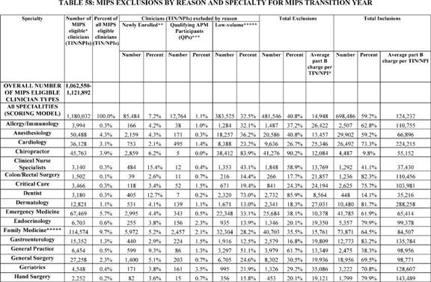

**[*77519]**



**[*77520]**

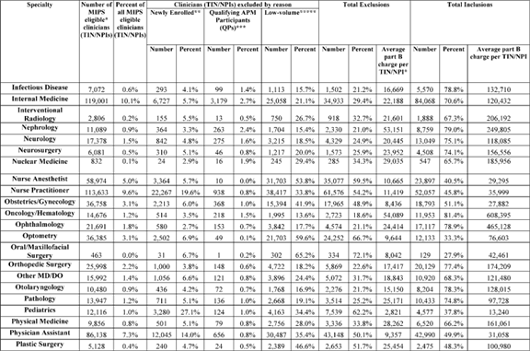

**[*77520]**



**[*77521]**

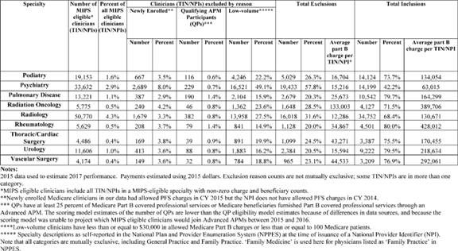

**[*77521]**



**[*77522]**

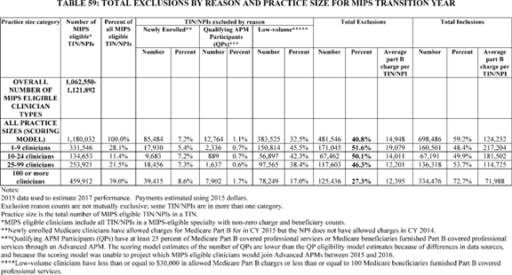

**[*77522]**



BILLING CODE 4120-01-C

3. Estimated Impacts on Payments to MIPS Eligible Clinicians

Based on the estimates of excluded clinicians in Table 57, we estimate that between approximately 592,119 and 642,119 eligible clinicians will be required to submit MIPS data to CMS in year 1. n57 They are clinicians with eligible clinician types that (a) are not QPs participating in Advanced APMs (b) exceeded the low volume threshold and (c) have been enrolled as Medicare physicians for more than 1 year.

n57 Because our model assigned final scores using data from the quality performance category, our model did not assign final scores to 21,764 eligible clinicians who are eligible for MIPS, but reported measures groups which is no longer continuing in MIPS. However, these eligible clinicians may be scored on advancing care information and improvement activities, and those two performance categories could not be modeled at this time given limited historical data.

Payment impacts in this final rule with comment period reflect averages by specialty and practice size based on Medicare utilization. The payment impact for a MIPS eligible clinician could vary from the average and would depend on the mix of services that the MIPS eligible clinician furnishes. The average percentage change in total revenues would be less than the impact displayed here because MIPS eligible clinicians generally furnish services to both Medicare and non-Medicare patients. In addition, MIPS eligible clinicians may receive substantial Medicare revenues for services under other Medicare payment systems that would not be affected by MIPS payment adjustment factors.

In order to estimate the impact of MIPS on clinicians required to report, we used the most recently available data, including data from 2015 PQRS, NPPES data and other available data to model the scoring provisions described in this ***regulation***. First, we arithmetically calculated a hypothetical final score for each MIPS eligible clinician based on quality performance. Because the cost performance category has a zero percent weight for the initial payment year, we did not include any cost measures in the final score. Because of the lack of historical data for the advancing care information and improvement activities measures, the model does not estimate scores for the advancing care information and improvement activities performance categories either.

Then, we implemented an exchange function based on the provisions of this final rule with comment period to translate the hypothetical final score into a negative MIPS payment adjustment or positive MIPS payment adjustment. This entailed modifying parameters of the exchange function iteratively in order to achieve distributions in MIPS payment adjustments that meet requirements related to budget neutrality and aggregate exceptional performance payment amounts using a 3 point performance threshold and a 70 point additional performance threshold.

Given the wide diversity of clinical practices, the initial development period of the Quality Payment Program implementation was designed to allow physicians to pick their pace of participation for the first performance period that begins January 1, 2017. Eligible clinicians will have three flexible options to submit data to MIPS and a fourth option to join Advanced APMs in order to become QPs, all of which would ensure they do not receive a negative payment adjustment in 2019. With the extensive changes to policy and flexibility, estimating impacts of this final rule with comment period using only historic 2015 quality submission data significantly overestimates the impact on clinicians, particularly on clinicians in practices with 1-9 clinicians, which have traditionally had lower participation rates. In order to assess the sensitivity of the impact to the participation rate, we have prepared two sets of analyses.

The first analysis, which we label as "standard participation assumptions," relies on the assumption that policy goals are designed to encourage a minimum 90 percent of MIPS eligible clinicians to participate, regardless of practice size. Therefore, we assumed that, on average, the categories of practices with 1-9 clinicians and practices with 10-24 clinicians would have 90 percent participation. This assumption is an increase from existing historical data. PQRS participation rates have increased steadily since the program began; the 2014 PQRS experience report showed an increase in the participation rate from 15 percent in 2007 to 62 percent in 2014. n58 In 2015, among those eligible for MIPS, 87.2 percent participated in the PQRS. In 2015, MIPS eligible practices of less than 10 clinicians participated in the PQRS at a rate of 58.2 percent, and MIPS eligible practices of 10-24 clinicians participated in the PQRS at a rate of 83.7 percent. Because practices of 25-99 clinicians have a 92.6 percent participation rate based on historical data and practices of 100+ clinicians have a 98.5 percent participation rate, we assumed the average participation rates of those categories of clinicians would be the same as under the 2015 PQRS. Our assumption of 90 percent average participation for the categories of practices with 1-9 or 10-24 clinicians reflects our belief that small and solo practices will respond to this final rule with comment period's flexibility, reduced data submission burden, financial incentives, the support they will receive through technical assistance by participating at a rate close to that of other practice sizes, enhancing the existing upward trend in quality data submission rates. Therefore, we assume that the quality scores assigned to new participants reflect the distribution of MIPS quality scores.

n58 2014 PQRS Experience Report at [*https://www.cms.gov/Medicare/Quality-Initiatives-Patient-Assessment-Instruments/PQRS/Downloads/2014_PQRS_Experience_Rpt.pdf*](https://www.cms.gov/Medicare/Quality-Initiatives-Patient-Assessment-Instruments/PQRS/Downloads/2014_PQRS_Experience_Rpt.pdf).

The second analysis, which we label as "alternative participation assumptions," assumes a minimum participation rate of 80 percent. Because the 2015 PQRS participation rates for practices of more than 10 clinicians are greater than 80 percent, this analysis assumes increased participation for practices of 1-9 clinicians. Practices of more than 10 clinicians are included in the model at their historic participation rates.

Table 60 summarizes the impact on Part B services of MIPS eligible clinicians by specialty for the standard participation assumptions. Table 61 summarizes the impact on Part B services of MIPS eligible clinicians by specialty under the alternative participation assumptions.

Tables 62 and 63 summarize the impact on Part B services of MIPS eligible clinicians by practice size for the standard participation assumptions (Table 62) and the alternative participation assumptions (Table 63).

Tables 60 and 62 show that under our standard participation assumptions, the vast majority (94.7percent) of MIPS eligible clinicians are anticipated to receive positive or neutral payment adjustments for the 2019 MIPS payment year, with only 5.3 percent receiving negative MIPS payment adjustments. Using the alternative participation assumptions, Table 63 shows that 91.9 percent of MIPS eligible clinicians are expected to receive positive or neutral payment adjustments. Due to limitations of modeling the new payment policies using historic data, it is not possible to differentiate between positive and neutral adjustment expectations. However, in both the standard and alternative assumptions, participating practices of all sizes are expected to experience a neutral or small net **[*77523]** positive impact in the 2019 MIPS payment year.

The distribution of funds reflects this final rule with comment period's emphasis on increasing participation of MIPS eligible clinicians for the transition year of MIPS, which creates a ramp to more robust participation in future MIPS performance years.

The following policy changes were made between the proposed and final rule with comment period to support that emphasis: modifying the low-volume threshold to exclude more clinicians, modifying the performance threshold to 3 for the initial payment year, and adding a performance floor on quality measure benchmarks.

BILLING CODE 4120-01-P **[*77524]**

**[*77525]**

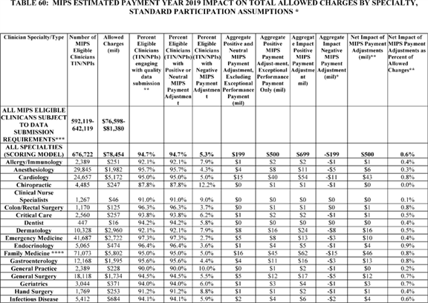

**[*77525]**



**[*77526]**

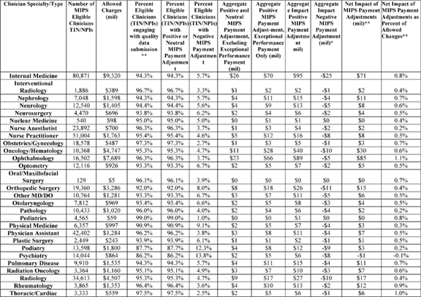

**[*77526]**



**[*77527]**

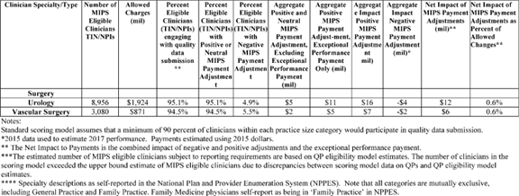

**[*77527]**



**[*77528]**

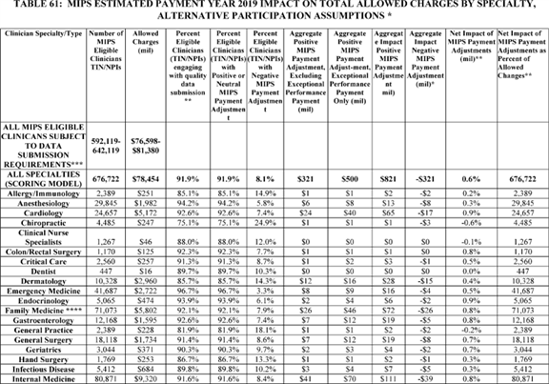

**[*77528]**



**[*77529]**

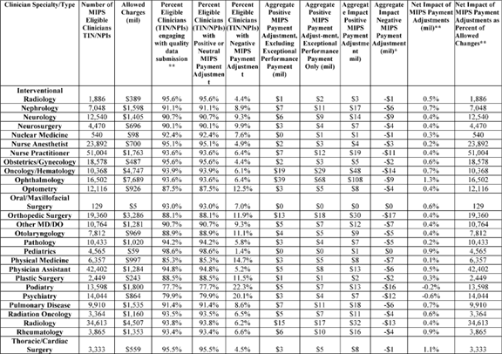

**[*77529]**



**[*77530]**

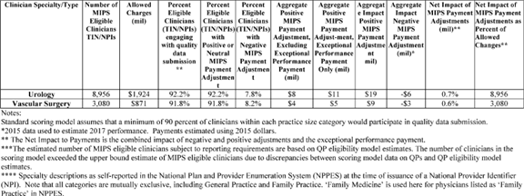

**[*77530]**



**[*77531]**

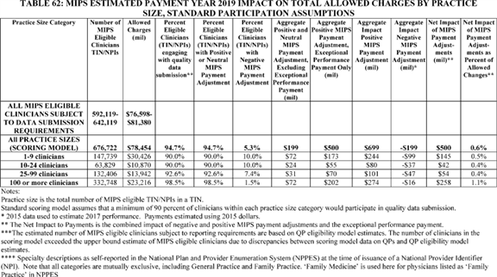

**[*77531]**

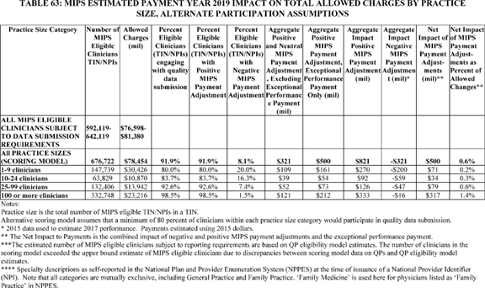

BILLING CODE 4120-01-C

We received several comments about the data used in the RIA.

*Comment:* Several commenters noted that the 2014 data used in the RIA was **[*77532]** not representative of the 2019 MIPS payment year of MIPS. One commenter requested that CMS use 2015 data for its RIA estimates.

*Response:* The RIA has been updated as requested, to the extent feasible, with 2015 data, which is the most recently available data. The claims-based readmission measures are still based on 2014 data. The identification of newly enrolled Medicare clinicians is based on both 2014 and 2015 data, and the estimated number of QPs and their allowed charges is based on 2014, 2015, and more recent data.

In summary, in response to comments, the RIA was updated with more recent data where feasible.

4. Potential Impact of Advancing Care Information Score

As noted earlier, our impact does not include either the advancing care information or the improvement activities performance categories. The proposed rule discussed preliminary data on potential advancing care information scores [*(81 FR 28370).*](https://advance.lexis.com/api/document?collection=administrative-codes&id=urn:contentItem:5JR6-TD50-006W-8163-00000-00&context=) While we estimate the final score using only the quality performance category score, we recognize the final scores for the 2019 MIPS payment year would be estimated using advancing care information and improvement activities data.

The costs for implementation and complying with the advancing care information performance category requirements could potentially lead to higher operational expenses for MIPS eligible clinicians. However, we believe that the combination of MIPS payment adjustments and long-term overall gains in efficiency will likely offset the initial expenditures. Because section II.E.5.g of this final rule with comment period establishes a policy to reweight the advancing care information performance category scores for MIPS eligible clinicians that were exempt from the Medicare EHR Incentive Program or received hardship exemptions (see [*81 FR 28232),*](https://advance.lexis.com/api/document?collection=administrative-codes&id=urn:contentItem:5JR6-TD50-006W-8163-00000-00&context=) the final rule with comment period would not impose additional requirements for EHR adoption during the transition year. Health IT vendors may face additional costs in the transition year of MIPS if they choose to develop additional capabilities in their systems in order to submit advancing care information and improvement activities performance category data on behalf of MIPS eligible clinicians.

Additionally, we believe a majority of MIPS eligible clinicians who are able to report the advancing care information performance category of MIPS have already adopted an EHR during Stage 1 and 2 of the prior Medicare EHR Incentive Program. As we have stated with respect to the Medicare EHR Incentive Program, we believe that future retrospective studies on the costs to implement an EHR and the return on investment (ROI) will demonstrate efficiency improvements that offset the actual costs incurred by MIPS eligible clinicians participating in MIPS and specifically in the advancing care information performance category, but we are unable to quantify those costs and benefits at this time.

At present, evidence on EHR benefits in either improving quality of care or reducing health care costs is mixed. This is not surprising since the adoption of EHR as a fully functioning part of medical practice is progressing, with numerous areas of adoption, use, and sophistication demonstrating need for improvement. Even physicians and hospitals that can meet Medicare EHR Incentive Program standards have not necessarily fully implemented all the functionality of their systems or fully exploited the diagnostic, prescribing, and coordination of care capabilities that these systems promise. Moreover, many of the most important benefits of EHR depend on interoperability among systems and this functionality is still lacking in many EHR systems. A recent RAND report prepared for the ONC reviewed 236 recent studies that related the use of health IT to quality, safety, and efficacy in ambulatory and non-ambulatory care settings and found that--

A majority of studies that evaluated the effects of health IT on healthcare quality, safety, and efficiency reported findings that were at least partially positive. These studies evaluated several forms of health IT: metrics of satisfaction, care process, and cost and health outcomes across many different care settings . . . Our findings agree with previous [research] suggesting that health IT, particularly those functionalities included in the Medicare EHR Incentive Program ***regulation***, can improve healthcare quality and safety. The relationship between health IT and [health care] efficiency is complex and remains poorly documented or understood, particularly in terms of healthcare costs, which are highly dependent upon the care delivery and financial context in which the technology is implemented. n59

n59 Paul G. Shekelle, *et al. Health Information Technology: An Updated Systematic Review with a Focus on Meaningful Use Functionalities.* RAND Corporation. 2014.

Other recent studies have not found definitive quantitative evidence of benefits. n60 The proposed rule requested comments providing better evidence concerning EHR benefits in reducing the costs or increasing the value of EHR-supported health care. No commenters provided evidence concerning EHR benefits in reducing the costs or increasing the value of EHR-supported health care.

n60 See, for example, Saurabh Rahurkar, et al, "Despite the Spread of Health Information Exchange, There Is Little Information of Its Impact On Cost, Use, And Quality of Care," *Health Affairs,* March 2015; and Hemant K. Bharga and Abhay Nath Mishra, "Electronic Medical Records and Physician Productivity: Evidence from Panel Data Analysis," *Management Science,* July 2014.

Similarly, the costs for implementation and complying with the improvement activities performance category requirements could potentially lead to higher expenses for MIPS eligible clinicians. Costs per full-time equivalent primary care clinician for improvement activities will vary across practices, including for some activities or certified patient-centered medical home practices, in incremental costs per encounter, and in estimated costs per member per month. Costs may vary based on panel size and location of practice among other variables. For example, Magill (2015), conducted a study of certified patient-centered medical home practices in two states. n61 Magill (2015), found that costs associated with a full-time equivalent primary care clinician, who were associated with certified patient-centered medical home practices, varied across practices. Specifically, Magill (2015) found an average of $ 7,691 per month in Utah practices, and an average of $ 9,658 in Colorado practices. Consequently, certified patient-centered medical home practices incremental costs per encounter were $ 32.71 in Utah and $ 36.68 in Colorado (Magill, 2015). Magill (2015) also found that the average estimated cost per member, per month, for an assumed panel of 2,000 patients was $ 3.85 in Utah and $ 4.83 in Colorado. However, given the lack of comprehensive historical data for proposed improvement activities, we are unable to quantify those costs in detail at this time. The proposed rule requested public comments on the costs associated with improvement activities from practices that have implemented clinical practice improvements in the past. No commenters provided specific cost estimates of improvement activities.

n61 Magill et al. "The Cost of Sustaining a Patient-Centered Medical Home: Experience from 2 States." *Annals of Family Medicine,* 2015; 13:429-435.

*D. Impact on Beneficiaries*

There are a number of changes in this final rule with comment period that would have an effect on beneficiaries. In general, we believe that the changes will have a positive impact and improve the **[*77533]** quality and value of care provided to Medicare beneficiaries.

More broadly, we expect that over time clinician engagement in the Quality Payment Program will increasingly result in improved quality of care, resulting in lower morbidity and mortality, and in reduced spending, as physicians respond to the incentives offered by MIPS and APMs and adjust their clinical practices in order to maximize their performance on specified quality measures and activities. The various shared savings initiatives already operating have demonstrated that all three outcomes are possible. For example, in August of 2015, we issued 2014 quality and financial performance results showing that Medicare ACOs continue to improve the quality of care for Medicare beneficiaries while generating net savings to the Medicare trust fund as well as shared savings to some model participants. n62 In 2014, the 20 ACOs in the Pioneer ACO Model and 333 Shared Shavings Program ACOs generated more than $ 411 million in total savings, which includes all ACOs' savings and losses. Additionally, in their first years of implementation, both Pioneer and Shared Savings Program ACOs had higher quality care than Medicare FFS providers on measures for which comparable data were available. Shared Savings Program patients with multiple chronic conditions and with high predicted Medicare spending received better quality care than comparable FFS patients. n63 Between the first and third performance periods, Pioneer ACOs improved their average quality score from 73 percent to 87 percent. The Shared Savings Program ACOs yielded $ 465 million in savings to the Medicare Trust Funds in 2014. n64

n62 [*https://www.cms.gov/Newsroom/MediaReleaseDatabase/Fact-sheets/2015-Fact-sheets-items/2015-08-25.html*](https://www.cms.gov/Newsroom/MediaReleaseDatabase/Fact-sheets/2015-Fact-sheets-items/2015-08-25.html).

n63 J.M. McWilliams et al., "Changes in Patients' Experiences in Medicare Accountable Care Organizations." New England Journal of Medicine 2014; 371:1715-1724, DOI: 10.1056/NEJMsa1406552.

n64 The cost savings were for the second year of Shared Savings Program implementation and the third year of Pioneer ACO implementation. [*https://www.cms.gov/Newsroom/MediaReleaseDatabase/Fact-sheets/2015-Fact-sheets-items/2015-08-25.html*](https://www.cms.gov/Newsroom/MediaReleaseDatabase/Fact-sheets/2015-Fact-sheets-items/2015-08-25.html).

Results from the first year of the CPC Initiative indicate that it has generated nearly enough savings in Medicare health care expenditures to offset care management fees paid by CMS. The primary sources of the savings were reduced rates of hospital admissions and ED visits. The bulk of the savings was generated by patients in the highest-risk quartile, but favorable results were also seen in other patients. Over 90 percent of practices successfully met all first-year transformation requirements. The expenditure impact estimates differ across the seven regions. Additional time and data are needed to assess impact on care quality. The results from the first year of the CPC Initiative should be interpreted cautiously as effects are emerging earlier than anticipated, and additional research is needed to assess how the initiative affects cost and quality of care beyond the first year. Because the effects of the CPC Initiative are likely to be larger in subsequent years, these early results suggest it is likely the model will eventually break even or generate savings. n65

n65 [*https://blog.cms.gov/2015/01/23/moving-forward-on-primary-care-transformation/*](https://blog.cms.gov/2015/01/23/moving-forward-on-primary-care-transformation/). For more detail see [*https://innovation.cms.gov/files/reports/cpci-evalrpt1.pdf*](https://innovation.cms.gov/files/reports/cpci-evalrpt1.pdf).

Basing payment in part on performance metrics is still an evolving art and, as discussed throughout this preamble, there are multiple variables and as yet no definitive answers as to what combinations of measures, benchmarks, and other variables will achieve the best results over time. Accordingly, we are unable at this time to provide specific dollar estimates of these benefits and cost reductions.

*E. Impact on Other Health Care Programs and Providers*

The MIPS is aimed at Medicare FFS physicians and other clinicians paid under the PFS. These physicians and other clinicians are almost all engaged in serving patients covered by other payers as well. Because Medicare covers only about one in seven persons (though a considerably higher share of total healthcare spending, since older persons incur far higher expenses on average than younger persons), for most of those services that will be subject to MIPS payment adjustments, Medicare provides only a fraction of practice revenues. Moreover, it is unlikely that many insurance payers will adopt MIPS or MIPS-like payment models in the short run. Hence, MIPS incentives are necessarily attenuated. On the other hand, changing practices for one group of patients will possibly lead to changes for other patients (for example, EHR systems are almost always used for all patients served by a physician). Physicians and other clinicians may find it simpler and more efficient to adopt clinical practice improvements for all patients, regardless of payer, in response to the Quality Payment Program's incentives, through the use of both MIPS measures and activities and APMs. Furthermore, since the Quality Payment Program eventually rewards participation in APMs based on services furnished to patients beyond those in Medicare, other payers may start to develop more models in which clinicians and patients can participate. Hence, there are likely to be beneficial effects on a far broader range of patients in the health care system than simply Medicare patients, and we believe those effects would include improved health care quality and lower costs over time. However, we have no basis at this time for quantifying such effects.

We note that large proportions of the Medicare and Medicaid programs are already delivered through capitated insurance payments to HMOs, PPOs, and related organizations. The Medicare Advantage Plans and related State programs therefore already have substantial incentives to improve quality and reduce costs. MIPS does not affect provider payments under those programs directly, which have their own reimbursement mechanisms for physicians and other clinicians. In many but not all cases, those insurance carriers do use incentive mechanisms that are similar in purpose and design to the kinds of APMs that we expect will arise under the new payment adjustments. We would not expect major near-term changes in HMO and PPO payment arrangements, or performance, from any MIPS or APM spillover effects. Regardless, we have no basis at this time for quantifying any such effects.

There are other potentially affected provider entities, including hospitals, skilled nursing facilities, CAHs (largely small rural hospitals), and providers serving unique populations, such as providers of tribal health care services. In none of these cases do we believe that MIPS would have significant effects on substantial numbers of providers. But to the extent that MIPS and increasing participation in APMs over time succeed in improving quality and reducing costs, there may be some beneficial effects not only on patients but also on some providers.

As noted previously in this section of the final rule with comment period, and as discussed in this subsection, we have concluded that financial effects on either directly or indirectly affected small entities, including rural hospitals, will be minimal. We welcomed comments on these conclusions.

The following is summary of the comments we received regarding the financial effects on either directly or indirectly affected small entities, including rural hospitals. **[*77534]**

*Comment:* Many commenters expressed concerns that the proposed rule would have negative financial consequences on small or solo practices, practices in rural and medically underserved areas, small hospital systems, primary care practices, and practices treating medically complex patients. Several commenters recommended policies to address the disparate effect on small and solo practices.

*Response:* As noted above, in response to many public comments, we implemented several policy changes that reduced the impact of this final rule with comment period on small and solo practices, including modifying the low-volume threshold to reduce the burden for small and solo practices. Further, this final rule with comment period's scoring provisions are designed to encourage participation, incentivize continuous improvement, and move participants on a glide path to improved health care delivery in the quality payment program. The RIA has been modified to reflect these policy changes, and shows that this final rule with comment period does not have disparate effects of small and solo practices that participate in reporting.

*Comment:* Several commenters were concerned that the negative effects of small/solo practices would be discriminatory against racial/ethnic minority physicians or racial/ethnic minority/patients. One commenter noted that Hispanic physicians were more likely to be in small and solo practices, and Hispanic and non-English speaking patients were more likely to be treated for small and solo practices, and recommended that small and solo practices be protected for their diversity value. Further, one commenter stated the rule would have a negative impact on inner city clinics and lower-income patients.

*Response:* As noted above, we implemented several policy changes designed to address the commenters' concerns. The RIA has been modified to reflect these policy changes, and our modeling shows that the rule does not have disparate effects of small and solo practices that participate in reporting.

*Comment:* Many commenters believed that the rule was administratively complex and confusing, and increased administrative burden for clinicians, especially small and solo practices, and rural practices, including hospitals.

*Response:* We have taken numerous steps to simplify the Quality Payment Program, particularly for the transition. For example, as discussed in II.E.5.f.(3) and II.E.5.g.(6) of this final rule with comment period, the advancing care information and improvement activities performance category reporting requirements have been simplified between the proposed and final rule with comment period. We do not believe, however, that our general discussion of the potential costs of implementing the rule need further modification.

*Comment:* Several commenters expressed concerns about the increased administrative costs and potential detrimental effects to IHS and Tribal providers. Several commenters requested clarification on the extent to which the proposed rule requirements would affect IHS and tribal providers. Two commenters requested clarification on the extent to which the RIA tables included IHS and tribal providers, and requested further analyses if they were not included. Several commenters recommended provisions to limit any detrimental impact to IHS and tribal providers including: Excluding them from MIPS, accepting the measures they report to other programs, technical assistance, separate benchmarks, and non-putative approaches to compliance.

*Response:* As we stated in the proposed rule, we continue to believe that the Quality Payment Program will not have significant effects on substantial numbers of providers of tribal health care services. Because the data used for our scoring model does not identify tribal and IHS providers, we are unable to estimate the amount of MIPS payments for those providers. While tribal and IHS provided care is not covered under MACRA, physicians working in tribal or IHS health facilities may be eligible for MACRA if they treat Medicare beneficiaries. However, we believe the number of IHS and tribal providers that will be covered under MACRA will be small, especially because many of those clinicians will not exceed the low-volume threshold. We will consider whether we should adopt any policies aimed specifically at IHS and other tribal providers in the future.

We will consider whether we should adopt any policies aimed specifically at IHS and other tribal providers in the future.

*Comment:* Many commenters noted the high cost of implementing EHRs and Health IT, particularly for small, solo, or rural clinicians. Several commenters noted that Medicare does not reimburse physicians for the time required to implement or use EHRs and other Health IT. Several commenters noted their practices had spent large amounts of money to comply with the previous EHR Incentive Program requirements, and expressed frustration that they needed to spend additional funds to comply with the new requirements.

*Response:* As we noted in the CY 2012 PFS final rule [*(76 FR 73464),*](https://advance.lexis.com/api/document?collection=administrative-codes&id=urn:contentItem:54BY-8C70-006W-8222-00000-00&context=) we believe some eligible clinicians will incur costs associated with purchasing an EHR product if they have not purchased them already. However, we do not believe that the majority of eligible clinicians will purchase an EHR solely for the purpose of participating in MIPS.

We understand commenters' concerns about the costs of purchasing and implementing EHR systems in order to participate in MIPS. In response to public comments, we have further simplified the advancing care information reporting requirement and modified the low-volume threshold to exclude more small and solo clinicians with few encounters and low Medicare allowed costs.

In summary, we received many comments about the potential impacts of the rule on small, solo, or rural clinicians. In response to many comments, we modified the low-volume threshold to increase the number of small, solo, and rural clinicians exempt from MIPS requirements. Further, as a result of comments, we have decided to finalize policies throughout the rule, which will focus the Quality Payment Program in its transition year on encouraging participation and educating clinicians while minimizing the risks for negative MIPS payment adjustment. The transition year policies will create a ramp to more robust participation in future years. The policy changes are reflected in the RIA estimates, which show that the risk for negative MIPS payment adjustment is minimal for MIPS eligible clinicians, including small and solo practices that participate.

*F. Alternatives Considered*

This final rule with comment period contains a range of policies, including many provisions related to specific statutory provisions. The preceding preamble provides descriptions of the statutory provisions that are addressed, identifies those policies where discretion has been exercised, presents our rationale for our finalized policies and, where relevant, analyzes alternatives that we considered. Although it is hard to single out any one alternative for public comment, the proposed rule particularly called attention to and requested comments on the performance threshold and the level at which it is set for scoring purposes under MIPS.

As described previously, under section 1848(q)(6)(D)(i) of the Act, for each year of MIPS, the Secretary shall **[*77535]** compute a performance threshold with respect to which the final scores of MIPS eligible clinicians are compared for purposes of determining the MIPS payment adjustment factors under section 1848(q)(6)(A) of the Act for a year. The performance threshold for a year must be either the mean or median (as selected by the Secretary, which may be reassessed every 3 years) of the final scores for all MIPS eligible clinicians for a prior period specified by the Secretary. Section 1848(q)(6)(D)(iii) of the Act outlines a special rule for the initial 2 years of MIPS, which requires the Secretary, prior to the performance period for such years, to establish a performance threshold for purposes of determining the MIPS payment adjustment factors under paragraph (A) and an additional performance threshold for purposes of determining the additional MIPS payment adjustment factors under paragraph (C), each of which shall be based on a period prior to the performance periods and take into account data available with respect to performance on measures and activities that may be used under the performance categories and other factors determined appropriate by the Secretary.

Depending on where the threshold is set within those parameters, the proportions and distributions of MIPS eligible clinicians receiving payment reductions versus positive payment adjustments can change dramatically from our estimates. For example, in Table 60, we estimated (based on available data) that 3.7 percent of Colon/Rectal Surgery specialists will receive a negative payment adjustment under MIPS. Setting the performance threshold at a lower level would enable more Colon/Rectal Surgery specialists to avoid negative MIPS payment adjustments and potentially qualify for more positive MIPS payment adjustments. Conversely, we estimated above that 96.7 percent of Interventional Radiology specialists would receive a positive MIPS payment adjustment under the current proposal. Setting the performance threshold at a higher level would result in fewer Interventional Radiology specialists qualifying for positive MIPS payment adjustments, and potentially more of them receiving negative MIPS payment adjustments. But any payment changes resulting from changes to the performance threshold policy will depend primarily on changes to practices and other responses from MIPS eligible clinicians.

The proposed rule requested comment on these alternatives, on all previous estimates of effects, and on any other issues or options that might improve the substantive effects of the proposed rule, or our estimates of those effects. We were particularly interested in comments on any aspects of the proposed rule that might inadvertently or unintentionally create adverse effects on the delivery of high quality and high value health care, and on options that might reduce such effects.

Comments on the alternatives to the proposed performance threshold are discussed in section II.E.7.c. of this final rule with comment period.

*G. Assumptions and Limitations*

We would like to note several limitations to the analyses that estimated MIPS eligible clinicians' eligibility, negative MIPS payment adjustments, and positive payment adjustments based for the first MIPS performance period (2017) based primarily on 2015 data described above:

* *The scoring model cannot fully reflect MIPS eligible clinicians' behavioral responses to MIPS.* The scoring model assumes higher participation in MIPS quality reporting than under the PQRS. Other potential behavioral responses are not addressed in our scoring model. The scoring model assumes that quality measures submitted and the distribution of scores on those measures would be similar under the transition year as they were under the 2015 PQRS program.

1. *Limited historical data for two performance categories.* Because we have limited historical data for the proposed advancing care information and improvement activities performance categories, the modeled scoring estimates were based solely on quality measures. Our scoring model estimates do not include advancing care information or improvement activities performance category scores.
2. *The scoring model does not reflect the growth in Advanced APM participation between 2015 and 2017.* Due to data limitations, the scoring model could only identify clinicians that participated in APMs that may have been determined to be Advanced APM in 2015 were they operating in 2017. Several new APMs that we anticipate will be Advanced APM have been implemented or will be implemented between 2015 and 2017. Further, some eligible clinicians will join the successors of APMs already in existence in 2015. In contrast to the scoring model, the CMS Innovation Center's QP estimates use methods that do reflect projected growth in APM participation between 2015 and 2017.

There are additional limitations to our estimates. To the extent that there are year-to-year changes in the data submission, volume and mix of services provided by MIPS eligible clinicians, the actual impact on total Medicare revenues will be different from those shown in Tables 60-63. Due the limitations above, there is considerable uncertainty around our estimates that is difficult to quantify in detail.

*H. Accounting Statement*

As required by OMB Circular A-4 (available at [*http://www.whitehouse.gov/omb/circulars/a004/a-4.pdf*](http://www.whitehouse.gov/omb/circulars/a004/a-4.pdf)), in Table 64 (Accounting Statement), we have prepared an accounting statement.

We have not attempted to quantify the benefits of this rule because of the many uncertainties as to both clinician behaviors and resulting effects on patient health and cost reductions. For example, the applicable percentage for MIPS incentives changes over time, increasing from 4 percent in 2019 to 9 percent in 2022 and subsequent years, and we are unable to estimate precisely how physicians will respond to the increasing incentives. As noted above, in CY 2019, we estimate that we will distribute approximately $ 199 million in payment adjustments on a budget-neutral basis, which represents the applicable percent for 2019 required under section 1848(q)(6)(B)(i) of the Act and excludes $ 500 million in exceptional performance payments. In 2020, section 1848(q)(6)(B)(ii) of the Act specifies that the applicable percent will be 5 percent, which we estimate would mean that we will distribute approximately $ 249 million in payment adjustments on a budget-neutral basis, ignoring changes in clinical practice, volume growth, inflation, or other changes that may affect Medicare physician payments, effects of changes in data submission practices, advancing care information scores, and innovation activities scores, as well as the $ 500 million in exceptional performance payments. Finally, in 2021, section 1848(q)(6)(B)(iii) of the Act specifies that the applicable percent will be 7 percent, which we estimate would mean that we will distribute approximately $ 435 million in payment adjustments on a budget-neutral basis, again ignoring changes in clinical practice, volume growth, inflation or other changes that may affect Medicare physician payments, as well as the $ 500 million in exceptional performance payments.

Further, the addition of new Advanced APMs and growth in Advanced APM participation over time will affect the pool of MIPS eligible clinicians, and for those that are MIPS eligible clinicians, may change their relative performance. The $ 500 million **[*77536]** available for exceptional performance and the 5 percent APM Incentive Payment for QPs are only available from 2019 through 2024. Beginning in 2026, payment for services furnished by QPs will receive a higher update than for services furnished by non-QPs. However, we are unable to estimate the number of QPs in those years, as we cannot project the number or types of Advanced APMs that will be made available in those years through future CMS initiatives proposed and implemented in those years, nor the number of QPs for those future Advanced APMs.

The percentage of the final score attributable to each performance category will change over time, and we will incorporate improvement scoring in future years. The Improvement activities category represents an entirely new category for measuring MIPS eligible clinicians' performance. We may also propose policy changes in future years as we continue implementing MIPS and as MIPS eligible clinicians accumulate experience with the new system. Moreover, there are interactions between the MIPS and APM incentive programs and other shared savings and incentive programs that we cannot model or project. Nonetheless, even if ultimate savings and health benefits represent only low fractions of current experience, benefits are likely to be substantial in overall magnitude.

Table 64 includes our estimate for MIPS payment adjustments ($ 199 million), the exceptional performance payments under MIPS ($ 500 million), and incentive payments to QPs (using the range described in the preceding analysis, approximately $ 333-$ 571 million). However, of these three elements, only the negative MIPS payment adjustments are shown as estimated decreases.

n66 A range of estimates is provided due to uncertainty about the number of Advanced APM participants that will meet the QP threshold in 2016.

| **Table 64--Accounting Statement** | |
| --- | --- |
|  |  |
| **Category** | **Transfers** |
| CY 2019 Annualized Monetized Transfers | Estimated increase of between $ 1,032 |
|  | and $ 1,270 million in payments for |
|  | higher performance under MIPS and to |
|  | QPs. fn66 |
| From Whom to Whom? | Increased Federal Government payments |
|  | to physicians, other practitioners and |
|  | suppliers who receive payment under |
|  | the Medicare Physician Fee Schedule. |
| CY 2019 Annualized Monetized Transfers | Estimated decrease of $ 199 million |
|  | for lower performance under MIPS. |
| From Whom to Whom? | Reduced Federal Government payments to |
|  | physicians, other practitioners and |
|  | suppliers who receive payment under |
|  | the Medicare Physician Fee Schedule. |

Note: These estimates are identical under both a 7 percent and 3 percent discount rate.

We received three comments in response to the estimated federal costs of implementing the rule in Table 64.

Based on National Health Expenditure data, n67 total Medicare expenditures for physician and clinical services in 2014 reached $ 138.4 billion. Expenditures for physician and clinical services from all sources reached $ 603.7 billion. Table 60 shows that the aggregate negative MIPS payment adjustment for all MIPS eligible clinicians under MIPS is estimated at $ 199 million, which represents less than 0.2 percent of Medicare payments for physician and clinical services and less than 0.1 percent of payments for physician and clinician services from all sources. Table 60 also shows that the aggregate positive payment adjustment for MIPS eligible clinicians under MIPS is estimated at $ 699 million (including additional MIPS payment adjustments for exceptional performance), which represents less than 1 percent of Medicare expenditures for physician and clinician services and 0.2 percent of expenditures from all sources for physician and clinical services.

n67 Physicians and Clinical Services Expenditures, [*https://www.cms.gov/Research-Statistics-Data-and-Systems/Statistics-Trends-and-Reports/NationalHealthExpendData/NationalHealthAccountsProjected.html*](https://www.cms.gov/Research-Statistics-Data-and-Systems/Statistics-Trends-and-Reports/NationalHealthExpendData/NationalHealthAccountsProjected.html).

*Comment:* One commenter requested that the government provide an estimate of its costs to implement the rule.

*Response:* Supporting Statement A of this rule's Paperwork Reduction Act package has a discussion of the cost to the government of implementing the rule. Hence, no revisions were made to the accounting table as result of this comment.

*Comment:* Two commenters noted the administrative complexity of meeting both federal Medicare and state Medicaid administrative requirements for dually eligible beneficiaries, those commenters requested that CMS factor dually eligible beneficiaries into its thinking about the timing of the MIPS and requested that CMS provide guidance to states on implementing the Quality Payment Program.

*Response:* We intend to work with the states during the MIPS' implementation, and will consider commenters' suggestions about policies with respect to dually-eligible beneficiaries in the future. No revisions were made to the accounting table as result of this comment.

In summary, after considering comments on government costs, no changes were made to the accounting table.

***Regulations***

**List of Subjects**

*42 CFR Part 414*

Administrative practice and procedure, Biologics, Drugs, Health facilities, Health professions, Kidney diseases, Medicare, Reporting and recordkeeping requirements.

*42 CFR Part 495*

Administrative practice and procedure, Health facilities, Health maintenance organizations (HMO), Health professions, Health records, Medicaid, Medicare, Penalties, Reporting and recordkeeping requirements.

For the reasons set forth in the preamble, the Centers for Medicare & Medicaid Services amends 42 CFR chapter IV as set forth below:

1. **MEDICAL AND OTHER HEALTH SERVICES**
2. The authority citation for part 414 continues to read as follows:

**Authority:** Secs. 1102, 1871, and 1881(b)(l) of the Social Security Act ([*42 U.S.C. 1302*](https://advance.lexis.com/api/document?collection=statutes-legislation&id=urn:contentItem:4YF7-GM31-NRF4-40JV-00000-00&context=), [*1395hh*](https://advance.lexis.com/api/document?collection=statutes-legislation&id=urn:contentItem:4YF7-GKD1-NRF4-453S-00000-00&context=), and [*1395rr(b)(l)*](https://advance.lexis.com/api/document?collection=statutes-legislation&id=urn:contentItem:4YF7-GPS1-NRF4-41KB-00000-00&context=)). **[*77537]**

1. In § 414.90--
2. Amend paragraph (e) introductory text by removing the phrase "and subsequent years" and adding in its place the phrase "through 2018"; and
3. Amend paragraph (e)(1)(ii) by removing the phrase "and each subsequent year" and adding in its place the phrase "through 2018".
4. Subpart O is added to part 414 to read as follows:
5. **ive Payment System and Alternative Payment Model Incentive**

Sec.

1. **od.**
2. **rements.**
3. **ategory.**
4. **ria for the quality performance category.**
5. **teria for the quality performance category.**
6. **gory.**
7. **s performance category.**
8. **ria for the improvement activities performance category.**
9. **improvement activities performance category.**
10. **under MIPS.**
11. **ation performance category.**
12. **eview limitations.**
13. **uditing.**
14. **ission.**
15. **ation.**
16. **.**
17. **APMs.**
18. **ipant determination: In general.**
19. **ipant determination: QP and partial QP thresholds.**
20. **ipant determination: Medicare option.**
21. **ipant determination: All-payer combination option.**
22. **er payer advanced APMs.**
23. **.**
24. **m integrity.**
25. **ment models.**
26. **ive Payment System and Alternative Payment Model Incentive**
27. This subpart implements the following provisions of the Act:
28. Section 1833(z)--Incentive Payments for Participation in Eligible Alternative Payment Models.
29. Section 1848(a)--Payment for Physicians' Services Based on Fee Schedule.
30. Section 1848(k)--Quality Reporting System.
31. Section 1848(q)--Merit-based Incentive Payment System.
32. This subpart part sets forth the following:
33. The circumstances under which eligible clinicians are not considered MIPS eligible clinicians with respect to a year.
34. How individual MIPS eligible clinicians can have their performance assessed as a group.
35. The data submission methods and data submission criteria for each of the MIPS performance categories.
36. Methods for calculating a performance category score for each of the MIPS performance categories.
37. Methods for calculating a MIPS final score and applying the MIPS payment adjustment to MIPS eligible clinicians.
38. Requirements for an APM to be designated an "Advanced APM."
39. Methods for eligible clinicians and entities participating in Advanced APMs to meet the participation thresholds to become Qualifying APM Participants (QPs) and Partial QPs.
40. Methods and processes for counting participation in Other Payer Advanced APMs in making QP and Partial QP determinations.
41. Methods for calculating and paying the APM Incentive Payment to QPs.
42. Criteria for Physician-Focused Payment Models (PFPMs).

As used in this section, unless otherwise indicated--

*Additional performance threshold* means the numerical threshold for a MIPS payment year against which the final scores of MIPS eligible clinicians are compared to determine the additional MIPS payment adjustment factors for exceptional performance.

*Advanced Alternative Payment Model (Advanced APM)* means an APM that CMS determines meets the criteria set forth in § 414.1415.

*Advanced APM Entity* means an APM Entity that participates in an Advanced APM or Other Payer Advanced APM.

*Affiliated practitioner* means an eligible clinician identified by a unique APM participant identifier on a CMS-maintained list who has a contractual relationship with the Advanced APM Entity for the purposes of supporting the Advanced APM Entity's quality or cost goals under the Advanced APM.

*Affiliated practitioner list* means the list of Affiliated Practitioners of an APM Entity that is compiled from a CMS-maintained list.

*Alternative Payment Model (APM)* means any of the following:

1. A model under section 1115A of the Act (other than a health care innovation award).
2. The shared savings program under section 1899 of the Act.
3. A demonstration under section 1866C of the Act.
4. A demonstration required by Federal law.

*APM Entity* means an entity that participates in an APM or payment arrangement with a non-Medicare payer through a direct agreement or through Federal or State law or ***regulation***.

*APM Entity group* means the group of eligible clinicians participating in an APM Entity, as identified by a combination of the APM identifier, APM Entity identifier, Taxpayer Identification Number (TIN), and National Provider Identifier (NPI) for each participating eligible clinician.

*APM Incentive Payment* means the lump sum incentive payment for a year paid to an eligible clinician who is a QP for the year from 2019 through 2024.

*Attestation* means a secure mechanism, specified by CMS, with respect to a particular performance period, whereby a MIPS eligible clinician or group may submit the required data for the advancing care information or the improvement activities performance categories of MIPS in a manner specified by CMS.

*Attributed beneficiary* means a beneficiary attributed to the Advanced APM Entity under the terms of the Advanced APM or Other Payer Advanced APM and listed as an attributed beneficiary on the latest available list of attributed beneficiaries at the time of a QP determination.

*Attribution-eligible beneficiary* means a beneficiary who during the QP Performance Period:

1. Is not enrolled in Medicare Advantage or a Medicare cost plan;
2. Does not have Medicare as a secondary payer;
3. Is enrolled in both Medicare Parts A and B;
4. Is at least 18 years of age;
5. Is a United States resident; and
6. Has a minimum of one claim for evaluation and management services **[*77538]** furnished by an eligible clinician who is in the APM Entity for any period during the QP Performance Period or, for an Advanced APM that does not base attribution on evaluation and management services and for which attributed beneficiaries are not a subset of the attribution-eligible beneficiary population based on the requirement to have at least one claim for evaluation and management services furnished by an eligible clinician who is in the APM Entity for any period during the QP Performance Period, the attribution basis determined by CMS based upon the methodology the Advanced APM uses for attribution, which may include a combination of evaluation and management and/or other services.

*Certified Electronic Health Record Technology (CEHRT)* means the following:

1. For any calendar year before 2018, EHR technology (which could include multiple technologies) certified under the ONC Health IT Certification Program that meets one of the following:
2. The 2014 Edition Base EHR definition (as defined at [*45 CFR 170.102*](https://advance.lexis.com/api/document?collection=administrative-codes&id=urn:contentItem:5J86-9SR0-008H-02TK-00000-00&context=)) and that has been certified to the certification criteria that are necessary to report on applicable objectives and measures specified for the MIPS advancing care information performance category, including the applicable measure calculation certification criterion at [*45 CFR 170.314(g)(1)*](https://advance.lexis.com/api/document?collection=administrative-codes&id=urn:contentItem:5JCK-P4D0-008H-01K6-00000-00&context=) or (2) for all certification criteria that support an objective with a percentage-based measure.
3. Certification to--
4. The following certification criteria:
5. CPOE at--
6. [*45 CFR 170.314(a)(1)*](https://advance.lexis.com/api/document?collection=administrative-codes&id=urn:contentItem:5JCK-P4D0-008H-01K6-00000-00&context=), (18), (19) or (20); or
7. [*45 CFR 170.315(a)(1)*](https://advance.lexis.com/api/document?collection=administrative-codes&id=urn:contentItem:5JCK-P4D0-008H-01K7-00000-00&context=), (2) or (3).

(*2*)(*i*) Record demographics at [*45 CFR 170.314(a)(3)*](https://advance.lexis.com/api/document?collection=administrative-codes&id=urn:contentItem:5JCK-P4D0-008H-01K6-00000-00&context=); or

1. [*45 CFR 170.315(a)(5)*](https://advance.lexis.com/api/document?collection=administrative-codes&id=urn:contentItem:5JCK-P4D0-008H-01K7-00000-00&context=).

(*3*)(*i*) Problem list at [*45 CFR 170.314(a)(5)*](https://advance.lexis.com/api/document?collection=administrative-codes&id=urn:contentItem:5JCK-P4D0-008H-01K6-00000-00&context=); or

1. [*45 CFR 170.315(a)(6)*](https://advance.lexis.com/api/document?collection=administrative-codes&id=urn:contentItem:5JCK-P4D0-008H-01K7-00000-00&context=).

(*4*)(*i*) Medication list at [*45 CFR 170.314(a)(6)*](https://advance.lexis.com/api/document?collection=administrative-codes&id=urn:contentItem:5JCK-P4D0-008H-01K6-00000-00&context=); or

1. [*45 CFR 170.315(a)(7)*](https://advance.lexis.com/api/document?collection=administrative-codes&id=urn:contentItem:5JCK-P4D0-008H-01K7-00000-00&context=).

(*5*)(*i*) Medication allergy list [*45 CFR 170.314(a)(7)*](https://advance.lexis.com/api/document?collection=administrative-codes&id=urn:contentItem:5JCK-P4D0-008H-01K6-00000-00&context=); or

1. [*45 CFR 170.315(a)(8)*](https://advance.lexis.com/api/document?collection=administrative-codes&id=urn:contentItem:5JCK-P4D0-008H-01K7-00000-00&context=).

(*6*)(*i*) Clinical decision support at [*45 CFR 170.314(a)(8)*](https://advance.lexis.com/api/document?collection=administrative-codes&id=urn:contentItem:5JCK-P4D0-008H-01K6-00000-00&context=); or

1. [*45 CFR 170.315(a)(9)*](https://advance.lexis.com/api/document?collection=administrative-codes&id=urn:contentItem:5JCK-P4D0-008H-01K7-00000-00&context=).
2. Health information exchange at transitions of care at one of the following:
3. [*45 CFR 170.314(b)(1)*](https://advance.lexis.com/api/document?collection=administrative-codes&id=urn:contentItem:5JCK-P4D0-008H-01K6-00000-00&context=)and (2).
4. [*45 CFR 170.314(b)(1)*](https://advance.lexis.com/api/document?collection=administrative-codes&id=urn:contentItem:5JCK-P4D0-008H-01K6-00000-00&context=), (b)(2), and (h)(1).
5. [*45 CFR 170.314(b)(1)*](https://advance.lexis.com/api/document?collection=administrative-codes&id=urn:contentItem:5JCK-P4D0-008H-01K6-00000-00&context=), (b)(2), and (b)(8).
6. [*45 CFR 170.314(b)(1)*](https://advance.lexis.com/api/document?collection=administrative-codes&id=urn:contentItem:5JCK-P4D0-008H-01K6-00000-00&context=), (b)(2), (b)(8), and (h)(1).
7. [*45 CFR 170.314(b)(8)*](https://advance.lexis.com/api/document?collection=administrative-codes&id=urn:contentItem:5JCK-P4D0-008H-01K6-00000-00&context=)and (h)(1).
8. [*45 CFR 170.314(b)(1)*](https://advance.lexis.com/api/document?collection=administrative-codes&id=urn:contentItem:5JCK-P4D0-008H-01K6-00000-00&context=), (b)(2), and 170.315(h)(2).
9. [*45 CFR 170.314(b)(1)*](https://advance.lexis.com/api/document?collection=administrative-codes&id=urn:contentItem:5JCK-P4D0-008H-01K6-00000-00&context=), (b)(2), (h)(1), and 170.315(h)(2).
10. [*45 CFR 170.314(b)(1)*](https://advance.lexis.com/api/document?collection=administrative-codes&id=urn:contentItem:5JCK-P4D0-008H-01K6-00000-00&context=), (b)(2), (b)(8), and 170.315(h)(2).
11. [*45 CFR 170.314(b)(1)*](https://advance.lexis.com/api/document?collection=administrative-codes&id=urn:contentItem:5JCK-P4D0-008H-01K6-00000-00&context=), (b)(2), (b)(8), (h)(1), and 170.315(h)(2).
12. [*45 CFR 170.314(b)(8)*](https://advance.lexis.com/api/document?collection=administrative-codes&id=urn:contentItem:5JCK-P4D0-008H-01K6-00000-00&context=), (h)(1), and 170.315(h)(2).
13. [*45 CFR 170.314(b)(1)*](https://advance.lexis.com/api/document?collection=administrative-codes&id=urn:contentItem:5JCK-P4D0-008H-01K6-00000-00&context=), (b)(2), and 170.315(b)(1).
14. [*45 CFR 170.314(b)(1)*](https://advance.lexis.com/api/document?collection=administrative-codes&id=urn:contentItem:5JCK-P4D0-008H-01K6-00000-00&context=), (b)(2), (h)(1), and 170.315(b)(1).
15. [*45 CFR 170.314(b)(1)*](https://advance.lexis.com/api/document?collection=administrative-codes&id=urn:contentItem:5JCK-P4D0-008H-01K6-00000-00&context=), (b)(2), (b)(8), and 170.315(b)(1).
16. [*45 CFR 170.314(b)(1)*](https://advance.lexis.com/api/document?collection=administrative-codes&id=urn:contentItem:5JCK-P4D0-008H-01K6-00000-00&context=), (b)(2), (b)(8), (h)(1), and 170.315(b)(1).
17. [*45 CFR 170.314(b)(8)*](https://advance.lexis.com/api/document?collection=administrative-codes&id=urn:contentItem:5JCK-P4D0-008H-01K6-00000-00&context=), (h)(1), and 170.315(b)(1).
18. [*45 CFR 170.314(b)(1)*](https://advance.lexis.com/api/document?collection=administrative-codes&id=urn:contentItem:5JCK-P4D0-008H-01K6-00000-00&context=), (b)(2), (b)(8), (h)(1), 170.315(b)(1), and 170.315(h)(1).
19. [*45 CFR 170.314(b)(1)*](https://advance.lexis.com/api/document?collection=administrative-codes&id=urn:contentItem:5JCK-P4D0-008H-01K6-00000-00&context=), (b)(2), (b)(8), (h)(1), 170.315(b)(1), and 170.315(h)(2).
20. [*45 CFR 170.314(h)(1)*](https://advance.lexis.com/api/document?collection=administrative-codes&id=urn:contentItem:5JCK-P4D0-008H-01K6-00000-00&context=)and [*170.315(b)(1)*](https://advance.lexis.com/api/document?collection=administrative-codes&id=urn:contentItem:5JCK-P4D0-008H-01K7-00000-00&context=).
21. [*45 CFR 170.315(b)(1)*](https://advance.lexis.com/api/document?collection=administrative-codes&id=urn:contentItem:5JCK-P4D0-008H-01K7-00000-00&context=)and (h)(1).
22. [*45 CFR 170.315(b)(1)*](https://advance.lexis.com/api/document?collection=administrative-codes&id=urn:contentItem:5JCK-P4D0-008H-01K7-00000-00&context=)and (h)(2).
23. [*45 CFR 170.315(b)(1)*](https://advance.lexis.com/api/document?collection=administrative-codes&id=urn:contentItem:5JCK-P4D0-008H-01K7-00000-00&context=), (h)(1), and (h)(2); and
24. Clinical quality measures at--
25. [*45 CFR 170.314(c)(1)*](https://advance.lexis.com/api/document?collection=administrative-codes&id=urn:contentItem:5JCK-P4D0-008H-01K6-00000-00&context=)or [*170.315(c)(1)*](https://advance.lexis.com/api/document?collection=administrative-codes&id=urn:contentItem:5JCK-P4D0-008H-01K7-00000-00&context=);
26. [*45 CFR 170.314(c)(2)*](https://advance.lexis.com/api/document?collection=administrative-codes&id=urn:contentItem:5JCK-P4D0-008H-01K6-00000-00&context=)or [*170.315(c)(2)*](https://advance.lexis.com/api/document?collection=administrative-codes&id=urn:contentItem:5JCK-P4D0-008H-01K7-00000-00&context=);
27. Clinical quality measure certification criteria that support the calculation and reporting of clinical quality measures at [*45 CFR 170.314(c)(2)*](https://advance.lexis.com/api/document?collection=administrative-codes&id=urn:contentItem:5JCK-P4D0-008H-01K6-00000-00&context=) and (3) and optionally (4); or [*45 CFR 170.315(c)(3)(i)*](https://advance.lexis.com/api/document?collection=administrative-codes&id=urn:contentItem:5JCK-P4D0-008H-01K7-00000-00&context=) and (ii) and optionally (c)(4); and can be electronically accepted by CMS if the data is submitted electronically.
28. Privacy and security at--
29. [*45 CFR 170.314(d)(1)*](https://advance.lexis.com/api/document?collection=administrative-codes&id=urn:contentItem:5JCK-P4D0-008H-01K6-00000-00&context=)or [*170.315(d)(1)*](https://advance.lexis.com/api/document?collection=administrative-codes&id=urn:contentItem:5JCK-P4D0-008H-01K7-00000-00&context=);
30. [*45 CFR 170.314(d)(2)*](https://advance.lexis.com/api/document?collection=administrative-codes&id=urn:contentItem:5JCK-P4D0-008H-01K6-00000-00&context=)or [*170.315(d)(2)*](https://advance.lexis.com/api/document?collection=administrative-codes&id=urn:contentItem:5JCK-P4D0-008H-01K7-00000-00&context=);
31. [*45 CFR 170.314(d)(3)*](https://advance.lexis.com/api/document?collection=administrative-codes&id=urn:contentItem:5JCK-P4D0-008H-01K6-00000-00&context=)or [*170.315(d)(3)*](https://advance.lexis.com/api/document?collection=administrative-codes&id=urn:contentItem:5JCK-P4D0-008H-01K7-00000-00&context=);
32. [*45 CFR 170.314(d)(4)*](https://advance.lexis.com/api/document?collection=administrative-codes&id=urn:contentItem:5JCK-P4D0-008H-01K6-00000-00&context=)or [*170.315(d)(4)*](https://advance.lexis.com/api/document?collection=administrative-codes&id=urn:contentItem:5JCK-P4D0-008H-01K7-00000-00&context=);
33. [*45 CFR 170.314(d)(5)*](https://advance.lexis.com/api/document?collection=administrative-codes&id=urn:contentItem:5JCK-P4D0-008H-01K6-00000-00&context=)or [*170.315(d)(5)*](https://advance.lexis.com/api/document?collection=administrative-codes&id=urn:contentItem:5JCK-P4D0-008H-01K7-00000-00&context=);
34. [*45 CFR 170.314(d)(6)*](https://advance.lexis.com/api/document?collection=administrative-codes&id=urn:contentItem:5JCK-P4D0-008H-01K6-00000-00&context=)or [*170.315(d)(6)*](https://advance.lexis.com/api/document?collection=administrative-codes&id=urn:contentItem:5JCK-P4D0-008H-01K7-00000-00&context=);
35. [*45 CFR 170.314(d)(7)*](https://advance.lexis.com/api/document?collection=administrative-codes&id=urn:contentItem:5JCK-P4D0-008H-01K6-00000-00&context=)or [*170.315(d)(7)*](https://advance.lexis.com/api/document?collection=administrative-codes&id=urn:contentItem:5JCK-P4D0-008H-01K7-00000-00&context=);
36. [*45 CFR 170.314(d)(8)*](https://advance.lexis.com/api/document?collection=administrative-codes&id=urn:contentItem:5JCK-P4D0-008H-01K6-00000-00&context=)or [*170.315(d)(8)*](https://advance.lexis.com/api/document?collection=administrative-codes&id=urn:contentItem:5JCK-P4D0-008H-01K7-00000-00&context=); and
37. The certification criteria that are necessary to report on applicable objectives and measures specified for the MIPS advancing care information performance category, including the applicable measure calculation certification criterion at [*45 CFR 170.314(g)(1)*](https://advance.lexis.com/api/document?collection=administrative-codes&id=urn:contentItem:5JCK-P4D0-008H-01K6-00000-00&context=) or (2) or [*45 CFR 170.315(g)(1)*](https://advance.lexis.com/api/document?collection=administrative-codes&id=urn:contentItem:5JCK-P4D0-008H-01K7-00000-00&context=) or (2) for all certification criteria that support an objective with a percentage-based measure.
38. The definition for 2018 and subsequent years specified in paragraph (2) of this definition.
39. For 2018 and subsequent years, EHR technology (which could include multiple technologies) certified under the ONC Health IT Certification Program that meets the 2015 Edition Base EHR definition (as defined at [*45 CFR 170.102*](https://advance.lexis.com/api/document?collection=administrative-codes&id=urn:contentItem:5J86-9SR0-008H-02TK-00000-00&context=)) and has been certified to the 2015 Edition health IT certification criteria--
40. At [*45 CFR 170.315(a)(12)*](https://advance.lexis.com/api/document?collection=administrative-codes&id=urn:contentItem:5JCK-P4D0-008H-01K7-00000-00&context=) (family health history) and [*45 CFR 170.315(e)(3)*](https://advance.lexis.com/api/document?collection=administrative-codes&id=urn:contentItem:5JCK-P4D0-008H-01K7-00000-00&context=) (patient health information capture); and
41. Necessary to report on applicable objectives and measures specified for the MIPS advancing care information performance category including the following:
42. The applicable measure calculation certification criterion at [*45 CFR 170.315(g)(1)*](https://advance.lexis.com/api/document?collection=administrative-codes&id=urn:contentItem:5JCK-P4D0-008H-01K7-00000-00&context=) or (2) for all certification criteria that support an objective with a percentage-based measure.
43. Clinical quality measure certification criteria that support the calculation and reporting of clinical quality measures at [*45 CFR 170.315(c)(2)*](https://advance.lexis.com/api/document?collection=administrative-codes&id=urn:contentItem:5JCK-P4D0-008H-01K7-00000-00&context=) and (c)(3)(i) and (ii) and optionally (c)(4), and can be electronically accepted by CMS.

*CMS-approved survey vendor* means a survey vendor that is approved by CMS for a particular performance period to administer the CAHPS for MIPS survey and to transmit survey measures data to CMS.

*CMS Web Interface* means a web product developed by CMS that is used by groups that have elected to utilize the CMS Web Interface to submit data on the MIPS measures and activities.

*Covered professional services* has the meaning given by section 1848(k)(3)(A) of the Act.

*Eligible clinician* means "eligible professional" as defined in section 1848(k)(3) of the Act, as identified by a unique TIN and NPI combination and, includes any of the following:

1. A physician.
2. A practitioner described in section 1842(b)(18)(C) of the Act.
3. A physical or occupational therapist or a qualified speech-language pathologist.
4. A qualified audiologist (as defined in section 1861(ll)(3)(B) of the Act). **[*77539]**

*Episode payment model* means an APM or other payer arrangement designed to improve the efficiency and quality of care for an episode of care by bundling payment for services furnished to an individual over a defined period of time for a specific clinical condition or conditions.

*Estimated aggregate payment amounts* means the total payments to a QP for Medicare Part B covered professional services for the incentive payment base period, estimated by CMS as described in § 414.1450(b).

*Final score* means a composite assessment (using a scoring scale of 0 to 100) for each MIPS eligible clinician for a performance period determined using the methodology for assessing the total performance of a MIPS eligible clinician according to performance standards for applicable measures and activities for each performance category. The final score is the sum of each of the products of each performance category score and each performance category's assigned weight, multiplied by 100.

*Group* means a single TIN with two or more eligible clinicians (including at least one MIPS eligible clinician), as identified by their individual NPI, who have reassigned their billing rights to the TIN.

*Health Professional Shortage Areas (HPSA)* means areas as designated under section 332(a)(1)(A) of the Public Health Service Act.

*High priority measure* means an outcome, appropriate use, patient safety, efficiency, patient experience, or care coordination quality measure.

*Hospital-based MIPS eligible clinician* is a MIPS eligible clinician who furnishes 75 percent or more of his or her covered professional services in sites of service identified by the Place of Service codes used in the HIPAA standard transaction as an inpatient hospital, on-campus outpatient hospital or emergency room setting based on claims for a period prior to the performance period as specified by CMS.

*Improvement activities* means an activity that relevant MIPS eligible clinician, organizations and other relevant stakeholders identify as improving clinical practice or care delivery and that the Secretary determines, when effectively executed, is likely to result in improved outcomes.

*Incentive payment base period* means the calendar year prior to the year in which CMS disburses the APM Incentive Payment.

*Low-volume threshold* means an individual MIPS eligible clinician or group who, during the low-volume threshold determination period, have Medicare Part B allowed charges less than or equal to $ 30,000 or provides care for 100 or fewer Part B-enrolled Medicare beneficiaries.

*Meaningful EHR user for MIPS* means a MIPS eligible clinician who possesses CEHRT, uses the functionality of CEHRT, and reports on applicable objectives and measures specified for the advancing care information performance category for a performance period in the form and manner specified by CMS, supports information exchange and the prevention of health information blocking, and engages in activities related to supporting providers with the performance of CEHRT.

*Measure benchmark* means the level of performance that the MIPS eligible clinician is assessed on for a specific performance period at the measures and activities level.

*Medicaid APM* means a payment arrangement authorized by a State Medicaid program that meets the criteria for an Other Payer Advanced APM under § 414.1420(a).

*Medical Home Model* means an APM under section 1115A of the Act that is determined by CMS to have the following characteristics:

1. The APM has a primary care focus with participants that primarily include primary care practices or multispecialty practices that include primary care physicians and practitioners and offer primary care services. For the purposes of this provision, primary care focus means the inclusion of specific design elements related to eligible clinicians practicing under one or more of the following Physician Specialty Codes: 01 General Practice; 08 Family Medicine; 11 Internal Medicine; 16 Obstetrics and Gynecology; 37 Pediatric Medicine; 38 Geriatric Medicine; 50 Nurse Practitioner; 89 Clinical Nurse Specialist; and 97 Physician Assistant;
2. Empanelment of each patient to a primary clinician; and
3. At least four of the following:
4. Planned coordination of chronic and preventive care.
5. Patient access and continuity of care.
6. Risk-stratified care management.
7. Coordination of care across the medical neighborhood.
8. Patient and caregiver engagement.
9. Shared decision-making.
10. Payment arrangements in addition to, or substituting for, fee-for-service payments (for example, shared savings or population-based payments).

*Medicaid Medical Home Model* means a payment arrangement under title XIX that CMS determines to have the following characteristics:

1. The payment arrangement has a primary care focus with participants that primarily include primary care practices or multispecialty practices that include primary care physicians and practitioners and offer primary care services. For the purposes of this provision, primary care focus means the inclusion of specific design elements related to eligible clinicians practicing under one or more of the following Physician Specialty Codes: 01 General Practice; 08 Family Medicine; 11 Internal Medicine; 16 Obstetrics and Gynecology; 37 Pediatric Medicine; 38 Geriatric Medicine; 50 Nurse Practitioner; 89 Clinical Nurse Specialist; and 97 Physician Assistant;
2. Empanelment of each patient to a primary clinician; and
3. At least four of the following:
4. Planned coordination of chronic and preventive care.
5. Patient access and continuity.
6. Risk-stratified care management.
7. Coordination of care across the medical neighborhood.
8. Patient and caregiver engagement.
9. Shared decision-making.
10. Payment arrangements in addition to, or substituting for, fee-for-service payments (for example, shared savings or population-based payments).

*Merit-based Incentive Payment System (MIPS)* means the program required by section 1848(q) of the Act.

*MIPS APM* means an APM that meets the criteria specified under § 414.1370(b).

*MIPS eligible clinician* as identified by a unique billing TIN and NPI combination used to assess performance, means any of the following (excluding those identified at § 414.1310(b)):

1. A physician as defined in section 1861(r) of the Act.
2. A physician assistant, a nurse practitioner, and clinical nurse specialist as such terms are defined in section 1861(aa)(5) of the Act.
3. A certified registered nurse anesthetist as defined in section 1861(bb)(2) of the Act.
4. A group that includes such clinicians.

*MIPS payment year* means a calendar year in which the MIPS payment adjustment factor, and if applicable the additional MIPS payment adjustment factor, are applied to Medicare Part B payments.

*New Medicare-Enrolled MIPS eligible clinician* means an eligible clinician who first becomes a Medicare-enrolled eligible clinician within the Provider Enrollment, Chain and Ownership System (PECOS) during the performance period for a year and had not previously **[*77540]** submitted claims under Medicare as an individual, an entity, or a part of a physician group or under a different billing number or tax identifier.

*Non-patient facing MIPS eligible clinician* means an individual MIPS eligible clinician that bills 100 or fewer patient facing encounters (including Medicare telehealth services defined in section 1834(m) of the Act) during the non-patient facing determination period, and a group provided that more than 75 percent of the NPIs billing under the group's TIN meet the definition of a non-patient facing individual MIPS eligible clinician during the non-patient facing determination period.

*Other Payer Advanced APM* means a payment arrangement that meets the criteria set forth in § 414.1420.

*Other payer arrangement* means a payment arrangement with any payer that is not an APM.

*Partial Qualifying APM Participant (Partial QP)* means an eligible clinician determined by CMS to have met the relevant Partial QP threshold under § 414.1430(a)(2) and (4) and (b)(2) and (4) for a year.

*Partial QP patient count threshold* means the minimum threshold score specified in § 414.1430(a)(4) and (b)(4) that an eligible clinician must attain through a patient count methodology described in §§ 414.1435(b) and 414.1440(c) to become a Partial QP for a year.

*Partial QP payment amount threshold* means the minimum threshold score specified in § 414.1430(a)(2) and (b)(2) that an eligible clinician must attain through a payment amount methodology described §§ 414.1435(a) and 414.1440(b) to become a Partial QP for a year.

*Participation List* means the list of participants in an APM Entity that is compiled from a CMS-maintained list.

*Performance category score* means the assessment of each MIPS eligible clinician's performance on the applicable measures and activities for a performance category for a performance period based on the performance standards for those measures and activities.

*Performance standards* means the level of performance and methodology that the MIPS eligible clinician is assessed on for a MIPS performance period at the measures and activities level for all MIPS performance categories.

*Performance threshold* means the numerical threshold for a MIPS payment year against which the final scores of MIPS eligible clinicians are compared to determine the MIPS payment adjustment factors.

*QP patient count threshold* means the minimum threshold score specified in § 414.1430(a)(3) and (b)(3) that an eligible clinician must attain through a patient count methodology described in §§ 414.1435(b) and 414.1440(c) to become a QP for a year.

*QP payment amount threshold* means the minimum threshold score specified in § 414.1430(a)(1) and (b)(1) that an eligible clinician must attain through the payment amount methodology described in §§ 414.1435(a) and 414.1440(b) to become a QP for a year.

*QP Performance Period* means the time period that CMS will use to assess the level of participation by an eligible clinician in Advanced APMs and Other Payer Advanced APMs for purposes of making a QP determination for the eligible clinician for the year as specified in § 414.1425. The QP Performance Period begins on January 1 and ends on August 31 of the calendar year that is 2 years prior to the payment year.

*Qualified Clinical Data Registry (QCDR)* means a CMS-approved entity that has self-nominated and successfully completed a qualification process to determine whether the entity may collect medical or clinical data for the purpose of patient and disease tracking to foster improvement in the quality of care provided to patients.

*Qualified registry* means a medical registry, a maintenance of certification program operated by a specialty body of the American Board of Medical Specialties or other data intermediary that, with respect to a particular performance period, has self-nominated and successfully completed a vetting process (as specified by CMS) to demonstrate its compliance with the MIPS qualification requirements specified by CMS for that performance period. The registry must have the requisite legal authority to submit MIPS data (as specified by CMS) on behalf of a MIPS eligible clinician or group to CMS.

*Qualifying APM Participant (QP)* means an eligible clinician determined by CMS to have met or exceeded the relevant QP payment amount or QP patient count threshold under § 414.1430(a)(1), (a)(3), (b)(1), or (b)(3) for a year based on participation in an Advanced APM Entity.

*Rural areas* means clinicians in zip codes designated as rural, using the most recent HRSA Area Health Resource File data set available.

*Small practices* means practices consisting of 15 or fewer clinicians and solo practitioners.

*Threshold Score* means the percentage value that CMS determines for an eligible clinician based on the calculations described in § 414.1435 or § 414.1440.

*Topped out non-process measure* means a measure where the Truncated Coefficient of Variation is less than 0.10 and the 75th and 90th percentiles are within 2 standard errors.

*Topped out process measure* means a measure with a median performance rate of 95 percent or higher.

1. Except as specified in paragraph (b) of this section, MIPS applies to payments for items and services furnished by MIPS eligible clinicians on or after January 1, 2019.
2. For a year, a MIPS eligible clinician does not include an eligible clinician who:
3. Is a Qualifying APM Participant (as defined at § 414.1305);
4. Is a Partial Qualifying APM Participant (as defined at § 414.1305) and does not report on applicable measures and activities that are required to be reported under MIPS for any given performance period in a year; or
5. For the performance period with respect to a year, does not exceed the low-volume threshold as defined at § 414.1305.
6. Eligible clinicians, as defined at § 414.1305, who are not MIPS eligible clinicians, as defined at § 414.1305, have the option to voluntarily report measures and activities for MIPS.
7. ***enrolled eligible clinicians.***New Medicare-enrolled eligible clinician, as defined at § 414.1305, will not be treated as a MIPS eligible clinician until the subsequent year and the performance period for such subsequent year.
8. In no case will a MIPS payment adjustment apply to the items and services furnished during a year by individual eligible clinicians, as described in paragraphs (b) and (c) of this section, who are not MIPS eligible clinicians, including eligible clinicians who voluntarily report on applicable measures and activities specified under MIPS.
9. The following way is for individual eligible clinicians and individual MIPS eligible clinicians to have their performance assessed as a group:
10. As part of a single TIN associated with two or more eligible clinicians (including at least one MIPS eligible clinician), as identified by a NPI, that **[*77541]** have their Medicare billing rights reassigned to the TIN.
11. [Reserved]
12. A group must meet the definition of a group at all times during the performance period for the MIPS payment year in order to have its performance assessed as a group.
13. Eligible clinicians and MIPS eligible clinicians within a group must aggregate their performance data across the TIN in order for their performance to be assessed as a group.
14. A group that elects to have its performance assessed as a group will be assessed as a group across all four MIPS performance categories.
15. A group must adhere to an election process established and required by CMS.
16. **riod.**
17. For purposes of the 2019 MIPS payment year, the performance period for all performance categories and submission mechanisms except for the cost performance category and data for the quality performance category reported through the CMS Web Interface, for the CAHPS for MIPS survey, and for the all-cause hospital readmission measure, is a minimum of a continuous 90-day period within CY 2017, up to and including the full CY 2017 (January 1, 2017 through December 31, 2017). For purposes of the 2019 MIPS payment year, for data reported through the CMS Web Interface or the CAHPS for MIPS survey and administrative claims-based cost and quality measures, the performance period under MIPS is CY 2017 (January 1, 2017 through December 31, 2017).
18. For purposes of the 2020 MIPS payment year, the performance period for:
19. The quality and cost performance categories is CY 2018 (January 1, 2018 through December 31, 2018).
20. The advancing care information and improvement activities performance categories is a minimum of a continuous 90-day period within CY 2018, up to and including the full CY 2018 (January 1, 2018 through December 31, 2018).
21. **uirements.**
22. ***e categories.***MIPS eligible clinicians and groups must submit measures, objectives, and activities for the quality, improvement activities, and advancing care information performance categories.
23. ***for individual eligible clinicians.***An individual MIPS eligible clinician may elect to submit their MIPS data using:
24. A qualified registry for the quality, improvement activities, or advancing care information performance categories;
25. The EHR submission mechanism (which includes submission of data by health IT vendors or other authorized providers on behalf of MIPS eligible clinicians) for the quality, improvement activities, or advancing care information performance categories;
26. A QCDR for the quality, improvement activities, or advancing care information performance categories;
27. Medicare Part B claims for the quality performance category; or
28. Attestation for the improvement activities and advancing care information performance categories.
29. ***for groups that are not reporting through an APM.***Groups may submit their MIPS data using:
30. A qualified registry for the quality, improvement activities, or advancing care information performance categories;
31. The EHR submission mechanism (which includes the submission of data by health IT vendors on behalf of groups) for the quality, improvement activities, or advancing care information performance categories;
32. A QCDR for the quality, improvement activities, or advancing care information performance categories;
33. A CMS Web Interface (for groups comprised of at least 25 MIPS eligible clinicians) for the quality, improvement activities, and advancing care information performance categories;
34. Attestation for the improvement activities and advancing care information performance categories; or
35. A CMS-approved survey vendor for groups that elect to include the CAHPS for MIPS survey as a quality measure. Groups that elect to include the CAHPS for MIPS survey as a quality measure must select one of the above data submission mechanisms to submit their other quality information.
36. ***e submission mechanism per performance category.***Except as described in paragraph (c)(6) of this section, MIPS eligible clinicians and groups may elect to submit information via multiple mechanisms; however, they must use the same identifier for all performance categories and they may only use one submission mechanism per performance category.
37. ***ments for the cost performance category and certain quality measures.***There are no data submission requirements for the cost performance category and for certain quality measures used to assess performance in the quality performance category. CMS will calculate performance on these measures using administrative claims data.
38. ***for all submission mechanisms for individual eligible clinicians and groups for all performance categories.***The submission deadlines are:
39. For the qualified registry, QCDR, EHR, and attestation submission mechanisms are March 31 following the close of the performance period.
40. For Medicare Part B claims, data must be submitted on claims with dates of service during the performance period that must be processed no later than 60 days following the close of the performance period.
41. For the CMS Web Interface, data must be submitted during an 8-week period following the close of the performance period. The period must begin no earlier than January 2 and end no later than March 31.
42. **category.**
43. For purposes of assessing performance of MIPS eligible clinicians on the quality performance category, CMS will use:
44. Quality measures included in the MIPS final list of quality measures.
45. Quality measures used by QCDRs.
46. Subject to CMS's authority to reweight performance category weights under section 1848(q)(5)(F) of the Act, performance in the quality performance category will comprise:
47. 60 percent of a MIPS eligible clinician's final score for MIPS payment year 2019.
48. 50 percent of a MIPS eligible clinician's final score for MIPS payment year 2020.
49. 30 percent of a MIPS eligible clinician's final score for each MIPS payment year thereafter.
50. **teria for the quality performance category.**
51. A MIPS eligible clinician or group must submit data on MIPS quality measures in one of the following manners, as applicable:
52. ***stry, EHR or QCDR submission mechanism.***For the performance period--
53. Submit data on at least six measures including at least one outcome measure. If an applicable outcome measure is not available, report one other high priority measure (appropriate use, patient safety, efficiency, patient experience, and care coordination measures). If fewer than six measures apply to the MIPS eligible clinician or **[*77542]** group, report on each measure that is applicable.
54. Subject to paragraph (a)(1)(i) of this section, MIPS eligible clinicians and groups can either select their measures from the complete MIPS final measure list or a subset of that list, MIPS specialty-specific measure sets, as designated by CMS.
55. ***-for groups only.***For the 12-month performance period-
56. For a group of 25 or more MIPS eligible clinicians, report on all measures included in the CMS Web Interface. The group must report on the first 248 consecutively ranked beneficiaries in the sample for each measure or module.
57. If the sample of eligible assigned beneficiaries is less than 248, then the group must report on 100 percent of assigned beneficiaries. In some instances, the sampling methodology will not be able to assign at least 248 patients on which a group may report, particularly those groups on the smaller end of the range of 25-99 MIPS eligible clinicians.
58. The group is required to report on at least one measure for which there is Medicare patient data.
59. Groups reporting via the CMS Web Interface are required to report on all of the measures in the set.
60. ***ndor for CAHPS for MIPS survey- for groups only.***
61. For the 12-month performance period, a group that wishes to voluntarily elect to participate in the CAHPS for MIPS survey measures must use a survey vendor that is approved by CMS for a particular performance period to transmit survey measures data to CMS.
62. The CAHPS for MIPS survey counts for one measure towards the MIPS quality performance category and, as a patient experience measure, also fulfills the requirement to report at least one high priority measure in the absence of an applicable outcome measure.
63. Groups that elect this data submission mechanism must select an additional group data submission mechanism in order to meet the data submission criteria for the MIPS quality performance category.
64. [Reserved]
65. [Reserved]
66. **riteria for the quality performance category.**
67. MIPS eligible clinicians and groups submitting quality measures data using the QCDR, qualified registry, or EHR submission mechanism must submit data on:
68. At least 50 percent of the MIPS eligible clinician or group's patients that meet the measure's denominator criteria, regardless of payer for MIPS payment year 2019.
69. At least 60 percent of the MIPS eligible clinician or group's patients that meet the measure's denominator criteria, regardless of payer for MIPS payment year 2020.
70. MIPS eligible clinicians submitting quality measures data using Medicare Part B claims, must submit data on:
71. At least 50 percent of the applicable Medicare Part B patients seen during the performance period to which the measure applies for MIPS payment year 2019.
72. At least 60 percent of the applicable Medicare Part B patients seen during the performance period to which the measure applies for MIPS payment year 2020.
73. Groups submitting quality measures data using the CMS Web Interface or a CMS-approved survey vendor to submit the CAHPS for MIPS survey must meet the data submission requirement on the sample of the Medicare Part B patients CMS provides.
74. **tegory.**
75. For purposes of assessing performance of MIPS eligible clinicians on the cost performance category, CMS specifies cost measures for a performance period.
76. Subject to CMS's authority to reweight performance category weights under section 1848(q)(5)(F) of the Act, performance in the cost performance category comprises:
77. 0 percent of a MIPS eligible clinician's final score for MIPS payment year 2019.
78. 10 percent of a MIPS eligible clinician's final score for MIPS payment year 2020.
79. 30 percent of a MIPS eligible clinician's final score for each MIPS payment year thereafter.
80. **ies performance category.**
81. For purposes of assessing performance of MIPS eligible clinicians on the improvement activities performance category, CMS specifies an inventory of measures and activities for a performance period.
82. Subject to CMS's authority to reweight performance category weights under section 1848(q)(5)(F) of the Act, performance in the improvement activities performance category comprises:
83. 15 percent of a MIPS eligible clinician's final score for MIPS payment year 2019 and for each MIPS payment year thereafter.
84. [Reserved].
85. For purposes of assessing performance of MIPS eligible clinicians on the improvement activities performance category, CMS uses activities included in the improvement activities inventory established by CMS through rulemaking.
86. **teria for the improvement activities performance category.**
87. MIPS eligible clinicians must submit data on MIPS improvement activities in one of the following manners:
88. Via qualified registry, EHR submission mechanisms, QCDR, CMS Web Interface or Attestation. For activities that are performed for at least a continuous 90-days during the performance period, MIPS eligible clinicians must--
89. Submit a yes response for activities within the improvement activities inventory.
90. [Reserved]
91. [Reserved]
92. [Reserved]
93. **he improvement activities performance category.**
94. The following are the list of subcategories, of which, with the exception of Participation in an APM, include activities for selection by a MIPS eligible clinician or group:
95. Expanded practice access, such as same day appointments for urgent needs and after-hours access to clinician advice.
96. Population management, such as monitoring health conditions of individuals to provide timely health care interventions or participation in a QCDR.
97. Care coordination, such as timely communication of test results, timely exchange of clinical information to patients or other clinicians, and use of remote monitoring or telehealth.
98. Beneficiary engagement, such as the establishment of care plans for individuals with complex care needs, beneficiary self-management assessment and training, and using shared decision-making mechanisms.
99. Patient safety and practice assessment, such as through the use of clinical or surgical checklists and practice assessments related to maintaining certification.
100. Participation in an APM.
101. Achieving health equity, such as for MIPS eligible clinicians that achieve high quality for underserved populations, including persons with behavioral health conditions, racial and **[*77543]** ethnic minorities, sexual and gender minorities, people with disabilities, people living in rural areas, and people in geographic HPSAs.
102. Emergency preparedness and response, such as measuring MIPS eligible clinician participation in the Medical Reserve Corps, measuring registration in the Emergency System for Advance Registration of Volunteer Health Professionals, measuring relevant reserve and active duty uniformed services MIPS eligible clinician activities, and measuring MIPS eligible clinician volunteer participation in domestic or international humanitarian medical relief work.
103. Integrated behavioral and mental health, such as measuring or evaluating such practices as: Co-location of behavioral health and primary care services; shared/integrated behavioral health and primary care records; cross-training of MIPS eligible clinicians, and integrating behavioral health with primary care to address substance use disorders or other behavioral health conditions, as well as integrating mental health with primary care.
104. [Reserved]
105. **d under MIPS.**
106. The APM scoring standard is the MIPS scoring methodology applicable for MIPS eligible clinicians identified on the Participation List for the performance period of an APM Entity participating in a MIPS APM.
107. MIPS APMs are those in which:
108. APM Entities participate in the APM under an agreement with CMS or through a law or ***regulation***;
109. The APM is designed such that APM Entities participating in the APM include at least one MIPS eligible clinician on a Participation List;
110. The APM bases payment on cost/utilization and quality measures; and
111. The APM is not either of the following:
112. An APM for which the first performance year begins after the first day of the MIPS performance period for the year.
113. ***ation for which the APM scoring standard is impracticable.***An APM in the final year of operation for which CMS determines, within 60 days after the beginning of the MIPS performance period for the year, that it is impracticable for APM Entity groups to report to MIPS using the APM scoring standard.
114. ***rmance period.***The MIPS performance period under § 414.1320 applies for the APM scoring standard.
115. ***.***The APM participant identifier for an eligible clinician is the combination of four identifiers:
116. APM identifier (established for the APM by CMS);
117. APM Entity identifier (established for the APM Entity by CMS);
118. Medicare-enrolled billing TIN; and
119. Eligible clinician NPI.
120. ***tion.***The APM Entity group is determined in the manner prescribed in § 414.1425(b)(1).
121. ***nder the APM scoring standard.***The MIPS final score calculated for the APM Entity group is applied to each MIPS eligible clinician in the APM Entity group. The MIPS payment adjustment is applied at the TIN/NPI level for each of the MIPS eligible clinicians in the APM Entity group. In the event that a Shared Savings Program ACO does not report quality measures as required by the Shared Savings Program, the ACO participant TINs will each be considered a unique APM Entity for purposes of the APM scoring standard.
122. ***scoring under the APM scoring standard--***
123. ***Entities to submit quality data using the CMS Web Interface.***The MIPS performance category score for quality for a performance period will be calculated for the APM Entity group using the data submitted for the APM Entity through the CMS Web Interface according to the terms of the APM. In the event that a Shared Savings Program ACO does not report on quality measures as required by the Shared Savings Program, the ACO participant TINs must report data for the MIPS quality performance category according to the MIPS submission and reporting requirements.
124. [Reserved]
125. The cost performance category weight is zero percent for APM Entity groups in MIPS APMs.
126. CMS assigns an improvement activities score for each MIPS APM for a performance period based on the requirements of the MIPS APM. The assigned improvement activities score applies to each APM Entity group in the MIPS APM for the performance year. In the event that the assigned score does not represent the maximum improvement activities score, APM Entities may report additional activities.
127. [Reserved]
128. ***.***
129. For APM Entity groups in the Shared Savings Program, each ACO participant TIN submits data on the advancing care information performance category as specified in § 414.1375(b) and performance on the advancing care information performance category is assessed for the APM Entity group by calculating the weighted mean of the TIN level scores, weighted based on the number of MIPS eligible clinicians in the TINs as compared to the total number of MIPS eligible clinicians in the APM Entity group.
130. For APM Entity groups in MIPS APMs other than the Shared Savings Program, CMS uses one score for each MIPS eligible clinician in the APM Entity group to derive a single average APM Entity group score for advancing care information. The score for each MIPS eligible clinician is the higher of either:
131. A group score based on the measure data for the advancing care information performance category reported by a TIN for the MIPS eligible clinician according to the MIPS submission and reporting requirements for groups; or
132. An individual score based on the measure data for the advancing care information performance category reported by the MIPS eligible clinician according to the MIPS submission and reporting requirements for individuals.
133. ***rmance category weights.***The performance category weights used to calculate the final score for an APM Entity group are:
134. For the Shared Savings Program and other MIPS APMs that require APM Entities to submit quality data through the CMS Web Interface: 50 percent.
135. For 2017, for MIPS APMs that do not require APM Entities to submit quality data through the CMS Web Interface: 0 percent.
136. 0 percent.
137. For the Shared Savings Program and other MIPS APMs that require APM Entities to submit quality data through the CMS Web Interface: 20 percent.
138. For 2017, for MIPS APMs that do not require APM Entities to submit quality data through the CMS Web Interface: 25 percent.
139. ***.***
140. For the Shared Savings Program and other MIPS APMs that require APM Entities to submit quality data through the CMS Web Interface: 30 percent.
141. For 2017, for MIPS APMs that do not require APM Entities to submit quality data through the CMS Web Interface: 75 percent. **[*77544]**
142. **rmation performance category.**
143. Subject to CMS's authority to reweight performance category weights under section 1848(q)(5)(E)(ii) and (q)(5)(F) of the Act, performance in the advancing care information performance category will comprise 25 percent of a MIPS eligible clinician's final score for MIPS payment year 2019 and each MIPS payment year thereafter.
144. ***g care information performance category:***To earn a performance category score for the advancing care information performance category for inclusion in the final score, a MIPS eligible clinician must:
145. Use CEHRT as defined at § 414.1305 for the performance period;
146. ***e information objectives and measures.***Report on the objectives and associated measures as specified by CMS for the advancing care information performance category for the performance period as follows:
147. Report the numerator (of at least one) and denominator, or yes/no statement as applicable, for each required measure; or
148. Report a null value for each required measure that includes a null value as an acceptable result in the measure specification.
149. ***nge and the prevention of health information blocking, and engage in activities related to supporting providers with the performance of CEHRT.***
150. Supporting providers with the performance of CEHRT (SPPC). To engage in activities related to supporting providers with the performance of CEHRT, the MIPS eligible clinician--
151. Must attest that he or she:
152. Acknowledges the requirement to cooperate in good faith with ONC direct review of his or her health information technology certified under the ONC Health IT Certification Program if a request to assist in ONC direct review is received; and
153. If requested, cooperated in good faith with ONC direct review of his or her health information technology certified under the ONC Health IT Certification Program as authorized by 45 CFR part 170, subpart E, to the extent that such technology meets (or can be used to meet) the definition of CEHRT, including by permitting timely access to such technology and demonstrating its capabilities as implemented and used by the MIPS eligible clinician in the field.
154. Optionally, may also attest that he or she:
155. Acknowledges the option to cooperate in good faith with ONC-ACB surveillance of his or her health information technology certified under the ONC Health IT Certification Program if a request to assist in ONC-ACB surveillance is received; and
156. If requested, cooperated in good faith with ONC-ACB surveillance of his or her health information technology certified under the ONC Health IT Certification Program as authorized by 45 CFR part 170, subpart E, to the extent that such technology meets (or can be used to meet) the definition of CEHRT, including by permitting timely access to such technology and demonstrating its capabilities as implemented and used by the MIPS eligible clinician in the field.
157. ***ation exchange and the prevention of information blocking.***The MIPS eligible clinician must attest to CMS that he or she--
158. Did not knowingly and willfully take action (such as to disable functionality) to limit or restrict the compatibility or interoperability of certified EHR technology.
159. Implemented technologies, standards, policies, practices, and agreements reasonably calculated to ensure, to the greatest extent practicable and permitted by law, that the certified EHR technology was, at all relevant times--
160. Connected in accordance with applicable law;
161. Compliant with all standards applicable to the exchange of information, including the standards, implementation specifications, and certification criteria adopted at 45 CFR part 170;
162. Implemented in a manner that allowed for timely access by patients to their electronic health information; and
163. Implemented in a manner that allowed for the timely, secure, and trusted bi-directional exchange of structured electronic health information with other health care providers (as defined by [*42 U.S.C. 300jj(3)*](https://advance.lexis.com/api/document?collection=statutes-legislation&id=urn:contentItem:4YF7-GTP1-NRF4-44DH-00000-00&context=)), including unaffiliated providers, and with disparate certified EHR technology and health IT vendors.
164. Responded in good faith and in a timely manner to requests to retrieve or exchange electronic health information, including from patients, health care providers (as defined by [*42 U.S.C. 300jj(3)*](https://advance.lexis.com/api/document?collection=statutes-legislation&id=urn:contentItem:4YF7-GTP1-NRF4-44DH-00000-00&context=)), and other persons, regardless of the requestor's affiliation or technology vendor.
165. MIPS eligible clinicians are scored under MIPS based on their performance on measures and activities in four performance categories. MIPS eligible clinicians are scored against performance standards for each performance category and receive a final score, composed of their scores on individual measures and activities, and calculated according to the final score methodology.
166. Measures and activities in the four performance categories are scored against performance standards.
167. For the quality performance category, measures are scored between zero and 10 points. Performance is measured against benchmarks. Bonus points are available for both submitting specific types of measures and submitting measures using end-to-end electronic reporting.
168. For the cost performance category, measures are scored between one and 10 points. Performance is measured against a benchmark.
169. For the improvement activities performance category, each improvement activity is worth a certain number of points. The points for each reported activity are summed and scored against a total potential performance category score of 40 points.
170. For the advancing care information performance category, the performance category score is the sum of a base score, performance score, and bonus score.
171. [Reserved]
172. MIPS eligible clinicians are scored under MIPS in four performance categories.
173. ***ry.***For the 2017 performance period. MIPS eligible clinicians receive three to ten achievement points for each scored quality measure in the quality performance category based on the MIPS eligible clinician's performance compared to measure benchmarks. A MIPS quality measure must have a measure benchmark to be scored based on performance. MIPS quality measures that do not have a benchmark will not be scored based on performance. Instead, these measures will receive 3 points for the 2017 performance period.
174. Measure benchmarks are based on historical performance for the measure based on a baseline period. Each benchmark must have a minimum of 20 individual clinicians or groups who reported the measure meeting the data completeness requirement and minimum case size criteria and performance greater than zero. We will restrict the benchmarks to data from MIPS eligible clinicians and comparable APM data, including data from QPs and Partial QPs. **[*77545]**
175. As an exception, if there is no comparable data from the baseline period, CMS would use information from the performance period to create measure benchmarks, which would not be published until after the performance period. For the 2017 performance period, CMS would use information from CY 2017 during which MIPS eligible clinicians may report for a minimum of any continuous 90-day period.
176. CMS Web Interface submission uses benchmarks from the corresponding reporting year of the Shared Savings Program.
177. [Reserved]
178. Separate benchmarks are used for the following submission mechanisms:
179. EHR submission options;
180. QCDR and qualified registry submission options;
181. Claims submission options;
182. CMS Web Interface submission options;
183. CMS-approved survey vendor for CAHPS for MIPS submission options; and
184. Administrative claims submission options.
185. Minimum case requirements for quality measures are 20 cases, unless a measure is subject to an exception.
186. As an exception, the minimum case requirements for the all-cause hospital readmission measure is 200 cases.
187. MIPS eligible clinicians failing to report a measure required under this category receive zero points for that measure.
188. MIPS eligible clinicians do not receive zero points if the expected measure is submitted but is unable to be scored because it does not meet the required case minimum or if the measure does not have a measure benchmark for MIPS payment year 2019. Instead, these measures as well as measures that are below the data completeness requirement receive a score of 3 points in MIPS payment year 2019.
189. As an exception, the administrative claims-based measures and CMS Web Interface measures will not be scored if these measures do not meet the required case minimum. For CMS Web Interface measures, we will recognize the measure was submitted but exclude the measure from being scored. For CMS Web Interface measures: measures that do not have a measure benchmark will also not be scored, although we will recognize that the measure was submitted, and measures that are below the data completeness requirement receive 0 points.
190. Measures submitted by MIPS eligible clinicians are scored using a percentile distribution, separated by decile categories.
191. For each set of benchmarks, CMS calculates the decile breaks for measure performance and assigns points based on which benchmark decile range the MIPS eligible clinician's measure rate is between.
192. CMS assigns partial points based on the percentile distribution.
193. MIPS eligible clinicians are required to submit measures consistent with § 414.1335.
194. Bonus points are available for measures determined to be high priority measures when two or more high priority measures are reported.
195. Bonus points are not available for the first reported high priority measure which is required to be reported. To qualify for bonus points, each measure must be reported with sufficient case volume to the meet the required case minimum and the required data completeness criteria and does not have a zero percent performance rate, regardless of whether it is included in the calculation of the quality performance category score.
196. Outcome and patient experience measures receive two bonus points.
197. Other high priority measures receive one bonus point.
198. Bonus points for high priority measures cannot exceed 10 percent of the total possible points for MIPS payment year 2019 and 2020.
199. One bonus point is also available for each measure submitted with end-to-end electronic reporting for a quality measure under certain criteria determined by the Secretary. Bonus points cannot exceed 10 percent of the total possible points for MIPS payment year 2019 and 2020.
200. A MIPS eligible clinician's quality performance category score is the sum of all the points assigned for the measures required for the quality performance category criteria plus the bonus points in paragraph (b)(1)(xiii) of this section and bonus points in paragraph (b)(1)(xiv) of this section. The sum is divided by the sum of total possible points. The quality performance category score cannot exceed the total possible points for the quality performance category.
201. A MIPS eligible clinician receives one to ten achievement points for each cost measure attributed to the MIPS eligible clinician based on the MIPS eligible clinician's performance compared to the measure benchmark.
202. Cost measure benchmarks are based on the performance period. Cost measures must have a benchmark to be scored.
203. A MIPS eligible clinician must meet the minimum case volume specified by CMS to be scored on a cost measure.
204. A MIPS eligible clinician's cost performance category score is the equally-weighted average of all scored cost measures.
205. ***formance category.***MIPS eligible clinicians and groups receive points for improvement activities based on patient-centered medical home or comparable specialty practice participation, APM participation, and improvement activities reported by the MIPS eligible clinician in comparison to the highest potential score (40 points) for a given MIPS year.
206. CMS assigns credit for the total possible category score for each reported improvement activity based on two weights: Medium-weighted; and high-weighted activities.
207. Improvement activities with a high weighting receive credit for 20 points, toward the total possible category score.
208. Improvement activities with a medium weighting receive credit for
209. **sible category score.**
210. A MIPS eligible clinician or group in a practice that is certified as a patient-centered medical home or comparable specialty practice, as determined by the Secretary, receives full credit for performance on the improvement activities performance category. For purposes of this paragraph (b)(3)(iv), "full credit" means that the MIPS eligible clinician or group has met the highest potential score of 40 points. A practice is certified as a patient-centered medical home if it meets any of the following criteria:
211. The practice has received accreditation from one of four accreditation organizations that are nationally recognized;
212. The Accreditation Association for Ambulatory Health Care;
213. The National Committee for Quality Assurance (NCQA);
214. The Joint Commission; or
215. The Utilization Review Accreditation Commission (URAC).
216. The practice is participating in a Medicaid Medical Home Model or Medical Home Model.
217. The practice is a comparable specialty practice that has received the NCQA Patient-Centered Specialty Recognition.
218. The practice has received accreditation from other certifying bodies that have certified a large **[*77546]** number of medical organizations and meet national guidelines, as determined by the Secretary. The Secretary must determine that these certifying bodies must have 500 or more certified member practices, and require practices to include the following:
219. Have a personal physician/clinician in a team-based practice.
220. Have a whole-person orientation.
221. Provide coordination or integrated care.
222. Focus on quality and safety.
223. Provide enhanced access.
224. CMS compares the points associated with the reported activities against the highest potential category score of 40 points.
225. A MIPS eligible clinician or group's improvement activities category score is the sum of points for all of their reported activities, which is capped at 40 points, divided by the highest potential category score of 40 points.
226. Non-patient facing MIPS eligible clinicians and groups, small practices, and practices located in rural areas and geographic HPSAs receive full credit for improvement activities by selecting one high-weighted improvement activity or two medium-weighted improvement activities. Non-patient facing MIPS eligible clinicians and groups, small practices, and practices located in rural areas and geographic HPSAs receive half credit for improvement activities by selecting one medium-weighted improvement activity.
227. To receive full credit as a certified patient-centered medical home or comparable specialty practice requires that a TIN that is reporting includes at least one practice which is a certified patient-centered medical home or comparable specialty practice.
228. MIPS eligible clinicians participating in APMs that are not patient-centered medical homes for a performance period shall earn a minimum score of one-half of the highest potential score for the improvement activities performance category.
229. ***performance category.***
230. A MIPS eligible clinician's advancing care information performance category score equals the sum of the base score, performance score, Public Health and Clinical Data Registry bonus score and completing improvement activities using CEHRT bonus score. The advancing care information performance category score will not exceed 100 percentage points.
231. A MIPS eligible clinician earns a base score by reporting the numerator (of at least one) and denominator or yes/no statement or null value as applicable, for each required measure
232. A MIPS eligible clinician earns a performance score by reporting on certain measures specified by CMS. MIPS eligible clinicians may earn up to 10 or 20 percentage points as specified by CMS for each measure reported for the performance score.
233. A MIPS eligible clinician earn a bonus of five percentage points for reporting any measures beyond than the Immunization Registry Reporting measure for the Public Health and Clinical Data Registry objective.
234. A MIPS eligible clinician earns a bonus of 10 percentage points for attesting to completing one or more improvement activities specified by CMS using CEHRT.
235. [Reserved]
236. Each MIPS eligible clinician receives a final score of 0 to 100 points equal to the sum of each of the products of each performance category score and each performance category's assigned weight, multiplied by 100.
237. ***ts.***Subject to CMS's authority to reweight, performance category weights under section 1848(q)(5)(F) of the Act:
238. Quality performance category weight is defined under § 414.1330(b).
239. Cost performance category weight is defined under § 414.1350(b).
240. Improvement activities performance category weight is defined under § 414.1355(b).
241. Advancing care information performance category weight is defined under § 414.1375(a).
242. ***e categories.***If CMS determines there are not sufficient measures and activities applicable and available to MIPS eligible clinicians, CMS will assign weights to the performance categories that are different from the weights specified in § 414.1380(c)(1).
243. MIPS eligible clinicians in APM Entities that are subject to the APM scoring standard are scored using the methodology under § 414.1370.
244. **review limitations.**
245. MIPS eligible clinicians or groups may request a targeted review of the calculation of the MIPS payment adjustment factor under section 1848(q)(6)(A) of the Act and, as applicable, the calculation of the additional MIPS payment adjustment factor under section 1848(q)(6)(C) of the Act applicable to such MIPS eligible clinician or group for a year. The process for targeted reviews is:
246. MIPS eligible clinicians and groups have a 60-day period to submit a request for targeted review, which begins on the day CMS makes available the MIPS payment adjustment factor, and if applicable the additional MIPS payment adjustment factor, for the MIPS payment year and ends on September 30 of the year prior to the MIPS payment year or a later date specified by CMS.
247. CMS will respond to each request for targeted review timely submitted and determine whether a targeted review is warranted.
248. The MIPS eligible clinician or group may include additional information in support of their request for targeted review at the time the request is submitted. If CMS requests additional information from the MIPS eligible clinician or group, it must be provided and received by CMS within 30 days of the request. Non-responsiveness to the request for additional information may result in the closure of the targeted review request, although the MIPS eligible clinician or group may submit another request for targeted review before the deadline.
249. Decisions based on the targeted review are final, and there is no further review or appeal.
250. Except as specified in paragraph (a)(4) of this section, there is no administrative or judicial review under section 1869 or 1879 of the Act, or otherwise of--
251. The methodology used to determine the amount of the MIPS payment adjustment factor and the amount of the additional MIPS payment adjustment factor and the determination of such amounts;
252. The establishment of the performance standards and the performance period;
253. The identification of measures and activities specified for a MIPS performance category and information made public or posted on the Physician Compare Internet Web site of the CMS; and
254. The methodology developed that is used to calculate performance scores and the calculation of such scores, including the weighting of measures and activities under such methodology.
255. **auditing.**
256. CMS will selectively audit MIPS eligible clinicians and groups on a yearly basis. If a MIPS eligible clinician or group is selected for audit, the MIPS eligible clinician or group will be required to do the following in accordance with applicable law and timelines CMS establishes:
257. Comply with data sharing requests, providing all data as requested **[*77547]** by CMS or our designated entity. All data must be shared with CMS or our designated entity within 45 days of the data sharing request, or an alternate timeframe that is agreed to by CMS and the MIPS eligible clinician or group. Data will be submitted via email, facsimile, or an electronic method via a secure Web site maintained by CMS.
258. Provide substantive, primary source documents as requested. These documents may include: Copies of claims, medical records for applicable patients, or other resources used in the data calculations for MIPS measures, objectives, and activities. Primary source documentation also may include verification of records for Medicare and non-Medicare beneficiaries where applicable.
259. [Reserved]
260. ***eligible clinician's MIPS data.***For each program year, CMS will post on a public Web site, in an easily understandable format, information regarding the performance of MIPS eligible clinicians or groups under the MIPS.
261. [Reserved]
262. **bmission.**
263. MIPS data may be submitted by third party intermediaries on behalf of a MIPS eligible clinician or group by:
264. A qualified registry;
265. A QCDR;
266. A health IT vendor or other authorized third party that obtains data from a MIPS eligible clinician's CEHRT; or
267. A CMS-approved survey vendor.
268. Qualified registries, QCDRs, and health IT vendors or other authorized third parties may submit data on measures, activities, or objectives for any of the following MIPS performance categories:
269. Quality;
270. Improvement activities; or
271. Advancing care information, if the MIPS eligible clinician or group is using CEHRT.
272. CMS-approved survey vendors may submit data for the CAHPS for MIPS survey under the MIPS quality performance category.
273. Third party intermediaries must meet all the criteria specified by CMS to qualify and be approved as a third party intermediary for purposes of MIPS, including, but not limited to, the following criteria:
274. For measures, activities, and objectives under the quality, advancing care information, and improvement activities performance categories, if the data is derived from CEHRT, the QCDR, qualified registry, or health IT vendor must be able to indicate its data source.
275. All submitted data must be submitted in the form and manner specified by CMS.
276. ***ria.***QCDRs must self-nominate, for the 2017 performance period, from November 15, 2016 until January 15, 2017. For future years of the program, starting with the 2018 performance period, QCDRs must self-nominate from September 1 of the prior year until November 1 of the prior year. Entities that desire to qualify as a QCDR for the purposes of MIPS for a given performance period will need to self-nominate for that performance period and provide all information requested by CMS at the time of self-nomination. Having qualified as a QCDR does not automatically qualify the entity to participate in subsequent MIPS performance periods.
277. ***tity.***For an entity to become qualified for a given performance period as a QCDR, the entity must:
278. Be in existence as of January 1 of the performance period for which the entity seeks to become a QCDR.
279. Have at least 25 participants by January 1 of the performance period.
280. ***to become a QCDR.***In situations where an entity may not meet the criteria of a QCDR solely on its own but can do so in conjunction with another entity, the entity must also comply with the following:
281. An entity that uses an external organization for purposes of data collection, calculation, or transmission may meet the definition of a QCDR as long as the entity has a signed, written agreement that specifically details the relationship and responsibilities of the entity with the external organization effective as of September 1 the year prior to the year for which the entity seeks to become a QCDR.
282. [Reserved]
283. ***ity measures.***For purposes of QCDRs submitting data for the MIPS quality performance category, CMS considers the following types of quality measures to be non-MIPS quality measures:
284. A measure that is not contained in the annual list of MIPS quality measures for the applicable performance period.
285. A measure that may be in the annual list of MIPS quality measures but has substantive differences, as determined by the Secretary, in the manner it is reported by the QCDR.
286. CAHPS for MIPS survey. Although the CAHPS for MIPS survey included in the MIPS measure set, we consider the changes that need to be made for reporting by individual MIPS eligible clinicians (and not as a part of a group) significant enough as to treat the CAHPS for MIPS survey as a non-MIPS quality measure for purposes of individual MIPS eligible clinicians reporting the CAHPS for MIPS survey via a QCDR.
287. ***s criteria.***A QCDR must provide specifications for each measure, activity, or objective the QCDR intends to submit to CMS. The QCDR must provide CMS descriptions and narrative specifications for each measure, activity, or objective no later than January 15 of the applicable performance period for which the QCDR wishes to submit quality measures or other performance category (improvement activities and advancing care information) data. In future years, starting with the 2018 performance period, those specifications must be provided to CMS by no later than November 1 prior to the applicable performance period for which the QCDR wishes to submit quality measures or other performance category (improvement activities and advancing care information) data.
288. For non-MIPS quality measures, the quality measure specifications must include the following for each measure: Name/title of measures, NQF number (if NQF-endorsed), descriptions of the denominator, numerator, and when applicable, denominator exceptions, denominator exclusions, risk adjustment variables, and risk adjustment algorithms. The narrative specifications provided must be similar to the narrative specifications we provide in our measures list. CMS will consider all non-MIPS quality measures submitted by the QCDR but the measures must address a gap in care and outcome or other high priority measures are preferred. Documentation or "check box" measures are discouraged. Measures that have very high performance rates already or address extremely rare gaps in care (thereby allowing for little or no quality distinction between eligible clinicians) are also unlikely to be approved for inclusion.
289. For MIPS quality measures, the QCDR only needs to submit the MIPS measure numbers or specialty-specific measure sets (if applicable).
290. The QCDR must publicly post the measure specifications (no later than 15 days following CMS approval of the measure specifications) for each non-MIPS quality measure it intends to submit for MIPS. The QCDR may use any public format it prefers. Immediately following posting of the measures specification, the QCDR must **[*77548]** provide CMS with the link to where this information is posted.
291. ***mination criteria.***Qualified registries must self-nominate, for the 2017 performance period from November 15, 2016 until January 15, 2017. For future years of the program, starting with the 2018 performance period, the qualified registry must self-nominate from September 1 of the prior year until November 1 of the prior year. Entities that desire to qualify as a qualified registry for a given performance period must self-nominate and provide all information requested by CMS at the time of self-nomination. Having qualified as a qualified registry does not automatically qualify the entity to participate in subsequent MIPS performance periods.
292. ***ed registry entity.***For an entity to become qualified for a given performance period as a qualified registry, the entity must:
293. Be in existence as of January 1 of the performance period for which the entity seeks to become a qualified registry.
294. Have at least 25 participants by January 1 of the performance period.
295. ***application criteria.***Vendors are required to undergo the CMS approval process for each year in which the survey vendor seeks to transmit survey measures data to CMS. All CMS-approved survey vendor applications and materials will be due by April 30 of the performance period.
296. ***tting MIPS data.***Any third party intermediary (that is, a QCDR, health IT vendor, qualified registry, or CMS-approved survey vendor) must comply with the following procedures as a condition of their qualification and approval to participate in MIPS as a third party intermediary.
297. The entity must make available to CMS the contact information of each MIPS eligible clinician or group on behalf of whom it submits data. The contact information will include, at a minimum, the MIPS eligible clinician or group's practice phone number, address, and, if available, email.
298. The entity must retain all data submitted to CMS for MIPS for a minimum of 10 years.
299. For the purposes of auditing, CMS may request any records or data retained for the purposes of MIPS for up to 6 years and 3 months.
300. ***tion of a third party intermediary.***
301. If at any time we determine that a third party intermediary (that is, a QCDR, health IT vendor, qualified registry, or CMS-approved survey vendor) has not met all of the applicable criteria for qualification and approval, CMS may place the third party intermediary on probation for the current performance period or the following performance period, as applicable.
302. For purposes of this section, probation means that, for the applicable performance period, the third party intermediary must meet all applicable criteria for qualification and approval and must submit a corrective action plan for remediation or correction of any deficiencies identified by CMS that resulted in the probation.
303. CMS requires a corrective action plan from the third party intermediary to address any deficiencies or issues and prevent them from recurring. The corrective action plan must be received and accepted by CMS within 14 days of the CMS notification to the third party intermediary of the deficiency or probation. If the corrective action plan is not received and accepted by CMS within the specified time, CMS may disqualify the third party intermediary from the MIPS program for the subsequent performance period.
304. If the third party intermediary has data inaccuracies including (but not limited to) TIN/NPI mismatches, formatting issues, calculation errors, data audit discrepancies affecting in excess of 3 percent (but less than 5 percent) of the total number of MIPS eligible clinicians or groups submitted by the third party intermediary, such inaccuracies will trigger paragraph (k)(3) of this section and may result in this information being posted on the CMS Web site.
305. If the third party intermediary does not reduce their data error rate below 3 percent for the subsequent performance period, the third party intermediary will continue to be on probation and have their listing on the CMS Web site continue to note the poor quality of the data they are submitting for MIPS for one additional year. After 2 years on probation, the third party intermediary will be disqualified for the subsequent performance period.
306. Before placing the third party intermediary on probation; CMS would notify the third party intermediary of the identified issues, at the time of discovery of such issues.
307. If the third party intermediary does not submit an acceptable corrective action plan within 14 days of notification of deficiencies, and correct the deficiencies within 30 days or before the submission deadline--whichever is sooner, CMS may disqualify the third party intermediary from participating in MIPS for the current performance period or the following performance period, as applicable.
308. Each MIPS eligible clinician receives a MIPS payment adjustment factor, and if applicable an additional MIPS payment adjustment factor for exceptional performance, for a MIPS payment year determined by comparing their final score to the performance threshold and additional performance threshold for the year.
309. A performance threshold will be specified for each MIPS payment year.
310. MIPS eligible clinicians with a final score at or above the performance threshold receive a zero or positive MIPS payment adjustment factor on a linear sliding scale such that an adjustment factor of 0 percent is assigned for a final score at the performance threshold and an adjustment factor of the applicable percent is assigned for a final score of 100.
311. MIPS eligible clinicians with a final score below the performance threshold receive a negative MIPS payment adjustment factor on a linear sliding scale such that an adjustment factor of 0 percent is assigned for a final score at the performance threshold and an adjustment factor of the negative of the applicable percent is assigned for a final score of 0; further, MIPS eligible clinicians with final scores that are equal to or greater than zero, but not greater than one-fourth of the performance threshold, receive a negative MIPS payment adjustment factor that is equal to the negative of the applicable percent.
312. A scaling factor not to exceed 3.0 may be applied to positive MIPS payment adjustment factors to ensure budget neutrality such that the estimated increase in aggregate allowed charges resulting from the application of the positive MIPS payment adjustment factors for the MIPS payment year equals the estimated decrease in aggregate allowed charges resulting from the application of negative MIPS payment adjustment factors for the MIPS payment year.
313. For MIPS payment year 2019, 4 percent. For MIPS payment year 2020, 5 percent. For MIPS payment year 2021, 7 percent. For MIPS payment year 2022 and each subsequent MIPS payment year, 9 percent.
314. ***eshold.***An additional performance threshold will be specified for each of the MIPS payment years 2019 through 2024.
315. In addition to the MIPS payment adjustment factor, MIPS eligible **[*77549]** clinicians with a final score at or above the additional performance threshold receive an additional MIPS payment adjustment factor for exceptional performance on a linear sliding scale such that an additional adjustment factor of 0.5 percent is assigned for a final score at the additional performance threshold and an additional adjustment factor of 10 percent is assigned for a final score of 100, subject to the application of a scaling factor as determined by CMS, such that the estimated aggregate increase in payments resulting from the application of the additional MIPS payment adjustment factors for the MIPS payment year shall not exceed $ 500,000,000 for each of the MIPS payment years 2019 through 2024.
316. [Reserved]
317. ***to payments.***For each MIPS payment year, the MIPS payment adjustment factor, and if applicable the additional MIPS payment adjustment factor, are applied to Medicare Part B payments for items and services furnished by the MIPS eligible clinician during the year.
318. **ination.**
319. An APM is an Advanced APM for a payment year if CMS determines that it meets the criteria in § 414.1415 during the QP Performance Period.
320. ***er Advanced APM determination process.***CMS identifies Advanced APMs and Other Payer Advanced APMs in the following manner:
321. ***.***
322. No later than January 1, 2017, CMS will post on its Web site a list of all Advanced APMs for the first QP Performance Period.
323. CMS updates the Advanced APM list on its Web site at intervals no less than annually.
324. CMS will include notice of whether a new APM is an Advanced APM in the first public notice of the new APM.
325. ***etermination.***
326. CMS identifies Other Payer Advanced APMs following conclusion of the QP Performance Period using information submitted to CMS according to § 414.1445. CMS will not make determinations for other payer arrangements for which insufficient information is submitted.
327. CMS makes Other Payer Advanced APM determinations prior to QP determinations under § 414.1440.
328. CMS makes final Other Payer Advanced APM determinations and notifies Advanced APM Entities and eligible clinicians of such determinations as soon as practicable.
329. **ia.**
330. ***c health record technology (CEHRT) --***
331. To be an Advanced APM, an APM must:
332. Require at least 50 percent of eligible clinicians in each participating APM Entity group, or, for APMs in which hospitals are the APM Entities, each hospital, to use CEHRT to document and communicate clinical care to their patients or other health care providers; or
333. For the Shared Savings Program, apply a penalty or reward to an APM Entity based on the degree of the use of CEHRT of the eligible clinicians in the APM Entity.
334. ***easures.***
335. To be an Advanced APM, an APM must include quality measure results as a factor when determining payment to participants under the terms of the APM.
336. At least one of the quality measures upon which an Advanced APM bases the payment in paragraph (b)(1) of this section must have an evidence-based focus, be reliable and valid, and meet at least one of the following criteria:
337. Used in the MIPS quality performance category as described in § 414.1330;
338. Endorsed by a consensus-based entity;
339. Developed under section 1848(s) of the Act;
340. Submitted in response to the MIPS Call for Quality Measures under section 1848(q)(2)(D)(ii) of the Act; or
341. Any other quality measures that CMS determines to have an evidence-based focus and to be reliable and valid.
342. In addition to the quality measure requirements under paragraph (b)(2) of this section, the quality measures upon which an Advanced APM bases the payment in paragraph (b)(1) of this section must include at least one outcome measure. This requirement does not apply if CMS determines that there are no available or applicable outcome measures included in the MIPS quality measures list for the Advanced APM's first QP Performance Period.
343. To be an Advanced APM, an APM must either meet the financial risk standard under paragraph (d)(1) or (2) of this section and the nominal amount standard under paragraph (d)(3) or (4) of this section or be an expanded Medical Home Model under section 1115A(c) of the Act.
344. ***cial risk standard.***Except for paragraph (c)(2) of this section, to be an Advanced APM, an APM must, based on whether an APM Entity's actual expenditures for which the APM Entity is responsible under the APM exceed expected expenditures during a specified QP Performance Period, do one or more of the following:
345. Withhold payment for services to the APM Entity or the APM Entity's eligible clinicians;
346. Reduce payment rates to the APM Entity or the APM Entity's eligible clinicians; or
347. Require the APM Entity to owe payment(s) to CMS.
348. ***al risk standard.***The following standard applies only for APM Entities that are participating in Medical Home Models, and, starting in the 2018 QP Performance Period, such APM Entities must be owned and operated by an organization with fewer than 50 eligible clinicians whose Medicare billing rights have been reassigned to the TIN(s) of the organization(s) or any of the organization's subsidiary entities. The APM Entity participates in a Medical Home Model that, based on the APM Entity's failure to meet or exceed one or more specified performance standards, which may include expected expenditures, does one or more of the following:
349. Withholds payment for services to the APM Entity or the APM Entity's eligible clinicians;
350. Reduces payment rates to the APM Entity or the APM Entity's eligible clinicians;
351. Requires the APM Entity to owe payment(s) to CMS; or
352. Causes the APM Entity to lose the right to all or part of an otherwise guaranteed payment or payments.
353. ***al amount standard.***
354. Except as provided in paragraph (c)(4) of this section, the total amount an APM Entity potentially owes CMS or foregoes under an APM must be at least equal to either:
355. For QP Performance Periods 2017 and 2018, 8 percent of the estimated average total Medicare Parts A and B revenues of participating APM Entities; or
356. 3 percent of the expected expenditures for which an APM Entity is responsible under the APM.
357. [Reserved]
358. ***amount standard.***
359. For a Medical Home Model to be an Advanced APM, the total annual amount that an Advanced APM Entity potentially owes CMS or foregoes must be at least the following amounts:
360. For QP Performance Period 2017, 2.5 percent of the estimated average **[*77550]** total Medicare Parts A and B revenues of participating APM Entities.
361. For QP Performance Period 2018, 3 percent of the estimated average total Medicare Parts A and B revenues of participating APM Entities;
362. For QP Performance Period 2019, 4 percent of the estimated average total Medicare Parts A and B revenues of participating APM Entities.
363. For QP Performance Period 2020 and later, 5 percent of the estimated average total Medicare Parts A and B revenues of participating APM Entities.
364. For the purposes of this section, expected expenditures is defined as the beneficiary expenditures for which an APM Entity is responsible under an APM. For episode payment models, expected expenditures mean the episode target price.
365. A full capitation arrangement meets this Advanced APM criterion. For purposes of this part, a capitation arrangement means a payment arrangement in which a per capita or otherwise predetermined payment is made under the APM for all items and services for which payment is made through the APM furnished to a population of beneficiaries, and no settlement is performed to reconcile or share losses incurred or savings earned by the APM Entity. Arrangements between CMS and Medicare Advantage Organizations under the Medicare Advantage program ([*42 U.S.C. 422*](https://advance.lexis.com/api/document?collection=statutes-legislation&id=urn:contentItem:4YF7-GKX1-NRF4-44BW-00000-00&context=)) are not considered capitation arrangements for purposes of this paragraph.
366. **d APMs.**
367. ***riteria.***A payment arrangement with a payer other than Medicare is an Other Payer Advanced APM for a QP Performance Period if CMS determines that the arrangement meets the following criteria during the QP Performance Period:
368. Use of CEHRT, as described in paragraph (b) of this section;
369. Quality measures comparable to measures under the MIPS quality performance category apply, as described in paragraph (c) of this section; and
370. Either:
371. Requires APM Entities to bears more than nominal financial risk if actual aggregate expenditures exceed expected aggregate expenditures, as described in paragraph (d) of this section; or
372. Is a Medicaid Medical Home Model that meets criteria comparable to Medical Home Models expanded under section 1115A(c) of the Act, as described in paragraph (d)(3) of this section.
373. To be an Other Payer Advanced APM, an other payer arrangement must require participants to use CEHRT as defined in § 414.1305. The other payer arrangement must require at least 50 percent of eligible clinicians in each participating APM Entity group, or each hospital if hospitals are the APM Entities, to use CEHRT to document and communicate clinical care.
374. To be an Other Payer Advanced APM, a payment arrangement must apply quality measures comparable to measures under the MIPS quality performance category, as described in paragraph (c)(2) of this section.
375. At least one of the quality measures used in the payment arrangement with an APM Entity must have an evidence-based focus, be reliable and valid, and meet at least one of the following criteria:
376. Used in the MIPS quality performance category, as described in § 414.1330;
377. Endorsed by a consensus-based entity;
378. Developed under section 1848(s) of the Act;
379. Submitted in response to the MIPS Call for Quality Measures under section 1848(q)(2)(D)(ii) of the Act; or
380. Any other quality measures that CMS determines to have an evidence-based focus and to be reliable and valid.
381. To meet the quality measure use criterion, an other payment arrangement must use an outcome measure if there is an applicable outcome measure on the MIPS quality measure list. If an Other Payer Advanced APM has no outcome measure, the Advanced APM Entity must attest that there is no applicable outcome measure on the MIPS list.
382. ***inancial risk.***To be an Other Payer Advanced APM, an other payer arrangement must meet either the financial risk standard under paragraph (d)(1) or (2) of this section and the nominal risk standard under paragraph (d)(3) or (4) of this section, make payment using a full capitation arrangement under paragraph (d)(6) of this section, or be a Medicaid Medical Home Model that meets criteria comparable to an expanded Medical Home Model under section 1115A(c) of the Act.
383. ***inancial risk standard.***Except for APM Entities to which paragraph (d)(2) of this section applies, to be an Other Payer Advanced APM, an APM Entity must, based on whether an APM Entity's actual expenditures for which the APM Entity is responsible under the APM exceed expected expenditures during a specified performance period do one or more of the following:
384. Withhold payment for services to the APM Entity or the APM Entity's eligible clinicians;
385. Reduce payment rates to the APM Entity or the APM Entity's eligible clinicians; or
386. Require direct payment by the APM Entity to the payer.
387. ***l financial risk standard.***For an APM Entity owned and operated by an organization with fewer than 50 eligible clinicians whose Medicare billing rights have been reassigned to the TIN(s) of the organization(s) or any of the organization's subsidiary entities, the following standard applies. The APM Entity participates in a Medicaid Medical Home Model that, based on the APM Entity's failure to meet or exceed one or more specified performance standards, does one or more of the following:
388. Withhold payment for services to the APM Entity or the APM Entity's eligible clinicians;
389. Require direct payment by the APM Entity to the Medicaid program;
390. Reduce payment rates to the APM Entity or the APM Entity's eligible clinicians; or
391. Require the APM Entity to lose the right to all or part of an otherwise guaranteed payment or payments.
392. ***nominal amount standard.***
393. Except for risk arrangements described under paragraph (d)(2) of this section, the total amount an APM Entity potentially owes us or foregoes under an Other Payer Advanced APM is at least be equal to 3 percent of the expected expenditures for which an APM Entity is responsible under the payment arrangement.
394. Except for risk arrangements described under paragraph (d)(2) of this section, the risk arrangement must have:
395. A marginal risk rate of at least 30 percent; and
396. Total potential risk of at least 4 percent of expected expenditures.
397. ***el nominal amount standard.***For an APM Entity owned and operated by an organization with fewer than 50 eligible clinicians whose Medicare billing rights have been reassigned to the TIN(s) of the organization(s) or any of the organization's subsidiary entities, the following standard applies. For a Medicaid Medical Home Model to be an Other Payer Advanced APM, the total annual amount that an Advanced APM **[*77551]** Entity potentially owes CMS or foregoes must be at least the following amounts:
398. For QP Performance Period 2019, 4 percent of the estimated average total revenue of participating APM Entities from the payer.
399. For QP Performance Period 2020 and later, 5 percent of the estimated average total revenue of participating APM Entities for the payer.
400. For purposes of this section, the marginal risk rate is defined as the percentage of actual expenditures that exceed expected expenditures for which an APM Entity is responsible under an APM.
401. In the event that the marginal risk rate varies depending on the amount by which actual expenditures exceed expected expenditures, the lowest marginal risk rate across all possible levels of actual expenditures would be used for comparison to the marginal risk rate specified in paragraph (d)(3)(ii)(A) of this section, with exceptions for large losses as described in paragraph (d)(5)(ii) of this section and small losses as described in paragraph (d)(5)(iii) of this section.
402. Allowance for large losses. The determination in paragraph (d)(3)(ii)(A) of this section may disregard the marginal risk rates that apply in cases when actual expenditures exceed expected expenditures by an amount sufficient to require the APM Entity to make financial risk payments under the Other Payer Advanced APM greater than or equal to the total risk requirement under paragraph (d)(3)(i) of this section.
403. Allowance for minimum loss rate. The determination in paragraph (d)(3)(ii)(A) of this section may disregard the marginal risk rates that apply in cases when actual expenditures exceed expected expenditures by less than 4 percent of expected expenditures.
404. For the purposes of this section, expected expenditures is defined as the Other Payer Advanced APM benchmark, except for episode payment models, for which it is defined as the episode target price.
405. A capitation arrangement meets this Other Payer Advanced APM criterion. For purposes of paragraph (d)(3) of this section, a capitation arrangement means a payment arrangement in which a per capita or otherwise predetermined payment is made under the APM for all items and services for which payment is made through the APM furnished to a population of beneficiaries, and no settlement is performed for the purpose of reconciling or sharing losses incurred or savings earned by the APM Entity. Arrangements made directly between CMS and Medicare Advantage Organizations under the Medicare Advantage program ([*42 U.S.C. 422*](https://advance.lexis.com/api/document?collection=statutes-legislation&id=urn:contentItem:4YF7-GKX1-NRF4-44BW-00000-00&context=)) are not considered capitation arrangements for purposes of this paragraph.
406. **icipant determination: In general.**
407. ***tion.***
408. For Advanced APMs with Advanced APM Entities that include eligible clinicians on a Participation List, the Participation List defines the APM Entity group, regardless of whether the Advanced APM Entity also has eligible clinicians on an Affiliated Practitioner List.
409. For Advanced APMs with Advanced APM Entities that do not include eligible clinicians on a Participation List but do include eligible clinicians on an Affiliated Practitioner List, the Affiliated Practitioner List defines the eligible clinicians who will be assessed to become QPs.
410. For Advanced APMs with some Advanced APM Entities that include eligible clinicians on a Participation List and other Advanced APM Entities that only include eligible clinicians on an Affiliated Practitioner List, paragraph (a)(1) applies to APM Entities that include eligible clinicians on a Participation List, and paragraph (a)(2) applies to APM Entities that only include eligible clinicians on an Affiliated Practitioner List.
411. ***ination --***
412. ***tion.***Except for § 414.1445 and paragraph (b)(2) of this section, for purposes of the QP determinations for a year, eligible clinicians are grouped and assessed through their collective participation in an APM Entity group that is in an Advanced APM. To be included in the APM Entity group for purposes of the QP determination, an eligible clinician's APM participant identifier must be present on a Participation List of an APM Entity group on one of the dates: March 31, June 30, or August 31 of the QP Performance Period. An eligible clinician included on a Participation List on any one of these dates is included the APM Entity group even if that eligible clinician is not included on that Participation List at one of the prior or later listed dates. CMS performs QP determinations for the eligible clinicians in APM Entity group three times during the QP Performance Period using claims data for services furnished from January 1 through each of the respective QP determination dates: March 31, June 30, and August 31. An eligible clinician can only be determined to be a QP if the eligible clinician appears on the Participation List on a date (March 31, June 30, or August 31) CMS uses to determine the APM Entity group and to make QP determinations collectively for the APM Entity group based on participation in the Advanced APM.
413. ***dividual determination.***When the Affiliated Practitioner List defines the eligible clinicians to be assessed, for purposes of the QP determinations for a year, those eligible clinicians are assessed individually. To be assessed as an Affiliated Practitioner, an eligible clinician must be identified on an Affiliated Practitioner List on one of the dates: March 31, June 30, or August 31 of the QP Performance Period. An eligible clinician included on an Affiliated Practitioner List on any one of these dates is assessed as an Affiliated Practitioner even if that eligible clinician is not included on that Affiliated Practitioner List at one of the prior or later listed dates. For such eligible clinicians, CMS performs QP determinations during the QP Performance Period using claims data for services furnished from January 1 through each of the respective QP determination dates that the eligible clinician is on the Affiliated Practitioner List: March 31, June 30, and August 31.
414. CMS makes QP determinations as set forth in §§ 414.1435 and 414.1440.
415. An eligible clinician cannot be both a QP and a Partial QP for a year. A determination that an eligible clinician is a QP means that the eligible clinician is not a Partial QP.
416. An eligible clinician is a QP for a year if the eligible clinician is in an APM Entity group that achieves a Threshold Score that meets or exceeds the corresponding QP payment amount threshold or QP patient count threshold for that QP Performance Period, as described in § 414.1430(a)(1) and (3) and (b)(1) and (3).
417. Notwithstanding paragraph (c)(3) of this section, an eligible clinician is a QP for a year if:
418. The eligible clinician is included in more than one Advanced APM Entity group and none of the Advanced APM Entity groups in which the eligible clinician is included meets the QP payment amount threshold or the QP patient count threshold, or the eligible clinician is an Affiliated Practitioner; and
419. CMS determines that the eligible clinician individually achieves a Threshold Score that meets or exceeds the QP payment amount threshold or the QP patient count threshold. **[*77552]**
420. Notwithstanding paragraph (c)(3) of this section, an eligible clinician is not a QP for a year if the APM Entity group voluntarily or involuntarily terminates from an Advanced APM before the end of the QP Performance Period.
421. Notwithstanding paragraph (c)(4) of this section, an eligible clinician is not a QP for a year if any of the Advanced APM Entities in which the eligible clinician participates voluntarily or involuntarily terminates from the Advanced APM before the end of the QP Performance Period.
422. An eligible clinician is a Partial QP for a year if the APM Entity group collectively achieves a Threshold Score that meets or exceeds the corresponding Partial QP threshold for that year, as described in § 414.1430(a)(2) and (4) and (b)(2) and (4).
423. Notwithstanding paragraph (d)(1) of this section, an eligible clinician is a Partial QP for a year if:
424. The eligible clinician is included in more than one APM Entity group and none of the APM Entity groups in which the eligible clinician is included meets the corresponding QP or Partial QP threshold, or the eligible clinician is an Affiliated Practitioner; and
425. CMS determines that the eligible clinician individually achieves a Threshold Score that meets or exceeds the corresponding Partial QP Threshold.
426. Notwithstanding paragraph (d)(1) of this section, an eligible clinician is not a Partial QP for a year if the APM Entity group voluntarily or involuntarily terminates from an Advanced APM before the end of the QP Performance Period.
427. Notwithstanding paragraph (d)(2) of this section, an eligible clinician is not a Partial QP for a year if any of the Advanced APM Entities in which the eligible clinician participates voluntarily or involuntarily terminates from the Advanced APM before the end of the QP Performance Period.
428. ***nation.***CMS notifies eligible clinicians determined to be QPs or Partial QPs for a year as soon as practicable following each QP determination date in the QP Performance Period.
429. ***s.***
430. For payment years 2019 and 2020, CMS performs QP determinations for an eligible clinicians only under the Medicare Option described in § 414.1435.
431. For payment years 2021 and later, CMS performs QP determinations for eligible clinicians under the Medicare Option, as described in § 414.1435 and, except as specified in paragraphs (d)(2)(i) and (ii) of this section, the All-Payer Combination Option, described in § 414.1440.
432. If CMS determines the eligible clinician to be a QP under the Medicare Option, then CMS does not calculate a Threshold Score for such eligible clinician under the All-Payer Combination Option.
433. If the Threshold Score for an eligible clinician under the Medicare Option is less than the amount specified in § 414.1430(b)(2)(ii) and (b)(3)(iii), then CMS does not perform a QP determination for such eligible clinician(s) under the All-Payer Combination Option.
434. **icipant determination: QP and partial QP thresholds.**
435. ***d.***The QP payment amount thresholds are the following values for the indicated payment years:
436. 2019 and 2020: 25 percent.
437. 2021 and 2022: 50 percent.
438. 2023 and later: 75 percent.
439. ***threshold.***The Partial QP payment amount thresholds are the following values for the indicated payment years:
440. 2019 and 2020: 20 percent.
441. 2021 and 2022: 40 percent.
442. 2023 and later: 50 percent.
443. ***.***The QP patient count thresholds are the following values for the indicated payment years:
444. 2019 and 2020: 20 percent
445. 2021 and 2022: 35 percent
446. 2023 and later: 50 percent
447. ***hreshold.***The Partial QP patient count thresholds are the following values for the indicated payment years:
448. 2019 and 2020: 10 percent
449. 2021 and 2022: 25 percent
450. 2023 and later: 35 percent
451. ***on --***
452. ***d.***
453. The QP payment amount thresholds are the following values for the indicated payment years:
454. 2021 and 2022: 50 percent.
455. 2023 and later: 75 percent.
456. To meet the QP payment amount threshold under this option, the eligible clinician must also meet a 25 percent QP payment amount threshold under the Medicare Option.
457. ***threshold.***
458. The Partial QP payment amount thresholds are the following values for the indicated payment years:
459. 2021 and 2022: 40 percent.
460. 2023 and later: 50 percent.
461. To meet the QP payment amount threshold under this option, the eligible clinician must also meet a 20 percent Partial QP payment amount threshold under the Medicare Option.
462. ***.***
463. The QP patient count thresholds are the following values for the indicated payment years:
464. 2021 and 2022: 35 percent.
465. 2023 and later: 50 percent.
466. To meet the QP patient count threshold under this option, the eligible clinician must also meet a 20 percent QP patient count threshold under the Medicare Option.
467. ***hreshold.***
468. The Partial QP patient count thresholds are the following values for the indicated payment years:
469. 2021 and 2022: 25 percent.
470. 2023 and later: 35 percent.
471. To meet the Partial QP patient count threshold under this option, the eligible clinician group or eligible clinician must also meet a 10 percent QP patient count threshold under the Medicare Option.
472. **icipant determination: Medicare option.**
473. The Threshold Score for an Advanced APM Entity group or eligible clinician is calculated as a percent by dividing the value described under paragraph (a)(1) of this section by the value described under paragraph (a)(2) of this section.
474. The aggregate of payments for Medicare Part B covered professional services furnished by the Advanced APM Entity group to attributed beneficiaries during the QP Performance Period.
475. The aggregate of payments for Medicare Part B covered professional services furnished by the APM Entity group to all attribution-eligible beneficiaries during the QP Performance Period.
476. In the calculations under paragraphs (a)(1) and (2) of this section, CMS compiles claims and treats claims adjustments, supplemental service payments, and alternative payment methods in the same manner as described in § 414.1450.
477. The Threshold Score for each eligible clinician in an APM Entity group is calculated as a percent under the patient count method by dividing the value described under paragraph (b)(1) of this section by the value described under paragraph (b)(2) of this section.
478. The number of attributed beneficiaries to whom the Advanced APM Entity group furnishes Medicare Part B covered professional services or services by a Rural Health **[*77553]** Clinic (RHC) or Federally-Qualified Health Center (FQHC) during the QP Performance Period.
479. The number of attribution-eligible beneficiaries to whom the APM Entity group or eligible clinician furnish Medicare Part B covered professional services or services by a Rural Health Clinic (RHC) or Federally-Qualified Health Center (FQHC) during the QP Performance Period.
480. For each Advanced APM Entity group, a unique Medicare beneficiary is counted no more than one time for the numerator and no more than one time for the denominator.
481. ***le times.***Based on attribution under the terms of an Advanced APM, a single Medicare beneficiary may be counted in the numerator or denominator for multiple different Advanced APM Entity groups.
482. Attributed beneficiaries are determined from Advanced APM attributed beneficiary lists generated by each Advanced APM's specific attribution methodology.
483. When operationally feasible, this attributed beneficiary list will be the final beneficiary list used for reconciliation purposes in the Advanced APM.
484. When it is not operationally feasible to use the final attributed beneficiary list, the attributed beneficiary list will be taken from the Advanced APM's most recently available attributed beneficiary list at the end of the QP Performance Period.
485. CMS calculates Threshold Scores for an Advanced APM Entity under both the payment amount and patient count methods for each QP Performance Period. CMS then assigns the score to the eligible clinicians included in the Advanced APM Entity that results in the greater QP status. QP status is greater than a Partial QP status, which is greater than no QP status.
486. **icipant determination: All-payer combination option.**
487. ***culations.***
488. These calculations include a combination of both Medicare payments for Part B covered professional services and all other payments for all other payers, except for payments made by:
489. The Secretary of Defense for the costs of Department of Defense health care programs;
490. The Secretary of Veterans Affairs for the cost of Department of Veterans Affairs health care programs; and
491. Under Title XIX in a State in which no Medicaid Medical Home Model or APM is available.
492. Title XIX payments will only be included in the numerator and denominator as specified in paragraphs (b)(2) and (3) of this section for an Advanced APM Entity if:
493. A State has at least one Medicaid Medical Home Model or Medicaid APM in operation that is determined to be an Other Payer Advanced APM; and
494. The Advanced APM Entity is eligible to participate in at least one of such Other Payer Advanced APMs during the QP Performance Period, regardless of whether the Advanced APM Entity actually participates in such Other Payer Advanced APMs. This will apply to both the payment amount and patient count methods.
495. The Threshold Score for an Advanced APM Entity group or eligible clinician will be calculated by dividing the value described under the numerator by the value described under the denominator as specified in paragraphs (b)(2) and (3) of this section.
496. The aggregate amount of all payments from all payers, except those excluded under paragraph (a) of this section, to the Advanced APM Entity group or eligible clinician under the terms of Other Payer Advanced APMs during the QP Performance Period. CMS calculates Medicare Part B covered professional services under the All-Payer Combination Option in the same manner as it is calculated under the Medicare Option.
497. The aggregate amount of all payments from all payers, except those excluded under paragraph (a) of this section, to the Advanced APM Entity group during the QP Performance Period. The portion of this amount that relates to Medicare Part B covered professional services is calculated under the All-Payer Combination Option in the same manner as it is calculated under the Medicare Option.
498. The Threshold Score for an Advanced APM Entity group or eligible clinician is calculated by dividing the value described under the numerator by the value described under the denominator as specified in paragraphs (c)(2) and (3) of this section).
499. The number of unique patients to whom the Advanced APM Entity group or eligible clinician furnishes services that are included in the measures of aggregate expenditures used under the terms of all of their Other Payer Advanced APMs during the QP Performance Period, plus the patient count numerator specified in paragraph (a)(1) of this section.
500. The number of unique patients to whom eligible clinicians in the Advanced APM Entity group furnish services under all non-excluded payers during the QP Performance Period.
501. ***Other Payer Advanced APMs.***
502. For each APM Entity group or eligible clinician, a unique patient is counted no more than one time for the numerator and no more than one time for the denominator for each payer.
503. CMS may count a single patient in the numerator and/or denominator for multiple different Advanced APM Entities or eligible clinicians.
504. For purposes of this section, Advanced APM Entities are considered the same entity across Other Payer Advanced APMs if CMS determines that the Participation Lists are substantially similar or if one entity is a subset of the other.
505. **ther payer advanced APMs.**
506. ***APMs.***CMS will make an annual determination prior to the QP Performance Period to identify Medicaid Medical Home Models and Medicaid APMs.
507. ***Threshold Score under the All-Payer Combination Option.***To be assessed under the All-Payer Combination Option, APM Entities or eligible clinicians must submit the following information for each other payment arrangement in a manner and by a date specified by CMS:
508. Payment arrangement information necessary to assess the other payer arrangement on all Other Payer Advanced APM criteria under § 414.1420;
509. For each other payment arrangement, the amount of revenues for services furnished through the arrangement, the total revenues from the payer, the numbers of patients furnished any service through the arrangement, and the total numbers of patients furnished any service through the payer.
510. An attestation from the payer that the submitted information is accurate.
511. ***uate information.***
512. CMS makes a QP determination with respect to the individual eligible clinician under the All-Payer Combination Option if:
513. The eligible clinician's Advanced APM Entity submits the information required under this section for CMS to assess the APM Entity group under the All-Payer Combination Option; or
514. The eligible clinician submits adequate information under this section. **[*77554]**
515. If neither the Advanced APM Entity nor the eligible clinician submits all of the information required under this section, then CMS does not make a QP assessment for such eligible clinician under the All-Payer Combination Option.
516. An Other Payer Advanced APM must base payment on at least one outcome measure.
517. If an Other Payer Advanced APM has no outcome measure, the Advanced APM Entity must submit an attestation in a manner and by a date determined by CMS that there is no available or applicable outcome measure on the MIPS list of quality measures.
518. [Reserved]
519. **nt.**
520. CMS makes a lump sum payment to QPs in the amount described in paragraph (b) of this section in the manner described in paragraphs (d) and (e) of this section.
521. CMS provides notice of the amount of the APM Incentive Payment to QPs as soon as practicable following the calculation and validation of the APM Incentive Payment amount, but in any event no later than 1 year after the incentive payment base period.
522. ***nt.***
523. The amount of the APM Incentive Payment is equal to 5 percent of the estimated aggregate payments for covered professional services as defined in section 1848(k)(3)(A) of the Act furnished during the calendar year immediately preceding the payment year.
524. The estimated aggregate payment amount for covered professional services includes all such payments to any and all of the TIN/NPI combinations associated with the NPI of the QP.
525. In calculating the estimated aggregate payment amount for a QP, CMS uses claims submitted with dates of service from January 1 through December 31 of the incentive payment base period, and processing dates of January 1 of the base period through March 31 of the subsequent payment year.
526. The payment adjustment amounts, negative or positive, as described in sections 1848(m), (o), (p), and (q) of the Act are not included in calculating the APM Incentive Payment amount.
527. Incentive payments made to eligible clinicians under sections 1833(m), (x), and (y) of the Act are not included in calculating the APM Incentive Payment amount.
528. Financial risk payments such as shared savings payments or net reconciliation payments are excluded from the amount of covered professional services in calculating the APM Incentive Payment amount.
529. Supplemental service payments in the amount of covered professional services are included in calculating the APM Incentive Payment amount according to this paragraph (b). Supplemental service payments are included in the amount of covered professional services when calculating the APM Incentive Payment amount when the supplemental service payment meets the following four criteria:
530. Is payment for services that constitute physicians services authorized under section 1832(a) and defined under section 1861(s) of the Act.
531. Is made for only Part B services under the criterion in paragraph (b)(9)(i) of this section.
532. Is directly attributable to services furnished to an individual beneficiary.
533. Is directly attributable to an eligible clinician, including an eligible clinician that is a group of individual eligible clinicians.
534. For payment amounts that are affected by a cash flow mechanism, the payment amounts that would have occurred if the cash flow mechanism were not in place are used in calculating the APM Incentive Payment amount.
535. ***pient.***
536. CMS pays the entire APM Incentive Payment amount to the TIN associated with the QP's participation in the Advanced APM entity that met the applicable QP threshold during the QP Performance Period.
537. In the event that an eligible clinician is no longer affiliated with the TIN associated with the QP's participation in the Advanced APM Entity that met the applicable QP threshold during the QP Performance Period at the time of the APM Incentive Payment distribution, CMS makes the APM Incentive Payment to the TIN listed on the eligible clinician's CMS-588 EFT Application form on the date that the APM Incentive Payment is distributed.
538. In the event that an eligible clinician becomes a QP through participation in multiple Advanced APMs, CMS divides the APM Incentive Payment amount between the TINs associated with the QP's participation in each Advanced APM during the QP Performance Period. Such payments will be divided in proportion to the amount of payments associated with each TIN that the eligible clinician received for covered professional services during the QP Performance Period.
539. ***e Payment.***APM Incentive Payments made under this section are made as soon as practicable following the calculation and validation of the APM Incentive Payment amount, but in any event no later than 1 year after the incentive payment base period.
540. ***Payment amount in APMs.***
541. APM Incentive Payments made under this section are not included in determining actual expenditures under an APM.
542. APM Incentive Payments made under this section are not included in calculations for the purposes of rebasing benchmarks in an APM.
543. ***Payment for other Medicare incentive payments and payment adjustments.***APM Incentive Payments made under this section will not be included in determining the amount of incentive payment made to eligible clinicians under section 1833(m), (x), and (y) of the Act.
544. **w.**

There is no administrative or judicial review under sections 1869, 1878, or otherwise, of the Act of the following:

1. The determination that an eligible clinician is a QP or Partial QP under § 414.1425 and the determination that an APM Entity is an Advanced APM Entity under § 414.1410.
2. The determination of the amount of the APM Incentive Payment under § 414.1450, including any estimation as part of such determination.
3. **ram integrity.**
4. ***s prior to payment of the APM Incentive Payment.***Prior to payment of the APM Incentive Payment, CMS determines if eligible clinicians were in compliance with all Medicare conditions of participation and the terms of the relevant Advanced APMs in which they participate during the QP Performance Period. For QPs not meeting these standards there may be a reduction or denial of the APM Incentive Payment. A determination under this provision is not binding for other purposes.
5. ***Ms.***CMS may reduce or deny an APM Incentive Payment to eligible clinicians who are terminated by APMs or whose Advanced APM Entities are terminated by APMs for non-compliance with all Medicare conditions of participation or the terms of the relevant Advanced APMS in which they participate during the QP Performance Periods.
6. ***All-Payer Combination Option.***Information **[*77555]** submitted by eligible clinicians or Advanced APM Entities to meet the requirements of the All-Payer Combination Option may be subject to audit by CMS. Eligible clinicians and Advanced APM Entities must maintain copies of any supporting documentation related to All-Payer Combination Option for at least 10 years and must attest to the accuracy and completeness of the data submitted.
7. ***e Payment.***For any QPs who are terminated from an Advanced APM or found to be in violation of any Federal, State, or tribal statute, ***regulation***, or other binding guidance during the QP Performance Period or Incentive Payment Base Period or terminated after these periods as a result of a violation occurring during either period, CMS may rescind such eligible clinicians' QP determinations and, if necessary, recoup part or all of any such eligible clinicians' APM Incentive Payment or deduct such amount from future payments to such individuals. CMS may reopen and recoup any payments that were made in error in accordance with procedures similar to those set forth at [*42 CFR 405.980*](https://advance.lexis.com/api/document?collection=administrative-codes&id=urn:contentItem:5RJD-CKM0-008H-04F0-00000-00&context=) and [*42 CFR 405.370*](https://advance.lexis.com/api/document?collection=administrative-codes&id=urn:contentItem:5RJD-CKN0-008H-04M2-00000-00&context=) through [*405.379*](https://advance.lexis.com/api/document?collection=administrative-codes&id=urn:contentItem:5RJD-CKM0-008H-04CR-00000-00&context=) or established under the relevant APM. The APM Incentive Payment will be recouped if an audit reveals a lack of support for attested statements provided by eligible clinicians and Advanced APM Entities.
8. An Advanced APM Entity or eligible clinician that submits information to CMS under § 414.1445 for assessment under the All-Payer Combination Option must maintain such books contracts, records, documents, and other evidence for a period of 10 years from the final date of the QP Performance Period or from the date of completion of any audit, evaluation, or inspection, whichever is later, unless:
9. CMS determines there is a special need to retain a particular record or group of records for a longer period and notifies the Advanced APM Entity of eligible clinician at least 30 days before the formal disposition date; or
10. There has been a termination, dispute, or allegation of fraud or similar fault against the Advanced APM Entity or eligible clinician, in which case the Advanced APM Entity or eligible clinician must retain records for an additional 6 years from the date of any resulting final resolution of the termination, dispute, or allegation of fraud or similar fault.
11. None of the provisions of this part limit or restrict OIG's authority to audit, evaluate, investigate, or inspect the Advanced APM Entity, its eligible clinicians, and other individuals or entities performing functions or services related to its APM activities.
12. **ayment models.**
13. A physician-focused payment model (PFPM) is an Alternative Payment Model:
14. In which Medicare is a payer;
15. In which eligible clinicians that are eligible professionals as defined in section 1848(k)(3)(B) of the Act are participants and play a core role in implementing the APM's payment methodology; and
16. Which targets the quality and costs of services that eligible professionals participating in the Alternative Payment Model provide, order, or can significantly influence.
17. In carrying out its review of physician-focused payment model proposals, the PTAC must assess whether the physician-focused payment model meets the following criteria for PFPMs sought by the Secretary. The Secretary seeks PFPMs that:
18. ***-value care.***
19. Value over volume: provide incentives to practitioners to deliver high-quality health care.
20. Flexibility: provide the flexibility needed for practitioners to deliver high-quality health care.
21. Quality and Cost: are anticipated to improve health care quality at no additional cost, maintain health care quality while decreasing cost, or both improve health care quality and decrease cost.
22. Payment methodology: pay APM Entities with a payment methodology designed to achieve the goals of the PFPM Criteria. Addresses in detail through this methodology how Medicare, and other payers if applicable, pay APM Entities, how the payment methodology differs from current payment methodologies, and why the PFPM cannot be tested under current payment methodologies.
23. Scope: aim to broaden or expand the CMS APM portfolio by addressing an issue in payment policy in a new way or including APM Entities whose opportunities to participate in APMs have been limited.
24. Ability to be evaluated: have evaluable goals for quality of care, cost, and any other goals of the PFPM.
25. ***: Promote better care coordination, protect patient safety, and encourage patient engagement.***
26. Integration and Care Coordination: encourage greater integration and care coordination among practitioners and across settings where multiple practitioners or settings are relevant to delivering care to the population treated under the PFPM.
27. Patient Choice: encourage greater attention to the health of the population served while also supporting the unique needs and preferences of individual patients.
28. Patient Safety: aim to maintain or improve standards of patient safety.
29. ***Improving the availability of information to guide decision-making.***
30. Health Information Technology: encourage use of health information technology to inform care.
31. [Reserved]
32. **LECTRONIC HEALTH RECORD TECHNOLOGY INCENTIVE PROGRAM**
33. The authority citation for part 495 continues to read as follows:

**Authority:** Secs. 1102 and 1871 of the Social Security Act ([*42 U.S.C. 1302*](https://advance.lexis.com/api/document?collection=statutes-legislation&id=urn:contentItem:4YF7-GM31-NRF4-40JV-00000-00&context=) and [*1395hh*](https://advance.lexis.com/api/document?collection=statutes-legislation&id=urn:contentItem:4YF7-GKD1-NRF4-453S-00000-00&context=)).

1. Section 495.4 is amended by revising the definition of "Meaningful EHR user" to read as follows:

*    *    *    *    *

*Meaningful EHR user* means--

1. Subject to paragraph (3) of this definition, an EP, eligible hospital or CAH that, for an EHR reporting period for a payment year or payment adjustment year, demonstrates in accordance with § 495.40 meaningful use of certified EHR technology by meeting the applicable objectives and associated measures under §§ 495.20, 495.22, and 495.24, supporting information exchange and the prevention of health information blocking and engaging in activities related to supporting providers with the performance of CEHRT, and successfully reporting the clinical quality measures selected by CMS to CMS or the States, as applicable, in the form and manner specified by CMS or the States, as applicable; and
2. Except as specified in paragraph (2)(ii) of this definition, a Medicaid EP or Medicaid eligible hospital, that meets the requirements of paragraph (1) of this definition and any additional criteria for meaningful use imposed by the State and approved by CMS under §§ 495.316 and 495.332.
3. An eligible hospital or CAH is deemed to be a meaningful EHR user for purposes of receiving an incentive payment under subpart D of this part, if the hospital participates in both the Medicare and Medicaid EHR incentive programs, and the hospital meets the **[*77556]** requirements of paragraph (1) of this definition.
4. To be considered a meaningful EHR user, at least 50 percent of an EP's patient encounters during an EHR reporting period for a payment year (or, in the case of a payment adjustment year, during an applicable EHR reporting period for such payment adjustment year) must occur at a practice/location or practices/locations equipped with certified EHR technology.

   *    *    *    *    *

1. Section 495.40 is amended by--
2. Revising paragraph (a) introductory text;
3. Revising paragraphs (a)(2)(i)(E) and (F);
4. Adding paragraphs (a)(2)(i)(G), (H), and (I);
5. Revising paragraph (b) introductory text; and
6. Adding paragraphs (b)(2)(i)(H) and (I).

The revisions and additions read as follows:

1. **ingful use criteria.**
2. An EP must demonstrate that he or she satisfies each of the applicable objectives and associated measures under § 495.20 or § 495.24, supports information exchange and the prevention of health information blocking, and engages in activities related to supporting providers with the performance of CEHRT:

   *    *    *    *    *

1. * * *
2. * * *
3. For CY 2015 and 2016, satisfied the required objectives and associated measures under § 495.22(e) for meaningful use.
4. For CY 2017, the EP may satisfy either the objectives and measures specified in § 495.22(e), or the objectives and measures specified in § 495.24(d).
5. For CY 2018 and subsequent years, satisfied the required objectives and associated measures under § 495.24(d) for meaningful use.
6. Supporting providers with the performance of CEHRT (SPPC). To engage in activities related to supporting providers with the performance of CEHRT, the EP--
7. Must attest that he or she:
8. Acknowledges the requirement to cooperate in good faith with ONC direct review of his or her health information technology certified under the ONC Health IT Certification Program if a request to assist in ONC direct review is received; and
9. If requested, cooperated in good faith with ONC direct review of his or her health information technology certified under the ONC Health IT Certification Program as authorized by 45 CFR part 170, subpart E, to the extent that such technology meets (or can be used to meet) the definition of CEHRT, including by permitting timely access to such technology and demonstrating its capabilities as implemented and used by the EP in the field.
10. Optionally, may also attest that he or she:
11. Acknowledges the option to cooperate in good faith with ONC-ACB surveillance of his or her health information technology certified under the ONC Health IT Certification Program if a request to assist in ONC-ACB surveillance is received; and
12. If requested, cooperated in good faith with ONC-ACB surveillance of his or her health information technology certified under the ONC Health IT Certification Program as authorized by 45 CFR part 170, subpart E, to the extent that such technology meets (or can be used to meet) the definition of CEHRT, including by permitting timely access to such technology and demonstrating capabilities as implemented and used by the EP in the field.
13. Support for health information exchange and the prevention of information blocking. For an EHR reporting period in CY 2017 and subsequent years, the EP must attest that he or she--
14. Did not knowingly and willfully take action (such as to disable functionality) to limit or restrict the compatibility or interoperability of certified EHR technology.
15. Implemented technologies, standards, policies, practices, and agreements reasonably calculated to ensure, to the greatest extent practicable and permitted by law, that the certified EHR technology was, at all relevant times--
16. Connected in accordance with applicable law;
17. Compliant with all standards applicable to the exchange of information, including the standards, implementation specifications, and certification criteria adopted at 45 CFR part 170;
18. Implemented in a manner that allowed for timely access by patients to their electronic health information; and
19. Implemented in a manner that allowed for the timely, secure, and trusted bi-directional exchange of structured electronic health information with other health care providers (as defined by [*42 U.S.C. 300jj(3)*](https://advance.lexis.com/api/document?collection=statutes-legislation&id=urn:contentItem:4YF7-GTP1-NRF4-44DH-00000-00&context=)), including unaffiliated providers, and with disparate certified EHR technology and vendors.
20. Responded in good faith and in a timely manner to requests to retrieve or exchange electronic health information, including from patients, health care providers (as defined by [*42 U.S.C. 300jj(3)*](https://advance.lexis.com/api/document?collection=statutes-legislation&id=urn:contentItem:4YF7-GTP1-NRF4-44DH-00000-00&context=)), and other persons, regardless of the requestor's affiliation or technology vendor.

   *    *    *    *    *

1. ***Hospitals and CAHs.***An eligible hospital or CAH must demonstrate that it satisfies each of the applicable objectives and associated measures under § 495.20 or § 495.24, supports information exchange and the prevention of health information blocking, and engages in activities related to supporting providers with the performance of CEHRT, as follows:

   *    *    *    *    *

1. * * *
2. * * *
3. Supporting providers with the performance of CEHRT (SPPC). To engage in activities related to supporting providers with the performance of CEHRT, the eligible hospital or CAH--
4. Must attest that it:
5. Acknowledges the requirement to cooperate in good faith with ONC direct review of his or her health information technology certified under the ONC Health IT Certification Program if a request to assist in ONC direct review is received; and
6. If requested, cooperated in good faith with ONC direct review of its health information technology certified under the ONC Health IT Certification Program as authorized by 45 CFR part 170, subpart E, to the extent that such technology meets (or can be used to meet) the definition of CEHRT, including by permitting timely access to such technology and demonstrating its capabilities as implemented and used by the eligible hospital or CAH in the field.
7. Optionally, may attest that it *:*
8. Acknowledges the option to cooperate in good faith with ONC-ACB surveillance of his or her health information technology certified under the ONC Health IT Certification Program if a request to assist in ONC-ACB surveillance is received; and
9. If requested, cooperated in good faith with ONC-ACB surveillance of his or her health information technology certified under the ONC Health IT Certification Program as authorized by 45 CFR part 170, subpart E, to the extent that such technology meets (or can be used to meet) the definition of CEHRT, including by permitting timely access to **[*77557]** such technology and demonstrating its capabilities as implemented and used by the eligible hospital or CAH in the field.
10. Support for health information exchange and the prevention of information blocking. For an EHR reporting period in CY 2017 and subsequent years, the eligible hospital or CAH must attest that it--
11. Did not knowingly and willfully take action (such as to disable functionality) to limit or restrict the compatibility or interoperability of certified EHR technology.
12. Implemented technologies, standards, policies, practices, and agreements reasonably calculated to ensure, to the greatest extent practicable and permitted by law, that the certified EHR technology was, at all relevant times--
13. Connected in accordance with applicable law;
14. Compliant with all standards applicable to the exchange of information, including the standards, implementation specifications, and certification criteria adopted at 45 CFR part 170;
15. Implemented in a manner that allowed for timely access by patients to their electronic health information; and
16. Implemented in a manner that allowed for the timely, secure, and trusted bi-directional exchange of structured electronic health information with other health care providers (as defined by [*42 U.S.C. 300jj(3)*](https://advance.lexis.com/api/document?collection=statutes-legislation&id=urn:contentItem:4YF7-GTP1-NRF4-44DH-00000-00&context=)), including unaffiliated providers, and with disparate certified EHR technology and vendors.
17. Responded in good faith and in a timely manner to requests to retrieve or exchange electronic health information, including from patients, health care providers (as defined by [*42 U.S.C. 300jj(3)*](https://advance.lexis.com/api/document?collection=statutes-legislation&id=urn:contentItem:4YF7-GTP1-NRF4-44DH-00000-00&context=)), and other persons, regardless of the requestor's affiliation or technology vendor.

   *    *    *    *    *

1. Section 495.102 is amended by revising paragraph (d)(1), (d)(2)(iv) and (d)(3) to read as follows:
2. **o EPs.**

*    *    *    *    *

1. * * *
2. Subject to paragraphs (d)(3) and (4) of this section, for CY 2015 through the end of CY 2018, for covered professional services furnished by an EP who is not hospital-based, and who is not a qualifying EP by virtue of not being a meaningful EHR user (for the EHR reporting period applicable to the payment adjustment year), the payment amount for such services is equal to the product of the applicable percent specified in paragraph (d)(2) of this section and the Medicare physician fee schedule amount for such services.
3. * * *
4. For 2018, 97 percent, except as provided in paragraph (d)(3) of this section.
5. ***cent in certain circumstances.***In CY 2018, if the Secretary finds that the proportion of EPs who are meaningful EHR users is less than 75 percent, the applicable percent must be decreased by 1 percentage point for EPs from the applicable percent in the preceding year.

   *    *    *    *    *

1. Section 495.316 is amended by revising paragraph (g)(2) and adding paragraph (g)(3) to read as follows:
2. **reporting regarding activities required to receive an incentive payment.**

*    *    *    *    *

1. * * *
2. Subject to paragraph (h)(2) of this section, provider-level attestation data for each eligible hospital that attests to demonstrating meaningful use for each payment year beginning with 2013.
3. Subject to paragraph (h)(2) of this section, provider-level attestation data for each eligible EP that attests to demonstrating meaningful use for each payment year beginning with 2013 and ending after 2016.

   *    *    *    *    *

Dated: October 5, 2016.

**Andrew M. Slavitt,**

*Acting Administrator, Centers for Medicare & Medicaid Services.*

Dated: October 13, 2016.

**Sylvia M. Burwell,**

*Secretary, Department of Health and Human Services.*

**Note:** The following Appendix will not appear in the Code of Federal ***Regulations***.

**Appendix** **[*77558]**

**[*77559]**

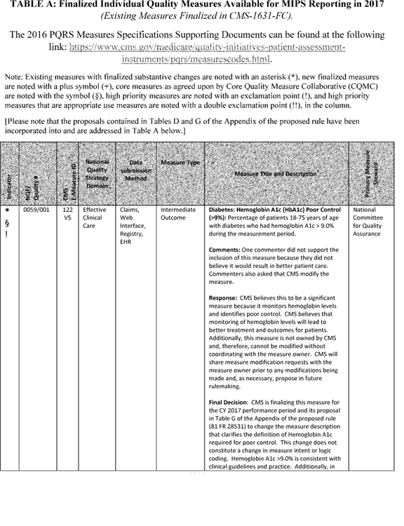

**[*77559]**



**[*77560]**

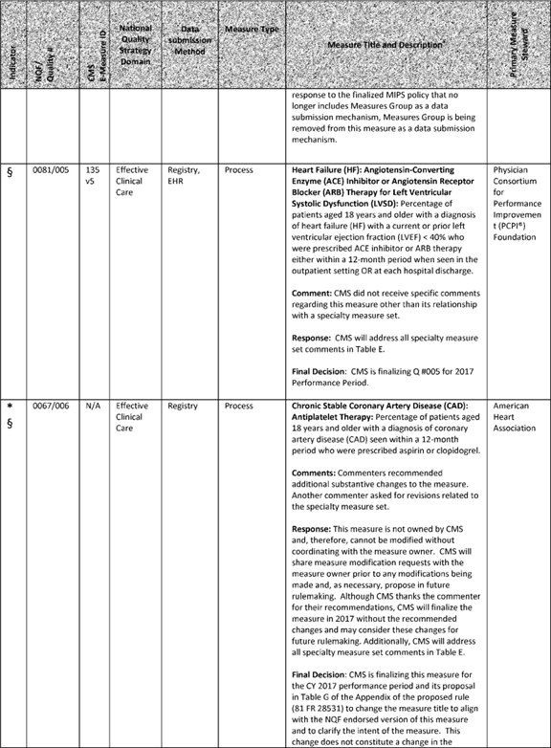

**[*77560]**



**[*77561]**

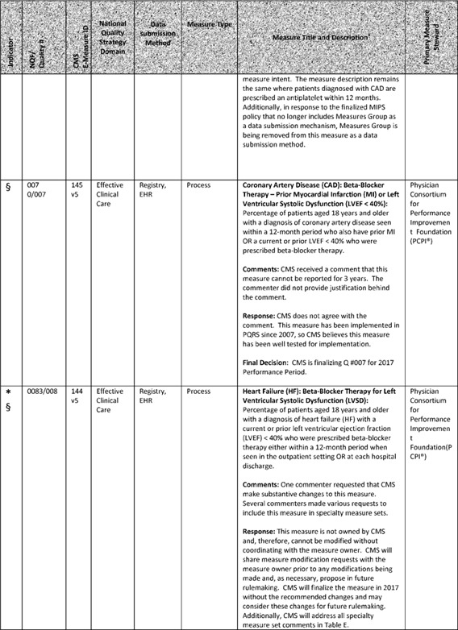

**[*77561]**



**[*77562]**

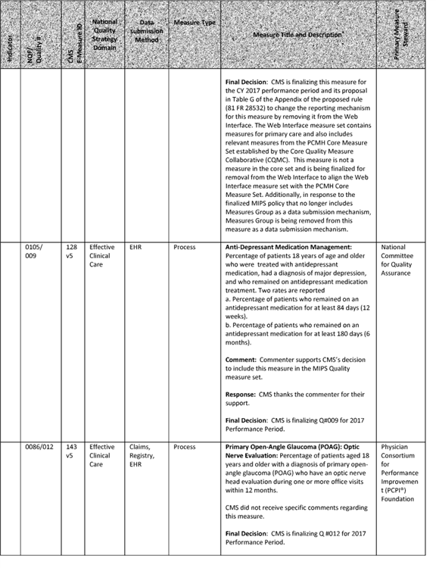

**[*77562]**



**[*77563]**

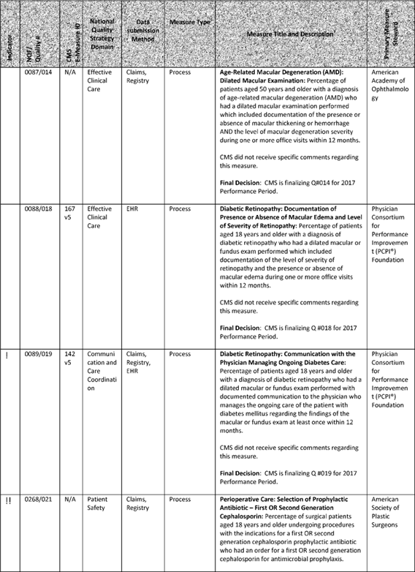

**[*77563]**



**[*77564]**

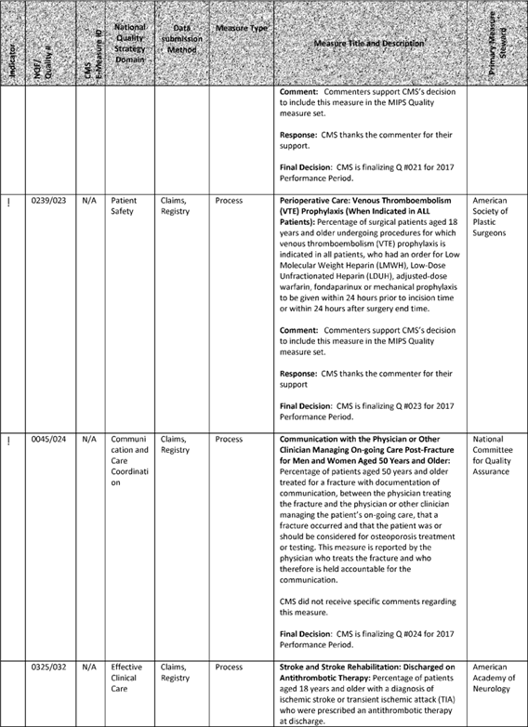

**[*77564]**



**[*77565]**

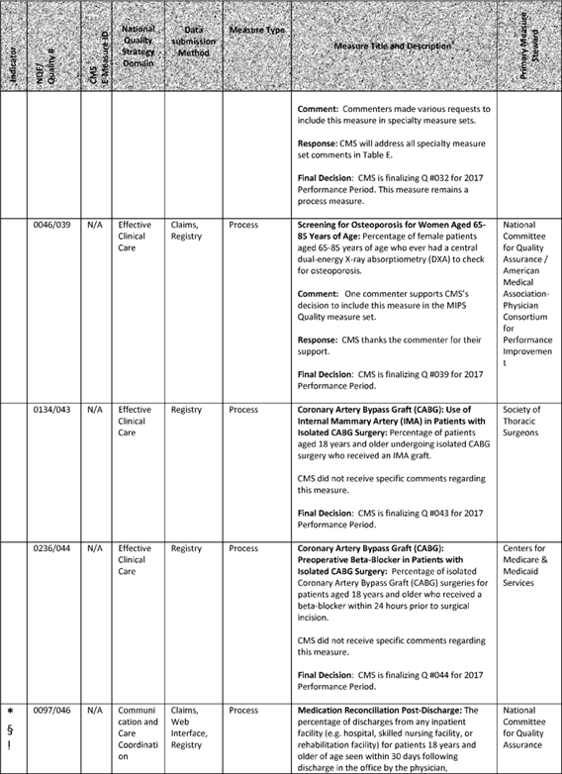

**[*77565]**



**[*77566]**

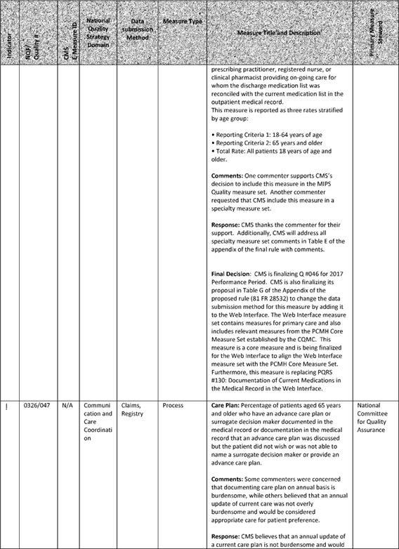

**[*77566]**



**[*77567]**

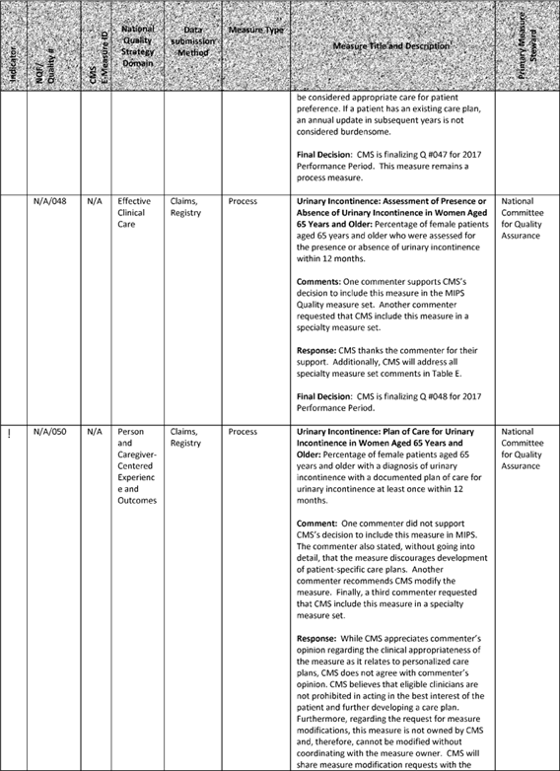

**[*77567]**



**[*77568]**

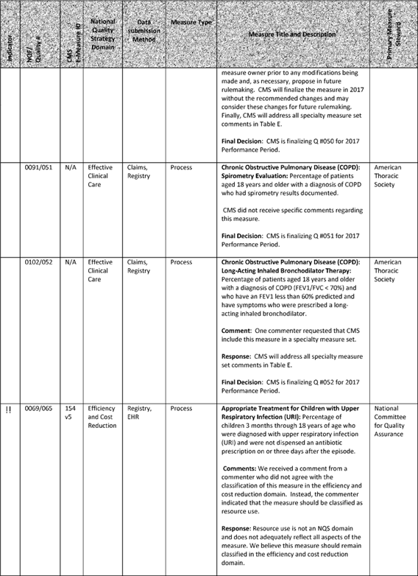

**[*77568]**



**[*77569]**

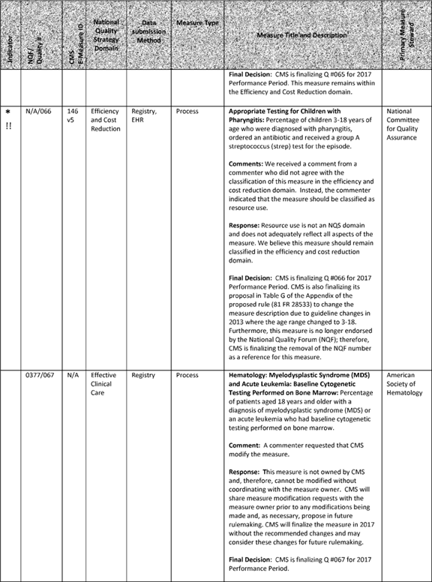

**[*77569]**



**[*77570]**

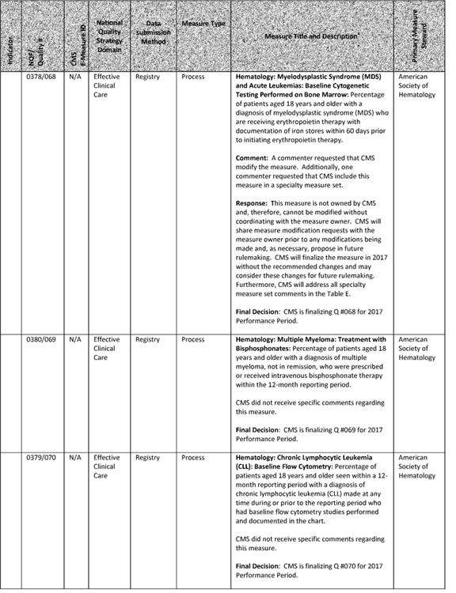

**[*77570]**



**[*77571]**

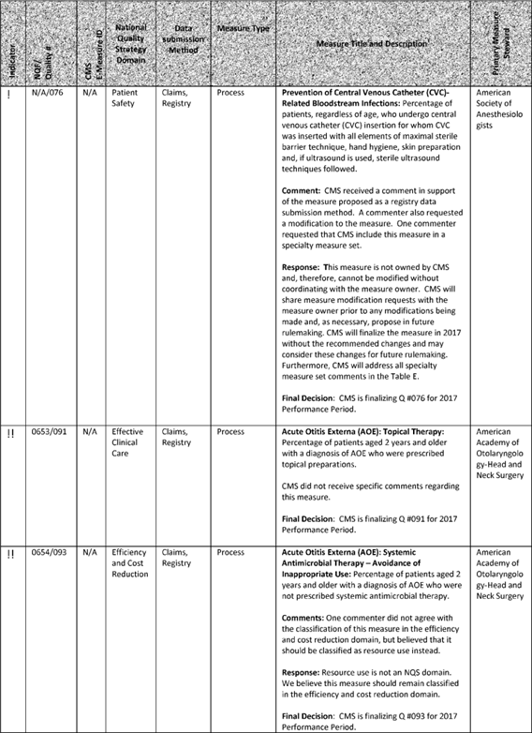

**[*77571]**



**[*77572]**

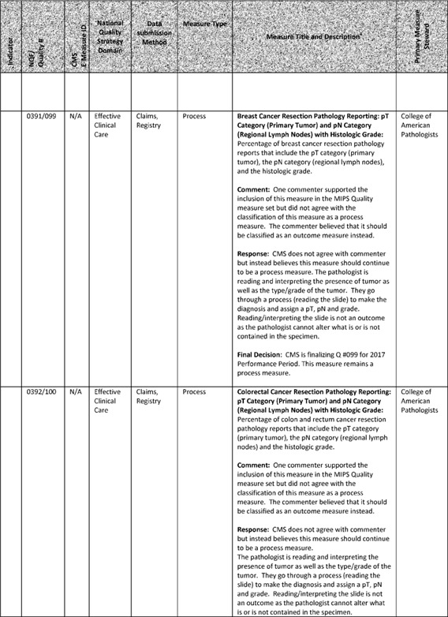

**[*77572]**



**[*77573]**

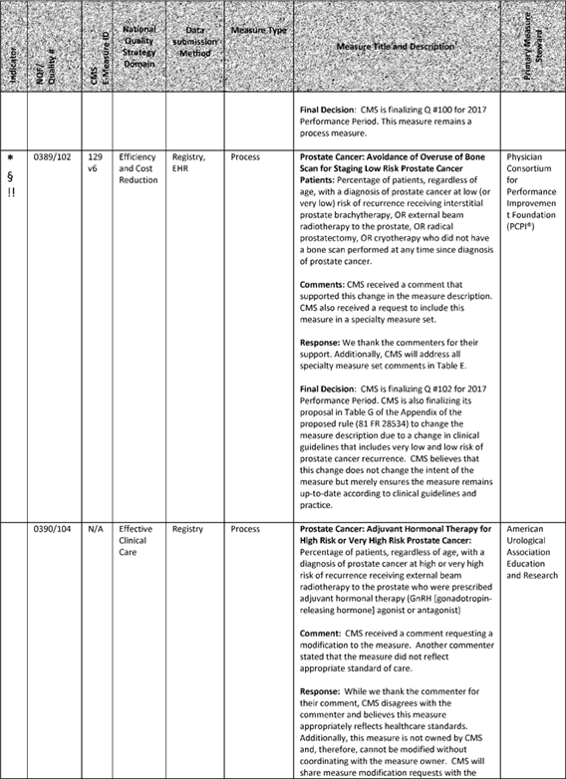

**[*77573]**



**[*77574]**

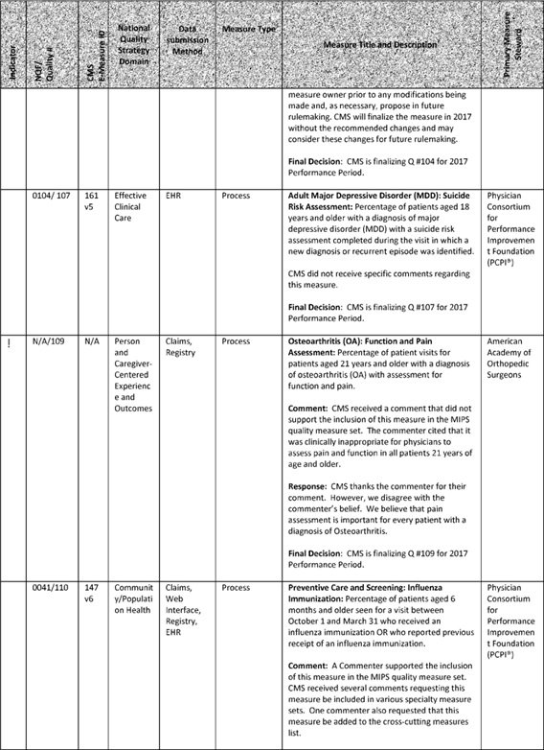

**[*77574]**



**[*77575]**

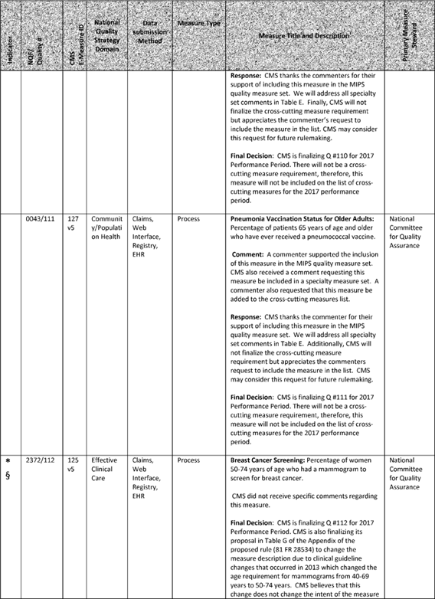

**[*77575]**



**[*77576]**

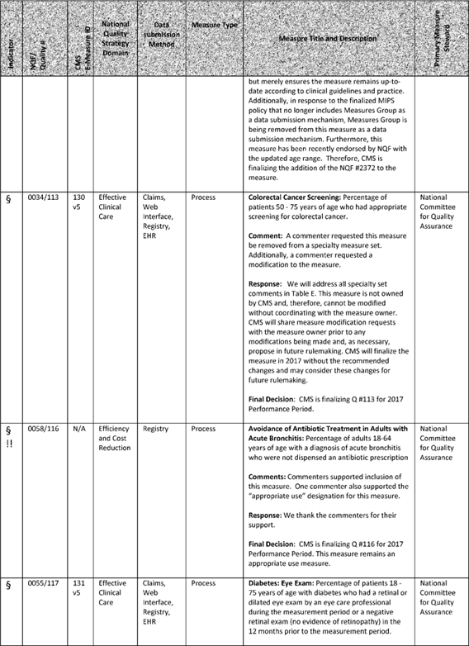

**[*77576]**



**[*77577]**

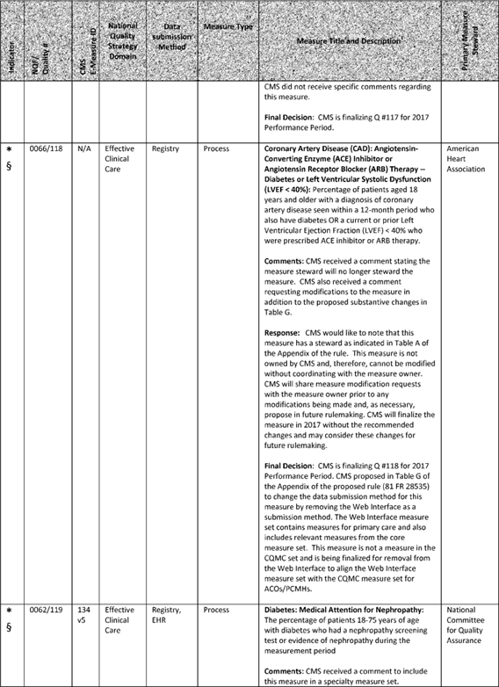

**[*77577]**



**[*77578]**

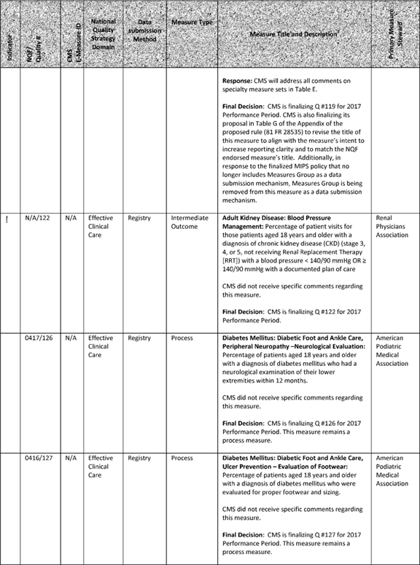

**[*77578]**



**[*77579]**

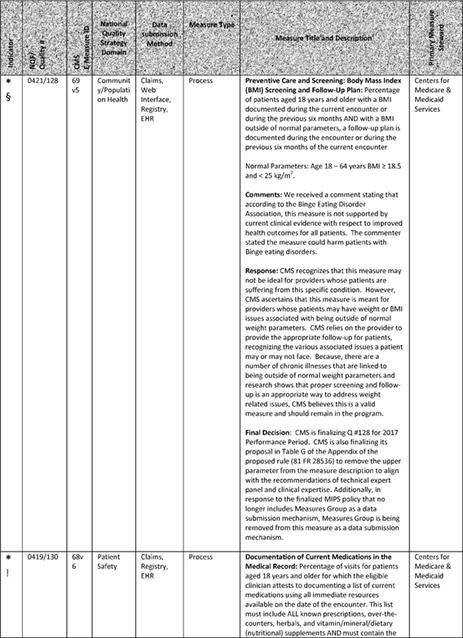

**[*77579]**



**[*77580]**

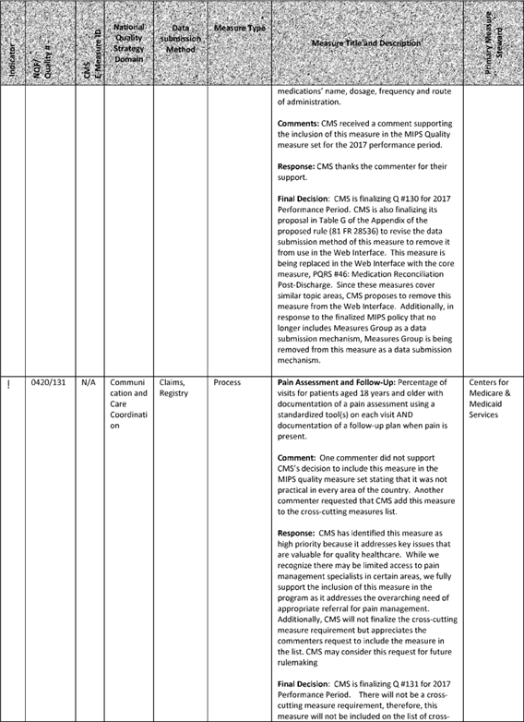

**[*77580]**



**[*77581]**

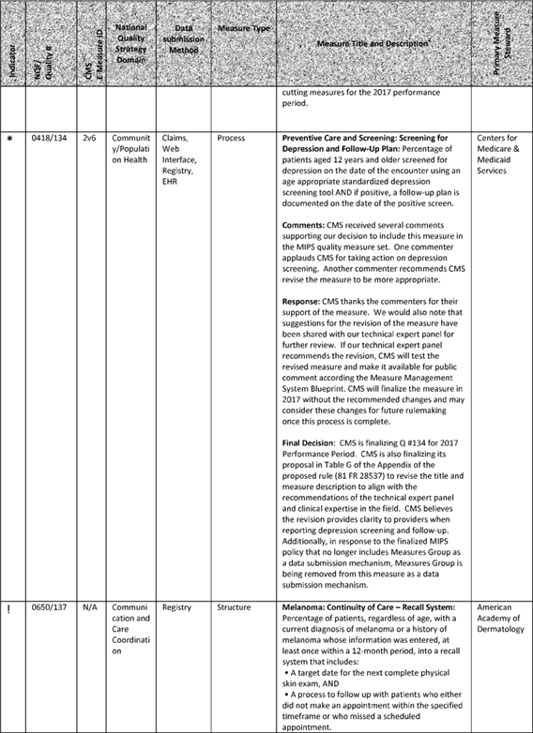

**[*77581]**



**[*77582]**

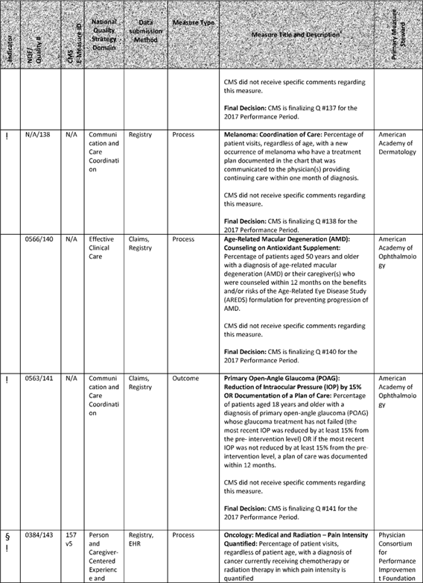

**[*77582]**



**[*77583]**



**[*77583]**



**[*77584]**

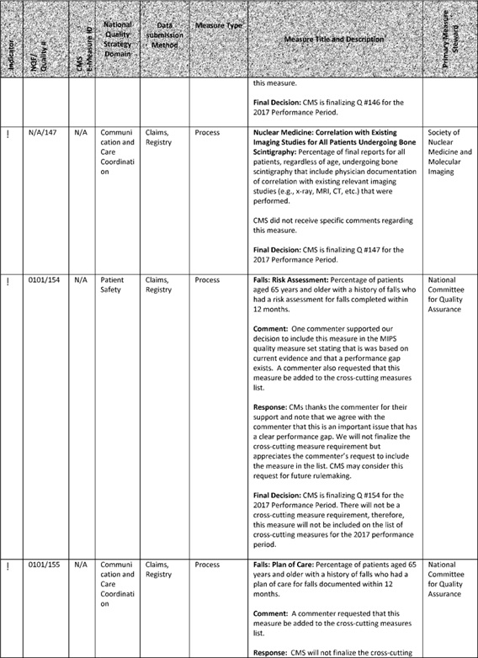

**[*77584]**



**[*77585]**

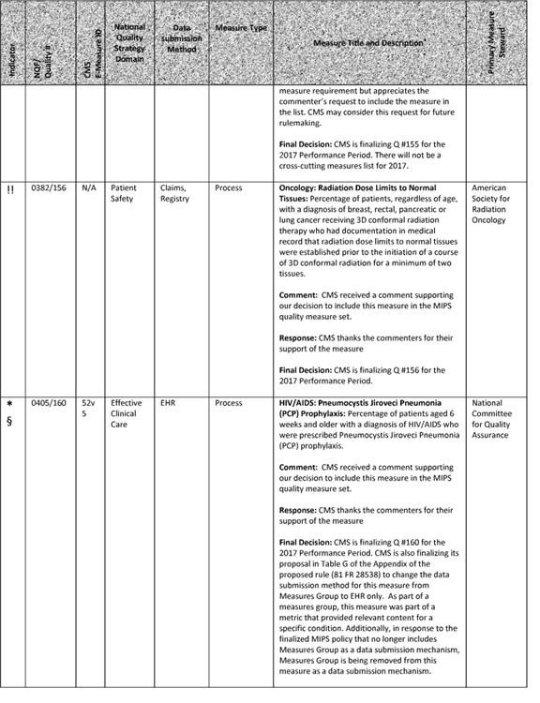

**[*77585]**



**[*77586]**

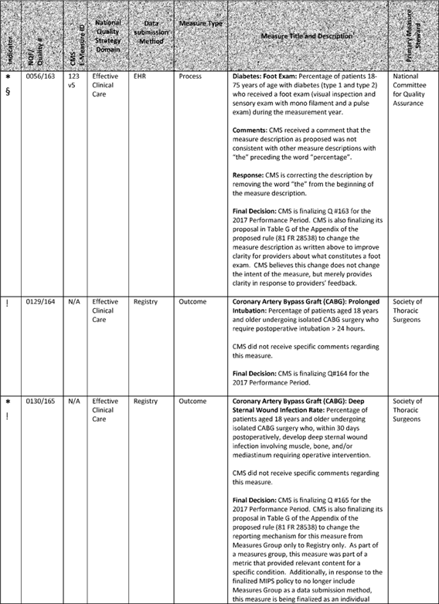

**[*77586]**



**[*77587]**

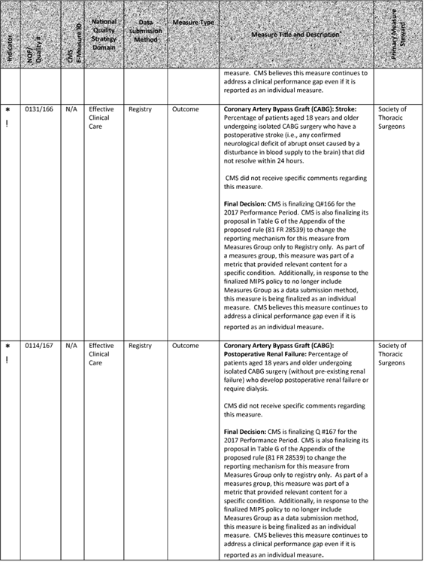

**[*77587]**



**[*77588]**

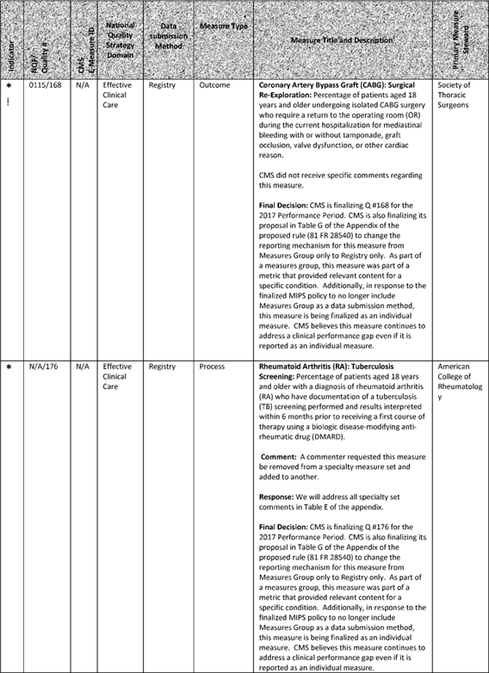

**[*77588]**



**[*77589]**

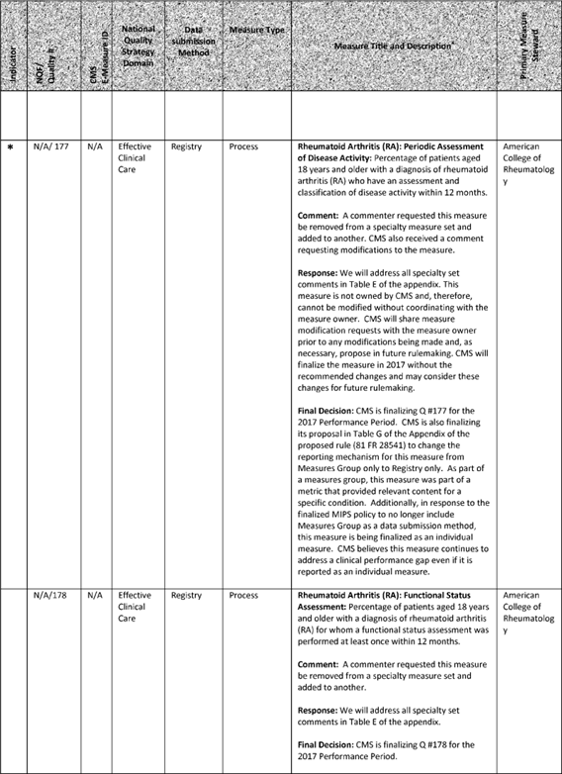

**[*77589]**



**[*77590]**

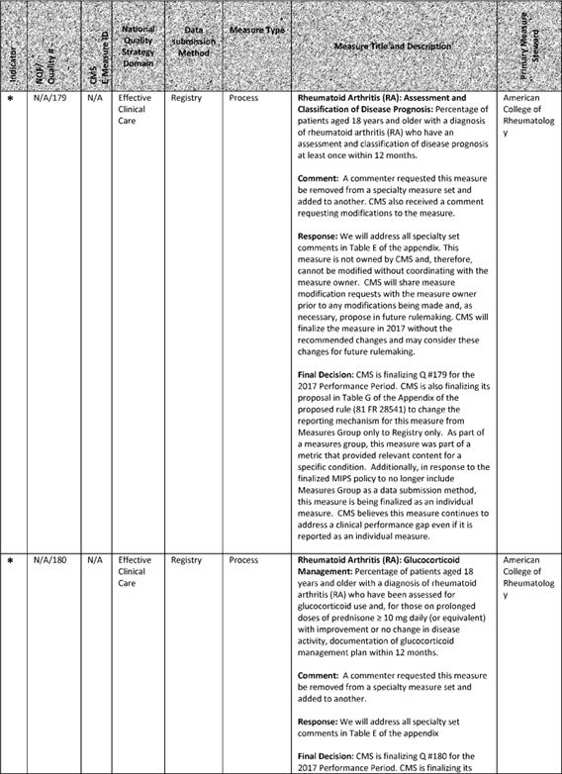

**[*77590]**



**[*77591]**

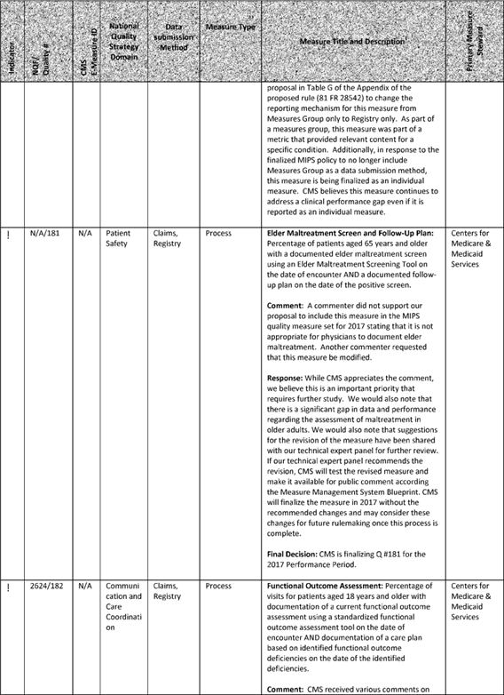

**[*77591]**



**[*77592]**

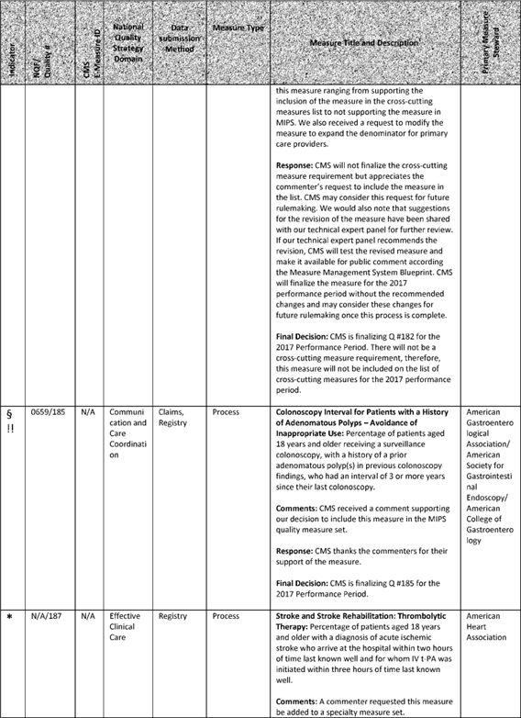

**[*77592]**



**[*77593]**

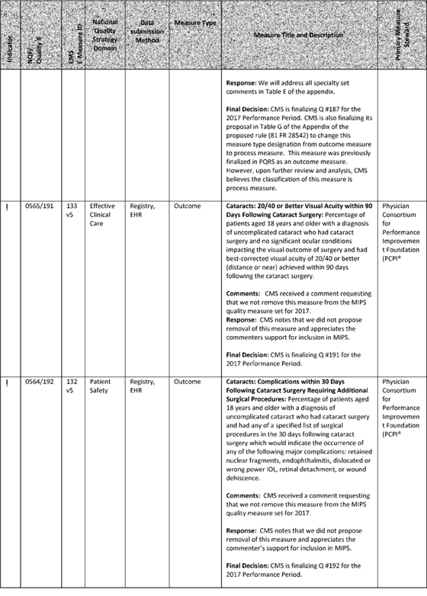

**[*77593]**



**[*77594]**

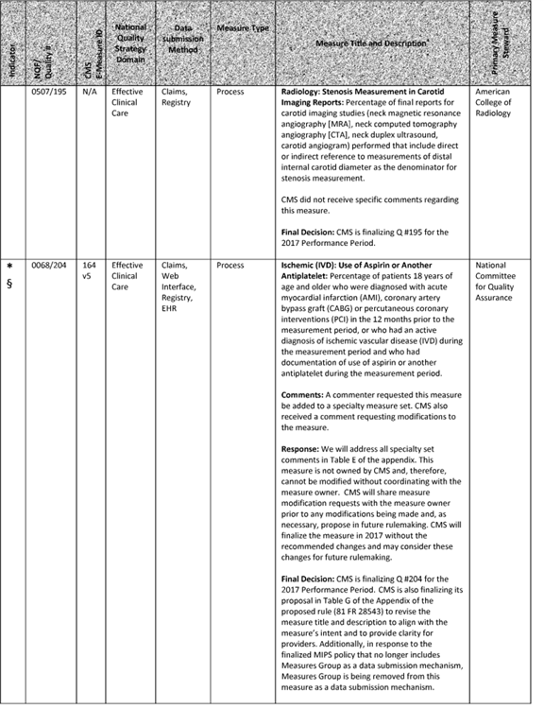

**[*77594]**



**[*77595]**

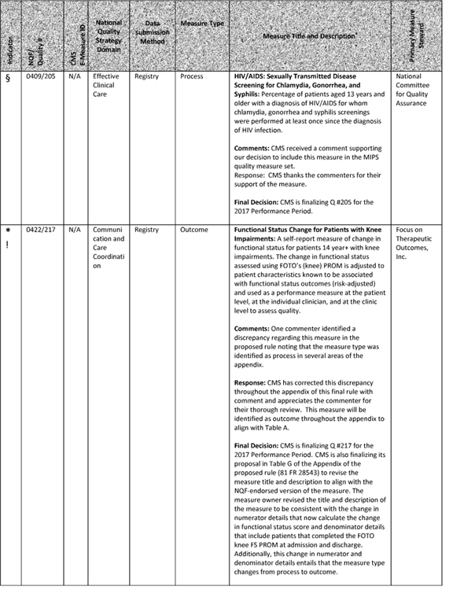

**[*77595]**



**[*77596]**

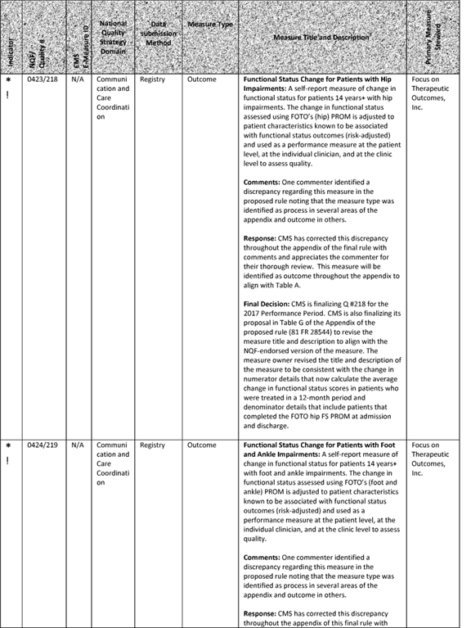

**[*77596]**



**[*77597]**

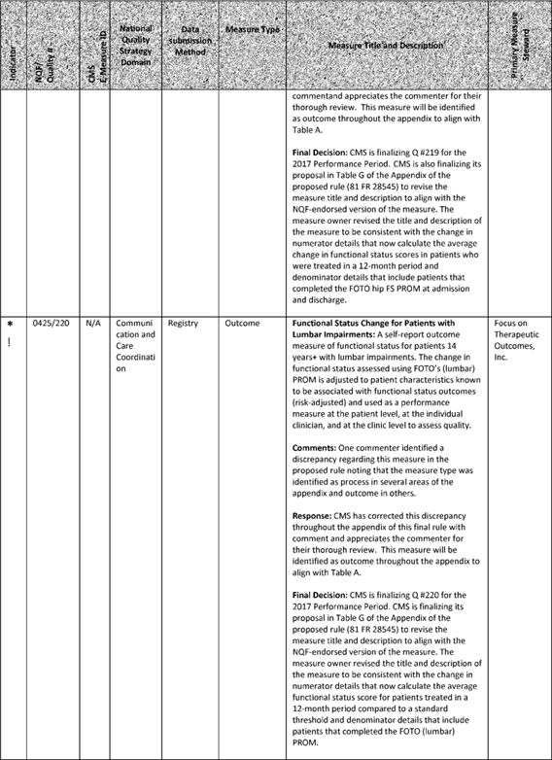

**[*77597]**



**[*77598]**

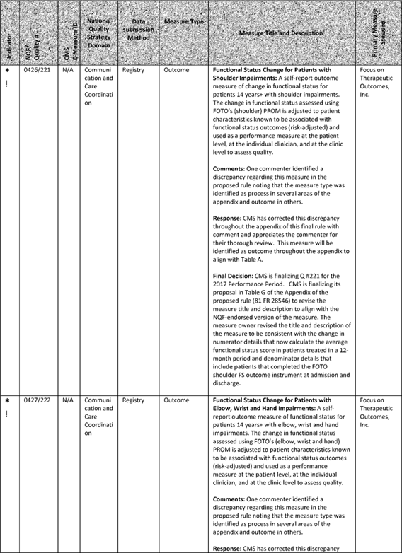

**[*77598]**



**[*77599]**

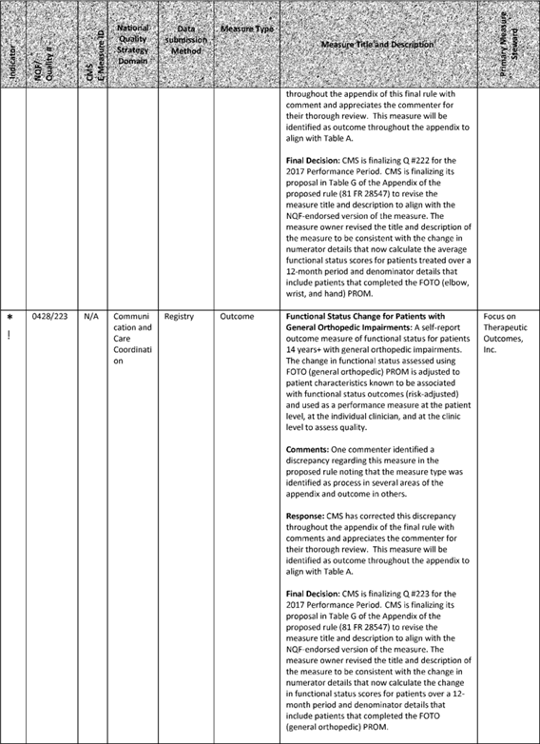

**[*77599]**



**[*77600]**

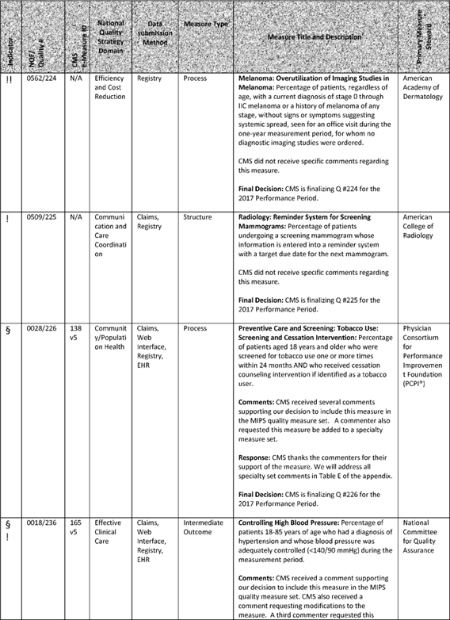

**[*77600]**



**[*77601]**

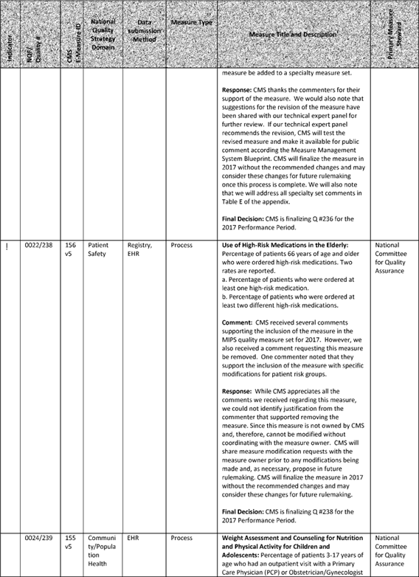

**[*77601]**



**[*77602]**

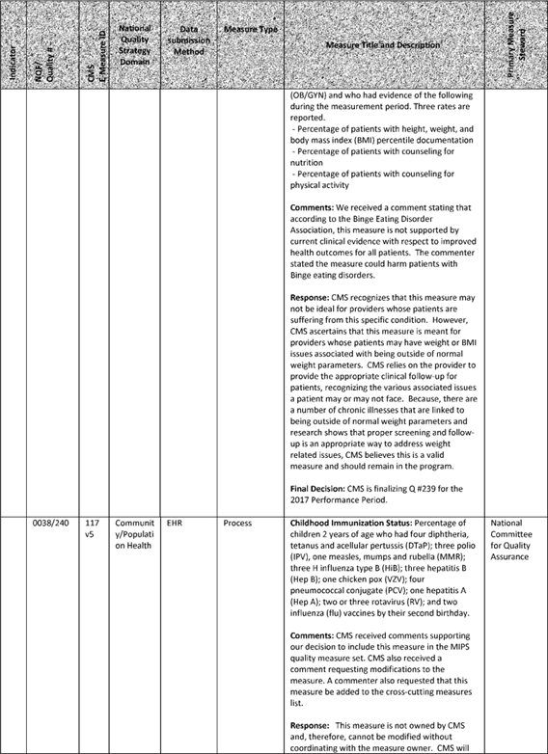

**[*77602]**



**[*77603]**

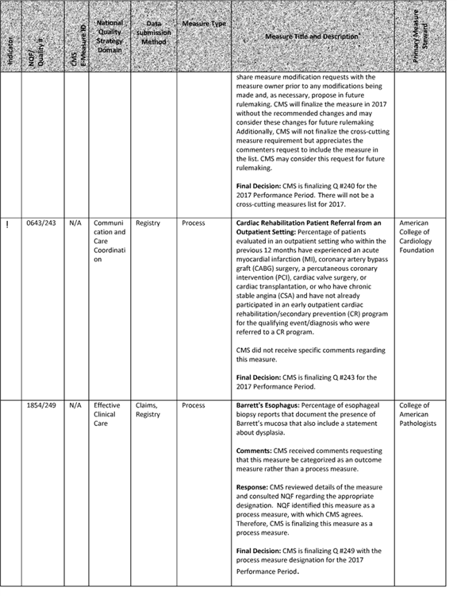

**[*77603]**



**[*77604]**

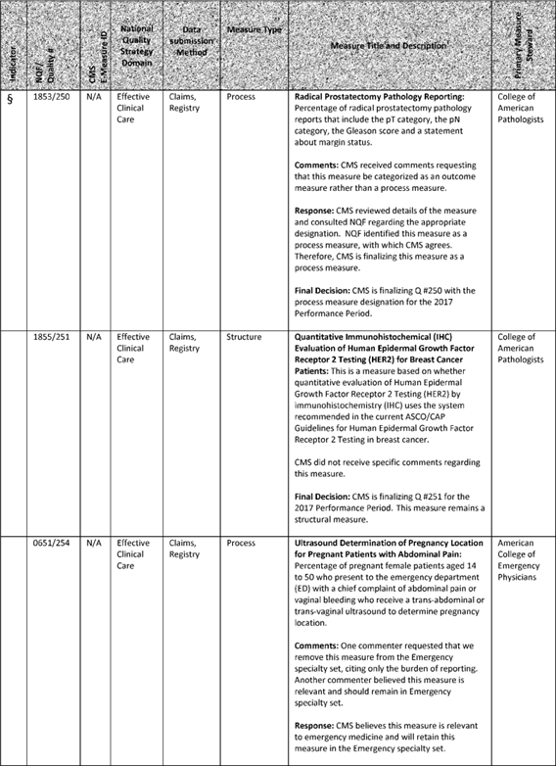

**[*77604]**



**[*77605]**

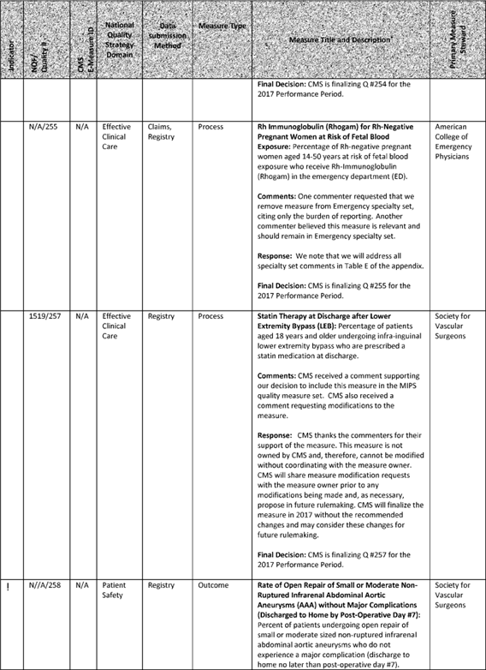

**[*77605]**



**[*77606]**

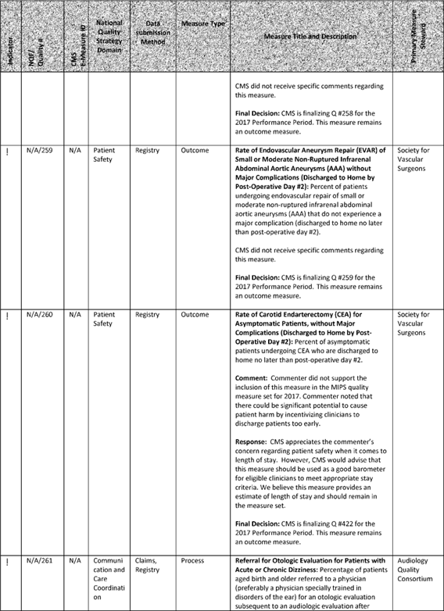

**[*77606]**



**[*77607]**

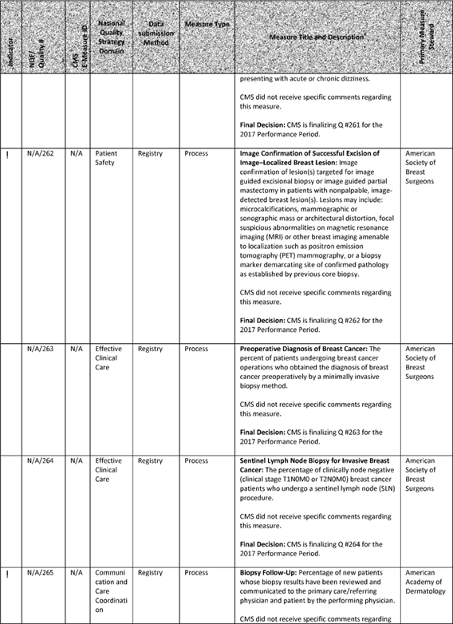

**[*77607]**



**[*77608]**

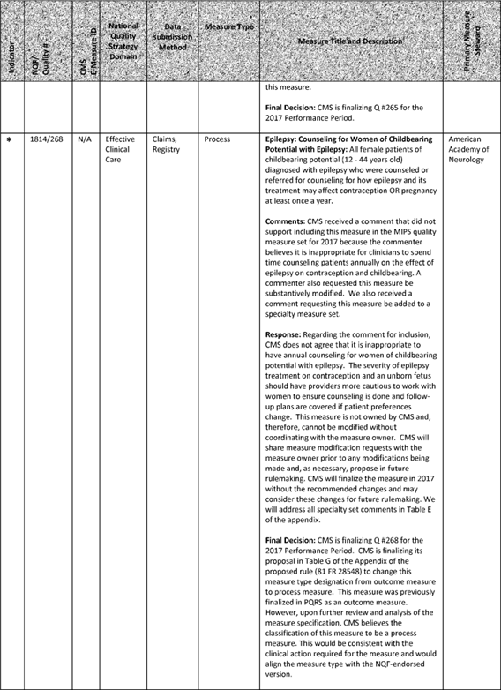

**[*77608]**



**[*77609]**



**[*77609]**



**[*77610]**

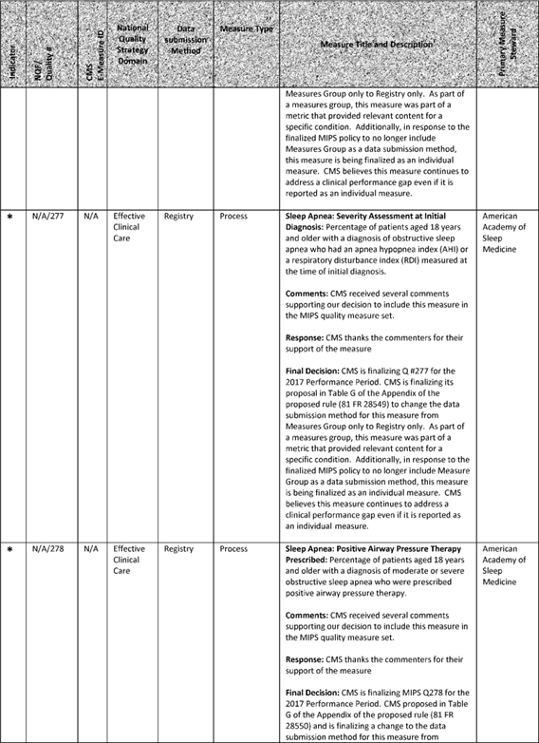

**[*77610]**



**[*77611]**

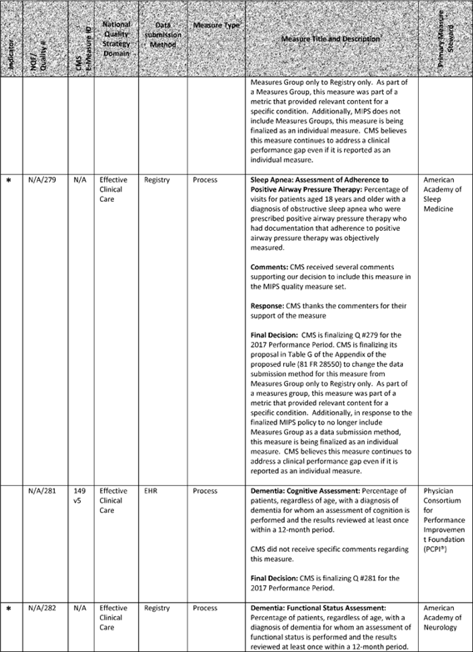

**[*77611]**



**[*77612]**

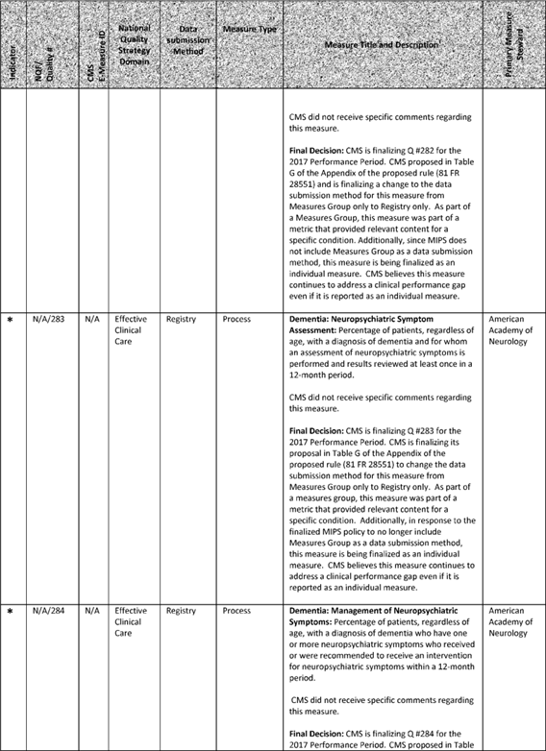

**[*77612]**



**[*77613]**

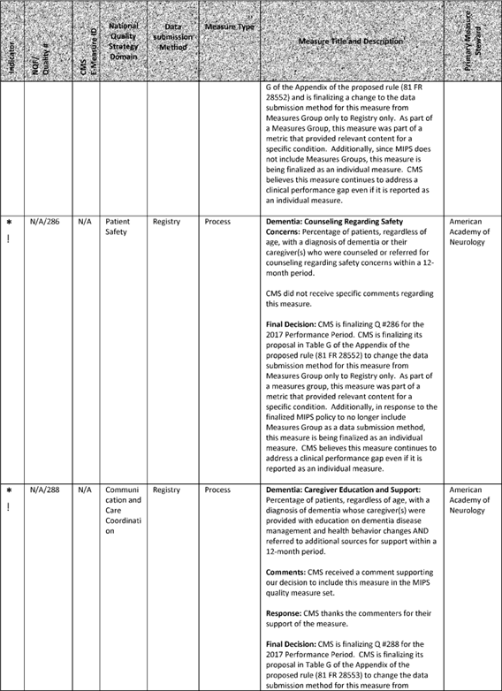

**[*77613]**



**[*77614]**

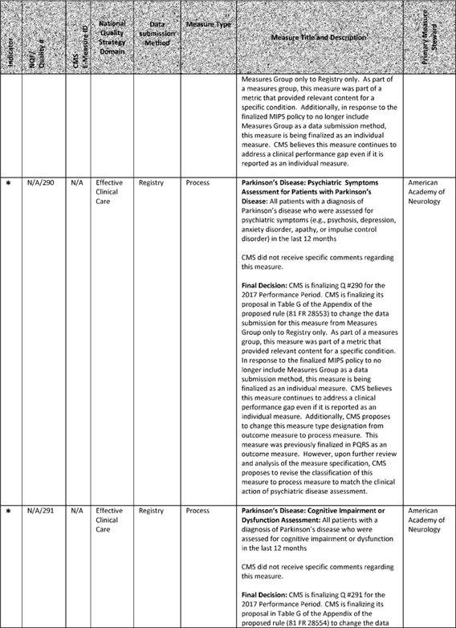

**[*77614]**



**[*77615]**

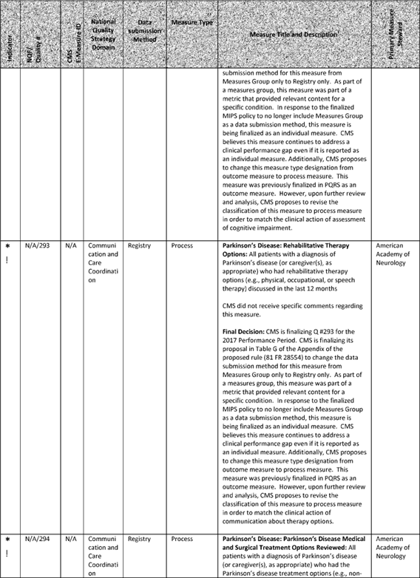

**[*77615]**



**[*77616]**

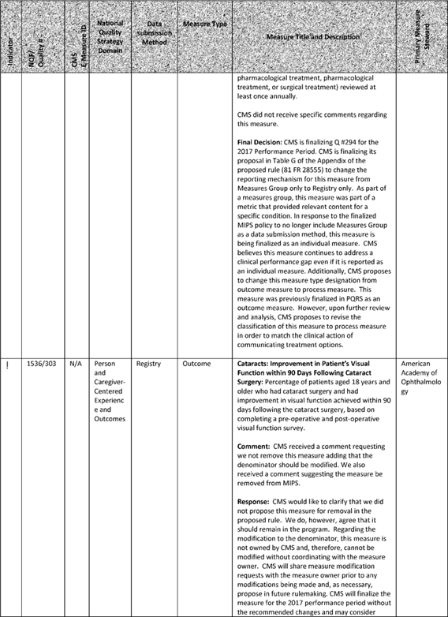

**[*77616]**



**[*77617]**

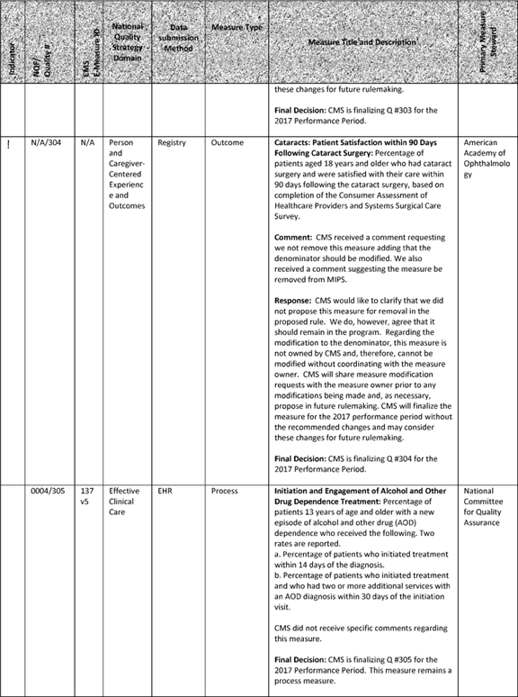

**[*77617]**



**[*77618]**

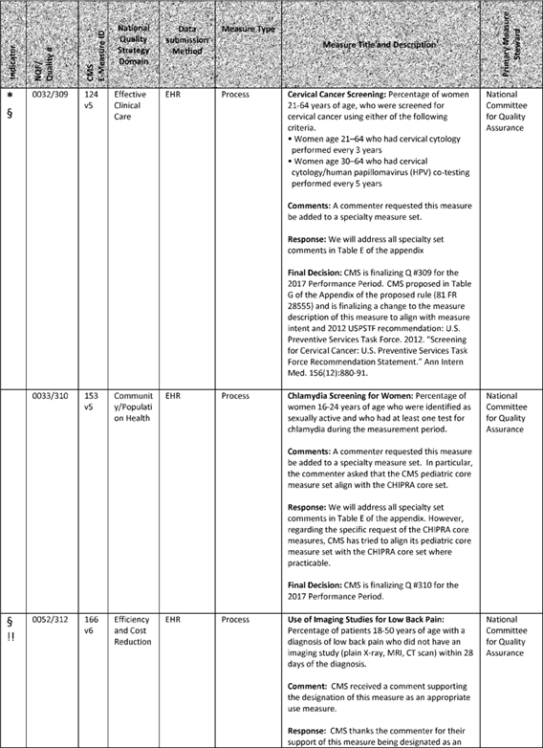

**[*77618]**



**[*77619]**

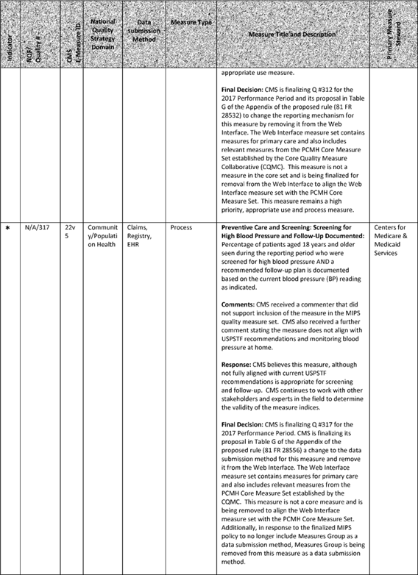

**[*77619]**



**[*77620]**



**[*77620]**



**[*77621]**

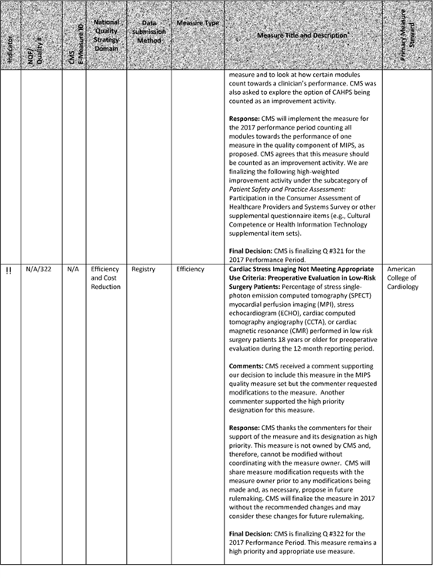

**[*77621]**



**[*77622]**

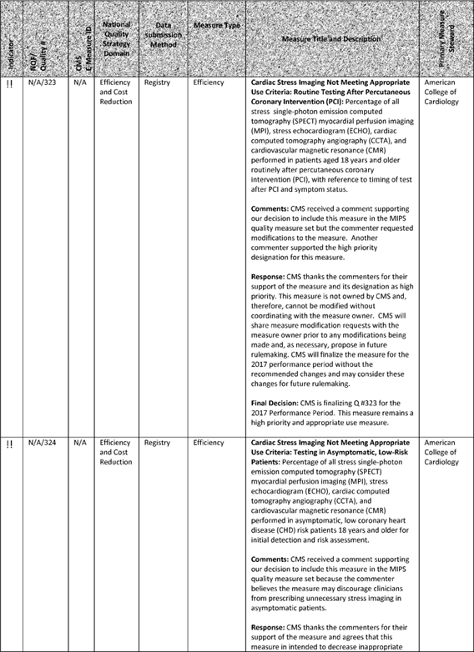

**[*77622]**



**[*77623]**

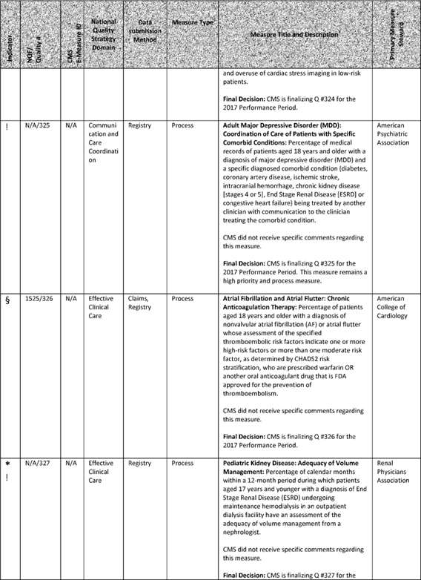

**[*77623]**



**[*77624]**

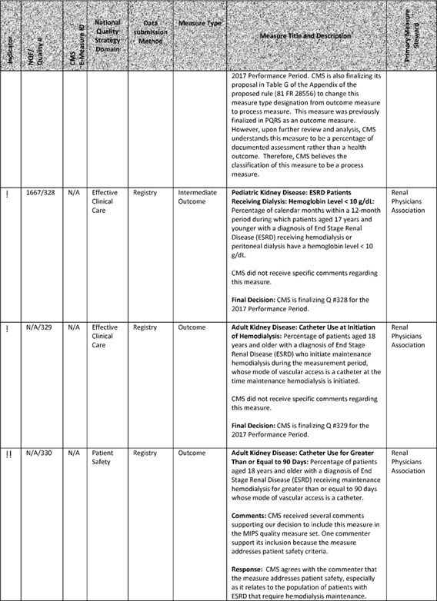

**[*77624]**



**[*77625]**

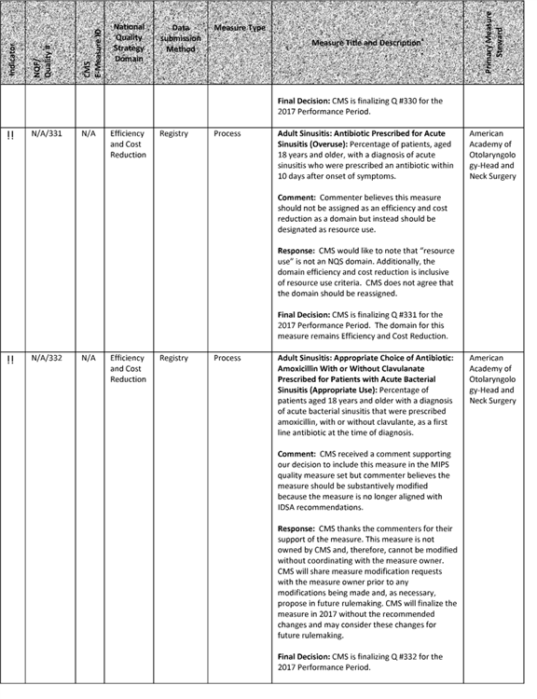

**[*77625]**



**[*77626]**

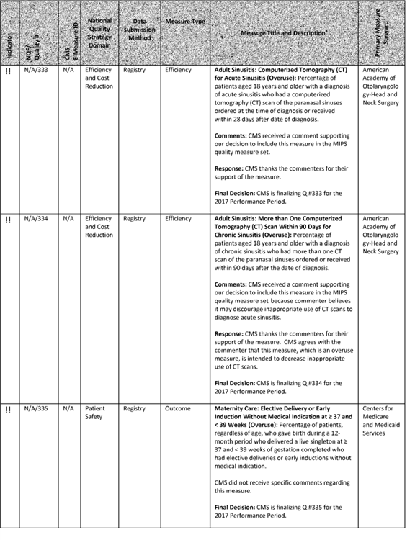

**[*77626]**



**[*77627]**

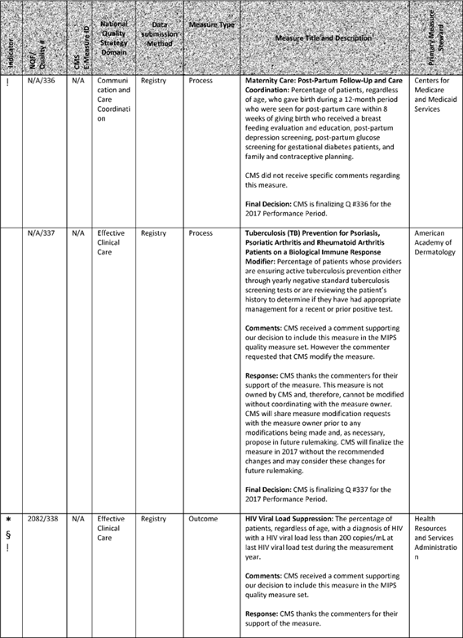

**[*77627]**



**[*77628]**

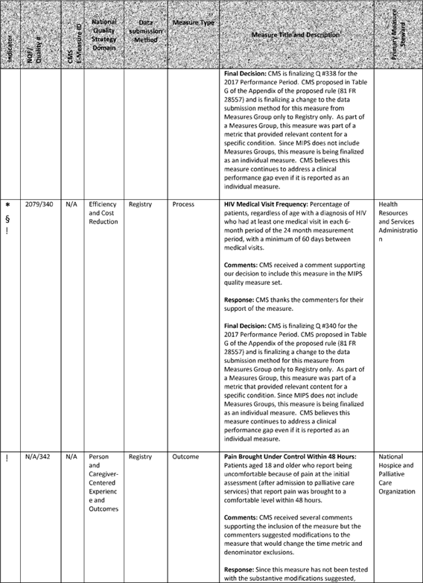

**[*77628]**



**[*77629]**



**[*77629]**



**[*77630]**

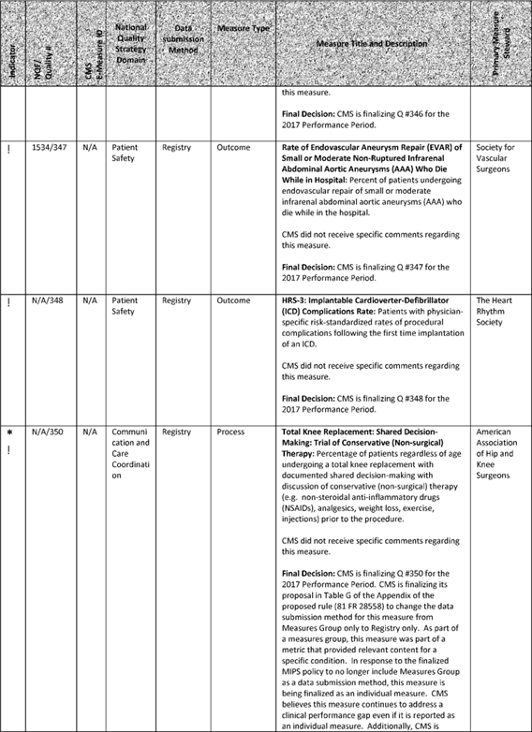

**[*77630]**



**[*77631]**

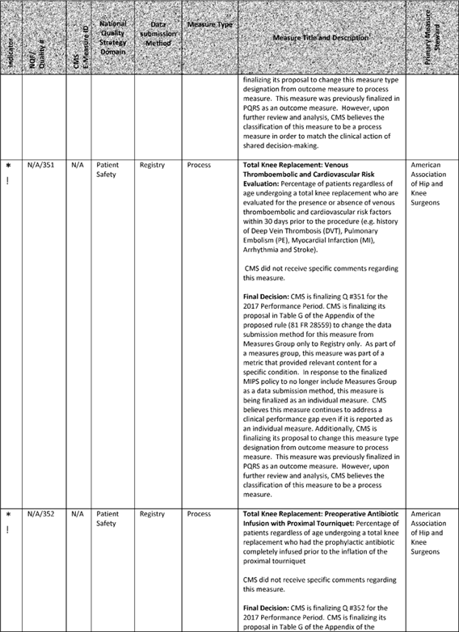

**[*77631]**



**[*77632]**

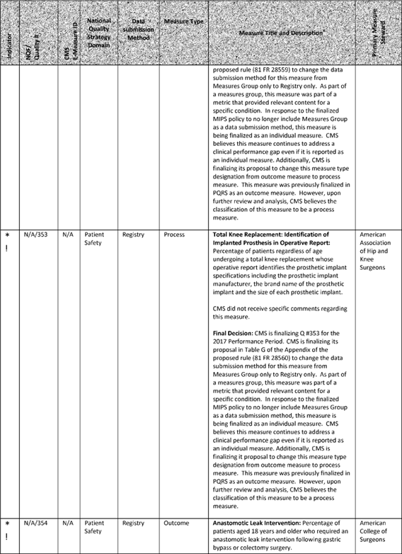

**[*77632]**



**[*77633]**

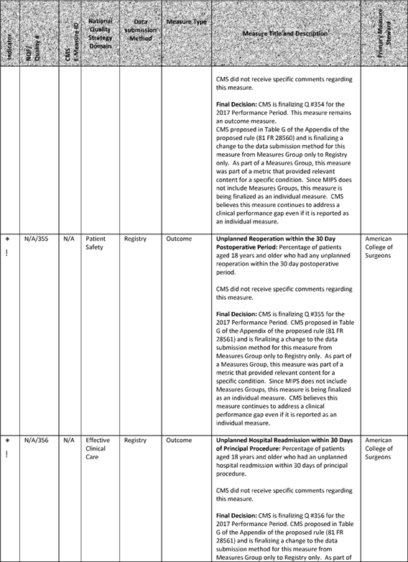

**[*77633]**



**[*77634]**

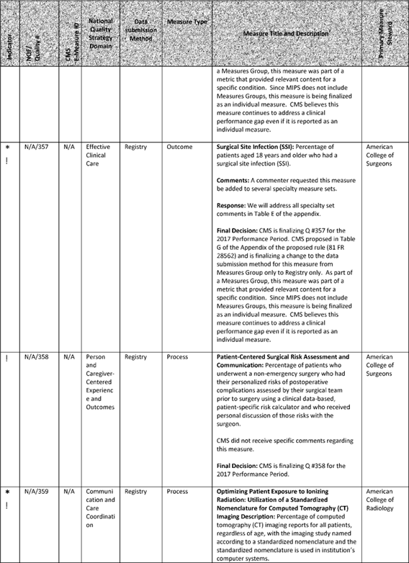

**[*77634]**



**[*77635]**

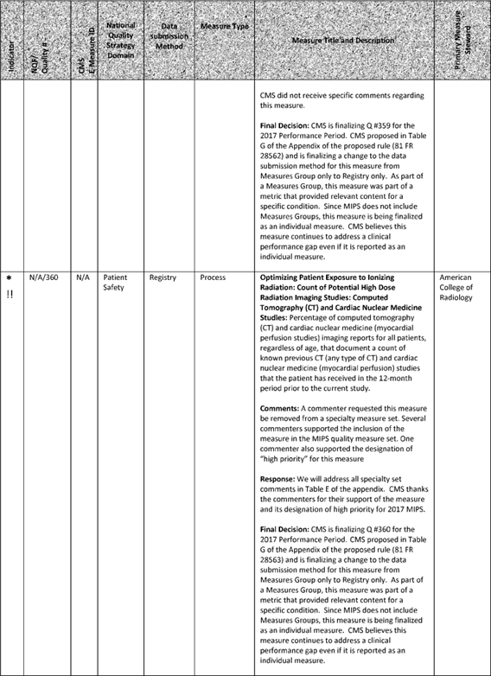

**[*77635]**



**[*77636]**

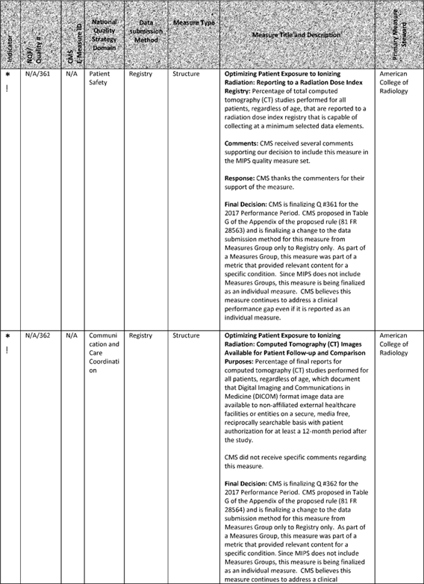

**[*77636]**



**[*77637]**

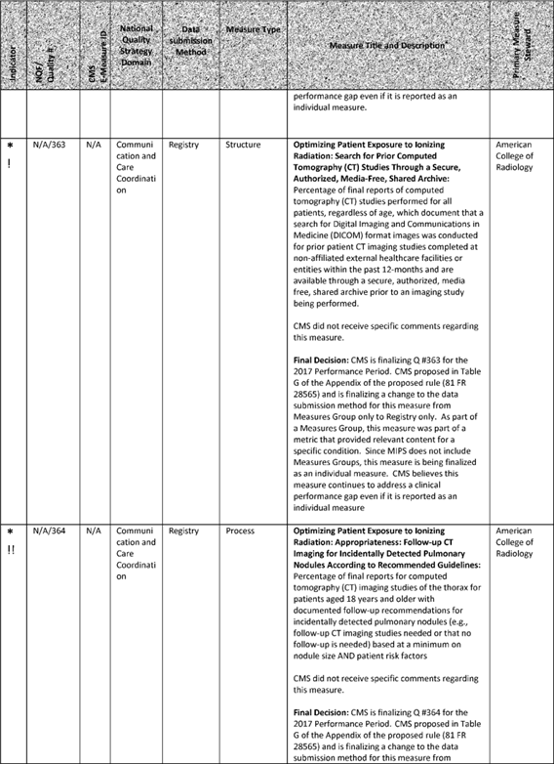

**[*77637]**



**[*77638]**

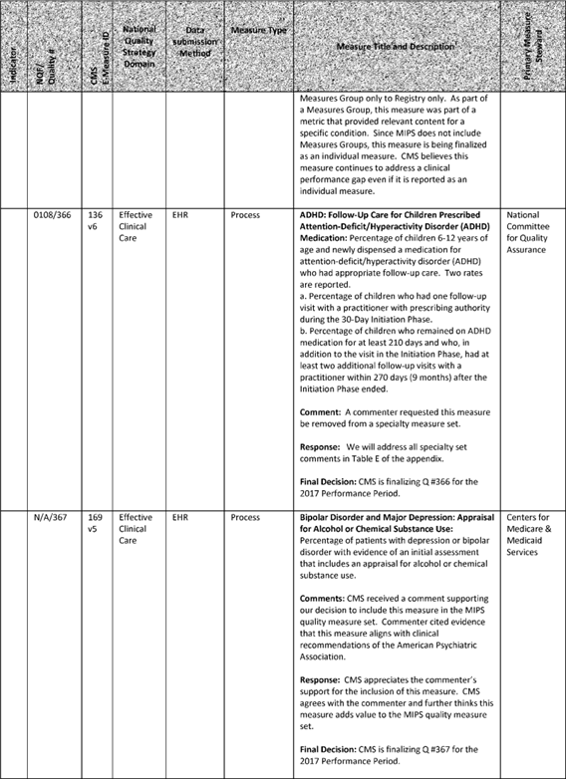

**[*77638]**



**[*77639]**

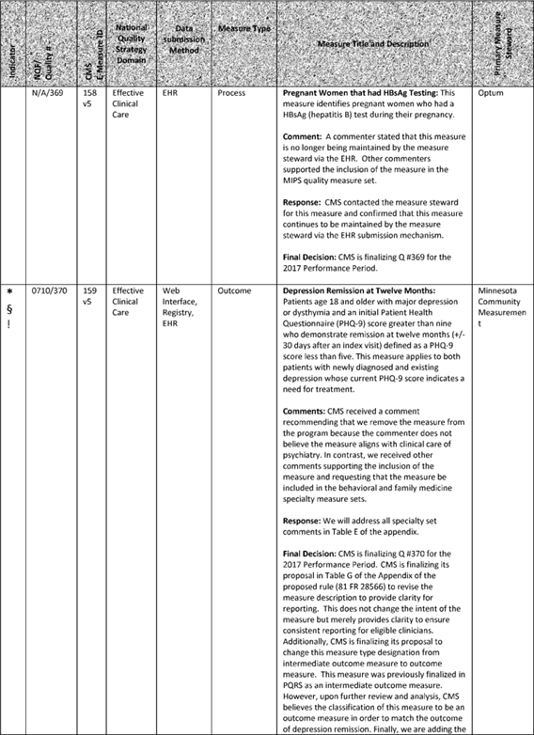

**[*77639]**



**[*77640]**

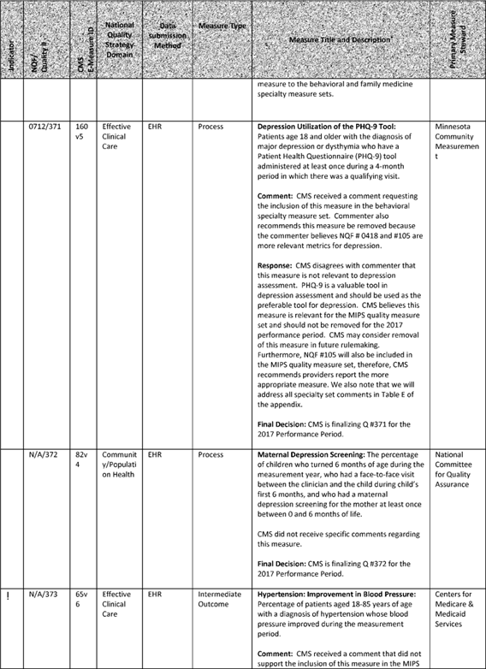

**[*77640]**



**[*77641]**

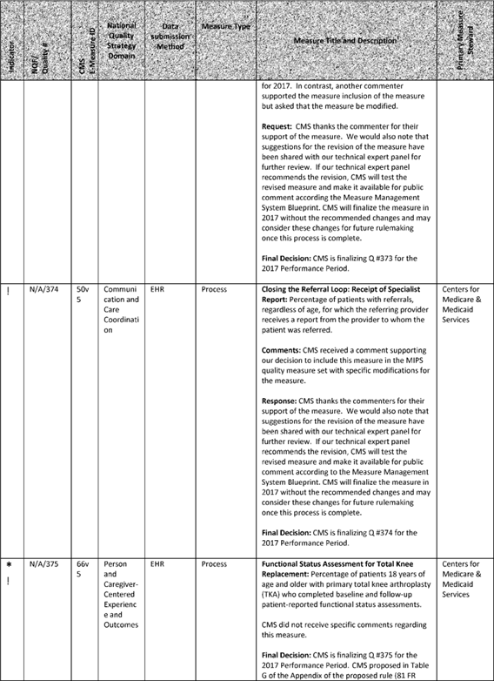

**[*77641]**



**[*77642]**

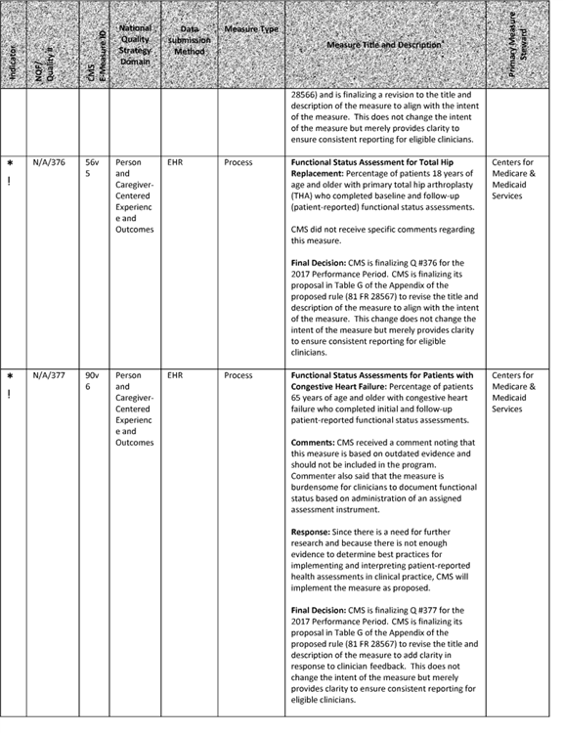

**[*77642]**



**[*77643]**

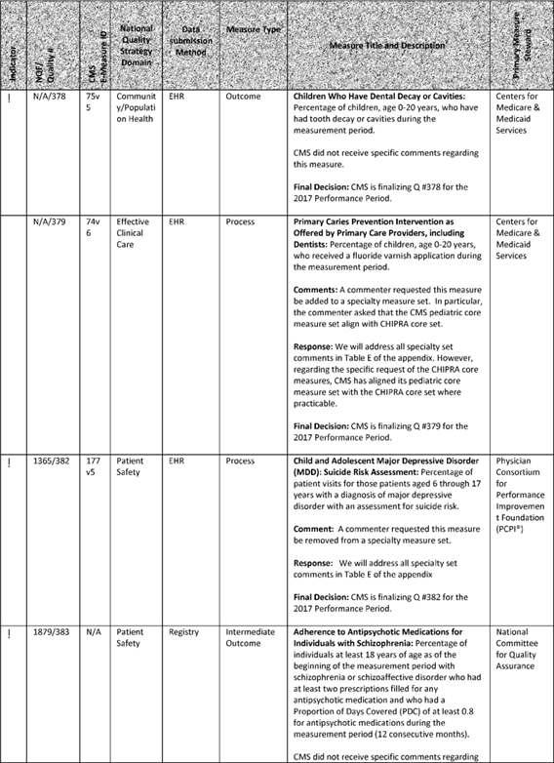

**[*77643]**



**[*77644]**

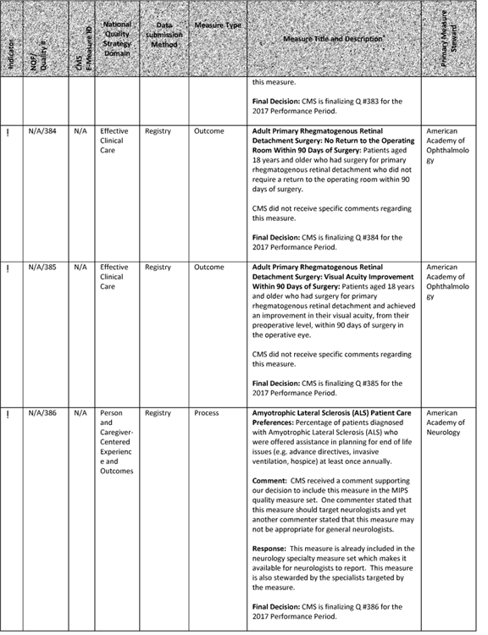

**[*77644]**



**[*77645]**

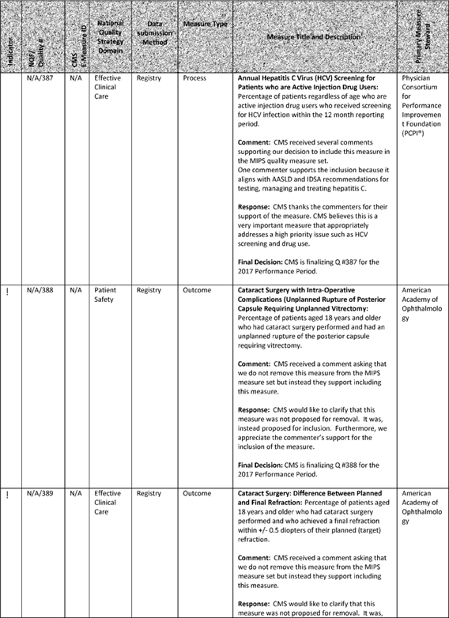

**[*77645]**



**[*77646]**

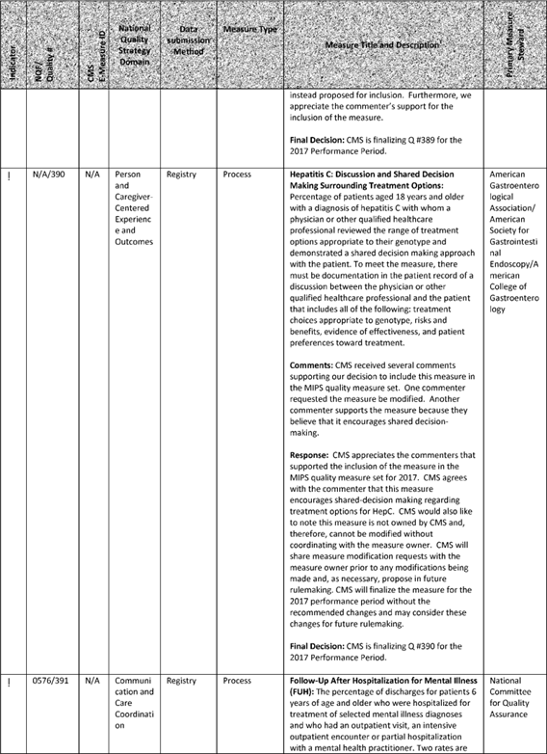

**[*77646]**



**[*77647]**

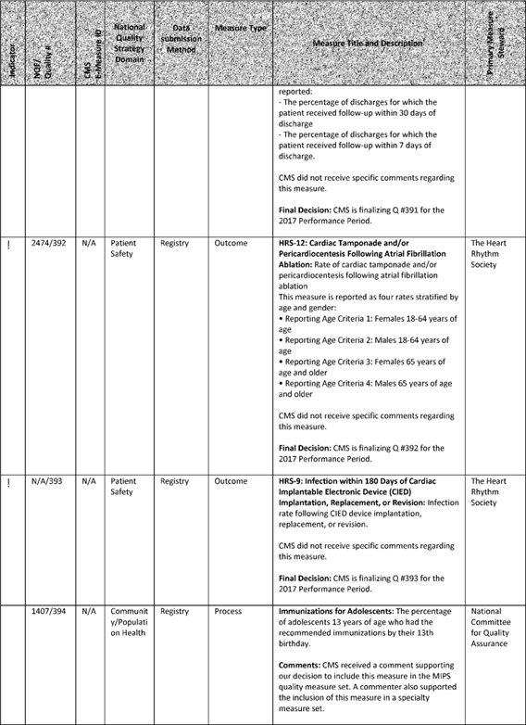

**[*77647]**



**[*77648]**

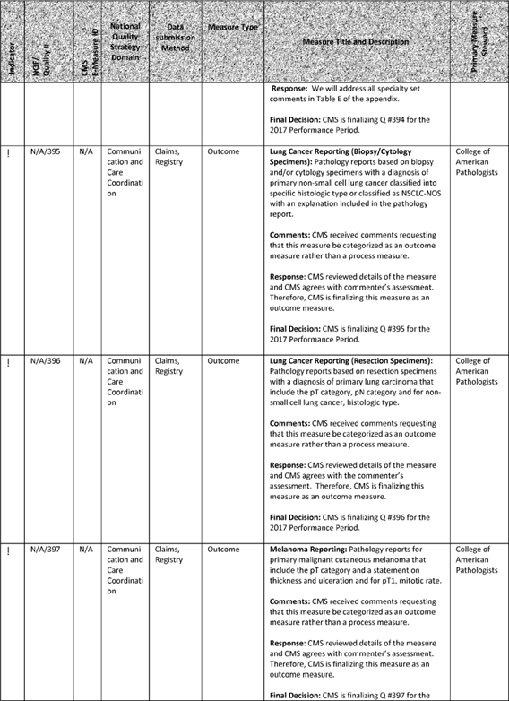

**[*77648]**



**[*77649]**

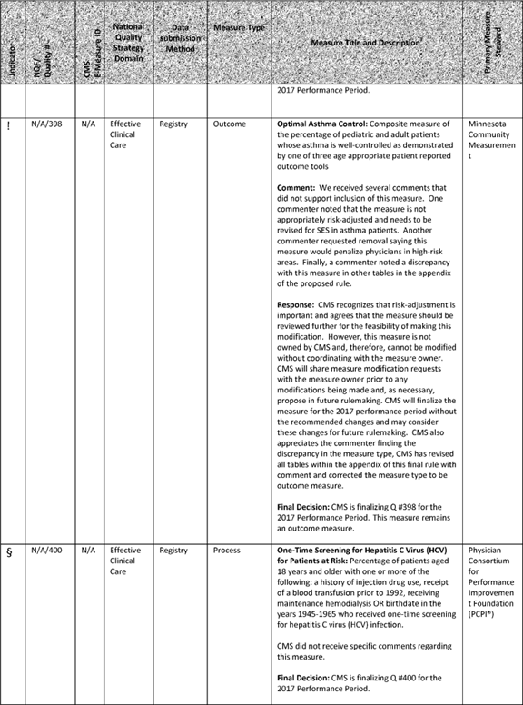

**[*77649]**



**[*77650]**

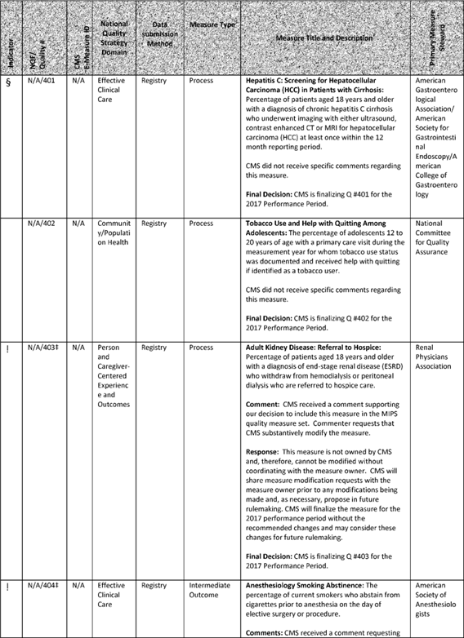

**[*77650]**



**[*77651]**

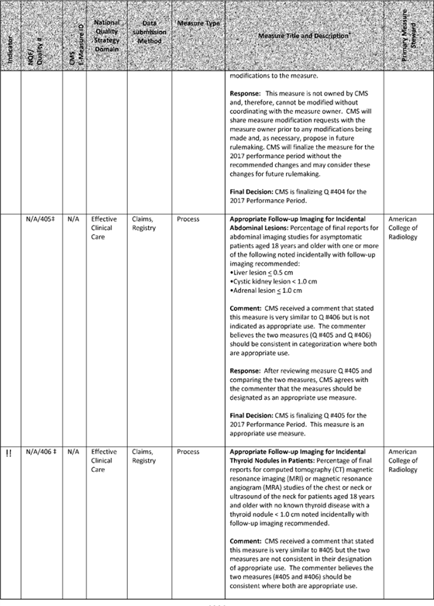

**[*77651]**



**[*77652]**

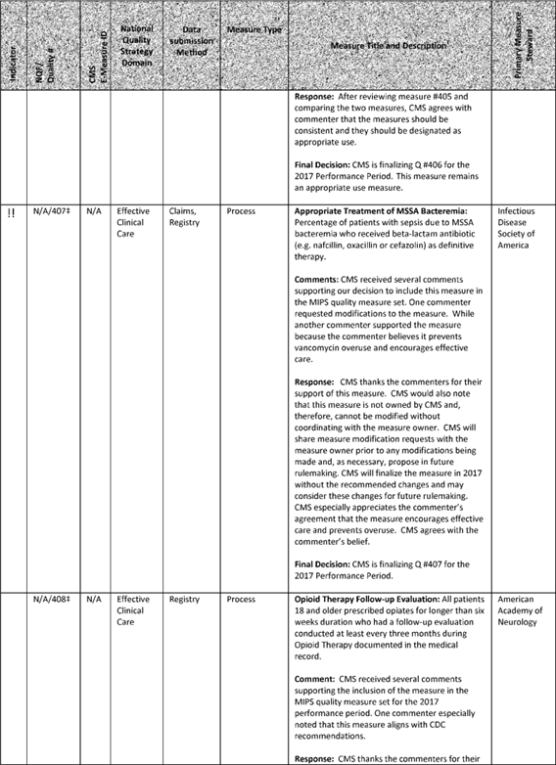

**[*77652]**



**[*77653]**

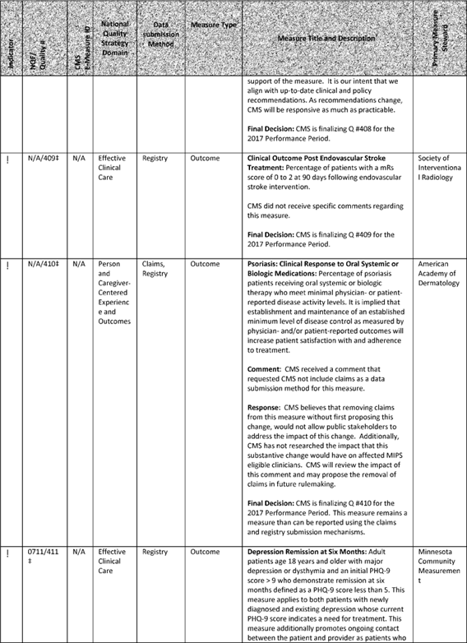

**[*77653]**



**[*77654]**

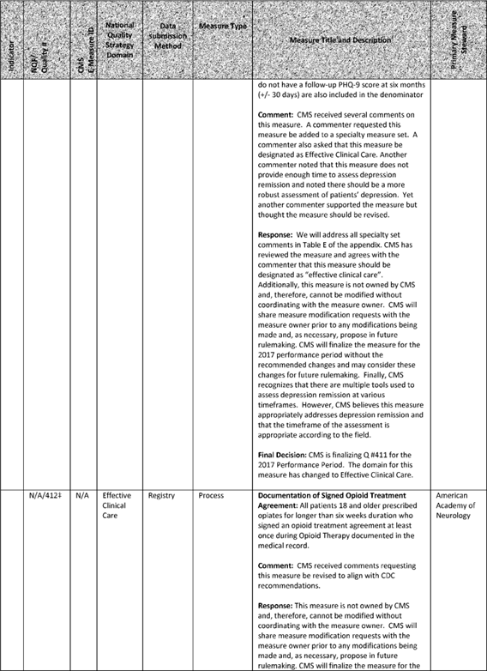

**[*77654]**



**[*77655]**

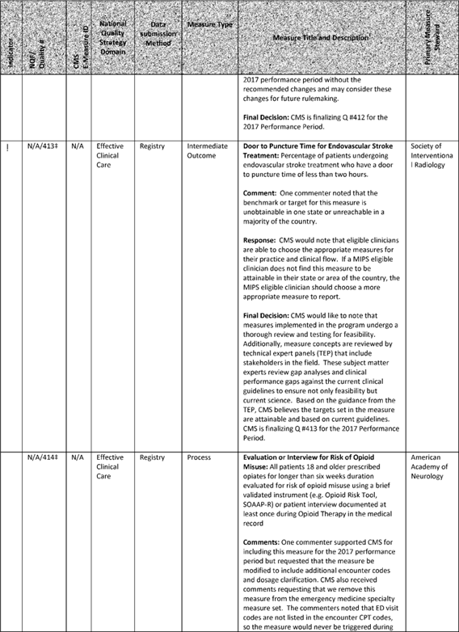

**[*77655]**



**[*77656]**

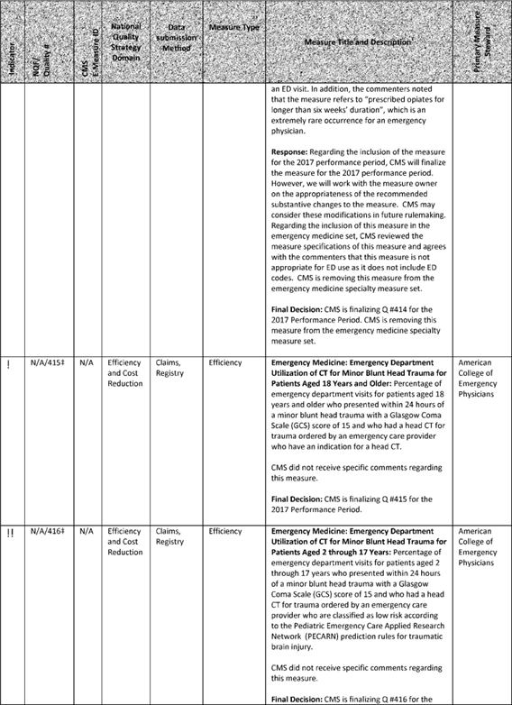

**[*77656]**



**[*77657]**

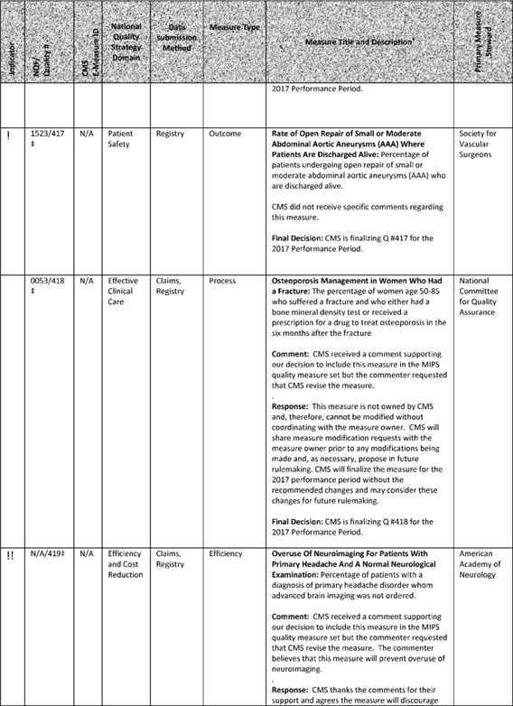

**[*77657]**



**[*77658]**

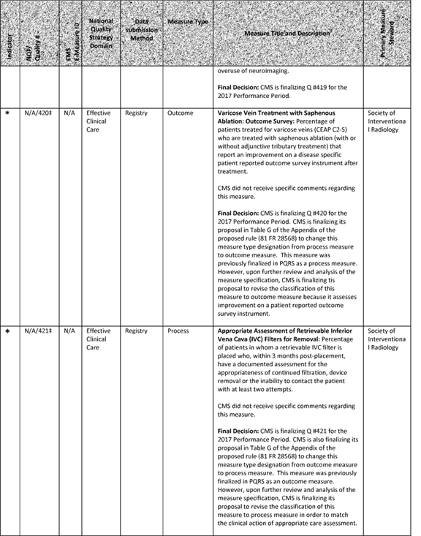

**[*77658]**



**[*77659]**

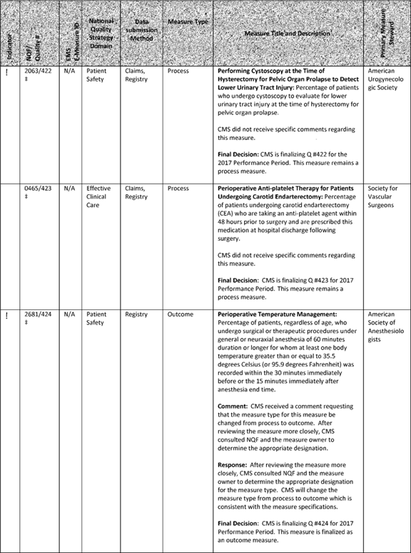

**[*77659]**



**[*77660]**

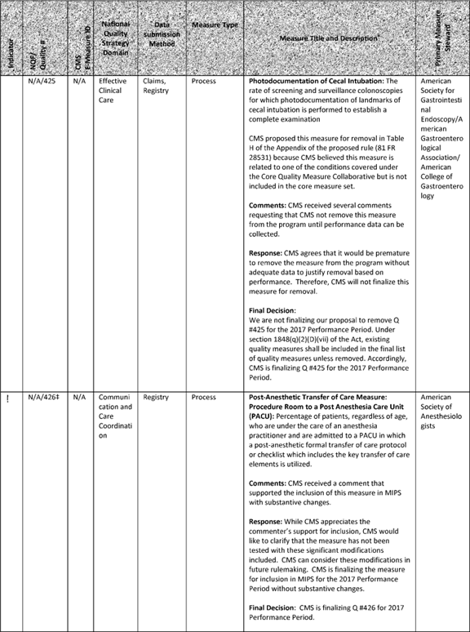

**[*77660]**



**[*77661]**

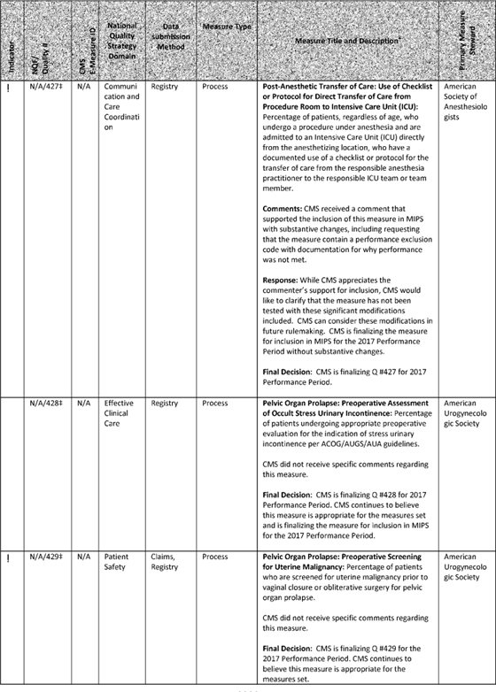

**[*77661]**



**[*77662]**

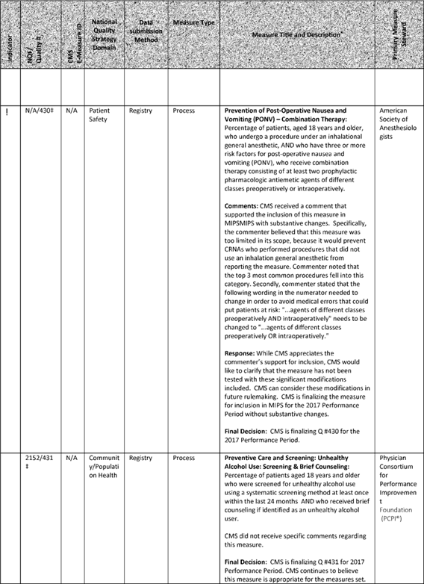

**[*77662]**



**[*77663]**



**[*77663]**



**[*77664]**

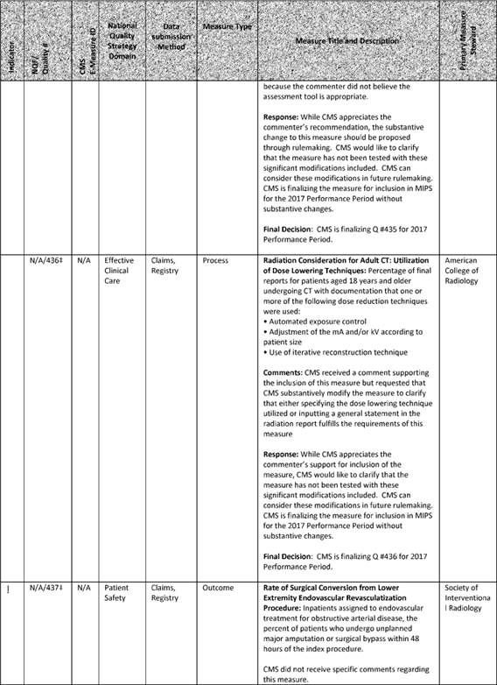

**[*77664]**



**[*77665]**

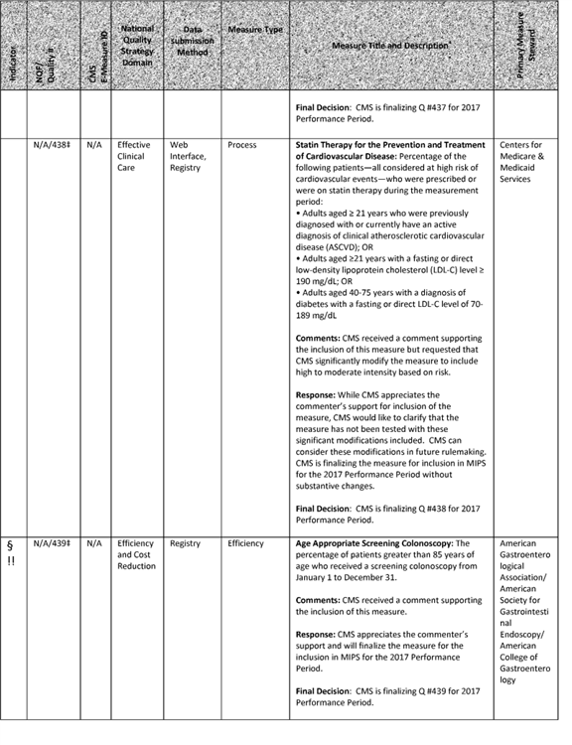

**[*77665]**



**[*77666]**

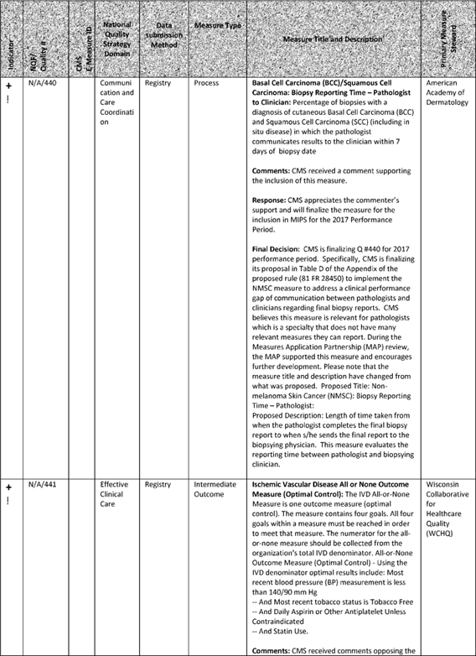

**[*77666]**



**[*77667]**

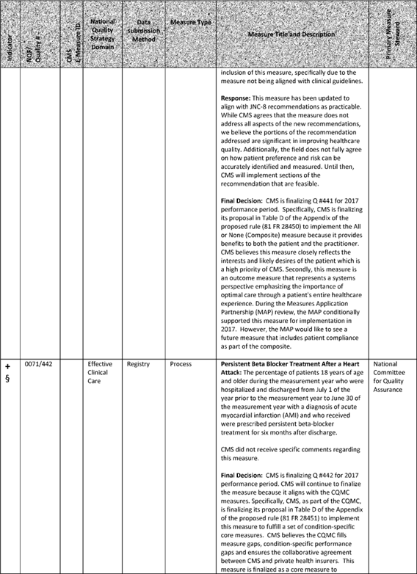

**[*77667]**



**[*77668]**

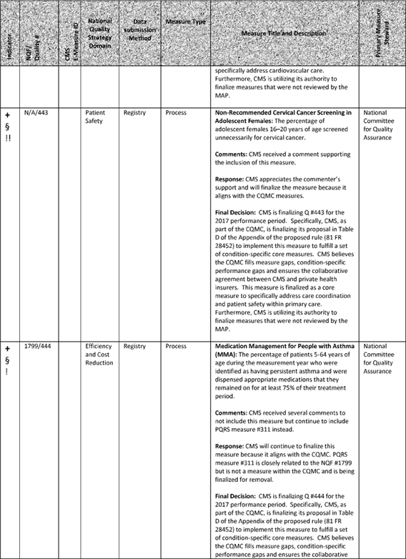

**[*77668]**



**[*77669]**

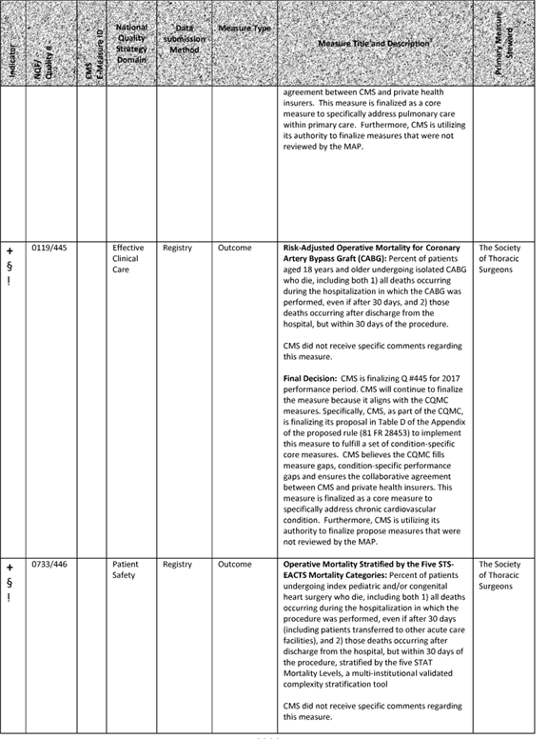

**[*77669]**



**[*77670]**

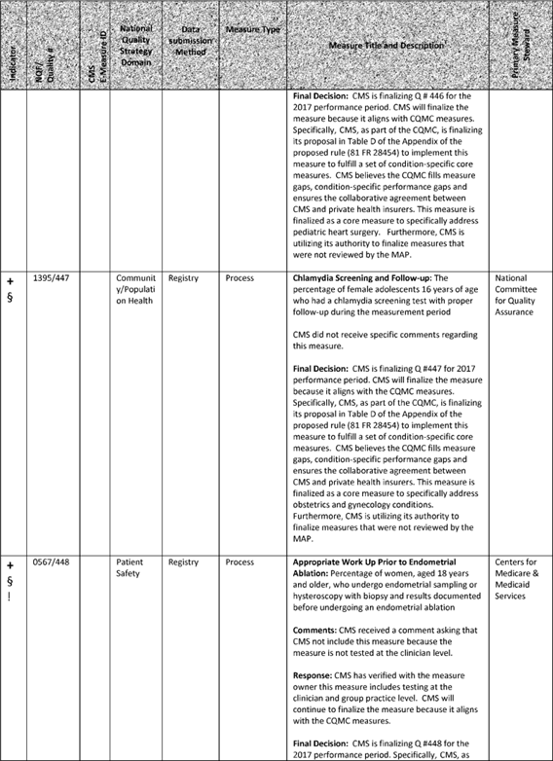

**[*77670]**



**[*77671]**

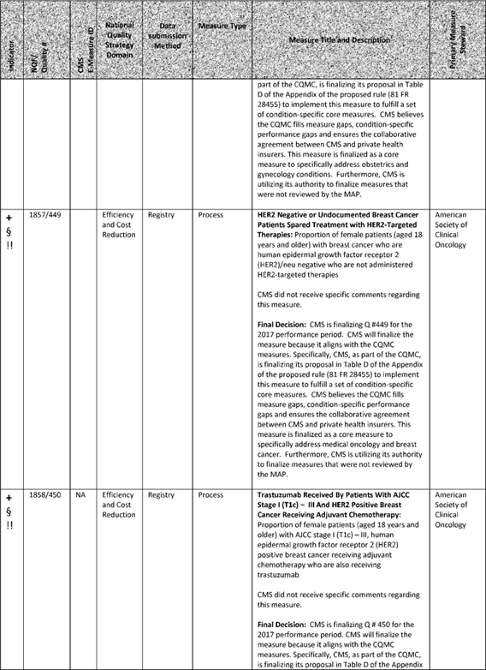

**[*77671]**



**[*77672]**

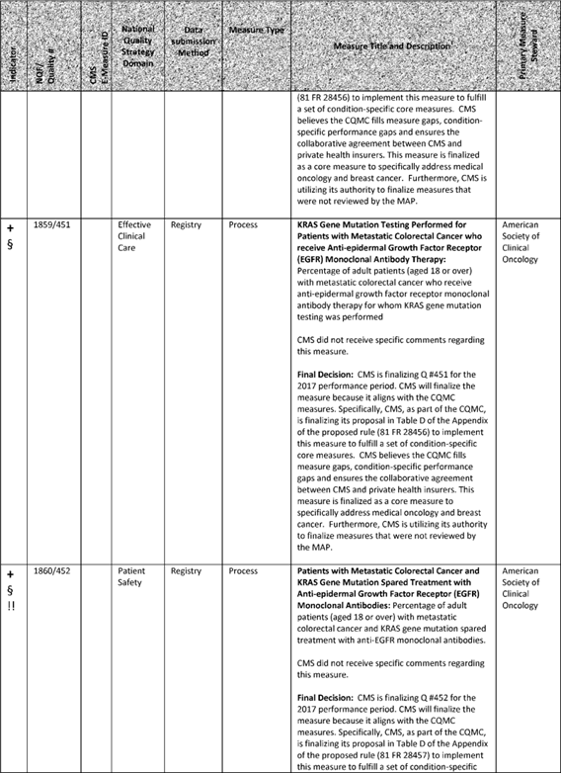

**[*77672]**



**[*77673]**

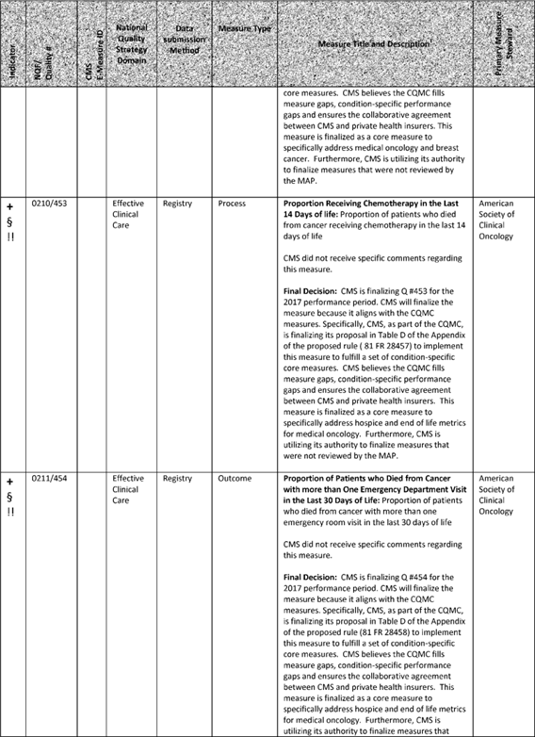

**[*77673]**



**[*77674]**

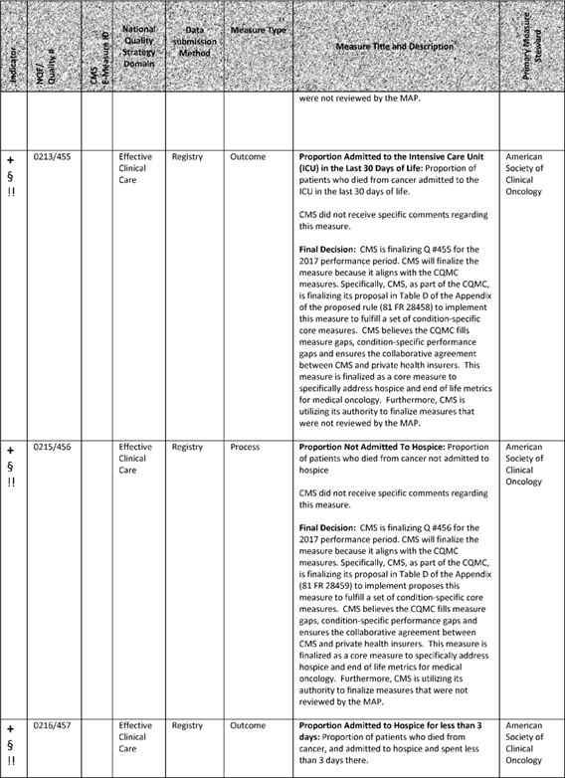

**[*77674]**



**[*77675]**

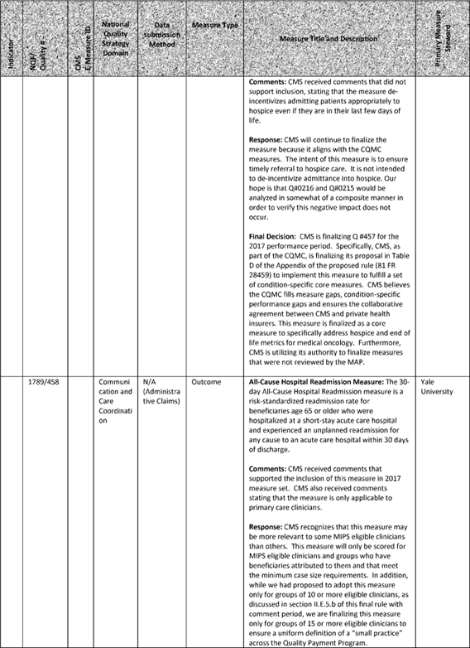

**[*77675]**



**[*77676]**

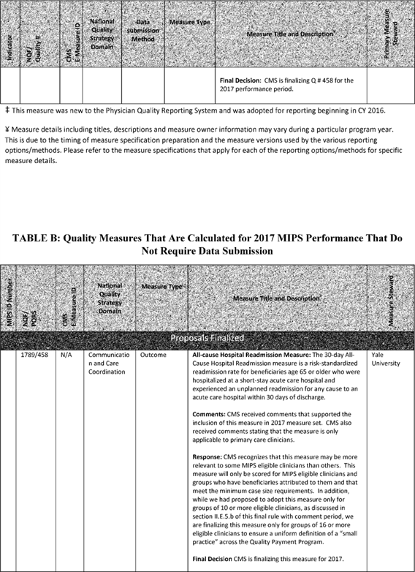

**[*77676]**



**[*77677]**

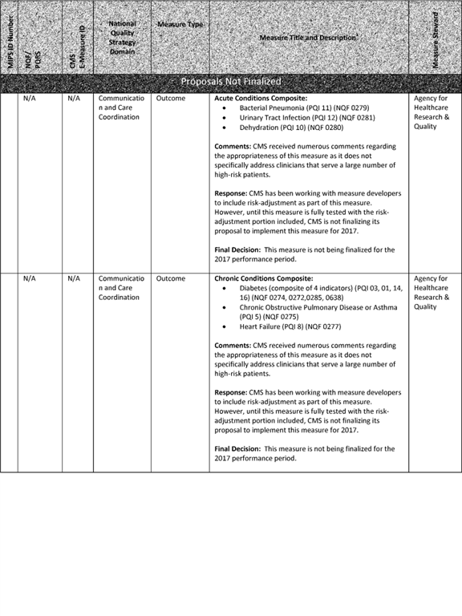

**[*77677]**

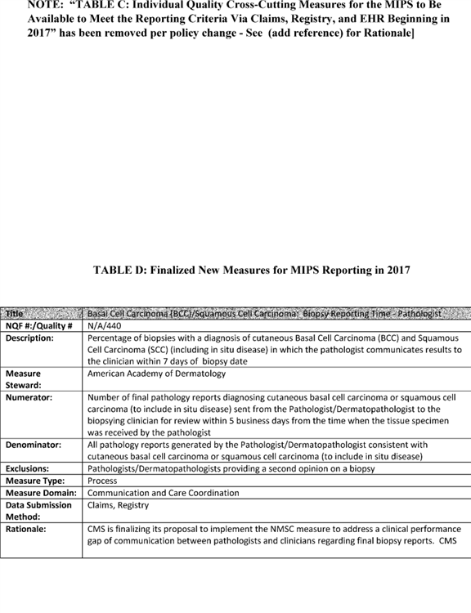

NOTE: "TABLE C: Individual Quality Cross-Cutting Measures for the MIPS to Be Available to Meet the Reporting Criteria Via Claims, Registry, and EHR Beginning in 2017" has been removed per policy change--See (add reference) for Rationale] **[*77678]**

**[*77679]**

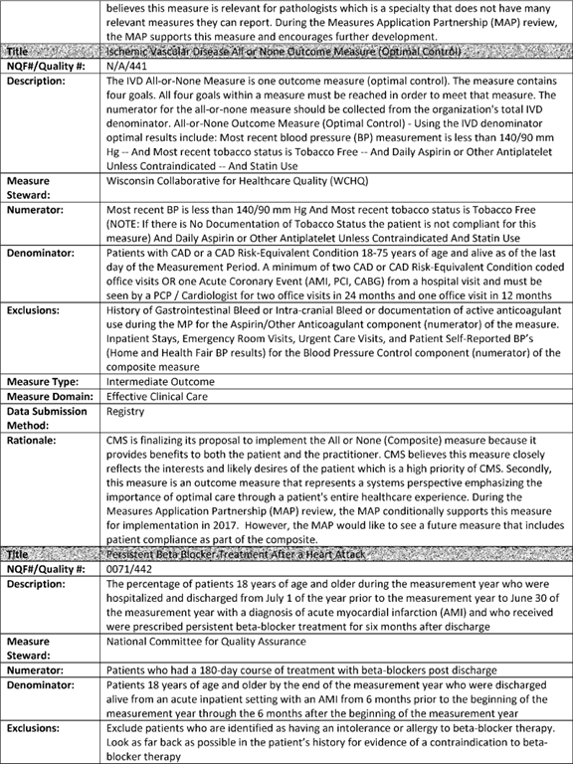

**[*77679]**



**[*77680]**

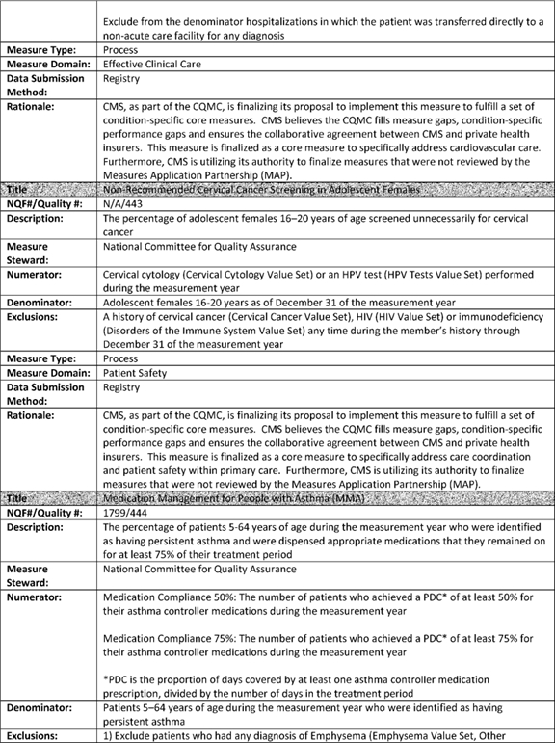

**[*77680]**



**[*77681]**

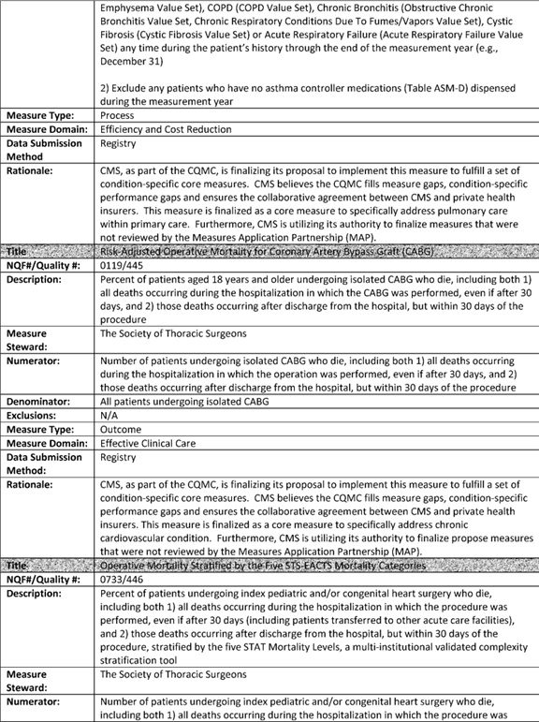

**[*77681]**



**[*77682]**

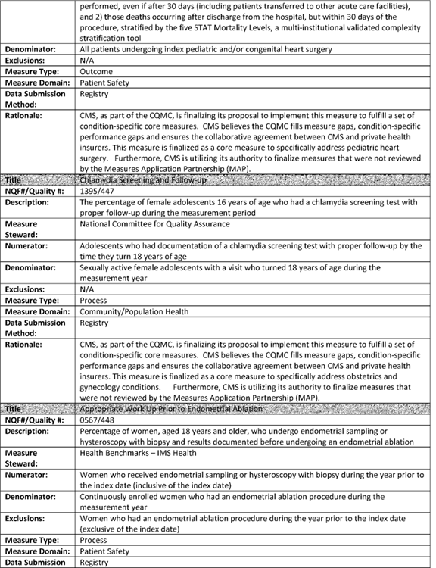

**[*77682]**



**[*77683]**

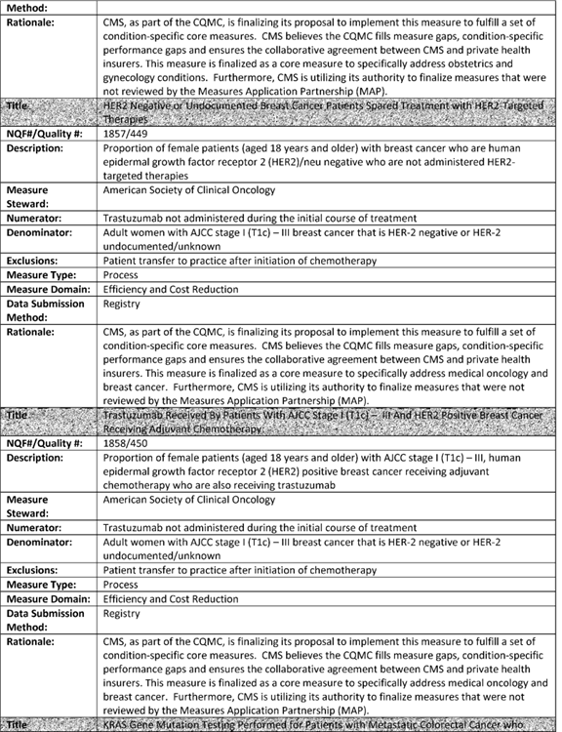

**[*77683]**



**[*77684]**

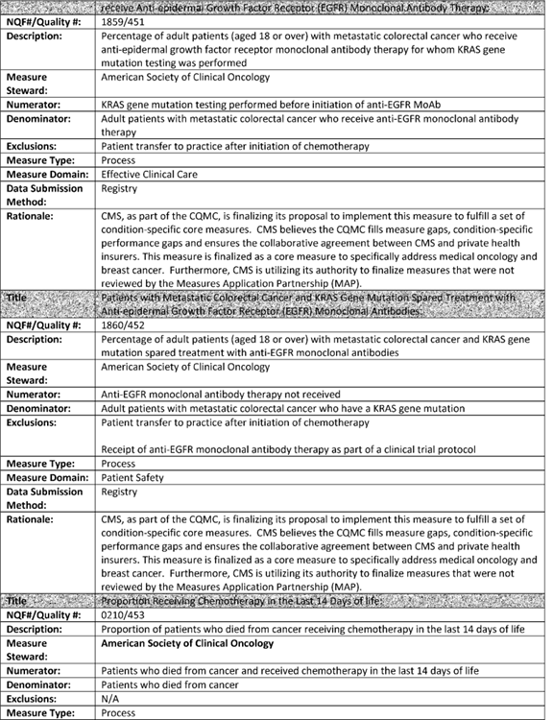

**[*77684]**



**[*77685]**

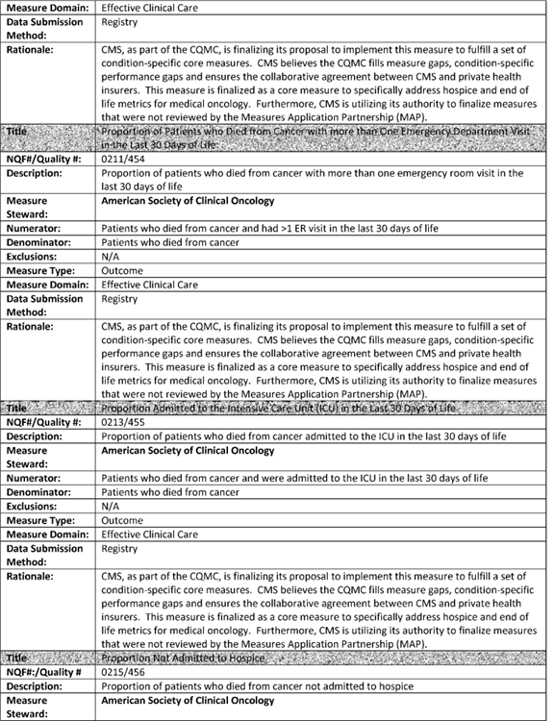

**[*77685]**



**[*77686]**

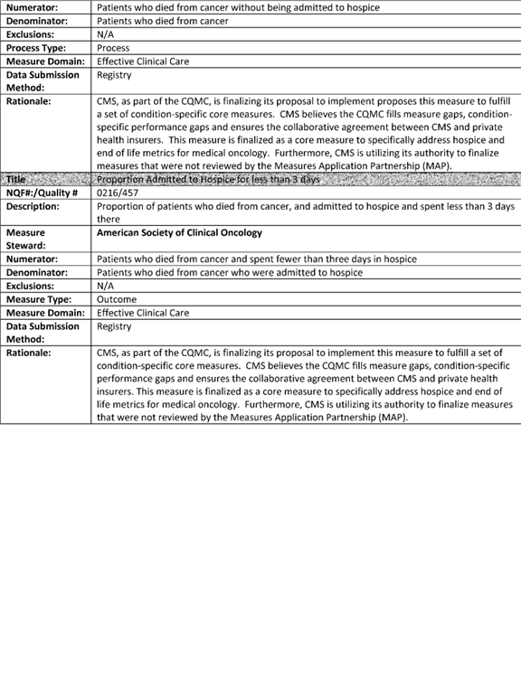

**[*77686]**



**[*77687]**

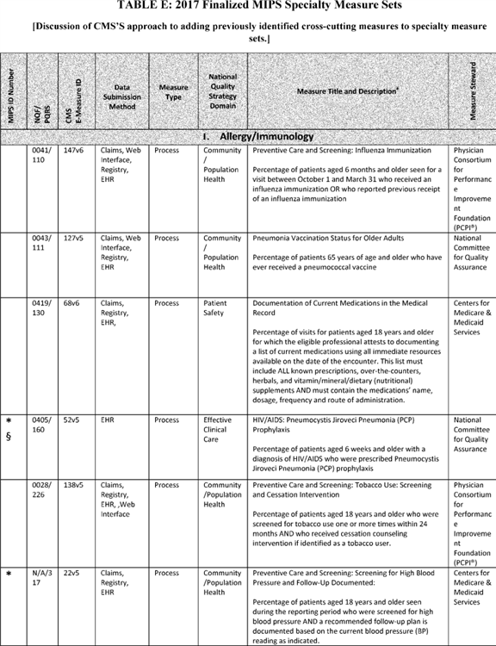

**[*77687]**



**[*77688]**

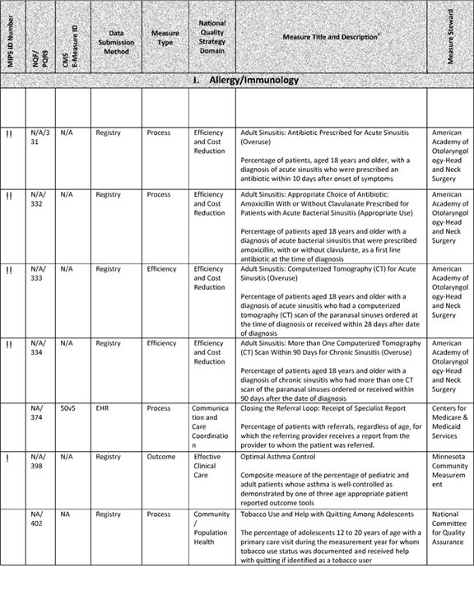

**[*77688]**



**[*77689]**

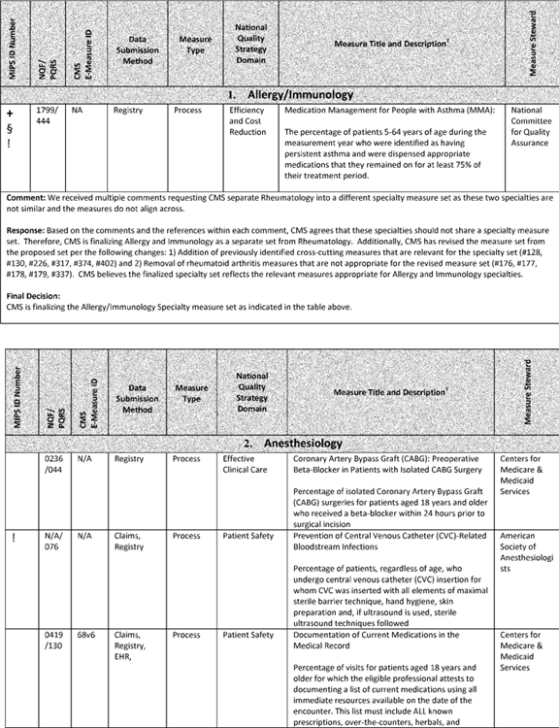

**[*77689]**



**[*77690]**

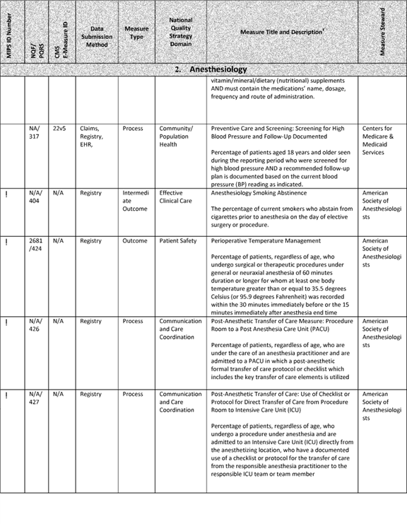

**[*77690]**



**[*77691]**

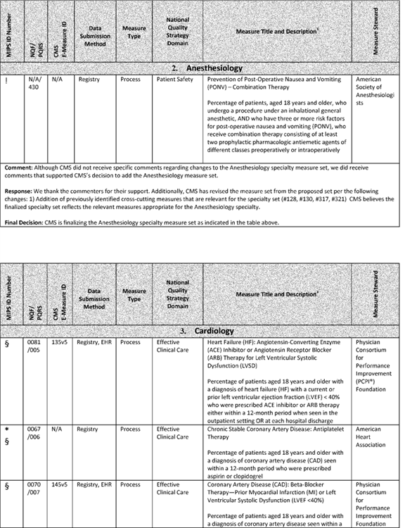

**[*77691]**



**[*77692]**

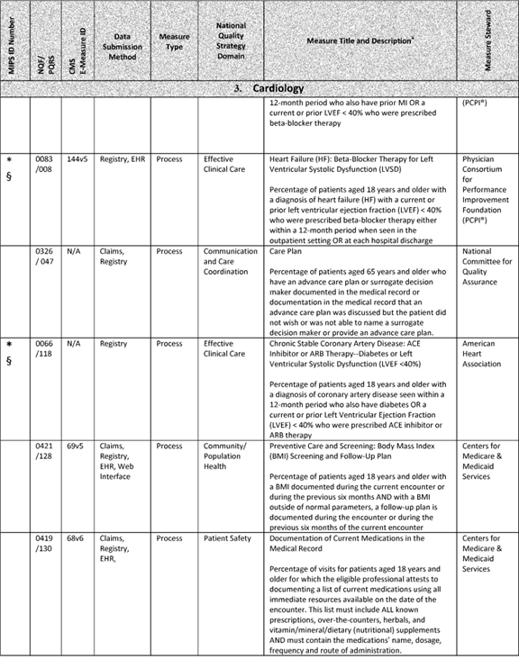

**[*77692]**



**[*77693]**

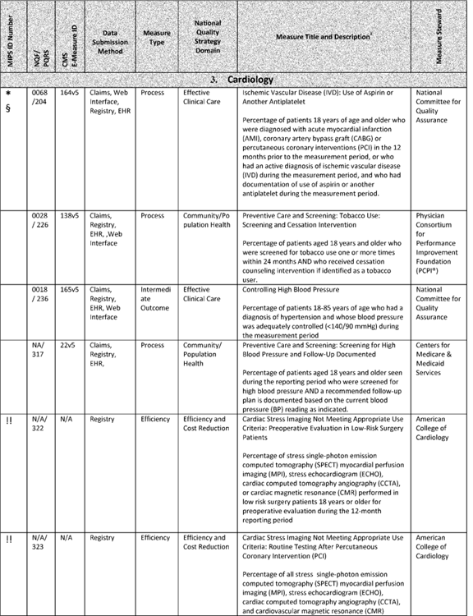

**[*77693]**



**[*77694]**

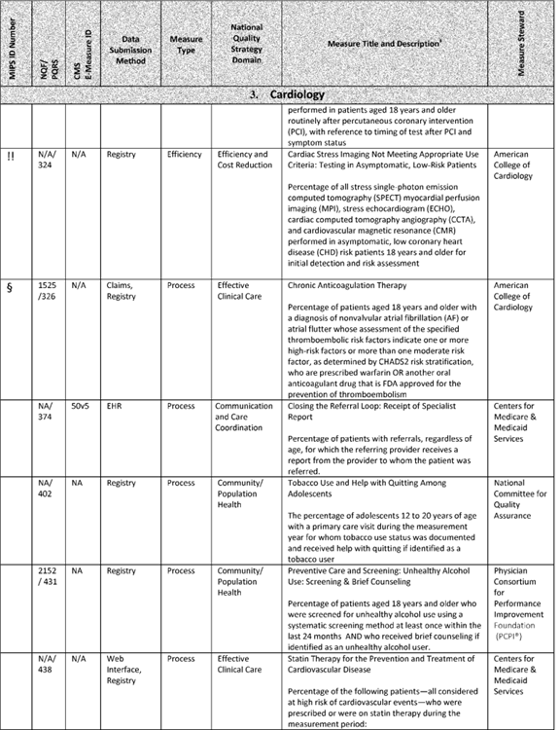

**[*77694]**



**[*77695]**

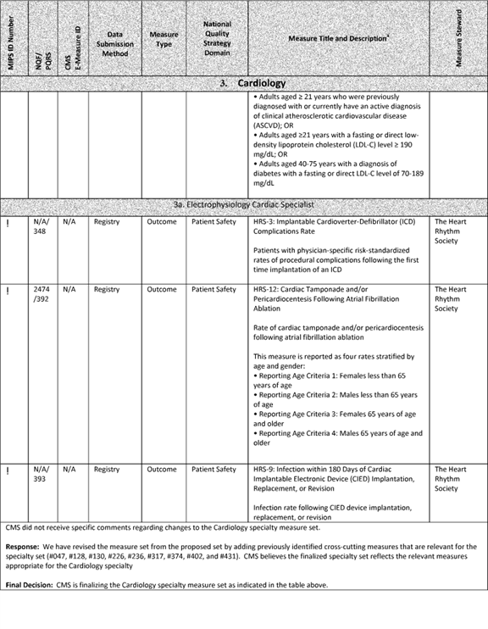

**[*77695]**



**[*77696]**

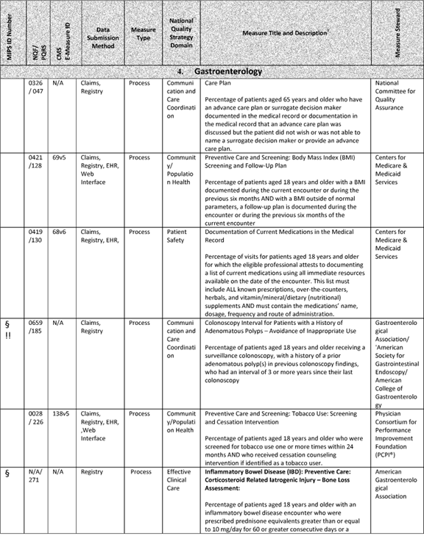

**[*77696]**



**[*77697]**



**[*77697]**



**[*77698]**

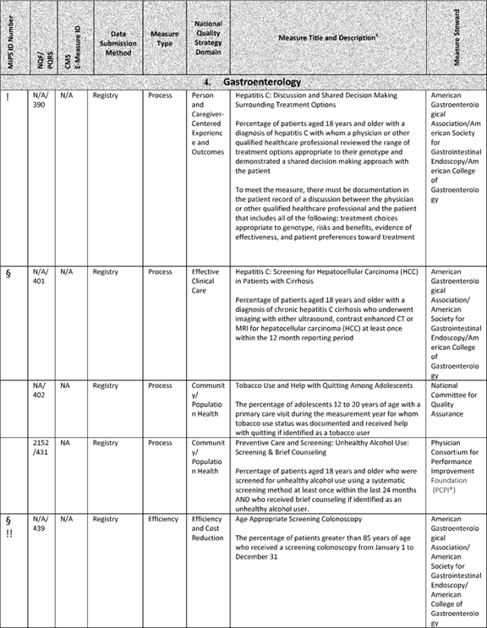

**[*77698]**



**[*77699]**

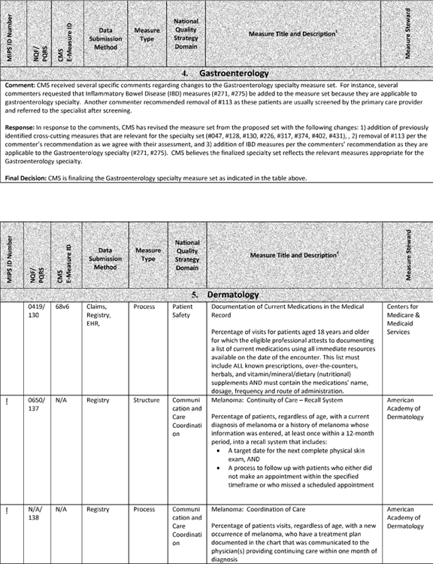

**[*77699]**



**[*77700]**

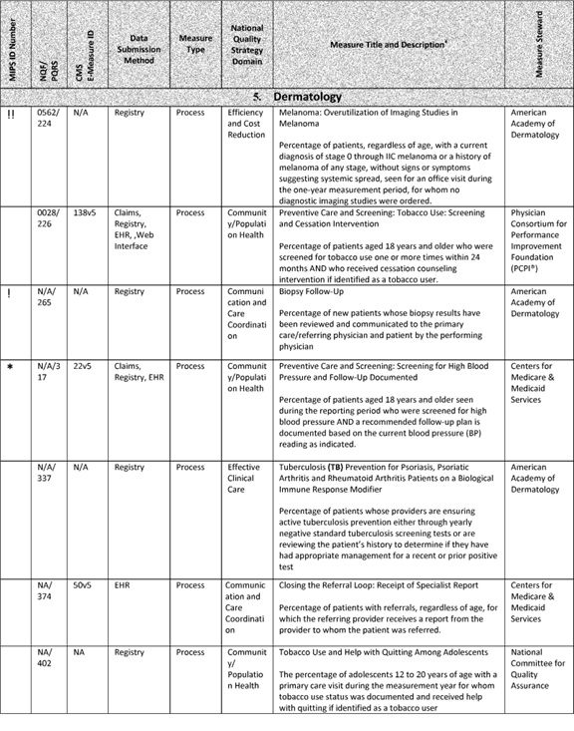

**[*77700]**



**[*77701]**

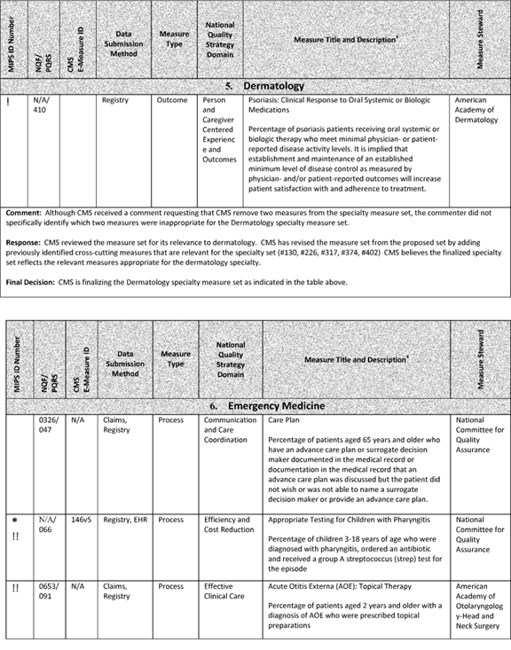

**[*77701]**



**[*77702]**

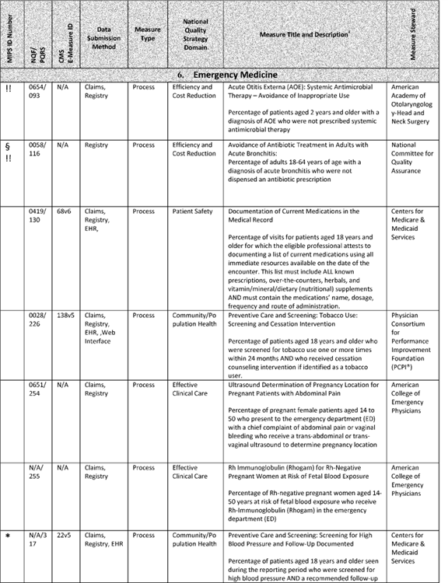

**[*77702]**



**[*77703]**

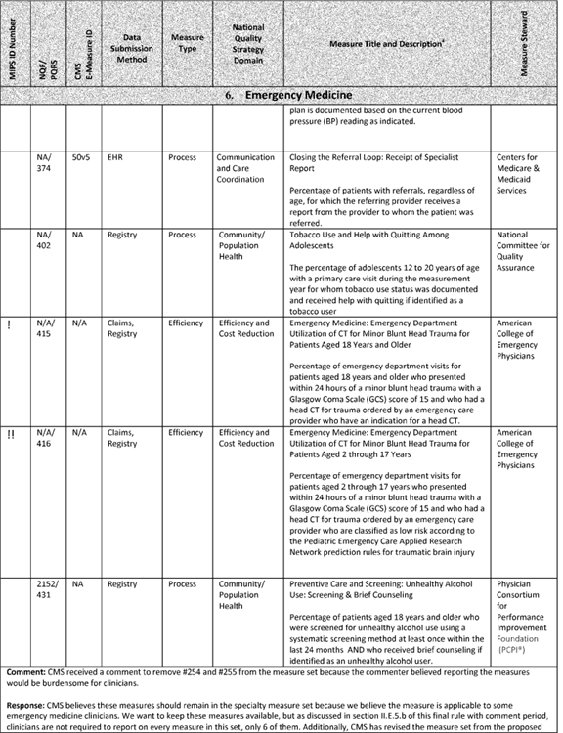

**[*77703]**



**[*77704]**

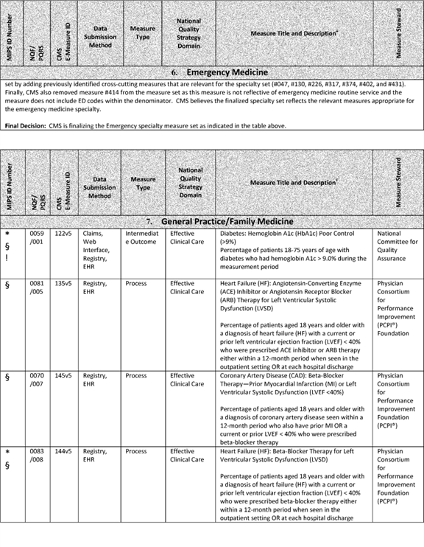

**[*77704]**



**[*77705]**

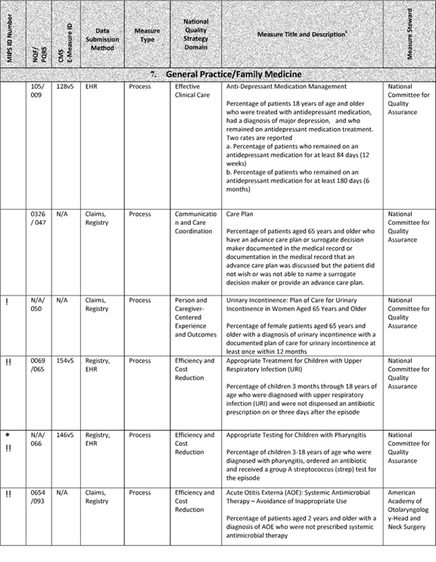

**[*77705]**



**[*77706]**

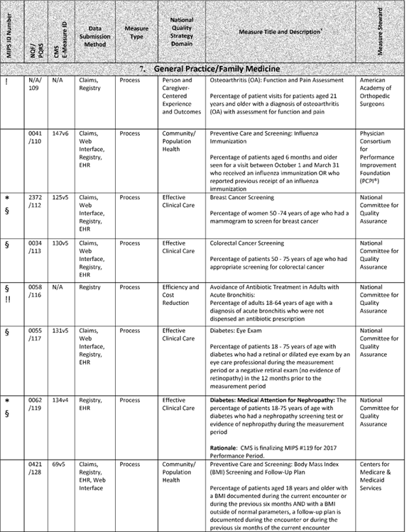

**[*77706]**



**[*77707]**

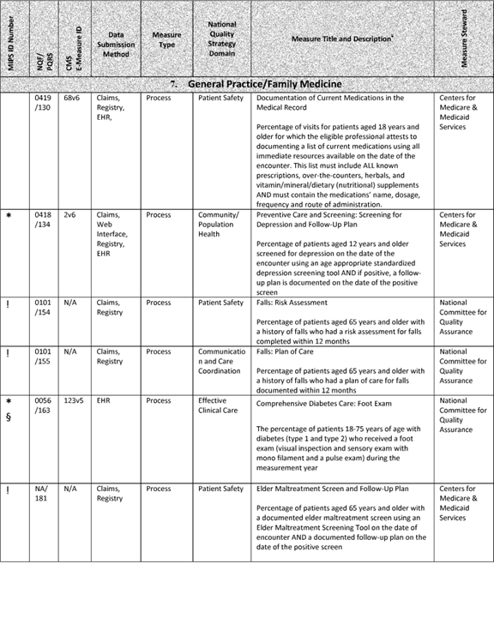

**[*77707]**



**[*77708]**

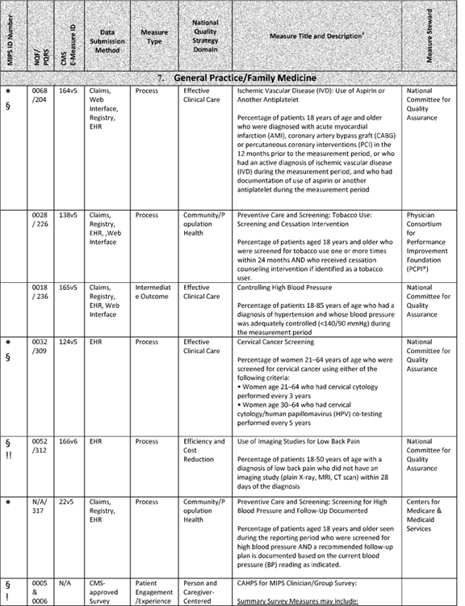

**[*77708]**



**[*77709]**

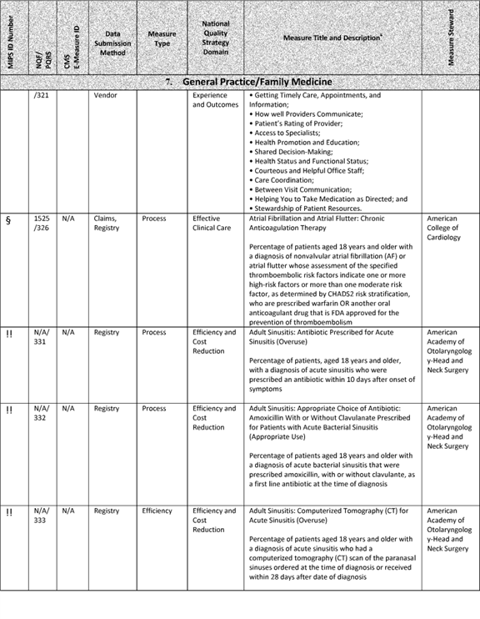

**[*77709]**



**[*77710]**

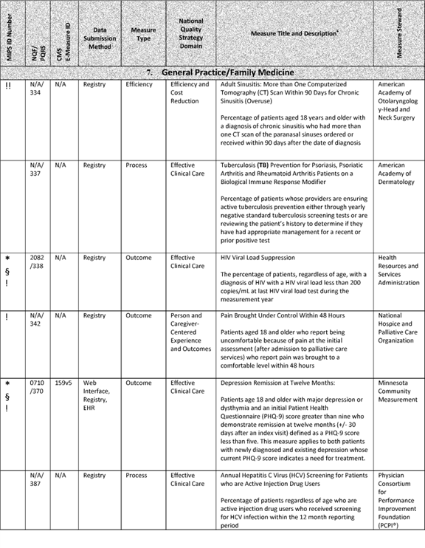

**[*77710]**



**[*77711]**

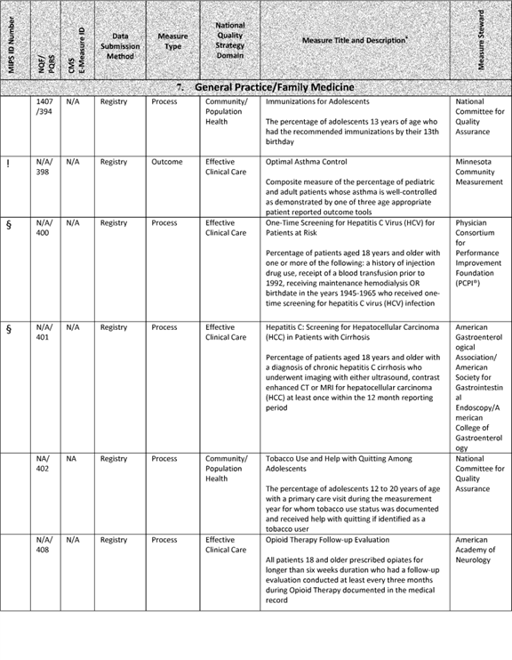

**[*77711]**



**[*77712]**

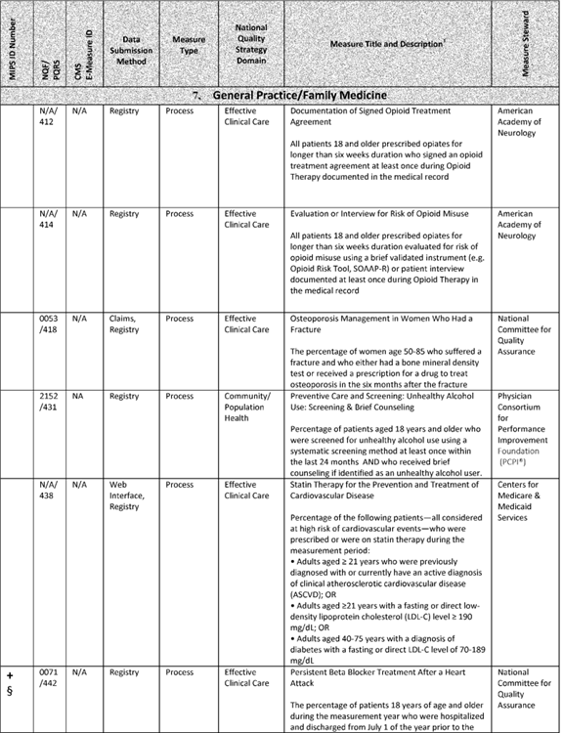

**[*77712]**



**[*77713]**

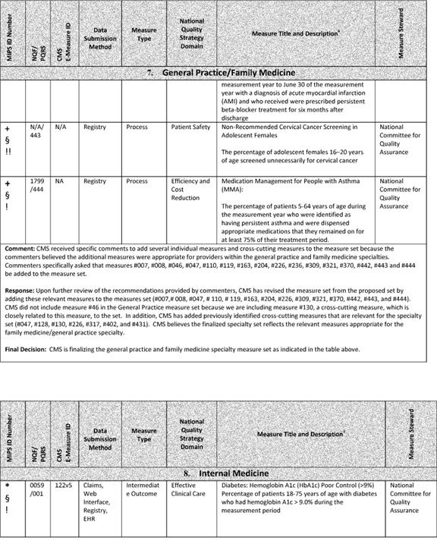

**[*77713]**



**[*77714]**

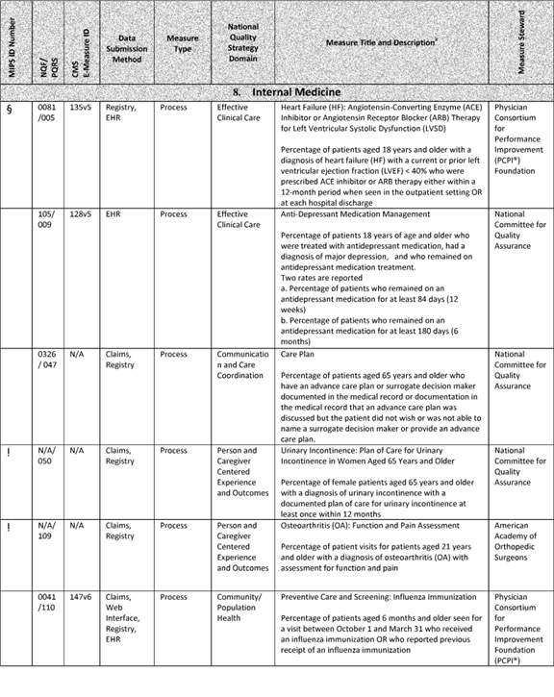

**[*77714]**



**[*77715]**

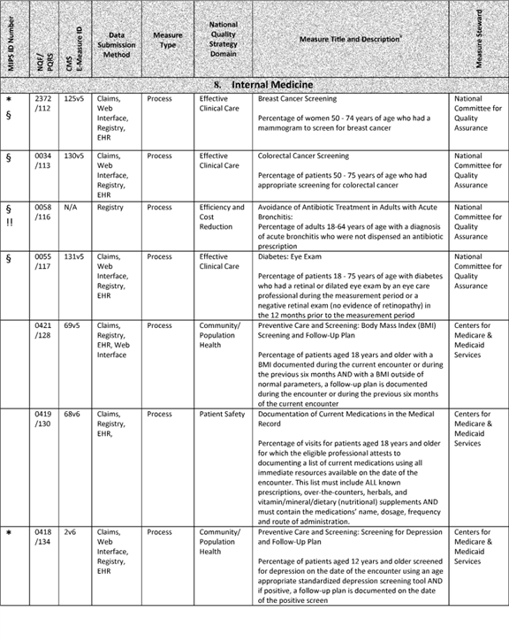

**[*77715]**



**[*77716]**

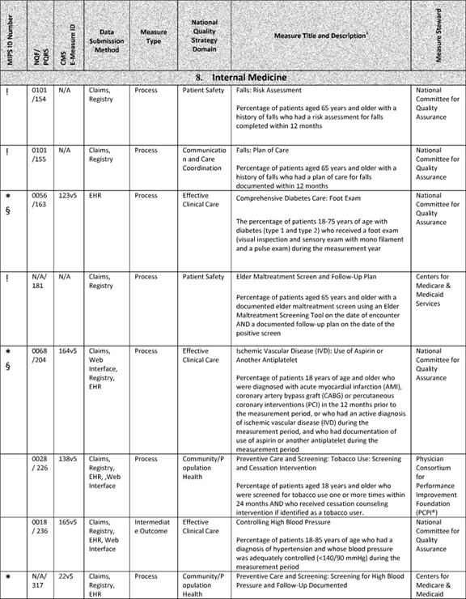

**[*77716]**



**[*77717]**

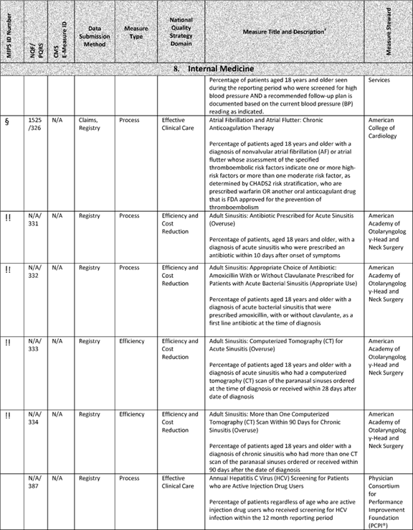

**[*77717]**



**[*77718]**

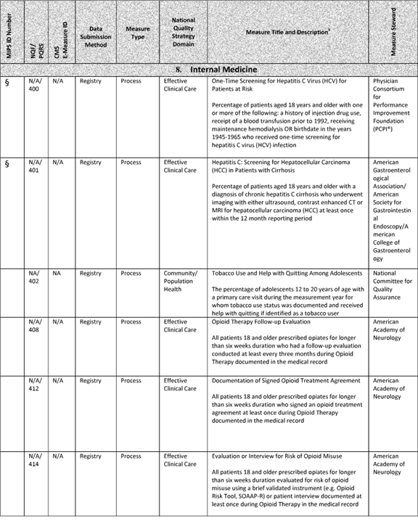

**[*77718]**



**[*77719]**

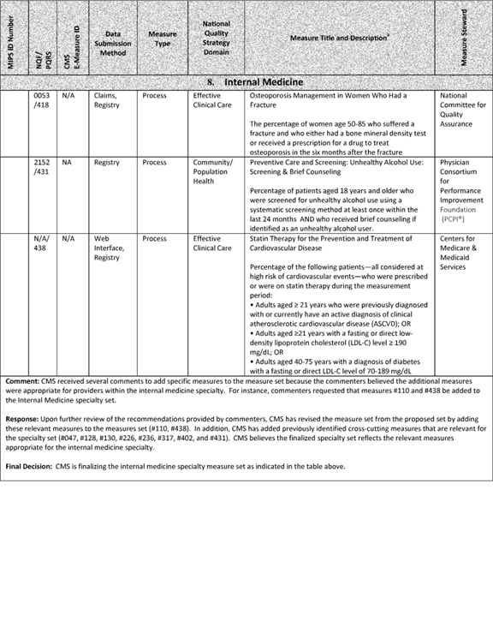

**[*77719]**



**[*77720]**

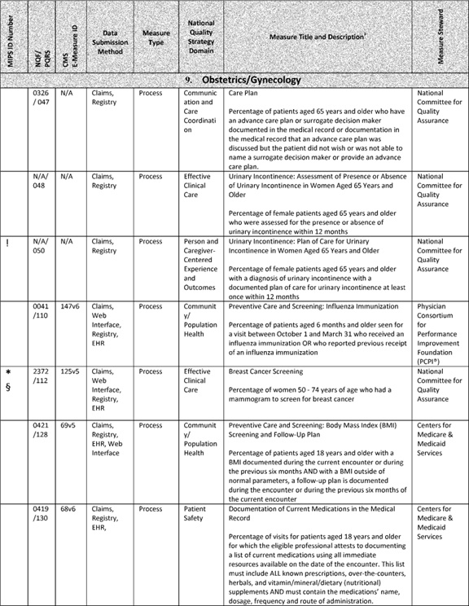

**[*77720]**



**[*77721]**

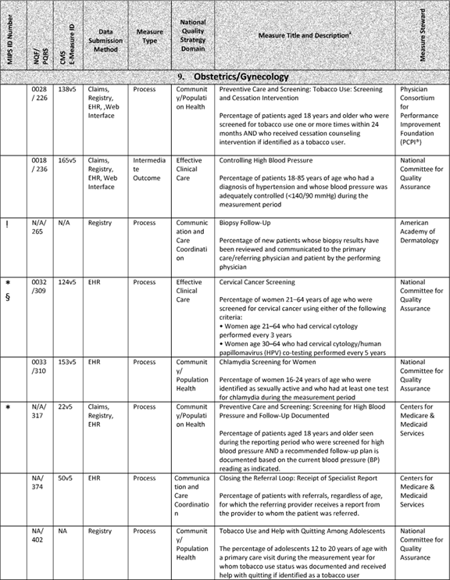

**[*77721]**



**[*77722]**



**[*77722]**



**[*77723]**

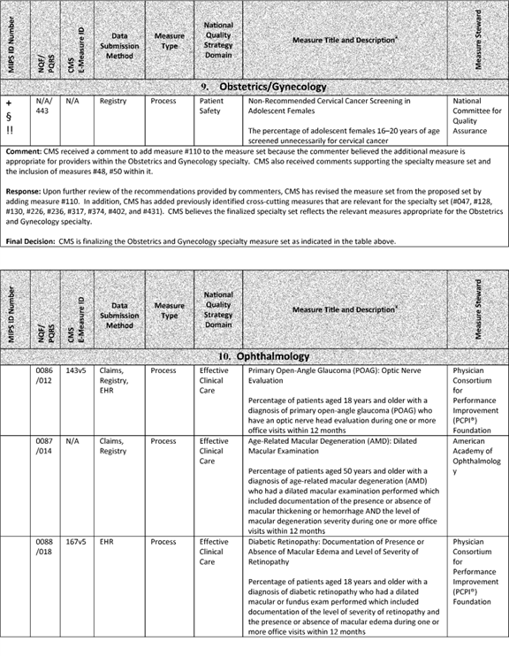

**[*77723]**



**[*77724]**

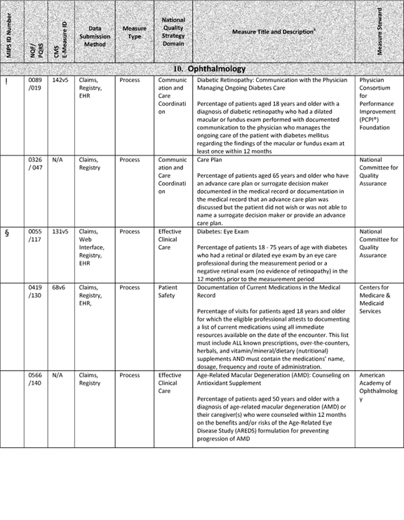

**[*77724]**



**[*77725]**

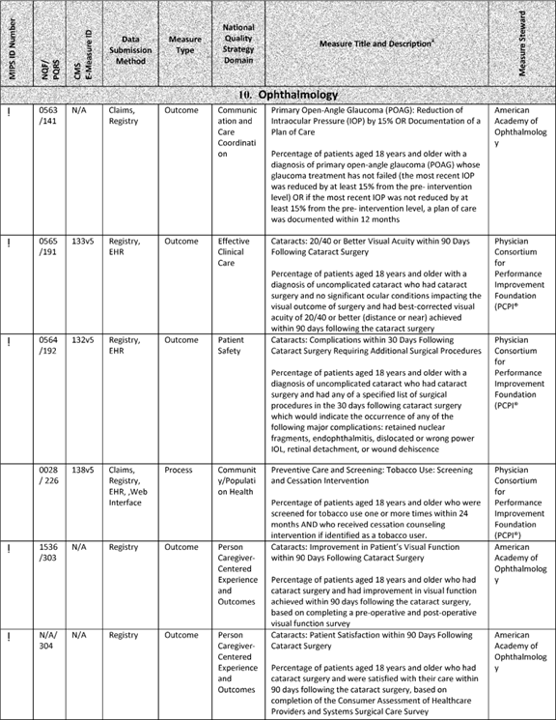

**[*77725]**



**[*77726]**

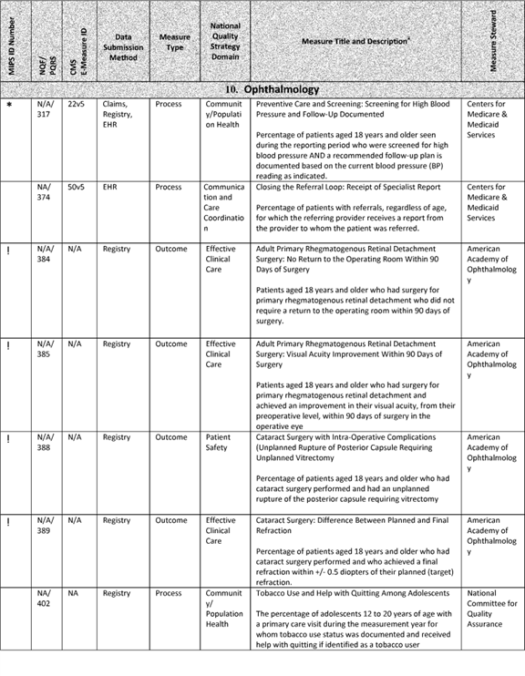

**[*77726]**



**[*77727]**

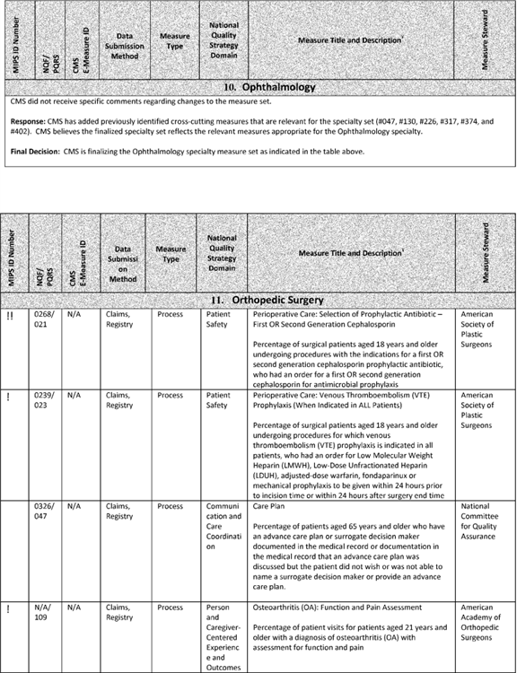

**[*77727]**



**[*77728]**

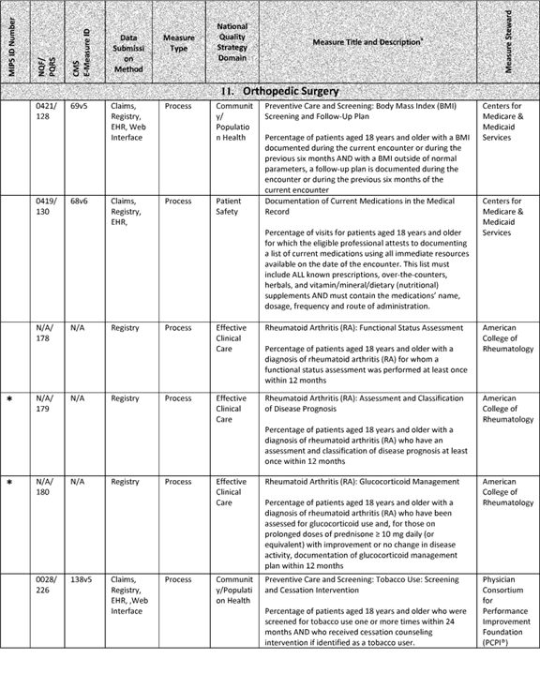

**[*77728]**



**[*77729]**



**[*77729]**



**[*77730]**

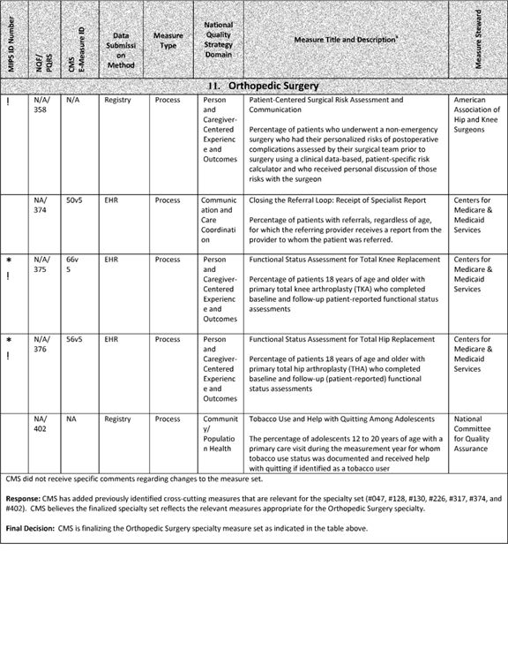

**[*77730]**



**[*77731]**

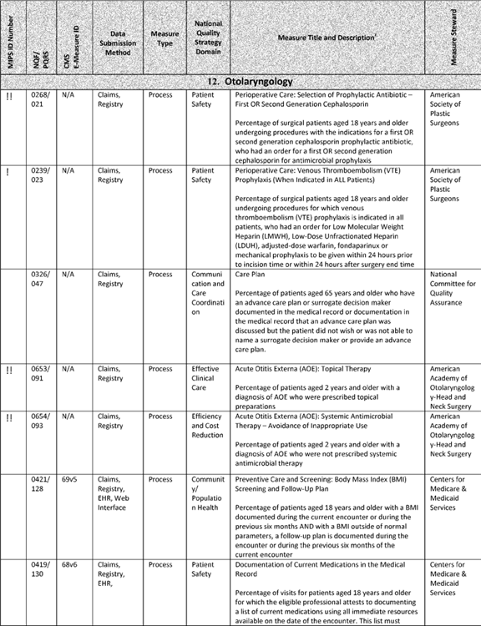

**[*77731]**



**[*77732]**

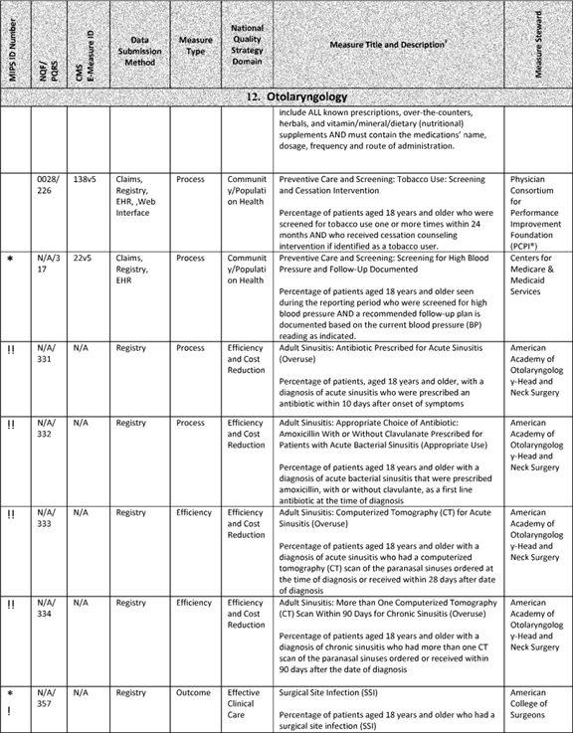

**[*77732]**



**[*77733]**

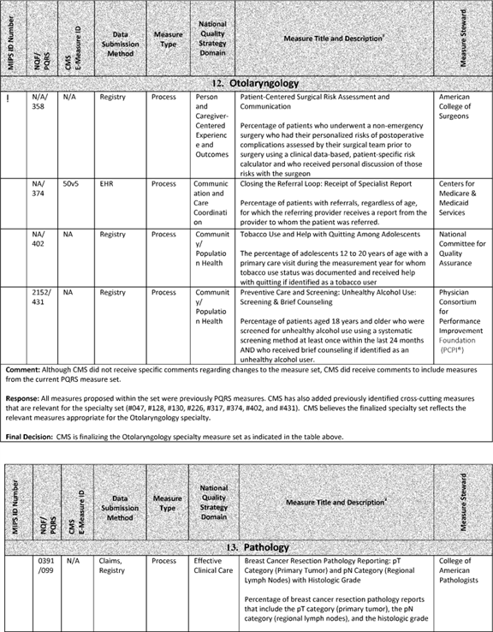

**[*77733]**



**[*77734]**



**[*77734]**



**[*77735]**

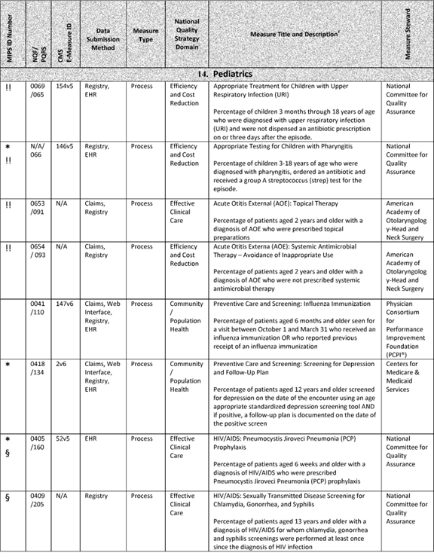

**[*77735]**



**[*77736]**

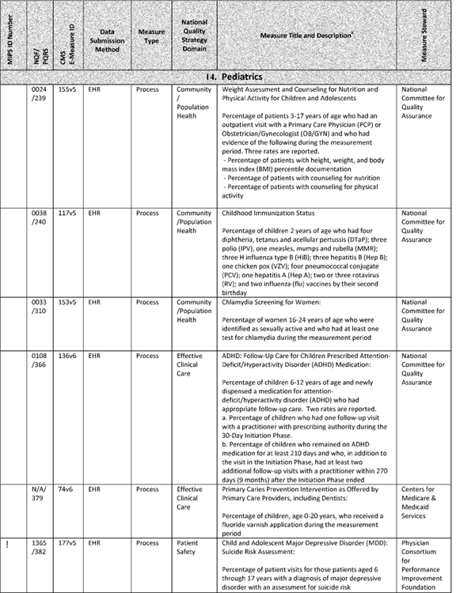

**[*77736]**



**[*77737]**

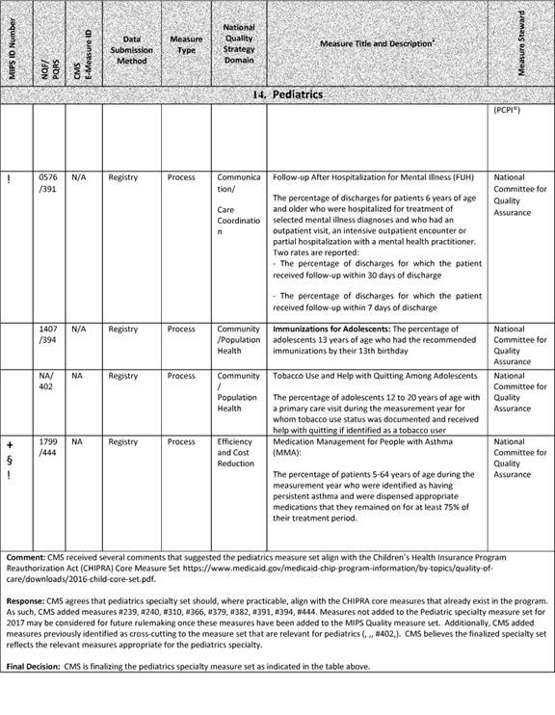

**[*77737]**



**[*77738]**

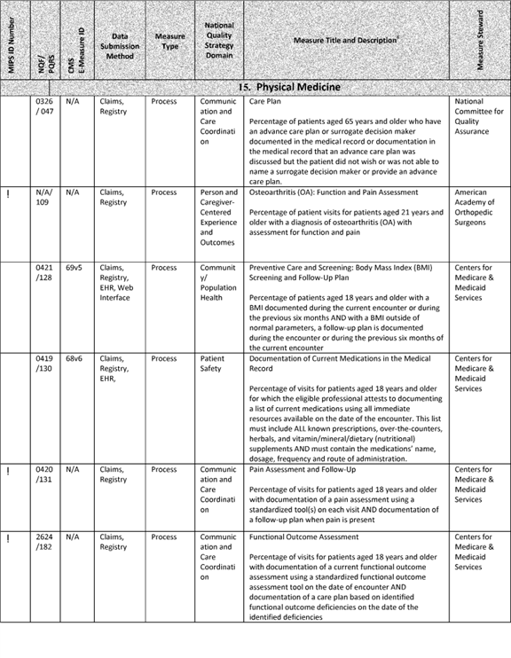

**[*77738]**



**[*77739]**

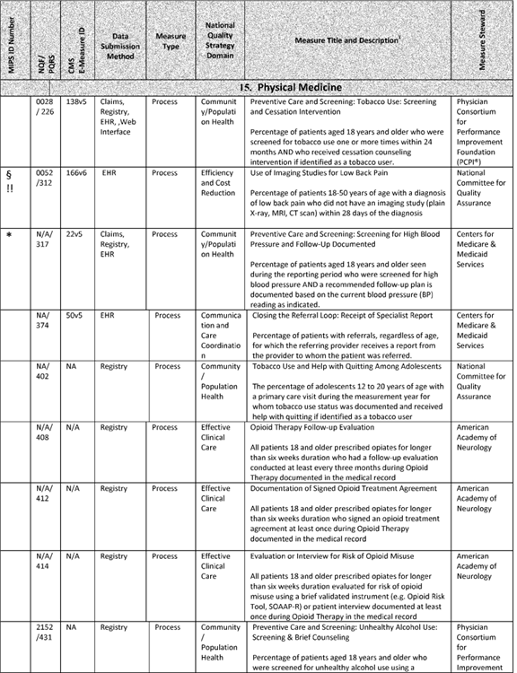

**[*77739]**



**[*77740]**

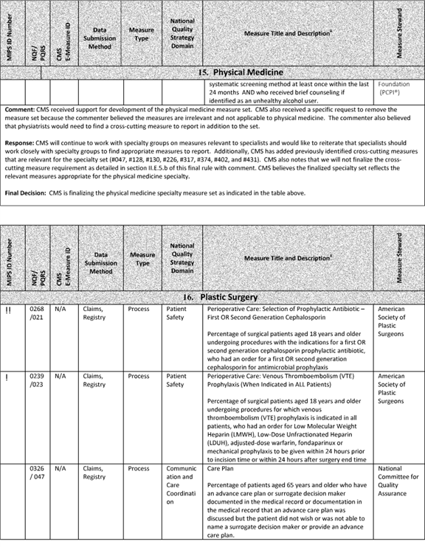

**[*77740]**



**[*77741]**

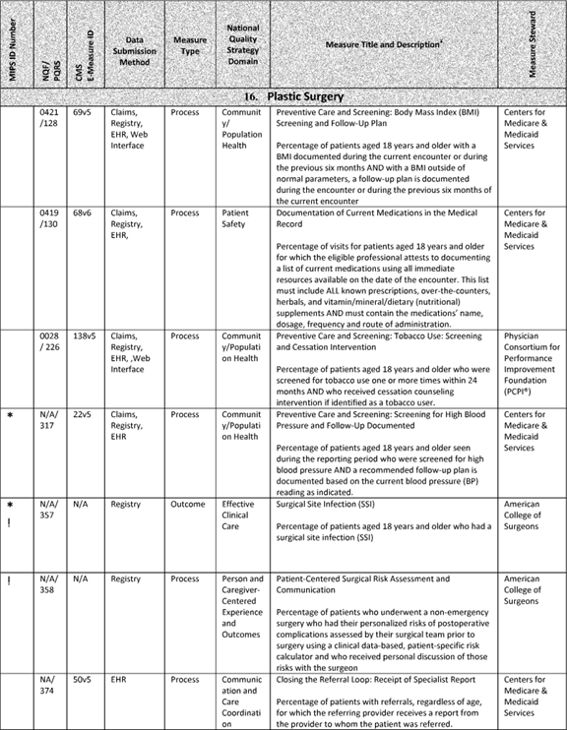

**[*77741]**



**[*77742]**

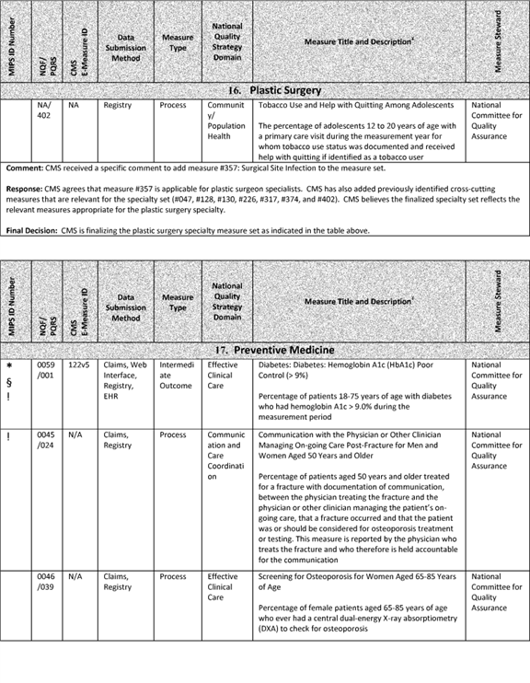

**[*77742]**



**[*77743]**

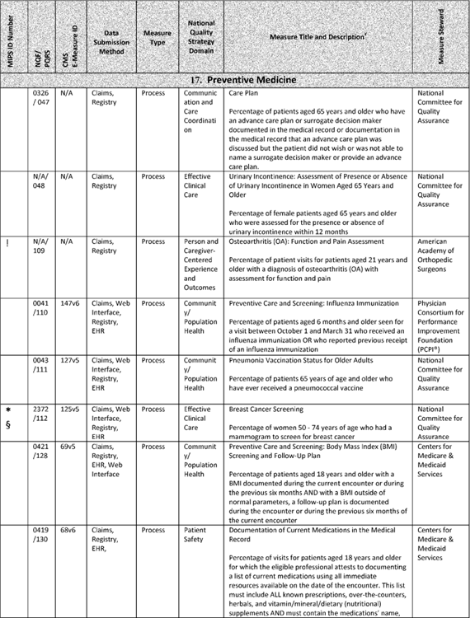

**[*77743]**



**[*77744]**

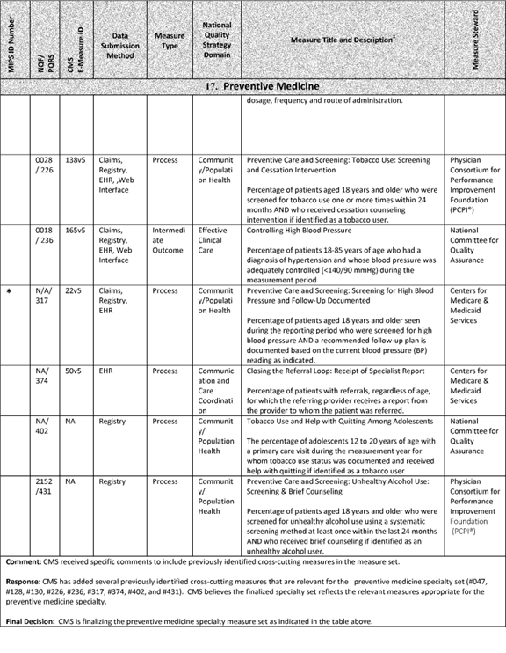

**[*77744]**



**[*77745]**



**[*77745]**



**[*77746]**



**[*77746]**



**[*77747]**

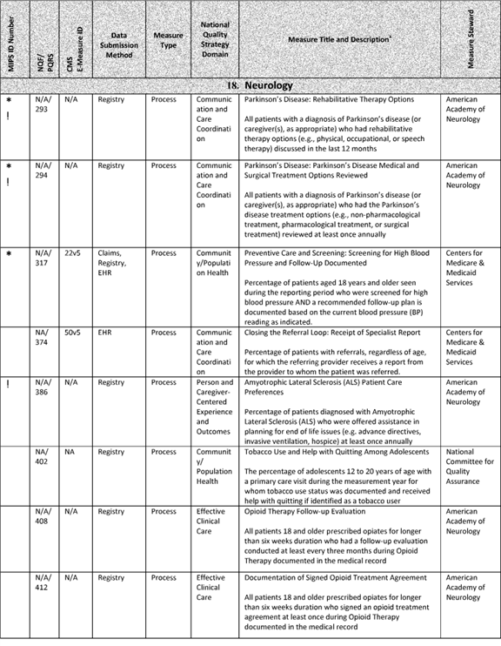

**[*77747]**



**[*77748]**

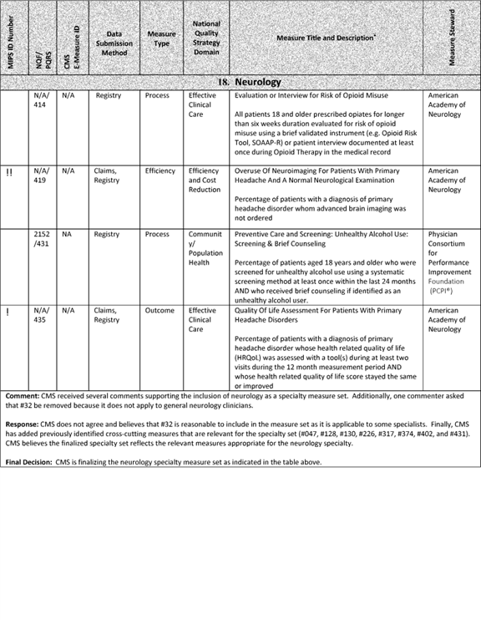

**[*77748]**



**[*77749]**

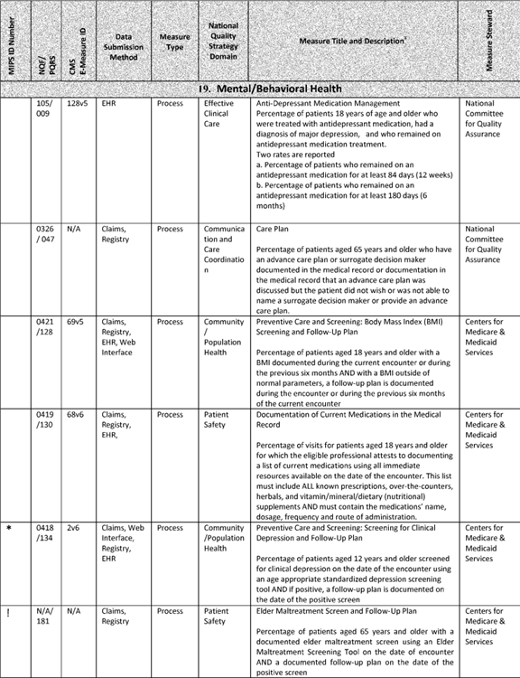

**[*77749]**



**[*77750]**

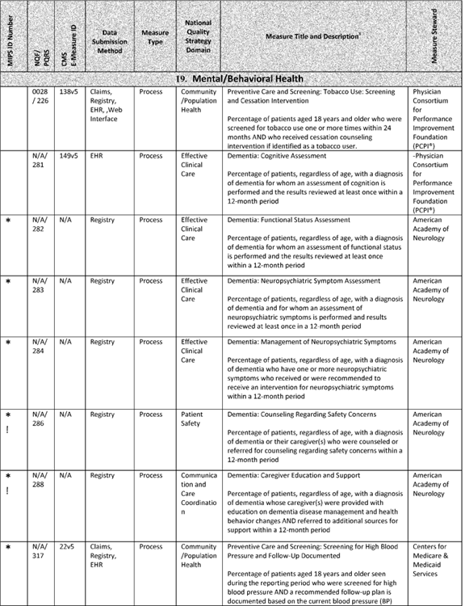

**[*77750]**



**[*77751]**

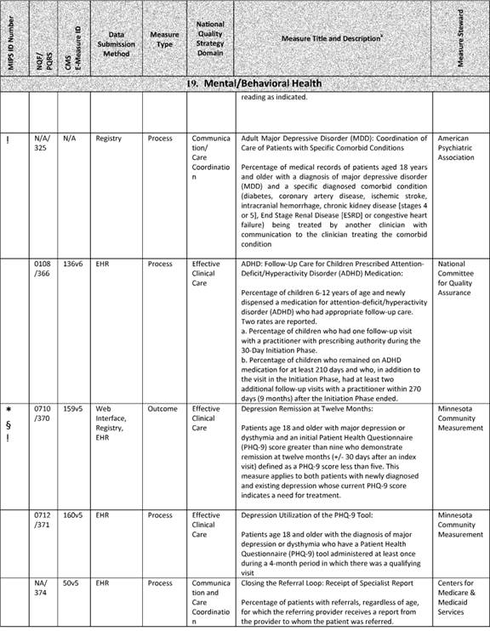

**[*77751]**



**[*77752]**

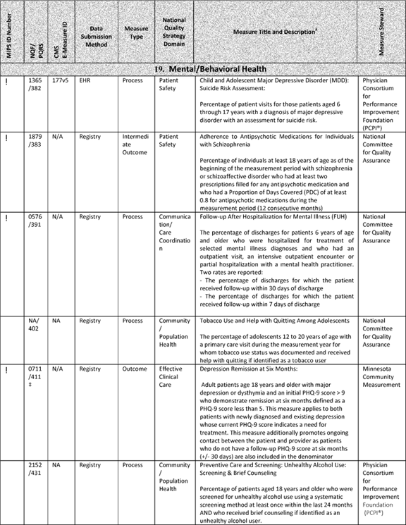

**[*77752]**



**[*77753]**

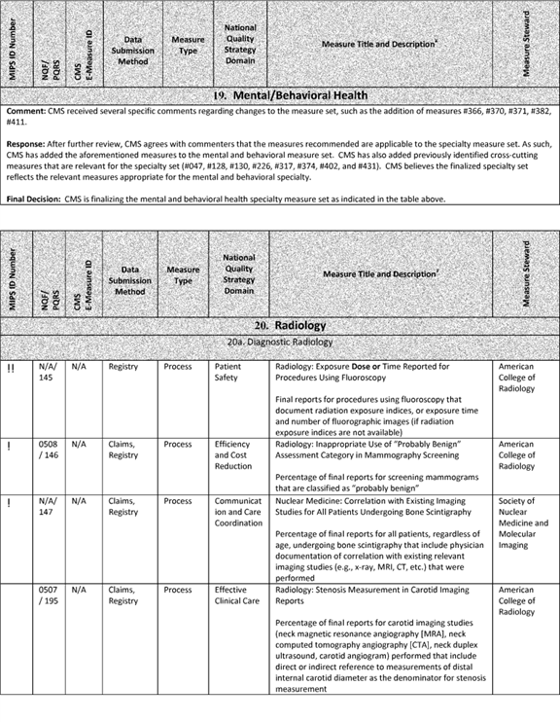

**[*77753]**



**[*77754]**

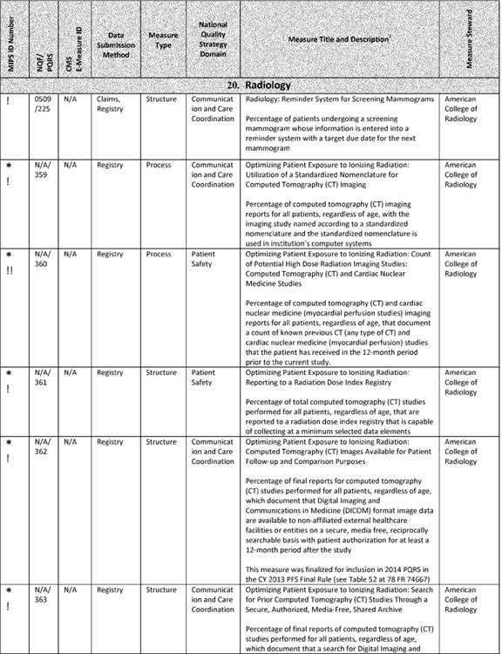

**[*77754]**



**[*77755]**

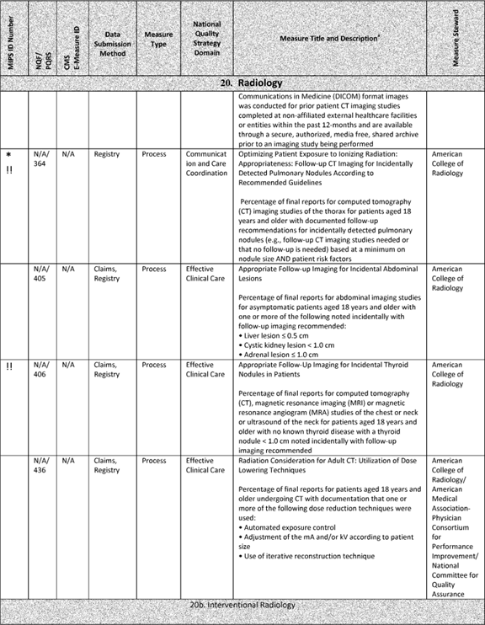

**[*77755]**



**[*77756]**

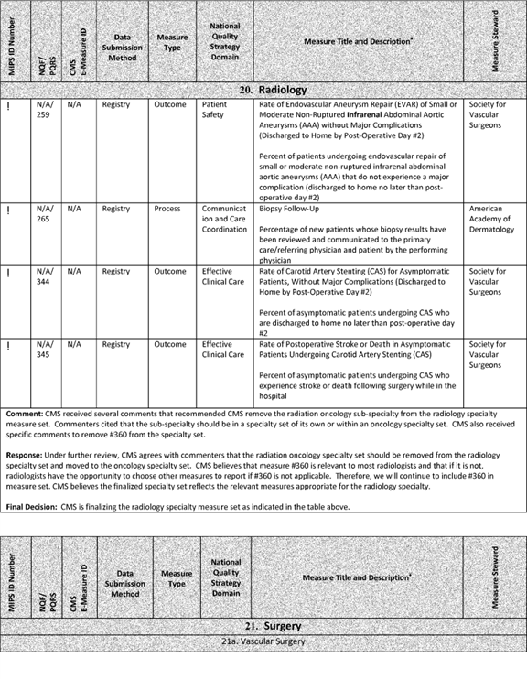

**[*77756]**



**[*77757]**

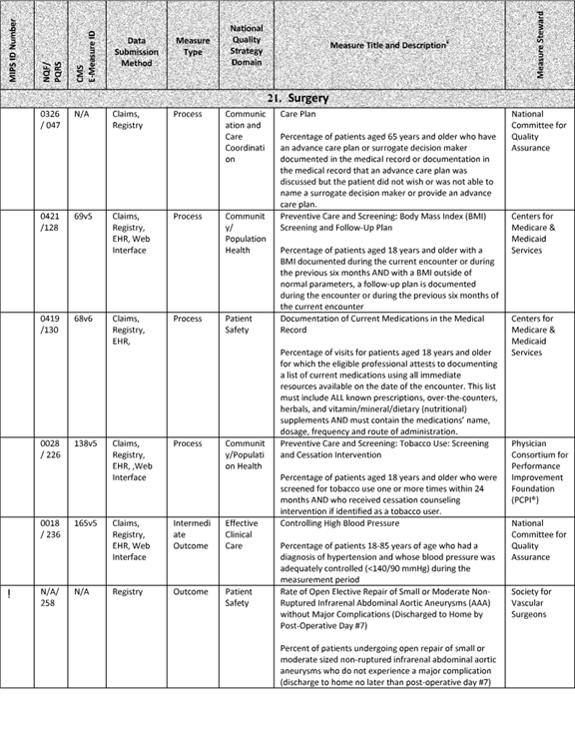

**[*77757]**



**[*77758]**

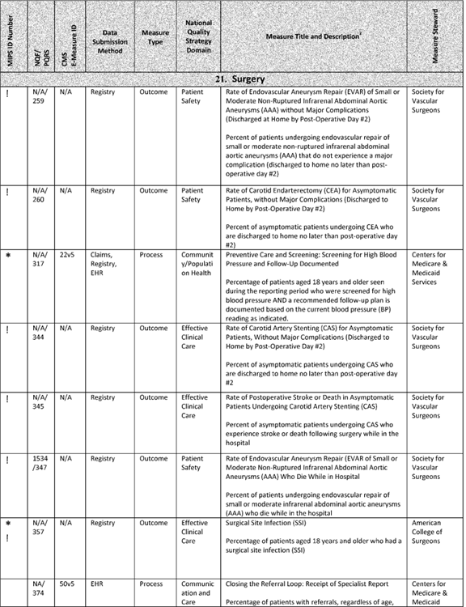

**[*77758]**



**[*77759]**

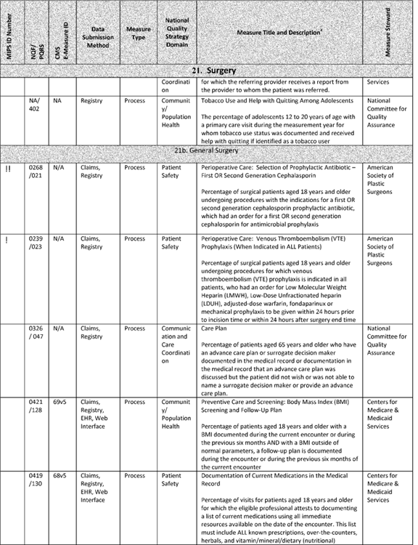

**[*77759]**



**[*77760]**

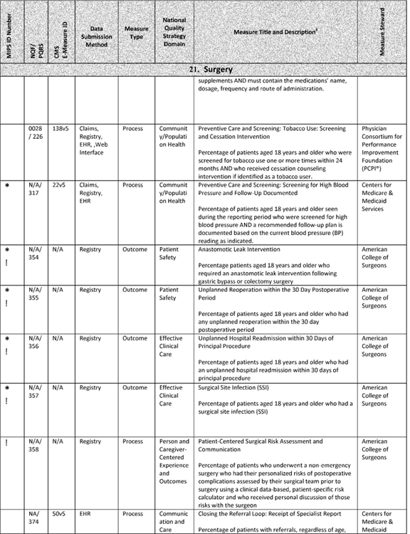

**[*77760]**



**[*77761]**

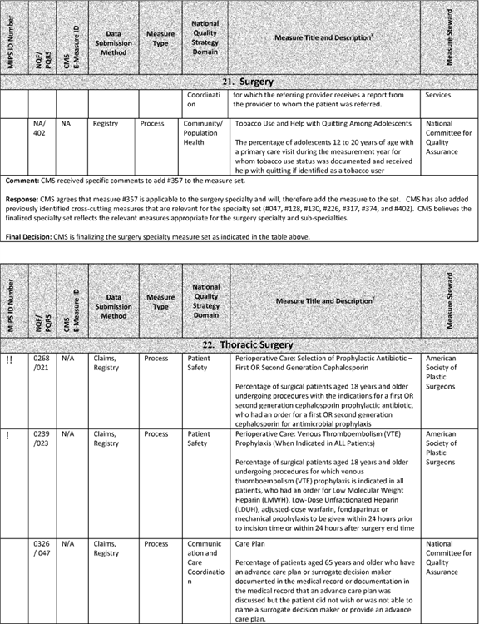

**[*77761]**



**[*77762]**

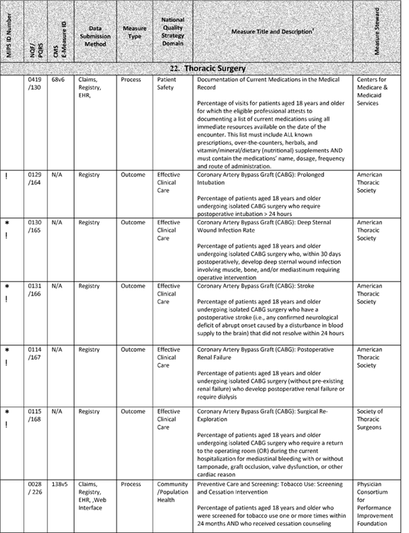

**[*77762]**



**[*77763]**

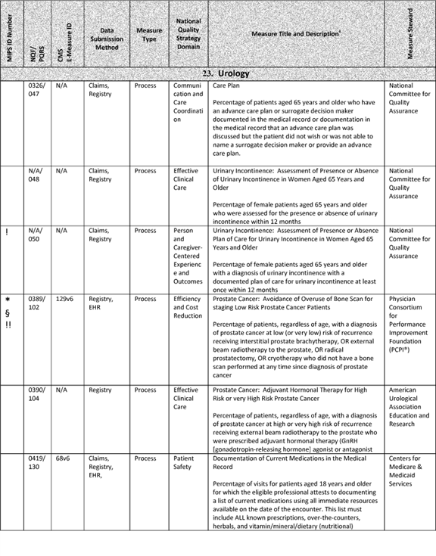

**[*77763]**



**[*77764]**

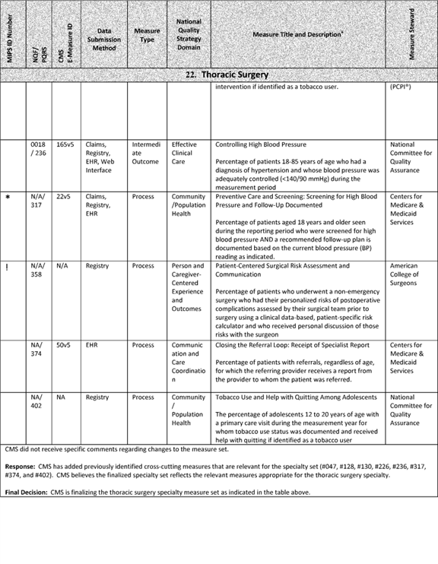

**[*77764]**



**[*77765]**

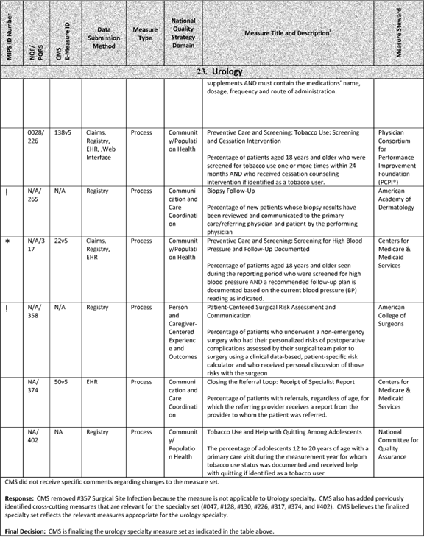

**[*77765]**



**[*77766]**

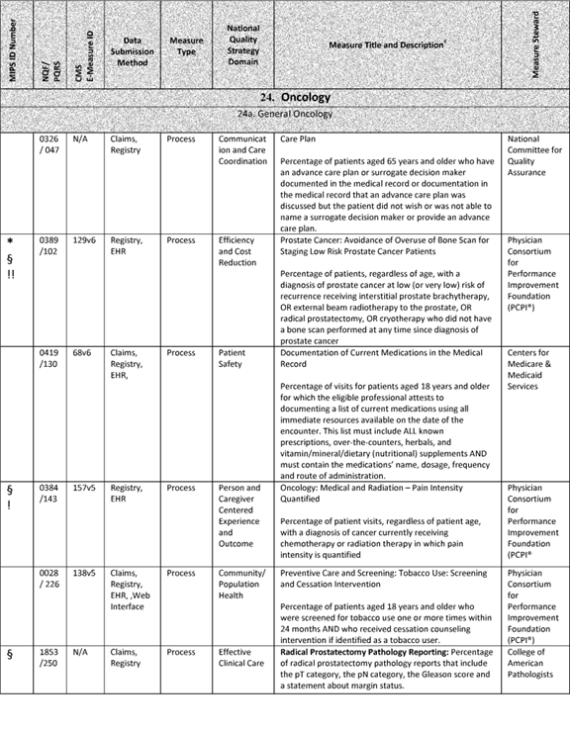

**[*77766]**



**[*77767]**

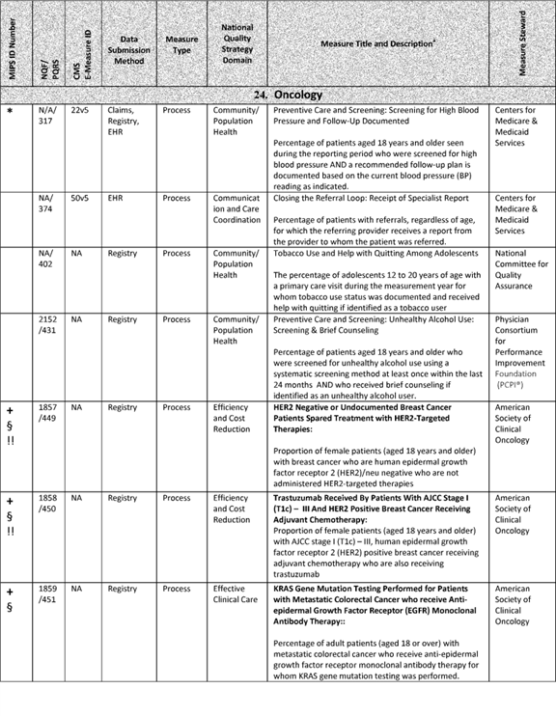

**[*77767]**



**[*77768]**

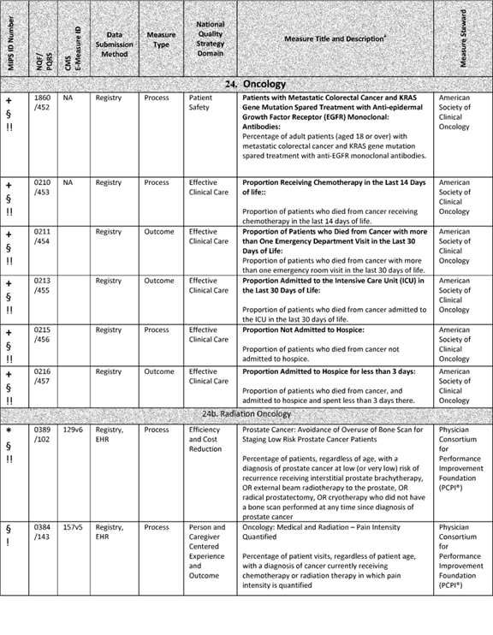

**[*77768]**



**[*77769]**

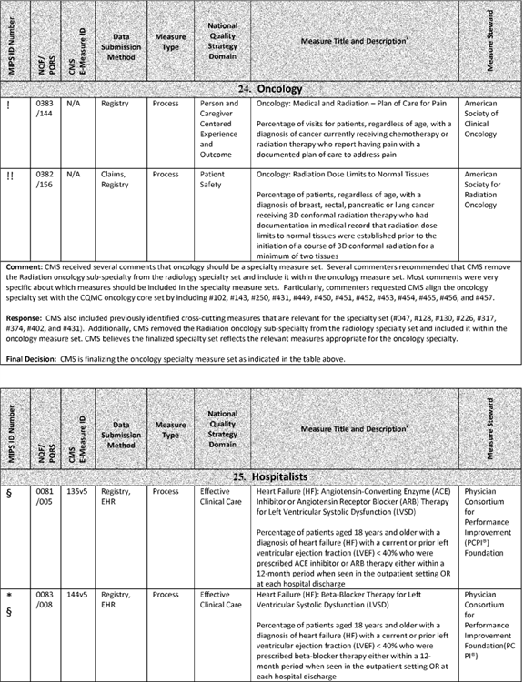

**[*77769]**



**[*77770]**

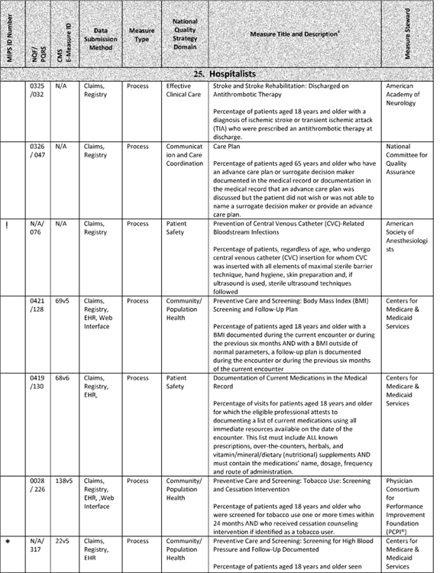

**[*77770]**



**[*77771]**

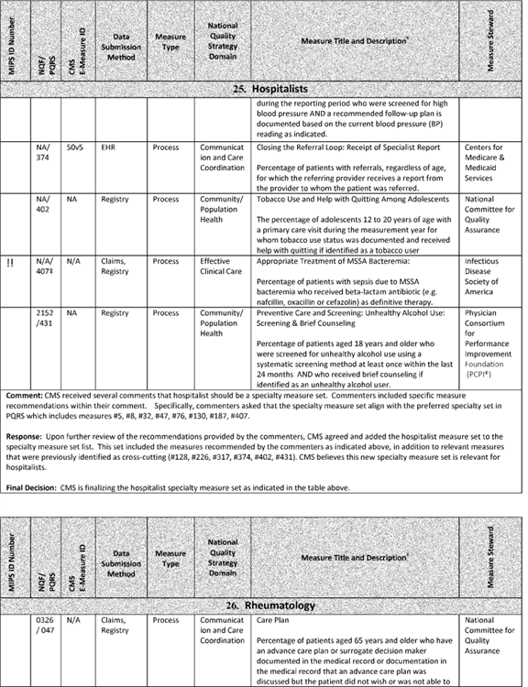

**[*77771]**



**[*77772]**

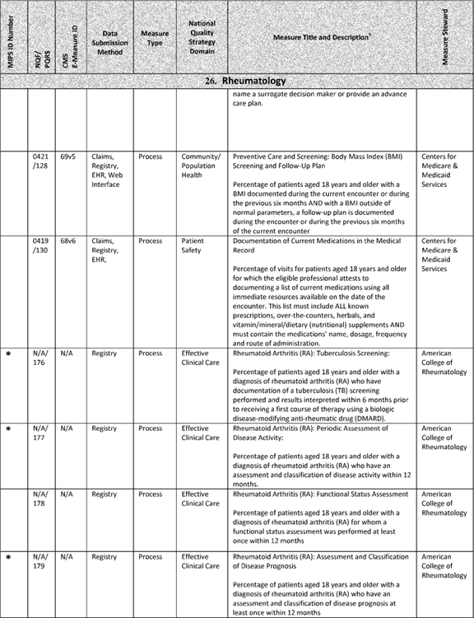

**[*77772]**



**[*77773]**

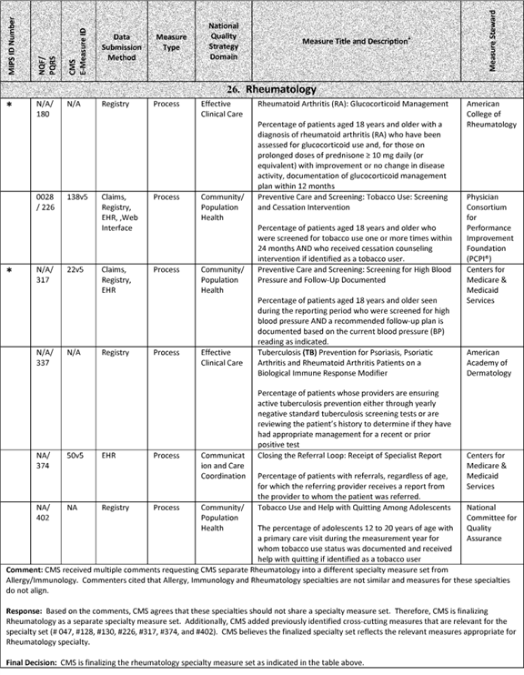

**[*77773]**



**[*77774]**

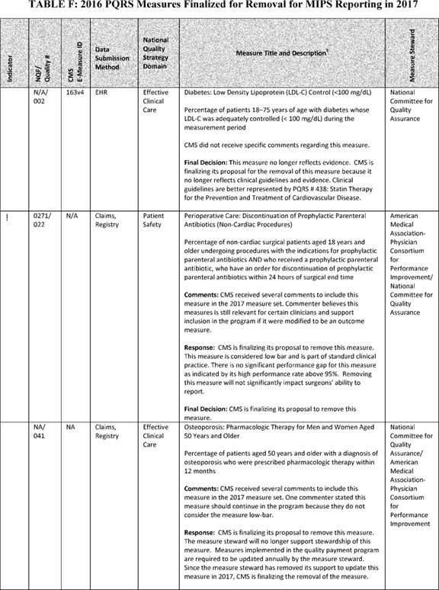

**[*77774]**



**[*77775]**

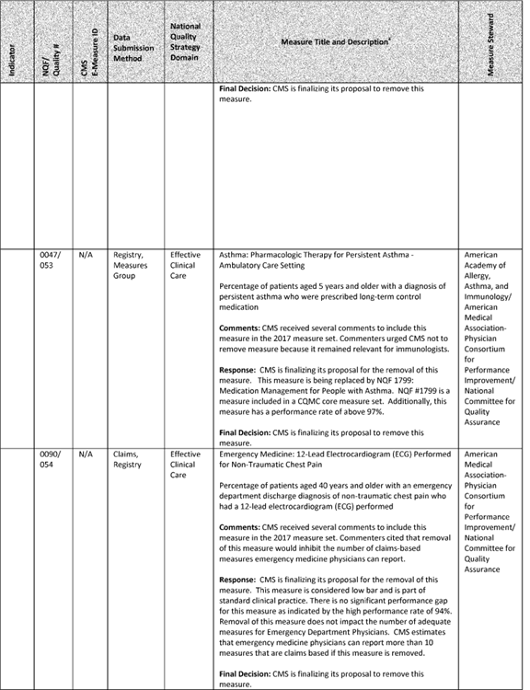

**[*77775]**



**[*77776]**

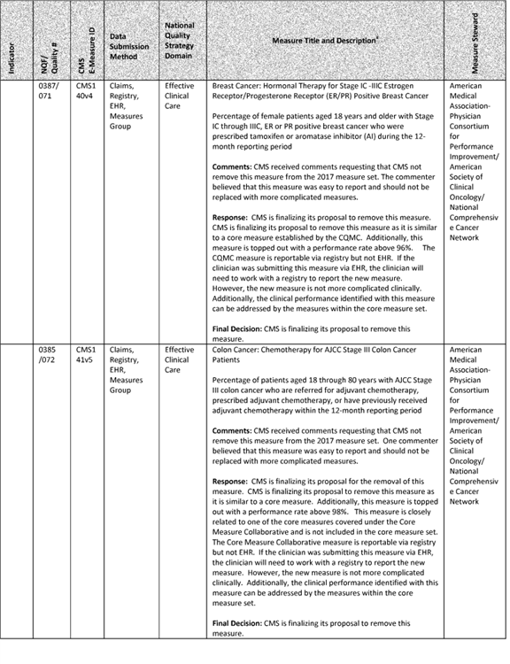

**[*77776]**



**[*77777]**

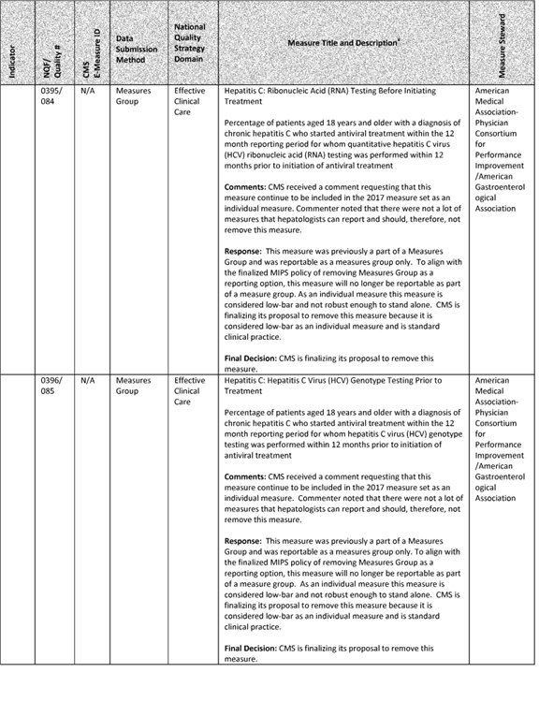

**[*77777]**



**[*77778]**

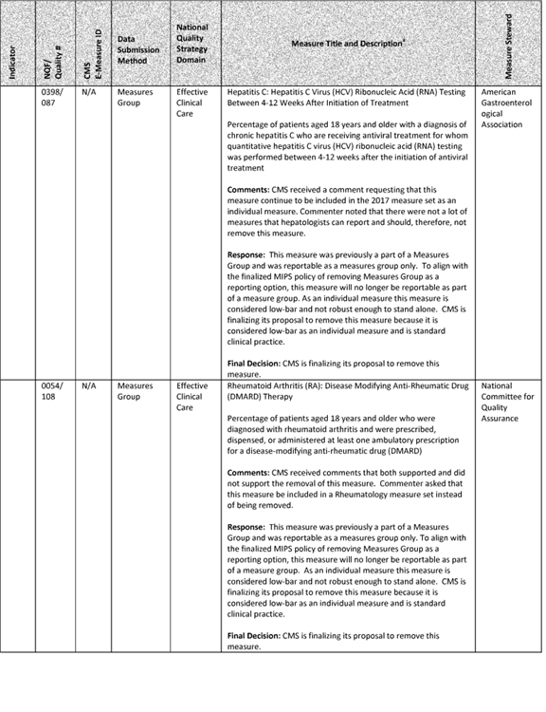

**[*77778]**



**[*77779]**

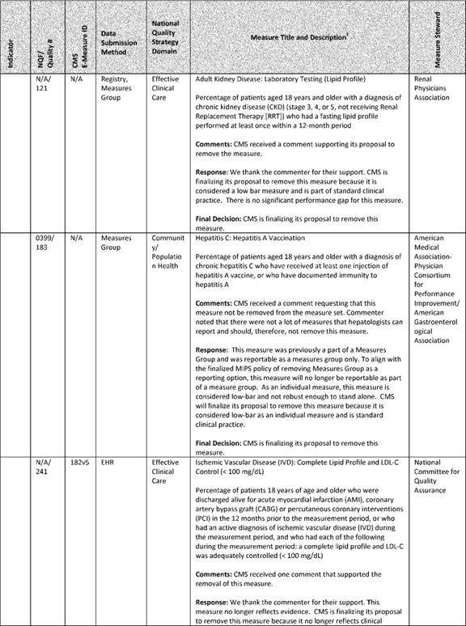

**[*77779]**



**[*77780]**

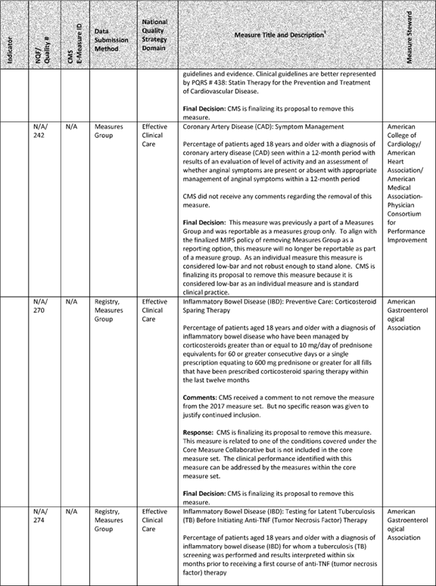

**[*77780]**



**[*77781]**

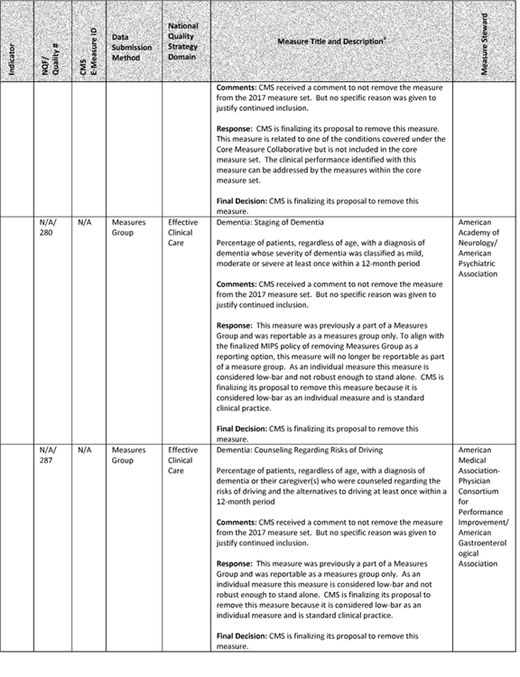

**[*77781]**



**[*77782]**

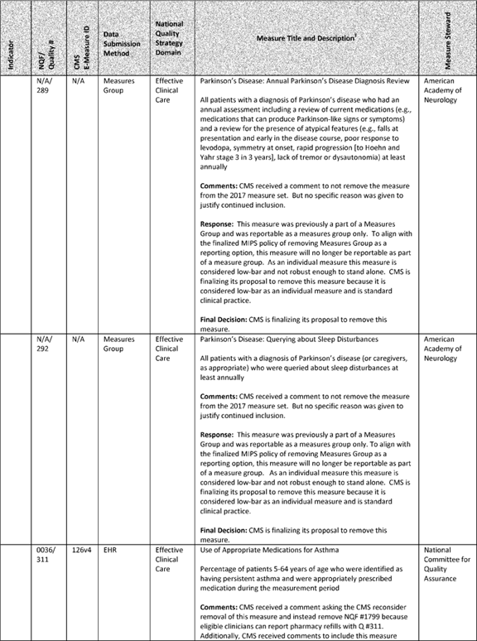

**[*77782]**



**[*77783]**

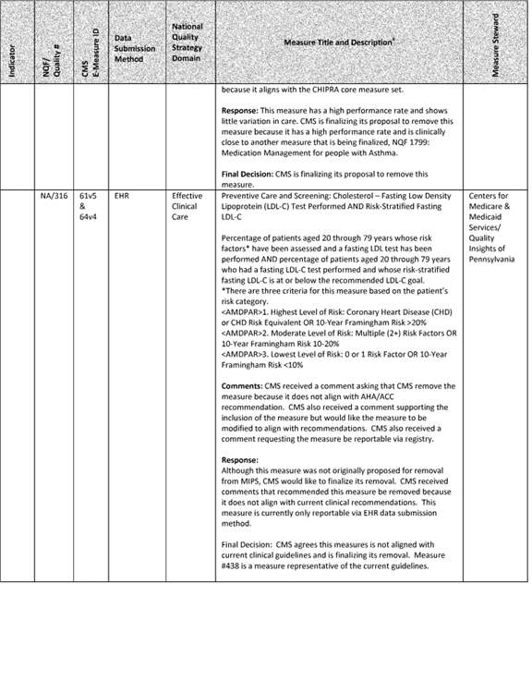

**[*77783]**



**[*77784]**

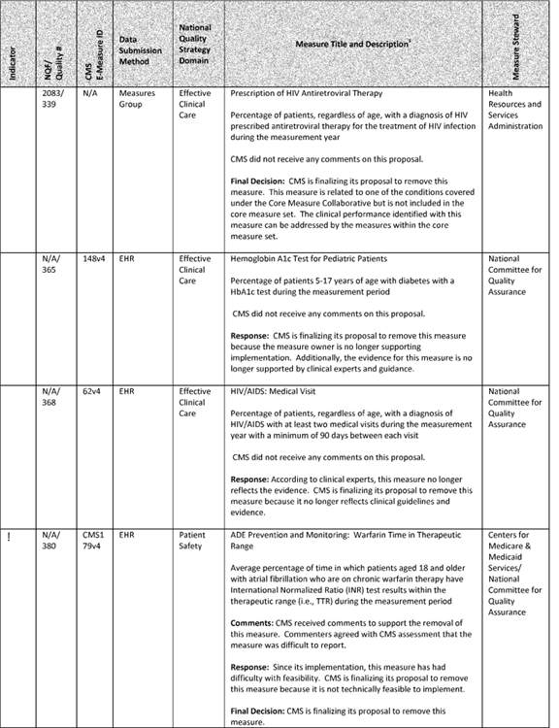

**[*77784]**



**[*77785]**

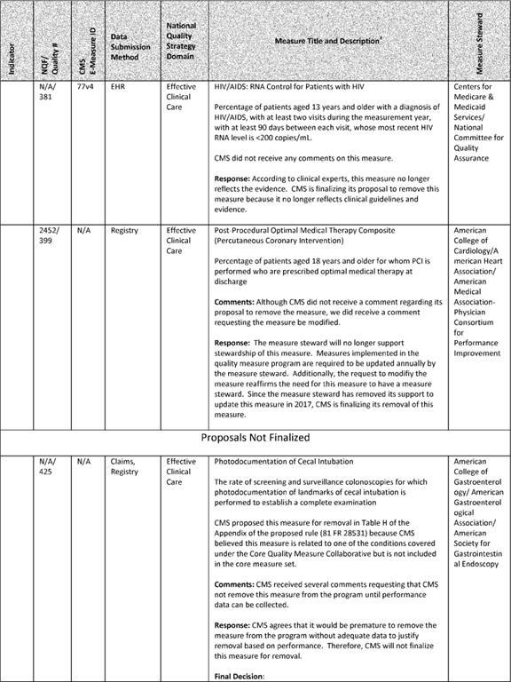

**[*77785]**



**[*77786]**



**[*77786]**



**[*77787]**

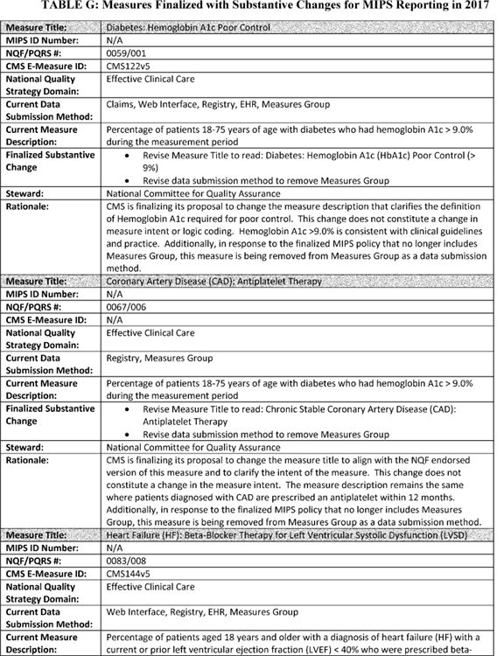

**[*77787]**



**[*77788]**

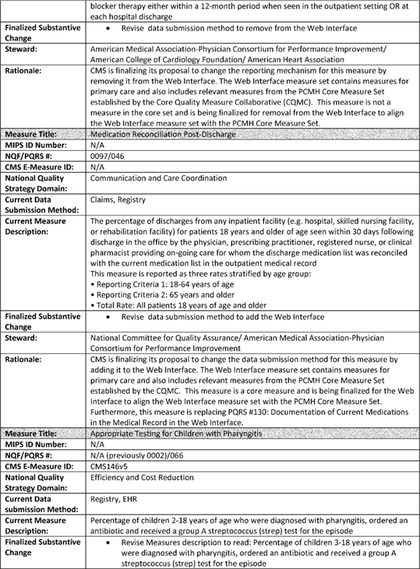

**[*77788]**



**[*77789]**

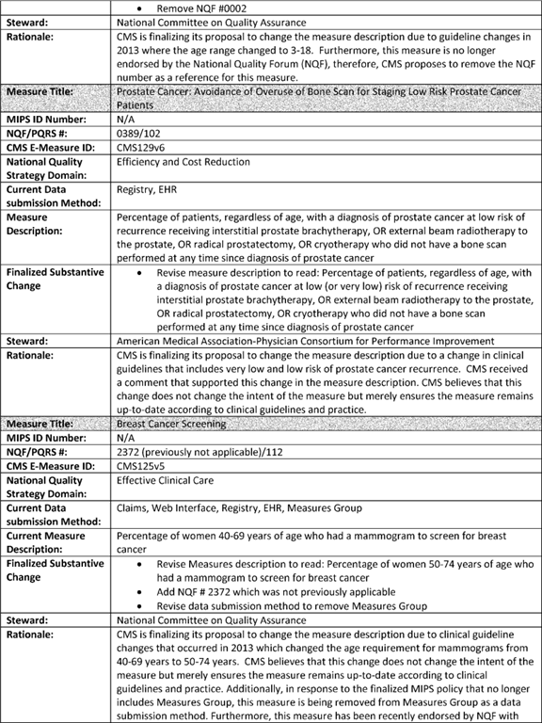

**[*77789]**



**[*77790]**

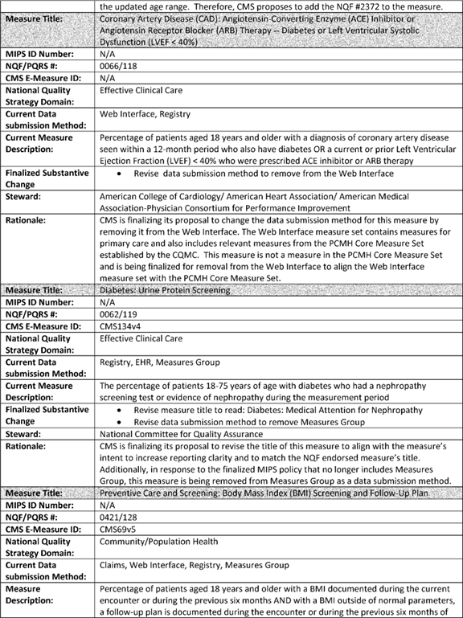

**[*77790]**



**[*77791]**

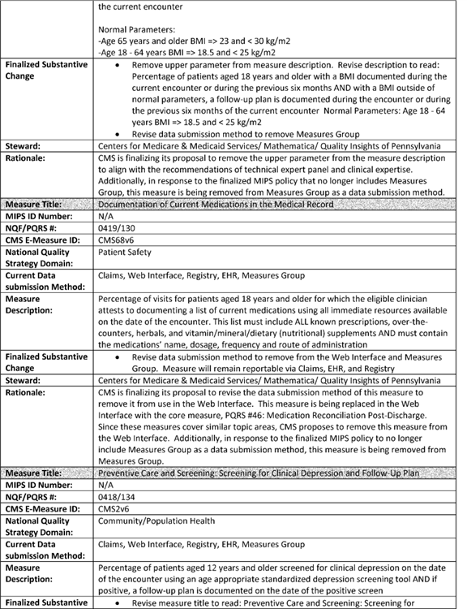

**[*77791]**



**[*77792]**

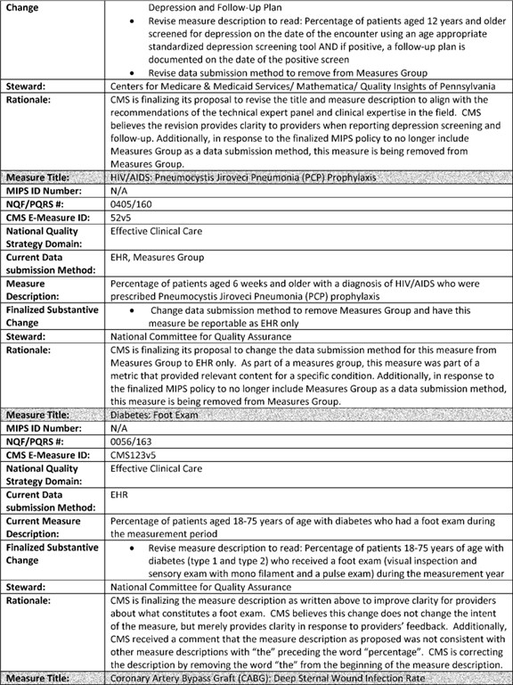

**[*77792]**



**[*77793]**

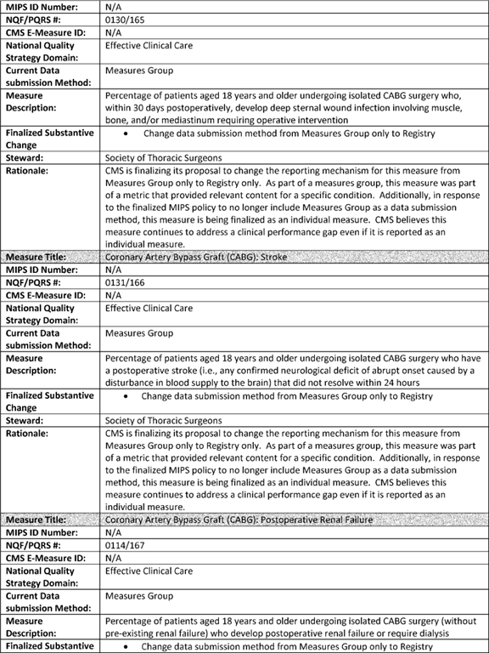

**[*77793]**



**[*77794]**

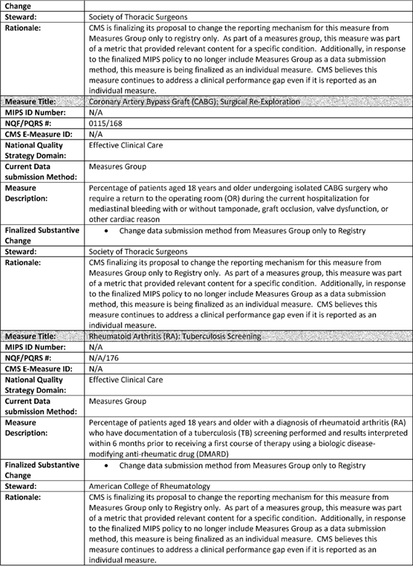

**[*77794]**



**[*77795]**

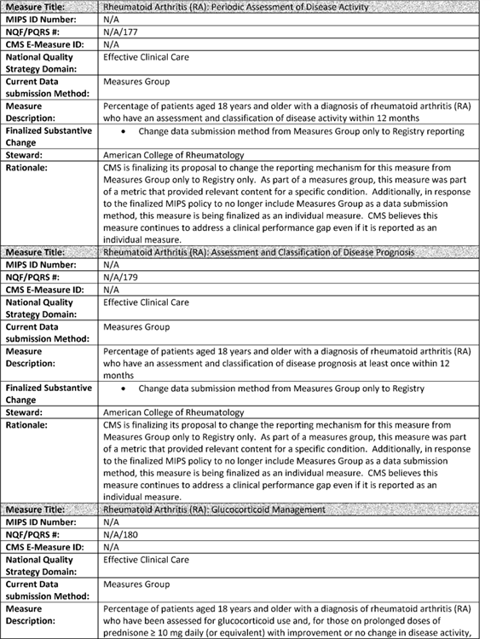

**[*77795]**



**[*77796]**

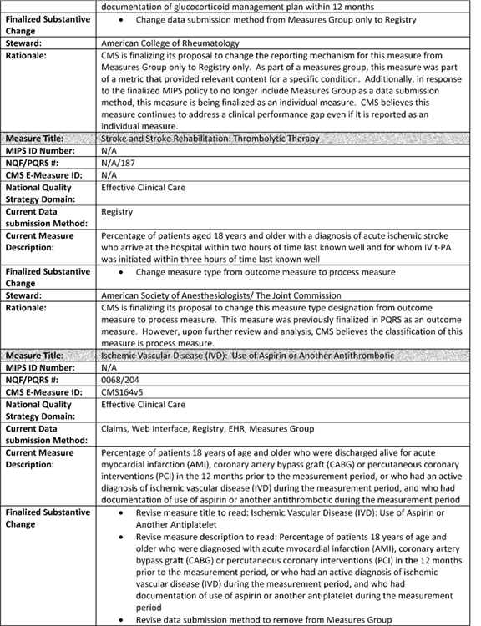

**[*77796]**



**[*77797]**

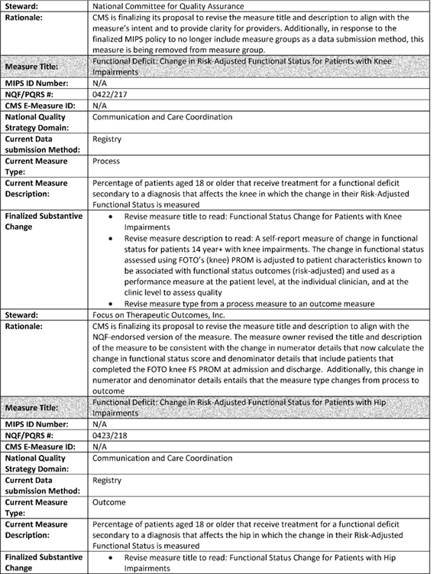

**[*77797]**



**[*77798]**

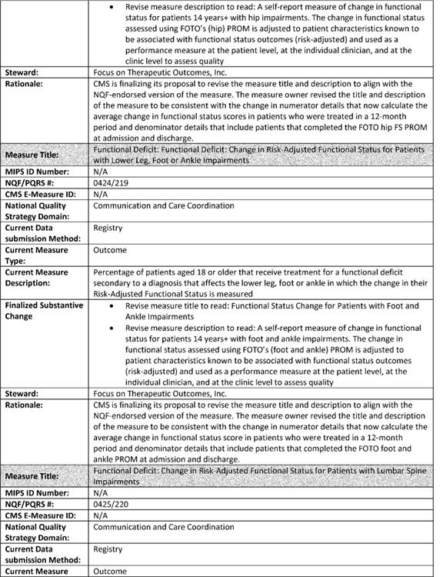

**[*77798]**



**[*77799]**

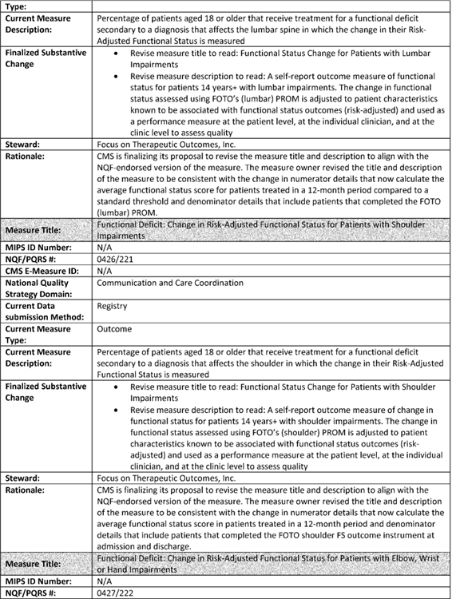

**[*77799]**



**[*77800]**

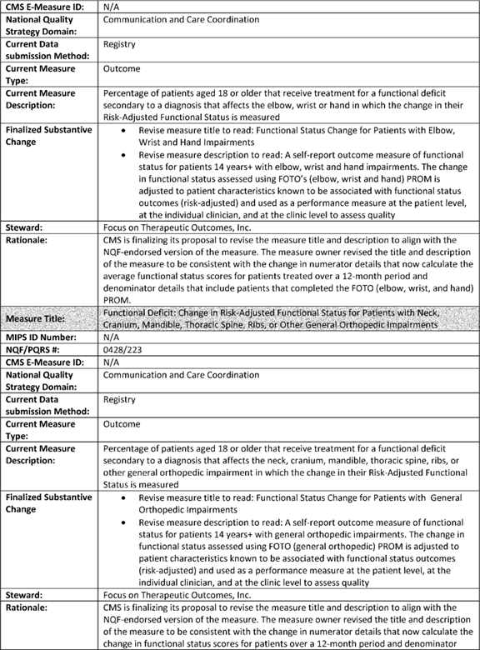

**[*77800]**



**[*77801]**

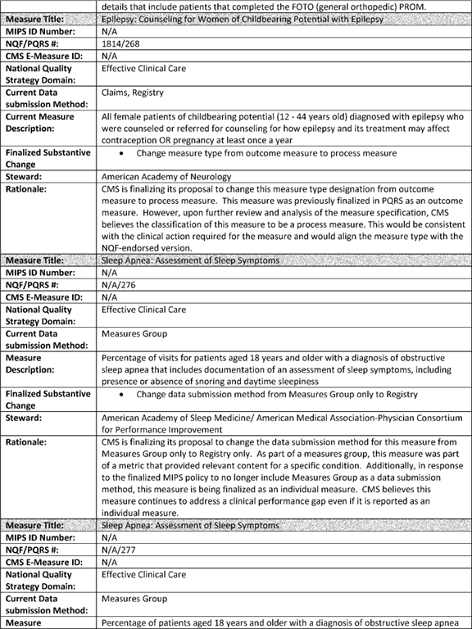

**[*77801]**



**[*77802]**

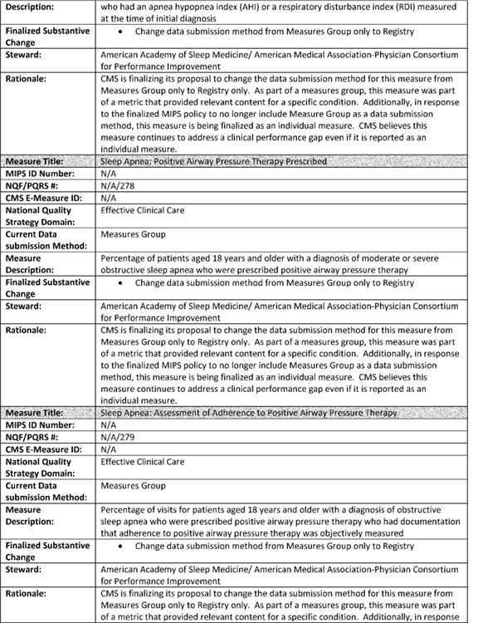

**[*77802]**



**[*77803]**

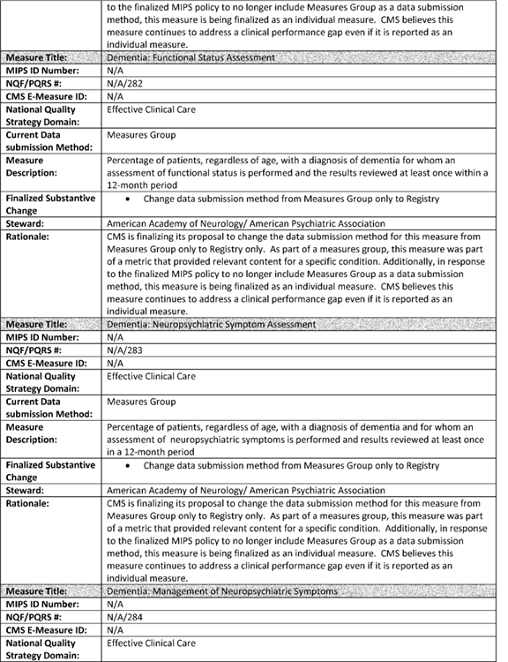

**[*77803]**



**[*77804]**

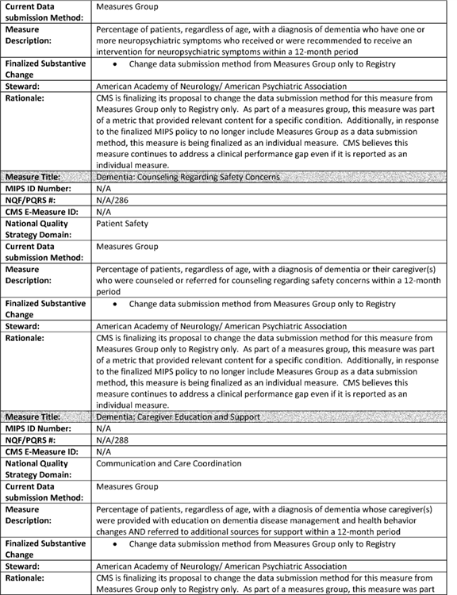

**[*77804]**



**[*77805]**

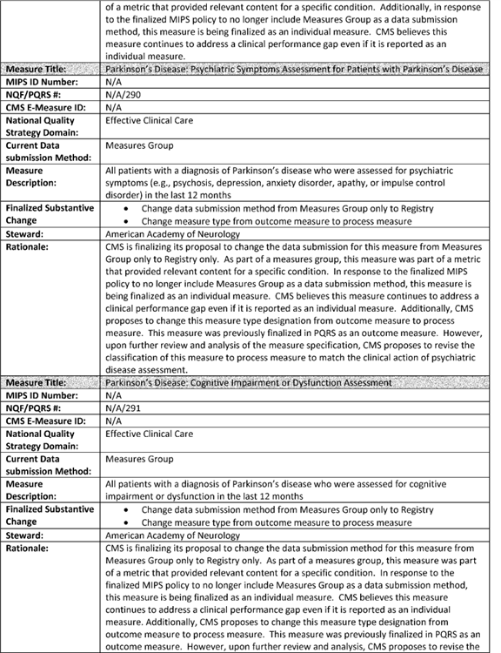

**[*77805]**



**[*77806]**

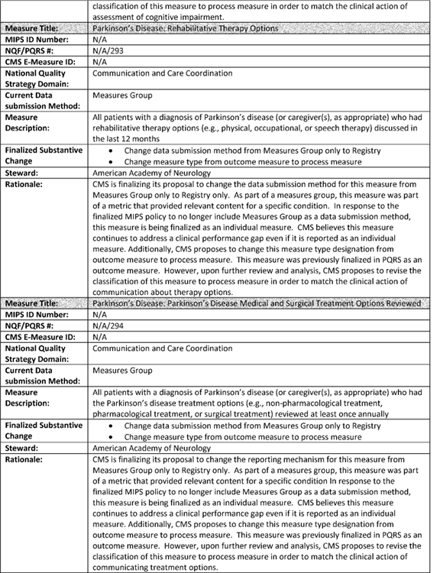

**[*77806]**



**[*77807]**

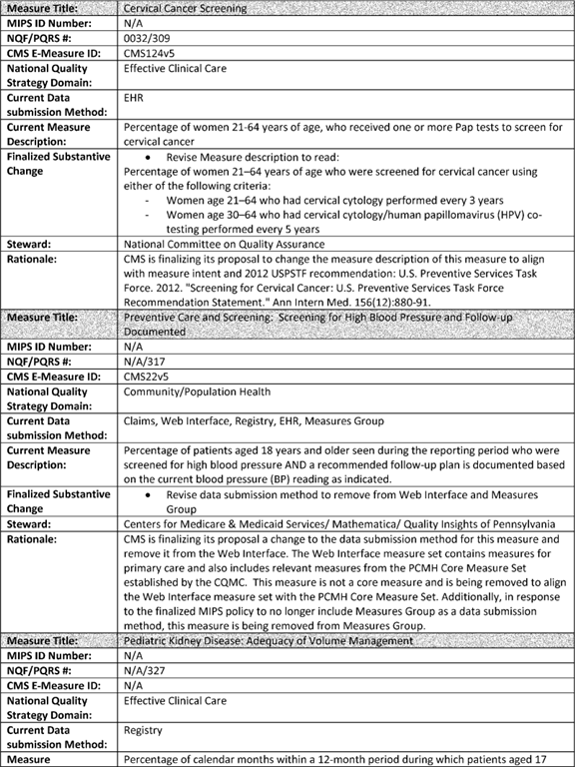

**[*77807]**



**[*77808]**

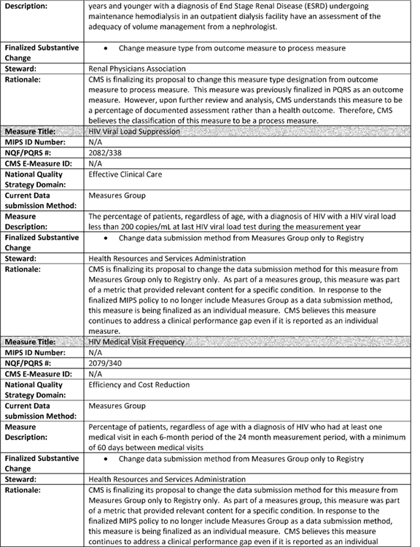

**[*77808]**



**[*77809]**

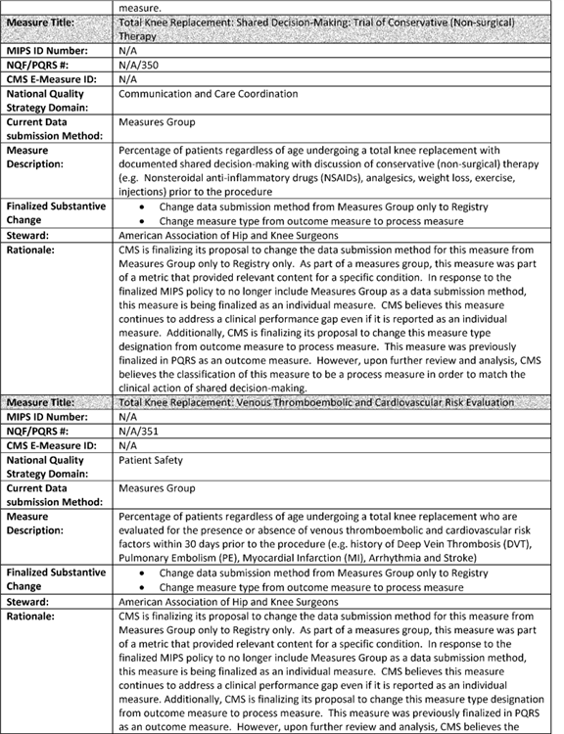

**[*77809]**



**[*77810]**

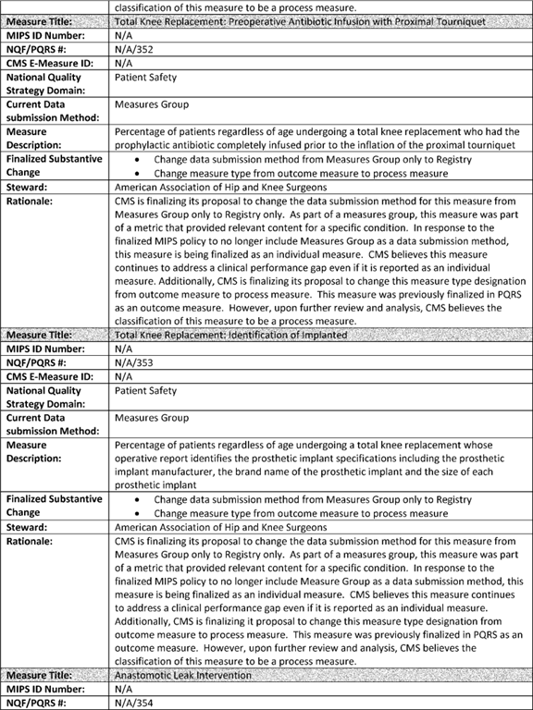

**[*77810]**



**[*77811]**

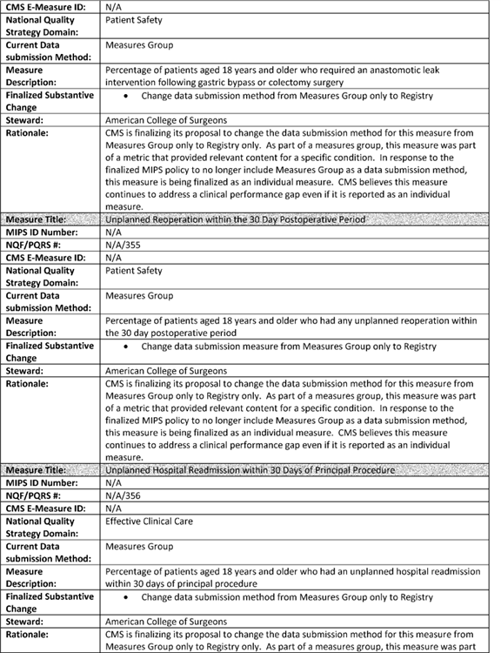

**[*77811]**



**[*77812]**

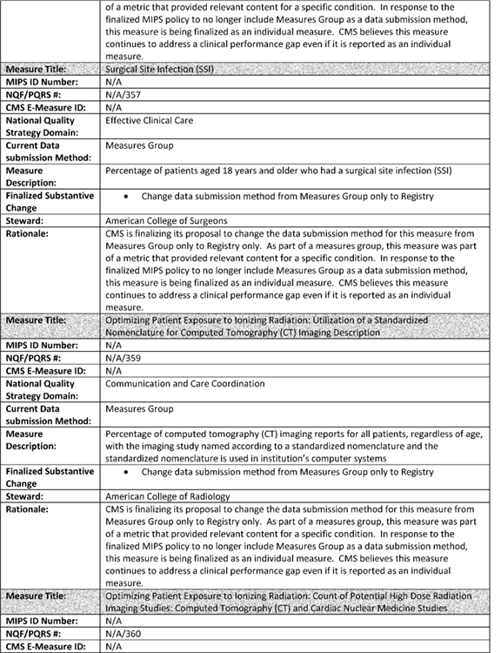

**[*77812]**



**[*77813]**

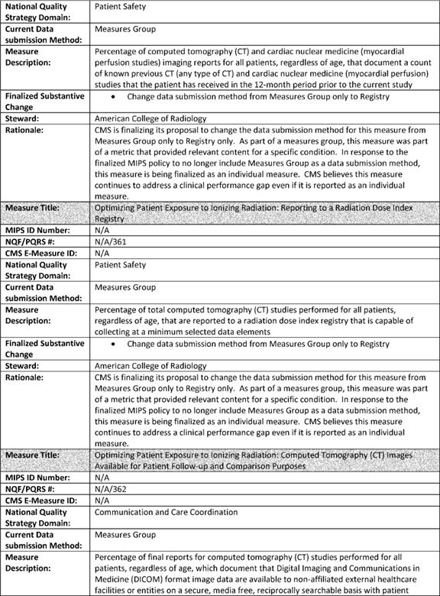

**[*77813]**



**[*77814]**

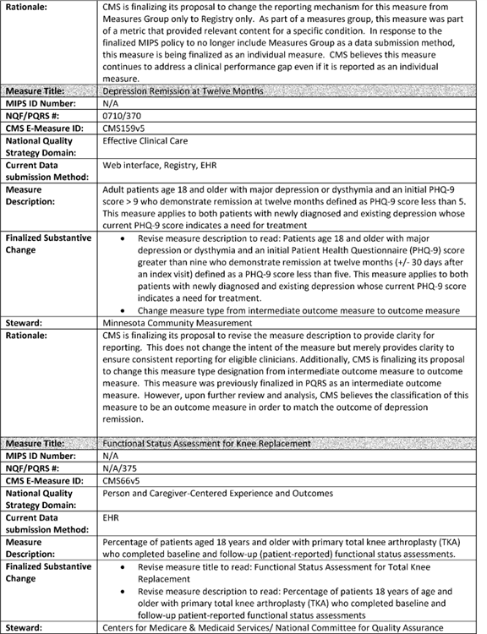

**[*77814]**



**[*77815]**

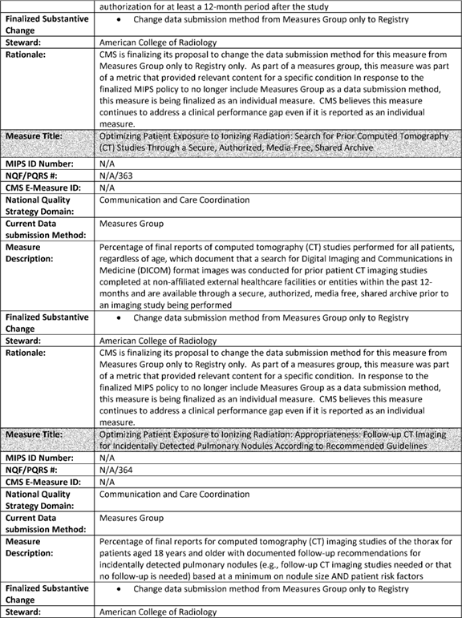

**[*77815]**



**[*77816]**

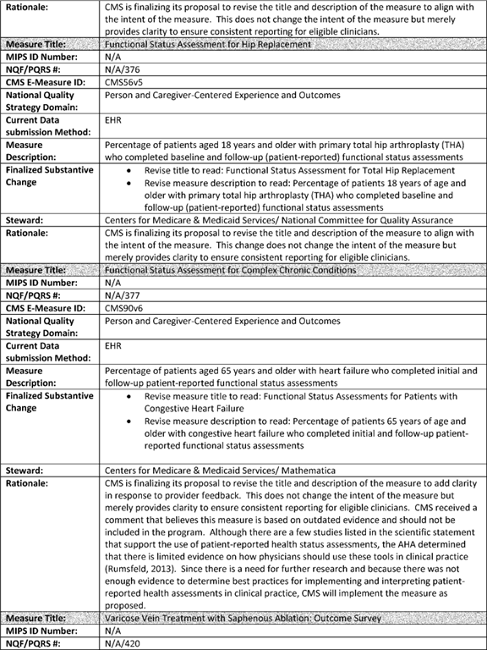

**[*77816]**



**[*77817]**

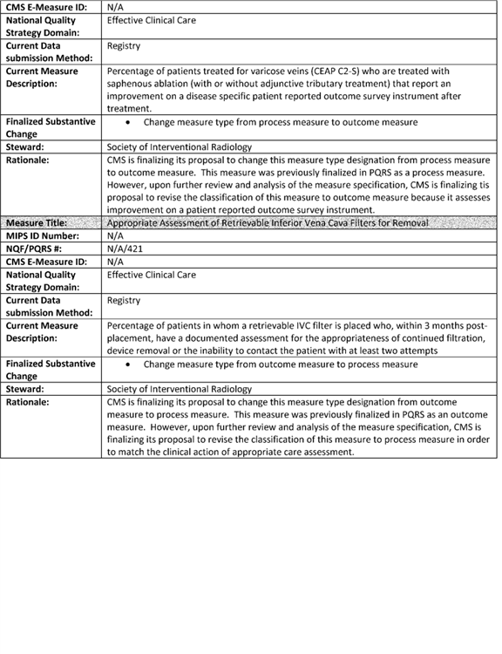

**[*77817]**



**[*77818]**

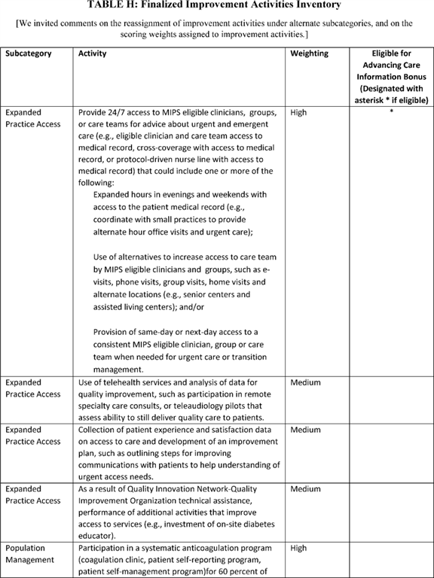

**[*77818]**



**[*77819]**

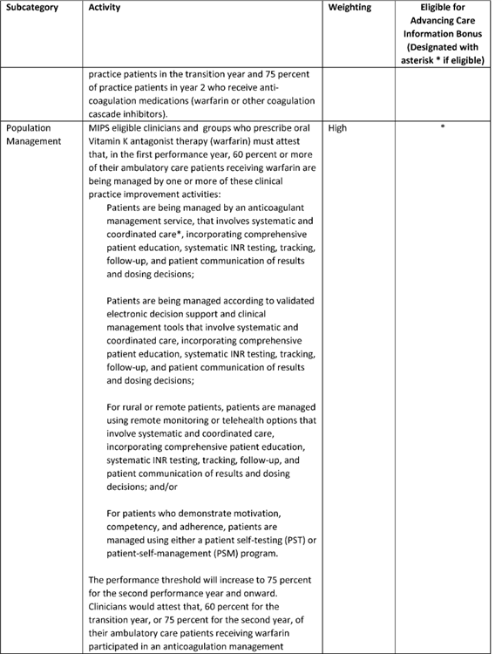

**[*77819]**



**[*77820]**

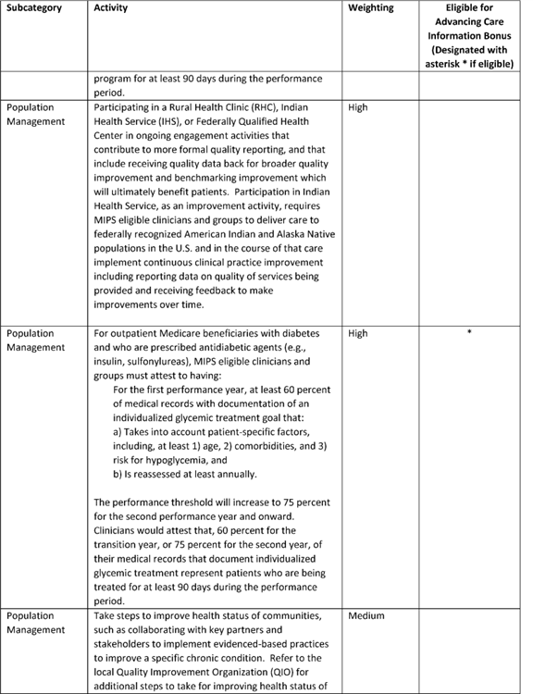

**[*77820]**



**[*77821]**

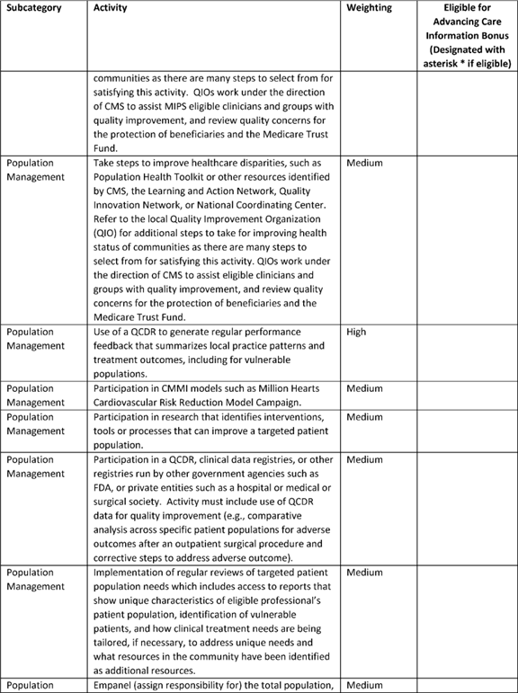

**[*77821]**



**[*77822]**

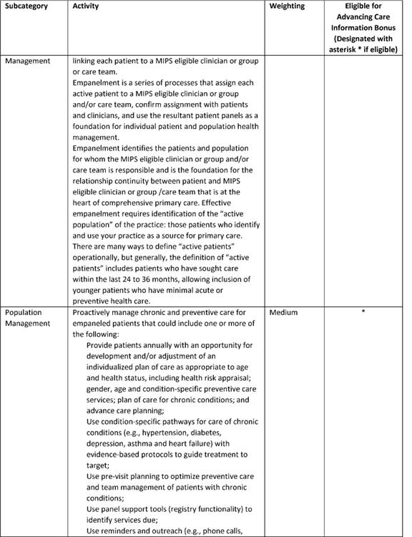

**[*77822]**



**[*77823]**

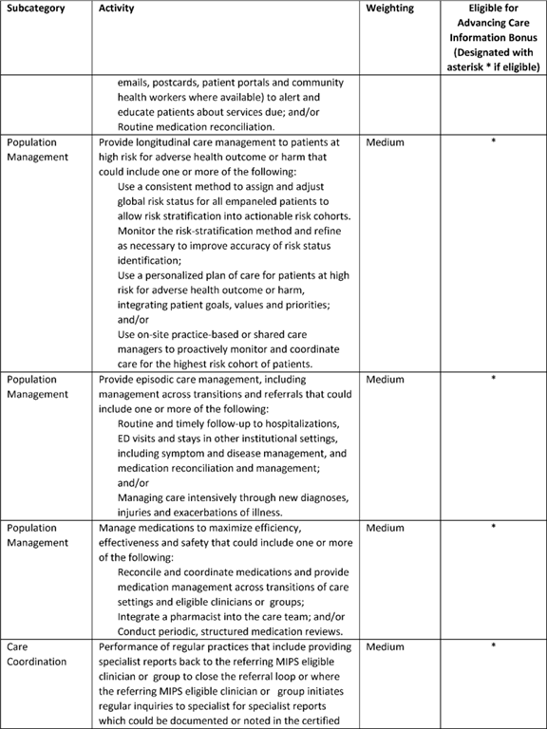

**[*77823]**



**[*77824]**

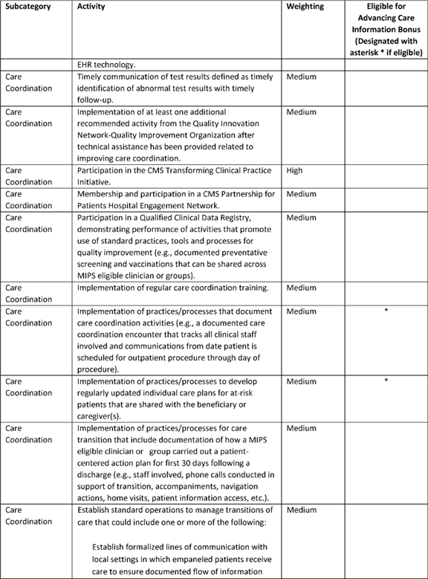

**[*77824]**



**[*77825]**

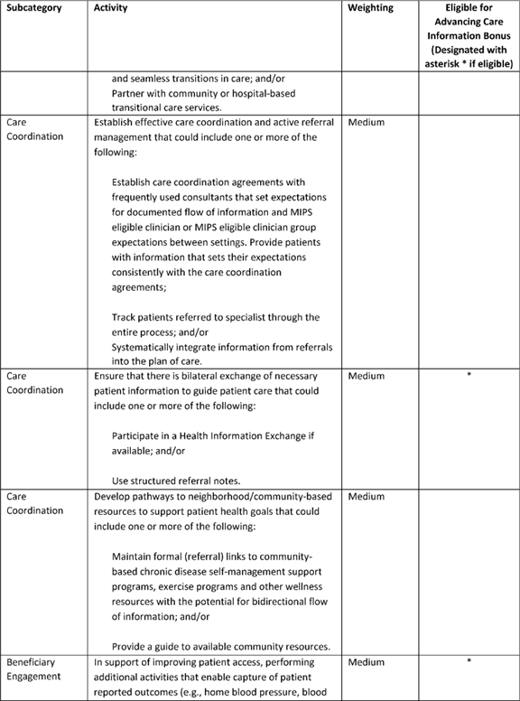

**[*77825]**



**[*77826]**

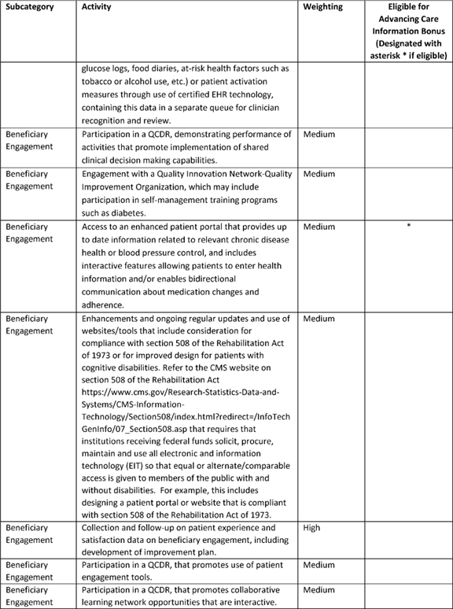

**[*77826]**



**[*77827]**

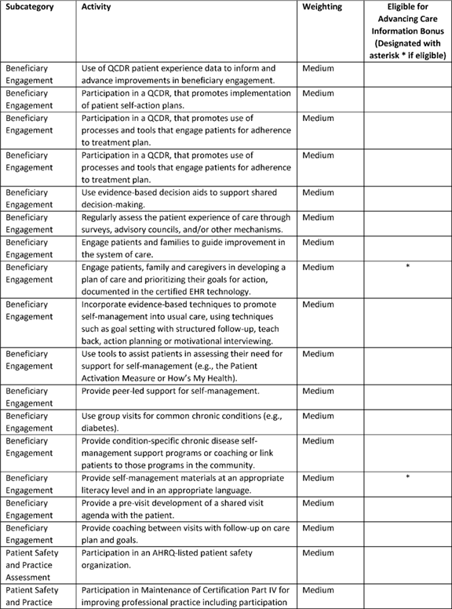

**[*77827]**



**[*77828]**

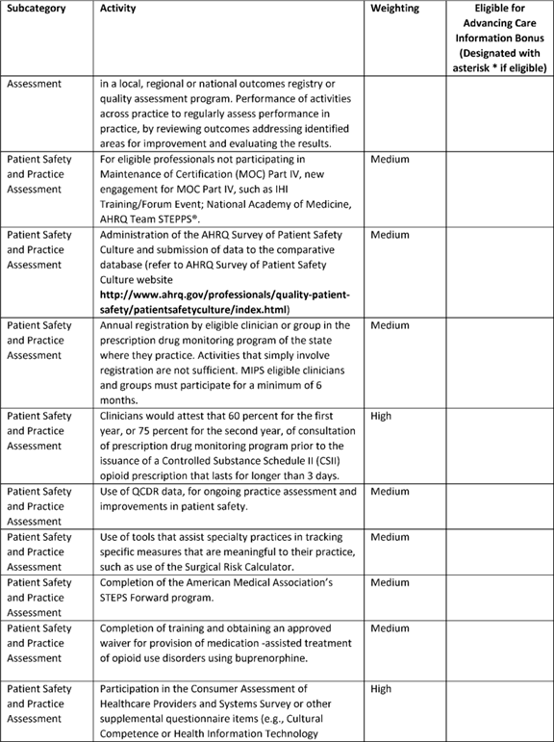

**[*77828]**



**[*77829]**

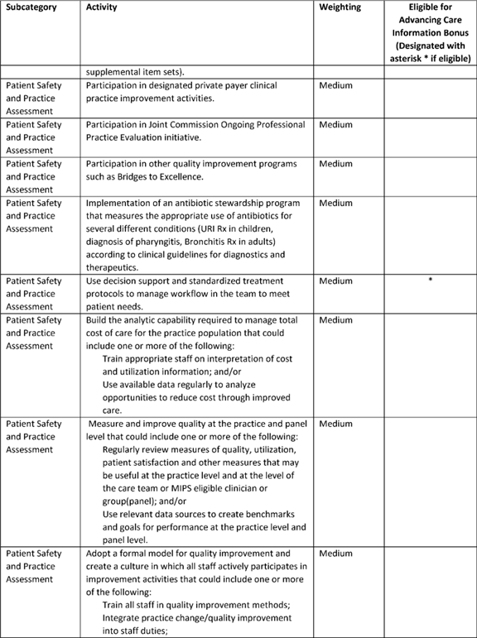

**[*77829]**



**[*77830]**

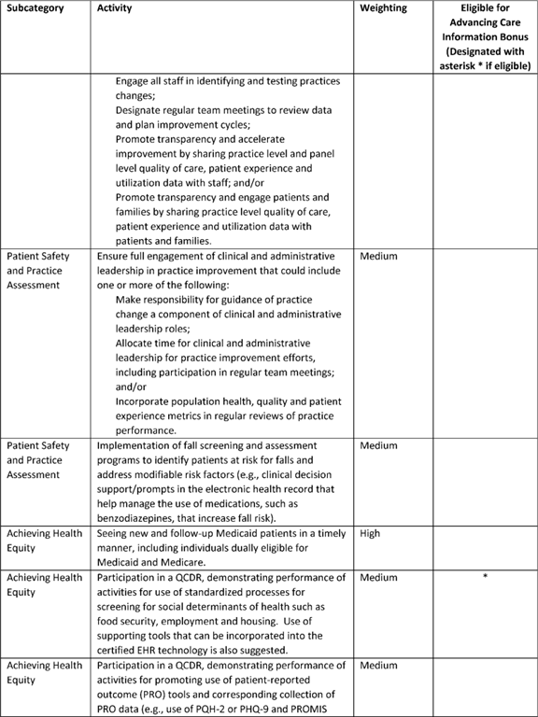

**[*77830]**



**[*77831]**

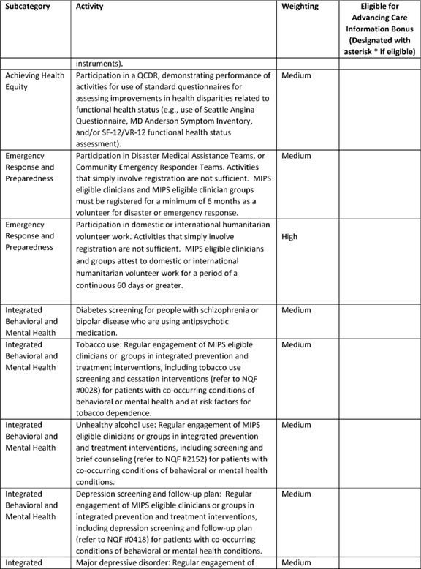

**[*77831]**

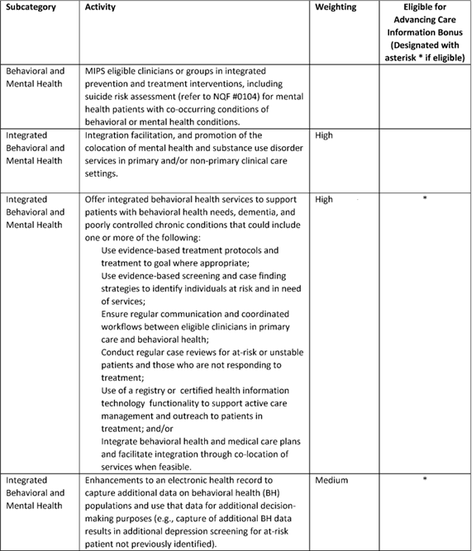

[FR Doc. 2016-25240 Filed 10-19-16; 4:15 pm]

BILLING CODE 4120-01-P

**Dates**

**DATES:** *Effective date:* The provisions of this final rule with comment period are effective on January 1, 2017.

*Comment date:* To be assured consideration, comments must be received at one of the addresses provided below, no later than 5 p.m. on December 19, 2016.

**Contacts**

**ADDRESSES:** In commenting, please refer to file code CMS-5517-FC. Because of staff and resource limitations, we cannot accept comments by facsimile (FAX) transmission. You may submit comments in one of four ways (please choose only one of the ways listed):

1. *Electronically.* You may submit electronic comments on this ***regulation*** to [*http://www.****regulations****.gov*](http://www.regulations.gov). Follow the "Submit a comment" instructions.

2. *By regular mail.* You may mail written comments to the following address ONLY: Centers for Medicare & Medicaid Services, Department of Health and Human Services, Attention: CMS-5517-FC, P.O. Box 8013, Baltimore, MD 21244-8013.

Please allow sufficient time for mailed comments to be received before the close of the comment period.

3. *By express or overnight mail.* You may send written comments to the following address ONLY: Centers for Medicare & Medicaid Services, Department of Health and Human Services, Attention: CMS-5517-FC, Mail Stop C4-26-05, 7500 Security Boulevard, Baltimore, MD 21244-1850.

4. *By hand or courier.* Alternatively, you may deliver (by hand or courier) your written comments ONLY to the following addresses prior to the close of the comment period:

a. For delivery in Washington, DC--Centers for Medicare & Medicaid Services, Department of Health and Human Services, Room 445-G, Hubert H. Humphrey Building, 200 Independence Avenue SW., Washington, DC 20201.

(Because access to the interior of the Hubert H. Humphrey Building is not readily available to persons without Federal government identification, commenters are encouraged to leave their comments in the CMS drop slots located in the main lobby of the building. A stamp-in clock is available for persons wishing to retain a proof of filing by stamping in and retaining an extra copy of the comments being filed.)

b. For delivery in Baltimore, MD--Centers for Medicare & Medicaid Services, Department of Health and Human Services, 7500 Security Boulevard, Baltimore, MD 21244-1850.

If you intend to deliver your comments to the Baltimore address, call telephone number (410) 786-7195 in advance to schedule your arrival with one of our staff members.

Comments erroneously mailed to the addresses indicated as appropriate for hand or courier delivery may be delayed and received after the comment period.

For information on viewing public comments, see the beginning of the **SUPPLEMENTARY INFORMATION** section.

**FOR FURTHER INFORMATION CONTACT:** Molly MacHarris, (410) 786-4461, for inquiries related to MIPS. James P. Sharp, (410) 786-7388, for inquiries related to APMs.

FEDERAL REGISTER

**End of Document**